

Business Skills for International

Hotel Industry

Module code: B4X01917

Name : Manolis Areza

Student Number : 1813603



INTRODUCTION

Firstly, at this part of this assignment it has been given to me to write a five hundred words. To write a report that is based on group presentation and how we work as a team. The presentation I’ll talk about is : How would be a good CV , How Must be the PDP and The interviews and what they need to be perfect. Secondly I will be using Gibbs reflective cycle to do my report.
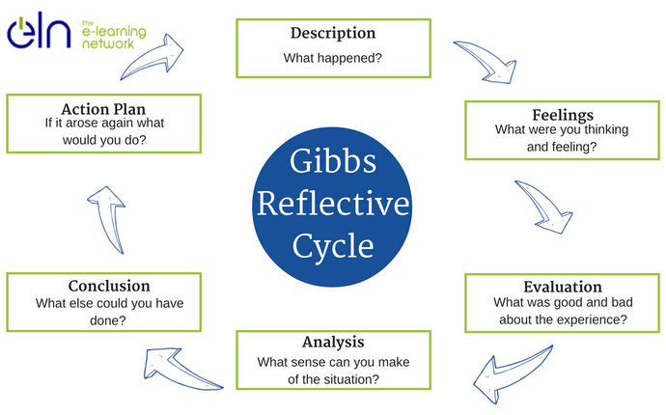

DESCRIPTION

So it have been given to me and to my team to present “How to be a perfect Interview”. So we start making plan all together , after that we start searching for a nice images and to have chat online all together and we was sending the images that we had found to the group chat.

REFLECTIVE REPORT

As a group presentation we were tasked to complete our presentation in fifteen minutes so we were three groups and we all had at our disposal fifteen minutes and we was the group who had to discuss the “Interview” stage.

FEELINGS

In the beginning of the presentation I was a little bit stressed and my team as well cause it was our first presentation as a group and we had to do a perfect job. During the presentation my stress gone and I was sure for me and my team that we had done a perfect job and when all of that had been finished we were all happy because we had done something good and had worth .

EVALUATION

So the presentation went very well because we were completely ready to face everything and we had answer to all the questions the colleagues had I think they. The only bad thing was that at the beginning we was stressed nothing more. The good thing was that we were concentrate to our target and our target was not to struggle with the language and I think we did it properly.

ANALYSIS

- I don’t think we done something wrong because we were very concentrate on our target as I said the only obstacle was not to struggle with the language and we overcome that obstacle with a 100% success.

- All went good because during the presentation we were all listening to our teammate in case of one of us started struggling with the language.

- Maybe if all the groups had more time we would have done it better.

CONCLUSION
I don’t think we could have it done differently because we have changed a lot of ideas so when we found the correctly we stuck to the plan

ACTION PLAN

- I will be better on facing the time that they give to us (those 15minutes)
- For the next time I’ll try to improve more my English language
- To another presentation I need to feel more comfortable when I’m speaking
- I need to explore myself and push it to the limit to see when I’m gonna stop

References:
Corfield, R. (2009). Successful interview skills. London: Kogan Page.
Johns, C. (2004). Becoming a reflective practitioner. Oxford, UK: Blackwell.

