

University of Wales Trinity Saint David
School of Engineering

Electronic Ignition & Fuel Injection Systems

Oscar Pollitt 1900412

BSc Motorsport Engineering

M4X02197

Table of Contents
CHAPTER 1.0 INTRODUCTION 5
CHAPTER 2.0 LITERATURE REVIEW 6
CHAPTER 3.0 METHODOLOGY 7
3.1 Equipment 7
3.2 Health and Safety 7
3.3 Motronic Testing Methodology 8
3.3.1 Static Tests 8
3.3.2 Warm Up Phase Testing 9
3.4 Jetronic Testing Methodology 10
3.4.1 Static Test 10
3.4.2 Warm Up Phase Testing 11
3.4.3 Engine at Temperature 11
CHAPTER 4.0 RESULTS 12
4.1 Motronic 12
4.1.1 Scope Patterns 12
4.1.2 Static Testing 13
4.1.3 Engine Warm Up Phase Testing 14
4.2 Jetronic 15
4.2.1 Scope Patterns 15
4.2.2 Static Testing 15
4.2.3 Engine Warm Up Phase Testing 16
CHAPTER 5.0 ANALYSIS 17
5.1 Motronic 17
5.1.1 Pin 1 Primary Coil Waveform 17
5.1.2 Pin 4 Rotary Idle Valve Waveform 18
5.1.3 Pin 27 and 2 Supply from Ignition and Earth Return Waveform 19
5.1.4 Pin 7 MAF and Pin 53 Throttle Potientiometer Waveform 20
5.1.5 Pin 16 Injectors Waveform 21
5.1.6 Pin 16 and 17 Injectors Waveform 22
5.1.7 Pin 28 Lambda Sensor Waveform 23
5.1.8 Pin 49 Speed Sensor Waveform 24
5.1.9 Secondary Wave Pattern Waveform 25
5.1.10 Static Testing Analysis 26
5.1.11 Warm Up Phase Testing Analysis 27
Jetronic 5.2 30
5.2.1 Pin 3 Injectors Waveform 30
5.2.2 Pin 12 Crank Signal Waveform 31
5.2.3 Pin 1 Primary Coil Waveform 32
5.2.4 Pin 4 Spark Advance Signal and Pin 1 33
5.2.5 Pin 3 Supply and Pin 2 Earth 34
5.2.6 Pin 5 Speed Reference for fuel ECU Waveform 35
5.2.7 Secondary Voltage Waveform 36
5.2.8 Static Testing Analysis 37
5.2.9 Warm Up Phase Testing Analysis x 38
CHAPTER 6.0 EVALUATION 39
6.1 Testing Validation 39
6.2 Operating Conditions 40
6.2.1 Motronic 40
6.2.2 Jetronic 41
6.3 Comparing Systems 42
6.4 Modifications 42
CHAPTER 7.0 CONCLUSION 43
CHAPTER 8.0 BIBLIOGRAPHY 44

Table of Figures
Figure 1 Pin 1 Primary Coil Output 17
Figure 2 Pin 4 Rotary Idle Valve 18
Figure 3 Pin 27 and Pin 2 19
Figure 4 Pin 7 and 53 20
Figure 5 Pin 16 at 80deg 21
Figure 6 Pin 16 Acceleration and Deceleration 21
Figure 7 pin 16 and 17 22
Figure 8 Pin 28 Lambda 23
Figure 9 Pin 49 Speed Sensor 24
Figure 10 Secondary Wave Pattern 25
Figure 11 Motronic Table 27
Figure 12 NTC2 Graphs 27
Figure 13 Idle Valve 28
Figure 14 Injector On Time 28
Figure 15 Emission Control Valve 29
Figure 16 Pin 3 Injector Idle 30
Figure 17 Pin 3 Acceleration and Deceleration 30
Figure 18 Pin 12 Crank Signal 31
Figure 19 Pin 1 Primary Coil Output 32
Figure 20 Pin 4 and 1 33
Figure 21 Pin 3 supply and Pin 2 Earth 34
Figure 22 Pin 5 Speed reference for fuel ECU 35
Figure 23 Secondary Wave Pattern 36
Figure 24 NTC2 Graphs 38
Figure 25 Injector on time 38

CHAPTER 1.0 INTRODUCTION

The aim of this technical report is to analyse and evaluate the operation of different types of electronic ignition and fuel injection systems. Dedicated test equipment will be used, working in a group using systematic testing to achieve a common objective. Which is to investigate technical applications and solutions for electrical and electronic circuits. This will be done by analysing and evaluating voltage, current, resistance and power in automotive circuits that include an array of sensors, actuators and displays. Test equipment that is used includes an oscilloscope and a multimeter that will be used under the correct procedure meeting safety requirements. The test equipment will also be reviewed to ensure the credibility of the report is complete.
From testing, the principles of operation and electrical characteristics of sensors and actuators will be determined, analysed and reviewed identifying solutions for improvement or modification. Two engines with varied technology will be compared and contrasted with to identify similarities and differences, strengths and weaknesses. The data collected about various components will be interpreted to understand how the components are addressed to operate in certain operating conditions. To ensure the complete understanding, results will be compared with the manufactures specifications and identifiable issues will be analysed and explained.

CHAPTER 2.0 LITERATURE REVIEW
The purpose of electronic engine control system is to regulate the air fuel mixture and the ignition timing. The engine control system is responsible for all possible operating conditions. For a typical engine there are seven operating modes that affect fuel control: engine crank, engine warm up, open loop control, closed loop control, hard acceleration, deceleration and idle. (William, B 2003)
The purpose of ignition in an engine is to generate a proficient electrical spark to bridge the gap between two electrodes on spark plug, maintain that gap and provide a spark to each cylinder at the right time in order to allow for combustion
In modern electronic ignition distributors are rarely found. Most engines now have two different primary designs of EI system, doubled ended coil and coil per cylinder systems. In both cases, coil longevity is considered to be significantly longer than a coil on a distributor. Also worn distributors can cause erratic ignition timing and spark advance. (Erjavec 2004 p. 615)
A waste spark ignition or double ended coil use one ignition coil for two spark plugs. Both ends of the coil’s secondary side are directly connected to a spark plug. This means two plugs are ignited at the same time, one on the compression stroke and one on an exhaust stroke. And a coil per cylinder uses a single coil for each cylinder, both have advantages and disadvantages (Erjavec 2004 p. 615)
Fuel injectors are solenoid-operated, normally closed valves powered by switched ignition voltage. The ECU provides a ground which causes the injectors to open, the normal amount of time that the injectors are open is typically two to five milliseconds. Injectors along with a fuel pressure regulator are attached to a fuel rail which feeds fuel to the injectors and fuel pressure regulator. (Watson 1992 p. 91)

CHAPTER 3.0 METHODOLOGY

3.1 Equipment
Bosch BEA 850 Oscilloscope
The BEA 850 is equipped to meet all and current future requirements on analysis of petrol and diesel exhaust gases. In this experiment the technology will be utilised to measure sensors and actuators using the oscilloscope features to create waveforms and scope patterns measuring voltage and temperature (Bosch 2020)

FLUKE Digital Multimeter
This device will be used for static tests of the ECU pins and components for voltage and resistance. Measurements will also be taken in warm up phase testing using this device.

Jetronic and Motronic Engine Control Systems
Two engine control systems that will be tested, with the Jetronic being an older generation and Motronic a more modern generation of control systems

3.2 Health and Safety
To meet health and safety standards. The workshop will utilize its ventilation system extracting the exhaust gases from the running engines and the fire escape doors kept open as a backup in case of a fault with the ventilation system. Any objects that are spinning at a high velocity should have a guard that protects limbs from these possible dangers. Fire exits must not be blocked and if a fire should occur, the members inside the workshop must follow the evacuation guidelines written out in the workshop
The lighting, temperature and will be kept at a suitable level to carry out the required test. Working in a group on the engines can prove to be a hazard if a member is unaware of the situation and therefore when the engine is cranking, each member within the workshop should be made aware with an audible notification.
To ensure that there are no tripping hazards the workshop will be cleared of potential tripping hazards and steel toe cap boots along with laboratory coats must be worn to ensure falling objects and chemicals are at a reduced risk of harm. Because of electrical equipment and the innate hazards that this provides, extra care should be taken around electrical objects ensuring no contact with live surfaces, especially conductive items such as watches and metal bracelets, which should be removed before entering the workshop. (Health and Safety in Motor Vehicle Repair and Associated Industries 2009) (Holt 2015)

3.3 Motronic Testing Methodology

3.3.1 Static Tests

Ignition Off ECU Pin Test
- Ignition Off, using multimeter to test voltage and resistance
- Test all ECU pins for voltage
- Reverse Voltmeter Probe position to check earth qualities
Ignition On ECU Pin Test
- Ignition On, using multimeter to test voltage and resistance
- Test all ECU pins for voltage
- Reverse Voltmeter Probe positions to check earth qualities
Component Ignition Off Test
Test pins for resistance Ω on each component, by attaching multimeter leads to pins on component e.g. positive lead on pin 1 and negative lead on pin 3, then leads on pin 1 and 2 (note for later if bad isn’t written pin was fine)
- Throttle Potentiometer (note for later that 1 and 2 good but pin 3 bad)
- Injectors
- Air Flow Sensor (note for later without carbon monoxide potentiometer how can resistance be measured?) (note for later pins 4 & 3 bad reading, pins 4 & 1 no reading due to absence of a CO potentiometer)
- Air Temperature Sensor (within same unit of airflow sensor)
- Coolant Temperature Sensor
- Idle Speed Control Valve

3.3.2 Warm Up Phase Testing
Create table:
Temperature  Degrees Celsius | Pin 45 (ntc2)  ohms | Pin 45 (ntc2)  V | Pin 16 (injector)  ms | Pin 4  (idle valve)  % | Pin 5 (emission control valve) | Pin 28 Lambda
20
30
40
50
50
60
70
80

- Connect oscilloscope to the engine battery, remove dipstick and place temperature probe in dipstick tube to take coolant temperature, using scope probe on appropriate ECU pins
- Start engine, making colleagues aware engine is cranking, to warm up and turn off at required temp (firstly 20 degrees Celsius)
- Test Pin 45 resistance using multimeter leads
- Test Pin 45 for voltage using scope with the ignition on only
- Test Pin 16 by going to “universal oscilloscope” screen and going to “test” and then crank engine, making colleagues aware engine is cranking, Pin 16 measurement is taken from injector on time, found by measuring the start and end of voltage spike
- Pin 4, Pin 5 and Pin 28 with engine on, using scope on each pin
- Pin 5 requires partial throttle for scope to read
- Test Pin 5 and pin 28 until it is on, this can be detected by a change in the scope pattern. After this there is no need to test these pins
- When temperature reaches 60 switch on the auxiliary fan to regulate temperature
- Take measurements at 30 and 40 degrees when the scope reads 1 degree less (29 and 39 degrees) Take measurements at 50, 60, 70 and 80 at 2 degrees less. This is done because of residual temperature that will increase the engine temp even though it is off.

3.4 Jetronic Testing Methodology

3.4.1 Static Test

Ignition Off Test
- Ignition Off, test ignition ECU using multimeter to test voltage and resistance
- Test fuel ECU voltages
- Test Adapter voltages
Ignition On, Engine Off
- Ignition on and engine off, test ignition ECU using multimeter to test voltage and resistance
- Test fuel ECU voltages
- Test Adapter voltages
Component Ignition Off Test
Test pins for resistance on each component, by attaching multimeter leads to pins on component, e.g. one lead on pin 1 and other lead on pin 3, then leads on pin 1 and 2 (not for later if bad isn’t written pin was fine)
- Throttle Switch
- Coolant Temperature Sensor
- Auxiliary air valve
- Injector valve
- Ignition coil, testing primary and secondary resistance values
- Spark plug lead, testing resistance from plug side to pack side

3.4.2 Warm Up Phase Testing
Create table:
Temp | Pin 8 (NTC2) ohm | Pin 8 (NTC2) V | Pin 3 Injector pulse (m/s)
20
30
40
50
60
66-operating temp

- Connect oscilloscope to the engine battery, remove dipstick and place temperature probe in dipstick tube to take coolant temperature, using scope probe on appropriate ECU pins
- Start engine, to warm up and turn off at required temp (firstly 20 degrees)
- each time the engine is ensure colleagues are aware engine is cranking.

- On screen go into Universal Oscilloscope, go to test, enter pin 3 using scope probe, run engine, pause and view injector on time, turn off the engine, measure the start and end of voltage spike
- Measure coolant temperature sensor resistance using multimeter
- Probe pin 8, ignition on, pause test and drag cursor to view voltage and take average.
- Cycle through table up to 60 degrees.
- Take measurements at 30 and 40 degrees when the scope reads 1 degree less (29 and 39degrees) Take measurements at 50, 60, at 2 degrees less. This is done because of residual temperature that will increase the engine temp even though it is off.

3.4.3 Engine at Temperature
- Run engine until it reaches operating temperature (66 degrees)
- Measure coolant temperature resistance.
- Turn engine fan on, turn engine on and measure Pin 3 injector duration, rev engine and capture the injector duration and frequency change. Drag cursors and measure new injection duration.
- Pin 8 and measure voltage average
- Probe Pin 12 (Crank Speed Sensor) on injector ECU, crank engine on and view analogue signal, rev engine and view the change of signal.
- With both probes yellow and red, place yellow probe into pin 1 and red into pin 4 turn engine on and view and compare the two signals from adapter.
- Probe pin 3 and pin 2 for the adapter and view signals
- Probe pin 5 and view digital signal, rev and see frequency increase.
- Go to secondary scope and view secondary injector output.

CHAPTER 4.0 RESULTS

4.1 Motronic

4.1.1 Scope Patterns
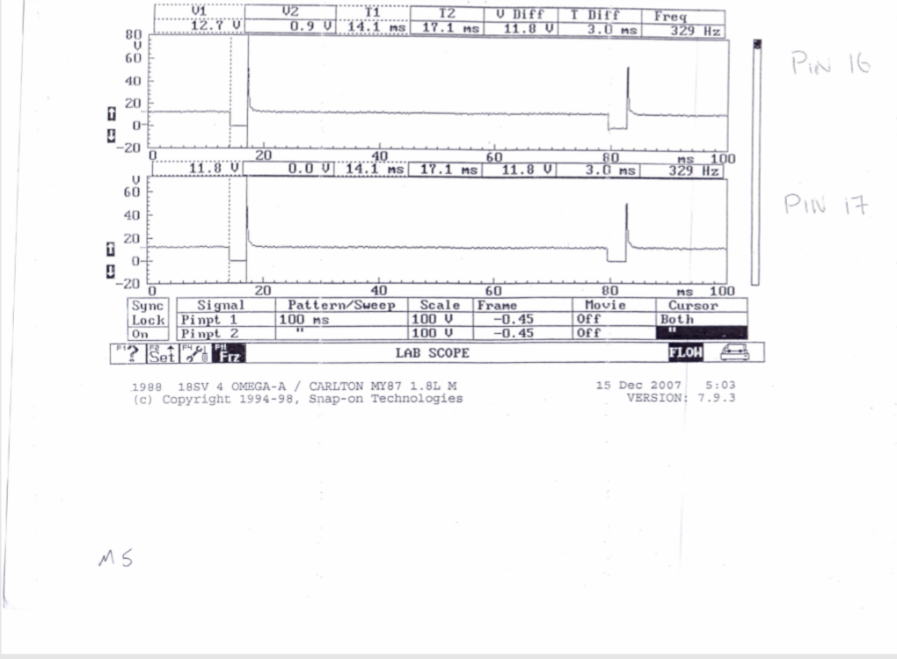

4.1.2 Static Testing
Throttle Potentiometer
Book Reference Data | Data Found
Pin 1 & 2 Throttle closed 1900-2000 Ω | 1994 Ω
Pin 1 & 3 Throttle open 1000-2000 Ω | 2550 Ω

Airflow Sensor
Book Reference Data | Data Found
Pins 4 & 2 = 8 – 2500 Ω | 34.6 Ω
Pins 4 & 3 = 300 – 550 Ω | 556 Ω
Pins 4 & 1 = 270 – 520 Ω | No Reading

Injector Values
Book Reference Data | Data Found
15 - 17 Ω | 1 – 16.3 Ω  2 – 16.1 Ω  3 – 16.3 Ω  4 – 16.1 Ω

Coolant Temp Sensor
Book Reference Data | Data Found
@20°C = 2200– 2800 Ω | 2230 Ω

Idle Speed Control Valve
Book Reference Data | Data Found
8 Ω | 8.1 Ω

Air Temp Sensor
Book Reference Data | Data Found
15 – 30°C = 1500 - 3300 Ω | 2750 Ω

4.1.3 Engine Warm Up Phase Testing
Temperature  °C | Pin 45 (ntc2)  ohms | Pin 45 (ntc2)  V | Pin 16 (injector)  ms | Pin 4  (idle valve)  % | Pin 5 (emission control valve) | Pin 28 Lambda
20 | 2230 | 3.6 | 4.6 | 46 | Off | Off
30 | 1010 | 2.52 | 3.1 | 42 | Off | Off
40 | 660 | 2 | 3.3 | 40 | Off | on
50 | 450 | 1.6 | 2.9 | 42 | Off
60 | 320 | 1.3 | 3 | 42 | On
70 | 260 | 1.1 | 3.1 | 42
80 | 250 | 1.03 | 3.1 | 44

4.2 Jetronic

4.2.1 Scope Patterns
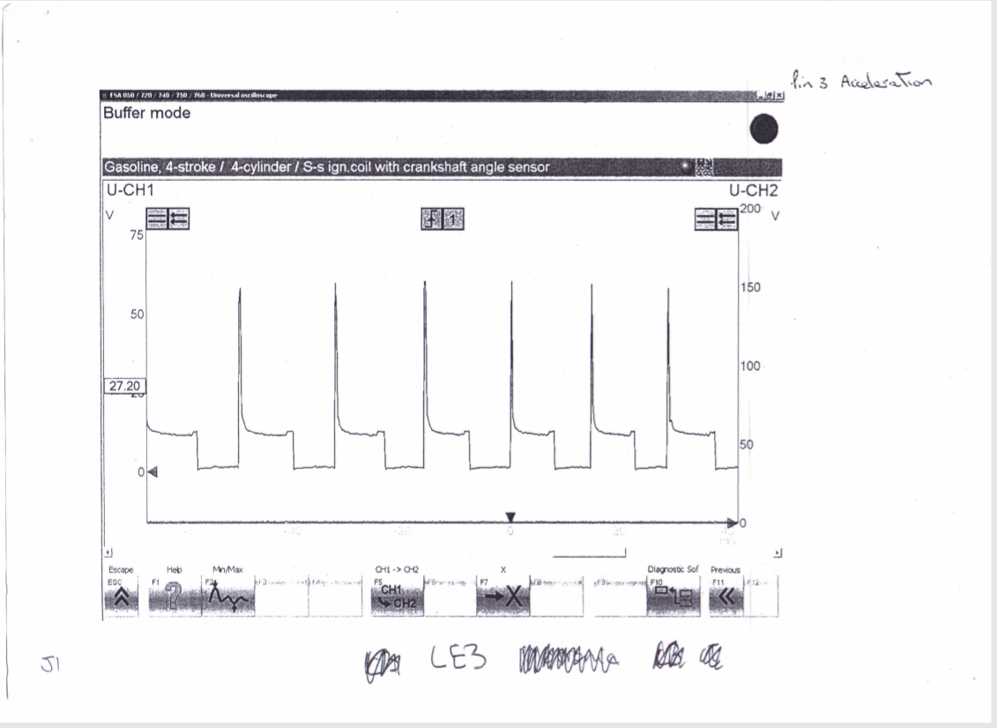

4.2.2 Static Testing
Amplifier testing
#1 | Ignition off  0 | Ignition on  11.94v
#2 | 0 | 0.02v
#3 | 0 | 11.94v
#4 | 0 | 0.13v

Throttle switch
Book Reference Values | Tested Values
2&18-closed-0 ohm | 2&18-closed-0 ohm
3&18-closed-infinity | 3&18-closed-infinity

Auxiliary air valve
Book Reference Values | Tested Values
40 ohm | 45.8 ohm

Injector values
Book Reference Values | Tested Values
15-17 ohm | #1. 15.7 ohm
“ | #2. 15.7 ohm
“ | #3. 15.8 ohm
“ | #4. 15.8 ohm

Primary resistance  0.8 ohm | Secondary resistance  7333 ohm | Lead resistance  #1. 8640 ohm  #2. 8770 ohm  #3. 7700 ohm  #4. 5500 ohm

4.2.3 Engine Warm Up Phase Testing
Temp °C | Pin 8 (NTC2) ohm | Pin 8 (NTC2) V | Injector pulse (m/s)
20 | 2030 | 1.7 | 4.3
30 | 1130 | 1.2 | 3.1
40 | 730 | 0.9 | 3
50 | 510 | 0.7 | 2.8
60 | 390 | 0.5 | 2.6
66-operating temp | 568 (engine thermostat opened, changed resistance) | 0.7 | 2.6

CHAPTER 5.0 ANALYSIS

5.1 Motronic

5.1.1 Pin 1 Primary Coil Waveform
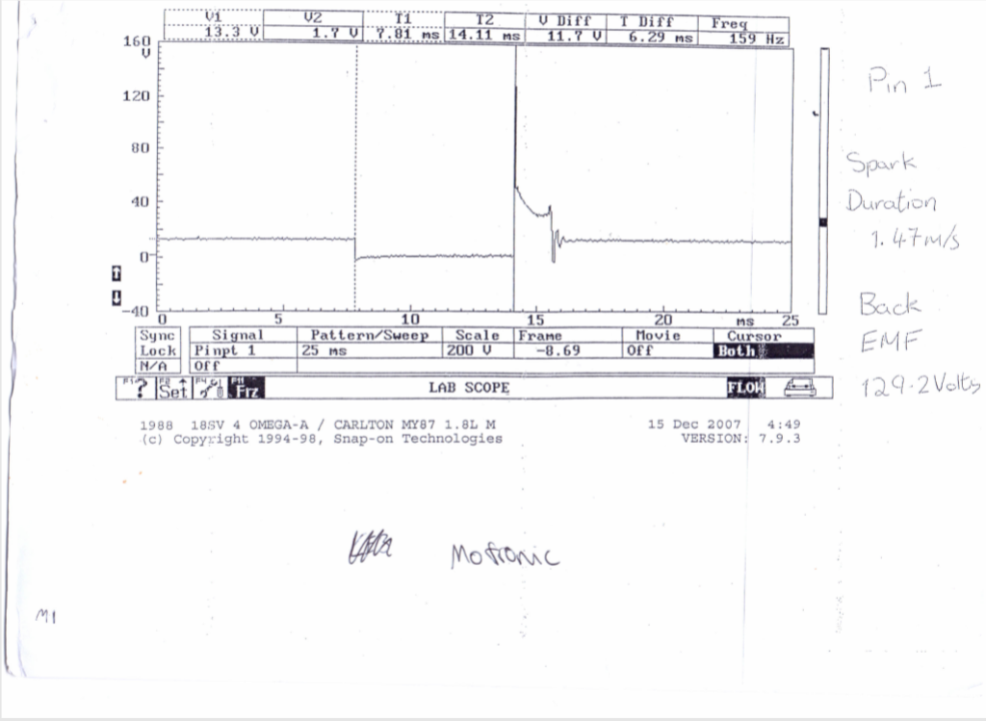
c
d
b
a
Figure 1 Pin 1 Primary Coil Output
(Figure 1) Part a) Dwell period. The dwell period is when the coil is earthed and the voltage is dropped to zero. This is controlled by the ignition ECU, where the dwell time is deptermined by the time it takes to build up to 8A. Part b) Igntion voltage. This occurs when the primary current stops increasing and earth is removed from the coil causing the mangetic flux to collapse which induces a voltage spike, in this case 129.2V. Part c) Spark duration or burn time. Part d) Coil oscilation. The coil oscisliataion period should gave four to five peaks both upper and lower. A loss of peaks indicates a coil problem (Bosch p. 670) (Denton 2006 p. 55)

5.1.2 Pin 4 Rotary Idle Valve Waveform
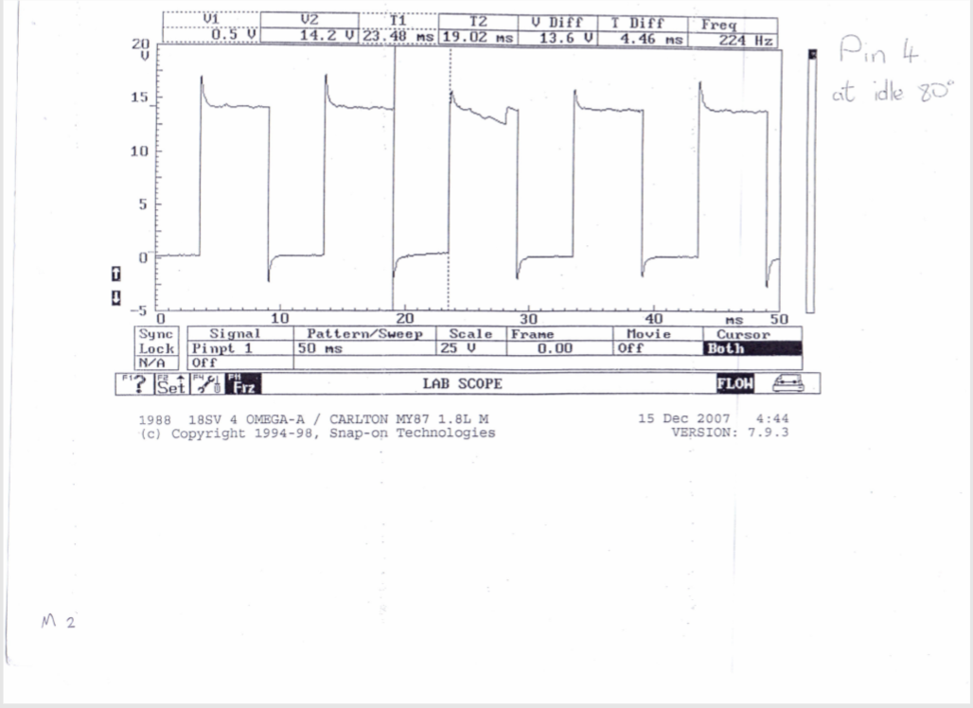
b
a
Figure 2 Pin 4 Rotary Idle Valve
(Figure 2) Part a) Earth. The rate of which the earth path is switched is determined by the ECU to maintain idle speed according to programming Part b) Rotary Idle Valve with voltage. The idle control takes up a position determined by the on/off ratio of the supplied signal. (Denton 2011 p. 97)

5.1.3 Pin 27 and 2 Supply from Ignition and Earth Return Waveform
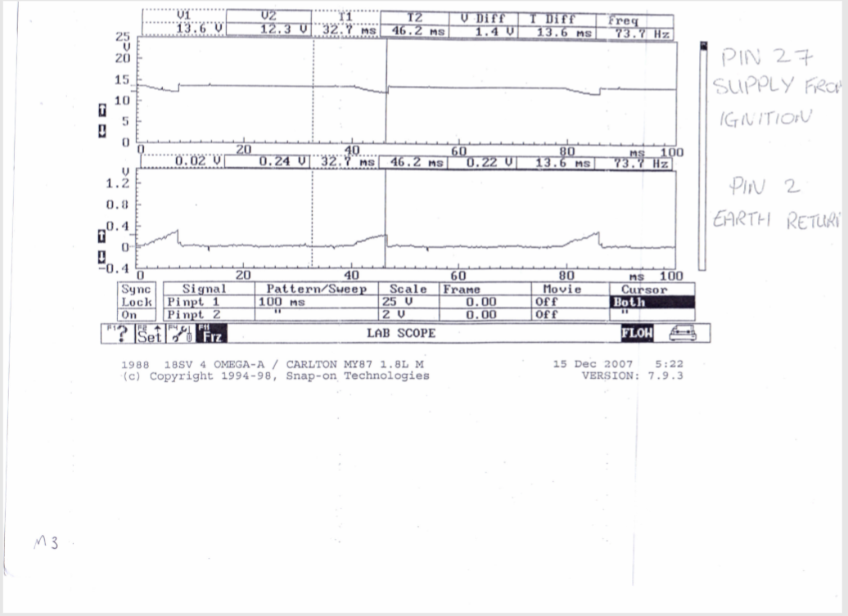
Figure 3 Pin 27 and Pin 2
Figure 3 shows that the earth return, and the ignition supply are inverse of each other, where when the supply dips in voltage the earth increases. This is because the as the signal gets sent to the ECU the earth returns the voltage to the battery to complete the circuit.

5.1.4 Pin 7 MAF and Pin 53 Throttle Potientiometer Waveform
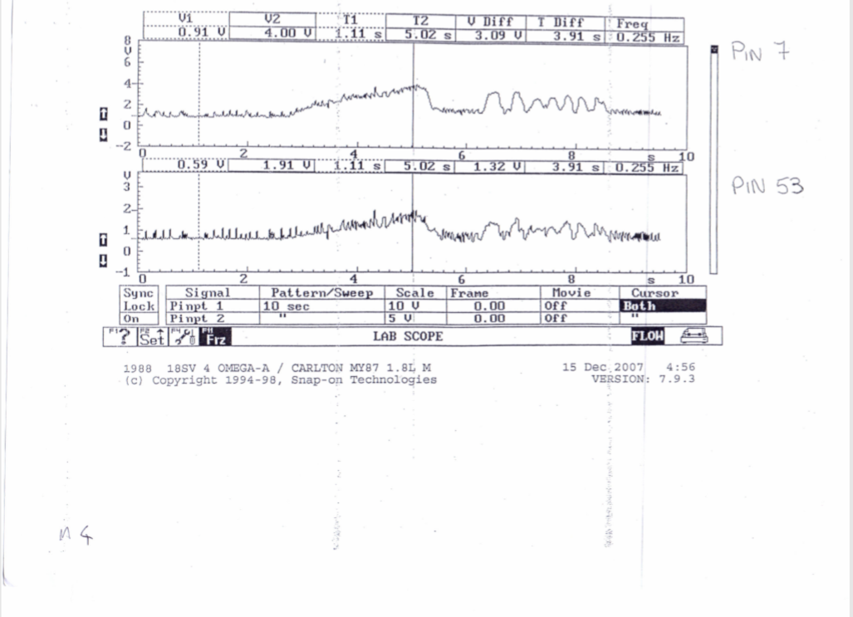
Figure 4 Pin 7 and 53

Figure 4 shows that as the Mass Airflow Sensor changes in voltage, the throttle potentiometer matches it proportianlly . Throttle dictates load, therefore pin 53 and pin 7 are correlated. This is because the airflow sensor is measuring how much airflow the throttle is letting through the vavleso as one increases the other matches it.

5.1.5 Pin 16 Injectors Waveform
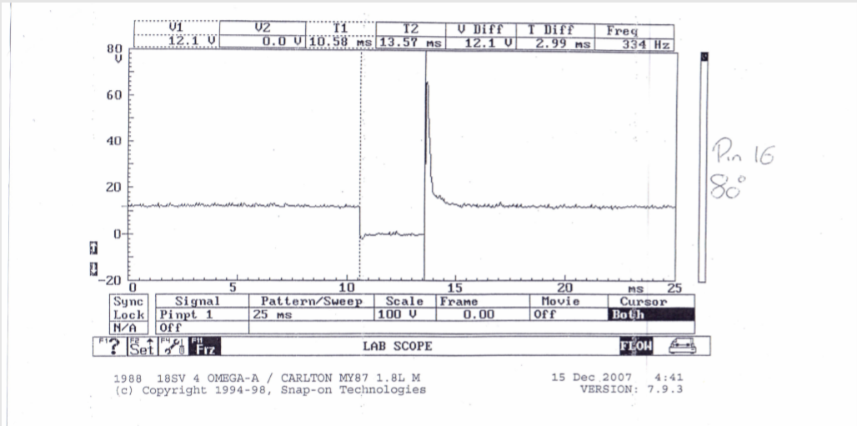
c
b
a
Figure 5 Pin 16 at 80deg
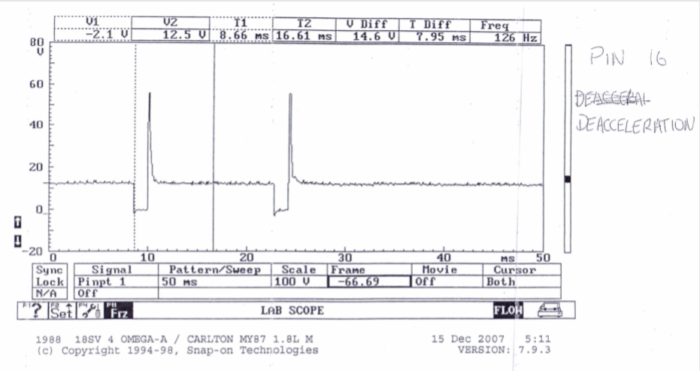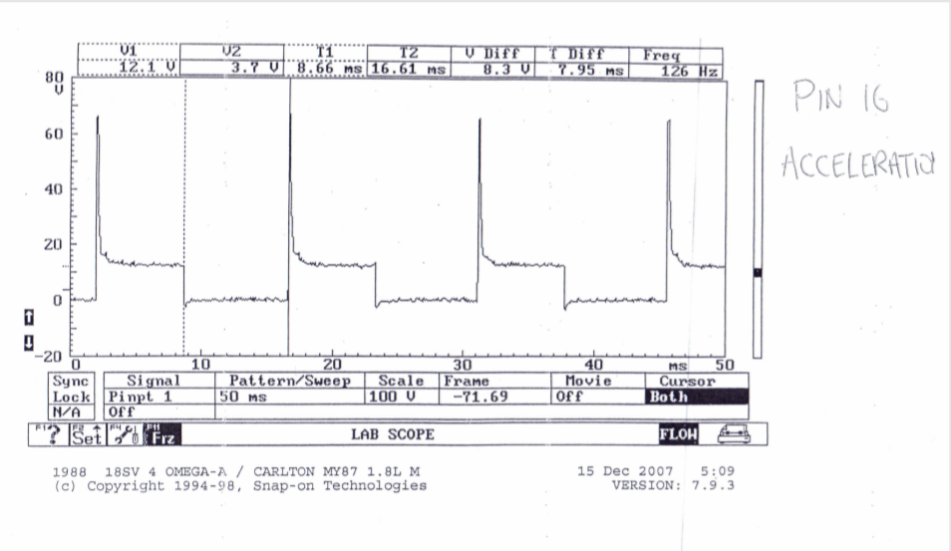
Figure 6 Pin 16 Acceleration and Deceleration
Figure 5 part a) costant voltage supply. Part b) is the injectors on time where they are grounding. Part c) is the voltage spike as the injectors regain voltage. This is because a zener diode is used in the ECU to match the voltage. Figure 6 shows the injectors under accerlation and deceleration. It can be seen that the injector on time is lesser while the frequency is less. It can also been seen that the injectors cut off. This is to save fuel and fuel emissions. This only happens when the throttle is closed. The injectors will eventually pulse again to stop the engine from stalling. Meanwhile the injectors under acceleration have a greater amount of time grounded. The frequency between grounds is also faster then idle or deceleration. While the engine increases in speed, the injectors will increase in frequency to a certain point, 8.5 to 9 m/s is maximum injector on time, on this engine. If more fuel is needed the injectors atomise more frequently rather than opening for longer. Injector on time is determined by speed, load, temperature. Snap acceleration causes the engine to anticipate load and injectors are opened longer. (Denton 2006 p. 51). (Bosch 2013 p. 24)

5.1.6 Pin 16 and 17 Injectors Waveform

Figure 7 pin 16 and 17
Figure 7 shows us that the method of injection is simultaneous because pin 16 and 17 wave form pulse at the same time. Each pin controls a bank of 2 injectors. If the injectors had been out of time the injection pattern would be sequential. Simultaneous injection means the injectors will fire all four injectors at the same time with each cylinder receiving two injection pulses per cycle (720 deg crankshaft rotation. Both injector pins have exactly the same waveform showing that they are working correctly.

5.1.7 Pin 28 Lambda Sensor Waveform
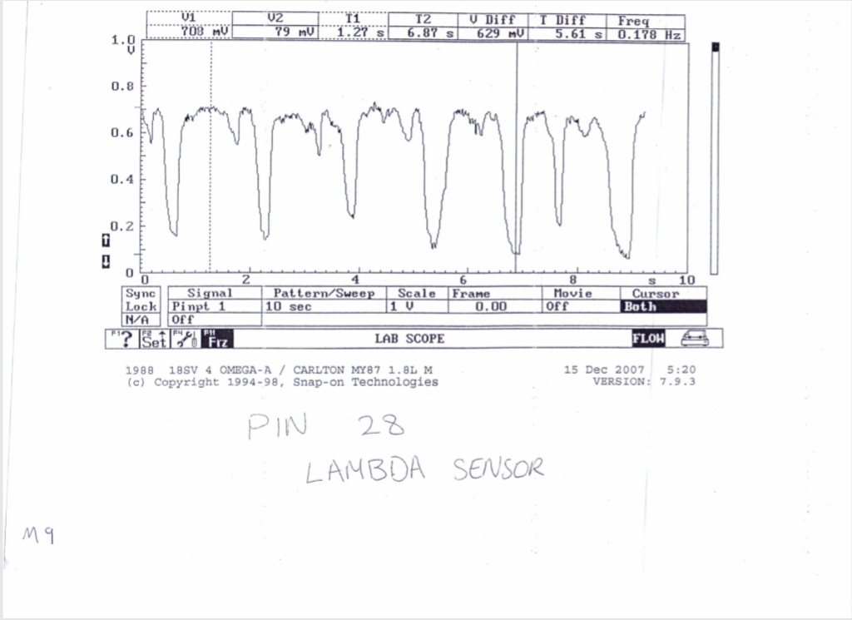
Figure 8 Pin 28 Lambda
Figure 8 shows the lambda sensor, which measures oxygen content in the exhaust system. According to (Denton 2011) produces a small voltage depending on the air/fule mixture seen at the time. In most cases will vary between 0.2 and 0.8V. where 0.2 and 0.8 shows a richer mixture. Looking at figure… it fits within these parameters. The sensors switch at aproximately 1 Hz or once per second and will only start to switch at operating temperature. This can also seen in figure 8 on the waveform.

5.1.8 Pin 49 Speed Sensor Waveform
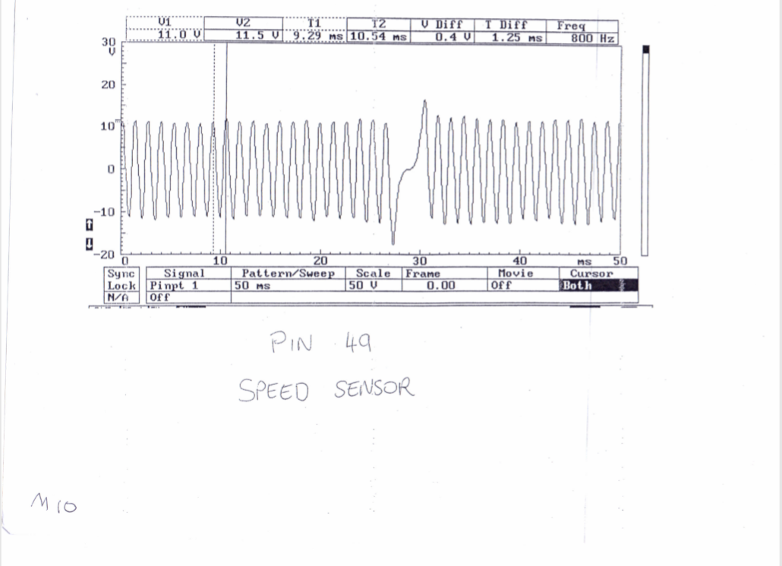
a
Figure 9 Pin 49 Speed Sensor
Figure 9 shows the crankshaft speed, it can be seen to be oscillating bewtween 0 volts each time a tooth on the crankshaft passes the sensor. Looking at a) a gap can be seen in the waveform. This is because there will be a gap in the teeth on the flywheel or reluctor to represent one revolution of the crankshaft. This allows the ECU to see the position of the crankshaft. According to (Denton 2011) the voltage from the crank sensor increases with engine speed.

5.1.9 Secondary Wave Pattern Waveform
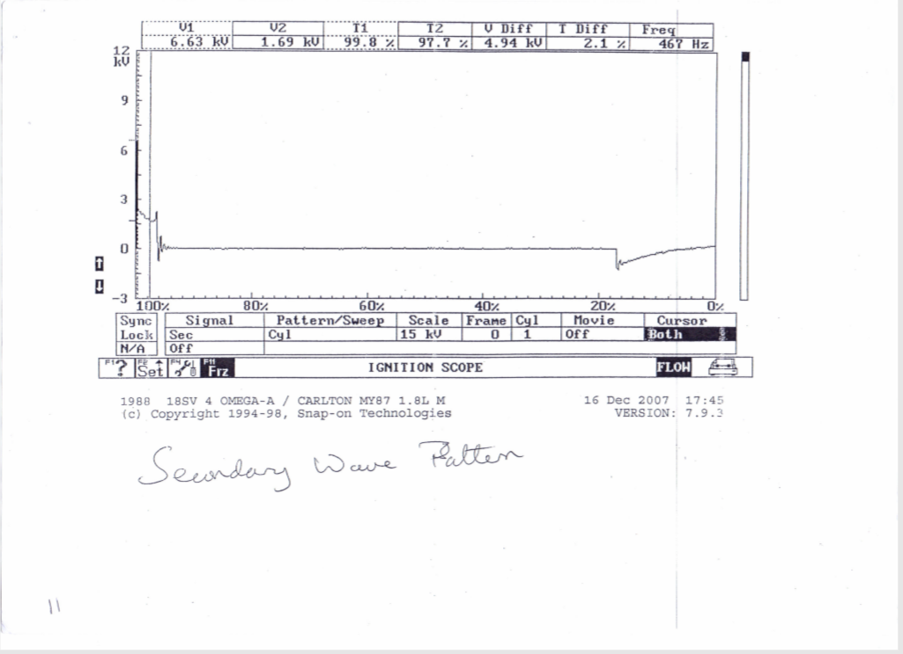
Figure 10 Secondary Wave Pattern
Figure 10 shows a similar pattern to the primary ignition. With a dwell time, a voltage spike, a constant voltage and then the coil oscillation. According to (Denton 2011) figure 10 shows the length of time that the HT is flowing across the spark plug electrode after the initial voltage. Which is required to jump the plug gap. This is known as the spark duration. Comparing this to the primary waveform in figure earlier in the report shows that the secondary waveform has a considerably larger voltage with a spike of around 6KV (6000V) compared to the primary spike of 129V. The reason that the voltage is so high is because the voltage is required to jump and bridge the gap with the electrodes, known as the plug KV. The spark duration is also at a high voltage in order to maintain the bridge between the plug electrodes. (Denton 2011)

5.1.10 Static Testing Analysis
Throttle Potentiometer
Book Reference Data | Data Found
Pin 1 & 2 Throttle closed 1900-2000 Ω | 1994 Ω
Pin 1 & 3 Throttle fully open 1000-2000 Ω | 2550 Ω
The throttle closed is within parameters, however, throttle open reads 550 Ω over the stated values. Assuming the more open the throttle the more voltage it sends back to the ECU. A resistance that is higher than stated value means that the throttle potentiometer will be sending a signal that is higher in voltage. Because the potentiometer is higher resistance and out of parameters, the signal back to the ECU is giving a false reading that is more then the actual throttle position. This could cause the ECU could be over fuelling the engine.
Airflow Sensor
Book Reference Data | Data Found
Pins 4 & 2 = 8 – 2500 Ω | 34.6 Ω
Pins 4 & 3 = 300 – 550 Ω | 556 Ω
Pins 4 & 1 = 270 – 520 Ω | No Reading
Pins 2 and 4 are within parameters, 4 &1 have no reading because this specific engine lacks a charcoal canister that would otherwise be there. The airflow resistance at pins 4 & 3 reads 6 Ω higher than the maximum value and therefore the sensor will be sending a signal that is stronger back to the ECU. As the hotwire airmass meter decreases resistance with more air as the hotwire cools. The mass airflow sensor might be sending a false signal back to the ECU that there is less air then there actually is and could under fuel the engine.
Injector Values
Book Reference Data | Data Found
15 - 17 Ω | 1 – 16.3 Ω  2 – 16.1 Ω  3 – 16.3 Ω  4 – 16.1 Ω
These values are within parameters.
Coolant Temp Sensor
Book Reference Data | Data Found
@20°C = 2200– 2800 Ω | 2230 Ω
This reads within the manufacture specification
Idle Speed Control Valve
Book Reference Data | Data Found
8 Ω | 8.1 Ω
This reads only 0.1 ohm over the stated value and therefore will have minimal effect
Air Temp Sensor
Book Reference Data | Data Found
15 – 30°C = 1500 - 3300 Ω | 2750 Ω
This fits within the manufactures specfication

5.1.11 Warm Up Phase Testing Analysis
Temperature | Pin 45 (ntc2) | Pin 45 (ntc2) | Pin 16 (injector) | Pin 4 | Pin 5 (emission control valve) | Pin 28 Lambda
Degrees Celsius | ohms | V | ms | (idle valve) | Pin 5 (emission control valve) | Pin 28 Lambda
 |  |  |  | % | Pin 5 (emission control valve) | Pin 28 Lambda
20 | 2230 | 3.6 | 4.6 | 46 | 0 | 0
30 | 1010 | 2.52 | 3.1 | 42 | 0 | 0
40 | 660 | 2 | 3.3 | 40 | 0 | 1
50 | 450 | 1.6 | 2.9 | 42 | 0 | 1
60 | 320 | 1.3 | 3 | 42 | 1 | 1
70 | 260 | 1.1 | 3.1 | 42 | 1 | 1
80 | 250 | 1.03 | 3.1 | 44 | 1 | 1
Figure 11 Motronic Table
Figure 12 NTC2 Graphs
Looking at figure 12 shows us a negative correlation that as temperature increases the resistance and voltage of the NTC2 decreases noticeably the gradient on both graphs is steepest at the beginning of the warmup phase then levels out showing a decreasing exponential curve. NTC2 is measuring the water temperature of the engine from the water jacket. It shows that the resistance is controlled by temperature where a decrease in temperature reduces the signal voltage. This will communicate to the ECU the temperature with voltage representing temperature so it can monitor warming up when the engine reaches its operating temperature and control the appropriate components. The reason for the exponential gradient could be the properties of the liquid where oil heats faster than water and cause the line not to be linear. Also, the location of the oil and water could have an effect.
Looking at figure 13 we can see a high value idle valve open of 46% at 20 degrees to begin with then closes sharply to 40% at 40 degrees. The idle valve then opens again to 42% at 50 degrees and then at 70 degrees it increases to 44%. The initial value could be high to ensure the engine has high levels of air coming in to, to ensure combustion. However, the reduction in idle valve could mean that the engine is designed to close the valve to let less air into the engine to increase the rate at which it increases in temperature. Interesting when the idle valve is at its smallest value, the injector on time is at its greatest. This shows us that the engine is attempting to run with a rich mixture of fuel/ air mix as the lambda sensor is switched on.
Figure 13 Idle Valve
Figure 14 Injector On Time
Looking at figure 14 shows that injector on time decreases from its initial peak value at 4.5ms at 20 degrees where it decreases to 3ms at 30 degrees. The graph then increase to 3.3ms at 40 degrees, decrease to 2.9ms at 50 and increase to 70 where it levels out at 3.1ms. The increase in injector on time at 40 degrees can be linked to figure 11 (table) where this is the value where the lambda sensor is now on. It would be theorised that after this the on time would continually decrease after 40 degrees however due to procedure, the auxiliary fan is switched on to cool the engine at 60 degrees. This creates extra load on the engine (auxiliary load) and increases the on time of the injectors to compensate for this.

Figure 15 Emission Control Valve
Figure 15 shows us the temperature that the emission control valve and lambda sensors are switched on, with 0 representing off and 1 representing on. The emission control valve can be seen switching on between 50 and 60 degrees and the lambda sensor at 30 to 40 degrees. Comparing emission control valve to other pins using figure… table there appears to be no correlation between the other pins. However, lambda as mentioned in the analysis of the previous figures 14 and 13 as lambda is switched on, the injector on time increases and the idle control valve decreases showing a richer mixture of the fuel. This could suggest that without the lambda sensor the fuel air mix is too lean and as the ECU accounts for lambda it creates a richer air fuel mix. This could be down to faulty components that are giving false signals to the ECU. One theory could be that it’s the air flow sensor, referring to the static test for the Motronic, it suggested that the airflow sensor could be giving a smaller value then true and therefore under fuelling.

Jetronic 5.2

5.2.1 Pin 3 Injectors Waveform
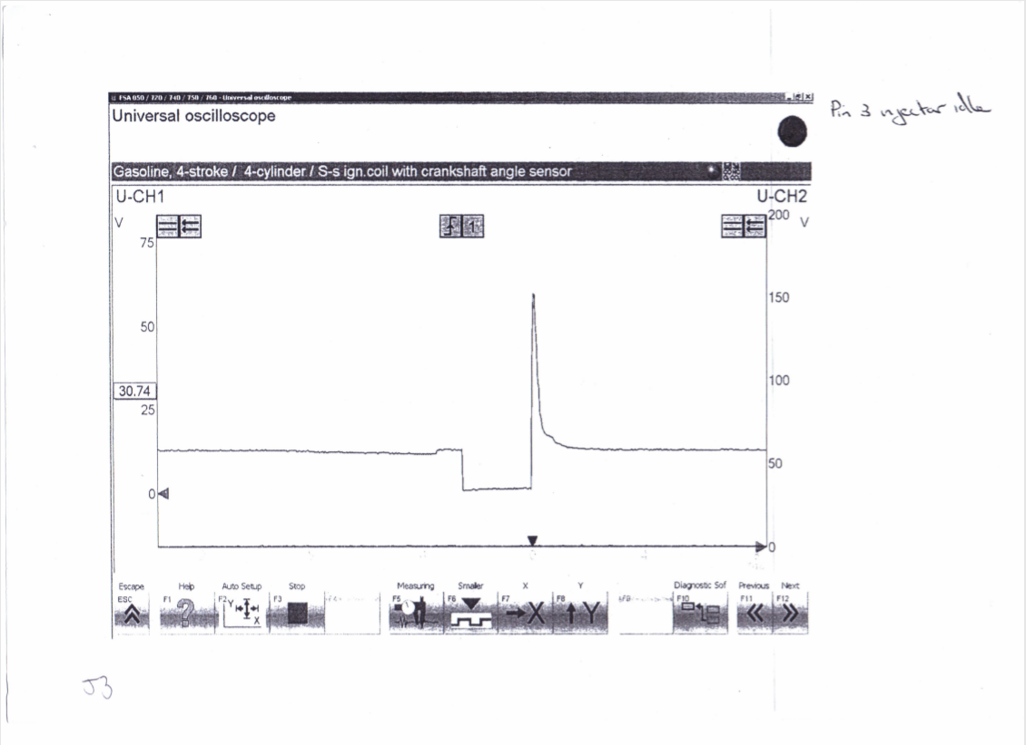
b
a
c
Figure 16 Pin 3 Injector Idle
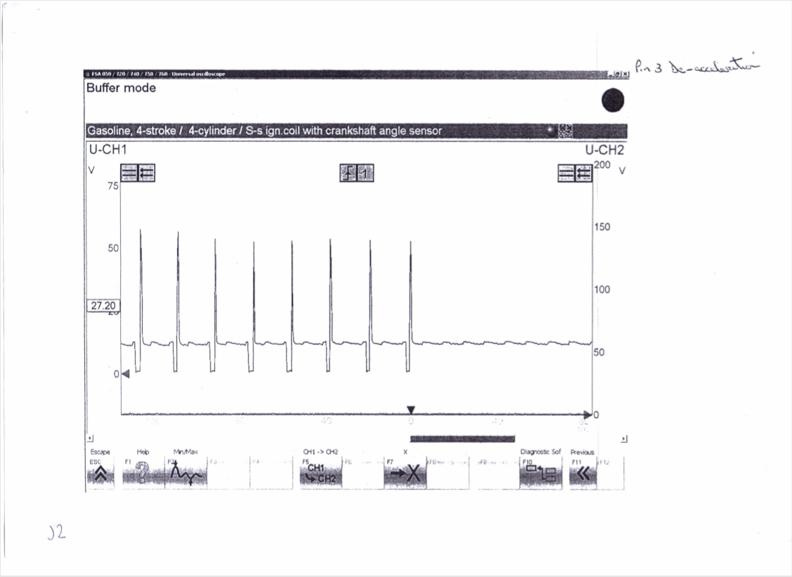
a
Figure 17 Pin 3 Acceleration and Deceleration
(Figure 17) Part a) contant voltage supply. Part b) Injector on time as it is grounded . Part c) voltage spike as injector regains voltage. Comparing to figure 16 to figure 17 The frequency is slowest during idle. The frequency is fastest under deceleration and the injectors are open for the shotertest amount of time. However, under acceleration the injectors are open for longer but the frequency is shorter then under deceleration. Figure 17 Part a) This shows the injectors cut off the end of the waveform. This feature is designed to improve fuel economy and reduce emissions. This only happens when the throttle is closed. The injectors will eventually pulse again to stop the engine from stalling. Injector on time is determined by speed, load, temperature. (Tom Denton 2000 p.244) (Denton 2011 p. 51)

5.2.2 Pin 12 Crank Signal Waveform
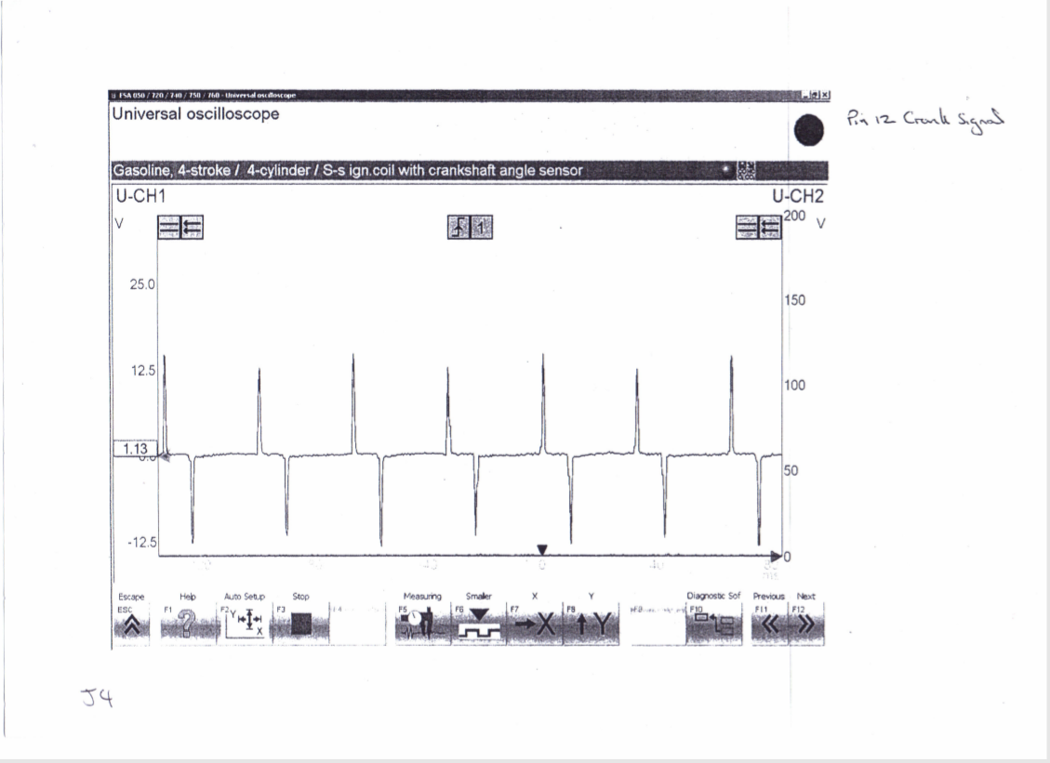
Figure 18 Pin 12 Crank Signal
Figure 18 can be seen with an alternating voltage signal (Denton 2006 p. 43) where each time the crank tooth passes the sensor it creates a voltage. This provides engine speed to the ECU.

5.2.3 Pin 1 Primary Coil Waveform
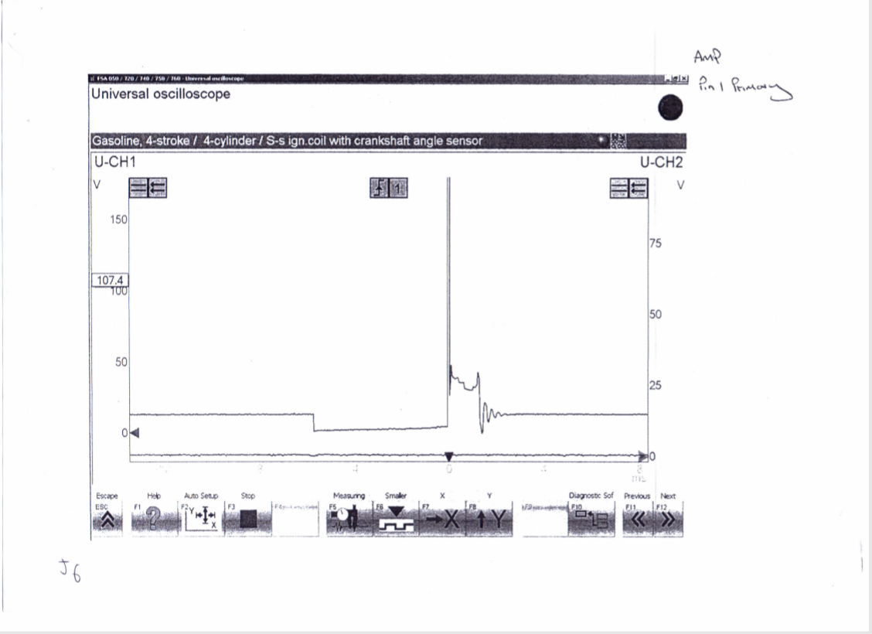
d
c
b
a
Figure 19 Pin 1 Primary Coil Output
(Figure 19) Part a) Dwell period. The dwell period is when the coil is earthed and the voltage is dropped to zero. This is controlled by the ignition amplifier, where the dwell time is deptermined by the time it takes to build up to 8A. Part b) Igntion voltage. This occurs when the primary current stops increasing, controlled by the ignition amplifier and earth is removed from the coil causing the mangetic flux to collapse which induces a voltage spike, in this case 129.2V. Part c) Spark duration or burn time. Part d) Coil oscilation.The coil oscsillation period should gave four to five peaks both upper and lower. A loss of peaks indicates a coil problem. (Bosch 2018 p. 670) (Denton 2006 p.55)

5.2.4 Pin 4 Spark Advance Signal and Pin 1
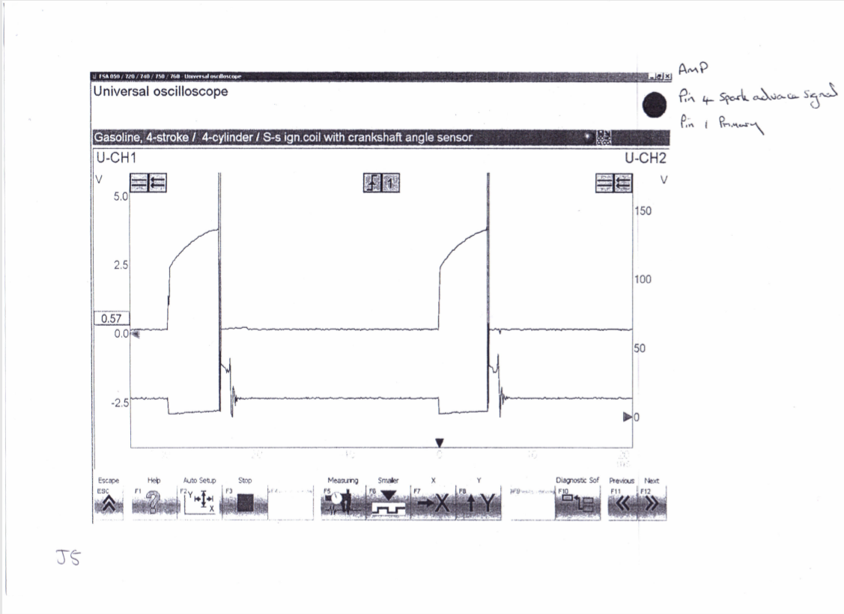
Figure 20 Pin 4 and 1
Figure 20 shows that Pin 4 and 1 are correlated where when the spark advance signal increases in voltage when the primary is grounded. The signal from the igntion amplifier that supplies the signal for the length of time that the primary coil is grounded. (Denton 2006 p.56)

5.2.5 Pin 3 Supply and Pin 2 Earth
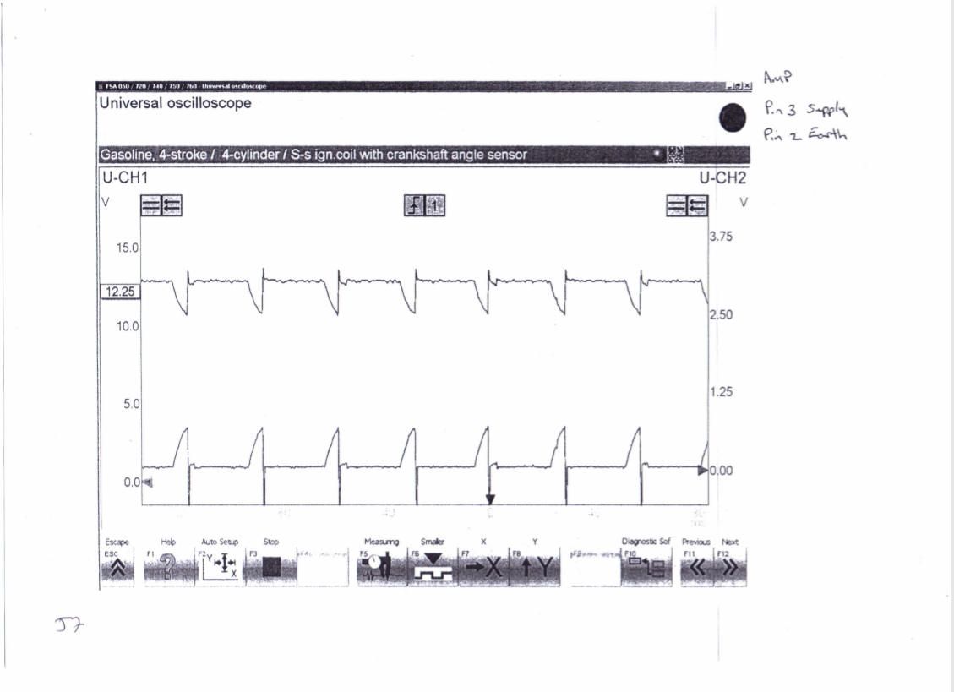
Figure 21 Pin 3 supply and Pin 2 Earth
Figure 21 shows that the earth return, and the injector supply are inverse of each other, where when the supply dips in voltage the earth increases. This is because the as the signal gets sent to the ECU the earth returns the voltage to the battery to complete the circuit.

5.2.6 Pin 5 Speed Reference for fuel ECU Waveform
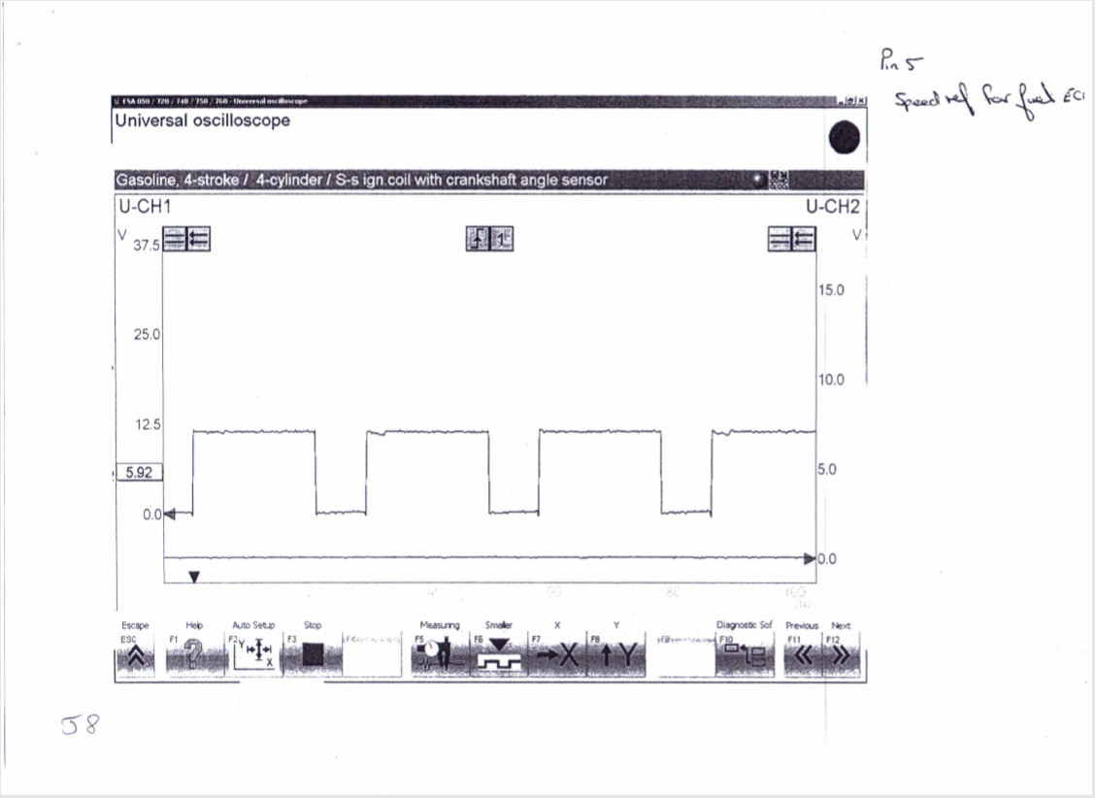
Figure 22 Pin 5 Speed reference for fuel ECU
Figure 22 shows a digital pattern with a switch between a constant voltage lead by a constant ground. This voltage provides information of the the crank speed to the fuel ECU so it can time injection correctly.

5.2.7 Secondary Voltage Waveform
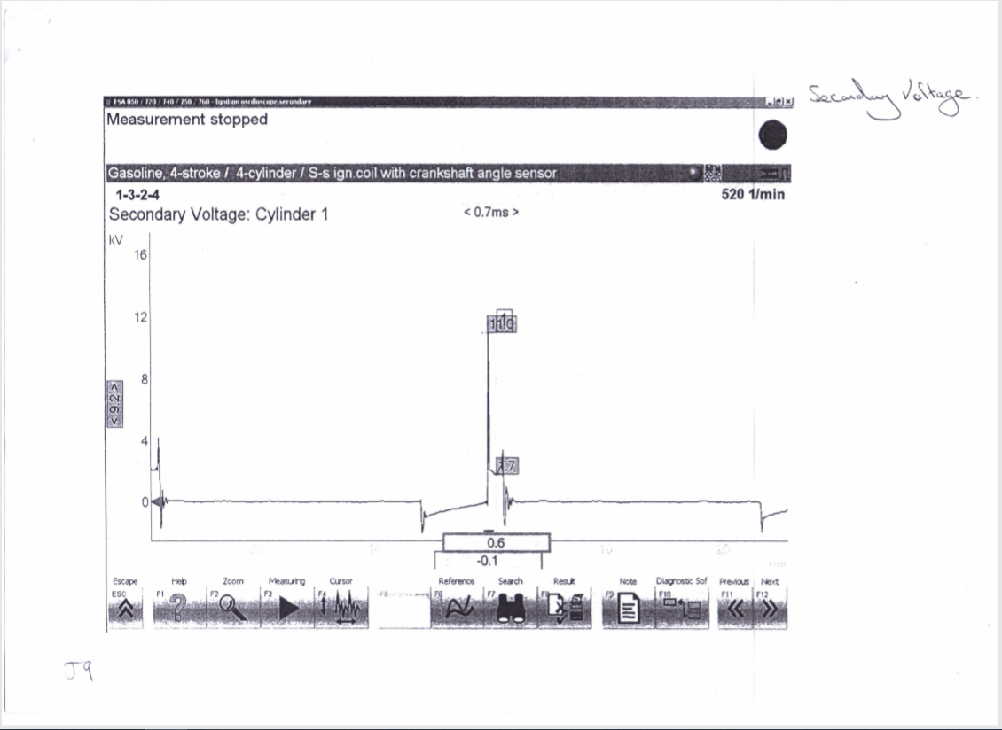
Figure 23 Secondary Wave Pattern
Figure 23 shows a similar pattern to the primary ignition. With a dwell time, a voltage spike, a constant voltage and then the coil oscillation. Figure shows the length of time that the HT is flowing across the spark plug electrode after the initial voltage. Which is required to jump the plug gap. This is known as the spark duration. Comparing this to the primary waveform in figure earlier in the report shows that the secondary waveform has a considerably larger voltage with a spike of around 11KV compared to the primary spike of around 175V. The reason that the voltage is so high is because the voltage is required to jump and bridge the gap with the electrodes, known as the plug KV. The spark duration is also at a high voltage in order to maintain the bridge between the plug electrodes. (Denton 2006)

5.2.8 Static Testing Analysis
Amplifier testing
#1 | Ignition off  0 | Ignition on  11.94v
#2 | 0 | 0.02v
#3 | 0 | 11.94v
#4 | 0 | 0.13v
This shows the earth and ground of the amplifier
Throttle switch
Book Reference Values | Tested Values
2&18-closed-0 ohm | 2&18-closed-0 ohm
3&18-closed-infinity | 3&18-closed-infinity
This is within the manufacture specification
Auxiliary air valve
Book Reference Values | Tested Values
40 ohm | 45.8 ohm
This reads 5.8 ohms over the stated value. This means that the air valve which regulates addition air into the engine based on the heat of the engine could be supplying the incorrect amount of air.
Injector values
Book Reference Values | Tested Values
15-17 ohm | #1. 15.7 ohm
“ | #2. 15.7 ohm
“ | #3. 15.8 ohm
“ | #4. 15.8 ohm
These are within the stated values.
Primary resistance  0.8 ohm | Secondary resistance  7333 ohm | Lead resistance  #1. 8640 ohm  #2. 8770 ohm  #3. 7700 ohm  #4. 5500 ohm
The primary resistance is less than the secondary resistance. This is because the secondary coil a considerable number of windings which cause the wire to have high resistance. The spark lead has different resistance values in each wire. This is because the longer the wire the more resistance it has. This could mean that the quality of spark is different in each of the spark plugs. (Bosch 2013)

5.2.9 Warm Up Phase Testing Analysis x

Figure 24 NTC2 Graphs
Looking at figure 24 shows that the voltage and resistance has negative correlation voltage and resistance decreases, the temperature increases. Looking at the resistance graph, an increase at 66°C to a value of 568 Ohms. This could be because the water jacket is being cycled by the thermostat as the water has reached its operating temperature, and therefore changing the resistance measurement of the NTC2. One observation is that while the resistance changed. The NTC2 voltage did not change.
Looking at figure 25 shows a constant decline in injector on time as the engine temperature increases. At 66°C the injector on time increases. this could potentially be because the auxiliary fan has been switched on after 60°C to regulate temperature and is requiring more load from the engine to run and therefore increasing injector on time.
Figure 25 Injector on time

CHAPTER 6.0 EVALUATION

6.1 Testing Validation
The test in this report was conducted correctly according to the procedure written in methodology. However, the test could have been improved.
Firstly, the test could have been conducted more then once for every part of the testing. At least three times would allow for any errors in the test to have been identifiable.
Secondly, in an ideal world, a workshop with controllable environmental conditions such as air temperature and air density would allow numerous tests to be carried out in multiple scenarios to further understand the effect of the environment and how or if the components are addressed for these scenarios. However, in this test a standard workshop was used and therefore results could be affected by these factors.
Another issue with the test could be that the test was one of the first times the members of the testing group worked with each other testing. This could lead to problems in communication and understanding of each individual and lead to more human errors. If in a working group that was experienced in testing together, it would be more efficient and more likely accurate.
When validating the equipment, the use of a digital multimeter and a digital scope rather than analogue counterpart was advantageous. This is because digital measurements are simpler to use and record results from, this is especially useful for a group of more inexperienced engineers testing. It also more accurate as it removes any degree of mismeasurement from reading the result.
Warm up Phase Testing also had a disadvantage where measuring multiple pins at multiple temperatures caused the results to be taken at marginally different temperatures due to the engine still warming after being switched off due to residual temperatures. For example, that at “20°C” on the test all pins were measured at varied temperatures, likely from 19 to 21°C. If the test was to be improved one pin would be tested at once in the warm phase testing and repeated with other pins. This is only possible where you have a controllable environment to ensure each test is exactly the same condition, although saying this test would be time inefficient.

6.2 Operating Conditions

6.2.1 Motronic
Ignition on, engine not running
The battery will be supplying voltage to components, a component that is a supply should have a reading of near 12V. An earth should read near 0V. A signal voltage will be determined by the component and the pin should be identified.
Engine cranking (from cold)
Engine cranking from cold causes the injectors to be open for longer, and the idle valve to be its widest. Allowing the engine to get the most fuel and air to start the engine as at cold is when its hardest for fuel to combust.
Engine warm-up
Injectors are open for longer and the idle valve is at its most open in the initial warm up phase to 40°C when the lambda sensor is activated that regulates how rich or lean the engine runs. The lambda being absent at the initial warm up will stop it interfering with allowing the engine to use more fuel. This also goes for the emission control which activates around 50°C which interferes with the engine under acceleration. These parameters allow for the engine to warm up smoothly and as quickly as possible.
Acceleration
Under acceleration the frequency of the pulses increase to a certain point. Then injectors open for longer. Under snap acceleration using the throttle potentiometer the engine predicts load and supplies the engine with more fuel even though the MAF will not be reading a higher value instantly.
Deceleration
Under deceleration, the injectors will pulse more frequently and open for short amounts of time. They will also cut off to save fuel and emissions for a period of time.
Idle speed (engine at operating temperature)
The components will be at a stable level where they all reach an optimum value for fuel efficiency, emissions and driving scenarios.

6.2.2 Jetronic
Ignition on, engine not running
The same as the Motronic. The battery will be supplying voltage to components, a component that is a supply should have a reading of near 12V. An earth should read near 0V. A signal voltage will be determined by the component and the pin should be identified.
Engine cranking (from cold)
Engine cranking from cold causes the injectors to be open for longer, and the idle valve to be its widest. Allowing the engine to get the most fuel and air to start the engine as at cold is when its hardest for fuel to combust
Engine warm-up
The injector on time and both NTC2 voltage and resistance decreases as the engine increases in temperature.
Acceleration
Under acceleration the frequency of the pulses increase to a certain point. Then injectors open for longer. The engine only has a throttle switch reading on or off and therefore cannot predict snap acceleration compared to the Motronic. And only reacts through the manifold pressure sensor.
Deceleration
Similar to the Motronic, under deceleration, the injectors will pulse more frequently and open for short amounts of time. They will also cut off to save fuel and emissions for a period of time.
Idle speed (engine at operating temperature)
The components will be at a stable level where they all reach an optimum value for fuel efficiency, emissions and driving scenarios

6.3 Comparing Systems
Comparing the two systems, in summary the Motronic is obviously the most modern engine with more sensors and one ECU that controls the engine control systems. The main advantageous components are the lambda sensor, and the speed sensor and the throttle potentiometer connected to one ECU on the Motronic allowing for ECU to control ignition and injection more efficiently and effectively according to the engine’s situation.
NTC2 Graphs
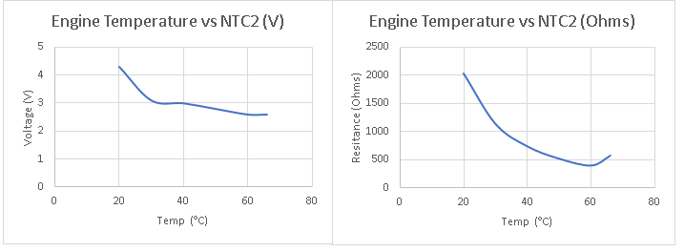
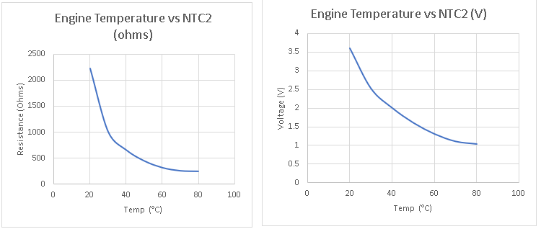
Comparing the NTC2 graphs where the top is the Jetronic and the bottom Motronic. The values are similar with both having a maximum resistance of around 2000 Ohms and a minimum under 500. The voltage on the Jetronic has a higher peak and less range going down to just under 3V. the Jetronic goes from 3.5 to 1V. One difference is that the resistance at the operating temperature of the Jetronic changes, possibly due to the thermostat opening. While the Motronic does not see this change. The NTC2 voltage of the Jetronic has a slight increase at 40°C whereas the Motronic does not. This could highlight a problem in the Jetronic’s NTC2 sensor.

6.4 Modifications
Modifications that could be justifiable could be a sequential injection, which could lead to the car being able to run on a fewer number of cylinders to save fuel and be more emissions friendly and would be beneficial in an environment such as a city. Wasted spark or coil on plug could also improve the system by removing the distributor which would increase the longevity of the coils. (Erjavec 2004 p.615)

CHAPTER 7.0 CONCLUSION
In conclusion, the test was success with the time limits and resources required, if more time and resources where available more tests could be conducted to further improve the report. This includes changing environmental conditions and the increases the number of tests.
The analysis evaluation found that the engine systems of the Jetronic and Motronic shared a lot of features, however the Motronic showed to be superior with greater information to control and the engine. This included more advanced sensors like a throttle potentiometer over a switch, along with a lambda and emissions controls valve. This allows the engine to achieve better fuel economy and emissions.
If an engine would have been to be improved with modifications and an engine was to be chosen for said modification, it would have to be the Motronic with more advanced sensors to start with and one ECU controlling ignition rather than the Jetronic controlling the ignition with an amplifier and fuel with ECU Designs like wasted spark or coil on cylinder could improve the engines longevity removing a distributor. It was also found that sequential injection could be beneficial with the theory that using this system cylinders could be cut off from running to improve fuel economy and emissions at slow speed. Overall, the report was largely successful in its aims and objectives were met

CHAPTER 8.0 BIBLIOGRAPHY
Bosch (2020) Bosch BEA 850. Available at http://www.adesystems.co.uk/garage-equipment/bea-emissions-analysers/bea-unit/100/bea-850 (April 2020)
Holt, JH. (2015) Principles of Health and Safety at Work 8th Ed. Oxon: Routledge
Health and Safety in Motor Vehicle Repair and Associated Industries (2009) London: UK Government
Bosch, R. (2013) Bosch Automotive Electrics add Automotive Electronics 5th Ed. Plochingen: Bosch
Denton, T (2011) Advanced Automotive Fault Diagnosis: Automotive Technology – Vehicle Maintenance and Repair 3rd Ed. Oxon: Routledge
Denton, T (2006) Advanced Automotive Fault Diagnosis 2nd Ed. Oxford: Elsevier
Martyr, A.J (2012) Engine Testing 4th Ed. Oxford: Elsevier
Bosch, R et al. (2018) Automotive Handbook 10th Ed. Karlsruhe: Bosch
Heisler, H. (2002) Advanced Vehicle Technology 2nd Ed. Oxford: Elsevier
Hillier, V.A.W (2006) Fundamentals of Motor Vehicle Technology 5th Ed. Cheltenham: Nelson Thornes Ltd
William, B et al. (2003) Understanding Automotive Electronics 6th Ed. Oxford: Elsevier
Erjavec, J (2005) Automotive Technology 4th Ed. Clifton Park, NY: Thomson Delmar Learning
Watson, B (1992) How to Tune & Modify Bosch Fuel Injection 1st Ed. Osceola, WI: MBI Publishing Company
Denton, T (2000) Automobile Electrical and Electronic Systems 2nd Ed. Oxford: Elsevier

