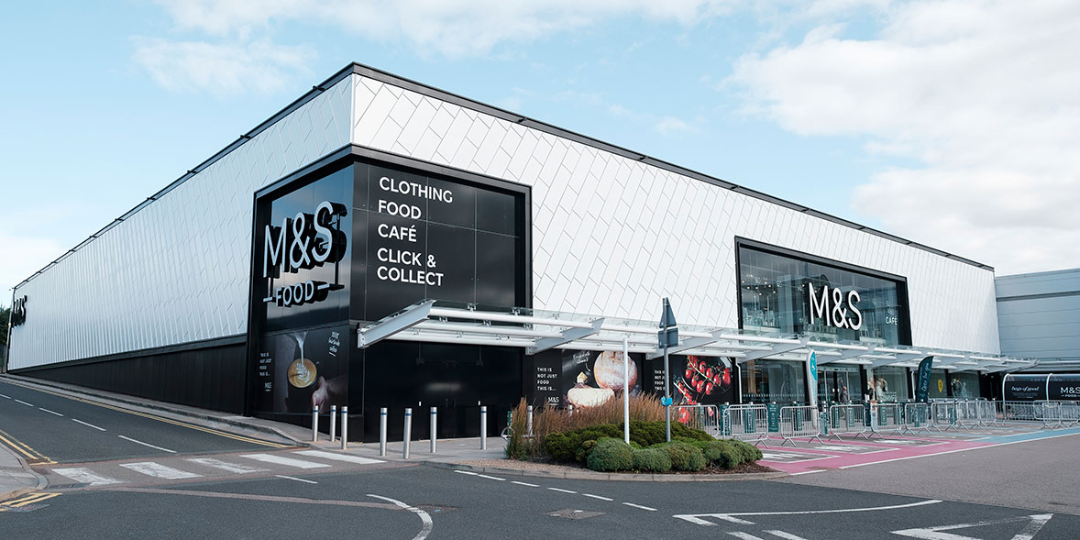
(Source: which.co.uk)
M&S’s Approach Integrating Digital Assets & Machine Learning in Marketing Excellence

Subject: Digital Marketing
Tutor Name: Amitave Banik
Module: LCMB7010
Student Name: Vraj Ashwinkumar Pandya
Student ID: 2244599
Date: 18 Dec, 2023

Contents
Introduction 4
Part 1: Digital Marketing Landscape of M&S 4
Digital Assets - Foundations of M&S’s Digital Presence 5
Internal and External Communication Flows 7
Sostac analysis 8
Situation 8
Objectives 8
Strategy 9
Tactics 9
Action 9
Continuous Monitoring and Control: 9
Marketing Mix 10
OMNI-CHANNEL ADVANTAGE……………………………………………………………………………………..………………13
Marketing Information System (MIS) and Information Architecture 15
Robust MIS Implementation 15

Cookies & Web Beacons ………………………………………………………………………………………………………..……17

Google Analytics of M&S………………………………………………………………………………………………………….….19
Information Architecture for Data Organization 22
Effective Strategies: Maximizing Digital Marketing Impact 23
Content Marketing: Elevating Customer Engagement and Fostering Brand Loyalty 23
Pay-Per-Click (PPC)………………………………………………………………………………………………………………27
Search Engine Optimization (SEO): Elevating M&S’s Digital Visibility 29
Social Media Marketing: Crafting Digital Symphony of Engagement 32
Building Brand Awareness and Fostering Loyalty……………………………………………………………34
Email Marketing: Elevating Engagement through Segmentation and Personalization 35
Sweet Spot………………………………………………………………………………………………………………………………36 CRM of M&S………………………………………………………………………………………………………………………………37
Part 2: Role of Machine Learning in M&S’s Digital Marketing 39
Embracing Machine Learning in Digital Marketing: Revolutionary Leap 39
Customer Segmentation and Targeting: Precision through ML Algorithms 42
Marketing Intelligence and Forecasting: Unleashing Predictive Capabilities of ML 42
ML’s Role in Predicting Customer Behaviour and Campaign Performance 43
M&S and its increased Engagement 43
ROI & ROS………………………………………………………………………………………………………………………………...45
Real-world Examples of Successful Predictions 46
Personalized Customer Experiences: ML-Driven Engagement and Satisfaction 46
Conclusion 46
References 48

Introduction
Marks & Spencer (M&S) has embarked on transformative digital marketing journey, positioning itself at forefront of innovation. This strategy intricately weaves together online and offline channels to engage customers dynamically. M&S recognizes symbiotic relationship between these channels, leveraging seamless blend to enhance overall customer experience. This introduction sets stage for in-depth exploration of M&S’s digital landscape.
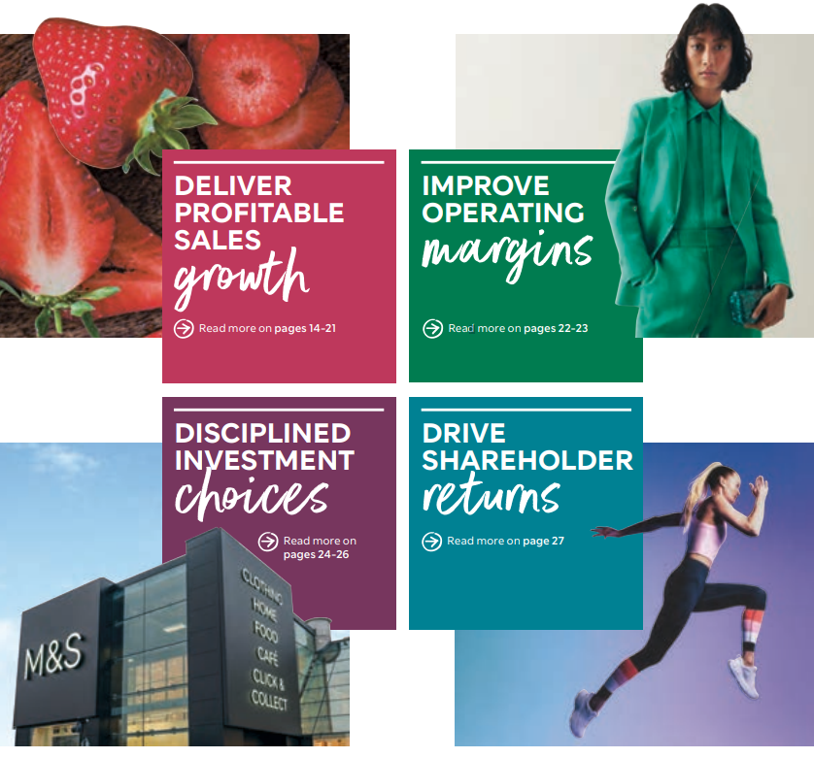(Source: corporate.marksandspencer.com)

Part 1: Digital Marketing Landscape of M&S
Digital Assets - Foundations of M&S’s Digital Presence
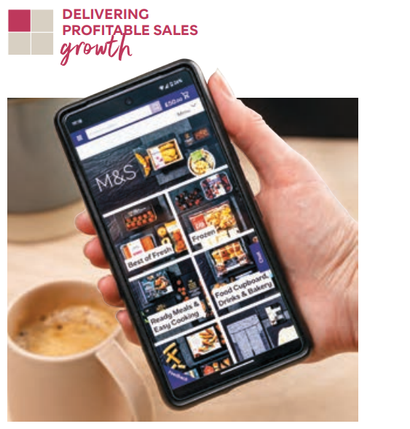
(Source: corporate.marksandspencer.com)

A. Business Website (marksandspencer.com) - M&S’s business website, marksandspencer.com, stands as pivotal element in establishing its robust online presence in retail landscape. Significance of this digital asset in realm of digital marketing cannot be overstated (Marks & Spencer, 2022). Acting as central hub, website serves multiple strategic functions. Website serves as cornerstone of M&S’s digital strategy, acting as central hub for its online presence. It is primary touchpoint for customers, offering seamless user experience and facilitating online purchases. Website’s architecture and design prioritize user-friendly navigation, ensuring visitors can effortlessly explore M&S’s extensive product range. Business website is instrumental in establishing M&S’s online presence by showcasing its diverse product offerings, engaging content, and key brand messaging. This online representation is critical in digital landscape where consumers increasingly turn to web for information and shopping (Francis, 2017). One of website’s primary functions is to facilitate online purchases, offering customers convenient and efficient platform to explore products and complete transactions. Seamless user experience is curated to enhance customer satisfaction, ensuring that digital journey mirrors high standards associated with M&S brand.
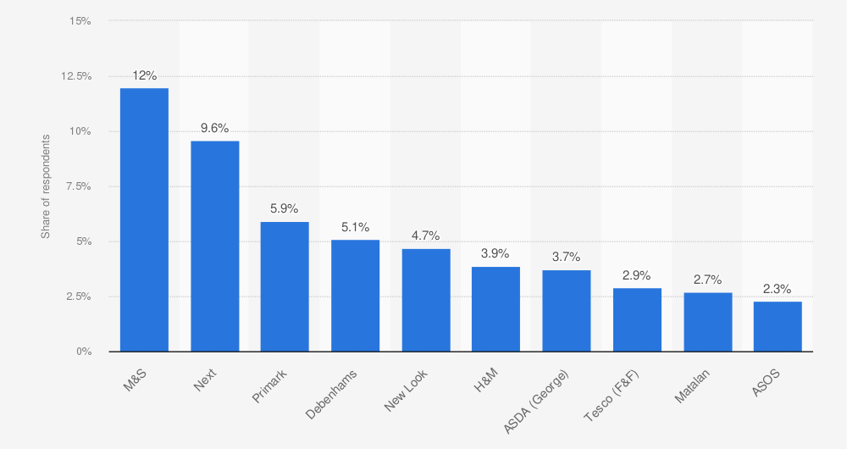
B. Engaging Content and User Experience - M&S employs content marketing strategies that go beyond conventional retail practices. Company’s blog, social media channels, and email campaigns feature diverse array of content, including product reviews, style guides, and behind-the-scenes insights (Samuels, 2022). This multifaceted content approach resonates with target audience, fostering deeper connection and engagement. User experience on M&S website is carefully curated to align with customer expectations and preferences. Seamless navigation, visually appealing layout, and intuitive design contribute to positive online experience. Studies have shown that satisfying user experience correlates with increased customer satisfaction and loyalty (Dumitriu et al., 2019).

Source: (Statista. (n.d.). Loyalty index top ten retailers)

Internal and External Communication Flows
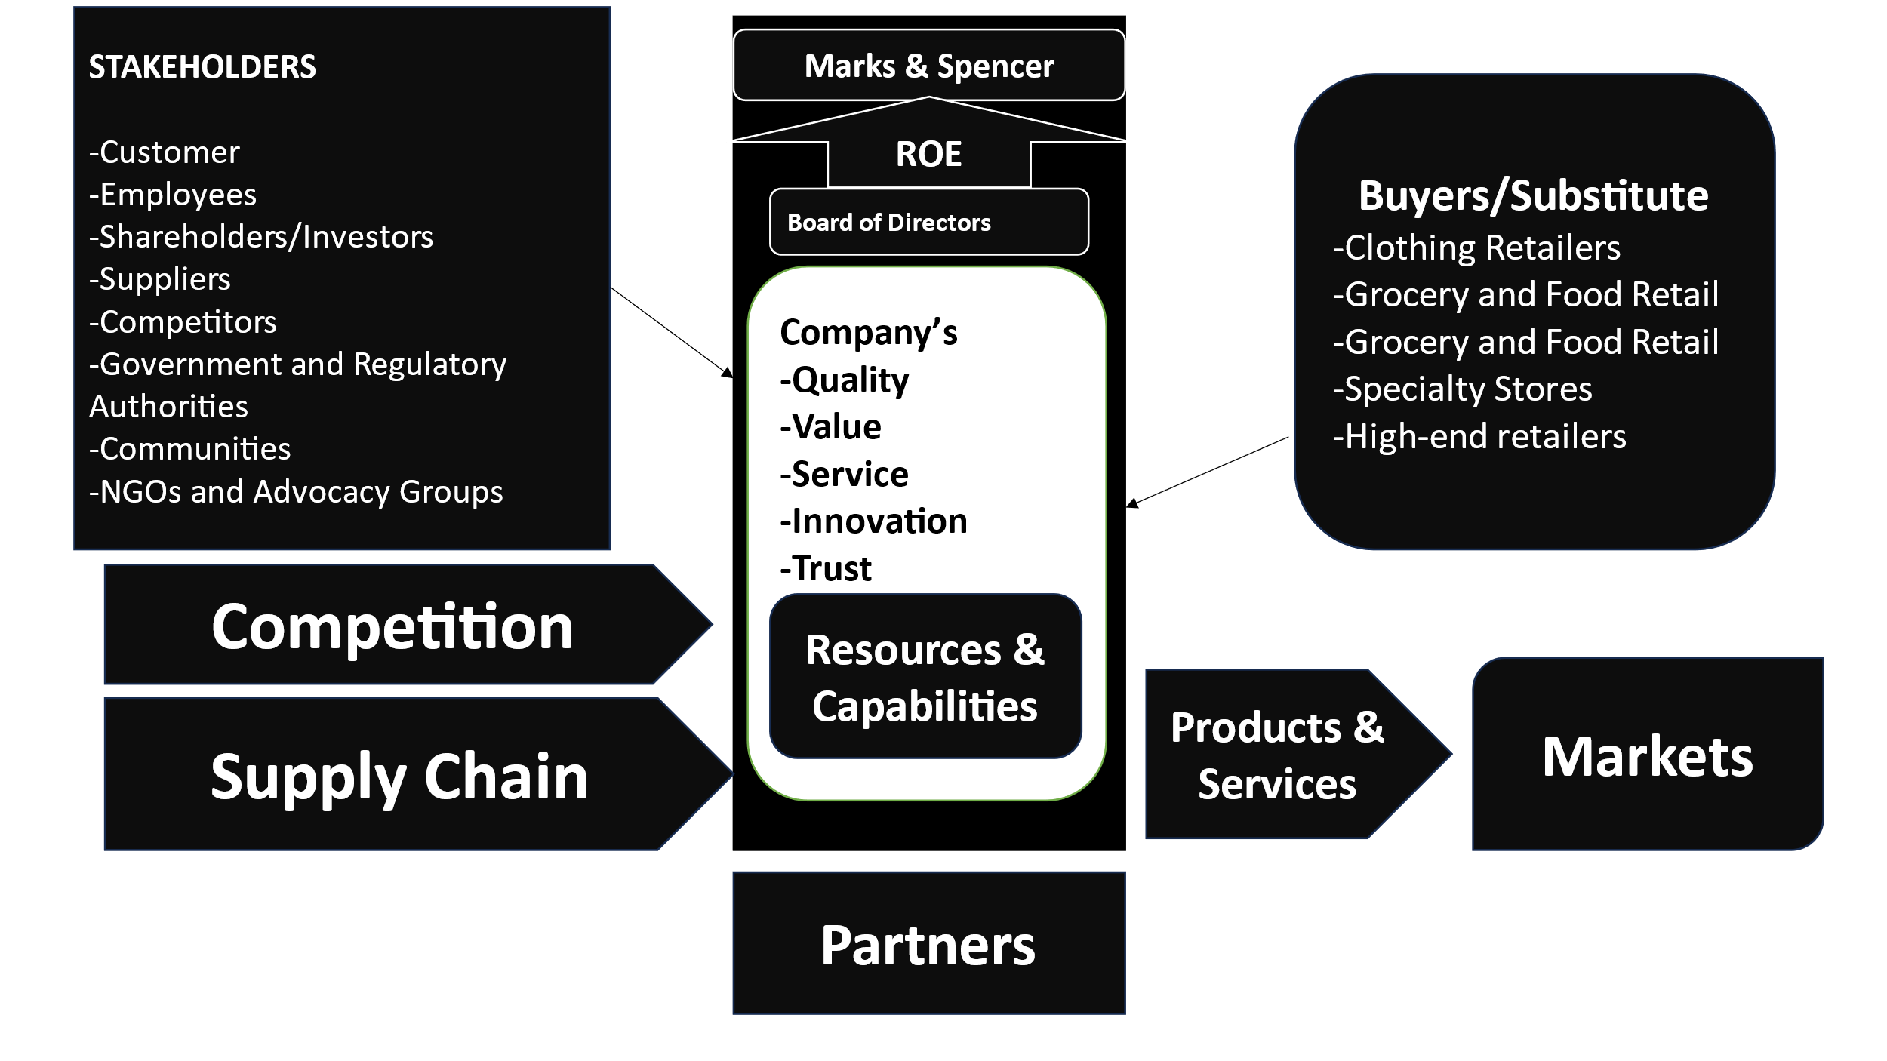
(Source: Self Develop)
Internal Communication - Marks and Spencer (M&S) deliberately leverages its site, marksandspencer.com, not as it were as customer-facing stage but moreover as strong apparatus for inside communications (Gebrmicheal, 2019). Integration of inside communication inside site illustrates forward-thinking approach to cultivating cohesive organizational environment. This inner utilization goes past ordinary strategies, giving centralized space available to workers for overhauls, news, and inner activities. M&S effectively locks in workers through its advanced resources, utilizing site as conduit for dispersing company news and advancing inner activities. Site serves as energetic stage where workers can get to data around corporate upgrades, up and coming occasions, and inner ventures. This approach not as it were upgrades communication productivity but too contributes to building sense of community among workers.
External Communication - M&S utilizes multifaceted approach to outside communication, locks in clients through site, social media channels, and e-mail campaigns. These advanced touchpoints serve as capable instruments for coming to and connection with target group of onlookers. Site, acting as nexus, guarantees reliable stream of data, adjusting with brand’s personality and catering to inclinations of assorted client base. In domain of outside communication, M&S is fastidious in curating substance that adjusts consistently with its brand personality and resounds with inclinations of its group of onlookers (Pyykkö, 2020). Whether through site, social media, or e-mail campaigns, substance is made to reflect values and fashion related with M&S. This key substance arrangement contributes altogether to brand devotion and foundation of brand picture in computerized scene.

SOSTAC Analysis
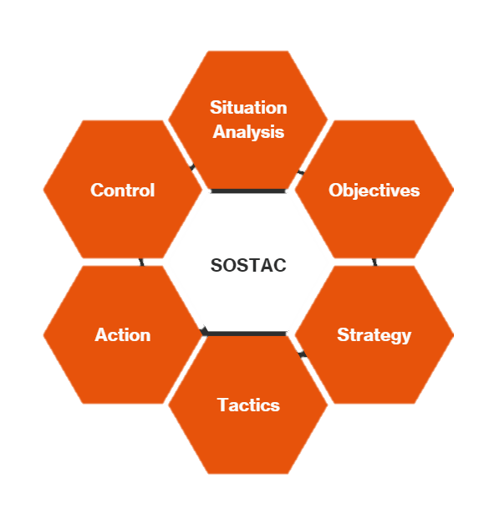
Source: (Broadhurst. Digital)

Situation Analysis
M&S faces an energetic computerized scene with expanding client dependence on online stages. Openings lie in leveraging the advantageous relationship between online and offline channels to upgrade in general client encounter.

Objectives
- Improve how much customers like and interact with your website.
- Build a stronger connection with customers online to make them more loyal to the brand.
- Improve online presence by using good SEO techniques.
- Use machine learning to create custom experiences for customers.
- Improve how we talk with each other inside and outside our company.

Strategy
With an easy way for people to get around and buy things online. Use different ways to promote content so that many people are interested and involved. Implement a complete SEO strategy to improve your online presence. Use machine learning to make customer interactions more personalized. Improve talking inside the company using the website and talking outside the company using social media and email ads.

Tactics
- Update the website design to make it easier to find things.
- Start interesting blog posts and social media posts.
- Research and find the best keywords to improve your website for search engines.
- Create computer programs that can learn and make suggestions tailored to individual users.
- Create a plan for how to communicate within the organization using the website.
- Find and share outside content that matches the brand's image on different online platforms.

Action
- Start changing the website to make it better and easier to use.
- Create a schedule for posting content online regularly.
- Use the right words to help people find you on the internet.
- Use machine learning in online shopping.
- Create a schedule for updating the website and carry out plans for communicating with the public.

Control:
Regularly check how many people visit the website, how well social media posts are doing, and how the website is doing in search engine results. Check to see if the computer programs that learn are working well and if customers are happy. Change the way you create content based on feedback and new trends. Make sure our website is always updated so that everyone can communicate easily within our organization. Change how we talk to customers based on what they say and how the market is doing.

Marketing Mix Strategies
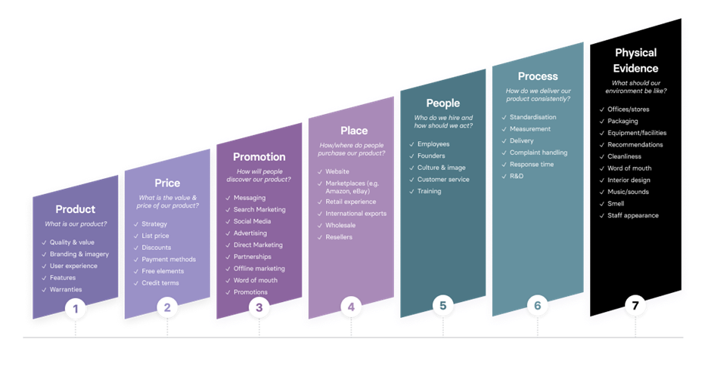
Marks & Spencer's (M&S) showcasing blend deliberately combines key components to meet client needs and keep up a competitive edge.
(Source: ventureharbour.com)
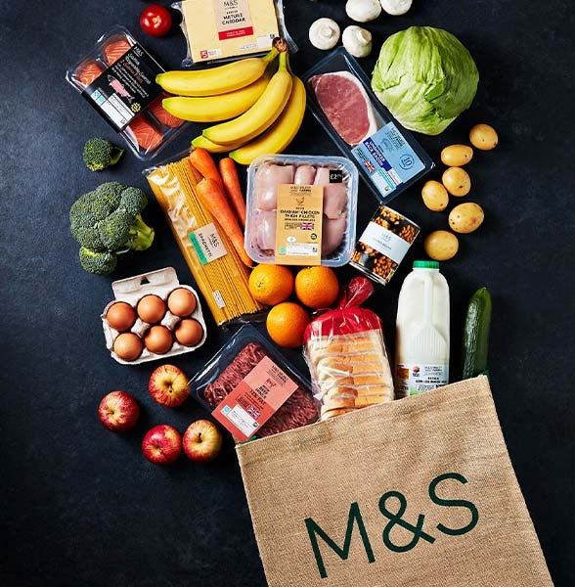
- Product: M&S offers a differing run of high-quality items, counting clothing, nourishment, and homeware. Emphasizing quality and development, M&S persistently overhauls its item lines to remain significant.
(Source: corporate.marksandspencer.com)
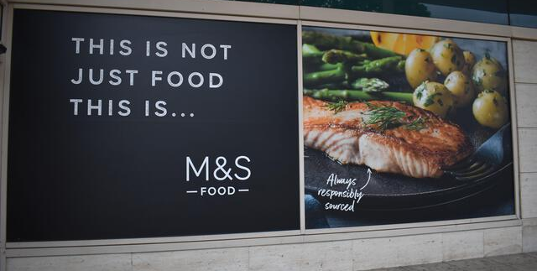
- Price: Situated as a premium brand, M&S embraces a value-based estimating procedure. Whereas advertising quality items, the estimating reflects a adjust between seen esteem and client reasonableness.
(Source: alamyimages.fr)
- Promotion: M&S utilizes a multi-channel special procedure, utilizing conventional publicizing, advanced showcasing, and social media. The brand centres on narrating and client engagement to construct passionate associations.
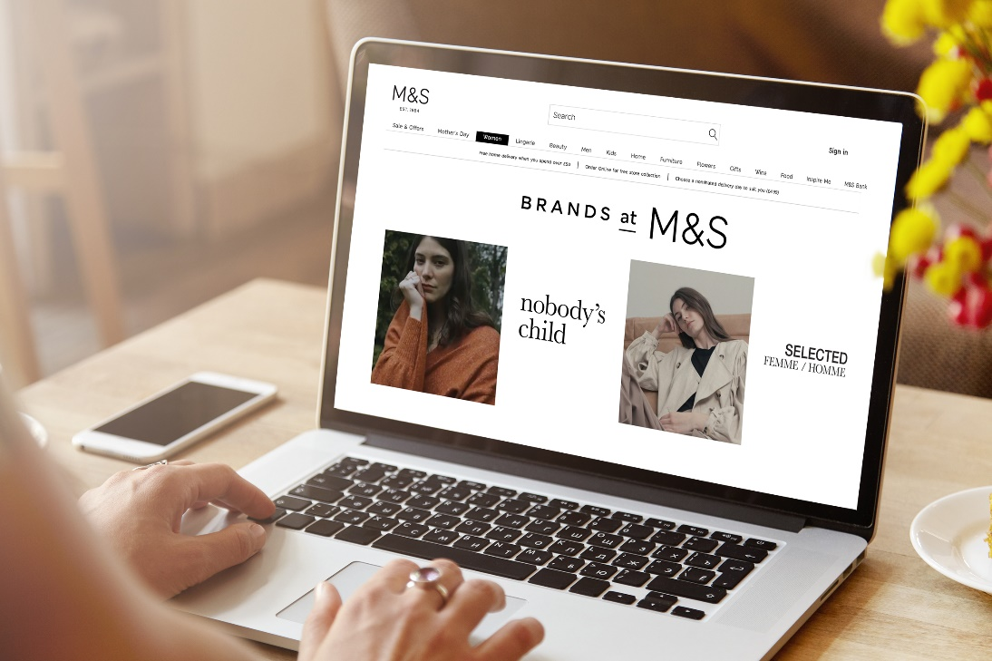
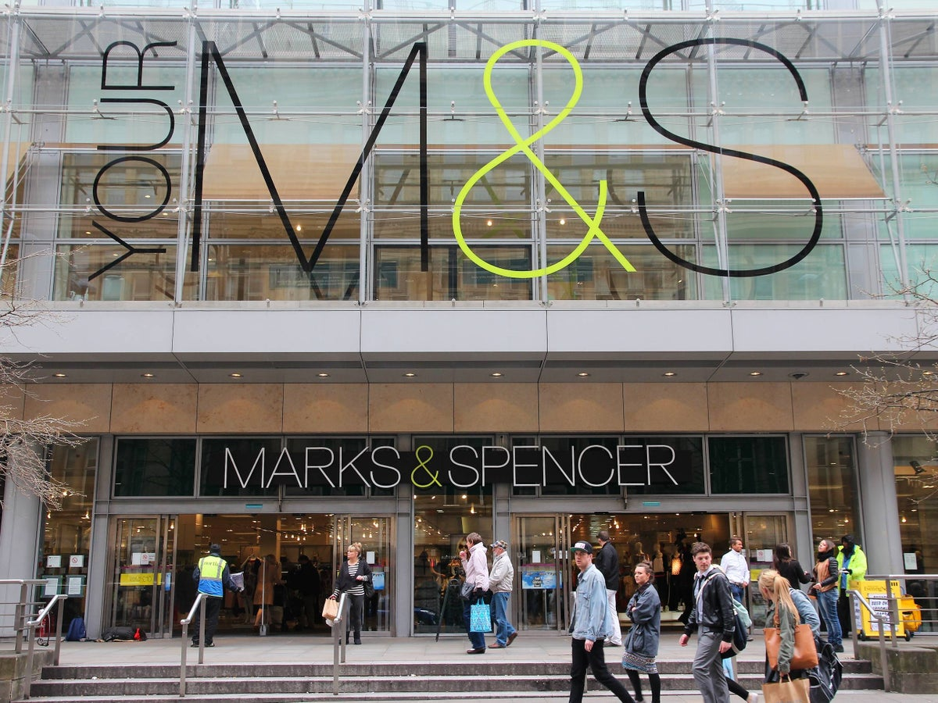
- Place: With an endless retail arrange comprising 1,063 stores, M&S guarantees far reaching openness. Moreover, the brand works online through its site, giving a consistent omni-channel shopping encounter.
Offline Store Online Website
(Source: corporate.marksandspencer.com) (Source: independent.co.uk)
- People: Client benefit could be a need for M&S, with prepared staff advancing a positive in-store encounter. The brand's accentuation on representative fulfilment contributes to a customer-centric culture.
- Process: M&S prioritizes effective forms, guaranteeing consistent operations from item advancement to client benefit. The brand leverages innovation for online exchanges and offers administrations like click-and-collect to improve comfort.
- Physical Evidence: The physical introduction of M&S stores adjusts with its premium picture. Well-designed stores and bundling contribute to a positive client recognition.

OMNI-CHANNEL ADVANTAGE
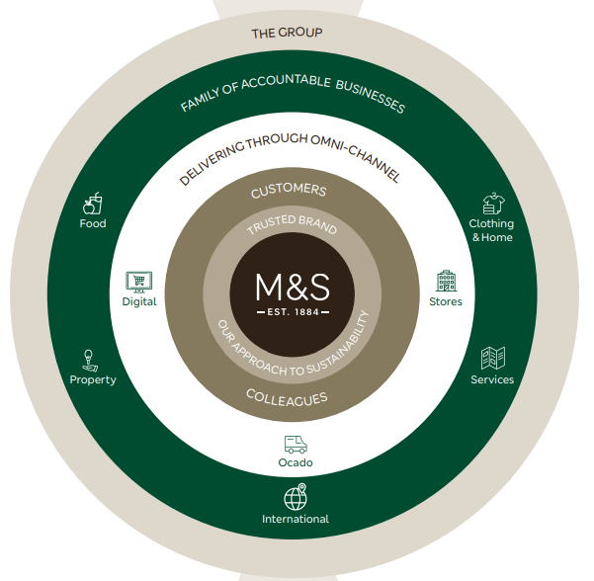
(Source: corporate.marksandspencer.com)
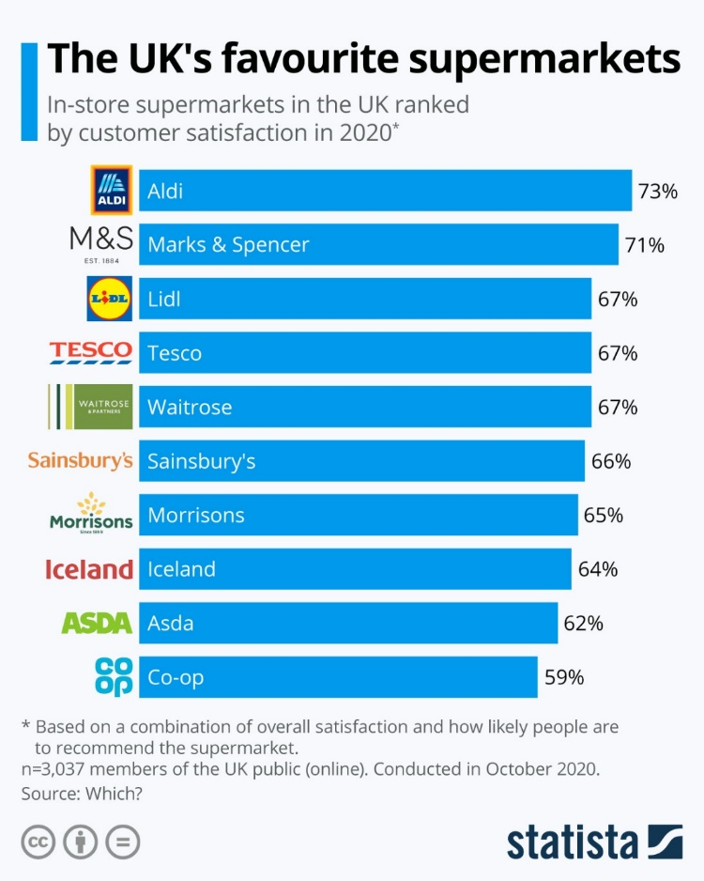
The network, consisting of 1,064 UK-owned and franchise stores, enables a seamless connection between the digital and physical shopping experiences, offering customers increased flexibility in their preferred shopping methods. With a 50% investment in Ocado Retail, M&S is further enhancing its presence, and the company is expanding globally, reaching over 100 international markets.

Figure 3: Armstrong, M. (2021). Infographic: The UK’s favourite supermarkets

Marketing Information System (MIS) and Information Architecture
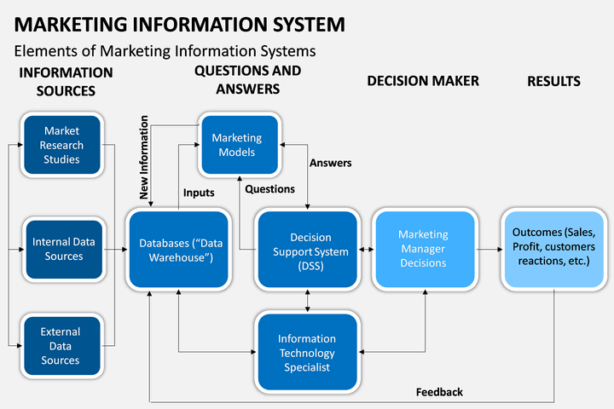
(Source : sketchbubble.com)

Robust MIS Implementation
Marks and Spencer (M&S) exemplify robust Management Information System (MIS) implementation, leveraging diverse data sources to inform strategic decisions (Le, 2021). Company employs multifaceted approach, incorporating website traffic data, customer purchase information, and insights from social media interactions. Sources of Data are as follows -
- Website Traffic - official M&S website serves as primary source for data collection, offering valuable insights into customer behaviour, preferences, and engagement metrics. Website’s analytics provide comprehensive overview of visitor traffic, page views, and effectiveness of various online campaigns.
- Customer Purchases - M&S harnesses transactional data from customer purchases, generating wealth of information on buying patterns, popular products, and customer demographics (Black, 2020). This data enables company to optimize inventory, personalize marketing efforts, and enhance overall customer experience.
- Social Media Interactions - Engaging with customers on social media platforms, M&S collects data on social interactions, sentiment analysis, and user-generated content (Samuels, 2022). This social data provides real-time feedback, helping company stay attuned to customer opinions, market trends, and potential areas for improvement.
- Advanced Analytics Tools - M&S employs cutting-edge analytics tools to derive actionable insights from collected data. Advanced tools such as AI and machine learning algorithms enable company to analyse vast datasets efficiently (News-Desk, 2023). These tools facilitate predictive modelling, allowing M&S to anticipate customer trends and make data-driven decisions.
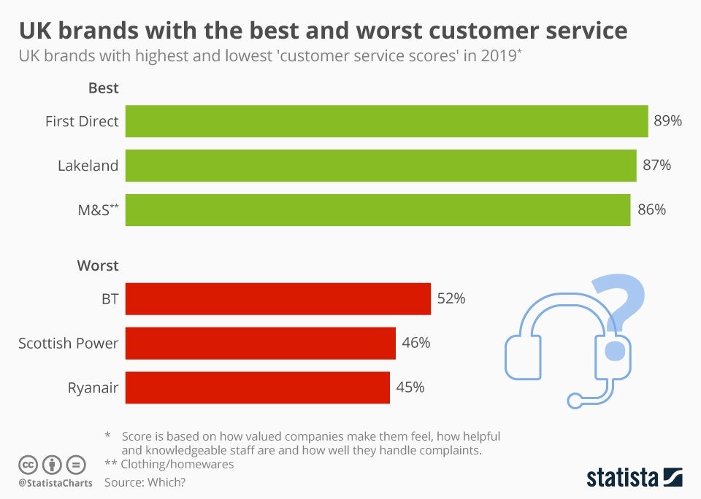
Figure 4: Statista Infographics. (n.d.). Infographic: UK brands with the best and worst customer service

Cookies & Web Beacons:
Web beacons and cookies are tools employed in online settings for diverse purposes, such as monitoring user behaviour, gathering data, and improving user interactions. Nevertheless, they fulfil distinct roles.
Cookies: 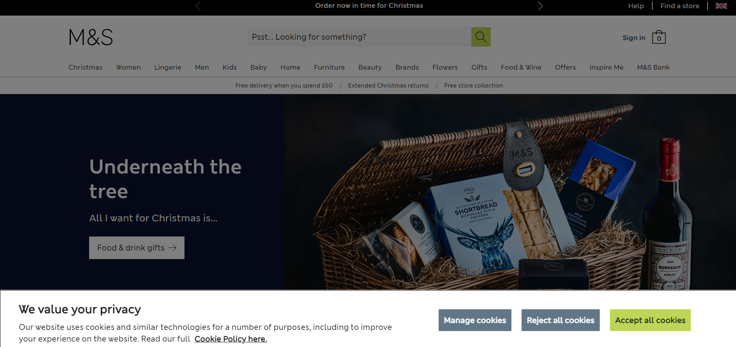
(Source: marksandspencers.com)
Cookies are petite text files stored on a user's device (e.g., computer or smartphone) during website visits. Cookies serve multiple functions, encompassing the retention of user preferences, storage of login details, monitoring user behaviour, and customization of content. They may be either first-party or third-party.
User Experience: Cookies enhance user experiences by recollecting preferences and login specifics.
Analytics: Companies utilize cookies for tracking website analytics, gaining insights into user behaviour, and refining their services and content.
Targeted Advertising: Cookies are frequently deployed to trace users' browsing tendencies and preferences, empowering companies to deliver more precise and individualized advertisements.
Web Beacons:

(Source: ouriken.com)
Web beacons, also recognized as pixel tags or clear GIFs, are minute, see-through graphics embedded in web pages or emails. Web beacons are employed for collecting data on user behaviour, gauging the effectiveness of marketing campaigns, and compiling statistics on email open rates and click-through rates.
Tracking and Analytics: Web beacons aid companies in observing user interactions with their websites or email campaigns, furnishing valuable insights into user engagement.
Personalization: Data amassed through web beacons contributes to personalized marketing strategies, enhancing the pertinence of content and advertisements.
Marks & Spencer and their utilization of web beacons and cookies hinge on their privacy policy and online practices, which may evolve over time. Companies frequently employ these tools to refine user experiences, provide targeted content, and deepen their comprehension of customer behaviour. For information on how M&S specifically employs these technologies, consulting their current privacy policy on their official website or reaching out to their customer support is advisable. (Frow, J., 2022).

Google Analytics of M&S:
Overview of M&S Website -
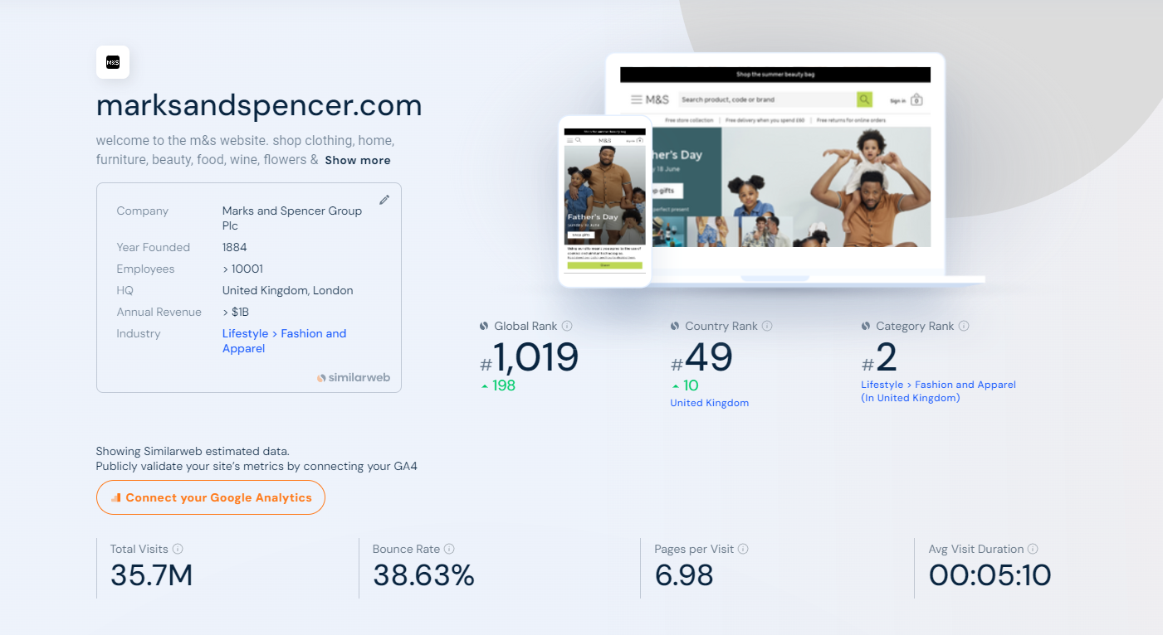
(Source: similarweb.com)
Ranking of M&S Website –
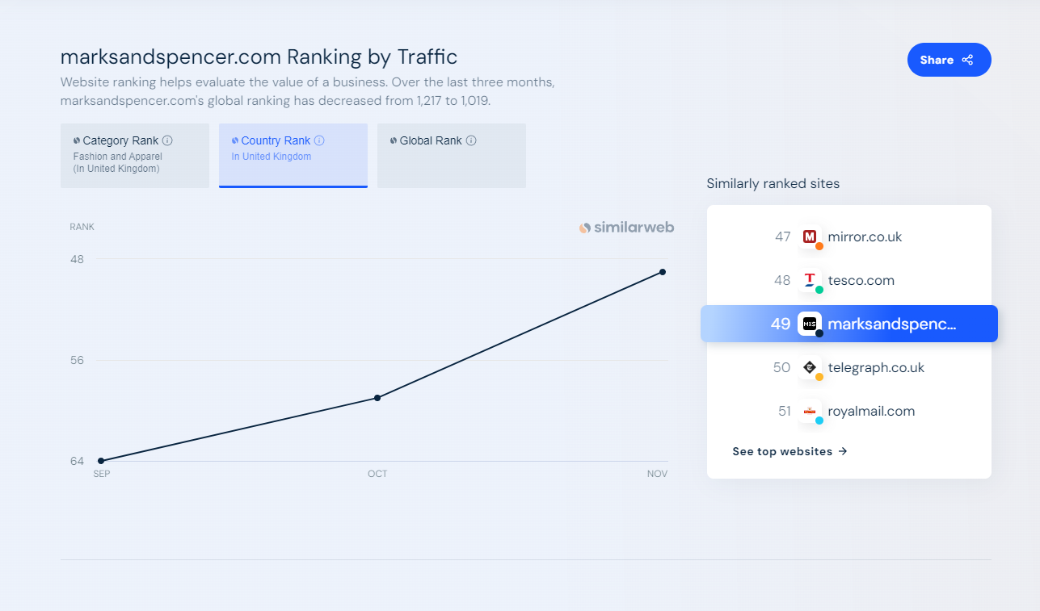
(Source: similarweb.com)

Audience of M&S Website –
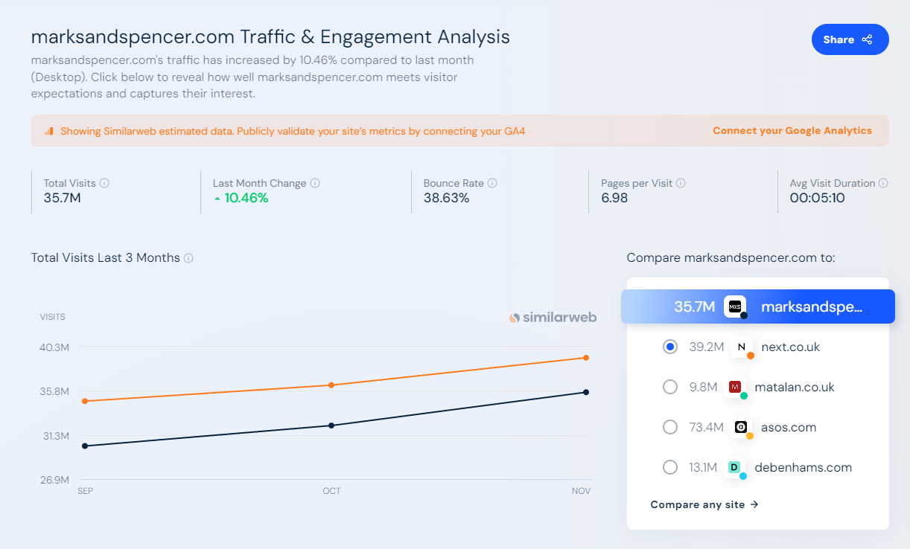
(Source: similarweb.com)
Competitors of M&S Website –
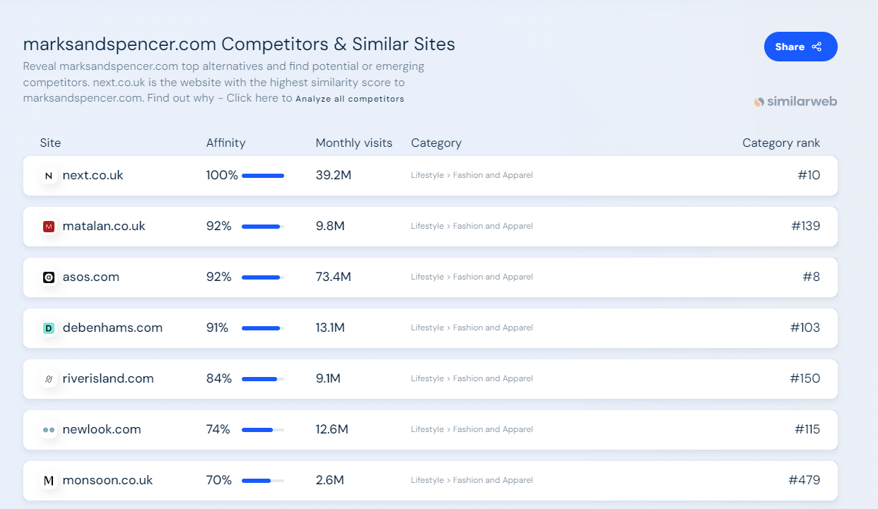
(Source: similarweb.com)

Marketing Channels of M&S Website –
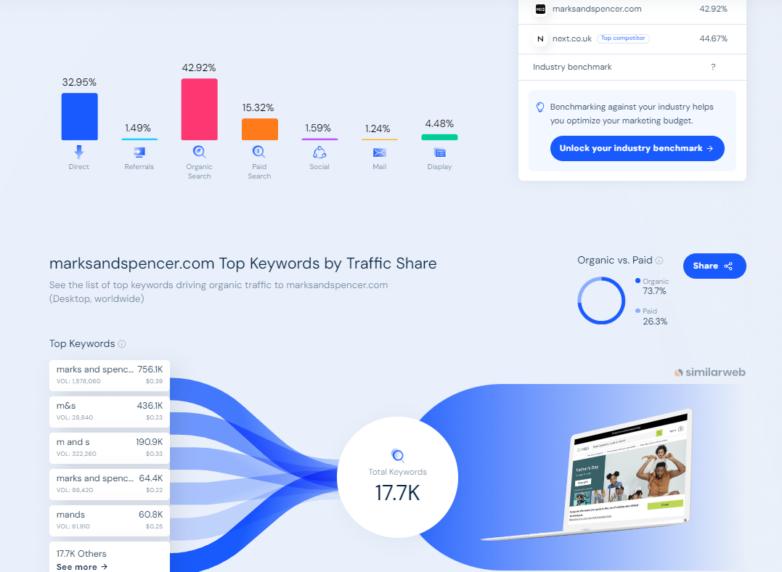
(Source: similarweb.com)
Outgoing links of M&S Website –
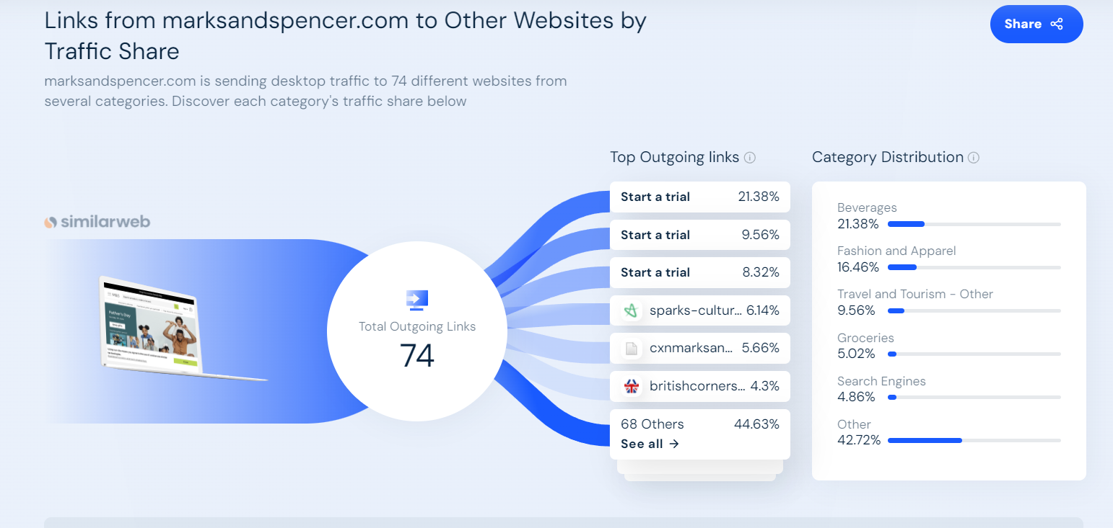

Information Architecture for Data Organization
- Website Traffic Data - M&S site serves as foundation for information collection, and its data engineering guarantees efficient organization of site activity information. This incorporates measurements such as page sees, click-through rates, and client engagement (Bhoomika, 2023). By organizing this information productively, M&S picks up all encompassing see of online client intuitive, empowering educated decision-making in computerized showcasing procedures.
- Customer Purchases - Value-based information from client buys is fastidiously organized inside data design. This organized approach includes categorizing items, following buy recurrence, and dissecting client socioeconomics (Kingsnorth, 2022). Result is well-organized dataset that encourages focused on promoting campaigns and personalized client encounters.
- Social Media Interactions - Locks in with clients on social media produces endless sum of information, and M&S utilizes data engineering to organize social media intuitive methodically. This incorporates assumption investigation, user-generated substance, and engagement measurements (Samuels, 2022). Organizing social media information empowers M&S to extricate important bits of knowledge, recognize patterns, and react expeditiously to client input, Benefits in Identifying Patterns, Trends, and Anomalies
- Pattern Recognition - Organized data design at M&S plays urgent part in recognizing designs inside promoting information. By categorizing and organizing information sets, company can perceive repeating patterns in client conduct, inclinations, and obtaining designs (News-Desk, 2023). This empowers M&S to tailor its promoting techniques to adjust with winning patterns, guaranteeing pertinence and reverberation with target group of onlookers.
- Trend Analysis - Data engineering demonstrates instrumental in conducting slant examinations. M&S utilizes authentic information, organized efficiently, to distinguish developing patterns in showcase (Professional, 2022). This proactive approach permits company to remain ahead of competitors and alter its showcasing strategies in like manner.
- Anomaly Detection - In expansion to designs and patterns, M&S leverages data design for irregularity discovery. By setting up baselines and organizing information for simple peculiarity distinguishing proof, company can quickly address abnormalities or unforeseen shifts in client conduct (Dumitriu et al., 2019). This upgrades by and large security and unwavering quality of showcasing information.

Effective Strategies: Maximizing Digital Marketing Impact

Content Marketing: Elevating Customer Engagement and Fostering Brand Loyalty
In advanced age, substance showcasing has risen as vital foundation for businesses looking for to lock in gatherings of people and invigorate brand dependability. Marks and Spencer (M&S), retail mammoth, represents nuanced approach to substance showcasing over assorted channels, counting blogs, social media, and e-mail campaigns. This examination dives into specifics of M&S’s substance promoting techniques, evaluating their effect on client engagement and brand devotion. 
(Source: Ja, S. (2023). Marks & Spencer sale)
- M&S’s Blog - M&S’s web journal serves as central point for instructive and locks in substance. Company adeptly utilizes narrating, advertising clients’ bits of knowledge into its brand logic, maintainability activities, and item stories (Yousuf, 2019). This adjusts with modern consumer’s slant towards brands with account, cultivating more profound passionate association.
- Social Media Initiatives - Social media platforms amplify M&S’s reach, and company harnesses these channels for dynamic content dissemination. From visually appealing product showcases to behind-the-scenes glimpses, M&S crafts diverse content mix tailored to different platforms (Samuels, 2022). Goal is to resonate with varied audience segments, enhancing engagement levels.
- Email Campaigns - M&S’s email campaigns go beyond mere promotional content. Through data-driven personalization, company tailors’ content to individual preferences, showcasing products aligned with past purchases and customer interests (Marks & Spencer, 2022). This not only enhances engagement but also contributes to overall customer experience.
Analysis of Impact: Customer Engagement and Brand Loyalty
- Customer Engagement - M&S’s content marketing strategies have resulted in commendable customer engagement across channels. Blog, through its informative content, keeps customers informed and invested in brand’s values (Samuels, 2022). Social media interactions contribute to vibrant online community, fostering dialogue and feedback. Personalized touch in email campaigns ensures that customers receive content that resonates with their preferences (Marks & Spencer, 2022). Cumulatively, these efforts significantly enhance overall customer engagement.
- Brand Loyalty - Impact of M&S’s content marketing on brand loyalty is palpable. By delivering value through informative blog posts and maintaining active social media presence, M&S solidifies its position as more than just retail entity it becomes brand with personality and ethos (Samuels, 2022). Personalized content in email campaigns contributes to sense of exclusivity and understanding, further fortifying brand loyalty (Marks & Spencer, 2022). This allegiance translates into repeat business and positive word-of-mouth, crucial in today’s competitive market.
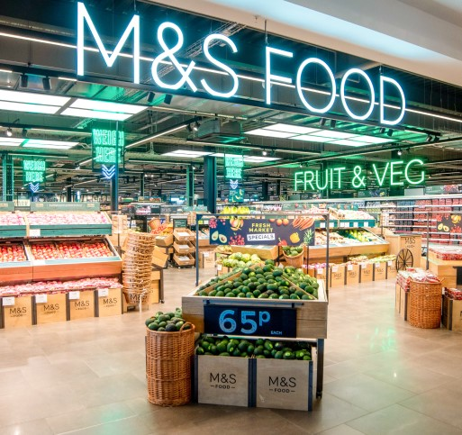
(Source: Marks & Spencer (2023). Food)
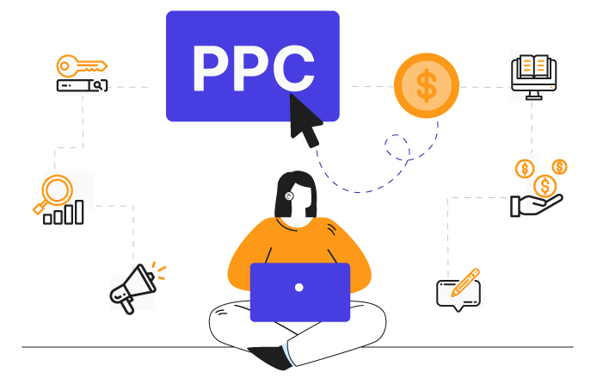
Pay-Per-Click (PPC):
(source: wpswings.com)
Pay-Per-Click, is an internet advertising model where advertisers pay a fee each time a user clicks on their ad, providing a method to purchase site visits rather than relying on organic traffic. Advertisers engage in keyword bidding for phrases pertinent to their target audience, and when users search for these terms on search engines, the corresponding ads are displayed.

Operational Process:

Keyword Selection: Advertisers opt for relevant keywords linked to their products or services.
Bid Amount: Advertisers establish a bid amount, signifying the maximum they are willing to pay for a click on their ad.
Ad Placement: Ads are exhibited on search engines, social media platforms, or other websites, determined by keyword bids and relevance.
Ad Display: In response to a user's keyword search, an auction is conducted to determine the ads to be shown. Ad ranking is influenced by bid amounts and other factors.
Clicks and Charges: Advertisers incur charges when users click on their ad, leading them to the advertiser's website.
Marks & Spencer and PPC
Major retailers like Marks & Spencer, integrate PPC into their online marketing strategies. A generalized approach for Marks & Spencer could involve:
Keyword Research: Identifying pertinent terms, such as "clothing" or "home goods," through keyword research.
Ad Campaign Creation: Crafting tailored ad campaigns for various product categories or promotions, each with specific keyword groups.
Bidding Strategy: Establishing a bidding strategy aligned with the advertising budget and objectives, potentially adjusting bids for high-value keywords or peak seasons.
Ad Creatives: Developing compelling ad copies and visuals to encourage user clicks, directing traffic to the Marks & Spencer website.
Monitoring and Optimization: Consistently monitoring PPC campaigns to analyse performance, refine ad copies, adjust bids, and optimize campaigns for improved return on investment. Specifics of PPC campaigns may evolve over time based on market dynamics and a company's marketing goals. (McGruer, D., 2020).

Search Engine Optimization (SEO): Elevating M&S’s Digital Visibility
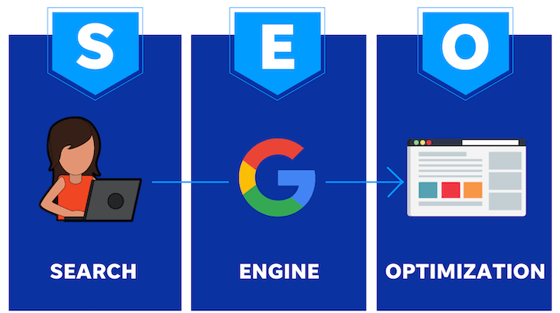
(source: wordstream.com)
1. Strategic Keyword Integration - M&S deliberately coordinating significant watchwords over its advanced substance, guaranteeing arrangement with client look questions. This key catchphrase integration is obvious in item depictions, web journal posts, and other online collateral (Chaffey & Smith, 2022). By comprehensively understanding client look conduct, M&S tailors its substance to rank unmistakably in look motor comes about.
2. Mobile-Friendly Website Design - Recognizing worldview move towards versatile browsing, M&S has contributed in mobile-friendly site plan. This not as it were upgrades client involvement but moreover adjusts with look motor calculations that prioritize versatile responsiveness in positioning websites (Chaffey & Smith, 2022).
3. Quality Content Creation - M&S prioritizes creation of high-quality, significant, and locks in substance over its advanced stages. Whether through web journal posts, item portrayals, or social media overhauls, company guarantees that substance not as it were caters to client interface but moreover adjusts with SEO best hones (Chaffey & Smith, 2022). This commitment to quality substance contributes essentially to M&S’s computerized perceivability.
4. Backlinking Strategies - Backlinking remains cornerstone of M&S’s SEO strategy. Company actively seeks reputable and relevant websites for backlinking, thereby establishing its credibility in digital ecosystem (Chaffey & Smith, 2022). Quality backlinks serve as vote of confidence in eyes of search engines, contributing to higher rankings.
Enhancing Visibility through SEO
1. Top Search Engine Rankings - M&S’s meticulous SEO strategies translate into top rankings on search engine results pages (SERPs). Strategic integration of keywords, combined with mobile-friendly website design, propels M&S to prominent positions when potential customers search for relevant products or information (Marks & Spencer, 2022).
2. Increased Organic Traffic - Effective implementation of SEO tactics results in increased organic traffic to M&S’s digital platforms. Customers, actively searching for products or information, are more likely to discover M&S due to its high visibility on search engines. This influx of organic traffic is testament to success of M&S’s SEO endeavours (Marks & Spencer, 2022).

(Source: Marks & Spencer (2023). Food)
Attracting Potential Customers through Optimized Content
1. Content Personalization for Target Audiences - M&S optimizes its content not just for search engines but also for potential customers. By understanding demographics and preferences of its target audience, company tailors’ content to resonate with specific customer segments. This personalized approach contributes to more engaging and relevant online experience, attracting potential customers and fostering brand loyalty (Samuels, 2022).
2. Strategic Product Placement in Search Results - Through SEO, M&S strategically positions its products in search results, ensuring that they are prominently displayed when customers search for relevant items. This strategic product placement enhances likelihood of potential customers clicking through to M&S’s website, ultimately driving conversion rates (Samuels, 2022).

Social Media Marketing: Crafting Digital Symphony of Engagement
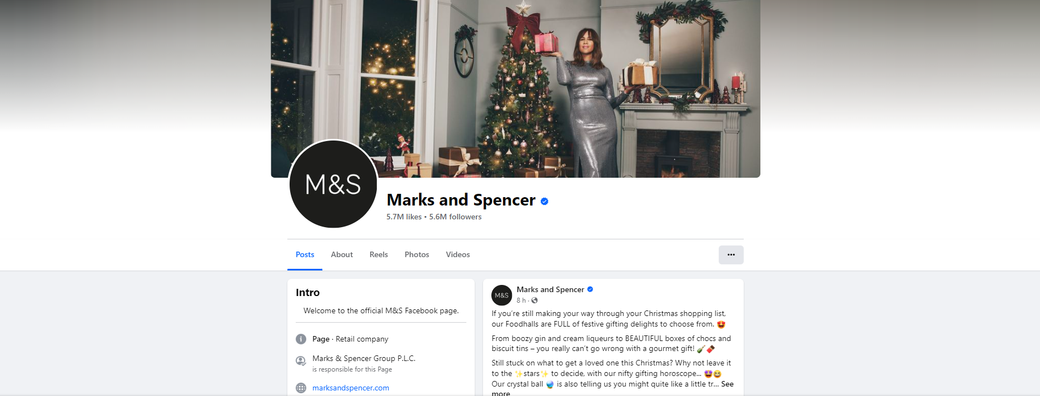
1. Facebook: Interactive Product Showcases - M&S utilizes Facebook as energetic stage for intelligently item grandstands. Company leverages live video highlights to disclose modern collections, permitting clients to lock in in real-time by inquiring questions and communicating inclinations (Marks & Spencer, 2022). This coordinate interaction makes sense of elite ness and inclusion, changing detached adherents into locked in brand devotees.
(Source: facebook.com/MarksandSpencer)
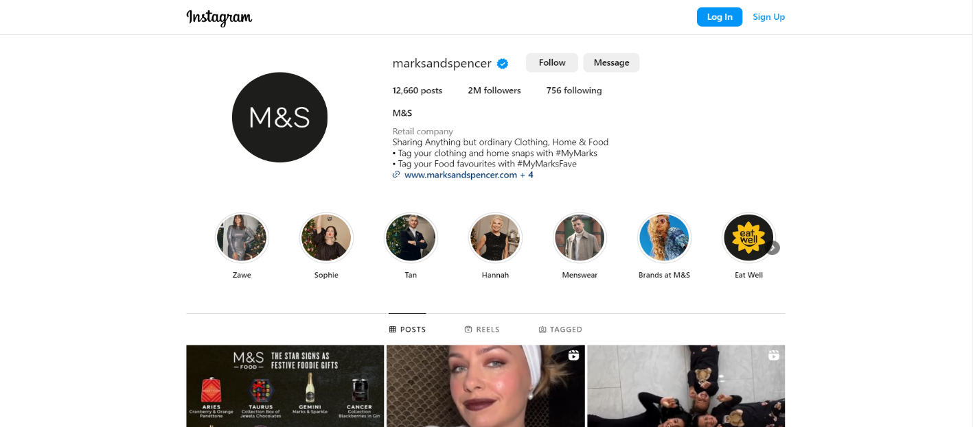
2. Instagram: Visual Narrating and Influencer Collaborations - On Instagram, M&S exceeds expectations in visual narrating. Company utilizes platform’s visual-centric nature to narrate compelling brand stories through aesthetically pleasing images and short videos.
(Source: instagram.com/marksandspencer)
Moreover, strategic collaborations with influencers amplify M&S’s reach, as influencers share their M&S experiences with their followers, creating domino effect of engagement (Marks & Spencer, 2022).

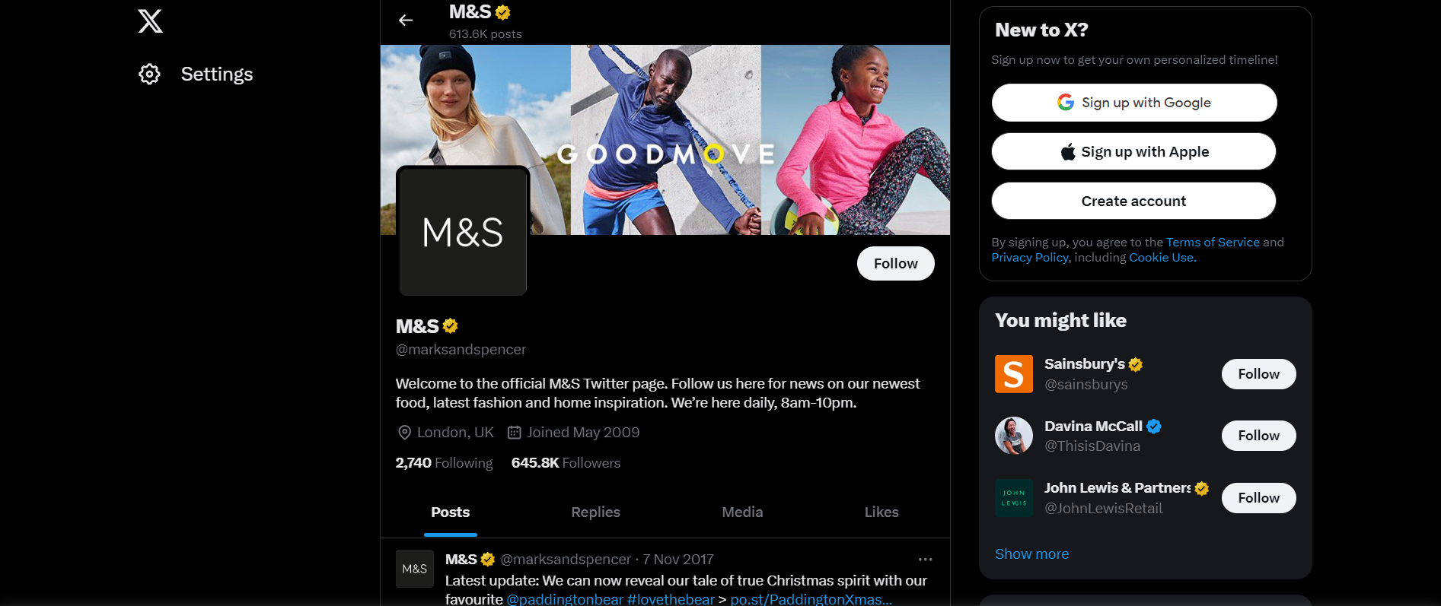
3. Twitter: Real-time Customer Interaction - Twitter serves as M&S’s real-time communication hub. Company engages with customers by promptly responding to queries, acknowledging feedback, and participating in relevant trending conversations. This proactive approach not only showcases M&S’s commitment to customer satisfaction but also humanizes brand, fostering sense of community (Marks & Spencer, 2022).

Building Brand Awareness and Fostering Loyalty
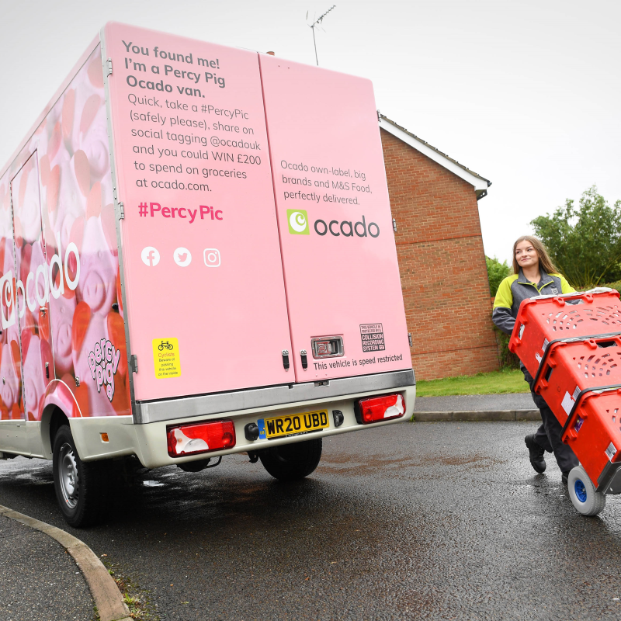
(Source: Marks & Spencer (2023). Food)
1. Strategic Content Personalization - M&S goes beyond generic content sharing; it strategically personalizes its social media content. By tailoring posts to specific demographics and customer preferences, brand ensures that its content resonates with intended audience, fostering deeper connection and increasing likelihood of content sharing (Samuels, 2022).
2. Innovative Campaigns for Brand Recognition - In ever-evolving social media landscape, M&S stays ahead with innovative campaigns. For instance, company’s experimentation with augmented reality (AR) for launching virtual influencer showcases commitment to pushing boundaries and staying relevant in digital sphere (Marks & Spencer, 2022). Such campaigns not only garner immediate attention but also contribute to long-term brand recall.
3. Customer-Centric Engagement Initiatives - M&S places customer at centre of its social media engagement initiatives. Brand actively seeks customer opinions, conducts polls, and encourages user-generated content. By involving customers in brand narrative, M&S not only builds loyalty but also harnesses power of social proof, with satisfied customers becoming brand advocates (Bovsh et al., 2021).

Email Marketing: Elevating Engagement through Segmentation and Personalization
1. Enhanced Targeting through Demographic Segmentation - M&S recognizes differing qualities among its client base and utilizes statistic division to classify endorsers based on variables such as age, area, and shopping inclinations (Giovannoni, 2020). This division permits M&S to tailor its e-mail substance, guaranteeing that special offers, item suggestions, and occasion notices adjust with interface of each section (Pro, E., 2022).
2. Behavioural Segmentation for Tailored Recommendations - Behavioural division is linchpin in M&S’s mail showcasing methodology. By dissecting customers past intuitive, buy history, and browsing conduct, M&S tailors item suggestions and elite offers. This personalized approach not as it were increments probability of change but too improves by and large client encounter (Chaffey & Smith, 2022).
3. Lifecycle Stage Segmentation for Targeted Communication - Recognizing that clients are at diverse stages in their lifecycle, M&S utilizes lifecycle arrange division. Modern supporters get welcome emails with early on offers, whereas steadfast clients may get elite sneak peaks or early get to deal occasions. This guarantees that substance isn't as it were important but too adjusts with customer’s travel with brand (Nagyová, 2020).
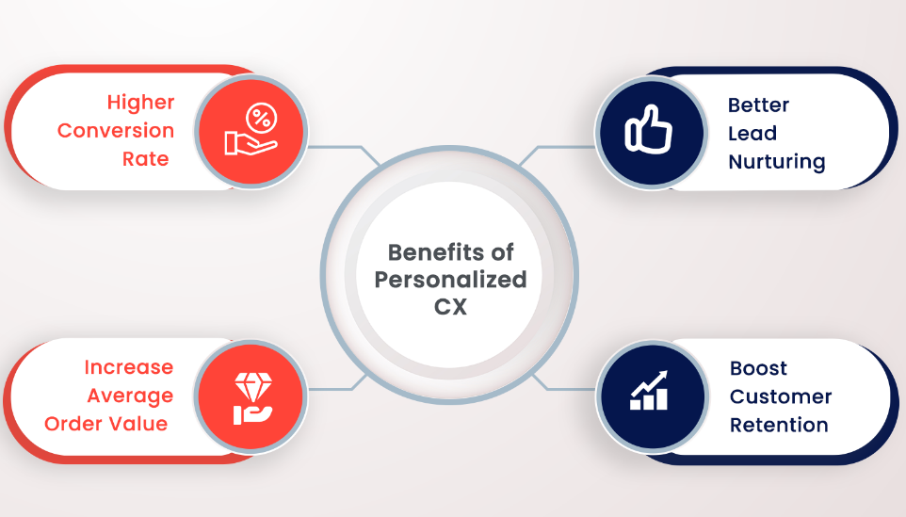
Personalization Strategies that Resonate with Customers
(Source: contactpoint360.com)
1. Dynamic Content for Tailored Experiences - M&S doesn’t settle for inactive emails. Instep, company consolidates energetic substance that adjusts based on recipient’s profile and conduct. For occasion, in case client regularly shops for women’s attire, mail might transcendently exhibit important items from that category. This energetic approach boosts engagement by displaying personalized storefront inside mail itself (Chaffey & Smith, 2022).
2. Personalized Offers and Discounts - Personalization amplifies past tending to client by title. M&S deliberately tailors limited time offers and rebates based on person inclinations and buy history. For occurrence, on the off chance that client has appeared inclination for item category, e-mail advancements may highlight rebates or modern entries inside that category. This not as it were empowering rehash commerce but too illustrates that M&S values its customer’s one-of-a-kind inclinations (Samuels, M., 2022).
3. Interactive Content for Engaging Experiences - M&S gets it advancing scene of e-mail engagement and consolidates intelligently components inside its emails. From clickable item carousels to implanted studies or tests, these intelligently highlights not as it were capturing recipient’s consideration but moreover give important bits of knowledge into client inclinations, making a difference M&S refine its personalization procedures encourage (Marks & Spencer, 2022).
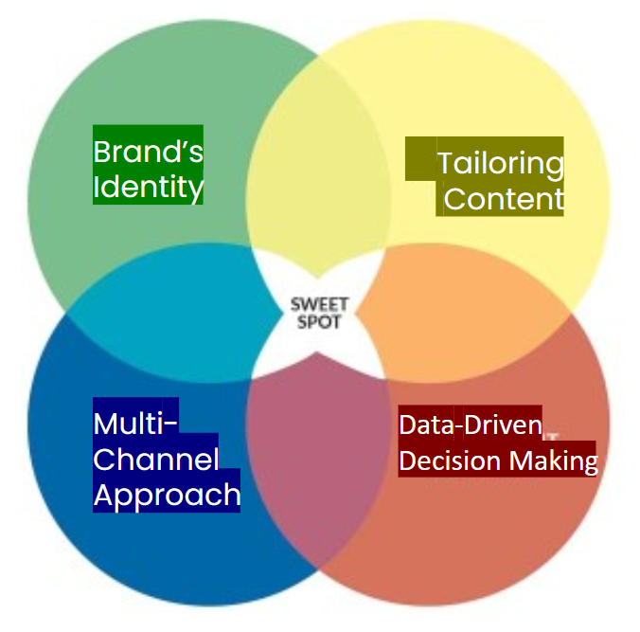
Sweet Spot
(Source: ifms-ltd.com)
Crafting an effective content strategy for Marks & Spencer entails focusing on four crucial pillars: aligning with the brand's identity, tailoring content to diverse audience personas, adopting a multi-channel approach, and utilizing data-driven decision-making for continuous improvement. This strategy ensures consistency, resonates with the audience, and adapts to the dynamic retail landscape. Regular evaluations using data and analytics are key to ongoing success and achieving strategic objectives. (Schantin, 2021).

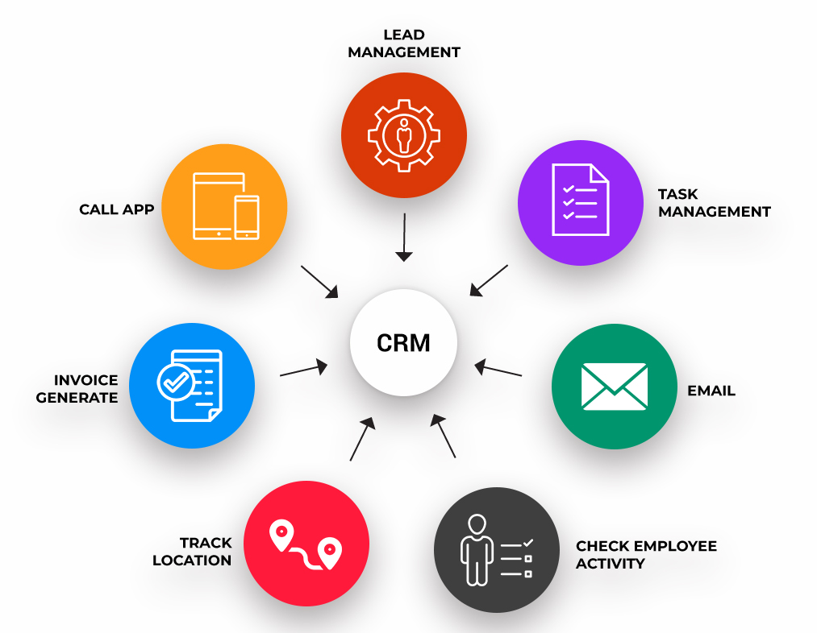
CRM of M&S
(Source: alicesoft.co.in)
Customer Relationship Management (CRM) is an acronym denoting the management of interactions and data pertaining to customers across their lifecycle. It encompasses an array of technologies, strategies, and practices employed by companies to enhance customer satisfaction, boost customer retention, and propel sales growth. CRM systems typically incorporate features like lead management, contact management, sales automation, marketing automation, customer service and support, along with analytics. These tools play a pivotal role in organizing customer information, monitoring interactions, and optimizing processes associated with customer engagement.
The significance of CRM: Customer Retention: CRM aids in cultivating enduring relationships with customers, fostering loyalty, and mitigating churn. Customer Satisfaction: By monitoring customer interactions and preferences, businesses can offer personalized services, ultimately elevating customer satisfaction.
Efficient Marketing: CRM systems empower targeted marketing endeavours by analysing customer data, enabling companies to tailor campaigns to specific customer segments.
Sales Growth: CRM tools streamline the sales process, enhancing efficiency from lead generation to deal closure, potentially resulting in increased sales.
Data Centralization: CRM systems consolidate customer data, facilitating easy access for different departments. This ensures coordinated efforts and a unified perspective on customer interactions.
Improved Communication: CRM facilitates enhanced communication among teams, ensuring everyone stays abreast of the latest customer information and collaborates effectively.
Analytics and Reporting: CRM systems furnish valuable insights through analytics and reporting, enabling data-driven decision-making for businesses.
CRM plays a pivotal role for businesses seeking to establish and sustain robust customer relationships, optimize operations, and achieve lasting growth in a competitive market. (Ever, C.T., 2018).

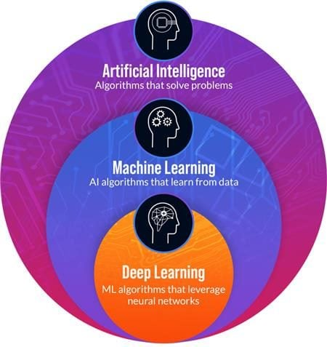
Part 2: Role of Machine Learning in M&S’s Digital Marketing
(source: cmswire.com)

Embracing Machine Learning in Digital Marketing: Revolutionary Leap
1. Dynamic Customer Profiling - M&S deliberately utilizes ML calculations to powerfully profile its endless client base. By examining horde of information focuses, counting buy history, browsing conduct, and intuitive with promoting substance, ML empowers M&S to make nuanced client profiles that advance in real-time. This energetic profiling guarantees that showcasing procedures stay adjusted with ever-changing inclinations of person clients (Mahmutović, 2022).
2. Predictive Customer Behaviour Analysis - ML-driven prescient analytics at M&S are tackled to anticipate client conduct designs. By leveraging verifiable information, these calculations can foresee future activities, permitting M&S to proactively tailor showcasing procedures. This prescient edge is instrumental in expecting client needs and inclinations, enabling M&S to remain ahead of showcase patterns (News-Desk, A.R., 2023).
3. Real-time Content Optimization - Integration of ML amplifies to optimizing real-time substance over different computerized channels. M&S utilizes calculations that powerfully alter substance of emails, notices, and social media posts based on client intuitive. This real-time optimization guarantees that clients get personalized and significant substance, subsequently improving engagement and transformation rates (Hernāndez et al, n.d.).
Enhancing Overall Digital Marketing Strategies

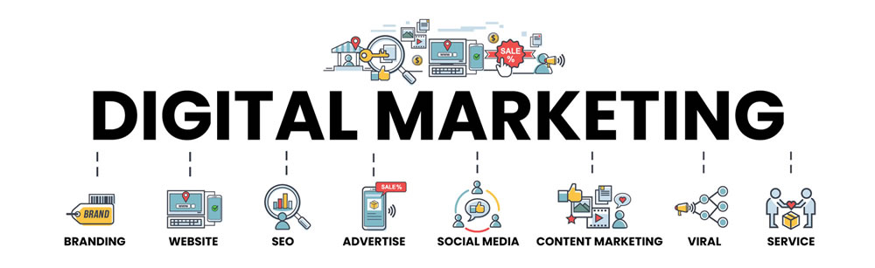
(Source: redfishgroup.co.uk)
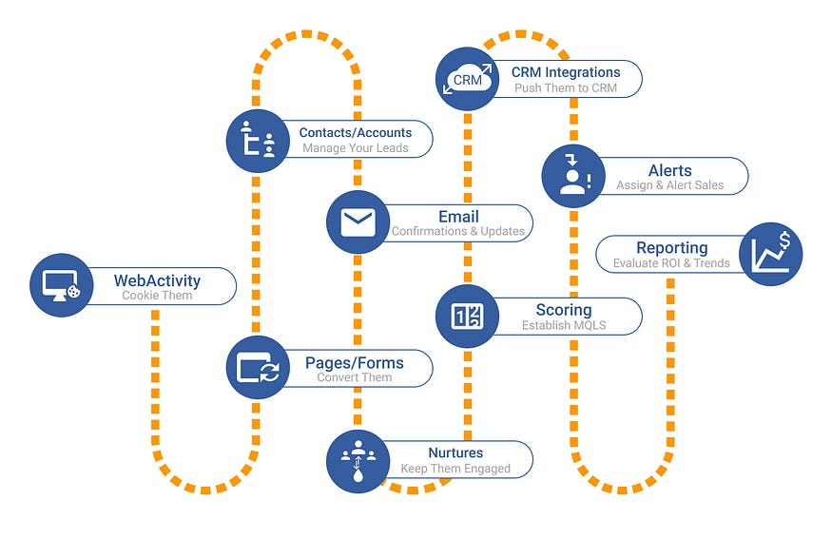
1. Automated Campaign Customization - ML not as it were refining client division but too computerizes customization of showcasing campaigns. M&S utilizes ML calculations to examine client fragments and tailor campaigns with tall degree of robotization. This not as it were spares time but too guarantees that each campaign is absolutely calibrated to resound with inclinations of focused on client bunches (Algharabat et al., 2020).
(Source: medium.com)

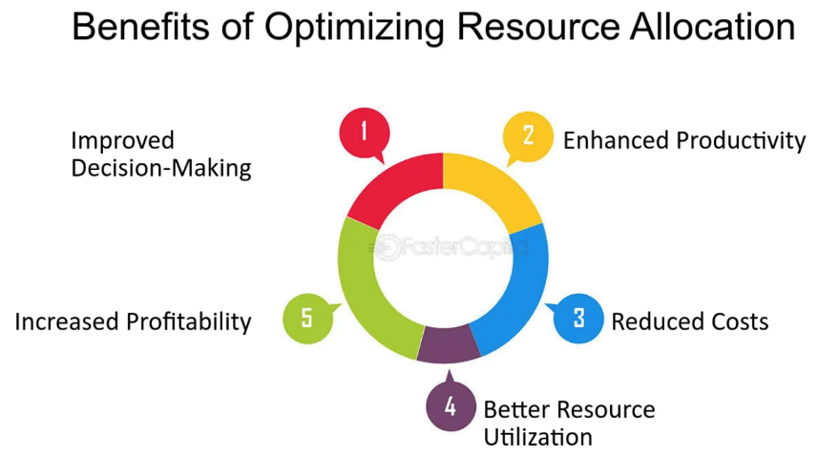
2. Optimized Resource Allocation - ML calculations play pivotal part in optimizing assignment of promoting assets. By dissecting chronicled information on execution of diverse promoting channels, these calculations help M&S distribute budget and endeavours more successfully. This data-driven approach guarantees that assets are coordinated towards channels that abdicate most elevated returns on venture, maximizing effect of M&S’s promoting tries (Chaffey & Smith, 2022).
(Source: fastercapital.com)
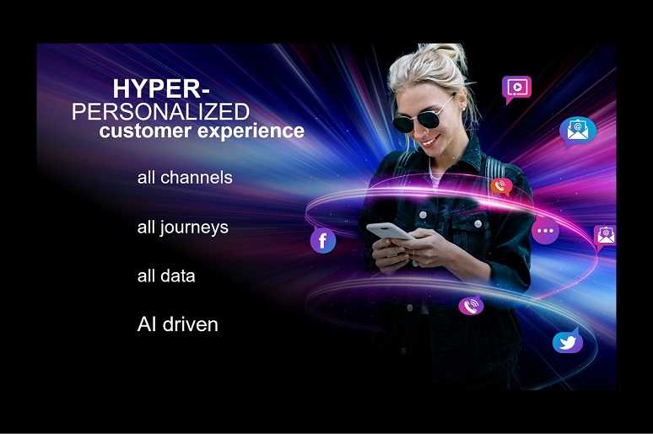
3. Hyper-personalized Customer Experiences - ML-driven personalization takes middle arrange in M&S’s computerized showcasing techniques. Through modern proposal motors, M&S gives clients with hyper-personalized item proposals. These motors examine not as it were past buying information but moreover real-time browsing conduct, guaranteeing that each customer’s travel is custom-made to their special inclinations (Case Middle., n.d.).
(Source: nojitter.com)

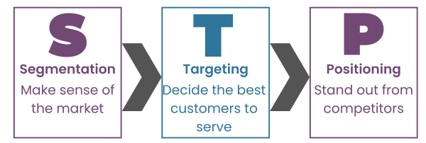
Customer Segmentation and Targeting: Precision through ML Algorithms
(source: blog.oxfordcollegeofmarketing.com)
- ML Algorithms for Segmentation - Marks & Spencer (M&S) has redefined customer segmentation through implementation of advanced Machine Learning (ML) algorithms. These algorithms, unlike traditional methods, go beyond basic demographic information. They analyse multifaceted data, including online behaviour, purchase history, and preferences, to create highly specific and dynamic customer segments (Ebrahim, 2020).
- Analysis of ML-driven Position - analysis of ML-driven customer position at M&S reveals level of precision unattainable through traditional methods. These algorithms continuously adapt to evolving customer behaviours, ensuring that position remain relevant over time. M&S gains not only snapshot of who their customers are but also in-depth understanding of how and why their preferences change, providing invaluable insights for targeted marketing strategies (Koay et al., 2020).
- Targeted Campaigns for Specific Customer Groups - Outfitted with bits of knowledge from ML-driven division, M&S tailors promoting campaigns for client bunches. Personalized substance, advancements, and item proposals are curated based on characteristics of each fragment. This customization upgrades pertinence of showcasing messages, cultivating more grounded associations between M&S and its differing client base (Zollo et al., 2020); (Choedon & Lee, 2020).

Marketing Intelligence and Forecasting: Unleashing Predictive Capabilities of ML
In ever-evolving scene of computerized showcasing, Marks & Spencer (M&S) has tackled control of Machine Learning (ML) to promote its promoting insights and determining capabilities. This area dives into significant part of ML in anticipating client conduct and campaign execution, advertising real-world cases that emphasize its transformative affect.

(source: analyticsvidhya.com)
1. Customer Behaviour Prediction - ML calculations at M&S are at cutting edge of foreseeing client conduct with unparalleled precision. By dissecting chronicled information, such as buy designs and online intelligent, these calculations make prescient models. These models expect future activities of person clients, empowering M&S to proactively tailor showcasing procedures to adjust with advancing client inclinations (Chaffey & Smith, 2022).
2. Campaign Performance Forecasting - ML’s ability expands to estimating campaign execution. M&S utilizes prescient analytics to survey potential victory of showcasing campaigns. By considering different components like authentic campaign information, client reactions, and showcase patterns, ML calculations give noteworthy experiences. This foreknowledge engages M&S to optimize campaigns some time recently dispatch, guaranteeing greatest affect and return on venture (ROI) (Chaffey & Smith, 2022).

ML’s Role in Predicting Customer Behaviour and Campaign Performance
1. Dynamic Customer Segmentation - One of foundations of M&S’s victory lies in ML-driven energetic client division. Conventional inactive division strategies drop brief in capturing smoothness of client inclinations. ML, on other hand, persistently adjusts to changing practices. It empowers M&S to not as it were anticipating how clients will carry on but too to alter division powerfully as practices advance (Pro, E., 2022).
2. Sentiment Analysis for Campaign Success - ML is instrumental in foreseeing campaign victory through opinion investigation. By combing through tremendous datasets from social media, client audits, and online intelligent, M&S utilizes ML calculations to gage client opinion. Positive assumption pointers are utilized to fine-tune showcasing campaigns, guaranteeing they adjust with winning opinions of target gathering of people (Choedon & Lee, 2020).

M&S and its increased Engagement
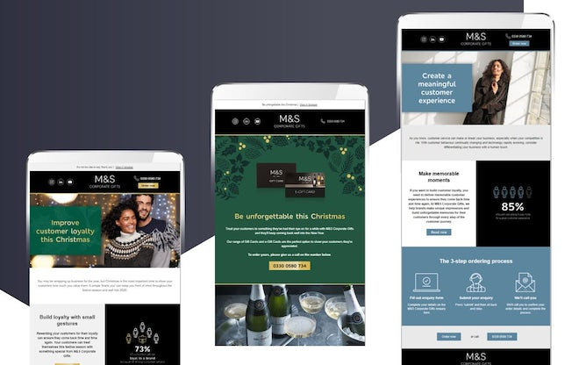
(Source: econsultancy.com)
Marks & Spencer worked hard to make sure their stores were all consistent and gave customers a good experience, so they could make more money. Understanding how important it is to be visible online and have accurate information, M&S worked together with Uberall. M&S used Uberall's Listings tool to make sure that their information was always up to date on different websites. This helped their local SEO and marketing for each location. M&S's ability to handle their online listings on different platforms like Google, Yelp, Waze, and Apple Maps has made it much easier for people to find them in the local area. The plan made it easier for customers to find M&S stores nearby and helped M&S improve their local online visibility and understand what customers like (MacRae, 2021). As a result, more people were looking at M&S pictures on Google, and more customers were interacting with the company. This shows that M&S is dedicated to using digital tools to make customers happier, improve their online presence, and make more money in a tough retail market.
Marks & Spencer (M&S) wants to increase their ROI by investing in digital technology, making their website better, and making sure all their 1,063 stores are the same. This method, along with ROS, is made easier by interacting better with customers, making sure lists are correct, and using data to improve online and in-store sales.

ROI and ROS
Marks & Spencer is making plans to improve ROI and how much they sell. They hope these plans will make their business do better financially. Using digital technology and making sure our stores are easily found online, we expect to ROI - maybe 15-20% more. This prediction is based on the belief that more people interacting with our company, using data to make better decisions, and having a smooth experience across all channels will make sales go up. At the same time, M&S aiming for a 10-15% increase in Return on Sales. M&S is focused on making sure their listings are correct, investing in online platforms, and using machine learning to give customers personalized experiences. This will help M&S make more sales and make it easier for customers to shop both online and in their stores. Although the percentages are not exact and may change, M&S's focus on using data and prioritizing customers will help improve the brand's financial success and competitiveness in the market.

Real-world Examples of Successful Predictions
1. Product Recommendations at Scale - M&S has effectively utilized ML to anticipate person client inclinations for item proposals. By dissecting buy history, browsing conduct, and relevant information, ML calculations create personalized suggestions. This procedure essentially boosts cross-selling and upselling openings, making win-win situation for clients and M&S alike (Marks & Spencer, 2022).
2. Optimized Email Campaigns - ML’s prescient capabilities sparkle in e-mail campaign optimization. M&S utilizes calculations that estimate probability of client engagement with mail substance. By fitting substance based on these expectations, M&S has experienced increased open rates and click-through rates, exhibiting unmistakable effect of ML in improving campaign viability (Chaffey & Smith, 2022).

Personalized Customer Experiences: ML-Driven Engagement and Satisfaction

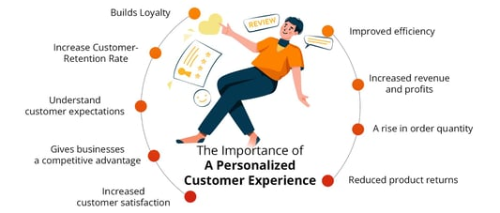

(Source: clootrack.com)
1. Behavioural Analysis for Personalization - ML calculations conduct perplexing behavioural investigation, interpreting designs in how clients explore online stages. This investigation educates M&S around person inclinations in terms of item categories, styles, and indeed favoured browsing times. By understanding these subtleties, M&S tailors its online interfacing to reverberate with each client (Choedon & Lee, 2020).
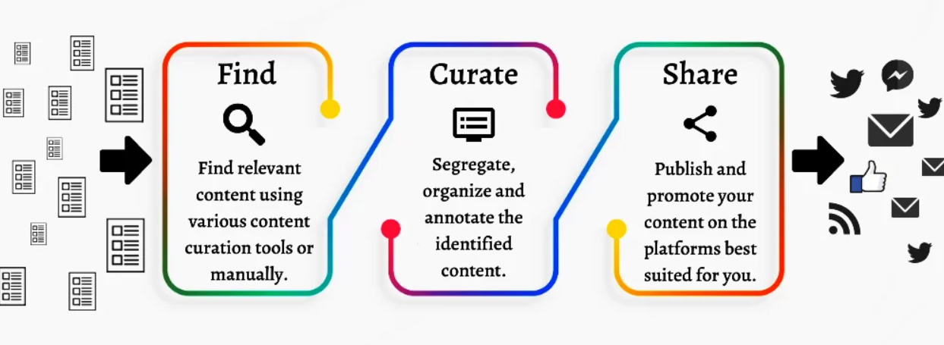
2. Predictive Personalization Engines - M&S utilizes prescient personalization motors driven by ML to expect client needs. These motors calculate in authentic information, relevant data, and real-time intuitive to anticipate what client may well be fascinated by. This proactive approach guarantees that personalized proposals and substance are displayed to clients some time recently they unequivocally express their inclinations (Marks & Spencer, 2022).
(Source: hitechnectar.com)
Impact on Customer Engagement and Satisfaction
1. Heightened Customer Engagement - ML-driven personalization has driven to increased client engagement for M&S. By conveying substance and proposals custom-made to person tastes, clients discover more prominent pertinence in their intelligent with M&S. This increased engagement deciphers into expanded time went through on stage, more visit visits, and more profound association between brand and its clients (Zollo et al., 2020).
2. Elevated Customer Satisfaction - Personalized encounters encouraged by ML contribute essentially to lifted client fulfilment levels. When clients feel caught on and catered to one person level, there by and large fulfilment with brand surges. This fulfilment is result of not as it were accepting important item suggestions but too encountering consistent and personalized client travel over different touchpoints (Zollo et al., 2020).

Conclusion
M&S’s triumph in advanced domain underscores vital significance of embracing all-encompassing showcasing technique. Interconnecting between advanced resources and machine learning rises as linchpin for victory. As we reflect on M&S’s accomplishments, it gets to be apparent that comprehensive computerized promoting approach not as it were guarantees brand flexibility but moreover impels organization into future where advancement and customer-centricity focalize. This calls for supported optimization and sharp eye on developing advances, clearing way for M&S to lead in ever-evolving computerized scene.

References
Francis, A. (2017). Case Study on Information Systems: Integrated Customer Ordering Service at Marks & Spencer. [online] MBA Knowledge Base. Available at: https://www.mbaknol.com/information-systems-management/case-study-on-information-systems-integrated-customer-ordering-service-at-marks-spencer/.
Marks & Spencer (2022). Marks & Spencer Experiments with AR to Launch its First Virtual Influencer. [online] Marks & Spencer. Available at: https://corporate.marksandspencer.com/media/press-releases/marks-spencer-experiments-ar-launch-its-first-virtual-influencer.
Marks & Spencer (2023). Food. [online] Marks & Spencer. Available at: https://corporate.marksandspencer.com/about-us/our-businesses/food.
Ja, S. (2023). Marks & Spencer sale | December 2023. [online] Check n’ Shop India. Available at: https://checknshop.in/advert/marks-spencer/ [Accessed 9 Dec. 2023].
Statista Infographics. (n.d.). Infographic: UK brands with the best and worst customer service. [online] Available at: https://www.statista.com/chart/19106/uk-brands-customer-service-which/.
Armstrong, M. (2021). Infographic: The UK’s favourite supermarkets. [online] Statista Infographics. Available at: https://www.statista.com/chart/17117/uk-favourite-supermarkets/.
Statista. (n.d.). Loyalty index top ten retailers UK 2015. [online] Available at: https://www.statista.com/statistics/643434/shopping-clothing-top-ten-retailers-loyalty-uk/.
News-Desk, A.R. (2023). Marks & Spencer taps AI and computer vision for enhanced store experience | Retail Tech News USA. [online] Apparel Resources. Available at: https://apparelresources.com/technology-news/retail-tech/marks-spencer-taps-ai-computer-vision-enhanced-store-experience/.
Pro, E. (n.d.). [2022] Marks & Spencer Marketing Segmentation Targeting Differentiation Positioning Solution. [online] embapro.com. Available at: https://embapro.com/frontpage/marketingstpcoanalysis/30057-marks---spencer.
Samuels, M. (2022). M&S focuses on personalization to deliver value to customers. Diginomica. [online] 17 Mar. Available at: https://diginomica.com/ms-focuses-personalization-deliver-value-customers.
Case Centre. (n.d.). Marks & Spencer’s Digital Marketing Strategy. [online] Available at: https://www.thecasecentre.org/products/view?id=171715.
next phase of M&S’ transformation Shaping FUTURE. (2022). Available at: https://corporate.marksandspencer.com/sites/marksandspencer/files/marks-spencer/investor/m-and-s-ar22-strategic-report.pdf.
Dumitriu, D., Militaru, G., Deselnicu, D.C., Niculescu, A. and Popescu, M.A.M., 2019. perspective over modern SMEs: Managing brand equity, growth and sustainability through digital marketing tools and techniques. Sustainability, 11(7), p.2111.
Ebrahim, R.S., 2020. role of trust in understanding impact of social media marketing on brand equity and brand loyalty. Journal of Relationship Marketing, 19(4), pp.287-308.
Choedon, T. and Lee, Y.C., 2020. effect of social media marketing activities on purchase intention with brand equity and social brand engagement: Empirical evidence from Korean cosmetic firms. Knowledge Management Research, 21(3), pp.141-160.
Koay, K.Y., Ong, D.L.T., Khoo, K.L. and Yeoh, H.J., 2020. Perceived social media marketing activities and consumer-based brand equity: Testing moderated mediation model. Asia Pacific journal of marketing and logistics, 33(1), pp.53-72.
Zollo, L., Filieri, R., Rialti, R. and Yoon, S., 2020. Unpacking relationship between social media marketing and brand equity: mediating role of consumers’ benefits and experience. Journal of Business research, 117, pp.256-267.
Algharabat, R., Rana, N.P., Alalwan, A.A., Baabdullah, A. and Gupta, A., 2020. Investigating antecedents of customer brand engagement and consumer-based brand equity in social media. Journal of Retailing and Consumer Services, 53, p.101767.
Chaffey, D. and Smith, P.R., 2022. Digital marketing excellence: planning, optimizing, and integrating online marketing. Taylor & Francis.
Hernāndez, M.R., Matamoros, K.L.V. and Huerta, E.M., (n.d.) Digital Marketing Plan for Market Manufacturers of San Martin Texmelucan Puebla.
Mahmutović, K., 2021. Development and validation of scale for measuring digital marketing orientation in hotel industry. EKONOMSKI VJESNIK/ECONVIEWS: REVIEW OF CONTEMPORARY BUSINESS, ENTREPRENEURSHIP AND ECONOMIC ISSUES, 34(1), pp.115-129.
Puertas, M., 2021. Digital marketing plan: case company: ProGrupper Oy.
Nagyová, B.S., 2020. Digital marketing plan for book using service-oriented marketing mix. Masaryk University.
Giovannoni, E., 2020. Digital Marketing Planning. Chasefive. com.
Yankovets, T.М. and Vyshnevska, M.О., 2020. Digital marketing: background, essence, management. Publishing House “Baltija Publishing”.
Bovsh, L., Rasulova, А. and Hopkalo, L., 2021. Digital marketing of hotel business entities. Publishing House “Baltija Publishing”.
Gebrmicheal, D., 2019. Digital marketing plan for project X.
Pyykkö, R.A.O., 2020. Digital Marketing Plan Steni Finland Oy.
Le, T., 2021. Digital marketing plan for mobile application: Case Memoa.
Black, C., 2020. Aligning Digital Marketing Strategy with Consumer Decision Journey: Applications for Small Business Start-Ups.
Rosario, A.M.F.T. and Cruz, R.N., 2019. Determinants of innovation in digital marketing. Journal of Reviews on Global Economics, 8(1), pp.1722-1731.
Vichit, U., 2020. Digital Marketing for E-Business with Perspective of Supply Chain Visibility.
Adi, N., 2022. Social Media Marketing Plan: Case Company INGO.
Bhoomika, G., 2023. Developing Digital Marketing Plan for Kajaani University of Applied Sciences Master School.
Kingsnorth, S., 2022. Digital marketing strategy: integrated approach to online marketing. Kogan Page Publishers.
Yousuf, F.A., 2019. Managing digital marketing communications: case study on City Bank Limited digital marketing team.
MacRae, D. (2021) How M&S achieved listings consistency with 1,063 stores, Marketing Tech News. Available at: https://www.marketingtechnews.net/news/2021/nov/18/how-ms-increased-engagement-and-achieved-listings-consistency-with-1063-stores/ (Accessed: 17 December 2023).
Schantin , D. (2021). Content strategy sweet spot needs to hit 4 key pillars. [online] IFMS Media. Available at: https://www.ifms-ltd.com/content-strategy-sweet-spot-hits-4-key-pillars/ [Accessed 18 Dec. 2023].
Ever, C.T., 2018. Strategic CRM Today. Customer Relationship Management: Concept, Strategy, and Tools, p.7
McGruer, D., 2020. Dynamic digital marketing: Master the world of online and social media marketing to grow your business. John Wiley & Sons.
Frow, J., 2022. Ubiquitous Surveillance and Data Selves. In Figure: Concept and Method (pp. 243-261). Singapore: Springer Nature Singapore.

