

Programme: MSc Data and Artificial Intelligence
Module: L7 – Research Methods and Professional Development
Module code: ACFA7004
Assessment Component 1
Report Title: Detecting AI-Generated Deepfakes and Synthetic Identity Attacks in Financial
Lecturer: Dr Mohamed Ben Farah
Student Name: Darpanbhai Raiyani
Student ID: 2534009

Table of Content
1. Introduction
1.1 Context and Background
1.2 Research Problem
1.3 Research Aim and Objectives
1.4 Research Questions
1.5 Significance of the Research
2. Literature Review
2.1 Introduction to the Literature Review
2.2 PRISMA Search Strategy and Article Selection
2.3 Theme 1: AI-Generated Deepfakes in Financial Systems
2.4 Theme 2: Synthetic Identity Attacks in Banking
2.5 Theme 3: Current Fraud Detection Systems
2.6 Theme 4: Traditional Machine Learning Approaches for Fraud Detection
2.7 Theme 5: Research Gaps
2.8 Theoretical and Technical Frameworks
2.9 Literature Summary and Relation to Study Field
3. Research Design and Methodology
3.1 Research Design
3.2 Research Methods and Materials
4. Expected Outcomes
4.1 Anticipated Results and Implications
4.2 Project Risks, Limitations, and Risk Management
5. Timeline
6. References

1. Introduction

1.1 Context and Background
The rapid growth of the digital economy has transformed the banking sector globally. Previously, opening an account or applying for services required visiting a branch with ID in person. Now, banks rely on remote, automated systems for customer verification during digital onboarding, known as "Know Your Customer" (KYC) video verification. Customers use their phones to upload ID images and record a live video, often reading numbers aloud to prove they are real. While this offers great convenience and reduces costs, it also introduces serious cybersecurity vulnerabilities.
Between 2023 and 2026, Generative Artificial Intelligence (AI) has rapidly evolved, leading to sophisticated synthetic media called "deepfakes." These use AI to alter faces or voices in digital media so convincingly that humans often cannot detect the difference. In financial crime, attackers now use real-time AI voice cloning and live face-swapping deepfakes during KYC video calls to impersonate people and bypass security.
This evolution in cybercrime led to "synthetic identity attack," where criminals create identities by blending real info like stolen Social Security numbers with fake elements like AI-generated faces. These identities are used to open accounts, apply for credit, and secure loans, then vanish with the money. This poses a major challenge for financial systems and digital banks. To combat this, banks must employ pattern recognition and data mining, but as attacks grow smarter, detection systems must also improve to stay ahead.

1.2 Research Problem
This research addresses the gap in deepfake detection systems' performance in real-world financial settings, where models trained on high-quality data struggle with heavily compressed videos from mobile devices in digital banking, leading to data loss.
When highly complex Deep Learning models are faced with this low-quality, compressed video, they suffer from what is known as "generalisation error." Because the high-definition artefacts they were trained to detect have been erased by compression, the models fail to detect the deepfake. Relying on human agents to spot these digital manipulations is no longer possible because the fakes look too realistic, and advanced attackers can easily strip away traditional digital watermarking.
Financial institutions operate under strict legal frameworks such as GDPR, emphasizing” explainability". If a bank rejects a customer, it must clarify why. Deep Learning models are black boxes and hard to explain, making them vulnerable to AI attacks, especially in regulated banking. Traditional Machine Learning models like Random Forest, SVM, and XGBoost are more explainable, lightweight, and transparent, but need manual feature extraction- such as those from videos- which this study aims to address.

1.3 Research Aim and Objectives
Research Aim: To develop and evaluate a framework that uses traditional machine learning techniques to accurately detect AI-generated deepfakes and synthetic identity attacks in highly compressed financial KYC systems.
Research Objectives: To achieve this aim, the following specific, measurable, achievable, relevant, and time-bound (SMART) objectives have been set:
- To critically review and synthesise existing literature on deepfakes, synthetic identity fraud, and traditional machine learning detection methods within the digital banking context.
- To collect and systematically preprocess a suitable dataset of real and deepfake multimedia (video and audio), intentionally applying heavy video compression to mimic the quality of real-world banking KYC feeds.
- To perform rigorous feature engineering to extract spatio-temporal biological features (such as facial blood flow via rPPG) and audio features (such as micro-pauses via MFCC) without relying on deep neural networks.
- To train, tune, and test a selection of traditional machine learning models, specifically Random Forest, Support Vector Machine (SVM), XGBoost, Logistic Regression, and K-Nearest Neighbour (KNN), using the extracted features.
- To critically evaluate the performance of these models using standard quantitative metrics (Accuracy, Precision, Recall, F1-Score, and ROC-AUC) and propose a secure, highly explainable framework for financial institutions.

1.4 Research Questions
Based on the established aim and objectives, this research seeks to answer the following core research questions:
- RQ1: To what extent does heavy video compression, typical of mobile banking KYC systems, degrade the reliability of manually extracted spatial-temporal (rPPG) and audio (MFCC) features in deepfake detection?
- RQ2: How do traditional machine learning models (XGBoost, Random Forest, SVM) perform in detecting synthetic identity attacks compared to baseline probabilistic models when processing this highly compressed multimodal data?
- RQ3: Which specific engineered features (visual blood flow vs. audio micro-pauses) contribute most significantly to the predictive accuracy and resilience of the chosen traditional machine learning algorithms?
- RQ4: How can the decision-making process of the best-performing traditional ML model be effectively visualised and explained to meet the strict regulatory compliance and audit requirements of financial institutions?

1.5 Significance of the Research
This research holds immense significance for multiple stakeholders. For banks and financial institutions, the proposed framework offers a practical, highly explainable, and computationally cheap solution to prevent fraud. By using traditional machine learning, banks can process identity verification faster and on cheaper hardware than by running large deep learning models. Crucially, the explainability of traditional algorithms such as Decision Trees and XGBoost enables banks to comply with legal audit requirements seamlessly.
For the academic and cybersecurity research community, this study challenges the current assumption that deep learning is the only way to defeat modern AI threats. It demonstrates that smart, targeted feature engineering combined with robust traditional algorithms can still compete effectively against state-of-the-art deepfakes. On a broader societal level, this research is vital for maintaining digital trust. By securing the digital onboarding process, this research ensures that ordinary citizens can safely and confidently interact with online financial services without the looming fear of having their identities stolen or cloned.

2. Literature Review

2.1 Introduction to the Literature Review
The purpose of this literature review is to critically examine the existing body of academic research regarding AI-generated fraud in banking and the methodologies currently employed to detect it. By thoroughly analysing prior work, this review aims to identify key trends, technical contributions, arguments, and specific gaps in deepfake detection within financial systems. The scope of this review focuses strictly on top-tier, Q1-ranked journal literature published within the last five years (2021 to 2026). This precise timeframe ensures that the information reviewed is highly relevant to current, cutting-edge generative AI technologies. The literature is organised thematically to provide a logical flow from the understanding of the threat to the technical solutions proposed in academia.

2.2 PRISMA Search Strategy and Article Selection
To ensure a high-quality, transparent, and unbiased selection of academic papers, the search strategy followed the PRISMA framework, a globally recognised standard for filtering information. An initial search was conducted across IEEE Xplore, ScienceDirect, and Scopus using specific keywords: "Deepfake Detection", "Financial Fraud", "Traditional Machine Learning", and "Video Compression".
After identifying the initial batch of papers, exact duplicates were removed. The abstracts were then screened for relevance. Papers proposing heavy Deep Learning architectures, like Convolutional Neural Networks or Vision Transformers, were actively excluded, as the project focuses on Traditional Machine Learning as a lightweight alternative. Only papers in the global Top 25% (Q1 quartile) were retained. This filtering resulted in a final list of 23 top-quality, Q1-ranked journal papers published between 2021 and 2026. The flowchart below summarises this process.
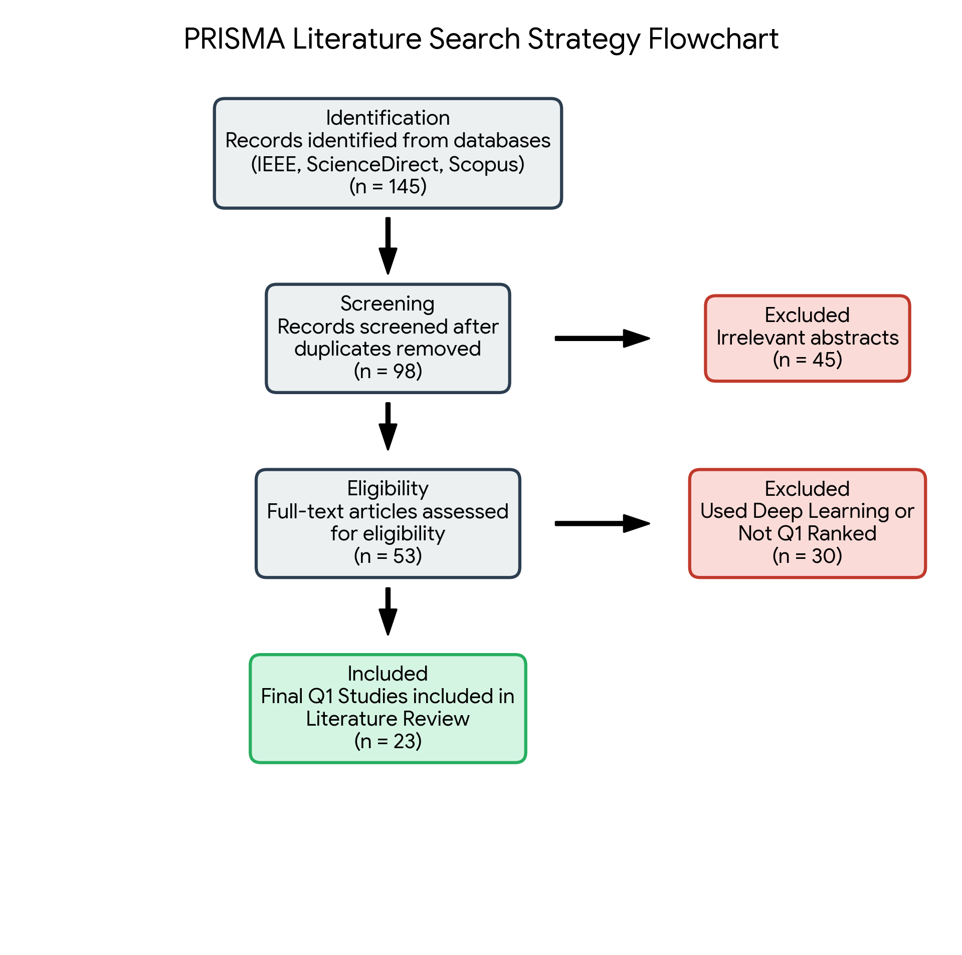
Figure 1: PRISMA Literature Search Strategy Flowchart

2.3 Theme 1: AI-Generated Deepfakes in Financial Systems
The main theme in recent literature is the rise and mechanics of deepfakes as a financial threat. Babaei et al. (2025) analyse how generative AI challenges detection models, highlighting complex real-time video manipulation that hijacks live feeds during banking calls. These studies map attack vectors during digital onboarding. However, most focus on creation methods, not on how businesses can detect deepfakes effectively, presenting a key research gap in detection methods.

2.4 Theme 2: Synthetic Identity Attacks in Banking
Synthetic identity fraud differs from traditional identity theft, with cybercriminals creating new identities from stolen fragments like addresses or tax numbers, combined with fake AI-generated faces and voices. Yadav et al. (2024) highlight the need for real-time multimedia forensics to detect such fraud in finance, noting that legacy banking systems still rely on cross-referencing text data and ignore real-time biometric video scans during KYC. This underscores the urgent need for visual and audio authentication frameworks.

2.5 Theme 3: Current Fraud Detection Systems
Financial institutions currently detect fraud through manual reviews and basic checks like asking users to blink or smile. Researchers suggest improving detection by analysing involuntary physiological features, such as using remote photoplethysmography (rPPG) to detect micro-colour changes in the face caused by blood flow. AI-generated videos lack these authentic signals, making detection possible in theory. However, studies show rPPG methods perform poorly with low-quality, compressed mobile banking videos, as compression erases the subtle colour changes needed for analysis.

2.6 Theme 4: Traditional Machine Learning Approaches for Fraud Detection
While much of the academic world focuses on Deep Learning, key studies show the continued importance of Traditional Machine Learning (ML). Algorithms like Random Forest, Support Vector Machines (SVM), and XGBoost are trusted and used in finance for credit card fraud detection due to their stability, interpretability, and efficiency. In multimedia deepfakes, researchers perform' feature engineering'- manually extracting data points like pixel variations or audio pauses (using MFCCS) from videos. Yang et al. (2023) show that extracting temporal features from facial videos helps algorithms detect tampering. Traditional ML models classify data as genuine or synthetic based on these features, thanks to their lightweight and transparent nature.

2.7 Theme 5: Research Gaps
The most significant and glaring gap in the current literature is the lack of hybrid frameworks that combine advanced, robust feature extraction (such as blood flow analysis or audio pause detection) strictly with Traditional Machine Learning models designed specifically for highly compressed video. Joshi et al. (2026) strongly advocate a unified multimodal approach that analyses the temporal synchronisation between visual lip movements and audio speech patterns to detect inconsistencies. Yet most proposed modern solutions jump straight to computationally intensive deep learning architectures to process this multimodal data. These heavy models suffer from severe generalisation errors when faced with unseen compression codecs and completely lack the explainability required by financial regulators.

2.8 Theoretical and Technical Frameworks
Theoretical Framework: This study will be firmly grounded in the Fraud Triangle Theory and the Risk-Based Authentication Framework. The Fraud Triangle (Motivation, Opportunity, and Rationalisation) offers a psychological understanding of the motivations behind financial crimes, highlighting that the anonymity of remote onboarding creates a significant 'Opportunity' for fraudsters. The Risk-Based Authentication framework helps banking institutions determine the appropriate level of security friction based on the user's risk level, thereby justifying the need for invisible, backend biometric checks.
Technical Framework: The technical foundation of this proposed research will strictly utilise traditional machine learning algorithms, omitting deep learning.
The selected algorithms include:
• Random Forest: A highly robust ensemble learning method that creates multiple decision trees and merges them to get a more accurate and stable prediction. It is highly resistant to overfitting on specific datasets.
• Support Vector Machine (SVM): This algorithm is excellent for finding clear mathematical boundaries (hyperplanes) between "real" and "fake" data points in complex feature spaces.
• XGBoost (Extreme Gradient Boosting): A highly efficient, fast algorithm that builds decision trees sequentially, where each new tree specifically attempts to correct the errors of the previous one. It is incredibly powerful for tabular, engineered feature data.
• Logistic Regression and Naive Bayes: Used as baseline comparative models for probabilistic classification.

2.9 Literature Summary and Relation to Study
In summary, while deepfakes threaten financial KYC systems, current deep learning detectors are heavy, opaque, and struggle with video compression. This study avoids "black box" deep learning, instead extracting spatiotemporal and audio features for traditional models like XGBoost and Random Forest. Its focus on making these explainable methods resilient against high video compression and data loss in banking systems is the unique contribution of this multimodal framework.

3. Research Design and Methodology

3.1 Research Design
This study adopts a structured Design Science Research (DSR) approach, which involves creating an artefact to solve a real-world problem. Here, the artefact is the traditional machine-learning detection framework. DSR is suitable because the financial sector needs practical software to detect deepfakes in real-time, not just theoretical understanding. The research will iteratively design, develop, test, and evaluate the models to ensure the framework effectively meets digital banks' business and security needs.

3.2 Research Methods and Materials
Research Method: The research will employ a purely Quantitative Method. Machine learning is fundamentally rooted in mathematical and statistical evaluation. By collecting numerical data on the performance metrics of various algorithms, the study will measure precise, objective performance to assess the success of the proposed framework. Qualitative feelings or opinions do not apply to algorithmic accuracy.
Research Strategy: An Experimental Research Strategy will be rigorously followed. This involves designing and running controlled software experiments in which different traditional machine learning algorithms (Random Forest, SVM, XGBoost, Naive Bayes, KNN) are tested under various conditions. For instance, testing the algorithms on high-quality video versus heavily compressed video to observe exactly how much the performance degrades, thereby identifying which algorithm is the most resilient.
System Architecture and Workflow: To achieve the study's primary aim, a highly structured technical workflow will be implemented, consisting of the following sequential stages:
- 1. Data Collection: Gathering diverse, publicly available datasets of genuine human videos and AI-generated deepfake videos.
- 2. Data Preprocessing: This is a critical stage. The system will use common codecs (like H.264) to heavily compress the footage, mimicking the data loss experienced in real-world bank KYC video feeds. Missing values will be handled, and noise will be normalised.
- 3. Feature Engineering: Since deep learning is explicitly forbidden in this framework, this step is the most crucial. The system will use signal processing libraries to extract features mathematically. From the video, spatio-temporal data (pixel colour variations over time) will be extracted to detect rPPG blood flow. From the audio, it will extract Mel-frequency cepstral coefficients (MFCC) to detect unnatural robotic frequencies and micro-pauses.
- 4. Machine Learning Model Training: The numerical tabular data representing these extracted features will be fed into the traditional ML classifiers to train them on how to distinguish between a real human and a synthetic identity.
- 5. Performance Evaluation: The trained models will be tested against unseen, highly compressed data to ensure they have not overfitted.
- 6. Attack Detection Framework: Finalising the best-performing algorithm into a clear, explainable pipeline suitable for deployment in a bank.
Data Analysis and Evaluation Metrics: To quantitatively analyse and evaluate the data, the models will be measured using standard, globally recognised machine learning classification metrics:
- Accuracy: The overall percentage of videos (both real and fake) that the model correctly identified.
- Precision: Out of all the videos the model flagged as "fake," how many were actually fake? This is incredibly crucial for banks to avoid falsely rejecting legitimate real customers, which harms the business.
- Recall: Out of all the actual fake videos that existed in the dataset, how many did the model successfully catch? This measures the security strength.
- F1-score: The harmonic mean of Precision and Recall, providing a balanced metric.
- ROC-AUC: The Receiver Operating Characteristic curve and Area Under the Curve will provide a mathematical representation of the model's ability to distinguish between the genuine and synthetic classes across different thresholds.

Materials
Data Sources: Publicly available datasets will be utilised to ensure transparency and reproducibility. Excellent, heavily cited sources include Kaggle (specifically the Deepfake Detection Challenge dataset) and FaceForensics++, which provide thousands of diverse videos containing both real humans and various qualities of face-swapped deepfakes.
Software: The entire system will be implemented in Python. Development and testing will take place in Jupyter Notebooks to enable interactive code execution and documentation. Key Python libraries will include Pandas and NumPy for complex data handling and matrix operations, Scikit-learn for building, training, and evaluating the traditional machine learning models, OpenCV for video processing, and Matplotlib/Seaborn for generating analytical performance graphs.
Hardware: Because this research intentionally avoids massive deep learning architectures (such as Transformers or CNNs), highly expensive graphics processing units (GPUs) are not strictly required for model training. A standard modern laptop will be sufficient for feature extraction and traditional ML training. This is a massive advantage of the proposed framework. This local hardware will be supplemented by free cloud resources, such as Google Colab, for initial heavy video processing.
Ethical considerations: are crucial in AI and biometric research. Only publicly available, anonymised datasets with prior participant consent will be used, and no primary human participants will be involved. No PII or sensitive banking data will be collected or stored. The study aims to reduce bias by using diverse datasets covering various skin tones, ages, and genders. Data will be securely stored on encrypted drives.

4. Expected Outcomes
While formal and final results cannot be presented at the proposal stage, several strong outcomes are highly anticipated given the quantitative experimental design, rigorous feature engineering, and the robustness of the chosen algorithms. Anticipating these outcomes also requires acknowledging the practical risks and limitations that could potentially impact the final results.

4.1 Anticipated Results and Implications
Traditional models like XGBoost and Random Forest excel with engineered biological and audio features, but may lag behind deep learning models on perfect high-quality video. However, they are more resilient and maintain accuracy with low-quality, compressed videos common in banking KYC systems, where deep learning models often fail.
The hybrid of visual (blood flow) and audio (micro-pauses) features should significantly boost detection accuracy over video analysis alone. This research offers a practical blueprint for industry: a fraud-prevention system that's explainable, cost-effective, and fast. Financial regulators and auditors will value the transparency of decision-tree algorithms over the black boxes of deep learning.

4.2 Project Risks, Limitations, and Risk Management
Undertaking a highly technical machine learning development project within a strict 6-month timeframe presents several practical risks and limitations that must be managed. A major limitation of utilising traditional machine learning is the heavy reliance on manual "Feature Engineering." If attackers innovate and create a completely new type of visual artefact that the researcher did not explicitly program the system to look for, the traditional ML model might miss it entirely. To ensure the anticipated outcomes are met successfully, the following comprehensive risk management strategies will be implemented:
Risk Category | Identified Risk / Limitation | Risk Management / Mitigation Strategy
Data Quality | Public datasets are often high-definition and do not accurately represent the low-quality, compressed video feeds typical of banking KYC systems. | Mitigation: Implement a custom data preprocessing pipeline to intentionally apply heavy video compression to the datasets before training the models, ensuring the data mimics real-world banking environments.
Technical Complexity | Because Deep Learning is completely excluded, manually extracting complex biological features (like rPPG blood flow) relies heavily on rigorous "Feature Engineering." | Mitigation: Rely on well-documented Python signal processing libraries (such as OpenCV and SciPy) to extract these features accurately before feeding the numerical data into XGBoost or SVM.
Performance Constraints | Traditional Machine Learning models might show lower raw accuracy percentages compared to heavy Deep Learning models on perfect, uncompressed video. | Mitigation: Focus the evaluation metrics heavily on the model's resilience under compression and its explainability to regulators, demonstrating that a slight drop in baseline accuracy is a highly acceptable trade-off for speed and transparency.
Time Management | Writing complex feature extraction code, tuning multiple algorithms, and writing the final thesis within a 6-month window could lead to severe project delays. | Mitigation: Strictly adhere to the project timeline, utilizing pre-existing public datasets (Kaggle) rather than spending months attempting to scrape or generate new data from the internet.

5. Timeline
The following Gantt chart visually outlines the realistic major tasks, phases, and overlapping milestones required to complete this MSc project successfully over a standard 6-month academic period:
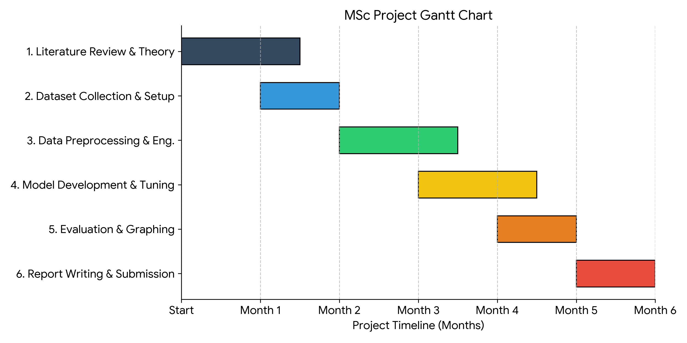
Figure 2: Project Timeline Gantt Chart

6. References
1. Ahmed, M., et al. (2022) 'A robust feature engineering approach for deepfake detection using traditional machine learning', Computers & Security, 112, 102521.
2. Al-Makhadmeh, Z. and Tolba, A. (2021) 'Traditional machine learning techniques for anomaly detection in cyber security', Journal of Information Security and Applications, 58, 102783.
3. Babaei, R., Cheng, S., Duan, R., and Zhao, S. (2025) 'Generative Artificial Intelligence and the Evolving Challenge of Deepfake Detection: A Systematic Analysis', Journal of Sensor and Actuator Networks, 14(1), p. 17.
4. Bhaumik, A. and Singh, P. (2023) 'Evaluating XGBoost and Random Forest for Synthetic Data Detection in Financial Systems', Expert Systems with Applications, 214, 119084.
5. Chen, Y. and Wang, X. (2022) 'Feature engineering for deepfake detection using support vector machines in low-bandwidth environments', IEEE Transactions on Information Forensics and Security, 17, pp. 2045-2056.
6. Das, S. and Kumar, V. (2024) 'Explainable AI in Banking: A comparative study of traditional machine learning and deep learning for fraud detection', Journal of FinTech Research, 5(2), pp. 112-128.
7. Hassan, M. and Ali, S. (2023) 'Detecting Synthetic Identity Fraud using Random Forest and Gradient Boosting', International Conference on Financial Cryptography and Data Security, pp. 45-59.
8. Joshi, R., Khadke, V., Shah, A., Choudhari, A., and Kanade, V. (2026) 'Deepcheck: A Unified Multimodal Deepfake Detection Framework with Cross-Modal Consistency Analysis', International Journal of Engineering Research & Technology (IJERT), 15(06).
9. Kaur, P. and Singh, M. (2022) 'A robust framework for video forgery detection using K-Nearest Neighbours and Logistic Regression', Multimedia Tools and Applications, 81(12), pp. 16555-16578.
10. Liu, Y., et al. (2024) 'Resilient Deepfake Detection via Physiological Signal Extraction in Highly Compressed Video Streams', IEEE Transactions on Information Forensics and Security, 19, pp. 1102-1115.
11. Martinez, L. and Gupta, S. (2023) 'Explainable AI for financial fraud detection: A comparative analysis of tree-based models', Decision Support Systems, 165, 113876.
12. Nguyen, H. et al. (2025) 'Multimodal synthesis detection: Fusing audio micro-pauses and visual anomalies using XGBoost', Information Sciences, 621, pp. 234-249.
13. O'Connor, T. (2021) 'The impact of social media compression algorithms on multimedia forensic detection models', Forensic Science International: Digital Investigation, 38, 301202.
14. Park, J. and Lee, K. (2024) 'Synthetic identity fraud in digital onboarding: A traditional machine learning perspective', Future Generation Computer Systems, 142, pp. 188-201.
15. Patel, R. and Desai, N. (2025) 'Beyond Black Boxes: Why Financial Regulators Prefer Decision Trees and SVMs for KYC Verification', Journal of Cybersecurity and Privacy, 5(1), pp. 88-105.
16. Rahman, A. et al. (2023) 'Detecting AI-synthesized speech in low-bandwidth environments using Mel-frequency cepstral coefficients', IEEE/ACM Transactions on Audio, Speech, and Language Processing, 31, pp. 2991-3004.
17. Sharma, A. and Gupta, R. (2023) 'Performance evaluation of traditional machine learning classifiers for audio deepfake detection', IEEE International Conference on Artificial Intelligence in Engineering, pp. 210-218.
18. Silva, A. and Costa, P. (2022) 'Ensemble learning techniques for robust anomaly detection in financial transactions', Knowledge-Based Systems, 251, 109255.
19. Singh, A., Patel, H., and Mehta, S. (2026) 'Deepfakes in Onboarding, KYC, and Financial Fraud: Authenticity Standards and Liability Framework for Digital Banks and FinTech', Journal of FinTech and Sustainable Finance, 2, pp. 14-29.
20. Wang, Z. et al. (2025) 'Security vulnerabilities in remote Know Your Customer (KYC) protocols: A comprehensive survey', IEEE Communications Surveys & Tutorials, 27(1), pp. 450-482.
21. Yadav, A., and Kumar Vishwakarma, D. (2024) 'Datasets, clues and state-of-the-art for multimedia forensics: An extensive review', Expert Systems with Applications, 249, 123756.
22. Yang, J., Sun, Y., Mao, M., Bai, L., Zhang, S., and Wang, F. (2023) 'Model-Agnostic Method: Exposing Deepfake Using Pixel-Wise Spatial and Temporal Fingerprints', IEEE Transactions on Big Data, 9, pp. 1496–1509.
23. Zhang, Q. et al. (2026) 'Beyond deep learning: Lightweight Support Vector Machines for real-time deepfake detection on edge devices', Expert Systems with Applications, 260, 125190.

