Internet Technology and Security – ACCA4018
Peter Evans 1810610

A solution to a potential real-life scenario
BYOD Design for Hyper-fort LTD

I declare that this report is the product of my own work and is not being submitted for any other degree etc.

Signed – Peter Evans

Abstract
Designing a secure BYOD solution for Hyper-Fort LTD a Global company with an estimated 95% of wireless devices. Report includes network structure recommendation, security concerns and policy ideas to overcome potential problems with BYOD.

Word count = 4001
Contents
1. Introduction 1
2. Framework 1
2.1. Responsibility. 1
3. BYOD – Cost vs Risk 1
4. What classes as BYOD 2
5. BYOD Users 2
5.1 Staff Members 2
5.2 Customers 3
5.3 Guests 3
5.4 Personal Vs Business Usage 3
6. Data Flow Diagram 4
7. Mobile Device Management 5
7.1. MDM – Which Product. 5
8. Network Structure 7
8.1 Core Tier 8
8.2 Distribution Tier 9
8.3 Access Tier 9
8.4 Router Configuration 9
8.5 Switch Configuration 9
8.6 Server’s Configuration 9
8.7 Guest Wireless Network 9
8.8 Remote Users 10
9. Network/Device Security 10
9.1. Hardware Security 10
9.2 Physical Network Security 11
9.3. Policy Security 11
9.4 Network Resilience 11
10. Packet Tracer 12
10.1 Structure 12
10.2 Limitations 12
11. Conclusion 13
12. References 14
13. Appendix 15
13.1 Packet Tracer Configuration 15
13.2 Switch Configuration (Click to Expand) 15
13.3 Router Configuration (Click to Expand) 15

Introduction

This report provides a solution for Hyper-fort LTD in relation to an adopting a new network to take advantage of ‘Bring Your Own Device’. This is required to keep up with an ever-expanding international customer base and to take advantage of new technologies to provide an easy to access and secure network for employees, customers and guests. The report recommends a Mobile Device Management software to overcome the security risks surrounding BYOD.

Framework
The framework forms the base of the BYOD policy, infrastructure and users. It creates the interconnection between the personal device and the corporate usage and defines who is responsible for what.

2.1. Responsibility.

The Device is the responsibility of the user. It will be their responsibility to keep the device in a good condition, up to date firmware, software and security.
The corporate data on the device is the intellectual property of the company in this case Hyper-Fort LTD. Hyper-Fort LTD retains the right to de-authenticate any user or device and remove access to the corporate or customer network at any time.
Both parties are responsible for the confidentiality, integrity and availability of the data. This conforms to the CIA Triad: –
“Data confidentiality entails the protection of sensitive information from unauthorized users. Data integrity encompasses changes to the data and the identification of the individual or system that changed it. Availability is whether or not the data can be accessed by users or systems when required.” [1]

BYOD – Cost vs Risk

A BYOD scheme offers many advantages to companies. Dell conducted a study and found that implementing a BYOD increased productivity by 74% [2].

Security is the biggest issue to overcome. The report by Waterfall and Dilworth [3] clearly highlights the risks but also offers solutions. Managing the security, there should be a set of minimum-security measures that devices should abide by such as OS firmware versions, Anti-Virus etc. There also must be policies that the users abide by such as acceptable use, compliancy and any laws relating to data protection and governance.
Device management software must at a minimum protect against Theft/Loss of device, protection from employee leaving, unauthorised access to data and the device. This will be covered in more detail below.
BYOD should be a necessity as benefits far out way the risks as long as appropriate measures are put in place along with a proper implementation. The positives such as equipment cost saving are evident but also allowing staff to work more flexibly will improve efficiency and has been shown to improve moral.
Developing a strategy for BYOD can be as simple as adhering to 5 steps according to Cohen [4].
Employees generally take better care of their own devices over that over company issued ones. They will also have a better knowledge of their own devices which they use everyday compared to something they are issues through work.

What classes as BYOD
Any personal device accompanied by an authorised user that requires access to corporate data of Hyper-Fort LTD. The device can be an IOS device, Android, Microsoft Windows or Linux.

BYOD Users
BYOD will be aimed at a Staff members and customers. A separate guest network will be available to customers or visitors who require internet access but don’t necessarily need access to Hyper-fort LTD corporate data.

5.1 Staff Members
Staff members are permitted to use their personal devices as long as the following criteria is met.
Sign an acceptable use policy, this will define what the user can and can’t do with their device.
Sign a Security Policy, before signing the policy a short presentation/talk will be required to advise the user of potential security risks. Loss of device, information on what happens to the device when the user leaves employment and threats including virus’, phishing etc.
IT staff will check the device for firmware version, anti-virus, security updates and install necessary software.
MDM or Mobile Device Management software will be installed on the device. More details on this below.
NAC tools (Network Access Control) will be used to allow devices to connect to the Corporate network, this can be in the form of Radius authentication. This allows role-based authentication and will give the user access to only areas or data they need. More information below in the section on MDM.

5.2 Customers
Customers of Hyper-Fort LTD are permitted to use their personal devices as long as the following criteria is met.
- The must be a customer of Hyper-Fort LTD with an agreed contract.
- Devices must be up to date and follow the same path as the Staff devices.
- Once the contract is over or customers leave their organisation access will be revoked.
- Same MDM software will be used, roles will be set on this and Radius server as to what access and privileges customer devices will have.

5.3 Guests
Guest of Hyper-Fort LTD are permitted to use the Guest Wireless network, there will be a terms and conditions captive portal which they will need to agree to before connection. The Guest network will have no access to Hyper-Fort LTD corporate data, it will have its own VLAN with isolation and only have access to the Internet. A Guest profile will be used to limit the bandwidth of the devices connected and a time-limit will be imposed. Once the time-limit has expired the user can re-connect as long as they re-agree to the terms and conditions. This is to prevent device

5.4 Personal Vs Business Usage
A limitation of BYOD is that users could be using their own devices in business time to check personal emails, social media and play games. This should be covered by an acceptable use policy which the employee should agree to. This wouldn’t be such an issue for customers.

Data Flow Diagram

The data flow diagram displaying BYOD network access.
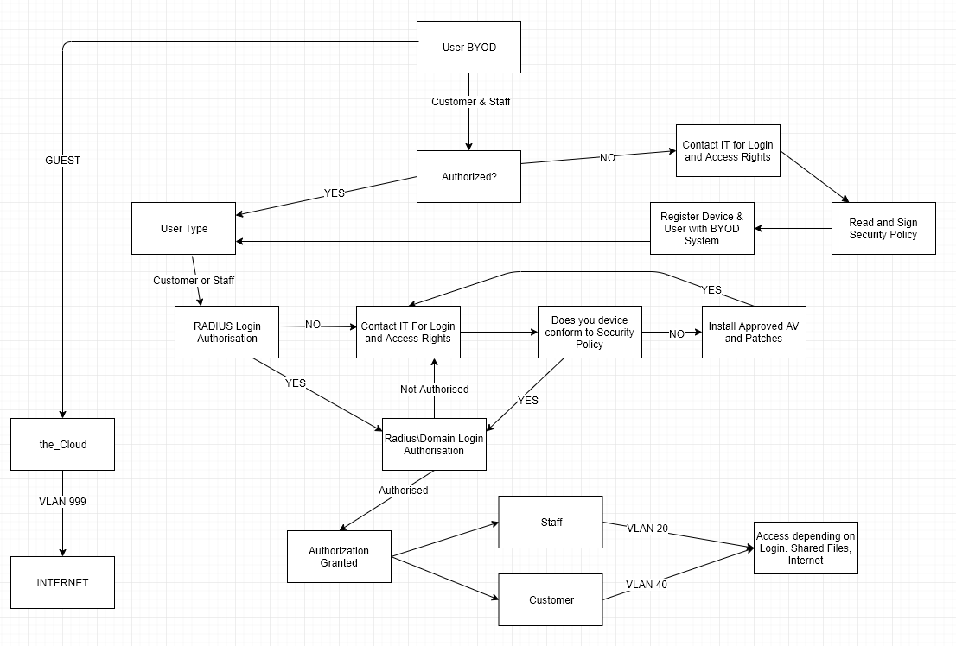
Figure 1 – Data flow diagram created with Draw.io

The data flow diagram above shows the procedure that a Staff member, Customer or Guest users will go through to authenticated onto the Hyper-fort Network. The Diagram assumes wireless connection but can also work for wired devices.
User brings a device to Hyper-fort LTD offices.
- If a guest arrives with a device, they are able to connect to the guest wireless network, which is isolated on VLAN 999 and has no connection to the corporate network, has basic internet access after agreeing to terms and conditions using a captive portal.
- Staff or Customers of Hyper-fort LTD are able to connect to the corporate wi-fi with their own device following the dataflow diagram above. They will need to conform to the following
  - Have a registered device on the BYOD management software
  - Sign and conform to security BYOD policy
  - Have a Radius (AAA) login linked to Hyper-Fort domain Active Directory
  - Agree to AV and patching policy

Mobile Device Management

To mitigate risks to the Hyper-Fort LTD network and its data a certain criterion has to be met before a device not belonging to Hyper-Fort LTD is connected to the corporate network. This section will advise on the Device Management Software, it will list what MDMs can offer their pros and cons and finally a short summary.

Device Management software offers a level of protection. If a staff member or customer wants to use their own device to access the company network or data then device management software will have to be installed on the device. The benefits of this software are as follows: -
- Mobile Device Security
- Mobile App Management
- Integration for Corporate applications such as Microsoft Exchange
- Secure Access to Company Data
- Remote Management and support
An article from Stephenson [5] emphasis that mobile device management software must be used to enforce security and ensuring compliance with the companies’ policies regarding data. The report mentions how to overcome data leaks but also managing policy restrictions and where to draw the line.

MDM – Which Product.

There are many different companies out there offering an MDM solution. Having a definitive list of requirements for Hyper-Fort LTD before approaching or researching each product will be the first task. The following requirements are what have been defined in the brief so far along with recommendations from the security consultancy firm providing this report.
- Remote management
- Remote wipe/format
- Passcode/password enforcement policy
- Remote install of applications
- Must support IOS, Android, MacOS and Windows
- Provide a solution to segregate personal and company data on the device
- Secure remote access to company data

Rather than compare each product in this report, financeonline.com have conducted their own research into the top 20 MDMs [6]. From the list this report will compare 2 products Cisco Meraki [7] and MobileIron [8].
Cisco Meraki lists the following features on their website: -
- Unified multi-platform device management. It will monitor all devices authorised with BYOD. From within the management console it will offer hardware, software information. The administrator can remotely lock and wipe/format any device.
- Security Enforcement. The administrator can create and enforce security policies onto devices, add restrictions to what the user can and can’t do from installing applications to the use of camera and microphone.
- System management. Remotely deploy settings to the device. Pre-configured Wireless access, security settings, VPN. This removes the repetitiveness of configuring each device manually, create one configuration and deploy to all devices.
- Data encryption. Cisco Meraki offers the option to encrypt the data on the device, offering security in case the device is lost or stolen.
- Cisco Meraki offers a cloud servers or on-site servers.
MobileIron lists the following features on their website: -
- Multiplatform support. Works with Android, IOS, macOS and Windows.
- Provides a secure workspace where the administrator can publish/push their own applications onto the device. The workspace separates the user’s private function of the BYOD device from the corporate side keeping information and data segregated. Also included encryption.
- Remotely wipe/format the device in case it is lost or stolen or if the user leaves Hyper-Fort LTD.
- Enforce Security Policies which can block untrusted applications from being installed, used or accessing services.
- Provides its own security software which detects threats and remotely alerts the MDM and administrators
- MobileIron provides its own cloud servers to use or an on-site option.
- Adaptive Authentication, uses role-based authentication to give the user access to what they require, i.e. Staff connect to the Staff SSID and the Customers to their own SSID, also uses permissions to give access to particular files and folders.
- No data is stored on the device, everything is accessed through the Workspace Cloud app, remote access can be given using VPN.

Both products meet the requirements set by Hyper-Fort LTD. Interestingly both products have the option of a cloud-based system which requires no hardware on site. Due the size of the Hyper-Fort LTD and that it is a global company a Cloud based solution would be ideal. A benefit of MobileIron is that it offers a secure workspace, the workspace keeps the users personal data separate from the companies. It also offers encryption of the workspace but more importantly offers a way to access the company’s documents, emails, intranet and apps securely.


Figure 2 – Image of Mobile iron apps

All MDMs listed in the article from financeonline.com [6] provide a way to remotely wipe the device of all company data. This will be required when a device is lost or stolen or if an employee no longer works at Hyper-Fort LTD or if a customer no longer should have access. Cisco Meraki and MobileIron also support policy enforcement which can be pre-configured to set password/passcode strength and whitelisting and blacklist applications. It also offers pre-configured wireless access using wpa2 enterprise either requiring certificate-based authentication or Radius authentication. With this depending if it’s a staff member or customer it will give the user the appropriate permissions they require. Another benefit of it being preconfigured is that permission can also be just as easily removed, no need to change WPA2 passcodes etc.

Network Structure

This section will be referring to the Packet Tracer file “Peter Evans 1810610” which will be attached as an Appendix.
The recommendation for the network hierarchy is to use a 3-tier design. The 3-tier design follows the concept of a separate Core, Distribution and Access layers which the image below demonstrates.
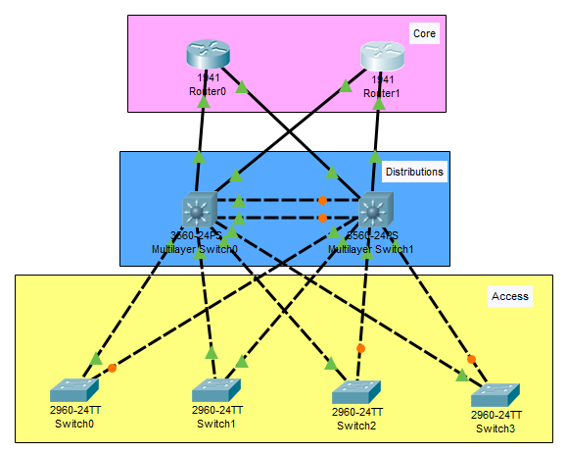
Figure 3 – Network hierarchy – Image created in packet tracer 7.2

This 3-tier architecture is the most scalable and resilient solution. It’s clear and simple design that makes it easy to manage and expand upon in future. [9]
The principle of the design is to provide resilience and performance. A single or in some case a dual cabling failure will not results in network failure. The same can also be said about a single device failure. For example, if a core router fails or a distribution switch fails the network will re-calculate its path. Not shown in the image above are the wireless access points, servers and firewalls which are included in the packet tracer file.

8.1 Core Tier
The core tier will contain the core infrastructure equipment for the business. In this case it will contain the ISP routers, Firewalls, Internal Layer 3 Routers and Distribution Switches. For demonstration referring to Packet Tracer Appendix 1. Core devices are displayed in the Blue box area. In reality an Internet connection (ISP Router), firewall and core layer 3 router will be located in one area of the building and the second Internet link (ISP Router), firewall and core layer 3 router will be located in a separate part of the building. This will provide resilience. This setup also allows for equipment to be removed from the network, upgraded, replaced or to have security patches applied without causing disruption to users.

8.2 Distribution Tier
The second tier to the design is the distribution layer. This will house the distribution switches. All network traffic will transverse this layer. It will have a similar setup to the above where as there would be 2 devices located in separate areas both with links to each and the routers in the core tier. This provides redundancy in case a device or link were to fail.

8.3 Access Tier
This is made up of the access or edge switches and wireless access points. This will be what the users connect to. As the brief describes 95% wireless access there will be many access points covering all the areas within the sites.

8.4 Router Configuration
The Core tier router will be configured with VRRP – Virtual Router Redundancy Protocol. VRRP is an IEEE standard compared to HSRP (Hot Standby Router Protocol). It will allow 2 physical routers to be present each containing their own dedicated Ips but joined with a virtual IP. All devices will point at the virtual IP. What this means is if a router was to fail the other router would continue to forward packets with little to no disruption to the users.

8.5 Switch Configuration
The Distribution switches will be configured with separate VLANs to segregate networks. Device management will be on VLAN 10 (network devices, servers etc) Staff will be on VLAN 20, Customers on VLAN 40, Voice traffic will be on VLAN 80 and finally Guest access on VLAN 999. Each VLAN is assigned a different IP pool from DHCP.

8.6 Server’s Configuration
The packet tracer file only displays 2 servers. In reality there may be many more, they may take the form of physical servers with virtual OS or they could be cloud based. For the purposes of this report I created 2 servers, each linked to 2 switches for resilience. Each server supports a number of different services: -
- DHCP – For IP address allocation
- DNS – For name resolution of local devices
- AAA – Radius login control for Wireless and other devices
- NTP – Time server to synchronize time across network devices
- Syslog – Logging information from the network devices for security
- Web Server – HTTPS web server hosting Hyper-Fort LTD intranet, internet and any other portals
- Email – email server with user/pass to login
- FTP or Database Server – Containing files, folders, data.
There servers would also be backed up both locally and remotely.

8.7 Guest Wireless Network
The guest wireless network would ideally be provided by a service such as Sky’s the_cloud. This will have its own separate VLAN, router and ISP connection. This is demonstrated on the attached packet tracer file.

8.8 Remote Users
Remote users will be allowed to connect to Hyper-Fort LTD network by the use of a Virtual Private Network. The user will only be able to connect via VPN if the device is enrolled in the MDM software and that they have a Radius or active directory login. The MDM will controller the access to the data. The VPN creates a secure connection to the Hyper-Fort LTD network even if they are connected to an insecure wireless network. This creates a secure working environment for the user to access the data.

Network/Device Security

Hardware Security

All the devices in the core, distribution and access layers will confine to a standard security policy. Each network device will be at a minimum configured with the following.
Enable secret
Service password-encryption – encrypts the passwords so they are stored in plain text on the device.
Line con 0 – requires password when connecting to the device with a console cable.
Password 7 cisco
Logging to syslog server
Line vty 0 – 15 – requires a password when connecting to the device using telnet, ssh and other vty lines.
Password 7 cisco
Logging to syslog server
Banner motd – creates a banner at login to inform unauthorised users that they aren’t allowed to access the device and their details have been logged with syslog server.
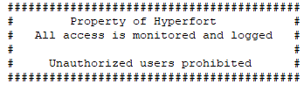
IP ssh time-out (time) – creates a time out when connecting with SSH to prevent administrators leaving their session open indefinitely.
Shutting down unused ports – prevents unauthorised users connecting a device to a switch port.
Ntp server – time synchronisation, mainly for accurate log files across all devices.
Access points will be configured with WPA2 enterprise and will require a Radius login to authenticate. The radius login will be linked with active directory and MDM which will give the user the correct access and permissions. The reason to use WPA2 over WEP or WPA is that WPA2 support AES encryption which is currently a lot harder to brute force [10]. WEP can be cracked in minutes.

9.2 Physical Network Security
As demonstrated in the packet tracer file, most of the core network devices will be located in a sperate room to where the staff and customers have access to. In practise the core network will be split up into 2 locations, Core Room 1 and Core Room 2. Each of these rooms will host an ISP router with an external connection, Firewall, Internal router, Distribution/Core switch and a server. In packet tracer it displays all the devices in one room or area for ease of viewing and configuration.
The rooms will be kept behind a double locked door, in this case a key lock along with a RFID lock. This adds physical security to the rooms but also timed stamped access logs of who accessed the rooms. Outside and inside the room will have CCTV cameras which will be recorded offsite to a cloud solution. The reason for offsite cloud solution is that secure access can be given to third parties if needed such as the police. This prevents administrators having to give access to Hyper-Fort LTD network access un-necessarily. Various IoT devices will be used for environmental monitoring such as temperature, smoke, water and motion. These will be linked to a central station on a separated VLAN and provide alerts to IT staff.

Policy Security
Policy Security will be the set of rules to refer to and agree upon when devices or users request connection to the network. The policy will include but not limited to, Device, User, Security, Acceptable Use, Misuse Policy’s etc. They will also cover what happens if a device is lost or stolen and if the employ leaves the company.

9.4 Network Resilience
Network resilience is the process of providing and maintaining a maximum level of service to users even if faults develop.
The packet tracer demonstrates that network resilience is accomplished in the following ways.
- Each core room will have a UPS supplied from different distribution boards. This provides each core room independently supplied electricity in case an issue arises in one room the other will continue to function.
- Having 2 core rooms, i.e. each room duplicated means that if a router or ISP connection develops a fault it won’t have a major effect on the company. It also provides a manageable system for upgrades, swapping out routers, switches or APs and will only cause minor disruption as the devices re-negotiate a new path through the network.
- Backups will be required of the servers and network device configuration which must be stored locally and remotely.

Packet Tracer

The attached packet tracer file Peter Evans 1810610.pkt was created in version 7.2 of packet tracer.
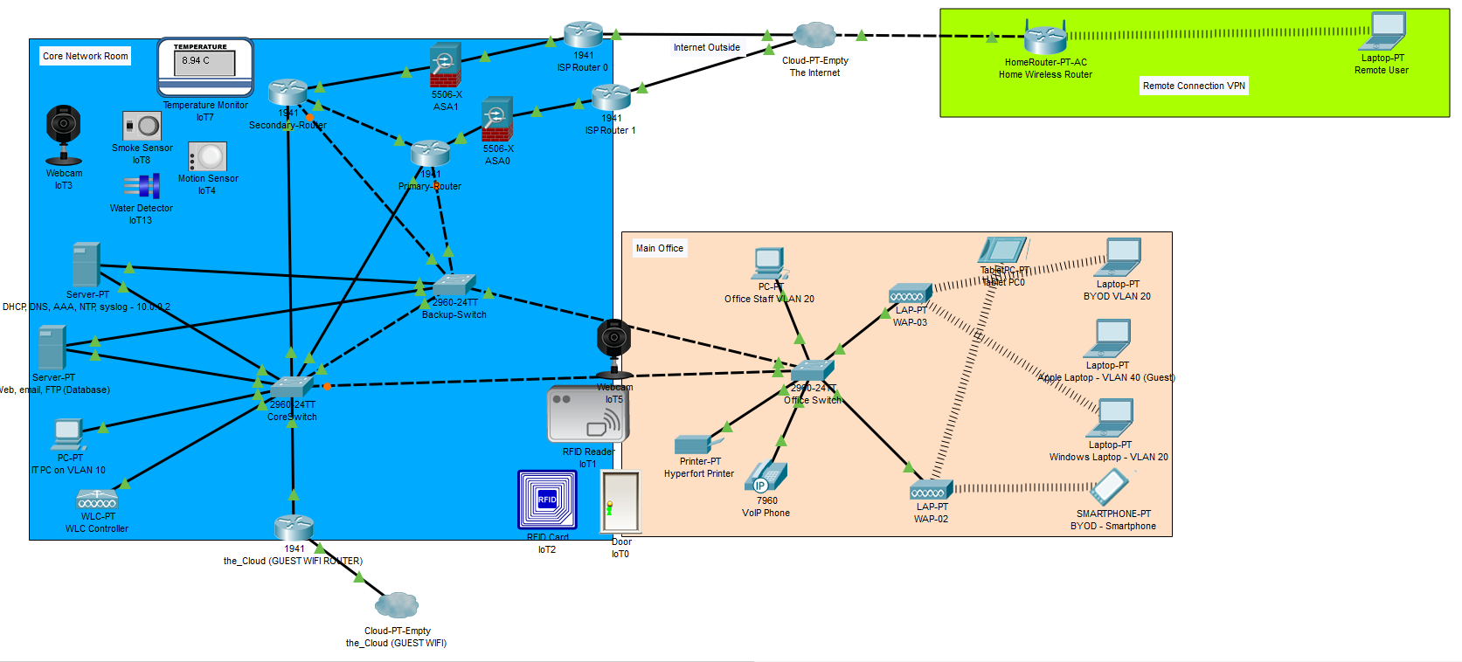
Figure 4 – Packet Tracer Network
Passwords
Routers and Switches
User exec mode – cisco
Privilege exec mode – class

10.1 Structure
Core Rooms – I only demonstrated 1 core network room on the packet tracer network, in reality there would be 2 physical rooms in opposite side of the building or 2 separate sites.
Wireless APs – the packet tracer file only demonstrates 2 Wireless APs, in reality there will be many more depending on the size of the building and number of sites.
Access Switches – as above, depending on size or building and sites there can be any number of access switches. Only 1 is displayed in the packet tracer file.

10.2 Limitations
- WLC Controller – There is an issue with the WLC. Currently it is setup on VLAN 10 (Management VLAN), the APs are also on VLAN 10. When a User connects wireless they are given a DHCP address from VLAN 10 (Management VLAN).
What it should be is – WLC on a trunk port but management interface on VLAN 10 (Management VLAN) , the APs also on VLAN 10. The SSID is broadcasting “Hyperfort” which should be tagged with VLAN 20 & VLAN 40 for Staff and Authorised Customers. When the Devices connect, they login with Radius details and depending on login they should get an IP from VLAN 20 - DHCP pool OfficePool for Staff or VLAN 40 – DHCP Cusotmerpool for Customers. However, I couldn’t get this to work in Packet Tracer.

Also, with the Guest SSID the_CLOUD which should be tagged on VLAN 999, devices should be getting an IP from the the_CLOUD pool. However, I wasn’t able to get this to work therefore devices are getting an IP from VLAN 10 (management)

- Configuring the Cisco ASA Firewalls – I was unable to set a password on the devices or set password encryption. No configuration was created for example Access Control Lists or port/service white/black listing.
- IOT devices not configured. I thought this was outside of the scope of the assignment.

Conclusion
This report has highlighted the benefits of BYOD for both cost savings and productivity. It covers the risks and challenges that administrators face when implementing a BYOD scheme into a company and how best to manage the devices. The report centres around Mobile Device Management and the necessity of it when managing data on personal devices. The MDM package would manage data leakage on the device along with a VPN creating a secure remote connection. The last section of the report demonstrates a network layout using packet tracer. The packet tracer network is configured for security and resilience. It also shows how a company with a 95% wireless device inventory would function using radius authentication linked to active directory giving users access to what they need but restricting access to what they shouldn’t need.
A BYOD scheme at a minimum requires an MDM solution, robust policies and the physical infrastructure to support the scheme. If anyone of these requirements fails to meet the needs then the solution will fail.

References

[1] M. Meikle, “BYOD Security: Expert Tips on Policy, Mitigating Risks, &amp; Preventing a Breach |,” Digital Guardian, 2018. [Online]. Available: https://digitalguardian.com/blog/byod-security-expert-tips-policy-mitigating-risks-preventing-breach. [Accessed: 08-Jan-2019].
[2] S. Marshall, Technology innovation management review., vol. 4, no. March 2014: Emerging Technologies. Talent First Network, 2014.
[3] M. Waterfill and C. Dilworth, “BYOD : Where the Employee and Enterprise Intersect,” Employee Relat. Law J., vol. 40, no. 2, pp. 26–37, 2014.
[4] M. Cohen, “5 Steps for Developing a Successful BYOD Environment - ECC IT Solutions LLC - Rockville MD,” eccitsolutions.com. [Online]. Available: https://eccitsolutions.com/5-steps-for-developing-a-successful-byod-environment/. [Accessed: 03-Jan-2019].
[5] P. Stephenson, “Mobile device management,” New York, 2014.
[6] fianaceonline, “20 Best Mobile Device Management Software in 2019 - Financesonline.com,” financeonline, 2018. [Online]. Available: https://financesonline.com/mobile-device-management/. [Accessed: 06-Jan-2019].
[7] Cisco, “Cisco Meraki | Mobile device management.” [Online]. Available: https://meraki.cisco.com/solutions/mobile-device-management. [Accessed: 06-Jan-2019].
[8] MobileIron, “Platform | MobileIron.com.” [Online]. Available: https://www.mobileiron.com/en/unified-endpoint-management/platform. [Accessed: 06-Jan-2019].
[9] ICTShore, “Cisco Three Tier Architecture Explained - ICTShore.com.” [Online]. Available: https://www.ictshore.com/free-ccna-course/three-tier-architecture/. [Accessed: 12-Dec-2018].
[10] P. Mah, “8 Tips to protect your business’s wireless network,” PC World Online, pp. 48–51, 2014.

Appendix

13.1 Packet Tracer Configuration
File Uploaded to other section on moodle named Peter Evans 1810610.pkt

13.2 Switch Configuration (Click to Expand)
Building configuration...

Current configuration : 2826 bytes
!
version 12.2
no service timestamps log datetime msec
no service timestamps debug datetime msec
service password-encryption
!
hostname Core-Switch
!
enable secret 5 $1$mERr$9cTjUIEqNGurQiFU.ZeCi1
!
!
!
ip ssh version 2
ip ssh time-out 10
!
!
spanning-tree mode rapid-pvst
spanning-tree extend system-id
!
interface FastEthernet0/1
switchport access vlan 10
switchport mode trunk
!
interface FastEthernet0/2
switchport access vlan 999
!
interface FastEthernet0/3
switchport access vlan 10
!
interface FastEthernet0/4
switchport access vlan 10
shutdown
!
interface FastEthernet0/5
switchport access vlan 10
switchport mode access
!
interface FastEthernet0/6
switchport access vlan 10
switchport mode access
shutdown
!
interface FastEthernet0/7
switchport access vlan 10
shutdown
!
interface FastEthernet0/8
switchport access vlan 10
shutdown
!
interface FastEthernet0/9
switchport access vlan 10
shutdown
!
interface FastEthernet0/10
switchport access vlan 10
shutdown
!
interface FastEthernet0/11
switchport access vlan 10
shutdown
!
interface FastEthernet0/12
switchport access vlan 10
shutdown
!
interface FastEthernet0/13
switchport access vlan 10
shutdown
!
interface FastEthernet0/14
switchport access vlan 10
shutdown
!
interface FastEthernet0/15
switchport access vlan 10
shutdown
!
interface FastEthernet0/16
switchport access vlan 10
shutdown
!
interface FastEthernet0/17
switchport access vlan 10
shutdown
!
interface FastEthernet0/18
switchport access vlan 10
shutdown
!
interface FastEthernet0/19
switchport access vlan 10
shutdown
!
interface FastEthernet0/20
switchport access vlan 10
shutdown
!
interface FastEthernet0/21
switchport access vlan 20
shutdown
!
interface FastEthernet0/22
description Link to WLC Controller
switchport access vlan 10
switchport mode access
!
interface FastEthernet0/23
description Uplink to BackupSwitch
switchport mode trunk
!
interface FastEthernet0/24
switchport access vlan 10
switchport mode access
!
interface GigabitEthernet0/1
switchport mode trunk
!
interface GigabitEthernet0/2
description Uplink to Office Switch
switchport mode trunk
!
interface Vlan1
no ip address
shutdown
!
interface Vlan10
mac-address 00d0.58a8.7b01
ip address 10.0.0.3 255.255.255.0
!
interface Vlan20
mac-address 00d0.58a8.7b02
no ip address
!
banner motd ^C
##########################################
# Property of Hyperfort #
# All access is monitored and logged #
# #
# Unauthorized users prohibited #
##########################################
^C
logging trap debugging
logging 10.0.0.2
!
!
!
line con 0
password 7 0822455D0A16
login
!
line vty 0 4
password 7 0822455D0A16
login
line vty 5 15
password 7 0822455D0A16
login
!
!
!
ntp server 10.0.0.2
!
end

13.3 Router Configuration (Click to Expand)

Building configuration...

Current configuration : 1998 bytes
!
version 15.1
no service timestamps log datetime msec
no service timestamps debug datetime msec
service password-encryption
!
hostname Core-Router
!
!
!
enable secret 5 $1$mERr$9cTjUIEqNGurQiFU.ZeCi1
!
!
!
!
!
!
ip cef
no ipv6 cef
!
!
!
username administrator
!
!
license udi pid CISCO1941/K9 sn FTX1524F881-
!
!
!
!
!
!
!
!
!
ip ssh version 2
ip ssh time-out 10
!
!
spanning-tree mode pvst
!
!
!
!
!
!
interface GigabitEthernet0/0
no ip address
duplex auto
speed auto
!
interface GigabitEthernet0/0.10
encapsulation dot1Q 10
ip address 10.0.0.1 255.255.255.0
ip helper-address 10.0.0.2
!
interface GigabitEthernet0/0.20
encapsulation dot1Q 20
ip address 10.100.0.1 255.255.255.0
ip helper-address 10.0.0.2
!
interface GigabitEthernet0/0.40
encapsulation dot1Q 40
ip address 10.200.0.1 255.255.255.0
ip helper-address 10.0.0.2
!
interface GigabitEthernet0/0.80
encapsulation dot1Q 80
no ip address
ip helper-address 10.0.0.2
!
interface GigabitEthernet0/1
no ip address
duplex auto
speed auto
!
interface FastEthernet0/1/0
switchport mode access
switchport nonegotiate
!
interface FastEthernet0/1/1
switchport mode access
switchport nonegotiate
!
interface FastEthernet0/1/2
switchport mode access
switchport nonegotiate
!
interface FastEthernet0/1/3
switchport mode access
switchport nonegotiate
!
interface Vlan1
no ip address
shutdown
!
ip classless
!
ip flow-export version 9
!
!
!
banner motd ^C
##########################################
# Property of Hyperfort #
# All access is monitored and logged #
# #
# Unauthorized users prohibited #
##########################################
^C
!
!
!
!
!
logging 10.0.0.2
line con 0
password 7 0822455D0A16
login
!
line aux 0
password 7 0822455D0A16
login
!
line vty 0 4
password 7 0822455D0A16
login
line vty 5 15
password 7 0822455D0A16
login
!
!
ntp authentication-key 1 md5 0822455D0A16 7
ntp server 10.0.0.2
ntp update-calendar
!
end

