10/03/2018

[Web Development]
[Programming 1]
Liam Salter (1702256)
Table Of Contents:

- Part A (Understanding)……………………………………………….… 2.
  - What is a variable and why are they important in writing programs?......................……………………………………….2.
  - Explain why the for-loop can also be referred to as a counting-loop and give an example of why you would use it……….2.
  - Explain how arguments in functions can be used… 3.
  - Describe the purpose of a class in Object Oriented
Programming ……………………………………………………….3.
- Part B (interpretation) …….……………………………………………. 4.
  - Explanation of code implementation…………………….4.
  - Bug identification………………………………………………... 5.
- Part C (Implementation)……………………………………..…………. 6.
- Appendix……………………………………………………………………….. 17.
- References…………………………………………………………………….. 35.

- Part A (Understanding).
  - What is a variable and why are they important in writing programs?
A variable within programming is a named location of storage in memory, that a user can input and store data into. A variable can hold many types of data, such int (integers), string (strings of characters), bool (Booleans), double (numbers with decimal points), char (a single character) and void (a valueless special purpose type, commonly used in functions) [1].
Variables have 5 distinct features, the first one being that a variable has a value identifier, which is a name given to the variable to identify what’s being stored within the variable. Another feature being a variable has a Memory Address, which points to its stored location in memory. Yet another feature is that a variable has a data type, which identifies the type of data stored in the variable. From the data type, the legal operations and its memory size are defined. The legal operations are the operations the variable must and can only perform, and the memory size identifies the amount of space it takes up in memory.
Programmers would need variables to store data in due to many operations can be performed with the data. Operations such comparing the data stored in a variable with other data, displaying the data stored in a variable either for testing or another purpose, calculation using other data and storing the calculation in another variable etc.

  - Explain why the for-loop can also be referred to as a counting-loop and give an example of why you would use it.
The ‘for-loop’ can be referred to as a counting-loop as a result of the loop ‘counts’ until a certain limit or condition is reached. A counter variable is set at the beginning of the program (typically an integer) and is set within the for-loop alongside a maximum limit, the for-loop will continue to increment through each cycle until the loop reaches the limit set within its conditions.
Programmers would use the ‘counting-loop’ due to it carrying a very useful attribute, being there is a set limit to the amount of times the loop can cycle through itself due to the limit. This is very useful to programmers who know the specific amount of times they’d want to cycle through the loop. Compared to a ‘while-loop’ where it would continue to cycle through the loop until a certain condition is met.
An example of a ‘counting-loop’ would be a guessing game. The programmer would allow the user five guesses (by setting the limit of the loop to 5) to guess the correct answer, and if the user has failed to guess the answer within 5 guesses (loop cycles), the loop would close display a “you failed” message for instance.

  - Explain how arguments in functions can be used.
Arguments within functions hold a very useful purpose within functions, which allows functions to do more operations. Arguments within functions are useful for passing data from one location in the program outside the function, into the function itself. As a function acts a “clean slate” [Mike Dacey] of sorts, when data is needed from outside the function, arguments are then used to retrieve that data and pass it into the function.
An example of argument declaration would look like this : int MakeFinalScore(int score)
Arguments work by a few passing methods. One method would be that arguments can be passed into a function by value, where the data from the original variable is copied into a new variable created inside the function, and the original value is not changed (referring to the “clean slate” statement), the only time the original value is changed is when the variable inside the function is returned from the function. The other method is also arguments can be passed in via reference, meaning the value from the variable passed in can be modified and changed directly from the function.

  - Describe the purpose of a class in Object Oriented Programming.
Classes in Object Oriented Programming are used to define a data type and then the class can keep track of all objects being used with that data type. An object within a class is seen as a specific instance, meaning they contain real values alternatively to variables. Some characteristics of classes are that classes can contain subclasses, which can inherit some or even all of the characteristics of the class. Class Hierarchy refers to the structure classes and its subclasses [2]. A brief example of classes work is there would be a class called ‘Car’, and then objects inside the class would be called, for example ‘Audi’, ‘Vauxhall’ and ‘Lamborghini’.
To handle or work with data inside a class, programmers work with (in no specific order) Attributes, Constructors, Properties and Methods. All of these hold specific reasons to be used within classes. Attributes, in layman’s terms, are simply variables of sorts that a class will hold. Constructors hold the purpose of initialising objects within the class, it is comparable to a programmer to initialising a variable and placing a ‘0’ as placeholder data, or usable data in the future. Properties hold the purpose of Getting and Setting data between classes. ‘Get’ is used to obtain or fetch an appropriate variable value from a class, while ‘Set’ is used to simple store the variables. Finally, Methods again in Layman’s terms, can be seen as the place where the functions of the class are stored, these functions perform the main manipulation of the data if it’s from the programmer or by an end user. These functions are important to Data Encapsulation as these functions are the only way an end user can interact with the ‘flow of data’ (loosely) of the program.

Classes hold a very valuable trait and it can be seen as one of the primary reasons why programmers use classes within Object Oriented Programming. This trait is known as Data Encapsulation or ‘Data Hiding’ [3]. Data Encapsulation is the method whereby the implementation details are purposefully kept away and hidden from the end user. The end user can only perform a restricted amount of actions on the hidden elements of the class by using special functions created by the programmer(s), referring back to Methods.

- Part B (Interpretation).
  - Explanation of code implementation.
Below is a description of the implementation and execution of the code provided within the 1st appendix of the assignment brief, prior to any form of debugging and code fixing.

- When the program is executed, the DisplayHeader function is called to display the menu header, then the DisplayMenu function is called to display the main menu where the end user can interact with.
- When the user inputs the number ‘1’, the ReadNumber function is called where the user can input three number, if the user inputs an invalid input, the IgnoreInput function is called where the input is ignored.
- When the user inputs the number ‘2’, the FindSmallest function is called where the smallest number the user input is displayed in the console window.
- When the user inputs the number ‘3’, the FindLargest function is called where the largest number the user input is displayed in the console window.
- When the user inputs the number ‘4’, the program prompts the user to quit the program by calling the IsQuitting function, where as the expected result would have been to call the DisplayAllNumbers function where all the numbers the user input, are displayed in the console window.
- When the user inputs the number ‘5’, the program calls the IsQuitting function, where the user is prompted to quit the program, if the user press the ‘ENTER’ key, the program exits, while any other key press returns the user to the main menu.

  - Bug identification.
After looking through the code, fixing the code, and testing the code through the console window, a few bugs have been identified with the code.
Problem No. 1, while ‘#define _CRT_SECURE_NO_WARNINGS’ was present at the top of the code, problems with ‘printf’ and ‘scanf’ were occurring. By adding ‘#pragma warning(disable:4996)’ to the top of the code along with ‘_CRT…’, this had fixed the problem. Another issue that occurred that strings were not recognised within the main function, this issue was also fixed with the inclusion of ‘#pragma...’. Below is a screenshot to demonstrate the problem.
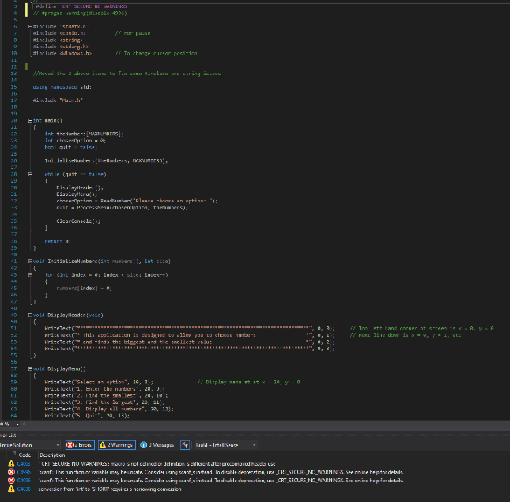

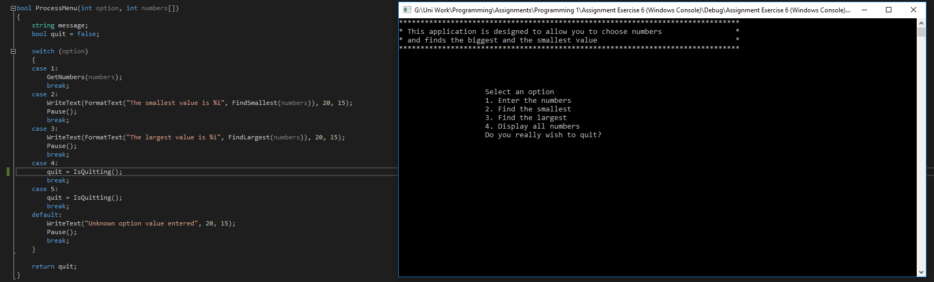
Problem No. 2, After opening the menu, choosing option 4 from the list would not display the numbers input by the user and would instead prompt the user to quit the program. Below is a screengrab to show the problem.

Problem No. 3, After choosing option 1 from the menu, when inputting numbers into the program, any value with more than 1 digit would not be properly cleared from the line and would only clear the first digit input. Below are screenshots to illustrate the problem.
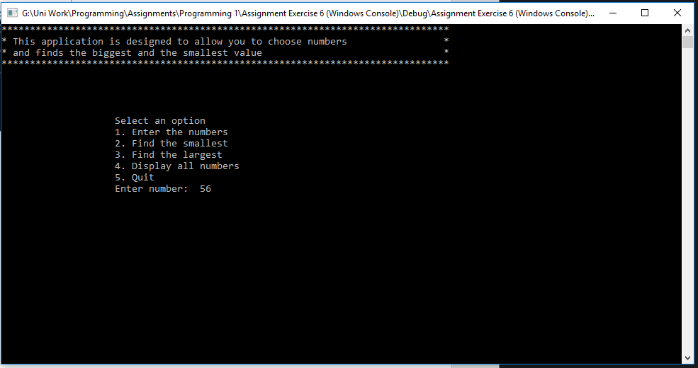
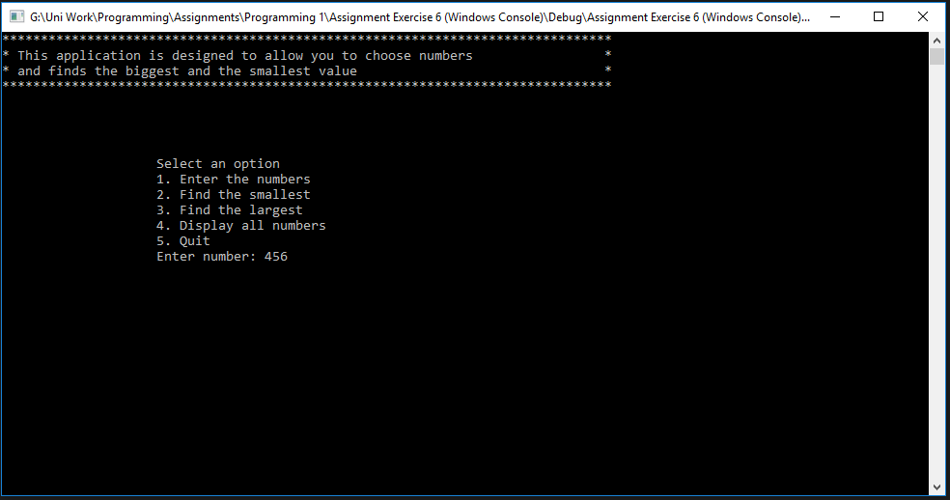

- Part C (Implementation).

Code located in Appendix.
(DISCLAIMER: Screenshots may or may not look different on different resolutions such as 1920x1080 due personal to screen resolution [3440x1440], Windows Scaling has been known to cause problems with screenshots. Steps have been taken to try and rectify the problem but aren’t guaranteed to work.)

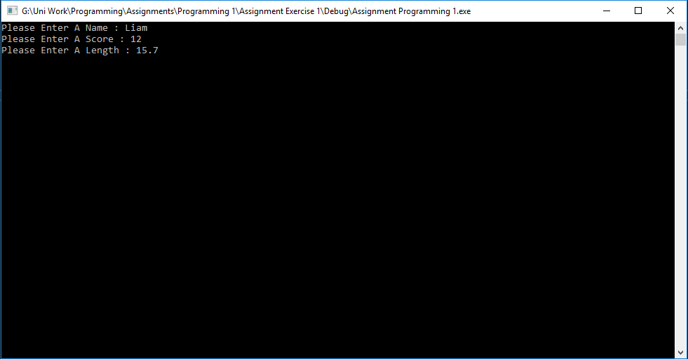
Exercise 1.

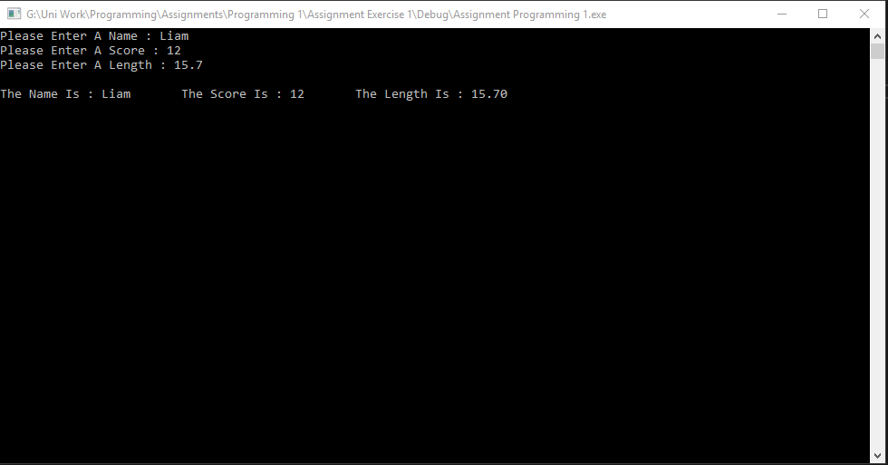
User inputs data into variables.

The data input by the user is displayed.

Exercise 2.
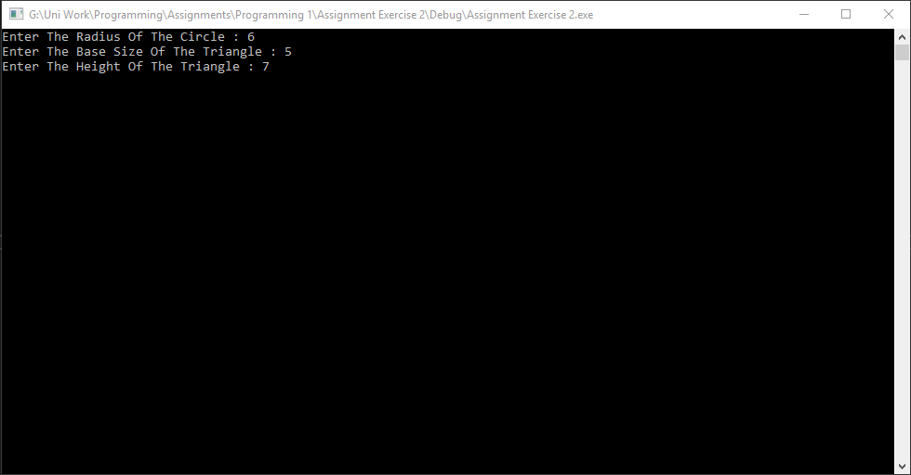

User enters radius of the circle, size of the base of the triangle and the height of the triangle.

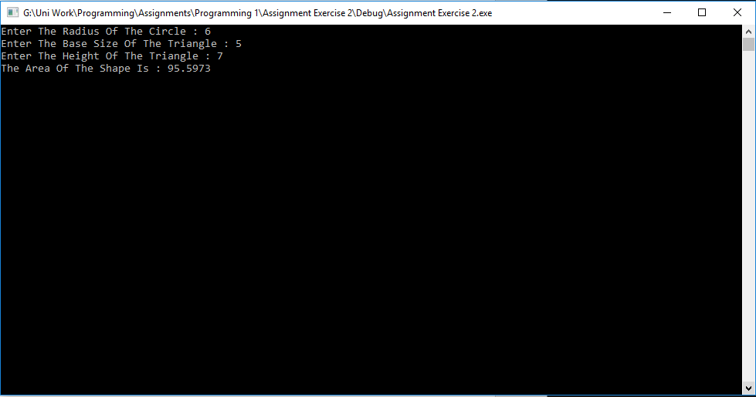

The area of the shape is then displayed.

Exercise 3.
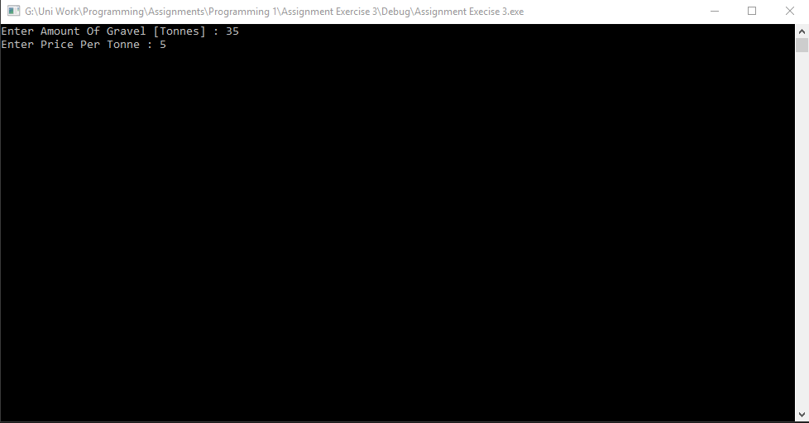

User enters amount of gravel in tonnes and price per tonne.

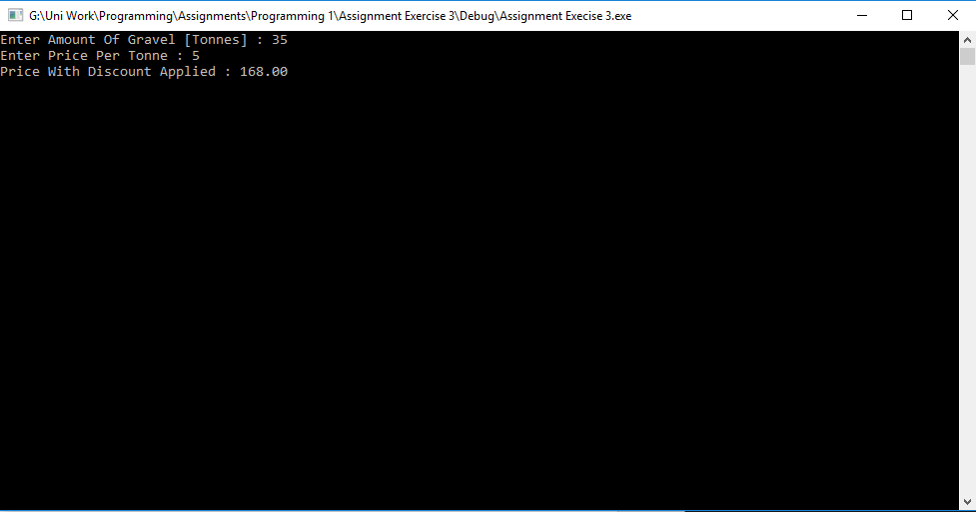

Price with discount applied displayed.

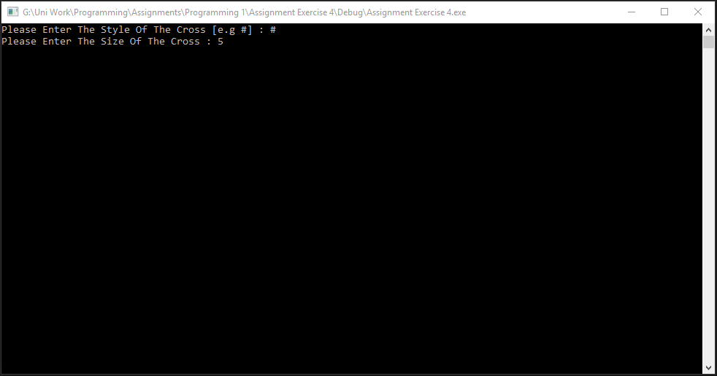
Exercise 4.

User enters the style of the shape and the size of the shape.
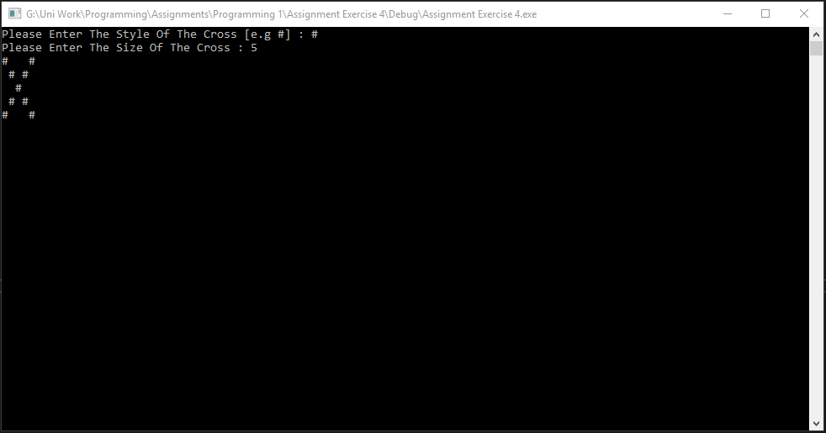

The shape is displayed.
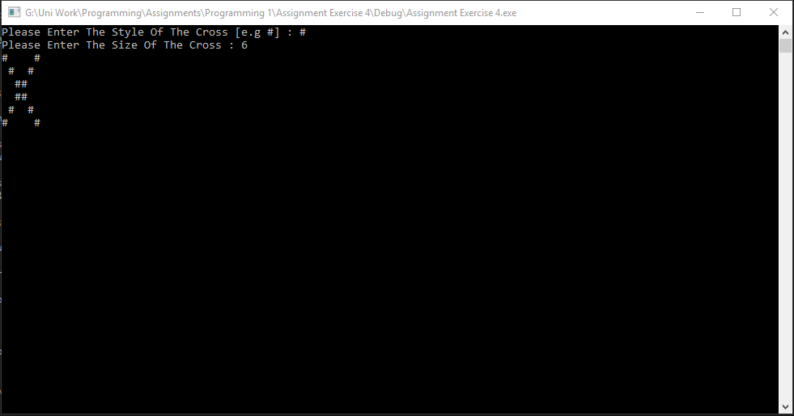

When she number input is even, the shape prints differently but correctly due to the number.
Exercise 5.
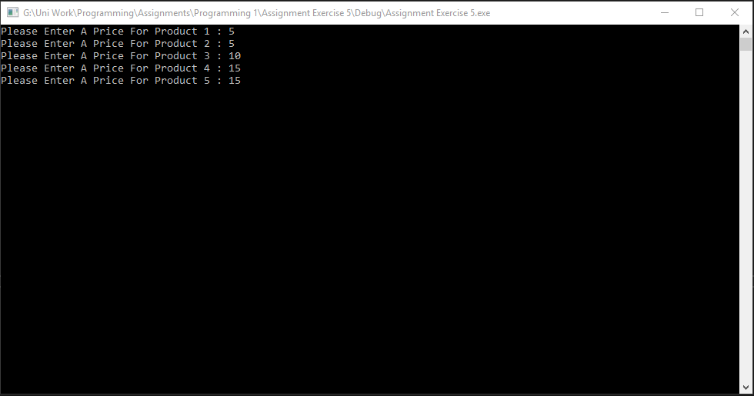

User enters the price for 5 different products.
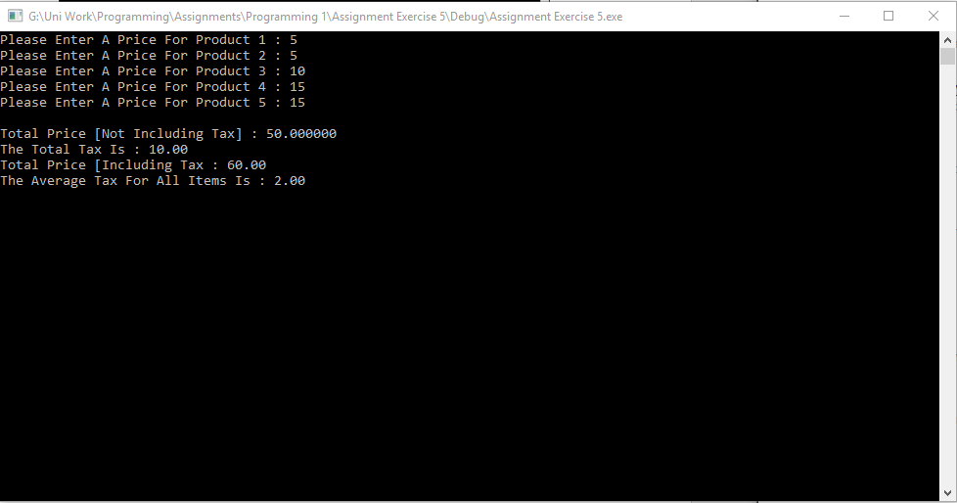

The price (not including tax), the total tax, the total price (including tax) and the average tax for all items are displayed.

Exercise 6.
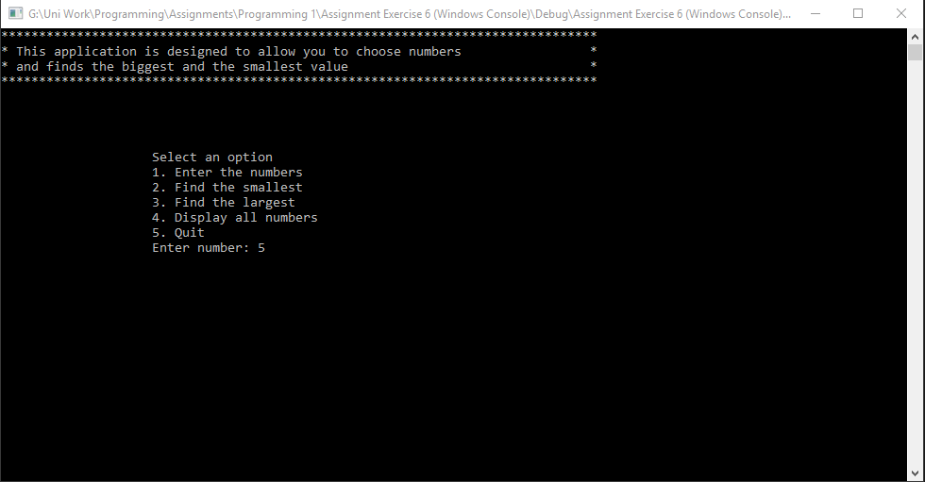

Option 1 allows the user to enter 3 numbers.
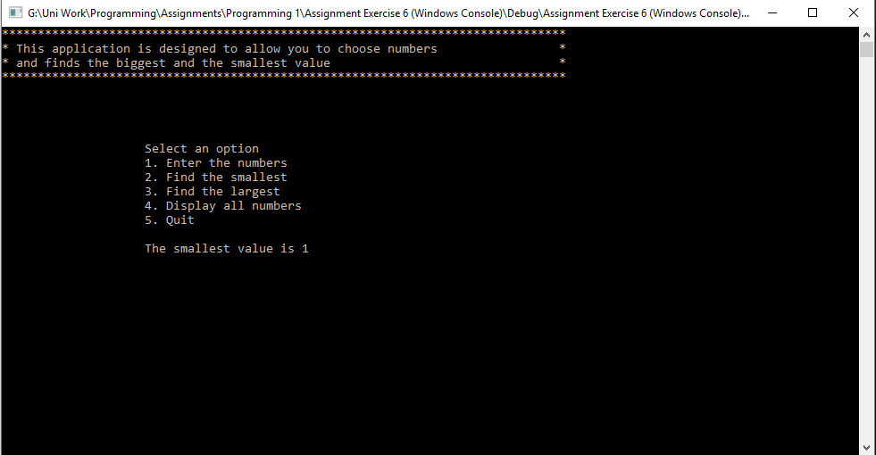

Option 2 displays the smallest number the user input.
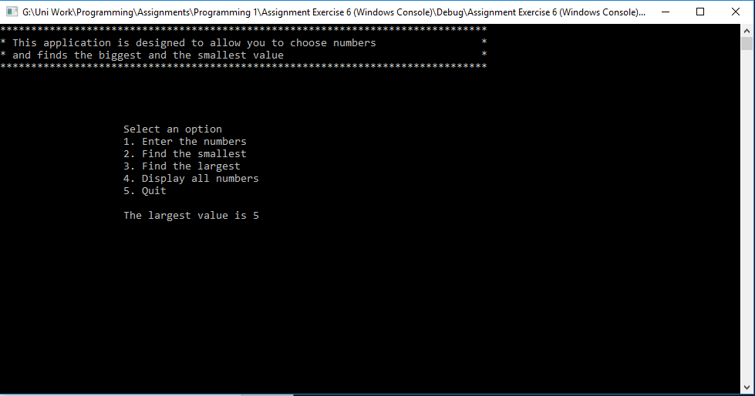

Option 3 displays the largest number the user input.

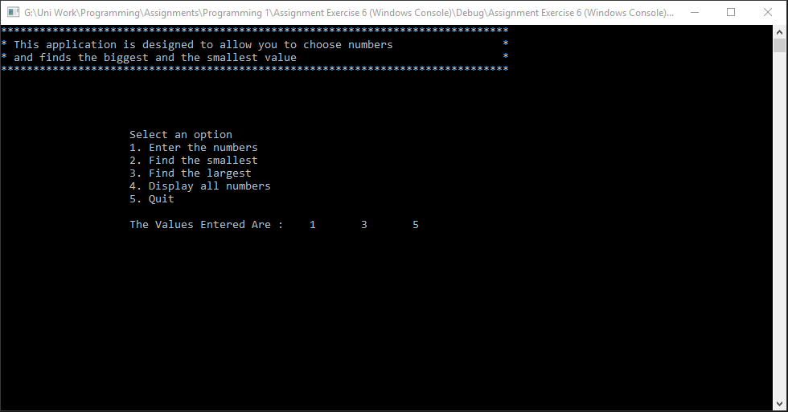

Option 4 displays all the numbers the user input.
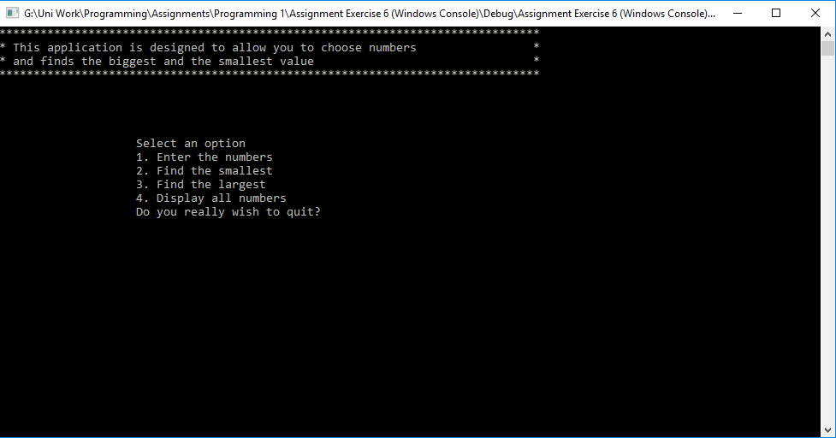

Option 5 prompts the user if they would like to exit the program.

Exercise 7.
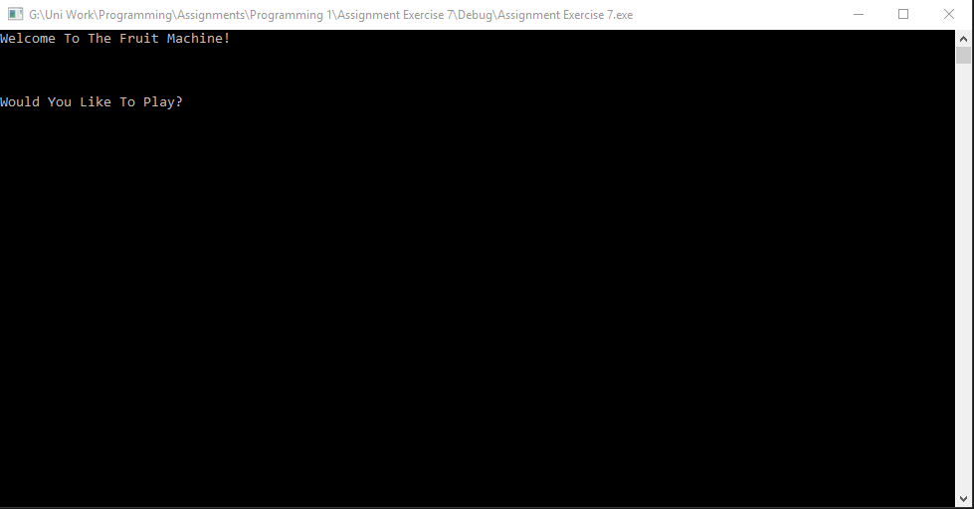

The user is prompted if they would like to play.
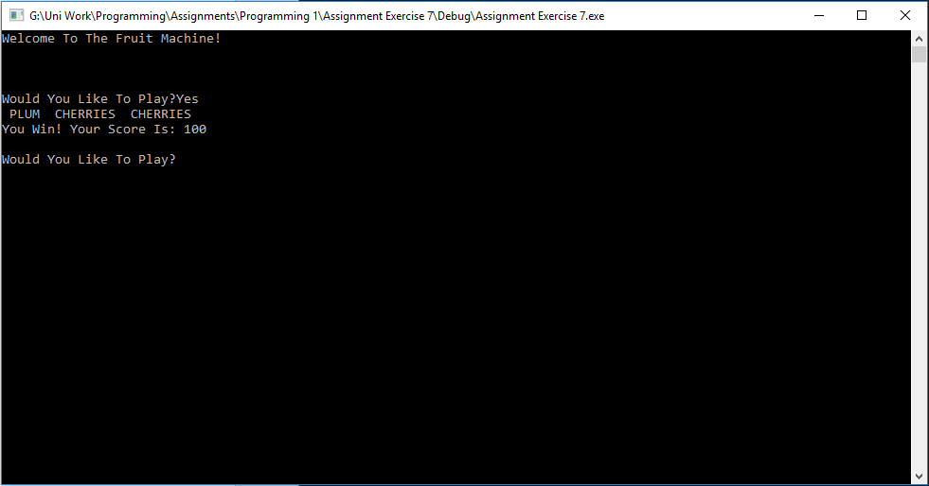

If the user gets 2 cherries, 100 points are acquired.

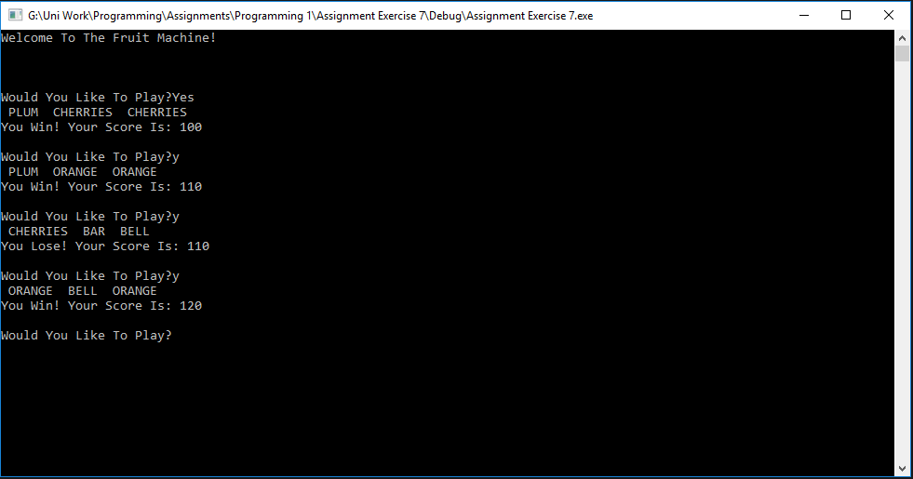

If the user gets no matches, the user loses the game.

If the user gets a double of any other type, 10 points are acquired.
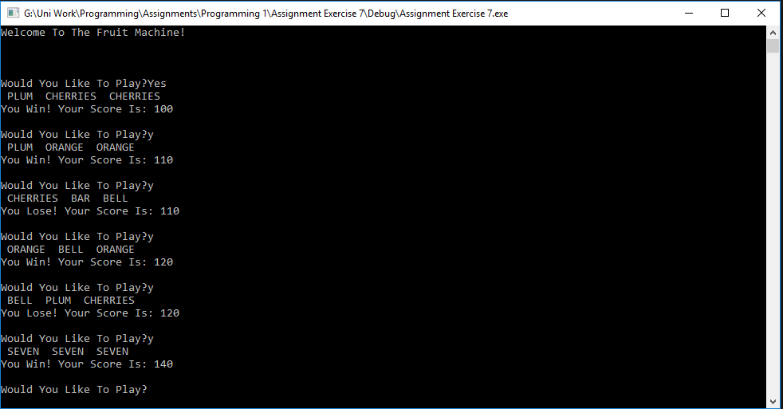

If the user gains double ‘SEVEN’, 20 points are gained.
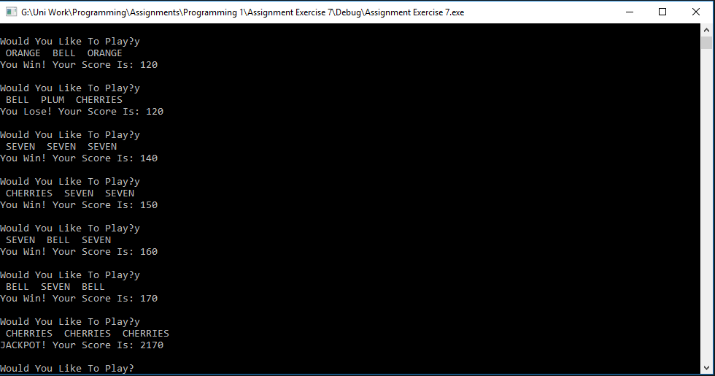

If the user gets triple ‘CHERRIES’, 2000 points are gained and the user gets a jackpot win.

Exercise 8.
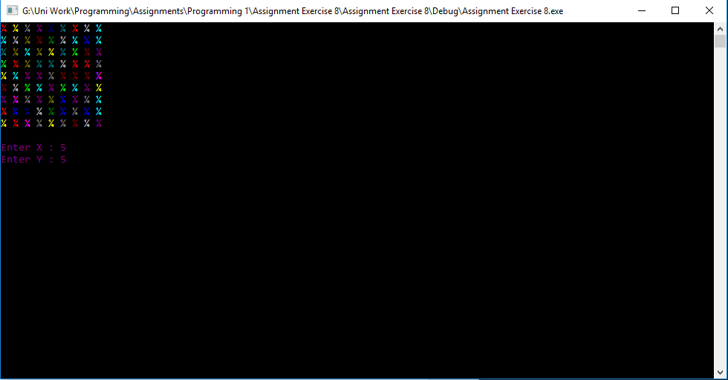

User inputs X and Y coordinates.

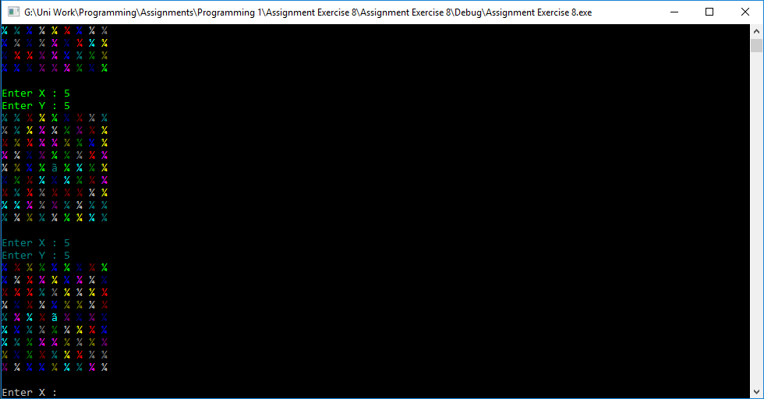

Symbol placed into position user selected.
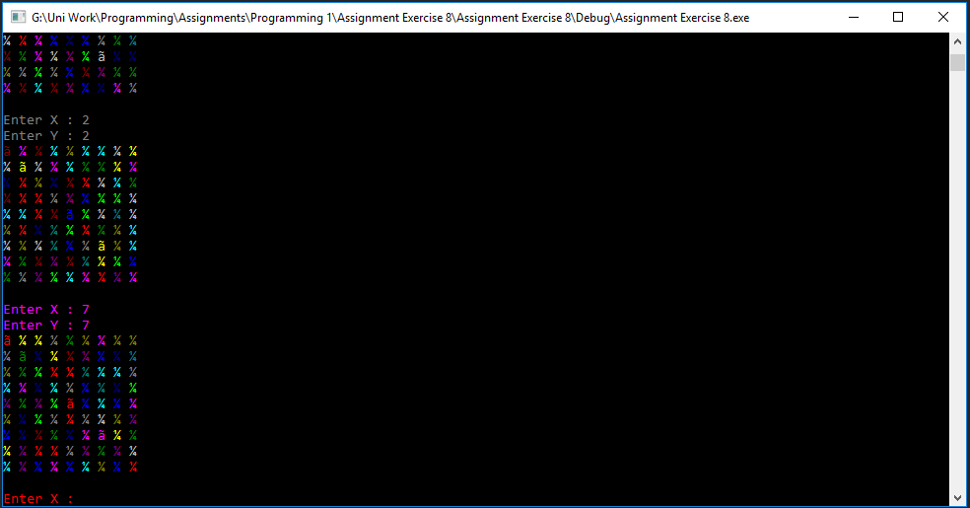

Program loops.
- Appendices.

Exercise 1.
Source.cpp
#define _CRT_SECURE_NO_WARNINGS
#include <string>
using namespace std;

int main(int argc, char** argv)
{
char text[100];

string name = "";
int score = 0;
double length = 0.0;

printf("Please Enter A Name : ");
scanf("%99s", name.c_str());

printf("Please Enter A Score : ");
scanf("%i", &score);

printf("Please Enter A Length : ");
scanf("%lf", &length);

printf("\r\nThe Name Is : %s The Score Is : %i The Length Is : %0.2f", name.c_str(), score, length);

return 0;
}

Exercise 2.
Source.cpp
#define _CRT_SECURE_NO_WARNINGS
#include <string>
using namespace std;

int main(int argc, char** argv)
{
char text[100];

double circleArea = 0.0;
double triangleArea = 0.0;

double radius = 0.0;
double triangleBottom = 0.0;
double triangleHeight = 0.0;

double pi = 3.1415926;

double answer = 0.0;

printf("Enter The Radius Of The Circle : ");
scanf("%lf", &radius);

printf("Enter The Base Size Of The Triangle : ");
scanf("%lf", &triangleBottom);

printf("Enter The Height Of The Triangle : ");
scanf("%lf", &triangleHeight);

circleArea = pi * (radius * radius);
triangleArea = (triangleBottom * triangleHeight) / 2;

answer = circleArea - triangleArea;

printf("The Area Of The Shape Is : %0.4f", answer);

return 0;
}

Exercise 3.
Source.cpp
#define _CRT_SECURE_NO_WARNINGS
#include <string>
using namespace std;

int main(int argc, char** argv)
{
char text[100];

double weight = 0.0;
double tonneCost = 0.0;

double discountPercent = 0.0;
double discountPrice = 0.0;
double discount = 0.0;

printf("Enter Amount Of Gravel [Tonnes] : ");
scanf("%lf", &weight);

printf("Enter Price Per Tonne : ");
scanf("%lf", &tonneCost);

if (weight >= 5 && weight <= 8)
{
discountPercent = 2;
}

else
{
if (weight >= 9 && weight <= 40)
{
discountPercent = 4;
}
else
{
if (weight > 40)
{
discountPercent = 6;
}
}
}

discount = (weight * tonneCost) * (discountPercent / 100);
//Calculate discount by getting cost without discount and multiply it by the discount percent / 100.
//e.g. if discount percent is 2, the value multiplied by will be 0.02

discountPrice = (weight * tonneCost) - discount;
//Get the final price by finding non-discounted price and subtracting the discount from it

printf("Price With Discount Applied : %0.2lf ", discountPrice);

return 0;
}
Exercise 4.
Source.cpp
#define _CRT_SECURE_NO_WARNINGS
#include <string>
using namespace std;

int main(int argc, char** argv)
{
char text[100];

int row = 0;
int column = 0;
int size = 0;

string userInput = "";

printf("Please Enter The Style Of The Cross [e.g #] : ");
scanf("%s", userInput);

printf("Please Enter The Size Of The Cross : ");
scanf("%i", &size);

for (row = 1; row <= size; row++)
{
for (column = 1; column <= size; column++)
{
if (row == column || column == (size+1)-row)
{
printf("%s", userInput);
}
else
{
printf(" ");
}
}
printf("\r\n");
}

return 0;
}

Exercise 5.
Source.cpp
#define _CRT_SECURE_NO_WARNINGS
#include <string>
using namespace std;
#include "TotalPrice.h"

int main(int argc, char** argv)
{
char text[100];

int numberProducts = 5;

double tempPrice = 0.0;

TotalPrice* priceTotal = new TotalPrice;

priceTotal->SetPrice(0.0);
priceTotal->SetTax(0.0);
priceTotal->SetTaxPercent(0.20);
priceTotal->SetProductNumber(numberProducts);

for (numberProducts = 0; numberProducts < 5; numberProducts++)
{
printf("Please Enter A Price For Product %i : ", numberProducts+1);
scanf("%lf", &tempPrice);
priceTotal->RunningTotal(tempPrice);
priceTotal->AddToTaxTotal(tempPrice);
}

priceTotal->CalculatePriceIncludingTax();

printf("\r\nTotal Price [Not Including Tax] : %lf\r\n", priceTotal->GetPrice());
printf("The Total Tax Is : %0.2f\r\n", priceTotal->GetTax());
printf("Total Price [Including Tax] : %0.2f\r\n", priceTotal->GetPriceIncludingTax());
printf("The Average Tax For All Items Is : %0.2f\r\n", priceTotal->GetAverageTax());

delete priceTotal;

return 0;
}

TotalPrice.cpp
#include "TotalPrice.h"

TotalPrice::TotalPrice()
{
}

TotalPrice::~TotalPrice()
{
}

void TotalPrice::SetPrice(double price)
{
this->_total = price;
}

void TotalPrice::SetTax(double tax)
{
this->_taxTotal = tax;
}

void TotalPrice::SetTaxPercent(double taxPercent)
{
this->_taxPercent = taxPercent;
}

void TotalPrice::SetProductNumber(int numberOfProducts)
{
this->_numberOfProducts = numberOfProducts;
}

double TotalPrice::GetPrice()
{
return this->_total;
}

double TotalPrice::GetTax()
{
return this->_taxTotal;
}

double TotalPrice::GetAverageTax()
{
return this->_taxTotal / this->_numberOfProducts;
}

double TotalPrice::GetPriceIncludingTax()
{
return this->_priceIncludingTax;
}

void TotalPrice::RunningTotal(double price)
{
this->_total = this->_total + price;
}

void TotalPrice::AddToTaxTotal(double productPrice)
{
this->_taxTotal = this->_taxTotal + (this->_taxPercent * productPrice);
}

void TotalPrice::CalculatePriceIncludingTax()
{
this->_priceIncludingTax = this->_total + this->_taxTotal;
}

Exercise 6. Menu.cpp
#include "stdafx.h"
#include <conio.h> // For pause
#include <string>
#include <stdarg.h>
#include <Windows.h> // To change cursor position

#define _CRT_SECURE_NO_WARNINGS
#pragma warning(disable:4996)
//Moved the 2 above items to fix some #include and string issues

using namespace std;

#include "Main.h"

int main()
{
int theNumbers[MAXNUMBERS];
int chosenOption = 0;
bool quit = false;

InitialiseNumbers(theNumbers, MAXNUMBERS);

while (quit == false)
{
DisplayHeader();
DisplayMenu();
chosenOption = ReadNumber("Please choose an option: ");
quit = ProcessMenu(chosenOption, theNumbers);

ClearConsole();
}

return 0;
}

void InitialiseNumbers(int numbers[], int size)
{
for (int index = 0; index < size; index++)
{
numbers[index] = 0;
}
}

void DisplayHeader(void)
{
WriteText("*******************************************************************************", 0, 0); // Top left hand corner of screen is x = 0, y = 0
WriteText("* This application is designed to allow you to choose numbers *", 0, 1); // Next line down is x = 0, y = 1, etc
WriteText("* and finds the biggest and the smallest value *", 0, 2);
WriteText("*******************************************************************************", 0, 3);
}

void DisplayMenu()
{
WriteText("Select an option", 20, 8); // Display menu at at x = 20, y = 8
WriteText("1. Enter the numbers", 20, 9);
WriteText("2. Find the smallest", 20, 10);
WriteText("3. Find the largest", 20, 11);
WriteText("4. Display all numbers", 20, 12);
WriteText("5. Quit", 20, 13);
}
int ReadNumber(string prompt)
{
int number = -1;
int inputCharCount;

WriteText(prompt, 20, 14);
inputCharCount = scanf("%i", &number);
if (inputCharCount == 0) // Wasn’t a number, so ignore what they typed in!!
{
IgnoreInput();
}

ClearText(20, 14, prompt.length() + inputCharCount); // Clear the text at this line

return number;
}

void IgnoreInput(void)
{
char ch;
while ((ch = getchar()) != '\n' && ch != EOF);
}

void ClearText(int x, int y, int length)
{
// Write space ' ' characters starting at x, y for 'length' times
string spaces(length, ' ');
WriteText(spaces, x, y);
}

bool ProcessMenu(int option, int numbers[])
{
string message;
bool quit = false;

switch (option)
{
case 1:
GetNumbers(numbers);
break;
case 2:
WriteText(FormatText("The smallest value is %i", FindSmallest(numbers)), 20, 15);
Pause();
break;
case 3:
WriteText(FormatText("The largest value is %i", FindLargest(numbers)), 20, 15);
Pause();
break;
case 4:
DisplayAllNumbers(numbers);
Pause();
break;
case 5:
quit = IsQuitting();
break;
default:
WriteText("Unknown option value entered", 20, 15);
Pause();
break;
}

return quit;
}

void GetNumbers(int numbers[])
{
for (int index = 0; index < MAXNUMBERS; index++)
{
numbers[index] = ReadNumber("Enter number: ");
}
}
int FindSmallest(int numbers[])
{
int smallest = numbers[0];

for (int index = 0; index < MAXNUMBERS - 1; index++) // <-- subtract 1
{
if (numbers[index + 1] < smallest)
{
smallest = numbers[index + 1];
}
}

return smallest;
}

int FindLargest(int numbers[])
{
int largest = numbers[0];

for (int index = 0; index < MAXNUMBERS - 1; index++) // <-- subtract 1
{
if (numbers[index + 1] > largest)
{
largest = numbers[index + 1];
}
}

return largest;
}

bool IsQuitting()
{
char input[100];
string response;

bool quit = false;

WriteText("Do you really wish to quit? ", 20, 13);
scanf("%99s", input);

response = input;

if (response == "YES" || response == "yes") //Added an extra 'yes' option for the sake of user friendliness
{
quit = true;
}

return quit;
}

void WriteText(string text, int x, int y)
{
SetCursorPosition(x, y);
printf(text.c_str());
}

// JUST USE THIS FUNCTION
// This function positions cursor in Console window,
// and you DON'T need to understand it!!!
void SetCursorPosition(int x, int y)
{
static HANDLE handle = NULL;
if (!handle)
{
handle = GetStdHandle(STD_OUTPUT_HANDLE);
}
COORD coords = { x, y };
SetConsoleCursorPosition(handle, coords);
}

// JUST USE THIS FUNCTION
// This function does creates a string
// using a format string and values i.e.
// FormatText("Number is %i", 5) returns "Number is 5",
// and you DON'T need to understand it!!!
string FormatText(const char *c_format, ...)
{
char ch[100];
va_list args;
va_start(args, c_format);
vsnprintf(ch, 100, c_format, args);
va_end(args);
return string(ch);
}

// JUST USE THIS FUNCTION
// This function clears the screen,
// and you DON'T need to understand it!!!
void ClearConsole(void)
{
system("cls");
}

void Pause(void)
{
// Pause
while (1) { if (_kbhit()) break; }
_getch(); // Clear the keypress
}

//New Function

void DisplayAllNumbers(int numbers[MAXNUMBERS]) //Function outputs all user input numbers when case 4 is called
{
int count = 0;

WriteText(FormatText("The Values Entered Are : "), 20, 15);

for (count = 0; count < MAXNUMBERS; count++)
{
printf(" %i", numbers[count]);
}
}

stdafx.cpp
// stdafx.cpp : source file that includes just the standard includes
// Assignment Exercise 6 (Windows Console).pch will be the pre-compiled header
// stdafx.obj will contain the pre-compiled type information

#include "stdafx.h"

// TODO: reference any additional headers you need in STDAFX.H
// and not in this file

targerver.h
#pragma once

// Including SDKDDKVer.h defines the highest available Windows platform.

// If you wish to build your application for a previous Windows platform, include WinSDKVer.h and
// set the _WIN32_WINNT macro to the platform you wish to support before including SDKDDKVer.h.

#include <SDKDDKVer.h>

stdafx.h
// stdafx.h : include file for standard system include files,
// or project specific include files that are used frequently, but
// are changed infrequently
//

#pragma once

#include "targetver.h"

#include <stdio.h>
#include <tchar.h>

// TODO: reference additional headers your program requires here

Main.h
#pragma once

const int MAXNUMBERS = 3;
const int MAXINPUTCHARS = 100;

void InitialiseNumbers(int numbers[], int size);
void DisplayHeader(void);
void DisplayMenu(void);
int ReadNumber(string prompt);
void IgnoreInput(void);
void ClearText(int x, int y, int length);
bool ProcessMenu(int option, int numbers[]);
void GetNumbers(int numbers[]);
int FindSmallest(int numbers[]);
int FindLargest(int numbers[]);
bool IsQuitting();
void WriteText(string text, int x, int y);
void SetCursorPosition(int x, int y);
string FormatText(const char *format, ...);
void ClearConsole(void);
void Pause(void);

void DisplayAllNumbers(int numbers[MAXNUMBERS]); //Added new funtion

Exercise 7.
Source.cpp
#define _CRT_SECURE_NO_WARNINGS
#include <string>
#include "time.h"

using namespace std;

int RandomValue(int maxValue);
void PrintOutcome(int randomNumbers[3]);
int GenerateThreeRandomNumbers(int randomNumbers[3]);
int CalculateScore(int randomNumbers[3], int score);
void DisplayWinLoseJackpot(char result);
string PlayChoice();

int main(int argc, char** argv)
{
char text[100];

time_t theTime;
srand((unsigned)time(&theTime));

string spinDecision = "";
int randomNumbers[3];
int score = 0;

printf("Welcome To The Fruit Machine!\r\n \r\n");

spinDecision = PlayChoice();

while (spinDecision == "YES" || spinDecision == "Yes" || spinDecision == "yes" || spinDecision == "y")
{
GenerateThreeRandomNumbers(randomNumbers);
PrintOutcome(randomNumbers);
score = CalculateScore(randomNumbers, score);

printf(" Your Score Is: %i", score);

spinDecision = PlayChoice();
}

printf("Thank You For Playing! Goodbye!");

return 0;
}

int RandomValue(int maxValue)
{
return rand() % (maxValue + 1);
}

void PrintOutcome(int randomNumbers[3])
{
int currentValue = 0;
int count = 0;

for (count = 0; count < 3; count++)
{
currentValue = randomNumbers[count];

switch (currentValue)
{
case 0:
printf(" SEVEN ");
break;
case 1:
printf(" BAR ");
break;
case 2:
printf(" BELL ");
break;
case 3:
printf(" PLUM ");
break;
case 4:
printf(" ORANGE ");
break;
case 5:
printf(" CHERRIES ");
break;
}
}
}

int GenerateThreeRandomNumbers(int randomNumbers[3])
{
int count = 0;

for (count = 0; count < 3; count++)
{
randomNumbers[count] = RandomValue(5);
}
return randomNumbers[3];
}

int CalculateScore(int randomNumbers[3], int score)
{

if (randomNumbers[0] == randomNumbers[1] || randomNumbers[1] == randomNumbers[2]
|| randomNumbers[0] == randomNumbers[2]) //Checking if any combination of 2 numbers match
{
if (randomNumbers[0] == randomNumbers[1] && randomNumbers[0] == randomNumbers[2]) //Check if all three values are the same
{

if (randomNumbers[0] == 5)
{
score = score + 2000;

DisplayWinLoseJackpot('J');
}
else
{
score = score + 20;

DisplayWinLoseJackpot('W');
}
}
else
{
if ((randomNumbers[0] == 5 && randomNumbers[1] == 5) || (randomNumbers[1] == 5 && randomNumbers[2] == 5)
|| (randomNumbers[0] == 5 && randomNumbers[2] == 5))
{
score = score + 100;

DisplayWinLoseJackpot('W');
}
else
{
score = score + 10;

DisplayWinLoseJackpot('W');
}
}
}
else
{
DisplayWinLoseJackpot('L');
}
return score;
}

void DisplayWinLoseJackpot(char result)
{

switch (result)
{
case 'W':
printf("\r\nYou Win!");
break;

case 'J':
printf("\r\nJACKPOT!");
break;

case 'L':
printf("\r\nYou Lose!");
break;
}
}

string PlayChoice()
{
char text[100];

string spinDecision = "";

printf("\r\n \r\nWould You Like To Play?");
scanf("%99s", text);

spinDecision = text;

return spinDecision;
}

Exercise 8.
Source.cpp
#define _CRT_SECURE_NO_WARNINGS
#include <string>
#include "Board.h"
#include "time.h"

using namespace std;

int main(int argc, char** argv)
{
char text[100];
time_t t;
srand((unsigned)time(&t));

Board *PlayerOneBoard1 = new Board;

while (true)
{

PlayerOneBoard1->PrintBoard();

int x, y = 0;

printf("Enter X : ");
scanf("%i", &x);

printf("Enter Y : ");
scanf("%i", &y);

PlayerOneBoard1->PlaceBoat(x, y);
}

return 0;
}

Board.cpp
#include "Board.h"
#include <string>
#include <Windows.h>

using namespace std;

Board::Board()
{

int row = 0;
int column = 0;

for (row = 0; row < 9; row++)
{
for (column = 0; column < 9; column++)
{
_Board[row][column] = '¬';
}
}
}

Board::~Board()
{
}

void Board::PrintBoard()
{

int row = 0;
int column = 0;

for (row = 0; row < 9; row++)
{
for (column = 0; column < 9; column++)
{

int randomNumber = 0;
randomNumber = (rand() % 14 + (1));

SetConsoleTextAttribute(GetStdHandle(STD_OUTPUT_HANDLE), randomNumber);

printf("%c ", _Board[row][column]);
}
printf("\r\n");
}
printf("\r\n");
}

void Board::PlaceBoat(int x, int y)
{
_Board[x-1][y-1] = 'Æ';
}
Board.h
#pragma once
class Board
{
//Attributes
private:
char _Board[9][9]; //The example used in the assignment uses a 9x9 sqaure for the board

//Constructors
public:
Board();
~Board();

//Properties

//Methods

void PrintBoard();
void PlaceBoat(int x, int y);
};

References

[1] | "Data Types," University Of Leicester, [Online]. Available: https://www.le.ac.uk/users/rjm1/cotter/page_19.htm. [Accessed 10 March 2018].
[2] | M. Rouse, "Class," TechTarget, August 2005. [Online]. Available: http://whatis.techtarget.com/definition/class. [Accessed 11 March 2018].
[3] | "Data Hiding," Techopedia, [Online]. Available: https://www.techopedia.com/definition/14738/data-hiding. [Accessed 11 March 2018].

