LCBB4005: The Global Business Environment
Assessment 2

Environmental Analysis of an industry:
Automobile Industry
Bentley Motors Limited
Student Id: 2021614
Student Name: Andrei Nalivaico

Table of Contents
Introduction 3
Forces shaping the Global Business Environment 4
Changes in the Global Business Environment 5
Impact of the pandemic on the Automobile Industry 6
Success and Survival of the industry in consideration with Megatrends 8
Business Models for international environmental Analysis 9
Reasons for engagement of the organisation in International Trade 12
Analysis of the Market 13
Conclusion 14
References 15

Introduction
Bentley Motors Limited is an automobile company operating in UK. It was founded in the year 1998 and has become the most desirable manufacturer of luxury and SUV cars. This assessment focuses on the impact of the pandemic on the automobile Industry. Different types of success and survival factors of the automobile industry have been explained in consideration with the megatrends (Kretschmar, 2020). This assessment also discusses about the forces and changes taking place in the Global Business Environment. Different Business models such as Porter's Diamond Model, Value Network and Five Force Model have been used for analyzing the international environment of automobile industry.

Figure 1: Bentley Motors Limited
Source: (Bentley motors, 2021)

Forces shaping the Global Business Environment
The automobile industry is mainly affected by certain forces which shape the Global Business Environment. These forces are availability of raw materials, supply of labor, demand of the consumers, reliability of supply chain, expectation of the workers and changes in government regulations. Proper availability of raw materials is possible when Bentley Motors Limited conducts its working in the global environment. One of the reasons why automobile industries are expanding the activities globally is to secure maximum raw materials (Friesendorf, and Uedelhoven, 2021). The supply of labors from the foreign market helps automobile industry to conduct the activities effectively. Hence, the availability of human resources is one of the essential factors which promote the working of the company in a Global Business Environment. The demand of the automobiles in the global environment is higher. Bentley Motors Limited tries to fulfill the demand of the customers for existing in the Global Business Environment.

Changes in the Global Business Environment
With changing situation, there are certain changes which are taking place in the Global Business Environment of Bentley Motors Limited. There has been a change in the Global banking structure, the level of power of the emerging markets, evolution of technology, increase in privatization, international arbitration, promoting clean energy and sustainable energy and competitive advantage (Kim, et al., 2021). These changes have created a positive impact on the automobile industries. Some of the additional changes comprises of technological advancements in terms of electrification, down speeding, downsizing and hybridization. This changes in the automobile industries help in racing towards a new world which is mainly characterized by changing consumer behavior, mobility fleet sharing, connected cars, sustainability etc.

Impact of the pandemic on the Automobile Industry
The covid-19 pandemic has created a severe and swift impact on the global integration of automobile industries. One of the major impacts is reduction in the export of automobile parts from China, interruptions in the manufacturing activities across Europe and shutting down of automobile plants in US. All the impact of the pandemic on the automobile industry can be discussed as follows:
Restriction on travel: Since there has been a certain restriction which are imposed by the government on travelling, people are not using vehicles (Matovic, 2020). This has led to a decrease in the demand of automobiles. Moreover, in the situation of covid-19 people are preferring to buy second hand vehicles rather than purchasing a first-hand vehicle from the company.
Rescheduling and cancelling of auto shows: Auto shows are mainly a platform for introducing the new automobile vehicle to the customers. Due to the pandemic situation, government had put a restriction on social gatherings. This has led to cancellation of auto shows. A large amount of investment of the company is made in auto shows. This has led to a decrease in the profit margin of the companies operating in automobile industry (Çitilci, and Akbalık, 2020).
Lay off of the employees: Since the demand of vehicles in the automobile industries have been reduced due to the pandemic situation, the company had to lay off its employees. Moreover, after the economy recovers, the company has to make huge amount of investment for increasing the skills and hiring new employees. Moreover, layoff of the employees reduces the productivity and morality of the employees. This creates a bad reputation of the automobile industry.
Reduction in the demand of automobiles: It is seen that, people are avoiding public transportation and use of automobiles due to the pandemic situation. This has led to a decrease in the sale of automobiles as compared to the last year's sale. This great recession has however increased the demand of second-hand automobiles.
Investment for adopting new technologies: Due to the pandemic situation, people are not showing any interest to visit the automobile showroom and to take test drive of the vehicles. Hence, in order to cope with this situation, the automobile industry is focusing on adapting digital technologies to sell their products (Albuquerque, et al., 2020). For the purpose of surviving in the pandemic, digital showrooms, VR test drives, home test drives etc. are provided by the automobile company. Due to this pandemic situation a large amount of expenditure has to be incurred by the company.

Success and Survival of the industry in consideration with Megatrends
A large number of technological developments are used automobile industries for its growth and development. Some of the technologies used by automobile industries are electrification, Artificial Intelligence, block chain, Data Analytics, Human Machine Interface, Big Data, shared mobility, autonomous vehicles etc. These are some of the megatrends which are observed in automobile industry (Baek, et al., 2020). These megatrends have contributed towards the survival and success of Bentley motor Limited in the automobile industry. The success and survival factors are easy engagement with the customer using digital techniques. Now it has become easier for automobile industries to promote their products using digital platforms. All the information about the customers can be easily stored with effective safety and security by using Data Analytics. The future demand of the automobiles can be easily determined with the help of Big Data Technology. Electronic vehicles are being designed by the automobile industries for surviving in the competitive market (Radic, et al., 2020).

Business Models for international environmental Analysis
Porter’s Diamond Model: The application of Porter's Diamond Model in Bentley Motors Limited is analyzed as follows:
- Demand condition: The demand of automobiles in Bentley Motors Limited is higher in UK.
- Firm strategy, structure and rivalry: The strategy of the firm is to use digital marketing for promoting its automobiles. Hierarchical structure is followed by Bentley Motors Limited. The level of rivalry among the competitors is higher (Wu, et l., 2021).
- Factor conditions: Demand and supply are the essential factors which operates in automobile industry.
- Supporting and related industries: There are limited related automobile industries.
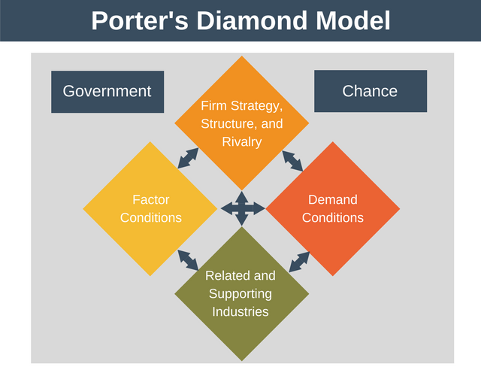
Figure 2:Porter’s Diamond Model
Source: (KM, and KG, 2021)
Porter’s Value Network: The first step of Bentley Motor Limited in the value chain analysis is to procure raw materials. Inbound logistic in the first stage in the manufacturing of automobiles in the company. This involves collecting raw materials from the vendors. The second stage of the manufacturing process is the production stage. This helps in producing the finished vehicle. This stage is also known as operational stage since raw materials are transformed into finished products. The third stage is outbound logistics. This involves moving of finished vehicles from the manufacturing site to the showrooms (Zulkifli, et al., 2020). The fourth stage involves marketing and sales activity. This is done to promote the vehicles. The last stage is after sales services to the customers.
Porter’s Five Force Model: Porter's five force model helps in analyzing and identifying the competitive forces that operates in automobile industry. It helps in determining the profit potential of Bentley Motors Limited in the automobile industry. These five factors are as follows:
- The threat of new entrants is low.
- The bargaining power of the supplier is high.
- The bargaining power of the buyer is high.
- The level of competitive rivalry is high (Bentley motors, 2021).
- The threat of substitute products is high.
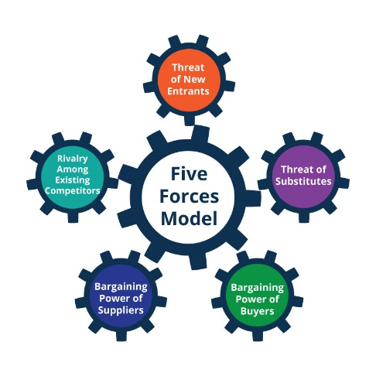
Figure 3:Porter’s Five Force Model
Source: (Kretschmar, 2020)
PESTEL Analysis:
Political Factors | Political factors such as taxation level and trade barriers impact the workings of Bentley Motor Limited. The level of taxes in UK is increasing, this it demotivates the companies. Increase in trade barriers creates obstruction for operating the company in UK (Friesendorf, and Uedelhoven, 2021).
Economic Factors | Economic factors such as exchange rate and GDP rate are properly analyzed for the growth of Bentley Motors Limited. The GDP rate in UK is higher which promotes the growth of automobile industry. There exists a stable exchange rate in UK economy which creates an impact on the currency stability.
Social Factors | Demographics and standard of living of the people are some of the social factors which are compiled by Bentley. The population of UK comprises of elderly people and females who control the sales of the company. Proper health standards are promoted by the company. This is due to the highly educated customers.
Technological Factors | A large number of technological opportunities are provided in UK. Bentley Motors Limited makes the best use of these technological opportunities. Latest technologies are used by the company for surviving in the competitive market.
Environmental Factors | The company follows all the discrimination laws and intellectual property laws for successful operation in UK. In the UK it is essential to follow all these laws (Kim, et al., 2021).
Legal Factors | The production of automobile industry is mainly improved by the climate changes and weathering conditions prevailing in UK. Waste management programs are undertaken in order to provide environmental protection.

Reasons for engagement of the organization in International Trade
Bentley Motors Limited is an automobile industry which engages in international trade. Certain reasons behind the engagement of the organization in international trade. International trade helps the company to earn a large amount of profit (Çitilci, and Akbalık, 2020). This company mainly invest in import and export activities and foreign trade for earning a high level of resources can be easily acquired from suppliers through international trade. This helps in long-term survival of the company in the automobile industry. Bentley Motors Limited focuses on exporting its excess products to foreign countries. This is possible only because of international trade. The company also provides maximum satisfaction to the human needs at the time of engaging in international trade. Necessary goods and services are imported from abroad to improve the skills and knowledge of the employees of Bentley Motors Limited. These are some of the major reasons for engaging in international trade is to spread the business activities of the company in abroad.

Analysis of the Market
- Micro-economic Foundation: Microeconomic Foundation relates to the behavior of Bentley Motor Limited in the automobile industry. The brand value and brand uniqueness of Bentley is higher in the automobile industry. A large number of technologies are being used for manufacturing the luxury cars of Bentley.
- Macroeconomic Foundations: Macroeconomic Foundation refers to the legal procedures which are followed by the automobile industries by operating in the international market (Albuquerque, et al., 2020). All the international rules and regulations for operating in international trade are followed by Bentley Motors Limited.
- Market structures and their influence on firm strategy: Bentley Motors Limited occupiers 53% of the market share in the automobile industry. The strategy of the firm is to apply advanced technology in its manufacturing process (Radic, et al., 2020).
- Long-run Changes: Some of the long run changes implemented by Bentley Motors Limited are adapting sustainability policies, introduction of electronic cars, on-board sensors, use of advanced Business models etc.
- Short-run Changes: Short run changes made by the company are changes in the staff, changing the organizational policy and use of Artificial Intelligence (Baek, et al., 2020).
- Major features of the current international economy: The current international economy is characterized by bigger thinking of small firms, creating new market prospects, new methods of production, use of advanced technology, promoting import and export activities etc.

Conclusion
It can be concluded that, due to the covid-19 pandemic, the demand of automobiles has been immensely decreased. A large number of workers in the automobile industries have been laid off due to the pandemic situation. Moreover, a large number of employees of the automobile industries are leaving their job due to the impact of pandemic on their health. Environmental analysis of Bentley Motors Limited has been conducted with the help of PESTEL analysis. Different reasons have been determined regarding the organizational engagement in international trade. It also discusses about analysis of automobile industries.

References
Albuquerque, R., Koskinen, Y., Yang, S. and Zhang, C., (2020). Resiliency of environmental and social stocks: An analysis of the exogenous COVID-19 market crash. The Review of Corporate Finance Studies, 9(3), pp.593-621.
Baek, S., Mohanty, S.K. and Glambosky, M., (2020). COVID-19 and stock market volatility: An industry level analysis. Finance Research Letters, 37, p.101748.
Bentley motors, (2021) THE BENTLEY STORY [online] Available from: https://www.bentleymotors.com/en/world-of-bentley/the-bentley-story.html [Accessed on 17 November 2021]
Çitilci, T. and Akbalık, M., (2020). The Importance of PESTEL Analysis for Environmental Scanning Process. In Handbook of Research on Decision-Making Techniques in Financial Marketing (pp. 336-357). IGI Global.
Friesendorf, C. and Uedelhoven, L., (2021). Digital Transformation of Global Mobility Markets. In Mobility in Germany (pp. 1-9). Springer, Cham.
Kim, S., Connerton, T.P. and Park, C., (2021). Exploring the impact of technological disruptions in the automotive retail: A futures studies and systems thinking approach based on causal layered analysis and causal loop diagram. Technological Forecasting and Social Change, 172, p.121024.
KM, K.R. and KG, N.K., (2021). Impact of Covid-19 Pandemic in the Automobile Industry: A Case Study. International Journal of Case Studies in Business, IT and Education (IJCSBE), 5(1), pp.36-49.
Kretschmar, D.K.M., (2020). A Synoptic View on Organizational Change Theories applied on Current Developments in the Automotive Industry. ACADEMIC JOURNAL, p.24.
Matovic, I.M., (2020). PESTEL Analysis of External Environment as a Success Factor of Startup Business. ConScienS, p.96.
Radic, N., Radic, V. and Stevanovic, M., (2020). Economy Impact of the Coronavirus Pandemic on the Automobile Industry. Oditor, p.55.
Wu, X., Zhang, C. and Du, W., (2021), July. An analysis on the crisis of “chips shortage” in automobile industry——Based on the double influence of COVID-19 and trade friction. In Journal of Physics: Conference Series (Vol. 1971, No. 1, p. 012100). IOP Publishing.
Zulkifli, N.A., Yazid, M.F.M. and Shamsudin, M.F., (2020). How will the market players in the automotive industry strengthen their market positioning during the pandemic Covid-19 outbreak and recession. Journal of Postgraduate Current Business Research, 1(1).

