LCBB5004
Managing People
Assessment 2
Name:NICOLETA OIAGA
Student Number:1913093
Submission Date: 20 Jan 22
Wordcount: 2000

Table of Contents

Introduction 2
Definition of Employee Engagement 2
Concept of Employee Engagement 2
Drivers of Employee Engagement 3
Management 3
Communication 3
Collaboration 3
Training Employees 3
Employee Well-being 3
HR Policies 4
Compensation and Benefits 4
Corporate Environment 4
Tools to Measure Employee Engagement 4
Work from Home 4
Flexible Working Time 5
Employee Value Proposition 5
Strategies to Raise Levels of Engagement 6
Conclusion 7
References 9

Introduction
Because of the global pandemic of COVID-19, the business climate is changing. Human resource managers are always gererating unique, creative, and successful tactics to engaging employees in a good manner during this challenging time. Employee engagement is a work mentality that encourages all business personnel to provide their great try every day while remaining committed to the firm's aims and values. Employees that are well engaged in an organisation will drive to work productivity, which produces greater customer satisfaction and, without a doubt, progressions in income and revenue in the firm. This report investigates the concept of employee’s engagement and its drivers to raise levels of employee engagement. Furthermore, various tools are also discussed to measure employee engagement.

Definition of Employee Engagement
Work engagement and organisational engagement are the two key components of employee engagement. An engaged employee is indeed engaged with their efforts, job, and achievement, and they like to think that their efforts, labour, and achievements are important. Employee engagement is characterised as an inner mental state, or a physical, psychological, and mental state that combines an employee's devotion, contentment, and job effort. Employees who are engaged contribute to the firm's achievement of its goals, execution of its strategy, and delivery of substantial business results (Phin, 2017). Different HR methods, such as job design, hiring, selection, compensation, training, and performance appraisal, can improve employee engagement. Organizations that assist employee engagement, control personnel quickly, and connect with workers truly, properly, and at the right moment will ride today's market turmoil and achieve success.

Concept of Employee Engagement
As a result, engagement is inextricably related to the concept of job satisfaction. Employee gets help from work that they find fascinating and useful, while organisations benefit from having employees who will give their all and "go the additional mile." Organizational commitment is typically related to engagement. A significant contrast between the two notions is that the emotional feeling of dedication happens independently of, or because of, daily job activity, while engagement is established and constant via work, especially interactions with managers and co-workers. As a result, while engaged employees are more likely to be committed, not all dedicated employees are actively committed (Thompson and Beardwell, 2017). The type of commitment determines the degree to which engagement and commitment are linked. Thus, engagement may be defined as characteristics of dedication to the organisation and its principles, as well as a readiness to interact with and assist colleagues (organisational citizenship). It is more than just motivation and extends beyond work happiness.
Engagement is one that the employee must feel interested and motivated to propose; it cannot be mandatory as part of the employment agreement and, as such, has strong connections to the concept of the affective commitment, in that it is spoken, is strongly affected by the individual's connection with their direct line manager, contains loyalty and fairness, and is easily damaged or infringed. Engagement as per Phin (2017) is a dual-way street: companies must aim to retain the worker, who has a prime selection regarding the amount of engagement to provide the company. Each strengthens the other. An engaged employee feels a combination of job satisfaction, managerial dedication, job participation, and emotions of power. It is an idea that is bigger than that of the total of its components.

Drivers of Employee Engagement

Management
Leaders who value their people, care for them equally, motivate them to do well, are interested in their professional goals, and offer possibilities for advancement.

Communication
This allows workers to share their views and opinions while also keeping them aware of issues that are important to them.

Collaboration
Effective collaboration occurs across departments as well as between management and labour unions.

Training Employees
Focus on giving employees the training they require for their present position as well as equal access to advancement possibilities.

Employee Well-being
To take health and safety honestly, to try to reduce incidents, damages, hostility, and bullying, and to take appropriate action whenever an issue comes.

HR Policies
The commitment of upper leadership and line management to evaluations, equal opportunity, and family engagement.

Compensation and Benefits
In terms of comparing internal and external to the company.

Corporate Environment
Encourage workers to appreciate and assist one another.

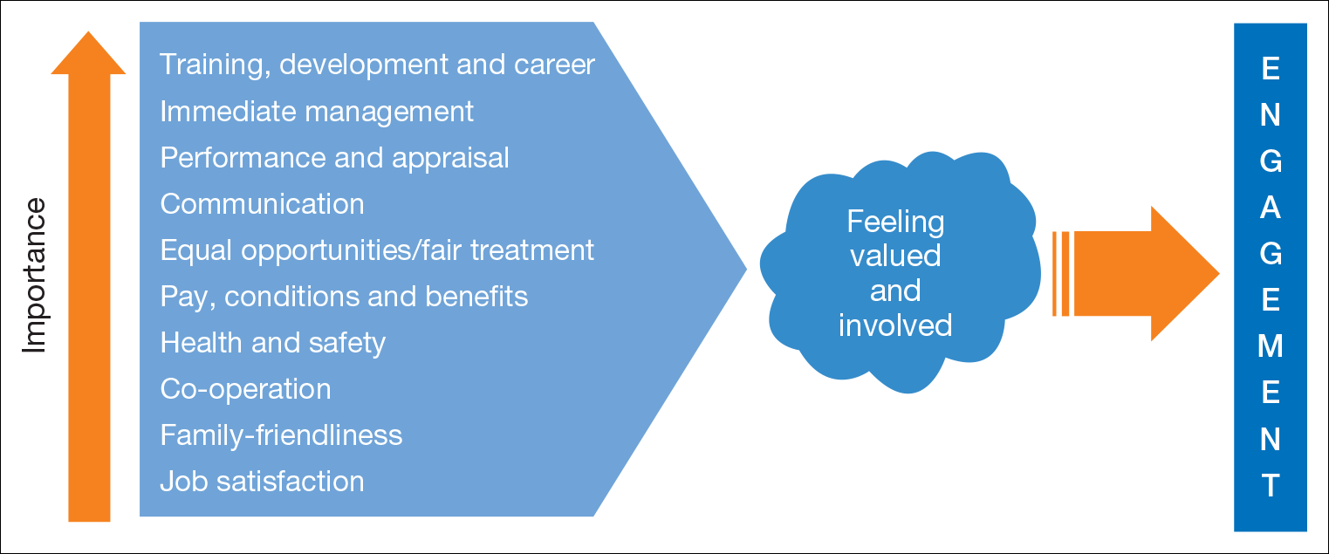
Source: Thompson and Beardwell (2017)

Tools to Measure Employee Engagement

Work from Home
Previous study has indicated that employers are increasingly encouraging employees to work from home to stabilize their professional and personal life (Mas and Pallais, 2017). Several studies have also indicated that employees are willing to accept lower pay in exchange for the flexibility of working from home. The flexibility afforded by a WFH structure in how and when to arrange work around their personal obligations may lessen work-to-home conflicts, commuting time, the incidence of work breaks, arising in lesser notified sickness absence, and the convenience of a calmer office atmosphere (Versey, 2015). In contradiction to these outcomes, some studies suggest that, rather than offering convenience, a WFH model may be a cause of dispute among job and personal duties. The simplicity of use of the WFH format is more assisted by information and communications technology (ICT), which enables for the chronological and spatial flexibility of certain types of work. Employees are more likely to acknowledge ICT if they genuinely think they will be functionally endorsed, according to research. As previously noted, the simplicity of the WFH model offers numerous substantial benefits, like shorter commute hours, less work breaks, fewer reported sick leaves, and a simpler work environment (Mehta, 2021). All these issues lead to high employee efficiency. Aside from employee productivity, research on employee engagement emphasise the need of considering occurrences in an employee's life beyond work.

Flexible Working Time
Once social isolation restrictions are lifted and businesses reopen, employee expectations for flexible hours and virtual office options will become the new normal. Providing flexible work schedules has grown more common as many organisations have discovered how advantageous telecommuting can be for their business or how work hours other than the usual 9-to-5 can be introduced without impacting productivity (Torrington, 2017).
Even during an epidemic, flexible work times may help with recruiting and retention, enhance organisational diversity objectives, encourage ethical behavior, and aid in social responsibility actions. Employers can keep money, improve timeliness and efficiency, and increase employee engagement (Chanana and Sangeeta, 2021).

Employee Value Proposition
EVP outlines what workers may anticipate from a firm in terms of policies, salary, benefits, bonuses, and prospects for advancement. It also specifies what workers are required to do in exchange, such as work hours, responsibility, corporate citizenship, and so on. The EVP explains why workers work where they do and how a firm recruit, engages and keeps its personnel (Wang et al., 2021).
To accomplish people-related organisational goals, executives should be attentive and conscientious of EVP, taking the time to consciously define it. EVP must relate to the Employment Brand and fit with the people strategy. It must also be compatible with how the firm functions, including its projects, programmes, and culture — in other words, organisations must 'talk the walk.'
EVP also entails having a thorough grasp of what is presently being offered to identify and address gaps. This entails learning about workers' genuine impressions – both good and negative – and not simply accepting what they say whenever their boss or HR asks (Mehta, 2021). Acquiring a third party interact directly with workers to get to the base of their views and interpretations is frequently required.
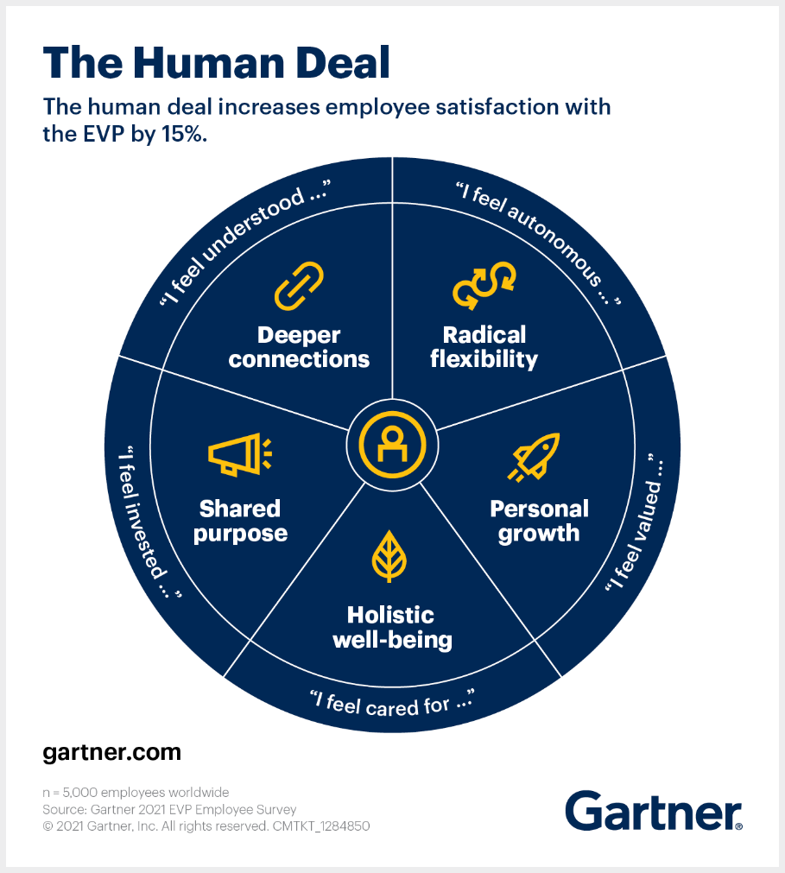
Source: Venkataramani, S. (2021)

Strategies to Raise Levels of Engagement
Firms should make further efforts to make employees think that their organisation is engaged in them to enhance employee engagement during challenging times. Management, according to Formato (2014), is more obvious in difficult moments than in other times. If companies want their employees to be engaged, CEOs must take responsibility and inspire them to achieve the strategic and long goals. A successful communication plan stimulates staff to contribute to their jobs and reach their objectives in difficult conditions. Staff involvement is critical during challenging times, and only competent leadership can accomplish questions through employee engagement and a strong interaction strategy. Personnel want to interact over several channels, and the best way to do it is to use multimedia to deliver information.
Deal et al. (2013) observed that during difficult times, businesses should give supplemental compensation packages as well as equitable and comparable remuneration systems to keep their employees motivated and engaged. Companies also offer employees with all the tools and knowledge they require to achieve their tasks effectively. Managers should offer valuable feedback and instruction to their employees regularly to maintain employee engagement. According to Nienaber and Martins (2020), leaders should efficiently consult with staff about their career advancement so that employees perceive the procedures are fair and equal. Managers should be forthright and aid employees in recognising their growth needs as well as strengthening their talents in the face of adversity. Other recommendations include leaders serving as mentors in tough moments, incorporating employee feedback into your corporate culture, interacting plainly and honestly, supporting your supervisors, and maintaining motivation through outstanding prizes. Thompson and Beardwell (2017) presented various strategies for increasing employee engagement and organisational performance during difficult times. These strategies are:
1. Encourage employees in their hard times by staying centred on the company’s core values.
2. Support employees during their tough times to keep them motivated
3. Encourage employees to share any information freely and openly for their own and others benefit.
4. There should be two-way communication between employees and leaders so that employees can perform effectively.
5. According to Robertson and Cooper (2012), vision must be clear and precise, and it should be well conveyed to employees so that they can gain guidance during difficult times. Organizations should be completely upfront with their workers, this type of transparency fosters employee trust in the business amid challenging times.

Conclusion
Due to COVID-19, employee interest has become critical in today's pandemic scenario. Assuming the top position without the help of the colleagues would be a daft idea in our current condition of lockdown. Organizations recognise that engaged people are the secret to achievement in these trying times. As a result, businesses must devise strategies to keep their motivates employees during pandemics (Pond, 2020). Developing employee satisfaction measurements with the use of technology is vital for company progress in the current situation.

References
Anon (2013) Building a Magnetic Culture: How to Attract Top Employees, Engage Them, and Make Them Want to Stay, in Retaining Great Employees: Tactics for Hanging on to Your Best Talent. Academic Video Online. [Online]. Available from: https://ezproxy.uwtsd.ac.uk/login?url=https://search.proquest.com/docview/1822825936?pq-origsite=summon.
Chanana, N. and Sangeeta (2021) ‘Employee engagement practices during COVID‐19 lockdown’, Journal of public affairs, 21(4), p. e2508–n/a. doi:10.1002/pa.2508.
Deal, J.J. et al. (2013) ‘MOTIVATION AT WORK: WHICH MATTERS MORE, GENERATION OR MANAGERIAL LEVEL?’, Consulting psychology journal, 65(1), pp. 1–16. doi:10.1037/a0032693.
Formato, B. (2014). Groove Management. [online] Groove Management. Available at: https://www.groovemanagement.com/blog/why-employee-engagement-is-so-critical-during-tough-times [Accessed 20 Jan. 2022].
Mas, A. and Pallais, A. (2017) ‘Valuing Alternative Work Arrangements’, The American economic review, 107(12), pp. 3722–3759. doi:10.1257/aer.20161500.
Mehta, P. (2021) ‘Work from home—Work engagement amid COVID‐19 lockdown and employee happiness’, Journal of public affairs, 21(4), p. e2709–n/a. doi:10.1002/pa.2709.
Nienaber, H. and Martins, N. (2020) ‘Exploratory study: Determine which dimensions enhance the levels of employee engagement to improve organisational effectiveness’, TQM journal, 32(3), pp. 475–495. doi:10.1108/TQM-05-2019-0151.
Phin, D. (2017) Employee Engagement. Carpenteria, CA: linkedin.com
Pond, K. (2020) Insolvencies in the era of COVID 19.
Robertson, I. and Cooper, C. (2012), ‘Job and work attitudes, engagement and employee performance: Where does psychological well-being fit in?’, Leadership and Organisational Development Journal, 33, 2: 224–32.
Thompson, A. and Beardwell, J. (2017) Human resource management: a contemporary approach. Eighth edition. Harlow, England: Pearson Education Limited.
Torrington, D. (2017) Human resource management. Tenth edition. Laura Hall 1952- author., Stephen Taylor 1965- author., & Carol Atkinson author. (eds.). Harlow, England: Pearson.
Venkataramani, S. (2021) Employee Value Proposition (EVP) Postpandemic Should Focus on the Why, Gartner. Available at: https://www.gartner.com/smarterwithgartner/make-way-for-a-more-human-centric-employee-value-proposition.
Versey, H.S. (2015) ‘Managing Work and Family: Do Control Strategies Help?’, Developmental psychology, 51(11), pp. 1672–1681. doi:10.1037/a0039607.
Wang, B. et al. (2021) ‘Achieving Effective Remote Working During the COVID‐19 Pandemic: A Work Design Perspective’, Applied psychology, 70(1), pp. 16–59. doi:10.1111/apps.12290.

