Demilade Ayo-Famola 2304836

GENERALISTS AND SPECIALISTS’ ANIMATION ROLES IN GAMES/VFX/FILM

ANIMATION
A generalist is an animator that has the skills to do multiple things in animation such as lighting, compositing, modelling, and animating while a specialist focuses on a specific field. Specialists animate on what they are most familiar with such as doing hand drawing, stop motion, 2d animation or 3d animation. In recent years specialists have gone out of favour as more companies are requiring employees to be generalists and to be skilled in one than more area and get more task variety. It is also more expensive to hire specialists so instead companies would hire multiple generalists as it is more practical and cost effective. Bigger studios on the other hand are more likely to hire specialists. Specialists also work shorter gigs as they are less likely to be needed to be around for the entire duration of an animation project giving them the opportunity to do a different work. Generalists are seen as freelancers due to them being cheaper and being able to work on a project much longer

VFX
In VFX studios the demand for specialists and generalists are similar to animation studios with smaller studios demanding more generalists and bigger studios demanding more specialists. Generalists in the VFX industry still have a broad understanding of how to do multiple tasks but are advice to still have a strong focus on role in order to be able to apply for a role at a big studio. In the industry roles such as environment artists, rigging artists and 3d modeler are the most beneficial for generalists while roles such as FX artist, 3D animator and VFX compositor are the most beneficial for specialists
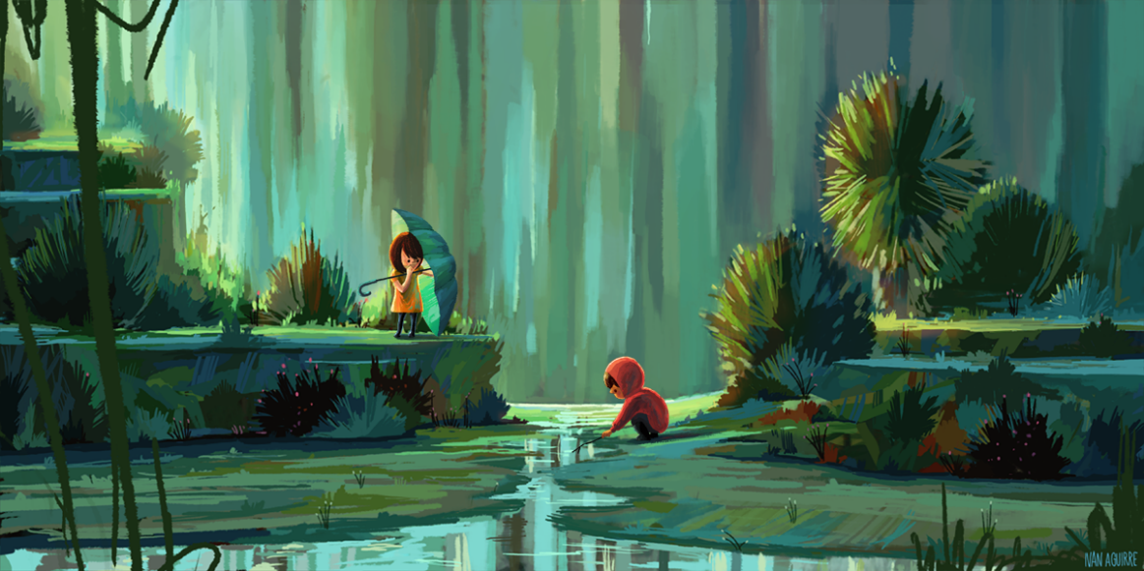
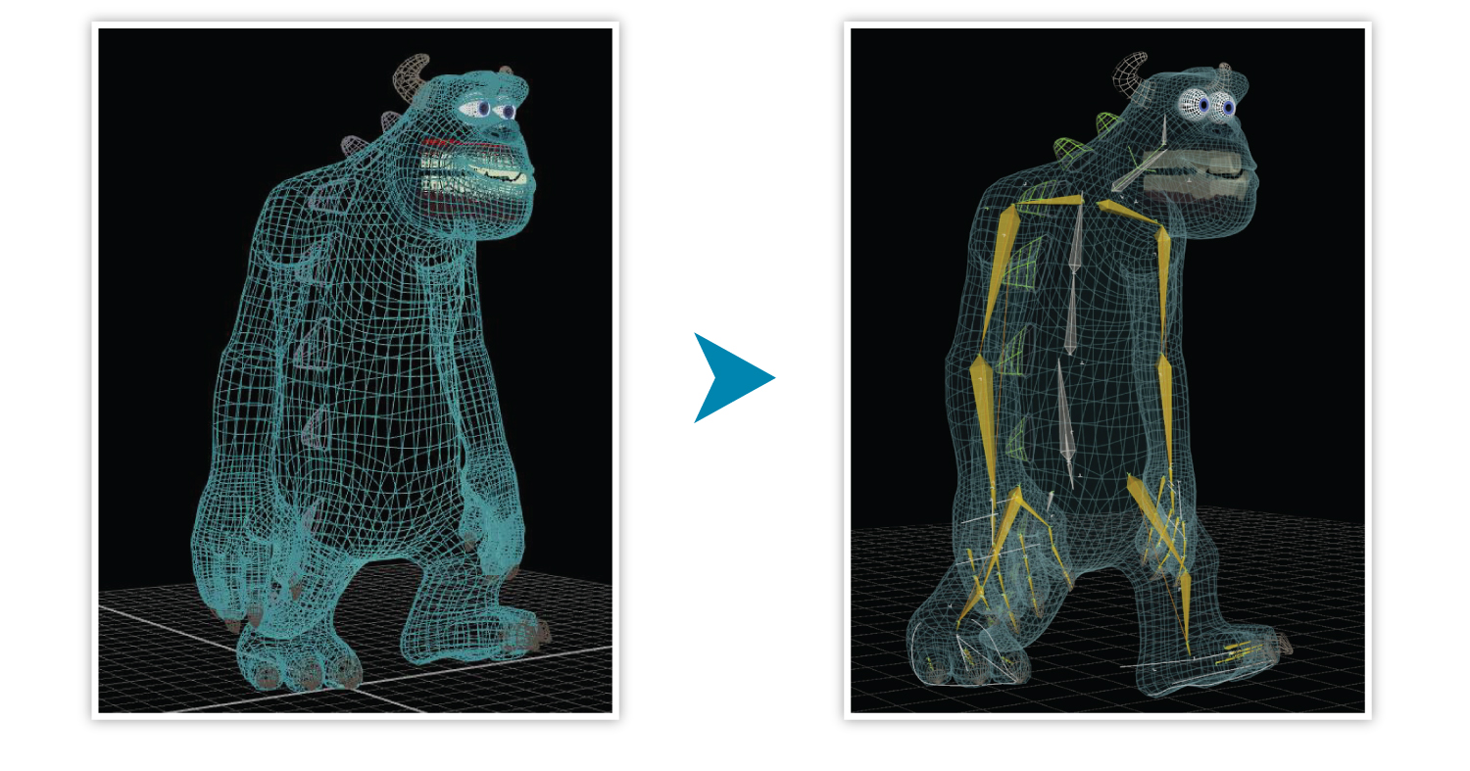
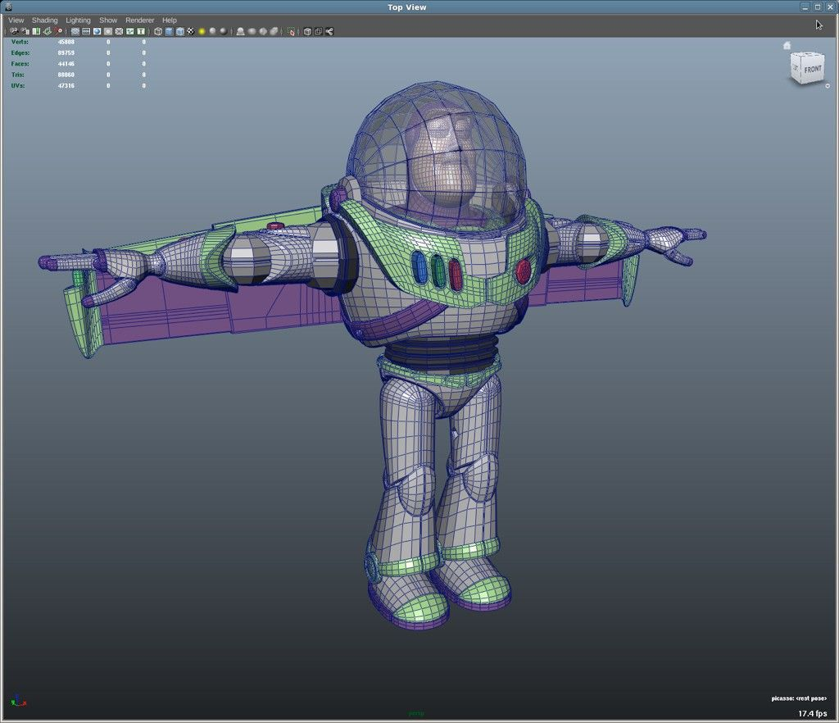

WHAT IM WORKING ON
Ill be doing a rig animation focused on body mechanics. The animation will focus on a human in a storage room attempting to pick up a box and moving it on top of another box.
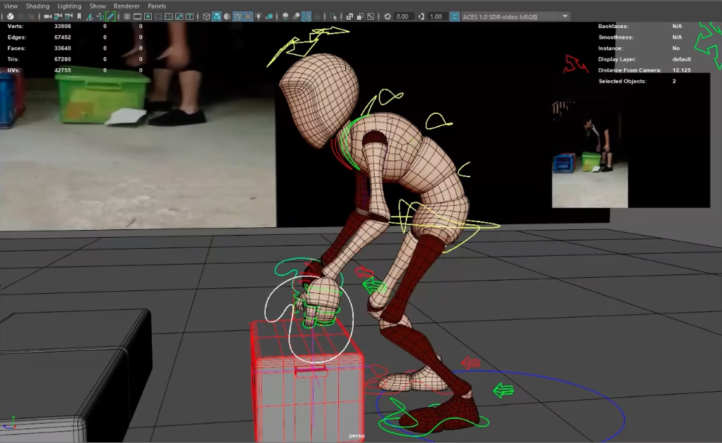
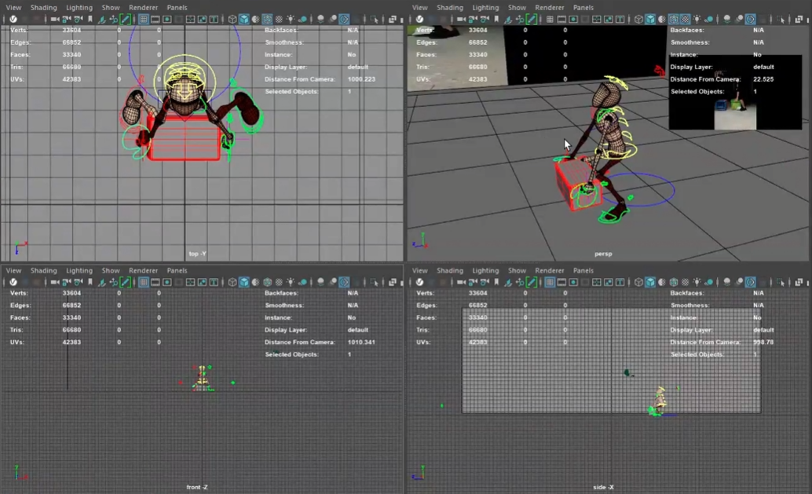
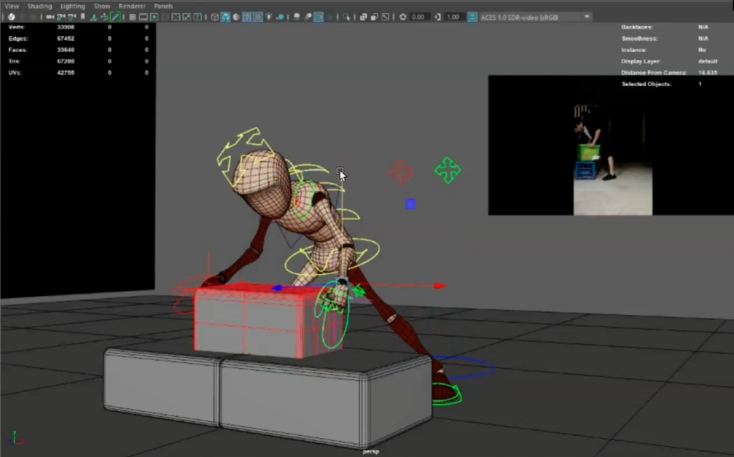

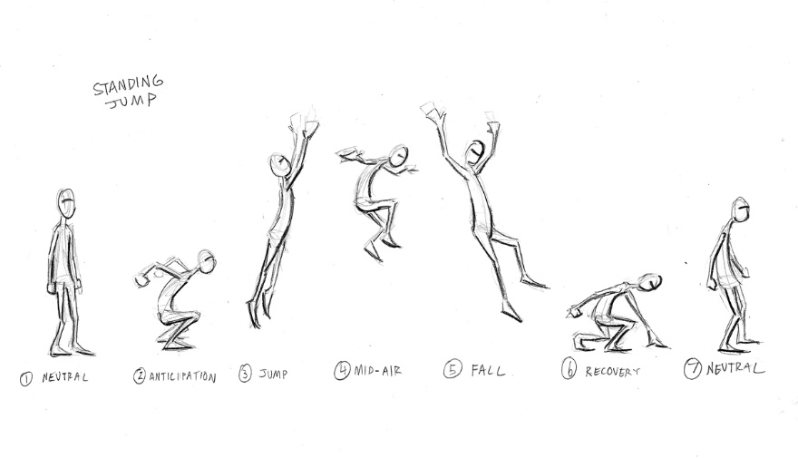

PART 2:
Animation sequence:
https://uowtsd-my.sharepoint.com/:f:/g/personal/2304836_student_uwtsd_ac_uk/EieSIXjjKvdBhDw2qWDDV9cBN9F3AOoRE8wvmIuiAHoA9Q?e=vndM53

Animation maya folder:
https://uowtsd-my.sharepoint.com/:f:/g/personal/2304836_student_uwtsd_ac_uk/EsKJrTW6BOFOrzx7NswArJwBCMCCcykWaLv86l3WY1HUhg?e=jRqUKN

