Table of Content
Introduction 2
Current reward at Hanoi Hat Company 2
Contemporary reward practices 2
Effort- reward model 4
Total Reward 4
Importance of fixed salaries in the total reward system 5
Importance of profit sharing in the proposed total reward system 6
Conclusion 6

Introduction

Employees reward or incentive pay out latter are systems refer to plan from the company to reward performance and motivate employees. Rewards positively affect the intrinsic motivation of employees and help the good relationship between the company and employees. Appreciation is certainly important and essential human being. If the company give poor reward and incentives will dissatisfy employees. (Jones, 2019)

Current reward at Hanoi Hat Company

The Hanoi Hat Company, it is a small company with a simple structure, currently use practice reward, performance-based pay.
Performed base pay means to provide financial compensation on an individual or group performance. (Archer, 2000) The reward in the organisation is a important role in the employee performance. Its system is a very good way for employee engagement and better employee performance in the company. Hanoi Hat pay to the employ for the manufacture hat. Performance – base pay is used normally in manufacture company. (Perryer, 2019)
When the circumstances are great for company and employee performance-based pay is a good structure but the output not always depends of the employees because there is a lot different external and internal factors.
In the case at hand, we can see how by changing the templates of the manufacturing, the employees have to learn how to make the new models, so they waste their time in training and cannot be so fast in the manufacturing. consequently, production is slower and they receive less money. This circumstance is external to the employees and in this case, they are suffering it in their salaries.
This structure encourage employee to work harder, it can cause higher stress levels. By 2017 Human Resource Management Journal revealed that the employee in this type of company only have hard stress and high level of job dissatisfaction. The employees think that this structure is good and encourage good motivation but for other hands most all the time think that the work is to hard and the time is not enough (Gladkov, 2020)

Contemporary reward practices

The function of every company is to attract, retain and motivate employees. (Parke, 1997). Reward strategies can have profound consequences for employee satisfaction, behaviour and performance. There reward is benefits that the company administer to the employees, usually is money, promotion or gift derived from the job, it gives the employees feeling part of the team and positive emotional response.
There is two types of motivation or reward, intrinsic and extrinsic both of them are important for motivation. (Deci, 2000)
Intrinsic reward are the non-physical rewards, cannot be seen or touch but are emotionally connected with the employees, it is also the satisfaction a person gets the jobs itself. The employees can receive a reward when job performance as a successful.
There is a lot of satisfaction when some task takes a lot of effort to performance but in the end, the job is a well done. Also, words are important when they came from the senior and they appreciate the work that you did. The employees can feel the reward when co- worker and other members of the company renowned the work that you have done. Other of the intrinsic reward is when the employee can be freedom and less pressure from the line manager for the continue better output. Offering excessive rewards can actually lead to a decrease in intrinsic motivation. (Motivation, 2020)
In the case at hand, we can see how by changing the templates of the manufacturing, the employees have to learn how to make the new models, so they waste their time in training and cannot be so fast in the manufacturing. consequently production is slower and they receive less money. This circumstance is external to the employees and in this case, they are suffering it in their salaries

Extrinsic reward is when the employees reward come from the external source it can be financial or non- financial such as pay raises, bonuses and other benefits. (Anon., 2019) It is directly related to the job performance.

This modern theory is the most relevant and useful by Edwin Locke , it is good for setting goals in the organization. Employees need to know the desired result and goals setting has been used as a way of improving organization and personal performance.
There are five principles goals setting in order to motivate employees: Clarity, Challenge, Commitment, Feedback, Task complexity. (Buonarroti, n.d.)

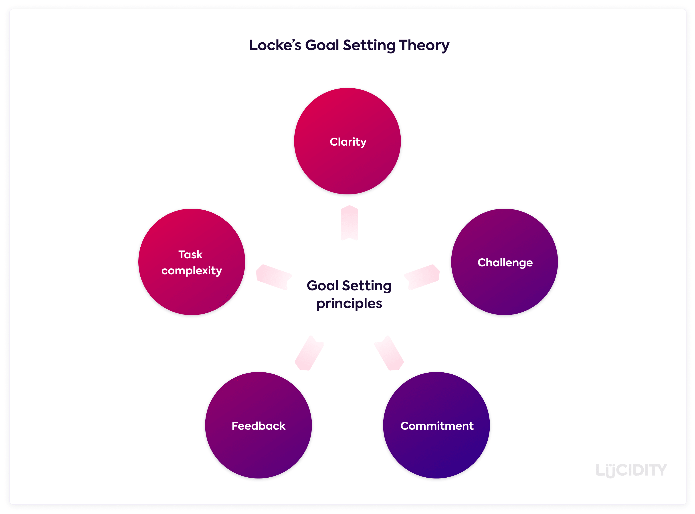

Effort- reward model

This model is base of work stress, job termination or job instability so condition of reward are low and low security. For the employees in this case are as well low mobility, lack of promotion or growth at job and held with inconsistent education background. Also, includes piecework, shift work, noise, work pressure, and increase in workload. The employees feel frustrated but continued efforts and associated negative feeling appears the vulnerability and the employee experiences came be of high demand and low status control. (Wigger, 2011)
The reward in this model is provide by appropriate salary, sufficient respect, support and jobs status consistency.
The effort – reward explain is that the effort need to be complete by reward.

This is the reward model that is represented in Hanoi Hat Company. The workers are paid according to the number of hats they manufacture without being limited. This makes employees work much harder to get the amount of salary.
Although the employees had assumed the work and the benefits for their work. In this type of model, the external and internal factors of the company are not controlled by the worker. When the company grew and the manufacturing plan changed, the employees saw their salaries reduced and their dissatisfaction became more visible.
The line managers of the company do not want to change the type of model because they would be losing power in front of their employees. Currently they are working without a human resources department and they are in charge of all the problems that exist.

Total Reward

Every company need a plan of Rewards. this strategy takes commitment and engage employees in the shape of loyalty to and identification with the firm, it has been around for a long time (Armstrong, 2012)
Total reward encompasses not only compensation and benefits but also personal and professional growth opportunities and a motivating work environment.
By Manus and Graham (2003) total reward include all types of reward indirect as direct, intrinsic as extrinsic. (Armstrong, 2012) some element such a healthcare and pension, training and development.
Total Reward is the tool that employer should be use to attract, retain , motivate and satisfy employees.
The benefits of this model are the great impact because the different of reward will make motivation and commitment of people, compelling future of employees is part of this benefit they want to feel that the organization have a positive vision in The future and set values that they can support it.
Improving relationship, the employees with the firm and the flexibility to know individual need. The individual growth is one of the benefits in this model. The employees want the opportunities for training and development in the company. The organization need to prepare the employees to fill the positions available. (Silverman, 2003)
Talent management that mean the relation reward delivery a positive phycological. So the organization became a employees choice because is a great place to work and thus attracting and retaining the talent people. The employees need to understand the role is relates to the organization goal.
In this model the company has total pay comprises basic pay, performance-related pay, benefits and recognition. Also, this model reduce the cost of the employees in the firm.
First Phase is assessment , the manager evaluate the organisation’s and analyze the potential rewards systems and work in generate ideas for improve. (Heneman, 2007)
Secondly the firm designed, implemented and evaluated changes to those system and they will decide which type of reward to offer. The team will think about the whole range of reward that the company can give to its employee like compensation, benefits, personal and professional development and work environment.
Execution is the implementation process, today every member of the company can have reward from the highest to the lower level.
The last is the most important phase is Evaluation, in this step the team compared and make sure that the reward strategies is work with the desired result.

The best workforce deal in an organization is that the employer and employees meet halfway. The organization invest in people and people learn a new skill to reach the organization goals. (Silverman, 2003)

After employee dissatisfaction with current wages due to its pay model, which was focused on efford - reward, the company runs into a problem. Currently, employees receive more training because they manufacture limited units of product and have to be trained from each one of them, which means that employees never become experts in that type of product, but the company is collaborating with international companies and its profits are gradually increasing.
The total reward is one of the most productive ways to engage employees, be happy in their jobs and with the company. This model proposes monetary and non-monetary compensation in our company to be dealt with. Currently, there is no salary for employees, this could be a source of motivation, also, each training that they carry out is giving value as a person and are giving value to the company. The training that company employees receive costs the employer money, this is a way of investing in the workforce.

Importance of fixed salaries in the total reward system

The people work for money and the salary is the amount of pay that the firm gives to its employees for the job, it can modify depending on the position in the company, as a grade of the job and level of skill required.
To have the attractive e salary, the company need to measure the market internal and externally.
External means that depend of the job and location the company, the firm need to have a equity salary as the competition firm, it need to have a salary rate. Internal is a job evaluation inside the company. (Armstrong, 2012)
Salary and rewards covers all benefits that the company offers its employees.
The salary needs to be similar to the national living wage and the minimum wage a additional viable pay and reward system is really important to recruitment new staff, engaging employees. (Anon., 2020).
People generally think about annual salary and pay level give value for money to the organization.
The salaries might use pay scales to determine the wage a worker, it is entitled also the organization need to pay according to the skill and qualifications of every employee.
Avoid pay disputes is essential for the company, it can give a negative effect on the staff morale, normally it is happening because the company make a change about a pay rise or any payment issues concerning pay swiftly.

The problem that concerns us in the Hanoi Hat Company is that the employees are having a less salary because they changed the way of manufacturing. This produces unsatisfaction in the workplace. The general manager of the company has proposed to the rest of managers that to end the dissatisfied, they should have a human resources department in the company. This department should set a fixed salary for employees and make an incentive plan for when employees exceed the manufacturing target.

Importance of profit sharing in the proposed total reward system

Profit-sharing is a tool for improving the productivity and profitability of the firm, for this reason, the firm uses to become competitive in the market.
Employees are motivated by different factor, the company need to study about the intensity and which kind of reward for performance should be used. (Fibirova Jana, 2013)
Profit-sharing is an incentivized compensation program that awards employees a percentage of the company's profits. The amount awarded is based on the company's earnings over a set period of time, usually once a year. Unlike employee bonuses, profit sharing is only applied when the company sees a profit.
It is important when the focus of the organization is big amount of profit. The employees need to have understanding their mission statement and the metrics are that drive business success. (Robertson, 2007)
This kind of model is suitable for big organization with people the same role, like manufacturing plant because the staff contribute equally.
The unique inconvenient in the model is that if the company have capital investment has the potential negative impact on the amount for distribution.
The managers of the company ensure that the staff understand the link between payment and results that means that the amount can modify from one year to the other. The company should be careful not to be the goals so high because if the employee does not receive the payment for several years they will lose the interest.

In the Hanoi Hat Company, currently, the employees do not receive any benefit from the company, they simply get salaries for what they work. This model could change the perspective of the company. Employees would have a salary and could participate in the benefits generated by the company. This model is used for companies like the ones we are studying since they are large companies and have many workers in the same position. If the company decided to install this type of model, every year, it should be very clear with the accumulated benefits and what would be the percentage that each employee would receive. It is a way of motivating employees and that together with the company they can work towards the same goal.

Conclusion

