Butterworth Design
Fc = 10kHz, Order = 6
C =1nF
R = 1/(2*pi*10k*1n) = 15915.4 = about 16k
These R’s and C’s are identical for ALL stages in our filter – only the gain resistors will be different.
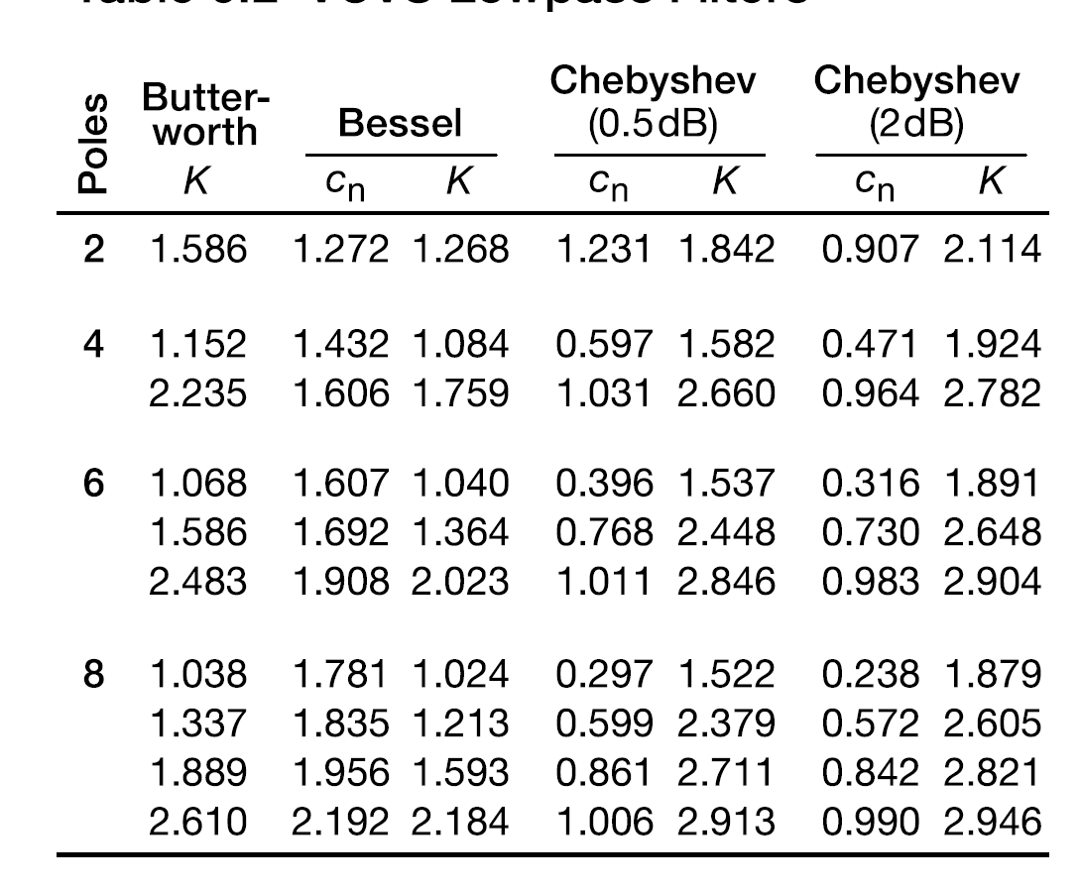
Copied from Art of Electronics – Horowitz & Hill p.408
From the table, our k values need to be 1.068, 1.586 and 2.483
$$k=1+\frac{R2}{R1}$$
$$\frac{R2}{R1}=k-1$$
Choosing R1 = 10k, we can calculate R2
$$R2=R1\left(k-1\right)$$
This means our feedback resistor values will be:
Stage 1 R2 = 10k*(1.068 – 1) = 680
Stage 2 R2 = 10k * (1.586 – 1) = 5860 = 5k6
Stage 3 R2 = 10k * (2.483 – 1) = 14830 = 15k

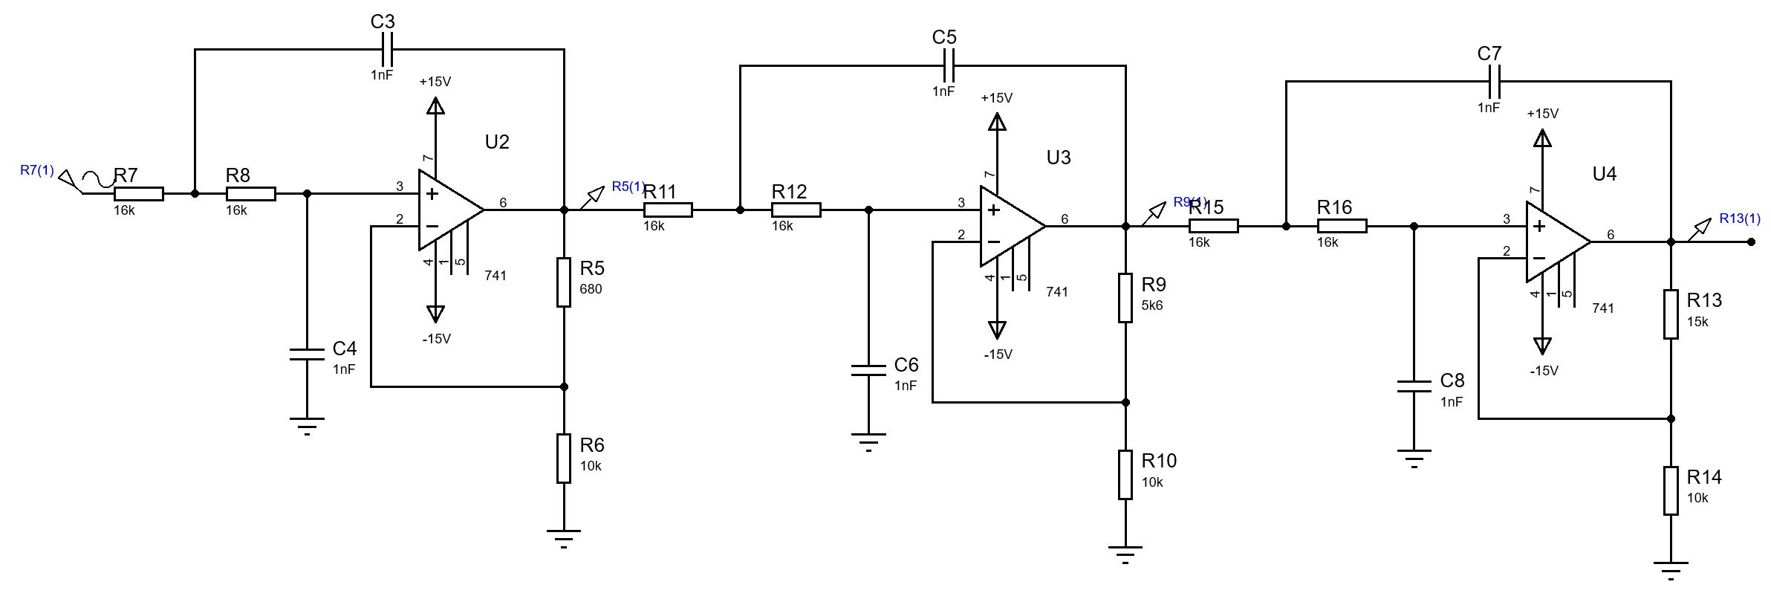
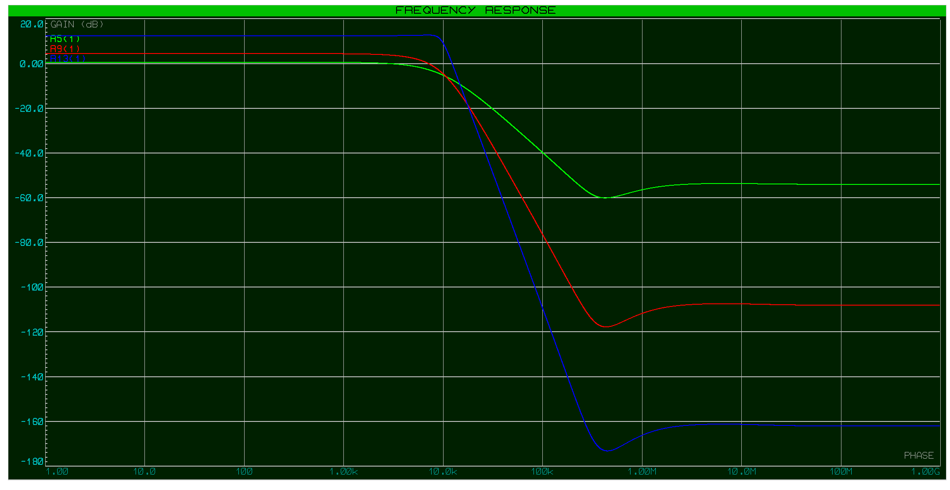

Bessel Design
Fc = 10kHz, Order = 6
C =1nF
R’s will be different for each stage
$$R=\frac{1}{2πf_{c}c_{n}C}$$
Stage 1 R = 9903.85 = closest = 9k98
Stage 2 R = 9406.32 = closest = 9k42
Stage 3 R = 8341.45 = closest = 8k35

From the table, our k values need to be 1.040, 1.364 and 2.023
$$k=1+\frac{R2}{R1}$$
$$\frac{R2}{R1}=k-1$$
Choosing R1 = 10k, we can calculate R2
$$R2=R1\left(k-1\right)$$
This means our feedback resistor values will be:
Stage 1 R2 = 10k*(1.040 – 1) = 400 closest = 390 – this is too low, we need to increase this value. Choose R1=100k, R2 = 3k9, this is a bit better.
Stage 2 R2 = 10k * (1.364 – 1) = 3640 closest = 3k6
Stage 3 R2 = 10k * (2.023 – 1) = 10230 closest = 10k2

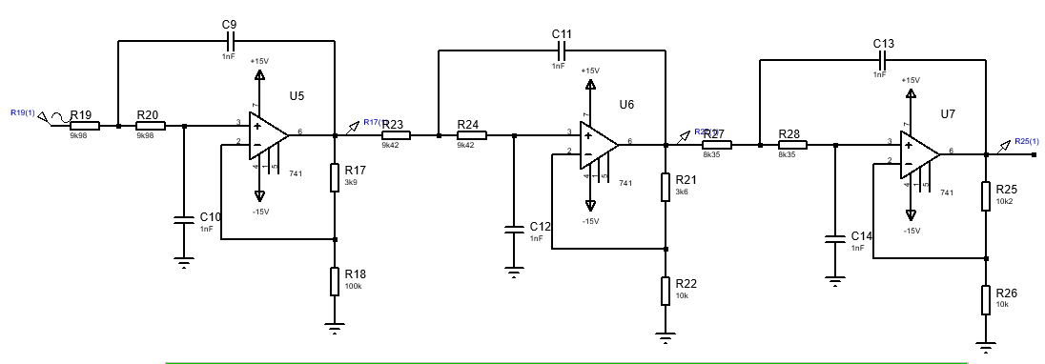
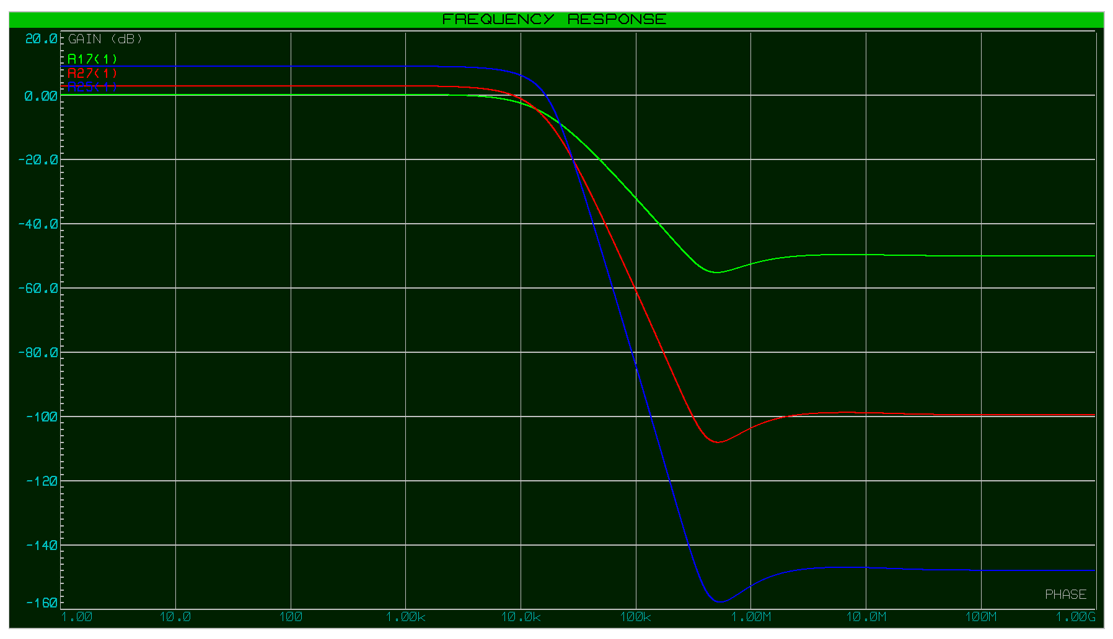

Chebyshev Design (2dB)
Fc = 10kHz, Order = 6
C =1nF
R’s will be different for each stage
$$R=\frac{1}{2πf_{c}c_{n}C}$$
Stage 1 R = 50365.488 = closest = 50.5k
Stage 2 R = 21802.047 = closest = 21.8k
Stage 3 R = 16190.737 = closest = 16.2k

From the table, our k values need to be 1.891, 2.648 and 2.904
$$k=1+\frac{R2}{R1}$$
$$\frac{R2}{R1}=k-1$$
Choosing R1 = 10k, we can calculate R2
$$R2=R1\left(k-1\right)$$
This means our feedback resistor values will be:
Stage 1 R2 = 10k*(1.891 – 1) = 8910 = closest 8k87
Stage 2 R2 = 10k * (2.648 – 1) = 16480 closest 16k5
Stage 3 R2 = 10k * (2.904 – 1) = 19040 closest 19k1

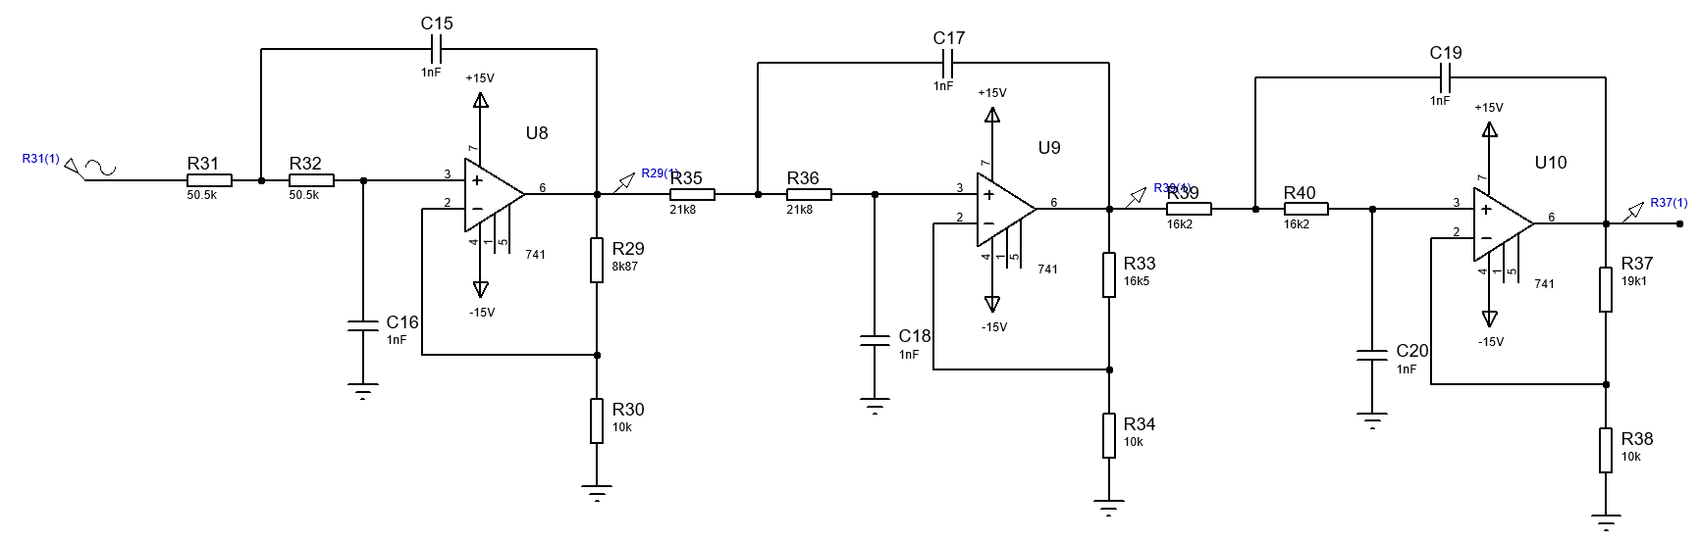
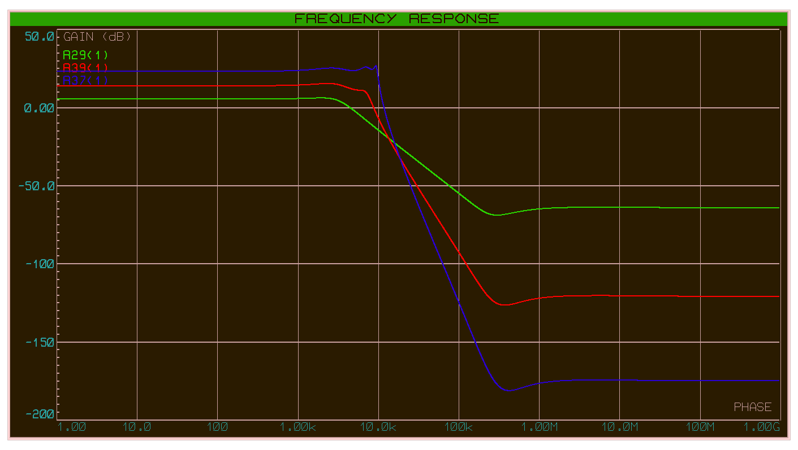

Comparison


