TITLE.
Does the nature and standard of Post Graduate Certificate in Education (PGCE) science students’ prior qualifications at level three and above have an impact on their final Qualified Teacher Status (QTS) standards?

Peter Joseph Lloyd.

Submitted in partial fulfilment of the requirements for the degree of MA (Education). University of Wales Trinity Saint David.
20.3.2020

Abstract.
In Wales, there is a shortage of qualified science teachers. As a result the Welsh Government have directed the Education Workforce Council to increase the student target numbers of university providers in Wales who have been accredited to provide Initial Teacher Education (ITE) courses in biology, chemistry and physics. The implications of these increased targets will require providers to recruit far more science student teachers than in recent years. This case study analysed students’ prior qualifications at levels three and above and their effect on students’ final Qualified Teacher Status (QTS) standards. It also investigated the effect on QTS standards when students entered science ITE courses from non-traditional scientific degree backgrounds. The study concluded that although all students were successful in gaining QTS, the nature of their previous qualifications did affect the QTS standards that they achieved. The outcomes of the study are discussed along with recommendations for future admissions protocol and science ITE curriculum reform.

DECLARATION

This work has not previously been accepted in substance for any degree and is not being concurrently submitted in candidature for any degree.

Signed P Lloyd. (candidate)

Date 20.3.20

STATEMENT 1

This dissertation is being submitted in partial fulfilment of the requirements for the degree of MA(Education). University of Wales Trinity Saint David.

Signed P Lloyd. (candidate)

Date 20.3.20

STATEMENT 2

This dissertation is the result of my own independent work/investigation, except where otherwise stated. Other sources are acknowledged by footnotes giving explicit references. A bibliography is appended.

Signed P Lloyd. (candidate)

Date 20.3.20

STATEMENT 3

I hereby give consent for my dissertation, if accepted, to be available for photocopying and for inter library loan, and for the title and summary to be made available to outside organisations.

Signed P Lloyd (candidate)

Date 20.3.20



MA(Ed) Dissertation
Word Count

I confirm that the word count for my MA(Ed) dissertation (excluding appendices and reference list) is:

......................................................

Signed: P Lloyd

Contents:
Introduction
Literature Review
Methodology
Analysis and Findings
Conclusions and Recommendations

TITLE.
Does the nature and standard of Post Graduate Certificate in Education (PGCE) science students’ prior qualifications at level three and above have an impact on their final Qualified Teacher Status (QTS) standards?

Introduction
In Wales, Initial Teacher Education (ITE) programmes are accredited and regulated by the Education Workforce Council (EWC). From September 2019, all ITE programs in Wales will be assessed and monitored against Welsh Government accreditation criteria (EWC, 2019). The accreditation of institutions’ will be conducted by the EWC. At present, there are six universities throughout Wales that have been accredited to deliver one-year Postgraduate Certificate in Education (PGCE) courses for prospective secondary school teachers. I am currently employed as an ITE science lecturer in one of the accredited universities in South Wales. For purposes of anonymity, and in accordance with BERA guidelines (BERA, 2018), this will be referred to as university X in the remainder of this document. Annual intake targets for recruiting PGCE students are set by Welsh Government. These intake targets are based on the demand for teachers in subject areas. Target numbers are then assigned to the accredited universities. Based on previous intake numbers the future intake targets could be interpreted as ambitious. In order to achieve the intake figures for September 2020 university X would need to recruit 63% more biology PGCE students, 83% more chemistry PGCE students and 140% more physics PGCE students. These figures are based on the current student numbers for the 2019 to 2020 cohort (EWC, 2019a).
At present the entry requirement to the science PGCE courses are a minimum of a lower second-class honours degree in an area closely related to the chosen secondary subject (usually at least 50% of the degree). Candidates will also, potentially, be considered if they hold A levels, or other, level 3 qualifications, in the sciences and additional successful scientific study at an appropriate higher level.

Context
In recent years, the growing need for teacher training universities in the United Kingdom (UK) to train more secondary science teachers has appeared as a familiar news headline (BBC, 2017; BBC, 2018; BBC, 2019a).
There is a recognised global shortage of Science, Technology, Engineering and Mathematics (STEM) teachers. This is particularly acute in the science disciplines of physics and chemistry (Hillier, de Winter and Twidle, 2013). Much has been written about the decline of science in secondary schools in the UK and the resultant negative effect on the UK economy (Smith, 2011). Fears of a STEM skills shortage and the adverse effect on the UK economy were also outlined in a report of the same year by the Confederation of British Industry (2011). In addition, it has also been estimated that the increasingly technological driven changes in UK society will amount to more than 7 million jobs in science-based industries in the UK by 2030 with a potential shortfall in the required workforce (Kirby and Cullinane, 2017).
The shortage of science teachers (particularly physics and chemistry) has also been recognised in the UK for over the past three decades with many reports highlighting problems both with recruitment and retention of suitably qualified teachers in shortage areas (Constable,1999, Smithers and Hill, 1989, Smithers and Robinson, 2008, Gill and Bell (2013).
Furthermore, a report by the Royal Society (2011) highlighted that the number of schools and colleges in the UK offering A level physics had declined. In addition, the report concluded that a maximum number of students that could study physics post sixteen would be reached unless further teaching capacity is created. Other researchers, such as Gill and Bell (2013) also reported that unless the number of qualified physics teachers in the UK increases, post 16 physics provision will be compromised.
In addition, according to a recent study by Sibieta (2018) on the teacher labour market in the UK, there are significant recruitment and retention problems across all STEM subjects. Whilst the number of teachers has remained stable since 2010, the number of pupils has risen by 10 per cent. This is set to rise by a further 15 percent in secondary schools by 2026; yet applications for teacher training courses are currently falling. Sibieta (2018) reports that only 70% of training placement targets in STEM subjects were filled in 2017-18. In addition, targets in shortage science subjects such as physics and chemistry are being missed by an increasing figure over recent years exacerbating the recruitment problem. The study concludes that the teaching labour market faces severe challenges over the next few years, particularly in STEM areas in secondary schools.
This report also highlights that these challenges are further compounded by the number of STEM teachers leaving the profession. These exit rates have been increasingly concentrated early in teachers’ careers with only 50% of Physics teachers remaining in state schools in the UK five years after starting training. Another study of 80 STEM teachers by Hillier (2013) found that excessive workload and pressure to meet targets were increasingly becoming the overriding factors for teachers to leave the profession. Whist all 80 participants in the study found the profession to be ‘rewarding’ none of them expected to be teaching until retirement age.
Simms (2019) reported that a shortage of specialist science teachers in UK science departments has also shown to increase overall teachers’ workload in those departments, as more teachers will be required to teach subjects outside of their specialism. Simms (2019) also concluded that this was also proven to increase the chance that a teacher will leave that school. Another UK based study by Bélanger and Broeks (2016) found that 19.6% of STEM teachers left the profession in 2014, which was almost double the national average of 10.6%.
These problems are not unique to the UK. A major STEM initiative currently exists in the United States of America (USA) introduced in 2008 by the then president Barack Obama. Land (2013) explains that this was based on the belief of many professionals that by focusing on key STEM subject areas, students would be equipped to propel the global competitiveness forward by the development of innovative ideas. Land (2013) also reported that in 2013, the STEM job market in the USA was growing three times faster than the rest of the economy and therefore, without an investment in STEM subject areas this exponential growth would lead to a shortfall in the workforce.
In Australia, a successful STEM education system is seen as pivotal for future success (Timms et al 2014). Their report concluded that STEM skills are deemed necessary to solve world challenges and complex global problems and that the need for a skilled STEM workforce is necessary to compete globally. Timms et al. (2014) also reported that there had been shortcomings in STEM education in Australia for almost two decades. As a result, a ten-year National STEM School Education Strategy was endorsed in 2016 with the vision of increasing STEM teacher capacity.
In order to address shortfalls in STEM teacher capacity, both countries have implemented strategies to attract STEM teachers to the profession (Hoyle, 2016). These have largely comprised of financial incentives (bursaries) to attract prospective teachers to train in shortage STEM areas. There have also been incentives to teach in geographical areas in both countries that have experienced difficulties in recruiting teachers. A similar system has been adopted in the UK. Currently, prospective science student teachers in the UK can apply for a subject specific bursary. Further bursaries are also available to teach in schools that have traditionally experienced some difficulties in recruitment, such as Welsh and Gaelic language schools. In England, students with a first or second-class bachelor’s degree (or a higher degree such as a masters or a doctorate) in biology, chemistry or physics are eligible to a tax-free bursary of £26 000 (Gov.uk, 2020). The English bursary system has also been adopted by Northern Ireland (NIdirect, 2020). In Scotland, students’ with a first or second-class bachelors’ degree (or a higher degree) in chemistry or physics (but not biology) are eligible to a tax-free bursary of £20 000 (Teach in Scotland, 2020). In Wales, the bursary depends on the student’s prior qualifications and choice of subject. Students with a first-class degree (or a higher degree) in chemistry or physics are eligible to a tax-free bursary of £20 000. Students’ with an upper second-class degree in chemistry or physics are eligible to a tax-free bursary of £10 000. This reduces to £6000 for lower second-class degree students. There is also a bursary of £6000 for biology students’ who hold a first-class degree or higher. An additional £6000 is also available to students who study the course through the medium of Welsh (Gov.Wales, 2020). One of the aims of this dissertation is to determine whether the grade of a student’s degree influences their performance on a Post Graduate Certificate of Education (PGGE) science teacher-training course.
There are global reports that suggest that the bursary schemes have been a success. Cowan et al. (2016) report that targeted bursaries reduced the attrition of teachers in targeted shortage areas in USA schools in North Carolina by 17%. However, they add that further refinement of policy that acknowledges the specific nature of teacher shortage areas is needed if long-term shortages are to be reduced.
A study by Timms et al. (2018) considered the introduction of bursaries in Australia to be generally successful. However, their findings must be interpreted with caution, as there is no evaluation as to the extent that incentives have attracted teachers to the profession who would have already done so anyway in the absence of bursaries.
In the UK, financial incentives to train to teach in shortage areas have been in existence for over three decades. The findings of a study by Smith (2010) concluded that even a decade ago, twenty years after their implementation, financial incentives to attract student teachers to train in shortage subject areas had not placed the workforce in a better position. A more recent report by the Department of Education, School Teachers’ Review Body (2017) raised concerns about the efficacy of bursaries to attract trainee teachers. The report concluded that there was no guarantee that the trainees’ would follow a career in teaching after receiving the bursary. Concern was also raised about the cost of the bursaries, which amounted to 0.7% of total teachers’ pay. Sibieta (2018) also reports that there is no direct evidence to suggest that bursaries have led to an improvement in recruitment. Furthermore, this report also concludes that bursaries have not been conditional and because of this, students will not necessarily entre the teaching profession on completion of their PGCE.
According to Britton et al. (2016), science and engineering graduates generally earn more in other employment sectors outside teaching and will, therefore, be less likely to choose a career in teaching. In contrast, arts and humanities graduates tend to earn a better salary by choosing teaching as a profession. A report by Sims (2018) provides some qualitative data to support this. In 2018, the median salary for a physics teacher was £31 600. The median salary for a physics graduate working outside the teaching sector was £38 000, a shortfall for physics teachers of £6400. In the same year the mean salary of a history teacher was £34 000. The median salary for a history graduate working outside the teaching sector was £29 400, an increase for history teachers of £4700.
Again, this is not unique to the UK teacher workforce. A study of Australian schools by Timms et al. (2018) reports that STEM graduates have better opportunities outside teaching, and would therefore be less likely to consider teaching as a career or more likely to leave teaching. The report proposes that increasing teachers’ salaries in shortage areas could be a possible solution to address the problem. Further evidence from a study by Wang (2007) in Asian schools also reported that paying teachers in shortage subject areas more did make a difference. Furthermore, the study reported that teaching salaries in countries that experience difficulties recruiting in shortage areas, such as the UK, are lower than those that do not report recruitment difficulties. Countries such as South Korea, Japan and Taiwan, who offer financial incentives in STEM areas, are reported as having sufficient teachers. The study concluded that where there are recruitment issues, governments need to provide sufficient remuneration salaries for teachers. Similar findings are outlined in a study by Cowan et al. (2016) where evidence from the United States suggests that even modest salary increases of five per cent are effective in attracting teachers to the profession and in reducing teacher attrition. More generous bonuses of twenty thousand dollars, or more, have also been effective in attracting teachers to work in high-poverty areas.
However, other authors have challenged claims that salary supplements are effective in recruiting teachers in shortage subjects. Researchers such as Milanowski (2003) suggest that increasing teachers’ salaries would be of minimal effect as the overriding factor in choosing a career in teaching is whether or not that person would enjoy working with children. This view is also supported by Watt and Richardson (2008) who also reported that the desire to work with children was the most influential factor in choosing a career in teaching. Evidence in a more recent report presented by Hillier, de Winter and Twidle (2013) found that a significant number of student teachers had not considered teaching as a career until they experienced teaching in a school environment as an adult. This was commonly achieved by taking an education module as part of their undergraduate degree. They reported that the positive experiences that the students’ encountered in the school environment were far more important factors in motivating undergraduates to consider a career in teaching than financial incentives. They also added that this route of integration into the teaching profession seemed to be beneficial to the long-term retention of these students as teachers. A report by Sibetia (2018) also questions the holistic effectiveness of financial incentives. This report points out that schools in the UK do have the freedom to make salary supplements. However, they would have to self-fund these increments, which could produce additional financial problems in other areas.

As discussed above, there exists a growing shortage of STEM teachers. Williams (2011) outlined the STEM skills debate as a major global issue that is largely influenced by developments in the UK and the USA with Commonwealth countries tending to follow the lead of the UK and some European and Asian countries rather that of the USA. In addition, the study reports that future STEM curriculum initiatives will be pivotal to the economic success of countries in the future. However, some researchers have questioned the broad aims of a STEM driven curriculum. Wong, Dillon and King (2016) argue that it would only be a small percentage of students for which further study would be a realistic option; this would suggest that the curriculum is planned with the needs of a minority in mind. Millar (2014) also notes that influential scientific bodies have succeeded in prioritising STEM education for a minority group. He adds that it is difficult to deliver an effective balanced education system for learners based on the needs of an industry that will only employ a small percentage of the population. These ideas are also held by other researchers. Charette (2013), for example, reports that as lifetime expectancies are getting longer, today’s students are likely to have at least three distinct careers before they retire. The same report recommends that a curriculum should be developed that will ensure that all learners are literate in a broad range of subjects to enable them to have the best possible foundation for future careers and for transition to alternatives. Pitt (2009) also questions the morality of exposing all learners to a STEM curriculum, when only a small percentage will continue into STEM based employment. In England and Wales, the introduction of the National Curriculum in 1989 ensured that science became a compulsory subject for all schoolchildren in maintained schools to the age of 16. However, a report by Smith (2010) concluded that there is no evidence to suggest that these reforms have achieved a lasting impact on the number of pupils studying science to higher levels.

Aims and Rationale
The ambitious EWC targets previously outlined have put increased pressure on ITE providers in Wales to train more science teachers, particularly in chemistry and physics. The physics and chemistry targets for the number of PGCE students to be trained at university X from September 2020 amount to more than the total number of students trained in those subject areas over the past two years.
If the new intake targets are to be met, the entry requirements of university X will need to be examined and candidates from non-traditional backgrounds, with a wider range of qualifications than those accepted in previous years will need to be considered. This study will aim to inform admissions tutors and subject tutors at university X what previous qualifications prospective candidates need to ensure success on the science PGCE courses.
This study will be based on data obtained from previous cohorts of PGCE science students at university X. Firstly, the study will aim to determine whether the quality, and quantity, of students’ level 3 qualifications (A Levels, BTEC etc.) affected their final Qualified Teacher Status (QTS) standards. It will also analyse if the quantity and quality of their level 3 science qualifications affected their final QTS standards.
The second aim will be to analyse if there is a correlation between the standard of students’ degree qualifications (level 6 and above) and the final Qualified Teacher Standard (QTS) that they achieve at the end of their PGCE. The analysis will consider the standard and type (scientific and non-scientific) of students’ qualifications.
The third aim will be to ascertain if there is a single overriding factor that influences students’ success at QTS. In order to achieve this the study will analyse the students’ choice of pathway (biology, chemistry and physics) and ascertain whether students who follow a particular pathway are more likely to achieve higher final QTS standards.
Much work has been undertaken at university X focussing on improving science PGCE students’ ‘Subject Content Knowledge’ (SCK) which is measured in the second of the five separate strands of the QTS standards. The fourth aim will analyse the five separate strands of the QTS standards to ascertain if students are less likely to achieve the higher grades in a particular strand.
Following analysis of the above. The dissertation will also examine potential and future strategies that could be used to assist prospective candidates during and before they embark on their PGCE science studies. It is also envisaged that these outcomes will enable ITE subject lecture and admissions tutors to make more informed decisions when offering placements to candidates on science PGCE courses. The findings of the dissertation will be used to refine both future curriculum developments and my own practice.
The next sections of this dissertation will review the literature that is currently available on this topic. The methodology of the research will then be outlined followed by the results obtained. An analysis of the results will allow conclusions to be drawn along with discussion of the limitations of the study and future work that may be needed.

Literature Review
As previously outlined in the introduction, there is a general opinion that there is a shortage of science teachers. This shortage is particularly acute in specific science subjects such as chemistry and physics (Constable, 1999, Smithers and Hill, 1989, Smithers and Robinson, 2008, Gill and Bell (2013).
This Literature review will investigate the current and future education situation in Wales, and the impact on science teaching and recruitment of science teachers. It will also explore research into the effectiveness of teachers when they are deployed to teach outside their area of specialism, and whether possessing high qualifications in a specific subject specialism is a de facto guarantee that teachers will be effective educators in that subject area. The review will also consider global research relating to the above areas.
The triennial Program for International Student Assessment (PISA) tests in reading, mathematics and science are sat by 15-year-old schoolchildren in most countries that are part of the Organisation for Economic Co-operation and Development (OECD). The tests have become an increasingly important global measure of educational performance (BBC, 2019b). PISA has also become an indicator of the success or failure of global educational policies, and as a result, has become a major factor driving curriculum change in many global educational systems (Grek, 2009).
Curriculum reform in Australia was undertaken as the result of a continuing decline in results in PISA tests. Whilst there were concerns that Australia did not have sufficient teachers of STEM subjects, there were greater concerns that the Australian curriculum was packaged in discrete areas with a focus on specific subject topics, rather than having disciplines interlinked (Timms et al. 2018).
The report also concluded that this fragmented nature of the curriculum was leading to disinterest among students. Recommendations of the study included a new curriculum designed to develop STEM skills through recurrent themes across the years of schooling as part of a learning continuum (Timms et al. 2018).
A similar review into the Welsh education system was recently undertaken. In 2015, the Welsh Government commissioned Professor Graham Donaldson to review the education system in Wales. Declining performance in consecutive PISA tests was a significant driver for the review of educational policy in Wales (Donaldson, 2015, p9). The recommendations of the review published in the document ‘Successful Futures’ outlined far reaching recommendations. Welsh Government have accepted the recommendations and the new curriculum will be implemented in secondary schools in Wales from 2022, starting with year seven pupils.
The new curriculum is based around six Areas of Learning and Experience (AoLEs). STEM subjects are represented by two of the AoLEs, namely:
- Mathematics and Numeracy.
- Science and Technology.
The remainder of this section will focus mainly on the Science and Technology AoLE.
Over the past few years, the new curriculum has been trialled in a number of Pioneer Schools. The most recent PISA test scores (December 2019) showed a slight increase in performance in Welsh students’ science tests over previous years. Welsh students’ science attainment was reported to be close to the international average by PISA (BBC 2019c). This was reported positively by the Welsh Government’s Education Secretary who declared that the recent PISA results proved that Wales was heading in the right direction with curriculum reforms (BBC, 2019c). However, other researchers have questioned the new curriculum reform process. Newton (2018) holds the view that teachers will struggle with the interdisciplinary nature of the new curriculum, particularly those in more hierarchically structured subjects such as science. Similar concerns were expressed by teachers involved in the development of Scotland’s ‘Curriculum for Excellence’, which was also implemented following a review by Professor Graham Donaldson. Hulme et al (2009) reported concerns about the resulting pedagogical shift that would be needed if an interdisciplinary approach resulted in teachers teaching largely outside of their subject specialism. Newton (2018) has also expressed concerns that the new Welsh curriculum may favour lower ability pupils at the expense of more able pupils. Newton (2018) also raises concerns that this could have a potentially greater effect on older secondary school pupils, with the needs of more able pupils not being met. The same report raises concerns that teachers may struggle to relinquish their subject specialism identity and embrace the new structure of Areas of Learning Experience. Other authors such as Lambert and Biddulph (2014) also question the interdisciplinary approach to curriculum design stating that subject based learning provides boundaries and a sense of identity for both teachers and learners. In addition, Sims (2018) holds the view that a multi-disciplinary approach increases teachers’ workload and will require additional preparation, which might lead to more teachers leaving the profession. A recent report in Australia by Yates and Millar (2016) also advised against a multidisciplinary approach concluding that effective pedagogy was ultimately affected when boundaries between subjects were blurred.
However, these views are not held by all researchers. A report on a multidisciplinary project on STEM subjects in American schools by Wicklein and Schell (1995) concluded that both students and teachers benefitted from a multidiscipline approach, with students showing increased motivation and learning and teachers working more effectively in teams. A study on multidiscipline curriculum design by Jones (2010) also reported that the benefits of a multidiscipline STEM curriculum included advancements in student’s ability to think critically and solve complex problems autonomously.
In Wales, the need for biology, chemistry and physics teachers to teach outside of their subject specialism is not new. The implementation of the National Curriculum for science in 1989 made the study of science in secondary school compulsory for all learners in Wales up to the age of 16 (DES and Welsh Office, 1989). This led to less subject specialism, especially in the younger age groups of secondary students.
There have been different standpoints on multidisciplinary curricular by researchers. A study by Kind (2009) noted that whilst subject teachers may have specialist subject knowledge from their degrees in biology, chemistry or physics, they might not have studied the other sciences since their own schooling and will often be expected to teach science subjects that are outside their own specialism, often with a lack of confidence. Childs and Mc Nicholl (2007) also reported that science teachers were being increasingly utilised to teach outside their specialist subject areas and suggested that there should be further research on the actual implications of this with regard to the effectiveness of teachers when teaching outside their specialist subject areas.
Many organisations and academics have strongly advocated the need for specialist science disciplines to be taught by teachers who hold degrees in subjects that are closely related or those disciplines. Organisations such as the Royal Society of Chemistry (RSC, 2014) and the Campaign for Science and Engineering (CASE, 2014) have long campaigned for science lessons in schools to be taught by science specialists claiming that only they have the necessary Subject Content Knowledge (SCK) to teach those subjects effectively. These claims are also supported by other scholars. A study on science in secondary schools by Mak, Yip and Chung (1999) reported that when biology was taught by non-specialists, the level of SCK of the teachers was not perceived to be enough to teach the subject effectively. The same was found to be true when chemistry and physics lessons were taught by non- specialist teachers. These are views that are widely reported by other scholars. Childs and Mc Nicoll (2007), for example, reported that when lessons were taught by non-specialist science teachers they were often observed to be lacking in depth and of a lower degree of challenge. Both novice and experienced teachers interviewed expressed their concerns that when teaching topics outside of their specialism, their lack of a deeper understanding of the subject affected their confidence in delivering the subject content. A large American study of 20 000 students by Goldhaber and Brewer (1996) noted that, particularly in science, teacher’s subject specific knowledge is a very important predictor in determining pupil’s achievement. A more recent study by Sibieta (2018) also suggests that a degree in a subject closely related to that being taught is one of the main characteristics that can determine effective teaching in that subject area. In addition, the report concludes that this relationship is stronger for science subjects than others (ibid).
Furthermore, Ingersoll (1999) indicated that even teachers who were highly qualified could become highly unqualified if they were assigned to teach subjects outside their subject specialism. This is a view that is supported by Darling-Hammond and Berry (2006) who studied the effect on lessons when science teachers were teaching outside of their subject specialism. They concluded that teachers who were required to teach biology, chemistry and physics could not be expected to hold qualifications in all of these subject areas and that the better lessons were observed when teachers taught within their specialist areas.
The importance of robust specialist subject knowledge as a basic requirement for teaching was reported in the seminal study of Shulman (1987). However, he also reported that this subject knowledge needed to be combined with effective Pedagogical Content Knowledge (PCK) if the teaching was to be effective. Shulman (1987) defines PCK as an integration of the subject knowledge and skilled teaching of that particular subject (ibid).
Many scholars, such as Roth, Anderson and Smith (1986) are of the opinion that when teachers’ SCK is not fully developed it affects their ability to develop their PCK. They claimed that when teachers’ SCK was limited it affected their ability to plan strategies that effectively disseminated the subject content of the lessons to their pupils. The findings of Davies (2004) also indicate that when teachers’ SCK is compromised it affects the way that they can plan and select appropriate strategies that convey the necessary lesson content and skills to their pupils. In a study of experienced science teachers Sanders, Borko and Lockard (1993) found contrasts in PCK depending on whether teachers were teaching inside of their subject specialisms. They reported that when teaching within their specialism, teachers were able to build the lesson content in logical sequenced steps. However, when teaching outside their specialisms, the teachers frequently experienced difficulties in sequencing events in a logical fashion and they demonstrated an uncertainty in their teaching that reverted these experienced teachers to almost novices. This view is supported in a report by Childs and Mc Nicholl (2007) who analysed science teachers’ teaching inside and outside of their subject specialism. They reported that when teachers were teaching inside their specialism, they could explain the science concepts that they were teaching with a high degree of accuracy, resorting less frequently to simplistic dialogue when explaining scientific theories. However, when teaching topics that were unfamiliar and outside of their specialism students were forced to learn largely by factual recall. The teachers largely failed to explain concepts clearly and their interactions with the students were mainly focused on procedural matters.
Being a practical subject that demands that teachers are required to deliver and teach scientific concepts in a laboratory setting is considered a further constraint to effective science teaching by non-specialists (Du Plessis, 2018). The report concludes that the experience of not having sufficient SCK combined with an inability to effectively provide supervision for specific laboratory work will ultimately result in a reduced enthusiasm for teaching the subject that will ultimately affect student’s performance. Other researchers, such as Mizzi (2013), who observed science lessons taught by non-specialists, described how the lessons did not flow smoothly with teachers making frequent, sometimes irrational, changes. Teachers were also unable to build detailed explanations in response to students’ questions and lessons were more teacher dominated. Teachers were also less likely to teach practical lessons due to their lack of confidence.
If a degree in a specialist subject is pivotal to the success of being an effective educator in that subject Mizzi (2013) predicts severe problems facing the science teaching profession. Mizzi (2013) also reports that this is particularly relevant in the recruitment of effective science teachers as STEM graduates are less likely to follow a career path in teaching resulting in STEM subjects being taught by teachers who do not have robust qualifications in the subjects that they will be teaching.
Sibieta (2018) reported that in 2017, 78% of biology teachers in UK secondary schools held a relevant degree to teach biology. This figure fell to 60% for chemistry teachers and 55% for physics teachers. Given the predicted growth in pupil numbers and the problems in attracting enough science teachers to the profession, described earlier, the report concluded that the teacher labour market would soon experience significant problems. These problems are reported to be even worse in schools where there are a high proportion of Free School Meal (FSM) pupils (Kirby and Cullinane, 2017). They reported that in schools where there were over 40% FSM pupils, the problem in recruiting subject specialist science teachers was particularly acute. They also noted that pupils who were taught by teachers with relevant science qualifications were more likely to study the subject post 16; although there was no qualitative data provided in the report to justify this.
However, many scholars and analysts question the claim that a degree in a closely related subject is an overriding factor in producing effective science teachers. Kind and Kind (2014) reported that holding a good degree in chemistry was not a guarantee that graduates who subsequently studied a PGCE course would emerge as competent chemistry teachers. Such teachers often taught in a way that reflected their own experiences as school pupils. While they considered themselves to be ‘experts’ in their subject, they still held major misconceptions that they had carried with them from their schooldays and were often unable to understand or explain the underlying foundational concepts of their misunderstood topics when challenged. This inability to develop their own conceptual understanding of topics was also reported as a major restricting factor in their ability to convey understanding to their pupils and therefore, often, rendered their teaching ineffective.
Furthermore, Ofsted (2008) reported that while many science teachers held a subject specific degree in their specialist subject, they were often unable to engage with pupils and their learning. The degree of learning in many classes was reported as unsatisfactory with many teachers passing information to the pupils without any expectation of involving the pupils in their own learning.
Other researchers have also questioned the pedagogical ability of some specialist science teachers reporting that while teachers held subject specific qualifications and were considered to have good SCK. They often failed to convey this knowledge to school pupils in an effective manner (Osbourne and Simon, 2011).
Kind (2009) compared teacher trainees’ perceptions of their teaching when they taught within and outside of their subject specialism. She found that teachers’ perception of good SCK sometimes generated an over confidence in their ability that resulted in the teachers delivering lessons of a poorer quality within their own subject specialisms. Conversely, lessons taught outside of the teachers’ specialism were planned well and delivered effectively. Data from the report suggests that teachers who perceived that their SCK was of a high standard experienced difficulty in deciphering the information they needed to teach lessons effectively at a level appropriate to their pupils. However, when teaching outside of their subject specialism they experienced fewer difficulties as they learned alongside their students and used a range of richer resources, including other teachers, to plan and teach their lessons effectively.
A report by Kind (2014) also challenges claims that effective science teachers are those that hold a degree in a closely related discipline. She concludes that even teachers who enter the profession with a good degree in a related science subject are not guaranteed to be effective in teaching that subject to secondary school pupils.

School based study
A study of 2756 science teachers in the UK by Moor (2006) reported that almost 75% of science teachers held a degree in a science based subject, although the majority of these held a degree in biology. Within this sample 2% of teachers that were employed as science teachers did not hold a post A level qualification in science, and a further 1% had no post 16 science qualification. In the science departments studied 96% had to deploy other members of staff from other non-science departments to fulfil science timetabling requirements. The most frequent used departments used were mathematics (30%), PE (25%) and ICT (10%). In the schools studied, 1% reported that they had no biology specialist teachers within their science departments. This figure rose to 7%, for no chemistry specialists, and 16% for no physics specialists.
The report also considered the highest qualifications held by all teacher teaching science in these schools (including staff from outside the science departments). The results are as follows:
Degree in biology 27%, Degree in chemistry 16%, degree in physics 10%.Other general or degrees also accounted for a large percentage (33%) and a further 14% held a further qualification in science. However, there was no description as to the nature of these degrees or qualifications, or to the percentage of science-based content.
While these figures are interesting, there is no indication in the report as to whether or not there is a correlation between teachers’ background qualifications and the quality of teaching or percentage of pupils’ examination qualifications at 16 and post 16.
Moor (2006) carried out further analysis to determine how the deployment of all teachers of science varied by year group, course and science. This was presented in the report as a measure of confidence in the ability of the science teachers’ to deliver the curriculum. The higher numbers of teachers with a degree in biology or ‘other’ degree compared with those holding a degree in chemistry of physics resulted in those teachers being utilised to teach KS3 (12- 14 year old pupils) where the emphasis was more on general science, rather than each discipline taught separately. In most (but not all schools) KS4 pupils (14-16 year old pupils) could choose to study ‘Double award science’ which led to 2 General Certificate in Secondary Education (GCSE) qualifications in Science (no specialism), or ‘Triple Award Science’ which led to three separate GCSE qualifications in biology, chemistry and physics. The study found that in Double award science the biology element of the courses was the ‘best served’ with two thirds being taught by a teacher who held a biology degree. In contrast, the chemistry element only had two fifths of the courses taught by a teacher who held a degree in chemistry. The physics elements of the courses were taught by only one third of teachers who held a degree in physics (Moor, 2006). Compared with the ‘Double Science’ courses the pupils who had chosen the ‘Triple Science’ courses were far more likely to be taught by specific subject specialist teachers.
In KS5 classes (post 16 pupils), the vast majority of classes (approximately 90%) were taught by subject specialists in each of the three science disciplines. However, a significant percentage of KS5 physics classes (13%) were taught by teachers who either held no post 16 qualification in physics or whose highest post 16 qualification was A level physics (Moor, 2006).
Schools that did offer A level provision (11 – 18 schools) were reported as more likely to attract teachers with a degree in their subject specialism, this was particularly true for chemistry and physics. In these schools, the chemistry and physics teachers were teaching a much larger proportion of KS4 and KS5 classes. This inevitably meant that the chemistry and physics elements of KS3 science would be taught by non-specialist teachers and Moor (2006) concluded that this could affect students’ perception of these subjects and, ultimately, their decision to choose to study the sciences later on in KS4 and KS5. This view is also held by others. Gill and Bell (2013), for example, reported that when physics was taught by physics specialists, the in depth understanding and enthusiasm of the physics graduates was an encouragement for pupils to study the subject further. Furthermore, the findings of a study by Hillier (2013) also concluded that being taught by a specialist teacher had a significant impact on pupils choosing to study that subject to a higher level.

Qualifications of teachers entering the profession
A report by Smithers and Robinson (2000, p.6) describes trainee student teachers as having a ‘distinct profile’. According to the report, they are generally less qualified than other professionals are, more likely to be female and less likely to come from an ethnic minority (ibid). However, they also report that the qualifications of trainee student teachers varied across subjects. Subjects that are traditionally oversubscribed, such as history attracted a high percentage (64%) of candidates with a first or upper second-class degree. Other shortage subjects did not fare as well. Of the science candidates only 41% held a first or upper second-class degree, however there is no data comparison comparing individual disciplines within the sciences. The report also notes that over a third of physics and chemistry teachers entered the profession with a third-class degree or lower.
Research by Haycock (1998) claims that there is a strong correlation between the standard of teachers’ degrees and students’ achievement, particularly in technical subjects such as mathematics and the sciences. A similar view is held by Abe and Adu (2014). Their report on teachers’ qualifications and their effect on students’ performance in Mathematics found that the most influential factor in improving students’ achievement was by employing teachers who had first or upper second-class degrees in mathematics.
However, others have questioned this stance. Igwe (1990) found no significant correlation between teachers’ qualifications and pupils’ attainment. Similarly, Adenjil (1999) found that the classification of a teacher’s degree contributed minimally to students’ cognitive achievement. A detailed study by Khurshid (2008) who examined the relationship between the professional qualifications of teachers and the academic performance of their pupils found that pupils’ who were taught by teachers who held master’s degrees in their subjects did perform slightly better in chemistry (+2.8%). However, this was not the case in other science disciplines with contrasting effects in both biology (-4.57%) and physics (-6.37%). Therefore, no firm conclusions could be drawn from this report. Another example of the minimal effect of the standard of teachers’ qualifications on students’ achievement is presented in a report by Thompson, Greer and Greer (2004). They concluded that the standard of teachers’ qualifications only had a minimal effect on student outcomes. In addition, they found that students predominantly learnt more from teachers with certain characteristics. They noted that the characteristics of effective teachers all evolved around a common theme of ‘caring’. Students’ interviewed by the researchers listed fairness, positivity, compassion and a sense of humour as some of the most important traits of effective teachers. Casey and Childs (2007) also question whether or not SCK is the most important aspect of effective teachers or whether good teaching is more aligned with personality traits and personal characteristics.
It is clear that many diverse views exist on whether teachers’ qualifications and subject specialism influence their effectiveness as science teachers. However, very little research currently exists that can inform university admissions and subject tutors about what prior qualifications are necessary for students to hold if they are to become effective science teachers, especially regarding students whose degrees are not traditional science degrees. Similarly, there is also very little guidance available to university subject tutors as to what separate areas of the QTS criteria are likely to be compromised when students study for a science PGCE course with less science-based qualifications than other students. The remainder of this study will now investigate the above issues.
The next section will describe the chosen methodology used to investigate these issues further.

Methodology
This Methodology section will consider the aims of the research and the particular methods chosen for the research. It will also consider the research schedule, the chosen sample, ethical considerations and methods chosen for the analysis of the data.
Research aims
The study explored if the prior qualifications of science PGCE students’ at university X influenced their final QTS standards. There were four main aims:
Aim 1
To determine whether the quality, and quantity, of students’ level 3 qualifications (A Levels, BTEC etc.) affected their final Qualified Teacher Status (QTS) standards. Also, to determine if the quantity and quality of their level 3 science qualifications affected their final QTS standards.
Aim 2
To analyse if there is a correlation between the standard of students’ degree qualifications (level 6 and above) and the final Qualified Teacher Standard (QTS) that they achieve at the end of their PGCE. The analysis will consider the standard and type (scientific and non-scientific) of students’ qualifications.
Aim 3
To determine if there is a single overriding factor that influences students’ success at QTS. In order to achieve this the study was to analyse the students’ choice of pathway (biology, chemistry and physics) and ascertain whether students who follow a particular pathway are more likely to achieve higher final QTS standards.
Aim 4
To analyse the five separate strands of the QTS standards to ascertain if students were less likely to achieve higher grades in a particular strand.
Applicants apply to study on the PGCE course through the Universities and Colleges Admissions Service (UCAS). A detailed overview of the UCAS points system is described in the appendix section (Appendix 3. UCAS Tariff).
The data that was analysed to investigate the above aims was stored centrally on a database at university X. Comparisons between each of the data sets could be made quantitatively. The full methodology used to analyse the data is described later in this section.
Rationale
As explained in the literature review there has been some work undertaken on the influence of teachers’ qualification on their effectiveness as teachers and on their ability to teach effectively outside of their specialist subject areas. However, the available research is somewhat limited and has solely focused on teachers who have entered the profession from traditional scientific routes, and has only considered their qualifications at degree (level 6) or higher. As stated earlier, in the Introduction, if we are to meet the future intake targets to train sufficient science teachers we will have to consider candidates from more diverse backgrounds. There is currently no research available to inform university subject tutors and admissions tutors as to what are the minimum qualifications that prospective students need to hold to succeed in gaining QTS. This is the rationale behind aims one and two.
Science PGCE students will be assessed in teaching across all science areas and, therefore will be teaching outside of their specialist subject areas. At present, there is no research available that can inform university subject tutors if students who choose a particular pathway (biology, chemistry or physics) are more likely to succeed in gaining QTS. This is the rationale behind aim three.
Much work has been completed at university X to ensure that students’ can upskill their ‘’Subject Content Knowledge’ SCK prior to commencing their teaching placements. This is measured in strand 2 (S2) of the QTS standards, a full description of the QTS standards in available in the appendix section (Appendix4. Qualified Teacher Status (QTS) standards). There is currently no research available that can inform university tutors and school mentors whether students’ perform consistently across all QTS strands or whether students’ performance in certain areas is compromised. This is the rationale behind aim four.
Research Methods
A number of research methods were considered prior to starting this study, with the most appropriate chosen to answer the questions posed by the aims of the study.
This study involved analysing secondary data of students’ prior qualifications, and their final QTS standards. All data was extracted from university X’s database. Extensive data is available containing information on students’ previous qualifications’ and the final QTS standards that they achieved at the end of their PGCE course. This section will now discuss some of the research methods available and explain why a case study was chosen.
Students QTS standards are assessed during lesson observations by school mentors and university subject tutors. Ethnographic research techniques could be used in school based observations as in these types of observations the observer would be fully involved and gaining insight from the involvement (Thomas, 2010). However, Bell (1999) argues that ethnographic techniques are unsuitable in situations such as a school-based observation. She reports that usually ethnographic researcher would be entering an environment that was unfamiliar to them. However, the student teacher would be familiar to the university or school mentor observing them and Bell (1999) concludes that this familiarity would result in an inability to act impartially. Ethnographic research is also more suited to a long-term observational study of a particular topic (Cohen and Manion, 2011, p.224). Measuring students’ performance against the QTS standards is usually undertaken by a series of snapshot lessons that are independent of each other. Therefore, the use of an ethnographic approach was rejected as a research method for this study.
Action research is research that is often undertaken in educational settings (Thomas, 2010). However, action research in educational settings will usually be undertaken in situ and the nature of the research is usually for the purpose of the researcher developing their own practice (Basit 2010). As this research is a study of student science teachers, who are developing their practice largely outside of university X, rather than the researchers’ own practice, this method was also rejected.
This chosen method of investigation for this study was that of a Case Study. The reasons for choosing this research method are outlined below.
Basit (2010) describes case studies as ideal methods of research for researchers who are working alone and reports that they offer opportunities for studying situations in depth within a short time scale. The time scale for this study was six months. Thomas (2011, p116) also considers case studies as effective methods for looking at situations in depth and from many angles. This in itself made a case study a valid choice for this research as it was used to analyse a range of previously held qualifications by PGCE science students and then test the influence of each, if any, on their final QTS standards. As outlined in the literature review, there is very little literature currently available that investigates the effect of students’ previous qualifications on their final QTS standards. Kumar (2014, p155) supports the use of a case study in this context as his report maintains that a case study is a useful method for researching an area where there is previously little research available. As student teachers were observed teaching as part of this study Cohen and Manion (2011, p.289) provide further support for the use of a case study as they describe one of the strengths of a case study is the ability to observe and report events in real-life contexts. Robson McCartan (2016, p.178) also support this view as they also report that case studies are useful for analysing real-life contexts.
However, researchers, such as Yin (2014, p. 15) and Kumar (2014, p.155) report that case studies have limited generalisability. These views would imply that it would be difficult to apply the findings of this study to similar science PGCE courses in other universities. Despite this, Manion and Cohen (2011, p.294) hold the view that the generalisation of case studies can be extended by replication and thus future research by others could contribute to a larger data pool and greater generalisation.
The secondary data obtained from university X’s database was of a quantitative nature. Kumar (2014, p 17) describes qualitative studies to be ideal for analysing magnitude of variation. The variables in this study can all be represented quantitatively, students prior qualifications by their UCAS scores and their degree classification by their GPA scores (this is explained later in this section). Kumar (2014, p 16) also states that a quantitative study is appropriate to determine the extent that one or more independent variables have on a dependant variable, In this study the independent variables are the students’ prior qualifications and the dependant variable their final QTS standards. Thus, a quantitative study was considered appropriate to analyse the data. However, (Manion and Cohen (2011, p.607) highlight a number of issues that can occur in quantitative studies when discussing dependent and independent variables. Notably, the independent variable could influence other factors and these other factors could alter the outcome of the dependant variable. They also outline that there could be a range of other external factors that could have a bearing on the dependant variable. Using a mixed methods approach would have incorporate qualitative data into the study. Denscombe (2008) outlines that mixed methods approaches can increase accuracy of the data through additional triangulation and provide the researcher with a more complete picture. This additional qualitative data could have been, for example, interviews with students with regard to their experiences when teaching outside of their specialism. Unfortunately, time constraints were a limiting factor in this study and Basit (2010) describes transcribing interviews as a very lengthy process.
Having read other studies with a similar focus that had used a quantitative approach such as Gill and Bell (2013) and Sibetia (2018) increased my confidence in using such an approach for this study.

Research schedule
The research schedule was dictated, largely, by the timetabling structure of the science PGCE course. Even though students are assessed throughout the PGCE year, the final grades of students QTS standards are awarded at the end of their PGCE study period. Therefore, data collection was carried out after all students has been awarded their grades. As a small number of students needed to resubmit work to be assessed, the data collection was delayed until the end of the summer (August 2019). However, much of the necessary reading was undertaken during the summer months of 2019. This then allowed time from September 2019 until March 2020 for the dissertation to be written.

Sample size
At present four universities have been successfully accredited by the EWC to deliver secondary PGCE courses in Wales. Ideally, the student sample for this study would have included students from all four universities. However, this would have resulted in the researcher observing lessons taught by students in other institutions. These institutions are located throughout Wales and therefore, the logistics of travelling long distances to observe lessons in a relatively short time scale restricted this
Therefore, all prospective students involved in this study were PGCE science students from university X. As the admission criteria for the PGCE science courses are similar for all accredited institutions the sample group was representative of the larger population. There were 38 participants in the study, all of whom gave their informed consent to be part of this research; this is explained further in the Ethics section. Their ages ranged from 22 to 50. Of these 38 participants, 20 were male and 18 were female, this was considered an acceptable gender balance (Cohen and Manion, 2011, p.143). Of these participants, 13 studied the biology PGCE course, 13 studied the chemistry course, eight studied the physics course and a further four studied the general science 11-16 course.

Procedure
Students are assessed against the QTS standards during lesson observations, which take place in their placement schools. Lessons are typically of one-hour duration. The university provides a rubric that is used by university tutors and school mentors to evaluate students’ progress in each of the QTS strands. To ensure consistency in the assessment of lessons, the university provides mentoring training sessions for partnership schools. Shortly after students embark on their first placement, the university tutor meets with the subject mentor to further discuss the requirements of the lesson observations and agree on a focus. Lessons are then jointly observed by both university tutors and school mentors. The observations are subsequently discussed in order that a grade will be jointly agreed. Yin (2014 p.120) notes that the use of multiple sources of evidence to provide investigator triangulation increases the reliability of the data collected. This use of multiple observations of the same lesson also ensures that this data collection has concurrent validity (Manion and Cohen (2011, p.295). The standards are graded from ‘Excellent’ to ‘Unsatisfactory’ and assigned a numerical value from four to one. This is explained in the appendix (Appendix4. Qualified Teacher Status (QTS).
Students’ lesson observation data is stored centrally on a database in university X. All PGCE university tutors have access to this data. Information about students’ type and level of degree is also stored centrally on university X’s database and is accessible by all PGCE university tutors. Prospective students will normally hold a minimum of a level 6 Bachelor’s degree. All PGCE students involved in this research obtained their degrees in the UK and therefore the researcher was able to use the UK Global Points Average (GPA) scale from the Higher Education Academy (2019) to award a ‘points score’ to students’ achievement. The information available records the candidate’s degree in one of five categories. This information can then be compared with the GPA scale to award the following scores:
First class degree – 4, Upper second-class degree – 3.3, Lower second-class degree – 2.7, Third class degree – 2.0, Pass degree 1.3.
At present, the Higher Education Academy UK GPA scale only applies to Bachelor’s degrees. Therefore, for the purpose of this study, candidates with level 7 (master’s) qualifications were awarded a score of four on the GPA scale, the highest currently available. No students involved in the research had obtained level 8 (doctorate) qualifications.
These sets of qualitative data were transferred to the researchers USB memory device in an EXCEL spreadsheet format and stored securely. This is discussed further in the Ethics section, below.
The secondary data obtained from university X’s database was of a quantitative nature. Kumar (2014, p 17) describes qualitative studies to be ideal for analysing magnitude of variation. The variables in this study can all be represented quantitatively, students prior qualifications by their UCAS scores and their degree classification by their GPA scores. Kumar (2014, p 16) also states that a quantitative study is appropriate to determine the extent that one or more independent variables have on a dependant variable, In this study the independent variables are the students’ prior qualifications and the dependant variable their final QTS standards. Thus, a quantitative study was considered appropriate to analyse the data. However, (Manion and Cohen (2011, p.607) highlight a number of issues that can occur in quantitative studies when discussing dependent and independent variables. Notably, the independent variable could influence other factors and these other factors could alter the outcome of the dependant variable. They also outline that there could be a range of other external factors that could have a bearing on the dependant variable. Using a mixed methods approach would have incorporate qualitative data into the study. Denscombe (2008) outlines that mixed methods approaches can increase accuracy of the data through additional triangulation and provide the researcher with a more complete picture. This additional qualitative data could have been, for example, interviews with students with regard to their experiences when teaching outside of their specialism. Unfortunately, time constraints were a limiting factor in this study and Basit (2010) describes transcribing interviews as a very lengthy process.
The data collection methods used in this research were presented to five other university tutors and discussed. All tutors decided that the methods outlined were sufficient to collect reliable data for this study.

Research analysis methods
The data capture sheet is shown below (Appendix 1. Data capture form). Columns A to C provide background information of the students. It should be noted that the students’ names have been anonymised in accordance with BERA guidelines (2018). Columns D to V provide information about the students’ level 3 qualifications (A level or equivalent) and also their corresponding UCAS points the totals of which (scientific and non-scientific) are calculated in columns K and T by using the Excel ‘SUM’ function. Columns J and S utilise the Excel ‘AVERAGE’ function to calculate the averages of the students’ science UCAS points and non-science UCAS points respectively. The red flags in columns M and O denote that comments have been allocated to the cells in these columns. The cells contain information about the students’ non-scientific A levels e.g. mathematics, psychology etc. this is shown in the Analysis section, below.
Columns W to Y contain information regarding the students’ degree (level 6 and above) qualifications with the degree classification (science and non-science) listed in columns W and X respectively. The Global Points Average, calculated as explained above, is displayed in column Y. The red flags in the cells of column X contain information as to the nature of the students’ non-scientific degrees, mathematics, psychology etc. which is shown in the ‘Analysis’ section, below.
Columns Z to AF contain information regarding the students’ final QTS scores with columns Z to AD listing the final grading of all the separate QTS strands S1 to S5, as explained above. The Excel ‘Sum’ and ‘Average’ functions calculate the ‘Total QTS Points’ and ‘Average QTS Points’ in columns AE and AF respectively.
Data analysis was used to calculate various algorithms of the students’ A level (or equivalent) qualifications and their final QTS standards as described earlier in the aims of this study. This analysis was then also used to calculate various algorithms of the students’ GPA scores and their final QTS standards. This algorithmic comparison of the students’ data was achieved by using the EXCEL ‘SUMPRODUCT’ function.
For example =SUMPRODUCT(($Y$3:$Y$40=4)*($AF$3:$AF$40>3.9)) when applied to the data collection sheet (Appendix 1. Data capture form) would compare students GPA scores of 4 (equivalent to a first-class degree) and their average final QTS scores of ‘Excellent’ and return a numerical value. This was then be used to calculate a percentage for each set of data instructions which were subsequently displayed as a bar chart to compare all values graphically.
This formula was then used a second time to compare all variables with the QTS S2 values stored in column AA. The upskilling of students’ subject knowledge and understanding, which is represented by QTS standard S2 has been part of the development plan within the PGCE science department following an earlier study by the researcher that highlighted its effect on students’ final QTS standards.
All QTS strands for each student were then compared against their average QTS mark. EXCEL conditional formatting was then used to highlight the relevant cell ‘red’ if the value was less than the average QTS value and ‘green’ if the cell value was higher than the QTS average. This is shown in fig 13.

Ethical issues
Members of universities may be considered to be part of a community of critical enquiry who possess privileges that allow them to carry out research. However, these privileges must be balanced with responsibilities and it is this balancing of one with the other that concerns the process of ethics (Thomas, 2010). It is of paramount importance that all educational researchers should operate within an ethic of respect for any persons involved in the research that they are undertaking (BERA, 2018).
This research involves analysing the prior qualifications and QTS outcomes of students who studied on the science PGCE course at university X. All students were adults, over the age of 18, none of the adults were considered to be vulnerable.
In order for the researcher to gain informed consent, participants were issued with a bilingual (English and Welsh) brief of the research topic (Appendix 2. Research information) which outlined the purpose of the research. The intended research procedures were also explained to the participants. These procedures were important so that participants were fully aware of the situations that they were agreeing to (Cohen and Manion, 2011, p.78). The participants were informed that their participation was voluntary and that if they refused to participate it would not affect their education. Participants were also informed as to the nature of the data that would be collected. It was also explained that the data would be stored on a password protected USB memory, on which all student data was anonymised. Risks to all parties were also outlined and discussed and the participants were informed that they could withdraw from the research at any time in the future. If they chose to withdraw, their data would be subsequently removed from the research and deleted. All data would be deleted on completion of the research.
The next section of this report will analyse the data stored in the Excel spreadsheet. Where applicable the findings will be displayed graphically to aid analysis.

Analysis and Findings
For purpose of analysis students’ QTS standards are converted into numerical values as explained in the appendix section (Appendix4. Qualified Teacher Status (QTS) standards).

The first part of this analysis will focus on the first aim.
Aim 1
To determine whether the quality, and quantity, of students’ level 3 qualifications (A Levels, BTEC etc.) affected their final Qualified Teacher Status (QTS) standards. Also, to determine if the quantity and quality of their level 3 science qualifications affected their final QTS standards.
This analysis will firstly consider the PGCE science candidates’ level 3 qualifications. These are traditionally ‘A’ Level or BTEC qualifications. A very small percentage (3%) of the candidates entered the course via an ‘Access to Higher Education’ qualification.
It is interesting to note that only a minority (5%) of all candidates studied all three science A levels (biology, chemistry and physics) with the majority (55%) having studied 2 two science A levels. A further 29% of candidates only studied one science A level prior to starting the course.
The majority of candidates who studied non-scientific A levels studied mathematics (43%). Other subjects studied were:
Psychology (14%)
Geography (8%)
Computing / Information technology or Religious Education (7%)
Electronics, Drama, Welsh, French, Polish, Physical Education and Business Studies (3%)
Only a very small minority (5%) of students studied all three sciences at ‘A’ level. None of the physicists studied biology, and 50% of the physicists did not study another science to A level. 31% of the biologists did not study another science at A level, 15% of the chemists did not study another science at A level, all the general science students who studied A levels only choose to study one science. The following data sets will analyse whether the amount of science studied at ‘A’ level had an impact on final QTS standards.
Fig 1. Number of Science A levels studied Vs Final QTS Standard.

Fig 1 shows that studying 3 sciences to ‘A’ level does not appear to influence final QTS standards students. However, this must be treated with caution due to the small number of students in the sample that did study all three sciences to A level (Cohen and Manion, 2011, p.143). Students who studied 2 science A levels did achieve more final QTS standards of Excellent and Good. In order to analyse this further the total science UCAS points of candidates was split into 6 data sets (to correspond with the 6 A level grade bands of A* to E). The total range of the Science UCAS points is 120, therefore each of the 6 data sets will have a range of 20.To simplify the analysis this is represented in Fig 2 as Sci UCAS 1, being the top band and Sci UCAS 6 being the bottom band. The next analysis will compare the total number of science UCAS points achieved by each candidate with their final QTS standards.

Fig 2. Total Science UCAS Points Vs Final QTS Standard.

Fig 2 shows that there is no distinct correlation between the most Science UCAS points accumulated and the higher QTS standards achieved by students. Most students achieving a final QTS of ‘good’ are in bands 3 and 4 these would equate to students who achieved an average grade of B or C in their science A levels (or equivalent). However, it is worth noting that none of the students in the bottom Science UCAS band obtained an ‘Excellent’ final QTS standard. Furthermore, these were all students who sat only one science A level and achieved a grade ‘E’ (or equivalent).
This data will now be further analysed to examine students’ total final UCAS points (including non-scientific subjects). This is to determine if there is a correlation between the total UCAS points obtained by students’ and their final QTS standards achieved. This data will be analysed based on the usual UCAS points weighting system, again in 6 bands, corresponding to the 6 levels of A* to E. The total range of the data is 168, therefore the 6 data sets will have a range of 28. Again, for simplicity this is represented in Fig 3 asTotal UCAS 1, being the top band and Total UCAS 6 being the bottom band.

Fig 3. Total UCAS Points Vs Final QTS Standard.

Fig 3 shows that there is no direct correlation between the higher values of ‘Total UCAS Point’s accumulated and the higher final QTS standard achieved by students.
The percentage of students who achieve the highest standards are in band 4. This would equate to an average grade ‘C’ in subjects studied at A level (or equivalent). No students in the lowest band achieved an ‘Excellent’ grading in their final QTS. These were students that did not achieve higher than a grade ‘D’ at A level (or equivalent). Whilst this data does not show a significant trend between students’ who achieved the higher UCAS points (in both science and other subjects). It does show that students’ who achieved the very lowest UCAS points, corresponding to grades D or lower at A level (or equivalent) were less likely to achieve higher final QTS standards.
As outlined in the methodology section, the focus of the analysis will now shift to compare students’ A level and equivalent qualifications with their final standards achieved for their Subject Knowledge and Understanding component of their QTS. This was assessed, as explained earlier, in strand S2 of the QTS standards. The next data analysis will determine if there is a correlation between the number of science A levels (or equivalent) obtained by students’ and their final QTS subject knowledge standard.

Fig 4. Number of Science A levels studied Vs QTS standard S2 (Subject Knowledge and Understanding).

Fig 4 shows that there is no direct correlation between students who study all three sciences to A level (or equivalent) and their final QTS standard of subject knowledge and understanding. However, this must be treated with caution due to the small number of students who studied all three sciences in the sample. Students who studied at least two science A levels (or equivalent) do show a greater understanding of subject knowledge, particularly in the ’Excellent’ category. Students who did not study any of the sciences to A level (or equivalent) scored lower in the scientific knowledge and understanding category.
This data will now be further analysed by splitting the students’ science UCAS points into six data sets, each with a range of 20, as before and comparing each set against the final QTS (S2) standard on subject knowledge and understanding. This is shown in fig 5, below. This is to determine if there is a correlation between the total science UCAS points obtained by students’ and their final QTS knowledge and understanding standard.

Fig 5. Science UCAS Points VS QTS (S2) (Subject Knowledge and Understanding).

There is no correlation between the students’ science UCAS points accumulated and their final QTS subject knowledge and understanding. The total highest percentage of ‘Excellent’ and ‘Good’ grades is in band 4 which would equate to grades ‘C’ achieved at A level (or equivalent). The knowledge and understanding grades achieved by students in the lowest science UCAS points band are not affected to the same degree that their overall QTS standard were as was shown previously in fig 2.
The next data analysis will focus on students’ overall UCAS points (scientific and non-scientific) and compare this data with their final QTS S2 (subject knowledge and understanding) grades. As before, the students’ overall UCAS points will be divided into 6 sets, each with a range of 28 which will correspond to A level (or equivalent) grades of A* to E. This is to determine if there is a correlation between the total UCAS points obtained by students’ and their final QTS knowledge and understanding standard. This is displayed in fig 6, below.

Fig 6. Total UCAS points Vs QTS S2 (Subject Knowledge and understanding).

Fig 6 shows that there is no correlation between the total amount of UCAS points accumulated by students and their subject knowledge and understanding. The maximum percentage of grades ‘Excellent’ and ‘Good’ occur in band 4 which would equate to A level (or equivalent) grades ‘C’. The total amount of UCAS points accumulated by students has no influence on their science subject knowledge and understanding at the end of their PGCE year.

The next part of this analysis will focus on the second aim.
Aim 2
To analyse if there is a correlation between the standard of students’ degree qualifications (level 6 and above) and the final Qualified Teacher Standard (QTS) that they achieve at the end of their PGCE. The analysis will consider the standard and type (scientific and non-scientific) of students’ qualifications.

The next section of this analysis will focus on whether the type and standard of students’ degree has any effect on the QTS standards that they achieve at the end of their PGCE year.
Fig 7 displays an analysis of the final QTS standards obtained and the classification of students’ degrees (all types). As explained in the Methodology section the students’ degrees grades are converted into GPA.
Fig 7 Total GPA score (all types of degree) Vs average QTS score.
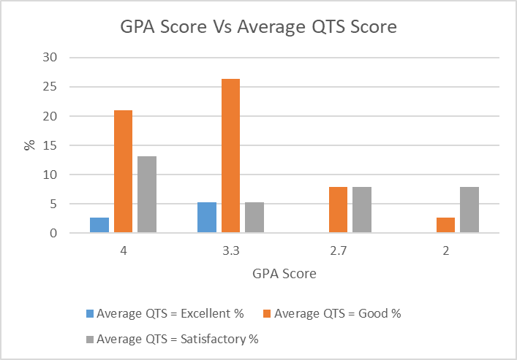
Fig 7 shows that the students who obtained the highest degrees with GPA scores of 4 and 3.3 (corresponding to ‘First’ and ‘Upper Second-Class’ degrees) did achieve higher final average QTS scores. None of the students who had GPA scores of 2.7 and 2 (corresponding to ‘Lower Second Class’ and ‘Third’ degrees) achieved a final average QTS score of excellent.
The majority (74%) of the students studied traditional science subject-based degrees. Other subjects studied were:
Forensic science – 10% of students.
Engineering – 7% of students.
Sports Science – 7% of students.
Environmental Science – 2% of students.
It should be noted that these students studied degrees where at least 50% of the course content was common to the chosen PGCE science pathway. Nonetheless, they would not have received as much common content as the other students who chose to study specific science subject-based degrees, such as biology, chemistry and physics. The next data analysis, figs 8 and 9, will focus on the final QTS standards of students who studied science-based degrees Vs students who studied other (non-scientific) degrees to determine if the nature of the degree studied affected the final QTS standards.
Fig 8 Science Degree GPA Vs Average QTS Score.
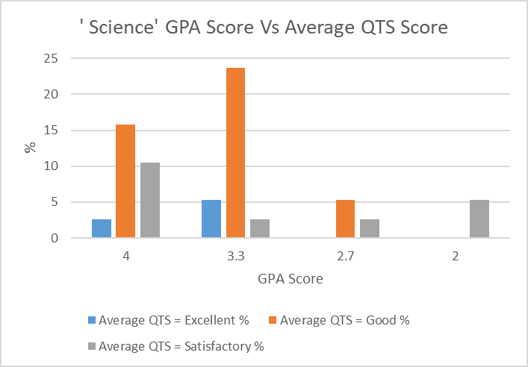

Fig 9 Non-Science Degree GPA Vs Average QTS Score.
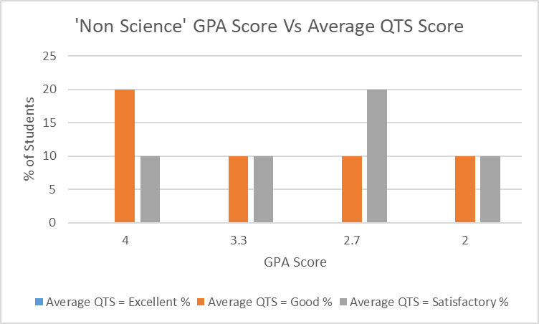
Figures 8 and 9 show that only students’ who studied scientific based degrees achieved the highest final QTS standard of ‘Excellent’. These were all students who held first or upper second-class scientific degrees. The highest percentage of non-science degree students’ who achieved the QTS standard of ‘Good’ were those had a GPA score of 4 (first-class degrees). This data demonstrates that the type and class of degree held does influence students’ final QTS standards.
Additionally, a higher proportion of students who achieved the lowest QTS pass of ‘satisfactory’ were those who had studied non science-based degrees.
As before, the focus of data analysis will now shift to analyse the students’ GPA scores Vs standard S2 of the QTS standards, namely the standard that measures the students’ subject knowledge and understanding. This will determine if students QTS subject knowledge is affected by the standard of their degree. The first analysis will consider all types of degree.

Fig 10 Total GPA score (all types of degree) Vs S2 (Subject Knowledge) QTS.
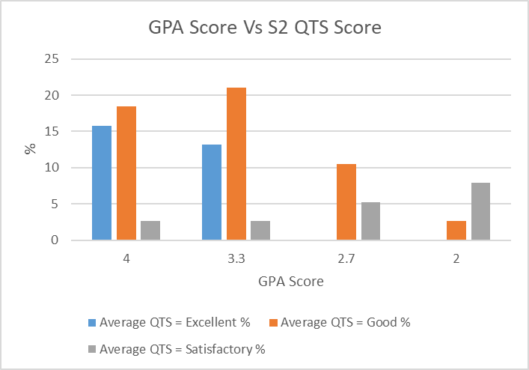
Fig 10 shows a distinct correlation between students who achieve higher classification degrees (first and upper second-class, GPA 4 and 3.3) and those who achieve ‘Excellent’ in their subject knowledge (S2) QTS standard. No students who achieved lower classification degrees (lower second-class and third) achieved ‘excellent’ in this QTS standard. This demonstrates that the class of degree obtained by students does influence their level of knowledge and understanding achieved in the QTS S2 strand.
Further analysis of the results will now compare the Subject Knowledge (S2) QTS standard of the students who studied scientific degrees against those who studied non-scientific degrees. The aim of this is to establish whether the S2 QTS subject knowledge standard is compromised when students enter the course after studying non-scientific degrees.

Fig 11 Science Degree GPA Vs S2 (Subject Knowledge) QTS Score.
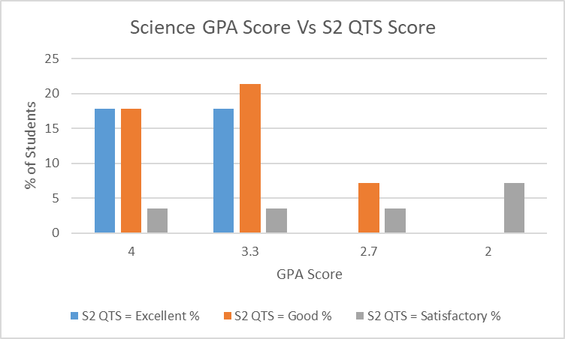
Fig 11 shows that students who achieved higher classification science degrees were most likely to achieve the higher subject knowledge and understanding S2 QTS standard. None of the higher standards (Excellent and Good) was achieved by students who held lower classification science degrees.

Fig 12 ‘Non Science’ Degree GPA Vs S2 (Subject Knowledge) QTS Score.
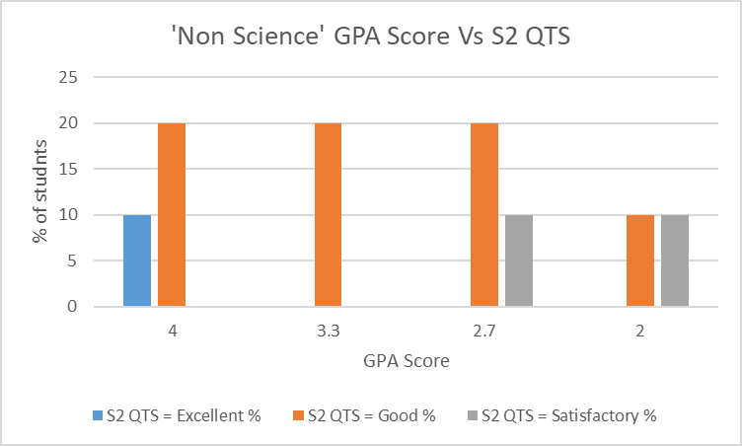
10% of students who studied non-scientific degrees and achieved a first-class degree managed to achieve a final standard of ‘Excellent’ in the S2 (knowledge and understanding) QTS category. This compares with 18% of students who studied scientific degrees and achieved a first-class degree. Figs 11 and 12 also show that the percentages of students who achieved a QTS S2 score of ‘Excellent’ were far more likely to be students who had studied scientific degrees.
The above findings do show that the nature and standard of the students’ degrees does influence their final QTS standards, both their overall QTS standards and their subject knowledge QTS standard. These findings will be discussed further in the Conclusions and Recommendations section.

The next section will focus on the third aim.
Aim 3
To determine if there is a single overriding factor that influences students’ success at QTS. In order to achieve this the study was to analyse the students’ choice of pathway (biology, chemistry and physics) and ascertain whether students who follow a particular pathway are more likely to achieve higher final QTS standards.

The tables, below, contain data that displays the chosen science PGCE course and the average QTS standard achieved at the end of the PGCE course.

Table 1. Biology course.
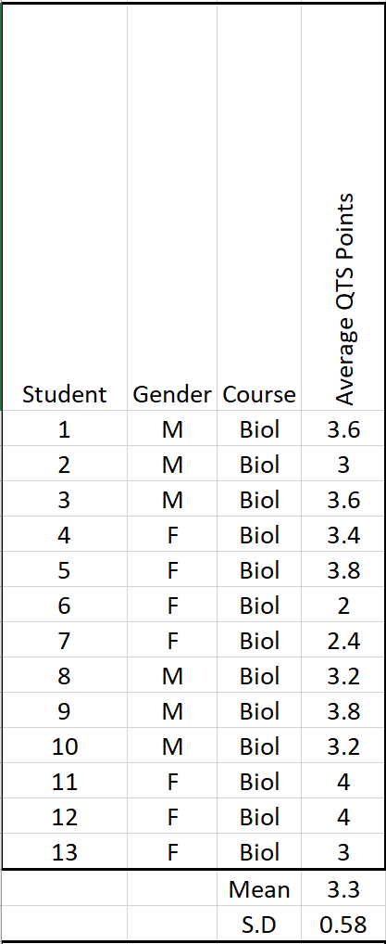
The mean value of the biologists final QTS score is 3.3.
The last row is a calculation of the Standard Deviation of the data. This low value shows that there is a low variance from the mean value for the Biology students (Cohen and Manion, 2011, p.627).

Table 1.2 Chemistry course.
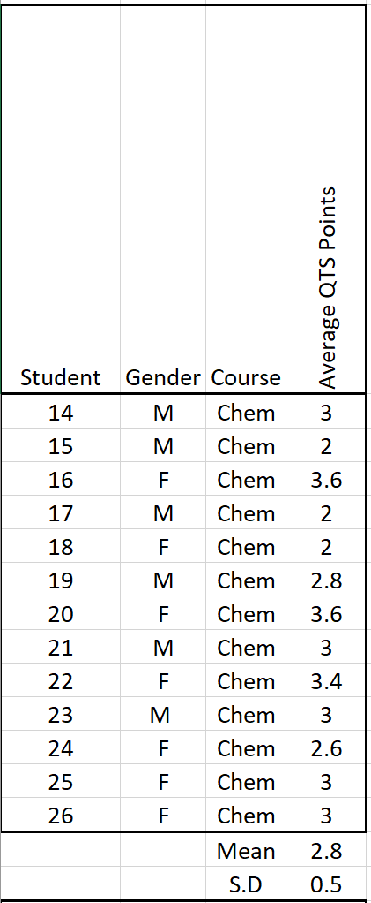
The mean value of the chemists final QTS score is 2.8.
The last row is a calculation of the Standard Deviation of the data. This low value shows that there is a low variance from the mean value for the Chemistry students (Cohen and Manion, 2011, p.627).

Table 1.3 Physics course.
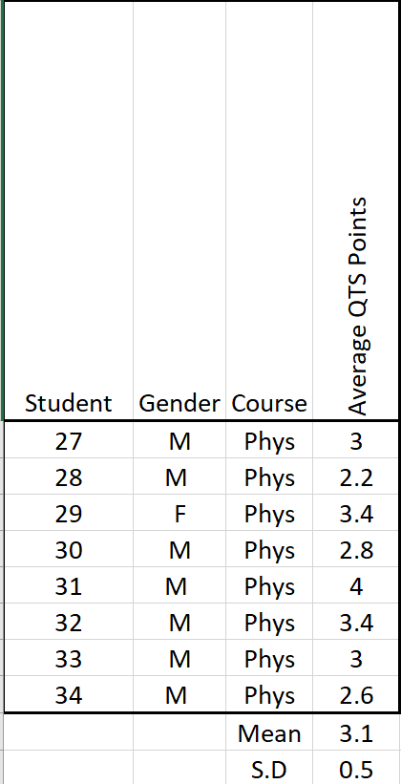
The mean value of the physicists final QTS score is 3.3.
The last row is a calculation of the Standard Deviation of the data. This low value shows that there is a low variance from the mean value for the Physics students (Cohen and Manion, 2011, p.627).
Table 1.4 Science course.
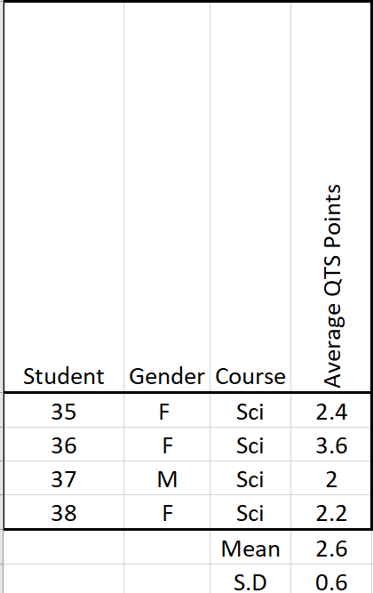
The mean value of the scientists final QTS score is 2.6
The last row is a calculation of the Standard Deviation of the data. This low value shows that there is a low variance from the mean value for the Science students.
Table 1.5 Average QTS Score by Course.
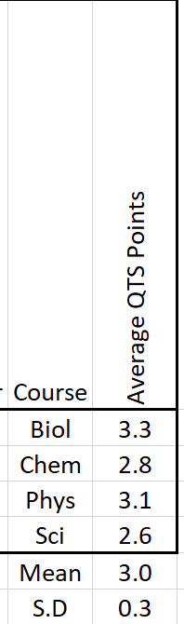
Table 1.5 displays the average QTS score by course which shows that whilst the Biologists have the highest mean score of 3.3 this is not significantly higher than the other courses. The standard deviation of the average QTS points score of each course is a very low 0.3 again, proving that the QTS standards achieved on each of the four courses were quite consistent and did not vary substantially from one course to another. This shows that the chosen pathway of the students (biology, chemistry, physics or science) did not adversely affect their final QTS standards.

The final section will focus on the fourth aim.
Aim 4
To analyse the five separate strands of the QTS standards to ascertain if students were less likely to achieve higher grades in a particular strand.

This final analysis will focus on comparing every one of the five QTS strands against the students’ final average QTS score to determine if students’ performance is lower in a particular strand. This is shown below in Fig 13. Conditional formatting was used to compare the value in each of the QTS strands S1 to S5 strand against each student’s average QTS score. A full explanation of the QTS strands is in the appendix section (Appendix4. Qualified Teacher Status (QTS) standards). Red denotes a value below the individual student’s average QTS points and green a value higher than the individual student’s average QTS points. The totals of the red and green cells in each of the columns are displayed at the bottom of the table. This can be used to compare students’ performance in each of the strands.

Fig 13. Comparison of all QTS Strands
 | Compare all QTS strands Vs Final QTS Standards
Student | Gender | Course |  | S1 Professional Values | S2 Knowledge and understanding | S3 Planning | S4 Monitoring and assessment | S5 Class management | Average QTS Points
1 | M | Biol |  | 4 | 4 | 3 | 3 | 4 | 3.6
2 | M | Biol |  | 3 | 3 | 3 | 3 | 3 | 3
3 | M | Biol |  | 4 | 3 | 4 | 3 | 4 | 3.6
4 | F | Biol |  | 4 | 3 | 3 | 3 | 4 | 3.4
5 | F | Biol |  | 4 | 4 | 4 | 3 | 4 | 3.8
6 | F | Biol |  | 2 | 2 | 2 | 2 | 2 | 2
7 | F | Biol |  | 3 | 2 | 2 | 2 | 3 | 2.4
8 | M | Biol |  | 3 | 3 | 3 | 3 | 4 | 3.2
9 | M | Biol |  | 4 | 3 | 3 | 2 | 3 | 3
10 | M | Biol |  | 2 | 2 | 2 | 2 | 2 | 2
11 | F | Biol |  | 4 | 4 | 4 | 3 | 3 | 3.6
12 | F | Biol |  | 2 | 2 | 2 | 2 | 2 | 2
13 | F | Biol |  | 2 | 2 | 2 | 2 | 2 | 2
14 | M | Chem |  | 3 | 3 | 3 | 2 | 3 | 2.8
15 | M | Chem |  | 4 | 3 | 4 | 3 | 4 | 3.6
16 | F | Chem |  | 3 | 3 | 3 | 3 | 3 | 3
17 | M | Chem |  | 2 | 3 | 2 | 2 | 2 | 2.2
18 | F | Chem |  | 4 | 4 | 3 | 3 | 3 | 3.4
19 | M | Chem |  | 3 | 3 | 3 | 3 | 2 | 2.8
20 | F | Chem |  | 3 | 3 | 2 | 2 | 2 | 2.4
21 | M | Chem |  | 3 | 4 | 4 | 3 | 4 | 3.6
22 | F | Chem |  | 4 | 4 | 4 | 4 | 3 | 3.8
23 | M | Chem |  | 3 | 3 | 3 | 3 | 3 | 3
24 | F | Chem |  | 3 | 3 | 4 | 3 | 3 | 3.2
25 | F | Chem |  | 4 | 4 | 4 | 4 | 4 | 4
26 | F | Chem |  | 4 | 4 | 4 | 4 | 4 | 4
27 | M | Phys |  | 3 | 3 | 3 | 3 | 3 | 3
28 | M | Phys |  | 4 | 4 | 3 | 3 | 3 | 3.4
29 | F | Phys |  | 3 | 3 | 3 | 3 | 3 | 3
30 | M | Phys |  | 3 | 3 | 3 | 2 | 2 | 2.6
31 | M | Phys |  | 3 | 3 | 3 | 3 | 3 | 3
32 | M | Phys |  | 3 | 3 | 3 | 3 | 3 | 3
33 | M | Phys |  | 4 | 4 | 4 | 4 | 4 | 4
34 | M | Phys |  | 4 | 4 | 3 | 3 | 3 | 3.4
35 | F | Sci |  | 3 | 3 | 3 | 3 | 3 | 3
36 | F | Sci |  | 3 | 3 | 3 | 2 | 2 | 2.6
37 | M | Sci |  | 2 | 2 | 2 | 2 | 2 | 2
38 | F | Sci |  | 2 | 2 | 2 | 2 | 3 | 2.2
 |  |  | Red totals = | 5 | 7 | 10 | 20 | 11
 |  |  | Green totals = | 17 | 14 | 11 | 2 | 10

Even though much research has focused on students SCK with regard to their subsequent success as teachers (as outlined in the Literature review) which corresponds to column S2 (subject knowledge and understanding). Only seven students scored lower than average values in this QTS strand compared to 20 in strand S4 (monitoring and assessment). This shows that students’ performance in strand S4 (monitoring and assessment) is significantly lower than in the other strands.
These findings will be discussed further in the Conclusions and Recommendations section.

Summary
The above findings prove that students who achieve the lower UCAS scores fail to achieve the higher QTS standards. These are students who would typically achieve grades of ‘D’ or lower in their A level qualifications (or equivalent). This is an important finding to disseminate to university science subject tutors because, as explained in the Literature Review, this is an area of study that remains largely unexplored. This will be discussed further in the Conclusions and Recommendations section. In addition, the standard of students’ degrees was also found to influence their final QTS standards, with those who achieve the higher class of degree also achieving higher QTS standards. As the final QTS standards are a measure of the student’s effectiveness as teachers at the end of their PGCE year. These findings are in agreement with the studies of researchers such as Haycock (1998) and Abe and Adu (2014) who also linked the standard of teachers’ degrees to their effectiveness as teachers. Furthermore, students’ who studied science-based degrees were also far more likely to achieve overall QTS standards of ‘Excellent’. Students who entered the PGCE science courses via non-traditional science degree routes were far more likely to achieve final QTS scores of ‘Average’. Again, this will be discussed further in the Conclusions and Recommendations section.
Students’ performance in the QTS S2 subject knowledge and understanding strand was also more likely to be ‘Excellent’ when they had entered the course via a traditional scientific degree. This is in some agreement with researchers such Mak, Yip and Chung (1999) and Childs and Mc Nicholl (2007) who claim that when teachers taught outside of the specialism their SCK was not sufficient to effectively teach the subject. However, more research on this topic would be needed to make robust conclusions as the percentages of students who achieved QTS standards of ‘Good’ was not particularly compromised when students entered via non-traditional science routes.
Limitations of the study
This study is limited in that data was collected from a relatively small sample (38) of students (Denscombe, 2003, p.33). Furthermore, the data was of a solely quantitative nature. A more robust study would have used a mixed methods approach that would have also incorporated qualitative data (Cohen and Manion, 2011, p.21). This could have been semi-structured interviews with science PGCE students in focus groups. This could have further informed the research from a student perspective of the best ways of ensuring that students who enter from a non-scientific background have the most effective ways of upskilling their scientific knowledge. Input from school-based mentors could also have been useful in this context as the students spend approximately two thirds of the course in their placement schools teaching science topics to classes that are frequently outside of their specialist areas. Students meet with their mentors on a fortnightly basis to discuss their progress. Therefore, interviews with school-based mentors would be useful to gain insight into what methods they would recommend to upskill students scientific knowledge. Unfortunately, time constrains did not facilitate the inclusion of additional qualitative data.
There is also, some debate as to effectiveness of the UCAS points system in calculating equivalencies across all qualifications, particularly with regard to ‘A levels’ in comparison to ‘BTEC’ qualifications. Some researchers suggest that an alternative method of calculating equivalent points scores should be available such as a maximum cap of 200 UCAS points on BTEC qualifications (Gill, 2016). However, there is no alternative system currently available. Furthermore, only a small percentage (2.6%) of students’ studied BTEC qualifications.
Despite these limitations, the study has provided PGCE educators with valuable information that can assist subject lecturers and admissions tutors with the entry admissions process and information that can be used to reflect on the current science PGCE curriculum and drive future improvement that could potentially raise the final QTS standards of students. The next section of this paper will now consider these findings further and set out recommendations for educators of science PGCE courses

Conclusions and Recommendations
The first aim of this study was to ascertain whether students’ final QTS scores were compromised if they had not studied the sciences as part of their level 3 (A level and equivalent) qualifications, and also if their total UCAS points attained (scientific and non-scientific) had an effect on their final QTS outcomes. While all student in this report succeeded in gaining QTS at the end of their PGCE year, they were far more likely to achieve a final QTS grading of ‘Excellent’ if they had studied at least 2 of the sciences to level 3. The study found that there was no direct correlation between students who attained that highest UCAS points, and those who achieved the highest QTS standards. This was also independent of whether the students had studied scientific or non-scientific subjects. However, students who entered the course with the very lowest UCAS points (equivalent to grades ‘D’ or lower at A level) did not achieve the higher QTS standards. The study concluded no direct correlation between students who attained the higher UCAS points and those who gained the highest QTS knowledge and understanding (S2) standard. However, those who entered the course with no level 3 science qualifications were less likely to perform well in the QTS S2 standard. These are important findings because, as discussed earlier, there is currently very little research literature available on this subject.
Recommendation 1.
Students who enter the course with the very lowest UCAS points, particularly those who have only one (or less) of their qualifications in a science discipline should have their progress monitored closely. Whilst these students should not be discouraged from studying the science PGCE course (as all managed to successfully gain QTS) they should, in future, benefit from extra help to enable them to attain the higher QTS standards. Furthermore, students who enter with no level 3 science qualifications should, in future, receive assistance in order to further upskill their science knowledge and understanding. This could take place in university curriculum studies sessions with students working in mixed ability groups focussing on a particular area of the school science curriculum. Admissions tutors should disseminate this information to subject tutors prior to the interview process. This process should start as soon as possible.
The second aim of this study was twofold. First, to ascertain whether students’ final QTS scores were affected by the standard of their degree (qualifications of level 6 and above). Second, to analyse if QTS standards were compromised when students entered the course after studying degrees that were not traditionally scientifically based.
The report found that only students who held higher classification scientific degrees of a first or upper-second class achieved the highest QTS standard of ‘Excellent’. In addition, students who entered the course after studying non-scientific degrees did not achieve the highest QTS standard of ‘Excellent’. However, all students managed to gain QTS.
Students who studied non-scientific degrees and achieved a first-class degree did achieved the highest QTS knowledge and understanding (S2) standard of ‘Excellent’ However, the percentage of students achieving this was significantly higher amongst those who had studied scientific degrees. In addition, students who achieved an upper second-class degree in a science-based discipline also achieved the highest QTS S2 standard. No students who entered the course with lower second class or third-class degrees achieved the highest QTS S2 standard. However, all students managed to pass the QTS S2 standard.
Recommendation 2.
The current minimum recommended entry qualification of a lower second-class degree should be changed to a third-class degree. All students in this study with third-class degrees were successful and managed to achieve QTS. However, their progress will need to be monitored, as none of these students achieved the higher QTS standards. Similarly, students who have not studied traditional science degrees, but others where at least 50% of the course is science based should not be discouraged from studying for a science PGCE. However, the progress of these students will also need to be monitored, as they are far less likely to achieve the higher QTS standards. The science PGCE department should implement a tracking system that regularly monitors that performance of all students.
As the current EWC targets for the September 2020 intake are 83% higher than the current cohort for chemistry and 140% higher for physics it would be wise for the Welsh Government to extend the bursary scheme to include potential students with third class degrees in order to attract more student teachers to these shortage subject areas. Furthermore, as the percentages of student who achieve ‘Excellent’ or ‘Good’ in their final QTS standards is no higher for students’ who obtained first-class degrees as opposed to those who obtained upper second-class degrees it would also be wise to bring the financial incentives allocated to both these groups of students closer together.
The third aim of this study was to determine whether students QTS standards were influence by their chosen science PGCE pathway (biology, chemistry of physics).
The report found that the biologists had a mean QTS score slightly higher than the other subjects (3.3). However, this was only a slightly better that the chemists and the physicists. The low standard deviation between the mean QTS score for all subjects (0.3) implies that there was not a great deal of variance between subjects and there the students’ chosen PGCE science pathway does not affect their overall QTS score.
The fourth aim of this study was to analyse if students’ performance in any one of the five QTS strands was significantly lower than the others. As stated earlier the university has implemented subject ‘upskilling’ sessions targeted at improving students’ subject ‘Knowledge and understanding’ as this was highlighted as a potential area of weakness in an earlier report by the author. This corresponds to QTS strand S2.
This report found that only 7 out of 38 students performed lower in QTS strand S2 compared with their mean QTS score overall. Fourteen students performed better in QTS strand S2 when compared to their mean QTS score. However, 20 students performed lower in strand QTS strand S4 (Monitoring and Assessment) compared with their mean QTS score overall. Only two students performed better in QTS strand S4 when compared to their mean QTS score. Students need to be monitored closely in strand S4 in order that their performance in this strand will improve.
Recommendation 3.
The PGCE science department needs to implement an action plan that will address the lower performance of students in QTS strand S4 compared to the other QTS strands. The department should carry out an audit on the effectiveness of current provision the results of which can then be used to inform the action plan. The audit should be carried out as soon as possible so that an action plan can inform a revision of the current science PGCE curriculum by September 2020.

Professional development.
This finding of this report will be used to influence my decisions on inviting potential students to interview based on their prior qualifications. It will also be used to highlight areas that need refined monitoring and tracking systems in order that I can ensure, through effective coaching, mentoring and intervention, that all students reach their full potential. The QTS standards have now changed since this study was undertaken. However, students’ ability to use assessment effectively in the classroom is still a fundamental element of the new professional standards. Effective Assessment for Learning also underpins the new ‘Successful Futures’ curriculum which will be implemented in all secondary schools in Wales from 2022. Therefore, the findings in this report that highlighted science students’ lower than average performance in the assessment strand (S4) of the legacy QTS standards will be used as part of my personal development plan to research and target effective methods that will enable PGCE science students to effectively asses their student better in the future. The findings of this report will also be disseminated to colleagues across all subjects of the PGCE course in order that they also may be able to identify with some of the issues studied.

Dissemination.
The findings of the aims of this study, particularly with regard to the effect of students’ prior qualifications on their final QTS standards, will be incorporated into a research paper. The title of the research is:
‘Developing Research Based Pedagogy for Teacher Education: A New Integrated Approach to Initial Teacher Education’
The research is being developed by a university in South Wales, and will examine how university subject experts can engage with an ITE programme providing subject expertise that can be used to upskill PGCE students who have been identified in this study as unlikely to achieve the higher QTS standards.

Future research.
The findings of this report have created some interesting topics for further study. A future study on factors that influence the students’ ability to monitor and assess pupils accurately would be beneficial to future PGCE science curriculum developments. Part of this study could assess if students’ ability to monitor and assess students effectively is impacted by their SCK. This could be further developed to focus on the effects of students’ assessment of pupils when they teach outside of their subject specialism.
As the nature, and class, of students’ degree was also found to impact their outcomes in the QTS strand of ‘Knowledge and Understanding’ further research in this area of study would be beneficial to determine the most effective methods of ‘upskilling’ students in the subject areas that they are less confident.
The study would also have benefitted from PGCE students’ own reflections on how the course could be modified to address shortcomings in student teachers’ abilities to monitor and assess pupils effectively, and how to upskill their SCK. This could have been achieved through semi-structured interviews by the researcher and the students in focus groups. Semi-structured interviews allow the interviewees to develop ideas and speak widely about the questions asked by the interviewer (Denscombe, 2003, p.167) This would have also provided more qualitative data for the research, again, making it a more ‘mixed methods’ approach. It would also be possible to compare the students’ interpretations with the qualitative data in this report for further triangulation purposes.

References.
Abe, T.O. and Adu, E.I., (2014). ‘The effect of teachers’ qualifications on students’ performance in mathematics’. Sky Journal of Educational Research, 2(1), pp.010-014.
Adeniji, I.A., (1999). ‘A Path Analytic Study of Some Teacher Characteristics and Teacher Job Performance in Secondary School in Ogun State, Nigeria’. University of Ibadan, Ibadan.
Basit, N.T. (2010). Conducting research in educational settings. Continuum international.
BBC (2017) How can schools recruit, and keep, more teachers. Available at: https://www.bbc.co.uk/news/education-40088691 (Accessed: 21/11/2019).
BBC (2018) Fewer teacher training applicants in Wales. Available at: https://www.bbc.co.uk/news/uk-wales-42582103 (Accessed: 21/11/2019).
BBC (2019a) Teachers to be offered cash to stay in school. Available at: https://www.bbc.co.uk/news/education-47023665 (Accessed: 21/11/2019).
BBC (2019b) Wales education system : lost it’s soul. Available at:
https://www.bbc.co.uk/news/uk-wales-50592611 (Accessed: 02/12/2019).

BBC (2019c) Pisa education tests: Wales improves performance. Available at:
https://www.bbc.co.uk/news/uk-wales-50629432 (Accessed: 03/12/2019).

Bell, J. 1999. Doing your research project. Open University press.

British Educational Research Association [BERA] (2018). ‘Ethical Guidelines for Educational Research, fourth edition’. London.

Bélanger, J. and Broeks, M., 2016. ‘Attracting and retaining teachers in Cambridgeshire’. Rand, Europe.

Berry, B., (2002). ‘What It Means To Be a Highly Qualified Teacher’. ERIC.

Britton, J., Dearden, L., Shephard, N. and Vignoles, A., 2016. ‘How English domiciled graduate earnings vary with gender, institution attended, subject and socio-economic background’ (No. W16/06). IFS Working Papers.
Campaign for Science and Engineering (CASE), 2014. ‘Improving diversity in STEM’. Kings college London.
Charette, R.N., 2013. The STEM crisis is a myth. IEEE Spectrum, 50(9), pp.44-59.
Childs, A. and McNicholl, J., (2007). ‘Investigating the relationship between subject content knowledge and pedagogical practice through the analysis of classroom discourse’. International Journal of Science Education, 29(13), pp.1629-1653.
Cohen, L. & Manion, L. (2011) Research Methods in Education 7th edition. London: Routledge.
Confederation of British Industry (2011). ‘Building for growth: business priorities for education and skills’. Education and skills survey 2011. CBI/EDI.

Constable, H. (1999). ‘Physics teachers: supply, training and retention—Interim report’. Newcastle, England: University of Northumbria.

Cowan, J., Goldhaber, D., Hayes, K. and Theobald, R., (2016). ‘Missing elements in the discussion of teacher shortages’. Educational Researcher, 45(8), pp.460-462.

Darling-Hammond, L. and Berry, B., (2006). Highly qualified teachers for all. Educational Leadership, 64(3), p.14.

Davis, E.A., 2004. Knowledge integration in science teaching: Analysing teachers' knowledge development. Research in Science Education, 34(1), pp.21-53.

Department of Education (2017) School Teachers Review Body. Available at: https://www.gov.uk/government/publications/school-teachers-review-body-27th-report-2017 (Accessed: 22/11/2019).
DES & Welsh Office (1989) ‘Science in the National Curriculum’ London, HMSO.
Denscome, M. (2003) (2nd ed) The Good Research Guide: for small-scale social research projects. Buckingham: Open University Press
Denscombe, M., 2008. ‘Communities of practice: A research paradigm for the mixed methods approach’. Journal of mixed methods research, 2(3), pp.270-283.
Du Plessis, A.E., 2018. ‘The Lived Experience of Out-of-field STEM Teachers: a Quandary for Strategising Quality Teaching in STEM?’. Research in Science Education, pp.1-35.
Goldhaber, D.D. and Brewer, D.J., 1996. ‘Evaluating the effect of teacher degree level on educational performance’. ERIC.
Donaldson, G., 2015 Successful Futures. Independent Review of Curriculum and Assessment Arrangements in Wales. Available at: https://gov.wales/docs/dcells/publications/150225-successful-futures-en.pdf (Accessed 24/11/2019).
EWC (2019a) Initial teacher Training Accreditation. Available at:
https://www.ewc.wales/site/index.php/en/accreditation/ite-accreditation.html
(Accessed: 1/3/2020)

EWC (2019b) Initial Teacher Education Intake Targets. Available at:
https://www.ewc.wales/site/index.php/en/accreditation/ite-accreditation/ite-intake-targets.html
(Accessed: 1/3/2020)

Firestone, W.A., (1987). ‘Meaning in method: The rhetoric of quantitative and qualitative research’. Educational researcher, 16(7), pp.16-21.
Gilbert, N. (2008). Researching social life. Sage.
Gill, T., (2015). ‘Using generalised boosting models to evaluate the UCAS tariff’. Research Matters: A Cambridge Assessment Publication, 20, pp.2-6.
Gill, T., (2016). ‘Assessing the equivalencies of the UCAS tariff for different qualifications’. Research Matters, 21, pp.16-23.
Gill, T. and Bell, J.F., (2013). ‘What factors determine the uptake of A-level physics?’. International Journal of Science Education, 35(5), pp.753-772.
Gov.UK (2020) Teacher Training Funding. Available at:
https://www.gov.uk/teacher-training-fundinghttps://www.gov.uk/teacher-training-funding.
(Accessed 1/3/2020).

Gov.Wales, (2020). Teacher training incentives in Wales. Available at: https://gov.wales/sites/default/files/publications/2019-02/teacher-training-incentives-in-wales-academic-year-2019-20.pdf
(Accessed: 1/3/2020)

Grek, S., 2009. ‘Governing by numbers: The PISA ‘effect’ in Europe’. Journal of education policy, 24(1), pp.23-37.
Haycock, K., (1998). ‘Good Teaching Matters: How Well-Qualified Teachers Can Close the Gap’. Thinking k-16, 3(2), p.n2.
Higher Education Academy (2019). Guide on Grade Point Average: Available at:
https://www.heacademy.ac.uk/system/files/resources/Guide%20on%20grade%20point%20average%20for%20students_0.pdf (Accessed 19/12/2019).

Hillier, J., de Winter, J. and Twidle, J., 2013. ‘I could enjoy teaching: the case of physics, Canadian Journal of Science, Mathematics and Technology Education, 13(3), pp.287-302.
Hoyle, P., 2016. Must try harder: ‘An evaluation of the UK government’s policy directions in STEM education’. Research.acer.edu
Hulme, M., Baumfield, V., Livingston, K. and Menter, I., 2009. ‘The Scottish curriculum in transition: Curriculum for Excellence’. BERA 2009.
Ingersoll, R.M., (1999). The problem of underqualified teachers in American secondary schools. Educational researcher, 28(2), pp.26-37.
Jones, C., 2010. Interdisciplinary approach-advantages, disadvantages, and the future benefits of interdisciplinary studies. Essai, 7(1), p.26.
Kind, V., 2009. ‘A conflict in your head: An exploration of trainee science teachers’ subject matter knowledge development and its impact on teacher self‐confidence’. International Journal of Science Education, 31(11), pp.1529-1562.

Kind, V. and Kind, P.M., 2011. ‘Beginning to Teach Chemistry: How personal and academic characteristics of pre-service science teachers compare with their understandings of basic chemical ideas’. International Journal of Science Education, 33(15), pp.2123-2158.
Kind, V., 2014. A degree is not enough: A quantitative study of aspects of pre-service science teachers’ chemistry content knowledge. International Journal of Science Education, 36(8), pp.1313-1345.
Kirby, P. and Cullinane, C., 2017. ‘Science shortfall’, Sutton Trust Research Brief, Edition 17.
Khurshid, K., (2008). A study of the relationship between the professional qualifications of the teachers and academic performance of their students at secondary school level. World Academy of Science, Engineering and Technology, 38(1), pp.445-451.
Kumar, R. 2014. Research Methodology. 4th edition. Sage publications Ltd.
Lambert, D. & Biddulph, M. (2014). ‘The Dialogic Space Offered by Curriculum-Making in the Process of Learning to Teach, and the Creation of a Progressive Knowledge-led Curriculum’. Asia-Pacific Journal of Teacher Education.
Land, M.H., 2013. Full STEAM ahead: The benefits of integrating the arts into STEM. Procedia Computer Science, 20, pp.547-552.
Milanowski, A., 2003. ‘An exploration of the pay levels needed to attract students with mathematics, science and technology skills to a career in K-12 teaching’. Education policy analysis archives, 11(50).
Millar, R., 2014. ‘Designing a science curriculum fit for purpose'. School Science Review, 95(352), pp.15-20.
Mizzi, D., 2013. ‘The Challenges Faced by Science Teachers When Teaching Outside Their Specific Science Specialism’. Acta Didactica Napocensia, 6(4), pp.1-6.
Moor, H., (2006). Mathematics and Science in Secondary Schools: the deployment of teachers and support staff to deliver the curriculum. NFER.
Newton, N.,2018 ‘The why, what & how of Successful Futures’. WISEARD, Cardiff University.
NIdirect (2020) Initial Teacher Training. Available at: https://www.nidirect.gov.uk/articles/initial-teacher-training
(Accessed: 1.3.2020)

Ofstead. (2008) Success in science. gov.uk/publications/070021.
Osborne, J. and Simon, S., 1996. Science: past and future directions. Directions, , 27:1, 99-147, DOI: 10.1080/03057269608560079
Robson, C. and McCartan, K., 2016. Real world research. John Wiley & Sons.
Roth, K, Anderson, C. & Smith, E. (1986). ‘Curriculum materials, teacher talk and student learning:
case studies in fifth grade science teaching’. Research Series #171 (East Lancing, MI, Michigan
State University, The Institute for Research in Teaching).
RSC

Royal Society (2011). Preparing for the transfer from school and college science and mathematics education to UK STEM higher education. Available at: https://royalsociety.org/policy/publications (Accessed: 25/11/2019).
RSC (2014). Do subject specialist teachers matter? Available at:
https://edu.rsc.org/opinion/do-subject-specialist-teachers-matter/2010024.article (Accessed: 5/12/2019)

Sanders, L.R., Borko, H. and Lockard, J.D., 1993. Secondary science teachers' knowledge base when teaching science courses in and out of their area of certification. Journal of Research in Science Teaching, 30(7), pp.723-736.

Shulman, L. S. (1987) ‘Knowledge and teaching: foundations of the new reform’. Harvard Educational
Review, 57(1).

Sibieta, L., 2018. ‘The teacher labour market in England: shortages, subject expertise and incentives’. Education policy institute.
Sims, S., 2018. ‘What happens when you pay shortage-subject teachers more money? Simulating the effect of early-career salary supplements on teacher supply in England’. Report for Gatsby Foundation.
Sims, S., 2019. ‘Modelling the relationships between teacher working conditions, job satisfaction and workplace mobility’. British Educational Research Journal.
Smith, E., 2010. ‘Is there a crisis in school science education in the UK?’. Educational Review, 62(2), pp.189-202.
Smith, E. 2011. ‘Staying in the Science Stream: Patterns of Participation in A‐level Science
Subjects in the UK.’ Educational Studies 37: 59–71.

Smithers, A., & Hill, S. (1989). ‘Recruitment to physics and mathematics teaching: A personality problem?’ Research Papers in Education, 4(1), 3–21.

Smithers, A. and Robinson, P., (2000). Attracting teachers. Past patterns, present polices, future prospect. CEER, Liverpool.

Smithers, A., & Robinson, P. (2008). ‘Physics in school IV: Supply and retention of teachers’. Buckingham, England: Carmichael Press.
Stake, R.E., (1995). The art of case study research. Sage.
Teach in Scotland (2020). Bursaries and loans for teaching in Scotland. Available at: https://teachinscotland.scot/become-a-teacher/new-to-teaching/
(Accessed: 1/3/2020)

Timms, M.J., Moyle, K., Weld n, P.R. and Mitchell, P. (2018). Challenges in STEM learning in Australian schools: Literature and policy review. ACER.
Thomas, G. (2010). How to do your research project. Sage publications Ltd.
Thomas, G. (2011). How to do your case study. Sage publications Ltd.
UCAS (2006). ‘Expert Group Report for awards seeking admission to the UCAS Tariff’. The International Baccalarureate. London.
UCAS Tariff Points (2019). Available at:
https://www.ucas.com/undergraduate/what-and-where-study/entry-requirements/ucas-tariff-points (Accessed 19/12/2019)

Watt, H.M. and Richardson, P.W., 2008. ‘Motivations, perceptions, and aspirations concerning teaching as a career for different types of beginning teachers’. Learning and instruction, 18(5), pp.408-428.
Wicklein, R.C. and Schell, J.W., 1995. Case studies of multidisciplinary approaches to integrating mathematics, science, & technology education. Volume 6 Issue 2 (spring 1995).
Williams, J., 2011. STEM education: Proceed with caution. Design and Technology Education: An International Journal, 16(1).
Wong, V., Dillon, J. and King, H., 2016. ‘STEM in England: meanings and motivations in the policy arena’. International Journal of Science Education, 38(15), pp.2346-2366.
Yin R.K. (2014). Case Study Research : Design and Methods (Fifth Edition). Thousand Oaks, CA: Sage.

Appendices.
Appendix 1. Data capture form.
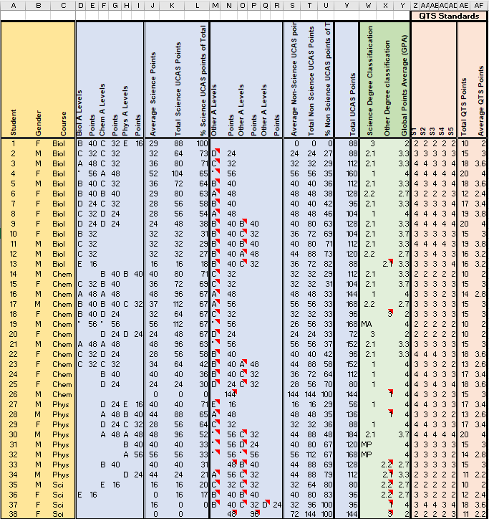

Appendix 2. Research information.
Gwaith ymchwil.
Ydy safonau SAC yn dibynnu ar gymhwysterau bleanorol?
Pwrpas yr ymchwil.
Mae’r Cyngor y Gweithlu Addysg wedi gosod targedau heriol i recriwtio athrawon ar gyfer y dyfodol.
Yn sgil y targedau mae’n bosib bydd rhaid I’r Brifysgol ystyried ymgeiswyr gyda chymwysterau mwy eang nag erioed.
Fe fydd yr ymchwil yn dadansoddi os yw safonau terfynnol SAC yn dibynnu ar gymhwsterau blaenorol.
Fe fydd y data yn cael eu casglu o fas data y Brifysgol a throsglwyddo I Ffon gof, yn hollol anhysbys.
Fe fydd y data yn cael eu dadansodii fel rhan o draethawd hir MA yn flwyddyn 2019 I 202o.
Ar ol gorffen yr ymchwiliad fe fydd y data i gyd yn cael eu dileu.
Fe fydd hawl i gyfranwyr tunn allan o’r ymchwil ar unrhyw adeg a fe fydd unrhyw ddata cysylltiedig yn cael eu dileu.
Oherwydd natur yr ymchwil ni fydd yn rhagfynegu unrhyw niwed i cyfanwyr / ymchwilwr.

Research.
Are QTS standards linked to prior qualifications?
Purpose of study.
The education workforce council has set ambitious targets to recruit teachers for the future.
In light of these targets the University will possibly need to consider candidates with a wider range of qualifications than currently considered.
The research will analyse whether or not final QTS standards depend on candidate’s prior qualifications and experience.
Initial data will be captured from university databases and copied to a USB stick, all data will be anonymised.
The data will be analysed in order to provide answers to the above question as part of a MA dissertation in 2019 to 2020.
On completion of the research all data will be erased.
Participants can withdraw at any time and any data collected will be erased.

Because of the nature of the research there are no significant risks envisaged to either the participants or the researcher.

Appendix 3. UCAS Tariff.
Prospective PGCE science students apply to study at university X through the UCAS system. This system allocates points to level 3 qualifications based on the UCAS Tariff Points (2019) calculator. These points are added to provide an overall tariff points score for each candidate. This information is readily available to admissions tutors on the admissions database at university X. The assumption is that any two students who would have achieved the same number of total UCAS points would be able to achieve the same potential (Gill, 2015). Most of the prospective Science PGCE students obtained ‘A level’ level 3 qualifications, although the tariff points system facilitates conversion points for a wide range of global qualifications. The A level points system is a sliding scale from A * to E with the following weightings:
A* 56, A 48, B 40, C 32, D 24, E 16.
This tariff system was used to calculate the total level 3 points of a prospective candidate. In the past UCAS has undertaken many studies to ensure that there is parity between different level 3 qualifications and the corresponding points score on the UCAS tariff (UCAS, 2006). However, Gill (2016) suggests that the tariff does not correctly align between different qualifications, most notably between A Levels and the BTEC Nationals. However, the UCAS points system is universally used by UK universities and is the only current model available to assign a point score to level 3 qualifications.

Appendix 4. Qualified Teacher Status (QTS) standards.
QTS standards are awarded to students who successfully pass the course at the end of their PGCE year. The students involved in this research were assessed in five strands of the pre 2020 QTS standards in alignment with all other secondary ITE providers in Wales. These were:
S1 - Professional values.
This strand is monitored by school-based mentors and senior mentors and relates to students’ adhering to a code of conduct that is expected of student teachers. It is also influenced by the students’ involvement with the school departments’ and the broader school environment.
S2 - Knowledge and understanding.
When students start their science PGCE course they undertake a subject knowledge audit. The results of this audit are then used to inform students of areas of the science curriculum that may need revision. University subject enrichment sessions are then organised prior to students’ embarking on their first teaching placement. On placement, this strand is monitored by school-based mentors and university tutors during lesson observations. The subject knowledge audit is revisited at key points throughout the year to ensure progression.
S3 - Teaching and planning.
University X provides all students with a planning template hat students’ complete when planning their lessons, use of the template is mandatory. The template focuses the students on producing lessons that have clear aims and objectives and are accessible by all learners. The template is saved to the students’ ‘One Drive’ that is then shared by the students to their school mentors and their university tutor. This planning template can then be accessed remotely and assessed by both school mentors and university tutors. The planning template is monitored by university staff and subject tutors throughout the students’ school placements.
S4 - Teaching – monitoring and assessment.
This strand is monitored internally by mentors in partnership schools and also, jointly by university tutors and school mentors on lesson observation. It assesses the students’ ability to use effective assessment techniques within a classroom environment and the students’ ability to disseminate effective feedback to school pupils both written and verbally.
S5 - Teaching and class management.
This strand is assessed by school mentors and university tutors during lesson observations. It assesses the students’ ability to create a safe and effective learning environment for school pupils.
Each of these five strands are assessed on a four-point scale:
Excellent – 4 points, Good – 3 points, Adequate – 2 points, Unsatisfactory – 1 point.
To gain QTS, teachers have to achieve a minimum of an ‘Adequate’ score in each of
the five QTS strands.

