

University of Wales Trinity Saint David
School of Engineering

Heat Exchanger Laboratory Analysis
Thermofluid Mechanics (M5X00406)
Professor: Dr Robert Goodson
Author: Alex Oke (P151012)
Experiment Date: 05/03/2019
Experiment Time: 15:00
Due Date: 05/04/2019
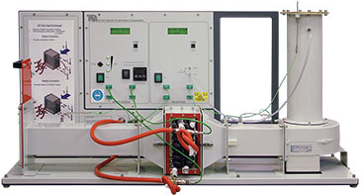
Table of Contents
1 Introduction 1
2 Experiment 1 (The Effect of Varying Water Flow Rate) 2
2.1 Aim 2
2.2 Procedure 2
2.3 Results Analysis 3
2.3.1 Data Table 3
2.3.2 Experiment 1 Graphs 4
3 Experiment 2 (The Effect of Varying Air Flow Rate) 7
3.1 Aim 7
3.2 Procedure 7
3.3 Results Analysis 8
3.3.1 Data Table 8
3.3.2 Experiment 2 Graphs 9
4 Experiment 3 (Effect of Varying Temperature) (Driving Force) 12
4.1 Aim 12
4.2 Procedure 12
4.3 Results Analysis 13
4.3.1 Data Table 13
4.3.2 Experiment 3 Graphs 14
5 Experimental Conclusions 18

Introduction
https://moodle.uwtsd.ac.uk/pluginfile.php/145911/mod_resource/content/1/TD1007_HX_laboratory_guide.pdf

Experiment 1 (The Effect of Varying Water Flow Rate)

Aim
- To show how different water flow rates affect the performance of the heat exchanger for a given fixed air flow and water temperature.

Procedure
Connect and set up the standard 32 tube heat exchanger. Connect as for parallel flow and set a heater tank temperature of 60°C. Water enters the bottom of the heat exchanger and exits from the top.
Note the ambient air pressure. Inspect the orifice and check its diameter - this is stamped on the surface of the orifice.
Switch on the fan and use the slide valve to set the airflow to give an orifice pressure drop of 250 Pa (+/- 5 Pa tolerance).
Switch on the pump and use the hand operated water supply valve to set the water flow to 2.25 L/minute (+/- 0.01 L/minute).
Allow at least five minutes for the heat exchanger temperatures to stabilize, then record all readings.
Your water and air flows may change slightly as you do the experiment, so regularly check and readjust them if necessary.
Repeat the procedure for lower water flow rates of 1.75, 1.25, 0.75 and 0.25 L/min

Results Analysis

Data Table

Experiment 1 Graphs

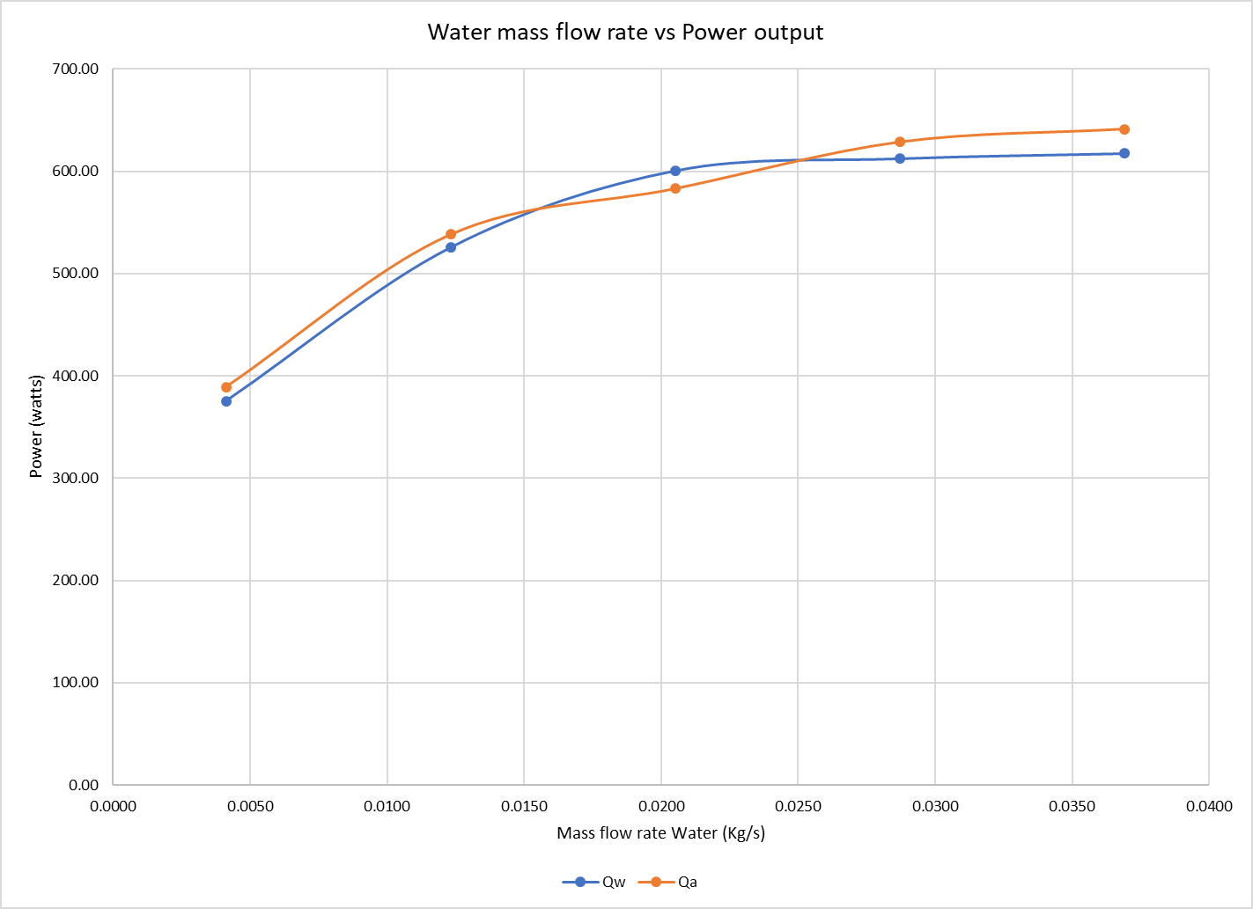
Water mass flow rate vs Power output

comment on how the flow rate affects the heat exchanger performance.

From your results, comment on how the water flow rate affects the heat exchanger performance.

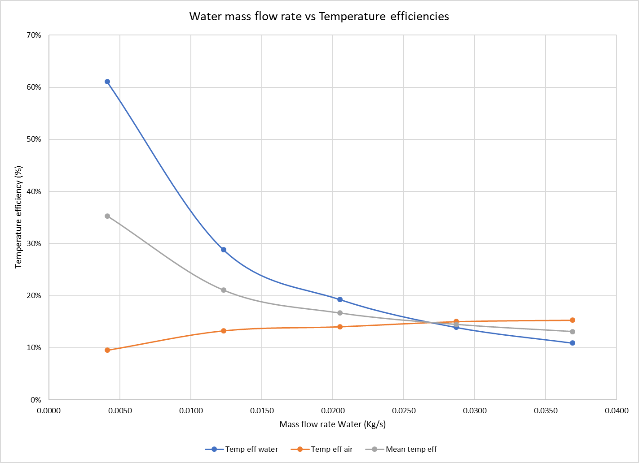
Water mass flow rate vs Temperature efficiencies

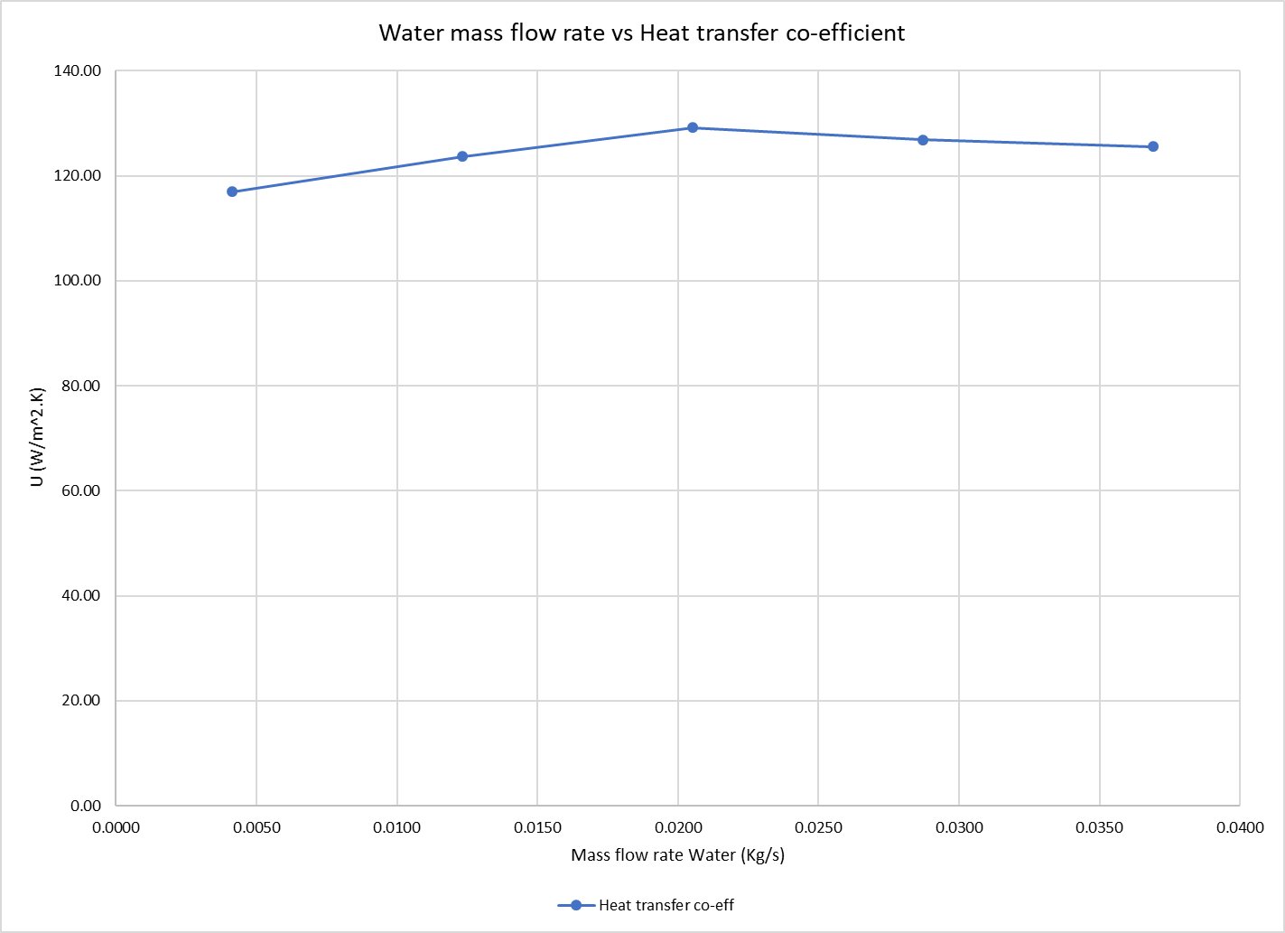
Water mass flow rate vs Heat transfer co-efficient

Experiment 2 (The Effect of Varying Air Flow Rate)

Aim
- To show how different air flow rates affect the performance of the heat exchanger for a given fixed water flow and temperature.

Procedure
Check connections are set for parallel flow and set a heater tank temperature of 60°C. Water enters the bottom of the heat exchanger and exits from the top.
Note the ambient air pressure. Inspect the orifice and check its diameter - this is stamped on the surface of the orifice.
Switch on the fan and use the slide valve to set the airflow to give an orifice pressure drop of 250 Pa (+/- 5 Pa).
Switch on the pump and use the hand operated water supply valve to set the flow to 0.25 L/minute (+/- 0.01 L/minute).
Allow at least five minutes for the heat exchanger temperatures to stabilize, then record all readings.
Your water and air flows may change slightly as you do the experiment, so regularly check them and adjust as necessary.
Repeat the procedure for lower air flow rates of 200, 150, 100 and 50 Pa pressure drop

Results Analysis

Data Table

Experiment 2 Graphs

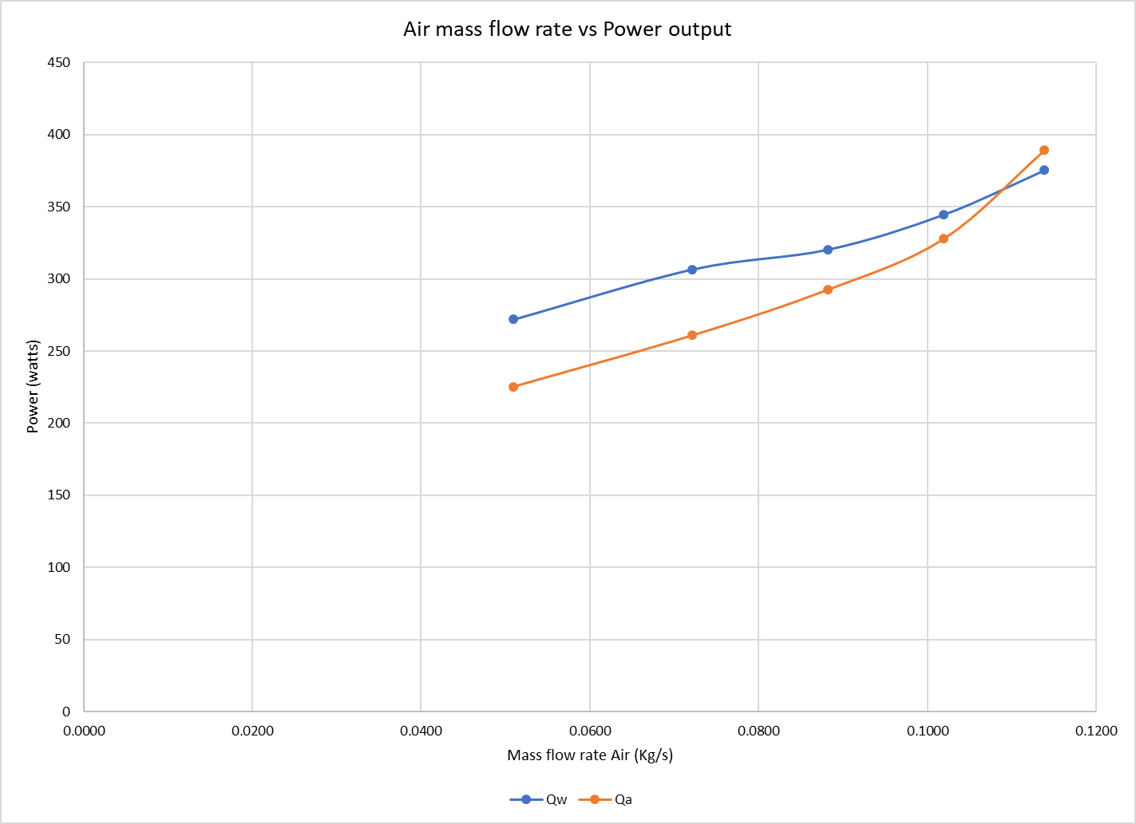
Air mass flow rate vs Power output

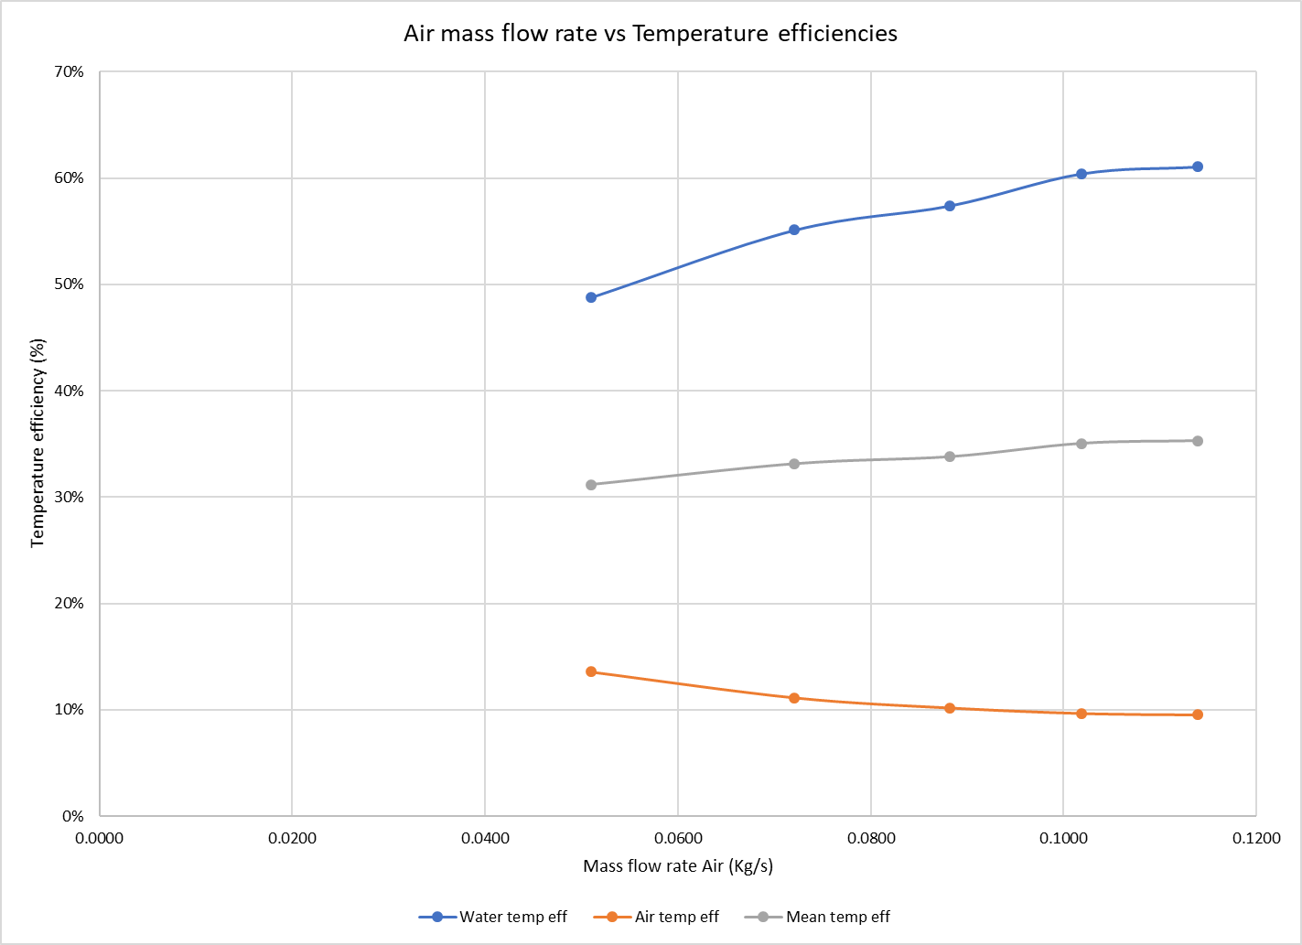
Air mass flow rate vs Temperature efficiencies

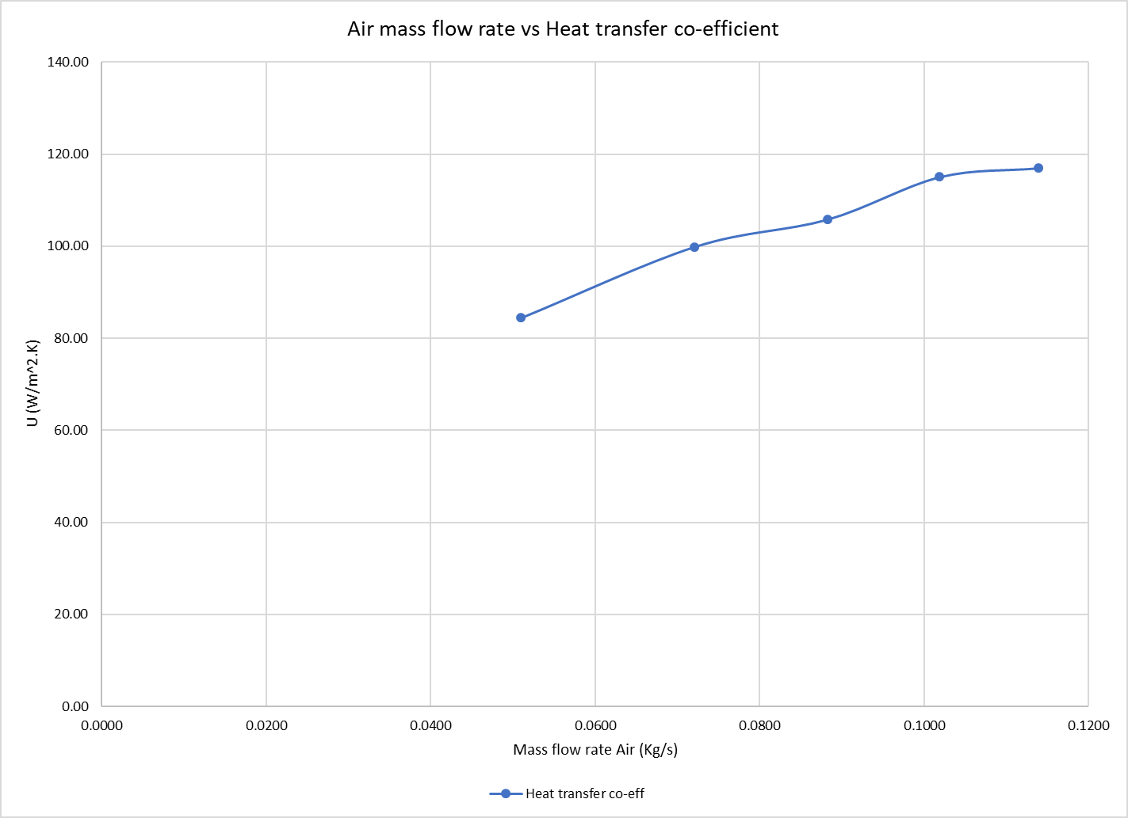
Air mass flow rate vs Heat transfer co-efficient

Experiment 3 (Effect of Varying Temperature) (Driving Force)

Aim
- To show how different hot water supply temperatures affect the performance of the heat exchanger for a given fixed water flow.

Procedure
1. Check connections are for parallel flow and set a heater tank temperature of 45°C. Water enters the bottom of the heat exchanger and exits from the top.
2. Repeat Experiment 2 - The Effect of Varying Air Flow Rate.

Results Analysis

Data Table
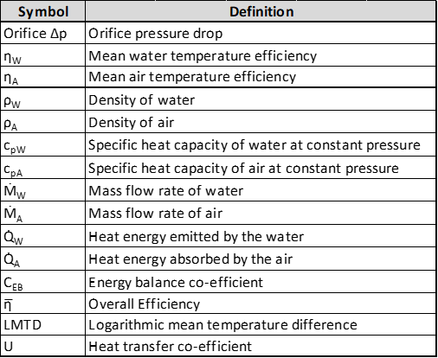

Experiment 3 Graphs

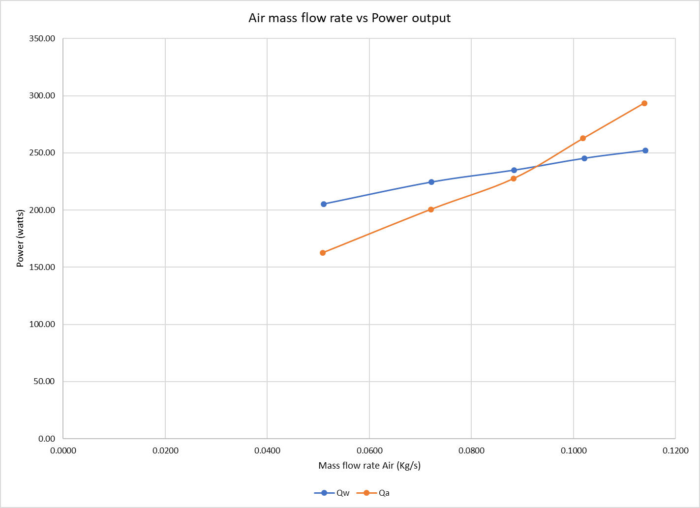
Air mass flow rate vs Power output

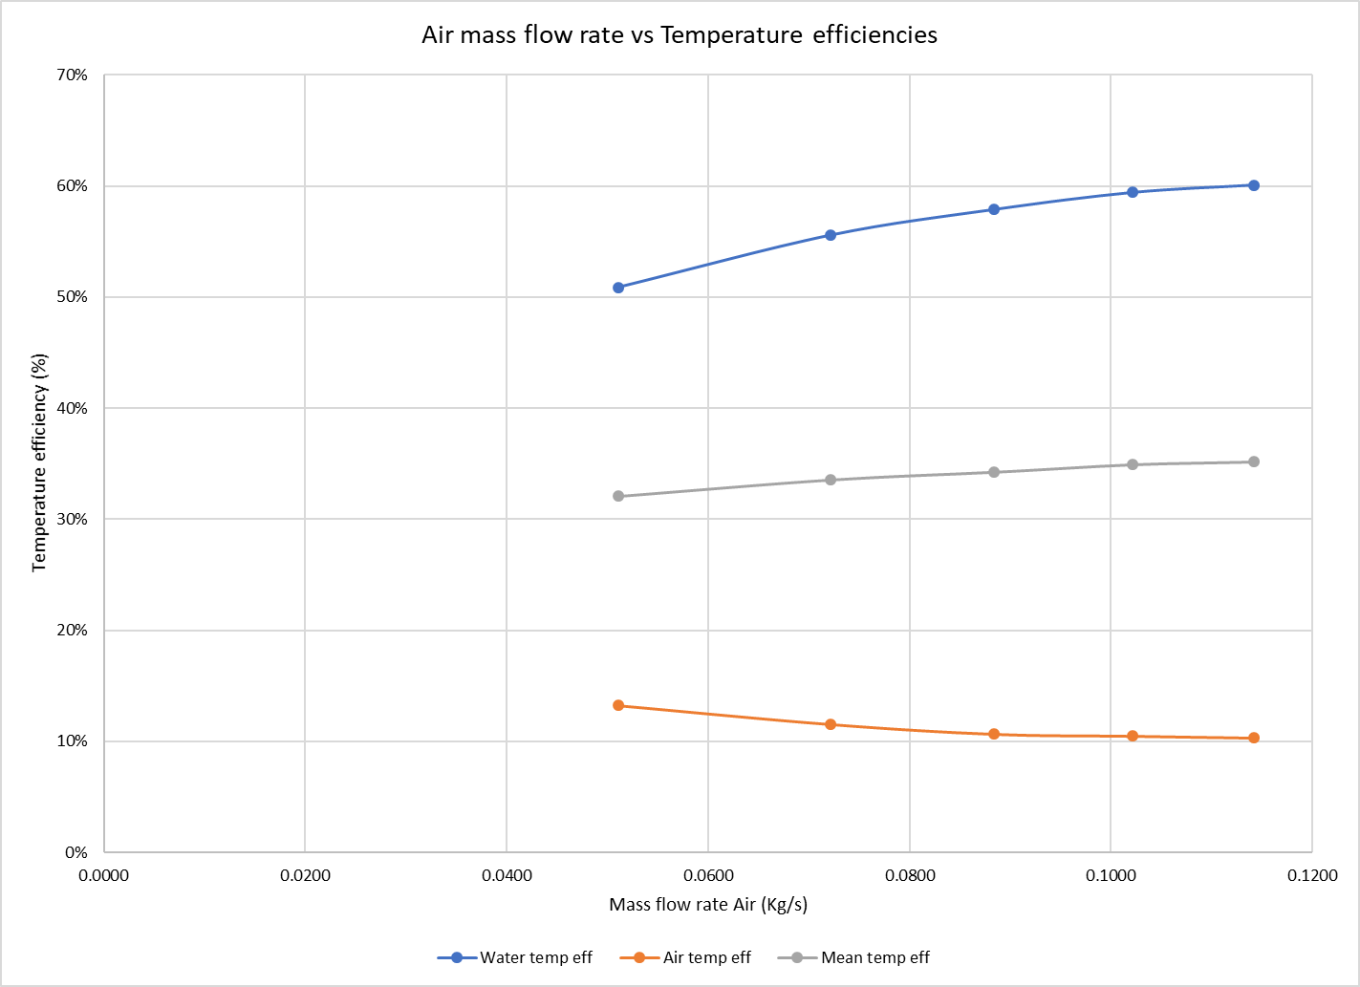
Air mass flow rate vs Temperature efficiencies

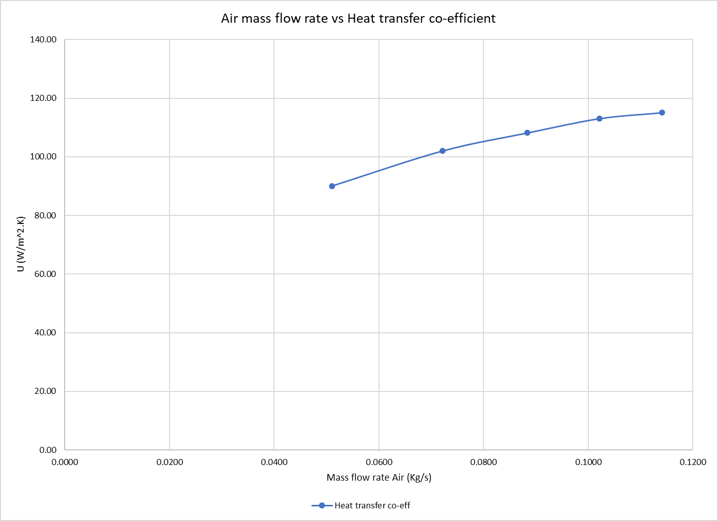
Air mass flow rate vs Heat transfer co-efficient

Complete the same analysis and plot the same charts as described in Experiment 2 - The Effect of Varying Air Flow Rate to compare how the two water temperatures affect the heat exchanger performance.

Experimental Conclusions
Using all the data that you have collected and the analysis you have performed on the three experiments, describe the key features and properties of heat exchanger performance and how your results have confirmed (or otherwise) the theoretical background of heat exchangers that you have learned in the classroom. You should analyse critically the overall results that you have gained from the three experiments and importantly, detail any errors or experimental discrepancies that you believe have affected the results. Also comment on how you think the performance of the heat exchanger could be improved.

