

Assessment 1 – Ekaterine Enukidze

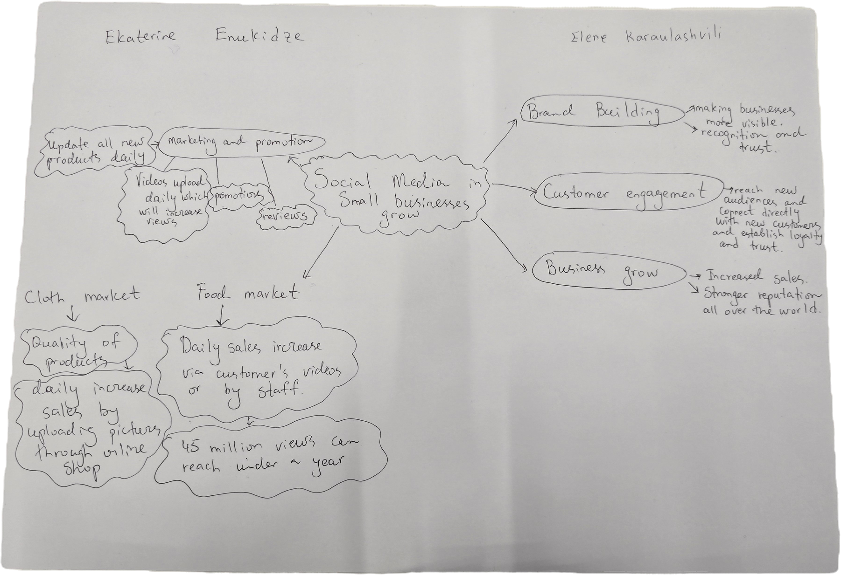

- What is the main idea of the whole text?

The main idea of this text is to show how effective business management and strategic use of social media can transform a business in a very short time, increase its global visibility attract more customers, boost sales and drive financial growth. All of this depends on how will the brand is presented, how effectively the business system is structured and how strategically social media opportunities are used.

- What is one key point that supports the main idea, and which specific example from the text shows this?
With the right strategy and presentation a business can transform from a local operation into a global brand through the power of social media, earn customers trust and archive longterm financial success.

- What is a different key point that supports the main idea, and which specific example from the text shows this?
The right business strategy includes presenting the business professionally with the right products, posting and updating information daily or weekly and maintaining regular communication with customers.

- Which part of the text do you think is most important, and why?
The most important is to represent your business daily or weekly in social media with uploaded videos, pictures or information to rech the customers all over the world to receive financial success and name for your business.

Reflection:
- What did you find difficult in this task (including in-class components), and why was it difficult?
How to create mind map with right strategy. As we worked in a class with different opinions had to created it with team together with different opinions.

- What helped you with this difficulty, and how did it help you?
We worked as a team with our own ideas and managed to to work together, to respect each other’s opinions which is very important if you are in the business together with others and also mind map helped us a lot to organize business plan and to receive success.

