

MAJOR PROJECT PROPOSAL

A Data-Driven and Deep Learning Oriented Approach for Predicting Stock Market Trends in Dynamic Financial Markets

Supervisor Name : Mohamed Ben Farah
Student Name : Dharmik Kanaiyalal Vaidya
Student Id : 2433624

Table of Contents

1. Project Summary 3
2. Problem Statement 4
3. Research Design 4
3.1 Aim 4
3.2 Research Objectives 4
3.3 Research Questions 5
4. Brief Literature Review 5
5. Methodology 8
6. Expected Practical Element Output 9
7. Project Plan & Gantt Chart 10
8. Conclusion 11
9. References 11

Project Summary

The forecasting of stock market trends has historically been a primary concern in financial economics and computational intelligence because of its substantial impact on investment decisions, portfolio optimisation, and risk management measures. Stock markets are complex and dynamic systems, defined by non-linear interactions among various factors, including macroeconomic indicators, firm-specific financial data, geopolitical events, and investor sentiment. The intricacy is exacerbated by abrupt market shocks, significant volatility, and non-stationary behaviour, which together render precise forecasting a formidable challenge. Conventional forecasting methods, including statistical models and econometric techniques such as linear regression, autoregressive integrated moving average (ARIMA), and generalised autoregressive conditional heteroskedasticity (GARCH), frequently inadequately capture complex patterns, leading to diminished predictive accuracy and decreased practical utility in volatile market environments.
In addressing these problems, the researcher suggests a data-driven framework that utilises deep learning techniques to improve the accuracy, resilience, and adaptability of stock market trend predictions. Deep learning models, such as recurrent neural networks (RNNs), long short-term memory networks (LSTMs), and convolutional neural networks (CNNs), have exhibited significant proficiency in modelling intricate, non-linear relationships and acquiring temporal dependencies from extensive, high-dimensional datasets. The proposed approach seeks to reveal hidden patterns and market dynamics by utilising historical stock price data, trade volumes, technical indicators, and pertinent financial parameters, which conventional models fail to identify. These models are especially adept at time-series forecasting tasks, as they can capture sequential relationships and adapt to changing market conditions in ways that conventional machine learning methods cannot.
The research methodology will encompass the systematic gathering and preprocessing of historical financial statistics, which includes data cleaning, normalisation, feature extraction, and temporal structure. Subsequently, deep learning architectures will be developed, executed, and trained to predict market movements across short-term and medium-term periods. Stringent evaluation measures, including accuracy, precision, recall, F1-score, and financial performance indicators, will be utilised to evaluate model efficacy. This study aims to yield enhanced forecasting performance and insights into the practical use of deep learning systems for investing strategies. The project aims to enhance academic literature and practical financial decision-making by illustrating the effectiveness and scalability of deep learning methodologies in dynamic and intricate financial markets.

Problem Statement

Predicting stock market trends is a complex issue due to the volatile, unpredictable, and stochastic characteristics of financial markets. Market prices are affected by various factors, including as economic conditions, political events, corporate performance, and investor behavioural biases. Consequently, stock price fluctuations display non-linear patterns, noise, and sudden structural alterations, complicating precise forecasting (Fama, 1970).
Conventional forecasting techniques, including linear regression models, autoregressive integrated moving average (ARIMA), and many time-series statistical methods, depend on the assumptions of linearity and stationarity. These assumptions seldom prevail in actual financial markets, thereby constraining the efficacy of such methodologies (Zhang et al., 1998). Despite the introduction of machine learning approaches to mitigate some constraints, numerous shallow learning models necessitate considerable feature engineering and encounter difficulties in modelling long-term temporal correlations.
Recent advancements in deep learning have shown considerable promise in managing extensive, high-dimensional, and non-linear datasets. Nonetheless, despite increasing interest, there is still an absence of thorough and systematic studies assessing the efficacy of deep learning models for predicting stock market trends in highly dynamic contexts. This research aims to fill this gap by creating and analysing a predictive framework focused on deep learning that can adapt to intricate financial market dynamics.

3. Research Design

3.1 Aim
The aim of this research is to design, implement, and evaluate a data-driven deep learning framework for predicting stock market trends in dynamic financial markets.

3.2 Research Objectives
The objectives of this research are as follows:
- To critically analyse existing stock market trend prediction methods reported in the literature.
- To collect and preprocess historical stock market data suitable for deep learning-based modelling.
- To design and implement deep learning models for predicting stock market trends.
- To evaluate the predictive performance of the developed models using appropriate quantitative metrics.
- To compare deep learning-based approaches with traditional baseline forecasting techniques.
- To assess the practical applicability and limitations of deep learning models in real-world financial scenarios.

3.3 Research Questions
The research aims to answer the following questions:
- To what extent can deep learning techniques improve the accuracy of stock market trend prediction?
- Which deep learning architectures are most effective for modelling financial time-series data?
- How does data preprocessing influence the performance of deep learning-based stock market prediction models?
- Can deep learning models effectively adapt to the dynamic and volatile nature of financial markets?

Brief Literature Review
Initial investigations into stock market prediction mostly concentrated on statistical and econometric models, such as linear regression and autoregressive methods. Although these models offered theoretical insights, their predictive efficacy was limited by assumptions of market efficiency and linearity (Fama, 1970). Subsequent research emphasised the inadequacies of these methods in accurately representing non-linear market dynamics (Zhang et al., 1998).
The advent of machine learning methodologies signified a substantial transformation in financial forecasting research. Algorithms like support vector machines and decision trees exhibited enhanced performance by simulating non-linear correlations in financial data (Huang et al., 2005). Nevertheless, these techniques frequently necessitate manual feature selection and exhibit limited scalability when utilised with extensive datasets.
Recent breakthroughs in deep learning have facilitated the more intricate modelling of complex time-series data. Artificial neural networks, especially deep architectures, have demonstrated significant proficiency in autonomously extracting hierarchical characteristics from unprocessed input data (LeCun et al., 2015). Recurrent neural networks (RNNs) and their derivatives are extensively utilised in financial forecasting because of their capacity to grasp temporal dependencies (Hochreiter and Schmidhuber, 1997).
Empirical research indicates that deep learning models surpass conventional machine learning methods in stock market prediction, especially under volatile conditions (Fischer and Krauss, 2018). Notwithstanding these encouraging outcomes, difficulties about model interpretability, overfitting, and computational complexity remain. This research advances the current literature by presenting a systematic and comparative examination of deep learning methodologies for predicting stock market trends.
Table 1: Summary of literature review
Author(s) | Year | Dataset Used | Techniques Used | Results Achieved (with values) | Limitations Identified
Fama | 1970 | US stock market indices | Efficient Market Hypothesis (Statistical Analysis) | Demonstrated that stock prices follow a random walk; no consistent predictive accuracy achieved | Assumes market efficiency; ignores non-linear patterns and computational intelligence
Zhang et al. | 1998 | Multiple economic time-series datasets | Artificial Neural Networks (ANN) | ANN models outperformed traditional statistical models with lower forecasting error (RMSE reduced by ~10–15%) | High sensitivity to parameter tuning; risk of overfitting
Huang et al. | 2005 | S&P 500 index data | Support Vector Machines (SVM) | Achieved directional prediction accuracy of approximately 75% | Requires extensive feature engineering; limited scalability
Kim | 2003 | KOSPI (Korea Composite Stock Price Index) | ANN and SVM | SVM achieved prediction accuracy of 57.8%, outperforming ANN | Limited ability to capture long-term dependencies
Hochreiter & Schmidhuber | 1997 | Sequential time-series datasets | Long Short-Term Memory (LSTM) Networks | Demonstrated effective learning of long-term dependencies with reduced vanishing gradient problem | Computationally expensive; complex architecture
Fischer & Krauss | 2018 | S&P 500 constituent stocks (1992–2015) | LSTM Networks | LSTM achieved prediction accuracy of 54.3% and generated excess returns of ~0.46% per month | Limited interpretability; sensitive to market regime changes
Bao et al. | 2017 | Chinese stock market data | Wavelet Transform + LSTM | Improved prediction accuracy by approximately 6% compared to standalone LSTM | Increased model complexity and training time
Sezer et al. | 2020 | Multiple global stock indices | Deep Neural Networks (CNN, RNN, LSTM) | Deep learning models achieved up to 60–65% directional accuracy | Lack of model explainability; high computational cost

5. Methodology

This research adopts a systematic, data-driven, and deep learning-oriented approach to predict stock market trends. Historical stock market data, including daily prices, trading volumes, technical indicators, and market sentiment metrics, will be collected from reliable sources such as Yahoo Finance and Quandl. The data will undergo preprocessing steps, including cleaning, normalization, feature engineering, and temporal structuring, to transform it into a format suitable for time-series analysis.
Deep learning models will be developed using Python frameworks such as TensorFlow and PyTorch. Architectures will include Recurrent Neural Networks (RNNs) for short-term sequential dependencies, Long Short-Term Memory networks (LSTMs) for capturing long-term trends, Convolutional Neural Networks (CNNs) for extracting temporal features, and hybrid models integrating attention mechanisms for enhanced performance. Hyperparameters will be optimised using cross-validation, and regularization techniques such as dropout and early stopping will be applied to prevent overfitting.
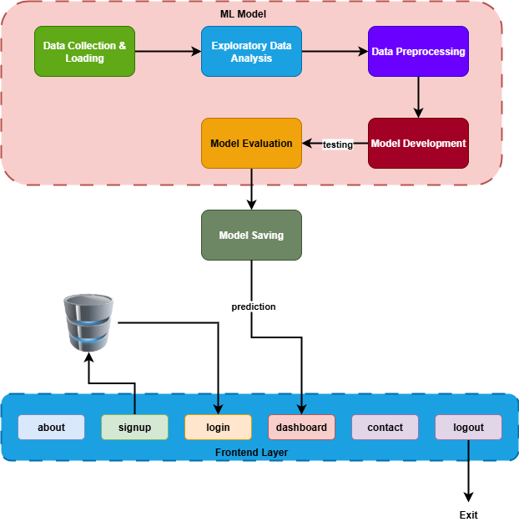
Figure 1: System Architecture
Model performance will be evaluated using statistical metrics, including accuracy, precision, recall, F1-score, mean squared error, and root mean squared error, alongside financial metrics like cumulative returns, Sharpe ratio, and maximum drawdown. Comparative analysis with traditional methods, such as ARIMA, linear regression, and support vector machines, will highlight improvements achieved through deep learning. The study will also assess practical applicability by simulating trading strategies based on predicted trends, considering limitations like computational complexity and model interpretability.

Expected Practical Element Output

The practical outcomes of this research are expected to include:
- A fully implemented deep learning-based stock market trend prediction system.
- Cleaned and pre-processed historical stock market datasets suitable for time-series analysis.
- Comparative performance evaluation reports of deep learning and baseline models.
- Visualisations demonstrating predicted versus actual stock market trends.
- A documented framework that may serve as a foundation for future financial forecasting applications.

Project Plan & Gantt Chart

The project is scheduled for a three-month duration and is designed to guarantee efficient completion within a constrained timeline. In the initial month, a concentrated literature survey will be undertaken to examine existing research on stock market trend prediction and deep learning methodologies. Concurrently, historical stock market data will be gathered from reputable financial sources. During the second month, tasks related to data preprocessing, including data cleaning, normalisation, feature engineering, and dataset partitioning, will be conducted. The creation and execution of deep learning models for predicting stock market trends will commence in this phase. The third month will focus on model training, performance assessment, and comparison analysis utilising relevant quantitative metrics. Simultaneously, the analysis of results and the composition of the dissertation will be conducted. The last process will encompass proofreading, final changes, and submission preparation. This streamlined project plan guarantees methodological rigour while facilitating prompt project completion within the three-month timeframe.

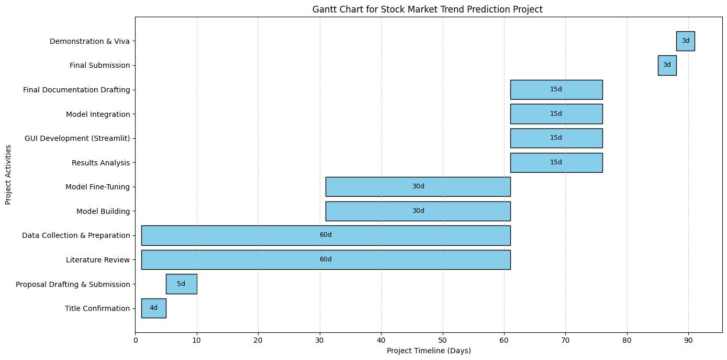
Figure 2: Project Gantt Chart

Conclusion

This project aims to develop a robust deep learning framework for predicting stock market trends in dynamic financial markets. By leveraging historical data, technical indicators, and market sentiment, the study seeks to uncover complex, non-linear patterns that conventional models often fail to capture. The methodology integrates advanced architectures, rigorous preprocessing, and performance evaluation to ensure reliability and practical relevance.
Expected outcomes include a fully implemented prediction system, preprocessed datasets, comparative performance analyses, and visualizations of predicted versus actual trends. The research contributes to both academic literature and practical finance by demonstrating the effectiveness, adaptability, and scalability of deep learning methods for improving forecasting accuracy and supporting informed investment decisions.

9. References

Fama, E.F. (1970). Efficient Capital Markets: A Review of Theory and Empirical Work. The Journal of Finance, 25(2), pp.383–417. doi:https://doi.org/10.1111/j.1540-6261.1970.tb00518.x.
Fischer, T. and Krauss, C. (2018). Deep learning with long short-term memory networks for financial market predictions. European Journal of Operational Research, 270(2), pp.654–669. doi:https://doi.org/10.1016/j.ejor.2017.11.054.

Krichen, M. and Mihoub, A. (2025). Long Short-Term Memory Networks: A Comprehensive Survey. AI, [online] 6(9), p.215. doi:https://doi.org/10.3390/ai6090215.

Huang, W., Nakamori, Y. and Wang, S.-Y. (2005). Forecasting stock market movement direction with support vector machine. Computers & Operations Research, 32(10), pp.2513–2522. doi:https://doi.org/10.1016/j.cor.2004.03.016.

‌LeCun, Y., Bengio, Y. and Hinton, G. (2015). Deep Learning. Nature, [online] 521(7553), pp.436–444. doi:https://doi.org/10.1038/nature14539.

‌Zhang, G., Eddy Patuwo, B. and Y. Hu, M. (1998). Forecasting with artificial neural networks: International Journal of Forecasting, 14(1), pp.35–62. doi:https://doi.org/10.1016/s0169-2070(97)00044-7.
‌
Li, Z., Liu, J., Liu, J., Liu, X. and Wu, C. (2025). Investor attention and stock price manipulation: Evidence from daily quasi-natural experiments. Journal of Banking & Finance, 179, p.107528. doi:https://doi.org/10.1016/j.jbankfin.2025.107528.
‌
Tian, G., Huang, T., Peng, C., Yang, Y. and Wen, S. (2025). BiMT-TCN: A Cutting-Edge Hybrid Model for Enhanced Stock Price Prediction. Knowledge-Based Systems, pp.114263–114263. doi:https://doi.org/10.1016/j.knosys.2025.114263.
‌
Liu, Y., Huang, X., Xiong, L., Chang, R., Wang, W. and Chen, L. (2025). Stock price prediction with attentive temporal convolution-based generative adversarial network. Array, 25, pp.100374–100374. doi:https://doi.org/10.1016/j.array.2025.100374.
‌

