Qualification: CIPD Diploma in Applied Human Resources

Module Name: Contributing to Coaching and Mentoring

Title: Portfolio of Evidence

Word Count:
LO1: 1440
LO2: 1033

Student Name: Maria Mellen Jimenez
Student Number: 2005457
CIPD Membership Number: 57501591

By signing below, I confirm that the work/evidence presented is my own, unaided work. I understand the regulations pertaining to candidate malpractice and the action that may be taken as a result.

Signed: Maria Mellen Jimenez
Date: 04/07/21

CONTENTS PAGE

Candidate Evidence Matrix 3
LO1: Be able to assess the impact of coaching and mentoring activity within an organisation and make recommendations for further development 5

  - Investigate the extent to which coaching and mentoring take place within an organisation 5
  - Evaluate how current coaching and mentoring activity supports achievement of individual, team and organisational objectives 6
  - Assess factors in the organisation including other learning strategies which could impact on the further development of coaching and mentoring. 7
  - Make justified recommendations for how coaching and mentoring activity can be developed to benefit the organisation 8
  - Reference list 10
  - Evidence 11

LO2: Be able to support the implementation of coaching and/or mentoring programmes within an organisation 13

  - Promote the benefits of coaching/mentoring within the organisation, recognising and addressing the potential barriers 13

  - Contribute to the development of organisational coaching/mentoring processes 14

  - & 2.4 Support coaches/mentors to build and develop the knowledge, skills and behaviours required for the role and assist potential coachees/ mentees to understand and participate fully in coaching/mentoring programmes 15

  - Support the on-going evaluation and continuous improvement of the organisation’s coaching/mentoring programmes 16

  - Reference list 17

  - Evidence list 18

Candidate name: Maria Mellen Jimenez |  |  |  |  | CIPD Membership/registration No.:  57501591
Qualification title: CIPD Level 5 in Applied HR |  |  |  |  | Unique Learner No. (ULN): 2005457
Unit code | Unit title |  | Assessment criteria no. | Evidence description | Evidence reference number |  | Assessor  initials | I/V initials if sampled
5ADCM | Contributing to Coaching and Mentoring in the Workplace |  | 1.1, 2.1, 2.2 | 121 Documents | EV1
5ADCM | Contributing to Coaching and Mentoring in the Workplace |  | 1.1 | Coaching training materials | EV2
5ADCM | Contributing to Coaching and Mentoring in the Workplace |  | 1.1 | Feedback training | EV3
5ADCM | Contributing to Coaching and Mentoring in the Workplace |  | 1.2, 1.3 | Screenshot website Professional Development | EV4
5ADCM | Contributing to Coaching and Mentoring in the Workplace |  | 1.2 | LEAP map | EV5
5ADCM | Contributing to Coaching and Mentoring in the Workplace |  | 1.2 | Detecting Talent | EV6
5ADCM | Contributing to Coaching and Mentoring in the Workplace |  | 1.2 | Training Booklet P1 | EV7
5ADCM | Contributing to Coaching and Mentoring in the Workplace |  | 1.2, 1.3 | File notes, 121s and Smart Objectives | EV8
5ADCM | Contributing to Coaching and Mentoring in the Workplace |  | 1.2, 2.1 | New Starter Record | EV9
5ADCM | Contributing to Coaching and Mentoring in the Workplace |  | 1.3 | L&D Policy | EV10
5ADCM | Contributing to Coaching and Mentoring in the Workplace |  | 1.3 | Screenshot Company results | EV11
5ADCM | Contributing to Coaching and Mentoring in the Workplace |  | 2.1, 2.3, 2.4 | C&M Promotion Presentation | EV12
5ADCM | Contributing to Coaching and Mentoring in the Workplace |  | 2.1 | Promotion Poster | EV13
5ADCM | Contributing to Coaching and Mentoring in the Workplace |  | 2.1 | Email about C&M promotion | EV14
5ADCM | Contributing to Coaching and Mentoring in the Workplace |  | 2.2 | GROW model applied | EV15
5ADCM | Contributing to Coaching and Mentoring in the Workplace |  | 2.2 | GROW model questions | EV16
5ADCM | Contributing to Coaching and Mentoring in the Workplace |  | 2.3, 2.4 | Survey mentor/mentee | EV17
5ADCM | Contributing to Coaching and Mentoring in the Workplace |  | 2.5 | Email about training feedback | EV18a  EV18b
5ADCM | Contributing to Coaching and Mentoring in the Workplace |  | 2.5 | Coaching assessment form | EV19
Candidate declaration:
- I confirm that the work/evidence presented for assessment is my own unaided work.
- I have read the assessment regulations and understand that if I am found to have ‘copied’ from published work without acknowledgement, or from other candidate’s work, this may be regarded as plagiarism which is an offence against the assessment regulations and leads to failure in the relevant unit and formal disciplinary action.
- I agree to this work being subjected to scrutiny by textual analysis software if required.
- I understand that my work may be used for future academic/quality assurance purposes in accordance with the provisions of the Data Protection Act 1998.
- I understand that the work/evidence submitted for assessment may not be returned to me and that I have retained a copy for my records.
- I understand that until such time as the assessment grade has been ratified through internal and external quality assurance processes it is not final.
Signature: |  | Maria Mellen Jimenez |  |  |  | Date: | 04.07.2021

Notes on candidate evidence matrices

Candidates should be encouraged to develop a matrix indicating how their evidence relates to each unit/module and learning outcomes/assessment criteria. This helps advisors and assessors to support candidates to draw links between units and encourage cross-referencing and the possible multi-use of evidence.

Evidence matrices can be developed using the unit/module and learning outcomes/assessment criteria, giving candidates an opportunity to link their evidence to each outcome.

Another approach is to have a more generic form where candidates list evidence and tick relevant boxes to show coverage.

Whatever approach is employed candidates should be encouraged to complete these forms themselves and not expect assessors to do this for them.

LO1: Be able to assess the impact of coaching and mentoring activity within an organisation and make recommendations for further development

  - Investigate the extent to which coaching and mentoring take place within an organisation.

After analysing the most recent training materials in my organisation, including the Learning and Development policy, I have come to the conclusion that as a company we do not have a coaching and mentoring approach per se. However, as we can see on EV1, this is based on the GROW model (Mindtools, 2021) by Alexander, Fine and Whitmore, and OSCAR, by Whittleworth and Gilbert (Lea, 2020).

A decade ago, coaching was briefly introduced during the organisation’s training sessions, specifically the GROW model (EV2), which shows how the company’s aim was to embed coaching activities into the 121 reviews, agreeing with the CIPD statement which expresses that companies apply coaching as a daily management activity, embedding it into one-to-one meetings (CIPD, 2020).

As a Deputy Store Manager, and previous Section Manager, I believe I have been unofficially career coaching (Zentis, 2016) the sales assistants in my team to become Section Managers, as I have not received formal training to become a coach. On the other hand, I was trained on the GROW model and also on how to give constructive feedback (EV3), in order to achieve the objectives and keep high levels of motivation.

  - Evaluate how current coaching and mentoring activity supports achievement of individual, team and organisational objectives.

When looking at the organisation’s website, we can see that one of the company’s objectives is ‘Our commitment to people’, being the first point the employees and their professional development (EV4). It explains how the main source of talent is the staff in the stores as they are the ones who best understand the customer’s needs.

The development program created in the last few years identify the employees’ interests and potential and offers different career paths too (EV5). Line managers are shown the skills and process to be followed for detecting talent within the teams, as we can see on EV6.

This objective agrees with the findings from Deloitte’s study (2021), where it explains that by providing workers with different choices to fit their interests and capabilities, they will learn in the workplace, boosting their skills that some may hide. The organisation will benefit this way reorganising workers to achieve company’s priorities. Simultaneously, the employees do what is important to them and become more engaged and motivated.

On the specific situation where the employee chooses the path for a career development as a manager, the trainer must ensure that the trainee learns the different aspects of the job description. In this case, the training material will be divided in six categories: People, Processes, Health and Safety, Product, Diversity and Inclusion and Customer Experience. The trainer goes through the training booklets with the trainee, using a directive approach to mentoring (Yap, 2018), once again, unofficially. (EV7).

Coaching strategies will be learnt by the trainee when the trainer is explaining how to conduct a 121 meeting (EV8), which has a structure derived from the GROW and OSCAR models (Mindtools, 2021). The trainer will be setting SMART objectives which will be agreed by the trainee, achieving this way both individual’s and organisation’s goals, such people development.

In terms of new starters’ training procedure, the HR department has created a guide for the first 4 weeks of training to ensure the minimums standards of performance are met by the employees. (EV9). The figure of the ‘buddy’ is present on the guide, as we can read on the first page of EV9, but the reality is that there is not enough support in terms of additional training hours, and this makes very hard to assign a buddy to the new employees, so they end up spending a lot of time on their own.

  - Assess factors in the organisation including other learning strategies which could impact on the further development of coaching and mentoring.

As I have previously mentioned, my organisation promotes a learning culture focused on the employee’s professional development (EV4). As a multinational, each country has an individual HR team, divided in different categories and regions, these last ones depending on the sales volume of each store. Just in the UK, the organisation has 58 stores, with a minimum of 6 managers in the smallest store, to a maximum of 20 managers on the largest ones (information provided by my regional manager).

The organisation has a L&D policy (EV10) whose vision is “to empower ownership of learning, by which we understand we all have to be proactive in seeking opportunities to learn, remain curious and in constant communication with our line managers”. There is no mention of any coaching and mentoring activities; however, training materials are based on coaching models like GROW (EV8), and store management is responsible for training and developing their teams, monitoring their performance, and discussing and agreeing learning needs and objectives.

During the lockdowns due to Covid-19, any staff development active plans were put on hold due to staff being on furlough and unable to attend the workplace, as most of the training must take place at work, although the company used videocall tools to provide any compulsory training, such as Employee Relations, or Fire Marshall courses. The main factor here is costs, which were significantly reduced in the past twelve months, as previously employees were required to travel to Head Office in London to take part in them (organisation’s internal information). Nowadays, even if the stores are operating again, this seems a method which will stay, so the company might be able to invest in other opportunities.

The sales in the group have increased in the first quarter of 2021 by 50% (EV11) which has put a big strain in the store teams, particularly on the line managers. The main priority has been achieving sales targets focusing on commerciality, leaving to one side the human factor and training. This has led to less specialized sales assistants and a constant atmosphere of stress for both managers and sales assistants, and not ‘having time’ to give feedback about the performance. Not many employees express their desire to progress in the company either, which does not support the company’s mission of staff development.

As cited on Michael Page (2021) website, mentoring has a few benefits which would help the actual situation in the stores, such as improving staff morale, having a culture of personal growth, staff engagement and retention or increasing the coaching skills in managers.

  - Make justified recommendations for how coaching and mentoring activity can be developed to benefit the organisation.

Barbato and Harrell (2018), both HR professionals at Google, establish the following 10 Oxygen behaviours of Google’s best managers:

- Good coach.
- Inspires the team and do not micromanage.
- Creates a work environment where inclusion, success and wellbeing are key.
- Productive and orientated to achieve results.
- Communicates well.
- Supportive of employee development and reviews performance.
- Holds a clear plan for the team.
- Advises the team through technically-skilled methods.
- Collaborative across Google.
- Strong decision maker.

As we can see, being a good coach is on the top of the list. However, the main issue we face in organisations like mine, where line managers are mostly commercially focused and feeling constantly pressured by the regional team. For them, training their team is classed as a ‘box-ticking’ exercise, where paperwork must be filled in case the HR manager asks for it.

Recommendation 1: Relaunching the induction process.

According to Clifton and Harter (2019), first impressions are extremely important as it is the easiest way of influencing them when they do not have any knowledge and are willing to learn. Starting from the day one, where their induction takes places in four hours, the manager in charge should only be focused on this employee. Additionally, investing extra training hours ensuring the new starter shadows their buddy for at least the first week or two would improve their performance and the organisation’s profits long term.

The induction process itself should last longer than four hours, and apart from Health and Safety, it should be focused too on the organisation’s purpose, so the new employees are aware of the process and opportunities of career development from day one.

Recommendation 2: Group coaching activities for all staff.

As Zentis (2019) explained in her article, it may be focused on career development, team building and stress management as individuals learn from each other. This would result in a decrease of stress levels and achievement of the organisation’s goals as a team.

Recommendation 3: To formally train line managers as career and performance coaches.

Career coaching is key to help employees understand the expectations from their career and make decisions to achieve their career goals balancing them with other aspects of their lives.

Performance coaching is essential too in order to help individuals understand what is expected from them, the skills needed and if they have any gaps, how they can improve their performance (Zentis, 2019).

With these trainings, the performance of all the employees would be improved which would lead to the achievement of the organisation goals.

  - Reference list

- CIPD (2020) Coaching and mentoring. Available at: https://www.cipd.co.uk/knowledge/fundamentals/people/development/coaching-mentoring-factsheet. Accessed 28/05/21.

- Barbato, L. and Harrell, M. (2019) Great managers still matter: the evolution of Google’s Project Oxygen. Available at: https://rework.withgoogle.com/blog/the-evolution-of-project-oxygen/. Accessed on 12/06/21.

- Clifton, J. and Harter, J. (2019) It’s the manager. Gallup Press. New York. Accessed on 12/06/21.

- Deloitte (2021) The social enterprise in a world disrupted. Leading the shift from survive to thrive. Accessed on 01/06/21.

- Lea, S. (2020) OSCAR Model. Available at: https://www.mindtools.com/pages/article/newLDR_89.htm. Accessed on 07/05/21.

- Michael Page (2021) Benefits of mentoring. Available at: https://www.michaelpage.com/advice/management-advice/development-and-retention/benefits-mentoring. Accessed on 12/05/21.

- Mindtools (2021) The GROW Model of Coaching and Mentoring. A simple process for developing your people. Available at: https://www.mindtools.com/pages/article/newLDR_89.htm. Accessed on 07/05/21.

- Yap, S. (2018) The Differences Between Coaching, Mentoring, Training and Counselling. Available at: https://minds-senses.com/coaching-mentoring-training-counselling/. Accessed on 05/05/21.

- Zentis, N. (2016) The 15 types of coaching. Available at: https://instituteod.com/15-types-coaching/. Accessed on 30/05/21.

  - Evidence list

EV4

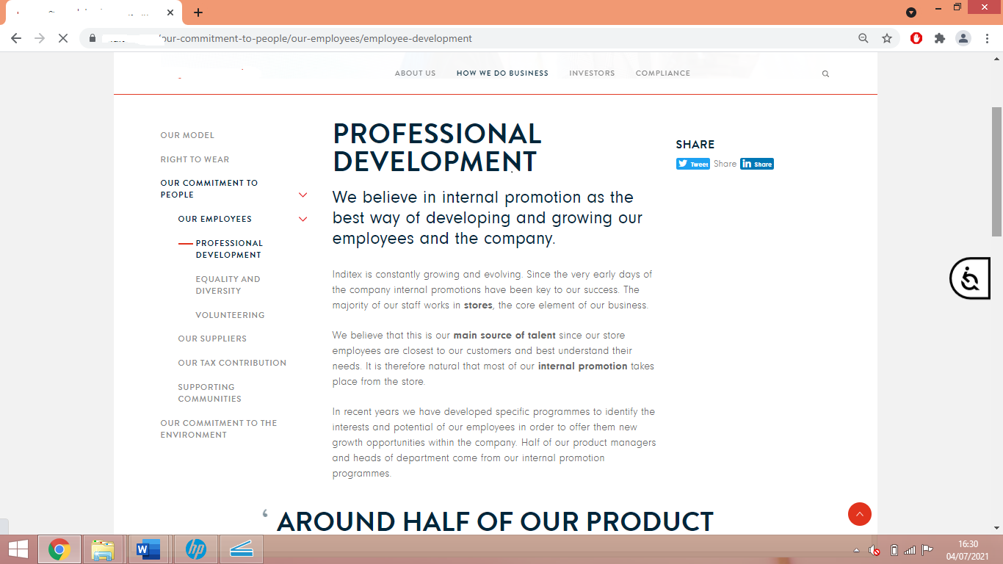

EV5

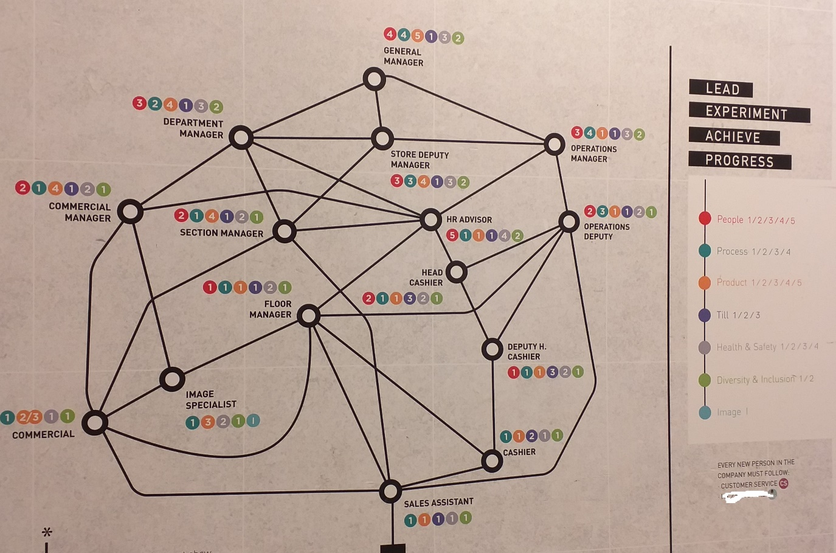

EV11

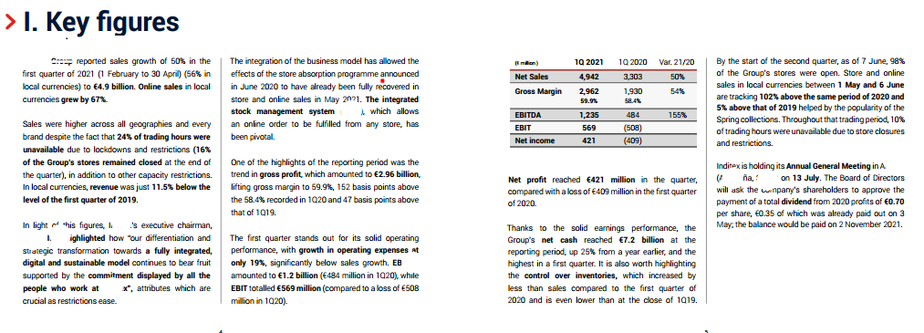

LO2: Be able to support the implementation of coaching and/or mentoring programmes within an organisation.

- Promote the benefits of coaching/mentoring within the organisation, recognising and addressing the potential barriers.

In my organisation, as I have previously explained, there is no formal coaching or mentoring activities, but I would like to promote it through my store and my regional team. I have created a presentation for the line managers and HR team about the concepts of Coaching and Mentoring and the benefits of implementing it as a learning solution (EV12)

At the moment we set objectives and provide feedback following a template with is based mainly in the GROW model, but in the last year, managers have been finding it extremely hard to conduct 121 meetings. When receiving feedback from them, the main reason they have given is that they do not have the time to stop and think about giving feedback to the sales assistants, as they are too busy making commercial decisions for the department. This and some other barriers have been identified by Sandra Steen in her article ‘The Top Five Barriers to Coaching in the Workplace and How to Overcome Them’ (2018). She explains that when coaching is done properly, it will improve performance and morale. An active coach in the workplace will increase the productivity of both as a team and individually (EV12).

According to Bajer et al (2016), the promotion or marketing of coaching and mentoring in an organisation intends to distinguish and establish how we can link the expressed needs of the people, from psychological to job-related, and the benefits of coaching. But before we promote coaching and mentoring, we need to have in place the following three elements:

- Understanding the need for coaching, through staff surveys, conversations, forums, or other events.

- Adequate coaching and mentoring methods, not all methods apply to all needs.

- Marketing plan, to align with the company’s strategy.

I have also created a promotion poster (EV13) which I have emailed to my colleagues (EV14), along with the presentation.

- Contribute to the development of organisational coaching/mentoring processes.

In order to introduce coaching and mentoring processes within the organisation developmental strategy, I believe the basics of coaching and mentoring should be introduced to the line managers, on whom it falls the responsibility of developing their team.

The concept of the GROW coaching model (Mindtools, 2021) was promoted during the management compulsory training sessions, over 10 years ago, and it explained how it may be used not only for training and development, but also on day to day situations, such as return to work interviews, as we can see on EV15 (GROW model applied and booklet spiral).

The template we use to conduct 121 reviews is mainly set for a quick feedback from the employee, following by the line manager’s feedback and moving on to the goal setting part, which is mainly led by the manager, who chooses the goals in terms of the business needs (EV1). But, in order to create a strong team to be part of the company succession plan, we also need to learn to coach our team to maximise their potential and to make them feel that they are involved in their goals.

The idea would be to use the 121 template mainly to help the sales assistants develop their skills detailed in their job description and covered with the New Starter Record (EV9), and for employees who do not wish to grow within the organisation.

We would use coaching strategies to help the employees who would like to progress to find their potential and change their performance, if needed, training the managers on coaching tools such as GROW model questions (EV16), and would introduce mentoring as well, as the directive tool to transfer skills, knowledge, and best practice (Yap, 2018).

- & 2.4 Support coaches/mentors to build and develop the knowledge, skills and behaviours required for the role and assist potential coachees/ mentees to understand and participate fully in coaching/mentoring programmes.

With the purpose of introducing coaching and mentoring within the managers and employees in the organisation, I have created a brief presentation (EV12) for them to understand the benefits of C&M strategies, mainly as a learning solution, and the skills and behaviours to be developed to become a coach/mentor.

It is also important to highlight the barriers to C&M activities and how to overcome them, with some examples from Steen (2018). This way, we will get more involvement from coachees/mentees.

Based on our internal skills assessments and supported with some ideas from Mentorloop (2021), I have created a survey to help match mentors and mentees (EV17). The objective is to get as much information as possible from the candidate in order to choose the right mentoring program with the most suitable mentor.

  - Support the on-going evaluation and continuous improvement of the organisation’s coaching/mentoring programmes.

At my organisation, even if we do not have any formal coaching and mentoring programmes, we have a very strong development programme where we fill 2/3 of the vacancies with employees who originally worked in the stores (internal information provided by the regional manager).

In terms of evaluation of the programme, my organisation does not request feedback from employees who have taken part in the programme in a survey format, but they are able to provide any comments on what they liked or what needs improving on their regular 121 meetings with their trainer. Unfortunately, my company is not very supportive with my personal development regarding this apprenticeship, so I do not have access to any further information that is not published in our website. However, I requested some feedback from one of my trainees, who took over my position when I was promoted earlier this year (EV18), and another colleague filled in the coaching assessment form too (EV19).

I believe it is important to introduce more feedback surveys, not only for the employees but also for the managers, as we are the ones who will be using the tools created for us by people who do not work on the same environment and we may provide real feedback on the challenges we have to overcome, opening the door for suggestions on areas of improvement.

After some research, I have found that Kirkpatrick’s ‘Four Levels’ model (Business Balls, 2020) would work quite well in my organisation, as it is not only focusing on the trainee’s reaction to their learning experience, or if they achieved their purpose, but also if the training has proved a change in their behaviour and if their performance is being reflected in an improvement of the business performance too, by measuring KPIs, such sales, staff turnover or complaints.

  - Reference list

- Bajer, A.; Clutterbuck, D. and Megginson, D. (2016) Building and Sustaining a Coaching Culture. CIPD: London. Accessed on 25/04/21.

- Burrows, K. (2021) Coaching Skills – Ultimate Guide – Coaching Techniques. Available at: https://www.makingbusinessmatter.co.uk/coaching-skills-ultimate-guide/#10. Accessed on 27/06/21.

- Business Balls (2020) Kirkpatrick Evaluation Method. Available at: https://www.businessballs.com/facilitation-workshops-and-training/kirkpatrick-evaluation-method/. Accessed on 01/07/21.

- CIPD (2017) Coaching: It’s a culture thing. Available at: https://www.cipd.co.uk/podcasts/coaching-culture. Accessed on 20/06/21.

- Coaching story (2021) Benefits of coaching. Available at: http://www.coachingstory.org/techniques/describe-benefits-of-coaching-to-other-people/. Accessed on 12/05/21.

- Institute of Coaching (2021) Benefits of Coaching. Available at: https://instituteofcoaching.org/coaching-overview/coaching-benefits. Accessed on 12/05/21.

- Michael Page (2021) Benefits of mentoring. Available at: https://www.michaelpage.com/advice/management-advice/development-and-retention/benefits-mentoring. Accessed on 12/05/21.

- Mindtools (2021) The GROW Model of Coaching and Mentoring. A simple process for developing your people. Available at: https://www.mindtools.com/pages/article/newLDR_89.htm. Accessed on 07/05/21.

- Steen, S. (2018) The Top Five Barriers to Coaching in the Workplace and How to Overcome Them. Available at: https://www.linkedin.com/pulse/top-five-barriers-coaching-workplace-how-overcome-them-steen/. Accessed on 21/06/21.

- UK Coaching (2019) Coaching Behaviours. Available at: https://www.ukcoaching.org/resources/topics/guides/coaching-behaviours. Accessed on 01/07/21.

- Yap, S. (2018) The Differences Between Coaching, Mentoring, Training and Counselling. Available at: https://minds-senses.com/coaching-mentoring-training-counselling/. Accessed on 05/05/21.

  - Evidence list

EV14

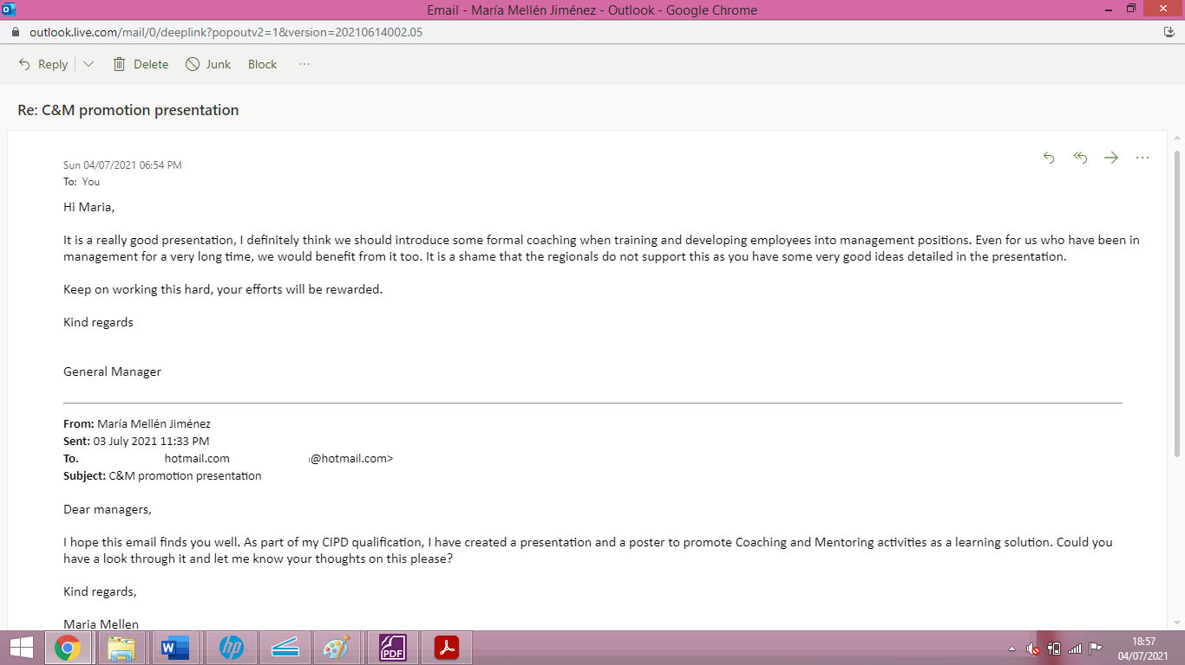

EV18a

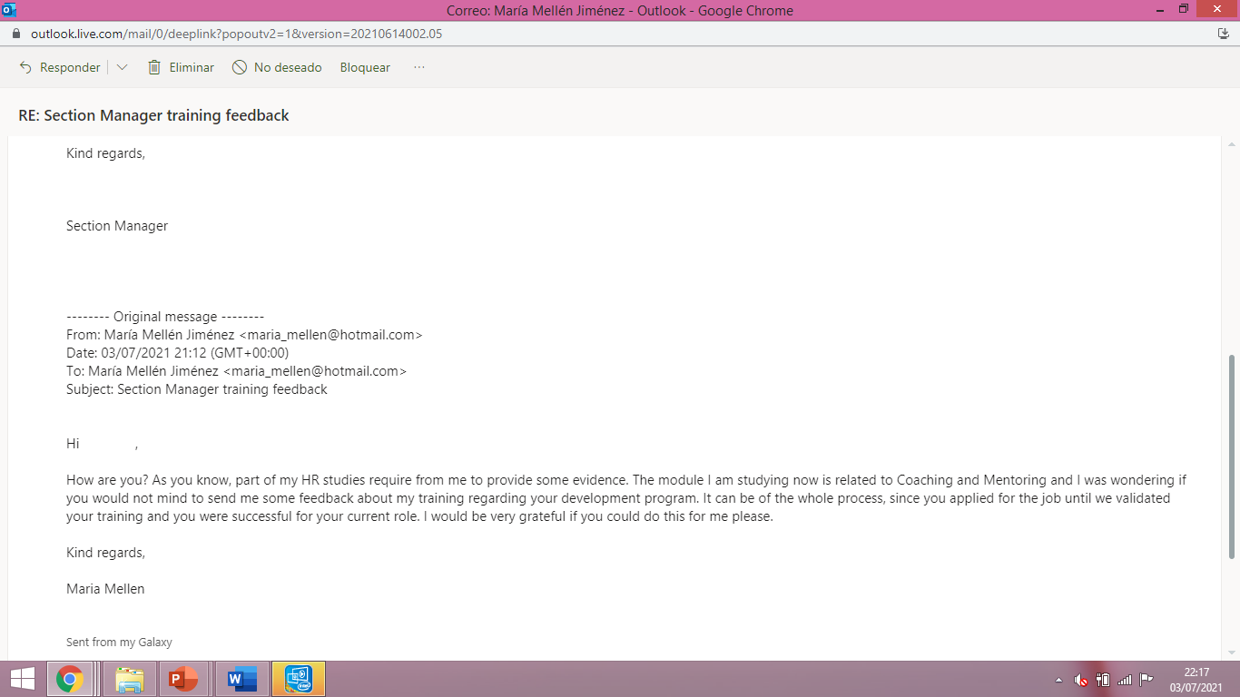

EV18b



