University of Wales Trinity Saint David

School of Engineering



CAD Report – Dry Sump Design Project

Engineering Design

ACMA4008

Rachel Williams

2208603

February 2024

Contents

Table of Contents
0 Contents 2
0.0 Table of Contents 2
0.1 Table of Figures 2
0.2 Table of Tables 3
1 Introduction 4
2 Problem Identification 5
2.0 Quality Function Deployment 5
2.1 Kano Model 6
2.2 Product Design Specification 7
2.2.0 Market Requirements 7
2.2.1 Life in Service 8
2.2.2 Production Requirements 9
2.2.3 Conformance Requirements 9
3 Methodology 10
3.0 Design Isolation 11
4 Discussion 13
5 Conclusions 15
6 References 16

Table of Figures
Figure 1 5
Figure 2 6
Figure 3 7
Figure 4 10
Figure 5 10
Figure 6 11
Figure 7 13
Figure 8 13
Figure 9 14

Table of Tables
Table 1 11

Introduction
At first glance, a dry sump differs from a wet sump due to the difference in the storage of oil. A wet sump stores its oil within the wet sump located beneath the engine block. Use of a wet sump for racing applications can cause horsepower reductions due to windage. To avoid windage a wet sump may be used. A wet sump stores the oil in a separate reservoir. The oil drains from the engine block into the dry sump pan and scavenger pumps displace the oil to the separate reservoir.
Outlined in this report is the design process undertaken for the design of a dry sump oil pan. Presented first is a quality function deployment (QFD) to identify the needs of the customer and prioritise the features of the dry sump. From the QFD a product design specification (PDS) was created to define the specifications of the sump designed. Using the kano model, features that were added to the design were discussed to anticipate the satisfaction of the customer and review what features maybe added to increase customer satisfaction.
Following the creation of the PDS, concept designs were created using SOLIDWORKS. The concept designs were then presented and evaluated to discover the optimal features to include in the final design. The final design was then presented and evaluated. Recommendations for testing of the dry sump were also included.

Problem Identification

Quality Function Deployment
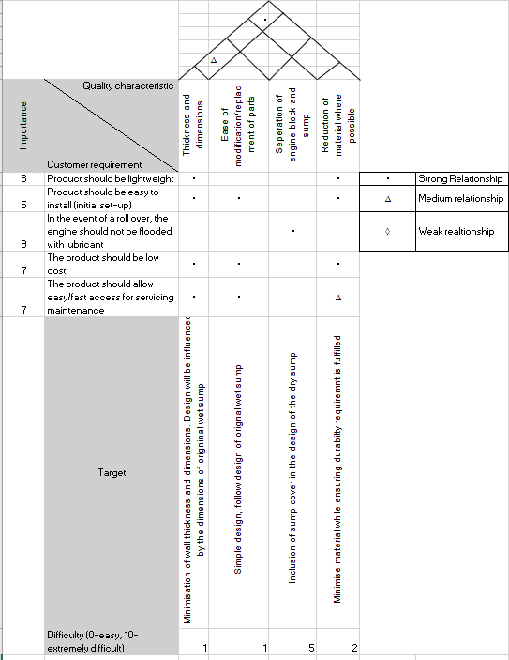
Figure 1
Featured in figure 1 is the quality function deployment (QFD) created from the demands of the customer and research.
From this QFD a Product Design Specification was created to specify the requirements for the product.

Kano Model
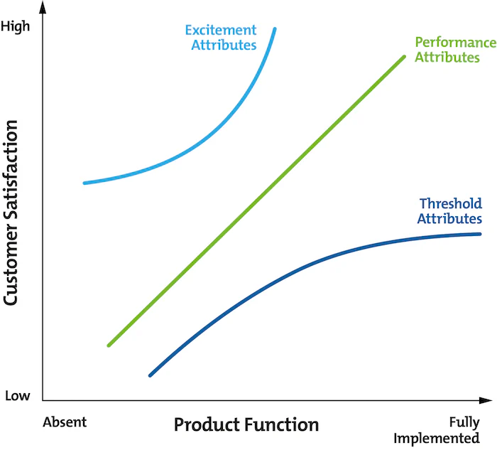
Figure 2
Displayed in figure 2 is the kano model. (Mind Tools Content Team, 2024)
Included in the QFD is the customer requirements for the dry sump, represented on the kano model by the performance and threshold attributes. For example, the dry sump systems ability to displace its oil to an external reservoir is a threshold attribute. While its speed at displacing the oil would be a performance attribute. Another performance attribute of the dry sump would be the weight, the more lightweight the dry sump the greater the horsepower achievable by the vehicle. For racing applications all weight is relevant due to its effect on the acceleration achievable by the engine.
Excitement attributes that may be included in the design of the dry sump are control of the speed of the displacement of oil and a windage tray to increase the horsepower achievable by the engine.
Control over the speed of displacement of oil is specific to each vehicle, control over the rate of displacement is achievable by the inclusion of a valve on the hose fittings leading to the pump, this may cause an increase or decrease in the amount of oil present in the dry sump at one time.
The presence of a windage tray in the design would be an excitement attribute as it will decrease the oil splashing back into the engine block, meaning less windage upon the engine and increasing the maximum horsepower achievable for the engine.

Product Design Specification

Market Requirements

Target Costs
Based on competitors the target price range for the customers will be roughly £500.

Performance
High performance is required from this product for track use. The dry sump must prevent the oil from entering the engine block in the event of a rollover.

Aesthetics
Aesthetics is unimportant in comparison to the performance of the sump.

Packaging
Must be packaged efficiently to prevent damage during shipping.

Standards and Specifications
Must conform to standards set by relevant regulation bodies.

Competition
The first dry sump competitor found online was an Alfa Romeo dry sump. The material used for this sump is alloy cast aluminium and cost £700.00. (Vision Motorsport Engineering Products LTD, 2024)
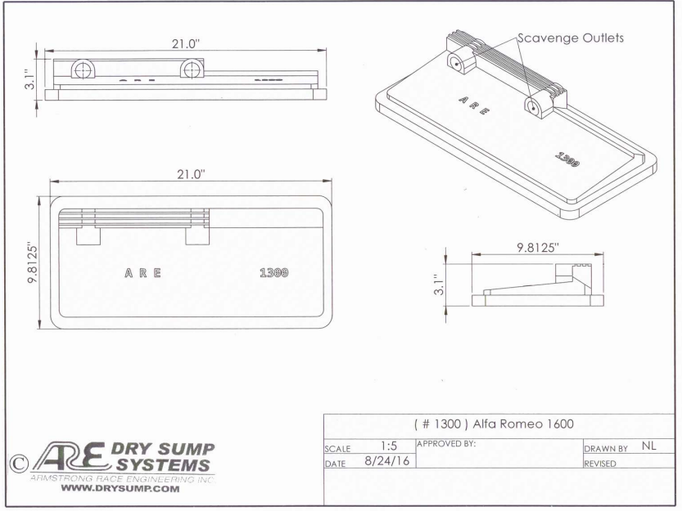
Figure 3
Figure 3 features technical drawings of the Alfa Romeo dry sump.
A second competitor for the creation of a dry sump is the Champ Pans Circle Track dry sump. This dry sump uses steel and costs £257.00. (Summit Racing Equipment, 2024)
Another competitor’s dry sump is the Canton Racing Circle Track Dry Sump. This sump is made of steel and costs £595.00. (Summit Racing Equipment, 2024)
Also to note is the Moroso Circle Track Oil Pan. This oil pan is made of aluminium and costs £659.00. (Summit Racing Equipment, 2024)

Customers
Individuals or groups that wish to convert their vehicles to a dry sump oil system, generally for racing applications.

Shipping
Appropriate shipping arrangements will be made dependent on the customer.

Life in Service

Installation
It is a customer requirement that the dry sump is easy to initially install.

Shelf Life
Generally, an oil sump pan should be capable to remain intact until the car is broken beyond repair. Due to the sump being designed for track use at high speeds it is necessary the sump be particularly resistant to damage.

Maintenance
It is a customer requirement that the sump is easy to conduct maintenance upon. Dry sump pans are generally easier to conduct maintenance on due to the usually smaller dimensions than the original wet sump. The additional space provided by the wet sumps dimensions means that maintenance will be easier to conduct around the sump.

Testing
To ensure the sump can withstand damage during high-speed collisions the dry sump will be tested under compressive forces to ascertain the force the sump is capable of withstanding in a collision. The sump will also be exposed to high frequency vibrations to simulate a vehicle travelling at high speeds. Another form of testing for the sump will be to rotate it to simulate the occurrence of a rollover to ensure the sump fulfils the customer requirement of the oil being prevented from flooding the engine during a rollover.

Environment
The dry sump will be exposed to a high temperature environment and may be involved in a rollover or collisions.

Production Requirements

Materials
During research of dry sump pans, it was found that most are made using steel or aluminium.
Aluminium is beneficial as it is one third lighter than steel and possesses better thermal conductivity than steel. Benefits of using steel are its cost efficiency and strength.

Size and Weight Restrictions
Maximum dimensions of 450x222x116 mm, due the size of the wet sump being replaced.

Manufacturing Processes
The sump will be made of a cast aluminium alloy. Reasons for this choice of material includes aluminium being lightweight in comparison to steel. Casting the aluminium ensures greater strength for the dry sump.

Conformance Requirements

Quality and Reliability
It is industry standard within the automotive industry that products be tested effectively to determine their quality and reliability is sufficient.

Safety and Legal requirements
The testing to be conducted on the product will ensure that all necessary safety and legal requirements are fulfilled.

Methodology

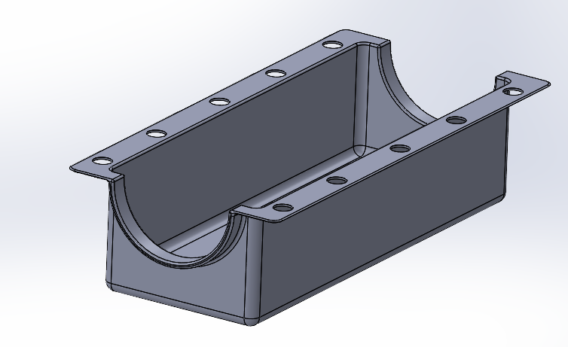
Figure 4
Figure 4 displays the first concept design for the dry sump. In the creation of this design the dimensions of the sump were determined by the wet sump model provided, to ensure compatibility for the vehicle the wet sump was removed from.
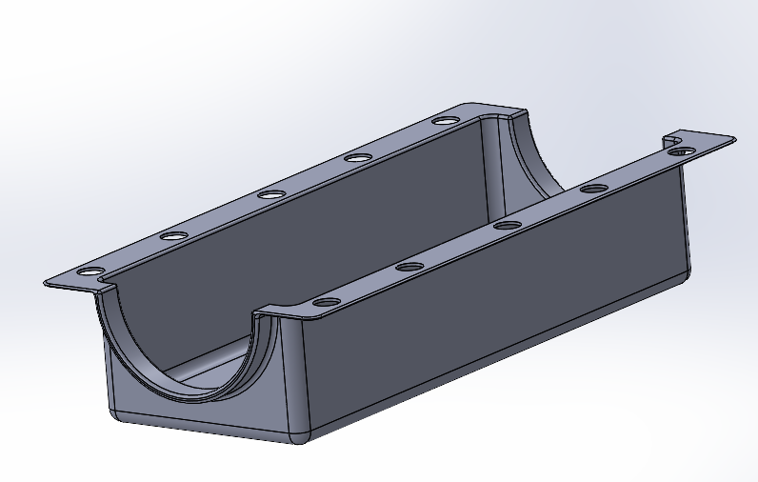
Figure 5
Displayed in figure 5 is the second concept design. The depth of the dry sump was adapted in this concept to improve the weight of the sump and to make installation easier.
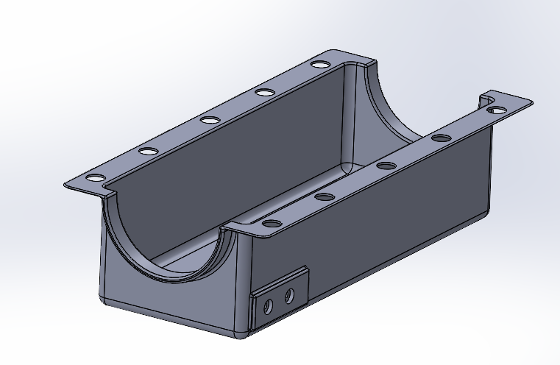
Figure 6
Displayed in figure 6 is the third concept design for the dry sump. Included in this design is the adapters for the fuel pump hoses to attach to drain the oil from the sump.

Design Isolation
Table 1
Feature | Weighting | Concept 1 | Concept 2 | Concept 3
Lightweight | 8 | 1 | 10 | 1
Ease of installation | 5 | 5 | 8 | 5
Engine will not be flooded with oil in event of rollover | 9 | 5 | 5 | 5
Low cost | 7 | 8 | 10 | 8
Ease of Maintenance | 7 | 5 | 8 | 9
Ease of Manufacture | 6 | 5 | 8 | 5
Efficiency of operation | 7 | 2 | 2 | 9
Simplicity of layout | 5 | 5 | 5 | 5
Design total |  | 238 | 378 | 315

Table 1 displays a Pugh matrix for the three concept designs. As can be seen in table 1, Concept 2 possesses the strongest design to fulfil the customer requirements, followed by Concept 3 then Concept 1.
The final design was created by combining the optimal features of each concept design.
The thinner design of the pan in Concept 2 was the optimal shape for the sump as it ensured a lower cost of manufacture and weight. The smaller dimensions also allow for easier maintenance and installation. The pump adaptor fittings from Concept 3 were utilised within the final design as they are sized to standard for pump hose fittings, also ensuring ease of installation and greater product compatibility with common hose sizes used for pumps.

Discussion
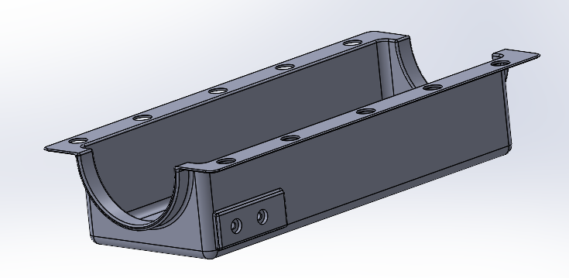
Figure 7
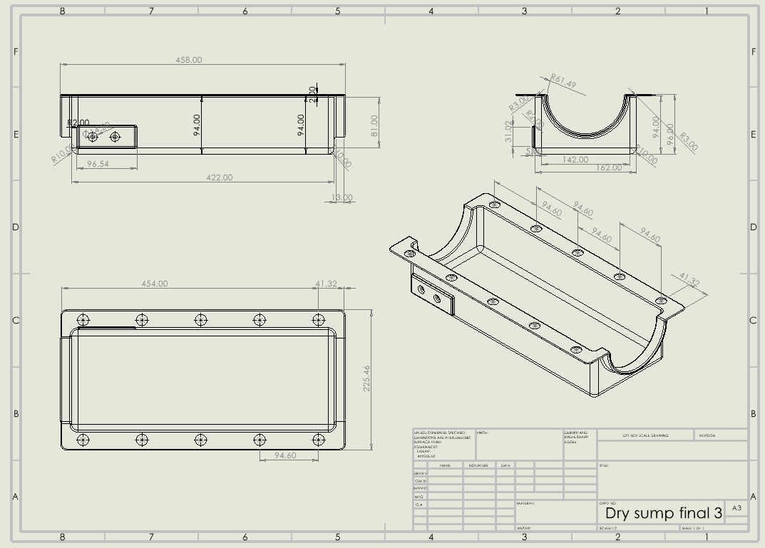
Figure 8
Displayed in figure 7 is the solid model of the final design of the dry sump. Figure 8 is the technical drawing of the dry sump. The depth of the sump of the second concept design was utilised as it was found to be beneficial for cost and ease of maintenance. The standard size fittings for the oil pickup adapter from Concept 3 were also utilised in the final design. The dimensions and spacing of the holes for attachment to the engine block were taken from the original wet sump, meaning ease of installation for the vehicle from which the wet sump was removed. An engine block for a different vehicle may be adapted to hold this dry sump fairly easily.
An addition to this sump post-processing will be the inclusion of a non-return valve in the external pump hoses used to displace the oil to the reservoir, and the pump used to circulate the oil to the engine will be located at the bottom of the reservoir. This will stop the oil from flowing backwards into the engine block in the event of a rollover.
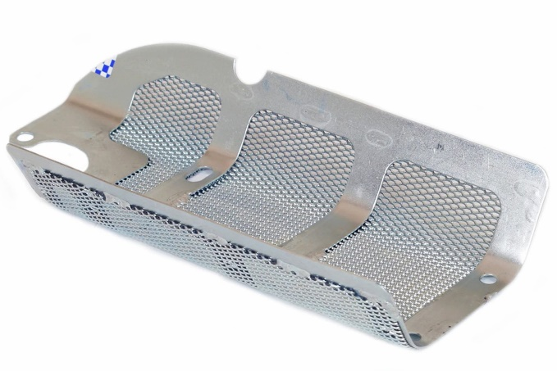
Figure 9
Displayed in figure 8 is a mesh windage tray. (Acosta, 2024)
A mesh windage tray was another post-processing addition to the design during assembly. The purpose of this tray is to restrict unnecessary windage in the form of oil splashing back into the engine block and exerting unwanted force upon the crank shaft. The windage tray will obstruct the oil from splashing back into the engine as it works as a filtering screen, with many holes as to still allow the oil to be drained from the engine.
To ensure the dry sump fulfils the safety and legal requirements, it is recommended that the sump undergo suitable testing. A test to ensure its structural integrity is essential due the flammable nature of its contents after installation. It is necessary that the dry sump be capable of enduring high compressive forces that would be present during a collision on track without cracking. A second test to be conducted would simulate the vibrational frequencies present in the engine block to ensure no damage will be caused by these frequencies. A high temperature test is also essential for the dry sump due to the environment within the racing vehicle the product will experience will be high temperature.

Conclusions
To summarise the work conducted in this report, a QFD was conducted to specify the needs of the customer, from which a PDS was created to outline the specific design requirements necessary for how the dry sump will fulfil the requirements of the customer.
From the PDS, concept designs were then created and evaluated for the purpose of finding the optimal design solution. A Pugh matrix was employed to ensure effective evaluation of the concept designs. Using the results of the Pugh matrix a final design solution was created, using features from each of the concept designs.
The final design solution was then presented and described to display how it fulfilled the customer requirements. Recommendations for testing the dry sump were also included to ensure the dry sump is fit for purpose prior to installation.

References
Acosta, G. (2024, February 15). Back to Basics: What Is Windage In An Engine And How Do We Fight It? Retrieved from www.enginelabs.com: https://www.enginelabs.com/engine-tech/back-to-basics-what-is-windage-in-an-engine-and-how-do-we-fight-it/
Mind Tools Content Team. (2024, February 15). Kano Model Analysis. Retrieved from Mind Tools: https://www.mindtools.com/asoc84u/kano-model-analysis
Summit Racing Equipment. (2024, February 14). Canton Racing Circle Track Dry Sump Oil Pans 12-464. Retrieved from www.summitracing.com: https://www.summitracing.com/parts/ctr-12-464
Summit Racing Equipment. (2024, February 14). Champ Pans Circle Track Dry Sump Oil Pans CP150R12. Retrieved from www.summitracing.com: https://www.summitracing.com/parts/chp-cp150r12
Summit Racing Equipment. (2024, February 14). Moroso Circle Track Oil Pans 21545. Retrieved from Summit Racing Equipment: https://www.summitracing.com/parts/mor-21545
Vision Motorsport Engineering Products LTD. (2024, February 14). Alfa Romeo 1750-2000 Dry Sump. Retrieved from Vision Motorsport Engineering Products LTD: https://www.vmep-ltd.co.uk/product-page/alfa-romeo-1750-2000-dry-sump

