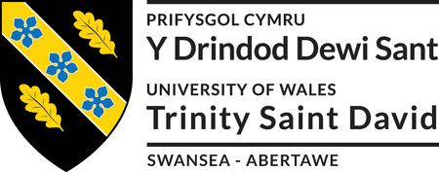

An Exploratory Study of Transformational, Transactional and Laissez-Faire Leadership Styles that exist within a Police Communications Centre, Examining their Impact on Staff and Performance Outcomes.

NAME – Peter Wyn Roderick
STUDENT NUMBER - 2115598
DEGREE TITLE - MA Criminal Justice and Policing
Acknowledgements

I would like to say a special thank you to my family for their support, encouragement and patience throughout my studies. Without this, I would never have completed the dissertation.

I would also like to thank Gareth Scanlon, the Head of Department at the Police Communications Centre where the study took place for his personal and strategic support, the very essence of which enabled me to get the very heart of the underlying issues within the study.

I would also like to thank my Supervisor and Programme Manager for their support, and for their words of wisdom in bringing about clarity of thought, which on occasions was much needed.

A real special thank you goes to my wife Anwyn, who without her none of this would have been possible. Her strength, encouragement and patience has supported me to finally submit this dissertation.

Declaration

This work has not previously been accepted in substance for any degree and is not being concurrently submitted in candidature for any degree.
Signed ............PW. Roderick (candidate)
Date ...............01/10/23

Statement 1
This dissertation is being submitted in partial fulfilment of the requirements for the degree of MA.
Signed ..............PW. Roderick (candidate)
Date ..................01/10/23

Statement 2
This dissertation is the result of my own independent work/investigation, except where otherwise stated. Other sources are acknowledged by footnotes giving explicit references. A bibliography is appended.
Signed ................PW. Roderick (candidate)
Date ....................01/10/23

Statement 3
I hereby give consent for my dissertation, if accepted, to be available for photocopying and for interlibrary loan, and for the title and summary to be made available to outside organisations.
Signed ...................................................................... (candidate)
Date ........................................................................

Statement 4
I hereby give consent for my dissertation, if accepted, to be available on the university’s IT system to those who have consent to use the system.
Signed ...................................................................... (candidate)
Date ........................................................................

Abstract

A Police Communication Centre within a Police Force is a critical area of business where high-risk and sensitive calls need to be handled within clearly defined procedural conventions (HMICFRS, 2021). Where this is considered to have failed, dire consequences can result.
This research study examined the main leadership styles (transactional, transformation and laissez-faire) evident within a Police Communications Centre and explored their relationship with performance delivery. Factors likely to impact on this relationship were included within the scope of the study, matters relating to demand, capacity and capability.
Through quantitative and qualitative research methodologies, emerging findings revealed that a dominant leadership style impacted heavily on staff within the workplace. This was significantly impacted upon by influencing factors associated with resourcing levels and an unyielding performance focus designed to perform well in the 999 league tables introduced by the Government.

Contents Table

Content | Page
Chapter 1  Introduction | 6-9
Chapter 2  Literature Review | 10-27
Chapter 3  Methodology | 28-38
Chapter 4  Data, Analysis & Interpretation | 39-71
Chapter 5  Findings, Conclusions & Recommendations | 72-76
Bibliography | 77-89
Appendices | 90-229

Chapter 1 – Introduction

  - Overview of Research:
This research study is undertaken within the workplace setting of a Police Force Communications Centre. It involves the examination of leadership styles used by supervisors and managers to strategically and tactically guide staff towards delivering national and local performance outcomes, this being in terms of its call and incident handling capabilities in responding to the public’s needs (National Contact Management Strategy (NCMS), 2020; Her Majesty’s Inspectorate of Constabulary and the Fire and Rescue Service (HMICFRS) PEEL Inspection Reports, 2020; 2021; 2023).

  - Background and Rationale for Research:
Research within the Police Service on the effectiveness of certain leadership styles has been undertaken within several studies over the past two decades. Findings have indicated a strong shift from the more traditional and disciplined approach of police leaders who adopt the task focused transactional style into the more transformational, empowering and innovative staff centred outlook, where leaders create followers who bring about change (Neyroud, 2011; Pearson-Goff and Herrington, 2013; Cockcroft, 2014, COP, 2015; Davis, 2018).
A Police Communications Centre operates within an environment whereby strict adherence to prescribed protocols for call and incident management practices exist (HMICFRS, 2023; IOPC, 2022). Being able to answer 999 emergency and 101 non-emergency calls speedily within set time limits, as specified within nationally agreed key performance indicators (NCMS, 2023), requires that the availability of Call and Incident Handlers are carefully managed, this enabling the higher priority emergency calls to be answered first, in line with the risk they pose to the callers (Source IOPC, 2022; NCMS, 2023; HMICFRS, 2021).
Supervising Call and Incident Handlers understandably, therefore, requires the skillset to dynamic shift from one leadership style to another in responding to dynamic and fast changing workplace environments, this being the routine given the nature of the business that policing involves (Cockcroft, 2014).
Understanding whether one style as compared to another is more effective in delivering better outcomes and in meeting the performance deliverables expected of a Police Communication Centre, goes to the very heart of what this research study seeks to explore. Determining this with a view to enhancing supervisory and managerial leadership practices, this intending to improve performance outcomes, are important findings for the study and for the Senior Leadership Team (SLT) within the organisation.

  - Aims and Objectives:
The aims and objectives agreed most suited for the study, as discussed and approved by the Head of Department for the Police Communications Centre, are outlined below:
Aim: To understand the impact of leadership styles and the performance focus on the staff and supervisors within the Police Communications Centre, acknowledging relevant factors likely to influence the study. Enabling different approaches to be considered by its leaders, in responding to the emerging findings from the research.
Objective 1: Investigate the relationship between any dominant leadership style observed within the workplace within Call and Incident Handling and its impact on staff.
Objective 2: Establish what leadership styles managers and supervisors use within the police communication centre environment and correlate this to the perceptions held by staff.
Objective 3: Investigate whether a relationship exists between the leadership styles used and performance focus within the department, understanding its impact on staff.
Objective 4: Identify any relevant factors likely to positively or negatively influence the leadership styles observed and its impact on performance outcomes.
Objective 5: Explore any necessary adjustments or improvements that emerge from the findings that could be adopted by the SLT to enhance leadership approaches within the department.
Objective 6: Understand whether the academic research findings examined within the study supports or challenges the emerging findings from the data analysis (Chapter 4).

  - Expected Findings and Potential Contribution:

The recommendations emerging from this study will provide the Senior Leadership team (SLT) of the Police Communications Centre with a number of practical and meaningful considerations upon which to improve the effectiveness of its leadership capabilities. It is intended that the study will provide additional value to existing literature studies on leadership styles within the police service, especially those being practised within such specialised workplace setting.

  - Limitations:
The research was undertaken during the summer months of 2022, this being a peak demand period. Nationally, 999 emergency calls recorded an all-time high in each Police Force over the relevant period (NCMS, 2023), this also significantly increasing demand. During this timeline, staffing abstractions within the Police Control Room were unprecedented due to its inability to recruit into existing vacant Call handling positions.
As a result of these internal factors, the researcher outlines the strong likelihood of negative attitudes being channelled into the data collected from the qualitative methods used in the study. Averting this risk by extending the research timeline was not possible due to the time constraints associated with the dissertation submission deadline.

1.8 Dissertation Structure:
This opening chapter (Chapter 1) provides the introduction, background, rationale and objectives for the study and is followed by five main chapters as summarised below:
Chapter 2, the ‘Literature Review’, explores and critically discusses the background literature and academic sources for three primary leadership styles observed in public sector organisations. It also reviews research undertaken into police leadership, this presenting an interesting and controversial viewpoint amongst researchers and practitioners. This Chapter concludes with an interesting discussion on the findings that have emerged in the literature review.
Chapter 3 outlines the methodological design adopted within the study, its philosophy and strategies in capturing sufficient and meaningful data to enhance the qualitative interpretation of the findings. It discusses how the research was undertaken through an epistemological and interpretivist approach utilising quantitative (a comprehensive staff survey), along with qualitative methodologies (survey free text responses, semi-structured interviews, focus groups and workplace observations). How the data was captured and presented for analysis, using the thematic and abductive approach, is addressed in this Chapter.
Chapter 4 – ‘Analysis of Data and Interpterion’, presents the relevant data from the survey and interviews, focus groups and workplace observations. It provides a meaningful interpretation and analysis of the real issues captured within the workplace, which is supported by previously established leadership theories and findings.
Meaningful findings and conclusions are discussed in Chapter 5, culminating in a series of practical recommendations being presented to the SLT, affording insights into the core issues underpinning their leadership capability and its future performance.

1.10 Additional Information:
For the reader to gain a clear understanding of the context of the key roles featuring within the Police Communications Centre, how they interact and support the delivery of core business within call management, a summary of the main tasks and activities they undertake, as reflected within the organisational ‘Job Descriptions’ for Call and Incident Handlers, has been outlined in Appendix ‘X’ and ‘Y’.

Chapter 2 – Literature Review

  - Introduction:

In this Chapter the three leadership styles of transformational, transactional and laissez-faire were discussed (Bass, 1985; Bass & Avolio, 1994; Burns, 1978). How these styles inter-relate with the hierarchical rank structure in existence within the Police, who operate in a fast moving and challenging environment, where decisions taken inevitably attract high levels of public and legal accountability (HMICFRS, 2020, IOPC, 2002), was explored and discussed through the findings of police leadership studies undertaken over the last two decades.

The understanding of what a ‘good and effective’ police leader looks like emerges within this Chapter, along with some of the challenges now facing police leadership, this providing a present-day understanding of the issues faced by police leaders.

In allowing the reader to grasp a good understanding of the intensions of the research study, in connecting the leadership styles explored in this Chapter to the performance expectations of a Police Communications Centre, key aspects have been explained around the 999 and 101 service provision.

The Chapter concludes with a discussion on the key issues, analysing and synthesising the salient points found in the literature study.

2.2 Leadership Styles Explained:

The three leadership styles of transformational, transactional and laissez-faire, which represent a revealing purpose within organisations in the delivery of performance outcomes, will now be explored in greater detail within this Chapter.
2.2.1 Transformational Leadership
Wren (2018) explains that transformational leadership is characterised by distinctive qualities, with idealised charismatic behaviour, inspirational motivation, intellectual stimulation and individualised consideration being four principal traits seen in such leaders (Onorato, 2013 cited by Wren, 2018). It is understood that the leader transfers these elements to the employees through a variety of different behaviours intended to pull the staff towards the leader’s objectives (Wren, 2018).
Attributable to charisma are the qualities of understanding, foresight and perception; the skill of developing self-confidence in staff and valuing their efforts (Antonakis and House, 2013). Charismatic behaviour inspires employees to persevere with tasks for the benefit of the team whilst at the same time being convinced that the targets and tasks are surmountable (Wren, 2018).
Antonakis and House, 2013 describe how a leader sets the norms for the employees and by the very same code become associated with those values and principles. They explain how this is achieved, in that it involves an approach combining inspiration and motivation to achieve their purpose. They add that complementing this, are the clearly articulated goals and intentions, which are confidently presented to the staff as being both reachable and practical in terms of achievement, this creating a sense of positive anticipation in the minds of the staff looking forward (Antonakis and House, 2013).
Henker, Sonnentag, & Unger, 2015 explain that intellectual stimulation enables staff to innovate and consider new concepts within the workplace. They assert that leaders who espouse this quality encourage reasonableness, intellect and problem solving. Adopting different viewpoints of the staff in problem solving is an approach that is positively viewed and favoured by staff (Henker et al., 2015). They explain that the fundamental concept of intellectual stimulation is based on developing an innovative mindset and skillset within the staff, which in turn is more likely to improve the workplace environment and foster a multi-dimensional approach to problem solving itself. This they assert is a transformational leader.
McCleskey, 2014 theorises that the personal development of staff within the workplace is directly related to the leader’s qualities of individualised consideration. Included within this concept are the associated activities of workplace coaching and mentoring, whilst also accepting the personal dissimilarities that exist with staff themselves. It is argued that transformational leaders far surpass the levels of interaction and collaboration with staff in the workplace in contrast with other leadership styles namely laissez-faire and transactional (McCleskey, 2014).
As outlined by Sadeghi & Pihie (2012), leaders who encourage confidence in staff and act as exemplars and champions for the organisation are transformational by description due to their style. Such leaders are characterised as being utopian, forward thinking, perceptive and creative.

2.2.2 Transactional Leadership
James MacGregor Burns (1978), through his distinguished studies on leadership, explains that albeit on the opposing end of the continuum to that of transformational leadership, transactional leadership takes place when the leader makes the decision to establish a connection with the staff, with the principal objective being to negotiate an exchange of matters of benefit and relevance.
Barnard M. Bass (1985) expands on Burn’s theory (as cited by Tavanti, 2008), asserting that transactional and transformational leadership does not occupy opposing ends on the leadership continuum and could be viewed as two self-contained conceptualisations. Bass claims that a composite mix of both leadership styles create the most effective leaders and that both styles are organisationally beneficial in achieving excellent results (Bass, 1985; Waldman et al., 1990; Avolio et al., 1999, as cited by Tavanti (2008).
Bass (1985) outlines that there are certain distinctive properties that characterise transactional methods to leadership. The main of these being contingent reward. This is described as the level at which the leader formulates structured transactions or engagements with their employees. Here the leader uses this platform to make explicit the level of expectation required from the staff and agrees the reward for achieving the objectives as set (Xenikou, 2017).
McCleskey, 2014 submits that transactional leadership relies mainly on the leader’s resourcefulness in delivering a benefit for the achievement of tasks by the staff, this being fulfilled through the perception of increased respect, or the promise of advancement in the organisation or for financial gain. Based on this arrangement, the staff are responsive and committed to the leader. McCleskey further outlines that leaders who practice this style of leadership concentrate primarily on the productiveness of staff, achieved through quantifying and assessing their efforts, using strong direction and governance to guide and regulate the team.
Kuhnert, 1994 explains that dependent upon the willingness of the staff to accept the leadership model in place, this being predicated on the hierarchical top-down power dynamic existing between the leader and employees, where the chain of command supporting the process is defined and visible, successful outcomes are expected.
Birasnav (2014) asserts that creativity is minimised and not developed within the transactional leadership approach, with its underlying ethos focusing on the level of understanding possessed by staff on how to achieve the agreed objectives and activities, this coupled with contingencies on how to eliminate barriers impeding the successful completion of the task.

2.2.3 Laissez-faire Leadership:
Sadeghi and Pihie, 2012 explain that the noticeable signs of a laissez-faire leadership are seen through an approach that consists of a decreasing level of leadership engagement with the team and where staff are enabled to self-orientate, explore and discover their own way through problems encountered in the workplace. Additionally, the leader often appears to sustain a sense of function in terms of achieving the business objectives, this being delivered through the approach of a silent leader.
Wren (2018) submits that whilst adopting a charismatic and personalised focus on staff appears to be within the intentions of a laissez-faire leadership approach, the unstructured and somewhat relaxed style practised, with little provided in terms of direction or guidance given to staff, in itself prevents the emergence of any charisma or inspiration being detected by the team (Skogstad, Hetland, Glaso, & Einarsen, 2014).
Robert and Vandenberghe (2021) explain that laissez-faire leadership is considered a passive form of leadership and has been regarded by many leadership theorists as having a damaging effect on staff and organisational business. Due to its close connection with deteriorating levels of performance and staff dissatisfaction in their work, this attributable to ineffective levels of direction and engagement received from leaders adopting the laissez-faire traits, it has been labelled as being a widespread and undesirable form of leadership in most organisations (Robert and Vandenberghe, 2021).

2.3 Police Leadership Studies
2.3.1 Characteristic Qualities of an Effective Police Leader:
Pearson-Goff and Herrington (2013) explored what is known about police leadership, its characteristic qualities and traits, and what police leaders do in creating a perception of being effective and a good leader. The findings concluded that seven characteristics were frequently associated with being an effective and good police leader, this based on the perceptions of the ‘rank and file’ in their assessment of their leaders. They presented these as being: (i) ethical – a clear sense of openness and integrity, (ii) legitimate - relating to the credibility of the leader in being able to do the job effectively, and to have walked the beat and undertaken the core duties of the police officer, (iii) trustworthy - perceived as the ability of the leader to build trust between the staff, creating a safe environment to learn, coaching and mentoring, having an enthusiastic interest in welfare. (iv) role model - demonstrating standards by walking the talk, (v) effective communicator, (vi) competent decision maker - how this is done was considered important by staff, as the inclusion of staff in the decision-making process resulted in respect for the leader, and (vii) effective thinking.

2.3.2 Police Leadership and Authority of Rank:
Davis (2018) explains that a strong centralised power base exists within the Police Service amongst its senior officer ranks and a twofold power dynamic operates between senior, middle and junior officers, this being depicted by aloofness, restraint and tension (Mastrofski, 2002; Punch,1983).
The dynamic whereby police leadership operates in an environment where the ground rules of ‘know your place’ and ‘rank knows best’ exist due to the hierarchical order of rank (Adlam, 2002; Silverstri, 2011). Accepting orders and responding to power is considered the norm and as such is straightforward and easily understood by the rank and file (Collinson, 2011; Gordon, 2002). Conforming to orders and following direction is seen as the manifestation of discipline by junior ranks in responding to the leadership provided (Davis, 2018). Non-conformity on the other hand presents a complication that is often dealt with through discipline procedures governed by a code (Collinson, 2012).
The Police Service routines and engagement protocols, historically embedded into the fabric of the organisation from its military origins, often mean that the characteristics of shared and joint leadership within the workplace clash due to the strict and disciplined compliance to the rank structure that operates within the Police (Craig et al; 2010; Steinberger and Wuestewald, 2008 as cited by Davis, 2018). The hierarchical order of rank in itself creates a disciplined structure enabling organisational processes to operate efficiently, many being enshrined in law (Davis, 2018).
The rank-ordered mechanism in the Police enables the swift flow of instructions, authorities and responsibility to be clearly communicated down the chain of command (Andersson and Tengblad, 2009). Such orders underpin the decisions taken by ranking officers in supporting action required to reduce harm and safeguard the public (HMICFRS, 2022). Despite this, as explained by Davis (2018), it is considered by leadership theorists that such a rank-dominated leadership process within the Police suffocates collaboration between leaders and staff, thus preventing open challenge and new ideas from being developed (Cowper, 2004 as cited by Davis, 2018).
Irrespective of the numerous endeavours to change the hierarchical order within the Police, its disciplined rank structure remains in situ (Adlam, 2002; Savage, 2003; Silvestri, 2011). From the studies undertaken, it appears that the recommendation of shared leadership fails to take regard for the relationship and influence that exists within rank.

2.3.3 Police College Review of Leadership:
The College of Policing (COP) in its review of leadership (COP, 2015) explored what the role of leadership involved within the police service and described it as being:
“Leadership can be described as the quality which connects an understanding of what must be done with the capability to achieve it.”
The findings in the COP Review (2015) went on to further describe what they considered to be the component parts of police leadership, these being defined as individual, operational, senior and organisational (COP, 2015). As explained, at the individual level, all staff within the police need leadership qualities to be effective at what they do. At the operational level, incident organisation and team effectiveness are imperative to positive outcomes, whereas, at the more senior level, whilst acknowledging that the job is different, there being a far more strategic requirement involved, command still features.
Views captured by the Review Team (COP, 2015) allowed the profile of a good leader to be described as someone who is motivated by the core values of the service, one who searches for problems and adjusts with agility, and one who is capable of finding the positives of combining technology and proficient commercial practice.
The Review defined the underpinning qualities of a good leader as being one who “empowers, trusts and supports every individual to succeed among their peers, within their teams and across organisations” (COP, 2015). The Review also emerged with an important finding that all future leaders needed to be a mix of coaches and mentors.

2.3.4 Transforming Police Leadership:
Peter Neyroud (2011, p.2) in reporting to the Home Secretary upon the conclusion of his Review into Police Leadership and Training stated,
I have concluded that, in the light of the government’s published ambitions for policing and the challenges that policing needs to meet, this is a moment for radical change in the approach to police leadership and training.
In pursuance of Neyroud’s Report (2011), the Home Office working closely with the College of Policing, designed and implemented two new police promotion schemes to attract, recruit, and develop talented and promising candidates into the service (Source). The initiatives were designed to transform the existing leadership construct within the Police Service, this in itself intending to address its culture. The ‘Direct Entry’ scheme for Superintendents and the ‘Fast Track’ programme for Inspectors developed new entrants and inexperienced officers into future senior leaders as a result of rapid promotions within the organisation (COP, 2015).
A study undertaken by Hoggett et al.; (2018) examined the views of officers toward police leadership and follower relationships. As explained in their study, the Home Office initiatives for accelerated advancement into leadership positions possessed consistency in their intentions, these being solely focused on the leader, with a resolute belief that the attributes and qualities of one person were sufficient to deliver effective leadership across the Police Service and bring about transformation (Schafer 2009; College of Policing 2015), Hoggett et al; (2018) outline that the latest leadership philosophy and position on such an ambitious initiative has since changed.
With the adjustment in academic viewpoint now concentrating on those who follow, this shifting away from the leader dominant position, the distinguishing point of important acknowledgement is that leadership does not merely connect with the qualities of persons in senior roles holding rank and power over staff more than it does with the staff themselves, and is in itself responsive to the synergy existing between both (Reicher et al. 2005 as cited by Hoggett et al; 2018).
In congruence with such a development, research reveals that those holding leadership positions attract the seal of approval of the team through the self-personification of attributes commonly held by the staff themselves (Haslam 2001; Platow and van Knippenberg 2001 as cited by Hoggett et al; 2018). Research indicates that the prevalent qualities held by staff likely to promote cohesion and progression are those of trust, fairness and charisma (Haslam et al. 2001; Platow et al. 2003 as cited by Hoggett et al.; 2018).
When juxtaposing this to the accelerated promotion schemes for new leaders in the Police Service, research shows a recurring theme whereby staff expressively respect the credibility of time spent on the front-line, this being a fundamental expectation in their senior leaders (Rowe 2006). This goes against the workings of the Direct Entry and Fast Track programmes, with staff viewing these leaders with a degree of uncertainty as to their operational competence.

2.3.5 Transactional Verses Transformational Leadership in the Police:
Engel and Worden (2003, p.136), described transactional leadership as being where,
The subordinate performs what is expected of him or her, while the leader specifies the conditions under which these expectations must be met and the rewards that the subordinate will receive when the requirements are fulfilled.

The transformational approach is on the contrary grounded upon the values of ‘participation, consultation and inclusion’ (Silvestri, 2007, p. 39), which serve to wear down the cultural fortifications that exist in the hierarchy of the establishment. In this regard its goal is to change the direction of the staff towards a preferred behavioural pattern, this moving from a position of traditional compliance, based on the belief that they will be rewarded or chastised, to one where conformity is motivated by a sense of sharing and buying into the mission of the business. For Mastrofski (2004), the start of the transformational programme has meant that,
Police managers are encouraged to persuade officers to embrace certain goals and values not because doing so will produce desirable personal consequences, or failing to do so will produce negative ones, but because doing so is simply right and proper or the best way (Martrofski 2004, p. 104).

Cockcroft (2014) in his research paper explored the relationship between transformational and transactional leadership in the police service. As he explained, it is necessary to avoid an over-generalisation of how we theorise transactional leadership and transformational leadership, and also the connection between both.
Cockcroft (2014) found that the basic argument used to praise the qualities of transformational over transactional leadership failed to identify the different shades present within the nature of police business. Another point of interest from the research showed that it was necessary to recognise that ‘policing’ encompassed a wide range of roles within progressively difficult areas of business. Cockcroft stated that it was therefore questionable whether one style of leadership would be suitable for every business area or policing activity (2014).
Leading a review into police leadership and training across the UK, ex-Chief Constable Peter Neyroud (Home Office, 2011), found that it could be entirely right to agree with the argument that transformational leadership is principally unsuited to situations requiring “transactional demands of command” (p. 39), which the police as part of their daily business encounter.

2.4 Expected Performance Outcomes - Police Communication Centres:
The New National Contact Management Strategy (NCMS) 2023 for the UK Police Service outlines several key strategic assumptions relevant to Police Communication Centres, these being:
- Emergency contact volumes, complexity and handling time will continue to rise
- Resource budgets will continue to be under pressure
- Challenges will continue to be felt in health, well-being and staff retention.

The above predictors allow a sense of understanding and exploration to be considered by all Contact Management Leads enabling them to prepare for the challenges ahead.
As acknowledged by the national statutory body with accountability for inspections of police forces and the fire and rescue services, Her Majesty’s Inspectorate of Constabulary and Fire & Rescue Services (HMICFRS) explains that in order to protect members of the public, it is imperative that the service manages its contact with the public effectively (HMICFRS, 2020).
It is accepted that public contact with the police is generally motivated by a pressing need or a dire predicament, which is often out of the caller’s control. Over a three-year period (2016/17 and 2018/19), demand on police control rooms, including their handling of 999 calls, has increased by 11% (HMICFRS, 2020). It is anticipated that this increased trend will continue and will encompass non-emergency 101 calls (HMICFRS, 2020).
It is also understood that calls to control rooms are now more complex than previously experienced, and that call handlers spend longer processing the reported issues, this in itself being a barrier to new calls being swiftly answered within pressing target times (HMICFRS, 2020). The increased complexity of calls now received by police communications centre staff consist of multifaceted issues of differing levels, ranging from matters of vulnerability, mental ill-health, drug and alcohol abuse, and reports of homelessness (HMICFRS, 2020). These now determine the level of new demand, with most of these intricate matters being previously dealt with directly at the point of call by other statutory partners (HMICFRS, 2020).
Since the majority of public services have restructured and reduced in operation, in response to financial austerity measures announced by the Coalition Government in 2010 (Comprehensive Spending Reviews 2011/12 – 2014/15) (BBC News, 2010), much of their demand has now shifted across to the police service (Institute for Government, Chartered Institute of Public Finance and Accountancy (CIPFA, 2022). In understanding the stark rise in police demand, recommendations made to the Police by the governing inspectorate focus steadfastly on management processes in ensuring that the service doesn’t become inundated (HMICFRS, 2020).
Public expectation in the way the police handle their calls for assistance is changing and with technological advancements, the service has become more confident and creative towards maximising its outcomes at the first point of contact (HMICFRS, 2020). Challenges to the way this is done are shadowed by reduced budgets and fewer staff, with increasing pressure felt through the recent publication of how each police force performs to the national key performance indicators for both 999 emergency and 101 non-emergency calls (Home Office, 2022a; Police.UK (2023). These relate to the average speed of answer and mean answering times for such contacts with the public.
The latest Home Office development has set the stage for rigorous competition amongst police forces and now places local Chief Constables and Police Crime Commissioners under intense scrutiny and accountability as to how they develop their existing performance by increasing ‘the speed of service provided to the public’ (Home Office, 2022a), acknowledging that this will in turn increase public confidence in the service (PCC, 2021).
The Association of Police and Crime Commissioners (APCC), in their press release commenting upon the Home Office publication of the 999 league tables, have publicly stated that they will be using the available data to hold Chief Constables to account on their 999 performance (APCC, 2022).
The publication of 999 data in a league table is purposeful in its intention, with its primary objective being to reconnect the police and public, making local police forces more accountable, redefining and sharpening their focus towards the identification of weaknesses and the enhancement of performance levels (Home Office, 2022a; Police.UK (2023).
The then Home Secretary leading the introduction of the league tables, Priti Patel, said:
Fundamentally, publishing this data is about driving up standards in our incredible emergency services even further, so that the public can have every confidence in the police’s ability to save lives and keep our streets safe.
(Home Office, 2022a)

2.4.1 Call Answering Targets:
999 calls are prioritised above all other calls as they represent urgent emergency requests for assistance where time is of the essence. National 999 call answering and abandonment targets have been set by the Home Office in conjunction with BT, the service who receives and transfers emergency calls from the public across to the emergency authority as relevant to the crisis in hand i.e. the Police, Ambulance or Fire Service PECS (2020). The national key performance indicator and target for 999 calls is:
- 90% of 999 calls answered within 10 seconds

DPP occupies and sustains a healthy position in the national 999 league table as seen in the below table:
Figure ‘X’: DPP Beating Crime Plan – 999 League Table Position Tracker
(Source: Data derived BT ‘Beating Crime Plan’ League Table as published on the police.uk website)

The 101 non-emergency service presents options to callers and has been standardised across England and Wales (Source), this allows for calls to be filtered according to their need. A breakdown of the 101 Options as presented by Dyfed-Powys Police are:
Option 1: A new incident i.e. something that is happening now that the caller believes that the Police should be alerted to deal with.
Option 2: An enquiry concerning an already reported incident, or where the caller wishes to speak to an officer relating to a crime update etc.
Option 3: Direct dial extension should the caller know the extension number required
Option 4: A call for advice and guidance on police related matters
(Source: Dyfed-Powys Police Telephony Integrated Voice Recording – Dialling 101)
For 101 calls, the target abandonment rate is set at being less than 10% (NCMS, 2023). The average speed of answer is set locally with each Police Force, this being 120 seconds for DPP (DPP, 2023).
DPP’s current performance on its abandonment rate and average speed of answer for 101 calls is reported to the Force as part of its performance metrics and is as follows:
Figure ‘X’ - 101/1: New Incident Call Performance Data (Source – FCC DMM Powerbi Report)
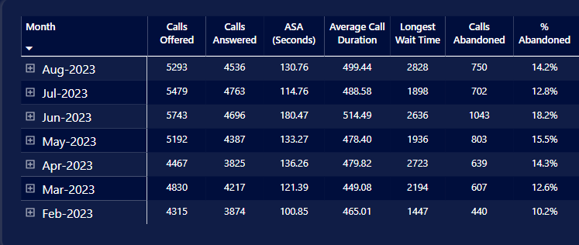

As can be seen in the data report on 101 new incident calls, the range in the abandonment rate can be seen as being between 10.2% and 18.2%.

Figure ‘X’ - 101/2: Existing Incident / Crime Enquiry or Update Call Performance Data (Source – FCC DMM Powerbi Report)
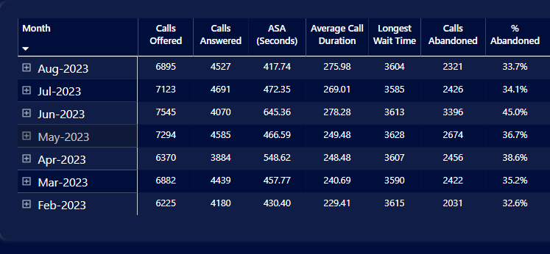
In contrast to the 101/1 new incident calls handled, the range in the abandonment rate can be seen to be between 32.6% and 45%, this being nearly 2 - 3 times greater than the 101 /1 new incident calls abandoned.
The picture is further reinforced in the 101/4, advice and guidance call management data, as seen below:
101/4: Advice and Guidance Calls
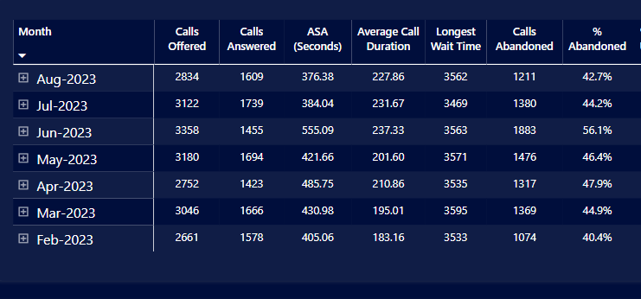
The range in the abandonment rate can be seen to be between 40.4% and 56.1%, this being just over 3 times greater than the 101 /1 new incident abandoned calls.

2.4.2 Areas for Improvement – HMICFRS Inspection and Feedback
The 2021 inspection undertaken by HMICFRS of the Police Communication Centre’s ability to effectively respond to the public resulted in two Areas for Improvement (AFIs) for the Force to improve upon (HMICFRS, 2022). These were:
AFI 1: “The Force should improve its scrutiny of its call handling performance and reduce its abandonment rate for non-emergency 101 calls” (HMICFRS, 2022).
AFI 2: “The Force should review the understanding of its demand within the force control room” (HMICFRS, 2019 and 2022).

2.4.3 Oversight on Performance:
Performance is overseen on a daily basis in the Daily Management Meetings (DMMs), these being chaired by a member of the SLT. Monthly performance meetings compliment this process, whereby supervisors and managers are held to account for the performance of their teams. Here, trends and variance in performance outcomes are scrutinised (Appendix Z2 - FCC Performance Agenda). Call handling performance and its associated AFI (HMICFRS, 2022) sits highly on the performance agenda and is scrutinised on a daily basis in the DMM (Appendix Z1 - FCC DMM Agenda). Supervisors and managers are expected to proactively manage the performance of their teams through clear leadership, and their staff appraisal objectives detail the required expectations of them (Z2).

2.5 Discussion: Analysis & Synthesis
Academic research outlined in this Chapter has shown that by police leaders adopting a hands-on approach with their staff and engaging in development opportunities such as coaching and mentoring, not only is the practice considered beneficial to professional growth, it has been found to forge a closer bond between the rank and file (Pearson-Goff and Herrington, 2013; COP, 2015; Davis, 2018).
Acknowledging that the transactional style of leadership focuses mainly on the achievement of targets and performance outcomes in betterment of organisational objectives (McCleskey, 2014), this approach is generally considered to lack key attributes now required in a modern-day police service, these being the empowerment of staff, professional growth, wellbeing support and cultural development (COP, 2015; Pearson-Goff and Herrington, 2013; Hoggett et al.; Davis, 2018). A strong argument is therefore made in favour of the transformational style becoming the default setting for police leaders. Accepting such a proposal is not quite as simple as it sounds in practice.
Determining which leadership style is more suited to policing, given the nature of its business, is a thought-provoking question that academics and researchers differ in viewpoint. Those without a background in policing or the services could slant towards the transformational style over that of transactional e.g. Davis (2018) verses Cockcroft (2014). Most leadership academics consider that the laissez-faire style can be ruled out due to its levels of inactive engagement with the team, it being described as a hands-off, self-orientated team led process. This style is described as lacking any sense of urgency and proactivity, when at a time of such fast-moving change, the Police Service appears to need strong leaders with a clear sense of purpose and direction (HMICFRS, 2023).
Davis (2018) presents a strong viewpoint in her findings asserting that police leadership mainly exists within its hierarchical structure, where a strong power base prevails amongst its senior officers, this being sceptically viewed as closed and detached. Davis (2018) further qualifies her critical stance, citing theorists who view a rank dominated model as suffocating close working, preventing open challenge and innovation. Albeit accepting that rank and authority is required in the Police due to legislative and operational requirements, Davis is clear in her viewpoint, that a radicle change towards a more transformational style is now needed in the service if it is to succeed.
Cockcroft (2014) presents a counter argument in that owing to the wide-ranging and diverse roles that exist in the service, the transformational style supported by many academics and theorists should not be favoured over that of the transactional style due to the challenging and operational nature of its business. Cockcroft (2014) asserts that the transactional command requirements of senior police leaders does not afford them the proper opportunities to exercise a shared, empowered and open to challenge environment, these being key attributes of transformational leadership. Cockcroft explains that this is largely down to the critical nature of the incident being managed and the high risks that are involved. This view was previously supported by Neyroud (2011) in his national review on leadership
In accepting the clear findings that have emerged from the literature studies reviewed, questions now need to be asked as to why police leaders appear to be more transactional in style than transformational, especially given the more positive attributes and benefits afforded to the leader, staff member and the organisation as a whole? A clue to the answer may be found in the changing environments police leaders now operate within, with decreasing budgets, unfilled vacancies, increasing levels of demand, greater spans of supervision and areas of responsibility. Accepting these, it may be understandable to some if a selfish focus on leaders takes precedence over staff on occasions. As explained in the HMICFRS publication “A Call for Help” (2020) and the State of Policing – The Annual Assessment of Policing in England and Wales 2022 (2023), such dilemmas are now being experienced by Forces which are impacting on its leadership and how services are being delivered to the public.

Chapter 3 - Methodology

3.1 Introduction
This Chapter discusses the research design, philosophy and methodology used to capture the necessary information and data required for the study, as steered by the research aims and objectives. It puts forward an explanation as to why certain methodological approaches were chosen when researching workplace environments involving the perceptions, views and feelings of staff, and includes the presence of a power dynamic involving supervisors and managers.
The collective focus of the research study’s aim and objectives, as agreed upon by the Head of Department for the Police Communications Centre, was to understand the underpinning issues and viewpoints as elicited from staff perceptions on the existing leadership styles prevalent within the police communications centre and, importantly, how this impacted on performance delivery.
It was understood at the outset that the study needed to arrive at tangible and realistic outcomes capable of assisting the Senior Leadership Team (SLT) in reshaping processes to better enhance its leadership effectiveness and performance delivery. In this regard, the below aim and objectives fulfil that requirement, as sanctioned by the Head of Department.
Aim: To understand the impact of leadership styles and the performance focus on the staff and supervisors within the Police Communications Centre, acknowledging relevant factors likely to influence the study. Enabling different approaches to be considered by its leaders, in responding to the emerging findings from the research.
Objective 1: Investigate the relationship between any dominant leadership style observed within the workplace within Call and Incident Handling and its impact on staff.
Objective 2: Establish what leadership styles managers and supervisors use within the police communication centre environment and correlate this to the perceptions held by staff.
Objective 3: Investigate whether a relationship exists between the leadership styles used and performance focus within the department, understanding its impact on staff.
Objective 4: Identify any relevant factors likely to positively or negatively influence the leadership styles observed and its impact on performance outcomes.
Objective 5: Explore any necessary adjustments or improvements that emerge from the findings that could be adopted by the SLT to enhance leadership approaches within the department.

3.2 Research Design
Choosing the appropriate research design and for the research methodology is of significant importance for the researcher. This can be achieved in a number of different ways and is defined as “the general plan of how you will go about answering your research questions” (Saunders, et al., 2016, p. 163). It is accepted that individual forms of research study will necessitate a different research design (Cohen, et al., 2011).
A phenomenological design was chosen for the research, this fitting the requirements of the study’s research objectives i.e. understanding the phenomenon through the real-life experiences of the police communications centre staff, the research participants themselves (Moustakas, 1994).
Phenomenology attempts to understand and define human experiences which may not be visible through routine observation (Sanders, 1982). This research design is considered appropriate when considering that the study will be examining the effects of leadership styles on the workforce, this the feelings of staff and the power dynamics between them, the supervisors and managers. These matters may not be obvious to the eye and will need to be heard through the real-life experiences of the staff.
Phenomenological research pursues the need to understand the sense and value people apply to real life experiences (Rocha Pereira, 2012). Its analysis seeks to include the collective experiences of all participants and focuses on their feelings, what they have seen and considered, in representing their reflections as part of the phenomenon captured within the study. It concludes with a blended mix and combined portrayal of the represented experiences of the sample group (Moustakas, 1994; Reiter, Stewart, & Bruce, 2011). The research intends to gather a rich bed of information that will comprise of perceptions and feelings on the impact of leadership styles and other influencing issues in the workplace.
The phenomenological approach and design adopted utilises both quantitative and qualitative methodologies and follows the phases defined by Creswell (2014), involving the collection of data by interviews, focus groups and workplace observations. Transcription, coding, theming, and data analysis were also undertaken as part of the techniques and procedures adopted to gather relevant data.

3.3 Research Philosophy:
Saunders et al., 2016 explains that research philosophy forms the footing of research studies and defines the set of principles the study is based upon. They explained that the philosophy identifies the researchers ontological (the what and how of what we know) and epistemological (how we acquire knowledge and understanding) assumptions.
As this particular study focuses on leadership styles within a police communication centre and its impact on staff, the research study is undertaken within the sphere of the epistemological research philosophy, with the standpoint that meanings and realities are created subjectively by human interpretation (Saunders, et al., 2016). As such the researcher will adopt an interpretivist approach when interpreting the data emerging from the survey questionnaire, enabling a meaningful understanding to be gained as to the differing realities held by the participants.

3.4 Research Type:
Suddaby (2006) explains that instead of shifting from theory to data (as seen in deduction) or data to theory (as seen in induction), an abductive approach alternates to and fro, in effect merging deduction and induction. Van Maanen et al., 2007 emphasise that deduction and induction compliment abduction as the rationale for examining credible hypothesis.
Given the differing variables contained in the research, this involving the sample group, the power dynamics of rank, the disciplined and structured environment along with the existing theory and research study findings that categorise leadership styles according to behavioural traits, the study is more suited to an abductive research approach due to its compatibility in shifting from a deductive to inductive methodology. This has ensured that a ‘best-fit’ research approach has been adopted throughout the study enabling the right depth and level of data to be captured and interpreted.
Saunders et al., 2016 (p.165) explains that “…quantitative and qualitative research may be viewed as two ends of a continuum, which in practice are often mixed”. The research study has adopted a quantitative and qualitative approach using mixed-method techniques. The research has drawn equal weight on these methods and activities.

3.5 Research Strategy:
Denzin and Lincoln (2011) explain that the research strategy forms the methodological connection between the philosophy and consequent choice of tactics to gather and analyse data.
A comprehensive and detailed survey questionnaire was used as part of the research strategy. This has been further supported by semi-structured interviews, focus groups and workplace observations, these building on the emerging survey information developed. This has enabled the researcher to collect data for both the quantitative and qualitative analysis and has allowed for the proposal of likely explanations for specific relationships amongst variables (Saunders et al., 2016).
In supporting the findings of the quantitative approach, so as to be able to triangulate and deepen any perceptions expressed by the respondents, qualitative research methods were included so that the research objectives could be fully met, this developed from the real-life experiences gathered from the interview and focus group material (Swanson & Holton, 2005).
The research has also necessitated the use of action research; the main reason for this being the encouragement of organisational learning in bringing about workable results by means of establishing the relevant issues, preparing and undertaking action and evaluating it (Saunders et al., 2016). Coghlan and Brannick (2014:4) describe action research as being “research in action rather than research about action”. The research study conclusions generate recommendations for the Senior Leadership Team (SLT) that will benefit the business area.

3.6 Time Horizon:
Working to the academic timeline for the dissertation submission date, the study has been undertaken at a point in time during the summer period of 2022, this being a six-week period when the survey and schedule of interviews took place. The summer period was considered to be a good time to carry out the research based on the high peak demands faced by the staff, this likely to fully expose any real issues of leadership and performance underpinned by factors likely to influence this relationship. Based on this approach therefore, it is necessary for the research undertaken to be cross sectional in nature (Saunders, et al., 2016).

3.7 Sampling Strategy:
The sample group consisted of call handlers and incident handlers, their supervisors and managers, these comprising the three sub-groups totalling 85 staff members out of the total 120 budgeted posts within the police communications centre.
Data collection techniques have been broken down into the following activities against the sample sub groups, as indicated in the below table:

Sample Sub Groups | Data Collection Technique | Methodology | Staff Numbers
Call Handlers and Digital Desk Operators (999 and 101) | Survey Questionnaire, Semi-structured interviews, Focus groups | Mixed method - Quantitative and Qualitative | 28
Incident Handler (999 /101 / Dispatch via Radios | Survey Questionnaire, Semi-structured interviews, Focus groups | Mixed method - Quantitative and Qualitative | 28
Call and Incident Handling Supervisors | Survey Questionnaire, Semi-structured interviews, Focus Groups | Mixed method - Quantitative and Qualitative | 7 + 7
CCTV Operators and Supervisor | Survey Questionnaire | Mixed method - | 4 + 1
Trainer & Command and Control Systems Administrator (also Supervisor) | Survey Questionnaire and Semi-structured interview | Mixed method - Quantitative and Qualitative | 1 + 1
Force Incident Managers (FIMs – Police Inspectors) | Survey Questionnaire and Semi-structured interview | Mixed method | 6
Operations Managers | Survey Questionnaire and Semi-structured interview | Mixed method | 2
Total |  |  | 85

The researcher adopted a non-probability and purposive sampling strategy for the quantitative (survey) based methodology, as the sample group represented the entire workforce within the Police Communications Centre.
Each of the respondents captured within the research study have been anonymised and this was clearly communicated to all staff prior to their participation within the survey.
The 32 participants selected to form part of the qualitative research, those being on duty during the period of the interview, focus group and workplace observation schedule, and therefore non-randomly selected, were assigned the letters R1 to R12 so as to anonymise their responses within the study. The sub-groups represented 40% of the overall quantitative sample group surveyed (79). A full breakdown of the sample groups can be seen in Appendix ‘B’ (Schedule of Interview/Focus Groups and Workplace Observations).
Responses captured in the transcripts for the audio interviews and focus groups, recorded iPhone, are now presented as individual reports, seen in the Appendices of this dissertation (Appendices ‘C’ – ‘L’). Audio files have been labelled accordingly R1 – R10 and are stored securely on the cloud.
The qualitative research data derived from the interviews and focus groups held, were captured from the three sub-groups selected to represent the different sections within the workplace i.e. Call and Incident Handling and their supervisors and managers. All the sub-groups were consistent in their representation of the larger sample group and contained the same characteristics as identified in the agreed themed and structured approach format i.e. mixed gender, varying levels of service, experience, competence and confidence (Appendix ‘M’). This provided a degree of confidence and reliability in the generalisations taken from the represented sample sub-groups.

3.8 Data Collection Methods:
A mixed method of research, using both quantitative and qualitative methodology was chosen, with one method building on the other to understand the deeper and more meaningful issues that underpin the responses. Albeit quantitative data has featured within the analysis, it contains a heavy reference towards qualitative information, this being further developed through the qualitative research undertaken.
For this purpose, the use of Microsoft Forms (Office 365) web-based application as an easily accessible on-line survey tool was used as the instrument for the survey. The careful development of appropriate questions ensured that the responses were capable of producing sufficient informative material for analysis in working to the research objectives.
A themed and structured focus, agreed by the researcher and the Head of Department for the Police Communication Centre detailed the approach to be adopted in refining the responses for analysis, given the survey’s extensive breadth (92 question set). Excel pivot sheets were used to filter down the results in accordance focused approach, this allowing for a deeper analysis and interpretation of the data.
The themed and adopted focus can be seen in Appendix ‘M’.
A number of the survey questions targeted the primary leadership styles discussed in the literature review, presenting these as behaviours in statement form for the sample group to express how they related to these as to their preferences, asking them to respond by placing a value ranging from strongly agree to strongly disagree. The survey also contained a number of closed questions as well as open-style free-text questions that elicited views, perceptions and feelings. Examples of the questions relating to leadership statements, of which there were 49 in the survey, are seen in Appendix ‘N’ – Questions 26-40 (14 statements) for all respondents to complete, and Questions 84-90 (35 statements) for supervisors and managers only.
The full survey consisting of 92 questions can be seen in Appendix ‘N’.
The open style free-text questions included within the survey allowed the researcher to gain an understanding of the views, perceptions and feelings of the respondents to certain questions purposefully included to elicit such a response.
Prior to the launch of the survey, the questionnaire was piloted on three members of staff within the department in testing their ease of use and understanding. Minor typos were corrected and certain permissions opened where certain question sets could not be accessed, this preventing full completion of the survey. Themes from the pilot informed the formulation of the full survey and the interview schedule.
In exploring key themes emerging from the trends and patterns captured in the survey responses, bespoke questions were developed and used by the researcher for the interviews and focus groups, these being clearly identifiable in the transcripts themselves (Appendices ‘C’ – ‘L’).

3.9 Data Analysis Techniques:
A thematic analysis was used for the repeated and relevant content arising from the qualitative free text questions contained within the survey. Emerging themes, and their interpretative meaning, further informed the semi-structured interviews and focus groups. This allowed the researcher to use a multi-dimensional approach in identifying how certain characteristics influenced a particular style of leadership, these themes being mapped across to understand their impact on the performance focus within the department. The narrative and thematic analysis method used to draw out meaningful insights informed the Analysis and Findings Section.

3.10 Methodological Limitations:
The number of interviews and focus groups that followed the survey was restricted to include a total of 20 respondents out of the 79 larger group surveyed. This approach was taken based on the number of activities required to coordinate against the available shift pattern of the sample groups, and importantly, in ensuring that sufficient time was factored into the research schedule for transcription and analysis of the data in working to academic timeline for completion and submission of the dissertation.
The researcher accepts that the study captures a period in time (summer months of 2022) and that many of the current workplace issues in existence within the workplace during that period could have influenced the true findings of research question, these consisting of issues such as reduced staffing levels and heightened seasonality demand factors, all of which would have contributed to the pressures and stresses felt by sample group.

3.11 Ethical Considerations:
Saunders et al describes research ethics as, “the standards of behaviour that guide our conduct in relation to the rights of those who become the subject of your work or are affected by it.” (2012, p. 226).
For this research, ethical approval was sought and granted by all necessary governing bodies including the Dyfed-Powys Police and the University (UWTSD). Participant consent from the sample group was obtained prior to their engagement.
As the research study involved police staff and the impact of leadership styles on working practices, ethical considerations and limitations were carefully considered throughout the life of the study. A conscientious oversight of survey responses was maintained allowing for the early identification of behaviour describing potential abuse of power or bullying as seen from the free-text responses. As agreed with the Head of Department, these matters were to be reported directly to him.
The respondents within the workplace were reassured as to their anonymity and the purpose of the study. This fact, and a strong reference to the researcher working within the University’s Code of Ethics in ensuring compliance at all stages, was fully captured on the frontispiece of the on-line survey, as seen in Appendix ‘N’. Email correspondence circulated to the staff throughout the survey completion timeline, also further corroborates and exemplifies this point.

3.12 Concluding Summary:
A full discussion as to the research design, philosophy and accompanying methodologies, along with the underpinning rationale as to why these have been chosen by the researcher, has been detailed in this Chapter. As explained, use of both primary data has been required to achieve the objectives of the research and that a mixed-method of both quantitative and qualitative research and analytical techniques utilised.
The use of the comprehensive survey designed for the study, with its free text questions purposefully designed to elicit perceptions and feelings held by the sample group, used alongside the qualitative methods of the semi-structured interviews, focus groups and workplace observations, affords the study a degree of triangulation on those more qualitative responses received, this increasing the confidence and credibility of the interpretative analysis undertaken from the rich bed of data obtained.
This Chapter has shown how the phenomenological and interpretivist design and abductive research approach chosen for the study, along with the non-probability and purposive sampling methodology, captures the agreed sub-groups within the workplace population, allowing for the requirements of the research objectives to be fully met.
The next Chapter of the dissertation will involve a thorough and in-depth thematic analysis of the research data captured in the quantitative and qualitative research, this promising to emerge with some interesting and clear findings.

Chapter 4 – Data, Interpretation & Analysis

4.1 Introduction:
This Chapter presents the data captured within the research methodology outlined in Chapter 3. It also provides an analysis of the data along with an interpretation of its meaning, this having been cross referenced to relevant literature findings that have emerged from Chapter 2. Relevant findings will be discussed at the end of this Chapter.
Data captured from the quantitative and qualitative methodologies was analysed to determine whether a predominant leadership style existed within the police communications centre, and whether this had any impact on performance delivery, especially on the subject of answer times for 999 and 101 emergency calls for service. Other associated matters likely to influence this relationship were also analysed i.e. resourcing levels.
Survey questionnaires were circulated to 85 police communications centre staff who were in work and capable of responding in the three-week window that the survey was open. A total of 79 responses were received, all being usable with non-disregarded, this representing a credible 93% response rate. Semi-structured interviews, focus groups and workplace observations also produced data that was analysed in this Chapter.
A number of relevant factors were explored that were likely to impact upon the relationship between supervisory leadership styles and performance delivery, these being categorised into the below themes to allow a clear structure to be followed in presenting the data for analysis and interpretation:
Theme 1: Evidence supporting the existence of a dominant leadership style within Call Handling Section and its impact on staff.
Theme 2: Evidence supporting the existence of a dominant leadership style within the Incident Handling Section and its impact on staff.
Theme 3: Supervisors and Managers – Preferred vs Actual Leadership Style and correlation to perceptions held by staff
Theme 4: The performance focus and the impact of leadership styles on the staff and supervisors within the workplace.
Theme 5: Influencing factors affecting leadership styles and performance outcomes – resourcing levels, moral and wellbeing.
These will now be explored and discussed in detail.

4.2 Presentation of Data and Analysis / Interpretation:

4.2.1 Theme 1: Evidence supporting the existence of a dominant leadership style within Call and Incident Handling and its impact on staff.
Call Handling Section:
A total of 25 Call Handlers responded to the survey, with five participating in a focus group, along with three Call handling Supervisors who were interviewed separately. Both the focus groups and workplace observation allowed for a first-hand insight as to some of the main issues mentioned in the free-text survey responses (Appendix ‘P’). It also enabled a degree of triangulation to occur as the styles of leadership mentioned by the respondents to that observed in the workplace. How this impacted on performance delivery and the emergence of trends and patterns was discussed with participants.
The below bar chart shows the preference of Call Handlers as a whole sub-group towards the transformational style of leadership, with transactional being a close second.
Figure 5. Q.26 – Q40 Survey: Leadership Style Preference (All Call Handling – 25 Respondents)

When asked if there was a predominant style of leadership evident in the department, the Call Handlers said:

Figure 6: Focus Group Interview with Call Handlers – R2 (Appendix ‘D’)
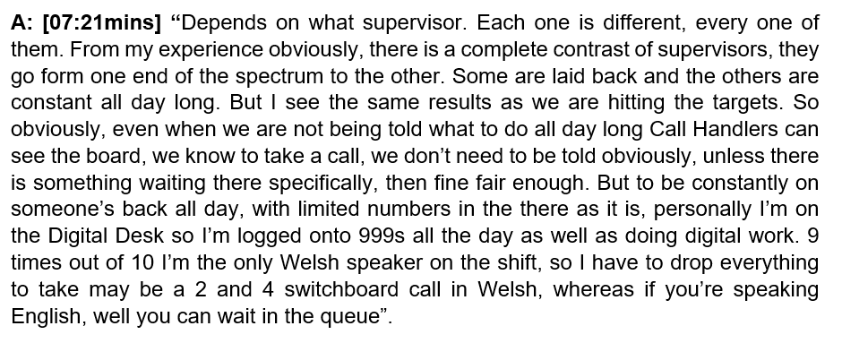

This data and its early indicative insights were triangulated from the themed summary of survey responses as seen in Appendix ‘P’ as presented below:
Figure 6a: Extract from the Themed Summary of Responses to Survey Questions – (Appendix ‘P’)

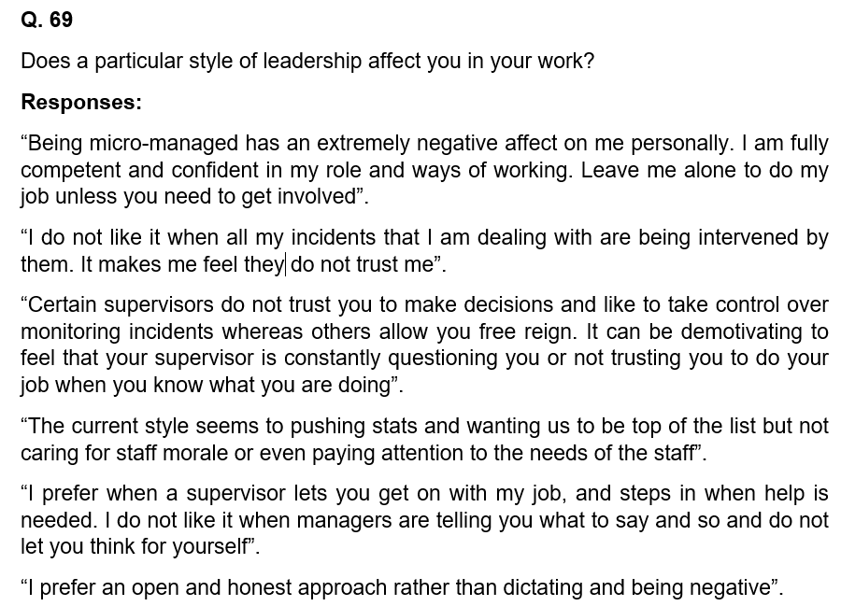

Analysis / Interpretation of Findings/ Data:
Data captured in the survey and as presented in Figure 5 above clearly shows the preferred leadership style within Call Handling as being Transformational (83% of the staff). This is contrast to what can be seen emerging from the focus group (Appendix ‘D’) and themed survey responses (Appendix ‘P’) where the dominant leadership style that prevails in the workplace is that of transactional leadership. It can be argued that the degree of incongruence can be explained through the context of what the Call Handlers would like to see in the workplace verses what they actually get.
The transactional leadership style is described as being quite domineering in terms of its control over the staff in ‘what and how’ tasks are undertaken as dictated by the supervisor. Terms used by the respondents indicate the nature of the dominant style through its effect on them, this being captured in the themed data (Appendix ‘P’) portrayed feelings relating to “being micro managed”, “lacking trust”, “feeling demotivated”, “style pushing for stats and being top of the list”, “not caring for staff morale”, “left alone to do the job” and “preference for open style and honesty over dictating and negative style”.
Interestingly, it can be seen in the data that the style varies dependent upon who the supervisor is, allowing an understanding of the variance in styles across teams with some being very directive to others being “laid back” (Appendix ‘D’).
A reference to no noticeable difference being detected on actual performance levels irrespective of the leadership style used by the supervisor, also gives an interesting insight as to the outlook of the staff towards supervision considered as being too controlling or oppressive and its actual gains (Appendix ‘D’). This will be revisited later in this Chapter.
Reference to “limited numbers” by the focus group (Appendix ‘P’) relates to staffing levels, its significance will also be further explored in later paragraphs of this Chapter.

Analysing the Data from an Academic Perspective:

It is clear from the data (Appendices ‘D’ and ‘P’) and findings presented that the dominant style in the workplace, as perceived by the Call Handling Staff, is that of transactional leadership, which is in contrast to the other two styles examined in Chapter 2, that of transformational and laissez-faire. Transactional leadership traits (Bass, 1985) are clearly evident as the dominant style when comparing supporting literature findings discussed in Chapter 2, these being:
- That the staff indicate that the leaders in the workplace concentrate mainly on the productiveness of the staff towards 999 and 101 answer times and abandonment figures and are continually watching over them and telling them what to do – McCleskey (2014) outlines that transactional leaders use strong direction to guide the team and assess their capability to quantify and control the staff. This is further supported by Xenikou (2017) who submits that leaders make explicit the level of expectation required from the staff, this to the detriment of everything else - 999 and 101 call handling expectations and instructions given by the supervisors to staff being the main focus over that of staff welfare and morale.

- Birasnav (2014) asserts that creativity is minimised and not developed in the transactional approach with its main focus being fixed on how the staff are able to achieve the objectives. Seen in the data with the description of when staff are not allowed to have a view on the approach to answering the 999 and 101 queues and are constantly being told what to do.

- That the leadership approach does not develop an innovative mindset and skillset within the staff, this in turn not improving the workplace environment and fostering a multi-dimensional approach to problem solving (Henker et al, 2015). These are proclaimed as being key qualities of a transformational leader which are in contrast to those seen in the transactional leadership style as evidence in their approach. This is seen in the data and findings when the staff describe explain the micro-managed approach being constant within the workplace.

- Antonakis and House (2013) explain that the positive hallmarks of a transformational leader are seen through a leadership approach whereby the goals, objectives and targets to be reached are set as being realistic to achieve in a practical sense. They are confidently presented to staff so as to create a positive mental attitude towards their work, these being what they can achieve going forward. The opposite in behavioural traits and the negative perceptions of staff are described as captured in the data, these being categorised as being opposite to that of the transformational leader and more aligned to a transactional approach.

- The data shows that there is little or no collaboration with the staff which is supported by McCleskey (2014) who argues that transformational leaders far surpass the levels of interaction and collaboration with staff in contrast with transactional and laissez-faire styles.

- Chasing targets is described as being prioritised ahead of staff welfare and morale. The feelings of “lacking trust”, “feeling demotivated”, “style pushing for stats and being top of the list” and “not caring for staff morale” all make for interesting descriptions of the dominant style perceived by the staff. The COP (2015) defined the qualities of a good leader as being one who empowers, trusts and supports staff to succeed within the team. Pearson-Goff and Herrington (2013) in submitting what the qualities of an effective and good police leader are, stated that one of the seven featuring characteristics was trustworthiness, this being described as being the ability of the leader to build trust between the staff, creating a safe environment to learn, coaching and mentoring, having an enthusiastic interest in welfare. These characteristics are not found in the description provided of the perceptions of staff as to the dominant leadership style seen in the workplace. On the contrary, the opposite is captured in the data, this allowing an assertion to be made that the prevailing leadership style in the call handling section of the department is that of the transactional style.

- Leaders who encourage confidence in the staff and act as exemplars for the organisation are transformational due to their style, these being forward thinking, understanding and creative (Sadeghi & Pihie, 2012). The description provided of the leadership style evident in the Call Handling workplace does not resonate with the findings of Sadeghi & Pihie (2012), which in turn affiliates it more to that of the transactional style.

- Laissez-faire is discounted due to its inactive and disengaged style, allowing the staff to self-orientate, explore and discover their own way through the working shift and any problems encountered along the way (Sadeghi & Pihie, 2012). This is not what the Call Handlers describe as to the dominant leadership style they experience in their workplace and as such can be discounted when considering whether their accounts and descriptions provided align more with the transactional or transformational styles.

- As submitted by Davis (2018), a rank dominated leadership process suffocates collaboration between leaders and staff, this preventing open challenge and new ideas from being developed. The structure of the Call and Incident Handling sections within the department are rank orientated, with clear visibility towards 1st and 2nd line managers and their levels of engagement with staff in meeting the business objectives (Appendix ‘R’ - Workplace Observation). The data shows that open challenge is very limited and there exists little opportunity for ideas to be explored due to the style of the supervisors, this being described as “micro-managing”, “controlling”, “being told what to do all day” and “constantly on your back” (Appendices ‘D’ and ‘P’).

- Reicher et al. 2005 as cited Hoggett et al; 2018 asserts that leadership does not only connect with senior roles holding power over staff but connects equally to the staff members themselves, and responds to the synergy that exists between the both. The descriptions provided of the leadership style in existence in the Call Handling Section fails to show the synergy Hoggett et al. 2018 refers to, this potentially being due on the style of leadership being practiced by the supervisors and the lack of transfer of that leadership to the staff. This is one of the hallmarks associated with transactional leadership as the focus of the power dynamic remains with the leader (McCleskey, 2014). This dynamic is more evident in police leadership as it operates in an environment where the ground rules of ‘know your place’ and ‘rank knows best’ exist due to the hierarchical order of rank (Adlam, 2002; Silverstri, 2011). This is evident in the Police Communication Centre where a clear rank structure exists and is operation.

- The qualities of trust, fairness and charisma are seen by staff as being likely to promote cohesion and progression. This can be seen in the transformational leader (Haslam et al. 2001; Platow et al. 2003 as cited by Hoggett et al.; 2018). The staff describe a lack of trust by the supervisor on a number of occasions in the data as well as mention that they prefer an open and honest approach as opposed to one that is dictatorial and negative, this evidently lacking fairness and charisma and being opposite to the qualities of a transformational leader.

- The transformational approach is predicated on the values of ‘participation, consultation and inclusion’ (Silvestri, 2007, p. 39), The data captured in Appendix ‘D’ and ‘P’ shows a lack of staff consultation and inclusion by the supervisors in their leadership style, seen by the micro-managing and controlling style described, without any references to staff being asked how to approach the issues or challenges the supervisor and team face.
Based on the above supporting literature, in analysing the data, it can be asserted that the dominant style being used by supervisors evident in the Call Handling Section of the Department is that of transactional leadership. The qualities of transformational leadership are seen in a very few references to supervisory style. Laissez-faire is not detected, which is unsurprising given the fact that the workplace is a police communications centre where staff handle emergency and non-emergency calls and radio dispatch to frontline officers.

4.2.2 Theme 2: Evidence supporting the existence of a dominant leadership style within the Incident Handling Section and its impact on staff.
When asked as to their leadership preference, Incident Handlers responded saying they related more to a transformational style (79%) as compared with the other two styles of transactional and laissez-faire, as can be seen in the below Figure:
All Incident Handling – 28 Respondents
Figure 7. Q.26 – Q40 Leadership Style Preference (All Incident Handling – 28 Respondents)

This was further triangulated in the Focus Group when they said:
Figure 8: Interview of Incident Handlers in a Focus Group (Appendix ‘F’)
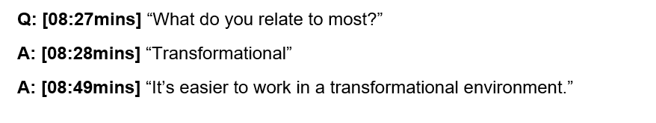[Other matters discussed between 08:28mins and 08:49mins not relevant for inclusion in transcript]
Interestingly, the above chart in Figure 7 shows that the transactional and laissez-faire responses are quite similar in value, despite these being starkly different in their characteristic traits. It also shows that just over half of the staff related to this hands-off and less accountable style of supervision. This was written into the relevant questions (Q.29, 32 and 34) of the survey allowing the respondents an opportunity to agree or disagree with the descriptors presented (Appendix ‘N’ - Survey).
Academic findings (Chapter 2) characterising laissez-faire show that its approach consists of decreasing levels of leadership engagement with team members where staff enjoy the ability to self-orientate and explore their own way through problems (Sadeghi and Pihie, 2012). Mirroring features are also seen within the transformational style, where through the concept of intellectual stimulation, staff innovation is developed by fostering a multi-dimensional approach to problem solving, this improving the workplace environment (Henker et al., 2015).
The workplace observation undertaken within the Incident Handling Section clearly shows the appropriate and necessary style of leadership adopted by the manager (FIM) and supervisor (Appendix ‘R’). Whereas the predominant style observed was transformational, which corroborates the respondent’s preferred style (Q. 26-40 Appendix ‘O’ – Survey Responses), the transactional style was dynamically utilised in response to their management of serious and critical incidents. The Incident Handlers responded well to this sudden and situational change in style, giving a distinct understanding that this was routinely accepted within their workplace, this appearing to work extremely well from a workplace observation perspective (Appendix ‘R’).
This was corroborated by the Incident Handlers in their Focus Group when they said:
Figure 9: Interview with Incident Handlers (Focus Groups) – R4 (Appendix ‘F’)
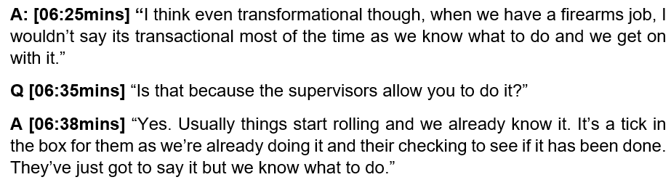
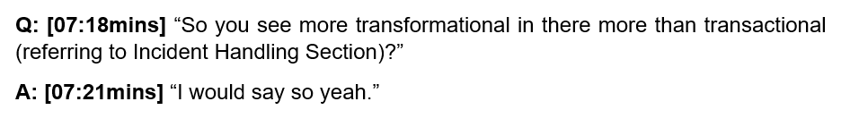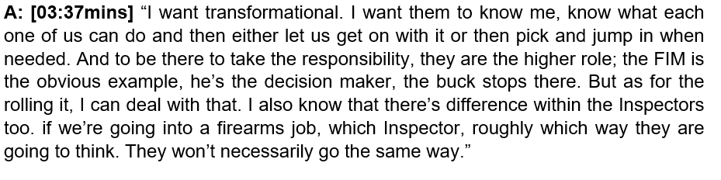
Here we can see that the staff yearn for a more transformational style of leadership as this allows them to be able to prove themselves as being worthy and competent in role by being able to get on with the task in hand and being trusted to do so. Antonakis and House (2013) outline transformational charismatic leaders’ qualities of understanding, foresight and perception; the skill of developing self-confidence in staff and valuing their efforts. Wren, 2018 describes how charismatic behaviour in leaders inspire staff.
This is also supported by Pearson-Goff and Herrington (2013) in their submission of the seven characteristics of a good and effective police leader, with trustworthiness being one such quality. This they explained includes the ability of the leader to create a safe learning environment in the workplace where staff are able to develop and grow, where trust exists between the staff and leader. One of the other seven qualities emerging form the research was the need for the police leader to be a competent decision maker, notably one who includes staff into the decision-making process, this resulting in respect being shown towards the leader. It can be seen in the data that the incident handlers want to be included in the process of incident management where they have a say in the decisions being made.
The data also shows that staff also recognise that certain incidents require a command protocol and require a more transactional and prescribed approach when certain authorities are necessary to effectively manage the incident, this more often than not dictating the direction and control of the incident by the senior officer on duty, this being referred to by the staff as the FIM (Force Incident Manager), a Police Inspector to illustrate their point. The incident the Incident Handlers refer to was a firearms incident, which is one that was observed as part of the workplace observational activity (Appendix ‘F’ and ‘R’). This is further commented upon later in the Chapter.
The use of the most suitable leadership style for the occasion or incident being managed is supported by academic research and considered very appropriate within the operational policing context. Cockcroft (2014) and Neyroud (2011) both support this point explaining that the operational demands of command are paramount in the consideration as to what leadership style should be adopted. Cockcroft (2014) asserts that to favour transformational over transactional approaches in the Police fails in itself to identify and appreciate the different demands within operational policing and as such questions the appropriateness of one approach befitting all activities.
Andersson and Tengblad (2009) assert that the rank-ordered mechanism in the Police allows for quick dissemination of instructions and authorities to be clearly communicated down the chain of command, this being evident in the data when observing the command of a firearms incident and its perception of the staff as to the dynamics occurring in the workplace setting at the time. The conformity of the staff in immediately accepting direction as provided by the senior ranking officer in the workplace (FIM) was very noticeable, this being supported by Collinson (2011) and Gordon (2002), who explain that responding to power and accepting orders within the Police are easily understood by staff and considered routine norms that they work within. This was evident in the data and supports a transactional style adopted throughout the firearms incident. Davies (2018) supports this finding and asserts that rank in itself creates a disciplined structure allowing organisational processes to operate efficiently, many being enshrined in law (Davis, 2018).
A very experienced Incident Handling supervisor commented on the difference in styles when dealing with the higher threat and risk incidents and highlighted the fact that staff appreciate the presence of the supervisors and managers in terms of security, looking to them for guidance at times of high-risk incident management:
Figure 10 - Interview with Incident Handling Supervisor – R1 (Appendix ‘C’)
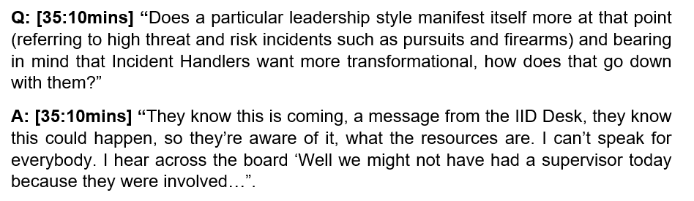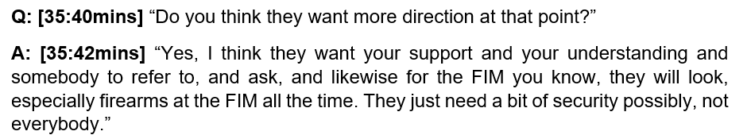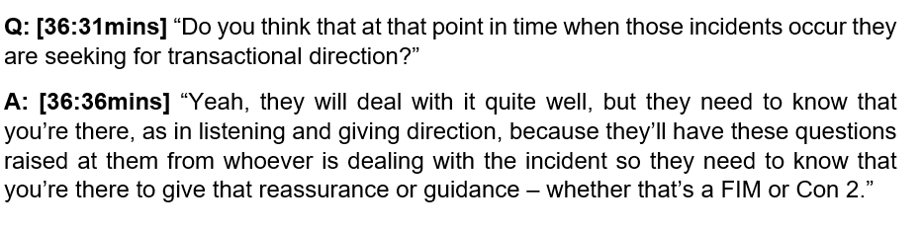
#
4.2.3 Theme 3: Supervisors and Managers – Preferred vs Actual Leadership Style and Correlation to Perceptions Held by Staff
Questions 26-40 (Appendix ‘O’) shows that the Supervisors and Managers have a stronger preference towards transformational leadership (83%) over transactional and laissez-faire (60%).
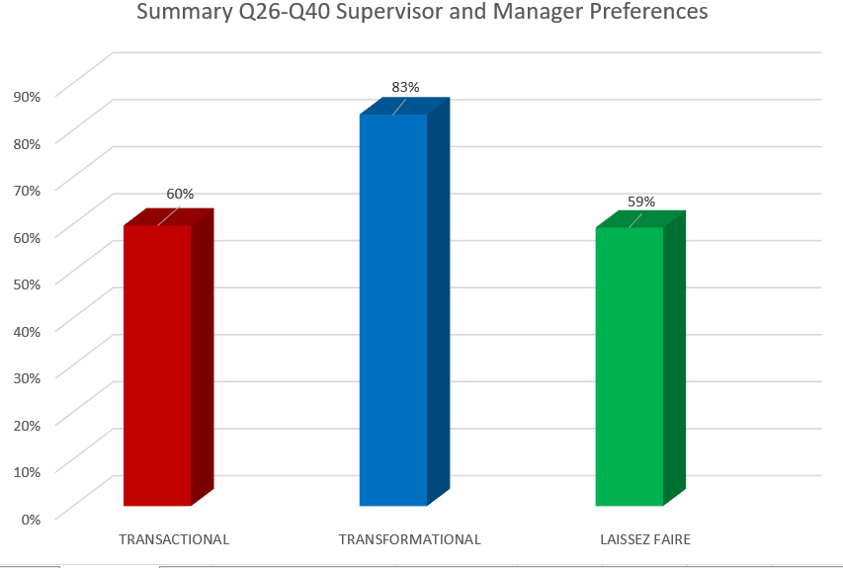
Figure 11: All Supervisors & Managers Q26-40 – 21 Respondents (Appendix ‘O’)

Interestingly, Figure 11 shows that laissez-faire nearly equals that of the transactional style with a marginal 1% difference. This allows an interpretation to be made that due to the similar characteristic attributes seen within the transformational leadership style, it could be argued that the supervisor’s preference leans more towards the staff empowered and exploratory qualities of that style (Henker et al., 2015; Silvestri, 2007) in contrast to the more directive and intensely focused style that transactional leadership is grounded upon (Birasnav, 2015; McCleskey, 2014; Xenikou, 2014). As such, the supervisor’s choice over the transactional style is the more telling picture in the data.
Whereas Questions 26-40 were focused towards establishing the supervisors and manager’s preference to a style of leadership described in the 15 leadership statements e.g. “What is your preference to the below statement regarding a particular style of leadership?” (Appendix ‘N’), these allowing a degree of aspiration to be factored into the interpretation of the responses, Questions 84-90 specifically asked “Which statement best describes your leadership style?” (Appendix ‘N’), of which there were 35 statements. This was purposefully designed so as to obtain responses that reflected ‘the actual leadership style used’ as opposed to the ‘potential or aspirational style they wanted to use”.
As can be seen from the responses to questions 26-40 (Appendix ‘O’), the style supervisors and managers relate to more is transformational, however, what they actually practice in the workplace, as stated by them to questions 84-90 is an equal blend of both transactional and transformational leadership as seen in the below chart:
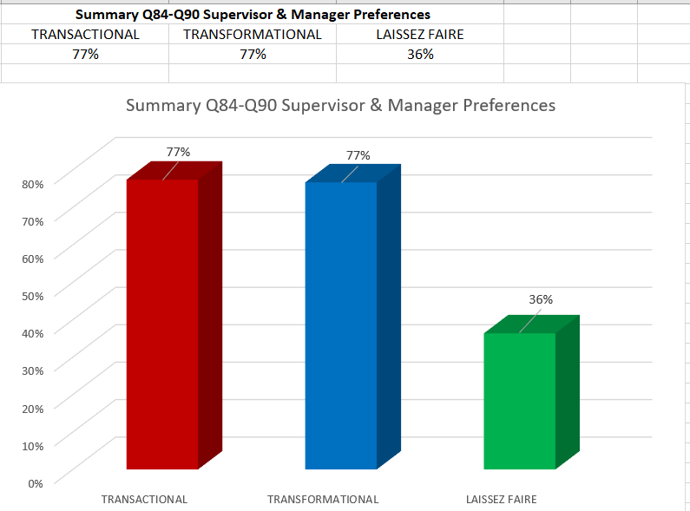
Figure 12: All Supervisors & Managers Q84-90 – 21 Respondents (Appendix ‘O’)

Workplace observations (Appendix ‘R’ and ‘S’) held in both sections of the department clearly show that a strong transactional leadership style was evident in Call Handling, this only featuring in Incident Handling when serious incidents were managed with a predominance for the transformational style when not in command mode.
Extracts from Appendix ‘R’ – Incident Handling Workplace Observations:
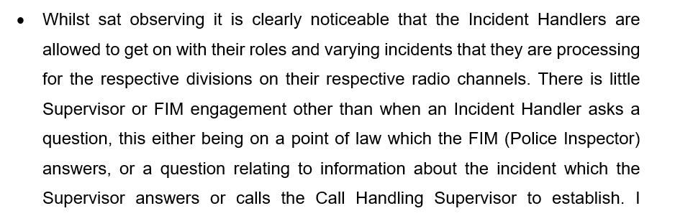
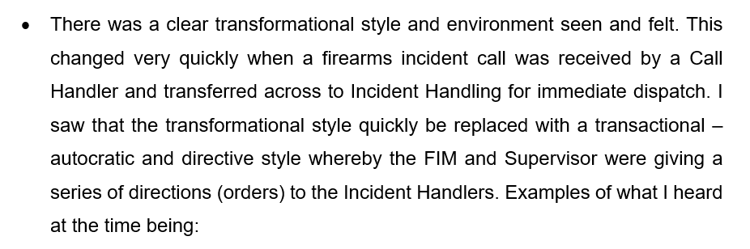
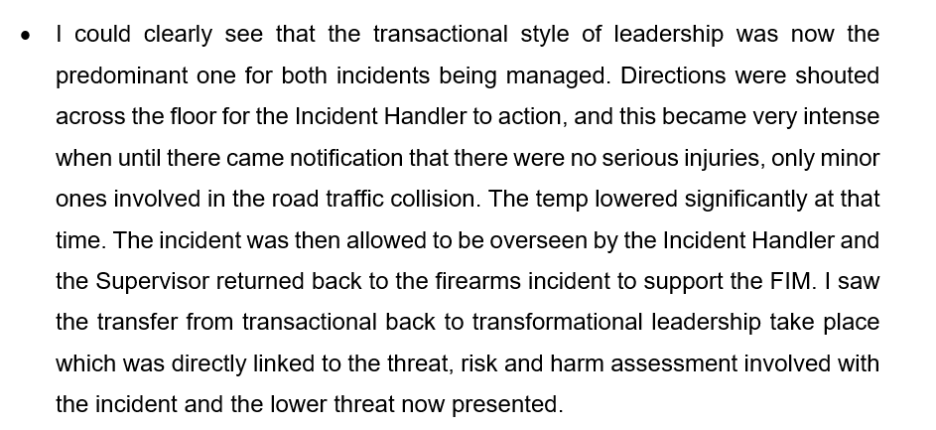
The above data shows the balance of use of the transformational style where staff are allowed to get on with their roles without the interference of their supervisor (self-empowerment and shared collaborative ownership of the work-related activities) to then dynamically moving into a transactional style so as to allow the incident to be appropriately commanded.
Figure X - Extracts from Appendix ‘S’: Call Handling Workplace Observations:
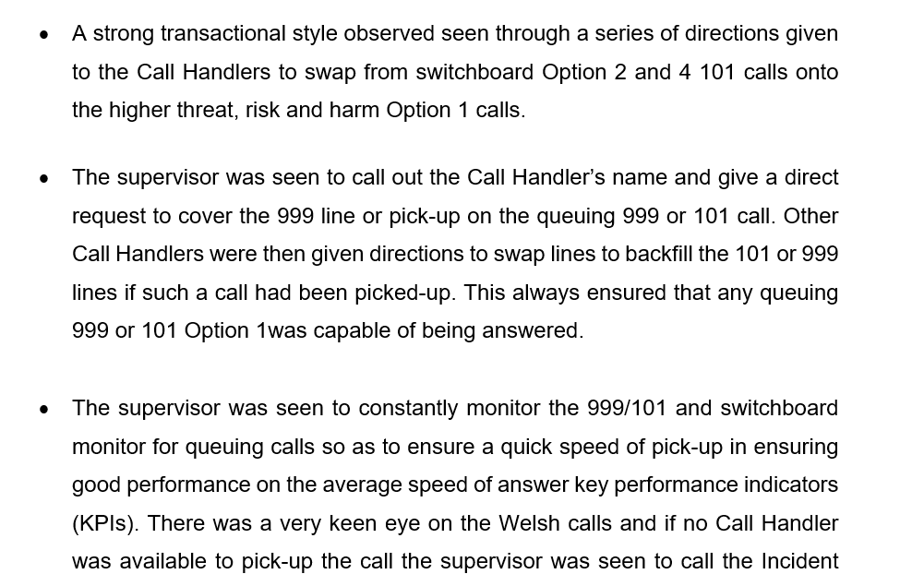
The workplace observation showed that that there was a continuous transactional style being used throughout the supervisory engagement with the staff, with an intense focus on 999 and 101 calls handled in ensuring that key performance expectations were met.
It was also observed that the supervisor did not stop for a break and it was felt by the researcher that this level of continuous activity would have been exhausting for the supervisor, certainly by the time the shift finished, who when asked if this was the case confirmed the observation.
Figure X - Appendix ‘S’ - Extract from Call Handling Workplace Observations:
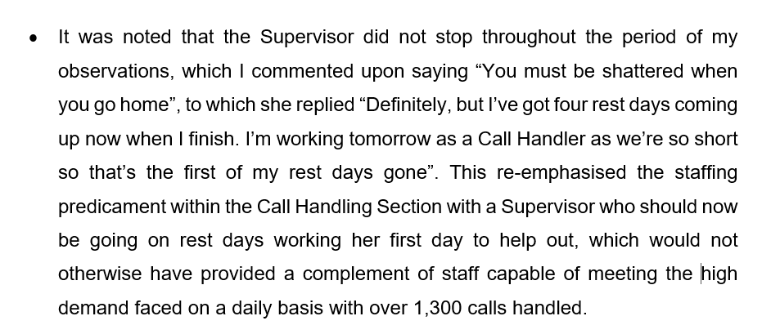
It can be strongly argued that such a level of concerted application in such an intense setting is detrimental to the wellbeing of the staff member, which adds to the perceptions already discussed concerning ‘burn out’ ‘exhaustion’ and ‘low staff morale’ as a result (Appendix ‘P’). Of note is the fact that the Supervisor then went onto work her first rest day off work due to staffing shortages (Appendix ‘P’), this allowing the assertion to be made that such a practice, albeit supporting the organisational need, compounds the issues of ‘burn out’ and is counter-productive in the medium to long term.
In an interview with the same supervisor a day later, she replied honestly in response to a number of questions concerning her leadership style as observed and of the performance expectations of her staff and indeed her.
Figure 13: Interview with Call Handling Supervisor: R3 (Appendix ‘E’)
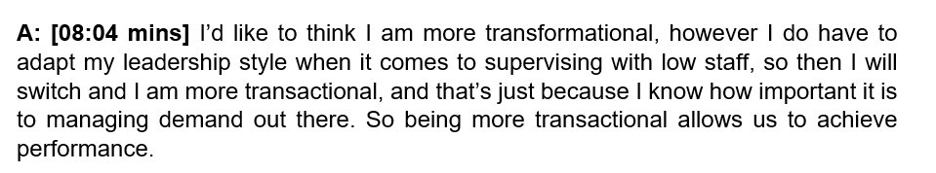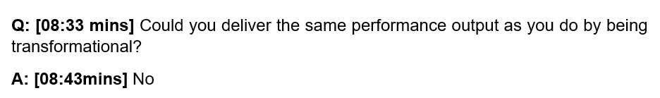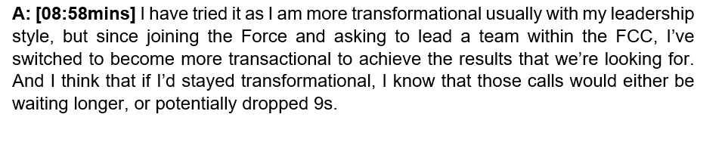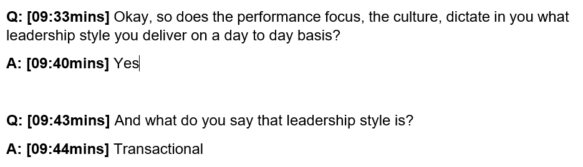
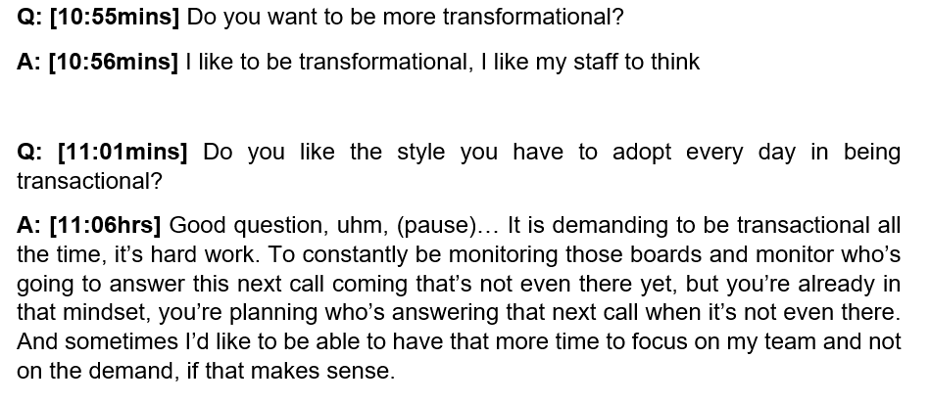
This interview allows for a clear picture to emerge where it appears that a supervisor is compelled to practice a style of leadership on a daily basis which is in conflict with her natural preference in ensuring that the 999 and 101 performance outcomes are upheld in sustaining the high position currently achieved by the department.
In an interview with Call Handling Supervisor (Appendix ‘J’), who described herself as being transformational in style, similar questions were asked of her with differing responses received, these challenging the need for a pure and sustained transactional leadership approach to be adopted towards the performance measures and outcomes achieved by the department.

Figure 14: Interview with Call Handling Supervisor Interview – R8 (Appendix ‘J’):
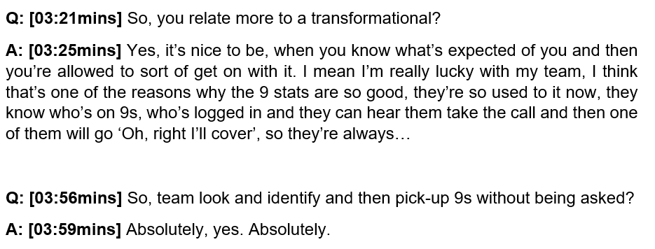
The supervisor was asked how the Police Communication Centre was top 5th in country for its 999 performance when it had such a staffing predicament, to which the transformational supervisor said: (Appendix ‘J’):
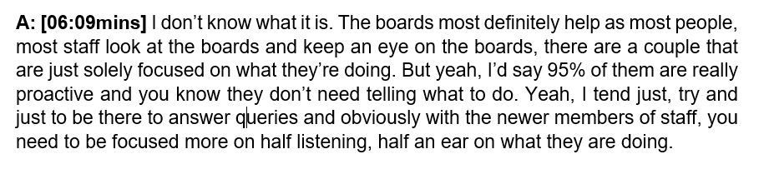
When asked if the performance focus created a transactional supervisor, she said: (Appendix ‘J’):
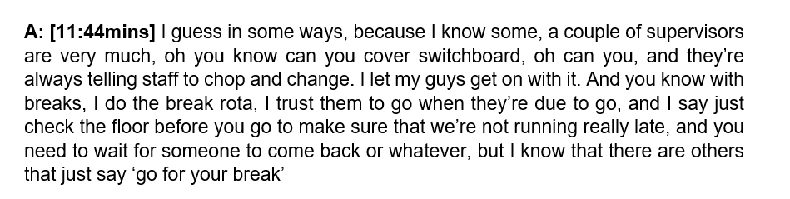
And of other supervisors using the transactional style she said: (Appendix ‘J’)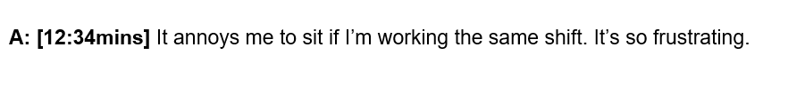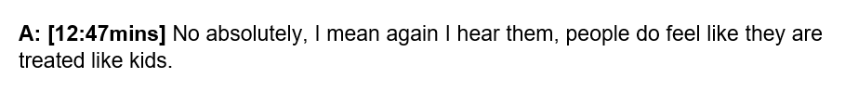
The same question was discussed with the Call Handlers in their Focus Group who also queried the need for transactional leadership over that of a more trusting and empowered style.

Figure 15: Focus Group Interview with Call Handlers – R2 (Appendix ‘D’)
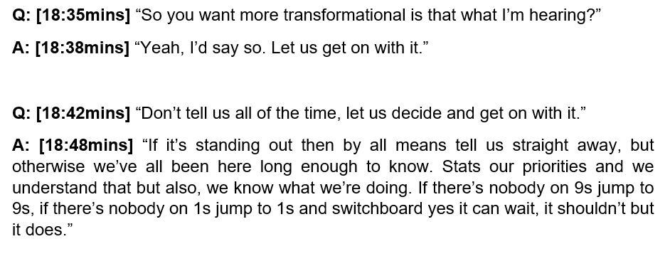
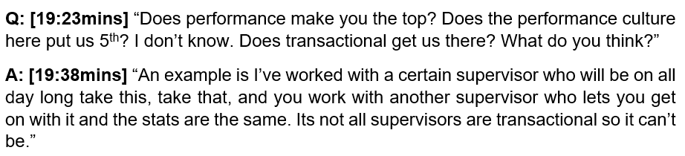

It can be seen that some of the supervisors and managers similarly query the real need to be transactional all of the time, agreeing with their staff in not supporting this over the transformational style they felt was needed in the workplace. They said:
Figure 16: Interview with Incident Handling Supervisor – R1 (Appendix ‘C’)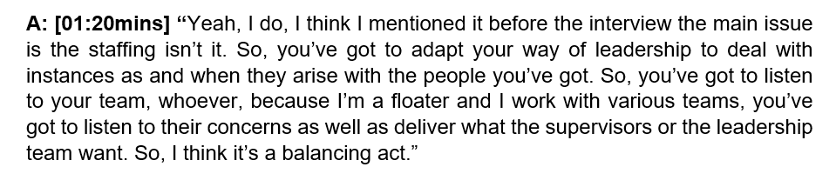
Figure 17: Interview with FIM – R6 (Appendix ‘’)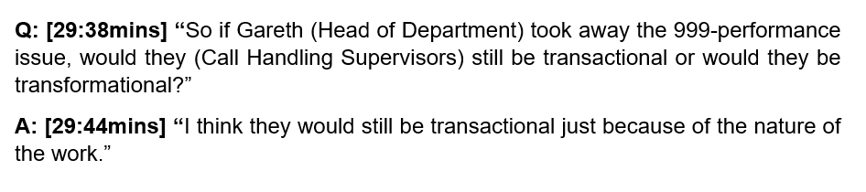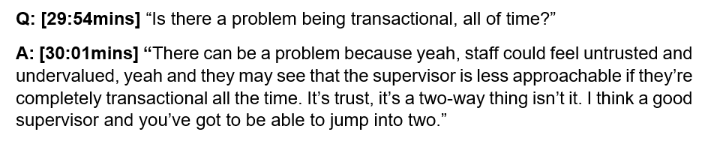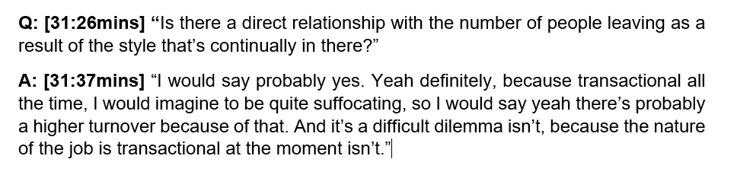
The analysis of the data allows us to understand that albeit supervisors recognise they need to be more transformational, this aligning with their aspirational responses to Questions 26-40 (Appendix ‘O’), with some actually displaying this in the workplace as their more natural style; the reality in the Call Handling Section is that given the workplace pressures of the 999 emergency calls and what they represent in terms of handling risk during a call for help from the public, coupled with the intense focus on 999 performance nationally (999 league tables and being top 5th in the country), supervisors adopt the more target orientated, controlling and intense approach of the transactional style to ensure that they deliver a good performance return. As can be staff disagree with this approach and speak of its negative impact upon them, which affects morale.
Confirmation was received by the Operations Manager that transformational supervisors were in the minority in the Call Handling Supervisory Team (Appendix ‘L’).

4.2.4 Theme 4: The performance focus and the impact of leadership styles on the staff and supervisors within the workplace.

A strong performance focus appears obvious from the sentiments captured in the free text responses (Appendix ‘P’) and this is aimed purely towards 999 and 101 answering times along with abandonment rates, which is stated to be at the detriment of the other more qualitative policing work carried out in the Incident Handling Section, this relating to incident dispatch, radio work, intelligence development to support frontline officers attending incidents (Appendix ‘P’).
It can be seen from the free-text responses obtained that there exists a real form of resentment in having to focus so heavily on 999 answer times which many express as merely chasing statistics and fulfilling the SLT’s mission and vision statement in aspiring to be the best performing Police Communications Centre in the Country (Appendix ‘T’ – Seven Strands to Success).
Respondents captured in the below Figure said:
Figure 19. Free-text Responses from Survey: (Appendix ‘P’)
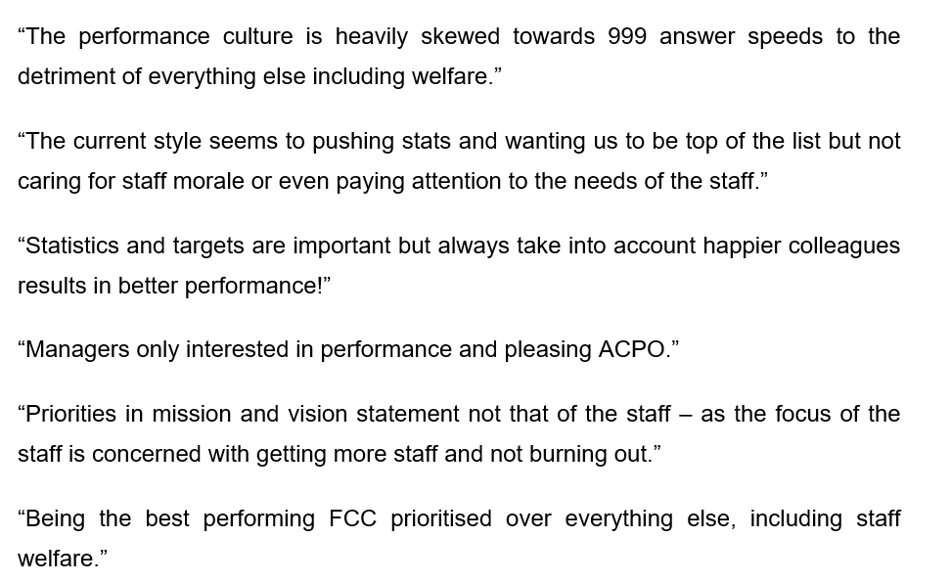
Emerging from the thematic analysis are the strongly held views of the Incident Handlers as regards the priorities of their role, relating more to ensuring that frontline officers are provided with the right level of information and intelligence to attend calls safely than that of the departmental mission and vision (Appendix X), as can be seen below in Figure 20.
Incident Handlers said:
Figure 20. Interview of Incident Handlers in Focus Group R4 – Appendix ‘F’
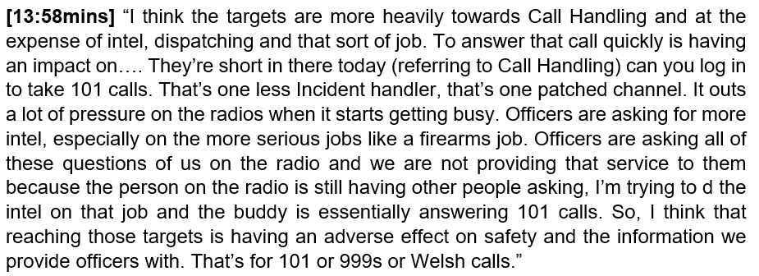
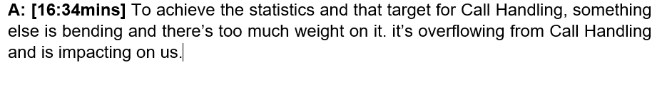It was observed that as part of the performance framework within the department, a Daily Management Meeting (DMM) takes place at 09:30hrs. A key part of the agenda (Appendix ‘Z1’) is 999 and 101 answer time performance and abandonment rates. Senior managers routinely chair this important ‘start of the day’ business meeting where the previous 24-hour call data and under-performance is discussed. Supervisors have commented upon how the DMM sharpens their focus on the 999 and 101 performance outcomes, this being captured in the interviews with them (Appendix ‘C’ and ‘E’).
Figure 21: Interview with Incident Handling Supervisor – R1 (Appendix ‘C’)
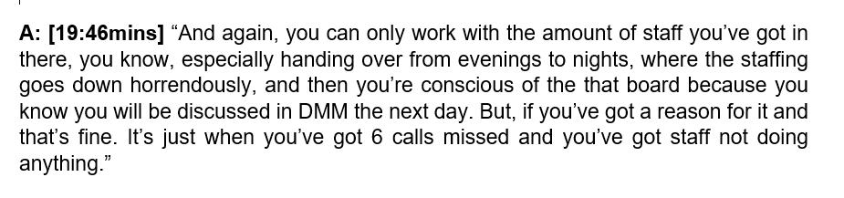
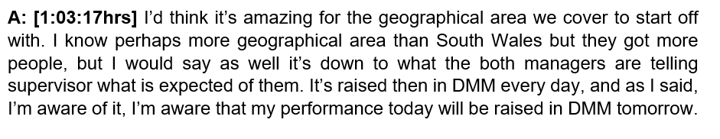

Figure 22: Interview with Call Handling Supervisor – R3 (Appendix ‘E’)
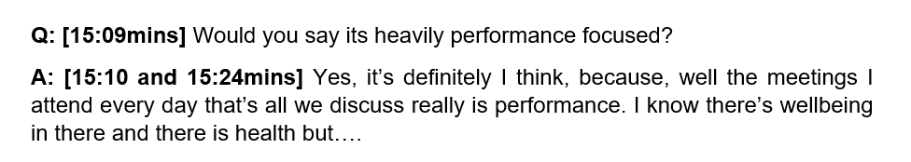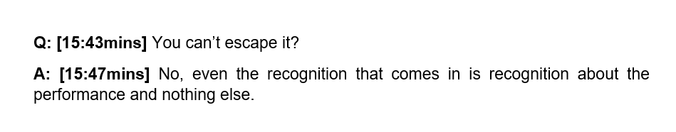
When Call and Incident Handlers, along with supervisors and managers were asked in their separately held focus groups and interviews, as to how the DPP Police Communications Centre currently held 5th position out of 43 Police Forces in England and Wales, as seen in the Home Office published league table for 999 answer times, they said:
Figure 23: Interview with Call Handling Supervisor – R5 (Appendix ‘G’)
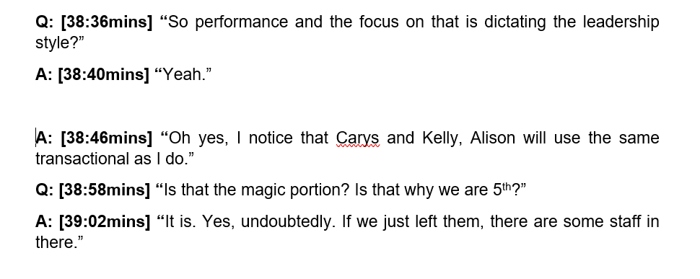This shows that four (including the supervisor being interviewed) out of the six Call Handling supervisors in the department use the same transactional style to drive performance and that it is considered to be the answer to reaching a top performing position.
An Incident Handling Supervisor with over 30 years’ service in the police communications centre said in her interview:
Figure 24: Interview with Incident Handling Supervisor – R1 (Appendix ‘C’)
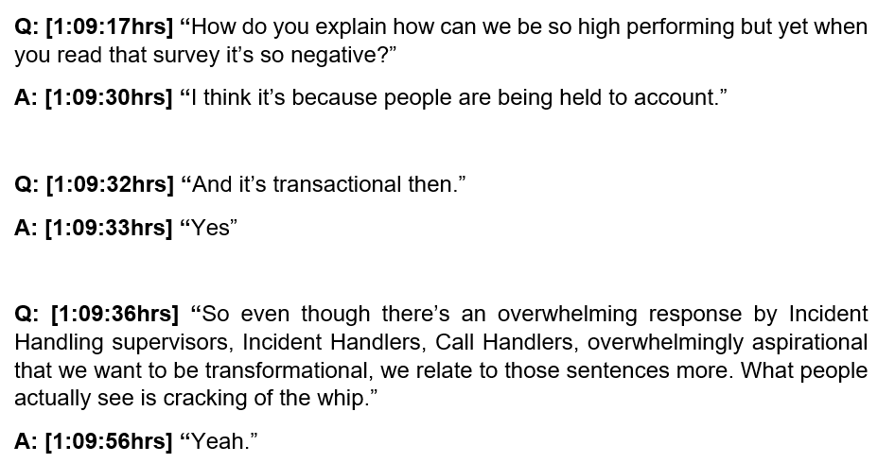
The Operations Manager said in his interview when asked how DPP was 5th in the country for 999 performance and what style of leadership gets the Force there, he said:
Figure 25: Interview with Operations Manager (SLT Member) – R10 (Appendix ‘L’):
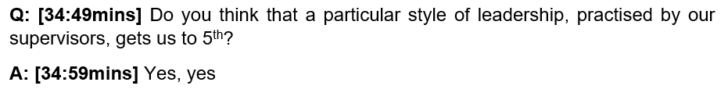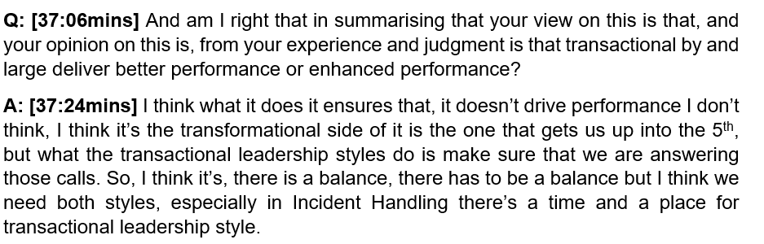
It can be clearly seen from the analysis that there exists a very strong performance focus and culture within the workplace, which the supervisors and managers relate and respond to. It is clear that this focus sets the pace and engenders a real sense of accountability within them. It is apparent supervisors worry over their performance levels ahead of the DMM, which enables 999 and 101 performance to be held to account on a daily basis. Despite this more transactional framework, such a strong focus on performance can only be considered to contribute positively towards the excellent performance levels experienced by the Department, this gaining them a top position in the 999 league tables, despite the staffing levels being mentioned by the supervisors and managers as severely impacting on their capacity to deliver (Appendices ‘C’ – ‘L’).
Irrespective of the top performing status of the department, the purpose of being transactional was queried by the Call Handlers themselves:
Figure 30: Interview with Call Handlers in Focus Group R2 (Appendix ‘D’)
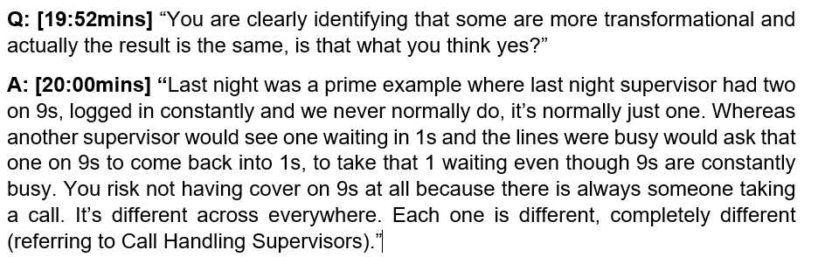
It is suggested by the Call and Incident Handlers (Appendix ‘D’ and ‘F’) that it may not be the supervisors who actually manage the performance of such calls, more so the experienced and competent staff who appear to get on with the job and deliver the results and in so doing appear to tolerate the transactional and directive style of some of their supervisors.
Two of the four transactional supervisors that formed part of the interview sample confirmed that they needed to be transactional to sustain and improve the high levels of performance currently being achieved (Appendix ‘E’ and ‘G’). The Operations Manager explained that in handling circa 800 -1,000 calls per day, this being high demand, the nature of the job meant they had to be transactional, which is expected of them. He said:
Figure 31: Interview with Operations Manager R10 – Appendix ‘L’
Q: [16:00mins] “That’s Call Handling, so the question to you then is what is your expectation of Call Handling Supervisors in their leadership style?”
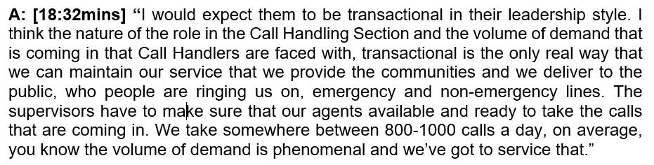
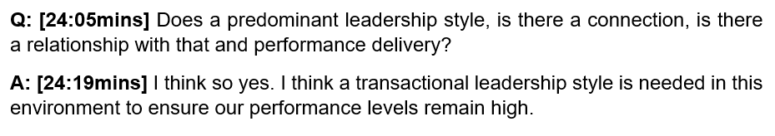
4.2.5 Theme 5: Influencing factors affecting leadership styles and performance outcomes – resourcing levels, training and development, moral and wellbeing.

Staffing Issues:
Throughout the survey responses and during the interviews and focus groups held, a consistent and overwhelming theme emerged, this relating to the very apparent dire staffing predicament that exists within the police communication centre. This is very noticeable early on in the study, as seen in the responses to Q. 23 and 24 below:
Figure 32: Survey Questions 23 & 24 (Appendix ‘O’)
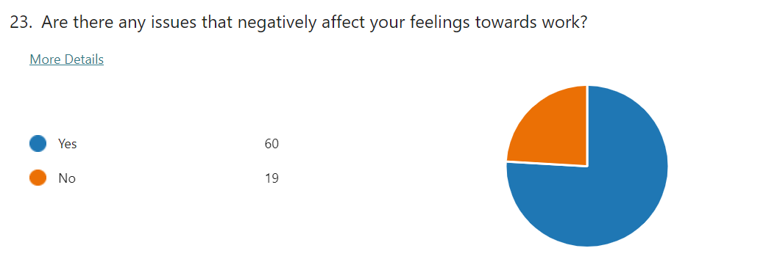
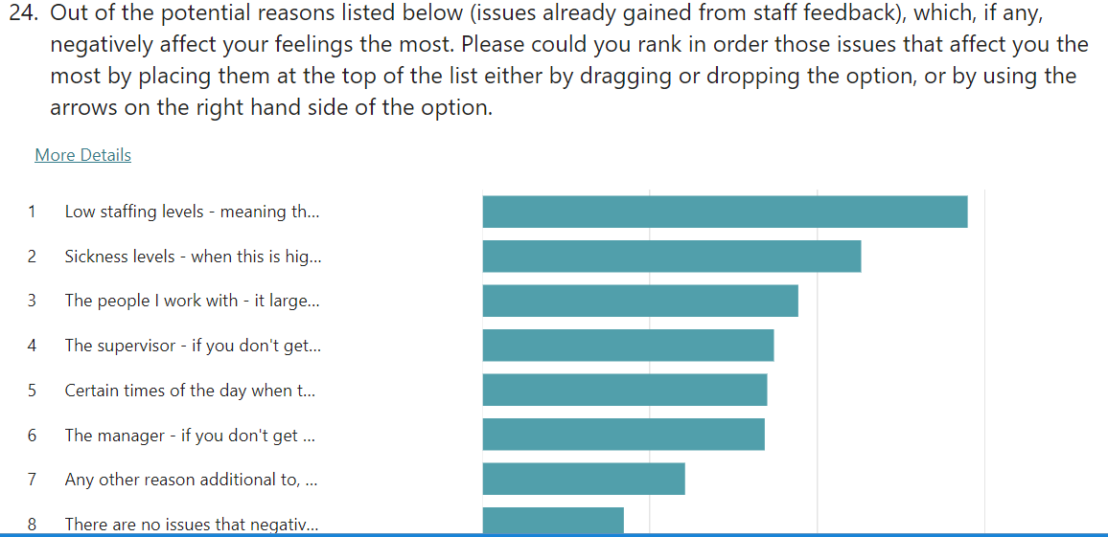

Numerous free-text statements also confirmed this position, in particular the low staffing levels, which was a repetitive theme (Question 25 - Appendix ‘O’).
In response to Question 77, which asked the sample group to describe how happy they were in their role, 62% stated that they were happy and content, with only 14% describing themselves as rarely happy. (Appendix ‘O’)
Figure33: Question 77 Survey (Appendix ‘X’)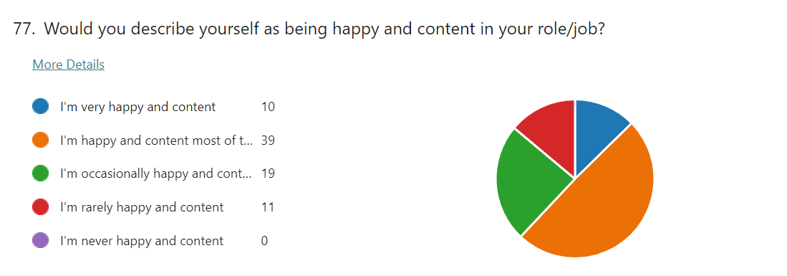
Question 78 - This asked the respondents to comment on their reasons for not being happy or content in work - 58 respondents commented with 30 stating that poor staffing levels were the main issues within the department (52% of respondents). Examples of the level of feeling expressed are seen in the below responses:
Figure 34: Free-text Responses to Q.78 (Appendix ‘P’)
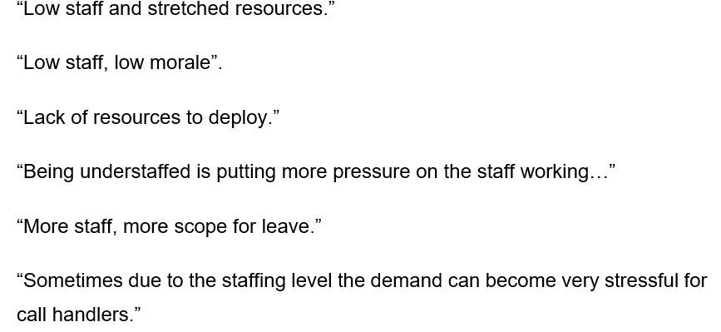
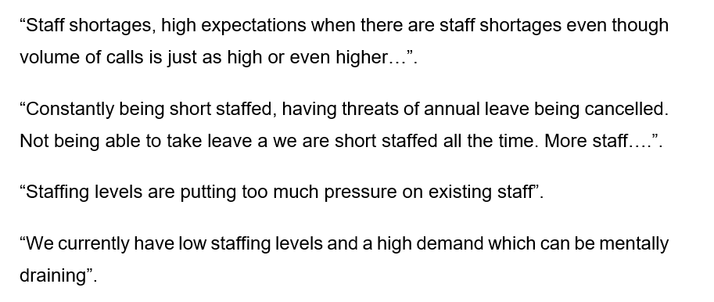
In juxtaposing the data from Figure 33 against the data contained within Figure 34, it can be seen that the data appears to conflict, this questioning the genuine levels of contentment and happiness within the staff. As seen in Figure 33 (Q. 77 staff survey), 62% of respondents stated they were happy and content in the workplace, however, 58% of respondents in Figure 34 (Q.78 staff survey) expressed feelings of unhappiness and low morale as captured due to the prevailing staffing issues.
It can also be seen in Figure 32 (Q.24 - Appendix ‘O’) that low staffing levels followed by sickness was the main reason for negatively affecting the feelings of staff, whereas their supervisor was fourth and the manager being sixth out of eight possible options, indicating that issues of leadership were not the main contributing factors for such unhappiness within the department. This was explored further in the Focus Group (Appendix ‘D’) with some degree of clarity being gained as to the contrasting difference now seen from both answers analysed. The interviews continued with the themes of low staffing levels causing low levels of morale (Appendix ‘E’ and ‘L’).
Figure 35: Interview with Call Handlers in Focus Group R2 – Appendix ‘D’
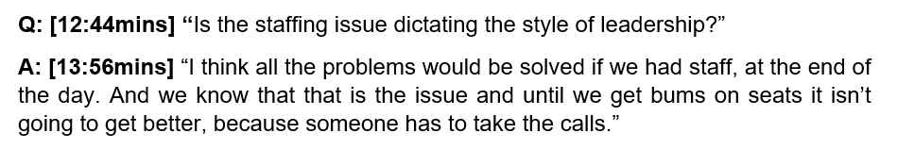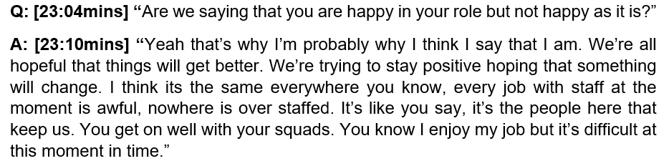
It can be seen that the discontentment felt by some is not solely focused on the leadership style but more so on the fact that there exists a serious staffing predicament within the department.
Further comments were captured on the issues of staff shortages with a supervisor and Operations Manager:
Figure 38: Interview of Call Handling Supervisor – R3 (Appendix ‘E’)
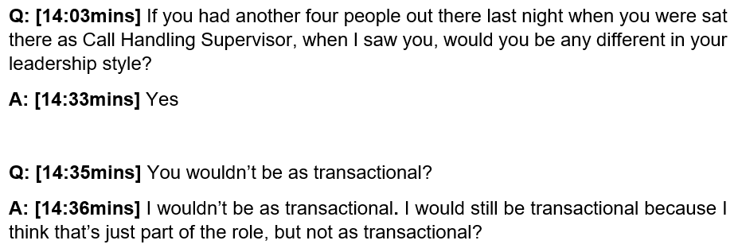
The Operations Manager stated that low staffing levels must affect the style of leadership practised by the supervisors, this being more prominent for Call Handlers as their area of business was more transactional due to its nature. The relevant part of the interview is captured below:
Figure 39: Interview with Operations Manager (SLT Member) – R10 (Appendix ‘L’).
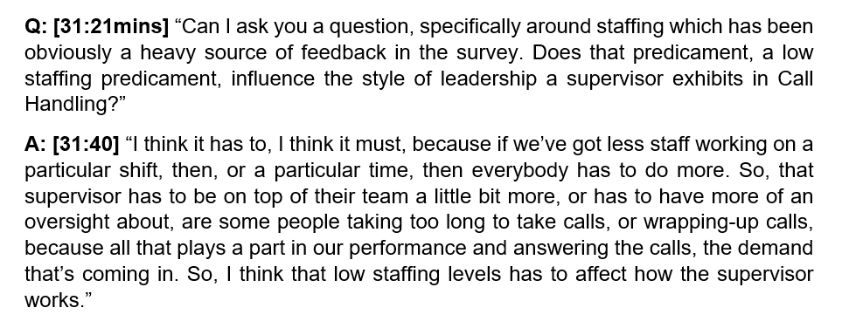

4.3 Summary:
A summary of the main findings emerging within Chapter 4 are presented in the Findings, Conclusions and Recommendations of Chapter 5.
The analysis and interpretation of the data within this Chapter, as supported from the main learning points emerging form the literature review, clearly identifies the dominant leadership styles in practice within both the Call and Incident Handling sections.
Recommendations emerging from the research study, along with their rationale, which seek to address some of the more critical findings are intended to be presented to the SLT, these being addressed in the next Chapter.

Chapter 5 – Findings, Conclusions & Recommendations

Introduction:
The research study’s intentions were focused on establishing what leadership styles supervisors and managers used within a Police Communication Centre to deliver upon the performance expectations set nationally and locally. Whether a dominant style prevailed and how this impacted upon the staff was also a specific objective within the research. Surveying academic literature studies on the three primary leadership styles of transformational, transactional and laissez-faire, with a review of studies undertaken within police leadership, allowed a good insight to be gained as what style delivers better outcomes in particular circumstances.
Using the emerging findings from both the literature review and data captured within the study, an in-depth and informed analysis was undertaken as discussed in Chapters 2 and 4, this providing meaningful overall findings along with key recommendations to be considered by the SLT. The research benefitted from both quantitative (comprehensive survey) and multiple qualitative methodologies (semi-structured interviews, focus groups and work place observations), these enabling a triangulation of the findings to be made.

Findings:
The research findings allow a high-level interpretation to be formed that supports the assertion that by adopting a ‘performance regime’ in response to the creation of a national 999 league table, along with other call management performance measures, it has in itself brought about the emergence of a perverse set of leadership behaviours, this compounding an already existing set of challenging complexities that co-exist in the workplace.
It can be understood why the strategic perspectives of an SLT, in its pursuit to become the highest performing Force within the country, may differ somewhat from the priorities held by staff (Appendix ‘P’). It can be seen in the data that this in itself has created resentment, distance and distrust between the staff and the SLT, this moving away from the principles of a more transformational led environment.
It can be reasonably asserted from the research findings that an organisation:
- who has a significant understaffing predicament,
- whose employees routinely handle high-risk life-threatening calls in an intense and demanding workplace setting,
- whose workplace environment is mainly dominated by a transactional and directive leadership style (Call Handling Section),
- whose staff yearn for a more empowered and shared leadership approach where they can be trusted, included in the decision-making process and developed as a result,
- where its leaders focus heavily on achieving high performance outcomes and being top of the charts, this considered by the staff to be to the detriment of everything else and the cause of low morale,
- where the staff perceive their welfare is neglected,
experiences a high-turnover of staff, and has retention and recruitment challenges.
This appropriately reflects some key aspects emerging from the findings of the analysis, and describes the situation within the workplace.
In addition to the circumstances already explained, data analysis shows that low levels of morale exist within the department, likely impacted upon by a lack of perceived recognition, reward, and consultation, these being considered as additional layers topping the exhaustion (burn-out) felt by the staff. Such matters as expressed, appear to coexist, and all exemplify the opposite characteristics of the more inclusive, self-empowering and staff orientated focus on welfare and wellbeing that transformational leadership espouses. It is fully accepted that matters describing supervisor behaviour such as “shouting at me”, “onto me all day” and “treating us like kids” (Appendix ‘P’), are attributed to a transactional style of leadership, which is far from the transformational behavioural traits sought after within the Police Service (COP, 2015).

Conclusions:
Such findings support academic research already in existence as addressed in Chapter 2. Within the context of policing, given its demanding and unpredictable nature of business, being transformational in a transactional environment can be described as being very challenging when applying it to certain policing activities e.g. the demands of police command. Here as research finds, it is very appropriate to be transactional as a leader especially when in a command situation where the rank structure and the authorities it provides enable swift decisions to be communicated to the staff for compliance (Neyroud, 2011; Cockcroft, 2014; Davis, 2018).
From workplace observations undertaken, it can be justifiably claimed that the Incident Handling Section contains an appropriate blend of transformational and transactional leadership styles. Both leadership styles observed were befitting of the prevailing circumstances, and the leaders (supervisors and managers) were very capable in adapting their styles in response to the changing levels of threat and risk as dictated by the incidents. This appears to be in direct contrast to the predominant transactional leadership style evident in the Call Handling Section, which appears to be heavily influenced by multiple factors, notably the acute focus on 999 and 101 call answering times and the significant resourcing challenges evident within the section.
Interestingly, staff perceptions indicated that despite there being a strong and predominant transactional leadership style within Call Handling, surprisingly, its impact was considered negligible in terms of its increased performance overall when comparing it to the transformational style other supervisors used. This view was strongly held by the staff who themselves claimed to closely monitor and compare their efforts with that of other teams (Appendices and ‘J’, ‘D’ and ‘P’). This was in contrast to the views of the Call Handling supervisors and the Operations Manager interviewed, who maintained that the sustained delivery of higher performance outcomes was attributable to the transactional style over that of transformational. All stated that the performance focus dictated the dominant style used. No tangible management data, however, supported the view that a particular style outperformed the other.
In competing with such multi-layered and complex matters affecting the staff, as described in the foregoing paragraphs, and in acknowledging the substantial effect on them in general, it is difficult to separate some of the qualitative feedback received in the survey free-text responses, in terms of their negative inferences, from those that genuinely relate to the leadership styles described by Call and Incident Handlers in the Focus Groups, where they were more complimentary and balanced towards the supervisors (Appendix ‘F’ and ‘D’). Unfortunately, such negativity has the potential to influence the true understanding and relationship that might exist between the different leadership styles and its impact on performance delivery.
The below recommendations are now submitted to the SLT for a considered discussion to be held on the suggested proposals put forward.

Recommendations:
- Addressing Staffing Predicament:
To address the existing staffing predicament in Call Handling, an urgent recruitment process should be prioritised. Adopting a cyclical process will ensure that the recruitment of ‘new starters’ matches the numbers of ‘leavers’, with a predictive analysis on previous ‘leaver’ dates within the department and its correlation to recruitment dates into the wider Police Service e.g. Police Constable and PCSO recruitment. Plotting this data will enable a good understanding of potential staffing shortages ensuring that Call Handling recruitment forward looks and works towards these dates.

- Leadership Training for Supervisors and Managers:
- Reinvigoration of leadership training for all supervisors to include the understanding of a ‘situational and responsive type’ approach to the deployment of transformational and transactional styles, with a key emphasis on how to be more transformational in a transactional setting in delivering good performance. Use of themed survey responses from Appendix ‘P to highlight negative effects of leadership styles.

- The development of workplace mentoring and coaching so that supervisors and managers are developed within the workplace (COP, 2015- definition of a good leader; Pearson-Goff and Herrington (2013) – seven characteristics of a good and effective leader).

- Performance Master Class:
The delivery of a ‘Performance Master Class’ to all supervisors and managers so that clear expectations are understood as to what is expected to be measured and why, and how to achieve good performance levels. Standardisation and consistency of supervisory approach will need to be factored into the input so as enable staff to see a unified approach in working towards performance outcomes (evidence of variance amongst supervisors confusing staff – Appendix ‘P’).

- Further Research:
Consideration of further and more in-depth research to be undertaken in 12-18 months following the delivery of the recommendations, so as to accurately understand and report upon the relationship between leadership styles and performance delivery within the workplace.

Bibliography

Adlam, R. (2002) ‘Governmental Rationalities in Police Leadership: An Essay Exploring some of the ‘Deep Structure’ in Police Leadership Praxis’ Policing and Society 12(1): 15-36
Ahearn et al., 2004, Leader Political Skill and Team Performance, Journal of Management 2004 30(3) 309–327
Available at: https://journals.sagepub.com/doi/epdf/10.1016/j.jm.2003.01.004
https://doi.org/10.1016/j.jm.2003.01.004
Accessed: 28th February 2023
Andersson, T. and Tengblad, S. (2009) ‘When Complexity Meets Culture: New Public Management and the Swedish Police.’ Qualitative Research in Accounting & Management 6(1/2): 41-56.
Antonakis, J. and House, R.J. (2013), "The Full-Range Leadership Theory: The Way Forward", Transformational and Charismatic Leadership: The Road Ahead 10th Anniversary Edition (Monographs in Leadership and Management, Vol. 5), Emerald Group Publishing Limited, Bingley, pp. 3-33.
Available at: https://doi.org/10.1108/S1479-357120130000005006 Accessed: 25th February 2023
Association of Police and Crime Commissioners (APCC) (2022) New Performance Tables Show How Quickly Police Forces Answer 999 Calls [Media Release] 31st May.
Available at: https://www.apccs.police.uk/latest-news/new-performance-tables-show-how-quickly-police-forces-answer-999-calls/ Accessed: 17th June 2022
Avolio, B. J., Bass, B. M., and Jung, D. I. (1999). Re-examining the components of transformational and transactional leadership using the Multifactor Leadership Questionnaire. J. Occup. Organ. Psychol. 72, 441–462. doi: 10.1348/096317999166789
Avolio, B. J. (2007). Promoting more integrated strategies for leadership theory-building. American Psychologist, 62(1), 25-33.
Bass, B. M. (1974). Bass and Stogdill’s Handbook of Leadership: Theory, research and Managerial Applications (Third Ed.). New York: The Free Press.
Bass, B. M. (1985). Leadership and performance. New York, NY: The Free Press.
Bass, B. M. (1990). “From transactional to transformational leadership: Learning to share the vision”. Organizational Dynamics. Winter, 19-31.
Available at: https://www.sciencedirect.com/sdfe/pdf/download/eid/1-s2.0-009026169090061S/first-page-pdf
Accessed: 25th February 2023
Bass, B. M. (2008). The Bass handbook of leadership: Theory, research, & managerial applications (4th ed.). New York, NY: Free Pres
Bass, B. M., & Avolio, B. J. (1994). Improving organizational effectiveness through transformational leadership. Thousand Oaks, CA: Sage.
BBC News (2010) ‘Key Points: Spending Review 2010’, 21 October. Available at: https://www.bbc.co.uk/news/uk-politics-11569160

Accessed: 24th June 2022

Bennis, W.G., and Townsend, R. (1995). Reinventing leadership. Collins Business Essential, New York.
Birasnav, M. (2014) Knowledge Management and Organizational Performance in the Service Industry: The Role of Transformational Leadership Beyond the Effects of Transactional Leadership. Journal of Business Research, 67, 1622-1629.
http://dx.doi.org/10.1016/j.jbusres.2013.09.006
Boonstra, J. J. (2012). Cultural change and leadership in organizations: A practical guide to successful organizational change. New York, NY: Wiley.
Braun, V. and Clarke, V. (2006) ‘Using Thematic Analysis in Psychology’, Qualitative Research in Psychology, 3(2), pp. 77–101. doi:10.1191/1478088706qp063oa.

Burns, J. M. (1978). Leadership. New York, NY: HarperCollins.
Cambridge University Dictionary (2023), Cambridge University Press and Assessment 2023
Available at: https://dictionary.cambridge.org/dictionary/english/process
Accessed: 25th February 2023
Carlyle, T. (2011). On heroes, hero-worship and the heroics in history. Create Space Independent Publishing Platform.
Chartered Institute of Public Finance and Accountancy (CIFPA) - Institute for Government (2022) - Police
Available at: https://www.instituteforgovernment.org.uk/publication/performance-tracker-2019/police Accessed: 24th June 2022
GOV.UK (2013), Spending Review 2010 (Comprehensive Spending Reviews 2011/12 – 2014/15)
Available at: https://www.gov.uk/government/publications/spending-review-2010
Accessed: 20th September 2022
Cockcroft, T.W. (2014) ‘Police culture and transformational leadership: outlining the contours of a troubled relationship’. Policing: A Journal of Policy and Practice, 8. pp. 5 - 13.
Available at: https://eprints.leedsbeckett.ac.uk/id/eprint/1249/2/Cockcroft_T_Transformational%20Leadership%20and%20Police%20Culture_Final.pdf Accessed: 18th June 2022
Coghlan and Brannick (2014:4) Coghlan, D. and Brannick, T. (2014) Doing action research in your own organization. London: SAGE Publications Ltd.
Cohen, et al., 2011 Cohen, L., Manion, L. and Morrison, K. (2011) Research methods in education. London: Routledge.
College of Policing (COP) 2015, Leadership Review - Recommendations for delivering leadership at all levels
Available at: https://assets.college.police.uk/s3fs-public/2021-03/cop-leadership-review-2015.pdf Accessed: 18th June 2022
Collinson, D. (2011) ‘Critical Leadership Studies’ in A. Bryman, D. Collinson, K. Grint, B. Jackson and M. Uhl-Bien (eds.) ‘The Sage Handbook of Leadership’. London: Sage Publications, pp.181-194 Confucius (1998). The Analects. Penguin Classics, 1st Edition
Collinson, D. (2012) ‘Prozac Leadership and the Limits of Positive Thinking’ Leadership 8(2): 87-107
Creswell. (2014). Educational research: planning, conducting and evaluating quantitative and qualitative research (4th ed., Pearson new international ed.). Pearson.
Davis, C. (2018). Rank Matters: police leadership and the authority of rank. Policing and Society 2020, VOL. 30, NO. 4, 446-461
Available at: https://doi.org/10.1080/10439463.2018.1555250
Accessed: 28th February 2023
Deloitte Insights University Press (Article): The quest for workforce capability. Create a global skills supply chain
Available at: https://www2.deloitte.com/global/en/pages/human-capital/articles/workforce-capability.html
Accessed: 17th June 2022
Drucker, P. (1996). “Your leadership is unique”. Christianity Today International/Leadership Journal. Fall 1996, Vol. XVII, No. 4, Page 54.
Engel, R.S. and Worden, R.E. (2003), ‘Police Officers’ Attitudes, Behavior and Supervisory Influences: An Analysis of Problem Solving’, Criminology, 41/1, pp. 131-166.
Available at: https://onlinelibrary.wiley.com/doi/epdf/10.1111/j.1745-9125.2003.tb00984.x?saml_referrer Accessed: 20th June 2022
Ferris, G. R., King, T. R., Judge, T. A., & Kacmar, R. M. 1991. The management of shared meaning in organizations: Opportunism in the reflection of attitudes, beliefs, and values. In R. A. Giacalone & P. Rosenfeld (Eds.), Applied impression management: How image making affects managerial decisions: 41–64. Newbury Park, CA: Sage Publications
Freeborough, R., & Patterson, K. (2015). Exploring the effect of transformational leadership on nonprofit leader engagement. Servant Leadership: Theory and Practice, 2(1), 49–70. https://pdfs.semanticscholar.org/2b10/b6943c50fa6f5191a3101e573a5ad8892a4a.pdf
Gordon, R. (2002). ‘Conceptualizing Leadership with Respect to its Historical-Contextual Antecedents to Power.’ The Leadership Quarterly 13(2): 151-167.
Handy, C. (1992). “The language of leadership”. Frontiers of Leadership. Eds. Syrett and Hogg. Oxford: Blackwell.
Hater, J. J. and B. M. Bass (1988) Superiors' Evaluations and Subordinates' Perceptions of Transformational and Transactional Leadership. Journal of Applied Psychology 73, 695-702.
Henker, N., Sonnentag, S., & Unger, D. (2015). Transformational leadership and employee creativity: The mediating role of promotion focus and creative process engagement. Journal of Business and Psychology, 30(2), 235.
doi:10.1007/s10869-014-9348-7
Howell, J. M., & Avolio, B. J. (1993). Transformational leadership, transactional leadership, locus of control, and support for innovation: Key predictors of consolidated-business-unit performance. Journal of Applied Psychology, 78(6), 891–902. https://doi.org/10.1037/0021-9010.78.6.891
HMICFRS (2019), Dyfed-Powys Police PEEL Assessment 2018/19 - Efficiency
Available at: https://www.justiceinspectorates.gov.uk/hmicfrs/peel-assessments/peel-2018/dyfed-powys/ Accessed: 26th June 2022
HMICFRS (2020), A call for help - Police contact management through call handling and control rooms in 2018/19
Available at: https://www.justiceinspectorates.gov.uk/hmicfrs/wp-content/uploads/a-call-for-help-police-contact-management-call-handling-control-rooms-2018-19.pdf Accessed: 16th June 2022
HMICFRS (2021) Peel Assessment Framework 2020/21
Available at: https://www.justiceinspectorates.gov.uk/hmicfrs/publication-html/peel-assessment-framework-2021-22/ Accessed: 17th June 2022

HMICFRS (2023), The State of Policing: The Annual Assessment of Policing in England and Wales

Available at: https://hmicfrs.justiceinspectorates.gov.uk/publication-html/state-of-policing-the-annual-assessment-of-policing-in-england-and-wales-2022/

Accessed: 11th September, 2023

Hoggett, J., Redford, P., Toher, D. and White, P. (2018). Challenges for Police Leadership: Identity, Experience, Legitimacy and Direct Entry. Journal of Police Criminal Psychology, [online] 34(2), pp.145-155. Doi:https://dor.org/10.1007/s11896-018-9264-2 Accessed: 10th September, 2023

Home Office, 2022(a). GOV. UK. New league tables show how quickly police forces answer 999 calls - Answering times for 999 calls published for the first time, delivering on the commitment in the Beating Crime Plan.

Available at: https://www.gov.uk/government/news/new-league-tables-show-how-quickly-police-forces-answer-999-calls Accessed: 16th June 2022
Hooper, A., & Potter, J. (2011). Intelligent leadership. New York, NY: Random House

IPOC (2022), Learning the Lessons – Call Handling. Issue 41 November 2022
Available at:
https://policeconduct.gov.uk/sites/default/files/Documents/Learningthelessons/41/LTL41_OFFICIAL.pdf Accessed: 24th November 2022
Javidan, M., Dorfman, P. W., Howell, J. P., & Hanges, P. J. (2010). Leadership and cultural context. In N. Nohria, & R. Khurana (Eds.), Handbook of Leadership Theory and Practice (pp. 346-372). Boston, MA: Harvard Review Press.
Johnson RB, Christensen LB (2014) Educational Research: Quantitative, Qualitative, And Mixed Approaches. Fifth edition. Sage, Thousand Oaks CA.
Kuhnert, K. W. and Lewis P. (1987). “Transactional and Transformational Leadership: A Constructive/Developmental Analysis.” Academy of Management Review 12, 648-657.
Kellerman, B. (2014). Hard times: Leadership in America. Stanford, CA: Stanford Business Books.
Kotter, J. (1988). The leadership factor. Free Press, 1st Edition
Lewin, K., Lippitt, R., & White, R. K. (1939). Patterns of aggressive behavior in experimentally created social climates. Journal of Social Psychology, 10(2), 269– 299. doi:10.1080/00224545.1939.9713366
Machiavelli, N. (1992). The Prince. Dover Publications
MacKenzie, S. B., Podsakoff, P. M., & Rich, G. A. (2001). Transformational and Transactional Leadership and Salesperson Performance. Journal of the Academy of Marketing Science, 29, 115–134.
Malik, S. H., Aziz, S., & Hassan, H. (2014). Leadership Behavior and Acceptance of Leaders by Subordinates: Application of Path Goal Theory in Telecom Sector. International Journal of Trade, Economics and Finance, 5(2), 170–175. doi:10.7763/IJTEF.2014.V5.364
Available at: http://www.ijtef.org/papers/364-N10017.pdf Accessed: 31st August 2023
Martindale S, Taylor R (2014) Alternative and complementary research approaches. In Taylor R (Ed) The Essentials of Nursing and Healthcare Research. Sage, Thousand Oaks CA.
Mastrofski, S.D. (2004), ‘Controlling Street-Level Police Discretion’, The Annals of the American Academy of Political and Social Science, 593/1: pp.100-118.
Available at: https://journals.sagepub.com/doi/pdf/10.1177/0002716203262584
Accessed: 20th June 2022
McCleskey, J. A. (2014). “Situational, transformational, and transactional leadership and leadership development”. Journal of Business Studies Quarterly, 2014, Volume 5, Number 4, pages 117- 130
Mintzberg, H. 1985. The organization as political arena. Journal of Management Studies, 22: 133–154.
Mintzberg, H. 1983. Power in and around organizations. Englewood Cliffs, NJ: Prentice-Hall
Mitchell Pearson-Goff, Victoria Herrington, Police Leadership: A Systematic Review of the Literature, Policing: A Journal of Policy and Practice, Volume 8, Issue 1, March 2014, Pages 14–26, https://doi.org/10.1093/police/pat027

Moriano, J. A., Molero, F., Topa, G., & Mangin, J. P. L. (2014). The influence of transformational leadership and organizational identification on intrapreneurship. International Entrepreneurship and Management Journal, 10(1), 103–119.
Moustakas, C. (1994) Phenomenological Research Methods. Thousand Oaks: SAGE Publications, Incorporated.
Nanjundeswaraswamy, T. S., & Swamy, D. R. (2014). Leadership styles. Advances in Management, 7(2), 57–62.
Available at: https://www.academia.edu/10946385/Leadership_styles Accessed: 3rd 7th September 2023
NCMS, 2023 National Contact Management Strategy (NPCC)
Available at: https://www.npcc.police.uk/SysSiteAssets/media/downloads/publications/publications-log/2019/npcc-national-contact-management-strategy.pdf
Accessed: 10th September 2023
NPCC 2017, Better Understanding Demand – Policing the Future
Available at: https://www.npcc.police.uk/2017%20FOI/CO/078%2017%20CCC%20April%202017%2024%20Better%20Understanding%20Demand%20Policing%20the%20Future.pdf
Accessed: 17th June 2022
Newell R, Burnard P (2011) Research for Evidence-Based Practice In Healthcare. First edition. John Wiley and Sons, Oxford
Available at: https://eclass.uoa.gr/modules/document/file.php/NURS239/%CE%A0%CE%95%CE%A4%CE%A1%CE%9F%CE%A3%20%CE%93%CE%91%CE%9B%CE%91%CE%9D%CE%97%CE%A3/%CE%91%CE%A1%CE%98%CE%A1%CE%91/research.pdf Accessed: 15th June 2022

Newstrom, J. W., & Davis, K. (1993). Organizational behaviour: Human behaviour at work. McGraw-Hill.
Neyroud, P. (2011), Review of Police Leadership and Training, London: Home Office.
Home Office, 2011. Review of Police Leadership and Training.
Available at: https://assets.publishing.service.gov.uk/government/uploads/system/uploads/attachment_data/file/118222/report.pdf Accessed: 20th June 2022
Northouse P. G. (2004) Leadership: Theories and Practices. London: Sage.
Onorato, M. (2013). Transformational leadership style in the educational sector: An empirical study of corporate managers and educational leaders. Academy of Educational Leadership Journal, 17(1), 33.
Available: at: https://www.proquest.com/docview/1368593704?parentSessionId=DlYtFh1WPWFqUjHyEbrhvB%2FcIA9mjtVrkp7qA%2BgIZ9s%3D&pq-origsite=primo&accountid=130472
Accessed: 25th February 2023
Onwuegbuzie AJ, Leech NL (2006) Linking research questions to mixed methods data analysis procedures. Qualitative Report. 11, 3, 474-498.

PCC, 2021 (Dyfed-Powys Police and Crime Commissioner publishes 2021-2022 Annual Report)
Available at: https://www.dyfedpowys-pcc.org.uk/en/news/press-releases/dyfed-powys-police-and-crime-commissioner-publishes-2021-2022-annual-report/
Accessed: 24th June 2022
PECS (2020) Code of Practice for the Public Emergency Call Service. [online] Available at: https://docslib.org/doc/10562131/code-of-practice-for-the-public-emergency-call-service Accessed 2 Oct. 2023
Pearson-Goff, Mitchell. and Herrington Victoria. (2013), Police leadership: A systematic review of the literature
Policing: A Journal of Policy and Practice, Volume 8, Issue 1, March 2014, Pages 14–26, Published: 21 November 2013
Available at: https://doi.org/10.1093/police/pat027 Accessed: 23rd November 2022
Pembi, S. Usman, F. Kwajaff, B, Ametti, M. Leadership styles and leadership qualities for organisational success – a review of literature. Nigerian Journal of Management Sciences, Vol. 23, Issue 2 August 2022
Available at: https://nigerianjournalofmanagementsciences.com/wp-content/uploads/2022/09/31.-LEADERSHIP-STYLES-AND-LEADERSHIP-QUALITIES-FOR-ORGANIZATIONAL-SUCCESS.pdf Accessed: 10th September 2023
Police.UK (2023). 999 Performance Data for Dyfed-Powys Police
Available at: https://www.police.uk/pu/your-area/dyfed-powys-police/performance/999-performance-data/?tc=A005 Accessed: 12th October, 2023.
Reiter, S., Stewart, G., & Bruce, C. (2011) A Strategy for Delayed Research Method Selection: Deciding Between Grounded Theory and Phenomenology
Available at: https://www.researchgate.net/publication/228755263_A_Strategy_for_Delayed_Research_Method_Selection_Deciding_Between_Grounded_Theory_and_Phenomenology Accessed: 10th September 2023
Rowe, M. (2006) ‘Following the Leader: Front-Line Narratives on Police Leadership.’ Policing: An International Journal of Police Strategies & Management 29(4): 757-767.
Richards, L. (2009) Handling Qualitative Data. SAGE.
Robert, V., Vandenberghe, C. (2021) Laissez-Faire Leadership and Affective Commitment: The Roles of Leader - Member Exchange and Subordinate Relational Self-concept. J Bus Psychol 36, 533–551 (2021).
Available at: https://doi.org/10.1007/s10869-020-09700-9
Accessed: 10th September 2023
Rost, J. (1993). Leadership for the 21st Century. Praeger
Sadeghi, A., & Pihie, Z. A. L. (2012). Transformational leadership and its predictive effects on leadership effectiveness. International Journal of Business and Social Science, 3(7), 186–197.
https://pdfs.semanticscholar.org/8b9c/0e1ba007d7585ab24e074492bdbad4c741fa.pdf
Saunders, M., Lewis, P. & Thornhill, A., 2007. Research Methods for Business Students. Essex: Pearson Education Ltd.
Saunders, M., Lewis, P. & Thornhill, A., 2012. Research Methods for Business Students. 6th ed. Essex: Pearson Education Limited
Saunders et al., 2016 Saunders, M., Lewis, P. and Thornhill, A. (2016) Research Methods for Business Students. 7th edn. Harlow, Essex, England: Pearson Education Limited.

Sanders, P. (1982) ‘Phenomenology: A new way of viewing organizational research. The Academy of Management Review, 7(3), p.353. https://doi.org/10.2307/257327
Schafer, J. (2009). ‘Developing Effective Leadership in Policing: Perils, Pitfalls and Paths Forward.’ Policing: An International Journal of Police Strategies and Management 32(2): 238–260.
Schaveling, J., Blaauw, S. & van Montfort, K. Predictors of Group Performance in a Police Criminal Investigation Department: the Role of Gender Homogeneity, Leadership and Team Characteristics. J Police Crim Psych 32, 358–368 (2017). https://doi.org/10.1007/s11896-017-9227-z
Available at: https://link.springer.com/article/10.1007/s11896-017-9227-z
Accessed: 10th September, 2023.
Silva, A. (2016). What is Leadership? Journal of Business Studies Quarterly 2016, Volume 8, Number 1
Available at: https://www.proquest.com/openview/da932f3ddd496ce36e7f30f9e133b141/1?pq-origsite=gscholar&cbl=1056382
Accessed: 20th February 2023
Silvestri, M. (2007) “Doing” Police Leadership: Enter the “New Smart Macho”, Policing and Society, An International Journal of Research and Policy, 17/1 pp. 38-58.
Available at: https://www.tandfonline.com/doi/full/10.1080/10439460601124130?scroll=top&needAccess=true Accessed: 20th June 2022
Silvestri, M. (2011) ‘Women in Charge: Policing, Gender and Leadership’. London: Routledge.
Skogstad, A., Hetland, J., Glasø, L., & Einarsen, S. (2014). Is avoidant leadership a root cause of subordinate stress? Longitudinal relationships between laissez-faire leadership and role ambiguity. Work & Stress, 28(4), 323–341.
Available at: doi:10.1080/02678373.2014.957362 Accessed: 11/09/23
Spencer, H. (2013). Study of sociology. Nabu Press
Steinwart, M. C., & Ziegler, J. A. (2014). Remembering Apple CEO Steve Jobs as a “transformational leader.” Journal of Leadership Education, 13(2), 52–66. doi:10.12806/v13/i2/rf3
Stogdill, R. M. (1950). “Leadership, membership, and organization”. Psychological Bulletin, Vol. 47(1), Jan 1950, 1-14.
Stogdill, R.M. (1974). Handbook of leadership: A survey of theory and research. New York: The Free Press.
Swanson & Holton, 2005 Swanson, R.A. and Holton, E.F. (2005). Research in organizations : foundations and methods of inquiry. San Francisco, Ca: Berrett-Koehler Publishers, p.30.

Takala, T. (1998). “Plato on Leadership”, Journal of Business Ethics 17:785- 798
Available at: https://linkspringercom.ezproxy.uwtsd.ac.uk/content/pdf/10.1023/A%3A1005789531144.pdf
Accessed: 25th February 2023
Tannenbaum, R., Weschler, I. R., and Massarik, F. (1961). Leadership and organization: A behavioral science approach. New York, McGraw- Hill Company.
Tavanti, M. (2008). Transactional Leadership. In A. Marturano & J. Gosling (Eds.). Leadership: The Key Concepts (pp. 166-170). London & New York: Routledge.
Available at: https://www.academia.edu/1183835/Transactional_Leadership
Accessed: 10th September, 2023
Van Maanen et al., 2007 ‘Phenomenology of Practice’, 1(1), pp. 11–30. Available at: http://www.maxvanmanen.com/files/2014/03/Max-Phenomenology-of-Practice1.pdf.

Volckmann, R. (2012). “Fresh perspective: Barbara Kellerman and the leadership industry”. Articles from Integral Leadership Review. 2012-06-08.
Waldman, D. A., Bass, B. M., and Yammarino, F. J. (1990). Adding to contingent-reward behaviour: the augmenting effect of charismatic leadership. Group Organ. Stud. 15, 381–394. doi: 10.1177/105960119001500404
Walliman 2011, Business Research Methodology (2011) methodology - Research -Methodology, Research-Methodology.
Available at: https://research-methodology.net/research-methodology/.
Accessed: 24th November 2022
Wren, C. (2018). Employee Perceptions of Leadership Styles That Influence Workplace Performance. Walden Dissertations and Doctoral Studies.
Available at: https://scholarworks.waldenu.edu/dissertations/7360
Accessed: 3rd September, 2022.
Wong, S. I., & Giessner, S. R. (2016). The thin line between empowering and laissez-faire leadership. Journal of Management. doi:10.1177/0149206315574597
Yukl, G., & Van Fleet, D. D. (1992). Theory and research on leadership in organizations. In M. D. Dunnette & L. M. Hough (Eds.), Handbook of industrial and organizational psychology (pp. 147–197). Palo Alto, CA: Consulting Psychologists Press.
Xenikou A (2017). Transformational Leadership, Transactional Contingent Reward, and Organizational Identification: The Mediating Effect of Perceived Innovation and Goal Culture Orientations. Front. Psychol. 8:1754. doi: 10.3389/fpsyg.2017.01754
Available at: https://www.frontiersin.org/articles/10.3389/fpsyg.2017.01754/full
Accessed: 30th August, 2023
Zaleznik, A. (1977). Managers and leaders: Are they different? Harvard Business Review, May/June 1977, 55(3), 67-76.
Appendix ‘A’

Generated on November 9, 2022 7:30:00 AM GMT by CUIC\administrator (37 records).
Filter CallTypeID: 999; DateTime: Yesterday, From 12:00 AM To 11:59 PM
Call Type Name | DateTime | Offered | Answered | Aban | MaxCallsQueued | ASA | MaxCallWaitTime
999 | Nov 8, 2022 12:00 AM | 1 | 1 | 0 | 0 | 00:00:00 | 00:00:00
999 | Nov 8, 2022 1:00 AM | 3 | 3 | 0 | 1 | 00:00:05 | 00:00:14
999 | Nov 8, 2022 2:00 AM | 2 | 2 | 0 | 0 | 00:00:00 | 00:00:01
999 | Nov 8, 2022 4:30 AM | 1 | 1 | 0 | 0 | 00:00:00 | 00:00:00
999 | Nov 8, 2022 5:00 AM | 2 | 2 | 0 | 1 | 00:00:13 | 00:00:14
999 | Nov 8, 2022 5:30 AM | 2 | 2 | 0 | 1 | 00:00:06 | 00:00:12
999 | Nov 8, 2022 6:00 AM | 1 | 1 | 0 | 0 | 00:00:01 | 00:00:01
999 | Nov 8, 2022 7:00 AM | 1 | 1 | 0 | 0 | 00:00:00 | 00:00:00
999 | Nov 8, 2022 8:00 AM | 5 | 5 | 0 | 0 | 00:00:00 | 00:00:01
999 | Nov 8, 2022 8:30 AM | 3 | 3 | 0 | 0 | 00:00:00 | 00:00:01
999 | Nov 8, 2022 9:30 AM | 1 | 1 | 0 | 0 | 00:00:01 | 00:00:01
999 | Nov 8, 2022 10:00 AM | 3 | 3 | 0 | 0 | 00:00:01 | 00:00:01
999 | Nov 8, 2022 10:30 AM | 1 | 1 | 0 | 0 | 00:00:01 | 00:00:01
999 | Nov 8, 2022 11:00 AM | 3 | 3 | 0 | 1 | 00:00:11 | 00:00:32
999 | Nov 8, 2022 12:00 PM | 9 | 9 | 0 | 0 | 00:00:00 | 00:00:01
999 | Nov 8, 2022 12:30 PM | 2 | 2 | 0 | 0 | 00:00:00 | 00:00:01
999 | Nov 8, 2022 1:00 PM | 7 | 7 | 0 | 0 | 00:00:00 | 00:00:01
999 | Nov 8, 2022 1:30 PM | 5 | 5 | 0 | 0 | 00:00:00 | 00:00:01
999 | Nov 8, 2022 2:00 PM | 3 | 3 | 0 | 1 | 00:00:13 | 00:00:38
999 | Nov 8, 2022 2:30 PM | 6 | 6 | 0 | 2 | 00:00:13 | 00:00:49
999 | Nov 8, 2022 3:00 PM | 5 | 5 | 0 | 1 | 00:00:03 | 00:00:14
999 | Nov 8, 2022 3:30 PM | 6 | 6 | 0 | 0 | 00:00:00 | 00:00:01
999 | Nov 8, 2022 4:00 PM | 5 | 5 | 0 | 0 | 00:00:00 | 00:00:01
999 | Nov 8, 2022 4:30 PM | 3 | 3 | 0 | 0 | 00:00:00 | 00:00:01
999 | Nov 8, 2022 5:00 PM | 4 | 4 | 0 | 0 | 00:00:00 | 00:00:01
999 | Nov 8, 2022 5:30 PM | 4 | 4 | 0 | 0 | 00:00:01 | 00:00:01
999 | Nov 8, 2022 6:00 PM | 3 | 3 | 0 | 0 | 00:00:00 | 00:00:01
999 | Nov 8, 2022 6:30 PM | 1 | 1 | 0 | 0 | 00:00:01 | 00:00:01
999 | Nov 8, 2022 7:00 PM | 5 | 5 | 0 | 0 | 00:00:01 | 00:00:01
999 | Nov 8, 2022 7:30 PM | 1 | 1 | 0 | 0 | 00:00:01 | 00:00:01
999 | Nov 8, 2022 8:00 PM | 3 | 3 | 0 | 0 | 00:00:00 | 00:00:01
999 | Nov 8, 2022 8:30 PM | 2 | 2 | 0 | 0 | 00:00:01 | 00:00:01
999 | Nov 8, 2022 9:00 PM | 2 | 2 | 0 | 0 | 00:00:00 | 00:00:01
999 | Nov 8, 2022 9:30 PM | 6 | 6 | 0 | 0 | 00:00:00 | 00:00:01
999 | Nov 8, 2022 10:00 PM | 2 | 2 | 0 | 0 | 00:00:01 | 00:00:01
999 | Nov 8, 2022 10:30 PM | 1 | 1 | 0 | 0 | 00:00:00 | 00:00:00
999 | Nov 8, 2022 11:30 PM | 2 | 2 | 0 | 0 | 00:00:00 | 00:00:01
999 |  | 116 | 116 | 0 | 2 | 00:00:02 | 00:00:49
 |  | 116 | 116 | 0 | 2 | 00:00:02 | 00:00:49

Appendix ‘B’

Role within Sample Study | Total Number of Overall Survey Respondents for Sub-group | Sample Number for Qualitative Research | % of Overall Survey Respondents for Sub-group as Represented in Qualitative Research | Type of Qualitative Research Methods | No. of Activities for Qualitative Sampling
Call Handler | 25 | 5 | 20% | Focus Group | 1
Incident Handler | 28 | 6 | 21% | Focus Group | 1
Call Handling Supervisor | 7 | 3 | 43% | Interview | 3
Incident Handling Supervisor | 6 | 2 | 33% | Interview | 2
Manager | 5 | 3 | 60% | Interview | 3
Call Handler Supervisor & Team  Incident Handling Supervisor & Team | 25 CH  28 IH  13 Supervisors  5 Managers | 1 Supervisor: 5 Call Handlers: & 1 DigiDesk  (Total -7)  1FIM:1Supervisor: 6 Incident Handlers: 1 CCTV (Total - 9) | N/A | Workplace Observations | 2
Totals | 79 | 19 Interviewed + 16 Workplace Observations  = 35 | Average 44% Representation from Survey | 3 | 12

Appendix ‘C’

Semi-structured Interview Transcript

Interview of Incident Handling Supervisor – Reference R1
Date: 3/11/22 Time: 14:00hrs – 15:13hrs

Profile: Female – 30 years’ service (very experienced Incident Handling Supervisor).

Summary of Initial Discussion:
[Pre-recording of interview discussion] The scene was set in providing the background information on the reason for the research study, with reference to the main research question. It was explained that the research sought to establish whether a predominant leadership style existed within the police communication centre, and if so, to gain an understanding of its relationship with performance delivery, acknowledging that Dyfed-Powys Police was currently positioned 5th in the country for its 999 performance. It was also explained that establishing how the predominant style of leadership affected matters of capacity and capability, and its impact on the staff, were also key elements of that research.
An explanation of the primary styles of leadership looked at within the survey i.e. transactional, transformational and laissez-fair, along with the other closely affiliated leadership sub-styles i.e. transactional – autocratic, directive and bureaucratic, and for transformational - situational, democratic, facilitative and supportive.
Reference was made to the 92 survey questions which were explored with the Incident Handling Supervisor along with the significant 93% response rate, with many of the responses discussed whilst using of a laptop to illustrate the pictorial and statistical results as seen on the Microsoft Form Survey responses.
Discussion on the survey responses to Q26-40 showing that the Call and Incident Handlers relate more to the transformational leadership style (81%) than that of transactional and laissez-faire (67% and 55% respectively). In saying this, this is what they are saying they prefer and this could be aspirational as to what they want to see in the workplace. The Supervisors stated in their responses to the same questions, that they also preferred to be more transformational (83%), with transactional and laissez-faire being quite evenly represented (60% and 59% respectively).
Bar charts shown on the laptop.

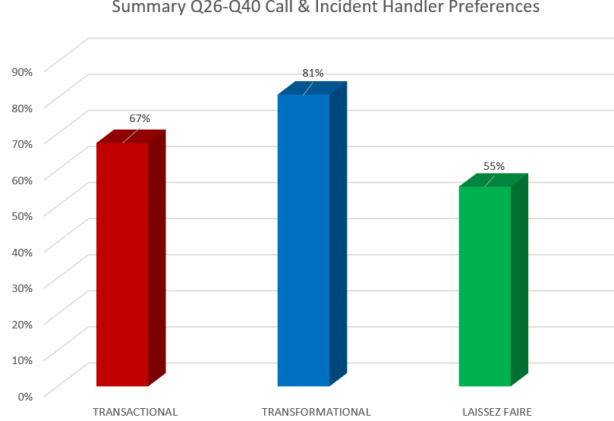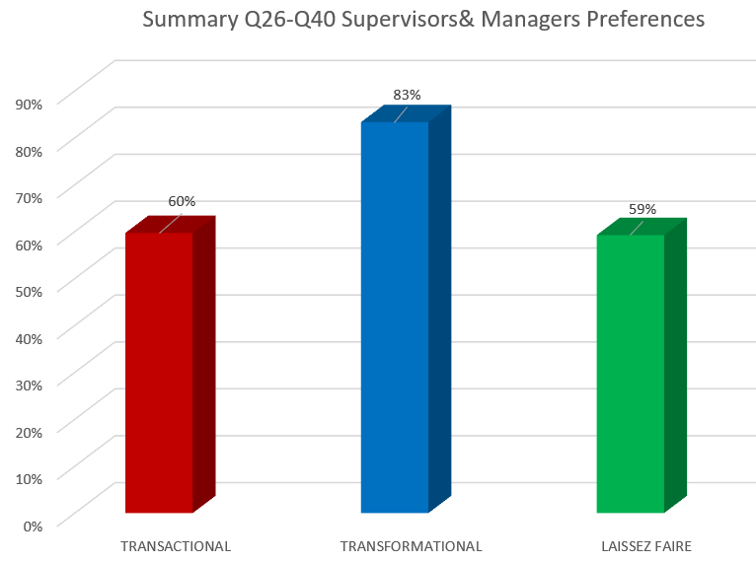

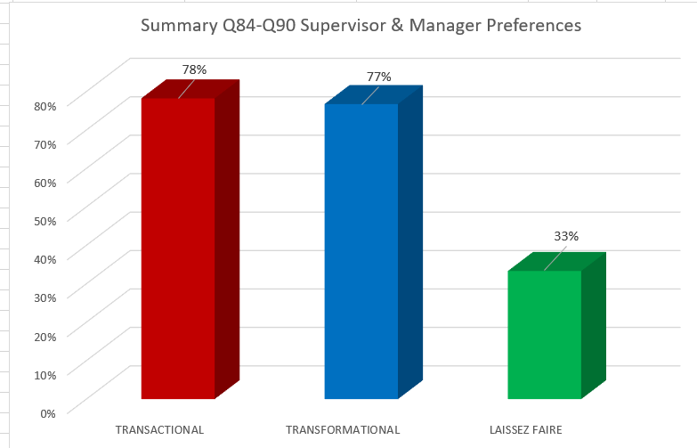
An examination of the responses from Section 2 - supervisors and managers only, specifically Q.84 – 90, which focused statements that best described their leadership style, showed that the transactional and transformational styles were evenly balanced (78% and 77% respectively), and that laissez-faire was less prominent (33%). A discussion ensured as to the potential reasons for this difference. A look at some of the 11 free-text questions, these forming the more qualitative responses, and thus enabling views, perceptions and feelings to be understood was also discussed, along with the workplace observations and focus groups held. The above bar charts and the existing analysis in identifying certain trends, patterns and themes was discussed.
Based on the above discussion with the Supervisor, the below questions and answers now provide for the salient points captured to triangulate and expand upon the initial findings that have emerged from the analysis of the survey data.

Q: [02:24secs] Do you understand the terms transactional, transformational and laissez-faire in terms of leadership styles?
A: [00:30] Yes

Q: [00:32secs] Because you’ve been on the leadership course?
A: [00:32secs] Yes

Q: [00:36mins] The survey indicates that there is a preference for transformational style of leadership over that of transactional and laissez-faire. So, transformational comes out the highest for supervisors in that, that’s what they relate to as to what they would want to see but when we look at Section 2 of the survey specifically for supervisors, what’s coming out loudly is that what they say they do is more transformational than transactional. Whether you’re one of those I don’t know as it’s anonymous, but that’s what’s coming out. Is that what you see in Incident handling. Does that hold true for you?
A: [01:20mins] “Yeah, I do, I think I mentioned it before the interview the main issue is the staffing isn’t it. So, you’ve got to adapt your way of leadership to deal with instances as and when they arise with the people you’ve got. So, you’ve got to listen to your team, whoever, because I’m a floater and I work with various teams, you’ve got to listen to their concerns as well as deliver what the supervisors or the leadership team want. So, I think it’s a balancing act.”

Q: [02:37mins] So do you see a specific code being more transactional or transformational or?
A: [02:42mins] I see a major difference in all the codes. I know we all as supervisors been on the same, some will dig their heels in and regardless of how many times you ask them to patch the channels, they take about 10-15 minutes to do it.

Q: [02:57mins] Because they want to do it themselves and not to be told?
A: [03:00mins] Because they feel it’s not the right thing to do, because by doing so you’re taking away the Buddy element for your Dispatcher - doing the intel logs, doing all the background work that that Dispatcher needs.

Q: [03:15mins] So they’re resisting that.
A: [03:16mins] Yes, they are resisting yes. And they have been allowed to get away with it, so you know that when you are working on that team you are fighting.

Q: [19:11mins] “Interestingly right, that next question on the survey asked, ‘does the focus on achieving night performance 999 and 101 etc. contribute to the stress felt by supervisors or managers and 80% of the respondents said it did, so staff now, call handling and incident handling are saying that chasing performance, or driving performance or trying to get better performance, 80% of them said that it affected the supervisors and managers stress levels. Is that something you relate to or?”
A: [19:46mins] “And again, you can only work with the amount of staff you’ve got in there, you know, especially handing over from evenings to nights, where the staffing goes down horrendously, and then you’re conscious of the that board because you know you will be discussed in DMM the next day. But, if you’ve got a reason for it and that’s fine. It’s just when you’ve got 6 calls missed and you’ve got staff not doing anything.”

Q: [20:16mins] And you worry about that then and you know it’s happened. You see it live then don’t you?
A: [20:22mins] Yeah, but I wouldn’t allow it to happen. But then again, we go back to this inconsistency across shifts

Q: [20:28mins] So, does that cause additional stress for you when you see that?
A: [20:30mins] It doesn’t cause me stress, I’m aware of it and I’m conscious of it, but I….

Q: [20:37mins] Okay you’re probably the exception because of your service, you know what to do with your eyes shut really don’t you. You know those under 10 years’ service, or 5 years’ service in the Incident Handling supervisory team, do you think that weighs heavily on them?
A: [20:56mins] I think that of the people in there, especially Con 2 side of things, possibly, I don’t think knowing my colleagues, I don’t think it causes them stress, it possibly, for a better word, makes them feel stressed in that when those figures come out the next day

Q: [21:18mins] “So they know they are going to be discussed and they are going to be accountable the next day. So, the DMM is an issue for them because they know it is going to be discussed, is that what it is?”
A: [ 21:26mins] “Yeah possibly, because on the DMM you’ve got your morning supervisor in there whose possibly been on 4 days off and doesn’t know why Code 5 have dropped six 999s last night. If I was on nights and there had been an issue with calls, I would pass on to the morning supervisor – listen this happened.”

Q: [21:45mins] “So, you have a hand-over ready for, okay.”
A: [ 21:49mins] “Yeah, yeah, it doesn’t happen with everybody because I’ve seen them on mornings.”

Q: [21:52mins] “So it’s continuity for DMM. Okay I like that. Perhaps that’s something we should include in the handover, not that you want to spend hours doing that, but even if its just like exceptional notes”.
A: [22:06mins] As you handover high risk mispers or something the next day. We could have missed two here, it was because of power failure or an influx of calls from South Wales Police, something like that as we do take a lot of their calls as well, so we possibly could miss some of ours. That sort of handover. That would help the obviously managers instead of trawling back to 2 o’clock in the morning, because it would save them listening to what was the buddy was doing.

Q: [22:45mins] I’ve made a note of that. Certain things I can use on the write-up.
[31:35mins – 35:10mins] Discussion on high threat, harm and risk incidents and command protocol with the types of leadership styles in play at that time. Explanation of transactional – autocratic and directive verses transformational democratic or facilitative. Reference to survey questions Q.68 (Does a particular style of leadership affect you in your work?) and Q35 (Working in a Police Communications Centre has an influential bearing on the style of leadership supervisors and managers predominantly exhibit?) and the responses to both, with the greater percentage saying yes to both (58% to Q. 68 and 54% to Q.35, with only 8% stating that working in the FCC didn’t have a strong bearing on the supervisor’s style).

Q: [35:10mins] “Does a particular leadership style manifest itself more at that point (referring to high threat and risk incidents such as pursuits and firearms) and bearing in mind that Incident Handlers want more transformational, how does that go down with them?”
A: [35:10mins] “They know this is coming, a message from the IID Desk, they know this could happen, so they’re aware of it, what the resources are. I can’t speak for everybody. I hear across the board ‘Well we might not have had a supervisor today because they were involved…”.

Q: [35:40mins] “Do you think they want more direction at that point?”
A: [35:42mins] “Yes, I think they want your support and your understanding and somebody to refer to, and ask, and likewise for the FIM you know, they will look, especially firearms at the FIM all the time. They just need a bit of security possibly, not everybody.”

Q: [36:03mins] Do you think at that point they will look at you for direction?
A: [36:09mins] Not everybody because.

Q: [36:20mins] But those under 5 years’ service?
A: [36:22mins] Yeah possibly…. They want your reassurance, they want you listening in

Q: [36:31mins] “Do you think that at that point in time when those incidents occur they are seeking for transactional direction?”
A: [36:36mins] “Yeah, they will deal with it quite well, but they need to know that you’re there, as in listening and giving direction, because they’ll have these questions raised at them from whoever is dealing with the incident so they need to know that you’re there to give that reassurance or guidance – whether that’s a FIM or Con 2.”

Q: [37:04mins] Is there a clear understanding then of performance measures for sure as a supervisor. Is there clarity as to what is expected of you?
A: [37:15mins] I understand what is expected of me as opposed to doing performance reviews because I’ve been a floater and tasked with other things, I haven’t been doing performance reviews, I’ve been doing other things. But you’re aware of what is required, what they need to do on the performance side of things.

Q: [37:38mins] And you’re talking about the quality assurance framework there, the QAF as they call it. That is the performance framework then is it for you.
A: [37:39mins] Yes

Q: [37:51mins] Do you think that across the supervisory teams then, that the expectation on achieving that performance, what that means is understood by the supervisors, all of them?
A: [38:03mins] It’s understood, definitely understood, but it’s a time issue to get things done isn’t…… Because rightly or wrongly you can sit down on an afternoon shift as a supervisor and not having moved for hours.

Q: [38:28mins] So the question is how do you fit in doing the quality assurance report – the measurement tool
A: [38:34mins] Yes, yes. And I think as well the performance side of things, they have other people doing it on a permanent basis. Because I think it would be fair and its not rushed because you’re coming to the end of the month and you haven’t done any…

[39:19 – 40:07mins] Discussion on the quality assurance form and the process of live monitoring in Incident Handling on live jobs as opposed to Call handling, which can be undertaken after the call. The added value of independent performance reviews discussed.

Q: [40:23mins] Do you think that staffing issue and also the sickness, do you think they are directly related to performance in any way or leadership? Is there a link between leadership, lack of staff and sickness?
A: [40:40mins] Yes, and staff out of the department for whatever reason, whether they are medically redeployed, on attachment. You know that the facility is there to boost the staffing but for whatever reason you can’t get them back. I’m talking about attachments to other departments….. when staffing is on our knees, why not pull them back isn’t, or if you go an attachment for more than a year possibly, that’s it off, goodbye – we’ll fill your place with someone else.

Q: [54:49mins] Do you think there’s more of a performance culture in Call Handling than Incident Handling, or different? I know overnight you take the 9s but in the day they take them, unless there’s too many of them and they bunce to you.
A: [55:01mins] I think as well there’s a lot of new staff coming in, there’s not enough mentors in there for them to do their job properly. They are new, lack of confidence perhaps. I don’t know what the set-up is in there how much supervisors get called I don’t know. But I don’t know either whether in the exit interviews why there’s such an influx of leaving. I know a lot have gone off to do…

[55:27mins] Explanation as to new process of exit interviews as they had stopped and weren’t being done with HR now undertaking this function for all members of staff leaving the department.

Q: [57:33mins] In Incident Handling, what is the predominant leadership style, what would you say it is?
A: [57:37mins] I think you are only as good as your team. You’ve got really fantastic FIMs in there and you’ve got FIMS who sit there looking at their phones all day. You’ve got to be approachable, direct. Yes, have a little bit of banter but you’ve got to remember when the incidents come in that’s the predominant, and you’ve got to make that straight to make them aware that this is what I expect of you. In briefings if they turn up at 3.05pm I’ll ask them ‘briefing starts at 3 you know’. If I’m expected to come into work I’m into work 10-15 minutes early to make sure I’m there. I address time issues, there’s no nonsense and you get what you see. I’m honest, I listen to everybody and that’s my approach.

Q: [58:31mins] Do you think that the leadership style does have an impact on performance?
A: [58:35mins] Oh yes definitely. I know form working on a team and from working with various teams. Your style of leadership will have an impact on how they deliver their work. Because. If you’re sat there on that role directing and criticising, and telling and shouting, then they are going to get turned off and not respond to you. And likewise, if your sat up there with your head down not engaging, well why am I bothering then?

Q: [59:11mins] So what style would you recommend to give you the best performance then?
A: [59:18mins] Well, you’ve got to know your job inside out basically, you’ve got to know your job and be approachable and you’ve got to be directive on the same hand. You know you can’t sit there and not do anything and you’ve got to be available to respond to any queries they have. And at the same time, you’ve got to address each incident that comes in and make sure everything is ticked off and done correctly. That’s my approach. I don’t not treat Joe Bloggs over there the same as somebody else over there because I don’t like them. At the end of the day I’m there with you.

Q: [59:55mins] Are you more of – let them get on with it or not, I’m more situational, if I need to go in I’ll go in otherwise I won’t?
A: [1:00:02hrs] Yeah, if I don’t need to, I know my audience as well. I know who to watch in there

Q: [1:00:08hrs] That’s more situational then isn’t. You’re picking your moment to do more or less
A: [1:00:15hrs] Yes. But I know people’s abilities and I know people in there who will not give 100% as well

Q: [1:00:19hrs] How important is that for you – knowing your audience?
A: [1:00:23hrs] Oh, yeah definitely. As I say, I could go into contact handling tomorrow, I don’t know half the people in there, when I use to have them all, as I said before, in one room, I would know everyone’s strength and weaknesses in there. But I don’t know half of their names. So yes, you have to know.

Q: [1:01:12hrs] Does for example, capacity affect leadership and then therefore, affect performance. Capacity is about having the right levels of staff. So, does staffing affect leadership styles and therefore, does staffing affect in the same hand performance?
A: [1:01:37hrs] It affects leadership styles in a way that you have to deal with the pressures of them, thinking ‘Oh come on we’re only 5 today, it’s ridiculous bla de bla de bla…, but again I wouldn’t change my style of leadership because you have to deal with things as they come in, regardless if you’re two or three or four people in there, you do your best.

Q: [1:02:00hrs] So listening to that then, if staffing does affect leadership and leadership affects performance, albeit you try your hardest not to, and Dyfed-Powys is 5th out of 43 in the country for 999 speed of answer and 999 under 10 seconds, I think we’re 9th, anyway we’re in the top 10. Top 5 for speed of answer, the quickness of speed of answer…… bearing in mind out staffing issues sometimes there’s only 4 or 5 Call Handlers in there… and at night time there’s no Call Handlers as they go home at 12, so but we’re performing fantastically aren’t we to be 5th in the country
A: [1:02:48hrs] Well it’s amazing.

Q: [1:02:47hrs] I am shocked by it. But we heard what the staff say that its transactional, its autocratic and poor staffing and morale is low, but we’re performing in that specific issue fantastically. So, I could turn around and say, well actually it doesn’t impact on performance delivery as we’re number 5, top of the country. What would you say about that?

A: [1:03:17hrs] I’d think it’s amazing for the geographical area we cover to start off with. I know perhaps more geographical area than South Wales but they got more people, but I would say as well it’s down to what the both managers are telling supervisor what is expected of them. It’s raised then in DMM every day, and as I said, I’m aware of it, I’m aware that my performance today will be raised in DMM tomorrow.

Q: [1:03:51hrs] So the scrutiny on it is quite intense?
A: [1:03:53hrs] Yes

Q: [1:03:55hrs] That tends to highlight then, that there’s a very focused performance regime, which I think there is.
[1:04:05hrs] The staff feedback from the free-text survey questions and responses discussed and the low staff, low morale and high-performance focused environment highlighted as areas of specific feedback, this pointing strongly towards a transactional leadership regime.

Q: [1:09:17hrs] “How do you explain how can we be so high performing but yet when you read that survey it’s so negative?”
A: [1:09:30hrs] “I think it’s because people are being held to account.”

Q: [1:09:32hrs] “And it’s transactional then.”
A: [1:09:33hrs] “Yes”

Q: [1:09:36hrs] “So even though there’s an overwhelming response by Incident Handling supervisors, Incident Handlers, Call Handlers, overwhelmingly aspirational that we want to be transformational, we relate to those sentences more. What people actually see is cracking of the whip.”
A: [1:09:56hrs] “Yeah.”

Q: [1:09:57hrs] I know that people crack the whip differently and some do it a bit more tactfully than others
A: [1:10:02hrs] And also the technology that’s available you know. Why weren’t you not ready for 20 minutes? You know we missed 5 calls in that time.

Q: [1:10:13hrs] Is it sustainable?
A: [1:10:15hrs] I think so because you’re having more staff come in. Hopefully, the negativity on the floor will be nipped in the bud straight away so that doesn’t drain people, and it can do as you have certain individuals that go on and on and on and if it doesn’t get nipped in the bud straight away by the supervisors as it drains other people who are there to do a good job.

End of Semi-structured Interview at 1:13hours

Appendix ‘D’

Semi-structured Interview Transcript

Call Handling Focus Group – Reference R2
Date: 4/11/22 Time: 15:05hrs – 15:47hrs

Profile: Call Handlers (3 females and 2 males) of varying experience ranging from 2 years to 5 years’ service.

Summary of Initial Discussion:
[0:02secs – 06:38mins] The scene was set in providing the background information on the reason for the research study, with reference to the main research question. It was explained that the research sought to establish whether a predominant leadership style existed within the police communication centre, and if so, to understand its relationship with performance delivery, acknowledging that Dyfed-Powys Police was currently positioned 5th in the country for its 999 performance. It was also explained that establishing how the predominant style of leadership affected matters of capacity and capability, and its impact on the staff, were also key elements of that research.
An explanation of the primary styles of leadership looked at within the survey i.e. transactional, transformational and laissez-fair, along with the other closely affiliated leadership sub-styles i.e. transactional – autocratic, directive and bureaucratic, and for transformational - situational, democratic, facilitative and supportive.
Reference was made to the 92 survey questions which were explored with the Call Handlers with the significant 93% response rate, this consisting of the 85 potential staff capable of responding with 79 who actually did. Many of the responses discussed whilst using of a laptop to illustrate the pictorial and statistical results as seen on the Microsoft Form Survey responses.
Discussion on the survey responses to Q26-40 showing that the Call and Incident Handlers relate more to the transformational leadership style (81%) than that of transactional and laissez-faire (67% and 55% respectively). In saying this, this is what they are saying they prefer and this could be aspirational as to what they want to see in the workplace. The Supervisors stated in their responses to the same questions, that they also preferred to be more transformational (83%), with transactional and laissez-faire being quite evenly represented (60% and 59% respectively).
Bar charts shown on the laptop.

An examination of the responses from Section 2 - supervisors and managers only, specifically Q.84 – 90, which focused statements that best described their leadership style, showed that the transactional and transformational styles were evenly balanced (78% and 77% respectively), and that laissez-faire was less prominent (33%). A discussion ensured as to the potential reasons for this difference. A look at some of the 11 free-text questions, these forming the more qualitative responses, and thus enabling views, perceptions and feelings to be understood was also discussed, along with the workplace observations and focus groups held. The above bar charts and the existing analysis in identifying certain trends, patterns and themes was discussed.
Based on the above discussion with the Call Handlers, the below questions and answers now provide for the salient points captured to triangulate and expand upon the initial findings that have emerged from the analysis of the survey data.

Q: [06:39mins] But what’s coming out in nearly all of it is that supervisors are saying what we relate to, and what we do, is more transformational. Staff are saying we want more transformational, and our performance is the 5th in the country, but what I’m seeing is very different. I’m not seeing transformational, certainly not in Call Handling in anyway because I did go in there last night as well (referring to Incident Handling Section). So, what do you see then, because it’s okay for you to say I like, I relate to it, are you saying when you answer those questions that’s what I aspire to see, that’s what I relate to, that’s what I’m more comfortable with, but what are you actually seeing?
A: [07:21mins] “Depends on what supervisor. Each one is different, every one of them. From my experience obviously, there is a complete contrast of supervisors, they go from one end of the spectrum to the other. Some are laid back and the others are constant all day long. But I see the same results as we are hitting the targets. So obviously, even when we are not being told what to do all day long Call Handlers can see the board, we know to take a call, we don’t need to be told obviously, unless there is something waiting there specifically, then fine fair enough. But to be constantly on someone’s back all day, with limited numbers in the there as it is, personally I’m on the Digital Desk so I’m logged onto 999s all the day as well as doing digital work. 9 times out of 10 I’m the only Welsh speaker on the shift, so I have to drop everything to take may be a 2 and 4 switchboard call in Welsh, whereas if you’re speaking English, well you can wait in the queue”.

Q: [08:30mins] How do you know to stop what you’re doing?
A: [08:34mins] I get told

Q: [12:44mins] “Is the staffing issue dictating the style of leadership?”
A: [13:56mins] “I think all the problems would be solved if we had staff, at the end of the day. And we know that that is the issue and until we get bums on seats it isn’t going to get better, because someone has to take the calls.”

Q: [13:08mins] Or do you think that staffing is one issue, but do you think that leadership then and the style…. Do the supervisors in your view then choose the style or are they dictated to as to what style they use? If I did it, would I be forced down a transactional route? Are they choosing to do it that way?
A: [13:40mins] No, I’d say it was a choice yeah. It’s a fine line I think. There’re many supervisors for an hour are telling you what to do but then for the rest of the shift then sit back as they can see it working on its own. The staff are keeping on top of the board. And then they step in then when there’s a load of 9s coming at once and they tell staff to come out of switchboard and concentrate on the 9s. Yeah that’s fine because of the circumstances. Whereas some other supervisors will be on your back telling where to go very single time. They call you even before you’ve finished a call, you’re being asked even though you’re in the middle of a report doing your admin THRIVES and you’re already being told to move over to another 9s and you haven’t even finished what you’re on and you may forget then something that you’re doing on that log and you’ve moved over and you’ve forgotten. And we get emails that we’ve duplicated a person field – in the middle of what you’re doing, it’s so patronising.

Q: [17:31mins] The clear performance framework is around what you do and we’re 5th in the country and the style that you’re describing to me, would you say that’s more, that’s the predominant style, because you’ve got six or seven supervisors
A: [17:45mins] No there’s different contact isn’t there

Q: [17:49mins] Supervisors are saying that they want to be transformational. You lot are saying you want more transformational. This is what you are hearing here now isn’t it. What are you saying – don’t shout at us and tell us what to do, we can see it - we know what to do. Is that what you are saying?
A: [18:04mins] Yeah, obviously if we need to be told absolutely yeah. If we need to be told yeah because if there’s no one on 9s whatever. Fair enough. Some are at you, some leave you go, and we are really good to be fair covering each other because if we hear someone take a 9 we cover. I don’t know if that’s the culture or where’s that come from. It’s imprinted on our brains to take the 9s and that’s probably why.

Q: [18:35mins] “So you want more transformational is that what I’m hearing?”
A: [18:38mins] “Yeah, I’d say so. Let us get on with it.”

Q: [18:42mins] “Don’t tell us all of the time, let us decide and get on with it.”
A: [18:48mins] “If it’s standing out then by all means tell us straight away, but otherwise we’ve all been here long enough to know. Stats our priorities and we understand that but also, we know what we’re doing. If there’s nobody on 9s jump to 9s, if there’s nobody on 1s jump to 1s and switchboard yes it can wait, it shouldn’t but it does.”

Q: [19:23mins] “Does performance make you the top? Does the performance culture here put us 5th? I don’t know. Does transactional get us there? What do you think?”
A: [19:38mins] “An example is I’ve worked with a certain supervisor who will be on all day long take this, take that, and you work with another supervisor who lets you get on with it and the stats are the same. Its not all supervisors are transactional so it can’t be.”

Q: [19:52mins] “You are clearly identifying that some are more transformational and actually the result is the same, is that what you think yes?”
A: [20:00mins] “Last night was a prime example where last night supervisor had two on 9s, logged in constantly and we never normally do, it’s normally just one. Whereas another supervisor would see one waiting in 1s and the lines were busy would ask that one on 9s to come back into 1s, to take that 1 waiting even though 9s are constantly busy. You risk not having cover on 9s at all because there is always someone taking a call. It’s different across everywhere. Each one is different, completely different (referring to Call Handling Supervisors).”
Q: [20:28mins] Do you think that the supervisor’s role is a difficult one because what they have go to try and do?
A: [20:35mins] I’ve done it. I think it’s more difficult now when I did it in November last year

Q: [20:40mins] What’s changed?
A: [20:41mins] Staff, you need staff to work with. We went through Covid and this is the worst it’s ever been as you know and even switchboard stuff we talk about, there’s one person sometimes on switchboard for the whole of the Force for hours, and I find switchboard more stressing than 999s and 101s, it’s draining, as its call after call, there having a go at you for officers, there’s loads of issues about not getting people. I think that needs to be managed better as well. I know 9s are important but how many switchboard calls are actually incidents and staff welfare wise, it is mentally draining. You leave here sometimes and you think what the hell…… Especially the new one coming onto the floor as well. One of the supervisors said a couple of weeks ago that she took switchboard for two days and she was absolutely shattered going home, but that’s us every day. You know it’s not just two days its every day.
[21:43mins] Reference and discussion on the survey response for Q.77 ‘Would you describe yourself as being happy and content in your role/job?’ Only 11% said they were not happy, with the majority saying that they were occasionally happy, happy most of the time and very happy, this accounting for 86% of the respondents. It was highlighted that this wasn’t the response expected given the extent of feeling expressed in the free-text responses, which were overwhelmingly saying that there was low staff morale, dire staffing issues and transactional autocratic leadership.
Q: [23:04mins] “Are we saying that you are happy in your role but not happy as it is?”
A: [23:10mins] “Yeah that’s why I’m probably why I think I say that I am. We’re all hopeful that things will get better. We’re trying to stay positive hoping that something will change. I think its the same everywhere you know, every job with staff at the moment is awful, nowhere is over staffed. It’s like you say, it’s the people here that keep us. You get on well with your squads. You know I enjoy my job but it’s difficult at this moment in time.”
Q: [23:49mins] And do you think it’s situational because of the staffing situation?
A: [23:51mins] Yes, that’s the cause I think.

Q: [24:21mins] The question was asked (reference to Q.56 and Q.72) do you rate your supervisor and a high percentage of you rated them as 80%. I think it was a scale of 1-10 and you had to rate them if you remember, and the majority 80% of you rated them 8-10.That’s a fantastic rating of a supervisor, but then further down a question 79 asked ‘How likely re you to recommend working in the FCC to a friend or colleague’ – 37 was the response because it was a 1-10 scale, and the other one Q.80 was ‘How likely are you to praise the quality of your supervisors to other staff in the police?’ and that was -27. So, your rate them extremely high but then I didn’t understand that you wouldn’t recommend them to others. So, I thought to myself is it that because you rate them personally but what they are expected to do you don’t like?
A: [25:28mins] I think it’s more of a personal level. We’ve got different supervisors. I’m more than happy with my supervisor at the moment however ask someone else about their supervisor as there so many different squads.

Q: [25:41mins] Question 74 asked if there were things in your supervisor you aspire to be, like role modelling, the majority (67%) said yes, but then Q. 80 asked if you would recommend them to others – and you said no (-27 score). So, I don’t know whether that’s an anomaly but the context there is like, no we rate the supervisor but they’re expected to do things like performance which is not them. Because another question was about stress – ‘Do you recognise when you are under stress?’ and you all said ‘yes’. ‘Do you recognise when your supervisor is under stress?’ and you said ‘yes’. ‘Does your supervisor lead or act differently when under stress?’ ‘Can’t tell a difference, they’re always like that’ was the response. So, they’re all questions to try and tell me, that’s why they were out in there, is ‘Does the leadership style, is it affected by things such as staffing or performance, a heavy focus on performance, do the leaders lead differently. Do you think that the focus on performance is creating more of a transactional supervisor?
A: [26:45mins] Yeah. Yeah.

Q: [26:48mins] You do. You know if we took away the performance thing do you think they would be different?
A: [26:50mins] Yes, I would say so. It wouldn’t be so… 999s are key stats at the minute, so if there was no, we dropped that then someone wouldn’t be asked that.

Q: [27:06mins] So performance sets the tone then and the leadership follows after it. But what you’re saying is that you want transformational, there are different ways of doing things, that’s what I hear you say.
A: [27:16mins] But as well, all the staff have to perform the same but we don’t, because everyone’s different, some can put more effort in than others and everyone knows that.
Q: [27:25mins] And what do you expect the supervisor to pick that up and deal with that you’re not seeing that
A: [27:29mins] No

Q: [27:31mins] And is that you all think that or?
A: [27:33mins] The sympathy I have for supervisors being sat in the chair is that they’ve got to go into DMM every morning and why is the stats, so that’s why that’s that, so when they’ve got such limited resources here, they got to be. And that’s escalates it doesn’t it, with the limited staffing we’ve got it’s going to seem ten times worse isn’t. Because they are going to be scrutinised in the morning, well hang on there’s three about the abandoned calls and why did that take 3 seconds more than yesterday.
[29:01mins] Discussion on whether the situation is sustainable i.e. achieving high performance with the current staffing level with concerns that it isn’t as people will leave. Efforts to recruit more outlined to the Call Handlers in the Focus Group with mention of the recent open evenings and the high numbers of potential applicants who attended.

Q: [30:42mins] Would you recommend this place to people if they said to you ‘Oh I can see the advert for Call Handling?’
A: [30:47mins] Right now no, but down the road yes. But for them to come in now and see what it’s like now, no.

Q: [30:54mins] Purely because of the staffing, not because of the supervisors and managers?
A: [30:58mins] Yes, everyone is stressed. Not being able to get leave, possibility of your leave being cancelled, you can’t organise anything in advance. We’ve got a life outside of this. When was this survey as I can’ remember the date of it. Was it in the summer, because this was the worst I’ve ever felt working here. If the survey was done then.

Q: [31:21mins] It was September. I think there would have been some stuff from summer, in feelings, coming through this definitely.

[31:37mins] Free text responses discussed with extent of feelings on the issues mentioned by the Call Handlers in the Focus Group i.e. leave, cancelled leave, overtime, worked rest days, low staff morale.
[34:27mins] Discussion on performance and leadership styles with the transactional style adopted all the time being very tiring for staff. A valid question was raised as to whether a particular style delivers more or the same performance?

Q: [34:57mins] Do you think that if they had a full complement of staff and another four people out there now with you this afternoon, do you think they would be more transformational?
A: [35:09mins] It depends who we are talking about as well.

Q: [35:12mins] It’s individuals. Is there something that we need to look at as a Senior Leadership Team in relation to developing our supervisors to be more transformational in a performance culture, but to be more transformational in it?
A: [35:27mins] I think it all comes down to what they see as their priorities because they must be different

Q: [35:30mins] Their priorities are answering within, they are driven by
A: [35:34mins] They’ve all got the same stats, stats, stats but then they go back to differently then so be it but then where’s the balance because one of them is basically do what you want and I’ll intervene when I need to and the other one constant

Q: [35:46mins] Do you think there is a need to look at, and we’ll do it for all and not just one, we won’t just do that, is there a need to look at leadership training in the context of police communication centre and the performance drivers and then the feedback is overwhelming, it’s here (reference to the survey responses). You want transformational, you understand that transactional does deliver the bacon but not 24/7, not constantly
A: [36:14mins] It’s tiring

Q: [36:16mins] Because listen there’s a certain, we are humans, the stuff that’s coming out (reference to the survey response), we’re not kids, treat us like adults, there’s all that coming out, and it’s a consequence of being told what to do all of the time, which takes you back to being a child doesn’t it
A: [36:31mins] “Is there that much difference in the stats when there’s a different supervisor?”
Q: [36:35mins] Yes that’s a good one. I can tell you that there’s a performance meeting here on the 15th in the training room and we will look at Codes then and performance.
A: [36:48mins] So just to give an idea, does one style work better than the other because it doesn’t then obviously. And obviously it depends on the amount of calls and the type of calls that come in but there should still be

Q: [36:53mins] an average over 6 months. Yes, we will look at that
A: [36:57mins] And the dates. That’s good

Q: [ 37:00mins] The issue being, can you imagine if the transactional one comes up higher. But what I’m hearing is that no, you can’t cope with that all of the time. Is that what you’re saying? Be honest.
A: [37:11mins] Yes, yeah.

Q: [37:12mins] You want more transformational, you sort things out yourself and I hear you saying, and I sometimes hear the supervisor saying ‘Can you go on’ – ‘I’ve already done it’. Michael last night (referring to the workplace observation undertaken in Call Handling), because he’s been here for a while – he was here in 2012 when I was here.
A: [37:18mins] Yes, and I do think that your supervisor board is more delayed than ours board, so by the time they’re asking us we’re already in.

Q: [37:39mins] So I suppose then that transformational is predicated on trust and when you empower somebody to do something on your behalf, there’s got to be trust. And I suppose that’s the developing of the skill in the supervisor to trust isn’t.
A: [37:50mins] Because I think that we trust the person sitting next to us

Q: [37:55mins] So why doesn’t the supervisor trust you is the question
A: [37:56mins] I think they do. I think my supervisor does.

Q: [38:07mins] The staffing I think we’ve got to look at that. It does impact on it of course it does, but we are trying to address that aren’t we. But we know that’s not going to come next week but we still got to deal with the leadership and the supervision and what I’m hearing is that could be different.
A: [38:23mins] Small little things that could make it a bit more pleasant environment to work. That’s the main issue but it definitely plays a part. For example, on a Training Day we’re in for 7, you’re on your last shift and you’re being shouted at, not shouted at but directed what to do constantly. Well one your tired as it is, two I know what I’m doing, not me personally but in general, it’s across the…. And those training days, I know they are pay back days really, to be expected to do seven days of Call Handling it is absolutely, oh it’s exhausting.

Q: [38:54mins] Because it’s not a training day, it’s a Call Handling day.
A: [38:57mins] It’s a Call Handling day. You can’t have that day off because they are short on staff. It’s not a training day you owe the organisation that day back. So, seven days on a row it is hard going.

Q: [39:07mins] And I think it’s desperate measures that forces the managers to do that because they
A: [39:40mins] I think the question to ask supervisors is whether they are happy to leave the room and not drop anything. Do they trust us. If they do leave the room that we can keep on top of it, or there’s people on the room that can step-up. With more experience and can do it when they are not in the room. Or do they stay there and don’t go for lunch because they don’t trust us.

Q: [40:07mins] So in your mind it could be a trust issue, potentially.
A: [40:09mins] Yes. Trust has got to be there for them to go on lunch and not come back early, because I know some supervisors don’t go for lunch and stay on the desk. Or get lunch to the desk. And that’s not healthy for them as they’ve got to have a break from their desk as well. It’s one of those questions you may ask if they trust us.

A: [41:31mins] The people that have left this year, has it been taken on board why they’re leaving
Q: [41:34mins] We are doing exist interviews. It hasn’t happened as frequently as, but we are going to get HR to do that not us.

End of Semi-structured Interview at 42:40mins

Appendix ‘E’

Semi-structured Interview Transcript

Interview of Call Handling Supervisor – Reference R3
Date: 04/11/22 Time: 16:02hrs – 16:27hrs (25 minutes duration)

Summary of Initial Discussion:
The scene was set in providing the background information on the reason for the research study, with reference to the main research question. It was explained that the research sought to establish whether a predominant leadership style existed within the police communication centre, and if so, to gain an understanding of its relationship with performance delivery, acknowledging that Dyfed-Powys Police was currently positioned 5th in the country for its 999 performance. It was also explained that establishing how the predominant style of leadership affected matters of capacity and capability, and its impact on the staff, were also key elements of that research.
A quick explanation of the primary styles of leadership looked at within the survey i.e. transactional, transformational and laissez-fair, along with the other closely affiliated leadership sub-styles i.e. transactional – autocratic, directive and bureaucratic, and for transformational - situational, democratic, facilitative and supportive.
Reference was made to the 92 survey questions which were explored with the Call Handling Supervisor along with the significant 93% response rate, with many of the responses discussed whilst using of a laptop to illustrate the pictorial and statistical results as seen on the Microsoft Form Survey responses.
Whilst doing so, particular discussion took place on the responses to Q26-40 (preferred style of leadership) for the Call and Incident Handlers as sub-groups within the overall sample surveyed, and also for the supervisors in response to these same questions. A look at some of the 11 free-text questions, these forming a more qualitative response, and thus enabling views, perceptions and feelings to be understood was also discussed. The below bar charts and the existing analysis in identifying certain trends, patterns and themes was discussed.
Based on the above discussion with the Call Handling Supervisor in the semi-structured interview, the below questions and answers provide for salient main points captured to triangulate and expanding upon the initial findings that have emerged from the analysis of the survey data.

Main discussion points in interview directly linked to Research Objectives:
Q: [0:22secs - 08.01 minutes] Discussion on the survey responses to Q26-40 showing that the Call and Incident Handlers relate more to the transformational leadership style (81%) than that of transactional and laissez-faire (67% and 55% respectively). In saying this, this is what they are saying they prefer and this could be aspirational as to what they want to see in the workplace. The Supervisors stated in their responses to the same questions, that they also preferred to be more transformational (83%), with transactional and laissez-faire being quite evenly represented (60% and 59% respectively). How do you relate to that as a pattern or a theme coming out then?
Bar charts shown on the laptop.

Discussion held.

A: [08:04 mins] I’d like to think I am more transformational, however I do have to adapt my leadership style when it comes to supervising with low staff, so then I will switch and I am more transactional, and that’s just because I know how important it is to managing demand out there. So being more transactional allows us to achieve performance.

Q: [08:33 mins] Could you deliver the same performance output as you do by being transformational?
A: [08:43mins] No

Q: [08:46mins] Okay explain that to me then because this is the nub of it. You can see what I’m trying to do is. Is there a predominant style and what is its relationship to performance, and what are the issues that affect it?
A: [08:58mins] I have tried it as I am more transformational usually with my leadership style, but since joining the Force and asking to lead a team within the FCC, I’ve switched to become more transactional to achieve the results that we’re looking for. And I think that if I’d stayed transformational, I know that those calls would either be waiting longer, or potentially dropped 9s.

Q: [09:33mins] Okay, so does the performance focus, the culture, dictate in you what leadership style you deliver on a day to day basis?
A: [09:40mins] Yes

Q: [09:43mins] And what do you say that leadership style is?
A: [09:44mins] Transactional

Q: [09:50mins] Is this wrong or is this right? Are you saying that you want to be transformational? Supervisors are saying that they relate more to transformational, but when you look at what the free text says, a rich bed of evidence in here, that say they are told what to do, shouted at etc., which I have seen in the workplace observations. The supervisors are all saying they want to be transformational, what the call handlers are saying we only see, not only, but we see more transactional, they do see transformational but they see far, so the predominant one is transactional. Do you think that’s right?
A: [10:30mins] They see more transactional than transformational I would definitely say that.

Q: [10:35mins] Now they want more transformational, supervisors are saying we want to be more transformational, but actually what is predominant is transactional. There’s a rub there isn’t there. It’s what is called incongruence.
A: [10:45mins] Again I do think a lot of its down to the staffing and having that 1-1 time with the call handler, where you can be more transformational.

Q: [10:52mins] Which is what you want to be?
A: [10:53mins] Yes

Q: [10:55mins] Do you want to be more transformational?
A: [10:56mins] I like to be transformational, I like my staff to think

Q: [11:01mins] Do you like the style you have to adopt every day in being transactional?
A: [11:06hrs] Good question, uhm, (pause)… It is demanding to be transactional all the time, it’s hard work. To constantly be monitoring those boards and monitor who’s going to answer this next call coming that’s not even there yet, but you’re already in that mindset, you’re planning who’s answering that next call when it’s not even there. And sometimes I’d like to be able to have that more time to focus on my team and not on the demand, if that makes sense.

Q: [11:42mins] What gives then when, because when you’re doing something that you have to do but actually your yearning to do something else, there’s a process there, there something, there’s a rub there isn’t there, and when there’s a rub there’s friction isn’t there, whether that’s internally or that I don’t know, it’s got to come out of the wash somewhere.
A: Yeah definitely

Q: [12:02mins] How does it come out of the wash? What does it do to you?
A: [12:08mins] So if I’m supervising and there’s no other supervisor on, and I’m om my own, I’ve got that whole demand to manage all day, it is hard to have that 1 on 1 time with staff or even just, I suppose to come across more supportive, because you are just constantly watching the boards, you’re constantly watching the calls coming in, and it does come across to the staff like we are move here, move here, move here, and I totally get that from the staff if that’s what they’re saying, I agree, because I’ve been a call handler here myself and I felt exactly the same as a call handler.

Q: [12:43mins] Yes, I understand that. And what they said was that they wanted more empowerment, they just wanted to be trusted more. And the issue about performance is, trust equals potentially varying performance. Is that what you see or what? Could you trust them more?
A: [13:01mins] Yes, I can, there’s certain staff I know that can be trusted and they do it, they’re great at doing it, they great at switching lines. But I think then that some of the staff have just, they do feel overworked because we are short staffed and I think sometimes they think I’m not switching because I need that little bit of a break. Sometimes I will push them to move over, we can just leave it.

Q: [13:32mins] The staffing issue. Is the staffing issue forcing in you a style of leadership?
A: [13:36mins]: Yes

Q: [13:37mins] Or is it performance?
A: [13:38mins] No

Q: [13:39mins] Or is it both?
A: [13:40mins] Both

Q: [13:42mins] Which is the greater pressure that you’re responding to?
A: [13:48mins] Yeah, I think performance, because that’s all I hear every day, it’s the main focus that I hear every single day is managing these 9s, managing these new incidents. There isn’t any focus on anything else.

Q: [14:03mins] If you had another four people out there last night when you were sat there as Call Handling Supervisor, when I saw you, would you be any different in your leadership style?
A: [14:33mins] Yes

Q: [14:35mins] You wouldn’t be as transactional?
A: [14:36mins] I wouldn’t be as transactional. I would still be transactional because I think that’s just part of the role, but not as transactional?

Q: [14:50mins] Are you saying that the role of Call Handling supervisor is more transactional role than transformational?
A: [14:57] It’s more transactional over transformational

Q: [15:00mins] The role itself?
A: [15:01mins] Yes

Q: [ 15:05mins] As to its performance focus?
A: [15:06mins] Yes, it is

Q: [15:09mins] Would you say its heavily performance focused?
A: [15:10 and 15:24mins] Yes, it’s definitely I think, because, well the meetings I attend every day that’s all we discuss really is performance. I know there’s wellbeing in there and there is health but….

Q: [15:39mins] Do you say that there’s a heavy performance focus in the department?
A: [15:42mins] Yes

Q: [15:43mins] You can’t escape it?
A: [15:47mins] No, even the recognition that comes in is recognition about the performance and nothing else.

Q: [15:52mins] If you were sat here as the Head or Deputy what would you do?
A: [16:00mins] I would ensure that the staff have time for protected time for 1-1s, definitely because I think that’s really important, and I do think even a 10 minute check-in, which is what I used for my staff in my previous role, at the start of every new set I would have that 10 minute check-in at the start of set just to check on their wellbeing, check how they are, is there anything that’s not bringing their full selves to work so that I can understand may be if there is something going and maybe I need to adapt my leadership to them then.

Q: [16:35mins] See that’s all very transformational.
A: [16:37mins] Yes, that is how I am usually.

Q: [16:54mins] So specifically, if you were the Deputy Head or Head in relation to the performance focus, as you’re saying that it’s dictating the style of leadership that supervisors exhibit, which is affecting the staff, can we deliver the same performance? We are 5th, would you change it and become 43rd. Would you do that?
A: [17:29mins] No absolutely not. To deliver the same message and to get the same results, if I could change something, it would be a recognition platform for the staff, and whether that would be call of the week, just some personal thank you messages, emails, feedback. Supervisors do downloads every day, we’re listening to calls for the role, so for me I do send emails out to someone that I might listen to a download and send them an email saying that I’ve just listened to this call for you saying well done, difficult call.

Q: [18:30mins] Can we change our supervisors to be more transformational and still hold 5th position? I know it’s a bit of a question and a half to predict performance based on a change but could you do your job as good as you do it… by being more transformational?
A: [19:05mins] Uhm… its hard. If I’m being honest, no.

Q: [20:03mins] Reference to Survey Question No. 35 “Working in a police communication centre where emergency and non-emergency calls are handled and responded to has an influential bearing on the style of leadership that supervisors and managers predominantly exists? What is your opinion? Strongly agree to strongly disagree?
A: [20:37] I agree or even strongly agree.

Q: [20:53mins] So let’s have a look to see what they said then (referring to the survey responses for Q.35 on Microsoft Forms]. There’s so much information in here, it’s rich right. Strongly agree and agree – that’s 43/79 its quite a percentage, 13 neither agree, that’s neither helpful or unhelpful really, that’s sitting on the fence they call that isn’t. Totally disagree only 6. There’s an overwhelming agreeance that it does compared to the don’t agree. Do you think that the leadership style in other areas, if I put you into BSU, you’d be more transformational?
A: [21:26mins] 100%

Q: [21:29mins] And is that where you’re saying your preference is as a leader?
A: [21:32mins] I like to be a bit of both
Q: [ 21:35mins] Situational then?
A: [21:36mins] Yes, but I’d probably say more transformational than transactional, but I just think that the role that we’re in at the moment, the importance of getting it right performance wise outweighs. You know they are 999 emergency calls, it’s not just doing it for performance for the business, it is doing it for that person that’s on the other end of the line waiting to come through.

Q: [22:08mins] Do the staff understand that. Well they take the calls so I suppose they must.
A: [ 22:11mins] Uhm, they do, I think it can be frustrating then when 999 line is being misused and that does frustrate a lot of the staff then, or the same as when they take new incidents. We don’t know what call we are going on the other end of that line so we can’t be in that mindset of thinking.

Q: [22:43mins] Talk to me about the managers then, and we will wrap this up very quickly, talk about performance, managers, you, relationships, predominant leadership style?
A: [22:53mins] I think there is no consistency with supervisors, if I’m being honest. So, I think you have, we are all transactional, I would say every one of us, but there are one or two that are transactional without the empathy with it, and it comes across as quite… (pause).

Q: [23:16mins] So, you’re talking about the supervisor team?
A: [23:17mins] Yes, I get on with them all but I just see their different leadership styles and I think….

Q: [ 23:23mins] Some are transactional and outside of the context of performance you are talking about now aren’t you.
A: [23:28mins] Yes

Q: [23:30mins] We can relate to performance making you transactional because that’s just the business isn’t it, but you’re saying forget performance these are transactional with no empathy and …
A: [23:38mins] Yes and that’s when

Q: [22:43mins] Are we talking about one mode, one trick pony, that is them by default?
A: [23:44mins] Yes, and I think that does, it does impact on staff and how staff are feeling and staff morale, and same with performance, when we’re managing performance and whether that is looking after their wellbeing or listening to what they’ve got to say and doing something about it, or them seeing you do something about it, again there’s no consistency with that either.

Q: [24:08mins] And what about the managers?
A: [24:11mins] Uhm… (pause and silence to think)

Q: [24:13mins] Transformational or transactional?
A: [24:16mins] Transactional, yeah. However, since the new structure I have seen a lot more transformational, from my manager, I can’t, like my manager has been has been great, from both sides.

Q: [24:34mins] But transactional mainly?
A: [24:35mins] Yes

Q: [24:36mins] Is that more transactional performance focused or transactional performance and all ancillary matters
A: [23:43mins] Yes, yep all matters

Q: [24:51mins] Okay, thank you. That’s it. This will be stored now as R3.

End of Semi-structured Interview

Appendix ‘F’

Semi-structured Interview Transcript

Incident Handling Focus Group – Reference R4
Date: 4/11/22 Time: 16:35hrs – 17:17hrs

Profile: Incident Handlers (3 females and 3 males) of varying experience ranging from 3 years to 25 years’ service.

Summary of Initial Discussion:
The scene was set in providing the background information on the reason for the research study, with reference to the main research question. It was explained that the research sought to establish whether a predominant leadership style existed within the police communication centre, and if so, to understand its relationship with performance delivery, acknowledging that Dyfed-Powys Police was currently positioned 5th in the country for its 999 performance. It was also explained that establishing how the predominant style of leadership affected matters of capacity and capability, and its impact on the staff, were also key elements of that research.
An explanation of the primary styles of leadership looked at within the survey i.e. transactional, transformational and laissez-fair, along with the other closely affiliated leadership sub-styles i.e. transactional – autocratic, directive and bureaucratic, and for transformational - situational, democratic, facilitative and supportive.
Reference was made to the 92 survey questions which were explored with the Call Handlers with the significant 93% response rate, this consisting of the 85 potential staff capable of responding with 79 who actually did. Many of the responses discussed whilst using of a laptop to illustrate the pictorial and statistical results as seen on the Microsoft Form Survey responses.
Discussion on the survey responses to Q26-40 showing that the Call and Incident Handlers relate more to the transformational leadership style (81%) than that of transactional and laissez-faire (67% and 55% respectively). In saying this, this is what they are saying they prefer and this could be aspirational as to what they want to see in the workplace. The Supervisors stated in their responses to the same questions, that they also preferred to be more transformational (83%), with transactional and laissez-faire being quite evenly represented (60% and 59% respectively).
Bar charts shown on the laptop.

An examination of the responses from Section 2 - supervisors and managers only, specifically Q.84 – 90, which focused statements that best described their leadership style, showed that the transactional and transformational styles were evenly balanced (78% and 77% respectively), and that laissez-faire was less prominent (33%). A discussion ensured as to the potential reasons for this difference. A look at some of the 11 free-text questions, these forming the more qualitative responses, and thus enabling views, perceptions and feelings to be understood was also discussed, along with the workplace observations and focus groups held. The above bar charts and the existing analysis in identifying certain trends, patterns and themes was discussed.
Based on the above discussion with the Incident Handlers, the below questions and answers now provide for the salient points captured to triangulate and expand upon the initial findings that have emerged from the analysis of the survey data.

Q: [00:18secs] “You are saying that you want transformational leadership, that’s what you want. The supervisors are saying they are transformational. Is that what you see? Do you see more empowerment to get on with it or are you seeing more of the transactional? What style is more predominant in your view?”
A: [01:00mins] “Every supervisor is different; every Inspector is different”.

Clarification as to what the supervisor and manager entailed and whether this included the SLT.
Q: [02:24mins] Are you seeing a certain style of leadership?
A: [02:28mins] “I’d agree with you, it varies from person to person. It’s not consistent. Some are very micro-managing which is very distracting, others let you get on with it and step in when they need to, which is transformational which is what I like as well.”
[02:56mins] The Incident Handlers confirm that they have had a different supervisor on their Code for the last 24 months, with it being used as a shift to carry rolling supervisors due to the substantive supervisor being seconded out of the department on a long-term abstraction. As such this has meant there they haven’t had one supervisor for any length of time and have experienced several different styles.
Q: [03:19mins] So you’ve had many styles in many supervisors who’ve been on your code, so tell me which one is your preferred style?
A: [03:37mins] “I want transformational. I want them to know me, know what each one of us can do and then either let us get on with it or then pick and jump in when needed. And to be there to take the responsibility, they are the higher role; the FIM is the obvious example, he’s the decision maker, the buck stops there. But as for the rolling it, I can deal with that. I also know that there’s difference within the Inspectors too. if we’re going into a firearms job, which Inspector, roughly which way they are going to think. They won’t necessarily go the same way.”

Q: [04:53mins] You get different supervisors, some will be more directing – transactional and others more empowering – transformational. What style do you respond to most?
A: [05:08mins] “It’s really hard as coz it all depends on the incident. I would say transformational as long as they take the responsibility and tell me if I wrong when I’m wrong. If I’m right, let me crack on with it. It depends on the length of service”.

Q: [05:22mins] So, Incident Handling staff are wanting more transformational leadership, this is what the survey is saying.
A: [05:26mins] What’s it saying we are getting at the moment?

Q: [05:33mins] When I read the free-text, which is a lot of it, what I’m hearing is transactional.
[05:41mins] Transactional and transformational explained further to the Incident Handlers
A: [06:25mins] “I think even transformational though, when we have a firearms job, I wouldn’t say its transactional most of the time as we know what to do and we get on with it.”
Q [06:35mins] “Is that because the supervisors allow you to do it?”
A [06:38mins] “Yes. Usually things start rolling and we already know it. It’s a tick in the box for them as we’re already doing it and their checking to see if it has been done. They’ve just got to say it but we know what to do.”

Q: [07:18mins] “So you see more transformational in there more than transactional (referring to Incident Handling Section)?”
A: [07:21mins] “I would say so yeah.”

Q: [08:27mins] “What do you relate to most?”
A: [08:28mins] “Transformational”
A: [08:49mins] “It’s easier to work in a transformational environment.”

[Other policing matters discussed between 08:28mins and 08:49mins not relevant for inclusion in transcript]

Q: [09:27- 11:25mins] Your Incident Handling Supervisors are saying that they want to be transformational and even further than that, they say they transformational in the workplace. Is that what you see. (Explanation of Q26-40 and Q.84-90 for the supervisors)
A: [11:38mins] The barometer would be pointing more towards transformational I’d say.
A: [11:52mins] All the substantive supervisors I’ve worked with I’d say lean more towards transformational but they are comfortable in their role. Sometimes we have the acting-up ones and they are more transactional as they feel they need to be more transactional but don’t need to be so much. We also get the ones crossing-over the shifts covering etc. and they are more transactional because they don’t know their shift.

Q: [12:14mins] So, what you’re saying is that the supervisors knowing your skills and experience does have an impact on their style of leadership?
A: [12:22mins] Yes 100%. Yes definitely.

Q: [13:06mins] How does the leadership style relate to the good performance we have?
A: [13:45mins] If we can see that there’s a 999 waiting, we can patch a channel and one of us take it.

Q: [13:49mins] On your own volition?
A: [13:50mins] Well if I can see the board and I’m on Powys and I can see it waiting I’ll ask for them to patch the channels and I’ll answer if the others are on a call.
A: [15:58mins] If the Supervisors see it and ask us to patch the channel to answer it then that’s fine we just get on with it.
A: [14:07mins] But obviously we can’t always see the board, the monitor to see if there’s one waiting.
[13:58mins] “I think the targets are more heavily towards Call Handling and at the expense of intel, dispatching and that sort of job. To answer that call quickly is having an impact on…. They’re short in there today (referring to Call Handling) can you log in to take 101 calls. That’s one less Incident handler, that’s one patched channel. It outs a lot of pressure on the radios when it starts getting busy. Officers are asking for more intel, especially on the more serious jobs like a firearms job. Officers are asking all of these questions of us on the radio and we are not providing that service to them because the person on the radio is still having other people asking, I’m trying to d the intel on that job and the buddy is essentially answering 101 calls. So, I think that reaching those targets is having an adverse effect on safety and the information we provide officers with. That’s for 101 or 999s or Welsh calls.”
A: [16:34mins] To achieve the statistics and that target for Call Handling, something else is bending and there’s too much weight on it. it’s overflowing from Call Handling and is impacting on us.

Q: [16:42mins] Is there a high focus on performance in Incident Handling? I hear you saying that’s there’s more of a focus in Call Handling, but it impacts on you.
A: [16:49mins] Yeah, it’s overflowing. Because we are getting rostered for someone to sit there to cover 101 calls, which we’re arguing before the whole system that they can wait because they are not an emergency, so it that’s the case then why are we taken off as a dispatcher to sit there and answer 101 calls, that are an emergency.
A: [17:09mins] We’re not the burden when it gets busy now, it’s pretty much the norm, and so I think the stats aren’t… we’re answering 9’s in the day at a certain time, it’s a bit squiff because people who should be doing other jobs are doing a lot that and the burden then and intelligence, because somebody’s going to go to a job one day and why didn’t you know there was previous firearm there, it’s because I was stuck on a call.

Q: [18:13mins] Someone who is 43rd or 35th for example is having a lot of pressure and flack and that’s Dyfed-Powys Police. What does being 5th in the country as regards our performance mean to you?
A: [18:14mins] To me personally, it’s all well and good being 5th but the quality needs to be in that call, otherwise it’s immaterial. You could be 1st or 43rd, if the call is useless…..
A: [ 22:25mins] So would it benefit more if we weren’t 5th and looked at viable options to go 24 hours within Call Handling?

Q: [22:41mins] How are we 5th?
A: [22:49mins] I don’t know.

Q: [ 23:14mins] Is it because the performance culture is so focused here that we get with so little staff because everyone is so wired?
A: [23:32mins] I think we do have a hard-working staff here, everyone is hard working.

Q: [26:34mins] Other than 999s and 101s, do you feel that there is a performance culture in Incident Handling? Do you know what is clearly expected of you -performance wise?
A: [26:55mins] I wouldn’t say that performance is hammered home as much as Call Handling.
A: [26:57mins] It’s not as obvious as statistics. We only know when we something wrong that this needs to be done. It’s hard to measure in Incident Handling.
Discussion on the intended performance metrics that will be analysed and discussed in the forthcoming performance meeting to be held on the 15th November. Views exchanged.

Q: [32:36mins] Does a particular style of leadership in a supervisor get more out of you than a transactional leader?
A: [32:53mins] It depends how much someone is breathing down their neck for them to push.
A: [33:00mins] No, I find that a transactional supervisor comes across a bit more like panicking. That’s how it comes across to me. Red mist we call it when we are doing pursuits. And I find that if they are shouting orders and asking questions as you’re dealing with something, it’s red mist there. Go out of the room and have a cup of tea and let us just deal with it and it goes. No transactional isn’t good.

Q: [33:55mins] You’ve got a lot of experience here in the room. Do you need transactional or do you need more transformational because of your service and experience?
A: [34:10mins] If there’s someone too transactional then it gets people’s backs up and you get a clash. If we need to be told something we’ll accept it as a shift and do what we need to do…. But if someone’s constantly on your back, not listening to what’s going on the channel….. back off. It’s just not needed. But if it’s not then don’t do it.

Q: [34:54mins] Reference to breathing down the neck, is that because of performance.
A: [34:58mins] I think it has a negative effect on performance. Transactional people are managing the incidents and not the people, so by putting that constant hassle and pressure you’re just fanning the fire and the pressure gauge is going up on the person on the radio.

Q: [35:24mins] You want transformational that what it says.
A: [35:25mins] Yeah definitely.

Q: [35:28mins] But some supervisors are transactional?
A: [35:30mins] More transactional than transformational. Yes, I’d some are.

Q: [35:55mins] How does staffing affect all this?
A: [35:59mins] It puts pressure on us. It’s not good at the moment. We’re used to it at the moment. It’s not good. We don’t go on our breaks if it’s a busy shift as we don’t want the team to suffer.

End of Semi-structured Interview at 42:33mins

Appendix ‘G’

Semi-structured Interview Transcript

Interview of Call Handling Supervisor – Reference R5
Date: 04/11/22 Time: 17:42hrs – 18:35hrs

Profile: Female – 45 years’ service (very experienced supervisor of 20 years).

Summary of Initial Discussion:
[00:03secs – 07:38mins]
The scene was set in providing the background information on the reason for the research study, with reference to the main research question. It was explained that the research sought to establish whether a predominant leadership style existed within the police communication centre, and if so, to gain an understanding of its relationship with performance delivery, acknowledging that Dyfed-Powys Police was currently positioned 5th in the country for its 999 performance. It was also explained that establishing how the predominant style of leadership affected matters of capacity and capability, and its impact on the staff, were also key elements of that research.
An explanation of the primary styles of leadership looked at within the survey i.e. transactional, transformational and laissez-fair, along with the other closely affiliated leadership sub-styles i.e. transactional – autocratic, directive and bureaucratic, and for transformational - situational, democratic, facilitative and supportive.
Reference was made to the 92 survey questions which were explored with the Call Handling Supervisor along with the significant 93% response rate, with many of the responses discussed whilst using of a laptop to illustrate the pictorial and statistical results as seen on the Microsoft Form Survey responses.
A particular discussion took place on the responses to Q26-40 (preferred style of leadership) for the Call and Incident Handlers as sub-groups within the overall sample surveyed, which showed that the transformational style was the one most preferred and reflected what they wanted to see. This was also confirmed for the supervisors and managers (as another sub-group) as seen in their responses to the same questions, in that they related more to a transformational style as being what they wanted to use in the workplace. In essence, the transformational style was the preferred style for all staff. In direct contrast to this however, a heavy transactional style was observed being used by the supervisor during the workplace observation in Call Handling, this being a dominant theme emerging from the numerous free-text responses within the survey. This theme was further expanded upon within the focus group held with Call Handlers, who stated that a strong transactional style was a consistent theme with the supervisors within that section of the department.
An examination of the responses from Section 2 - supervisors and managers only, specifically Q.84 – 90, which focused statements that best described their leadership style, showed that the transactional and transformational styles were evenly balanced (78% and 77% respectively), and that laissez-faire was less prominent (33%). A discussion ensured as to the potential reasons for this difference. A look at some of the 11 free-text questions, these forming the more qualitative responses, and thus enabling views, perceptions and feelings to be understood was also discussed. The below bar charts and the existing analysis in identifying certain trends, patterns and themes was discussed.
Based on the above discussion with the Call Handling Supervisor, the below questions and answers now provide for the salient points captured to triangulate and expand upon the initial findings that have emerged from the analysis of the survey data.

Main interview points directly linked to Research Objectives:
Q: [0:743secs - 08.01 minutes] Discussion on the survey responses to Q26-40 showing that the Call and Incident Handlers relate more to the transformational leadership style (81%) than that of transactional and laissez-faire (67% and 55% respectively). In saying this, this is what they and you are saying they prefer and this could be aspirational as to what they want to see in the workplace. The Supervisors stated in their responses to the same questions, that they also preferred to be more transformational (83%), with transactional and laissez-faire being quite evenly represented (60% and 59% respectively). Interestingly, laissez-faire associates more to the transformational characteristics than what it does with transactional i.e. empowerment and a less controlled style of supervision. How do you relate to that as a pattern or a theme coming out?
Bar charts shown on the laptop.

Q. [07:44mins] The survey indicates that the staff relate more to a transformational style. It also shows that the supervisors say they are more transformational than what they are transactional. That’s what they are saying. Do you see this in your role as a supervisor?
A: [08:07mins] I see the need to be transactional with certain members of staff, not all the staff. I know, I look around the room and I know that certain people will log onto 9s and cover 9s without being told. Other people will not and sit there and wait for you to tell them, which I don’t know whether that’s a ploy or what, but they wait for you to tell them to log on switchboard. They can see calls waiting there and they still want go across until I tell them to. So, that’s, I need to do that so that our performance, it looks better.

Q: [08:49mins] “And we are 5th in the country out of 43 Forces which is absolutely unbelievable. So, you see the need to be transactional for what purpose, to keep us to 5th?”
A: [09:04mins] “Exactly, yes, to make sure that 9 is answered, that 101 call is answered, and even when you tell staff to move across to another 101, they don’t like it. You can tell they don’t like to be told. They want to be left alone on ‘not ready’ when not doing anything.”

Q: [09:29mins] “That’s what they said actually, why aren’t we given, because when they go, leave the floor, to go for lunch or they go to toilet, we are left to make those decisions. Why don’t they trust us more? Do you feel you that could trust them more and let them decide, and if that is the case, what do you think our performance would look like?”
A: [09:50mins] “No. Not urh.. I think that it would be less. I think that we not meet the demand that’s there. But, I do think that it’s a minority of staff that are like that. There’s staff on my team that I don’t even tell to cover 9s, they do it.”

Q: 10:21mins] Are they the more experienced? 5 years’ service?
A: [10:22mins] They are yes.

Q: [10:23mins] But equally you know certain individuals you need to keep an eye on. That’s the supervisor’s role isn’t?
A: [10:30mins] Exactly, yes. But then other people then, that I work on other teams, I don’t find that. So, I have to tell them, there’s 10 calls waiting here and they’ll be talking.

Q: [10:44mins] How closely are you watching that change, because it changes doesn’t it, you can have 16 9s all of a sudden.
A: [10:53mins] I watch all the time, constantly.

Q: [10:56mins] And then you’re directing a lot, in fact would it be true to say that after a whole shift you’re probably quite tired?
A: [11:04mins] No, I’m so used to it now… supervisor in call handling for 20 years.

Q: [11:22mins] “Would you describe yourself as being transactional or transformational?”
A: [11:24mins] “Transactional.”

Q: [11:26mins] “Have you always been transactional?”
A: [11:27mins] “Yes.”

Q: [11:29mims] “Okay, where does that come from?”
A: [11:31mins] “It’s the need to have, to do, the performance to be as best as it can be on the day.”
Q: [11:38mins] “Do you think that transformational would deliver the same performance for us in the FCC, in Call Handling?”
A: [11:44mins] “No, I think it would be lacking.”

Q: [11:47mins] “Right, why’s that?”
A: [11:48mins] “Because those people who could have answered that 9, if I’d left them to do it themselves, that 9 may not have been answered, so I make sure that it is answered.”

Q: [12:03mins] Do you trust your staff?
A: [12:04mins] I trust my staff, on my team…. (explanation that call handling supervisors sometimes cover other shifts that follow theirs etc).
A Cont’d: [12:23mins] So, I do find that maybe they won’t respond the same as my team. I work as a team with my team and they know me and I know them, and they are, they just out of respect they are.

Q: [12:45mins] “Do you feel that the staff want more transformational style?”
A: [12:53mins] “Maybe, yes,”

Q: [12:54mins] “Do you get that feeling?”
A: [12:55mins] “Yes, sometimes I will say to a member of staff ‘Oh, can you cover on 9s’ - ‘I am on 9s’. I do get that sometimes but that’s only because there’s a blip on the screen. But I think that how I am doing it it’s the right way. It’s my responsibility to make sure that 9 is answered, that 101 is answered.”

Q: [14:29mins] “So what’s driving you to do that. Where’s your focus come from?”
A: [14:33mins] “To have good, best results really for the day. It’s just, I know that there’s staff shortages and what have you, but you know the staff are dealing with that shortage very well. They would like to have respite time in between calls, but sometimes they may have respite time between 3 and 5 and then people go home and then more busy until 10 ‘clock and then time to chat. It’s not constant all the time. I don’t think people are taking one call after the other and are exhausted by the time they go home. They do have down time”.

Q: [14:30mins] As Call Handlers, when they are not taking the calls?
A: [14:33mins] Yes. It gets easier after 10 o’clock. It’s easier between 3 and 5 because there’s more people on the floor.

Q: [14:46mins] It’s not consistent all throughout
A: [14:47mins] No, it’s not.

Q: [14:48mins - 16:04mins] Question 35 from the survey read out. Results on Microsoft Forms – pie diagram showing that the answer was an overwhelming ‘Yes’ with 43/79 (54%) agreeing compared to only 6/79 (8%) disagreeing.
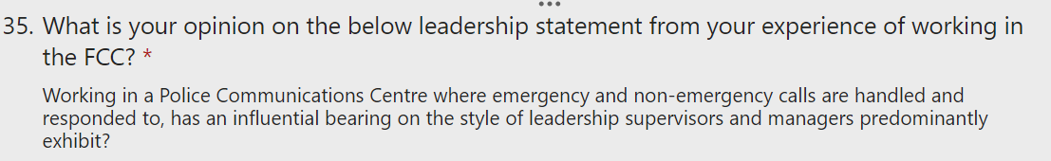
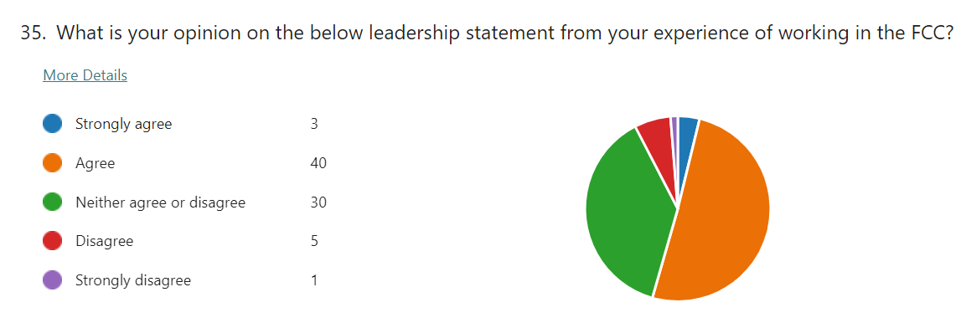
Do you feel that the style that you have got here, that you show, which is transactional, is that dictated by the environment, or would it be a case where I put you out of here and into BSU or CJD, would you be the same, would you have the same style or ….. (analogy of working on a building site and wearing different garments to that of call handling and the need for it).
[16:04mins] Are you adorning a style befitting of the environment?

A: [16:05hrs] Yes, because I remember when I was in Phoenix, I was always making sure that people were doing what they should have been doing, and watching what they were doing. So, yes, I would say that my style was the same then.
Q: [16:22mins] Okay, so you’ve always been transactional?
A: [16:24mins] Yeah.

Discussion on survey questions and responses relating to supervisors and feedback that supervisors are more transformational from responses to Q44 and 45.
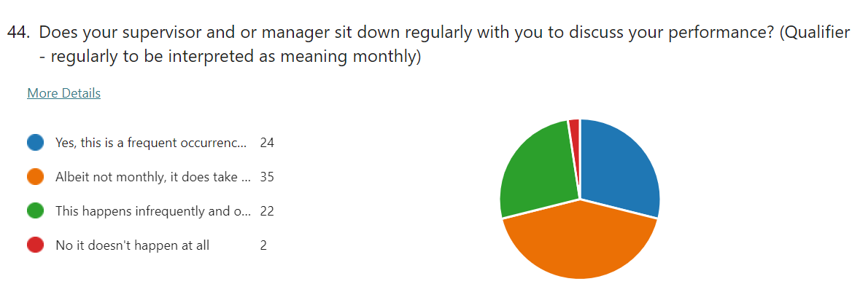

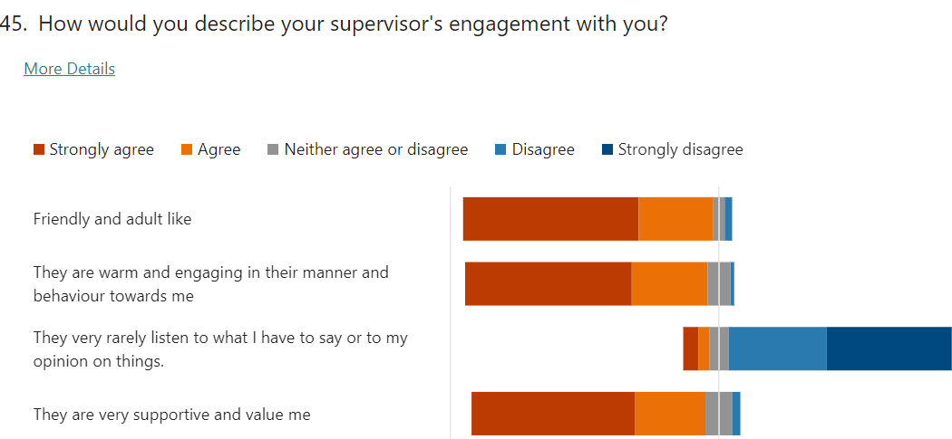

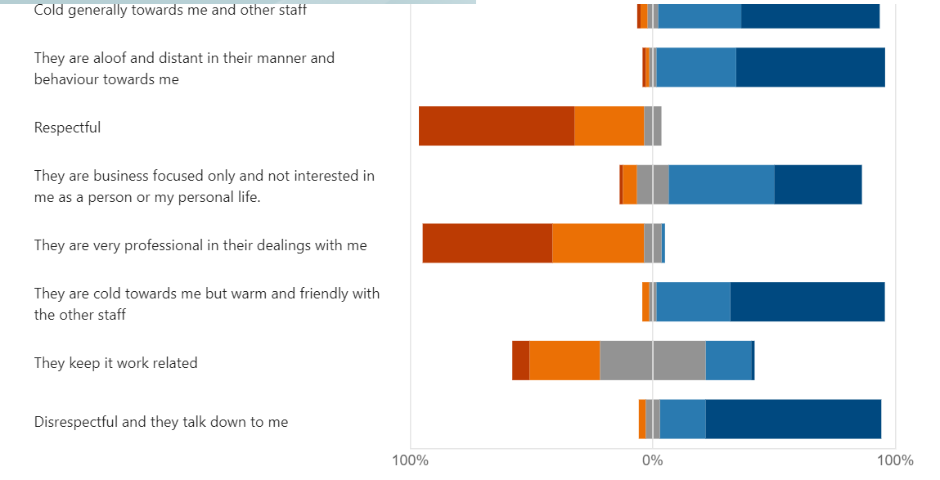

Q: [18:02mins] So this is more transformational isn’t really?
A: [18:06mins] Yes

Q: [18:14mins] So there’s good feedback in there for supervisors
A: [18:16mins] It is yeah. And I think that all of the supervisors are, I think we are a bit of both transformational and transactional, so transactional when we have to be and transformational when needed.

Discussion on many of the survey questions and their responses whilst showing responses on Microsoft Forms, including free text responses (see Question 68 and 69 summary).
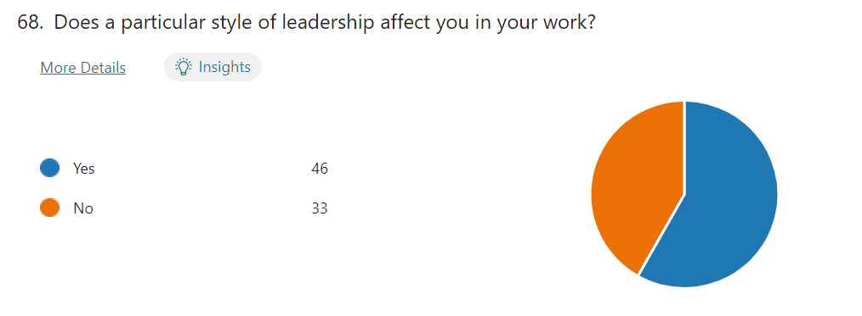
Q: [25:10] Do you get a flavour?
A: [25:11] Yes, but I don’t understand what they expect to have from you. They know the job, they know the role and it’s our job to ensure that it’s done….. I only say to people to cover on switchboard when there’s a need, not for the sake of saying go to switchboard.
Q: [25:43mins] Okay, let’s focus again. You’re doing it because we need to make sure
A: [ 25:48] That performance is met. I’m sure that most of my staff they do understand.

Q: [31:26mins] Supervisors are saying that they want to be more transformational. That’s not you, you wouldn’t have answered because you are very transactional aren’t you. Is there something stopping you being transformational?
A: [31:36mins] Well I think I am, in you know with certain staff, I just leave them to it. I know that they are going to do their job. But then, there are instances when I have to step in and say go take that call over there. But only with certain staff, it’s not all staff. It’s like today, I said to them ‘can you take your break now so that everything is, we’ve all had our breaks by the time 6 o’clock coms when a member of staff has to go home, and they, some of them, not on my team said ‘no, I’m not doing that, it’s too early for me to go for break’. I said ‘otherwise you want be back in the room to take that call’. I had to insist then.
Overnight 999 performance and Incident Handling discussed, with main points stated by the Incident Handlers from their focus group. The new telephony system and better performance recording for the 24/7 period mentioned.
Q: [35:24mins] But you can you see that there’s an issue overnight can you?
A: [35:28mins] Yeah. When they come in, like tonight, they are going to come in at 10.30pm, 11 o’clock because they’re working at 4.30pm to 2.30am shift and they’ll come into our room and log in as normal. They’re taking 101 calls, they’re taking switchboard calls, anything that presents to them, but instead of logging into 9s, where they specifically take 9s, and not anything else, they should be doing that, so that they don’t lose any calls at midnight. Whereas, if they go on anything, and just log on, they go on 101 call and there’s a 9 waiting.

Q [36:41 mins]: What you’re saying is they come across at around 11 o’clock, or should do, when that night shift comes in so that they’re spare, and they should come in and go on 9s.
A: [36:52mins] They should do, at least 2 of them should go on 9s

Q: [36:55mins] How many are there?
A: [36:56mins] Some of them is 4 or 5

Q: [36:58mins] And they come into Call Handling and take 101s, but they decide what they take.
A: [37:03mins] Yes, they just log onto everything
(Discussion over jurisdiction of the Incident Handler and Call Handling supervisor not having this. Suggestion as to changing this practice going forward by SLT).

Q: [37:39mins] The research question is, is there a predominant leadership style in existence the FCC and what is its relationship to performance delivery?
A: [37:52mins] There is, I’ve seen, noticed it in the last 6 months and being the same and it’s the transactional one, because you see certain supervisors, they will just say cover on 101s, cover on switchboard, and they do it. But not all supervisors do that.

Q: [38:14mins] And what is dictating that? Is there anything that’s causing that? What’s influencing that?
A: [38:21mins] Performance I think. I’m not saying that there’s some staff are lazy, but you do need to prompt some staff.
Q: [38:36mins] “So performance and the focus on that is dictating the leadership style?”
A: [38:40mins] “Yeah.”
Q: [38:41] “And you can see that now because you’ve been here a long time, certainly over the last, since 6 months, more so over 6 months?”
A: [38:46mins] “Oh yes, I notice that Carys and Kelly, Alison will use the same transactional as I do.”
Q: [38:58mins] “Is that the magic portion? Is that why we are 5th?”
A: [39:02mins] “It is. Yes, undoubtedly. If we just left them, there are some staff in there.”
Q: [39:07mins] But the staff are telling us that they want transformational and we are transactional, and what is that causing in the staff. Well we can see some of the answers, its low morale. Okay, the elephant in the room is the staffing issue. Now do you think the staffing issue affects supervisors and their style of leadership?
A: [39:29mins] Same. I think that they wouldn’t be so transactional, they would, because they’ve got more staff around, so if a 9 came in, oh it would bounce to so and so because he’s free, whereas now, they, because we’ve got little staff, we have to make sure that somebody’s logged on to 9s.

Q: [39:51mins] “So is it true then, that in those circumstances then supervisors are far more transactional?”
A: [39:57mins] “Yes.”
Q: [39:58mins] “Because they’ve got little leeway or little scope?”
A: [40:01mins] “Yes, because they’ve got less staff.”
Q: [40:03mins] “Do you think they want to be transformational those supervisors, but can’t?”
A: [40:07mins] “Yes, I think so. I think that… One supervisor who doesn’t… he just lets them be.”
Q: [40:18mins] “What like laissez-faire? Do you think that’s like laissez-faire?”
A: [40:21mins] “Yes, totally. And it’s annoying as you work hard at getting the performance right.”
Q: [40:35mins] Is it sustainable?
A: [40:38mins] What?
Q: [40:40mins] The current predicament and the leadership style and the transactional and the responses from the staff?
A: [40:44mins] Yes, the staff know what to expect. There’s nobody that’s on my team that would deliberately not take a call, but there are people in there that would do that.
Q: [41:39mins] When we look at Call Handling supervisors, when we look at those, is there a blend of these different leadership styles or is there a predominant one?
A: [41:49mins] There is a predominant one, it’s transactional.
Q: [41:52mins] But you do see one or two different ones like laissez-faire?
A: [41:56mins] Yeah, but you know, and that is the team possibly with the person that needs addressing. But since we’ve had this new management structure, it’s ten times better. I could go to Karen with anything….. She’s so supportive. I feel now I can do my job better because of her, and Simon the same…. (referring to the new Operations Managers).

A further discussion follows on some of the survey responses with views exchanged.

End of Semi-structured Interview at 53 mins.

Appendix ‘H’

Semi-structured Interview Transcript

Interview of Force Incident Manager (FIM) – Reference R6
Date: 04/11/22 Time: 13:00hrs – 13:32hrs

Profile: Male – 13 years’ service (very experienced Inspector FIM of 4 years).

Summary of Initial Discussion:
Pre-recording of interview discussion: The scene was set in providing the background information on the reason for the research study, with reference to the main research question. It was explained that the research sought to establish whether a predominant leadership style existed within the police communication centre, and if so, to gain an understanding of its relationship with performance delivery, acknowledging that Dyfed-Powys Police was currently positioned 5th in the country for its 999 performance. It was also explained that establishing how the predominant style of leadership affected matters of capacity and capability, and its impact on the staff, were also key elements of that research.
An explanation of the primary styles of leadership looked at within the survey i.e. transactional, transformational and laissez-fair, along with the other closely affiliated leadership sub-styles i.e. transactional – autocratic, directive and bureaucratic, and for transformational - situational, democratic, facilitative and supportive.
Reference was made to the 92 survey questions which were explored with the Call Handling Supervisor along with the significant 93% response rate, with many of the responses discussed whilst using of a laptop to illustrate the pictorial and statistical results as seen on the Microsoft Form Survey responses.
A particular discussion took place on the responses to Q26-40 (preferred style of leadership) for the Call and Incident Handlers as sub-groups within the overall sample surveyed, which showed that the transformational style was the one most preferred and reflected what they wanted to see. This was also confirmed for the supervisors and managers (as another sub-group) as seen in their responses to the same questions, in that they related more to a transformational style as being what they wanted to use in the workplace. In essence, the transformational style was the preferred style for all staff. In direct contrast to this however, a heavy transactional style was observed being used by the supervisor during the workplace observation in Call Handling, this being a dominant theme emerging from the numerous free-text responses within the survey. This theme was further expanded upon within the focus group held with Call Handlers, who stated that a strong transactional style was a consistent theme with the supervisors within that section of the department.
An examination of the responses from Section 2 - supervisors and managers only, specifically Q.84 – 90, which focused statements that best described their leadership style, showed that the transactional and transformational styles were evenly balanced (78% and 77% respectively), and that laissez-faire was less prominent (33%). A discussion ensured as to the potential reasons for this difference. A look at some of the 11 free-text questions, these forming the more qualitative responses, and thus enabling views, perceptions and feelings to be understood was also discussed. The below bar charts and the existing analysis in identifying certain trends, patterns and themes was discussed.
Based on the above discussion with the FIM, the below questions and answers now provide for the salient points captured to triangulate and expand upon the initial findings that have emerged from the analysis of the survey data.

[00:02secs – 00:22 secs] Discussion on the role of FIM and the Force Incident Manager role being in overall command and control of the Force Communication Centre, certainly when the Senior Leadership Team are not there, but certainly you are the warranted officer situated in the Incident Handling Room.
[00:22secs] The relationship with Call Handling discussed. Expectation that the FIM is notified early of any high-risk incidents being reported and recorded. Reference to the Daily Management Meetings (DMM) and the FIM’s role to make sure that Call Handling have enough staff to perform their function.

Q: [00:59secs] So do you directly supervise or manage the Call Handling?
A: [01:04mins] Yes

[01:19mins] relationship of FIM with Console 2 (Incident Handling Supervisor discussed.

Q: [01:11mins] So, predominantly then you’re sat in the Incident handling Room and basically describe your relationship with the Con 2 Supervisor and Incident Handlers?
A: [01:20mins] Con 2 is sat next to me, so basically, we discuss everything if there’s issues and they make me aware of things I am not aware of and they think I should be such a missing persons enquiry so that I can risk grade etc. We do a lot of interaction, we coordinate with other Forces a lot, depending on the situation and basically, they are there if I want something done, I can go to the Con 2 and ask them to do it. Incident Handlers, they’re there in the room with me, they’re all in sight, there’s a lot of interactions going on, they all ask me, they put their hand-up and ask me if they can downgrade or upgrade certain calls, priorities, if they want advice, which they often do I’m there, they want to know shall we go to this call etc. So yeah there’s a lot of interaction between myself and the Incident Handlers, more so because of the environment and I’m sat in there with them, more so than with myself and the Call Handlers.

Q: [02:17mins] So in terms of a serious or critical incident such as a firearms incident, its true to say you take control of that. The final word is yours. You give the authority for firearms which is the highest authority in the police service because of the potentially fatal consequences
A: [02:36mins] And pursuits.

Q: [02:37mins] And pursuits, you authorise pursuits. So, apart from when those issues occur, the running of the floor, is that down to the Console 2, then your supervisor or you and Console 2?
A: [02:50mins] Myself and Console 2 officially, but predominantly, they will do, because they know the business, the day to day, because they’ve got the experience of the whole FCC. They will run it but I’m there as well just to supervise and make sure everything is running smoothly.

Q: [03:08mins] So you perform a gatekeeping role for the Force, making sure that the incidents have got the right level of response to the threat, risk and harm that’s in them.
A: [03:16mins] Yeah that’s correct

Q: [03:19mins] That’s ultimately all down to you and if something is missed, arguably you are accountable.
A: [03:25mins] It will be down to me

Q: [03:26mins] It is isn’t. That’s it that’s the relationship, that’s the nature of the job.
A: [03:28mins] Nature of the job

Q: [04:56mins] When would you become transactional as a FIM?
A: [04:59mins] As a FIM I would become transactional when we do have the high-risk critical incidents. The main ones for me – firearms incidents, pursuits – fail to stop and high-risk missing persons. Obviously with that, we have to get staff and the right staff and resources to deal with the incident. So yeah, I’m in the middle of that basically, so I make all the initial decisions, making sure the correct resources go, we also allocate a member of staff to monitor the radio, make sure that’s done.

Q: [05:39mins] And then there’s a noticeable change in tempo
A: [05:39mins] Definitely

Q: [05:42mins] And if you’re in the room you can see there’s a change in the atmosphere there
A: [05:47mins] Definitely, obviously everything goes quiet, because they understand the risks in those incidents so they respect that then. And everyone kind of helps and mucks in.

Q: [06:01mins] Is there an expectation on your behalf that when you are calling the shots, if you want to use that term, that they listen?
A: [06:09mins] Oh definitely, definitely, they’ve got to.

Q: [06:11mins] And if there was an occasion when you had a bit of push-back from an Incident Handler ‘Oh Sir, I don’t think that’s…’ but you’re under pressure now, its true to say. I was watching last night (reference to the Workplace Observation undertaken in Incident Handling)
Discussion on command chain and firearms incidents and role of FIM
Q: [07:41mins] Because, you perform part of a command chain don’t you, there’s the Strategic Firearms Commander you’re on the phone to, you’re getting hold of a Chief Inspector TFC and you are the TFC, so there’s clear protocols nationally there. So that’s transactional. It’s accepted isn’t that in public order situations a Gold, Silver and it is a transactional sort of circumstance.
A: [08:03mins] Yes definitely.

Q: [08:04mins] In the FCC in the Incident Handling Room, transactional for those high-risk issues, certainly the firearms, pursuits and mispers, and then you are calling the shots and they are listening, but when that is then finished, it then reverts to
A: [08:19mins] Transformational

Q: [08:20mins] And then you just let the staff, the Incident Handlers, are you then in your mind sitting there thinking ‘They know what they need to do, they are trained, and you must admit they are good aren’t they?’
A: [08:31mins] I work with them day to day and I’ve worked with most of them for a long time so I understand their capabilities, and you do trust them. There are times when I have to go back into brief transactional mode, when there’s push back for instance from officers who might not want to go to an incident or who I don’t feel are dealing with an incident correctly, so obviously there is a bit of push back from myself for that, so I suppose I do go back into transactional mode, but on the whole it’s transformational. When there isn’t a high-risk incident going on I’d say my style of leadership is transformational and participative probably.

Q: [09:11mins] Yeah, yeah and I’ve seen that last night when I was there for two hours (referring to the workplace observation of the FIM being interviewed in the Incident Handling Section on the evening of the 3/11/22) and I totally agree its transformational and when the chips are down boy, you click into action and you’re good at it, and I’ve seen it, because there was a hint last night in that job shovel – taser by Con 2
A: [ 09:28mins] Yeah, I know I wasn’t happy with that

Q: [09:30mins] Yeah, full authority, and I was sitting there and I think I said ‘yeah that’s experience talking’. So, you carry the can and that weight is heavy isn’t on your shoulders, and it is. So, Dyfed-Powys is 5th and you work nights, and I think you’re working nights tomorrow, okay, we know that in the day Call Handlers take the lion share of that 999 performance accolade because that’s their job, some do bounce across and we know that and they are picked up here (referring to the Incident Handling Section), but at night time at 12 o’clock, because Call Handlers go home at mid-night, straight away then the average speed of answer and the 999 performance transfers across to the Incident Handling Room, and you’re in charge and you’re in there and we have Digi-desk, not always but they do work nights
A: [10:19mins] Yes, they always work nights and they come in there with us then.

Q: [10:2mins] And they take the 999s don’t they
A: [10:23mins] Yeah, yeah

Q: [11:56mins] How much if a performance focus is there at night on 999s?
A: [12:01mins] Well from personal experience with the Con 2 that I have been working with for the past couple of years, there is a high expectation that 9s will be answered promptly. At the end of the day we recognise that our core function is to serve the public and to take the treble 9 calls, because they’re only phoning treble 9s the majority of times because they’re in crisis. I understand what staff are saying about officer welfare and making sure they get, and it’s a balancing act but primarily we should be taking those 9s in good time you know.

Q: [13:17mins] So, Call Handling know that, that performance is on their shoulders. The supervisors want to be transformational. The survey is saying that the supervisors want to be transformational, we are transformational. When the Incident Handlers were in here they say their supervisors are transformational, but when the Call Handlers were in here, definitely not. Those Call Handling supervisors are transactional, through and through.
A: [13:42mins] And I think that’s the nature of the beast, because of the role they perform. It’s a different role to this side of the house to the Incident Handlers. They have got to be transactional, to a certain extent and I think that’s the nature of the beast isn’t.

Q: [13:57mins] So does the performance of 999s at night change that transformational in the incident handling to transactional?
A: [14:05mins] It can do, it can do

Q: [14:06mins] Can it.
A: [14:07mins] Yeah, definitely.

Q: [14:09mins] You’ve seen that.
A: [14:10mins] I’ve seen that.

Q: [14:11mins] And what do you see?
A: [14:12mins] Well myself or the Con 2 will say, if there’s a 999 not being answered we’ll tell someone to answer it. In fairness the Con 2 will answer it himself a lot of the time or themselves, because it is recognised that this is our primary function because someone is in crisis isn’t.

Q: [14:33mins] So you see it then as more dictatorial or more directive
A: [14:37mins] It can but we can change between the two, transactional and transformational

Q: [14:40mins] But when the 999 comes in… are you seeing them becoming more directive as to amalgamating the channels, patching the channels to do it (answer the 999s)?
A: [14:52mins] Yes.

Q: [15:30mins] Does the environment have an influence? Does working in the FCC – high threat, risk and harm have a heavy influence on the leadership style that’s displayed here, that’s exhibited here, that’s practised here?
A: [15:45mins] The FCC has changed because of Covid, obviously as you are aware it used to be in one room, and that was a lot easier then, especially from my point, the FIM point of my view, supervisor’s point of view, because if you wanted clarification on anything you could speak directly to the call taker, but now because of that its more

Q: [16:05mins] Do you think it’s a good thing or not that its separate?
A: [16:13mins] There’s pros and cons, its quieter….. Working relationships as well, that barrier has lessened that to a certain degree.

Q: [16:38mins] Do you recognise that in Call Handling that there is a heavy transactional style… if I were to say to you what do you think it is in Call Handling, would you say it was transformational?
A: [ 16:48mins] No

Q: [17:21mins] What are your views on that as I know you to be transformational?
A: [17:12mins] Most of the time I’m not in there, so probably there are supervisors who are transformational, but its just the demand in there is so high and expectation that they have to answer these calls, I think you’ve got to be transactional.

Q: [17:46mins] Put you to sit in Call Handling…… what would you become?
A: [17:59mins] I probably would have to become more transactional, and that’s just the nature of the environment.

Q: [19:18mins] Does that performance focus dictate a style of leadership? Does trying to be number one in the country force a certain style of leadership on supervisors?
A: [19:34mins] I don’t think so. That depends on the person doesn’t it. How they handle pressure and how they handle the expectation. That’s my opinion anyway.

Q: [19:54mins] Okay, staffing is obviously a situation we are trying to overcome, and we are working hard to do that. Does the fact that we are under staffed again force a particular style of leadership on supervisors?
A: [20:06mins] I would say yes, yeah.

Q: [20:10mins] In what way?
A: [20:11mins] … The Call Handling their core functions is receiving calls, and when you’ve got less staff, by definition, you are going to have people waiting longer, so there’s an expectation of that pressure.

Q: [20:36mins] Would you say that’s increased the performance culture over the last year or 6 months? The league tables came out in May.
A: [ 20:49mins] I would say yes. I would probably say that there’s greater scrutiny in the DMMs, and I would say yes people are more acutely aware of performance, because its discussed on a daily basis and therefore, I’m not saying it brings extra pressure but there’s extra expectation isn’t there. Some people would say its pressure probably but it depends on your personal style then and how you deal with it.
A: [21:27mins] Sorry, another thing I can say as well, because a load of them are relatively new in Call Handling, I would say that they are inexperienced so they probably expect more transactional.

Q: [21:36mins] So you’re making the connection there to service and experience
A: [21:40mins] And as the experience gets, as they get more experience they know the ins and outs of the role, then they probably would expect more transformational, and to be left, trusted to get on with things.

Q: [29:38mins] “So if Gareth (Head of Department) took away the 999-performance issue, would they (Call Handling Supervisors) still be transactional or would they be transformational?”
A: [29:44mins] “I think they would still be transactional just because of the nature of the work.”

Q: [29:54mins] “Is there a problem being transactional, all of time?”
A: [30:01mins] “There can be a problem because yeah, staff could feel untrusted and undervalued, yeah and they may see that the supervisor is less approachable if they’re completely transactional all the time. It’s trust, it’s a two-way thing isn’t it. I think a good supervisor and you’ve got to be able to jump into two.”

Q: [31:26mins] “Is there a direct relationship with the number of people leaving as a result of the style that’s continually in there?”
A: [31:37mins] “I would say probably yes. Yeah definitely, because transactional all the time, I would imagine to be quite suffocating, so I would say yeah there’s probably a higher turnover because of that. And it’s a difficult dilemma isn’t, because the nature of the job is transactional at the moment isn’t.”

End of Semi-structured Interview at 32:11mins.

Appendix ‘I’

FIM Interview R7 – Audio Recording Only.

Appendix ‘J’

Semi-structured Interview Transcript

Interview of Call Handling Supervisor – Reference R8
Date: 05/11/22 Time: 13:00hrs – 13:28hrs

Profile: Female – 13 years’ service (very experienced supervisor of 5 years).

Summary of Initial Discussion:
[00:03secs – 07:38mins]
The scene was set in providing the background information on the reason for the research study, with reference to the main research question. It was explained that the research sought to establish whether a predominant leadership style existed within the police communication centre, and if so, to gain an understanding of its relationship with performance delivery, acknowledging that Dyfed-Powys Police was currently positioned 5th in the country for its 999 performance. It was also explained that establishing how the predominant style of leadership affected matters of capacity and capability, and its impact on the staff, were also key elements of that research.
An explanation of the primary styles of leadership looked at within the survey i.e. transactional, transformational and laissez-fair, along with the other closely affiliated leadership sub-styles i.e. transactional – autocratic, directive and bureaucratic, and for transformational - situational, democratic, facilitative and supportive.
Reference was made to the 92 survey questions which were explored with the Call Handling Supervisor along with the significant 93% response rate, with many of the responses discussed whilst using of a laptop to illustrate the pictorial and statistical results as seen on the Microsoft Form Survey responses.
A particular discussion took place on the responses to Q26-40 (preferred style of leadership) for the Call and Incident Handlers as sub-groups within the overall sample surveyed, which showed that the transformational style was the one most preferred and reflected what they wanted to see. This was also confirmed for the supervisors and managers (as another sub-group) as seen in their responses to the same questions, in that they related more to a transformational style as being what they wanted to use in the workplace. In essence, the transformational style was the preferred style for all staff. In direct contrast to this however, a heavy transactional style was observed being used by the supervisor during the workplace observation in Call Handling, this being a dominant theme emerging from the numerous free-text responses within the survey. This theme was further expanded upon within the focus group held with Call Handlers, who stated that a strong transactional style was a consistent theme with the supervisors within that section of the department.
An examination of the responses from Section 2 - supervisors and managers only, specifically Q.84 – 90, which focused statements that best described their leadership style, showed that the transactional and transformational styles were evenly balanced (78% and 77% respectively), and that laissez-faire was less prominent (33%). A discussion ensured as to the potential reasons for this difference. A look at some of the 11 free-text questions, these forming the more qualitative responses, and thus enabling views, perceptions and feelings to be understood was also discussed. The below bar charts and the existing analysis in identifying certain trends, patterns and themes was discussed.
Based on the above discussion with the Call Handling Supervisor, the below questions and answers now provide for the salient points captured to triangulate and expand upon the initial findings that have emerged from the analysis of the survey data.

Main interview points directly linked to Research Objectives:
Q: [0:743secs - 08.01 minutes] Discussion on the survey responses to Q26-40 showing that the Call and Incident Handlers relate more to the transformational leadership style (81%) than that of transactional and laissez-faire (67% and 55% respectively). In saying this, this is what they and you are saying they prefer and this could be aspirational as to what they want to see in the workplace. The Supervisors stated in their responses to the same questions, that they also preferred to be more transformational (83%), with transactional and laissez-faire being quite evenly represented (60% and 59% respectively). Interestingly, laissez-faire associates more to the transformational characteristics than what it does with transactional i.e. empowerment and a less controlled style of supervision. How do you relate to that as a pattern or a theme coming out?
Bar charts shown on the laptop.

Q. [02:26mins] So, specifically then, you are all saying, and you are in here somewhere isn’t, in amongst the 79, you are all saying that you want more of a transformational style. Is that something you relate you to?
A: [02:37mins] Yeah, and it’s something I aspire to be, sort of having monthly meetings individually with staff, 1-1 meetings, and just getting them to reflect on where they want to be, what their goals are. Some are quite happy to be here for, some want to go to dispatch, what have you. Is there anything I can do for them, is there anything?
Q: [03:06mins] So, developing them?
A: [03:07mins] Developing them and also what do they need from me, how I deal with issues you know. Have they got a problem with how I deal with issues and that sort of thing.

Q: [03:18mins] And you’ve had the leadership course Alison?
A: [ 03:19mins] Yeah

Q: [03:21mins] So, you relate more to a transformational?
A: [03:25mins] Yes, it’s nice to be, when you know what’s expected of you and then you’re allowed to sort of get on with it. I mean I’m really lucky with my team, I think that’s one of the reasons why the 9 stats are so good, they’re so used to it now, they know who’s on 9s, who’s logged in and they can hear them take the call and then one of them will go ‘Oh, right I’ll cover’, so they’re always…

Q: [03:56mins] So, team look and identify and then pick-up 9s without being asked?
A: [03:59mins] Absolutely, yes. Absolutely.
Q: [04:04mins] That’s interesting then, has that always been the case, or have you had to, because that’s more transformational. So, you’re there watching that happen?
A[04:13mins] Yeah, and sometimes I have to say, ‘Oh guys, there’s two of you logged in’…

Q: [04:17mins] Which is more situational – reacting to an issue.
A: [04:22mins] Make sure then that we’ve got enough available to take 1s. But yeah, I rarely have to tell them to log into 9s, if anything you know I’m just pointing out that there’s two of them logged or something, but, its, very, very infrequent as they just shout to each other ‘I’m covering, or’.
Discussion on DMM and CUIC 999 and 101 data reporting on the previous 24 hours i.e. the day before the DMM so you rarely get to talk to the to the supervisor for that day who managed the actual calls, however you do get an understanding of the calls for that time of day and average speed of answer and abandonment etc.
Q: [05:46mins] We are 5th in the country, which if people from Hertfordshire came and visited us, or Surrey, knocked the door and came in and said ‘Look we are here, we understand your 5th, can you show us the magic potion?’ ‘What have you got and can we take some with us?’ What is it? How are we 5th in the country on our performance on 999 when you know the staffing issue is absolutely critical?
A: [06:09mins] I don’t know what it is. The boards most definitely help as most people, most staff look at the boards and keep an eye on the boards, there are a couple that are just solely focused on what they’re doing. But yeah, I’d say 95% of them are really proactive and you know they don’t need telling what to do. Yeah, I tend just, try and just to be there to answer queries and obviously with the newer members of staff, you need to be focused more on half listening, half an ear on what they are doing.
Q: [06:53mins] Are you more transactional with those or would you say more situational with them? (referring to newer members of staff)
A: [06:56mins] I’d say more situational, sort of, it’s not a job you can tell them how to do it because everyone takes a call differently, it could be the same call and everyone would take it differently. So yeah, it’s not telling them what to do but what we need to achieve form the call. What information we need and why we need it, that sort of thing.

Q: [07:21mins] So, when I did my workplace observation the other day, I could see that it was transactional, purely transactional. So, the question is then, what I’m hearing is that you’re transformational in there, I see transactional as well, and I’ve done two interviews with two Call Handler Supervisors, and they are more transactional, one of them wants to be far more transformational but can’t because of the nature of the focus on performance is driving that supervisor to be more transactional. So, the question asked now then is, you’re transformational, does the performance culture here, which I think it has changed in the last 6 months because of the 999 league tables, it’s changed for everybody hasn’t, does the performance culture…
A: [08:06mins] I’ve heard a few members of staff saying that it seems to be that staff welfare now is on a back burner, because once the stats comes in that’s all that matters, and I know that’s not true after speaking with you and Karen, but that’s how the staff are feeling so it will be interesting to see if to see if it is.

Q: [08:31mins] It comes out loud and clear. Does a performance culture and the performance focus on 999s, does that create in a supervisor, because supervisors are saying that they want to be transformational, and what I’m seeing is not all are transformational, some are very, very focused on being transactional, but when you speak to them, not all, when you speak to them, they want to be transformational and no, no that survey is right. We want to be more transformational but we can’t. And I have said ‘why is that then?’ - ‘it’s because of performance’. It’s such a focus.
A: [09:19mins] It is, and you know, I’d like to let some of my guys to go and sit in, especially the newer ones, to go and sit in dispatch because a lot of them are not of the generation that have worked in the same room as them and they don’t know what goes on, and you know why they need certain information in a certain order and clear and concise and not a ‘story fach’ for every message, but when you’re so focused on not missing 9s and not overworking everyone else that’s in there, it’s difficult to say right okay, half a day – you’re in there.

Q: [11:37mins] Does the performance focus create a transactional supervisor here?
A: [11:44mins] I guess in some ways, because I know some, a couple of supervisors are very much, oh you know can you cover switchboard, oh can you, and they’re always telling staff to chop and change. I let my guys get on with it. And you know with breaks, I do the break rota, I trust them to go when they’re due to go, and I say just check the floor before you go to make sure that we’re not running really late, and you need to wait for someone to come back or whatever, but I know that there are others that just say ‘go for your break’

Q: [12:30mins] What do you say then of those supervisors who are very transactional?
A: [12:34mins] It annoys me to sit if I’m working the same shift. It’s so frustrating.

Q: [12:42mins] In what way? I’m not saying anyone is right or wrong at the moment
A: [12:47mins] No absolutely, I mean again I hear them, people do feel like they are treated like kids.
Q: [12:57mins] But what is it about it that you’re not liking? ….. So, I asked the FIMs ‘Does that performance focus and culture create a transactional leader, supervisor in Call Handling and they both said, without any interference from me ‘Yeah, I can see how it would but no. I think it’s down to the supervisor’. Would you agree with that or does the focus push them? If we said don’t worry about that now and the Government took the league tables away, it was under another government and Prime Minister, and we had a phonecall off our Chief to say ‘stand down, chill out’, if we took the focus away would they still be transactional?
A: [14:51mins] Yes, certainly the ones I’m thinking of, it would be. They’ve always been focused on ‘right go to break’ and. And I don’t know what the answer is. But my thing is that they’re all adults, they don’t come to work to do a bad job and it does come down to, especially my team… it is awkward when, well not awkward, but obviously we work with different teams on the cross-overs and things, you know not having line manager responsibility for all of them and not knowing them. I know how they work but I don’t know what’s going on in the background, if you know what I mean. For my guys, I know how they tick, I know what’s going on with them so if one of them is having a bad day whatever, which do don’t get to know. Like in there (referring to Incident Handling Section), you always work with the team on the whole don’t you, xo you get to know your team really well.

Q: [15:56mins] So, do think that has an influence on your style of leadership?
A: [15:58mins] And I think that has an influence, because I do find sometimes staff on a code that aren’t on my team, I might have to tell a bit more because that’s what they are used to.

Q: [16:13mins] Do you think that the staffing predicament creates that, if we had more staff here we would have more consistently formed teams?
A: [16:21mins] Possibly, but just how the rota works, you’re always on cross-over with half another squad.

Q: [16:26mins] So the rota creates lack of consistency then is it?
A: [16:36mins] Yes, because, for instance the two middle shifts, I’ll be on my sort of mid-shift rota, so my team will be supervised by another supervisor, and again I was on my mornings I’ve got people not on my team normally…. So you do work with cross-over shifts.

Q: [17:07mins] So not knowing the team will create in you, that trust isn’t there is it?
A: 17:11mins] No

Q: [17:12mins] And therefore, you are more likely to be transactional is what you’re saying than transformational.
A: [17:15mins] Yeah

Q: [17:17mins] So, the rota can create it?
A: 17:20mins] Yeah

Q: [17:21mins] Are there other issues that influence the style of leadership? Staffing and the lack of staffing, does this influence the style of leadership?
A: [17:27mins] Uhm… not particularly. I’m more aware of where people are on breaks and things but again, I won’t tell them unless they are really late and it’s holding people up. Again, they are aware of when they need to be going.

Q: [17:48mins] Do you think certain people are more transactional anyway?
A: [17:52mins] Yeah

Q: [17:52mins] Do you think it’s to do with your constitutional make up, what I mean is it’s you?
A: [17:58mins] I think so. I know I’ve adapted because Karen had a word with me about people making comments about, because obviously I came from in there and doing Con 2 and stuff, and you want to make yourself heard or you want something, and you do sort of tend to loudly talk or shout, it has been interpreted as shouting whilst someone’s taking a call or whatever and I was told that it wasn’t appreciated, and I thought about it…. but in there (referring to call handling) they are not used to it. So, Okay point taken’, sat thought about it. So, now we will, if there is an issue I’ll just leave it till afterwards and go and have a word about it. So long as its not a major booboo, which has to be done on the phone.

Q: [19:17mins] Would you say then collectively, there is more of a transactional supervisory style in Call Handling?
A: [19:24mins] I only cross-over with a couple of supervisors so I don’t

Q: [22:34mins] So the other one’s you see, especially the younger supervisors, are they now more transactional?
A: [22:41mins] I think so yeah.

Q: [22:43mins] And is that because they are trying to impress, because we’ve all been there haven’t we right, or is it that the focus on performance is such that they feel that they have to be?
A: [22:56mins] I don’t know. I don’t feel the pressure of it. I want make sure that there’s always someone ready to answer a 9

Q: [23:07mins] And that’s it, that’s all we can do?
A: [23:08mins] Yeah

Q: [23:10mins] I think what they are doing then is dictating the situation there then, that there’s a 9 there and it must be and you have to come off that, which is more micro-management isn’t?
A: [23:22mins] I mean don’t even look at, I look at the board first thing to see how many 9s, if we’ve lost any overnight, so if anything does crop up I know how many we’ve lost overnight, but I don’t look at average speed of answer or anything for 9s. And I look 1s – new incidents, just to make sure that they are not waiting longer than switchboard for instance

Q: [23:41mins] And your style is transformational and situational.
A: [23:46mins] Yeas

Q: [23:48mins] But you’re more transformational than transactional, you’re not a micro-manager. I’m not picking that up of you.
A: [ 23:52mins] No

Q: [23:55mins] And you can see what I am trying to do. Is there a predominant style of leadership in the FCC, in Call Handling and Incident Handling, is there one, and there might not be, and what is its relationship then, and what is its impact on performance delivery? How are we 5th? Because I can’ turn around and say that we’ve got more staff….
A: [24:12mims] Because the staff are amazing.

Q: [24:14mins] It must be. What is the magic portion isn’t, because it’s a question we could be asked – how are we 5th? Oh, it’s our performance culture, yeah right okay, but what does that look like – well it’s average speed of answer
A: [24:28mins] I think they are just aware, and again I don’t think that they are just looking at it in terms of speed of answer, they just know that our focus is on 9s and then Option 1s.

Q: [26:13mins] Do we need to help our supervisors be more transformational in a transactional setting? Because there’s something about Call Handling, it’s quite rigid isn’t?
A: [26:27mins] It is. And they’re sat there for 8.4 hours a day just, there’s no variety it’s just….. And there some that prefer, you know don’t mind switchboard, some people hate it with a passion sort of thing, and I’m of the opinion if a call has been answered I don’t care where you are.

Q: [26:55mins] Do we need to develop our supervisors to be more transformational because we recognise it’s a transactional setting? Examples of incident handling and call handling mentioned to highlight the difference between the both key roles.
A: [27:24mins] There are some people in there that I very, very, very infrequently work with, because you know our rest day pattern is completely different, so I can’t say hand on heart that everyone is singing off the same hymn sheet. But certainly, the guys I work with 90% of the time, they’re grown adults, they know what they’re doing. They know what the priority is and I don’t think they are focused on ‘Oh right, what’s our average speed of answer time’, they just, ‘we need to be answering 9s’, and ‘we need to have someone in there’, and on the whole they can be trusted to get on with it.

End of Semi-structured Interview at 28:10mins.

Appendix ‘K’

Incident Handling Supervisor R9 – Audio Recording Only

Appendix ‘L’

Semi-structured Interview Transcript

Interview of Operations Manager – Reference R10
Date: 10/11/22 Time: 16:05hrs – 16:46hrs

Profile: Male – 18 years’ service (very experienced Incident Handling Supervisor and new to role Operations Manager).

Summary of Initial Discussion:
[00:01secs – 01:36mins] The scene was set in providing the background information on the reason for the research study, with reference to the main research question. It was explained that the research sought to establish whether a predominant leadership style existed within the police communication centre, and if so, to gain an understanding of its relationship with performance delivery, acknowledging that Dyfed-Powys Police was currently positioned 5th in the country for its 999 performance. It was also explained that establishing how the predominant style of leadership affected matters of capacity and capability, and its impact on the staff, were also key elements of that research.
An explanation of the primary styles of leadership looked at within the survey i.e. transactional, transformational and laissez-fair, along with the other closely affiliated leadership sub-styles i.e. transactional – autocratic, directive and bureaucratic, and for transformational - situational, democratic, facilitative and supportive.
Reference was made to the 92 survey questions which were explored with the Operations Manager along with the significant 93% response rate, with many of the responses discussed whilst using of a laptop to illustrate the pictorial and statistical results as seen on the Microsoft Form Survey responses.
A particular discussion took place on the responses to Q26-40 (preferred style of leadership) for the Call and Incident Handlers as sub-groups within the overall sample surveyed, which showed that the transformational style was the one most preferred and reflected what they wanted to see. This was also confirmed for the supervisors and managers (as another sub-group) as seen in their responses to the same questions, in that they related more to a transformational style as being what they wanted to use in the workplace. In essence, the transformational style was the preferred style for all staff. In direct contrast to this however, a heavy transactional style was observed being used by the supervisor during the workplace observation in Call Handling, this being a dominant theme emerging from the numerous free-text responses within the survey. This theme was further expanded upon within the focus group held with Call Handlers, who stated that a strong transactional style was a consistent theme with the supervisors within that section of the department.
An examination of the responses from Section 2 - supervisors and managers only, specifically Q.84 – 90, which focused statements that best described their leadership style, showed that the transactional and transformational styles were evenly balanced (78% and 77% respectively), and that laissez-faire was less prominent (33%). A discussion ensured as to the potential reasons for this difference. A look at some of the 11 free-text questions, these forming the more qualitative responses, and thus enabling views, perceptions and feelings to be understood was also discussed. The below bar charts and the existing analysis in identifying certain trends, patterns and themes was discussed.
Based on the above discussion with the FIM, the below questions and answers now provide for the salient points captured to triangulate and expand upon the initial findings that have emerged from the analysis of the survey data.

Q: [01:56mins] Your role is what?
A: [01:58mins] I’m the Operations Manager with responsibility for Incident Handling, so my colleague as Karen, who is the Operations Manager for Contact Handling, and we work very closely together, we share an office, we share a lot of responsibilities.

Q: [02:21mins] And is it true to say that when Karen is off you have the responsibility for Call Handling too?
A: [02:23mins] Oh yes, yes, we, cover each other, we share, we share a lot of responsibilities and duties and we overlap a lot as well.

Q: [02:58mins] Do you form part of the Senior Leadership Team, the newly formed SLT
A: [03:04mins] I do, yes along with Karen, and yourself and our Head of Department Gareth as well

Q: [03:12mins] And is it true that part and parcel of, one of the remits of that SLT is to oversee performance, the performance framework, performance delivery and other matters
A: [03:26mins] Yes of course, yes it’s a very important part of our role

Q: [03:30mins] How important is a particular leadership style for you in the FCC?
A: [03:42mins] It’s very important, it’s essential, you know it’s how we lead our teams, how we deliver change. Change is constant here in the FCC, new technology, new leadership, new ideas, new whatever it is, we need to lead our staff through those changes, we need our staff to perform to the highest standards at all times, we need to deliver our outstanding service to the communities. So, how we do that and how we lead out staff and teams is very important. How we do that as a leadership team is very important.

[04:34mins] Reference was made to the 92 survey questions which were explored with the Operations Manager along with the significant 93% response rate, with many of the responses discussed whilst using of a laptop to illustrate the pictorial and statistical results as seen on the Microsoft Form Survey responses.

Q: [05:31mins] What would you identify your specific leadership style in the main to be?
A: [05:36mins] I strive to be transformational, however there are times where I have to be transactional and I have to almost dictatorial really and tell people what to do and when to do it.

Q: [05:52mins] And just give me an example of when that switch would take place and when you would revert to the transactional?
A: [05:57mins] Well in the role that we are in, we are an emergency control room dispatching police officers, I’m responsible for with the dispatchers, dispatch supervisors, and in a previous role I was the Incident Handling Supervisor and I would have to say to a dispatcher, depending on the incident that they are dealing with, you need to do this, you need to contact, for example you need to get hold of the firearms team, you need to contact the helicopter team, things like that, you need to do this and do it now, because of the urgency of the role, because of the urgency of the incident that we would currently deal with

Q: [06:37mins] Is it true to say that what you are describing there is your more serious high threat risk and harm critical incidents
A: [06:43mins] Yes, absolutely, on those things I had to make sure that we were considering everything, there’s set procedures for different types of incidents and I had to make sure that the dispatch team were going through those steps. That all the i’s were dotted and t’s were crossed sort of thing, and if they weren’t I had to pick them up and as there was a collapsing timeframe we had to do that. But then on other times then, I was confident in the ability of the team and I could let them get on with it, so the less urgent, the less life-threatening incidents that we dealt with I was happy to take a step back and let them get on with it, you know.

Q: [07:48mins] What you’ve described there is your style. Is that your expectation of how it should be now in the Incident Handling Team?
A: [07:59mins] Yes, it is my expectation, I think the Incident Handling Supervisors have to keep control of their teams so there is a degree of transactional leadership styles, that has to be there especially on those high-threat risk and harm type incidents, there has to be that oversight. But also there are, the majority of the time, where the transformational side of it can come through, the coaching, the mentoring and development of the team, where that side, the supervisor has that opportunity, opportunities there to develop staff and that’s where the transformational leadership style will come in.
[08:49mins] Discussion on the survey responses to Q26-40 showing that the Call and Incident Handlers relate more to the transformational leadership style (81%) than that of transactional and laissez-faire (67% and 55% respectively). In saying this, this is what they are saying they prefer and this could be aspirational as to what they want to see in the workplace. The Supervisors stated in their responses to the same questions, that they also preferred to be more transformational (83%), with transactional and laissez-faire being quite evenly represented (60% and 59% respectively). How do you relate to that as a pattern or a theme coming out then?
Bar charts shown on the laptop.

An examination of the responses from Section 2 - supervisors and managers only, specifically Q.84 – 90, which focused statements that best described their leadership style, showed that the transactional and transformational styles were evenly balanced (78% and 77% respectively), and that laissez-faire was less prominent (33%). A discussion ensured as to the potential reasons for this difference. A look at some of the 11 free-text questions, these forming the more qualitative responses, and thus enabling views, perceptions and feelings to be understood was also discussed, along with the workplace observations and focus groups held. The above bar charts and the existing analysis in identifying certain trends, patterns and themes was discussed.
Q: [16:00mins] And interestingly, all supervisors when they were asked about those Questions 84-90, when they were asked about what describes them, what are, they have responded by saying ‘we are transformational and transactional’ and there is a 77% tie, and laissez-faire is a 36%. So, there’s a tie, and I would say that’s probably right okay for incident handling, or more transformational and less transactional for Incident Handling or you could look at this, and I haven’t got this broken down like this, and say that the transactional 77% is Call Handling and the 77% transformational is Incident Handling. It isn’t like that as it’s a mixture of both, but what I see in the workplace differs and the focus groups of the call handlers and also the free text questions in the survey, of which there were 11, gives a rich bed of information and it is clear that the sentiments coming out is very transactional focused and it actually talks about shouting across the floor, being told what to do, being treated like children, being told when to go to toilet. It talks about multiple responses about low staffing causing staff morale, significant enhanced focus on call handling at the detriment of everything else, stats focused, incident handling seriously have issues because it’s coming between them and providing a safe level of service for Police Officers attending calls and patching channels, not being able to service intelligence development for calls for officers. Call Handlers so beleaguered by the whole issue of cancelled rest days, working long hours, no light at the end of the tunnel. Loads and loads of statements there but it’s all transactional and presented. That’s Call Handling, so the question to you then is what is your expectation of Call Handling Supervisors in their leadership style?
A: [18:32mins] I would expect them to be transactional in their leadership style. I think the nature of the role in the Call Handling Section and the volume of demand that is coming in that Call Handlers are faced with, transactional is the only real way that we can maintain our service that we provide the communities and we deliver to the public, who people are ringing us on, emergency and non-emergency lines. The supervisors have to make sure that our agents available and ready to take the calls that are coming in. We take somewhere between 800-1000 calls a day, on average, you know the volume of demand is phenomenal and we’ve got to service that.

Q: [19:35mins] I interviewed the Call Handling supervisor I saw in my workplace observation the next day, and I talked to her like I’m talking to you about the these issues that have come from the survey and what I’ve seen in the workplace observation, and it was interesting because, when I asked what did she relate herself to in relation to leadership styles she said ‘transformational’. And then I said ‘What do you actually do in the workplace’ and she said ‘Oh very transactional’. And I said, ‘Do you ever have an opportunity to be transformational?’ and she said ‘Yes when I’m not in that supervisor position and I’ve got my two admin days which are in the middle of her run of shifts’, where she is, as she describes ‘very transformational’. So, then I asked her ‘What makes you so transactional then? Why are you changing and becoming set as a transactional supervisor? And she turned around and said ‘It’s the performance focus and 999s and 101s, there’s n way that she could ever guarantee that we wouldn’t abandon or have long queues if she didn’t, or wasn’t, transactional? Is this that something that you identify with?
A: [20:53mins] Absolutely, you know, everybody is here, we’re all employed here in the FCC because we want to help people. Right, so, we want to help members of the public who are ringing on the 999s and we want to be able to help them and make a difference for these people. Our supervisors are our Call Handlers from yesterday, our Contact Handlers have been promoted up into supervisory role, they are there because they want to help their staff. So, they want to be transformational, they want to develop their teams, and make their staff, progress their staff into other roles and things like that. They want to be able to give that help to their teams. So, they want to be transformational and they do have opportunities to be transformational, but the nature of the role, answering those calls, making sure we answer those 1,000 calls every day dictates that they become transactional and its difficult and hard for them to see, hard for them to make that change, its something that happens, it’s forced upon them. It’s not about performance and being number one, it’s about answering that persons call, that 999 call.

Q: [22:19mins] Is there a strong performance focus?
A: [22:23mins] There is, and there has to be, you know, but like I say, it’s not about stats and figures and being the best and number one. It’s about there’s a person on the end of that call. You know we have to answer all the calls and if we don’t answer that 999 call well then somebody then, well we’re failing that person aren’t we. So yes, there is a strong performance culture here in the FCC because we need to make sure that we are delivering that service, we are answering those calls.

Q: [22:58mins] Does 5th in the country, which is the position we currently hold, Dyfed-Powys, does that create additional pressures which forces a predominant style?
A: [23:11mins] For me it’s not about being 5th in the country, or 1st on the country, or the league tables themselves do not matter to me, they may matter to others, they may matter to the Chief Constable or the Police and Crime Commissioner, but for me it’s more about answering that person’s call for assistance or need, the need for call to service by the member of public whose ringing 999 in a time of need you know and it’s being able to deliver a service to those people. And, on an average, we are taking 150 999 calls every day, well if we drop 5 then that’s a big percentage that we’re losing and it’s not good enough. To drop one isn’t good enough.

Q: [24:05mins] Does a predominant leadership style, is there a connection, is there a relationship with that and performance delivery?
A: [24:19mins] I think so yes. I think a transactional leadership style is needed in this environment to ensure our performance levels remain high.

Q: [24:35mins] So, I interviewed another Call Handling supervisor who identified upon being asked as being transformational, and I observed that individual in the workplace and she was transformational. I asked her the same questions in relation to does a predominant leadership style have an impact on performance delivery, trying to get to the point where transactional deliver greater performance over transformational, and she claimed that good performance can be achieved by transformational. I triangulated that by looking at the QUIC Reports for when she was on duty over her 8-9 hours and also for when the transactional supervisor who I interviewed was on duty, to see if there were indeed any differences in the performance delivery or the outcomes and there were no differences, both performed exceptionally well. What’s your response to that?
A: [25:35mins] There could be factors in staffing levels

Q: [25:43mins] They both had the same number of staff working
A: [25:46mins] Well in that case I am a little bit surprised, but pleasantly surprised, so it shows then that transformational supervisors could get the same results, or as good results.

What is the predominant leadership style in Incident Handling and what is its relationship to performance delivery

Q: [31:21mins] “Can I ask you a question, specifically around staffing which has been obviously a heavy source of feedback in the survey. Does that predicament, a low staffing predicament, influence the style of leadership a supervisor exhibits in Call Handling?”
A: [31:40] “I think it has to, I think it must, because if we’ve got less staff working on a particular shift, then, or a particular time, then everybody has to do more. So, that supervisor has to be on top of their team a little bit more, or has to have more of an oversight about, are some people taking too long to take calls, or wrapping-up calls, because all that plays a part in our performance and answering the calls, the demand that’s coming in. So, I think that low staffing levels has to affect how the supervisor works.”

Q: [32:37mins] And the next question is – not being experienced or not having that level of confidence or the full range of training, does that impact on capability, thus impacting on the style of leadership a supervisor would exhibit?
A: [32:56mins] Yes, yes absolutely. You know if you’ve got a young team or young in-service team, then the supervisor has to have a greater oversight than your staff who’ve been here 5- or 10-years sort of thing, who are well versed know exactly what to do in almost every situation, you can let those people run, whereas if it’s a young, and we are predominantly young in service in the Call Handling, because of the turn-over etc. then the supervisor needs to have that greater oversight and be more transactional and give them more direction.

Q: [23:43mins] So the multi-billion-dollar question being then is – we are 5th in the country. Is that fact that we are 5th, and we have sustained that, call it in the top 10, 5th, 6th and 7th position, sustaining that high level of performance with such a staffing predicament in the Force Communications Centre with us, what enables us to be able to do that in terms of our leadership?
A: [34:23mins] I think there is pride and a lot of willingness in the staff to work extra hours, additional shifts because of the satisfaction they get from the reward, you know the job satisfaction they get from helping people and delivering that service.

Q: [34:49mins] Do you think that a particular style of leadership, practised by our supervisors, gets us to 5th?
A: [34:59mins] Yes, yes

Q: [35:03mins] How much of an influential bearing is it then that’s got us to 5th or sustains us at 5th?
A: [35:08mins] I think it has massive bearing on the performance levels. I think the supervisors are respected by the staff because they’ve come from the roots if you like, through the career pathway and the progression opportunities we give staff. We don’t recruit into supervisory posts or into Dispatch, you’ve got to come through the ranks. So, the supervisors have the knowledge, they’ve done the job themselves, so there’s the respect is given from the other staff, from the teams to the supervisors, so that all benefits. Staff then are willing to perform and willing to work to these higher standards and achieve the level of success we do.

Q: [36:14mins] Would you say there’s a predominant leadership style in the Force Communications Centre? Would you say there is one?
A: [36:20mins] Yes, I would say, but it is very, very close and I think your stats bear that out. I think that there has to be an element of transactional because of the nature if our business, but there’s also the desire to be transformational from all supervisors and managers, we want to be able to develop staff, we want to be able to encourage our teams to perform and as opposed to driving them and hitting them with a stick, you know, we want them to be able to do it. And there is that desire by staff to do it as well, you know it’s not

Q: [37:06mins] And am I right that in summarising that your view on this is that, and your opinion on this is, from your experience and judgment is that transactional by and large deliver better performance or enhanced performance?
A: [37:24mins] I think what it does it ensures that, it doesn’t drive performance I don’t think, I think it’s the transformational side of it is the one that gets us up into the 5th, but what the transactional leadership styles do is make sure that we are answering those calls. So, I think it’s, there is a balance, there has to be a balance but I think we need both styles, especially in Incident Handling there’s a time and a place for transactional leadership style.

Q: [38:30mins] The staff express the consequences, or the effects of transactional supervision in Call Handling and it’s predominantly around treating, it’s like a factory setting, and treating us all like kids, always told what to do, shouting across the room at us. So, is that a true reflection of the transactional leadership do you think in Call Handling?
A: [38:59mins] I don’t think they are treated like kids, I don’t think that’s a true reflection. There is a lot of direction given by supervisors, but I don’t think that’s a negative really. I think that direction needs to be given on occasions, on a lot of occasions, because of the inexperience of the staff or the role. Let’s not forget we are talking about a thousand calls a day, which has to be serviced by ten staff working at any one time, something like that, so there’s a lot of demand per member of staff so there has to be a lot of oversight by supervisors to make sure that we get through the demand, and we answer all those calls, but I don’t think there, I would challenge the fact that thy think they are treated like children. I don’t think that’s true.

End of Semi-structured Interview at 41:04mins.

Appendix ‘M’

- What do the Call and Incident Handlers Say of the Leadership Styles within the FCC? (The What – the current situation)
What has been identified by staff (not including supervisors and managers) as the predominate leadership style (transactional, autocratic, transformational, democratic, laisse faire) within the Force Communications Centre – broken down to the following characteristics within the two distinct and main areas of work (departmental sections) i.e. call handling and incident handling teams:
  - Level of Service
  - Gender
  - Competence rating assessment
  - Confidence rating assessment

- What do the Call and Incident Handling Supervisors and Managers Say of the Leadership Styles within the FCC? (The What – the current situation)

What has been identified by Call Handling and Incident Handling Supervisors and Managers as the predominate leadership style (transactional, autocratic, transformational, democratic, laisse faire) in their respective sections within the Force Communications Centre – broken down to the following characteristics:
  - Level of Service
  - Gender
  - Competence rating assessment
  - Confidence rating assessment

- What are Leadership Style Preferences of the Supervisors and Managers? (The What – the current situation)

From Section 2 of the Survey Questionnaire (Supervisors and Managers only section), what is the preferred and predominant leadership style as self-assessed by supervisors and managers within the FCC

- Comparison of Findings from Analysis and Any Disparity Explored:
(The What into the So What – viewing two different perspectives of the current situation within the same workplace environment)

How do the findings from Question 1 and 2 compare with Question 3 (what the staff say and what the supervisors/managers say? Is there any disparity in what is considered to be the preferred leadership style and what the analysis reveals, and furthermore, what is the perceived and actual relationship with performance delivery reveal?

- Potential Consequences of any Disparity Discovered? (The So What – exploring the wider consequences and impacts of the situation)

What are the potential consequences of any differences that emerge from the comparison and findings in Question 4 – is this visible from any of the qualitative results discovered in the semi-structured interviews (use of targeted and themed questions derived from the results of the quantitative methodology – survey questionnaire)

- The Deeper Insights Gained: (The So What – progressing from the exploration of the consequences into the Now What)
Have the semi-structured interviews gained further and deeper insights as to the differences identified in the comparison, their consequential effect on staff, leadership styles and performance outcomes. This involves using quantitative and qualitative analysis data and the resultant findings in comparing one against the other and the level of understanding as to what the staff feel and say about any potential disparity. This outcome will be compared against what the secondary data highlights of expected performance outcomes i.e. 999 performance league table data (Home Office, 2022) and 101 data (NCMS, 2019). This will capture the Call and Incident Handlers as well as the Supervisors and Managers.

- The Proposed Way Forward as Suggested by the Staff and Researcher (The Now What – proposals and recommendations as to the way forward)

What do the staff (Call and Incident Handlers, Supervisors and Managers) as well as the researcher consider to be the way forward i.e. the Now What’s).
Appendix ‘N’

Please See Separate Document due to Size

Appendix ‘O’

Please See Separate Document due to Size

Appendix ‘P’

Survey Question & Subject | Linked Theme  (Leadership/ Performance Delivery/ Capacity/ Capability & Other Associated Matter | Summary of Answers  (Including Direct Quotes) | Number of Respondents
Q.10  Training for role | Capability and Capacity – More training and lack of due to staff shortages | More training needed – topics named. Planned training not taking place due to support given to call handling instead (staff shortages cited). | 44
Q.12  Higher risk – lower frequency training | Capability and Capacity – More training and lack of due to staff shortages | More training on higher risk – less frequency incidents needed. Training often doesn’t take place due to support needed for call handling (staff shortages cited). | 36
Q. 21  Fairness of Assessment | Leadership style transactional - non-participative, non-democratic.  Performance – too much emphasis on 999s for assessment | Responses indicate lack of information available to base firm answer as to fairness of assessment. Feedback indicates that managers and senior managers do not interact with staff. Comments suggest assessment of 999 calls alone is not an overall fair assessment. Consistency of assessment attracting negative comments. | 20
Q. 24 & 25  Issues that negatively affect feelings towards work? | Capacity issues – staffing shortages significant factor  Performance culture and focus heavily skewed on 999s and statistics  Style of leadership – strong autocratic /bureaucratic transactional style described | Wide array of issues ranging from pay not being adequate for role compared to other grade C’s within the organisation, strong negative effect of staffing shortage, inconsistent working practices – CH and IH, performance culture and focus on 999s and statistics being valued over everything else, leadership – lack of valuing, reward and recognition of staff, lack of consultation with staff over decisions taken, problems with leave and time off, negative impact of performance focus, technology not fit for purpose, inconsistent working practices, low morale, lack of management communication and engagement, management not dealing with underperformance, inconsistency of assessment, lack of support, faulty equipment – chairs. [Notably – staffing issues being repetitive theme]. | 45
Q. 50  Reasons why not supportive of Departmental mission and vision statement | Performance - 999 answering times. Focus not balanced.  Leadership style – transactional bureaucratic  Capacity – staffing shortages and negative consequences for staff  Leadership style – transactional autocratic and not transformational | High number of responses highlighting that the performance culture is heavily skewed towards 999 answer speeds to the detriment of everything else including welfare. Too much emphasis on statistics on 999/101 calls. “If we don’t answer accused of ignoring 999 calls but that’s not the case….”. Vision being far-fetched when considering staffing problems. “I feel that managers of the FCC only care about stats and being the best force in the UK”. Staffing crisis and staff being threatened about their leave being cancelled. Priorities in mission and vision statement not that of the staff – as the focus of the staff is concerned with getting more staff and not burning out. Staffing crisis affecting performance. Being the best performing FCC prioritised over everything else, including staff welfare. | 19
Q. 60  Training Inputs that could be influenced by you? | Capability – more training with staffing issues stopping frequency  Capacity – staffing issues | Better understanding of other Force, Departments and agencies by guest speakers attending training or visiting them. Understanding of expectations from both sides - them and us. Suicidal calls and MH. Staffing issues prevent training or cuts it short. Higher threat and lower frequency calls. Team building and wellbeing days for motivation as staff morale is low. Too much emphasis on PowerPoint presentations in training – need more practical training. Group call review sessions. Refreshers on legislation. More info. on Digi-Desk forms and how to access them for callers. | 35
Q. 69  Does a particular style of leadership affect you in your work? | Performance  Leadership – Transactional and autocratic/directive style  “micro-managed”  Leadership Style: Transactional –autocratic and bureaucratic  Desire for transformational style  Transactional – autocratic leadership style  Transactional – directive communication  Strong transactional autocratic performance focus and environment  Desire for transformational leadership over transactional  Transactional autocratic leadership  Desire for transformational leadership  Transactional – autocratic and bureaucratic leadership style  Desire for Transformational leadership  Transformational over transactional  Transactional leadership and negative effect | “The focus is on achieving the target at all costs despite impact on individuals”.  Culture not supportive. “Constant emails highlighting where something has been done wrong/could have been done better…”.  “Being micro-managed has an extremely negative affect on me personally. I am fully competent and confident in my role and ways of working. Leave me alone to do my job unless you need to get involved”.  “If a supervisor is shouting questions at me whilst I’m on a call I find it effects my performance”. Lack of direction on how to achieve performance outcomes. Dropped 999s and 999 presented to you at the same time – which takes priority?  “I do not like it when all my incidents that I am dealing with are being intervened by them. It makes me feel they do not trust me”.  “I like it when supervisors and managers allow us to carry on with our role and be there if there is any question we may have”.  “Certain supervisors do not trust you to make decisions and like to take control over monitoring incidents whereas others allow you free reign. It can be demotivating to feel that your supervisor is constantly questioning you or not trusting you to do your job when you know what you are doing”.  Heavy performance focus and effect on staff welfare. Staffing levels low with little engagement of managers – not visible.  SLT engagement described as rare with no real interest in staff. Risk adverse supervisors who like to micro-manage. “From a management perspective, emails are often condescending and dictative in nature”.  “When some supervisors are getting stressed about a high number of calls waiting they pass on that extra stress to the call handlers”.  “The current style seems to pushing stats and wanting us to be top of the list but not caring for staff morale or even paying attention to the needs of the staff”.  “When a supervisor is constantly on your back to take a 9 or can you cover in 9’s – we can all see the board, and if we’re not available there is a reason for this”.  “Watching people being shouted over and talked down to makes people very uncomfortable and at times makes me dread coming into work when I know who I am working with”.  “I prefer when a supervisor lets you get on with my job, and steps in when help is needed. I do not like it when managers are telling you what to say and so and do not let you think for yourself”.  Low staff morale - “I would say 70% of staff are looking to leave”.  “Micro-managing staff and second guessing every decision made also the ‘what if’ where we go to calls just in case do not push back”.  “Styles of leadership where opinions are listened to and valued and where people feel valued members of the team and actual people rather than a means to achieve certain stats”.  “Overbearing FIMs/Con2’s who micromanage everything…”  “No consistency between supervisors and managing people and performance”. “I find overbearing and intrusive leadership to be a very ineffective style of leadership which doesn’t get the best of me. I also do not like to be micro managed”.  “You must have a particular style of leadership in the workplace, if it is a happy working environment, then you get the best out of your staff”.  “I prefer an open and honest approach rather than dictating and being negative”.  “Environment is very statistic driven. Call handlers are often felt sometimes that they are not valued in the work they carry out…”  “Working under pressure and under staff…” | 42
Q. 71  Do you have effective and strong leadership in workplace?  Q. 78  Reasons for not being happy or content in work | Transactional leadership  Transformational leadership in action – development of staff for self-sufficiency  Lack of strong and visible leadership  Transformational leadership of newly formed SLT  Transactional – autocratic leadership style of supervisor  Transactional style of leadership engagement via blanket emails  47/79 respondents stated they were happy (59%). 19 said they were happy occasionally (24%) and 10 stated they were unhappy (13%). | Mixed responses describing a variety of different styles of leadership with some being supportive and others not. Terse mannerism experienced with some managers and supervisors. Interest on work performance greater than welfare of staff.  “My supervisor has moulded people into working efficiently and on their own initiative. Trusting them to get on with the job. Other staff squads are heavily reliant of their supervisors and are unable to make the basic decisions on their own”.  Fear of the Union preventing certain staff being held to account for their behaviour. Supervisors inconsistencies in dealing with situations. Reluctance to deal with certain individuals and have the difficult conversations with them. Managers are not visible and some are risk adverse, disinterested in staff and micro manage. SLT described as excellent by one respondent and new leadership model has improved consistency of supervisory focus and objectives.  “We have a certain supervisor in the FCC that constantly tell us which calls to sign into, when we are the majority of times doing it anyway. We are not trusted by the supervisor to do things on our own accord”.  Some supervisors described as being in their role for a long time and possibly have become complacent and reluctant in adapting to change and new challenges. Pointless blanket emails circulated targeting everyone as opposed to being sent directly to certain individuals who it was clearly intended for.  Despite this, 58 respondents answered the free-text question which asked them to comment on the main reasons for not being happy in their job. These are summarised:  30 related to poor staffing levels (52% of respondents) and 6 related to poor pay. Other comments related to different leadership styles needed – honest leaders, the feeling of being undervalued, 999 performance culture of chasing stats and focus | 38  58
 | Transactional leadership style evident  Lack of engagement – more transactional than transformational  Transactional leadership creating environment where staff feel they are “treated like children”. | on answering speeds of calls, this being over everything else, especially staff welfare and the safety of officers on patrol (patching channels and dangerous practices). Lack of management support out of hours. Low morale in FCC, more engagement with staff needed from managers. FIMs outside management structure. Poor performing supervisors to be addressed. Factory environment where staff treated like children – “…hardly surprising there is a high turnover of staff”. Lack of valuing in department. Taking calls on a training day so no training. IH thought of less than CHs. Dealing with another agencies’ work. CH poor relations and hence always short staffed. Clear expectations from supervisors needed. Poor chairs (several comments on this). Lack of consistency – no performance structure for CHs. Transactional leadership of supervisor “Especially when we have a certain supervisor consistently on our back if we are shift with them”.
Q. 83  Supervisors and managers additional training inputs required to better equip you to undertake the role more effectively? | Transactional – autocratic/ bureaucratic supervisor  Capability - Supervisor training comments show that there is a significant lack of this in the Department.  (Repeated comments from the total 16 respondents). | “Show me how I can get the best out of my team”. Better understanding of HR procedures on performance, supportive and sickness plans. Further call review training. Leadership/ management training (a number of requests).  “Supervisors training so that I perform the way Dyfed-Powys Police expect me to perform”.  “I did not receive any training”. “Have not had any training”. “There isn’t a structured training package for supervisor. What I learned is through experience and asking others”.  “I do not feel that acting up supervisors receive adequate training prior to stepping up to that role on what is expected of them or what staff may want from a supervisory role”. Learning how to deal with conflict. | 16
Q. 92  Any other leadership views not covered in the survey questions that you wish to share as part of the survey? | 72 Responses received out of the total 79 sample group (91%).  Transactional style of leadership described.  Capacity issues – significant concern expressed on staffing.  Transactional leadership focus described  Behavioural styles of leadership described as being distant and not engaging, with a lack of consultation resulting in poor morale.  Capacity issues – described as serious.  Transactional bureaucratic – autocratic style of supervisor described. | “The SLT need to deliver adequate staffing levels…”. “Please employ more staff”.  “To focus on the staff! Statistics and targets are important but always take into account happier colleagues results in better performance!”  “As previously stated, we are a 24-hr business, with management only available during office hours”.  “Inability to retain experienced staff is going to have a knock on effect…”  More consistency needed. Focus on performance and stats over everything else. Management only available during office hours. Lack of consultation. Refreshers for supervisors. More Senior Managers on the floor. More reassurance needed that staffing issues are being dealt with. Managers only interested in performance and pleasing ACPO.  “Please don’t tarnish all staff with the same brush” (blanket emails for all in addressing the few that let the side down). Senior Managers seem aloof – little contact with CHs. Communication more face to face over emails sent by managers. More consulting of staff needed before arriving at decisions. Poor morale in FCC.  “Leaders and supervisors need to be stronger and more serious when it comes to stamping out bad culture within the FCC”. Poor pay (several comments). Staff retention a problem. Top of the list being staff welfare and current staffing levels. “A shame that the FCC has gone to absolute shambles”. “Morale is at its absolute lowest I have ever seen it”. “… we are so far away from ‘policing’ and so stats and admin focused its alarming…”.  Consistent approach to managing performance needed.  “Having supervisors constantly shouting to us to change to a different queue is very frustrating usually because we are already doing it”.  More visibility of SLT on both floors. | 72

Appendix ‘Q’

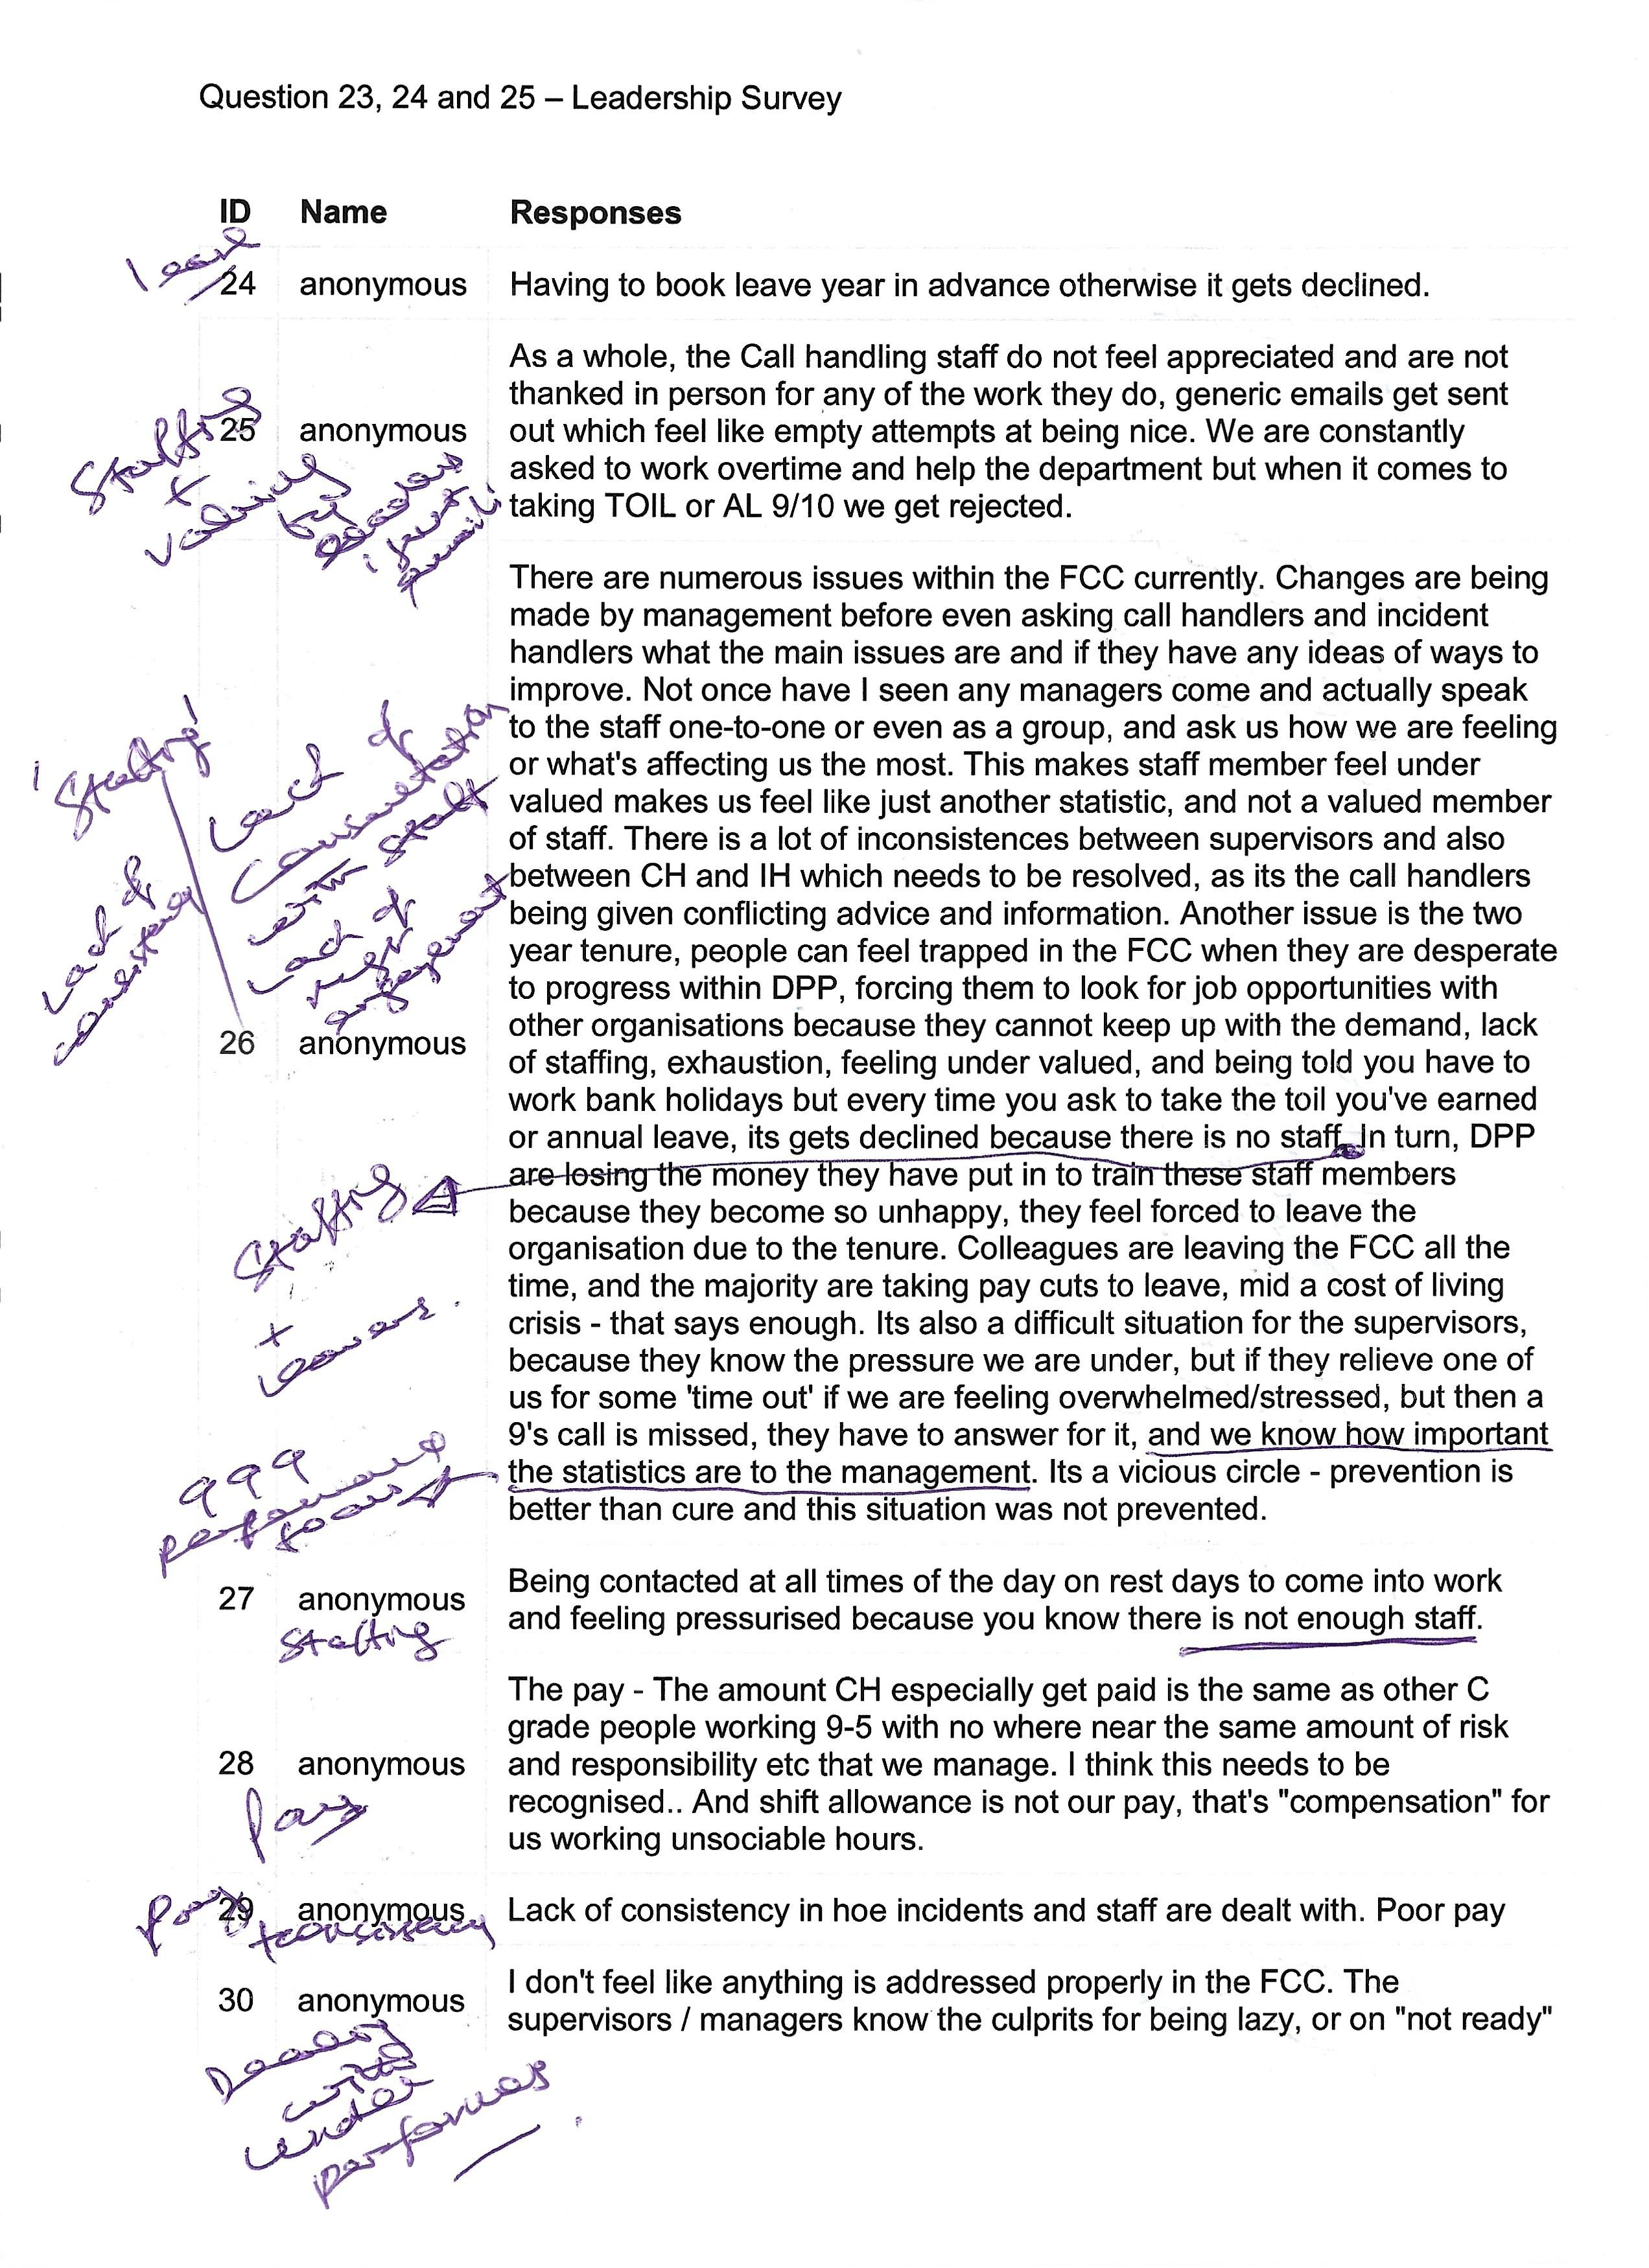

Appendix ‘R’

Workplace Observation

Incident Handling – Reference R12
Date: 3/11/22 Time: 19:25hrs – 21:00hrs

Profile: Inspector Force Incident Manager (FIM) (Male, very experienced Inspector with 5 years as a FIM), Incident Handling Supervisor (Male, extremely experienced Supervisor with 15 years’ service) with a team of 6 Incident Handlers (4 females and 2 males of varying experience ranging from 2 years to 14 years)
Summary of Observations:
- The layout of the floor sees the Supervisor and FIM sat elevated enabling a vantage point over the Incident Handlers sat at their console workstations, with four operating the radio dispatch and two acting as their buddies. The buddy role involves making calls to other agencies and police forces, undertaking additional intelligence checks as necessary to supplement or develop the information already contained on the command and control incident log which has been transferred across form the Call Handling Section upon answering either a 999 or 101 call for service. The radio dispatchers cover the four primary radio channels assigned to the four counties within the Force Area, these being Carmarthenshire, Pembrokeshire, Ceredigion and Powys, known as policing divisions.

- Whilst sat observing it is clearly noticeable that the Incident Handlers are allowed to get on with their roles and varying incidents that they are processing for the respective divisions on their respective radio channels. There is little Supervisor or FIM engagement other than when an Incident Handler asks a question, this either being on a point of law which the FIM (Police Inspector) answers, or a question relating to information about the incident which the Supervisor answers or calls the Call Handling Supervisor to establish. I observed the Incident Handling Supervisor leaving his chair and visiting the Call Handling Supervisor to listen to a call which involved a dropped 999 (where the caller has dropped the line and disengaged). The Incident Handling Supervisor returned with the necessary information and provided direction to the Incident Handler that the incident could now be downgraded from an immediate to a priority response, this reflecting the nature of the threat, risk and harm understood from the actual call recording itself. This was a good example of the Supervisor adopting a Transformational – situational style of leadership. Once the information was passed over to the Incident Handler, the style reverted back to transformational with empowerment being given to the staff to get on with their incidents and role.

- There was a clear transformational style and environment seen and felt. This changed very quickly when a firearms incident call was received by a Call Handler and transferred across to Incident Handling for immediate dispatch. I saw that the transformational style quickly be replaced with a transactional – autocratic and directive style whereby the FIM and Supervisor were giving a series of directions (orders) to the Incident Handlers. Examples of what I heard at the time being:

“Tell the ARV firearms units to make their way and await a briefing from the FIM. Get TAC Ad on the phone, make sure that we get a dog to make their way. Get a negotiator to be on stand-by. Go onto separate channel – the firearms channel. Patch the primary channels so that we have a spare Incident Handler. Give me more information on the subject. Get the Call Handler to ask what size the knife is. What clothing the subject is wearing – what’s his description and which way did he head off towards. Who is the evening Silver and Strategic Firearms Commander?”.

- The above sentences (directions) were quickly uttered and the Supervisor and Incident Handlers assigned to the incident were totally focused on the incident.

- An atmosphere of seriousness occupied the room

- I then observed at this time another call and incident being transferred across to from the Call Handling Section into the Incident Handling Room. This related to a report of an eight-car pile-up on an arterial route with little information understood as to whether there were any casualties. This created the tempo to raise even higher with the Supervisor taking overall command of that incident allowing the FIM to focus on the firearms incident that was being managed. I overserved a real good sense of team work throughout this period observation.

- I could clearly see that the transactional style of leadership was now the predominant one for both incidents being managed. Directions were shouted across the floor for the Incident Handler to action, and this became very intense when until there came notification that there were no serious injuries, only minor ones involved in the road traffic collision. The temp lowered significantly at that time. The incident was then allowed to be overseen by the Incident Handler and the Supervisor returned back to the firearms incident to support the FIM. I saw the transfer from transactional back to transformational leadership take place which was directly linked to the threat, risk and harm assessment involved with the incident and the lower threat now presented.

- I observed the FIM to make dynamic decisions based on threat, risk and harm which involved him authorising the use of firearms, with ARVs being deployed to the incident being managed. The FIM instructed that other specialist resources were deployed which the Supervisor and Incident Handlers actioned. This was very transactional – directive and autocratic. On occasions, the FIM immediately sought for further information to enable him to make the dynamic decision he needed to make. This was a serious incident and the staff recognised that they needed to quickly react to what the FIM wanted. The predominant style observed at this point in time was transactional – autocratic and directive.

- I observed the FIM quickly stand-up the Command Structure recording this on the command and control incident log. It was clear that he was following protocol and in so doing was transactional in nature.

- The transactional style continued for the entire duration of the firearms incident, which remained in place until the arrest of the subject armed with the knife. This lasted for over an hour and immediately thereafter, the tempo lowered and the leadership style reverted back to that of transformational, with the FIM and Supervisor allowing their staff to get on with their jobs and only engaging if they needed to in a situational leadership intervention.

- It was observed that meal breaks were managed with one being ff the floor at any one time, however, breaks were delayed over the period that the firearms and road traffic collision incident ere being managed. The arrangements around meal breaks were very flexible and Incident Handlers took it in turn to make a tea and coffee, using a trolley to assist in this regard. This was in direct contrast to that seen in Call Handling where the breaks were strictly overseen and no tea or coffee was brought back to the desk. The flexibility in this working arrangement within Incident Handling further exemplifies the transformational setting encouraged between staff.

Appendix ‘S’

Workplace Observation

Call Handling – Reference R11
Date: 3/11/22 Time: 17:20hrs – 19:21hrs

Profile: Call Handling Supervisor (Female with 1 years’ service) with a team of 5 Call handlers (3 females and 2 males of varying experience ranging from 3 years to 12 years)
Summary of Observations:
- Supervisor shows me the break schedules which are allocated to the staff and overseen on a spreadsheet – this showing staggered breaks with little overlap so as to maximise coverage on the floor.

- A strong transactional style observed seen through a series of directions given to the Call Handlers to swap from switchboard Option 2 and 4 101 calls onto the higher threat, risk and harm Option 1 calls.

- The supervisor was seen to call out the Call Handler’s name and give a direct request to cover the 999 line or pick-up on the queuing 999 or 101 call. Other Call Handlers were then given directions to swap lines to backfill the 101 or 999 lines if such a call had been picked-up. This always ensured that any queuing 999 or 101 Option 1was capable of being answered.

- The supervisor was seen to constantly monitor the 999/101 and switchboard monitor for queuing calls so as to ensure a quick speed of pick-up in ensuring good performance on the average speed of answer key performance indicators (KPIs). There was a very keen eye on the Welsh calls and if no Call Handler was available to pick-up the call the supervisor was seen to call the Incident Handling Supervisor and request for assistance from a Welsh speaking Incident Handler, if one was available.

- A strong directive style was observed throughout the 2-hour workplace observation.

- The supervisor was seen to be very focused in monitoring the average speed of answer for 999 and 101 Option 1 calls. A strong emphasis was passed across to the Call Handlers on this. On many an occasion, when calling out to the Call Handler, so that they could hear the supervisor, the response came back as “Yes, I’ve done it”. This did suggest that the staff knew what to do. (Transactional – directive/autocratic style when perhaps a transformational style may be needed on occasions).

- Further observations showed that staff were directed to immediately react to the direction given to cover telephony lines and pick-up on queuing calls.

- The lay-out of the floor with the elevated Supervisor’s desk allowed for a good vantage point on what the staff were doing and then allowing this to be triangulated against any queuing calls and the command and control incident log which they completed during the call. From both of these perspectives, the Supervisor took the decision to select the next Call Handler to pick-up any incoming call i.e. a serious incident being reported with the necessary information being recorded on the incident log allowing the Supervisor to leave that staff member alone in favour of choosing one less engaged. This worked well, however further added to the pressures experienced by the Supervisor

- It was noted that the Supervisor did not stop throughout the period of my observations, which I commented upon saying “You must be shattered when you go home”, to which she replied “Definitely, but I’ve got four rest days coming up now when I finish. I’m working tomorrow as a Call Handler as we’re so short so that’s the first of my rest days gone”. This re-emphasised the staffing predicament within the Call Handling Section with a Supervisor who should now be going on rest days working her first day to help out, which would not otherwise have provided a complement of staff capable of meeting the high demand faced on a daily basis with over 1,300 calls handled.

- I asked the Supervisor whether she had the opportunity to be more transformational to which she replied “No, I’d like to be as I am transformational, and used to be in my previous job working with the bank. This is the nature of this role though. You have to closely watch the boards as if we don’t we’ll miss some and abandon some 999s and 101s. Our call queues and average speed of answer time will show in our stats”.

- I asked when the Supervisor was transformational in the workplace and she said “I am very transformational when I’m on my admin days, which are the two days in the middle of the set of 6. My team are working and another Supervisor takes the floor with them. I sit on the floor and do admin. This is when I am fully transformational and have developed a staff development tool on One Note. I spend time doing 1-1s with my team and develop them this way. I also listen to calls, both live time and those already taken, and quality assure them, scoring them. I use this as feedback for my 1-1s. I circulate examples of good calls and good practice to the team via One Note”.

- One Note shown to me by the Call Handling Supervisor which was very impressive. I explain that this is an excellent example of a transformational style of leadership – that it is more supportive, facilitative and participative as a leadership style, which is in direct contrast to that of transactional – autocratic and directive as observed on the floor in my observations. The Supervisor explained that she couldn’t be like that when on the desk as the Supervisor as it didn’t allow for this - the demand was too high, the staffing too low and the performance stats meant that the supervisor needed to make sure that those calls were answered as quickly as possible. She said “For the 9s it’s the right thing to do as there’s someone waiting on the other end who could be in urgent need of assistance”.
- End of workplace observations with the acknowledgment that the Supervisor observed was going to take part in the Semi-structured Interview the next day.

Appendix ‘T’
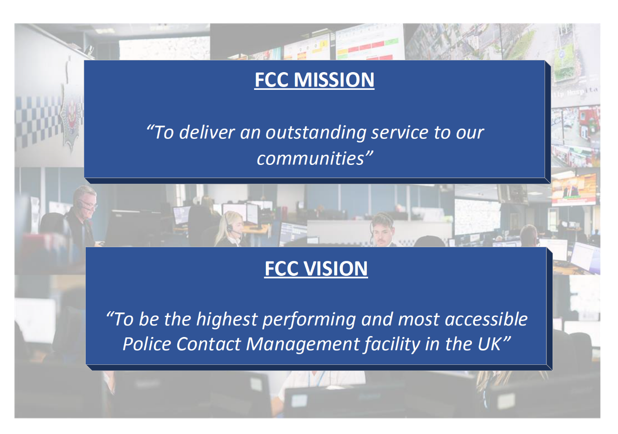

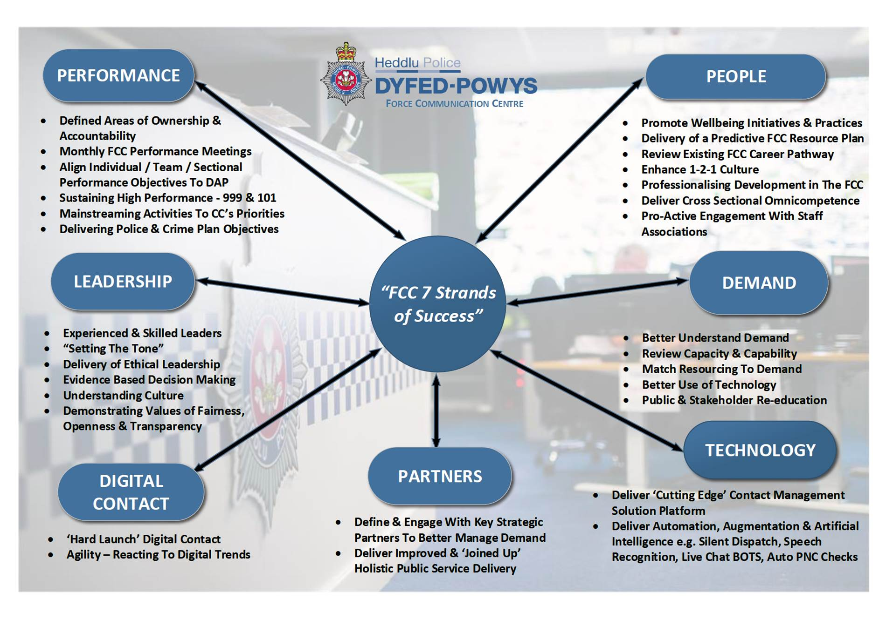
Appendix ‘U’

Transactional Call Handling Supervisor 999 Performance Data

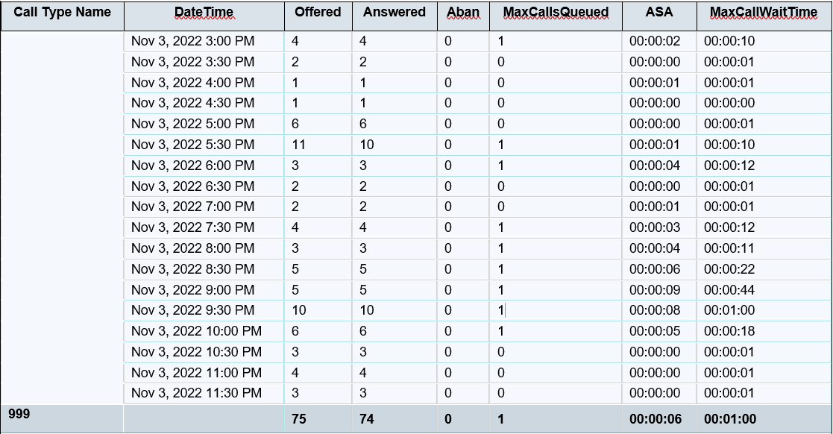

Appendix ‘V’

Transformational Call Handling Supervisor 999 Performance Data

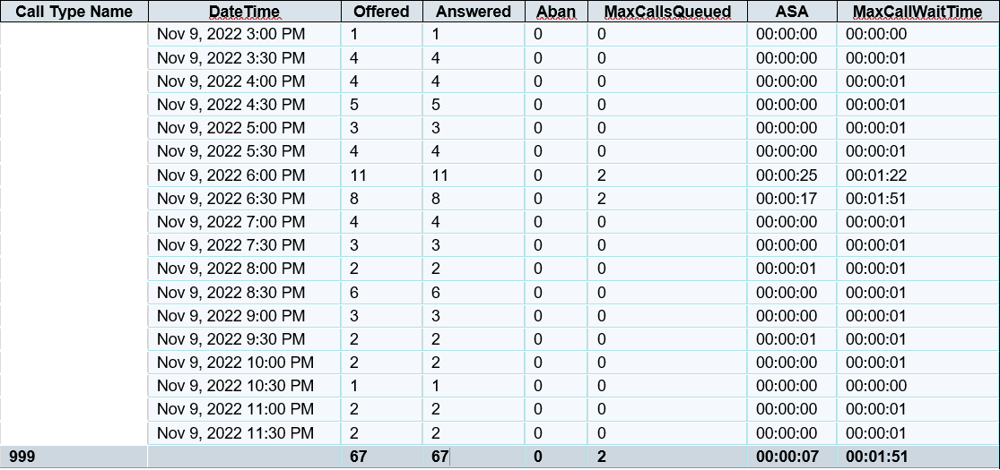

Appendix ‘W’

Transactional Call Handling Supervisor 101 Performance Data

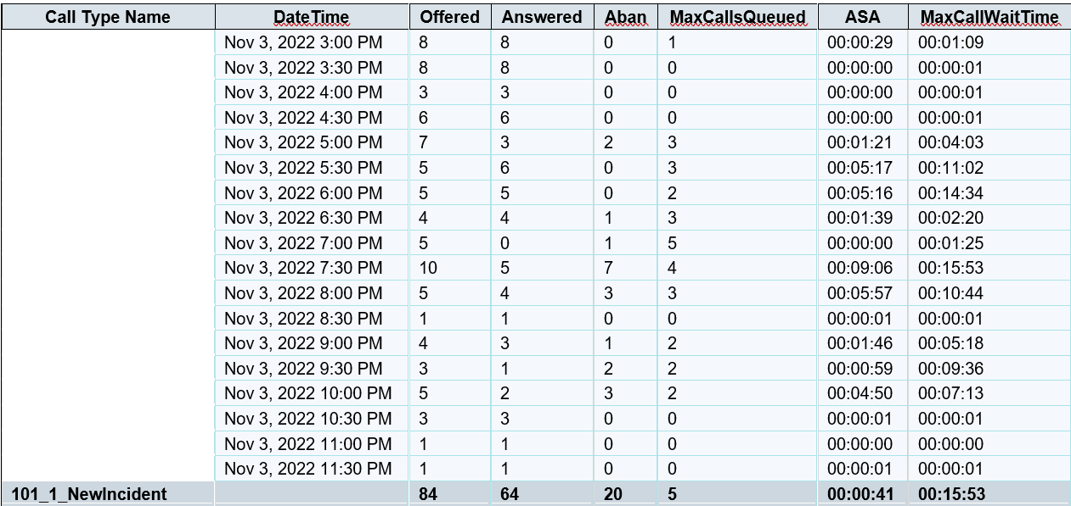

Appendix ‘X’

Transformational Call Handling Supervisor 101 Performance Data

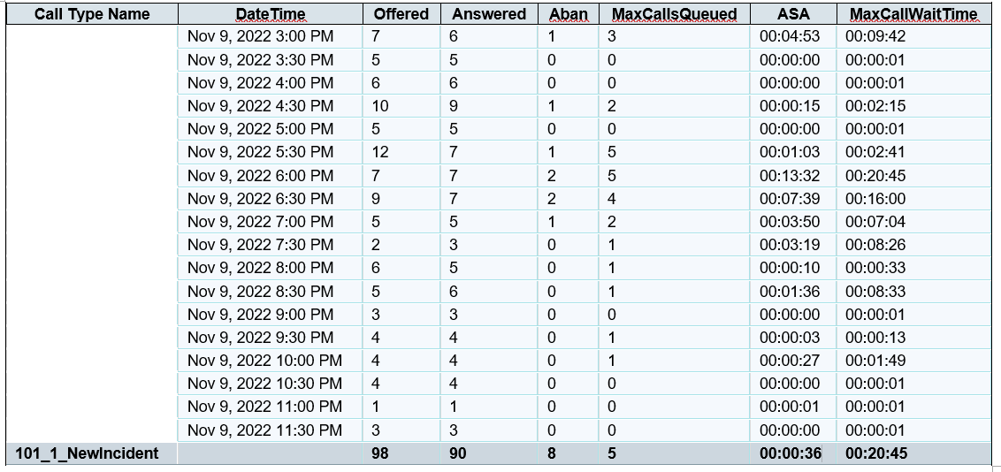

Appendix ‘Y’

APPLICATION FOR ETHICAL APPROVAL

In order for research to result in benefit and minimise risk of harm, it must be conducted ethically. A researcher may not be covered by the University’s insurance if ethical approval has not been obtained prior to commencement.

The University follows the OECD Frascati manual definition of research activity: “creative work undertaken on a systematic basis in order to increase the stock of knowledge, including knowledge of man, culture and society, and the use of this stock of knowledge to devise new applications”. As such this covers activities undertaken by members of staff, postgraduate research students, and both taught postgraduate and undergraduate students working on dissertations/projects.

The individual undertaking the research activity is known as the “principal researcher”.

Ethical approval is not required for routine audits, performance reviews, quality assurance studies, testing within normal educational requirements, and literary or artistic criticism.

Please read the notes for guidance before completing ALL sections of the form.

This form must be completed and approved prior to undertaking any research activity. Please see Checklist for details of process for different categories of application.

Delete the Guidance Notes at the end of the form BEFORE submitting your application

SECTION A: About You (Principal Researcher)
Full Name: |  | Peter Wyn Roderick
Tick all boxes which apply: |  | Member of staff: | ☐ | Honorary research fellow: | ☐
Undergraduate Student | ☐ | Taught Postgraduate Student | ☒ | Postgraduate Research Student | ☐

Institute/Academic Discipline/Centre: | University of Wales Trinity Saint David
Campus: | Swansea Institute of Management
E-mail address: | 2115598@student.uwtsd.ac.uk
Contact Telephone Number: | 07852 573531
For students:
Student Number: | 2115598
Programme of Study: | MA18 Criminal Justice and Policing
Director of Studies/Supervisor: | Jane Thomas / Luke Roach

SECTION B: Approval for Research Activity
Has the research activity received approval in principle?  (please check the Guidance Notes as to the appropriate approval process for different levels of research by different categories of individual) |  | YES | ☒ | NO | ☐
 |  |  |  | Date
If Yes, please indicate source of approval (and date where known): Approval in principle must be obtained from the relevant source prior to seeking ethical approval | Research Degrees Committee |  | ☐
 | Institute Research Committee |  | ☒ | 27/6/2022
 | Other (write in) |  | ☐

SECTION C: Internal and External Ethical Guidance Materials
Please list the core ethical guidance documents that have been referred to during the completion of this form (including any discipline-specific codes of research ethics, and also any specific ethical guidance relating to the proposed methodology). Please tick to confirm that your research proposal adheres to these codes and guidelines.
UWTSD Research Ethics & Integrity Code of Practice | ☒
UWTSD Research Data Management Policy | ☒
Dyfed-Powys Police Professional Standards of Behaviour | ☒

SECTION D: External Collaborative Research Activity
Does the research activity involve collaborators outside of the University? |  | YES | ☒ | NO | ☐
If Yes, please provide the name of the external organisation and name and contact details for the main contact person and confirmation this person has consented to their personal data being shared.as part of this collaboration.
Institution | Force Communication Centre, Dyfed-Powys Police
Contact person name | Mr Gareth Scanlon (Head of Department)
Contact person e-mail address | gareth.scanlon@Dyfed-Powys.police.uk
Has this individual consented to sharing their details on this form? |  | YES | ☒ | NO |  |  | ☐
Are you in receipt of a KESS scholarship? |  | YES | ☐ | NO |  |  | ☒
Is your research externally funded |  | YES | ☒ | NO |  |  | ☐
Are you specifically employed to undertake this research in either a paid or voluntary capacity? | Voluntary | YES | ☒ | NO |  | ☐
 | Employed | YES | ☐ | NO |  | ☒
Is the research being undertaken within an existing UWTSD Athrofa Professional Learning Partnership (APLP) | If YES then the permission question below does not need to be answered. | YES | ☐ | NO |  |  | ☒
Permission to undertake the research has been provided by the partner organisation | (If YES attach copy)  If NO the application cannot continue | YES | ☒ | NO |  |  | ☐

Where research activity is carried out in collaboration with an external organisation
Does this organisation have its own ethics approval system? | YES | ☒ | NO | ☐
If Yes, please attach a copy of any final approval (or interim approval) from the organisation

SECTION E: Details of Research Activity
Indicative title: | A Comparative Study of Police Leadership Styles and their Impact on Performance Levels within an Emergency Contact and Incident Management Centre – Case Study: Dyfed-Powys Police.
Proposed start date: | 24th June 2022 | Proposed end date: | 24th October 2022
Introduction to the Research (maximum 300 words)
Ensure that you write for a Non-Specialist Audience when outlining your response to the three points below:
- Purpose of Research Activity
- Proposed Research Question
- Aims of Research Activity
- Objectives of Research Activity
Demonstrate, briefly, how Existing Research has informed the proposed activity and explain
- What the research activity will add to the body of knowledge
- How it addresses an area of importance.
Purpose of Research Activity

This comparative study will analyse how different leadership styles have a particular bearing on performance results within a police emergency contact and incident management centre. It will explore existing management approaches within leadership teams in operation within the highly pressurised facility and will critically look at how certain leadership styles have a greater or lesser impact on the organisation’s ability to competitively perform on the national stage.
The dissertation will also pose the question as to whether senior leaders have a preferred style of leadership, and correlate this to performance levels experienced in such blue light environments, acknowledging the high threat, risk and harm calls processed by staff and overseen by their supervisors and managers.
Demonstrate, briefly, how Existing Research has informed the proposed activity and explain
- What the research activity will add to the body of knowledge
How it addresses an area of importance.
(this box should expand as you type)
Research Question

A Study of the Impact of Different Leadership Styles on Performance Delivery in a Police Control Room, acknowledging capacity and capability factors that may influence the relationship - Case Study Dyfed-Powys Police.

(this box should expand as you type)
Aims of Research Activity

The overall aim of this research is to explore, analyse and evaluate leadership styles that predominantly exist within emergency contact and incident room setting, and understand what emphasis senior leaders place on its relationship to the expected performance levels being achieved, especially when comparing their own standards to other top performing blue light establishments.
It is expected that the findings will be presented to the Head of Department for the Force Communications Centre (where the case study location is situated) and the Head of Uniform Policing for Dyfed-Powys Police, these having direct line management responsibility for this area of policing. The study’s findings will be discussed in a presentation style format and feedback generated as a result of the recommendations made.
(this box should expand as you type)
Objectives of Research Activity

Objective 1: Establish what type and level of leadership training managers and team leaders have received that whether this has equipped them sufficiently for their role within performance management.
Objective 2: Establish which leadership style managers and supervisors prefer using in managing performance within the emergency contact and incident centre setting and how this is perceived to enhance actual performance.
Objective 3: Investigate the relationship between any predominate leadership styles discovered within the emergency contact and incident handling centre and its impact on staff and performance levels.
Objective 4: Identify the extent of any capability and capacity issues that exist, and their consequent impact on actual performance levels and responses to leadership styles.
Objective 5: Explore any adjustments or improvements discovered that could be adopted by the Senior Leadership Team in the ongoing development of their leadership teams, specifically focused towards enhancing performance management.
(this box should expand as you type)
Proposed methods (maximum 600 words)
Provide a brief summary of all the methods that may be used in the research activity, making it clear what specific techniques may be used. If methods other than those listed in this section are deemed appropriate later, additional ethical approval for those methods will be needed.
The researcher will utilise a survey questionnaire as part of the research strategy, along with a structured observation phase. Structured interviews, where the same question is asked of those interviewed, will also feature as part of the study. This will enable the researcher the opportunity to collect data for both quantitative and qualitative analysis and will allow for likely explanations to be proposed for specific relationships amongst variables (Saunders et al., 2016).
The research group will be based within the police control room and will consist of call handlers and incident handlers, their supervisors and managers, along with the training staff, CCTV operators and members of the senior leadership team, including the Head of Department and senior police leaders with direct line management, or stakeholder association with the police control room. The target response rate will be 86 staff members.
Whereas the target group will consist of 86 staff based within the police control room (with three senior leaders based outside of the case study location), data collection techniques will be broken into the following activities:
Role within Police Control Room – Case Study | Data Collection Technique | Number within Sample Group
Call Handlers and Digital Desk (999 and 101) | Questionnaire and Workplace Observation | 30
Incident Handler (999 /101 / Dispatch via Radios | Questionnaire and Workplace Observation | 30
CCTV Operators | Questionnaire | 4
Call Handling Supervisors | Questionnaire and Semi-structured interview and workplace observation | 7
Incident Handling Supervisors | Questionnaire and Semi-structured interview and workplace observation | 7
CCTV Supervisor | Questionnaire and Semi-structured interview | 1
Trainer | Questionnaire and Semi-structured interview | 1
Operations Managers and Force Incident Managers (FIMs – Police Inspectors) | Questionnaire and Semi-structured interview | 2 and 6  (8)
Senior Leadership Team | Questionnaire and Semi-structured interview | 2
Police Senior Leaders with Line Management Responsibility for Police Control Room (including Direct Stakeholder Association with Police Control Room) | Questionnaire and Semi-structured interview | 3
Total |  | 92

The research activity will take place as outlined in the Gantt Chart – as seen on Appendix A to the Draft Research Proposal (27th June 2022).

(this box should expand as you type)

Location of research activity
Identify all locations where research activity will take place.
The Police Contact Management and Incident Handling Centre, based within the Force Communications Centre of the Dyfed-Powys Police, also known as the ‘police control room’, as referred to in the research proposal. This is situated in the Police Headquarters, Llangunnor, Carmarthen, Carmarthenshire.

(this box should expand as you type)
Research activity outside of the UK
If research activity will take place overseas, you are responsible for ensuring that local ethical considerations are complied with and that the relevant permissions are sought. Specify any local guidelines (e.g. from local professional associations/learned societies/universities) that exist and whether these involve any ethical stipulations beyond those usual in the UK (provide details of any licenses or permissions required). Also specify whether there are any specific ethical issues raised by the local context in which the research activity is taking place, for example, particular cultural and/or legal sensitivities or vulnerabilities of participants.
No research activity outside of the UK will form part of this research study.

(this box should expand as you type)
Use of documentation not in the public domain: Are any documents NOT publicly available? |  | NO | ☐
 |  | YES | ☒
If Yes, please provide details here of how you will gain access to specific documentation that is not in the public domain and that this is in accordance with prevailing data protection law of the country in question and England and Wales.

Documentation accessed which is not in the public domain will be accessed through consent provided by the Head of Department of the Force Communications Centre, Dyfed-Powys Police.

(this box should expand as you type)

SECTION F: Scope of Research Activity
Will the research activity include: | YES | NO
Use of a questionnaire or similar research instrument? | ☒ | ☐
Use of interviews? | ☒ | ☐
Use of diaries? | ☒ | ☐
Participant observation with their knowledge? | ☒ | ☐
Participant observation without their knowledge? | ☐ | ☒
Use of video or audio recording? | ☐ | ☒
Access to personal or confidential information without the participants’ specific consent? | ☐ | ☒
Administration of any questions, test stimuli, presentation that may be experienced as physically, mentally or emotionally harmful / offensive? | ☐ | ☒
Performance of any acts which may cause embarrassment or affect self-esteem? | ☐ | ☒
Investigation of participants involved in illegal activities? | ☐ | ☒
Use of procedures that involve deception? | ☐ | ☒
Administration of any substance, agent or placebo? | ☐ | ☒
Working with live vertebrate animals? | ☐ | ☒
Other primary data collection methods, please explain in this box  For example, ‘focus groups’. Please indicate the type of data collection method(s) in this box and tick the accompany box. | ☒ | ☐
Details of any other primary data collection method:  As detailed on the Proposed Methods section of the Ethical Approval Form.  (this box should expand as you type) | ☒ | ☐
If NO to every question, then the research activity is (ethically) low risk and may be exempt from some of the following sections (please refer to Guidance Notes).

If YES to any question, then no research activity should be undertaken until full ethical approval has been obtained.

SECTION G: Intended Participants
Who are the intended participants: | YES | NO
Students or staff at the University? | ☐ | ☒
Adults (over the age of 18 and competent to give consent)? | ☒ | ☐
Vulnerable adults? | ☐ | ☒
Children and Young People under the age of 18? (Consent from Parent, Carer or Guardian will be required) | ☐ | ☒
Prisoners? | ☐ | ☒
Young offenders? | ☐ | ☒
Those who could be considered to have a particularly dependent relationship with the investigator or a gatekeeper? | ☐ | ☒
People engaged in illegal activities? | ☐ | ☒
Others (please identify specifically any group who may be unable to give consent) please indicate here and tick the appropriate box. | ☒ | ☐
Other – please indicate here:  Staff, supervisors, managers and senior leaders in the Force Communications Centre and Uniform Policing  (this box should expand as you type) | ☒ | ☐

Participant numbers and source
Provide an estimate of the expected number of participants. How will you identify participants and how will they be recruited?
How many participants are expected? | 92  (this box should expand as you type)
Who will the participants be? | Existing employees of the Force Communication Centre – Police Control Room, as follows:  Call Handlers (Police Staff)  Incident Handlers (Police Staff)  CCTV Operators (Police Staff)  Call Handling Supervisors (Police Staff)  Incident Handling Supervisors (Police Staff)  Trainer (Police Staff)  Force Incident Managers (Police Inspectors)  Operations Managers (Police Staff)  Head of Department (Police Staff)  Chief Superintendent Head of Uniform  (this box should expand as you type)
How will you identify the participants? | Participants will be identified form existing from the main representative teams of Call and Incident Handers, CCTV operators, supervisors, managers and senior leaders in the Force Communications Centre (FCC) and Uniform Policing Senior Leaders with line management responsibility for the FCC.  (this box should expand as you type)

Information for participants: | YES | NO | N/A
Will you describe the main research procedures to participants in advance, so that they are informed about what to expect? | ☒ | ☐ | ☐
Will you tell participants that their participation is voluntary? | ☒ | ☐ | ☐
Will you obtain written consent for participation? | ☒ | ☐ | ☐
Will you explain to participants that refusal to participate in the research will not affect their treatment or education (if relevant)? | ☒ | ☐ | ☐
If the research is observational, will you ask participants for their consent to being observed? | ☒ | ☐ | ☐
Will you tell participants that they may withdraw from the research at any time and for any reason? | ☒ | ☐ | ☐
With questionnaires, will you give participants the option of omitting questions they do not want to answer? | ☒ | ☐ | ☐
Will you tell participants that their data will be treated with full confidentiality and that, if published, it will not be identifiable as theirs? | ☒ | ☐ | ☐
Will you debrief participants at the end of their participation, in a way appropriate to the type of research undertaken? | ☒ | ☐ | ☐
If NO to any of above questions, please give an explanation
(this box should expand as you type)

Information for participants: | YES | NO | N/A
Will participants be paid? | ☐ | ☒ | ☐
Is specialist electrical or other equipment to be used with participants? | ☐ | ☒ | ☐
Are there any financial or other interests to the investigator or University arising from this study? | ☐ | ☒ | ☐
Will the research activity involve deliberately misleading participants in any way, or the partial or full concealment of the specific study aims? | ☐ | ☒ | ☐
If YES to any question, please provide full details
(this box should expand as you type)

SECTION H: Anticipated Risks

Outline any anticipated risks that may adversely affect any of the participants, the researchers and/or the University, and the steps that will be taken to address them.

If you have completed a full risk assessment (for example as required by a laboratory, or external research collaborator) you may append that to this form.
Full risk assessment completed and appended? |  | Yes | ☐
 |  | No | ☒
Risks to participants
For example: emotional distress, financial disclosure, physical harm, transfer of personal data, sensitive organisational information
Risk to Participant:  - The research study may unearth oppressive leadership which may constitute bullying. This may cause emotional distress.  - The identity of participants who disclose issues that describe poor leadership practices may consider vulnerable should their data be identified.  - The organisation may be vulnerable to the research study findings being distributed outside of their business area or even into the public domain.  (this box should expand as you type) | How will you mitigate the Risk to Participant  - Should any oppressive leadership styles be discovered, these will be reported to the Senior Management Team at the earliest point for internal management via their Fairness At Work Policy (covering grievances in the workplace). Respective staff associations will be made aware.  - Should any practices describe weak or poor leadership styles, which is considered harmful to the staff, this will be reported to the Senior Management Team at its earliest point. Should leadership styles as found within the study not present harm to staff, this will be captured a part of the qualitative research and findings along with recommendations based on their impact as part of the research aim and objectives.  - The research report and any associated documents will be securely stored and not transmitted outside of the control group setting i.e. the case study setting, its Senior Management Team and the University Tutors directly supervising the research study.  (this box should expand as you type)
If research activity may include sensitive, embarrassing or upsetting topics (e.g. sexual activity, drug use) or issues likely to disclose information requiring further action (e.g. criminal activity), give details of the procedures to deal with these issues, including any support/advice (e.g. helpline numbers) to be offered to participants. Note that where applicable, consent procedures should make it clear that if something potentially or actually illegal is discovered in the course of a project, it may need to be disclosed to the proper authorities
Participants will be informed through a focused briefing that prior to engaging in the study, given the nature of the research, that any leadership behaviour discovered that potentially breaches the professional standards of behaviour for Police Officers and Police Staff Members, will be reported to the Senior Management Team. Poor practices that are identified that do not threaten or harm staff will be captured anonymously as part of the research study and will feature in the findings and recommendations as outlined in the aims and objectives of the study. Participants who have experienced emotional distress and who recall this as part of their engagement in the research will be afforded support from trained personnel who work in the Occupational Health Unit.

(this box should expand as you type)
Risks to investigator
For example: personal safety, physical harm, emotional distress, risk of accusation of harm/impropriety, conflict of interest
Risk to Investigator:  The Researcher is a newly appointed member of the Senior Management Team within the Force Communication Centre at Dyfed-Powys Police, this being the location of the case study.  This raises potential concerns regarding a possible conflict of interest in the ability of the researcher to present actual raw findings that emerge should they challenge the existing status quo and apportion a degree of criticism levied at the existing Senior Management Team.  (this box should expand as you type) | How will you mitigate the Risk to Investigator:  The issue of a conflict of interest that may exist between the researcher, research study and the potential lack of independence perceived has been discussed with the Head of Department who is satisfied that this will be mitigated by factors that will be in existence throughout the research period.  It is felt that given the recency of the appointment of the researcher as the Deputy Head of the Department, this being a matter of weeks, coupled to the fact that the researcher is unfamiliar with the majority of staff who will form part of the participating research population, that a high degree of independence will actually exist. It is also felt that the high level of ethical standards evident within the researcher, this demonstrated within a previous career with the same police force where a senior rank was attained, provides an additional level of protection from any potential conflict of interest perceived from split loyalties in reporting actual findings that emerge from the study.  The participants will be provided with an explanation as to how any perceived conflict of interest will be mitigated, thereby allowing for factual findings to be presented in their totality.  (this box should expand as you type)
University/institutional risks
For example: adverse publicity, financial loss, data protection
Risk to University:  The storage of primary data and research findings relating to a police force, which if disclosed, either accidentally, purposefully of through an illegal act, could damage the reputation of the organisation.  (this box should expand as you type) | How will you mitigate the Risk to University:  Storage of data will accord with the stringent security protocols of the university and its research policies, which mitigates the likelihood of this risk occurring. The risk therefore is assessed as low.  (this box should expand as you type)

Disclosure and Barring Service
If the research activity involves children or vulnerable adults, a Disclosure and Barring Service (DBS) certificate must be obtained before any contact with such participants. | YES | NO | N/A
Does your research require you to hold a current DBS Certificate? | ☐ | ☒ | ☐

SECTION I: Feedback, Consent and Confidentiality
Feedback
What de-briefing and feedback will be provided to participants, how will this be done and when?
A presentation will be created to brief participants and leaders within the Force Communication Centre (FCC) as to the findings of the research. This will be coordinated to ensure that the entire research population receives the emerging findings, and along with the Senior Leadership Team, the next steps will be discussed to embed the accepted recommendations.

(this box should expand as you type)
Informed consent
Describe the arrangements to inform potential participants, before providing consent, of what is involved in participating. Describe the arrangements for participants to provide full consent before data collection begins. If gaining consent in this way is inappropriate, explain how consent will be obtained and recorded in accordance with prevailing data protection legislation.
The participants will receive correspondence outlining the full nature of the research study, and their expected participation as members of staff will be communicated to them. Albeit participation will be voluntary, an expectation will exist for staff to actively contribute towards further developing the leadership capability of the teams that operate within the Force Communication Centre. An informative presentation will be delivered by the researcher at team briefings prior to the commencement of the research study and those identified as participating members in the questionnaires, interviews and workplace observations will be provided with an explanatory email outlining the purpose of the activities featuring as part of the study. At this stage, the researcher will seek their consent and explain the intended purpose of their engagement. Any concerns will be dealt with at that point and captured as part of the study. Matters that relate to organisational concerns will be fed-back to the relevant Senior Leadership Team for due process.

(this box should expand as you type)
Confidentiality / Anonymity
Set out how anonymity of participants and confidentiality will be ensured in any outputs. If anonymity is not being offered, explain why this is the case.
Participants will be afforded anonymity in their responses to the questionnaires, however, the interviews will be undertaken with all supervisors and managers within the study sample. Names will not be recorded and dates/times of responses not included or published, this therefore not allowing any retrospective scrutiny of duty rotas to be made in search of the identification of authors for specific commentary captured by the researcher.

(this box should expand as you type)

SECTION J: Data Protection and Storage
In completing this section refer to the University’s Research Data Management Policy and the extensive resources on the University’s Research Data Management web pages (http://uwtsd.ac.uk/library/research-data-management/).
Does the research activity involve personal data (as defined by the General Data Protection Regulation 2016 “GDPR” and the Data Protection Act 2018 “DPA”)? | YES | NO
“Personal data” means any information relating to an identified or identifiable natural person (‘data subject’). An identifiable natural person is one who can be identified, directly or indirectly, in particular by reference to an identifier such as a name, an identification number, location data, an online identifier or to one or more factors specific to the physical, physiological, genetic, mental, economic, cultural or social identity of that natural person. | - ☐ | ☐
If YES, provide a description of the data and explain why this data needs to be collected:
The data will be in the form of a written response from staff member working in the Force Communication Centre (FCC). Whereas names will not be included in the research of the study, roles will ned to be included so as to differentiate and understand the context of leadership and its effect on staff. This will delve down to team level as the leadership styles will differ in each team within the FCC. So as to understand what works best as regards to the preferred style adopted by a team and its performance return, roles and component team identifiers i.e. years in role, experience levels, skill levels etc. within teams and supervisors/managers alike, will be very necessary characteristics to capture, understand an analyse as part of the study’s investigation and findings.

(this box should expand as you type)
Does it involve special category data (as defined by the GDPR)? | YES | NO
“Special category data” means sensitive personal data consisting of information as to the data subjects’ –  (a) racial or ethnic origin,  (b) political opinions,  (c ) religious beliefs or other beliefs of a similar nature,  (d) membership of a trade union (within the meaning of the Trade Union and Labour Relations (Consolidation) Act 1992),  (e) physical or mental health or condition,  (f) sexual life,  (g) genetics,  (h) biometric data (as used for ID purposes), | ☐ | - ☐
If YES, provide a description of the special category data and explain why this data needs to be collected:
(this box should expand as you type)
Will the research activity involve storing personal data and/or special category data on one of the following: | YES | NO
Manual files (i.e. in paper form)? | ☐ | ☒
University computers? | ☐ | ☒
Private company computers? | ☐ | ☒
Home or other personal computers? | ☐ | ☒
Laptop computers/ CDs/ Portable disk-drives/ memory sticks? | ☒ | ☐
“Cloud” storage or websites? | ☐ | ☒
Other – specify: | ☐ | ☒
For all stored data, explain the measures in place to ensure the security of the data collected, data confidentiality, including details of password protection, encryption, anonymisation and pseudonymisation:
All data captured as part of the research study will be stored electronically on a secure laptop which will operate password protections at the set-up of the device (Windows), along with the

(this box should expand as you type)
All Data Storage
Will the research activity involve any of the following activities: | YES | NO
Electronic transfer of data in any form? | ☒ | ☐
Sharing of data with others at the University? | ☐ | ☒
Sharing of data with other organisations? | ☐ | ☒
Export of data outside the European Union or importing of data from outside the UK? | ☐ | ☒
Use of personal addresses, postcodes, faxes, emails or telephone numbers? | ☐ | ☒
Publication of data that might allow identification of individuals? | ☐ | ☒
Use of data management system? | ☐ | ☒
Data archiving? | ☐ | ☒
If YES to any question, please provide full details, explaining how this will be conducted in accordance with the GDPR and DPA (and/or any international equivalent):
Questionnaire data from members of staff will be transferred from the electronic document into the researches data spreadsheet for interpretation. The results from this will appear on the research findings section within the main dissertation body. Subject access controls will operate when accessing the data received from questionnaires, and the original documents will be stored until the dissertation is completed, assessed by the examining board and graded. At that stage, the documents will be destroyed from secure electronic storage.

(this box should expand as you type)
List all who will have access to the data generated by the research activity:
Only the researcher will have access to the generated data.

(this box should expand as you type)
List who will have control of, and act as custodian(s) for, data generated by the research activity:
The researcher.

(this box should expand as you type)
Give details of data storage arrangements, including security measures in place to protect the data, where data will be stored, how long for, and in what form. Will data be archived – if so how and if not why not.
The data will be stored on the researcher’s laptop and iCloud account. Security measures will involve the encrypted password to access the lap-top and log-in credentials, for which the information is only known by the researcher. The data collected will be stored for the duration of the research study and until the dissertation has been assessed and marked by the examining board. At that point, should there be no requirement for any further submissions to the dissertation, the data obtained within the study will be permanently deleted.

(this box should expand as you type)
Please indicate if your data will be stored in the UWTSD Research Data Repository (see https://researchdata.uwtsd.ac.uk/ ). If so please explain. (Most relevant to academic staff)
The data will not be stored on the UWTSD Research Data Repository.

(this box should expand as you type)
Confirm that you have read the UWTSD guidance on data management (see https://www.uwtsd.ac.uk/library/research-data-management/) | YES | ☒
 | NO | ☐
Confirm that you are aware that you need to keep all data until after your research has completed or the end of your funding | YES | ☒
 | NO | ☐

SECTION K: Declaration
The information which I have provided is correct and complete to the best of my knowledge. I have attempted to identify any risks and issues related to the research activity and acknowledge my obligations and the rights of the participants.

In submitting this application I hereby confirm that I undertake to ensure that the above named research activity will meet the University’s Research Ethics and Integrity Code of Practice which is published on the website: https://www.uwtsd.ac.uk/research/research-ethics/
Signature of applicant: | PW. Roderick | Date: 27.06.2022

For STUDENT Submissions:
Director of Studies/Supervisor: |  | Date:
Signature: |  | Date:

For STAFF Submissions:
Academic Director/ Assistant Dean: |  | Date:
Signature: |  | Date:

Checklist: Please complete the checklist below to ensure that you have completed the form according to the guidelines and attached any required documentation:
☒ | I have read the guidance notes supplied before completing the form.
☒ | I have completed ALL RELEVANT sections of the form in full.
☒ | I confirm that the research activity has received approval in principle
☒ | I have attached a copy of final/interim approval from external organisation (where appropriate)
☐ | I have attached a full risk assessment (and have NOT completed Section H of this form) (where appropriate) ONLY TICK IF YOU HAVE ATTACHED A FULL RISK ASSESSMENT
☒ | I understand that it is my responsibility to ensure that the above named research activity will meet the University’s Research Ethics and Integrity Code of Practice.
☒ | I understand that before commencing data collection all documents aimed at respondents (including information sheets, consent forms, questionnaires, interview schedules etc.) must be confirmed by the DoS/Supervisor, module tutor or Academic Director.
☒ | I have deleted the guidance notes before submitting the PG2 for consideration

RESEARCH STUDENTS AND STAFF ONLY
All communications relating to this application during its processing must be in writing and emailed to pgresearch@uwtsd.ac.uk , with the title ‘Ethical Approval’ followed by your name.
You will be informed of the outcome of your claim by email; therefore it is important that you check your University and personal email accounts regularly.

STUDENTS ON UNDERGRADUATE OR TAUGHT MASTERS PROGRAMMES should submit this form (and receive the outcome) via systems explained to you by the supervisor/module leader.

This form is available electronically from the Academic Office web pages: https://www.uwtsd.ac.uk/academic-office/appendices-and-forms/

Application Process

All staff research projects and all research students must submit the Ethical Approval Form to the University Research Ethics Committee via the Academic Office (pgresearch@uwtsd.ac.uk). Staff research directly in relation to personal study for taught undergraduate or Masters programmes should be submitted via the Institute procedures explained below.

Taught masters and taught undergraduate research Ethical Approval Forms are considered within Institutes. Institutes will provide details of the specific processes for this. Where the Ethical issues within any single ethical application are of particular concern the Institute will refer these to the University Research Ethics Committee. Any student activity that involves the collection of primary data needs to undergo Ethical approval, this includes assignment work as well as dissertations.

Notes for guidance in completion of this form

Section A: About You
Please complete all relevant sections

Section B: Approval for research activity
Research proposals must be approved in principle before applying for Ethical Approval. The proposal approval only becomes final when the ethical approval is received.

The process for proposal approval varies according the individual and programme of study:
- Research students, by application on form PG1 to the Research Degrees Committee
- Taught students by review of research proposal within Institutes (Institutes provide specific details of these processes)
- Staff, by agreement by the Academic Director/Assistant Dean

Section C: External Ethical Guidance materials
Many discipline areas are required to operate with the discipline specific codes of research ethics (for example health, psychology, education etc.), any such codes must be listed and you must tick to confirm that you have consulted with these.

Section D: External Collaborative Research Activity
Provide details of the external collaborative partners, where appropriate you might want to submit a copy of the external collaboration agreement with the Ethical Approval Form. If the partner requires the research to be subject to its own internal Ethical approval process then please provide details of that process and a copy of any final (or interim) approvals received from the organisation.

Section E: Details of Research Activity
Remember that the individuals reviewing this Ethical Approval Form may not have seen your research proposal, and also may not be experts in the specific area of your research. The information provided should therefore be jargon free and clearly stated.
Indicative Title: please use the same title as used on the research proposal.
Purpose: the Ethical approval process will want to ensure that the methods you propose are adequate and appropriate to address the research aims and objectives. Excessive additional data collection can be seen as unethical.
Proposed Methods: the Ethical approval process seeks to ensure that you understand the methods that are intended, and that the implementation of those methods will be appropriate and without unnecessary impact on respondents. This section must explain how the methods described will lead to the collection of necessary and sufficient data, but not excessive data. Please be specific.
Location: this needs to mention geographical location and also local situation (for example, within Local Authority Offices in Cardiff, using a private room but close to other individuals). If you are collecting data within an organisational setting then you need to explain the permissions that you have obtained to do this.
Research Activity outside of the UK: please complete this section in detail, and note any guidance you have received. Also describe your own familiarity (or not) with the location that you will be utilising.

Section F: Scope of Research Activity
Please tick ALL of the research activities that might be undertaken. If any additional types of activity are intended then please add an extra box and describe these.
If you have answered no to all questions in F then sections G and J do not need to be completed. Section H should be considered, and may be completed. Signatures are still required in section K.

Section G: Intended Participants
Please tick all categories that might apply.
Numbers & Source: if you are using a series of different methods or research activities please list numbers for each stage/phase. Be clear about how you will find respondents. Will you use intermediaries, and if so how? How will you ensure compliance with your sampling strategy?
Information for participants: all participants should be appropriately informed about the research, what is expected of them and what will happen to the information that they provide. The Ethical review process does not ask to see this documentation, but requires this to be reviewed and approved by the Director of Studies in the case of research students, the supervisor/module tutor in relation to students on taught programmes and the Academic Director/Assistant Dean in relation to staff research.

Section H: Anticipate Risks
All research carries some level of risk. The answers you provide to questions in this section will be reviewed to ensure that you have an appropriate understanding of the type of risks involved and how you can mitigate against these risks. If you have completed a full risk assessment, as required for example for laboratory work, field work, clinical tests, diving operations, or by a collaborative partner, you may append that to this form. In that case, please tick the box indicating this has been provided. You will not then be required to complete Section H.
Risk to participants Think very carefully about how your actions/questions/discussions might affect the people you are involving as participants. You might identify the risk as small but it would still be a risk. Many types of question have the potential to make respondents less content with their life / job; you need to recognise and try to ameliorate any such effects
If these are business owners, time with you may reduce profit.
In some locations physical risk is very real to both participants and yourself, please consider this.
Risk to you, the researcher Think about where you will meet people, if there are any dangers involved in the location. If you are meeting people as individuals think about using a public place. In general do not visit people in their own homes or remote locations. If you are talking to individuals about certain issues think about how their responses might affect you emotionally. What about the risk of collecting insufficient data?
Risk to the University When undertaking your research, you are acting as a member of the University (student or staff). Professionalism is important, so it is important to be well organised and well prepared. Punctuality, clarity etc. are all part of this. What will you do to ensure this? You must ensure you do not harm the good name of the University in any way and do nothing to undermine the reputation of the research it conducts and sponsors. Upholding high standards of conduct and integrity are vital in this regard. You must also conduct the research in such a way to minimise the potential for claims of negligence made against the University, its researchers and any collaborating individual or organisation. In this respect you should always comply with ethical, legal and professional frameworks, obligations and standards as required by statutory and regulatory authorities, as well as the university’s Research Integrity and Ethics Code of Practice. Research misconduct in this respect can take many forms, including:
- fabrication: making up results or other outputs (eg, artefacts) and presenting them as if they were real
- falsification: manipulating research processes or changing or omitting data without good cause
- plagiarism: using other people’s material without giving proper credit
- failure to meet ethical, legal and professional obligations: for example failure to declare competing interests; misrepresentation of involvement or authorship; misrepresentation of interests; breach of confidentiality; lack of informed consent; misuse of personal data; and abuse of research subjects or material
- improper dealing with allegations of misconduct: failing to address possible infringements such as attempts to cover up misconduct and reprisals against whistle-blowers

Adverse Outcomes. Think carefully about the possibilities, and cover here

Section I: Feedback, Consent and Confidentiality
Feedback to participants: outline your approach. Will interview transcripts be shared with respondents to check accuracy? Will summaries of questionnaire analysis be made available to respondents in some way? Will an overview report be provided? How and when?
Informed consent: Draft letter / e-mail / or heading (or footer) section of questionnaire must be approved by DoS/supervisor (if research student), supervisor/module tutor if taught student, or Academic Director / Assistant Dean if a member of staff.
Confidentiality/Anonymity. Explain clearly how you will ensure confidentiality and anonymity.

Section J: Data Protection and Storage
Before completing this section it is necessary to read the University’s Research Data Management information. The questions that follow are designed to ensure compliance with the Data Protection Act as well as established research protocols.

Many research activities will involve electronic transfer of data and use of data management systems in the summarisation and analysis of data. You will need to explain these in relation to compliance with the Data Protection Act.
Think carefully about who will have access to your data, this will include supervisors and examiners. Also that a thesis will be made available via the University library and the British Library system. If you are seeking an access bar for a period of time after completion then mention it here. If you will provide a copy of your findings, or intend to give a presentation, to a facilitating/ supporting/accessing organisation then explain that in this section. But also think about the general principle of data sharing, as explained in the Research Data Management information.
In terms of storage of data please ensure security, and also mitigate against loss of data.

Section K: Declaration
Ensure the appropriate countersignatures have been provided
Look carefully at the checklist and ensure that you comply with and tick all that are relevant to your research.

Appendix ‘Z’

Contact Handling Support

Job Family – Support
Grade: C |  | Department:
Location: HQ |  | Security Vetting: RV,
Role Specific Requirements/ Restrictions: | Shift Working, Weekend Working. Tenure Post – 2 Years
Role Specific Hazards: | Display Screen Equipment, Headsets
System Access Requirements: | PNC, Information Assets, MyTrent Manager Self Service, STORM, Outlook, Duty Management, Intelligence Overview Live, Custody Whiteboard, WTR, QAS, ORLO, NICHE, Briefing

Role Purpose
To deal promptly, professionally and effectively with all customer contact including the collection and appraisal of
information obtained from telephone calls and digital contact; the resolution of calls for service, whenever possible; the
scheduling of police/staff attendance to incidents when required; and to accurately record crimes in accordance with Home
Office Counting Rules (HOCR) and National Crime Recording Standards (NCRS)

Role Specific

- To answer and action non-emergency (101) and emergency (999) calls in a timely manner.
- To respond to, and action contact through digital channels (including Social Media, Single Online Home, emails etc) in a timely manner.
- To interpret and summarise information provided by customers and create an accurate record on STORM (System for Tasking and Operational Resource Management) where appropriate and update when necessary.
- To provide advice and guidance to customers, signposting where relevant to other agencies for non-police matters.
- To effectively apply the appropriate graded response to incidents, to mitigate threat risk and harm as evident.
- To effectively apply National Crime Recording Standards (NCRS) categorisation to incidents recorded.
- To deal with the progression of incidents which do not require police attendance via telephone and digital contact, extracting accurate information quickly and courteously, with the aim of resolving the incident.
- To provide timely updates to customers in relation to ongoing enquiries that are being managed within the Public Service Unit.
- To use and interrogate various systems (e.g. STORM, Police National Computer, Intelligence systems, to name a few) to progress incidents or to supply officers / relevant staff with accurate up-to-date information to assist with the evaluation and management of incidents.
- To communicate with Officers / Staff via radio in order to maintain an effective incident resolution system.
- Undertake all aspects of training necessary to achieve and maintain continuous professional development relevant to the role.
Role Generic

- To undertake as directed the transactional activities and administrative tasks required.
- To provide an effective and efficient service to both internal and external customers ensuring confidentiality is maintained at all times.
- To deal effectively with internal and external communication from staff and members of the public.
- To ensure force systems are maintained and updated effectively in line with business processes.
- To develop, maintain and ensure effective business processes.
- To comply and act in accordance with relevant legislation, Dyfed-Powys Police Policies and protocols, including Code of Ethics, Development Assessment Profile (DAP), Equal Opportunities, Health & Safety, Management of Police Information, Data Protection and Information Security.
To view descriptors of the level of responsibility required of this role please click here.
Note: This job description is provided to give post holders a broad outline of the job activities of this post. Dyfed-Powys Police may require other duties to be undertaken which are not necessarily specified on the job description but which are commensurate with the scale of the post. The job description may be amended from time to time within the scope and level of responsibility relevant to this post.

Skills / Attainments [to be evidenced on application] |  | Application | Interview
Role Specific | - Must be able to demonstrate resilience when dealing with challenging situations (E) | X | X
Role Specific | - Must have previous experience of working in a busy environment, providing advice and assistance to members of the public (E) | X | X
Role Specific | - Must possess NVQ Level 2 in Call Handling / Customer Service or commit to achieving this qualification within 12 months of commencing in role (E) | X | X
Role Generic | - Must possess G.C.S.E’s Grades A - C, in Mathematics and English Language, or have proven relevant experience to a comparable level in numeracy and literacy (E) | X
Role Generic | - Must demonstrate proficiency at working to a high degree of accuracy and show attention to detail (E) | X | X
Role Generic | - Must demonstrate a practical approach to problem solving (E) | X | X
Role Generic | - Must be proficient in the use of Microsoft Word for word processing and Excel for data manipulation and reporting (E) | X
Role Generic | - Must have effective keyboard inputting skills enabling effective inputting and retrieval of data (E) | X
Role Generic | - Must have effective written and oral communication skills (E) | X | X
Role Generic | - Must have previous experience of delivering high standards of service to internal and external customers (E) | X | X
Role Generic | - Must be prepared to successfully complete all training and assessment required of the role (E) | X
Role Generic | 14. Must have the ability to communicate through the medium of Welsh to level 1 or be prepared to achieve this within 6 months of appointment. (E)  [Click here for the DPP Welsh Language requirements] | X

KEY: (E) – Essential / (D) – Desirable

Please Note: At interview candidates will be assessed against the criteria detailed in the following link Click here. Further details on the interview process are provided as part of the candidate information pack.

Contact Handling Supervisor

Job Family - Supervisor
Grade: D |  | Department: Force Communication Centre
Location: Headquarters |  | Security Vetting: RV
Role Specific Requirements/ Restrictions: | Shift Working, Weekend Working
Role Specific Hazards: | Night Working, Display Screen Equipment, Headsets
System Access Requirements: | PNC, Information Assets, MyTrent Manager Self Service, MyTrent Managers

Role Purpose:
To provide day to day supervision of staff within Contact Handling ensuring efficient and effective First Point Customer Contact and Incident Resolution, showing flexibility in meeting changes in demand. To ensure accuracy in the recording of crimes in accordance with Home Office Counting Rules (HOCR) and national Crime Recording Standards (NCRS).

Role Specific Tasks

- Responsible for team performance in relation to achieving and maintaining the call handling key performance indicators,
including quality assuring standards in call processing, and resolution ensuring high level of customer satisfaction.
- Effectively manage staff rota changes to ensure sufficient coverage is maintained to provide an effective and resilient
service.
- To oversee staff development including the completion of DAP as first line manager and to carry out quality assurance of work, addressing performance issues in order to maximise efficiency, morale and discipline and to support the development of a cohesive team within the FCC.
- To support appropriate and timely intelligence-led response to incidents, undertaking threat, risk and harm assessments to enable safe deployment to incidents.
- Effectively manage performance and attendance of a team promoting effective team working by creating a supportive
environment encouraging self-motivation, continuous professional development and professionalism.
- To make effective decisions to deal with front line demands.
- To participate in debriefs post incident management and act upon feedback / lessons learnt to further improve incident management practices.
- Undertake all aspects of training necessary to achieve and maintain continuous professional development relevant to the role.
- To assist police officers and managers with tape and radio downloads for 999 and vehicle pursuits.
- To effectively analyse performance of the work area, utilising continuous improvement techniques to improve and develop

Role Generic Tasks
- To be responsible for the management, development and provision of quality services through flexible tasking processes.
- To provide day to day line management of employees, including the proactive management of workplace health and wellbeing.
- To deal with employee conduct, performance and attendance matters in adherence to Force policy.
- To work with customers at the initial point of contact and have the responsibility for resolving queries.
- To prepare original reports and statistical returns to improve quality and performance and meet statutory and regulatory requirements
- To be responsible for specific budgets and ensuring expenditure is monitored.
- To implement ongoing training and development activity to up skill staff, promoting flexibility of deployment and resilience.
- To identify activities and processes that requires improvement to deliver change and enhance performance.
- To provide supervisory resilience during periods of absence/abstraction.
- To comply and act in accordance with relevant legislation, Dyfed-Powys Police Policies and protocols, including Code of Ethics, Development Assessment Profile (DAP), Equal Opportunities, Health & Safety, Management of Police Information, Data Protection and Information Security.
To view descriptors of the level of responsibility required of this role please click here.
Note: This job description is provided to give post holders a broad outline of the job activities of this post. Dyfed-Powys Police may require other duties to be undertaken which are not necessarily specified on the job description but which are commensurate with the scale of the post. The job description may be amended from time to time within the scope and level of responsibility relevant to this post.

Skills / Attainments [to be evidenced on application] |  | Application | Interview
Role Specific | - Must have or working towards completing NVQ Level 4 Diploma in Contact Operations or be willing to achieve this qualification within 12 months of commencing the role (E) | X
Role Specific | - Must have a minimum of one year’s experience in the Contact Handling Support role (E) | X
Role Specific | - Should have experience of using call handling software packages e.g Cisco or equivalent (D) | X
Role Specific | - Should have experience of dealing accurately with sensitive or confidential information ensuring it is handled and disseminated appropriately (D) | X | X
Role Specific | - Should have experience of working within a busy pressurised environment (D) | X | X
Role Specific | - Should have experience of dealing with the general public in a call centre environment (D) | X | X
Role Generic | - Must possess GCSEs Grades A - C, in Mathematics and English Language, or have proven relevant experience to a comparable level in numeracy and literacy (E) | X
Role Generic | - Must have experience of mentoring, coaching or supervising others (E) | X | X
Role Generic | - Must have previous administrative experience (E) | X
Role Generic | - Must be able to administer policies and procedures to quality standards (E) | X | X
Role Generic | - Must have effective written and oral communication skills, with an ability to communicate with people at all levels of the organisation (E) | X | X
Role Generic | - Must have proven organisational skills and have the ability to effectively prioritise tasks to achieve deadlines (E) | X | X
Role Generic | - Must demonstrate proficiency at working to a high degree of accuracy and show attention to detail (E) | X | X
Role Generic | - Must demonstrate a practical approach to problem solving (E) | X | X
Role Generic | - Must be proficient in the use of Microsoft Word for word processing and Excel for data manipulation and reporting (E) | X
Role Generic | - Must be able to travel within the force area as required by the role (E) | X
Role Generic | - Must have the ability to communicate through the medium of Welsh to level 1 or be prepared to achieve this within 6 months of appointment. (E)  [Click here for the DPP Welsh Language requirements] | X

(E) – Essential / (D) – Desirable

Please Note: At interview candidates will be assessed against the criteria detailed in the following link Click here. Further details on the interview process are provided as part of the candidate information pack.

Incident Handling Officer

Job Family – Operational
Grade: D |  | Department: Force Communication Centre
Location: HQ |  | Security Vetting: RV, CTC
Role Specific Requirements/ Restrictions: | Shift Working, Weekend Working
Role Specific Hazards: | Night Working, Display Screen Equipment, Headsets
System Access Requirements: | PNC, Information Assets, MyTrent Manager Self Service, STORM, Outlook, Duty Management, Intelligence Overview Live, Custody Whiteboard, WTR, COMPACT, QAS, ANPR, NICHE

Role Purpose:

To meet front line demand through the effective use of ‘Command and Control’ within the environment of the Force Control Room. To provide a high standard of service delivery for both internal and external customers, in support of relevant service standards, Force guidance and policy.

Role Specific Tasks
- To effectively operate and monitor radio channels, recording details on STORM (System for Tasking and Operational Resource Management) where appropriate.
- To answer and action 999 emergency and 101 non-emergency calls in a timely manner and in compliance with National Call Handling standards
- To provide appropriate and timely intelligence-led response to incidents, undertaking threat, risk and harm assessments to enable safe deployment to incidents.
- To maximise the deployment of resources to secure and preserve golden hour principles at scenes of serious and critical incidents.
- To maximise the use of related Force IT systems to deliver effective command & control (e.g. STORM, CIS, QAS, PNC, ANPR, APD, AVLS, APLS and Force Incident Monitor).
- To make effective decisions around breaking front line demand.
- To accurately record and update incidents / messages on STORM.
- To respond to requests for assistance from the other emergency services.
- To participate in debriefs post incident management and act upon feedback / lessons learnt to further improve incident management practices.
- To undertake pro-active and reactive monitoring and control of CCTV cameras ensuring incidents and the potential for criminal incidents and anti-social behaviour are recorded.
- To comply with the CCTV Code of Practice, Data Protection Act, General Data Protection Regulation, Human Rights Act, Surveillance Camera Commissioner’s Code of Practice and related legislation.
- To assist with the research and analysis of CCTV evidence and potential identification of offenders.
- To provide support and assistance to operational officers and staff in extracting, downloading and storage of evidential CCTV images.
- To participate in user group meetings and consultation to assist in the development of the role and the improvement of working practices and quality of service provided.
- To contribute to the development of a cohesive FCC team in order to provide an efficient and quality policing service.
- To carry out PNC (Police National Computer) checks and update information on PNC as required.

Role Generic Tasks
- To complete activities and tasks required of the role in a timely manner.
- To provide an effective and efficient service to both internal and external customers ensuring confidentiality is maintained at all times.
- To communicate effectively with internal and external customers.
- To ensure all work is undertaken is compliant with relevant legislation and force policies and procedures.
- To comply and act in accordance with relevant legislation, Dyfed-Powys Police Policies and protocols, including Code of Ethics, Development Assessment Profile (DAP), Equal Opportunities, Health & Safety, Management of Police Information, Data Protection and Information Security.
To view descriptors of the level of responsibility required of this role please click here.
Note: This job description is provided to give post holders a broad outline of the job activities of this post. Dyfed-Powys Police may require other duties to be undertaken which are not necessarily specified on the job description but which are commensurate with the scale of the post. The job description may be amended from time to time within the scope and level of responsibility relevant to this post.

Skills / Attainments [to be evidenced on application] |  | Application | Interview
Role Specific | - Must have completed NVQ level 3 Call Centre Professional module or be prepared to successfully complete within 12 months of commencing the role. (E) | X
Role Specific | - Must have successfully completed a full attachment to Incident Handling within the last 24 months (indicated by ‘sign off’). (E) | X | X
Role Specific | - Must have substantial previous experience of working in a busy pressurised environment. (E) | X | X
Role Specific | - Must be able to organise and prioritise workload to ensure all incidents are resourced in a timely and efficient manner. (E) | X | X
Role Generic | - Must demonstrate a practical approach to problem solving (E) | X | X
Role Generic | - Must demonstrate proficiency at working to a high degree of accuracy and show attention to detail (E) | X | X
Role Generic | - Must be able to read and understand instructions and follow guidance (E) | X | X
Role Generic | - Must have effective written and oral communication skills (E) | X | X
Role Generic | - Must have basic numeracy skills (E) | X | X
Role Generic | - Must have basic keyboard skills and basic proficiency in the use of Microsoft Outlook and Word (E) | X | X
Role Generic | - Must have the ability to deal effectively with the general public in a customer service environment (E) | X | X
Role Generic | - Must possess an awareness of Health and Safety Legislation to support safe working practices (E) | X | X
Role Generic | - Must possess appropriate first aid skills or be prepared to undertake training in this, and in other Health & Safety issues (E) | X | X
Role Generic | - Must have a full driving license (E) | X | X
Role Generic | - Must have the ability to communicate through the medium of Welsh to level 1 or be prepared to achieve this within 6 months of appointment. (E)  [Click here for the DPP Welsh Language requirements] | X

KEY: (E) – Essential / (D) – Desirable

Please Note: At interview candidates will be assessed against the criteria detailed in the following link Click here. Further details on the interview process are provided as part of the candidate information pack.

APPENDIX Z1

FCC DMM – Agenda
09:30hrs Daily – Gold Room FCC (MS Teams by Exception)

Attendees

- Chair – HoD/DHod/Ops Manager/FIM
- All on duty FIMs
- All on duty FCC Supervisors
- FCC Trainer
- CCTV Coordinator
- Command & Control System Administrator

Agenda

- Review of Previous Days Actions

- FIM Update - Current Ongoing Operational Summary (High TRH Incidents & Chiefs Priorities)

- 999 Performance & Volumes Day

- 999 Performance & Volumes Night

- 101 Option 1 and Switchboard Performance & Volumes

- Digital Contact (SOH/Social Media) Performance & Volumes

- Quality Assurance & Audit Reviews Undertaken CH & IH Previous Day

- Sickness / Wellbeing / TRIM

- Resourcing Review & Projection (Wednesday ONLY – Update re: Weekend Resourcing)

- Health & Safety / Estates / ICT Issues

- Business Continuity Issues

- Reputational Issues / Matters for Escalation

- Learning The Lessons

- AOB

APPENDIX Z2
1. | 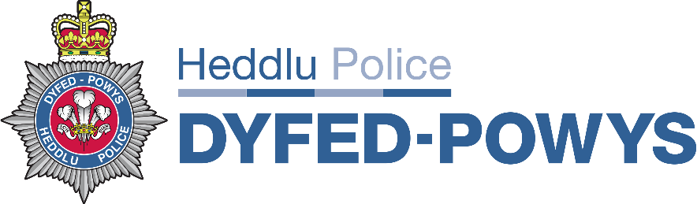  Administrative Matters
 | Apologies and Introductions | GS 15 min
2. | Terms of Reference
 |  | All
3. | Standing Agenda Items
 | - Update on (minutes)/actions from previous meeting  - Update from Force Monthly Performance Meeting  - 999 Performance  - 101 Performance  - Digital Contact Performance (In Development)  - Welsh Language Contact Performance  - FCC ‘Scrum’ (i.e call to save, save to transfer, transfer to acceptance, acceptance to deployment, deployment time)  - Immediate & Priority Response Times including Incident Monitor Review  - Quality Assurance & Audit  - CCTV (Metrics TBC) | PR 10 mins  GS 5 mins  All 20 mins  All 15 mins  SD 5 mins  KM 5 mins  GS/PR 20 mins  All 10 mins  All 15 mins  RT TBC
7. | AOB
Meeting attendees must ensure decisions made at this Board are in line with the principles of the Code of Ethics: Accountability, Integrity, Openness, Fairness, Leadership, Respect, Honesty, Objectivity and Selflessness.
Date of Next Meeting
TBC

Name of Group: FCC Performance Meeting
Location: FCC Training Room
Chair: Gareth Scanlon (FCC HoD) / Peter Roderick (FCC D/HoD)

Relevant Information Databases :
- FCC Qlikview Dashboard
- FCC PowerBi
- FCC Quality Assurance & Audit Database
- FCC Incident Monitor Response Time Audit Database
- Beating Crime Plan ‘Public Facing’ Contact Management League Tables

Relevant Documents :

----- Agenda -----

