TO WHAT EXTENT IS THE INTERNATIONAL TRADE OF BATTLEFIELD / MILITARY RELIC MATERIAL A MATTER OF MORAL CONCERN

By Jack Glascott

Wordcount: 3000

Candidate number: 191783
Heritage and Archaeology of Conflict (HPHE6003)
University of Wales trinity St David
February 2021
This essay will analyse and discuss the forms, reasonings for and evidence behind the trade of battlefield and military relics. It will investigate whether the actions people and organisations have taken either purely for economic gain, to build and enhance private or museum collections, or for political motives are of great moral concern or are more benevolent or innocuous. This essay will use World War Two artefacts as a standpoint due to the residency of the dead and the more significant moral and cultural consequence for interactions with the dead. However, to analyse this topic, some definitions must be stated to determine the underlying conditions for whether an action can be viewed as moral action or not. As the definition stated, 'an issue of moral concern is presented as an issue with the potential to help or harm anyone, including oneself' (Anscombe, 1958). By working with this definition, this essay will argue the relative morality of the actions, discussion and evidence presented in the essay and the level of concern these actions create.
Researchers of battlefield archaeology and cultural heritage, primarily where they work on sites relating to events in the 20th century, can become increasingly more involved in the process of both bereavement and recognition of the significance of events for the deceased and living. Sometimes this will include a degree of dark and challenging heritage. As stated, 'while the idea of heritage has long revolved around the elite, monumental and aesthetically pleasing things, in more recent years it has been deemed necessary to understand the more negative and painful sides of both warfare and humanity genocide and the Holocaust (Logan, Reeves 2008).
This section covers the movement, trade, and use of battlefield relics and materials as a business, where battlefield relics are sold worldwide, essentially to profit. The first question is whether the discovery and recovery of material from their resting place a moral action is to take in itself and then the morality of doing so to make money. An example of this is Jim Pearce, seen in image one, possibly one of Britain's most successful military war machine restorers and peddlers. Through connections to salvage companies, he acted as a 'middleman' between the 'unwanted refuse' of warplanes and war machines from Germany, Russia, and other countries found all around the world. This involves asking salvage companies to excavate the remains for low cost, transporting them over distance, fixing them up to a satisfactory standard and then selling them to collectors. This action in itself can be viewed in two ways both as a moral boon and of concern.
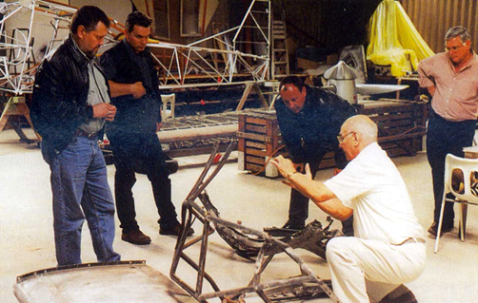
Figure 1 An image of Jim Peace working on the bulkhead of a German Luftwaffe in 2000 (The Aviation Historian, 2017)
On the one hand, this could be seen as morally full of issues as whilst there are examples of the dead being removed from planes after they have crashed or not even having individuals die within them, the fact is these planes not only represent what could be a grave memory for the local inhabitants but may also be the gravesite of the individual or individuals who flew it (Pollard, T 2005). It has been noted there are many examples of salvage activity not being respectful toward remains, as seen by dark diggers, later mentioned Nazi gravediggers suggesting that if any were gravesites, it would not be morally correct to dig them up and remove their treasures. This is the case, no matter the size or use they may have, this alongside the privatisation of the war but not only as materials but also as continuations of their memory presenting harrowing ideas and questionable beliefs for the usage of these planes. However, that being said, there is also the question of morality for collectors themselves. In the act of refurbishing and protecting the memory of each of these examples of engineering and history, to some, it may be considered an accolade, as an act of protecting an important historical artefact to be remembered in some form, as it is known that if it is not seen and observed and protected it disappears (Scott, D McFeaters, A, 2011) so by definition seen above stated above this action can be considered if done in a respectful manner, not a mora concern.
Sites connected to military action in World War Two are increasingly recognised as worthy of logical investigation (Thomas, Seitsonen., 2016). However, conversely, there is also an increasing market for objects excavated from such sites and opportunities for researchers. Notably, artefacts related to German military activity have encouraged the stripping of conflict landscapes and the extraction of items most valued by collectors. Some sites such as areas of the Somme and battlefields in Russia and Finland are regarded as treasure troves. They have become inundated with enthusiastic treasure hunters or 'diggers' becoming competition for legal archaeologists with none of the moral imperatives for the identification and preservation of the dead known as 'black diggers' seen in figure two due to the illegality of their actions and their lack if the morality for the dead only for profit (Ulst, 2010). This is complicated further by the myriad of ontology employed by different individuals in construction activity and government relationships with the material culture that connect to both recent and ancient conflict periods. This creates an increasing amount of both data and value with these pieces, and as such, it is hard to determine at what point it is preferable to preserve objects for study or make a profit through sale to a collector (Ulst, 2010).
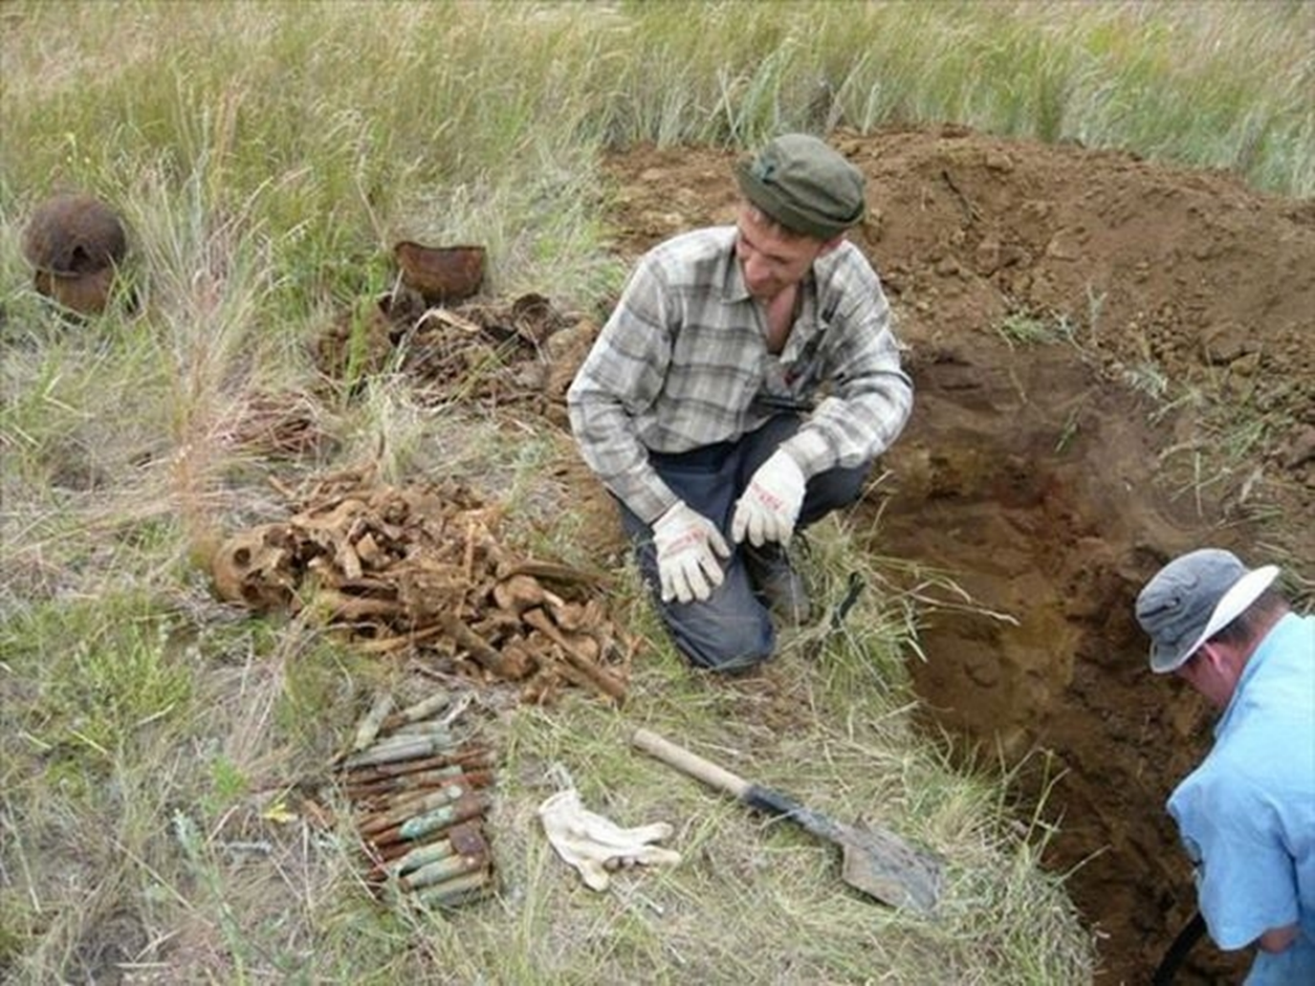
Figure 2: an image of black diggers in Russia near St Petersburg illegally digging up the dead and throwing their bones to the side (Ulst, 2010).
However, overall, the main point of this section boils down to the ethical necessity of digging up the dead for historical gain or monetary gain. Many have discussed this topic, which is why World War Two artefacts were chosen. However, the argument over whether the excavation and removal of these artefacts from their resting place are morally acceptable also extends to the activity of collecting and holding such materials. A vivid example of this is private collections. Examples such as Jacques Littlefield a tank collector who died in 2009 seen in image two who after death transformed his great amount of restored and well documented tanks into a museum demonstrate the association for keeping history alive and protected, which is overall positive. However, making a collection of such objects private depersonalises the artefact itself. XXX and his collection of tanks are excellent examples of preserving and presenting the history and development of tanks themselves. However, it also takes away the individuality of the history of each one, transforming these into a collection of objects to be seen rather than something to be understood for what it represents. However, working individually or in groups, people engage with archaeological heritage in ways that professional archaeologists are less comfortable, including treasure hunters, collectors of antiquities, and subscribers to fantastical interpretations of the past. Cooper (2006: 133) has noted that if archaeologists are to be inclusive of non-professionals, they have to be opened to accepting that sometimes the non-archaeologist may come up with a more substantial analysis, while at other times these interpretations may 'only be regarded by the archaeologist as an exercise in myth or superstition'. At the farthest end of this spectrum are the so-called 'pseudoarchaeology', providing strict interpretations of the past with often bizarre or spectacular-sounding conclusions drawn from particular ways of viewing particular aspects of archaeological material (Fagan, 2006).

Figure 3: an image of Jacques Littlefield displaying a Russian Pulitzer tank inside of one of his air hangers holding his collection Miller, S. 2009)
However, these active collections of artefacts, both war machines and memorabilia, also anchor a great way of preserving artefacts in a controlled setting rather than having them waste away to nothing in the ground to be forgotten or to be slowly hidden away and left to rot in vaults, giving them a chance to be held together in one place to be studied and better understood. Gordon Page was an Australian collector and aviation enthusiast who wanted a Messerschmitt. His adventure with his search for one is seen in his book (DeGroat, 2006). He put out social media that he wanted one. The book chronicles his journey to Mongolia, China, Russia and elsewhere, of his being robbed and swindled by the Mafia. Eventually, he found a severely damaged one in Russia with engineering students. After mortgaging his house and being in significant debt, he renovated it and brought it back home in an adventure as an Indiana Jones of aviation.
However, even after gaining the artefact, there is a need to transport it. For example, Bulgaria sold off a large amount of its World War Two weaponry, causing a mass scramble for armoured vehicles where now many are in private collections (Edensor, 2005). This seen in figure 4 an example of the forty-five tiger tanks left over from the first world war, and due to this action of leaving these for many years left a question over who owned not only the right to display the tanks as part of their history for tourism or for the rights of the metal itself and after some issue the country of Bulgaria sold the tanks for a significant sum of money, this was due to a moral and economic conflict of interest (Edensor, 2005). The conflict came from the representation of the dark history they held for the nation from the march of the Nazis over their lands and through the display of these artefacts in a museum setting gained a large economic bounty. However, this display of the German occupation through force would in all likely hood damage not only the pride and mental health of the older generation of the Bulgarians and Germans but also vilify the German people for future generations towards the Germans people for the treatment of their ancestors and family (Carr, 2014). Causing great harm overall and, as such great moral concern and examples of World War II were sold to man privet collectors for a significant sum to preserve the history and gain for the country at large.
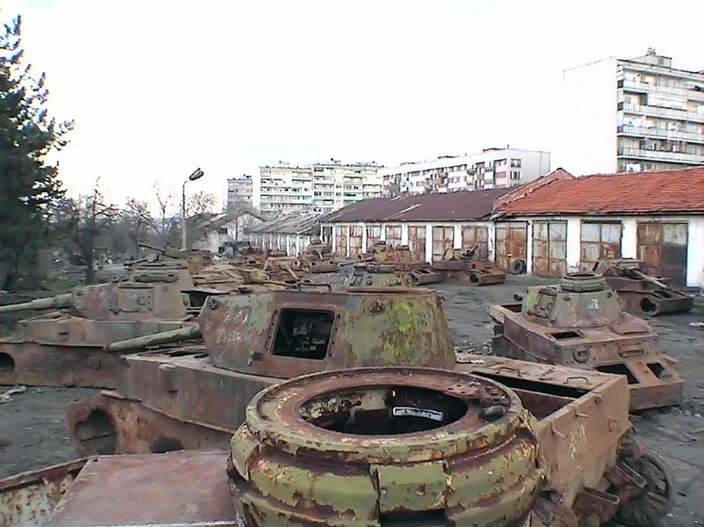
Figure 4: a picture of the forty-five recovered tiger tanks form Bulgaria to be sold and traded for the country’s future (Edensor, 2005).
There is also the question of how artefacts can be used in private hands. For example, Paul Allan (Flying heritage, 1998) had a great interest in German and Japanese planes, collecting many of them throughout his life but upon his death to give use to his collection and sped the knowledge, he created a museum using his artefacts. He created a 'flying heritage museum', but it was called a museum for tax purposes as it had heavily restricted access until this was uncovered, and it became a real museum. It has become a more public venue for a better understanding of history, even if this was not the original intention definition (Logan, K. Reeves, 2008). This suggests that the moral concern, whilst valid, is acceptable under certain circumstances, depending on how artefacts are used. This idea for the moral use of war machines is also recognised in the classic fighter plane recreation and restoration industry. This is a business that rebuilds and recreated classic planes such as the Messerschmitt 262, salvaged vessels of the original period akin for restoration each part catalogued and cast to gain not only knowledge on the method of construction but also the intricacies of the individual models and what makes them individuals vs the mas produced. An example of this is in 1995, a workshop when asked by a private collector who had a Messerschmitt 262 in disrepair, they stripped their renovated plane down to make moulds of the parts definition (Logan, K. Reeves, 2008). By repairing the collector's plane this way, they created a production line of parts for the model that was not genuine or authentic but allowed for the recreation of a piece of history that would be more morally correct to collect as there would be no lessons lost or offence given for the collection of the recreated planes leaving no concern for the trade apart from the salvage of the original from its resting place according to the definition (Logan, K. Reeves, 2008).
Alongside this is the containment and gaining of historical artefacts that have significant meaning to the individual (Holyoak, 2004). An example of this is the author's collection inherited from his grandfather. It is a small collection of World War Two memorabilia, including bomb casings and parts from planes that crashed near his grandfather's home. His grandfather gathered artefacts from the crash sites as a small boy. Is inheriting these artefacts a trade of battlefield relics and memorabilia? As such, with the definition stated above, is this action of passing down the collection a moral concern as if he did not directly connect with it? He is not displaying it for others to enhance their knowledge or usage, making it an immoral collection. However, it is not immoral to present a secure connection according to the definition. Without harm to those around him and the meaning and context of the objects themselves are defined, and the history within the object is not depersonalised and withheld, suggesting that this connection is not immoral (Carman, 1997). As such, it is only through the interpretation and belief of those who hold it in readiness for personal interest only rather than a connection to the history itself only then is the moral concern evaded.
The construction of museums themselves and their usage of artefacts has been under great scrutiny for a long time. Many have argued that through the usage of museums to display artefacts with themes sending representations of certain events, it becomes over time more of an attraction than an example of what the object represents 'public education, a popular way to frame public archaeology, at least for committees, addresses public awareness of ethical concerns in archaeological practice and interpretation (Carman, 1997). When trying to engage with the broader public, archaeologists realise that sometimes the audience is engaged and interested, eager to learn from trained archaeologists, and keen to apply this new knowledge and skillset to their research (Aston, 2012: 450). An excellent example of this can be seen in the World War Two museum in America displaying a replica of the atom bomb inside the gift shop presenting something of immense historical value whilst still being a replica is also an example of a lack of sensitivity to what the artefacts represent to the cultural memory of those affected by the war. It perhaps allows people to become more forgetful of its meaning producing a tremendous moral concern which could lead to great danger to the actions of others in future not genuinely understanding the dangers that these objects history represents (Orr, 2003). For example, if we do not understand and learn from the underlying issues of the Holocaust or Nazism in World War Two, we have failed and maybe destined to repeat them. As such, it is only through gaining the correct message in a museum can we indeed make the case that this is a morally acceptable way to display and share artefacts. This is further exemplified through the actions of the Holocaust Museum redecorating and displaying the Holocaust artefacts and knowledge in such a way that could be considered distasteful. Complaints reached the point where the museum had to redecorate it in 2008 (Lloyd, 1998). These examples highlight the need for better representations of history and the meaning and the culture behind artefacts to be adequately represented to understand and continue the lessons we learn from history. As such, it is of significant moral issue.
The last section of this essay will discuss the political and governmental need for the movement trade and appropriation of historical war artefacts. This is a complicated subject morally speaking as the morality, and the concern for such matters is subjective to the country themselves and their viewpoint on their history, even more so for the second world war action. Another example of the need for a political link to the past is dark tourism. This focuses on places of death, violence, suffering, trauma, and destruction, ranging from areas that have experienced catastrophe such as Chernobyl/Pripyat, through to sites of assassination and places of black metal violence in Norway (Podoshen, 2013).
This landscape is composed of diverse human and nonhuman elements with numerous cultural meanings and inhabited by various human and nonhuman beings, including spirits, ghosts and other such entities that are sometimes also associated with places where military materiality's are present (Herva 2014). In the local view, the material traces of the German military presence are a component of a historically layered and meaningful environment rather than "nature" in the modernist sense. Indeed, traditional Sámi and Finnish cosmologies and modes of perceiving the environment are not ordered around binary nature/culture, subject/object, or natural/supernatural categories to begin with but are characterised by what might be called a relational understanding of the world (Ingold 2000; Herva 2014). Seen against this background, a casual and pragmatic attitude towards the German military material decaying in Lapland landscapes makes more sense. This fascination with "darkish history" is likewise proven via way of means of the navy artefacts from WWII that seem in online salerooms, highlighting each the economic hobby and the capacity for gadgets to attain those salerooms via way of means of illicit way. A large portion WWII German history in Finnish Lapland presents a top-notch case to explore the values and meanings of darkish history, now no longer best domestically but globally and from a theoretical perspective. It permits us to cope with the relationships among the cutting-edge conflict, cloth tradition, reminiscence, and the query of identification from more than one viewpoint.
Overall, the action of trading military relics and war machines is not of great moral concern as stated above that there are many questionable actions taken with the objects but by the definitions selected for this essay will, there are many harmed by the actions of excavation, recovery, and hoarding of the relics themselves due to the loss not only the lost story they represent and the dead that ley with them harming the dead and the living they left behind even if there are examples of explanations those done for economic reasons are of an issue due to the methods and lack of care taken for the dead themselves. However, the action of the trade itself whilst could be construed as disrespectful if overall not of moral concern and in fact if done by the right hands and not for pure profit allowed us to understand the artefacts better themselves but inadvertently better spreads out the knowledge and preserves them in collections and museums for the future and protects the culture and history that they represent so if done in the correct manner it can be a moral action.

Bibliography
The Aviation Historian. 2017. “sad news confirmed a few minutes ago jim pearce ”Available from: https://www.facebook.com/TheAviationHistorian/posts/rip-jim-pearce-oct-21-1929-jul-26-2017sad-news-confirmed-a-few-minutes-ago-jim-p/1411447915599715/ {accessed 12/2/2022}
Ash, L. 2014. “Digging for their Lives: Russia's Volunteer Body Hunters,” BBC News Magazine, 1.13.2014. http://www.bbc.com/news/magazine-25589709
Campbell, P. 2013. “The Illicit Antiquities Trade as a Transnational Criminal Network: Characterizing and Anticipating Trafficking of Cultural Heritage,” International Journal of Cultural Property 20(2): 113–153. doi: 10.1017/S0940739113000015
Campillo, X; Cela, J. 2012. Simulating archaeologists? Using agent-based modelling to improve & Hernandez Cardona, F battlefield excavations Journal of Archaeological Science, v39 n2 (201202): 347-356PER 930.1
Carman, John. 1997. Material harm: archaeological studies of war and violence Glasgow : Cruithne Press,. 930.10285 MAT
Carr, G. 2014. Legacies of Occupation. New York: Springer
Chapman, A.R. 1980. The saga of a lost German bomber.
Cleere, H. 1989. Archaeological heritage management in the modern world (One World Archaeology, 9) London; Boston : Unwin Hyman 930.1 ARC
Crossland, J. 1990 To dig or not to dig History Today Vol.40
de Jong, A.P. 1976. Wreckology in Holland. After the Battle 12 Battle of Britain International
Delle, J. 2008. A tale of two tunnels ‘Journal of Social Archaeology, 8, no. 1: 63-93 PER 930.1
Edensor, T. 2005. “Waste matter: The Debris of Industrial Ruins and the Disordering of the Material World,” Journal of Material Culture 10(3): 311–332. doi: 10.1177/1359183505057346
Ferguson, N. 2013. “Biting the Bullet: the Role of Hobbyist Metal Detecting Within Battlefield Archaeology,” Internet Archaeology 33. http://dx.doi.org/10.11141/ia.33.3
Fiorato, V; Boylston, A. 2007. Blood red roses : the archaeology of a mass grave from the &
Flying heritage. 1998. ‘flyingheritage.org’ available at: https://flyingheritage.org/Explore/The-Collection.aspx [accessed: 13/2/2022]
Fowler, P. 2007 “Not archaeology and the Media,” in T. Clack and M. Brittain, eds., Archaeology and the Media. Walnut Creek: Left Coast, 89–107.
Freeman, P. 2000. Fields of Conflict: Progress and Prospect in Battlefield Archaeology, & Pollard, A (eds) 253-64. British Archaeological Reports International Series 958. Oxford.
Gander, Terry. 1979 Military Archaeology Cambridge: Patrick Stephens Limited
Gegner, M., and B. Ziino. 2012 [1986]. The Heritage of War. London: Routledge.
Gerstenblith, P. 2009. Archaeology in the Context of War: Legal Frameworks for Protecting Cultural Heritage during Armed Conflict Archaeologies, 5, no. 1 (2009): 18-31
Hart, S., and E. Chilton. 2015. “Digging and Destruction: Artifact Collecting as Meaningful Social Practice,” International Journal of Heritage Studies 21(4): 318–35. doi: 10.1080/13527258.2014.934267
Herva, V.-P. 2014. “Haunting Heritage in an Enchanted Land: Magic, Materiality and Second World War German Material Heritage in Finnish Lapland,” Journal of Contemporary Archaeology 1(2): 297–321. doi: 10.1558/jca.v1i2.18639
Hill, Terence. 1999. Final Descent: air crashes in Wales and the borders. Leo Cooper ISBN:0850526590
Hoffmann, Carl. 2001. Hunting Warbirds: the obsessive quest for the lost aircraft of World War II. Ballantine Publishing ISBN:0345436172
Holtorf, C. 2004. “Doing Archaeology in Popular Culture,” in H. Bolin, ed. The Interplay of Past and Present. Hiddinge: Södertörns högskola, 42–49.
Holyoak, V. 2002. Out of the blue: assessing military aircraft crash sites in England Antiquity 76(293)
Holyoak, V. 2004. Who owns our dead? British Archaeology 75
Krech, S. 1993. Battlefield archaeology under fire Nature, v365 n6442 (19930909): 116-116
Ladd, Brian. 1997. The Ghosts of Berlin: confronting German history in the urban landscape Chicago: University of Chicago Press
Layton, R; Thomas, J. 2001. Destruction and conservation of cultural property (One World & Stone, P Archaeology, 41). London ; New York : Routledge, 930.1 DES
Lloyd, David W. 1998. Battlefield Tourism: pilgrimage and the commemoration of the Great War in Britain, Australia and Canada 1919-39 Oxford: Berg
Logan, W., and K. Reeves, eds. 2008. Places of Pain and Shame: Dealing with ‘Difficult Heritage’. London: Routledge.
Lowenthal, David. 1985. The Past is a Foreign Country Cambridge University Press ISBN:0-521-29480-0
Mace, Martin. 1998. The Chanctonbury crashes: the story of five German aircraft that never returned from the Battle of Britain. Historic Military Press ISBN:1-901313-02-6
Moshenska, G. 2008. Charred churches or iron harvests?: Counter-monumentality and the commemoration of the London Blitz Journal of Social Archaeology, v10 n1 (2010 02 01): 5-27 PER 930.1
Murashima, T. 1980. Pacific War Recovery Kawanishi Shiden-Kai. After the Battle 28 Battle of Britain International
Nicoll, Alexander. 2001. Wrecks & Relics: German fighters over the United Kingdom. Historic Military Press ISBN:1-901313-07-7
Niven, Bill. 2002. Facing the Nazi Past London: Routledge
Orr, D. 2003. Landscapes of Conflict Historical Archaeology, 37, Part 3 (2003): 1-2 PER 930.1
Page, R Gordon. 2005. Warbird Recovery: the hunt for a rare WWII plane in Siberia, Russia. iuniverse.com ISBN:059567223X
Pearce, Susan1992. Museums, Objects and Collections: a cultural study Leicester University Press ISBN:0-7185-1442-4
Pollard, T & Banks, I. 2005. Past Tense: studies in the archaeology of conflict Brill Publishing
Pollard, T. 2009. “‘The Rust of Time’: Metal Detecting and Battlefield Archaeology,” in S. Thomas and P. G. Stone, eds., Metal Detecting and Archaeology. Woodbridge: The Boydell Press, 181–202.
Rainbird, P. 2003. Representing nation, dividing community World Archaeology, 35, no. 1 (2003): 22-34
Rasmussen, J. M. 2014. “Securing Cultural Heritage Objects and Fencing Stolen Goods? A Case Study on Museums and Metal Detecting in Norway,” Norwegian Archaeological Review 47(1): 83–107. doi: 10.1080/00293652.2014.899616
Robert S DeGroat. 2006. Warbird Recovery: The Hunt for a Rare WW II Plane in Siberia, Russia. Flight Journal, 11(3), 76–.
Robertson, Bruce. 1978. Epics of Aviation Archaeology Patrick Stephens ISBN:0850593050
Saunders, Nicholas J. 2000. Bodies of Metal, Shells of Memory 'Trench Art', and the Great War Re-cycled Journal of Material Culture, 5, Part 1 (2000): 43-68
Schenk, Peter. 2004. A relic from the battle of Leros. After the Battle 124 Battle of Britain International
Scott, D & McFeaters, A. 2011. The archaeology of historic battlefields: A history and theoretical development in conflict archaeology Journal of Archaeological Research, v19 n1 (01 01): 103-132
Starzmann, M. 2008. Cultural Imperialism and Heritage Politics in the Event of Armed Conflict: Prospects for an `Activist Archaeology'. Archaeologies, 4, no. 3 (2008): 368-389
Thomas, Seitsonen, O., & Herva, V.-P. 2016. Nazi memorabilia, dark heritage and treasure hunting as “alternative” tourism: Understanding the fascination with the material remains of World War II in Northern Finland. Journal of Field Archaeology, 41(3), 331–343. https://doi.org/10.1080/00934690.2016.116876
Ulst, I. 2010. “The Problems of ‘Black Archaeology’ in Estonia,” Estonian Journal of Archaeology 14(2): 153–169. doi: 10.3176/arch.2010.2.04
Waterton, E., and L. Smith. 2010. “The Recognition and Misrecognition of Community Heritage,” International Journal of Heritage Studies 16(1-2): 4–15. doi: 10.1080/13527250903441671
Miller, S. 2009. "Jacques Littlefield, 1949-2009: For Big Collector of Tanks, Panzer Was Last Hurrah". Wall Street Journal. p. A8. Retrieved May 5, 2009.

