
Skills for the Workplace
Module Assignment Submission
Sustainability and Global Citizenship
Student Name: | Pecos Dingu
Student Number: | 1605452
Module No: | EMPL4013
Module Title: | Project Pathway-1

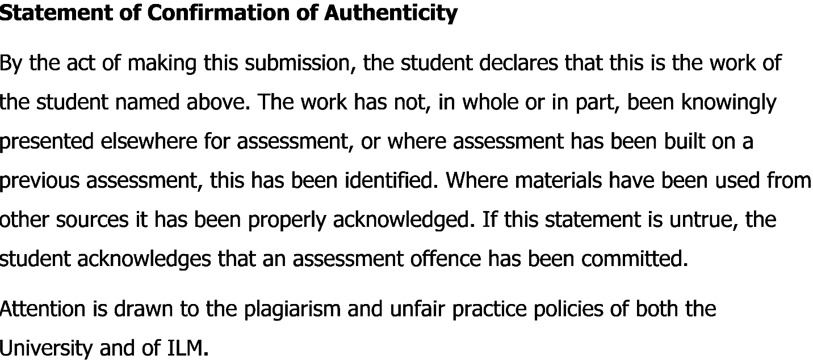

Table of Contents

Introduction…………………………………………………………………………………………….1
Description…………………………………………………………………………………………….1,2
Feelings…………………………………………………………………………………………………..2
Evaluation………………………………………………………………………………………………2,3,4
Analysis…………………………………………………………………………………………………...4
Conclusion……………………………………………………………………………………………….5
Action Plan……………………………………………………………………………………………….5
Reference…………………………………………………………………………………………………6

Introduction: A reflective essay is an essay in which the writer examines his or her experiences in life. In this reflective essay I will talk about my own experiences about working in a group for a course. I had to work with some of my group mates on a project and the project was about tourism. We also gave a presentation on “Global Citizen”. To make this presentation, we did lots of research on tourism and the responsibilities of the global citizen on sustainable environment development. I also include the skills that I have gained by doing this report and presentation. While working in this group, it helped me to improve my interpersonal skills including managing the time, communication skills and networking skills. I have also used “Gibbs Reflective cycle” to prepare this report regarding collaborative learning.
Description: The faculty formed a group of six people and discussed the topic in the class. But there were three topic but we choose the topic of Tourism and Global citizen. The total work divided among the group member based on discussion and sharing of opinion. There were three different issues that we had to present in the class. And the topic was leadership and entrepreneurship and community participation both locally and globally and sustainable environment and globalization.
I chose to work on the leadership and entrepreneurship part as they made me the group leader of the team. I had to do lots of research on leadership and entrepreneurship in tourism sector. By doing this research I have gathered lots of knowledge on this sector. I think this knowledge will help me to get into any travel sector company or to be an entrepreneur in future.
On the other hand, I had manage time for this report from my busy schedule and had to plan the activities that I will tell in the presentation. This report helped me how to manage and plan for the activity of work and how to allocate time for each activity. Now I can use this time management skills in future so that I can efficiently perform my employment duties.
While working on this report and working on this group, I had to communicate with different travel company for the valid information in some cases. Sometimes I had to take help for the group member about my topic and to collaborate the whole work. This has enhanced my interpersonal skills. So in future, when I will work in any company I will apply this communication and interpersonal skills to communicate with the colleague for any query. I can also use these interpersonal skills to give or take ideas from them and can apply solutions sometimes. It will also help me to work with flawlessly and create e bonding among the colleague, which will also help to increase my networking.
Feelings: After completing the task in this group, I am very happy because this task helped to gather lots of knowledge on Entrepreneurship. Now I know what should be done to be an entrepreneur in future. It gives me a confidence not to be an unemployed person. If I don’t get a job I can start a business of my own, this is one of the best feelings of reflecting the task.
On the other hand, I have also gathered knowledge of leadership and I also lead the team to complete the presentation. By doing this, I know how to manage people and make them work. These leadership skills will also add value in my employability skills to get a better job.
When I reflect on time management skills that I have learned by completing the presentation, I feel really happy. Because, now I know how to manage time for each activity and I wont be delaying for any work in future. This will also help me at my workplace and gives value in my employability. I have also learned and understood the importance of communication skills and interpersonal skills. This also makes me happy, when I think about of getting ideas and help from others whenever I face any problem. I can utilize those ideas to expand my business or to get an advantage at my workplace.
Evaluation: If I evaluate the whole learning process, I must say I have leaned a lot about the importance of collaboration and coordination of teamwork. I have also come to know that through collaborative working complex work can be done with maximum accuracy and with in a short time. The positive side of the report was the skills that I have learned by completing it. Those are time management skills, interpersonal communication skills and leadership and managing skills.
- Time management skills: I have learned the ability to manage the time for the presentation. We did our research on tourism timely. Then we have collected all the data. After collecting the data from different sites, journal, articles and different travel company, we had to come up with a conclusion with in given time by the faculty. We had to decide what to highlight in the presentation and how much a person can take for each part. Basically this presentation helped me to learn how to manage time for each activity.

- Interpersonal communication: For the presentation, I had to always communicate with the group members. As I was the group leader, they asked my help sometimes. I had to listen their problem and give them proper solution. To complete the presentation, the communication was necessary. And the communication between the group members was really good. Not only with the group member I had to communicate with the faculty as well. This helped me to develop my interpersonal communication skills. On the other hand, to collect information sometimes I had to visit some travel company. This engaged me to deal with a lot of professional people where communication plays a very important role. Now I know how to talk to the people by maintaining the professionalism. An in future, I will be able to contact with my colleague with this communication skills efficiently at my workplace.

- Leadership and managing skills: I chose the topic of leadership and entrepreneurship. This topic helped me to learn how to be an entrepreneur in future. On the other hand, I took the leadership of the group. This helped me to lead them to accomplish the task. Through leadership is not easy. I had to take update of their work regularly, sometime I had to motivate them and sometimes I had to listen to their problem and gave them solution. But this leadership will add value to my employability in future. Another important thing is, now I also know how to manage people to complete the task. As I had to manage them to according to my plan for the presentation.
But these research and group presentation did not include sufficient statistical data analysis and interpretation. That is why; I didn’t get the chance to learn statistical data collection, analysis and interpretation. But I really want to learn this tools so that I can prepare myself for the future employability.

Analysis: At first, I had no knowledge about “Global Citizen” and “Sustainable Development Projects”. Now I know the contribution of global citizen in the society. I also know the projects that are taken by different country to make the world a better place for living. I also know the name of the entrepreneurs who played a great role to create the process of tourism. And in some developing countries, this is main source of earning. And many people are working and investing in this sector recently. Global citizen should give more attention to this (Natalie clark, 2018).
I have also leaned the importance of collaboration between the group members. In every organization employee have to work and communicate with others. To get into a job, a person should have the experience of working with others. A candidate should know how to complete the task with collaboration with others. This knowledge will help a person to achieve organizational goals by working wit others. According to McLeod (2015), collective teams can perform in productive and innovative to achieve organization goals.
This report also helped me to understand the importance of time management skills in every activity. This is one of the key skills that every organization looks from a candidate. So an employee should have time management skills in order to get benefitted in job sector. According to Herzberg (2012) to become successful in professional life a person or a candidate should have the knowledge and practice of completing any task in time.
Another important skill that a candidate should have is accountability. This enables an employee to take responsibilities for his job. According to Jasper (2015), an employee must have accountability skill for ensuring that he is doing his job responsibly and honestly.

Conclusion: This course and group helped me lot to gain those skills that I have achieved by completing the task of leadership and entrepreneurship. I have learned time management skill, leadership skill and interpersonal skill, which will help me lot in my employability in future. I have also learned how to work effectively in a group. There are only two things that I haven’t learned from the report. One is- there was lack of accountability. And the second one is- lack of using statistical data. If I got the chance to learn accountability skills and using of statistical data, I think it will help more in my employability in future.
Action Plan: If I get a chance again to do research on any sector or a company in any course, I will definitely do survey to gather more primary data. So that, I can make a better conclusion of the research and can work with statistical data in future. And if I work in a group, I will tell them the importance of accountability skills. And if I got the chance to lead the team, I will strictly follow the accountability skills.
As I have learned three skills from this course and presentation, I will definitely apply those skills to get a part time job and I will practice those skills so that I can do better in future professions.

References:
- Boud, D., Keogh, R. and Walker, D. (2014). Reflection: Turning Experience into Learning. London: Kogan Page.

- Moon, J. (2015). Reflective Writing – some initial guidance for students. A Handbook of Reflective and Experiential Learning.. London: Routledge Falmer.

- Jasper, M. (2015). Beginning reflective practice. Cheltenham: Nelson Thornes.

- Bemycareercoachcom. 2018. Soft Skills - Ask a Wharton MBA. [Online]. [23 April 2018]. Available from: http://bemycareercoach.com/soft-skills/communication-skills/interpersonal-communication-definition.html

- Maldivesconservationportalorg. 2018. Maldivesconservationportalorg. [Online]. [23 April 2018]. Available from: https://maldivesconservationportal.org/lectures/coral-lines-project-making-coral-reef-restoration-more-accessible/

- Natalie clark. 2018. Solimarinternationalcom. [Online]. [23 April 2018]. Available from: http://www.solimarinternational.com/resources-page/blog/item/146-the-economic-impact-of-tourism-development

