

William Young
2113840
Word Count: 2890

Council Request for Safety Report: Siting an ammunition depot on the SA1 Waterfront

UWTSD
ACDA 6022 OME Safety Management & Law

BEng
Academic Year: 2025 - 2026

Supervisor: SSO PE Ltd
Associate Supervisor: Gareth Collett
December 2025

Academic integrity declaration
I declare that:
- the thesis submitted has been written by me alone.
- the thesis submitted has not been previously submitted to this university or any other.
- that all content, including primary and/or secondary data, is true to the best of my knowledge.
- that all quotations and references have been duly acknowledged according to the requirements of academic research.
I understand that to knowingly submit work in violation of the above statement will be considered by examiners as academic misconduct.

Abstract
A report to document the requirements for an OME storage facility in Swansea. This report will include a descriptions of the internal and external design of Earth-Cover Explosive Storehouses (EHS), a Quantity Distance (QD) assessment, an assessment of applicable Hazard Division (HD) Compatibility Group storage requirements within five EHSs, and safety issues to be considered for the site.

Table of Contents
Academic Integrity Declaration…………………………………………………………… 2
Abstract……………………………………………………………………………………… 3
1 Introduction……………………………………………………………………………….. 5
2 Magazine Design……………………………….........………………………………..… 8
3 Quantity Distance (QD) Assessment ………………………..………………………… 9
4 HD and Compatibility Group Storage………...……………………………….……… 10
4.1 ESH 1 ……..………………………………………………………………….. 10
4.2 ESH 2 …….………………………………...………………………………… 10
4.3 ESH 3 ………….…………………………………………………………...… 10
4.4 ESH 4 ……………….………..….………………………………………….… 11
4.4 ESH 5 ……………….………..….…………………….……………………… 11
5 Safety Considerations…..……………………………..…………………………….… 12
5.1 Storage…..…………………...……………………………………………….. 12
5.2 Transportation……………..………………………………………………….. 12
5.3 Public ……..……………….………………………………………………….. 13
5.4 Environmental…..…………………………………………………………….. 13
5.5 Emergency Response……………………………………………………….. 14
6 Recommendations .……………………………………………………………………. 15
7 References.……………………………………………………………………………... 16
Appendices.……………………………………………………………………………….. 17

1 Introduction
The City and County of Swansea Council (the Council) has received an application for planning permission for the construction of an explosive storage facility on the location shown in Figure 1. The proposal includes five Earth-Covered Explosives Storehouses (ESHs), each positioned east–west across the identified site.
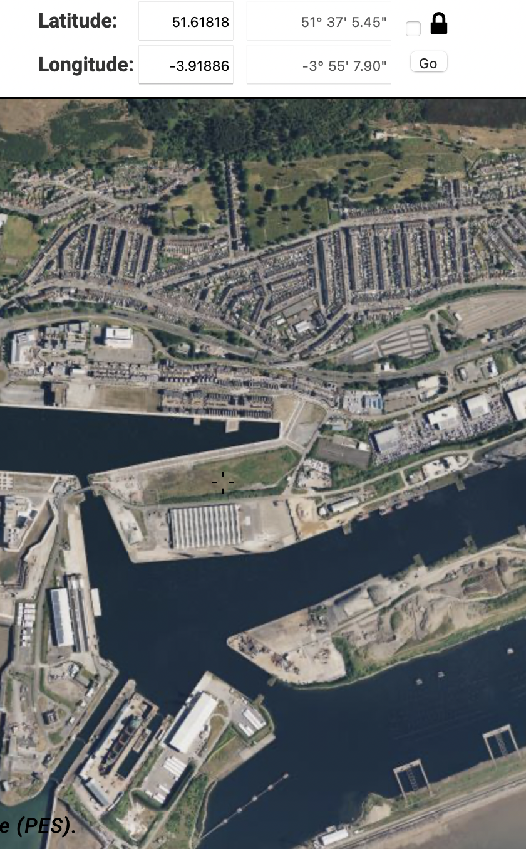
Figure 1 – Location of the proposed explosive facility

Further information regarding the explosive facility has been provided by BigBang Storage Solutions as follows:
- ‘Each ESH will be able to hold up 1000 kg of each type of hazard division (pallets stacked 3 high), thereby requiring no more than 5 x ESH built east to west along the waste land.
- The Vulnerable building distance is no more than 300 m for each ESH;
- The Inhabited building distance is no more than 125 m for each ESH
- The Public traffic route distance is 270 m for each ESH
- HD 1.1 is divided as follows:
  - HD 1.1B – 50 kg
  - HD 1.1D – 3200 kg
  - HD 1.1E – 1250 kg
  - HD 1.1F – 500 kg
- HD 1.2 is divided as:
  - HD 1.2C – 350 kg
  - HD 1.2D – 100 kg
  - HD 1.2F – 50 kg
- HD 1.3C – 1000 kg
- HD 1.4S – 1000 kg
The Council has indicated that it does not have an in-house Ordnance, Munitions and Explosives (OME) specialist, and therefore seeks an independent assessment of the information provided by the contractor, BigBang Storage Solutions. The proposed location is on currently unused grassland within the docks complex. This area is in proximity to:
- Residential areas to the north (approx. 250–350 m).
- Commercial and light-industrial premises (approx. 100–200 m).
- Public roads and pedestrian routes (approx. 80–150 m).
- Swansea Marina and associated maritime users.’ [1]
This report provides an explanation of terminology, a technical assessment of the storage proposal, an evaluation of the Quantity Distance (QD) claims, identification of risks and concerns relating to public safety, safety advice for maritime users, and safety questions to request further clarification and assurance from BigBang Storage Solutions.

2 Magazine Design
The applicant states that each ESH will be earth covered and constructed to provide directional blast effects, with the side of magazine perpendicular to the direction of the Exposed Site (ES). Each ESH is a separate Potential Explosive Site (PES).
Directional effects refer to intentional shaping of the protective earth cover, structural reinforcement, and venting orientation such that, in the event of an internal detonation, the majority of the destructive pressure and debris is directed upward rather than laterally. This will reduce blast effects from an unintended detonation internal to the ESH as the strongest structural face of the ESH is oriented toward the nearest hazard. Lateral blast waves are therefore reduced in the direction of populated or sensitive receptors, while the earth covering is intended to absorb primary fragmentation and reduce the initial shock front.

3 Quantity Distance (QD) Assessment
The NEQ of each ESH has been combined to treat them as one PES. The site would be required to demonstrate that no sympathetic detonation can occur between the ESHs. Traverses, adequate inter-magazine distances and a valid safety case would allow each ESH to be considered a PES and would significantly reduce the Quantity Distances (QD) of the provided OME. Below are the QDs taken from Annexes D and E of IATG 02.20 using a HD 1.1 NEQ of 5000kg for above ground storage. [2]
The Vulnerable Building Distance (VBD) of this PES is D15 x 2, where D15 = 400m.
The VBD is therefore 800m.
The Inhabited Building Distance of this PES is D15.
The IBD is therefore 400m.
The Public Traffic Route (PTR) was assumed to be a High Density PTR due to the location of the facility. The marina and nearby area is popular and includes footpaths, roads, and marine vessels. This was a pessimistic judgement and further information may reduce the QD. The High Density PTR of this PES is D15.
The High Density PTR is therefore 400m.
Below is a table comparing the provided QDs with those generated above.
 | VBD (m) | IBD (m) | PTR (High Density) (m)
Provided QDs | 300 | 125 | 270
Updated QDs | 800 | 400 | 400

Table 1 – Quantity Distance Comparison
There is a significant difference between the values provided and the QDs of the total NEQ of proposed PES. The VBD is a particular challenge given the proximity of the HMT Sancta Maria Hospital as well as the University of Wales Trinity St David. Further work on the proposed site would be required to allow each ESH to be considered individually as a PES, thereby reducing the QDs to more acceptable limits.
4 HD and Compatibility Group Storage
Consideration will be required for the mixing of the four HDs and their Compatibility Groups, both between ESHs and internally between pallets. Compatibility Groups may be stored together where their interaction does not increase the overall hazard, with mixed storage permissible only when specific allowances exist or clear segregation can be demonstrated. [3]
4.1 ESH 1
The first ESH should contain HD 1.1B pallets only. While the NEQ is lower than other ESHs, HD 1.1B is particularly sensitive to unintended initiation as they contain primary explosives designed to initiate less sensitive bulk explosives. If stored with such explosives, risk of a sympathetic detonation is significantly increased. [3] Therefore, they should not be stored with Groups D, E and F except where operational requirements demand immediate assembly. [3] As this does not apply to a storage facility in Swansea, HD 1.1B has been segregated within its own ESH.
Recommendations for the safe use of this ESH would be to include increased internal segregation from other ESHs by stacking pallets to the left of the ESH and limiting access to key personnel only.
4.1 ESH 2
The second ESH should contain HD 1.1D and HD 1.3C, where Group D consists of secondary high explosives and Group C consists of propellants and pyrotechnics. IATG permits storage of these Groups in the same ESH when they are physically segregated and a fire to detonation transition can be demonstrated as preventable within the structure. [3]
Group C OME is more likely to burn than detonate, while Group D is less sensitive than the Groups B and F. Internal segregation will be required to store this OME within the same ESH. Therefore, internal walls would allow the ESH to store the HD 1.1D and 1.3C in separate rooms; with fire detection and suppression systems in place to prevent fire hazards or reduce the risk of fire spreading to stored OME by improving emergency response times.
4.1 ESH 3
The third ESH should contain HD 1.1E and 1.1F, where Group E consists of secondary high explosives with propulsive charges and Group F consists of non-primary explosive with its own means of initiation. Group F should not be stored with other high explosives unless physical segregation prevents sympathetic detonation and a safety case justification is provided for the PES’s use.
This may be problematic for the proposed facility and a sixth ESH would allow the facility to provide a separate ESH for HD 1.1F explosives, due to the increased risk of self-initiation from Group F. If this is untenable, a safety case may be required for the use of HD 1.1F on site. An alternative would be to find alternative storage for the facility’s HD 1.4S, discussed in the ESH 5 section, which would provide ESH 5 for storage of HD 1.1F only.
4.1 ESH 4
The fourth ESH should contain HD 1.2C, 1.2D and 1.2F, where HD 1.2 presents a projection hazard without mass explosion. HD 1.2 items have been stored in separate PES to HD 1.1 due to the increased risk of initiation of HD 1.1 if HD 1.2 were to initiate. To store this OME in the same ESH, internal segregation would again be required. Fragment trajectories must not be capable of interacting with different Groups stored in the ESH, therefore internal walls would be required to store each Group in separate areas of the ESH, with their storage designed to direct fragmentation away from each internally walled storage compartment.
4.1 ESH 5
The fifth ESH should contain HD 1.4S, where Group S does not mass detonate, produce dangerous fragments, and are unlikely to propagate to nearby pallets. [3]
Storing HD 1.4S in an ESH may be overly safe for the hazard presented, and an alternative storage method, such as an ISO container, may be more suitable for HD 1.4S. If space allows for this on site, ESH 5 could be used to store HD 1.1F, negating the potential need for a safety case for a mixed ESH of HD 1.1E and 1.1F. This would provide significant cost reductions.

5 Safety Considerations
5.1 Storage
The first safety problem to consider is that the facility has a requirement to hold a certain amount of OME, and the UK MOD tender has granted the right to build only to that amount of NEQ for each HD. If the required amount stored on site is the maximum NEQ allowed by the licence, there may be a temptation to exceed the licence during busy periods in contravention of the site’s responsibilities. There may also be a requirement to increase the licence’s NEQ in the near future. A better alternative may be to slightly increase the allowed NEQ to provide a small buffer.
Stacking pallets three high may also result in problems for the new facility. Higher stacks of stored ammunition will increase the risk of human or mechanical errors occurring during movement of the stored OME, with the consequences of a drop and impact increased due to the higher height of the stacks. If space allows, shorter or no stacks would improve the safety of storage in this facility.
5.2 Transportation
One safety consideration for transportation is that the location of the proposed site is close to both industrial and residential areas. Care will need to be taken to ensure that OME is transported along predefined routes with the approval of the local authority. Further information will be required regarding the frequency of OME movements to and from the facility, as well as the frequency of internal movements between storage areas and associated facilities, before approval should be granted. The transportation of HD1.1 and 1.2 in particular is a significant hazard to the public during transit, given the proximity of the facility to built-up areas and that transport through a major Welsh city would be required.
Consideration will need to be given to the type of vehicle used for transportation, ensuring that it is safe to use both for OME safety as well as OME security. Hostile actors will need to be considered to ensure that OME cannot be stolen during transit by providing secure locks on all doors. If large NEQs of HD1.1 and 1.2 will be approved for transit, a specialised vehicle may be required to minimise external blast and fragmentation to reduce the risk of unintended detonations to the public.
Compliance with the UK Carriage of Dangerous Goods (CDG) Regulations will need to be demonstrated prior to approval of OME transportation within the UK. Prior to approval of transportation, all items of OME will require the correct classifications, labelling and records, the driver will need to be correctly qualified, and the vehicle must be demonstrated to be compliant by using the correct equipment and placards. Emergency procedures will also need to be agreed with the local authority to ensure risks are kept As Low As is Reasonably Practicable (ALARP) in the event of an emergency, such as vehicle breakdown or initiation of the cargo. [4]
If transporting OME from Europe, compliance may also be required with the Agreement concerning the International Carriage of Dangerous Goods by Road (ADR).
5.3 Public
The site will need a secure perimeter to ensure no encroachment from members of the public or other unwanted persons. Fences and locked gates will be required and, given the proximity to a large number of non-explosive workers, the site may also benefit from employing security guards to prevent unintended access to the site and to the stored OME.
For maritime users of the nearby area, vehicles should not be stored near to the proposed facility where possible. A permanent exclusion zone would ensure that maritime users can safely travel and moor in the nearby area without encroaching the Public Traffic Route Distance (PTRD) or Inhabited Building Distance (QD) of the storage facility. Temporary exclusion zones may also be used during OME movements. Signage and public outreach from this facility will also benefit maritime users, ensuring they are aware of explosive risks and the site’s emergency response plans.
5.4 Environmental
One environmental requirement to consider is the potential contamination from propellants, pyrotechnics and explosives stored on the site. Given the frequency of high-density rainwater at the location, all PES on site should be protected from flooding and flash flooding to ensure that no contaminants are leaked into the soil or nearby bay. A documented prevention plan may be required to assure the Interim Environmental Protection Assessor for Wales (IEPAW) that contaminants will not be released from the site.
5.5 Emergency Response
A fully planned emergency response will be required to ensure the local authority that the site is safe to operate. An evacuation plan, firefighting procedures and cooperation with local emergency services should be ensured prior to approval for the site.

6 Recommendations
Work is required to reduce the QDs of the proposed site. The current QDs are be unacceptable given the proximity of a number of vulnerable and inhabited buildings. Traverses and a safety case justifying that no sympathetic detonation can occur between ESHs are therefore recommended before site approval occurs.
Significant opposition to an explosives storage facility in the middle of Swansea would also be expected. Outreach to members of the public may help reduce tensions, but the location makes protests and unwanted public attention a frequent and likely risk to the safety of staff as well as the safety and security of stored OME.
A safety case should be produced to allow for the mixed storage of OME within ESH 3. If permission can be gained for alternative HD 1.4 storage, ESH 5 should be used to store HD 1.1F OME.
There are significant explosive safety and security concerns with using the suggested area for an explosive storage facility. Unless required for military operations, a more remote location should be used and it is recommended that the Council does not approve this application.

6 References

[1] | UWTSD, Assignment Brief.
[2] | UN SaferGuard, “Quantity and separation distances,” 2021.
[3] | UN SaferGuard, “UN explosive hazard classification system and codes,” UN SaferGuard, 2021.
[4] | Health and Safety Executive, Carriage of dangerous goods (CDG).

Appendices
Appendix A – Further Safety Questions for Risk Reduction
- Why were traverses omitted from the planning application and could they be added to the site?
- Provide a risk assessment justifying the stacking of OME three pallets high.
- Provide OME transit routes, site access plans, vehicle specifications and requirements from the Local Authority/ emergency services.
- Will any vehicles be used on site? Provide specifications and refuelling operations.
- Provide fire risk assessments where applicable.
- What emergency response plans do you have in place? How will you liaise with local emergency services?
- What assessments have been conducted to limit environmental harm? Provide drainage studies for the site and earth coverings. What control measures will prevent the release of contaminated water into the marina?
- Provide internal and external engineering drawings for the ESHs.
- What measures will be in place to prevent unintended access to the site.
- What measures will be in place to prevent disruptive actions from the public to transportation and storage activities?
- Provide blast modelling for all ESHs.
- What hours will the site operate during?

