

Module Name: Digital Skills and Research Methods
Module Code: BMSW4003_BIRM
Component 2- Research Report

THE USE OF TECHNOLOGY IN THE MODERN HEALTHCARE WORKPLACE

Submitted By

Student Name: Yetunde Akinyemi
Student No: 2133596
Lecturer Name: Amitave Banik
Submission Date: 01/09/2022

Abstract
The study provides an in-depth analysis of the adoption and the use of technology in order to improve the provisions of the healthcare sector. In this context, it can be stated that with the help of the secondary data gathered in the study, the information helps in explaining the potential advantages for the improvement of the healthcare standards, which ultimately leads to mitigation of mortality among the patients. The research questions in the study provide critical analysis of the concepts which help in explaining the role of technology in the process of healthcare operations. The approach of research methods focuses on the collection of data based on secondary sources and analysing them in order to meet the research questions. Lastly with the help of clear results and discussion the rationale for the selection of secondary research method along with the analysis of the role of technology in healthcare operations is effectively discussed.

Table of Contents
Introduction 4
Research design 5
Research questions 5
Methods 5
Ethical considerations 7
Results 7
Discussion 9
Conclusion 11
Reference list 12
Appendix 1: 14

Introduction
The adoption and use of technology in the provision of the healthcare sector over the years have contributed to enhanced diagnosis and facilities for patients. Amongst all the facilitated industries from technology adoption and usage, the healthcare sector is feasibly the most crucial one. Subsequently, it has the potential of improving the standard over time and can save many more lives. Since the healthcare industry is one that is concentrated on saving people's lives and enabling them with improved health conditions, an expectation related to using advanced technologies in modern healthcare institutes for saving more lives in a reduced period and for offering improved and probably more secure treatment processes. In alignment with this, the current study has decided to offer a descriptive report on the phenomenon of the utilisation of technology in the contemporary healthcare workplace. In doing so, this paper has explored the way the topic has been found and chosen, while briefly discussing the selected research idea. Next, this study has explored the methodology used to research the selected topic, along with explaining the technique of finding relevant and credible sources for supporting the research.
With the help of secondary sources of data adhered from articles, journals and news sources the role and the impact of technology on various healthcare operations provides the analysis of significant advantages. The advantages involve the mitigation of life-threatening risks song with the delivery of quality care and services to the patient which helps in the improvement of patient satisfaction.
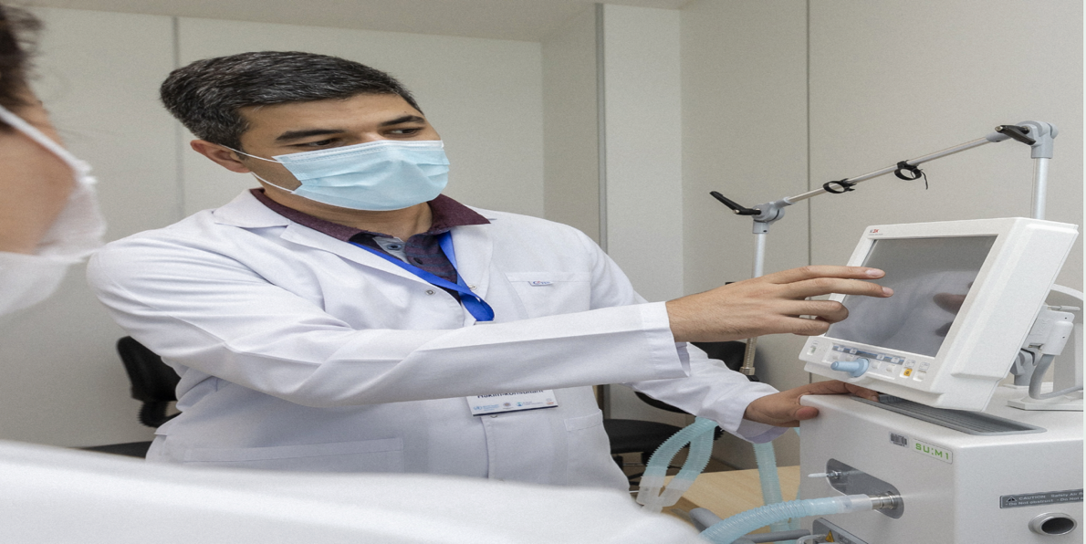
Fig: Digital system in Healthcare (Akhtar, 2016)

Research design

Research questions
In alignment with the need and function of technology in contemporary healthcare workplaces, the following research questions have been developed to address the phenomenon:
1. How technology is used in the modern healthcare workplace?
2. What are the benefits of using technology in the modern healthcare system?

Methods
The methodology is a vital component while pursuing research. Research methodology offers research authenticity and facilitates offering technically sound findings (Rinjit, 2020). It also aids in giving a detailed preparation that assists in keeping the learner on track, enabling the procedure to be efficient, flawless, and manageable. Opting for the ideal research methodology facilitates a learner to allow other researchers in replicating the research by having sufficient information. Besides, the ideal methodology also helps in offering the learner a particular plan to be a guiding path throughout the research.
However, in the context of the present report, the descriptive option has been chosen for appropriately describing the components associated with the chosen phenomenon. Besides, the research is a qualitative one, involving the collection and analysis of the prevailing information on the phenomenon or spoken words related to the topic. The qualitative research methodology is perceived to be subjective and helps in exploring the questions within research in a descriptive manner. Opting for the descriptive design in this research can be helpful as it aims in acquiring knowledge in a systematic manner for describing a topic and its associated elements (Akhtar, 2016). More particularly, it can assist in answering the when, what, how, and where questions related to the research phenomenon, instead of the why. The descriptive approach also renders the potential of involving the utilisation of several distinct forms of approaches in investigating the elements of the research question. Furthermore, it is crucial to mention that the research on the use of technology in contemporary healthcare workplaces has opted to collect secondary data only. Hence, it would be ideal to use a secondary data analysis technique in interpreting the findings from the gathered data. In this regard, the choice of using thematic analysis seems appropriate. The benefit of utilising the thematic analysis approach is that it is mostly unsupervised, indicating that the learner is not required to establish such categories in advance to straightforwardly capture the unknown elements related to the research topic (Javadi and Zarea, 2016). In the case of the current study, the use of thematic analysis is assistive in terms of positioning the insights from the gathered secondary data in alignment with the particular research questions to descriptively explain the utilisation of technology in contemporary healthcare workplaces.
The methodology is a vital component while pursuing research. Research methodology offers research authenticity and facilitates offering technically sound findings (Rinjit, 2020). It also aids in giving a detailed preparation that assists in keeping the learner on track, enabling the procedure to be efficient, flawless, and manageable. Opting for the ideal research methodology facilitates a learner to allow other researchers in replicating the research having sufficient information. Besides, the ideal methodology also helps in offering the learner a particular plan to be a guiding path throughout the research.
However, in the context of the present report, the descriptive option has been chosen for appropriately describing the components associated with the chosen phenomenon. Besides, the research is a qualitative one, involving the collection and analysis of the prevailing information on the phenomenon or spoken words related to the topic. The qualitative research methodology is perceived to be subjective and helps in exploring the questions within research in a descriptive manner. Opting for the descriptive design in this research can be helpful as it aims in acquiring knowledge in a systematic manner for describing a topic and its associated elements (Akhtar, 2016). More particularly, it can assist in answering the when, what, how, and where questions related to the research phenomenon, instead of the why. The descriptive approach also renders the potential of involving the utilisation of several distinct forms of approaches in investigating the elements of the research question. Furthermore, it is crucial to mention that the research on the use of technology in contemporary healthcare workplaces has opted to collect secondary data only. Hence, it would be ideal to use a secondary data analysis technique in interpreting the findings from the gathered data. In this regard, the choice of using thematic analysis seems appropriate. The benefit of utilising the thematic analysis approach is that it is mostly unsupervised, indicating that the learner is not required to establish such categories in advance to straightforwardly capture the unknown elements related to the research topic (Javadi and Zarea, 2016). In the case of the current study, the use of thematic analysis is assistive in terms of positioning the insights from the gathered secondary data in alignment with the particular research questions to descriptively explain the utilisation of technology in contemporary healthcare workplaces.

Ethical considerations
The approach of ethical considerations refers to the set of principles and regulations which helps in effectively designing the research and managing the practices. The approach of ethical considerations involves the factors of voluntary participation along with informed conscience and anonymity of the participants. Furthermore, the approach of participants' confidentiality, the potential for harm and the results of the communication are also constituted under the approach of ethical considerations. The study thereby aligns with the practices and regulations of the ethical consideration approach and no manipulation of data taken from secondary sources has been done in the present study. The study, therefore, maintains the authenticity of the overall research.

Results
Substantial technology, speedy change, and uncertainty in the workplace are crucial in the provision of the healthcare industry. It has been found that the majority of healthcare facilitators have been planning to render substantial advancements in applying cognitive and artificial intelligence components of technology in the coming years (Ross et al. 2016). They have also been planning to prioritise training workers within healthcare workplaces to enable them to perform work side by side with AI and robots. Despite such aspirations, there has only been a little progress and incorporating and applying such technologies. One reason behind this could be that several leaders in healthcare firms are anticipating that the scale and speed of transformation would be overwhelming for their workforce and complicate prevailing challenges, like a lack of nurse’s supply and a burned-out population of physicians. The worldwide strategy on digital health intends to assist and respond to nations' rising demands to deploy relevant digital technologies in accordance with local health objectives and to advance universal health coverage and health-related Sustainable Development Goals (WHO, 2021). It supports WHO's Thirteenth General Programme of Work, 2019–2023. Plan summary is in Appendix 1.
The results describe the data gathered from the sources where the role of technology in the healthcare process is observed to impact potential advantages. Thus, in this context, it can be observed that various types of technology can be implemented in the healthcare sector in order to generate positive impacts on healthcare operations. In this context, it can be observed that the massive use of the diagnostic imaging scanner is considered an integral part of modern healthcare. With the help of new treatments and medical procedures, the approach of technology impacts various improvements in healthcare business processes. Lastly, it can be stated that with the help of smart technology in the process of healthcare the conditions on the patients are majorly improved.

Fig: Use of Digital technology (WHO, 2021)

Discussion
The opted research idea or area in the context of the present study is the use of technology in contemporary healthcare workplaces. Progressively advancing digital technology can be seen to have been fostering enhanced automation, influencing the proximity of where business-related work is pursued, and allowing an increase in novel and open talent paradigms ("Health Care Technology and the Future of Work | Deloitte US", 2018). Along with such substantial change around different industries, several provider firms can be observed to have been understandably concerned regarding the way of grappling with such augmented change and its influences on where, when, and how to work is performed. Surprisingly, several healthcare providers have been considering the apprehensive workforce to be a crucial pattern in the modern context, while they have also been considering components like robotics, artificial intelligence, and cognitive computing. The aspect that such providers may not acknowledge is that all such areas are a portion of the identical change wave. According to Alotaibi and Federico (2017), the healthcare institutes that fail in fusing talent and technology related to the healthcare workforce, have the risk of neglecting abundant leaps in effectiveness and engagement. From the viewpoint of healthcare, it can imply that a dispirited workforce with progressing shortage of nurses and enhanced degrees of burnout, a diminished capability to attract and reserve highly expertise clinicians and non-clinicians, a minimisation in the standard of care, and position loss as a choice of a patient's healthcare needs provider.
It is crucial to look for credible sources in supporting research. It is vital when using secondary data as the main source of information for research. For recognising credible sources related to a specific phenomenon, it is crucial to ensure that the information is updated and current, while it also should be relevant to the chosen phenomenon (Eldh et al. 2020). Furthermore, selecting credible sources would also require a learner in identifying the publication and the author to be trusted ones, while guaranteeing that the citations for the sources are easily found. In the case of web-related sources, the URL must establish its trustworthiness. In the case of this ongoing study, credible sources related to the utilisation of technology have been collected by searching the phenomenon in Google’s search engine and in google scholar. The chosen sources, either web-based or articles from Google Scholar, are from the time period of 2016 and onwards. Specific keywords or phrases, such as "technology in healthcare workplaces", "use of technology in healthcare workplaces", "importance and use of technology in the healthcare sector", and "benefits of technology in healthcare workplaces", have been used while searching for credible information.
Since covid-19 pandemic can be observed to have been providing some essential limitations on when, how, and where patients avail healthcare, sources to digital health have surfaced as a worthy bridge that has the potential in helping to keep providers of healthcare services and patients interconnected. In recent times, it has been found that the technology health market is going to progress by twenty-five per cent by the end of 2025 (Haddad et al. 2022). Such development implicates the feasible advantages of digital health technology, involving its capability to foster more customised interactions among physicians and other healthcare professionals with patients, on the basis of data exchanged in real-time through interconnected health devices and software related to health systems. Since the providers of healthcare services have been looking for approaches to expanding patient services and improving their practices, taking advantage of digital technologies should be progressively crucial.
A research topic should be perceived as a phenomenon or an issue that formulates the foundation for pursuing research or a study (Praharaj and Ameen, 2020). It is a well-established subject or phenomenon that a learner has an interest in. While a research topic can be portrayed as a question, a learner is not needed to do so every time. The research next resolves the main question regarding the phenomenon chosen, phrasing it in the form of a research question. Thinking rationally and applying a creative approach are two vital methods a learner can utilise in generating research ideas. A learner can utilise either technique or both of the techniques and then can choose the most useful one in the provision of specific research (Praharaj and Ameen, 2020). Considering the subject education in social and healthcare, there can be several interesting topics that can position of utmost significance to the subject area to help improve information and knowledge on the specific phenomenon related to the subject area. It is known that technology is a component that has revolutionised different sectors, helping to improve its potential in offering industry-related commodities and services, ultimately enhancing the efficiency of the sector and businesses within it.
In alignment with the provision of technology revolutionising the activity in different sectors, it became crucial to understand the way technology has been used and will be used in the context of healthcare workplaces. From a rational perspective, the importance of understanding the need, benefits, and drawbacks of technology in the case of contemporary healthcare workplaces is vital as it would enable the learner to improve their knowledge and application related to technology, which the learner will be using in the professional arena ("Health Care Technology and the Future of Work | Deloitte US", 2018). At the time of looking for background information associated with the chosen phenomenon and its importance in the case of healthcare workplaces, it has been identified that the benefits rendered by contemporary technology have presently reached almost all spectrums of human lives, while healthcare has been identified to be one area that possibly attained the most from the advancement of technologies. It has been happening for the past few decades. A common purpose in the context of health and social care, for professionals, is to improve the healthcare facilities to safeguard patients with better safety (Braithwaite, 2018). Besides, since contemporary technology and its continual advancements can help the safety of patients in healthcare workplaces, researching and gathering knowledge related to this topic area can improve the learner's capabilities and knowledge regarding the technologies that are used in modern healthcare workplaces for offering better services to patients. This is why the specific phenomenon has been chosen in the current context.

Conclusion
This study has been based on providing a descriptive report on the utilisation of technology in contemporary healthcare workplaces. Taking into consideration the main points to be addressed in this report, this study has thoroughly explored the way the topic has been identified and the justification behind it, while giving a brief regarding the research phenomenon and explaining the selected methodology. Finally, this report states the way the reliable secondary sources associated with the topic have been chosen.
The study summarises the impact of technology on the various process of healthcare where the observations of the conditions of the patient along with the satisfaction obtained from the healthcare treatment can be effectively observed. With the help of smart technology along with the inclusion of different technological approaches, the reduction in the severity of the cases can be further summarised as the major benefit of technology. The ethical considerations of the study explain the authenticity and the confidentiality of the secondary sources taken into consideration for the management of patient care.

Reference list
Agbo, C.C., Mahmoud, Q.H. and Eklund, J.M., 2019, April. Blockchain technology in healthcare: a systematic review. In Healthcare (Vol. 7, No. 2, p. 56). MDPI.

Akhtar, D.M.I., 2016. Research design. Research Design (February 1, 2016).

Alotaibi, Y.K. and Federico, F., 2017. The impact of health information technology on patient safety. Saudi medical journal, 38(12), p.1173.

Braithwaite, J., 2018. Changing how we think about healthcare improvement. bmj, 361.

Deloitte United States. 2018. Health Care Technology and the Future of Work | Deloitte US. [online] Available at: <https://www2.deloitte.com/us/en/pages/life-sciences-and-health-care/articles/healthcare-workforce-technology.html> [Accessed 27 August 2022].

Eldh, A.C., Årestedt, L. and Berterö, C., 2020. Quotations in qualitative studies: Reflections on constituents, custom, and purpose. International Journal of Qualitative Methods, 19, p.1609406920969268.

Gordon, W.J. and Catalini, C., 2018. Blockchain technology for healthcare: facilitating the transition to patient-driven interoperability. Computational and structural biotechnology journal, 16, pp.224-230.

Haddad, L.M., Annamaraju, P. and Toney-Butler, T.J., 2022. Nursing shortage. In StatPearls [Internet]. StatPearls Publishing.

Javadi, M. and Zarea, K., 2016. Understanding thematic analysis and its pitfall. Journal of client care, 1(1), pp.33-39.

Praharaj, S.K. and Ameen, S., 2020. How to choose a research topic?. Kerala Journal of Psychiatry, 33(1), pp.80-84.
Rinjit, K., 2020. Research methodology.

Ross, J., Stevenson, F., Lau, R. and Murray, E., 2016. Factors that influence the implementation of e-health: a systematic review of systematic reviews (an update). Implementation science, 11(1), pp.1-12.

Ruiz Morilla, M.D., Sans, M., Casasa, A. and Giménez, N., 2017. Implementing technology in healthcare: insights from physicians. BMC medical informatics and decision making, 17(1), pp.1-9.

WHO, 2021. Summary implementation of the action plan of WHO’s 13th General Programme of work. Available on https://www.who.int/docs/default-source/documents/gs4dhdaa2a9f352b0445bafbc79ca799dce4d.pdf

Appendix 1:
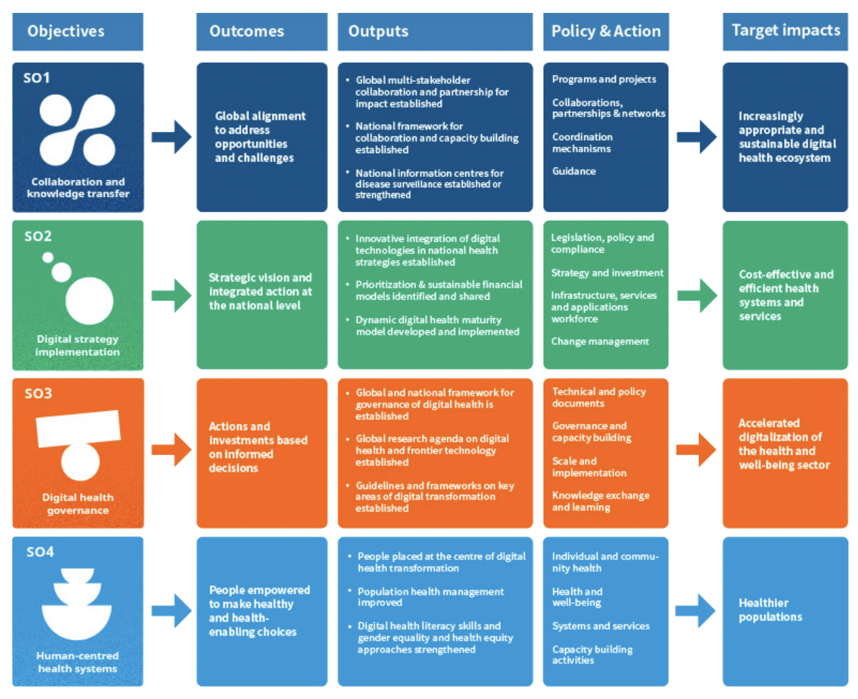

Fig: Summary implementation of the action plan of WHO’s 13th General Programme of work (WHO, 2021).

