International Hotel Management
BMMB7004
Environmental Sustainability in Hospitality Industry
Portfolio on Environmental Sustainability

Omica Charles
2113120

Environmental Experience
During the current Covid-19 pandemic, on April 9th, 2021, the La Soufriere Volcano began erupting in St. Vincent and the Grenadines. Due to this almost twenty thousand (20,000) people were displaced, destroying the livelihoods of Vincentians and having a negative impact on the environment of other Caribbean Island even to different states in Caribbean Mexico. This has cause people to relocate to Caribbean countries by boat because of the lack of air travel because of the effect the ash had on the atmosphere. The recurring explosions, ashfall, and pyroclastic flows destroyed crops and livestock, causing humanitarian needs, and having a significant impact on the environment.
Additionally, the eruption had produced hazardous effects for the environment, climate, and the health of the exposed persons but I will say that persons that were affected are those who chose to live the volcanic eruption as an experience. This is to say that there were persons in the restricted area or red zones that did not leave because of stubbornness or for experience purposes. However, during the eruption coast guards and police had to risk their lives and health to save those who did not wanted to leave the dangerous areas. Due to the ash fall in the atmosphere houses were destroyed. Further effects were deterioration of water quality where the country was out of pipe borne water for a few weeks, livestock damages, and the destruction of vegetation which caused the farmers to start anew. Moreover, the severe condition in the country Heavy rainfall in late April brought major flooding, landslides, and mud flows, posing an additional hazard concern to a vulnerable community, and further ruining their houses and other infrastructures.
On the other hand, the environment of the country was affected for months. Cleaning up after volcanic ash was really challenging, anything was contaminated. When the ash was dried it was blown by the wind, contaminating other areas as it spreads. While, wet ash, on the other hand, sticks to cement-like surfaces cause damages to clean. According to U.S. Geological Survey (NA) Climate change can be impacted by volcanoes with huge quantities of volcanic gas, aerosol droplets, and ash are injected into the stratosphere during massive explosive eruptions. Most of the injected ash dissipated from the stratosphere in a matter of days to weeks, having negligible influence on climate change. While volcanic carbon dioxide, a greenhouse gas, can contribute to global warming, volcanic gases such as sulfur dioxide can contribute to global cooling.

Reference:
Volcanoes Can Affect Climate | U.S. Geological Survey. (n.d.). https://www.usgs.gov/programs/VHP/volcanoes-can-affect-climate
Eruption at La Soufrière. (2021) Nasa Earth Observatory. https://earthobservatory.nasa.gov/images/148176/eruption-at-la-soufriere

Appendices
Appendix 1
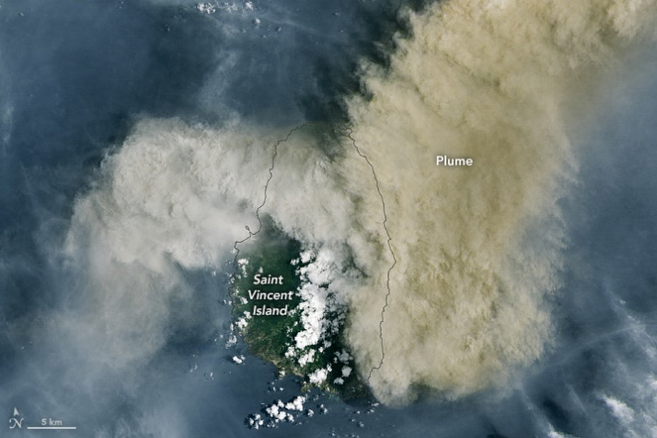
A picture showing the volcanic ash spreading over St. Vincent and the Grenadines (Nasa Earth Observatory, 2021)

Appendix 2
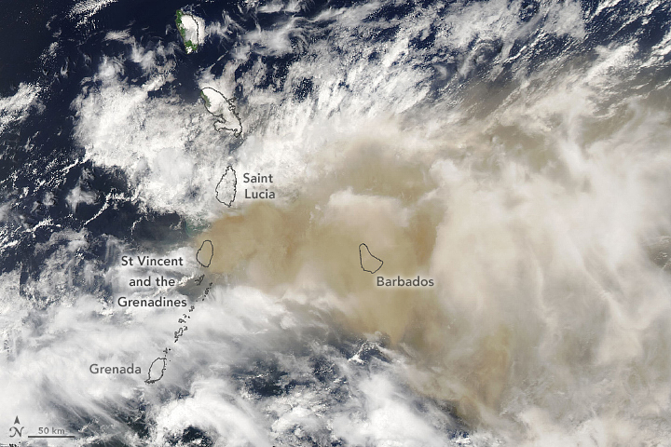
A picture showing the volcanic ash spreading across the Caribbean (Nasa Earth Observatory, 2021)

Fiscal and Economic Incentives
Most human activities generate waste (Brunner and Rechberger, 2014). Whilst wastes have also been defined as any product or material which is useless to the producer (Basu, 2009). Although, the countries in South Asia can benefit from the income created due to importation of plastic to their countries they have declined the number of plastics entering the same. According to World Bank (2021) the plastics manufacturing industry is a growing and dynamic sector in Malaysia, contributing US$7.23 billion to the national economy in 2018 (4.7% GDP). The continuous growth of the sector has helped Malaysian society in several ways. Nonetheless, poorly managed plastic trash, pollution from land-based sources, and inadequate infrastructure have a significant impact on marine life and the well-being of populations along Malaysia's beaches.
In contrast, according to Daniele, U., & Regan, H. (2019), Malaysia will return 450 tonnes of contaminated plastic waste to the countries that shipped it, in a refusal to become a dumping ground for the world’s trash. Whilst, according to CBC (2019) to In June, Indonesia sent back about one hundred tonnes of paper waste imported from Canada via the U.S. because it was contaminated with plastic and rubber. Additionally, due to contamination with items including plastic, rubber, and diapers, Indonesia has sent back a shipment of Canadian paper trash that was imported via the United States. Indonesia is the latest Southeast Asian country to send back waste amidst a spike in imports from Western countries after China banned imports, disrupting the global flow of millions of tonnes of waste each year. (Staff, 2019)
Therefore, the countries in South Asia need to protect the environment because plastic garbage can pollute both the water and the land, the ecosystem must be protected. Plastic pollution has a harmful effect on the ecosystem, harming both flora and fauna as well as the human population. Thus, the environment should be preserved for future generations.

Reference:
Basu, R. (2009). Solid Waste Management-A Model Study. Sies Journal of Management, 6, 20-24.
Brunner, P. H., & Rechberger, H. (2014). Waste to energy—key element for sustainable waste management. Waste Management, 37, 3-12. https://doi.org/10.1016/j.wasman.2014.02.003
CBC(2019) Indonesian village wants Canada's trash, available at https://www.cbc.ca/news/world/indonesia-village-trash-canada-1.5249153
Daniele, U., & Regan, H. (2019). Plastic waste dumped in Malaysia will be returned to UK, US and others. CNN, available at https://edition.cnn.com/2019/05/28/asia/malaysia-plastic-waste-return-intl/index.html
Staff, R. (2019, June 17). Indonesia becomes latest Southeast Asian country to return waste to the West. U.S. https://www.reuters.com/article/us-indonesia-environment-waste-idUSKCN1TI19O
VNA. (2020, December 25). Indonesia to return hazardous waste to countries of origin | World | Vietnam+ (VietnamPlus). VietnamPlus, available at https://en.vietnamplus.vn/indonesia-to-return-hazardous-waste-to-countries-of-origin/193777.vnp
World Bank Group. (2021). Market Study for Malaysia: Plastics Circularity Opportunities and Barriers. World Bank, available at https://www.worldbank.org/en/country/malaysia/publication/market-study-for-malaysia-plastics-circularity-opportunities-and-barriers

Regulatory Affairs
This report highlights the regulatory affairs that was implemented by COP27. According to Cambridge dictionary (2022) regulatory affairs is an area of work that involves responsibility for checking whether a business is following official rules or law. These laws were implemented to preserve the world through sustainable development for the future generations to appreciate.
According to Abdel Fattah El-Sisi (2022) the United Nations Climate Change Conference COP27 is an opportunity to showcase unity against an existential threat that we can only overcome through concerted action and effective implementation. Additionally, the 27th session of the Conference of the Parties (COP 27) to the UNFCCC took place in Sharm El-Sheikh, Egypt. This initiative aims to bring together government and non-party stakeholders in order to reduce greenhouse gas emissions and create an equitable transition to a net-zero economy that alleviates poverty and ensures a sustainable future.
According to Simon Stiell (2022) one of the initiatives that strengthened action by countries is to cut greenhouse gas emissions and adapt to the inevitable impacts of climate change, as well as boosting the support of finance, technology and capacity building needed by developing countries. Secondly, governments took the ground-breaking decision to establish new funding arrangements, as well as a dedicated fund, to assist developing countries in responding to loss and damage. Thirdly, parties also agreed on the institutional arrangements to operationalize the Santiago Network for Loss and Damage, to catalyze technical assistance to developing countries that are particularly vulnerable to the adverse effects of climate change. According to United Nations Climate Change (2022) the vision of the Santiago Network is to catalyze the technical assistance of relevant organizations, bodies, networks, and experts, for the implementation of relevant approaches for averting, minimize and addressing L&D at the local, national, and regional level, in developing countries that are particularly vulnerable to the adverse effects of climate change.
Furthermore, COP27 witnessed significant progress on adaptation, with states agreeing on how to move forward on the Global Goal on Adaption (GGA), which was created in 2015 by the Paris Agreement with the goal of boosting collective action on climate adaptation. The GGA was expected to be the counterpart to the goal of limiting global temperatures to "well below 2°C" and 1.5°C, with the hope of elevating adaptation to the same level as mitigation; thus, this will conclude at COP28 and inform the first Global Stocktake, improving resilience among the most vulnerable.
These pledges will help many more vulnerable communities adapt to climate change through concrete adaptation solutions. Furthermore, discussions highlighted solutions on themes including food security, vulnerable communities and just transition to chart a path to overcome climate challenges and how to provide the finance, resources, and tools to effectively deliver climate action at scale.
Following that, via the five-year Action for Climate Empowerment action plan and the intermediate review of the Gender Action Plan, the decisions made underline the fundamental significance of enabling all stakeholders to engage in climate action. These goals will enable all Parties to collaborate to address participation imbalances and give stakeholders with the tools needed to achieve better and more inclusive climate action at all levels. Finally, existing national government promises put the globe on course for a 2.5°C warmer planet by the end of the century. According to the Intergovernmental Panel on Climate Change, greenhouse gas emissions must fall by 45% by 2030 in order to keep global warming to 1.5°C.
The following technology is one of the important outcomes of COP27, which saw the introduction of a new five-year work program to promote climate technology solutions in poor nations. Following that, COP27 greatly advanced mitigation activities. A mitigation work program was established with the goal of rapidly increasing mitigation ambition and execution. In addition, efforts to reduce unabated coal power and phase out wasteful fossil fuel subsidies must be accelerated. This resolution acknowledges that the unprecedented global energy crisis emphasizes the need to swiftly reform energy systems to make them more safe, dependable, and resilient, by speeding clean and fair transitions to renewable energy during this key decade of action.
According to General António Guterres announced that a USD 3.1 billion plan to ensure everyone on the planet is protected by early warning systems within the next five years. Followed by a G7-led plan called the Global Shield Financing Facility was launched at COP27 to provide funding to countries suffering climate disasters. Finally, significant progress on forest conservation was achieved with the creation of the Forest and Climate Leaders' Partnership, which aims to coordinate efforts by governments, corporations, and community leaders to end forest loss and land degradation by 2030.
Reference:
Cambridge Dictionary. (2022e). regulatory affairs definition available at https://dictionary.cambridge.org/dictionary/english/regulatory-affairs
COP27 Agreement (2022), United Nations Climate Change, available at https://unfccc.int/news/cop27-reaches-breakthrough-agreement-on-new-loss-and-damage-fund-for-vulnerable-countries
COP27 2022, COP27 Official, available at https://cop27.eg/#/speeches/president-speech
Definition of Global Goal Adaptation (2022) How to Raise the Glass on the Global Goal on Adaptation at COP 27: Four foundations to build upon, International Institute for Sustainable Development, available at https://www.iisd.org/articles/deep-dive/glass-global-goal-adaptation-cop-27
Definition of Santiago Network (2022) United Nations Climate Change, available at https://unfccc.int/santiago-network/about

Guest experience
According to Lodify (2012) guest experience is defined as the interactions you have with your guests from before they check-in to after they leave. This is an overall level of contentment that people experience when interacting with a hospitality organisation. The United Nations Brundtland Commission defined sustainability as “meeting the needs of the present without compromising the ability of future generations to meet their own needs. While the UN World Commission on Environment and Development (1987) “sustainable development is development that meets the needs of the present without compromising the ability of future generations to meet their own needs”.
According to Accor (2011) the Planet 21 program was introduced which set objectives for 2015 and reinforced the Groups determination to put sustainable development at the heart of its activities. Planet twenty-one (21) is a continuously evolving program with a framework that allows Accor to learn from best practices, challenges, and trends to include these and strengthen the program for the following years. This framework allows Accor and its hotels to measure and improve its sustainability performance long-term with specific goals. The strength of the program resides in the clear expectations that have been outlined for the upcoming years.
One of the goals that Accor introduced is a program called Planet 21 Its first goal is to plant for the earth, which is a physical manifestation of its concept of positive hospitality and dedication to decreasing their environmental imprint. This initiative encourages visitors to reuse their towels and linen rather than laundering them every day when staying for numerous nights; in exchange, Accor finances tree planting with half of the laundry savings created by water, electricity, and detergent. Accor has also encouraged its hotels to purchase supplies from farmers who have implemented agro-ecological practices for guests, and visitors will be able to discover food in hotel restaurants from farms where they have supported tree planting through civic gestures.
Second, the objective of the Healthy & Sustainable Food Charter, which was created to foster an appetite for healthy, sustainable food and a waste-free diet. The charter's response to current food, health, and environmental issues is audacious. This allows the hotels to fight food waste, protect our guests' health, and source sustainable products.
Thirdly, the sole use plastic commitment was announced in 2020 with the goal to join the UN Global Tourism Plastics Initiative to remove all single-use plastic items in guest experience from its hotels by the end of 2022. According to UNWTO (2020) the Global Tourism Plastics Initiative unites the tourism sector behind a common vision to address the root causes of plastic pollution. It enables businesses, governments, and other tourism stakeholders to lead by example in the shift towards a circular economy of plastics. This is intended to reduce environmental damage and boost efforts to tackle plastic pollution in the world's seas and other natural ecosystems. It is a big step forward for the global hotel sector and the firm, which has been devoted to sustainability for many years. As a result, the Accor group created a new keycard that would give consumers with a keyless door access solution while guaranteeing that hotels retain the personal touch that visitors demand. (Group Accor, 2021)
Additionally, Patrick Mendes (2021) stated “We are thrilled to announce the launch of “Accor key” within our entire network. Making contactless and seamless guest experiences a reality is a priority for Accor. “Accor key” is a notable example of how the Group can build solutions and deploy them efficiently in all Accor operating countries.” Whilst Floor Bleeker (2021), said “We always strive to adopt technology which can improve the overall guest experience. Guests increasingly seek contact-light travel and hotel experiences. Therefore, the easy to operate and highly practical application will provide a streamlined process for our guests.” (Group Accor,2021)
Fourthly, the objective is to fight against the sexual exploitation of children in the hospitality sector. Accor developed a program called WATCH which aims to raise awareness about the issue of child sexual exploitation through the alertness of employees during suspicious situations. Therefore, guest will be comfortable while staying at the hotels because of the protection its offering. (Accor Planet 21 , NA) Finally, diversity, equity & inclusion is a mindset which is embedded into the culture of the company. The company ensure that Accor is a safe, welcoming place where ALL guests are offered equal opportunities, experiences, and voice. For example, Accor’s hotels are Proud Certifies because they are committed to offer inclusive hospitality to the LGBTQIA+ guests, therefore, everyone is welcome to the hotel to be whomever they want to be. (Group Accor,2021)
Reference:
Accor 2021 Sustainability, available at https://www.sofitel-los-angeles.com/wp-content/uploads/sites/8/2021/12/Accor-Sustainability-Sofitel-LA.pdf
Amenities (2021) Accor group available at https://group.accor.com/en/Actualites/2021/02/digital-key-solution
Diversity and Inclusion (2021) Group Accor available at https://group.accor.com/en/Actualites/2021/06/diversity-inclusion-week
Global tourism plastics initiative. (2020) UNWTO available at https://www.unwto.org/sustainable-development/global-tourism-plastics-initiative
Lodgify 2021, What Is Guest Experience: Lodgify Encyclopedia, available at: https://www.lodgify.com/encyclopedia/guest-experience.
UCLA Sustainability 2022, what is Sustainability, available at:
https://www.sustain.ucla.edu/what-is-sustainability/
United Nations, Academic impact, 1987, available at: https://www.un.org/en/academic-impact/sustainability.
WATCH (NA) Accor Planet 21. https://accorhotelscomms.com/newsletter/luxe/2019/issue_02/spotlight-pdfs/Accor-Planet21.pdf

Brand image
According to the American Marketing Association (AMA) defines brand as a “name, term, design, symbol, or any other feature that identifies one seller’s good or service as distinct from those of other sellers,” while brand image is defined as a “perception of a brand in the minds of persons[...]. It is what people believe about a brand – their thoughts, feelings, expectations” (AMA). While Brand image represents the emotional aspects that identify the brand of a company or its products and has a powerful impact on consumer buying behavior (Arora & Stoner, 2009).
According to Fashion Beta (2022) H & M Hennes & Mauritz AB (H&M) is a Swedish multinational retail-clothing company, known for its fast-fashion clothing for men, women, teenagers, and children. H & M Hennes & Mauritz AB comprises six independent brands: H&M, COS, Monki, Weekday, Cheap Monday and & Other Stories. Founded in 1947, H&M’s design team creates sustainable fashion following a low-cost principle.
According to H&M Group (2022) its material ethics commitment is to source raw materials in a sustainable manner, considering both social and environmental implications. Raw material manufacturing and procurement must be in conformity with both local regulations, as well as international standards and must not contribute to deterioration or destruction of ecosystems and biodiversity. Securing the supply of raw materials from an ethical standpoint is an incredibly essential aspect of H&M Group's business model. They are dedicated to ensuring that the natural raw materials used in their goods are produced in a way that promotes to sustainable development, respects human rights, safeguards natural resources, and contributes to the preservation of biodiversity.
No vulnerable or endangered animals may be used. Suppliers of natural raw materials must follow all relevant environmental, health and safety, labor, and social laws and regulations, as well as appropriate land tenure and use rights. The corporation does not allow any wood or other forest-derived products, including manufactured cellulosic fiber, to come from ancient and endangered forests, or from forest practices that harm high conservation values. No endangered or vulnerable animals may be used in the manufacture of our products." Furthermore, the company's mission is for all its materials to have an influence on our world, from manufacture to usage to end of life and disposal. As a result, to lessen our environmental effect, the goal is for 100% of the materials to be recycled or sourced in a more sustainable manner.
On the other hand, H&M have a Conscious choice which stated pieces created with a little extra consideration for the planet. Each Conscious choice product contains at least 50% of more sustainable materials like organic cotton or recycled polyester but many contain a lot more than that (H&M, 2022). Although, the company is environmentally conscious it is said that it’s for marketing purposes only because they are making no significant sustainability efforts. Therefore, this is considered greenwashing which is an “umbrella term” for behaviors that mislead consumers regarding the organization’s environmental performance (Lyon and Montgomery 2015).
On contrast, Webster’s New Millennium Dictionary of English (2022) define greenwash as “practice of promoting environmentally friendly programs to deflect attention from an organization’s environmentally unfriendly or less savoury activities”. In 1999 the term was added to the Concise Oxford English Dictionary, that defines it as: “Disinformation disseminated by an organization so as to present an environmentally responsible public image; a public image of environmental responsibility promulgated by or for an organization, etc., but perceived as being unfounded or intentionally misleading”.
According to Materia Rinnovabile 2022, H&M has come under formal accusation for greenwashing. The plaintiff was American marketing student Chelsea Commodore, who took the case to federal court in New York last July. The subject of the class action lawsuit brought by the plaintiff are the Conscious Collection clothing, created, according to the brand's claims, "with the planet in mind," but, according to what Commodore and others says, far from sustainable.

Reference.
American Marketing Association (2022) Branding available at: https://www.ama.org/topics/branding.
Arora R. & Stoner Ch. (2009). A mixed method approach to understanding brand personality. Journal of Product & Brand Management, 18(4), 272-283.
Fashion ABC Beta (2022) the company H&M available at https://www.fashionabc.org.
H&M Group (2022) Materials available at https://hmgroup.com/sustainability/circularity-and-climate/material
H&M (2022) Conscious choice explained, available at https://www2.hm.com/en_us/sustainability-at-hm/our-products/explained
Lyon, T. P., & Montgomery, A. W. (2015). The means andend of greenwash. https://doi.org/10.1177/1086026615575332
Materia Rinnovabile (2022) (Un)sustainable fashion: H&M is being sued for greenwashing, available at https://www.renewablematter.eu/articles/article/unsustainable-fashion-h-and-m-is-being-sued-for-greenwashing
Merriam-Webster: America’s most-trusted online dictionary (2018) https ://www.merriam-webster.com. Accessed 9 July 2018
Oxford English Dictionary (2018) https://www.oed.com/. Accessed 8 July 2018

Appendices
Figure 1
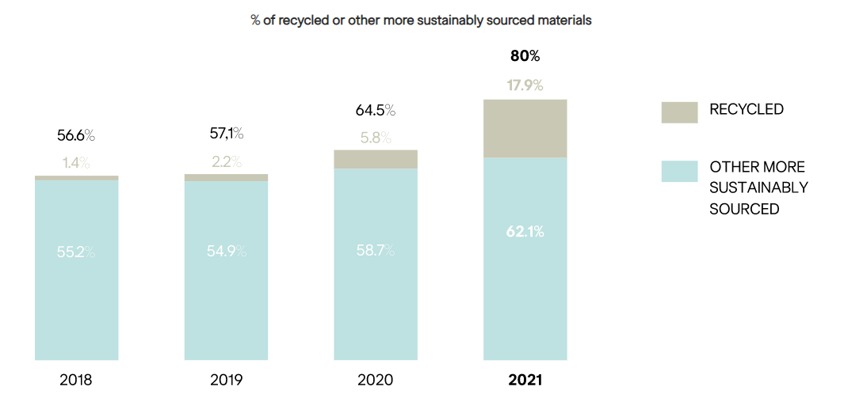
The graph shows the percentage of recycles and other sustainable sourced materials

Staff Awareness
Employers should develop staff awareness of what is steering the requirement for sustainable practices, processes, and behaviors in the hospitality sector all over the world. It is essential that you provide them with a detailed understanding of how the use of energy, water, and certain materials is unsustainable and contribute significantly to the climate crisis; why it is important to start initiatives now and evaluate their impact; and how sustainability supports the well-functioning of the world, resource conservation, better human health and well-being, and the industry's continuity and growth. According to Task Management Guide (2022) employee awareness is a level to which an employee knows certain policies, situation, documents, or any other valuable information. While 1987, the United Nations Brundtland Commission defined sustainability as “meeting the needs of the present without compromising the ability of future generations to meet their own needs.”
Hotels are seeking to introduce policies that are sustainable and consider their employees' knowledge, awareness, is of vital importance. In Mexico, the Xcaret group has implemented a sustainability model that allows them to easily communicate actions aimed at the performance of a prosperous business, the generation of social welfare, and the conservation of the environment, all of which are based on three pillars known as the "3P": people, planet, and prosperity. The activities' reach may be seen from two perspectives: internal and external. The internal category covers all acts carried out within the firm that are connected to the growth of the business, while the external category contains all actions that have an influence on the environment in which the organization works. (Group Xcaret, 2018)
Grupo Xcaret was started in 1990. It is a 100% Mexican corporate group and leader in sustainable touristic entertainment. Its history reveals its commitment by offering unforgettable experiences based on respect for nature, deep love for life and a great admiration for Mexico (Grupo Xcaret 2022).

Nestled in the heart of Riviera Maya, Mexico, the 401-room Fairmont Mayakoba is a AAA Five Diamond resort set on forty-five (45) acres within a private, luxury community. Surrounded by a lush mangrove forest intersected by clear canals. A dedication to a green philosophy has earned Fairmont Mayakoba the Rainforest Alliance Verification among other eco-accolades. (Luxury travel Magazine, 2022)
A team of Fairmont Mayakoba colleagues who are enthusiastic about caring for the environment meet regularly to coordinate an extensive sustainability program of activities and events. They coordinate Fairmont Mayakoba’s involvement in international celebration days like Earth Day and play a vital role in communicating our work to a wider audience and helping to raise colleague awareness. Also, the hotel offers employee training which is a permanent training program for colleagues including Mayan culture, charity projects, local traditions, cultural heritage sites, environmental and sustainability training is mandatory for new colleagues.

References
Grupo Xcaret (2022) Hoteles Xcaret available at https://www.hotelxcaret.com/en/group-xcaret-history

Fairmont Mayakoba Riviera Maya, Mexico (2022) Luxury Beach-Golf-Spa Resort. Retrieved from https://www.luxurytravelmagazine.com/property/the-fairmont-mayakoba
FAIRMONT SUSTAINABILITY - Fairmont Mayakoba. (2022). Retrieved from https://www.fairmont-mayakoba.com/home/guest-directory/fairmont-sustainability/
Task management guide(2022) What is Employee Awareness available at http://www.taskmanagementguide.com/glossary/what-is-employee-awareness-.php
United Nations, Academic impact, 1987, available at: https://www.un.org/en/academic-impact/sustainability.

Appendices
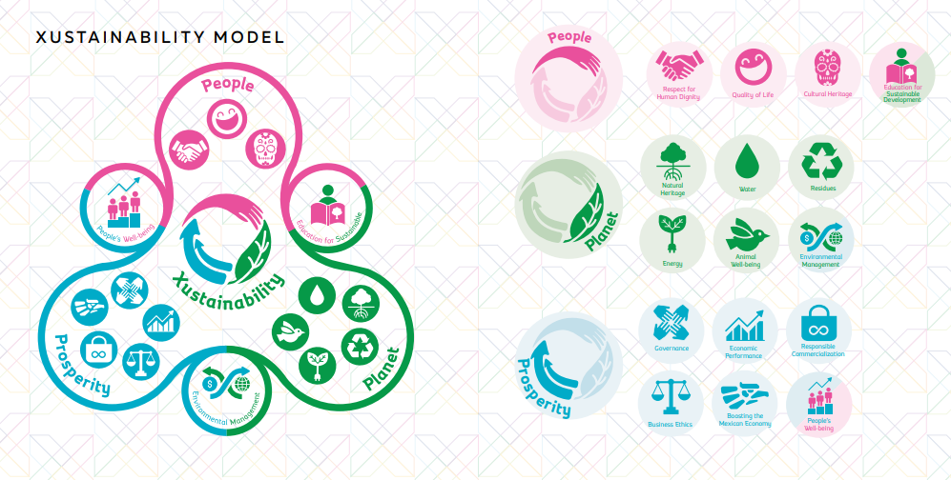
Figure 1 shows Xcaret sustainable model that is applied to the work place.

Essay Influencer
Social media inﬂuencers represent a new type of independent third-party endorser who shape audience attitudes through blogs, tweets, and the use of other social media. (Gorry & Westbrook, 2009).
According to World Life Fund (NA) Leonardo DiCaprio is an actor, environmentalist, and philanthropist. He established the Leonardo DiCaprio Foundation in 1998 to assist groups and activities devoted to ensuring our planet's long-term viability. Since then, Leonardo has developed long-term relationships with some of the world's greatest leaders and thinkers, remaining constantly engaged and active on the most pressing issues we face, including climate change, access to clean water, biodiversity protection, ocean conservation, and disaster relief.
On the contrary, United Nation (2014), stated Leonardo DiCaprio, an Academy Award-winning actor, has been an ardent campaigner for environmental causes for most of his career. Mr. DiCaprio founded his organization in 1998, at the age of twenty-four, with the purpose of safeguarding the Earth's last wild areas and implementing solutions to foster a more harmonious connection between mankind and the natural world. Mr. DiCaprio has campaigned to raise awareness and funds for biodiversity conservation, ocean and forest conservation, and climate change mitigation through grantmaking, public campaigns, and media ventures. DiCaprio received the coveted Clinton Global Citizen Award in 2014 for his charitable contributions.
According to Vogue (2021) the Leonardo DiCaprio foundation aims are protecting the world which includes the protection of the Nepal tigers, the reforestation of Brazil's Atlantic forest and the reintroduction of jaguars in Argentina, to the fight against elephant poaching in Gabon, the introduction of the world’s largest marine reserve in the Pacific and the protection of the largest tropical rainforest in Indonesia, the LDF are very active in their fight for all Earth’s inhabitants with more than 70 projects currently underway in more than 40 countries, 5 oceans and with over 65 environmental partners.
Additionally, the successful missions of the foundations are wild tigers which is after 100 years of constant decline, WWF announced that the number of tigers in the wild rose for the first time in 2016, estimating that there are now upwards of 3,890 wild tigers, which was predicted to double from then to 2022. This is a notable success for the foundation following their donation of $6.2 million dollars to WWF to help the cause. (Vogue, 2021)
However, one of Leonardo Di Caprio goal is to build an ecofriendly resort in the country of Belize. According to iexplore (NA), The actor refers to this as a "Restorative Island," and he intends to establish the world's greenest luxury property. His ambitious plan, "designed to promote the biological health of species on the island and in the waters around it," involves the construction of artificial reefs with "fish shelters" and nurseries for marine grass, manatees, and mangrove trees. The objective is to help restore equilibrium to an environment that has been harmed by years of overfishing, deforestation, and a receding shoreline.
The hotel will be powered entirely by renewable energy and will have programs centered on health, wellbeing, and sustainability. From locally grown foods to in-house water treatments, every green aspect will be included to lessen its carbon impact. A research station for ongoing restoration initiatives and global climate change will also be located on the property.
Reference:
Vogue (2021). Six ways Leonardo DiCaprio is protecting the planet. Vogue France. https://www.vogue.fr/vogue-hommes/culture/diaporama/five-ways-leonardo-dicaprio-is-protecting-the-planet/31057
Gorry, G. A., & Westbrook, R. A. (2009). Winning the internet conﬁdence game. Corporate Reputation Review,12(3), 195–203
iexplore (NA) Leonardo DiCaprio is Building the Greenest Hotel in the World on His Private Island. Avaliable at https://www.iexplore.com/experiences/ecotourism/leonardo-dicaprio-blackadore-cave-restorative-island
Leonardo DiCaprio | Leaders | WWF. (n.d.). World Wildlife Fund. https://www.worldwildlife.org/leaders/leonardo-dicaprio
United Nations. (2014). Leonardo DiCaprio. https://www.un.org/en/messengers-peace/leonardo-dicaprio

Reflection Group Work
The group work we were assigned to do was to create a hotel in Bali, Indonesia. The eco-friendly hotel will have twenty rooms for guest, and we wanted to ensure that the customers get the comfort that they are looking for as well as a chance to incline with nature. According to the Cambridge Dictionary (2022), being eco-friendly means being ‘designed to have little or no damaging effect on the environment’. The hotel will be called ‘Bamboo Greenhouse.’ The reputation of the hotel is to be surrounded rice fields and jungles which emphasize the traditional beauty of the country. The hotel will be in a rural zone called Ubud to encourage local tourism. This will develop the local area by employing villagers to work at the hotel, tourist and hotel can shop local. Also, this can develop infrastructure such as schools, hospitals, and roads. We will use environmentally friendly materials to build the hotel. These materials include placing solar panels on the hotel's roof or exterior walls to lessen your reliance on environmentally detrimental fossil fuel electricity.
Then, we will choose double or triple glazing for all your hotel's glass doors and windows. Our guest rooms will be quieter and warmer as a result, requiring less heating and costing us less money. We will utilize LED lighting throughout your hotel because it hardly uses any energy and offers quality lighting to standard light bulbs. Sustainable bamboo or wood will be used in our rooms. For the curtains and bedding, we will utilize organic materials and recycled metals. We will use bamboo toothbrushes and toiletry dispensers as amenities, decrease plastic waste, and provide glass and reusable cups. Also, our key card will be durable and environmentally friendly. It will be constructed of bamboo and feature the hotel's name and emblem. The hotel will be paperless which means we will use applications in preparation of visitors as the necessity for paperwork in the form of documentation and receipts has decreased due to technological advancements. Additionally, our main priority is to serve delectable, organic, and healthful food at your hotel. as a result, we will be buying locally grown, organic food can increase the nutritional value and lower the carbon footprint of our hotel. The hotel aim is to lessen its influence on the environment by recycling our waste. This will be a standard in our hotel which will encourage support to improve and protect the environment.
Finally, our mission of the hotel is to sensitize tourist of the importance of supporting environmentally friendly alternatives especially in places such as Bali in which nature plays a vital role and must be respected. Therefore, the ecosystem will profit from the construction of this eco-friendly hotel because it will reduce trash and energy used while avoiding dangerous emissions. Also, we will work to make sure that this hotel adopts sustainable and environmentally friendly practices as the standard rather than the exception, which will help the environment.
Reference:
Cambridge Dictionary. (2022). eco-friendly definition available at https://dictionary.cambridge.org/dictionary/english/eco-friendly

