My Targets from previous assignment

Target 1 | Always obtain written permission from your placement if using evidence from PTE in your academic work and include this within the appendix.
Target 2 | Further develop your skills of critical reflection and analysis by considering the strengths and limitations of practice.
Target 3 | Proof-read thoroughly before submitting to improve organisation and punctuation, i.e. paragraphing and punctuation.

Cycle 1 Researching the Learning:
what, how and why am I teaching?

A critical analysis and evaluation of the observation research tool, “Leuven Scale’.

Amanda Gould Student number 1909545

Table of Contents

A critical analysis and evaluation of the observation research tool, “Leuven Scale’. 4
References 9
Appendix 1. The Leuven Scales for Well-being and Involvement. 13
Appendix 2. Yr Athrofa Research Dispositions. 14
Appendix 3. My observation schedule. 15
Appendix 4. A summary of the UN convention on the rights of the child. 16
Appendix 5. My completed observation schedule 17

A critical analysis and evaluation of the observation research tool, “Leuven Scale’.

In Wales the current curriculum is the Foundation Phase. It is for children ages three to seven. This curriculum encourages active learning where children are given real life experiences and opportunities to be creative and use their imaginations (Welsh Government, 2018). As a first year BA Primary Education student, usually I would attend a school to observe children and complete an observation schedule but in view of the current situation we are unfortunately unable to do this. We have been given a selection of videos in order to do a critical analysis and evaluation of the observation research tool “Leuven Scale’. I have chosen video number 3 and the research question for this video is “To what extent does the role play environment provide opportunities for pupil involvement and learning. In the video, the children are actively learning in a pretend travel agent’s shop. I believe this is good area to research because one of the qualified teacher status professional standards for teaching and learning is that a teacher needs to ensure learners are provided with opportunities to learn in real life authentic contexts (Welsh Government, 2019).

There are seven areas of learning in the Foundation Phase, they are taught in a cross curricular way. A role play area is often used for enhanced provision (Estyn, 2017). When in my placement school, I observed children playing in a number of roleplay areas, such as Counting castle and a school of the past, with old fashioned desks (School x, 2020). Enhanced provision is used to make children practise new skills and think deeper. It is used to support learning. Jean Piaget and Lev Vygotsky believed children need to be actively involved in their learning. Vygotsky believed social connections were important however Piaget believed children are curious and being actively involved, discovering new ideas encourages understanding and development (Gray and Macblain, 2015). In contrast to this, some may suggest learning does not always happen when you provide real life experiences and concrete examples because if the learner does not have enough subject knowledge then it could cause the learner to just fixate on an item and not make a connection (Weinstein, Sumeracki and Caviglioli 2019).

Research suggests classroom teaching is what that influences learning the most and professional teaching standards in Wales require excellent pedagogy at the centre of teaching and improvement in schools (Estyn, 2018). Research is important in teaching because it is a way of reviewing existing knowledge, creating new knowledge and exploring effectiveness so that we can ensure best practice (Moore, Neville, Murphy and Connolly, 2010). In agreement is a Welsh Government document entitled “Observing Children” (Welsh Government, 2008). This document explains the importance of teachers understanding children’s development and that by observing children when they are actively involved in their learning, we can find out what the children are able to do and how they are developing their skills. This could then be used in future planning. Professor Ferre Laevers carried out research into successful early learning and development. He believed there are two important aspects, well-being and involvement. He developed a five-point scale to assess this which he called the Leuven Scale and he believed the outcome of a process depends on the learner’s well-being and involvement (Earlylearninghq.org.uk, 2013). Learners are given a score depending on the levels of their involvement and well-being. It is suggested that use of this scale can give a measure of effectiveness of learning (Laevers, 2011) (See appendix 1). The Foundation Phrase in Wales, builds upon prior knowledge and aims for learning to be meaningful. Professor Laevers believed children learn when they are actively involved in something that interests them and they have deep concentration, he called this “Involvement” (Welsh Government, 2008). In contrast to this, Parten believed children learn in stages and she called this “Stages of Play” (Bernstorf, 2012). Her theory suggests she does not agree with Ferre Laevers. Her stages of play explain how involvement is not necessarily needed for a child to learn and when a child is not taking part it does not mean that he is unaware of what is going on, so there still may be an element of learning from watching and listening. She also believed children who have additional learning needs may need opportunities to be onlookers before they feel they can do the activity themselves. A child maybe shy and feel more content playing independently, she believed this was normal in early years. This would contradict well-being and involvement on the Leuven scale (Bernstorf, 2012).

Professor Donaldson carried out a review of the curriculum and assessment arrangements in Wales. His Successful futures report identified that the new curriculum should be based on evidence, best practise and good research (Donaldson, 2015). I chose observation to carry out my research, because when observing you can see first-hand, what works and what doesn’t. You can then reflect and improve practice. In Reggio Emilia schools they have a pedagogy of listening which is linked to being reflective, and as a teacher we should always reflect and improve our practise as part of our professional development (Appleby, 2009). Some may believe observation is an opportunity to record data reliably because you have witnessed it yourself (Eales-Reynolds, Judge, McCreery and Jones, 2013). Another advantage of observation is it can be linked closely to assessment and planning, it can help with assessing children’s development and a teacher’s practice and it is a great tool for being able to obtain information to pass on to parents (Grigg, 2010). There are a number of types of observations. I used an observation schedule and I focused on qualitative data by using the Leuven Scale. It is suggested that gathering data this way, visually yourself could be more accurate, however some may say that this approach can be unreliable and non-factual (Burns and Sinfield, 2016). Other forms of observation are narrative observation and critical incident. When using narrative observation, the observer records everything that happens, this offers positives such as you will have comprehensive detailed account, however information can be taken out of context if interpreted wrongly because it is open to bias. The observer may also miss information which is relevant, this could change the end result and data may then be inaccurate, it is also difficult to note down everything because classrooms are so busy (Palaiologou, 2008).

When planning and creating my observation schedule, I adhered to Yr Athrofa research dispositions (See appendix 2). I included space to explain the context of the lesson, but I ensured that my observation schedule was anonymous as I am aware of the importance of confidentiality to ensure there is no way participants can be identified. Not respecting this may result in the wrong persons gaining private information (BERA, 2018). I used both the well-being and Involvement Leuven Scales, because I wanted to have a holistic approach. I feel this is a strength because it is suggested that we should look at the holistic development of children (Meggitt, 2012). I have however, decided for future observations when in a classroom, I may create two separate schedules to conduct my research, one for well-being and one for involvement to be able to make more notes on each specific area and reduce risk of missing information. I included a brief description of each point of the scale as a reminder. This helped me when deciding scores, however sometimes I still felt indecisive, which made me question how accurate this is? Another observer may mark higher or lower. In agreement with my concerns are New Zealand government guidelines which also suggests that different people can interpret things differently when doing an observation. NSW Government believes an observation team is important, they do trial runs to ensure everyone is consistent. So perhaps working with another student or the teaching assistant may result in more accurate data (New South Wales Government, 2019). (See appendix 3 for my observation schedule).

When conducting research, it is important to be ethical. The research may involve the lives and feelings of the people involved so it is important to ensure that the participants know what you will be doing with your findings and also there is the risk they may not agree with your interpretation. In view of this there is a requirement to submit proposals to an ethics committee before you proceed with an observation for research (Moore, Neville, Murphy and Connolly, 2010). Informed consent needs to be obtained prior to observation. The participant must keep on consenting. When I conduct an observation for research, I will provide participants with an information sheet and a consent form to ensure I am being ethical. The British Educational Research Association (BERA) (2011) explains that researchers must ensure they obtain consent from participants and make sure that participants know what they are engaging in and what will be done with the findings. It is also paramount that participants are informed that they have the right to withdraw at any stage (Ramrathan, Le Grange and Shawa, 2017). The best interest of the children needs to be the main consideration and children that are able to express their own views must be allowed to do this. An observer must obtain assent from children and take into account the UNCRC United Nations Convention on the Rights of the Child (UNICEF, 2020) (See appendix 4). There are many ways to obtain assent, examples such as the use of stickers or coloured aprons but if the child changes apron colour or if their body language shows that they do not want to be involved then you cannot use the information. For Foundation Phase research we should obtain consent from parents and assent from learners.

My findings have been positive because I observed more than one child and I used both the well-being and involvement Leuven Scales, therefore observing with a holistic approach. Whilst I feel that the Leuven Scale is a great tool for giving us an idea of if practice works and how children learn I do not feel it is sufficient enough to use the Leuven Scale as an observation tool on its own. Two of the children interacted well with each other. They were confident, asked good questions and expressed their feelings. They scored quite high overall. However, it could be argued that were they generally more confident children? Child 3 did not join in as much, she mostly just listened and watched. Using the Leuven Scales this scored her much lower than the other two children. However, children can change on a daily basis so maybe a one-off observation is not accurate? The child who scored low could be a shy child or a child who prefers to observe before taking part as suggested by Parten (Bernstorf, 2012). Another theory which maybe relevant here is that Vygotsky believed learning occurs with use of scaffolding. It could be that child 3 needs to be shown how to play with the items and how to speak in a travel agent shop. Maybe she has not played in this area before? Watching a more capable other, she could possibly score higher in well-being and involvement the next time she is in this area (Pound, 2014). Another suggestion could be that a child scores lower because of lack of interest if they are not be being challenged enough which would then impact learning negatively. It could even be that a child has things happening at home which may cause distraction. There could be a number of reasons for the way the children behaved in the observation. (See appendix 5 for my completed observation schedule).

I carried out an observation with use of the Leuven Scale and I critically analysed and evaluated this. It could be suggested that the Leuven Scale may work very well if you are making an assessment of a particular child or children that you are concerned about. I believe more so if you know more about the child / children too. You could focus on a child and observe, assess and reflect and it will give you a deeper understanding and you can then change planning in response to your findings. I feel it is a good tool for that, however I believe that to obtain more reliable data you need a mixed method approach where you can collect and analysis qualitative and quantitative data in order to strengthen your studies and your conclusion. Studying for this module has transformed my practice because I now understand the importance of being sceptical and ethical in research. I am looking forward to carrying out research as a participant observer, being fully involved in the classroom. A question I would like to research in the future is “Does teaching children in large groups benefit their overall learning? My interest in this is because when on placement I taught a lesson to half the class and I reflected and changed my practice before teaching the second half of the class and this worked better so I would like to research this area further.

References

Appleby, K. (2009) Children’s Learning and Development. Available at:
https://uk.sagepub.com/sites/default/files/upm-assets/29215_book_item_29215.pdf (Accessed: 9 May 2020).

Burns, T and Sinfield, S (2016) Essential Study Skills. London: Sage.

British Educational Research Association (BERA) (2018) Ethical Guidelines for Educational Research. Available at: https://moodle.uwtsd.ac.uk/pluginfile.php/362316/mod_resource/content/1/BERA-Ethical-Guidelines-for-Educational-Research_4thEdn_2018.pdf (Accessed: 10 May 2020).

Bernstorf, E. (2012) Parten’s Levels of in Kodaly Teaching. P.7 and p.8. Available at:
https://web-a-ebscohost-com.ezproxy.uwtsd.ac.uk/ehost/pdfviewer/pdfviewer?vid=1&sid=7665d0ca-5a6b-483b-a130-36d8b6a3b8f1%40sdc-v-sessmgr03 (Accessed: 6 May 2020).

Donaldson, G. (2015). Successful Futures. Available at: https://gov.wales/sites/default/files/publications/2018-03/successful-futures.pdf (Accessed: 4 May 2020).

Eales-Reynolds, L-J, Judge, B, McCreery, E and Jones, P. (2013) Critical Thinking Skills for Education Students. 2nd Ed. London: Sage.

Earlylearninghq.org.uk (2013) Communication, language and literacy: Planning your learning environment. Available at: https://www.earlylearninghq.org.uk/earlylearninghq-blog/the-leuven-well-being-and-involvement-scales/?fbclid=IwAR2deuBB9ywUHdCfokyXGb9KKlsYGoxQgWoCfVecavZXzMnIqHQcXdHEG9g (Accessed: 12 May 2020).

Education Scotland (2018) Involvement and Well-being as a measure of quality learning processes and provision. Available at: https://blogs.glowscotland.org.uk/gc/public/gccleadersofearlylearning/uploads/sites/7271/2018/12/Ferre-Laevers-SICS-for-LPAS.pdf (Accessed: 6 May 2020).

Estyn (2017) Active and Experiential learning. Available at:
https://www.estyn.gov.wales/thematic-reports/active-and-experiential-learning-effective-foundation-phase-practice-delivering (Accessed: 6 May 2020).

Estyn (2018) Improving teaching. Available at: https://www.estyn.gov.wales/sites/www.estyn.gov.wales/files/documents/Improving%20teaching.pdf (Accessed: 5 May 2020).

Gray, C and Macblain, S. (2015) Learning Theories in Childhood. 2nd Ed. London: Sage.

Grigg, R. (2010) Becoming an outstanding primary school teacher. Harlow: Pearson.

Leavers, F. (2011) Encyclopaedia on Early Childhood Development. Available at: http://expertisecentrum.cego.be/wp-content/uploads/2019/07/Laevers_2011_ChildEncyclopedia.pdf (Accessed: 9 May 2020)

Meggitt, C. (2012) Child Development. An Illustrated Guide. 3rd Ed. Harlow: Pearson.

Moore, S. Neville, C. Murphy, M and Connolly, C. (2010) The Ultimate Study skills Handbook. Berkshire: Open university Press.

New South Wales Government (NSW.gov) (2019) Observation: a guide for use in evaluation. Available at: https://education.nsw.gov.au/teaching-and-learning/professional-learning/evaluation-resource-hub/collecting-data/observation/step-2-prepare-the-tools-and-the-people (Accessed: 9 May 2020).

(Palaiologou, I. (2008) Childhood Observation. Available at: https://www-dawsonera-com.ezproxy.uwtsd.ac.uk/readonline/9781844455942 Exeter: Learning Matters ltd. (Accessed: 10 May 2020).

Pound, L. (2014) How children learn. Practical pre-school books: London.

Ramrathan, L, Le Grange, L and Shawa, L. (2017) Ethics in educational research. Available at: https://moodle.uwtsd.ac.uk/pluginfile.php/362318/mod_resource/content/1/Ethics%20in%20Educational%20Research%202017.pdf (Accessed: 10 May 2020).

School x. (2020)

UNICEF. (2020) A summary of the UN convention on the rights of the child. Available at: https://www.unicef.org.uk/wp-content/uploads/2010/05/UNCRC_summary-1.pdf (Accessed: 13 May 2020)

Weinstein, Y. Sumeracki, M and Caviglioli, O. (2019) Understanding how we learn. A visual Guide. Oxen: Routledge.

Welsh Assembly Government. Department for Children, Education, Lifelong Learning and Skills (2008) Learning and Teaching Pedagogy. Available at : https://hwb.gov.wales/storage/8f0b360f-f1f6-4bec-b11a-df88168007f9/learning-and-teaching-pedagogy.pdf (Accessed: 3 May 2020).

Welsh Government (2018) How is my child doing in the Foundation Phase? Available at: https://gov.wales/sites/default/files/publications/2018-06/how-is-my-child-doing-in-the-foundation-phase-a-guide-for-parents-and-carers.pdf (Accessed: 7 May 2020).

Welsh Government (2008) Observing Children. Available at: https://s3-eu-west-1.amazonaws.com/hwb-live-storage/a8/9c/a8/ee/f299432c801d025d875da415/observing-children.pdf (Accessed: 5 May 2020).

Welsh Government (2019) Professional standards for teaching and leadership. Available at: https://hwb.gov.wales/storage/19bc948b-8a3f-41e0-944a-7bf2cadf7d18/professional-standards-for-teaching-and-leadership-interactive-pdf-for-pc.pdf (Accessed: 3 May 2020).

YouTube Research question 3. Available at:
https://www.youtube.com/watch?v=yt69atPdg3I (Accessed 1 May 2020).

Appendices

Appendix 1. The Leuven Scales for Well-being and Involvement.
Lewis, A. (2020)
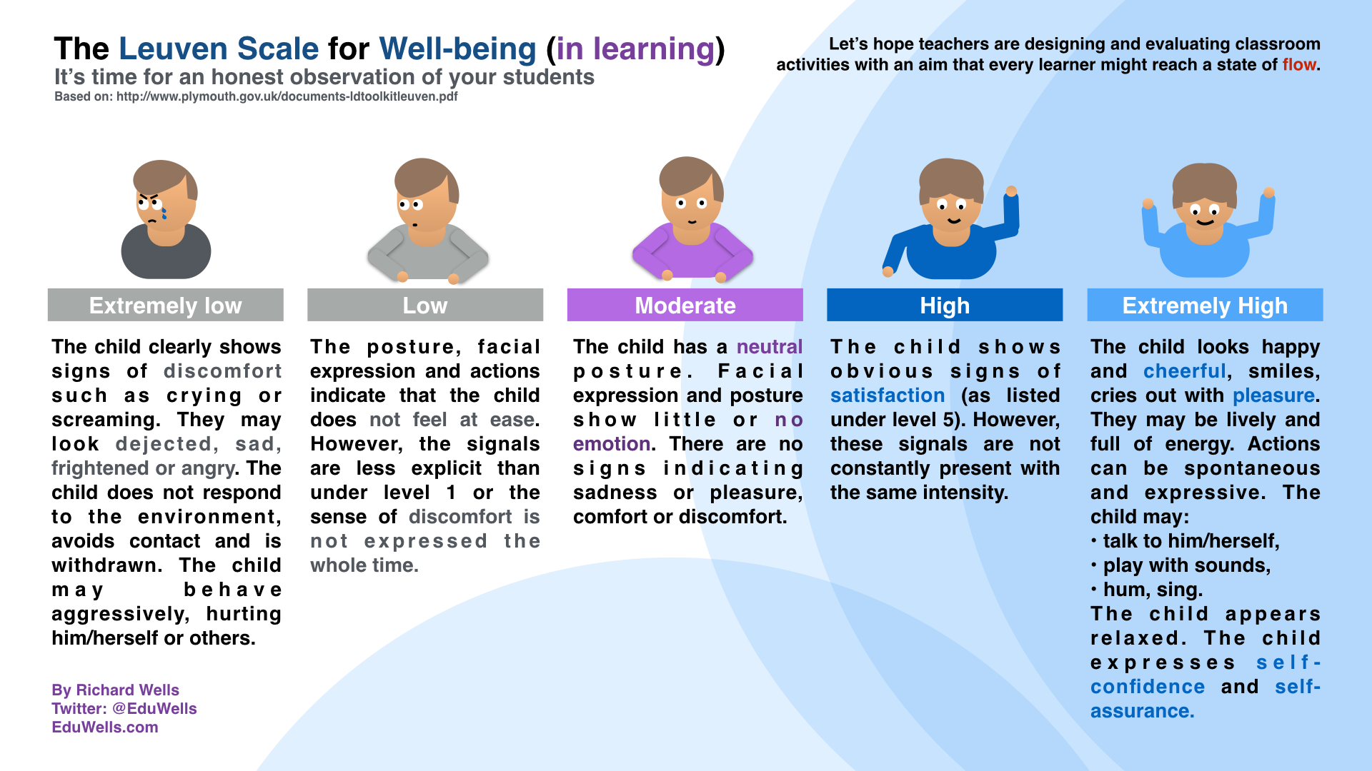

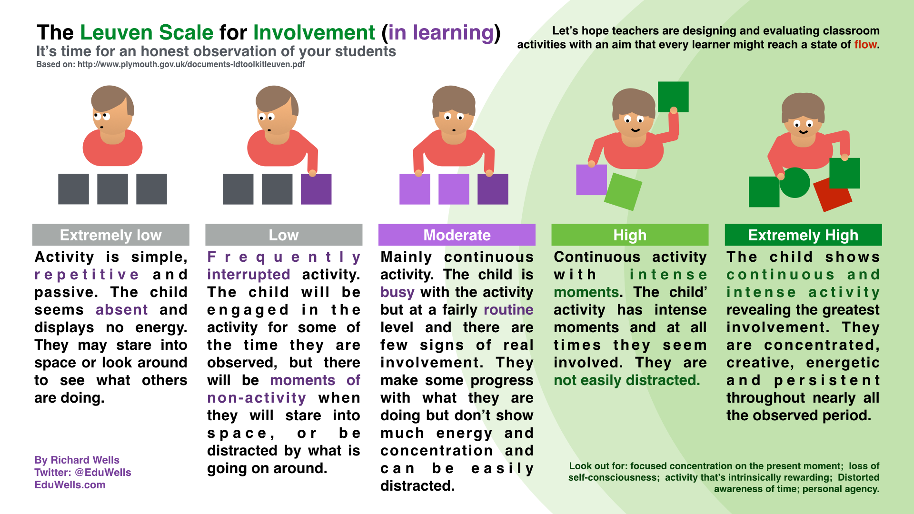

Appendix 2. Yr Athrofa Research Dispositions.
Lewis, A. (2020)
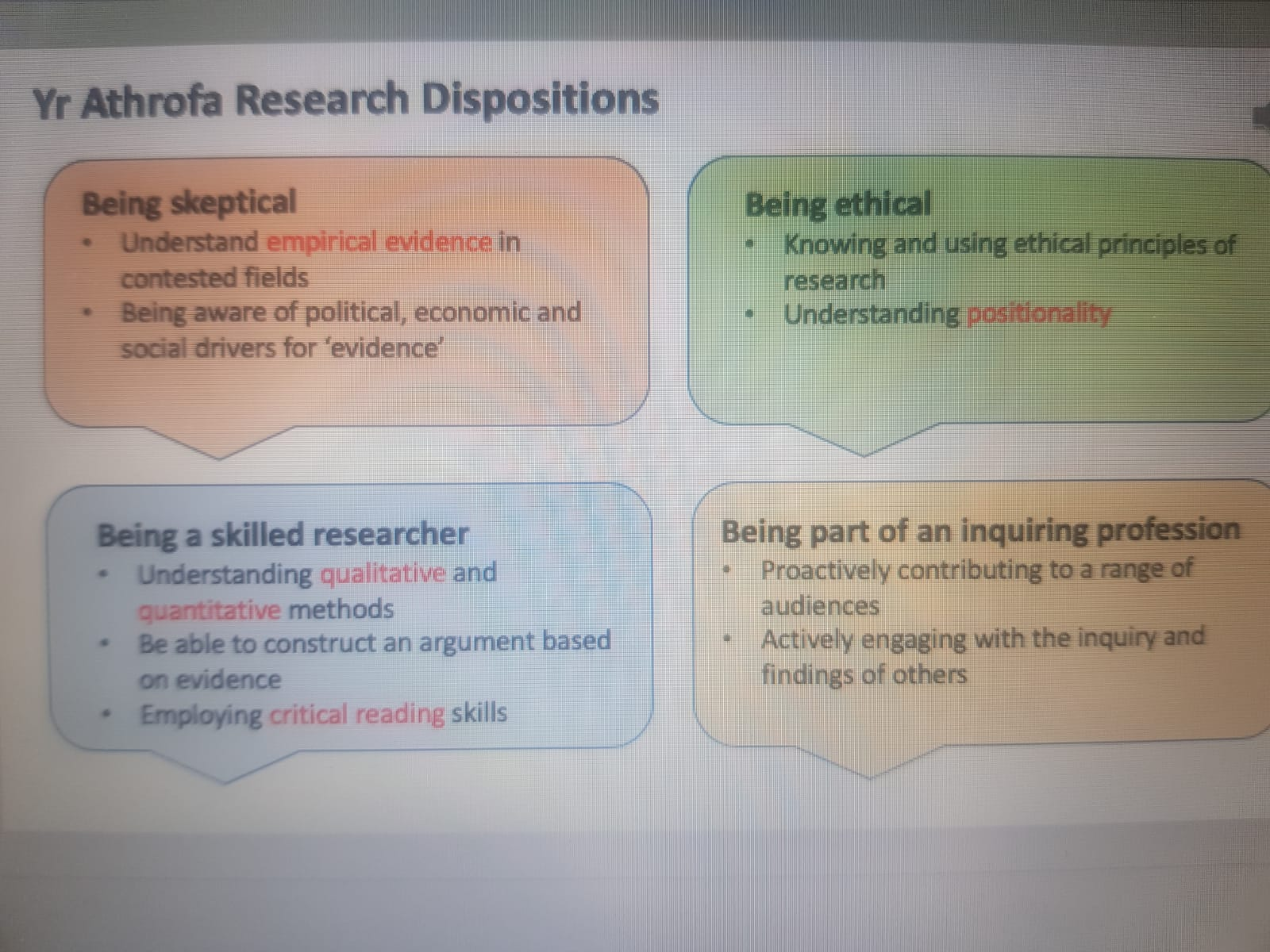

Appendix 3. My observation schedule.
Gould, A. (2020)
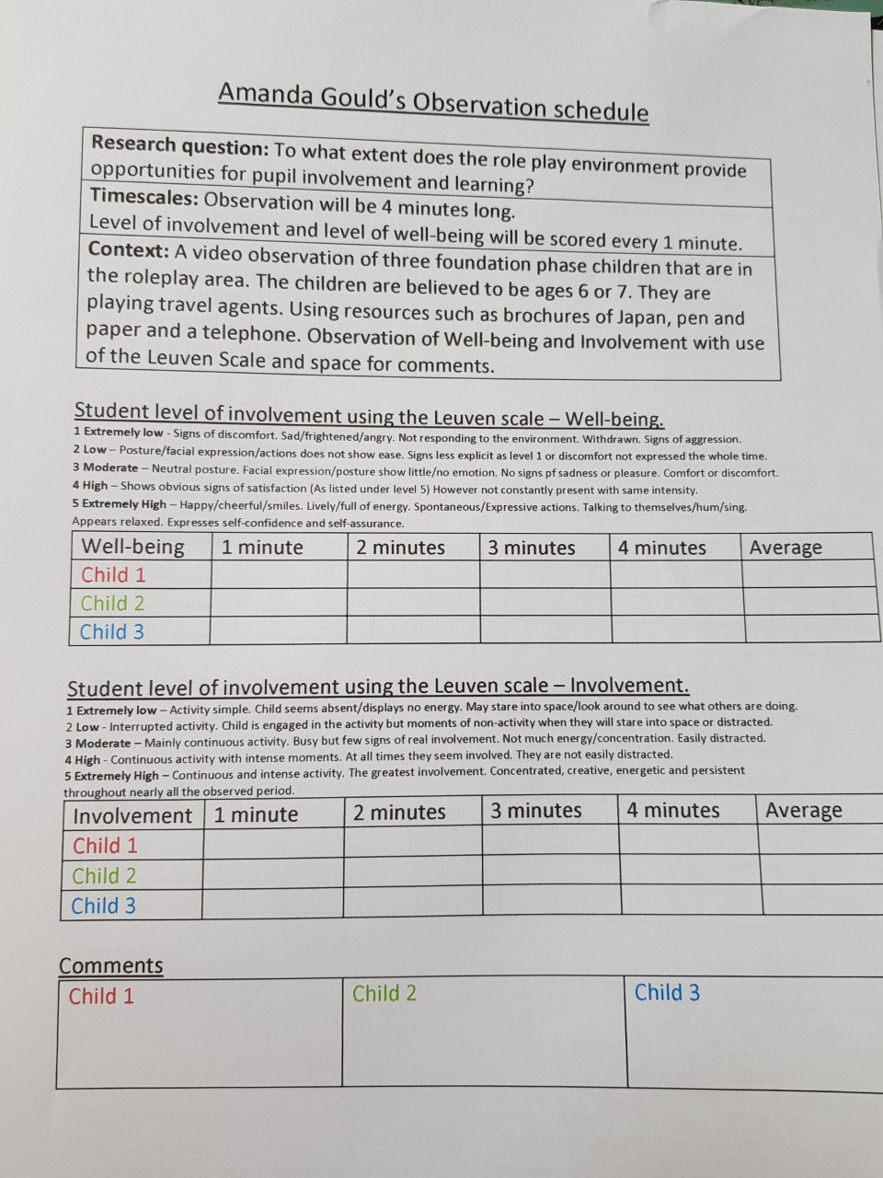

Appendix 4. A summary of the UN convention on the rights of the child.
UNICEF (2020)

Appendix 5. My completed observation schedule.
Gould, A. (2020)



