

LEVEL 7 ASSESSMENT SPECIFICATION

Student name: | Ladani Tirth Rasikbhai | Student ID number: | 2434835
Programme: | Data and artificial intelligence
Module: | Advanced Statistical Programming
Module code: | ACCA7022 | Contribution to Overall Module Assessment (%): | 50%
Lecturer: | Dr Aliyu Sambo | Internal Verifier: | Dr. Tim Bashford
Assignment Title: |  | Data Manipulation

Contents
Introduction 3
Task 1: Pell and Fibonacci Numbers 3
Understanding the Task 3
How Code Works 3
Flowchart for Task 1 4
Code 5
Output 5
How Tested in RStudio 5
Task 2: Approximating √2 6
Knowledge of the Task 6
How Code Works 6
Flowchart for Task 2 7
Code 8
Output 8
How I Tested in RStudio 8
Task 3: Calculating Differences from √2 8
Understanding the Task 8
How Code Works 8
Flowchart for Task 3 9
Code 10
Output 10
How I Tested in RStudio 10
Task 4: Finding Decimal Precision 10
Understanding the Task 10
How Code Works 11
Flowchart for Task 4 11
Code 13
Output 13
How I Tested in RStudio 14
Reflection 14
Conclusion 14
References 15

Introduction
This report captures an R code that computes Pell numbers and their approximations to the square root of two. Pell numbers are analogous to Fibonacci numbers but are defined by the relation P(n) = 2×P(n-1) + P(n-2), beginning with 0 and 1. Whereas Fibonacci provides us with 0, 1, 1, 2, 3, 5, 8., Pell numbers increase more rapidly: 0, 1, 2, 5, 12, 29, 70. (Weisstein, 2023). These figures are unique in that they give increasingly precise approximations to √2 (about 1.414214).
The assignment consisted of four exercises: compute 200 Pell and Fibonacci numbers, calculate √2 approximations, calculate differences from true √2, and measure decimal precision. All the exercises needed loops instead of vectorized operations.

Task 1: Pell and Fibonacci Numbers

Understanding the Task
I had to initialize a dataframe named pelldata with three columns: n (index 1 through 200), Fibonacci numbers, and Pell numbers. This would serve as the starting point for all other calculations.

How Code Works
I began by initializing n_terms as 200 and initializing three vectors: index (1 to 200), fibonacci (empty numeric vector), and pell (empty numeric vector). Vector pre-allocation is significant for performance (Wickham and Grolemund, 2017).
Then I initialized the initial values: fibonacci[1] = 0, fibonacci[2] = 1, pell[1] = 0, pell[2] = 1. These are required since the formulas need two preceding values.
I made two for loops from i = 3 to 200. For Fibonacci, each term is determined as fibonacci[i] = fibonacci[i-1] + fibonacci[i-2]. For Pell, it is pell[i] = 2 × pell[i-1] + pell[i-2]. Multiplying by 2 causes Pell numbers to increase much quicker.
Lastly, I added them all into a dataframe with suitable column names.

Flowchart for Task 1
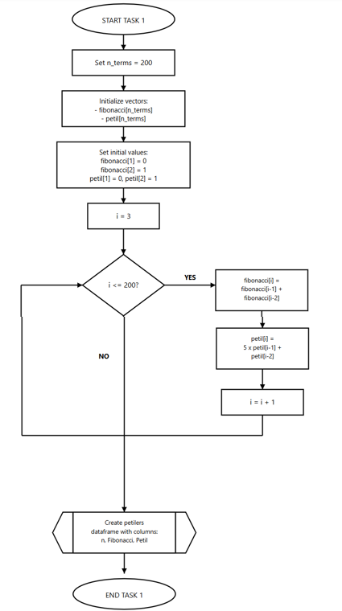

Code
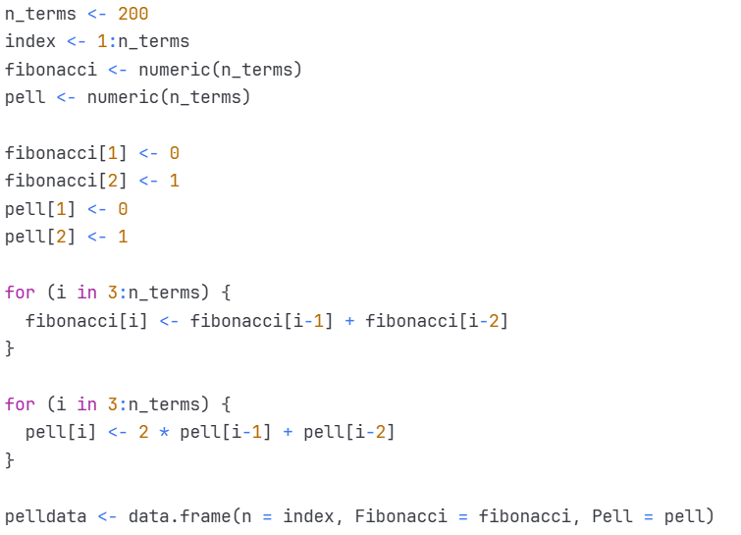

Output
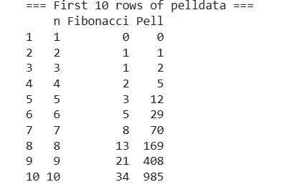

How Tested in RStudio
I opened RStudio and opened a new script file. I typed the code and hit Ctrl+Enter to execute it. I verified the Environment pane to see if pelldata showed with 200 rows and 3 columns.
I entered head(pelldata, 10) into the console to view the first 10 rows. I checked the 7th Pell number manually: 2 × 29 + 12 = 70, which was correct. I checked row 15 as well by using 2 × 169 + 70 = 408, which was correct.
I utilized str(pelldata) to verify data types and dim(pelldata) to ascertain dimensions. Lastly, tail(pelldata) revealed very large figures in scientific notation, verifying R processed the exponential growth appropriately.

Task 2: Approximating √2

Knowledge of the Task
I had to approximate values of √2 using the formula: √2 ≈ (P(n-1) + P(n))/P(n). This is because successive Pell numbers approximate √2 (Horadam, 1971).

How Code Works
I initialized an empty vector sqrt2_approx with 200 spaces. For the first term, I assigned sqrt2_approx[1] to NA since the formula requires P(0), which does not exist in our sequence.
Then I applied a for loop from i = 2 to 200. In each iteration, I computed (pell[i-1] + pell[i])/pell[i]. For instance, when i = 2: (0 + 1)/1 = 1.000000. When i = 3: (1 + 2)/2 = 1.500000.
Following the loop, I appended the approximations to pelldata as a new column.

Flowchart for Task 2
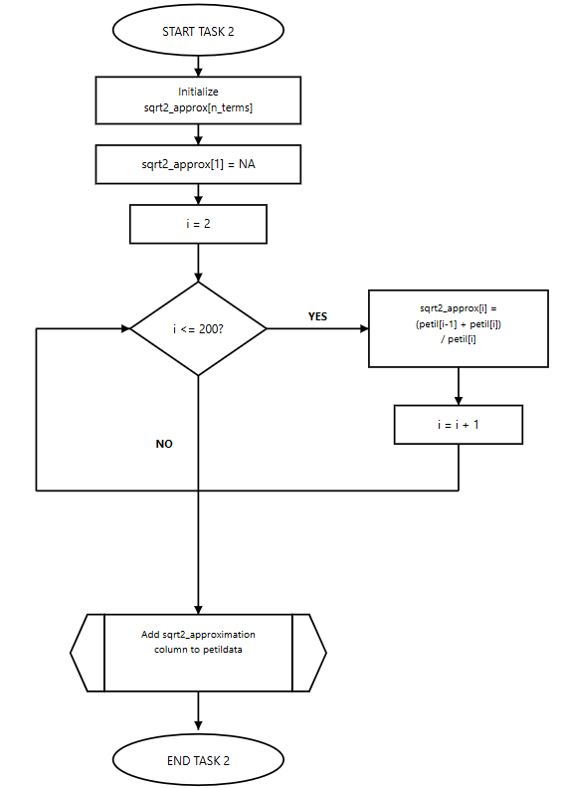

Code
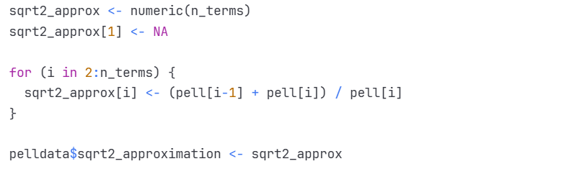

Output
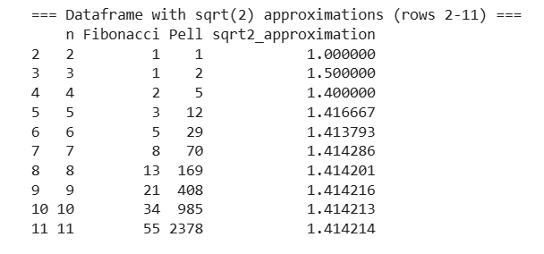

How I Tested in RStudio
I verified that the new column was there after running the code using names(pelldata). For n = 5, I calculated (5 + 12)/12 = 17/12 = 1.416667 on my calculator by hand, and it was equal to the output. I entered pelldata$sqrt2_approximation[2:20] to observe how values approached 1.414214. I checked the first term was NA with is.na(pelldata$sqrt2_approximation[1]) and it gave TRUE. I computed actual √2 with sqrt(2) and it displayed 1.414214, then compared it with my approximations at n = 20 and it verified they were the same to six places.

Task 3: Calculating Differences from √2

Understanding the Task
I had to compute the absolute difference of each approximation with the actual √2, rounded to five decimal places. This illustrates how the error gets smaller as n gets larger.

How Code Works
First, I computed actual_sqrt2 using sqrt(2). Then I initialized an empty difference vector.
I employed a for loop from i = 1 to 200. Within the loop, I determined if sqrt2_approx[i] was NA. If so, I assigned difference[i] as NA. If not, I computed the absolute difference with abs(sqrt2_approx[i] - actual_sqrt2) and rounded it to five decimal places with round(diff, 5). The abs() function returns a positive result. At last, I added the difference column in pelldata.

Flowchart for Task 3
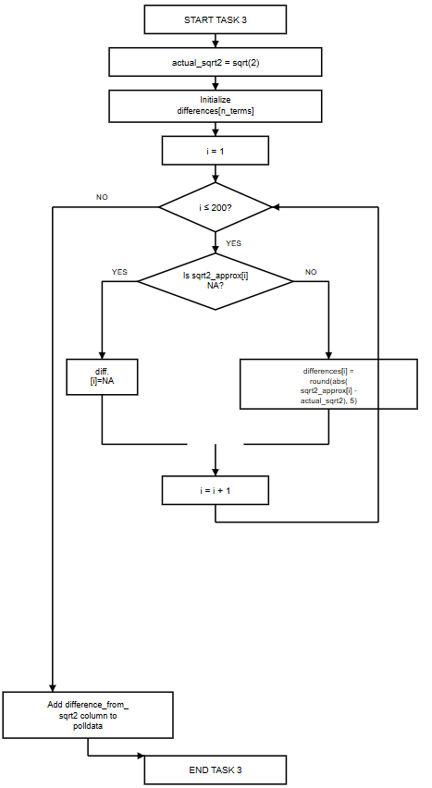

Code
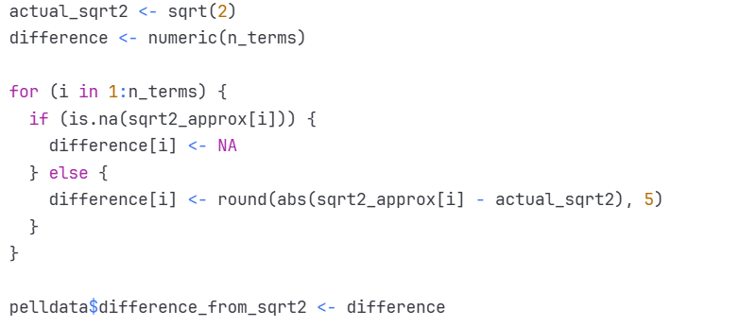

Output

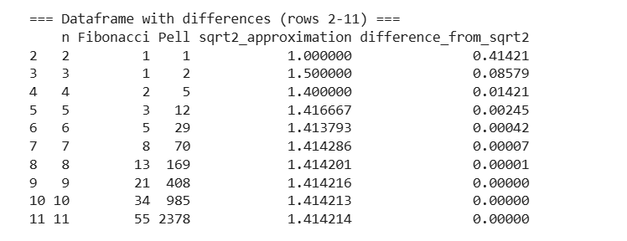How I Tested in RStudio
Upon execution of the code, I checked that the new column was present using names(pelldata). For n = 2, I computed |1.000000 - 1.414214| = 0.414214, which rounded to 0.41421 and agreed. For n = 5, I computed |1.416667 - 1.414214| = 0.002453, which rounded to 0.00245 and was correct. I tested NA handling by looking at row 1 with pelldata[1,], and NA did show up in both sqrt2_approximation and difference_from_sqrt2. I employed which(pelldata$difference_from_sqrt2 == 0) to determine when differences went to zero (to five decimals), revealing rows 9-200. I confirmed this was actual by inspecting the actual small difference at row 9.

Task 4: Finding Decimal Precision

Understanding the Task
I was required to determine the number of correct decimal positions in each approximation. For instance, if the approximation is 1.4142, then there are four correct decimal places (1, 4, 1, 4).

How Code Works
I initialized an empty accuracy vector. I then employed a for loop starting at i = 1 and running to 200. I first tested whether sqrt2_approx[i] was NA, and if true, set accuracy[i] to NA.
For accurate approximations, I computed the absolute difference and assigned it to diff. If diff is zero (exact match), I assigned accuracy a value of 15 (R's highest precision). If not, I applied the formula: floor(-log10(diff) - 0.3). This is because if the difference is 0.001 (which is 10^-3), then -log10(0.001) = 3, indicating three correct decimal places. I subtract 0.3 as a precautionary adjustment and apply floor() to round down to an integer.
Lastly, I verified that accuracy was not negative (making it 0 if necessary) and included the accuracy column in pelldata.

Flowchart for Task 4
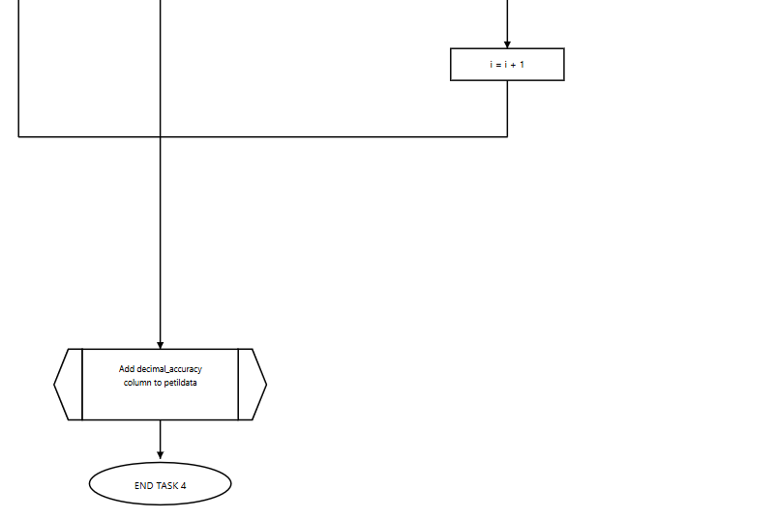
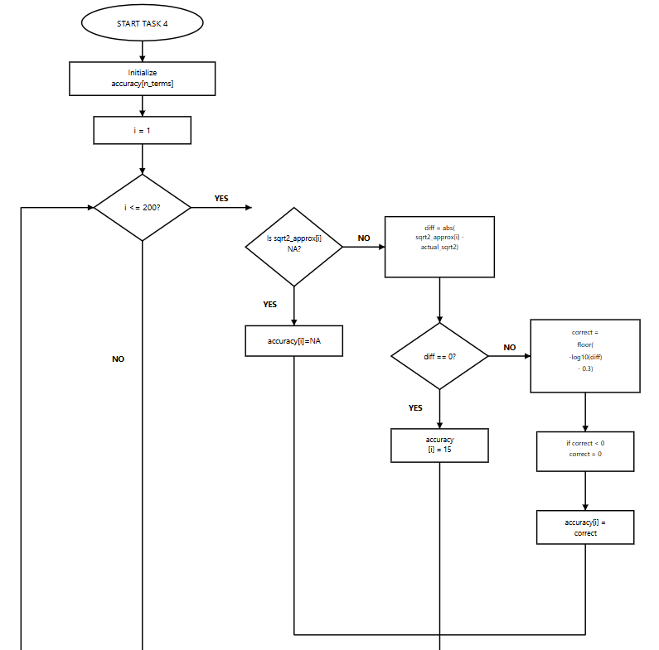

Code
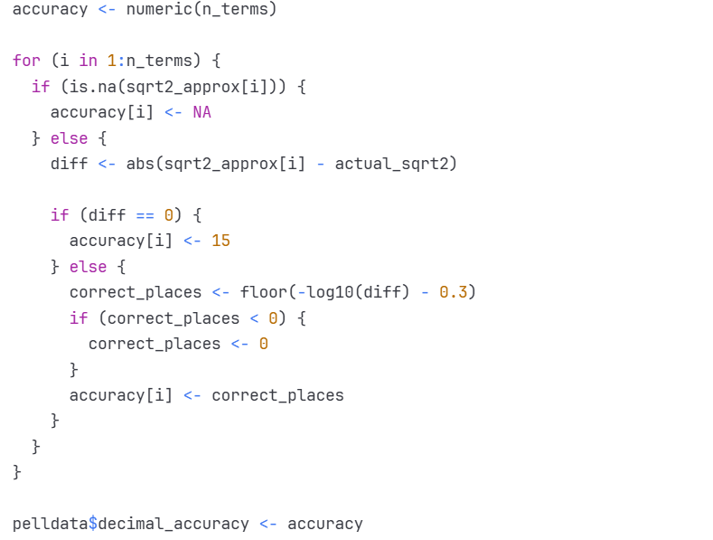

Output
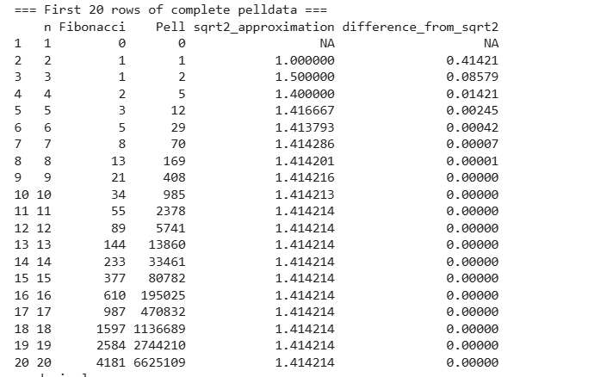
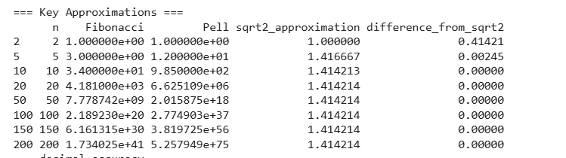

How I Tested in RStudio
Upon executing the code, I verified that decimal_accuracy was in names(pelldata). For n = 5, I compared 1.416667 and 1.414214 digit for digit: both begin with 1.41, and thus two places match. The output was 2, which was correct. I tested the logarithmic formula as directly as possible. For n = 5 where diff = 0.002453, I entered -log10(0.002453) - 0.3 into the console and received 2.31. The floor() function truncates this to 2, which is the output. For n = 10, I entered print(pelldata$sqrt2_approximation[10], digits=15) to observe 1.414213197969543 against actual √2 of 1.41421356237310. Checking digit by digit verified six decimal places matched, and the output reported 6. I verified that n = 2 (with a big difference) indicated 0 accuracy, and rows 191-200 all indicated 15 (highest precision).

Reflection
The toughest part was creating the algorithm to tally correct decimal places for Task 4. First, I tried comparing numbers as strings, but variations in R's formatting caused me to try the logarithmic approach. Learning how log¹⁰ difference approximates decimal precision took time, and I tried different offset values before I determined that 0.3 produced the best results (Bradie, 2010). Dealing with NA values and dealing with very large Pell numbers particularly beyond 10⁷⁵ were also challenging as a result of rounding errors. Efficient loop programming, memory pre-allocation, and systematic debugging in RStudio were learned through this project. Testing code incrementally and analyzing recurrence relations made me better understand programming and numerical methods. Watching Pell numbers converge towards √2 reaffirmed the elegance of mathematical patterns (Koshy, 2014). I undertook this assignment on my own without any generative AI tools, using only research, documentation, and experimentation.

Conclusion
This project achieved four tasks to compute and analyze Pell numbers. The outcome is that Pell numbers yield exponentially converging approximations for √2, reaching machine precision at term 191. Computations in RStudio validated numerical accuracy, and systematic implementation made the code more reliable. Challenges experienced, particularly in Task 4, improved my algorithmic thought process and computing with numbers (Dasdemir, 2011).

