University Name: University of Wales Trinity Saint David

Programme: MA Outdoor Education

Module: BMOE7001

Assessment: Assessment 1 – Outdoor Education as a site of cultural struggle

Title: How the development of outdoor experiential education in Britain has had to struggle with a complex and restrictive structure of land ownership and land access rights

Word Count: 4,070

Student ID: 2304185

Name: Julian Goode

How the development of outdoor experiential education in Britain has had to struggle with a complex and restrictive structure of land ownership and land access rights

Introduction

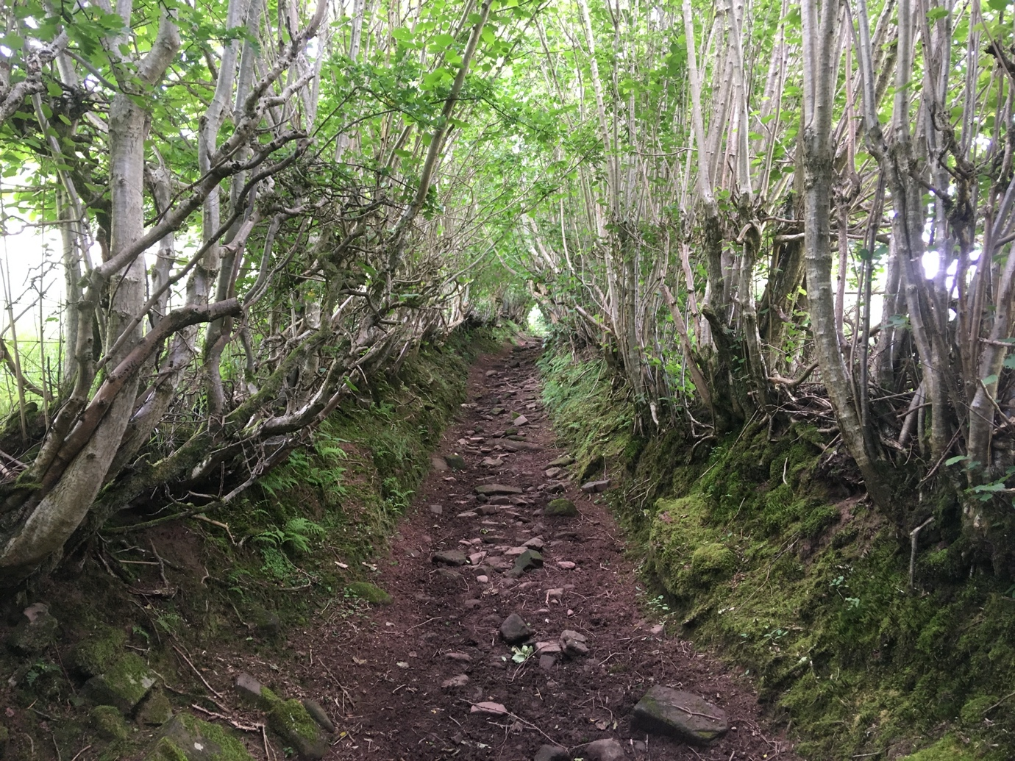
Photo 1 – Ancient byway in Wales (Goode, 2022a)

The subject of land ownership and public access rights to land in Britain is historically complex and, especially in England and Wales, has created arguable barriers to the use of the outdoors for recreational and educational purposes. The questions that this photo essay will examine is how has outdoor experiential education developed despite a societal and cultural struggle against real or perceived land use restrictions, what is the situation at present and how might it improve in the future?

To address these questions key writings on the subjects of public rights of access and land ownership, and those contributing to our understanding of British outdoor education and recreation advancement will be examined. In addition, sections will underline important legislative and cultural waymarks, and try to build an understanding of how an imbued sense of not belonging in vast areas of our own countryside may have built an equally habituated sense of self-restriction to participation, producing an ongoing battle for improvement. That struggle being explored has, to varying degrees, been access to the land, the countryside, the outdoors in general, for many hundreds of years, through the Enclosures and Highland Clearances of the 17th to 19th centuries to physical confrontations and protests such as the Kinder mass trespass.

Ancient tracks (like the byway in the Welsh Black Mountains shown in the first photo above) have formed in the landscape since the Middle Ages, as worn highways, the only means of transport between settlements. However, many have been lost in time and while it will be shown we now live in an era governed by defining land access legislation in Scotland as well as England and Wales - and, thanks to 150 years of development, established outdoor education and recreation practice - this essay will look at key legislative progress and any limitations to public access remaining thereafter, and evidence of any influence on the progression of outdoor recreation and education through that period. It will be argued that there is a crossover between the two, outdoor experiential education not developing in isolation from the growth of recreational use of the outdoors, one often following in the footsteps of the other.

The seeds of a public perception of not belonging

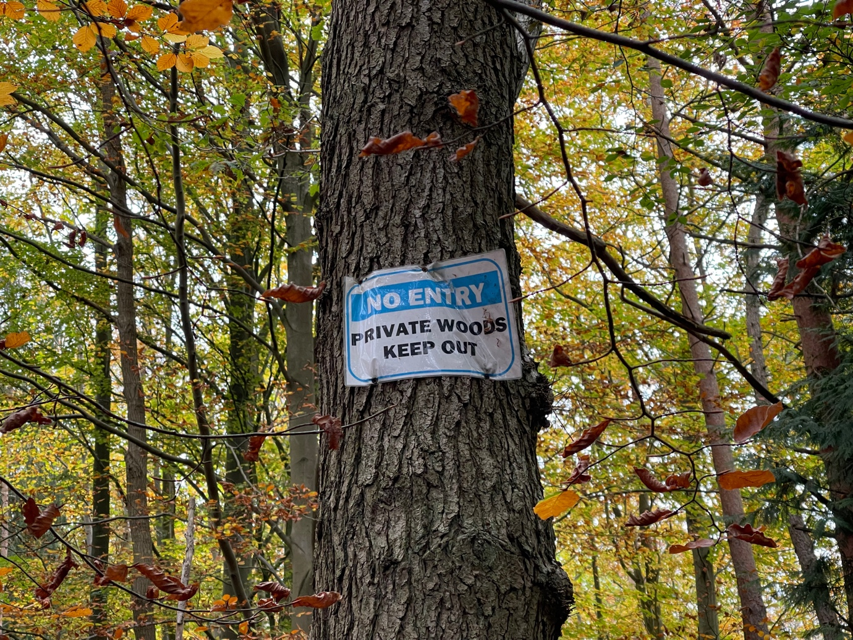
Photo 2 – Private woods Keep Out (Goode, 2024)

The initial argument outlined in this paper is that we have evolved an accustomed sense over generations of needing to ‘keep out’ when outdoors, from someone else’s land, where we don’t belong (as familiarly illustrated in the photo above) – with an implied threat of repercussions, notably the civil offence of trespass (Hayes, 2020), whereby you need the owner’s right to set foot on most land or you will be breaking the law explains Shoard (1999, p. 11).

A small group of landowners (0.06 per cent of the population) hold sway over large parts of the British countryside, and while there is legislated access across the whole of Scotland, only eight per cent of England and Wales has open access with a full right to roam (Shrubsole, 2020, pp. 17-28), and the “English countryside still bristles with a profusion of KEEP OUT, PRIVATE PROPERTY signs”. Little remembered in detail now, the Enclosures of once free-to-access common land and the Highland Clearances have had a lasting impact. A fifth of all English land was enclosed by Acts of Parliament in the 300 years preceding World War One; the ‘peasant poet’ John Clare exemplifying the chilling effect on the public consciousness with his lamentation for lost access to his beloved countryside, “Enclosure came and trampled on the grave / Of labour’s rights and left the poor a slave”. Similarly, Mitchell (2008, p. 354) bemoans the Enclosure movement as “belonging reduced to ownership and legal title”.

There is a moral stigma, argues Hayes (2020, pp. 8-34) at the thought of crossing walls, fences or barriers in the outdoors, and that as we’ve grown up living with this state of affairs for dozens of generations the fable of exclusive human land ownership has created a cult of exclusion.

Very few individuals own the 30,000 square miles of Scottish land outlines Higgins (2002, p. 150-153), the prevalence in wild areas of sporting estates appearing to conflict with an ethos of public access. Higgins also asserts that land ownership in Scotland has had “considerable influence on the ‘national psyche’ of Scots” and visitors for recreational purposes; the forced evictions of the Clearances largely for sheep farming, producing the now accepted deforested landscapes, which in turn were greatly turned over to shooting estates following the romanticised promotion of the Highlands as a ‘playground’ in Queen Victoria’s era. There remains an area of grouse moor the size of Greater London in Britain, and Shrubsole (2020, p. 95) asserts that none of this has made the upland outdoors a fundamentally welcoming place for recreation, and subsequently adventure education.

The secretive and restrictive nature of land ownership has built up a wariness, of needing to keep out, increasing a subconscious risk of legal threat, and hindrance to a roaming spirit simultaneously being inspired from the 19th century onwards by both Romantic artistic influences as well as explorers and adventurers from the heyday of the British Empire (Macfarlane, 2003). At various times over the past half century when participating in outdoor activities you could have inadvertently stumbled upon 3,000 military sites deliberately kept off Ordnance Survey maps (trip2themoon, 2011). Canoers, kayakers or paddleboarders on the 4,700 miles of UK rivers may be surprised to find only 1,400 miles carry a riparian right of public access (River Access for All, 2024). Hayes (2020, p. 298) argues that, “hundreds of years of private property laws have morphed into a strict orthodoxy in English society, an unquestioned consensus of what can and can’t happen”.

Key moments define, says Harker (2005, p. 222), the struggle between people demanding right of open access to the land and landowners trying to deny it such as 1932’s historic act of defiance (Mayfield, 2010, p. 70) on Kinder Scout, seen in the context of public rights of way being just “strips of legitimacy” suggests Hayes (2020, p. 90) - the 117,000 miles of public footpaths in England and Wales a double-edged sword as they by definition make it clear that adjoining land is markedly private. In moving to look at rights of access in more detail, it becomes useful to consider Curry’s summation that “in the end the legitimacy of a universal right of access depends on where you sit philosophically in relation to the ownership of land” (2000, p. 450).

Public rights of access to the land

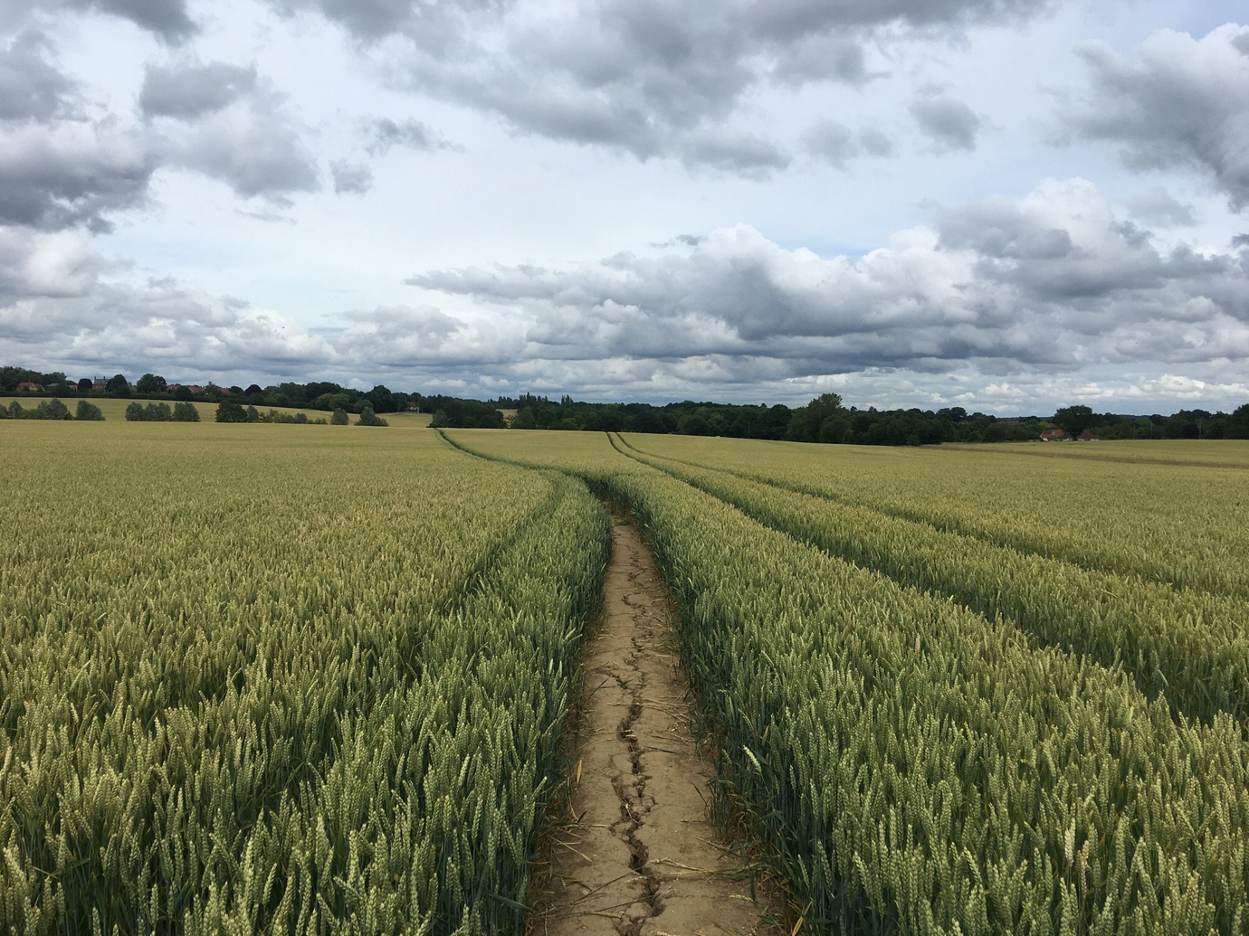
Photo 3 – Public footpath across Essex field (Goode, 2022b)

The Labour government kept its 1997 election promise to address land access with the Countryside and Rights of Way (CRoW) Act (2000), bringing clarity to rights of way being defined and mapped in England and Wales (like the one carved absolutely across an Essex field in the photo above). The sea-change (Shrubsole, 2020, p. 252) meant “mountains, moorland, downland, commons, heaths and coastlines were all to be opened up for public access, whether landowners liked it or not”. And a right of responsible access (Scottish Rights of Way & Access Society, 2024) was enacted by the Land Reform (Scotland) Act (2003), giving a general right of access to all Scottish land and inland water, although some does still remain excluded from access completely.

The Scottish Act of 2003 was, Allison and Telford (2005, p. 25) contend, a “crucially important development to the future of outdoor education”, giving a statutory public right of access to land in Scotland, except where there are considered justified exceptions for privacy, environmental, and commercial operations. In essence, despite land ownership being unchanged by the Act, the public now had a right to roam for recreation and education alike. That, however, was not the case in England and Wales. Provisions in Scotland were very different from the preceding legislation south of the border. And Hayes (2020, p. 88), is dismissive of advancements in the 2000 Act as “150 years of campaigning to get a right to wander on eight per cent of the land”, while Breen et al. (2023, p. 276) describe any concept of right to roam in England as a misnomer. And Mitchell (2008, p. 357) is equally disdainful, calling the Act a “defence of the injurious effect and perverse fictions of the propertized public/private divide in rural space”.

The CRoW Act didn’t though provide a legal right to wild camp and, with right to roam lands concentrated in upland areas, there remains a belief they have been carved off from the reach of the urban masses (Breen et al. 2023, p. 285), left to utilise public bridleways and footpaths (like the one depicted in the photo below).

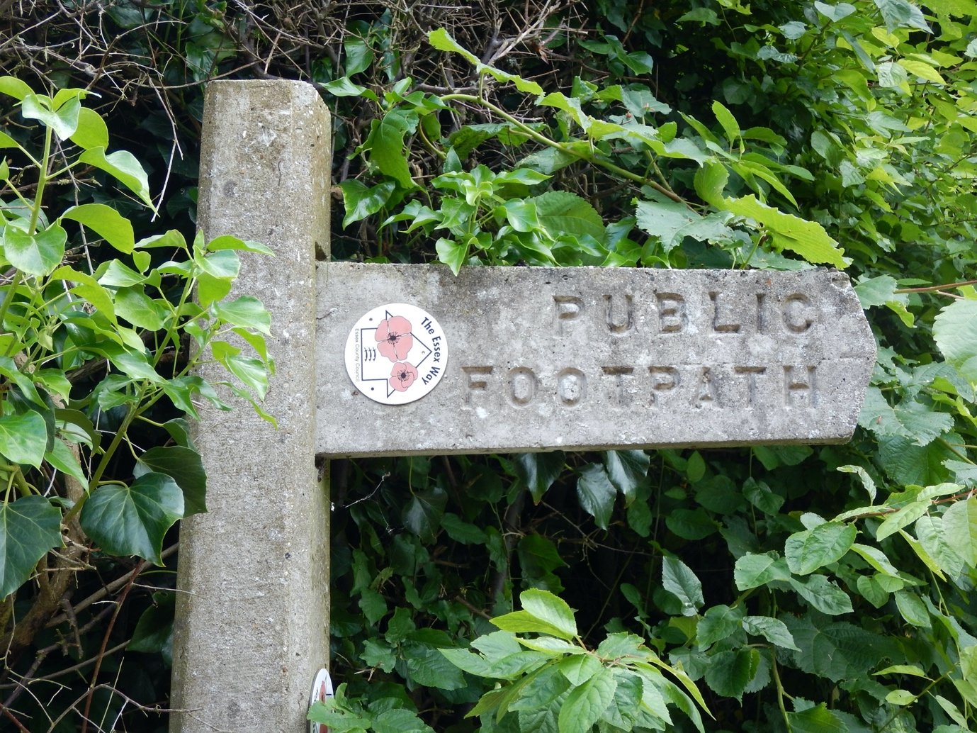
Photo 4 – Public footpath sign (Goode, 2016)

Land access, mainly confined in England and Wales to moorland, mountain and the coastal swathe, remains a postcode and financial lottery argues Hayes (2020, p. 371) depending on where you live and ease of transport to it; with city dwellers left alienated from rural life in a “peculiar kind of apartheid” by the restriction of countryside recreation facilities says Shoard (1979, p. 89). Jenkins (2024) scathingly highlights the absurdity of some CRoW Act provisions 20 years on:

The revelation that 2,500 areas of English countryside that supposedly enjoy a ‘right to roam’ can be reached only by trespassing over private land is absurd. It means that some 2,700 hectares of open land effectively require a helicopter for their legal access.

The National Parks and Access to the Countryside Act (1949), labelled as influential legislation in respect of recreational access outdoors (Parker and Ravenscroft, 1999, pp. 297-300), had previously spawned ten upland national parks in the 1950s. But it had stopped short of greater mass access rights on what remained private land, Parker and Ravenscroft believing it is hard to see anything unique or revolutionary within its exclusionary bounds; although Mayfield (2000, p. 72) conversely lauds it as an important milestone for success in the access battle.

The possibilities for the growth of recreational and educational use of the outdoors would seem to have been hindered in England and Wales in the same way that they broadened in Scotland as a result of these different legislative approaches. As Allison and Telford (2005, p. 25) conclude:

Whilst we have suggested that the access legislation in Scotland could be summed up as providing a right of public access except where there is justifiable reason to deny it, it could equally be argued that the approach taken in England and Wales has been one of denying a right of public access except where there is justifiable reason to provide it. The nuance of language may be small but the philosophy it reflects is powerful.

The growth of recreational and educational use of the outdoors

The pull of the outdoors increased alongside sweeping social-cultural changes through and beyond the industrial revolution. Macfarlane (2004) portrays the growing Romantic movement of the 1800s seeing mountains become “a ubiquitous symbol of emancipation for the city-bound spirit”. Breen et al. (2023, p. 278) highlight the evolution of a outdoors culture in that period following in the inspirational footsteps of poets Wordsworth and Clare.

Cycling grew apace as a recreational escape (akin to the bike outing in the photograph below) in the Victorian era, encouraging and facilitating movement of people into the countryside - the Cyclists’ Touring Club founded in 1878 (Hunt, 1989, p. 24). There followed a growing sense of a right to walk, hike, cycle and more activities in open spaces says Shrubsole (2020, p. 251) in the subsequent half century. There were a striking half a million hikers in Britain in the early 1930s (Harker, 2005, p. 220), with rambling the mass sport of working-class youth. And Hunt (1989, p. 25) cites the foundation of the Youth Hostels Association in 1930 as “a significant development for young people wishing to visit the countryside” (1989, p. 25). In addition, the Ramblers’ Association’s formation in 1935 built on the recreational opportunities afforded by local groups in previous decades. It all marked, states Hunt, “the acceleration of a movement by ordinary people into the countryside” (1989, p. 25).

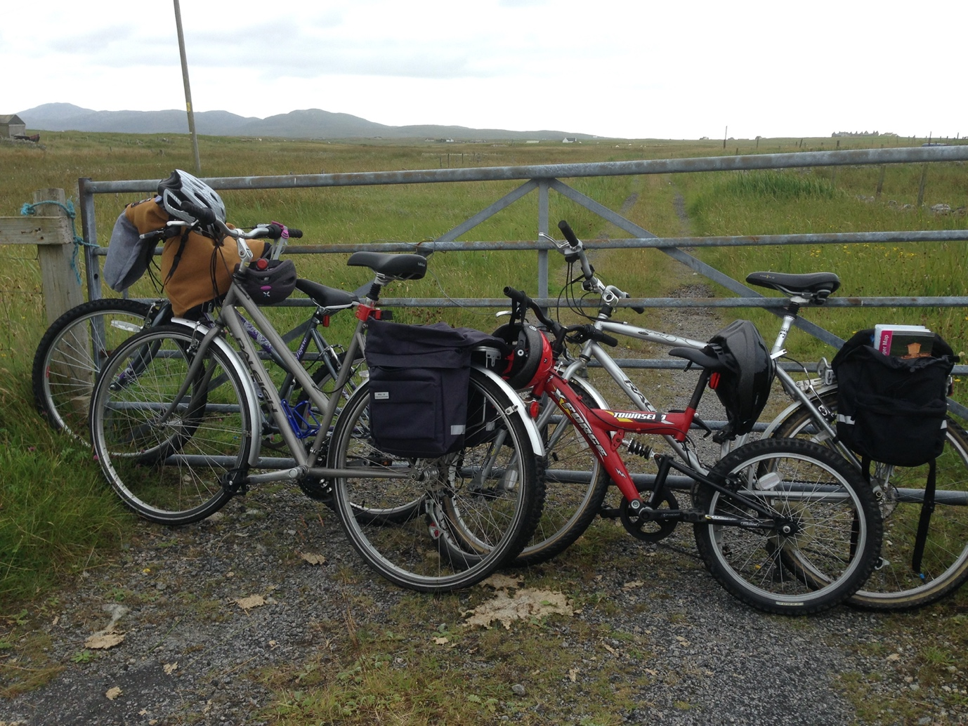
Photo 5 – Cycles parked in the countryside (Goode, 2014a)

Hunt (1989, pp. 31-32) also charts a steady increase in outdoor recreational use in the decades after World War Two as, fuelled by news of adventurers conquering Everest, the Antarctic ice cap and circumnavigating the world’s oceans, Britain’s high ground especially attracted hikers, to lakes and rivers sailors, and even skiers in the Scottish Highlands.

More people headed into the countryside for recreational and leisure activities as the century progressed, posing the question of parallel patterns of increased use for outdoor education (Nicol, 2002b, p.92) – and discussions on which was the biggest influence on the other in a crossover of developmental patterns.

Nicol (2002a, p. 30) also suggests that popular outdoor recreational activities such as hill walking, kayaking and canoeing, sailing (as depicted on the Norfolk Broads in the photo below) and climbing all became accepted as the bedrock of outdoor education alongside field studies.

And National Governing Bodies, many states Higgins (2002, p. 163) originally conceived as clubs - such as Mountain Training, formed in 1964 (Mountain Training, 2004); and the British Canoeing Union, formed in 1936 (Paddle UK, 2024) - brought qualification opportunities for their members experienced recreationally to work educationally.
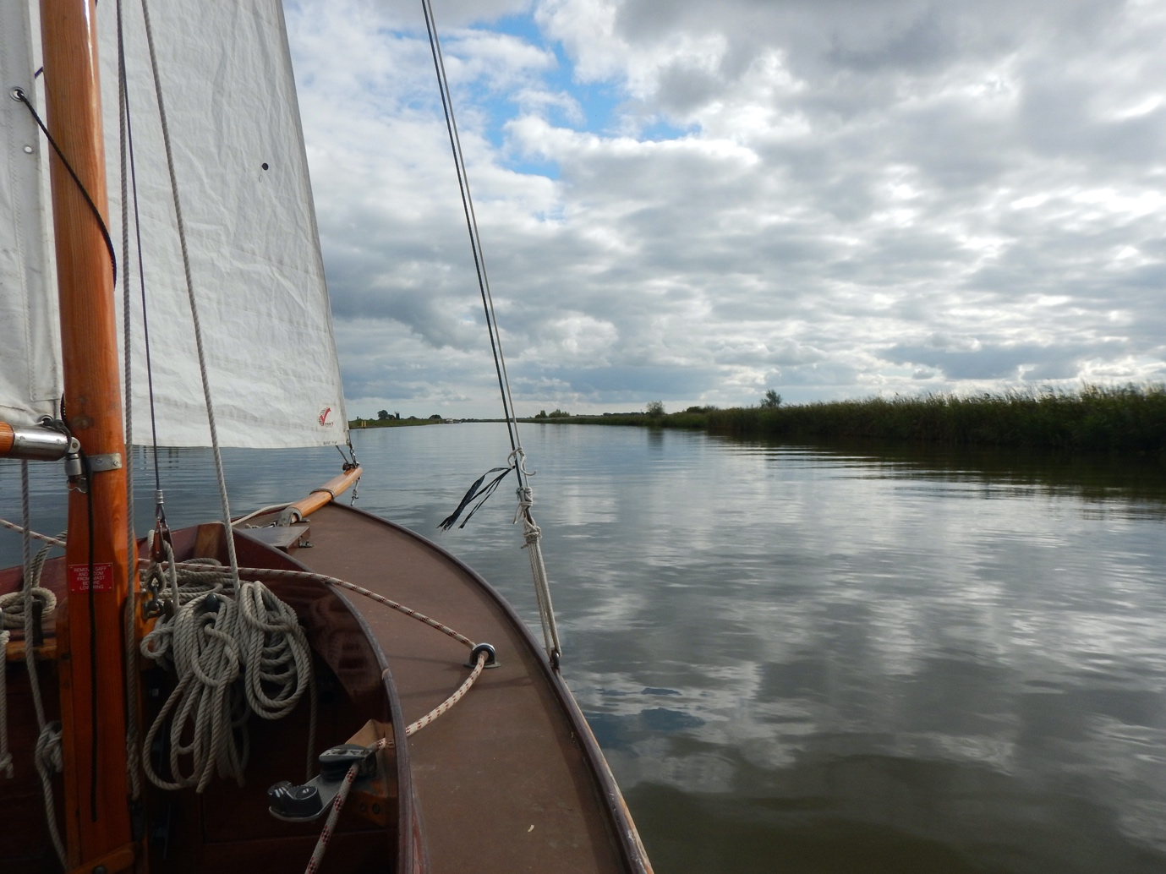
Photo 6 – Sailboat on the Norfolk Broads (Goode, 2017)

The development of outdoor experiential education

Nicol (2002a, p. 40) believes recreation for enjoyment to be one of the purposes of outdoor education; but also (2002b, p. 89-90) espouses the viewpoint that “outdoor education has ‘evolved’ into what it is more by chance than design” - with practice, in essence recreational activities, coming before theoretical or clear philosophical underpinnings.

Key landmarks in the development of outdoor education in Britain (now encompassing such activities as walking leader training, depicted in the photo below), are outlined below. Nicol (2002b, p. 85) succinctly describes outdoor education as “an umbrella term comprising a broad range of component parts”.

And Loynes (2007, p. 1) argues that the foundations of outdoor education lay in a “moral panic” in the late Victorian era, preoccupied with the fitness of young men for armed forces; these militaristic underpinnings resurfacing in Baden-Powell’s rapidly popular Boy Scouts Movement, as well as character-building outdoor activities for the privileged attending public schools in the first half of the twentieth century (Cook, 1999, p. 58).

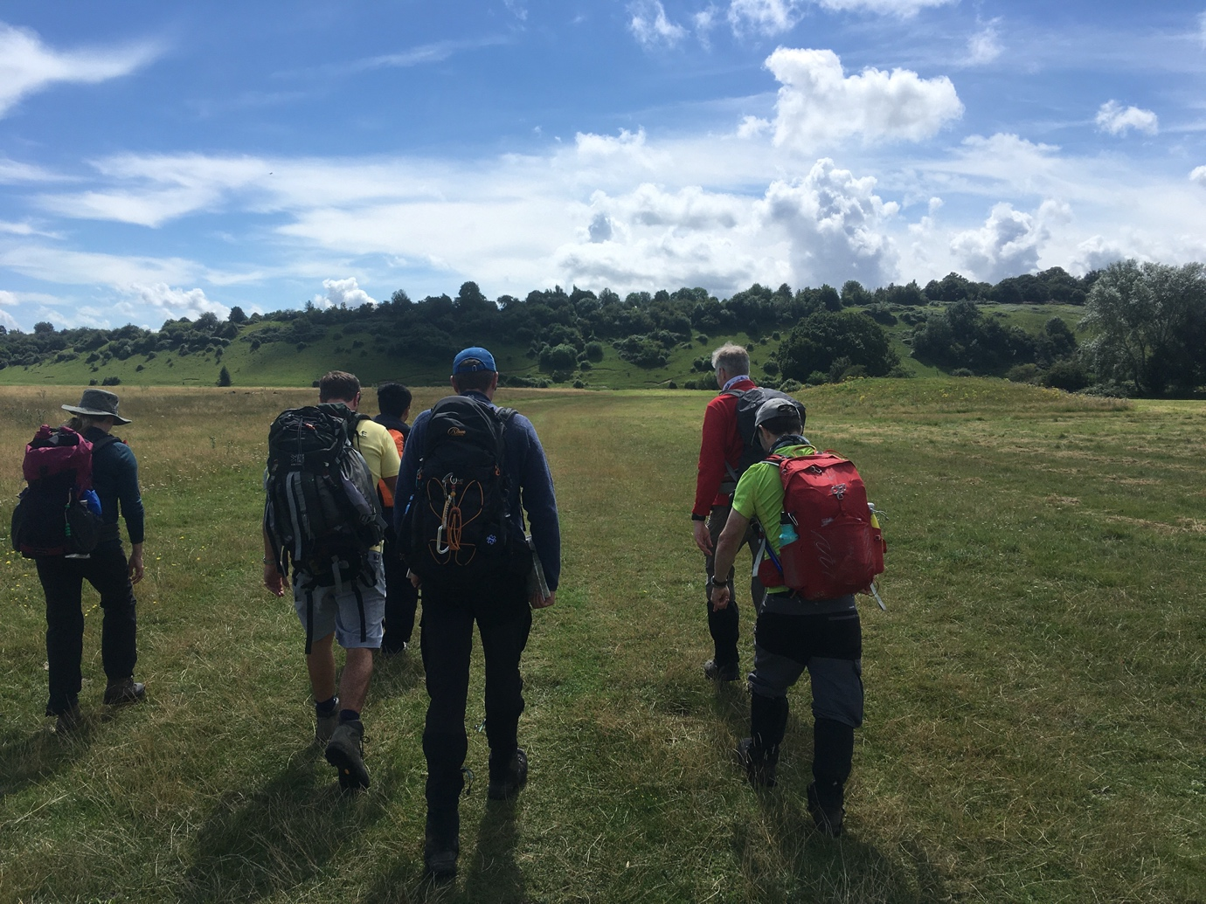
Photo 7 – Leadership walking group in training in Berkshire (Goode, 2021)

Access to the outdoors is vital to provide experiential possibilities, and as Quay and Seaman advocate (2018, p. 40) the notion of experience has long been engaged with outdoor studies. This is reinforced by Wurdinger (1997), who states “when one experiences something first hand, the level of understanding deepens”. And as Higgins (2002) points out, the natural environment has been a key underpinning of the expanding sector of outdoor education, which can be taken to encompass both the physical and also the cultural landscape.

Notwithstanding that greater access to the land was not truly to be enshrined until this century, there is evidence to illustrate the development of what evolved into the outdoor education sector in areas that were accessible or privately owned. Kurt Hahn’s landmark launching of Gordonstoun School in 1934 and first Outward Bound school in Wales at Aberdovey seven years later set a long-established tradition now manifesting itself in the Outward Bound mission for its residential courses at six British centres and summer adventures “to inspire young people to realise their potential through learning and adventure in the outdoors” (Outward Bound Trust, 2024).

Experiences charged with joy and wonder says James (1985, p. 93) were the quest of Hahn’s scholastic vision, with his multi-disciplined County Badge scheme providing the foundations for the Duke of Edinburgh’s Award, echo Hopkins and Putnam (2012, p. 24), instigated by his former Gordonstoun pupil HRH Prince Philip, that has taken thousands of young people outdoors since 1956.
The 1944 Education Act extended outdoor opportunities to the working classes argues Cook (1999, p.162), as local education authorities were granted powers to waive fees for residential attendance; Derbyshire the first county to establish a residential outdoor school, the White Hall Centre for Open Country Pursuits in 1950 says Hunt (1989, p. 29); the model, Cook (1999) states, for LEA residential centre developments in the following decades; with private residential outdoor courses also delivered at Brathay Hall in the Lake District from 1947, and the Cairngorms’ Glenmore Lodge from 1948.

Growth in the 1950s and 1960s depicted by Nicol (2002a, p. 38) occurred unperturbed by any land access rights issues as adventure training, Outward Bound development, increased use of residential schools, and school trips to the countryside drove an expansion; while the subsequent demand, emphasises Hunt (1989, p. 33), for more residential outdoor centres saw an increase from just a few in local authority management in 1960 to more than 400 by 1980, plus 500 run by the commercial or voluntary sectors.

The 1990s saw the consequential importation of the Scandinavian Forest School concept of ideally woodland-based play and educational settings into the UK, presents Knight (2018, p. 244) after an inspiring trip to Denmark by a group of Somerset college staff, the rapid implementational spread of which saw the establishment of professional body, the Forest School Association, in 2012.

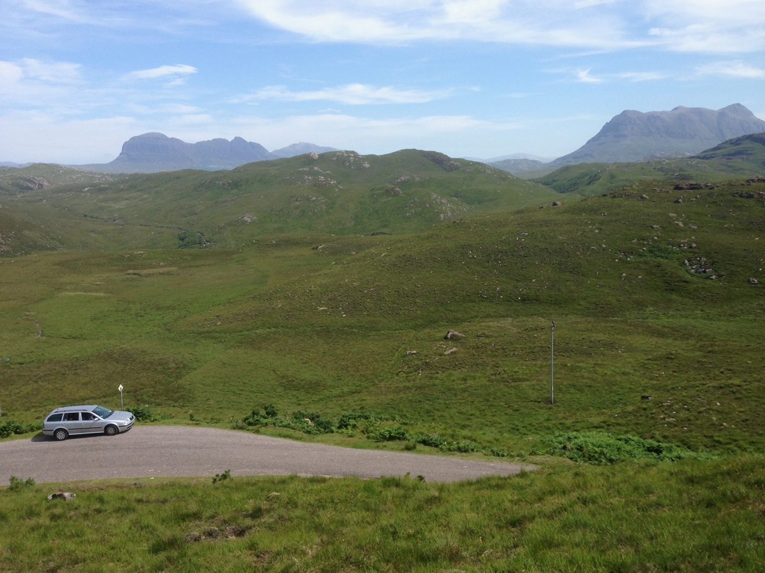
Photo 8 – Public access land as far as the eye can see in Assynt, Scotland (Goode, 2013)

Anyone who has visited Scotland’s vast wild areas (as illustrated in the photo above of the far north western Highlands) for outdoor pursuits of any kind will be aware of the huge opportunities provided for leisure, adventure and education thanks to widespread open access granted by the 2003 legislation.

Land ownership and usage from the 18th century in upland Scotland, with the notoriety of the Clearances, produced claims Higgins (2002, p.149) a perceived wilderness “attractive for outdoor recreation”: a distinct Scottish cultural identity thence giving rise to an outdoor education sector of international significance.

The struggle to belong manifested in Britain’s great outdoors

The debate as to whether the perception of being unwanted in the countryside (illustrated vividly by the barbed wire fence in the photo below) has stymied recreational and educational growth looks increasingly hard to quantify with a lack of explicit published evidence, and without re-running history outside the distinct British cultural model. That there has been a long-lasting battle for rights is not in doubt, however: while the right to roam and camp is accepted as a universal right in the Nordic countries says Hayes (2020, p. 368) and in central Europe add Breen et al. (2023, p. 299), a protracted struggle has taken place here as disputes over access to land were forced upon walkers from the late Victorian era at the start of 40 years of increasing protest (Hey, 2011, p. 201). Campion (2010, p. 19) depicts more than 100 years of struggle and no less than 20 failed access-extending bills in parliament.

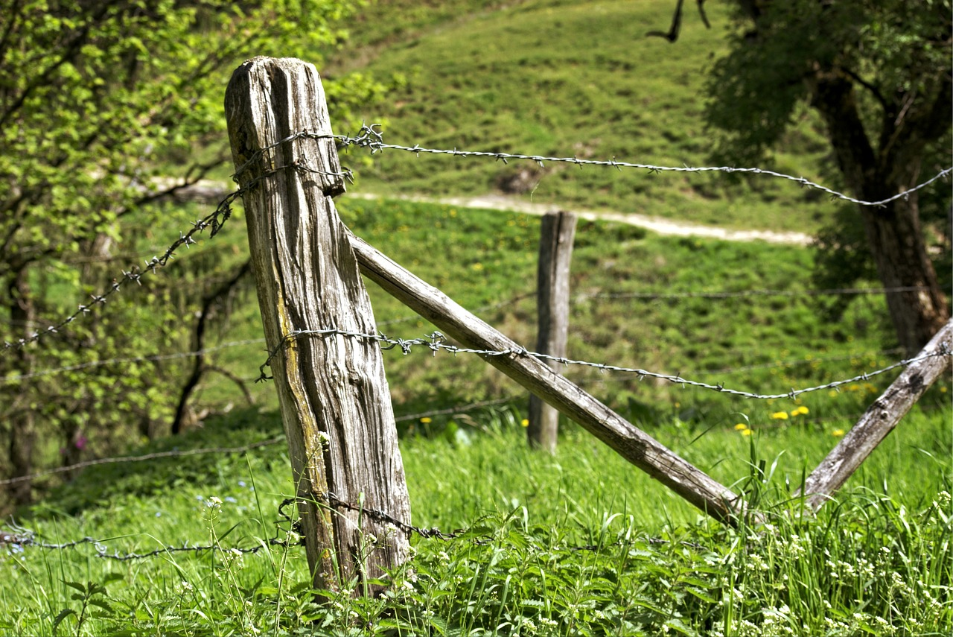
Photo 9 – Barbed wire fence in countryside (Pixabay, 2016)

Growth of interest in the countryside between the Wars went hand in hand with the struggle to secure better access to it, fulminating in the Kinder mass trespass as a violent expression of “the growing belief that access to open country was the birthright of the people” argue Hopkins and Putnam (2012, p. 27). The protest on Kinder Scout is seen as a milestone in the struggle for access to Britain's countryside says Stanistreet (2007, p. 2), credited as the turning point in the battle for a right to roam over forbidden lands (Hey, 2011, p. 199). Media coverage of the skirmish between walkers and landowners’ keepers on the Derbyshire peak, attended by unverified hundreds (Harker, 2005, pp. 223-224), then ensured national publicity - “nearly all of it hostile” says Hey (2011, pp. 212-216) - for the “harsh sentences” of months’ hard labour for young communist activist Benny Rothman and four fellow conspirators for riotous assembly. Conversely, Hey argues that although the legendary event “played an important part in publicising the struggle for access”, the continuation of the rights campaign by the newly retitled Ramblers’ Association and other countryside groups was more effective in the battle long-term. And Mayfield (2010, p. 70) adds doubt as to whether the trespass had a positive effect on the access goal at all.

The struggle has been undertaken by the public at large but not specifically by those pursuing growth within outdoor education, with nubilous evidence of that being a specific influence. Any sense of not belonging in the outdoors imbued in the public consciousness has been built over generations of living within the imposed boundaries of land ownership and access rights restrictions.

Higgins (2002, pp. 157-162) outlines convincingly the main contributing factors seen in a gradual decline of outdoor education provision by the public sector towards the turn of the twenty-first century: being increased financial pressures on local authority budgets overall; and specifically staffing and licensing resource issues as a result of increased health and safety legislation such as the Activities Centres (Young Persons’ Safety) Act 1995, a direct government response to the public outcry following the fatal Lyme Bay canoeing tragedy of 1993. But, alongside a continued steady growth of provision by the charitable and private sectors that he demonstrates to that point, there is no perceivable evidence of land access rights as a direct contributing barrier or facilitator.

While Shrubsole argues that a right to roam extension in England and Wales akin to Scotland and Scandinavian countries (2020, p. 288) could only increase a feeling of belonging in the countryside, Curry (2000, pp. 450-451) considers a counter-proposition, that there is no universal desire for unrestricted public land access, with rights contestations between the middle and landed classes now of “limited relevance to the wider population”.

There remain though high-profile fights for access rights, activists Hayes and Shrubsole’s jointly founded Right to Roam campaign garnering widespread public and political support since 2020, battling for a default right of responsible access to open space, as in Scotland and Scandinavia, across England and Wales (Right to Roam, 2024).

Wild camping can be happily enjoyed widely in Scotland (as shown in the photo below) but can land you in trouble south of the border. An ongoing supreme court case (Horton, 2024) will soon produce a landmark ruling on whether the right to camp on Dartmoor exists without landowner permission, with unquantifiable effects on recreational and educational use of outdoor spaces for all.

While the incoming Labour government has made manifesto access commitments to new national forests and river walks, its legislative position on further tackling thorny land rights issues remains unclear (Ramblers, 2024). Its appetite to find parliamentary time for the subject may be affected by disputes such as the current debate over a new national park in north east Wales, local Plaid Cymru politicians promoting the view that there is no need or desire for the new protections and greater access a park would create (Wall. 2024).

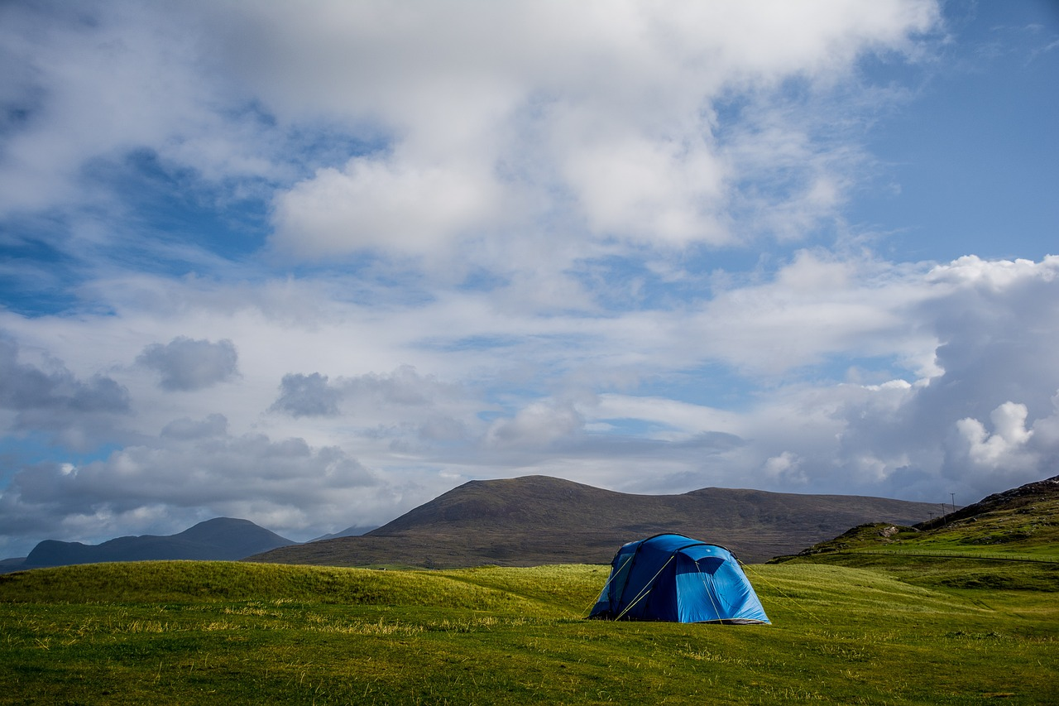Photo 10 – Wild camping (Pixabay, 2019)

Conclusion

The question remains whether change outlined above through legislation and campaign struggles leads to greater appetite for and delivery of outdoor recreation and education – and the way forward for rights access and benefits for both sectors (a puzzle teased visually through the final photo below).

There is, this paper concludes, despite the substantiation of the imbued sense of not belonging outdoors through great periods of a struggle against land ownership and restrictive land access rights, a lack of categorical evidence of direct correlation of the stymying of delivery of recreational and educational practices.

Further research is needed, maybe including comparisons with Scandinavia and elsewhere, although it will prove hard to analyse Britain alongside equally because of this country’s historical land rights idiosyncrasies.

And this paper has not touched upon Northern Ireland and its peculiarities with regards to both land ownership and a distinct lack of access rights both before and after the Republic of Ireland’s independence a century ago, suggesting a rich area for further comparative study on cultural struggles and historical influences.

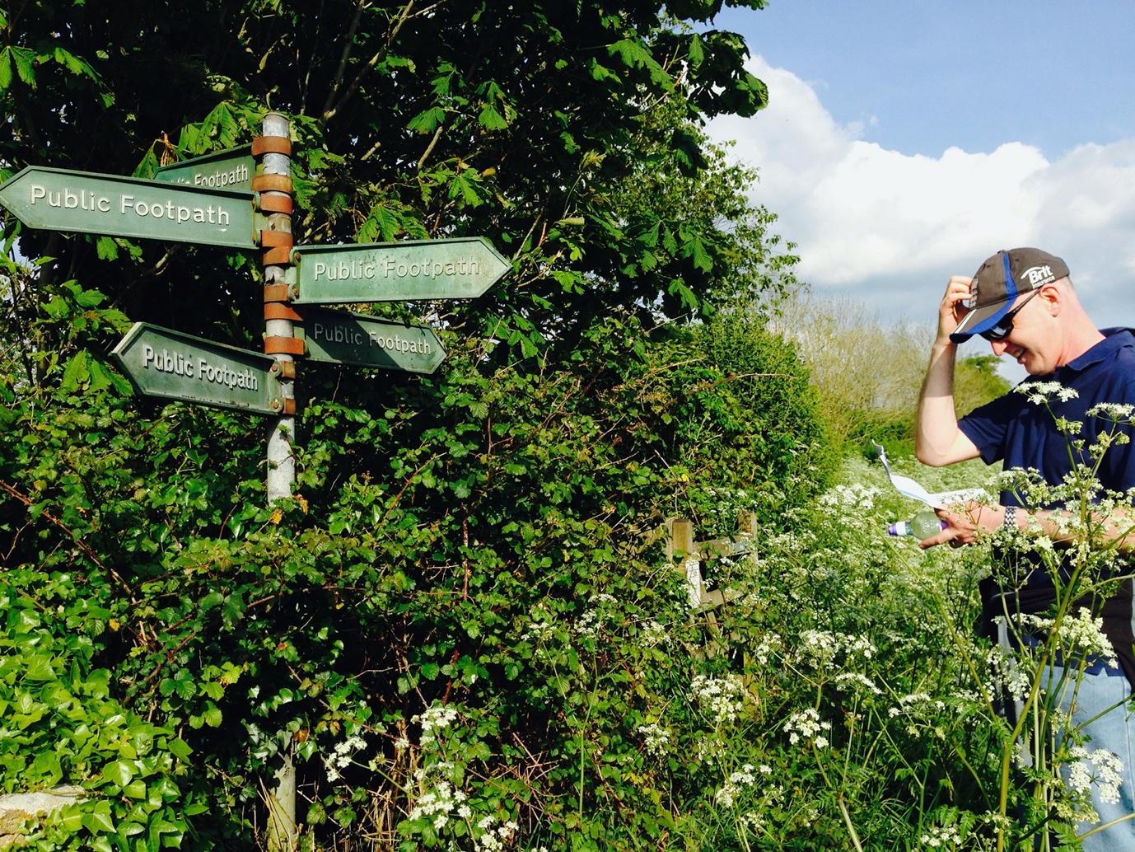
Photo 11 – Which way now? (Goode, 2014b)

References

Allison, P. & Telford, J. (2005) ‘Turbulent times: Outdoor education in Great Britain 1993-2003’, Australian Journal of Outdoor Education, 9(2), pp. 21-30.

Breen, T. et al. (2023) ‘Whose right to roam? Contesting access to England’s countryside’, Journal of transport history, 44(2), pp. 276–307. Available at: https://doi.org/10.1177/00225266231174766.

Campion, R. and Stephenson, J. (2010) ‘The “right to roam”: lessons for New Zealand from Sweden’s allemansrätt’, Australasian journal of environmental management, 17(1), pp. 18–26. Available at: https://doi.org/10.1080/14486563.2010.9725245.

Clare, J. (2004) ‘The moors’, in Bate, J (ed.) John Clare selected poems. London: Faber and Faber Limited.

Cook, L. (1999) The 1944 Education Act and outdoor education: from policy to practice, History of Education, 28:2, pp. 157-172. Available at: DOI: 10.1080/004676099284717

Countryside and Rights of Way Act (2000). Available at: http://www.legislation.hmso. gov.uk/acts/acts2000/20000037.htm (Accessed 7 November 2024).

Curry, N. (2000) ‘A Right to Roam: Should We Open up Britain’s Countryside?’, Journal of environmental planning and management. Abingdon: Taylor & Francis Ltd, pp. 450–450.

Duke of Edinburgh’s Award (2024). Available at: https://www.dofe.org (Accessed: 8th November 2024).

Forest School Association (2024). Available at: https://forestschoolassociation.org (Accessed: 9th November 2024).

Goode, J. (2013) Public access land as far as the eye can see in Assynt, Scotland [Photograph]. Author's personal collection.

Goode, J. (2014a) Cycles parked in the countryside [Photograph]. Author's personal collection.

Goode, J. (2014b) Which way now? [Photograph]. Author's personal collection.

Goode, J. (2016) Public footpath sign [Photograph]. Author's personal collection.

Goode, J. (2017) Sailboat on the Norfolk Broads [Photograph]. Author's personal collection.

Goode, J. (2021) Leadership walking group in training in Berkshire [Photograph]. Author's personal collection.

Goode, J. (2022a) Ancient byway in Wales [Photograph]. Author's personal collection.

Goode, J. (2022b) Public footpath across Essex field [Photograph]. Author's personal collection.

Goode, J. (2024) Private woods Keep Out [Photograph]. Author's personal collection.

Hayes, N. (2020) The book of trespass. London: Bloomsbury Publishing.

Harker, B. (2005) ‘“The Manchester Rambler”: Ewan MacColl and the 1932 Mass Trespass’, History workshop journal, 59(1), pp. 219–228. Available at: https://doi.org/10.1093/hwj/dbi016.

Hey, D. (2011) ‘Kinder Scout and the legend of the Mass Trespass’, Agricultural history review, 59(2), pp. 199–216.

Higgins, P. (2002) ‘Outdoor education in Scotland’, Journal of adventure education and outdoor learning, 2(2), pp. 149–168. Available at: https://doi.org/10.1080/14729670285200261.

Hopkins, D. and Putnam, R. (2012) Personal growth through adventure. Abingdon, Oxon: Routledge. Available at: https://doi.org/10.4324/9781315067537.

Horton, H. (2024) ‘Wild camping on Dartmoor not a significant fire risk, research shows’, The Guardian (London).

Hunt, J. (ed) (1989) In Search of Adventure. Guildford: Talbot Adair Press.

James, T. (1985) ‘Sketch of a moving spirit: Kurt Hahn’, in Kraft, R.J., & Sakofs, M.S. The Theory of Experiential Education. Dubuque, IA: Kendall Hunt Publishing Company.

Jenkins, S. (2024) ‘The right to roam … but you have to trespass to get there. England’s countryside rules are truly absurd’, The Guardian (Online).

Knight, S. (2018) ‘Forest school in the United Kingdom’, in Humberstone, B., Prince, P. & Henderson, K.A. Routledge International Handbook of Outdoor Studies. London: Routledge.

Land Reform (Scotland) Act (2003). Available at: http://www.scotland-legislation.hmso.gov.uk/ legislation/scotland/acts2003/20030002.htm (Accessed 8 November 2024).

Loynes, C. (2007) ‘Social reform, militarism and other historical influences on the practice of outdoor education in youth work’, in Becker, P., Braun, K-H., & Schirp, J. (eds) Abenteuer, erlebnisse und die pädagogik: kulturkritische und modernisierungstheoretische blicke auf die erlebnispädagogik. Leverkusen: BSJ-Jahrbuch. Available at: DOI:10.2307/j.ctvkjb23n.8.

Macfarlane, R. (2003) Mountains of the mind. London: Granta Books.

Mayfield, B. (2010) ‘Access to Land: Social Class, Activism and the Genealogy of the Countryside and Rights of Way Act’, Statute law review, 31(1), pp. 63–83. Available at: https://doi.org/10.1093/slr/hmq005.

Mitchell, J. (2008) ‘What Public Presence? Access, Commons and Property Rights’, Social & legal studies, 17(3), pp. 351–367. Available at: https://doi.org/10.1177/0964663908093968.

Mountain Training (2024). Available at: https://www.mountain-training.org (Accessed: 8th November 2024).

Nicol, R. (2002a) Outdoor education: Research topic or universal value? Part one, Journal of Adventure Education & Outdoor Learning, 2:1, 29-41. Available at: DOI: 10.1080/14729670285200141.

Nicol, R. (2002b) Outdoor education: Research topic or universal value? Part Two, Journal of Adventure Education & Outdoor Learning, 2:2, 85-99. Available at: DOI: 10.1080/14729670285200201.

Outward Bound Trust (2024). Available at: https://www.outwardbound.org.uk (Accessed: 7th November 2024).

Paddle UK (2024). Available at: https://paddleuk.org.uk (Accessed: 8th November 2024).

Parker, G. and Ravenscroft, N. (1999) ‘Benevolence, nationalism and hegemony: fifty years of the National Parks and Access to the Countryside Act 1949’, Leisure studies, 18(4), pp. 297–313. Available at: https://doi.org/10.1080/026143699374871.

Pixabay. (2016) Barbed wire fence in countryside [Photograph]. Available at: https://pixabay.com/photos/post-pasture-fence-fence-1429532/ (Accessed: November 2024).

Pixabay. (2019) Wild camping [Photograph]. Available at: https://pixabay.com/photos/tent-scotland-camping-travel-4558240/ (Accessed: November 2024).

Quay, J. and Seaman, J. (2018) ‘Outdoor studies and a sound philosophy of experience’, in Humberstone, B., Prince, P. & Henderson, K.A. Routledge International Handbook of Outdoor Studies. London: Routledge.

Ramblers (2024) ‘New Government, new opportunity for access?’ [blog] 5 July. Available at: https://www.ramblers.org.uk/news/new-government-new-opportunity-access (Accessed: 14 November 2024).

Ramblers’ Association (2024). Available at: https://www.ramblers.org.uk (Accessed: 13th November 2024).

Right to Roam (2024). Available at: https://www.righttoroam.org.uk (Accessed: 2nd November 2024).

River Access for All (2024). Available at: http://www.riveraccessforall.co.uk (Accessed: 10th November 2024).

Scottish Government, Landscape and outdoor access (2024). Available at: https://www.gov.scot/policies/landscape-and-outdoor-access/national-parks/ (Accessed: 9th November 2024).

Scottish Rights of Way & Access Society (2024). Available at: Scottish Rights of Way & Access Society (Accessed: 10th November 2024).

Shoard, M. (1979) ‘Metropolitan Escape Routes’, The London Journal, 5(1), pp. 87–112. doi: 10.1179/ldn.1979.5.1.87.

Shoard, M. (1999) A right to roam. Oxford: Oxford University Press.

Shrubsole, G. (2020) Who owns England? London: William Collins.

Stanistreet, P. (2007) ‘Coming up for air’, Adults learning, 19(2), pp. 26–28.

trip2themoon (2011) Mark Thomas secret map of Britain [video]. Available at: https://www.youtube.com/watch?v=itqMwuB8gOk&t=349s (Accessed: 10 November 2024).

Wall, T. (2024) ‘“It’s a play area for townies”: visitors and residents row over plan for new national park in Wales’, The Observer (London).

Wurdinger, S.D. (1997) Philosophical issues in adventure education. 3rd edn. Dubuque, IA: Kendall Hunt Publishing Company.

