Costel Iosip ( 2022687)
BA Business Management
The Global Business Environment
LCCB4005
Assessment 1

Environmental Analysis of
Automobile Industry
Mercedes Benz

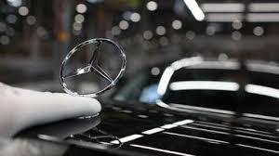

12.01.2022

German company Mercedes Benz is a well-known brand name that was established in the early 1900s. It is a branch of Daimler AG that specialises in the production of vehicles, buses, coaches and trucks. Mercedes Benz is owned by Daimler AG and is headquartered in Stuttgart. Mercedes is a name that is synonymous with luxury and elegance, and it is also considered to be one of the oldest automobile brands still in existence today, dating back to 1902. According to the 'best-global-brands 2011' ranking, Mercedes-Benz is the 12th most valuable brand in the world, up from the previous year's ranking of 12th. The company's current brand worth is $27,445 million USD. A branch of the German automaker Daimler AG, this business produces premium vehicles, buses, coaches, and trucks under the Mercedes-Benz brand name. Germany's Baden-Württemberg state is home to the company's headquarters. However, the name first appeared in 1926 under the Daimler-Benz brand, but its roots can be traced back to Daimler's 1901 Mercedes and Karl Benz's 1886 Benz Patent Motorwagen, which is usually considered to be the world's first vehicle.
Mercedes-Benz is a German vehicle manufacturer located in Stuttgart. It is a member of the "German Big 3" luxury automakers, which also include Audi and BMW, and is one of the world's best-selling luxury automotive manufacturers. It is a branch of the German company Daimler AG that operates on a global scale.
The Daimler-Motorn-Gesellschaft (Daimler Motors Corporation) was the first company to use the Mercedes automobile, which debuted in 1901. Following the merging of Karl Benz's and Gottlieb Daimler's firms into the Dailmer Benz Company on June 28, 1926, the first Mercedes-Benz brand name automobiles were built in 1926. Stuttgart, Germany, serves as the organization's headquarters. Automobiles, buses, and other types of transportation are among the goods.

Sectors of the business world
Private sector company, Mercedes-Benz India, develops, produces, imports, and sells Mercedes-Benz automobiles across the country. In addition, the company offers fleet solutions for small and medium-sized businesses, as well as preferential pricing, service support, and single-window account management services for corporate and customer accounts. The company also sells specially configured vehicles for hotels and rents vehicles for business purposes. Aside from that, the company sources and distributes vehicle components, as well as motorsports accessories and wristwatches, as well as bicycles and biking accessories, as well as utilitarian clothing.

Organizational structures of businesses
Corporate entities are businesses that are owned by their shareholders, who in turn elect a board of directors to manage the organization's operations. Businesses and philanthropic organisations are both examples of for-profit corporations. Corporations may either be for-profit or not-for-profit, depending on their goals. As a result, Mercedes Benz Company is a cooperative enterprise since its capital is split into shares. And the company is owned by its shareholders, and it performs its business primarily for the purpose of making a profit and expanding its operations.
The following are elements affecting the internal business environment:
System of Values
The value system of a commercial organisation also impacts how that organisation interacts with its workers, customers, and the general public. Business decision-makers' value systems play an essential role in the selection of a company's business and the implementation of its policies and procedures. A commercial organisation may refuse to create because of its value system. Human resources are a kind of resource. It is possible for workers to be either a company's strength or a weakness, depending on their degree of practical abilities, attitudes toward work, and other factors. Consider the following scenario: A company with skilled and motivated employees is almost certain to be the most valuable asset of that company. Employees who are not properly taught and who have poor attitudes about their jobs will provide a problem to the organisation.
Capital resources are a kind of financial asset.
Money is very necessary for any business to function properly. No business can exist if it does not have sufficient financial resources. Once a firm has secured sufficient funding, it may quickly begin implementing initiatives and expanding their reach. There are also a variety of approaches that businesses may use to keep their finances steady.

Structure of the organisation
A good organisational structure is essential for a successful business, and the owners must carefully consider how to set up a system that will allow the company to run without interruption. Everyone who uses information must be informed of any changes in the information flow, and the heads of departments must see to it that this occurs. It is beneficial for both employers and the company when appropriate laws and regulations are put in place.
Factors related to the external environment
The following are external elements affecting the micro business environment:
Suppliers
Suppliers supply raw supplies, human resources, technology, and components, among other things, to the firm. Any firm that is only reliant on a single supplier will be forced to close its doors shortly.
This makes maintaining constant contact with a variety of vendors very important for the company.
Customers
Customers are handled as though they are the most important person in the company. They are the sole reason why the company is still in operation today. A company may have a diverse range of consumers, including wholesalers, retailers, local purchasers, and international buyers, among others. Competitors It refers to the parties that are engaged in the same types of product production. Consequently, corporations must develop a variety of diverse marketing tactics to effectively market their goods.
The following are external macroeconomic business environment factors:
Factors pertaining to politics
Being responsible for the firm's global expansion since the invention of the vehicle, the corporation has had to deal with the issue of maintaining an international trade policy in regards to the importation of manufactured products from its inception. As a result, the political concerns surrounding the car sector are multifaceted and difficult to understand.
The automobiles and trucks manufactured by the Mercedes-Benz corporation are powered by engines that operate on fossil fuels such as gasoline and diesel, releasing carbon dioxide into the atmosphere and polluting the environment. Different legislations have been implemented by governments across the European Community to reduce the emission of such gases, requiring automobile manufacturers to create less polluting engines, such as the Euro 4. Automobiles are also a significant contributing factor to traffic accidents, and as a result, government legislation has been enacted to increase the safety of automobile drivers as well as users of public transit.
Factors related to the economy
Mercedes-Benz is experiencing difficulties as a result of worldwide currency changes. Because of the differing scales of taxation and revenue assessment, there has been a continuous worldwide slowdown. It also has an impact on the product's ability to sell. The rate of exchange between Euro and Ringgit automobiles. Because of the exchange rate between the currencies, selling a European automobile in Malaysia will result in a higher price.
Factors related to the economy In addition to Germany and the United States, Mercedes-Benz has production facilities in Brazil, South Africa, and a number of other nations. Its facilities employ tens of thousands of workers to manufacture automobiles and distribute them across the world. Because of the enormous scale of its activities and its worldwide presence, it is able to make large contributions to the different governments in the form of taxes and customs charges. It also helps significantly to the local economy via the use of locally sourced materials and components.
Factors of a social nature
Mercedes-Benz has developed electric vehicles and compact automobiles for those who live in cramped quarters in response to global warming concerns. They have also developed a vehicle known as the BLOME, which is ecologically friendly. The flue pipe of this vehicle releases oxygen into the atmosphere. The translucent organic solar cells used to construct
Social physicians are concerned with the values and advantages to society that they provide. Mercedes-Benz automobiles are pricey and are considered luxury vehicles by the majority of people. In today's society, owning a Mercedes-Benz is associated with wealth and success. Despite the fact that most automobile manufacturers, whether Japanese, European, or American-made, are of the highest quality and have the most up-to-date styling, Mercedes-Benz has effectively sold itself as the greatest automobile. This is accomplished by a large number of media campaigns featuring well-known people such as professional athletes, movie stars, and top fashion models.
Factors related to technology
Technology is very significant in the marketing and development of products. As a result, the industry has reduced its overall labour force. The tiny labour force allows Mercedes to save money on labour costs. Mercedes is now able to create more automobiles in a shorter amount of time because to the usage of new technologies.
Year after year, the corporation funds two high school students, one from Australia who travels to Germany and another from Germany who travels to Australia. Aside from that, Mercedes-Benz Australia/Pacific contributes to a variety of worthwhile causes via contributions and various types of sponsorship, including the Starlight Children's Foundation, the MS (Multiple Sclerosis) Society, and the Ovarian Cancer Research Foundation. Factors relating to technology Mercedes-Benz manufactures a comprehensive line of passenger, light commercial, and heavy commercial vehicles. Production takes place on a worldwide scale.
Factors related to the environment
Environmental activists are getting increasingly active and forceful in their campaigning for the environment. Aside from that, it has been revealed that customers are getting more environmentally sensitive, to the point where they may even examine if the automobile created by a certain manufacturer emits the least CO2.
Since 1994, the Smart brand of city ears has also been a member of the Mercedes-Benz Group, as has the Smart brand of city ears. Manufacturers are always producing new models that have the most up-to-date design and technology in order to improve sales. A significant amount of money is spent on research and development in order to produce a better automobile that will fulfil client demand, taste, and keep them one step ahead of their competition. In recent years, a significant amount of money has been invested in the development of new engines to comply with government-imposed low-pollutant emissions rules. Numerous computer technologies have also been implemented to increase performance and safety, as well as to save costs.

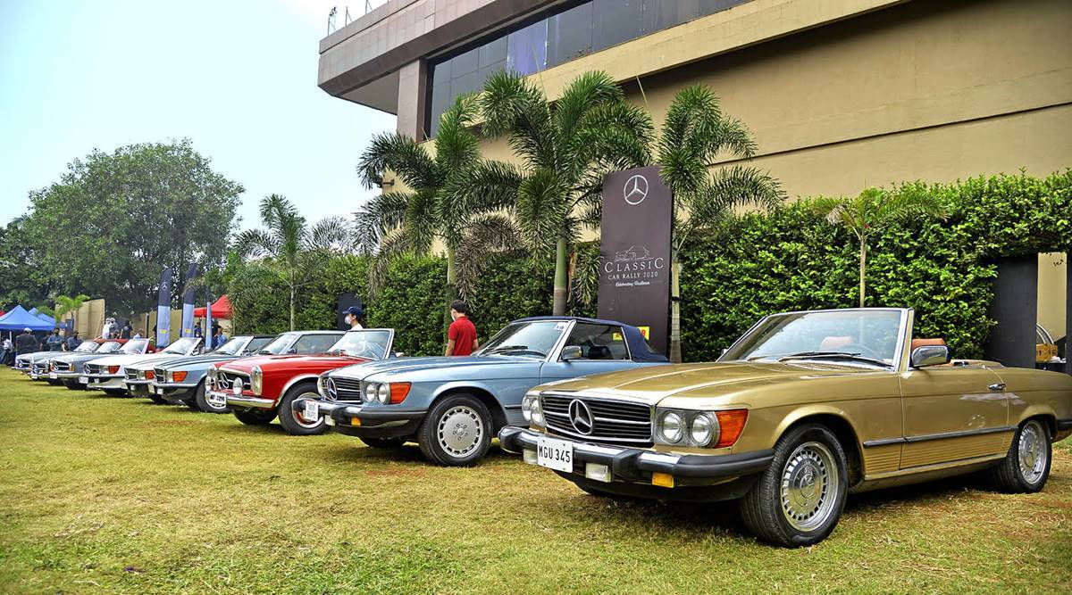

Mercedes-Benz SWOT analysis.
In the dictionary, a swot analysis is defined as a study carried out by a company in order to determine its internal strengths and weaknesses, as well as its external advantages and disadvantages.
Swot analysis is a framework for evaluating a company's competitive position by identifying its strengths, weaknesses, opportunities, and threats. It is often used in marketing and management. An organization's capabilities and limitations, as well as possible opportunities and threats, are measured using a swot analysis, which is a fundamental evaluation paradigm. The Mercedes-Benz swot analysis assesses the company's strengths, weaknesses, opportunities, and threats in relation to the luxury automobile manufacturer.
Strengths
The first point to mention is that Mercedes is a highly well-known automobile brand that has widespread brand awareness and whose popularity has been steadily expanding over the last several years. It has also produced a great number of automobiles, all of which are quite popular.
2. Mercedes has a robust product range that includes anything from sedans to SUVs, which is beneficial.

for them to be able to compete against other competitors in the market
3. The corporation is a leader in invention, and it is responsible for the internal combustion engine, airbags, and other technologies that are used today.
Weakness
1. Mercedes Benz automobiles are often costly, which explains why they are more popular in industrialised countries with greater per capita incomes. Mercedes automobiles are also quite expensive to maintain.
2. Because it is a worldwide automobile brand, even little flaws are exaggerated to the point that they have a negative impact on the brand.
3. Mercedes' market share growth will be constrained as a result of intense competition.
Opportunities
1. Mercedes may devote more resources to the development of hybrid vehicles and fuel-efficient vehicles in the future.
The second step is to tap into rising markets throughout the globe while also developing a worldwide brand.
3. The rapidly expanding demand for luxury vehicles, as well as the associated growth in wealth, may provide an opportunity for Mercedes Benz.
4. The brand's strong presence may be used to attract additional clients to the company.
Threats
1. Government actions affecting the car industry across the globe have the potential to lead Mercedes to lose money.
2. The ever-increasing cost of gasoline.
3. Intense rivalry from international automotive manufacturers.

Reference List

Free Essays - PhDessay.com. (2018). Pestle presentation mercedes benz - PHDessay.com. [online] Available at: https://phdessay.com/pestle-presentation-mercedes-benz/
Mercedes-benz.com. (2015). Mercedes-Benz: Innovation. [online] Available at: https://www.mercedes-benz.com/en/next/.
pestleanalysis.com. (n.d.). Mercedes-Benz SWOT Analysis 2021. [online] Available at: https://pestleanalysis.com/mercedes-benz-swot-analysis/.
Shastri, A. (n.d.). Inclusive SWOT Analysis of Mercedes Benz | IIDE. [online] Available at: https://iide.co/case-studies/swot-analysis-of-mercedes-benz/.
simconblog (2015). Mercedes Brand Analysis. [online] SIMCON Blog. Available at: https://simconblog.wordpress.com/2015/05/03/mercedes-brand-analysis/.
www.grin.com. (n.d.). GRIN - Mercedes Benz Cars Germany - Market Analysis. [online] Available at: https://www.grin.com/document/210854.
Zigu (n.d.). Mercedes Benz PESTLE Analysis. [online] MBA Skool-Study.Learn.Share. Available at: https://www.mbaskool.com/pestle-analysis/companies/18037-mercedes-benz.html.

