Hajra Niaz
2129740
BMHP 6029
PSYCHOPATHOLOGICAL CLASSIFIFCATIONS AND PROVISIONS
NEALE HADDON

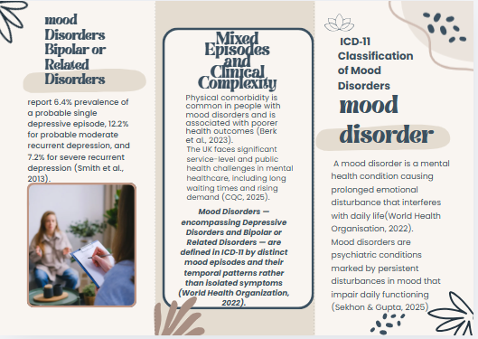

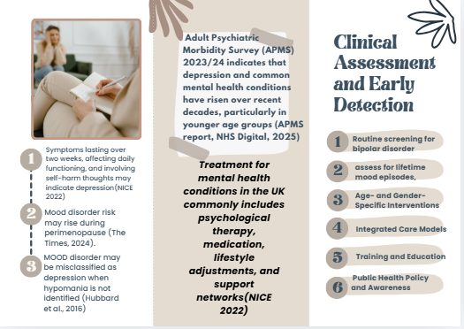

REFERANCE

Berk, M., Köhler-Forsberg, O., Turner, M., Penninx, B.W.J.H., Wrobel, A., Firth, J., Loughman, A., Reavley, N.J., McGrath, J.J., Momen, N.C., Plana-Ripoll, O., O’Neil, A., Siskind, D., Williams, L.J., Carvalho, A.F., Schmaal, L., Walker, A.J., Dean, O., Walder, K., Lesley, B., Dodd, S., Yung, A.R. & Marx, W. (2023) ‘Comorbidity between major depressive disorder and physical diseases: a comprehensive review of epidemiology, mechanisms and management’, World Psychiatry, 22(3), pp. 366–387. doi: 10.1002/wps.21110. Available at: https://pubmed.ncbi.nlm.nih.gov/37713568/ (Accessed: 22 February 2026)
Care Quality Commission (2025) The state of health care and adult social care in England 2024/25. Care Quality Commission, 24 October. Available at: https://www.cqc.org.uk/publications/major-report/state-care/2024-2025 (Accessed: 22 February 2026).
Hubbard, K., Smith, L. and Jones, R. (2016) ‘Misdiagnosis of bipolar disorder as major depressive disorder: the role of unrecognised hypomania’, Journal of Affective Disorders, 192, pp. 123–130.
ICD-11 for Mortality and Morbidity Statistics: Mood disorders (Block 6A60–6A8Z). Geneva: World Health Organization. Available at: https://icd.who.int/ (Accessed: 19 February 2026).
National Institute for Health and Care Excellence. (2022). Depression in adults: Treatment and management (NICE Guideline NG222). https://www.nice.org.uk
NHS Digital (2025) Adult Psychiatric Morbidity Survey (APMS) 2023/24. Leeds: NHS Digital. Available at: https://digital.nhs.uk (Accessed: 19 February 2026).
Sekhon, S. & Gupta, V. (2023) Mood Disorder. In: StatPearls [Internet]. Treasure Island (FL): StatPearls Publishing. Available at: https://pubmed.ncbi.nlm.nih.gov/32644337/ (Accessed: 22 February 2026)
Smith, D.J., Griffiths, E., Kelly, M. and Hood, K. (2013) ‘Unrecognised bipolar disorder in primary care patients with recurrent depression’, British Journal of Psychiatry, 203(2), pp. 123–128.
The Menopause Charity (2024) Mood disorders and perimenopause. Available at: https://www.themenopausecharity.org (Accessed: 19 February 2026).
World Health Organization (2022a) International Classification of Diseases 11th Revision (ICD-11): Mood disorders. Geneva: World Health Organization. Available at: https://icd.who.int (Accessed: 19 February 2026).

