LEVEL 4 jonathan Pugh

SEMESTER 2

MODULE CODE: M4X00386
Engineering Science 2

Question One(25 marks)
A 12 v battery has an internal resistance of 4 Ω
- With an 8 Ω load the power the power dissipated would be,
E – Ir =
(I = 12A/12Ω)
12v – 1(4Ω) = 8v
Therefore 12v – 8v = 4v dissipated
- Insert graph

- c) the internal resistance and the load resistance are at maximum power when they are equal in power, in this case 4Ω

i. wire length
- R = 100Ω r = d/2
p = 9.81x10^-8
R = pl/a
d = 0.1mm a = 7.85x10^-9
aR = PL = (7.85x10-7 / (9.81x10^-8) = 8.01m

- platinum wire volume
al = volume
a = 7.85x10^-9
l = 8.01m
(7.85x10^-9)(8.01) = 6.28x10^-8 m^3

- cost of the platinum used in the sensor
density = 21.45x10^3
cost £10000 pre Kg
desity x cost x volume = total cost
(6.28x10^-8) x (10000) x (21.45x10^-4) = £13.47

- the platinum film thickness
x = thickness 3.5x10^-4cm = 3.5x10^-6 m
l = 0.75m
r = 125 Ω
p = 9.81x10^-8

R = pl/a = a = pl/r = X = pl/3.5x10^-6r

X = (9.1x10^-8)0.75 / (3.5x10^-6)125 = 1.68x10^-4m

- cost of platinum in sensor
density = 21.45x10^3
cost = £10000 Kg
thickness = 1.68x10^-4
length = 0.75m
a = 3.5x10^-6m

(3.5x10^-6)(0.75) = 2.625x10^-6
(2.62x10^-6)(1.68x10^-4) = 4.41x10^-10
(4.41x10^-10)(10000)(21.45x10^3) =

= £0.09

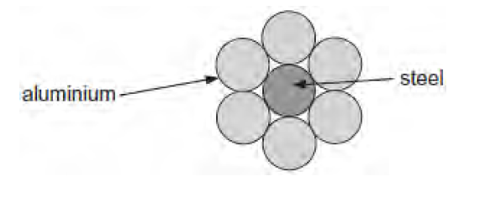
d)

- The steel wire with a diameter of 7.4mm
d = 7.4mm = 0.0074m
a = Pie r^2
r = 0.0037m
l = 1000m

r = 3.3Ω r = pl/a
p = (4.30x10^-5)3.3/1000

ar/l = p = 1.42x10^-7 Ω

- There is only a small percentage of total current that passes though the wire because the current prefers to go through the aluminium rather than the steel. The fact that there is 6 aluminium to 1 steel wire mean that this exacerbates the flow and makes it more susceptible for the electricity to pass through the aluminium rather that the steel.

- The potential difference across 1.0 km of cable is 75v and the total power loss is calculated below

1/rt = 6 aluminium + 1 steel
V = 75v
= 1/1.1 + 1/1.1 + 1/1.1 + 1/1.1 + 1/1.1 + 1/1.1 + 1/3.3 = 5.75

= 1/5.75 = 0.17

P= v^2/R = 75^2/0.17 = 3308823v

Question 2 (25 marks)
- Most types of microphone detect sound because the sound waves cause a diaphragm to vibrate. In one type of microphone this diaphragm forms one plate of a parallel plate capacitor. As the diaphragm plate moves. the capacitance chances. Moving the plates closer together increases the capacitance. Moving the plates further apart reduces the capacitance.
This effect is used to produce the electrical signal. The circuit shown below consists of a 3 V supply, an uncharged capacitor microphone C. a resistor R. and a switch S.
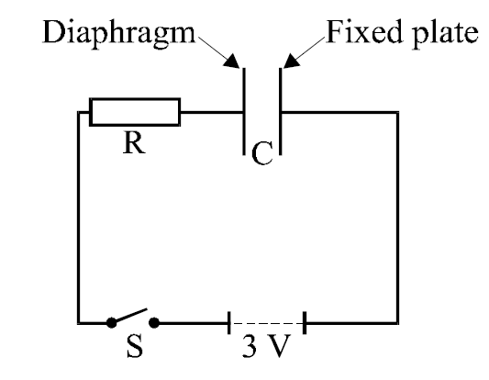

- Graph of the voltage across the capacitor microphone against time.

V
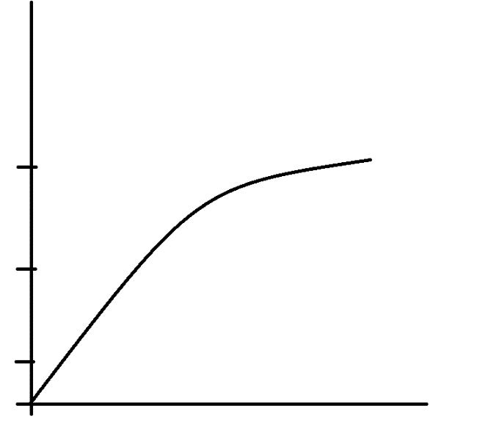

3

2

1

T(s)

- The movement of the diaphragm causes a potential difference (the signal) to change as the plates are moved, when the plate is closer the potential difference increases and further away it decreases. Therefore the proximity of the plate is the key factor in the signal.

- The circuit below models a single pixel of a CCD device. The photocell generates a voltage which depends on the intensity of light falling on it. When information about light intensity is required, the switch is opened. The voltage across the capacitor at that instant can be read out into an electronic circuit (represented by the voltmeter) at a later time.
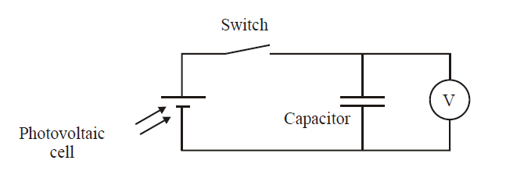

The capacitor has a value of 0.22 F. In an experiment the voltmeter reads 95 mV after the switch is opened. Calculate the charge on the capacitor. [3]

- the voltmeter by not updating the results and continuously showing 95mV would mean that the vault meter is faulty and not showing accurate readings

- The student doing the experiment changes the voltmeter for another. With the new voltmeter the voltage changes with time according to the table below.
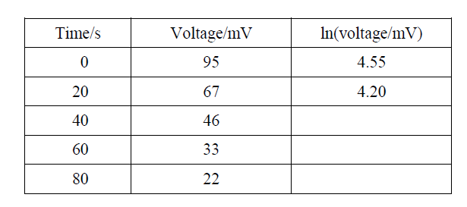

3.82
3.49
3.09

ln(46) = 3.82
ln(33) = 3.49
ln(22) = 3.09

- Table graph

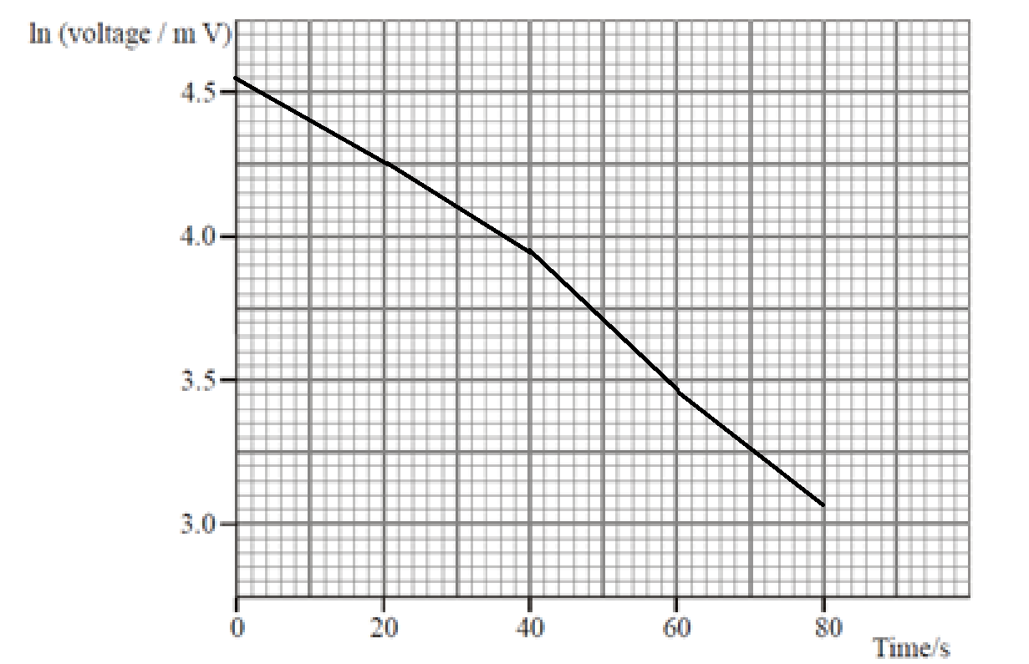

- The exponential voltage decreases in the graph above is quite easy seen due to the fall in voltage over the time. The voltage droops from 4.55 to 3.09 in 80s. [3]

- The approximate vale for the resistor of the second voltmeter is 268.18Ω

E = 0.22f
95 x 0.37 = 35.15 mV
Ln(35.15) = 3.56
Time on graph at 3.56 = 59s
- Time = 59s r = time/0.22 = 59/0.22 = 268.18Ω

Question 3 (25 Marks) Closed system

- The quality of the refrigerant in the final state would be………

- The amount of heat lost from the tank…….

Schematic:

Tank A
3 kg
1.6 MPa
x = 0.4
Saturated R-134a
Tank B
2.7 kg
1.2 MPa
120°C
Superheated R-134a
Q

Assumptions:
- Kinetic and potential energy changes are negligible.
- There are no work interactions.
- Tables A-12, and A-13 are required.
- In a saturated liquid-vapour mixture, the mass fraction of vapour is called the quality and is expressed as:
$$x=\frac{m_{vapour}}{m_{total}}$$
Quality may have values between 0 (saturated liquid) and 1 (saturated vapour). It has no meaning in the compressed liquid or superheated vapour regions. In the saturated mixture region, the average value of any intensive property y is determined from:
$$y=y_{f}+x.y_{fg}$$
where f stands for saturated liquid, g for saturated vapour and y stands for v, u or h.
- For specific volume, $v_{fg}=v_{g}-v_{f}$

Question 4 (25 Marks) steady-flow open system
In large steam power plants, the feedwater is frequently heated in closed feedwater heaters, which are basically heat exchangers, by steam extracted from the turbine at some stage. Steam enters the feedwater heater as superheated water at 50 kPa, 200°C and a mass flow rate of 21.6×10³ kg/hr, and leaves as saturated liquid-vapour mixture at 45 kPA and a quality of 15 percent. Feedwater enters the heater with a quality of 5 percent at 82 kPa and leaves with a quality of 12 percent at the same pressure. If the heat losses from the outer surfaces of the heater are 6% of the heat given up by the steam, determine,

- The heat transfer rate from steam to the feedwater would take………..

- The mass flow rate of the feedwater ${\dot{m}}_{W}$.

Schematic:

Assumptions:
- Steady-flow process.
- Kinetic and potential energy changes are negligible.
- There are no work interactions.
- The properties of saturated and superheated water can be found in Tables A-5 and A-6.
- In a saturated liquid-vapour mixture, the mass fraction of vapour is called the quality and is expressed as:
$$x=\frac{m_{vapour}}{m_{total}}$$
Quality may have values between 0 (saturated liquid) and 1 (saturated vapour). It has no meaning in the compressed liquid or superheated vapour regions. In the saturated mixture region, the average value of any intensive property y is determined from:
$$y=y_{f}+x.y_{fg}$$
where f stands for saturated liquid, g for saturated vapour and y stands for v, u or h.

