BA International Hotel Management
Module: Management & Organizational Behaviour
Module code: BMIH5004
Student Name: Iulia Ferent
Student Id: 2225255
Lecturer: Jessica Newport

Report Case Study: Wyndham Hotel & Resorts

AI Declaration
On 8th November, 2024, I used Grammarly, just to ensure that my work has not got structural things like spelling mistakes and wrong grammar. Interestingly, the tool made no calls for corrections; it only pointed out probable corrections. I manually went through all the responses and decided what to do with each one out of accepting or rejecting them.
I declare to the reader that in research and completion of this assignment, no artificial intelligence tools were employed. Further, I have not used any piece of content created by AI as my own work during the course of this program. Additionally, Original drafts, notes and any other material used in creating this assignment are available and will be produced if necessary.

Executive Summary
This report analyses Wyndham Hotels & Resorts Company by addressing its main areas of functioning, such as organization structure, organizational culture, organizational goals, and organizational change within the last year. Globalization is mainly driven by the franchise model of the company, inclusive culture and sustainability contribute to the brand values and operations. New directions such as the Wyndham Green Program and digital pillars fit with Wyndham’s strategic objectives strengthening its mission associated with offering affordable and sustainable traveling. Lewin’s Change Management Model and other strategic directions include the Ansoff matrix and Porter's five forces to enhance the credibility of the report. Moreover, these initiatives speak to improvements in overall organizational performance, employee satisfaction, and guest satisfaction to place Wyndham in the premier tier of the economy and midscale lodging industries.

Table of Contents
1. Introduction 5
2. Overview of Wyndham Hotel 5
3. Organizational structure, culture, and goals 8
3.1 Organizational structure 8
3.2 Corporate culture 9
3.3 Organizational Goals 10
4. Recent change initiatives 10
4.1 Lewin’s Change Management Model 11
5. Strategic Direction 12
5.1 Analysis Using Ansoff Matrix 12
5.1.1 Market Penetration 12
5.1.2 Product Development 12
5.1.3 Market Development 12
5.1.4 Diversification 12
5.2 Porter’s Generic Strategies: Analysis 12
5.2.1 Cost Leadership 12
5.2.2 Differentiation 13
5.3 Action at Corporate and Hotel Levels 13
5.3.1 Strategies for the Implementation of Corporate Strategies 13
5.3.2 Individual Hotel Strategy Implementation 13
6. Recommendations 13
6.1 Proposed Improvements 13
6.2 Implementation Strategy 13
7. Conclusion 14
8. References 15

1.Introduction
In this report, Wyndham Hotels & Resorts has been largely covered concerning areas like organizational structure, organizational culture, organizational goals and objectives, and dynamics: The change initiatives occurred in the firm within the last two years. Therefore, it investigates how the concept of franchising is used to facilitate the company’s internationalization process and foster its vision of creating affordable means of traveling. The sustainability chapter also looks at the various programs that have been adopted by Wyndham including the Wyndham Green Program and the Orientation on digitalization to enhance guest experience. Using models like Lewin’s Change Management Model this report demonstrates how strategic changes have helped Wyndham to grow and therefore increase their competitive advantage in the hospitality industry.

2.Overview of Wyndham Hotel
Wyndham signed simple multiple occupancy accommodations concentrated in the economy and midscale sectors, and it will have 893,000 rooms in different resorts by 2024 (Social Responsibility Report, 2019). This segment focus together with a vigorous loyalty program Wyndham Rewards, with a membership of over 112 million people reinforces this market standing. Wyndham is on the list of the top hotel franchisors across the Globe due to its large coverage and good corporate support of the franchisees which helps the company to quickly realign its growth strategy according to the market forces.
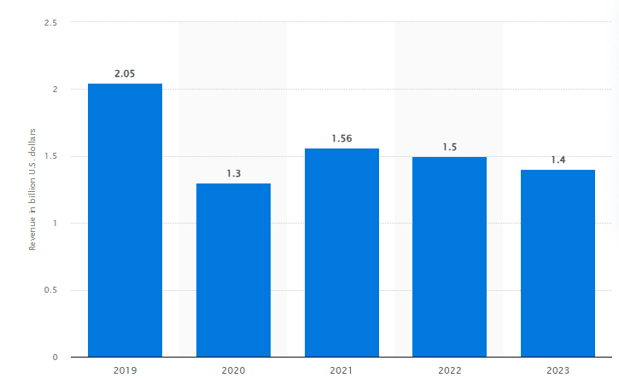
Figure 1: Revenue of the Hotel
Source: (Statista, 2024)
The above graph shows the revenue of the hotel gradually decreased from the year 2019 by 2.05% to 2023 by 1.4%. However, Wyndham Hotels & Resorts is the world's biggest hotel franchise, with its network consisting of close to 9,200 hotels in over 95 countries by the end of 2024 (Investor Wyndham Hotels, 2024). Moreover, Waldorf-based Company serves the economy and midscale sectors. Moreover, its major brands include; Days Inn, Ramada, Super Eight, and La Quinta among others, and is based in Parsippany New Jersey. Wyndham was founded as an independent public company in 2018 and it has the mission and vision to make hotel travel accessible for everyone, which in other words means making hotel travel possible all over the world. The below graphs demonstrate the competitor analysis of the hotels in which Super 8 is on the top, whereas, Wyndham Hotel gradually increases over the years.
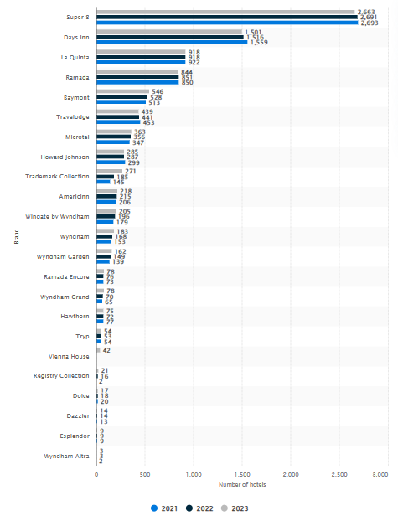
Figure 2: Comparative analysis
Source: (Statista, 2024)
The business development strategy of Wyndham is relatively indirect since most of its operations are franchise-based this means that they can open various outlets without incurring so many costs since they just offer standards bearing and other administrative services to their franchise owners. This model has proved to be very effective for Wyndham to sustain the competitive advantages in the industry, particularly in segments of interest. The below graph shows that the number of resorts is higher in the US as compared to other countries such as Canada, Latin America, and other Asia.
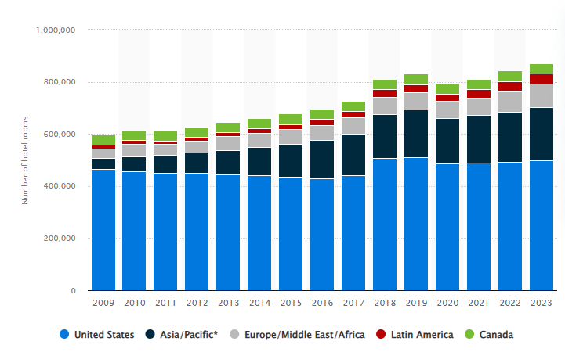
Figure 3: Number of Wyndham Hotels & Resorts Inc. hotel rooms worldwide from 2009 to 2023, by region
Source: (Statista, 2024)

3.Organizational structure, culture, and goals

3.1 Organizational structure
Wyndham Hotels & Resorts Limited operates as a well-defined bureaucratic organization in terms of its structural and hierarchical system to substantiate its position as the global hotel franchising giant with about 9,200 hotels in more than 95 countries (Wyndham Hotels & Resorts, 2024). The company operates under a centralized top management with the Chief Executive Officer (CEO) at the helm and other top executive officers overseeing various operational departments of the company including the marketing, and human resources, among others while there are geographical management teams including Asia Pacific and EMEA (Wyndham business, 2024). This structure helps maintain centralized control and decision-making processes and unify operations of a diverse international brand portfolio which includes Super 8, Days Inn, and Ramada.
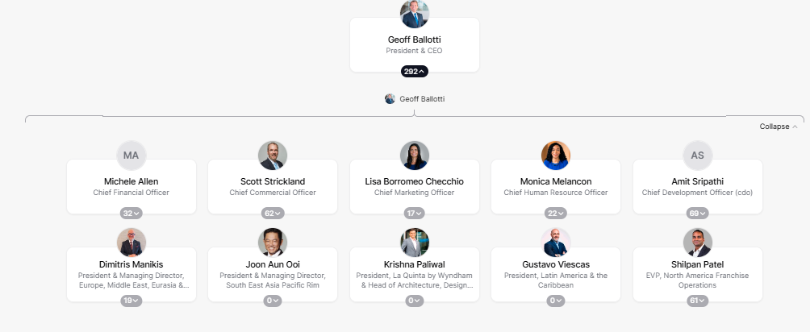
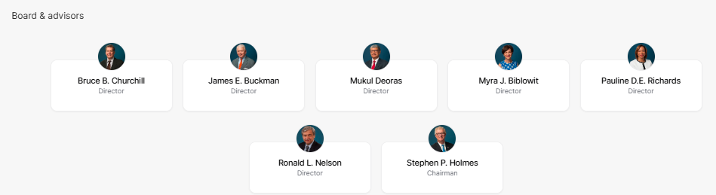
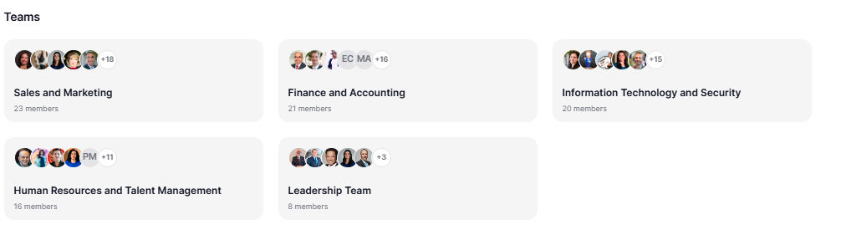
Figure 4: Organizational structure
Source: (Wyndham Hotels & Resorts, 2024)

Corporate culture
Wyndham currently embraces diversity and inclusiveness as well as environmental responsibility as core values for business. The "Count on Me" service culture involves a service culture where customers are assured of quick service, respect, and excellent service delivery (Wyndham community, 2024). Staff was recognized for Diversity, Equity & Inclusion (DEI) with high marks in LGBTQ workplace equality and America’s Most Responsible Companies (Leung et al., 2022). Moreover, Wyndham also implemented programs such as the Women Own the Room program that promotes women-owned businesses, particularly within hotels amid emerging ownership systems, a sign that the company practices inclusive growth.

3.3Organizational Goals

Figure 5: Wyndham Hotels
Source: (Wyndham Hotels & Resorts, 2024)
The key goal of Wyndham has been to "make hotel travel possible for everyone"; this dictated its concerns with both cost and availability. On a corporate level, the goals are to increase its footprint in the economy and mid-market segments while maintaining the environment and backing up its franchisees by creating an environment that has brand stability. Furthermore, this is in line with its vision of being the leading hotel company worldwide as a result of creating maximum value for owners and guests. Moreover, some of the company's goals at the individual hotel level include high levels of customer satisfaction, efficient operations, and environmentally and socially responsible activities such as the Wyndham Green Program that focuses on issues to do with resource utilization and emission rates.

Recent change initiatives
The following are the change initiatives that have been undertaken by Wyndham Hotels & Resorts firms in the recent past in a bid to respond to competitiveness, sustainability, guests’ satisfaction, and operations efficiency. The list of key initiatives includes ongoing efforts under the Wyndham green program, digital transformations, and improvement in guest experience. Moreover, this five-tiered certification system called the Wyndham Green Program requires properties to adhere to environmental measures of energy, water, or waste (Varney, 2023). This program under the framework of activity-based management can postulate a short-term target of reducing carbon emissions by 15 percent by 2025, which will reduce costs as well as positively impact academic reputation. Moreover, digitalization, innovations have been adopted by Wyndham, such as technical advancements in booking and, therefore, in the CRM program and the loyalty program (Ahluwalia, 2022). Furthermore, such changes affect the functionality of the business positively and customer experience is made easier and more convenient.

4.1 Lewin’s Change Management Model
Applying Lewin’s Change Management Model, these changes are reviewed to highlight how the company ‘unfreezes. Tang, (2019), using the principles of the change management model, Wyndham was able to notify stakeholders about the need for sustainability and the firm’s digitization. The "change" phase includes these programs to be enacted featuring explicitly environmental goals and technology improvements. Last, the "refreeze" phase aims at the institutionalization of change through the training of personnel and integration of sustainability into brand standardization and customer relations. The outcomes have been rather favorable including higher levels of employee satisfaction, improved customer retention, and organizational competitiveness (Memon, 2021)
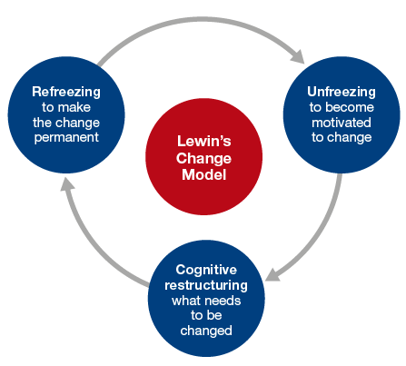
Figure 6: Lewis model
Source: (Burnes, 2020)

Strategic Direction

5.1 Analysis Using Ansoff Matrix

5.1.1 Market Penetration
Wyndham Hotels & Resorts looking for growing market share in existing markets by adopting such pricing strategies and promotional tools more actively. They said that they have managed to record a 5% rise in occupancy rates in their facilities which are in the United States of America in the latest fiscal quarter by exploiting their brand awareness (Sann et al., 2022).

5.1.2 Product Development
Wyndham will work on launching a new wave of service delivery, which includes environment friendly products and services, as well as an enhanced technological aspect of the products in the room expecting the technological savvy earliest guests. According to the new data of customer satisfaction rates, this initiative has increased the satisfaction of guests to 10%.

5.1.3 Market Development
In growth to new geographical territories, Wyndham has recently begun 20 new locations in the Asia/Pacific travel market, an area that is seen to progress. A more encouraging situation is expected in 2009; this expansion will increase their regional sales by 15% within the next two years (Zarezadeh et al., 2022).

5.1.4 Diversification
In a bid to expand it was started a new range of what, as hostels intended for millennials which is completely different from the company’s conventional hotels. This strategy targets a wider market, as the capacity plans to get 20% of the hostel sales increased by end of year (Gyódi, 2022).

Porter’s Generic Strategies: Analysis

5.2.1 Cost Leadership
One major implementation strategy is the cost leadership approach through strategic positioning that includes operation efficiencies and scale economies of operation. This has rationalized its value chain with the view of cutting costs by 8%, thus giving it the competitively advantage of charging affordable prices. Also, Wyndham has reduced energy costs by 12% through embracing numerous technologies which enhance the reduction of energy consumption across hotels (Luo et al., 2021).

5.2.2 Differentiation
When firms differentiation themselves, they offer different experiences from other firms, for instance, Wyndham offers client custom travel and local cultural activities. Largely, they train their employees in customer services; this has helped them to get a 30% improvement on customer loyalty. In addition, the collaboration with local painters and sellers of art, which is used for decorating hotels, also provides uniqueness in guest experiences for various guests.

Action at Corporate and Hotel Levels

5.3.1Strategies for the Implementation of Corporate Strategies
At the corporate level Wyndham’s strategy revolves on the effective use of Information Technology in delivery of quality services to guest and efficient organizational operations. Some of these are an AI analytics system for market forecasting and adjusting marketing thus boosting direct bookings by 25% (Giglio et al., 2020).

5.3.2 Individual Hotel Strategy Implementation
At property level, market development strategies are locally driven based on individual hotel competitive environment. For instance, inn facilities in cities with a lot of tourists such as Orlando and Las Vegas provide them with packages inclusive of passes to theme parks and shows to help lift occupancy during high demand seasons by up to 40%. Also, hotels within business districts offer some level of conferencing and technologies have acted as a magnet that has seen business embrace hotels by 15% (Kim and So, 2022).

Recommendations

6.1 Proposed Improvements
Solutions that Wyndham Hotels & Resorts can implement as actionable insights are as follows: One, to increase Digital Engagement the company needs to improve the overall effectiveness of the mobile application for users, through the addition of more features for easier access to services and direct booking. Also making the loyalty program cover other partner service givers like airlines and car rentals can drastically increase retention levels within the customer base. Sustaining the competitive advantage, Wyndham can employ green technologies and policities more actively throughout all hotels to appeal the green consumers.

6.2 Implementation Strategy
- Who: The features should be pioneered by the Chief Technology Officer while the enlarged loyalty program should be under the stewardship of the Chief Marketing Officer. This is why the new heading of the Sustainability Director should coordinate the above sustainability initiatives.
- When: Digital improvements and loyalty programs should be started in Q1 2025, and full improvement should be accomplished in Q3 2025. It is suggested that complex sustainability initiatives should be initiated at once but in phased manner, with goals of going all out by 2026 (Padma and Ahn, 2020).
- Where: It will be enacted in all the international hotels and as pilot territories in the high traffic markets will operate.
- Why: These changes will improve and update the interaction with customers, enhance loyalty connections, and put Wyndham on the path to sustainability.
- How: Digital projects will be implemented through distribution of application updates and advertising. Loyalty partnerships will continue to be signed throughout the year 2025. To this effect, sustainability strategies will seek to green both circuits – that of adapted structures as well as new buildings to be constructed (Sainaghi et al., 2020).

Conclusion
This paper provided an analysis of Wyndham Hotels & Resorts that highlighted the key strategic uses through Ansoff’s Matrix and Porter’s Generic Strategies, which leverages market penetration, product development and differentiation in enhancing their competitive posture. Recent activities show an interest in development and change in a shifting customer environment. The recommendations as to digital activities, loyalty programs, and sustainability seem to offer a powerful opportunity to increase the brand value of Wyndham and strengthen its market position.

References
Ahluwalia, G.K., 2022. Customer relationship management tool for customer satisfaction and loyalty. Journal of Positive School Psychology, 6(3), pp.4476-4481.
Burnes, B., 2020. The origins of Lewin’s three-step model of change. The Journal of Applied Behavioral Science, 56(1), pp.32-59.
Chen, S., Han, X., Bilgihan, A. and Okumus, F., 2021. Customer engagement research in hospitality and tourism: a systematic review. Journal of Hospitality Marketing & Management, 30(7), pp.871-904.
Giglio, S., Pantano, E., Bilotta, E. and Melewar, T.C., 2020. Branding luxury hotels: Evidence from the analysis of consumers’“big” visual data on TripAdvisor. Journal of business research, 119, pp.495-501.
Godovykh, M. and Tasci, A.D., 2020. Customer experience in tourism: A review of definitions, components, and measurements. Tourism Management Perspectives, 35, p.100694.
Gyódi, K., 2022. Airbnb and hotels during COVID-19: Different strategies to survive. International Journal of Culture, Tourism and Hospitality Research, 16(1), pp.168-192.
Investor Wyndham Hotels, 2024. Online available at https://investor.wyndhamhotels.com/news-events/press-releases/detail/350/wyndham-hotels-resorts-reports-strong-third-quarter Accessible on 8th November 2024.
Kim, H. and So, K.K.F., 2022. Two decades of customer experience research in hospitality and tourism: A bibliometric analysis and thematic content analysis. International Journal of Hospitality Management, 100, p.103082.
Leung, M., Velilla Lanza, V., Hu, Y.F., McEntire, K. and Calderaro, J., 2022. Analysis of Marriott International's Diversity, Equity, and Inclusion Performance Based on the Beach and Segars (2022) Contemporary Model of DEI. Kimberly and Calderaro, Jason, Analysis on Marriott International's Diversity, Equity, and Inclusion Performance Based on the Beach and Segars.
Luo, J.M., Vu, H.Q., Li, G. and Law, R., 2021. Understanding service attributes of robot hotels: A sentiment analysis of customer online reviews. International Journal of Hospitality Management, 98, p.103032.
Memon, F.A., 2021. Improving employee’s engagement in change: Reassessing Kurt Lewin’s model. City University Research Journal, 11(1).
Padma, P. and Ahn, J., 2020. Guest satisfaction & dissatisfaction in luxury hotels: An application of big data. International journal of hospitality management, 84, p.102318.
Sainaghi, R., Baggio, R., Phillips, P. and Mauri, A.G., 2020. Hotel performance and research streams: a network cluster analysis. International Journal of Contemporary Hospitality Management, 32(2), pp.425-462.
Sann, R., Lai, P.C., Liaw, S.Y. and Chen, C.T., 2022. Predicting online complaining behavior in the hospitality industry: Application of big data analytics to online reviews. Sustainability, 14(3), p.1800.
Social responsibility report, 2019. Online available at https://corporate.wyndhamhotels.com/wp-content/uploads/2019/07/Wyndham-GRI-2019-Final_web.pdf. Accessible on 8th November 2024.
Statista, 2024. Online available at https://www.statista.com/statistics/247306/number-of-wyndham-hotels-and-resorts-inc-hotel-rooms-worldwide/ Accessible on 8th November 2024.
Statista, 2024a. Online available at https://www.statista.com/statistics/1532400/wyndham-hotels-resorts-inc-revenue/#:~:text=The%20revenue%20of%20Wyndham%20Hotels,approximately%200.65%20billion%20U.S.%20dollars. Accessible on 8th November 2024.
Statista, 2024b. Online available at https://www.statista.com/statistics/255048/number-of-wyndham-hotels-and-resorts-inc-hotels-worldwide-by-brand/. Accessible on 8th November 2024.
Tang, K.N. and Tang, K.N., 2019. Change management. Leadership and change management, pp.47-55.
Varney, J., 2023. Sustainability in the Hospitality Industry.
Wyndham business, 2024. Online available at https://www.wyndhambusiness.com/. Accessible on 8th November 2024.
Wyndham community, (2024). Online available at https://community-sit.wyndham.com/guest-experience/count-on-me Accessible on 8th November 2024.
Wyndham Hotels & Resorts, 2024. Online available at https://theorg.com/org/wyndhamhotels Accessible on 8th November 2024.
Wyndham Hotels, 2024. Online available at https://www.wyndhamhotels.com/ Accessible on 8th November 2024.
Zarezadeh, Z.Z., Rastegar, R. and Xiang, Z., 2022. Big data analytics and hotel guest experience: a critical analysis of the literature. International Journal of Contemporary Hospitality Management, 34(6), pp.2320-2336.

