Anum Paracha
university of wales trinity saint david |
london campus
Software Solutions for Business
Portfolio
name: beren
surename: eren
id: 2525363

CertHE Computing Skills for Workplace
ACCA4026
Software Solutions for Business
Component 1
Coursework: Portfolio

Table of Contents
Task 1: e Commerce Website builders/software solutions 3
Shopify 3
Wix 3
Task 2: Mind map of contemporary software applications 4
a. Description of mind mapping and discussions on the advantages of using mind mapping in business operations 4
b. Mind map of contemporary software applications 5
Task 3. Office Applications for creating, storing, presenting, and analysing information/data 5
3.a. Explanation of four office software solutions 5
3.b. Practical Testing of Features 9
Task 4. Communication and Collaboration applications 12
4.a. Analyse one contemporary Communication and one Online Collaboration applications/tools used frequently in modern business world and document a summary of their key features 12
4.b. Test one feature of a freely available Communication (1) and one feature of a Collaboration (1) application and document several screenshots with brief accompanying description to provide evidence of practical use 16
References 21

Task 1: e Commerce Website builders/software solutions

Shopify
Shopify can be marked as one of the reputed website developers in the global market. The operations of the company are focused on easier management of online stores. This can be described as one of the Software as a Service or SaaS based platforms [1]. Users can use this platform without technical knowledge. Using this platform, online stores are able to provide high quality and reliable users to their customers. Website hosting, processing of payments and other domain services are the solutions provided by this platform. Secondly, unlimited listing of products can be marked as one of its other features. Thirdly, multi channel selling has been found as a key feature of the platform introduced by the company. The advanced checkout system of the company is able to provide smooth experiences to customers [2]. Moreover, this platform is reputed for its high conversation rate. AI Store builder is one of the Artificial Intelligence based tools introduced by the company. Using these tools, clients are able to generate descriptions of their products. In addition, website layouts can be created by users by using this tool. One of the advantages of using this platform is its high scalability [3]. This platform has been developed by mainly focusing on online sales and due to this reason, it is highly useful for ecommerce companies. Strong analytics along with global reach are its other strengths. On the other hand, high subscription fees is one of the limitations of this platform.

Wix
Wix can be marked as one of the reputed and well recognised builders of websites. Drag and drop interface can be marked as one of the features of the services provided by this company. This platform has been found as highly popular among small and medium enterprises [4]. Visual designing of websites can be marked as one of the features of the services provided by Wix to users. Extensive professional templates are the other features of the services. Search Engine Optimization or SEO and email marketing are the features included in the services of the company. Product listings and payments are supported by this platform. Using this platform, users are able to improve their inventory management and tracking of orders. AI Website builder is one of the features offered by Wix to its clients [5]. Along with these, AI tools for generating contents can be marked as one of the other features of the services introduced by Wix. Analysing the performance of this platform, it has been found that ease of use is its main advantage [6]. Secondly, flexibility in design is one of the other advantages of using this platform. At the same time, affordable pricing is one of the other advantages of using this platform. On the other hand, lack of scalability has been found as one of the other limitations of this platform. Speed of site can be affected due to the heavy design of the platform. Moreover, this platform has a lack of suitability for ecommerce businesses.

Task 2: Mind map of contemporary software applications

a. Description of mind mapping and discussions on the advantages of using mind mapping in business operations
Mind mapping can be described as one of the tools used for visual thinking. Using this tool, information, concepts and diverse ideas can be organised in a creative and effective way. In such diagrams, a central idea is there and various branches are designed for demonstrating subtopics [7]. In such diagrams, several keywords are used along with images and various symbols. Non linear format is one of the key features of such diagrams. Expansion and modification of these diagrams can be done in an easier way by users. Moreover, associated thinking can be marked as one of the factors present in these diagrams which foster connections among diverse ideas.
In business operations, idea generation can be enhanced to a great extent by mind mapping. Visual connection among various ideas through this tool can lead to brainstorming among the teams engaged in businesses. These tools can be used by organisations in structuring the complex procedures of complex businesses [8]. Furthermore, using mind mapping tools, businesses are able to plan projects in an impactful way. Along with these, marketing strategies can be determined by businesses in a more impactful way by using mind mapping tools. Using mind mapping, businesses are able to break down their complex tasks into multiple and manageable tasks [9]. Furthermore, mind mapping can allow organisations to obtain a clear overview regarding potential risks. Logical evaluation of risks is a major advantage of using these tools. Information can be organised by businesses at a faster pace by using these tools. In business operations of organisations, communications can be enhanced to a great extent. Information can be conveyed among organisations by using these tools with a high clarity. Applying these tools, businesses are able to identify the root causes of issues in an easier way [10]. Individuals are able to retain information in their memory for a longer time by using mind mapping. In businesses, training can be provided to employees in an effective way by using these tools.

b. Mind map of contemporary software applications
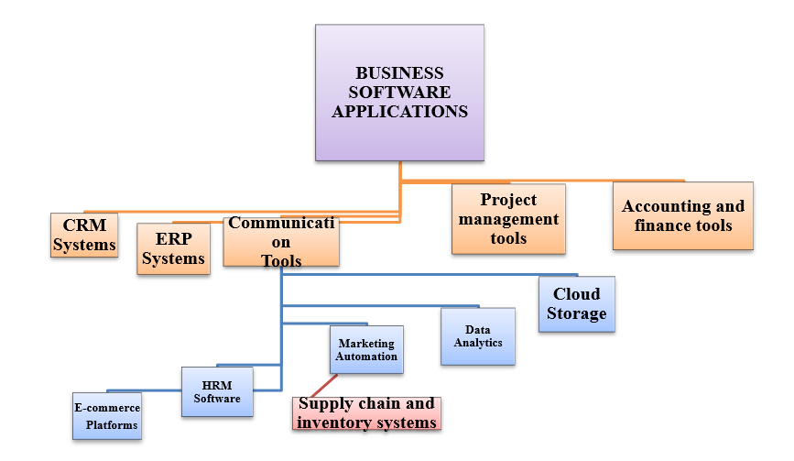
Figure 1. Mind map of the software application for the case
(Source: Self-created by Author)

Task 3. Office Applications for creating, storing, presenting, and analysing information/data

3.a. Explanation of four office software solutions
Office applications are used here for playing vital role in modern business operations by enabling organisations to create, manage, analyse, and present information effectively. Among the most widely used office software solutions are Microsoft Word, Microsoft PowerPoint, Microsoft Excel, and Microsoft Access. Each of these tools supports different business functions and contributes to productivity, decision-making, and communication [11].
Microsoft Word:
Overview:
It is a word processing application that is used to create and edit and format text documents like reports, letters and business documentations and proposals. MS Word is an effective tool for managing soft copy of business documentations and providing an insight of the real world. It is a real-world useful business management software for policy writing, documentation, technical documentation, and so on [12].
Key features:
The key features include formatting of the documents which include fonts, styles and headings. It also includes features like spell check and grammar tools, template for professional documents, mail merge for bulk document creation, and collaboration tools [12].
Benefits:
The benefits of MS Word include the following:
- It improves creation and communication by enabling the creation of professional and structured documents.
- It helps in report writing, official communication and documentation in a proper structured way.
- The collaboration features allow multiple users to edit and review documents efficiently, making teamwork easier [12].
- Templates in MS Word saves time and ensure documents consistencies.
Limitations:
MS word also has limitations. There are large documents that can become slow and difficult to manage. It is important to focus on limitations like unsuitable for data handling and formatting complex data. Also, formatting issues may arise when sharing documents across different systems or versions [13].
Microsoft PowerPoint:
Overview:
It is a presentation software that is used to creatively present any visual slideshow for meetings, training sessions and business presentations. The MS PowerPoint is a useful tool for effectively showing how business can use text, images and visuals to engage with the clients. Businesses use MS PowerPoint to build interactive and engaging contents. It also helps in quick comparison of documents, technical applications and so on [13].
Key features:
The key features include the following:
• Slide creation with text, images, and multimedia
• Animation and transition effects
• Templates and themes
• Presenter view and notes
• Integration with other Microsoft Office tools

Benefits:
The benefits of MS PowerPoint include the following:
- Enhanced communication with formally visualised content.
- Easier for audiences to understand complex ideas.
- Helps in wide planning of business meetings, marketing presentations, etc.
- Use of charts, images, and animations helps in engaging the audience and improving knowledge retention [13].
Limitations:
There are limitations of MS PowerPoint, such as overuse of animations and text-heavy slides can reduce effectiveness. It may not be seen as a good platform for official documentations. Also, it has poorly formatted documents [14].
Microsoft Excel:
Overview:
It is a spreadsheet software that is used to creatively present any visual optimisation of large datasets, data analytics and building graphs and charts.
Key features:
The key features include the following:
- Helps in using formulas and functions like IF and VLOOKUP.
- Helps in creating charts and graphs (data visualisation).
- Pivot tables and charts creation, data summarisation and use of sorting and filtering tools [14].
- Forecasting of data.
Benefits:
The benefits of MS PowerPoint include the following:
- Enhanced communication with formally visualised content.
- Easier for audiences to understand complex data with visualisation.
- Helps in wide planning of business meetings, marketing and sales operations and forecasting [15].
- Use of charts, images, and animations helps in engaging the audience and improving knowledge retention.
Limitations:

There are limitations of MS Excel, such as:
- Complex for large datasets and advanced analysis.
- Errors in formulas can lead to incorrect results.
- It is also less secure compared to database systems when handling sensitive data.
- Not suitable for multi-user environment.
Microsoft Access:
Overview:
It is a database management software that is used to create database mainly to store, manage, and retrieve data [15].
Key features:
The key features include table creation, building relations between the datasets, efficiently store and retrieve data, and so on. It also helps in forms creation for data entry, good presentation of large dataset and integration with Excel and other tools [15].
Benefits:
The benefits of MS Access include the following:
- Managing large datasets efficiently.
- Allows businesses to store structured data such as customer records, inventory, and transactions.
- MS Access queries help in extracting specific information quickly, supporting better decision-making [16].
- It is more powerful than Excel for data storage and organisation.
Limitations:
There are limitations of MS Access, such as:
- This software tool of Office has a steeper learning curve compared to other Office tools [17].
- It is not ideal for very large-scale enterprise systems.
- Performance may decrease with very large databases.
- It is less commonly used compared to cloud-based database solutions.
Summary table for comparison:
Software | Main Purpose | Strengths | Limitations
MS Word | Document creation | Easy to use, professional output | Limited data handling
MS PowerPoint | Presentations | Visual communication | Design dependent
MS Excel | Data analysis | Powerful calculations | Error-prone if misused
MS Access | Database management | Structured data storage | Complex and less scalable

3.b. Practical Testing of Features
Screenshots of the practical done on MS Excel:
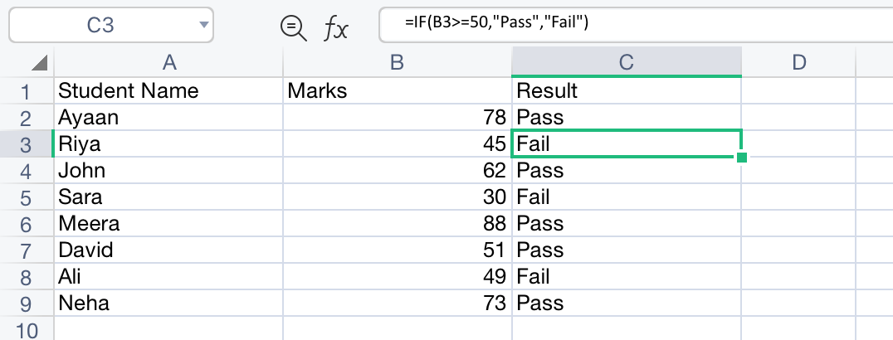

Thea above practical test shows the use of MS Excel to use the IF Function. To determine if the student has failed for passed, it is necessary to use such functions. The output demonstrates how the IF function can be effectively used for logical evaluation and automatic classification in Excel. In a business context, similar logic can be applied for performance appraisal, eligibility checks, and decision-making processes.

Screenshot for Pivot data:
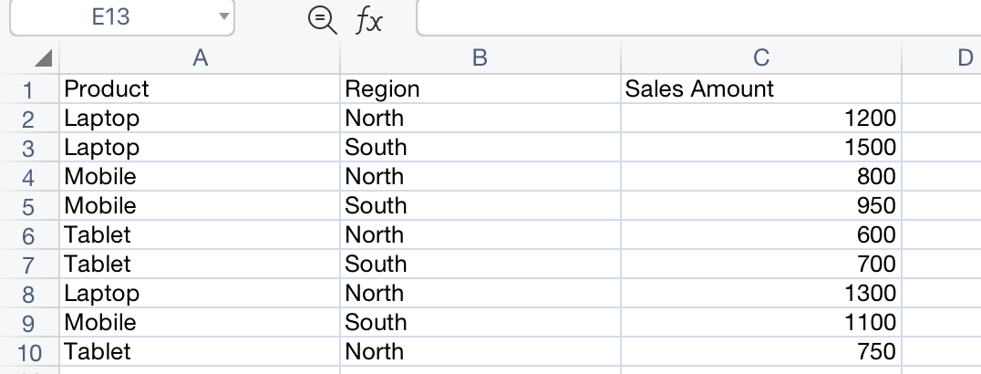
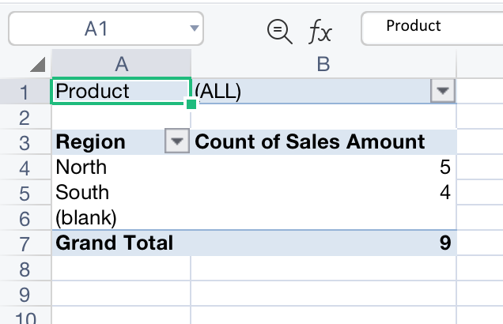
The above screenshot shows pivot table for the data above. The pivot table is used here for effective summarisation of the data. The Pivot Table summarises the sales dataset by grouping data based on regions. It shows that the North region has 5 sales entries, while the South region has 4 sales entries, making a total of 9 transactions. This indicates that the North region has slightly higher sales activity compared to the South. The Pivot Table effectively condenses raw data into a clear and structured summary, enabling quick comparison between regions [18]. It helps users identify patterns and trends without manually analysing each record, making it a valuable tool for business reporting, performance evaluation, and decision-making processes.

Explanation of the practical tests:

Feature 1: IF Function in Microsoft Excel
The IF function is a logical function in Microsoft Excel that allows users to perform conditional analysis. It evaluates a given condition and returns one value if the condition is true and another value if the condition is false. This function is widely used for decision-making and categorisation of data [19].
The objective for this test is to perform logical comparisons and return values based on conditions (here, it is IF condition).
Task completed:
A dataset of student marks is created. The IF function is used to determine whether a student has passed or failed.
The formula used for the IF Function is as follows:
=IF(A2>=50,"Pass","Fail")
Explanation of the formula used:
If the value in cell A2 is greater than or equal to 50, the result is “Pass”. If the value is less than 50, the result is “Fail”.
Result:
The function automatically categorises students based on their marks, reducing manual effort and improving accuracy.
Application in the business:
This function helps in performance evaluation in the business. It helps in analysing employee appraisals, making informed decisions, and evaluating effective employee management systems [20].

Feature 2: Pivot Table in Microsoft Excel
A Pivot Table is a powerful data analysis tool in Excel used to summarise, organise, and analyse large amounts of data quickly. It allows users to extract meaningful insights by grouping and aggregating data without altering the original dataset.
The objective of this task is to summarise as well as analyse large datasets efficiently.
Task completed here:
A sales dataset is created with columns such as Product, Region, and Sales Amount.
Here, a data set is created and then it is evaluated using Pivot table. The job of the pivot table is to analyse the company’s performance through a sequence of data dragged into proper columns, rows, and values and filters.
Explanations:
The pivot table summarises the performance of the products automatically through an informed table. The total sales for each category can be analysed through a pivot table.
Result:
It provides a clear summary of sales performance, making it easier to analyse trends and patterns. Clear evidence is provided using the pivot table.
Application in the business:
The pivot tables are generally used in companies for handling large datasets where financial stability is analysed, forecasted and so on. The pivot charts and tables are used for sales reporting, business intelligence management, and informed decision making. It also helps in providing quick insights [20].
The table below shows a detailed implication of the features used here.
Overall interpretation from the practical test:
Here, both tasks are performed widely in MS Excel using its functions and features that help in developing a right curriculum for sales reporting, data analysis and strategic decision making. These functions and features help in creating a good database and evaluating it efficiently to make business operations easier and flexible. Here, both the IF function and Pivot Table are essential Excel features that support data analysis and decision-making. In business applications, such features are used for building features, benefits, and limitations, making them suitable for specific tasks. The “IF” function in MS Excel simplifies logical evaluation and classification tasks, while Pivot Tables provide powerful tools for summarising and analysing large datasets. Together, these features enhance efficiency, accuracy, and productivity in business operations. These operations together help in creating efficiency in the business and increases accuracy in creating proper business analytics. In a real-world business scenario, such tools are useful for communication and data analysis, documentation, and high-quality data management. Here, the software has unique features, benefits, and limitations, making them suitable for specific tasks.

Task 4. Communication and Collaboration applications

4.a. Analyse one contemporary Communication and one Online Collaboration applications/tools used frequently in modern business world and document a summary of their key features
Here, the selected communication tool is Zoom and the selected collaboration tool is Slack.
Communication Application: Zoom
Zoom is an audio and video calling application where conferences can be held for real world businesses. It helps in holding virtual meetings, webinars, and remote communications handling for large and small companies. Zoom is a synchronous communication tool that helps the modern business make decisions. Zoom also supports meetings, chat, scheduling, and calls within one platform with easy communication and management [21].
The purpose of using Zoom in modern businesses include real-time effective audio and video calling facilities, chatting, screensharing, and so on. It helps in holding virtual meetings easily while consuming less internet bills. It is widely used due to features like screen sharing, breakout rooms, and HD video [21].
Key features of Zoom:
Feature | Description | Business Benefit
Video Conferencing | High-quality video meetings with multiple participants | Enables remote meetings and global communication
Screen Sharing | Users can share screens during meetings | Useful for presentations and training
Breakout Rooms | Split participants into smaller groups [22] | Enhances teamwork and discussions
Recording | Meetings can be recorded | Helps in documentation and training
Chat Function | Instant messaging during meetings | Improves communication clarity

Advantages and Limitations of Zoom:
The advantages of Zoom include user friendly interface that allows users to join and host meetings efficiently. It helps people to host and get into meetings with minimal technical knowledge. It supports high-quality video and audio conferencing, enabling clear communication among remote teams. Features such as screen sharing, recording, and breakout rooms enhance collaboration and make it suitable for presentations, training, and group discussions. Zoom is also a highly scalable tool for holding and arranging meetings. It also allows both small meetings and large webinars with hundreds of participants. It is also accessible across multiple devices, including laptops, tablets, and smartphones. There are also some limitations of Zoom where its free version can only hold meetings for only 40 minutes straight. This can interrupt proper discussions within an ongoing meeting and disrupt stakeholders from discussing something important. Zoom also requires a stable internet connection, and poor connectivity can lead to audio or video disruptions. There have also been security and privacy concerns, especially in earlier versions, such as unauthorised access to meetings. Furthermore, advanced features are only available in paid plans, which may increase costs for businesses. Moreover, it can be stated that Zoom is highly effective, its limitations must be managed for optimal use [23].
Collaboration Application: Slack
Overview of the Slack application:
Slack is a cloud-based collaboration tool for team communication and workflow management.
The purpose of using Slack enables real-time messaging and collaboration system within teams. It is both asynchronous and synchronous collaboration tool. Slack is used for going through effective communication channels for building teams and projects. It also integrates with multiple tools and centralised communication system [24].

Key Features of Slack
Feature | Description | Business Benefit
Channels | Organised chat rooms for teams/projects | Keeps communication structured
Direct Messaging | Private communication between users | Quick decision-making
File Sharing | Share documents and media | Improves collaboration
Integrations | Connects with apps like Google Drive, Zoom | Streamlines workflows
Search Function | Search past messages and files | Saves time and improves efficiency

Advantages and Limitations of Slack:
Advantages | Explanation | Limitations | Explanation
Real-time communication | Slack enables instant messaging between team members, allowing quick sharing of ideas, updates, and feedback. This improves responsiveness and helps teams make faster decisions without delays caused by emails [24]. | Can cause message overload | With constant notifications and multiple active channels, users may feel overwhelmed. Important messages can get lost, reducing productivity and causing confusion.
Easy collaboration | Slack supports teamwork through channels, file sharing, and group discussions. Teams can collaborate efficiently on projects, share documents, and track conversations in one place. | Learning curve for new users | New users may find Slack complex due to its features like channels, threads, and integrations. It may take time to understand and use effectively [24].
Strong integrations | Slack integrates with various tools such as Google Drive, Zoom, and Trello. This allows seamless workflow management and reduces the need to switch between applications [25]. | Limited features in free version | The free version restricts message history and advanced features. Businesses may need paid plans to access full functionality, increasing costs.
Accessible on multiple devices | Slack can be used on desktops, smartphones, and tablets, ensuring users stay connected anytime and anywhere [25]. | Not ideal for formal communication | Slack is more suitable for informal communication. For official or legal communication, emails or formal documents are preferred [26].

4.b. Test one feature of a freely available Communication (1) and one feature of a Collaboration (1) application and document several screenshots with brief accompanying description to provide evidence of practical use
Here, the testing has been done on Zoom and Slack and testing solutions are provided.
Practical Test table for Zoom:
Step | Action Performed | Result
1 | Open Zoom and start a meeting | Meeting interface displayed
2 | Click “Share Screen” | Screen sharing options appeared
3 | Select window/screen | Selected content displayed to participants
4 | Present document | Participants can view presentation

The outcome shows that there is improved clarity of audio and video during presentations. It also holds effective remote collaboration within the business. Real-time sharing of information is possible with such collaborations.
Screenshots:


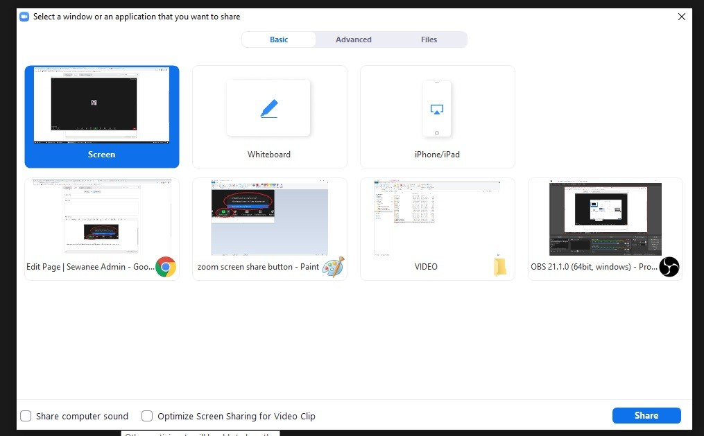

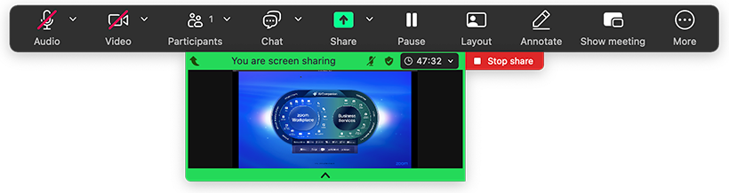

Feature 2: Slack – Channel Communication

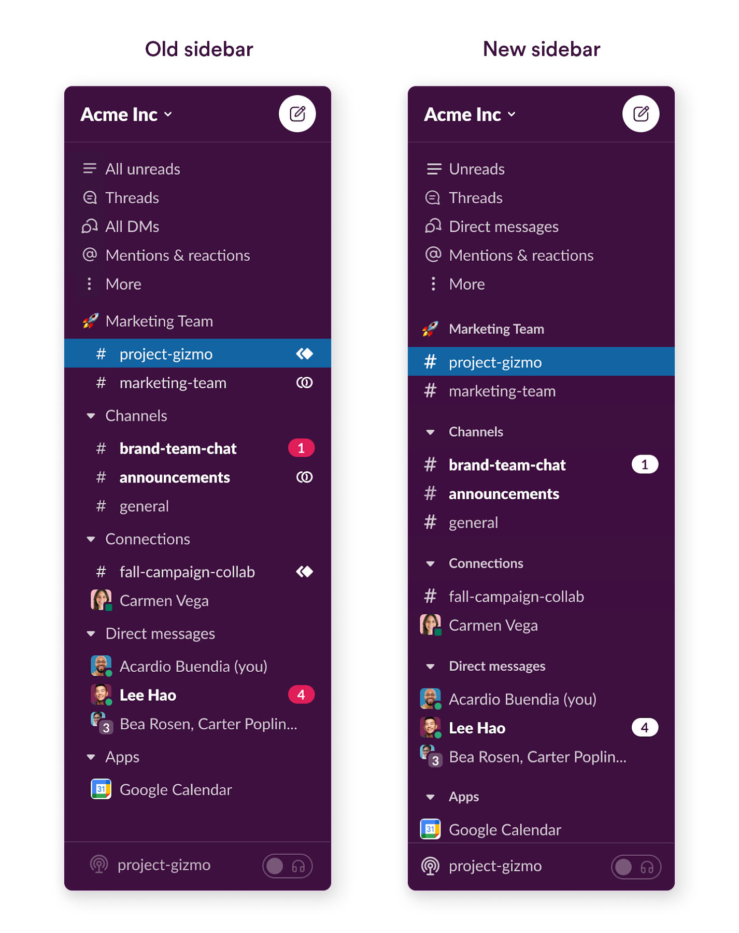

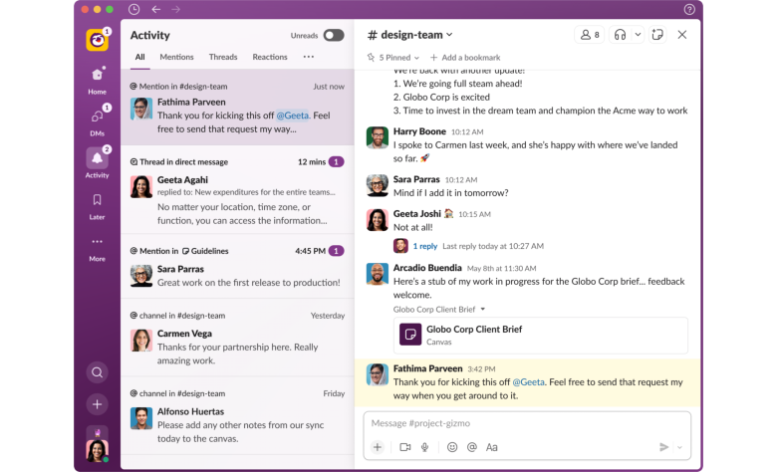

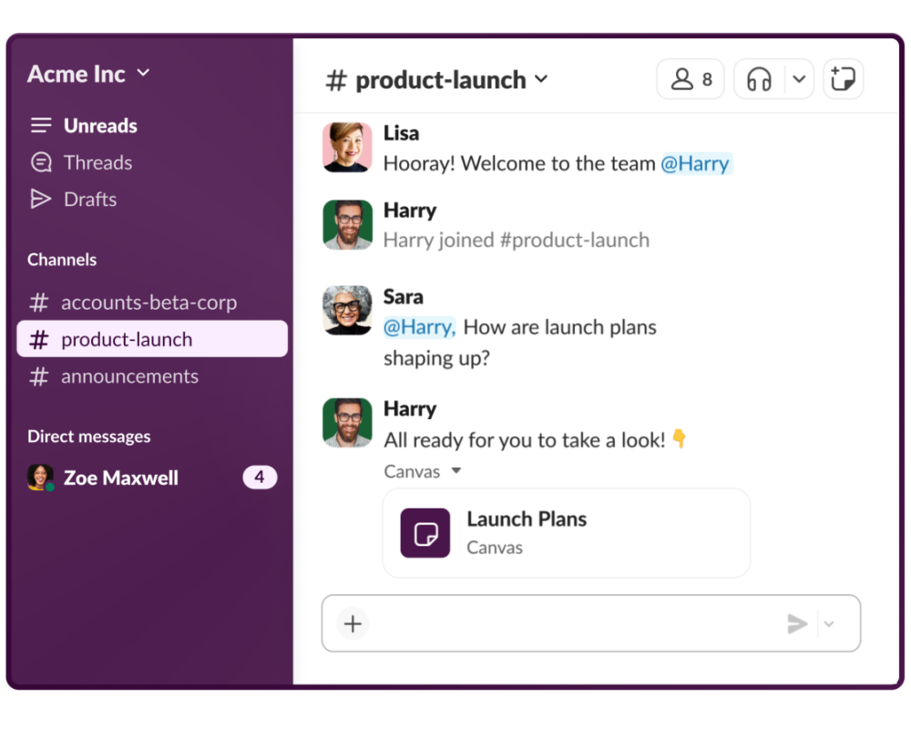



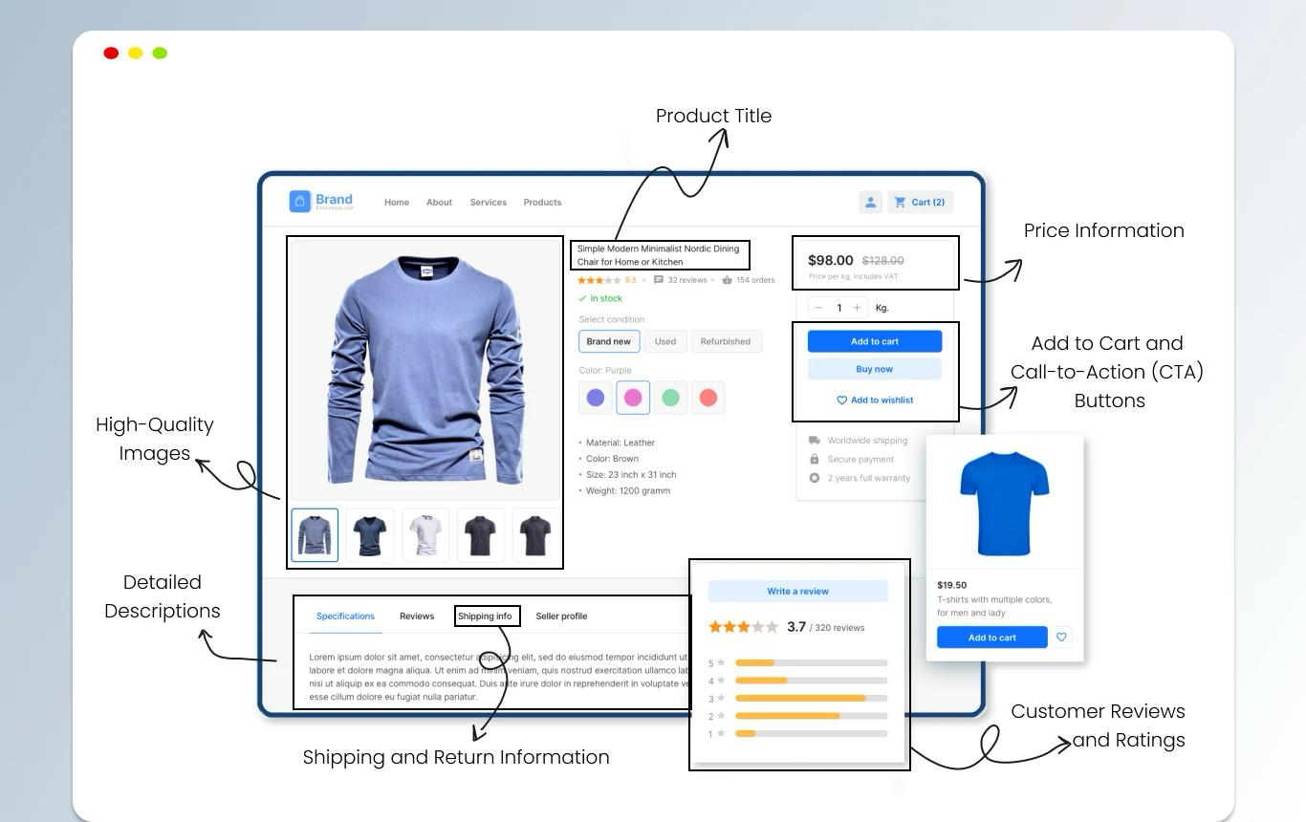
This screenshot shows a product listing on Shopify, including product image, price, description, and “Add to Cart” button.



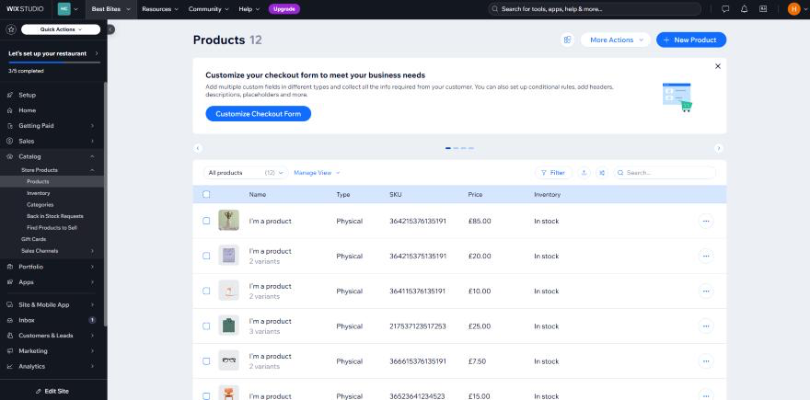
This screenshot shows a product page created using Wix, including product images, pricing, and purchase options. Wix provides a visually appealing drag-and-drop interface suitable for small businesses.

Test table for practical work
Step | Action Performed | Result
1 | Open Slack workspace | Dashboard displayed
2 | Create a new channel | Channel created successfully
3 | Add team members | Members joined channel
4 | Send message | Message visible to all members

2 | Create a new channel | Channel created successfully
3 | Add team members | Members joined channel
4 | Send message | Message visible to all members

The outcomes are shown below.
It has better team coordination, organised communication, and faster sharing of valuable business information.

References
[1] Pais, J.P.F.D.A., (2022). Shopify equity research-staying ahead of the market.
[2] Dolifka, D., (2023). Conducting Experimental Research on Shopify: An Initial Discussion and Guide to Getting Started. Available at SSRN 4451011.
[3] Bang, S., (2023). Top E-Commerce CMS platforms (Shopify/WordPress/BigCommerce).
[4] Kusumo, A.H., (2023), November. Has website design using website builder fulfilled usability aspects? a study case of three website builders. In Proceedings of the 4th International Conference on Informatics, Technology and Engineering 2023 (InCITE 2023) (pp. 545-557). Atlantis Highlights in Engineering.
[5] Cahyadi, A.T., Miftahudin, N., Islahiyah, N.S., Yulianti, F.D. and Masturah, B.N.H., (2022). Design of Website for Business Enterprises Using a Website Creation Application.
[6] Huriavi, C., (2025). Obstacles and Attitudes that Small and Medium Businesses have Towards Website Development: A Design-Thinking Approach (Doctoral dissertation).
[7] Sbaa, M., Faouzi, L., Eljahechi, M. and Lghdaic, F., (2022). The mind map at the service of learning. International Journal of Multidisciplinary Research and Analysis, 5(12), pp.3564-3581.
[8] Fearnley, C.J., (2022). Mind mapping in qualitative data analysis: Managing interview data in interdisciplinary and multi‐sited research projects. Geo: geography and environment, 9(1), p.e00109.
[9] Ramírez-Montoya, M.S., Castillo-Martínez, I.M., Sanabria-Z, J. and Miranda, J., (2022). Complex thinking in the framework of education 4.0 and open innovation—a systematic literature review. Journal of Open Innovation: Technology, Market, and Complexity, 8(1), p.4.
[10] BA Times, (2019). Mind Maps for Business Analysis. Available At: https://www.batimes.com/articles/mind-maps-for-business-analysis/. (Accessed On: 6th April, 2026)
[11] A. Kusumo, “Evaluation of website and office software usability in business environments,” in Proc. Int. Conf. Informatics, Technology and Engineering, 2023, pp. 545–557.
[12] D. Huriavi, Obstacles and Attitudes that Small and Medium Businesses Have Towards Digital Tools Adoption, PhD dissertation, 2025.
[13] M. S. Ramírez-Montoya et al., “Complex thinking and digital tools in education and business environments,” J. Open Innovation: Technology, Market, and Complexity, vol. 8, no. 1, pp. 1–15, 2022.
[14] R. G. Phillips, “Spreadsheet use and data errors in business decision making,” Journal of Accounting and Finance, vol. 23, no. 2, pp. 45–60, 2023.
[15] S. Powell and K. Baker, “Management science and spreadsheet modelling: Best practices,” Decision Support Systems, vol. 162, pp. 113–124, 2022.
[16] A. O. Ajayi, “The impact of Microsoft Office tools on organizational productivity,” International Journal of Information Systems and Technology, vol. 7, no. 2, pp. 88–96, 2024.
[17] J. Smith and L. Anderson, “Business communication through digital documentation tools,” Journal of Business Communication, vol. 61, no. 3, pp. 210–225, 2024.
[18] P. Brown, “Data management and analysis using Microsoft Excel and Access,” International Journal of Data Science, vol. 5, no. 1, pp. 33–48, 2023.
[19] K. Lee, “The effectiveness of presentation tools in enhancing workplace communication,” Computers & Education, vol. 190, 2023.
[20] S. Gupta and R. Sharma, “Database management systems in small and medium enterprises,” International Journal of Computer Applications, vol. 185, no. 12, pp. 1–6, 2022.
[21] J. Schulz, “Videoconferencing, instant messaging, and work-from-home dynamics,” American Behavioral Scientist, vol. 68, no. 4, pp. 1–15, 2024.
[22] A. Selvanayagam, T. Sathish, and R. Bharathi, “Impact of communication tools and organizational support on employee efficiency in hybrid work environments,” TIJER International Research Journal, vol. 12, no. 9, pp. 1–10, 2025.
[23] A. Jaizul and N. Lianingsih, “The role of digital communication in enhancing collaboration in the information technology industry,” International Journal of Linguistics, Communication and Broadcasting, vol. 3, no. 1, pp. 24–28, 2025.
[24] V. Stray, “Slack use in large-scale agile organizations: Enterprise social networking tools as communication platforms,” in Agile Processes in Software Engineering, Springer, 2024.
[25] A. Ahmadsimab, “Zoom communication Inc.: Keeping the good times going?,” The Case Journal, vol. 19, no. 6, pp. 800–810, 2023.
[26] C. Lim, “Meeting needs: Social interaction and virtual meeting fatigue in workplace communication,” Computers in Human Behavior Reports, vol. 12, 2025.

