

Module Name: Problem solving and innovation
Module Code: BMSW4014
Assignment Name: AI washing Presentation + 500 speaker notes
Student Name: Donna Waktins
Student Number: 2508071
Lecturer: Chris Wilkins
Deadline: Friday 12th June 2026

Speaker notes

Slide 1 – Background and Definition of AI Washing
• Introduce topic and relevance.
• AI becoming increasingly important in business.
• Define AI washing.
• Exaggerating AI use or capabilities.
• Used to appear innovative.
• Attract customers and investors.
• Short-term publicity benefits.
• Risk of mistrust if claims are misleading.
• Growing concern for businesses and consumers.
Slide 2 – What is Happening at the Moment?
• Rapid growth of AI across industries.
• Examples: social media, finance, customer service.
• AI used as a marketing tool.
• Companies promoting AI credentials.
• Concerns about exaggerated claims.
• Increased scrutiny from consumers.
• Investors questioning AI statements.
• Greater focus on transparency.
• Public awareness of AI washing increasing.
Slide 3 – What is Expected to Happen in the Near Future?
• More pressure to justify AI claims.
• Increased checks and auditing.
• Greater accountability requirements.
• Possible new regulations.
• Governments protecting consumers.
• Investors seeking reliable information.
• Transparency becoming essential.
• Honest communication builds trust.
• Organisations with credible claims may benefit.
Slide 4 – The Increasing Use of AI
• AI growing rapidly across industries
• More companies promoting AI capabilities
• AI attracts investors and customers
• 10% of tech start-ups mentioned AI in 2022
• Significant increase in 2023
• Some firms exaggerate AI involvement
• Study found many "AI startups" used little or no AI
• Links to concerns about AI washing

Slide 5 – Which Stakeholders Are Impacted?
• Consumers affected by misleading information.
• Products may not meet expectations.
• Investors making decisions on AI claims.
• Risk of inaccurate investment choices.
• Employees face unrealistic expectations.
• Internal pressure regarding AI performance.
• Regulators promote accountability.
• Need for transparency across organisations.
• AI washing impacts trust throughout the business environment.
• Key message: honest communication is essential.

AI critique
When creating my PowerPoint presentation, I used AI to help me research and understand the topic of AI washing. Initially, the AI provided information that linked AI washing closely with greenwashing. As a result, I included content about greenwashing in my first draft presentation. However, after discussing my work with my tutor, I was informed that this information was not directly relevant to the topic and that my explanation of AI washing was inaccurate.
This experience highlighted one of the main disadvantages of using AI. Although AI can provide information quickly and help generate ideas, it can sometimes produce incorrect, misleading, or oversimplified information. Because of this, it is important not to rely entirely on AI-generated content without checking its accuracy.
After receiving feedback, I returned to ChatGPT and reviewed the information it provided. To make sure the claims were accurate, I also read several articles about AI washing and compared them with the AI-generated responses. This allowed me to confirm the information and make corrections to my presentation where necessary.
Overall, AI was a useful tool because it allowed me to find information quickly and helped me develop ideas for my presentation. However, this experience showed that AI responses should always be checked against reliable sources, as mistakes or inaccuracies can occur. Using AI alongside independent research can help ensure that the final work is accurate and trustworthy.

Presentation
Slide 1
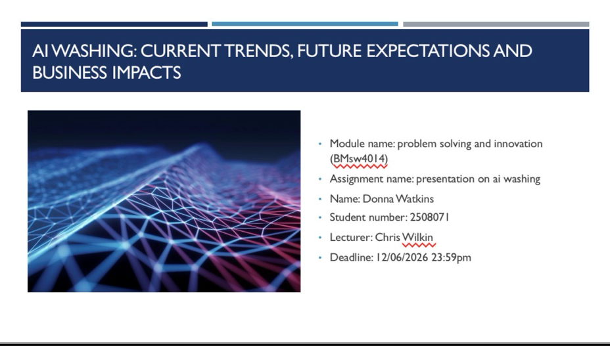

Slide 2
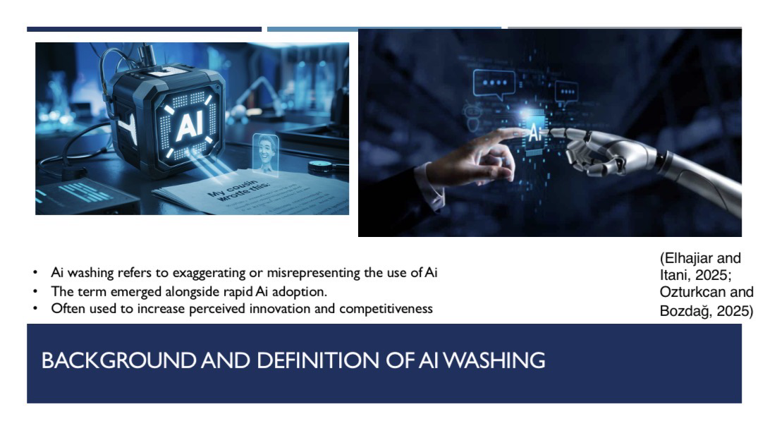

Slide 3
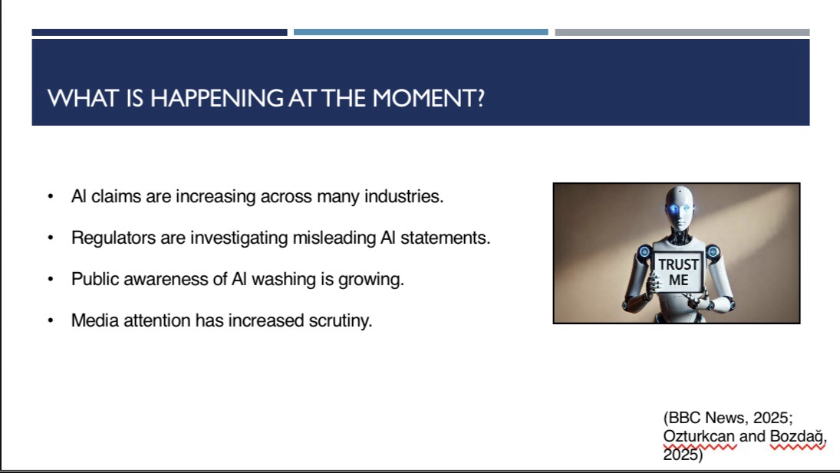

Slide 4
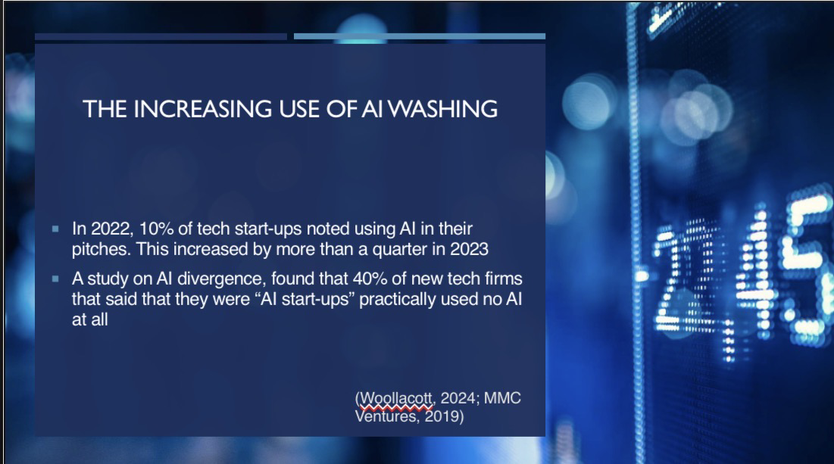

Slide 5
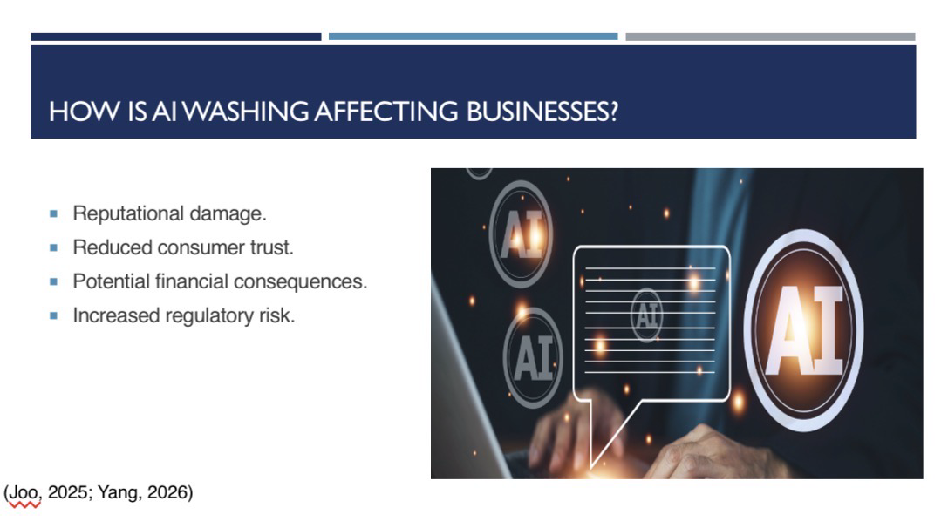

Slide 6
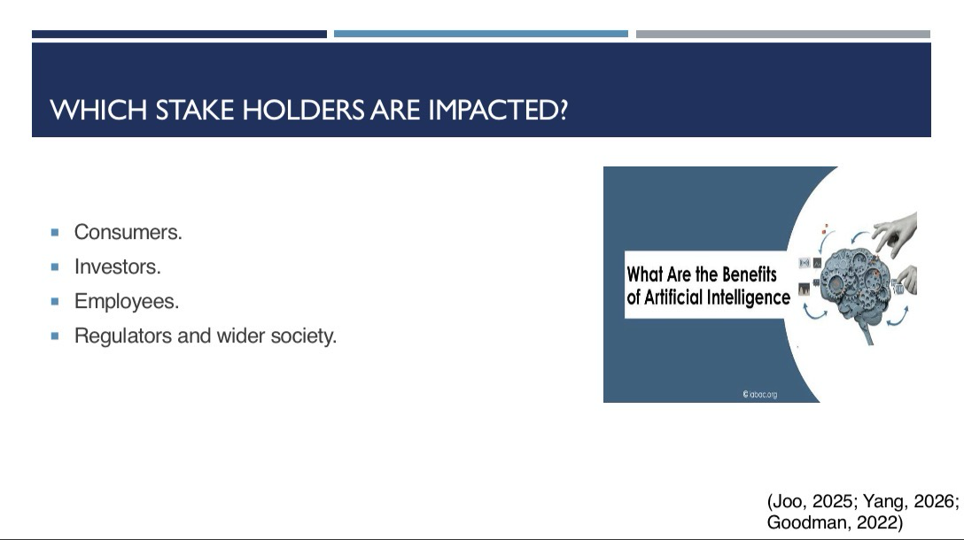

Slide 7
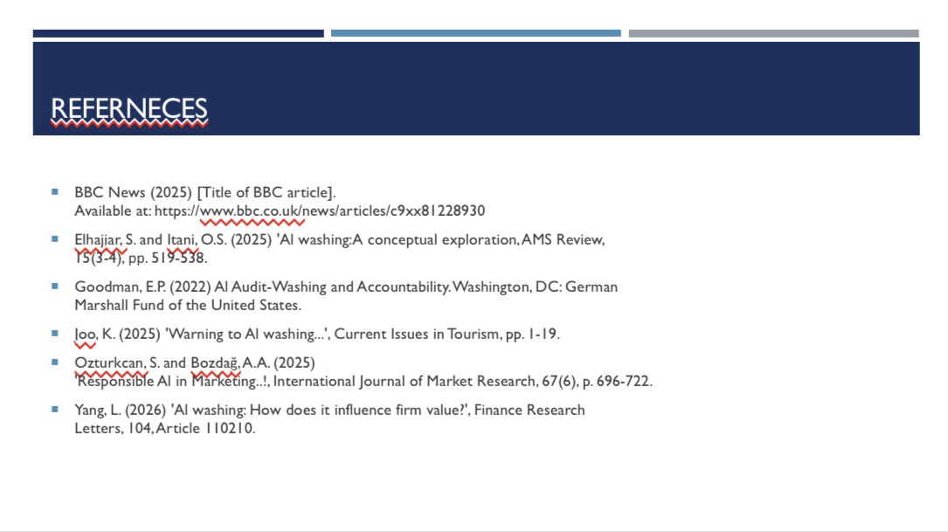

References
- BBC News (2025) [Title of BBC article].
Available at: https://www.bbc.co.uk/news/articles/c9xx81228930

- Elhajjar, S. and Itani, O.S. (2025) 'Al washing:A conceptual exploration, AMS Review,15(3-4), рр. 519-538.

- Goodman, E.P. (2022) Al Audit-Washing and Accountability. Washington, DC: German Marshall Fund of the United States.

- Joo, K. (2025) 'Warning to Al washing...', Current Issues in Tourism, pp. 1-19.

- Ozturkcan, S. and Bozdağ, A.A. (2025) 'Responsible Al in Marketing..!, International Journal of Market Research, 67(6), p. 696-722.

- Yang, L. (2026) 'Al washing: How does it influence firm value?', Finance Research Letters, 104, Article 110210.

Appendix



