Project report – Strategic response to a contemporary issue

M6X00874

Yijun Liu

1904772

Executive Summary
The article chooses social media marketing as the theme to introduce the content and importance of social media marketing. Taking Li Ning, a famous Chinese sports brand, as a case study, to analyse its activities on international social media platforms, it is found that the company's content on platforms such as Instagram and Facebook is single and unattractive; the frequency of posting dynamically is not fixed; the number of likes and comments is not too much, and less interaction with consumers. Therefore, the following strategic recommendations are proposed: set social media marketing goals that are consistent with business goals; develop social media content calendars; focus on two-way communication with customers, build humanized brands, etc.

1.Introduction
The ultimate goal of every company is to make profits, and the concept of modern marketing closely links the company's financial performance with retaining consumers. One of the best ways to keep customers is to establish long-term relationships with customers, and using social media as a marketing channel can greatly help and facilitate their communication with customers. Ford (2019) noted that the fiercest competition outside of the marketing campaign itself is the battle for social media to grab attention before, during, and after the event. For example, the cost of 30-second advertising hours for the Super Bowl campaign skyrocketed to more than $ 5 million, and the challenge for marketers was to find new ways to convey information to the widest audience. This article focuses on the importance of social media marketing, analyses the marketing activities of well-known Chinese sports brand Li Ning on international social media, and aims to make recommendations to enable companies to better use social media marketing to expand brand awareness and improve performance.

2.Main Findings

2.1 What is social media marketing？
Obar & Wildman (2015) believed that social media is a tool that enables people or organizations to create, share information, ideas, images, or videos in virtual communities. With the development of the Internet, social media has a great impact on people's daily consumption behaviour and ways. Gaitho (2018)noted that in the past, brand-to-consumer communication was one-way, with the development of social media, communication became two-way, consumers can use social media to timely feedback their ideas to the company. I-Ping, Ray, & Chih-hui (2019) said that
social media has become a new channel for marketing. In conclusion, social media marketing is a company based on social media platforms that broadly connect with its stakeholders (customers, potential customers, the public, etc.) and promote and sell its own products and services.

2.2 Why is it important？
According to data reports (2019), there are 3.5 billion active social media users worldwide, accounting for 45% of the world's population; of which 45 million are social media users in the UK, accounting for 67% of the total population of the UK, and each user spends nearly 2 hours per day on social media websites.
Kaplan & Haenlein (2010) thought that social media marketing has the advantage of strengthening connections between companies and consumers, building relationships in a timely manner, and building long-term relationships at low cost. Daniela, Martin, Johann, & Carina (2019) pointed that social media platforms are promising tools for marketing campaigns, as social media can promote social interaction and online word-of-mouth, making brands know more about customers. In addition, it has other advantages, such as promoting humanized brands, keeping brands brainstorming, and creating opportunities for brands to become industry leaders.
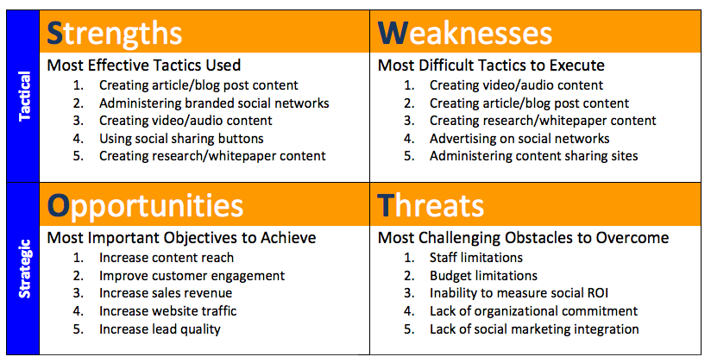

2.3 The impacts of social media marketing on LiNing
Li Ning is a leading sports brand company in China, with a focus on clothing and sporting goods. It was founded by former Olympic gymnastics champion Mr. Li Ning and has been developing for 30 years. Li Ning, as a sports brand, has an irreplaceable position in the Chinese mind, and is also a successful national brand to be proud of .The brand is also committed to becoming the world's leading sports brand, even if it is a household name in China, but its influence in the world is not satisfactory, The results of the brand's social media marketing are seriously inconsistent with the image of an internationally renowned brand, today we analyse the brand's marketing activities on international social media. The picture below is the homepage of Li Ning and the world famous sports brand Nike on Instagram. It is shocking that Nike has 30 times more fans than Li Ning.
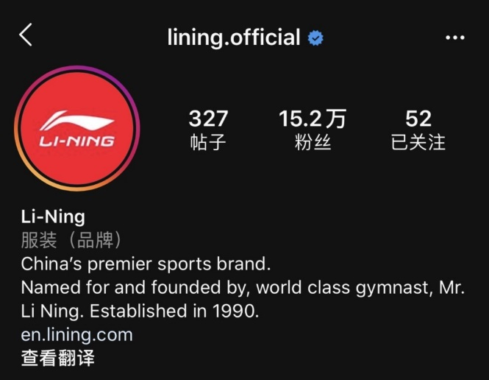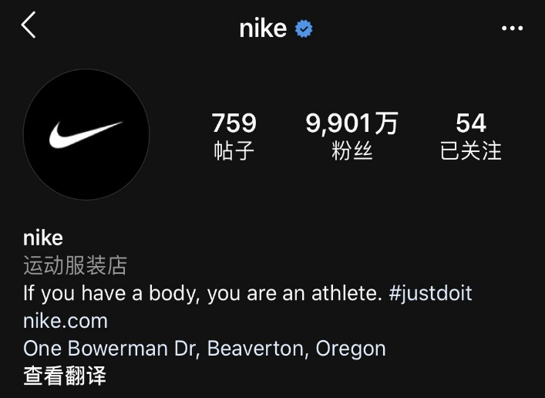Looking through what Li Ning has posted on international social media, I find that much of it is a blunt introduction to the product with pictures, which is not appealing. Patrutiu (2015) noted that content marketing has always been an important form of marketing, and the brand has not linked high-quality content to the correct release time. Nike managed to master the authenticity during the product release, and its Zoom Superfly Elite shoes helped Eliud Kipchoge finish the marathon in less than two hours. The whole process was broadcast live on Facebook and Twitter, putting the brand and shoes in front of running fans for a tense and exciting two hours (Ben, 2018). This is worth learning from li ning, and the content posted on social media should be more humane and perceived, so that users can really be interested in the brand. Using quality images, interesting videos to enrich the content at random, ensuring that social media pages do not appear unremarkable.
In addition, Li Ning's time and frequency of posting content on social platforms are not standard, and sometimes it is unreasonable to publish several items a day, and sometimes even a month without updating the dynamic. A brand for a long time disappeared in the public eye, is not conducive to enhance brand awareness, but also to a certain extent affect the brand loyalty of consumers. Sharing wonderful content is essential, but it is equally important to make appropriate plans to share the most influential time. The company should record the date and time of its own content posting on different social platforms to ensure that the post is published at the appropriate interval and at the best time, so that the content released supports the final performance goals.
The number of likes per dynamic location is only a few thousand, and the number of comments is only dozens or even a few. Obviously, the brand lacks the interaction with the customer, so the brand cannot understand the consumer's idea in time, and the consumer's loyalty and trust to the brand is not high. Ford (2019) thought that measuring the conversational lift of a brand can be an important indicator of whether the ad has reached the correct goal, transmitting relevant information, creating a brand identity and triggering a response, making someone consider buying and sharing that response with others. It should create a community for listeners, and while “followers ” and many other indicators are important, they are not all successful on social media, and communication is not one-way, and brands also need to collect feedback from consumers (Keran, 2019). It can ask the audience questions, collect the audience's opinions on certain things; share information with news value, not just about the products and services, but also encourage consumers to share the posts they like, so as to understand the interests of consumers and provide the basis for the decision after the brand. In a word, the company should learn everything you can about your audience (Hootsuite, 2019).
In the current social media platform, the most popular way is to publish videos and live broadcasts. Instagram, as a picture sharing platform, launched a long video sharing app IGTV in 2018, and began to compete with YouTube for the market. If you want to use the social media platform to market, you must keep up with the times. Li Ning can use Internet celebrity to introduce and promote its products through video or live broadcast; you can also use video or live broadcast to tell the story of the brand and spread the brand Values to let more consumers know (Murray Newlands, 2019). The purpose is to show customers that the brand is more than just a machine for making money. It is more about sharing the brand's values with them and creating shared and memorable content. This is high-level marketing (Wang, Zheng, Freeman, & Chapman, 2015).

3.Conclusions
In order to be successful and profitable, every business must focus on communication and build long-term relationships with consumers. Today, this relationship can be easily achieved through social media. Even though many companies have recognized the importance of social media marketing, not the applications every company are successful. Li ning is committed to becoming an international famous sports brand, its performance in international social media platform is unsatisfactory, need reasonable strategy to help it solve its current predicament.

4.Recommendations
In order to use the international social platform to achieve good marketing results, Li Ning must firstly recognize the importance of social media platforms for marketing, set social media marketing goals consistent with business goals, and refine the number of comments and likes for each dynamic, the goal-driven implementation effect will be better; followed by the formulation of an effective content marketing strategy, focusing on the content published on social media platforms, comprehensively using different forms such as pictures, videos, live broadcasts, etc., to make users feel interesting rather than plain, which plays a vital role in marketing results; develops a social media content calendar that lists the date and time that content types were posted on each channel, ensuring that posts are posted at appropriate intervals and optimal times, in order to get better communication results; attach importance to the interaction with the audience, using more personalized settings, especially the way of providing content to consumers in daily communication, to improve the relationship with customers and achieve two-way communication. All strategic recommendations are designed to drive the company's use of social media platforms to improve brand performance and generate more profits.

Bibliography
Ben, D. (2018, November 20). 30 brands with excellent social media strategies. Retrieved from Econsultancy: https://econsultancy.com/30-brands-with-excellent-social-media-strategies/
Daniela, B., Martin, S., Johann, F., & Carina, T. (2019). The impact of social media campaigns on the success of new product introductions. Journal of retailing and Consumer services, 289-297.
Digital in 2019. (2019). Retrieved from We are social: https://wearesocial.com/uk/digital-2019
Ford , J. B. (2019). What Do We Know About Social-Media Marketing? Journal of Advertising Research, 383-385.
Gaitho, M. (2018). What is the real impact of social media. Retrieved January 7, 2020, from Simplilearn: https://www.simplilearn.com/real-impact-social-media-article
Hootsuite. (2019). Social Media Marketing Strategy. Retrieved from Hootsuite: https://hootsuite.com/en-gb/resources/social-media-strategy-guide
I-Ping, C., Ray, W., & Chih-hui, H. (2019). Exploring the benefits of social media marketing for brands and communities. International Journal of Electronic Commerce Studies, 113-140.
Kaplan, A. M., & Haenlein, M. (2010). The challenges and opportunities of social media. Business Horizons, 59-68.
Keran, S. (2019, August 12). 15 Reasons Why Marketing Through Social Media is a Must For Every Small Business. Retrieved from Life Marketing: https://www.lyfemarketing.com/blog/marketing-through-social-media/
Murray Newlands. (2019, May 1). 10 Social-Media Marketing Strategies for Companies. Retrieved from Entrepreneur: https://www.entrepreneur.com/article/293321
Obar, J. A., & Wildman, S. (2015). Social media definition and the governance challenge: An introduction to the special issue. Telecommunications policy, 745-750.
Patrutiu, B. (2015). Content marketing - the fundamental tool of digital marketing. Economic Sciences, 111-119.
Wang, F., Zheng, P., Freeman, B., & Chapman, S. (2015, July). Chinese tobacco companies' social media marketing strategies. Tobacco Control, p. 408.

