03/08/2026
Assignment 2
Operating Systems
Module Name: Computer Architecture and Operating Systems
Module Code: ACCA 4022_LON

Student Name: Hanna Chris Mercado Navarro
Student ID: 2522973
Group: 1

Lecturer’s Name: Dr Redhwan Al-Amri

Table of Contents
INTRODUCTION 1
KEY FUNCTIONS OF GENERAL OPERATING SYSTEMS 1
PROCESS MANAGEMENT 1
MEMORY MANAGEMENT 1
FILE MANAGEMENT SYSTEM 2
DEVICE MANAGEMENT 2
PROTECTION AND SECURITY 2
USE OF WINDOWS OS CLI COMMANDS 2
PROCESS MANAGEMENT 3
tasklist/v command 3
tasklist/svc command 3
tasklist/m command 4
FILE AND DIRECTORY MANAGEMENT 5
dir/a command 5
dir/q command 5
NETWORK TESTING/MONITORING 6
ipconfig command 6
ping command 6
USER MANAGEMENT 7
net user <account name> command 7
net user /add and net user /delete command 7
TASK SCHEDULING 8
schtasks /create 8
schtasks/query command 8
USE OF LINUX OS CLI COMMANDS 9
PROCESS MANAGEMENT 10
ps aux command 10
pstree command 10
top command 10
FILE AND DIRECTORY MANAGEMENT 11
ls command 11
find 12
NETWORK TESTING/MONITORING 12
vmstat command 12
ss command 12
USER MANAGEMENT 13
who command 13
id command 13
TASK SCHEDULING 14
atq command 14
USE OF OS WINDOWS SCRIPTS 14
TEMPORARY FILE CLEANUP TOOL 14
AUTOMATED SYSTEM REPORT 16
USE OF LINUX OS SCRIPTS 19
SIMPLE CALCULATOR 19
COUNTDOWN TIMER 21
CONCLUSION 22
REFERENCES 23
APPENDICES 24
LIST OF FIGURES 24
Windows OS CLI Commands 24
Linux OS CLI Commands 24
Windows OS Batch Scripts 25
Linux OS Bash Scripts 25

INTRODUCTION
A general operating system (OS) is a basic software component that supervises computer hardware and provides services for application software. It serves as a link among users, applications, and hardware, facilitating the efficient performance of computer tasks. Popular operating systems such as Windows, macOS and Linux allow users to perform everyday tasks without necessarily understanding the technical details of the underlying hardware. The operating system provides a secure and reliable environment for running applications while efficiently managing system resources [1].

KEY FUNCTIONS OF GENERAL OPERATING SYSTEMS
PROCESS MANAGEMENT
Each process has its own set of features, including its virtual address space, program counter, register snapshots, file descriptors, and related system resources. The OS carefully manages these parts over time. These components are assigned by the OS at the beginning of process formation. [3]. In order to load runnable apps into ready queues, choose and allocate CPU resources and time slices, and then record detailed context information [3] to decide which processes will get CPU time next [2], the OS employs scheduling algorithms. The next stage is process execution, where OS secure processes systematically monitor virtual address spaces, inter-process synchronisation, communication protocols, and process state transitions to prevent race scenarios and to detect and break deadlocks [2]. During the final phase, called process termination, the OS manages resource cleanup by releasing physical memory, removing file descriptors, updating process data structures, modifying process tables, and de-allocating relevant resources. Furthermore, multitasking operating systems allow for safe data transfer and efficient collaboration across various tasks. [3].
MEMORY MANAGEMENT
The OS controls memory allocation (assigning memory areas to applications and making exclusive access regions to separate data between different applications), reclamation (recovering already allotted memory from processes, allowing the recycling of unused memory regions and effective resource utilisation), and fragmentation (compressing memory to maximise available space). The OS preserves application functioning by controlling virtual memory and using disc space to increase memory capacity. It also guarantees system stability and data integrity by erecting barriers to prevent unauthorised access and memory tampering. [3].
FILE MANAGEMENT SYSTEM
The OS enables users and programs to create new files and provides them with a filename, storage location and metadata (e.g., creation dates, permissions, ownership, etc). It also decides where files are kept, whether on a storage device (effectively distributing disk space to minimise fragmentation and boost efficiency) [4] or in the cloud [5], making it easier to access these files automatically across multiple devices for effective collaboration while imposing access control and permissions [4]. By automatically classifying documents and suggesting frequently visited and recently used files, artificial intelligence integration enhances file searching [6]. The OS safeguards files by providing multiple security tools like user authentication, access permissions, encryption, secure boot technology, zero-trust security, and ransomware protection [5].
DEVICE MANAGEMENT
The OS is responsible for managing, organising, and constantly keeping an eye on every input and output device linked to a computer system. It also serves as a bridge between hardware and application software, guaranteeing that devices run effectively, safely, and without interference [7]. Efficient hardware resource utilization, equitable device sharing among various users and processes, enhanced security through controlled hardware access, and reliable communication between software applications and hardware devices are all benefits of effective device management [8].

PROTECTION AND SECURITY
The OS protects system resources, user data, and hardware from malware, unauthorized access, and unintentional harm by limiting access to files, memory, processes, devices, and network resources while guaranteeing confidentiality, integrity, and availability (CIA) of information. It also protects from emerging cyberattacks by integrating advanced security features, including secure boot, encryption, authentication and access control protects from emerging cyber threats and attacks [9].

USE OF WINDOWS OS CLI COMMANDS
Windows Command Prompt (CMD) and PowerShell offer command-line utilities for the administration of system resources, files, users, networking, and scheduled tasks. The subsequent commands illustrate typical administrative functions [10]. Windows PowerShell streamlines system administration via object-oriented commands, minimizing text parsing and enhancing automation, configuration and management of Windows systems in contrast to conventional Linux text-based shell commands [11].

PROCESS MANAGEMENT

tasklist/v command

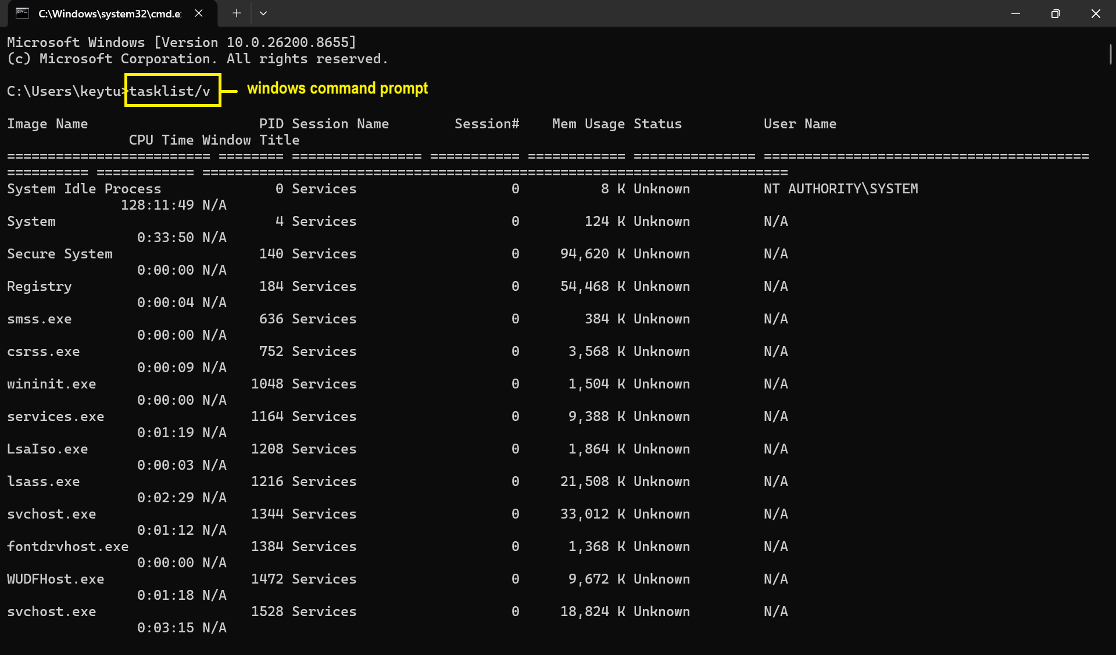
The tasklist/v command is primarily used to view the overall performance and resource utilisation of each process. [12].
Fig 1: Output of the tasklist/v command.

tasklist/svc command
The tasklist/svc command is utilised for displaying every service operating under every process, which can be quite helpful for identifying problems or comprehending how the system behaves [12].
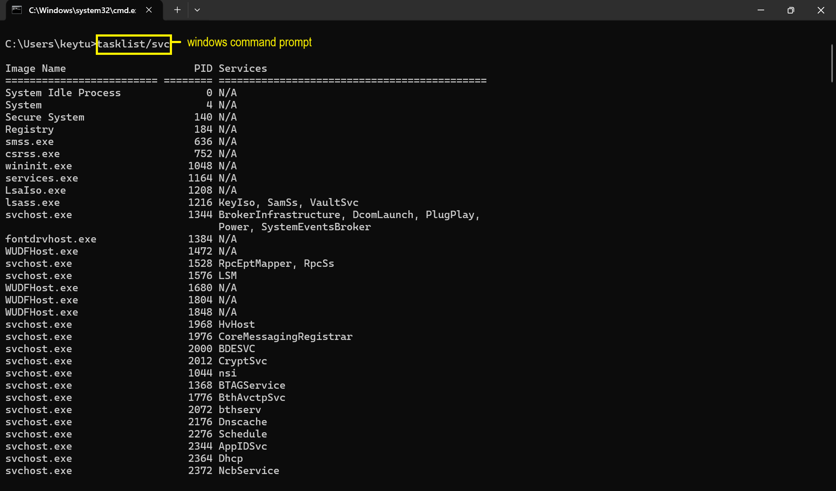
Fig 2: Output of the tasklist/svc command.

tasklist/m command
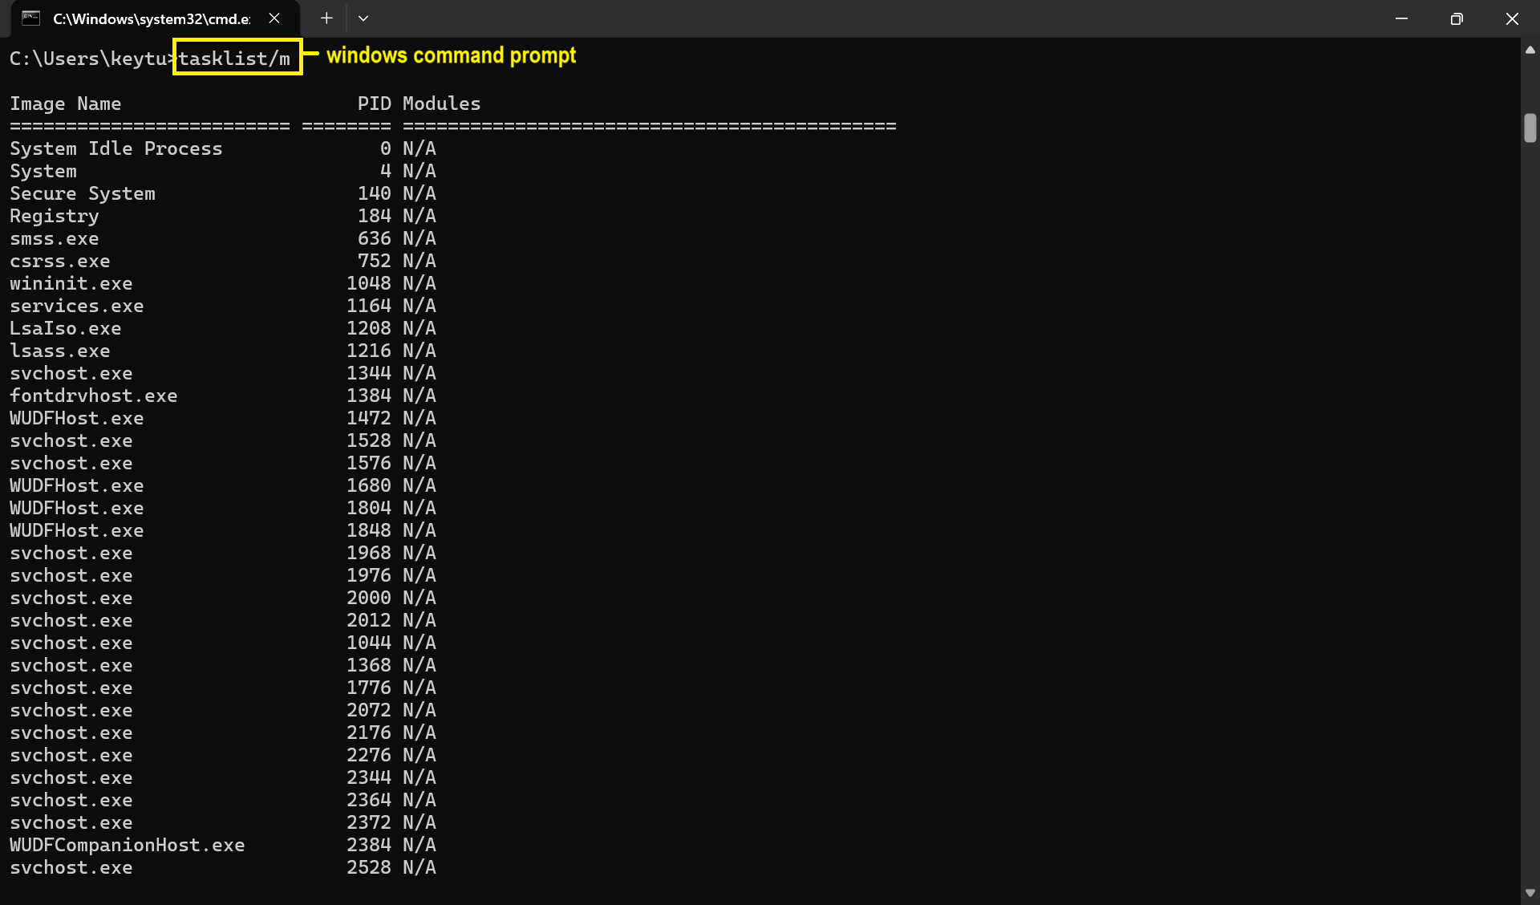
The tasklist/m command lists every task that matches the specified pattern name and is loaded with DLL modules. It shows all modules loaded by each job if the module name is left blank [12].
Fig 3 Output of tasklist/m command. command

FILE AND DIRECTORY MANAGEMENT

dir/a command
The dir/a command filters and displays the files in the current directory by attributes like hidden files, system files, or read-only files [12].
Fig 4 Output of dir/a command.
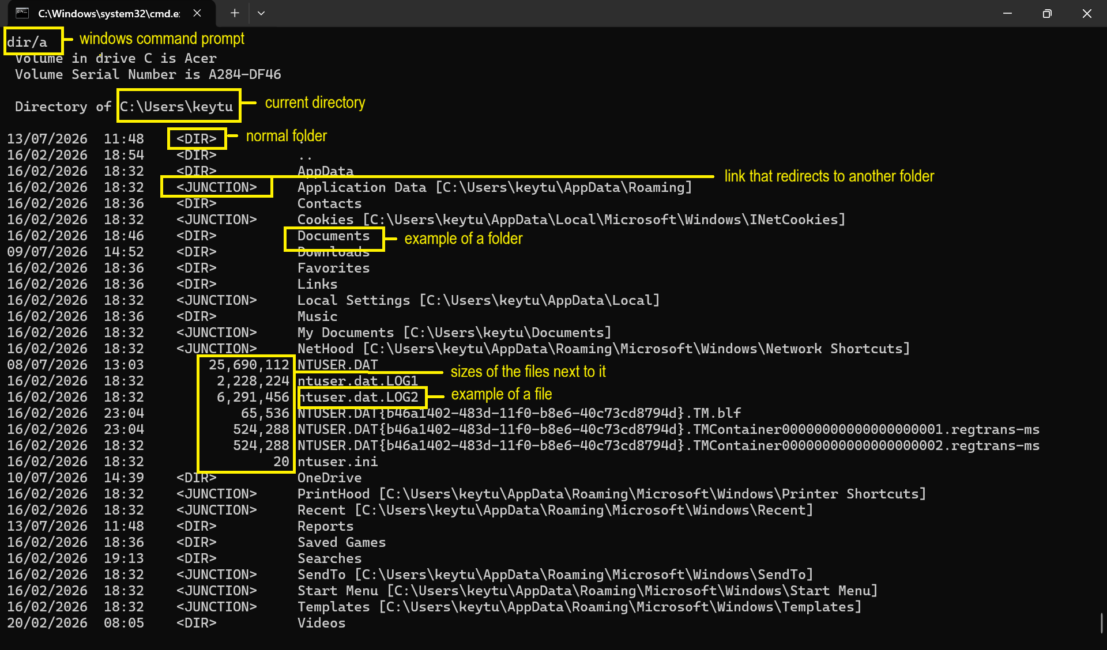

dir/q command
The dir/q command displays file and folder ownership details on top of the standard directory listing, which is helpful to verify ownership before removing files or altering permissions in multi-user settings. Understanding file ownership is crucial for monitoring accountability and guaranteeing compliance in corporate or regulated settings [12].
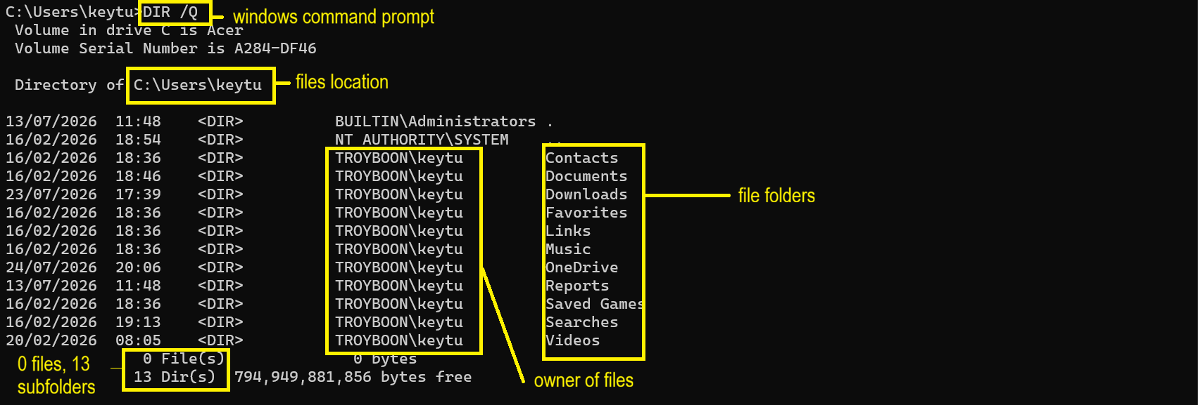
Fig 5 Output of dir/q command. command

NETWORK TESTING/MONITORING

ipconfig command
All of the current TCP/IP network configuration parameters, including IP addresses, subnet masks, and default gateways, are shown by the ipconfig command to resolve IP conflicts, and diagnose network connectivity problems, helping in network performance optimization and improving network management and troubleshooting skills [12].
Fig 6 Output of ipconfig .command. command
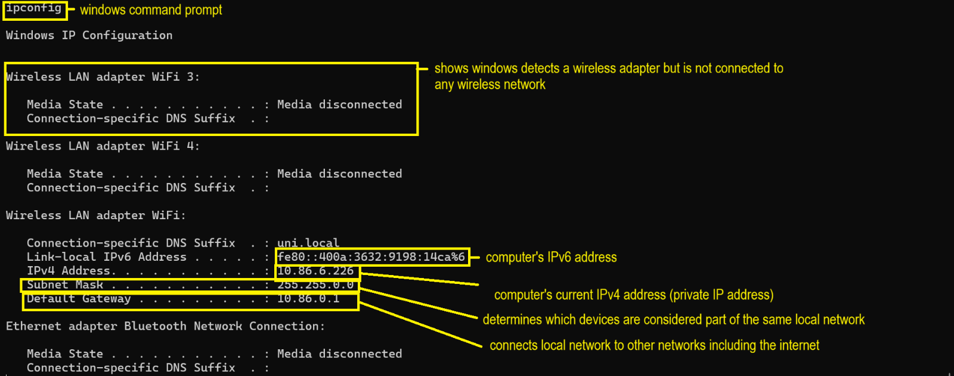

ping command
The ping command is used to determine whether a host on a network is reachable and responsive and offers useful details regarding the round-trip time (RTT) of a packet’s journey from its source to its destination and back to detect potential connectivity problems or network congestion by sending regular ping requests that would enable them to spot trends and possible issues before having a major effect on network performance [13].
Fig 7 Output of ping command.
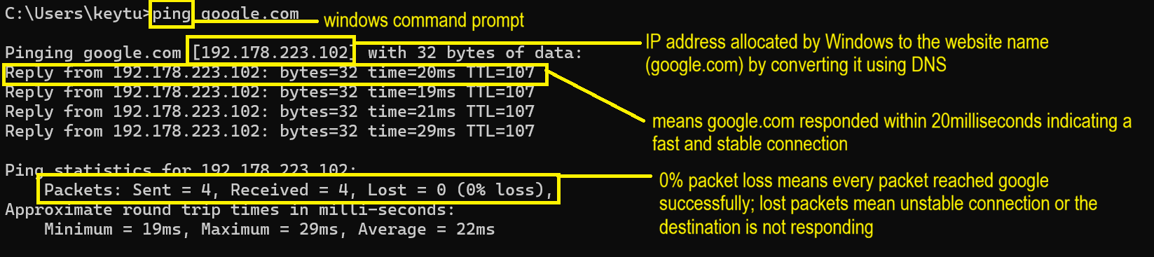

USER MANAGEMENT

net user <account name> command
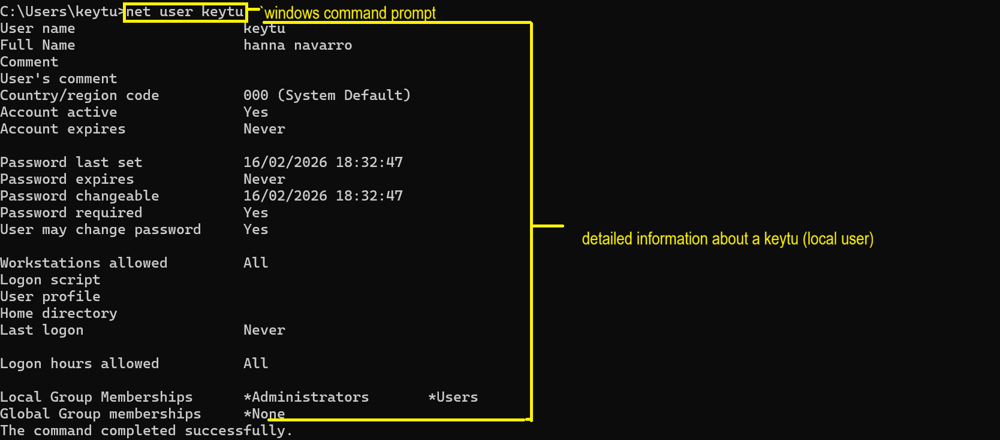
The net user <account name> command shows comprehensive details about a particular local user account. The account status, password, settings, logon details and group memberships are displayed [12].
Fig 8 Output of net user <account name> command.
Fig 8 net user command command

net user /add and net user /delete command
The net user <user name><password> /add command uses the specified username and password to create a new user account, while the net user /delete command removes an existing user account from the system [12].
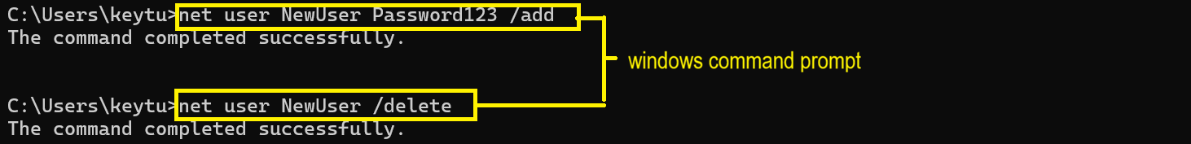
Fig 9 Output of net user /add and net user /delete command.

TASK SCHEDULING

schtasks /create

The schtasks /create command creates a new scheduled task. The particular schtask command (schtasks create /sc daily /tn "my task" /tr "C:RunMe.bat" /st 11:00) is created to run the batch file C:\RunMe.bat) everyday at 11AM and was confirmed to be created successfully [12].
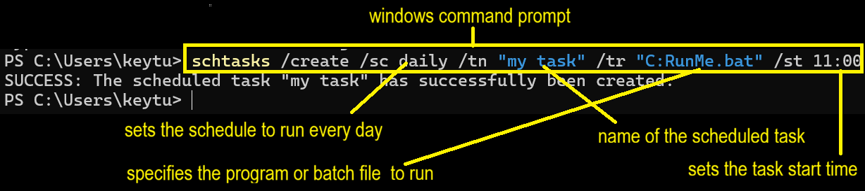
Fig 10 Output of schtasks /create

schtasks/query command
The schtasks /query command displays all scheduled tasks set up on the Windows system. It supplies information like the task name, the next scheduled run time, and the current status of each task. It is used to determine the persistence mechanisms used by malware and look for tasks that perform suspicious programs. [12].
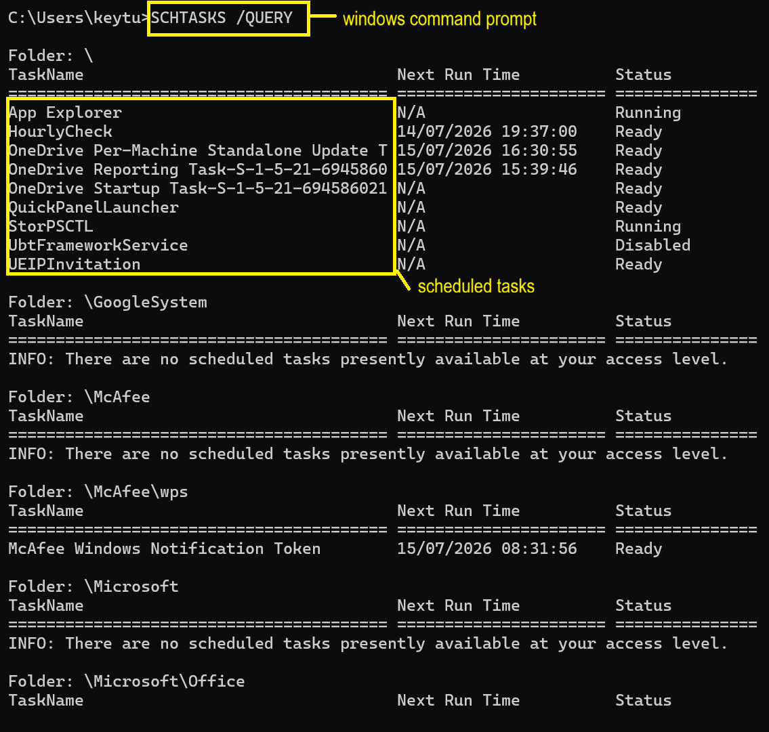
Fig 11 Output of schtasks /query.

USE OF LINUX OS CLI COMMANDS
Linux CLI commands facilitate rapid and effective system management, automate repetitive tasks, streamline troubleshooting, allow for remote administration, optimise system resources, and enhance productivity for developers, administrators and advanced users [14]. Linux CLI provides robust scripting capabilities, adheres to native POSIX standards, and facilitates efficient command pipelines, resulting in accelerated automation, software development, and server management compared to conventional Windows command-line interfaces [15].

PROCESS MANAGEMENT

ps aux command
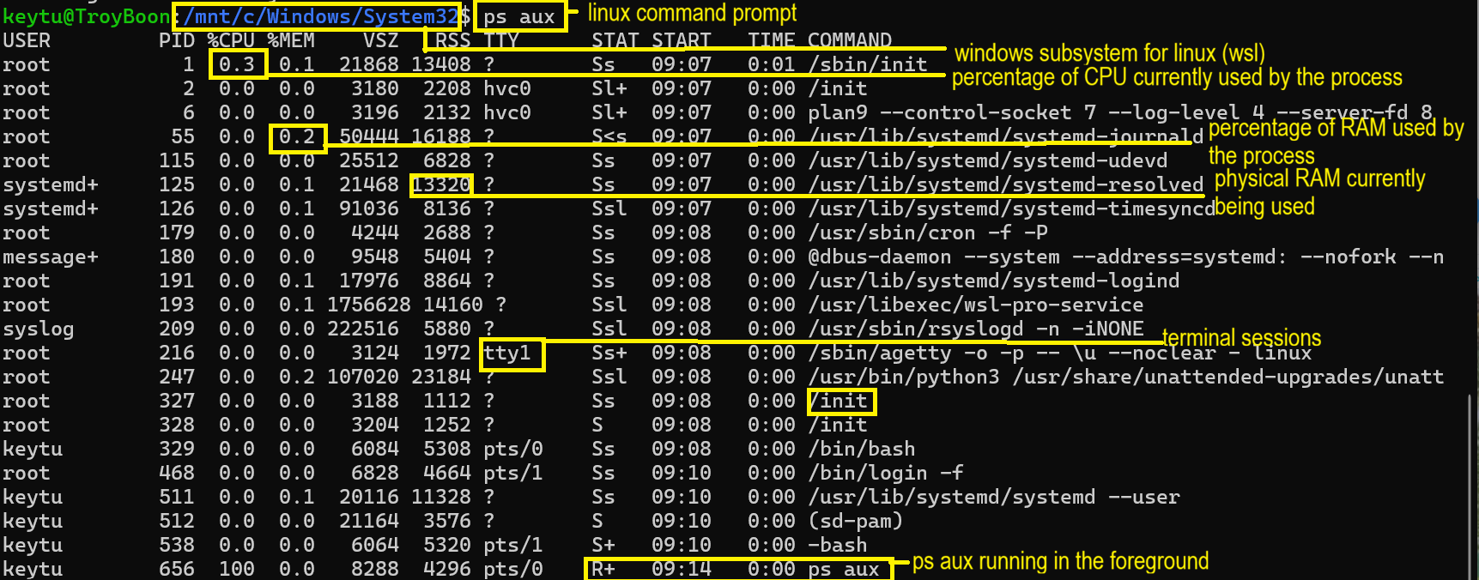
The ps aux command displays the details of the programs currently running on the computer, which is crucial for overseeing and administering system operations effectively [16].
Fig 12 Output of ps aux command.

pstree command
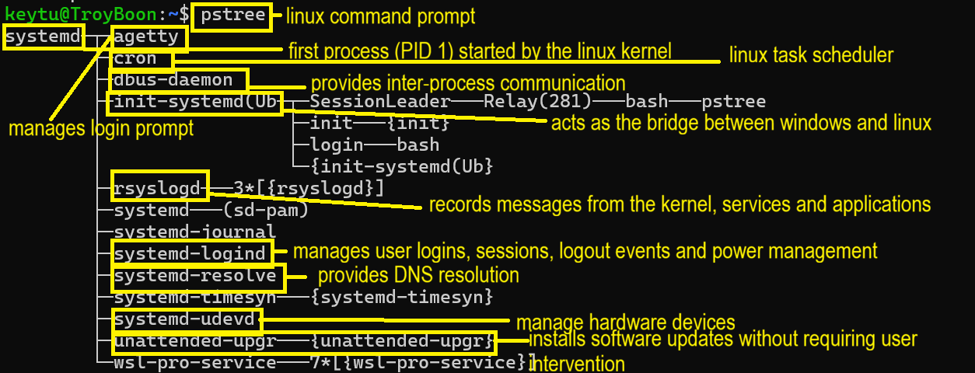
The pstree command shows the system processes in a hierarchical tree structure, facilitating the visualisation of the parent-child relationship among processes, hence aiding ion the comprehension of process creation and organization in Linux [16].
Fig 13 Output of pstree command.

top command
The top command enables you to observe the extent of utilisation of the computer’s resources (such as CPU and memory) along with specifics regarding the active apps and processes in real time by giving continuous updates every few seconds which is crucial for detecting performance problems, recognising resource-demanding tasks, and properly overseeing system resources [16].
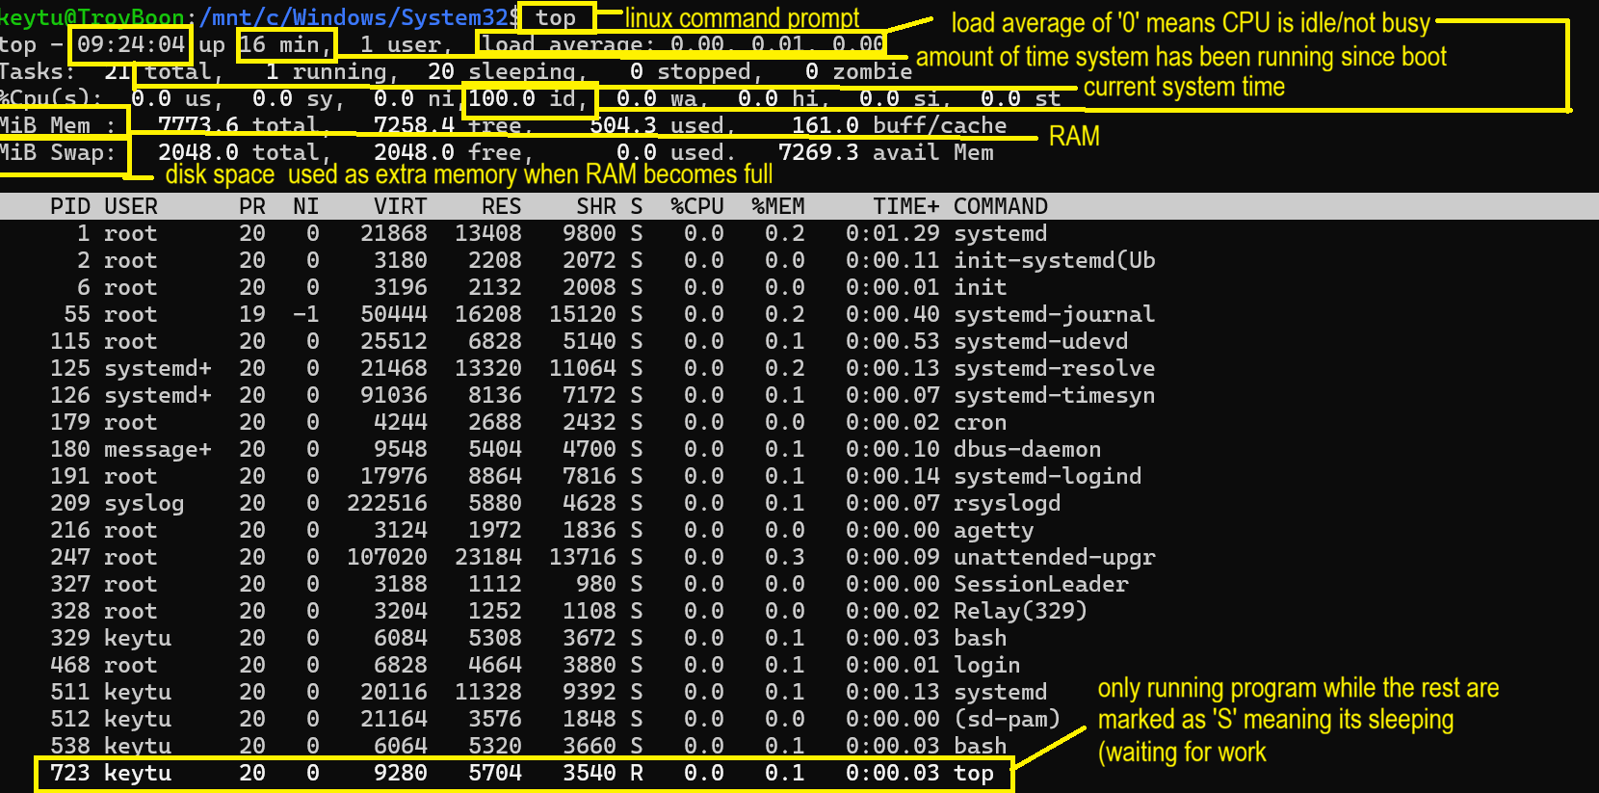
Fig 14 Output of top command.

FILE AND DIRECTORY MANAGEMENT

ls command
The ls command enables the effective viewing and management of files and directories in the current or designated path without the necessity of launching a file manager.It is crucial in administering servers without a graphical interface and aids in diagnostics by examining logs, configuration files, and permissions [16].

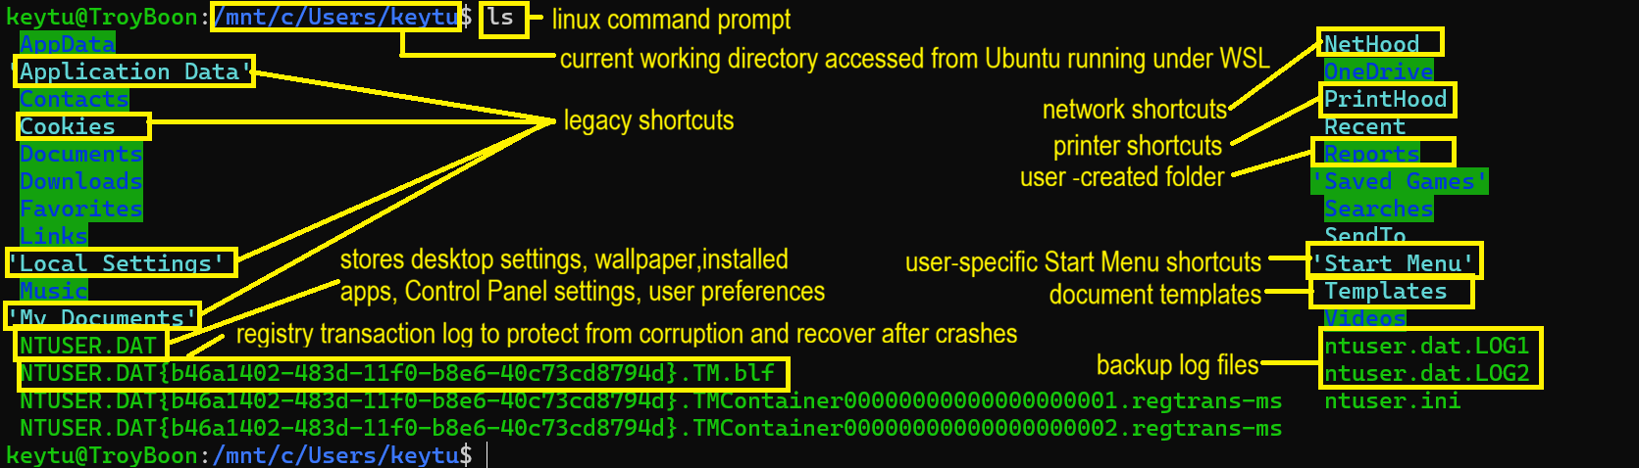
Fig 15 Output of ls command.

find
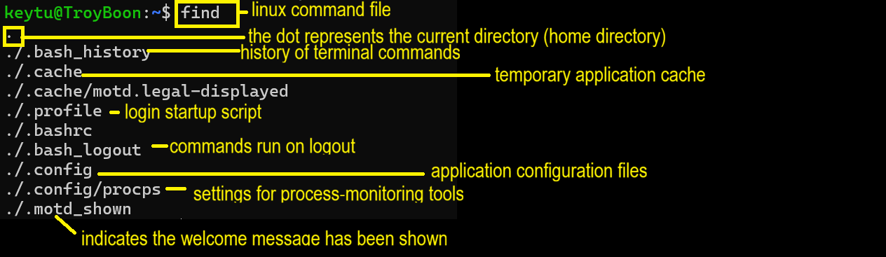
The find command rapidly identifies files in a directory or subdirectories, making it easier to perform commands on identified files, identify empty files and folders, identify files by pattern and verify file deletion. [16]. I'm a new WSL user, so the directory is very minimal and only contains default hidden configuration files.
Fig 16 Output of find command.

NETWORK TESTING/MONITORING

vmstat command
The vmstat command delivers real-time analysis of diverse system parameters (virtual memory, CPU usage, disk I/O, and process statistics. It is very beneficial for identifying performance constraints and evaluating resource consumption [16].
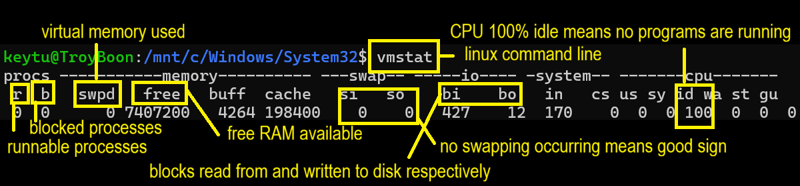
Fig 17 Output of vmstat command.

ss command
The ss command is a contemporary, fast, and enhanced version of the older netstat command that reveals extensive data about network sockets. It utilises the kernel’s netlink interface shows detailed socket information, and facilitates accurate filtration of outcomes (by state, port, address and protocol) which are all crucial for identifying network problems, verifying open ports , and observing connections [16].

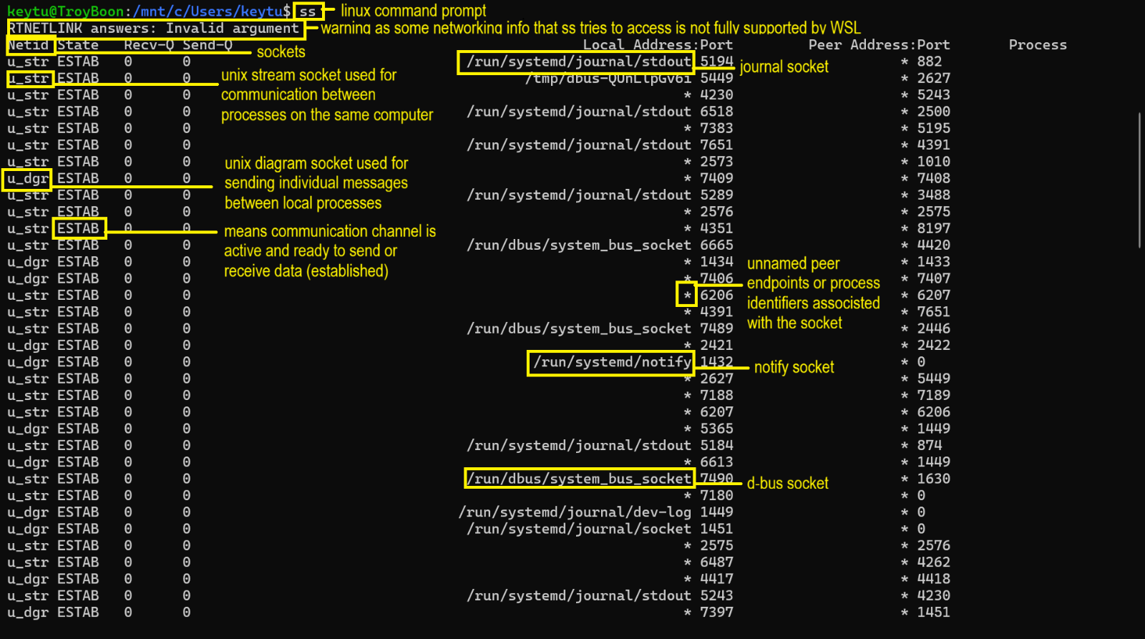
Fig 18 Output of ss command.

USER MANAGEMENT

who command
The who command shows data regarding users currently logged into the system, including session specifics such as terminal, login time, and source host/IP. It is ideal for rapid session evaluations [16].
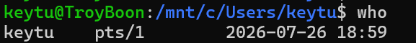
Fig 19 Output of who command.

id command
The id command shows user and group information, encompassing numeric identifiers (UID and GID) for the current and designated user. It is used to authenticate user identities and access rights [16].
Fig 20 Output of id command.

TASK SCHEDULING

atq command
The atq command enables the execution of commands at a specific time in the future. It is used to identify jobs that are queued but have yet to be executed, reveals just the jobs associated with the current user unless operated as a root (in which case it shows all users’ jobs), and assists in confirming whether a job was effectively scheduled, making it useful for administering and evaluating scheduled tasks [16].
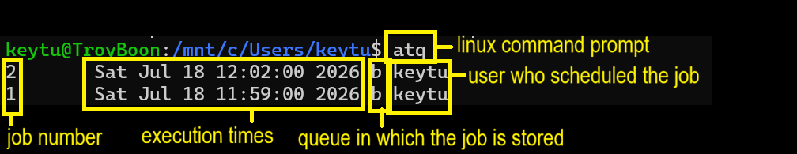
Fig 21 Output of atq command.

USE OF OS WINDOWS SCRIPTS

TEMPORARY FILE CLEANUP TOOL
The temporary file cleanup tool automatically identifies obsolete temporary files, assesses time conserved, removes files, monitors successful and unsuccessful deletions, and presents a concluding summary.

ASSIGNMENT REQUIREMENT | EXAMPLE FROM SCRIPT
Variables | CleanupFolder  Days  secondsPerFile  fileCount
User Input | set /p
Mathematical Calculations | set /a
Loops | for  forfiles
Conditional Statements | if  else

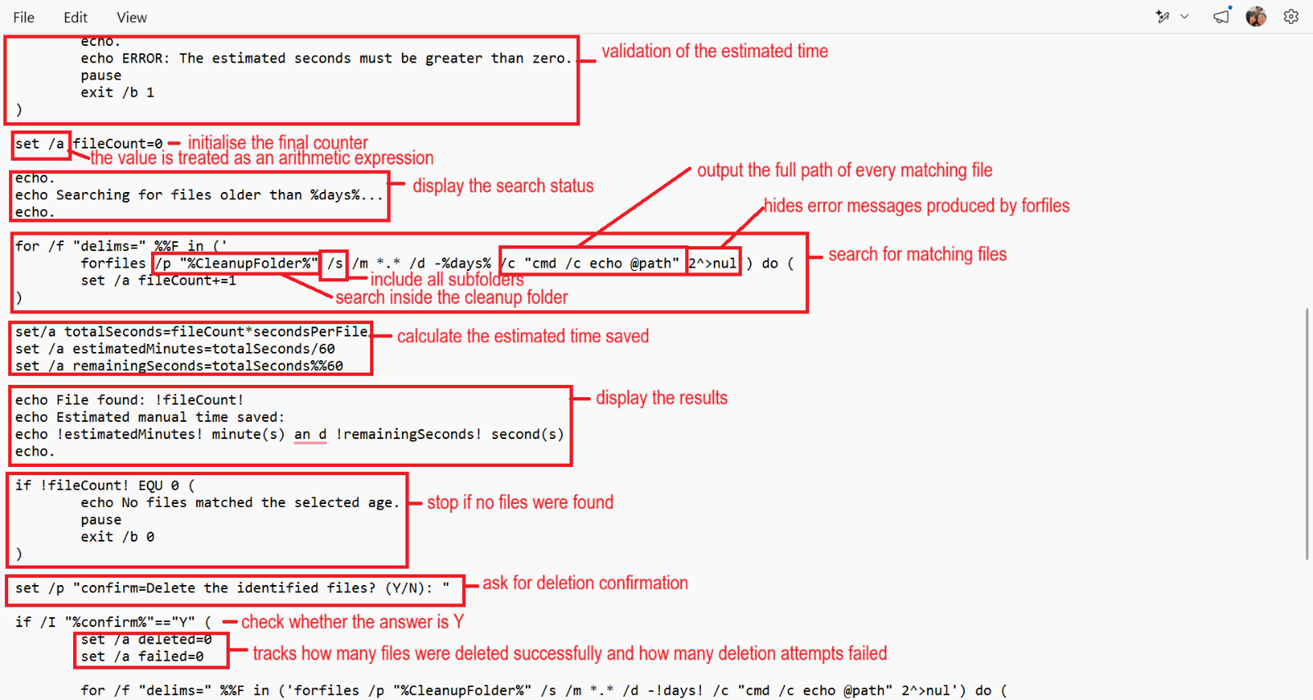
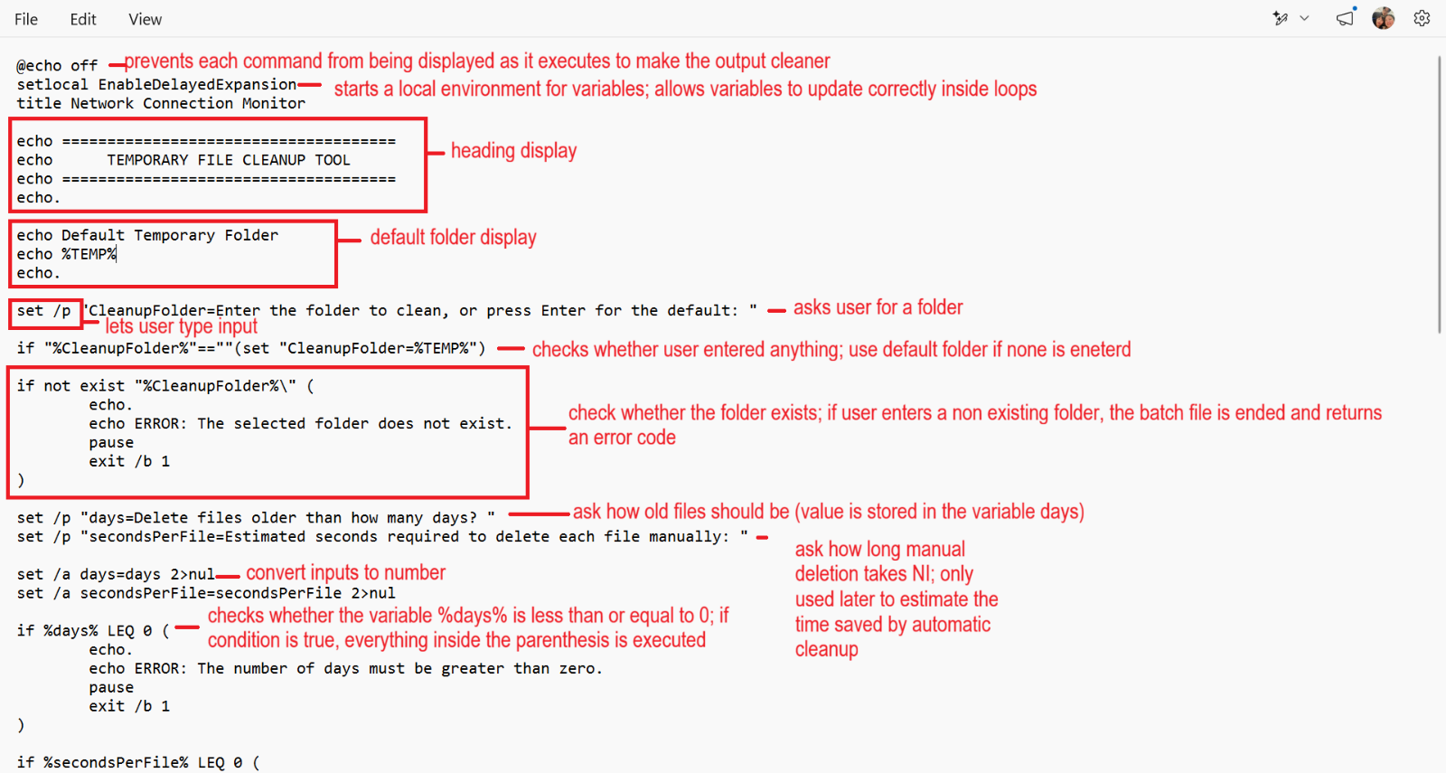
Fig 23 Temporary File Cleanup Tool codes (2/3).
Fig 22 Temporary File Cleanup Tool codes (1/3).

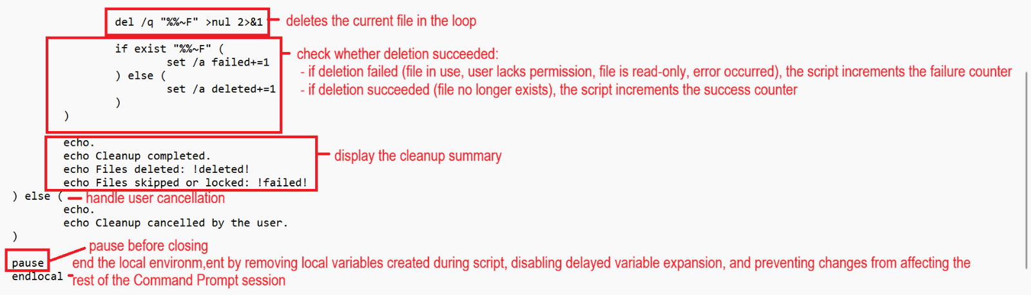
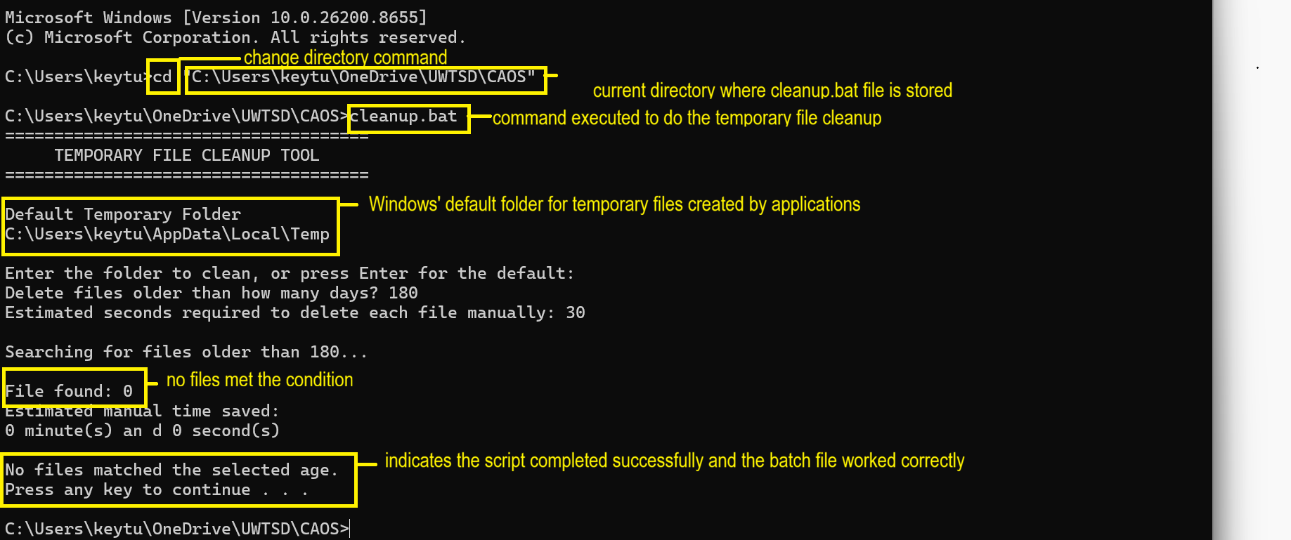
Fig 25 Temporary File Cleanup Tool execution output.
Fig 24 Temporary File Cleanup Tool codes (3/3).

AUTOMATED SYSTEM REPORT
The automated system report automatically establishes directories, produces reports, gathers system data, pauses between reports, and presents a summary.
ASSIGNMENT REQUIREMENT | EXAMPLE FROM SCRIPT
Variables | reportFolder  reportCount  delaySeconds  estimatedTime  completed  failed  reportFile
User Input | set /p reportFolder=  set /p reportCount=  set /p delaySeconds=
Mathematical Calculations | set /a estimatedTime=(reportCount-1)*delaySeconds  set /a completed+=1  set /a failed=reportCount-completed
Loops | For /L %%N in (1,1, !reportCount!)do(…) creates multiple reports automatically
Conditional Statements | if not exist,  if reportCount LEQ 0  if delaySeconds LSS 0  if exist  confirmnation using if/I
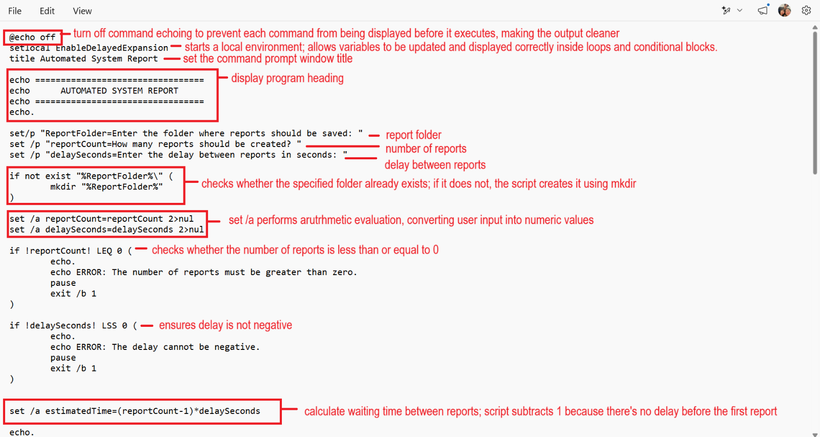
Fig 26 Automated System Report codes (1/3).
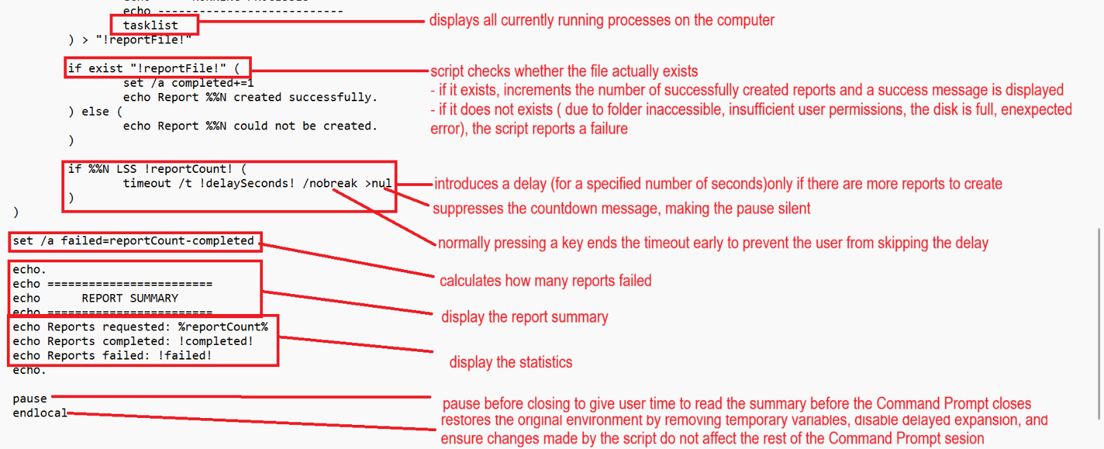
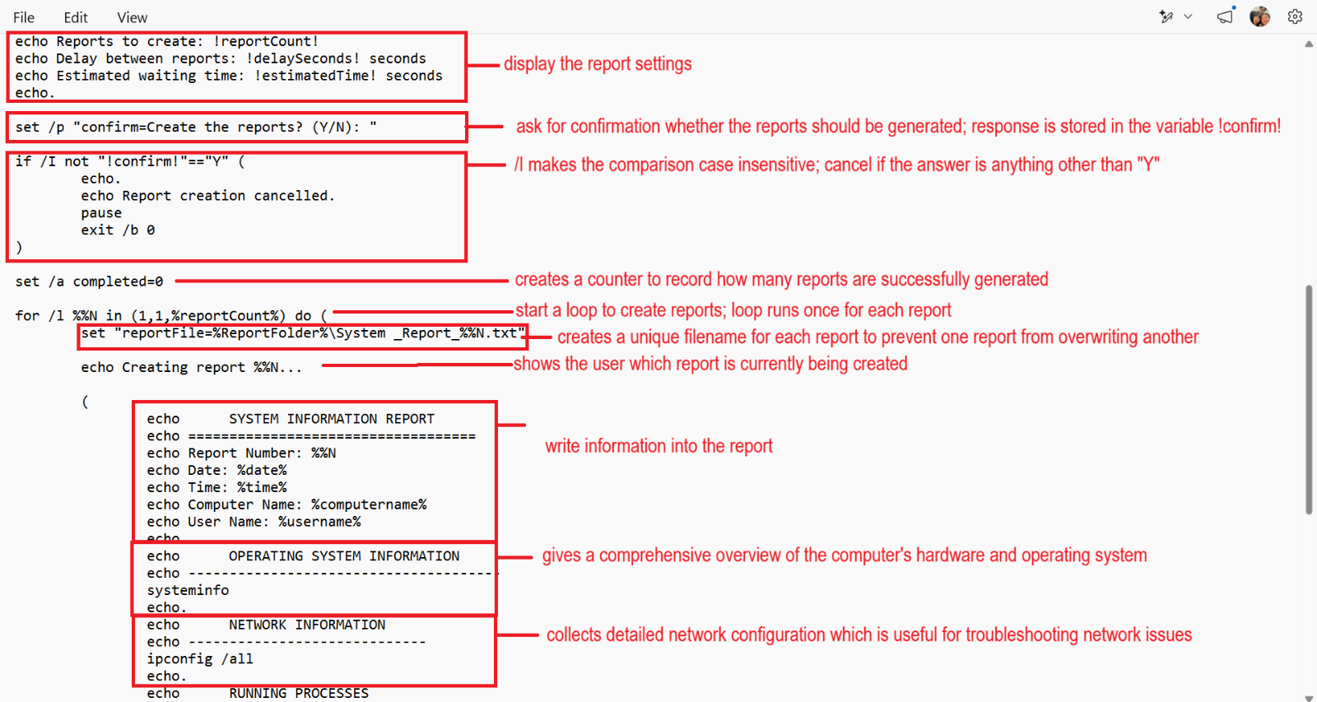
Fig 28 Automated System Report codes (3/3).
Fig 27 Automated System Report codes (2/3).

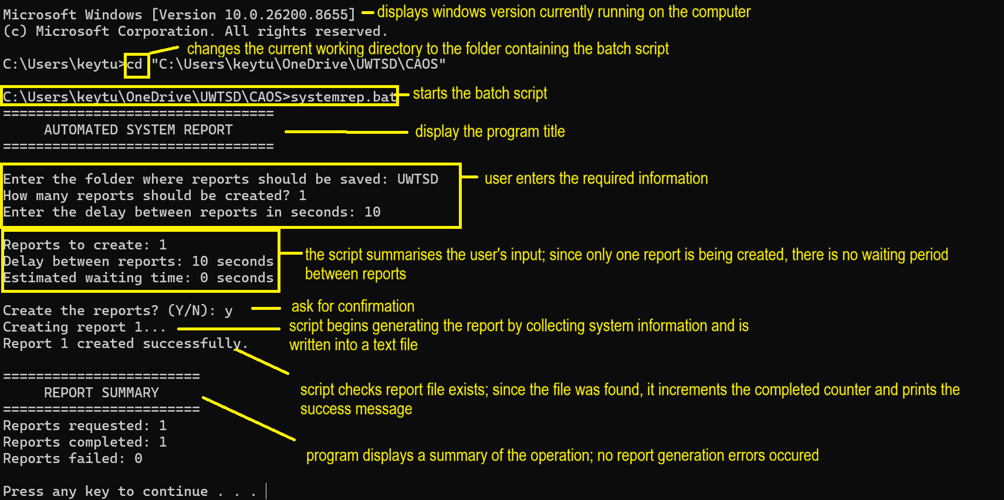
Fig 29 Automated System Report Execution Output.

USE OF LINUX OS SCRIPTS

SIMPLE CALCULATOR
The simple calculator facilitates calculator functions by receiving user input, executing the chosen operation, and presenting the outcome autonomously.
ASSIGNMENT REQUIREMENT | EXAMPLE FROM SCRIPT
Variables | first, second, choice, and result store the user inputs and calculated result
User Input | read -p “Enter the first number:”first  read -p Enter the second number:”second  read -p “Enter your choice:”choice
Mathematical Calculations | uses Bash arithmetic expansion $(( )) to perform addition (+), subtraction (-), multiplication (*), and division (/)
Conditional Statements | uses if to validate numeric input and prevent division by zero
Case Statement | Uses case “$choice” in to execute the selected operation based on the user’s menu choice
Input Validation | checks that the inputs are integers and prevents division by zero or invalid menu selection

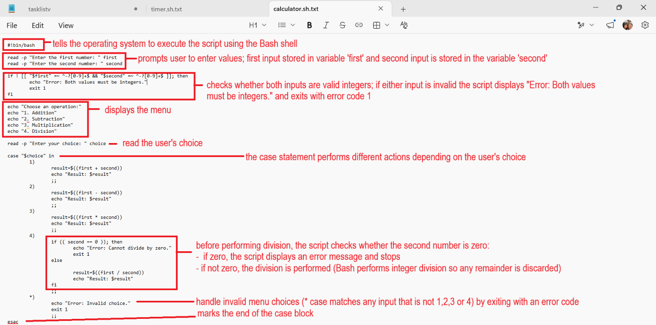
Fig 30 Output of Simple Calculator Codes.

Fig 31 Simple Calculator Execution Output.
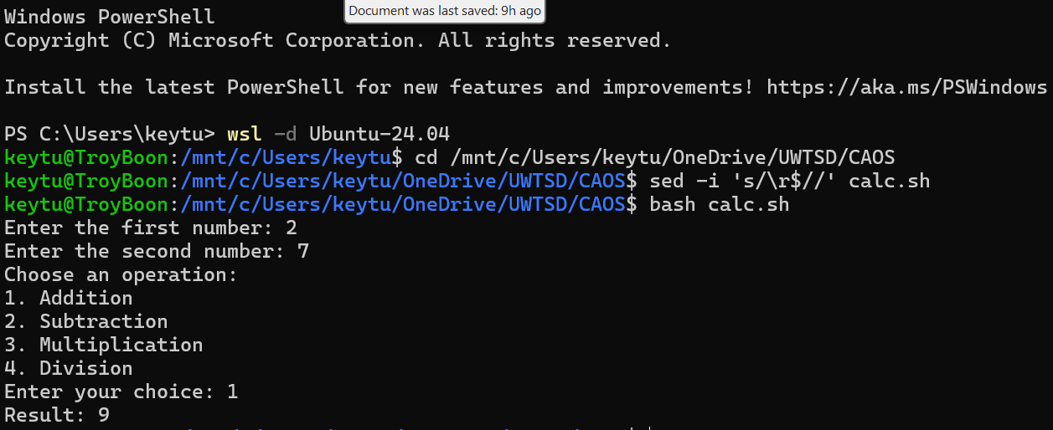

COUNTDOWN TIMER
The countdown timer executes a countdown autonomously, refreshes the remaining duration each second, and presents a finish notification without additional user interaction.

ASSIGNMENT REQUIREMENT | EXAMPLE FROM SCRIPT
Variables | uses seconds and remaining to store the user’s input and the countdown value
User Input | read -p “Enter the number of seconds:” seconds to accept the countdown time
Mathematical Calculations | uses arithmetic to decrement the countdown (((remaining--)))
Loop | uses a while loop to repeatedly display the remaining time until it reaches zero
Conditional Statement | uses an if statement to validate that the input is a positive whole number before starting the timer
Input Validation | checks that the inputs are integers and prevents division by zero or invalid menu selection
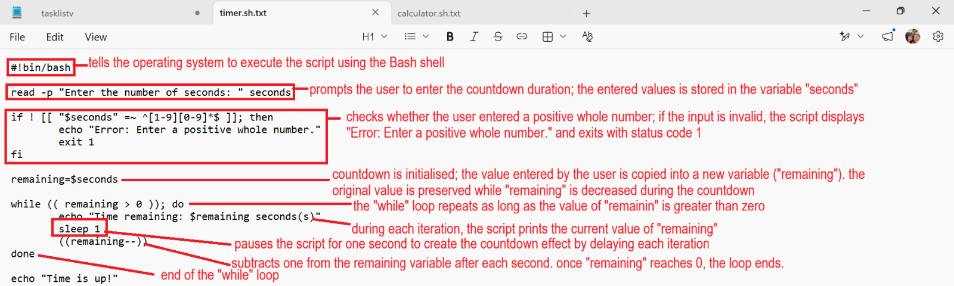
Fig 32 Output of Countdown Timer Codes.
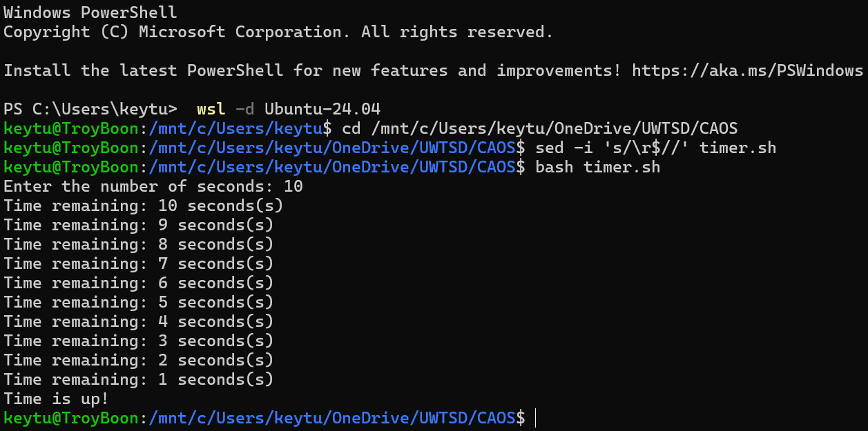
Fig 33 Countdown Timer Execution Output.

CONCLUSION
This assessment showed the practical usage of Windows OS commands, Linux OS commands, Windows Batch scripting and Linux Bash scripting to automate routine system management tasks. Windows and Linux command-line utilities offered critical tools for managing files, monitoring system resources, and executing administrative activities efficiently. Batch and Bash scripts automated repetitive processes such as deleting temporary files, generating system reports, doing computations, and creating countdown timers using variables, user input, arithmetic, loops, and conditionals. Overall, this assessment improved practical command-line abilities and demonstrated how scripting may improve efficiency, accuracy, consistency, and productivity when dealing with operating system tasks [17. 17. 18].

REFERENCES

[1] A. S. Tanenbaum and H. Bos,Modern Operating Systems, Global Edition, 5th Ed. Pearson Higher Ed, 2023.
[2] GeeksforGeeks. "Process in Operating System." GeeksforGeeks. [Online]. Available: https://www.geeksforgeeks.org/operating-systems/process-in-operating-system/
[3] J. Hao, Y. Xiao, W. Zhou and P. Wang,Operating System Basics and Practice : A Hands-on Approach with openEuler, 1st Ed. Singapore: Springer Nature Singapore, 2026. doi: 10.1007/978-981-95-2185-2.
[4] Z. B. Akhtar, "Operating systems (OS): An insight investigative research analysis and future directions," vol. 6, no. 1, pp.58–69, 2024,
[5] J. Sun, S. Li, J. Xu and J. Huang, "The security war in file systems: An empirical study from a vulnerability-centric perspective," vol. 19, no. 4, pp.1–26, 2023,
[6] Y. Zhang, X. Zhao, J. Yin, L. Zhang and Z. Chen, "Operating system and artificial intelligence: A systematic review," 2024,
[7] IBM. "Operating System." [Online]. Available: https://www.ibm.com/think/topics/operating-systems
[8] R. Bazuku, A. Anab, S. Gyemerah and I. D. Mohammed, "An Overview of Computer Operating Systems and Emerging Trends," 2023,
[9] S. W. A. Hamdani et al., , "Cybersecurity standards in the context of operating system: Practical aspects, analysis, and comparisons," vol. 54, no. 3, pp.1–36, 2021,
[10] R. H. T. Sianturi, G. H. Simanjuntak, J. Anugerah, W. B. N. Panggabean and D. R. Sitompul, "NAVIGATING COMPUTER OPERATING SYSTEM: AN IN-DEPTH OVERVIEW,"
[11] Microsoft. "What is PowerShell" microsoft.com. (May 12, 2026). Available at: https://learn.microsoft.com/en-us/powershell/scripting/overview?view=powershell-7.6
[12] Microsoft, "Windows Commands," Feb 24 2026, [Online]. Available: https://learn.microsoft.com/en-us/windows-server/administration/windows-commands/windows-commands
[13] squadcast.com. "What is Ping Command: A Deep Dive into Network Diagnostics" squadcast.com. (Aug 19, 2024). Available at: https://dev.to/squadcast/what-is-ping-command-a-deep-dive-into-network-diagnostics-fa
[14] Jim Hall. "5 Must Read Resources for Using the Linux Command Line" opensource.com. (dec 21, 2022). Available at: https://opensource.com/article/22/12/linux-command-line
[15] Red Hat. "What is Open Source Software" www.redhat.com. (May 11, 2022). Available at: https://www.redhat.com/en/topics/open-source/what-is-open-source-software
[16] W. Shotts, The Linux Command Line: A Complete Introduction, 3rd Ed. No Starch Press, 2026.
[17] V. Frank, P. S. Ulrich, R. Buettner and W. Becker, "Current Developments in Management Reporting-A Systematic Literature Review focusing on Digitization and Role Changes," 2022,
[18] S. Rana, N. Kumar, A. Handa and S. K. Shukla, "Automated windows behavioral tracing for malware analysis," vol. 5, no. 6, pp.e253, 2022,

APPENDICES

LIST OF FIGURES

Windows OS CLI Commands
Fig 1. Output of tasklist/v command.
Fig 2. Output of tasklist/svc command.
Fig 3. Output of tasklist/m command.
Fig 4. Output of dir/a command.
Fig 5. Output of dir/q command.
Fig 6. Output of ipconfig command.
Fig 7. Output of ping command.
Fig 8. Output of net user command.
Fig 9. Output of net user /add and net user /delete command.
Fig 10. Output of schtasks /create command.
Fig 11. Output of schtasks /query

Linux OS CLI Commands
Fig 12. Output of ps aux command.
Fig13.Output of top command.
Fig14.Output of pstree command.
Fig 15. Output of ls command.
Fig 16. Output of find command.
Fig 17. Output of ss command.
Fig 18. Output of vmstat command.
Fig 19. Output of who command.
Fig 20. Output of id command.
Fig 21. Output of atq command.

Windows OS Batch Scripts
Fig 22. Temporary File Cleanup Tool codes (1/3).
Fig 23. Temporary File Cleanup Tool codes (2/3).
Fig 24. Temporary File Cleanup Tool codes (3/3).
Fig 25. Temporary File Cleanup Tool Execution Output.
Fig 26. Automated System Report codes (1/3).
Fig 27. Automated System Report codes (2/3).
Fig 28. Automated System Report codes (3/3).
Fig 29. Automated System Report Execution Output.

Linux OS Bash Scripts
Fig 30. Output of Simple Calculator Codes.
Fig 31. Simple Calculator Scripts Execution Output.
Fig 32. Output of Countdown Timer Codes.
Fig 33. Countdown Timer Scripts Execution Output.

