Geographical Information Systems
  - Module ACCA5027 Assignment
by
  - John Dunkley-Williams
1903715

Contents

- Development Log
- Report
- References
- Appendices

Development Log

For the purposes of the assignment, the data focal point will be that of Bridgend. In order to analyse data to effectively inform healthcare professionals of vaccination uptakes, the first step will be to isolate the required data in order to build up a visualisation of vaccine uptake and population trends.
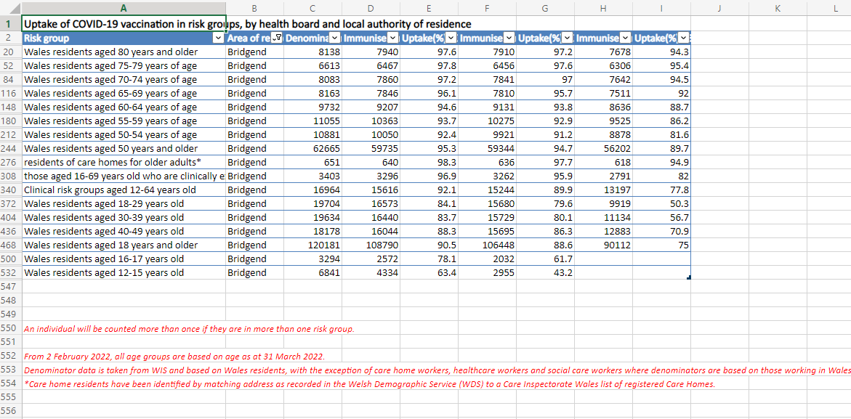
The Bridgend data for vaccination uptake is isolated from the all Wales data.
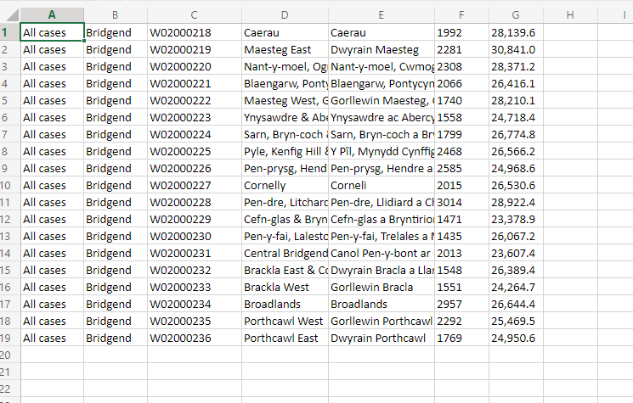
Then the data for Bridgend Covid cases are isolated. These will next need to be mapped to show the visualisation of the data geographically.
The first thing notable when the map data is examined however, is that the area codes do not match up. These will need to be uniform between data sets if the data is to map.
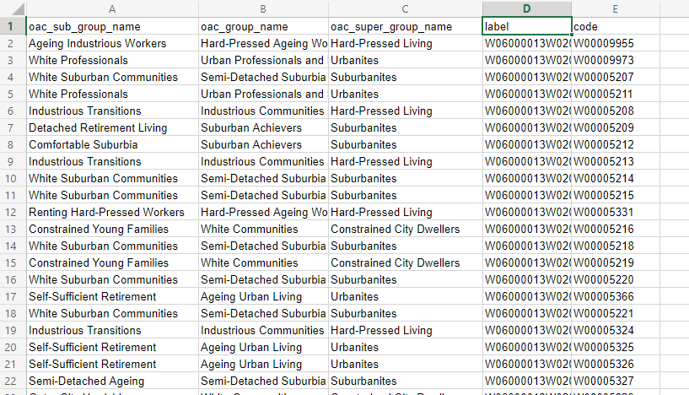
To resolve this, I need to obtain the data again, this time separating out the Mid Super Output Layer for the map download, in order to align with the area codes in the Covid data file.
With the MSOA area codes aligned, both tables can be loaded in to MapInfo, and the data visualised for Bridgend County;
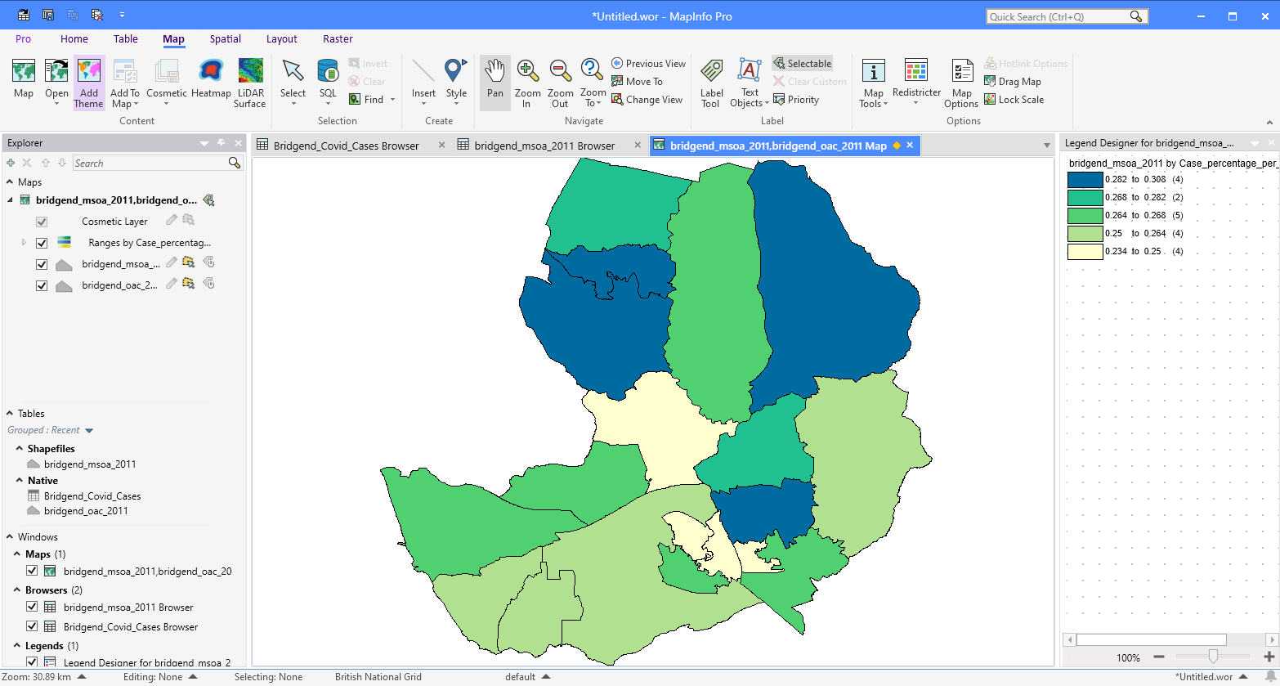
From light to darker colours, there are more Covid cases per 100,000 of the population. The lowest cases are around the town centre, with the addition of Aberkenfig, while further from the town and heading up the valleys, the case numbers increase.
Data is collected from InFuse to examine age, economic activity, and academic education levels to look for correlation between this data and Covid vaccine uptake.
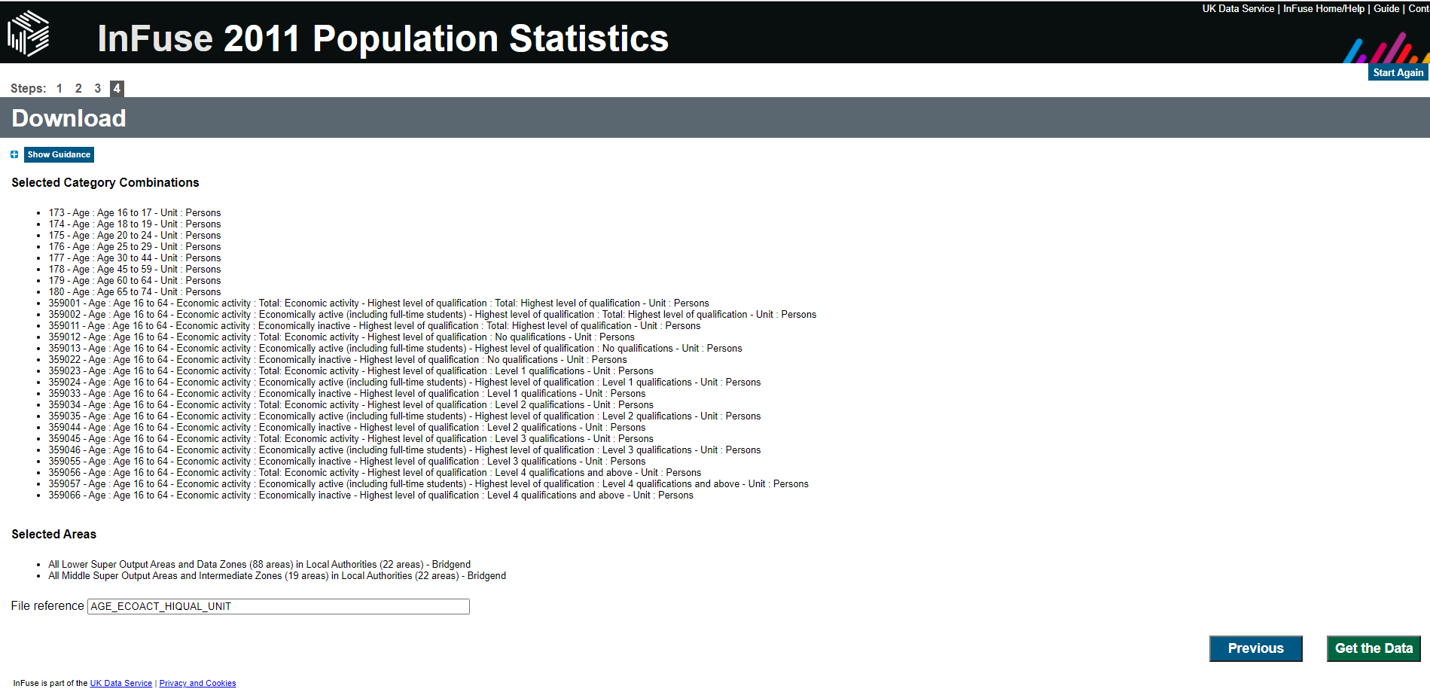
The Covid uptake data doesn’t allow for such a detailed look at Wales, and so instead a map of Wales must be used in order to map against our vaccine uptake data.
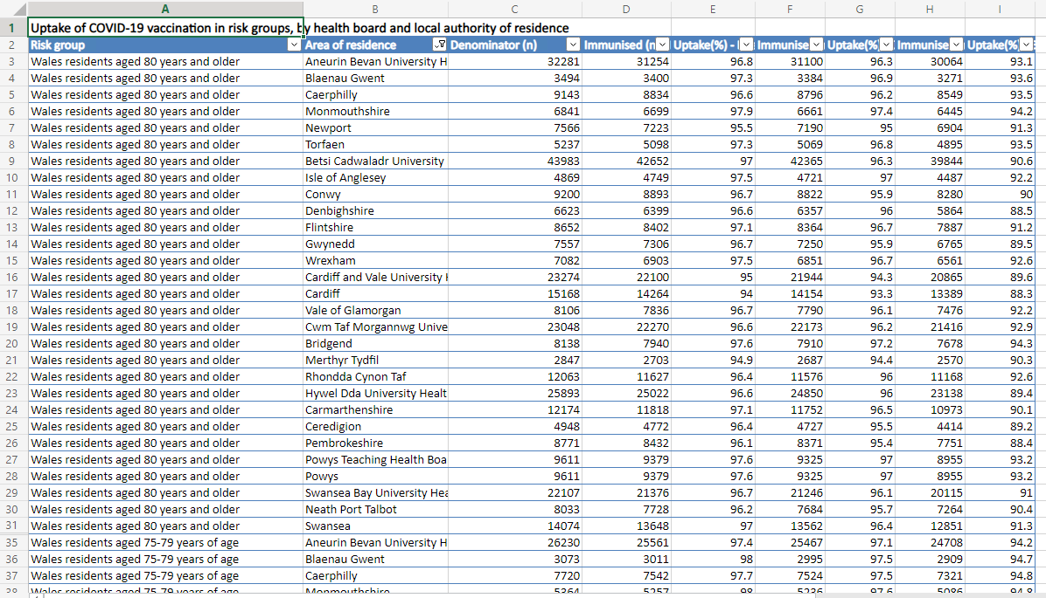
To map against this data, Welsh MSOA Rural/Urban Classification data was used.
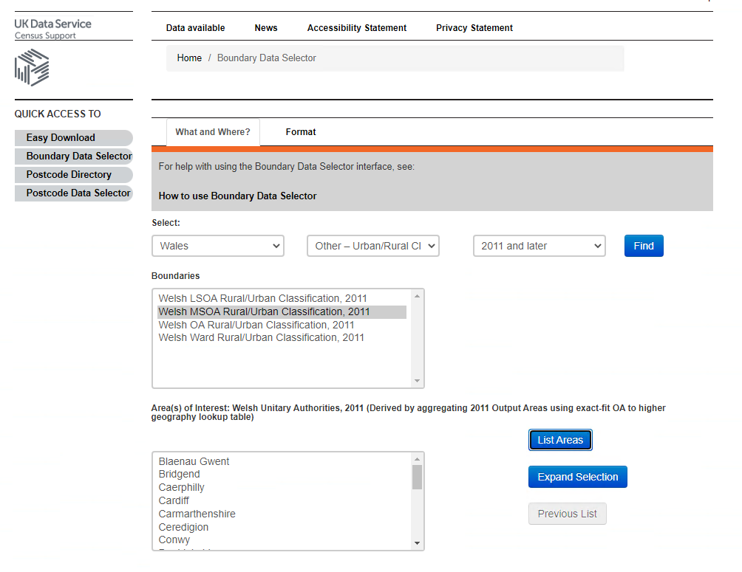
This data needed to be edited, again to match the Covid data by removing numerical identifiers.
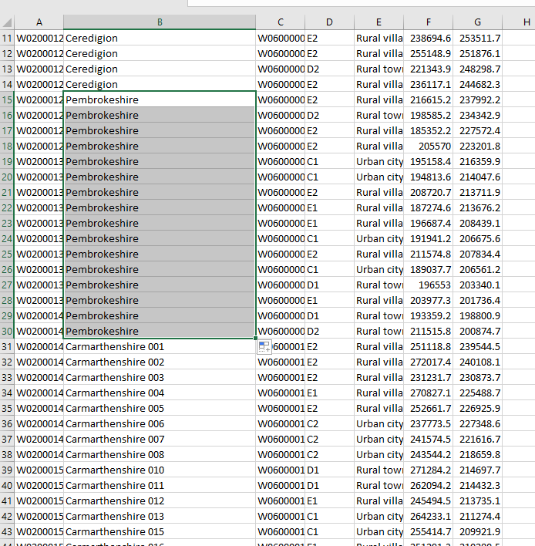
Because the data was edited in csv format, it needs to be remapped, so first the data needs to be marked as mappable.
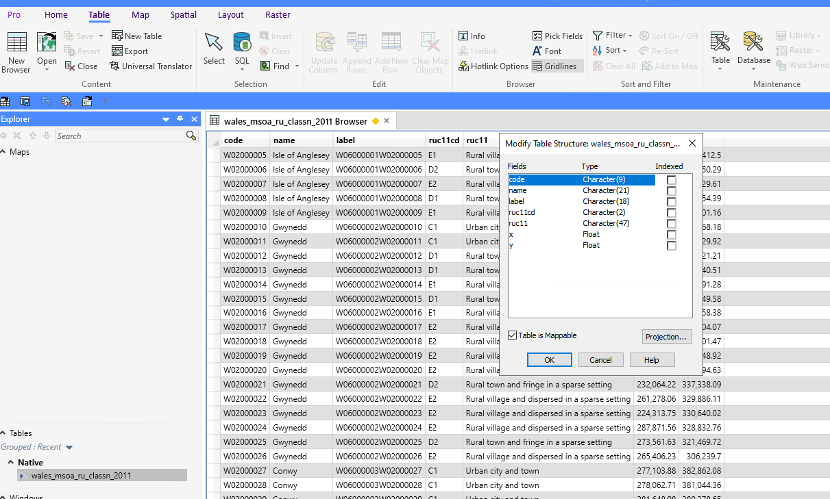
Then, using the spatial tab, points need to be created.
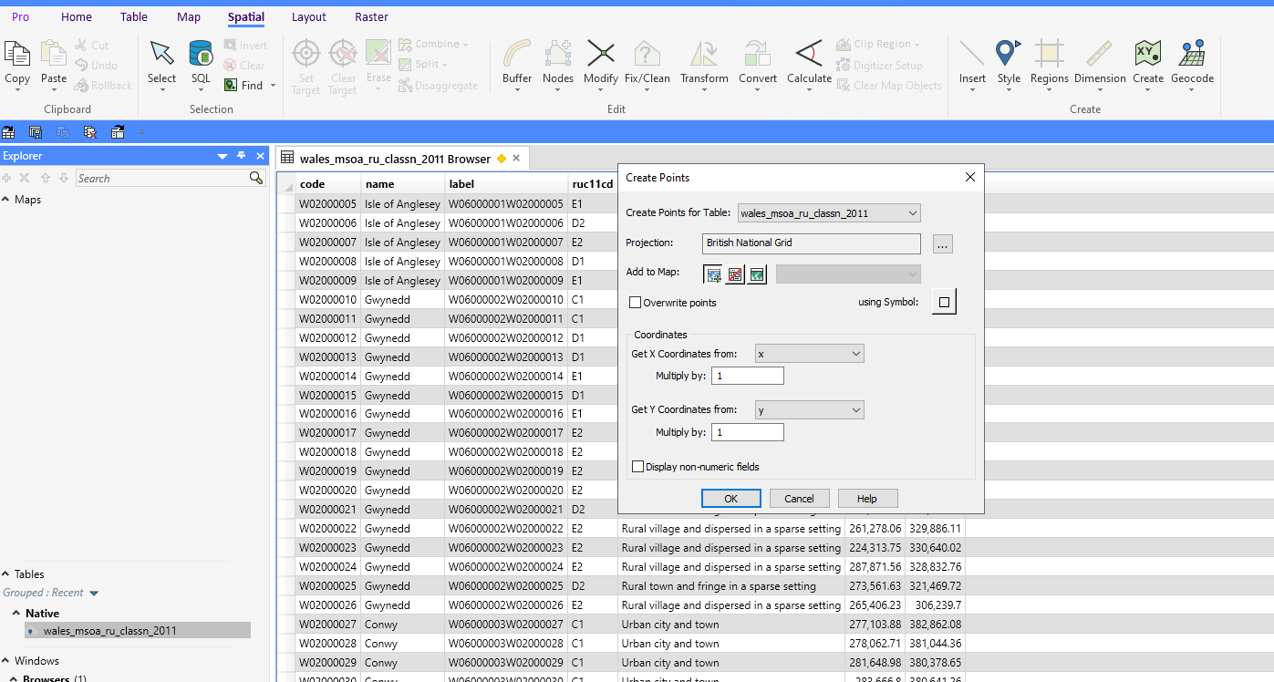
This still proved difficult to map with, so after some more searching, it was discovered that a different map better fitted the need.
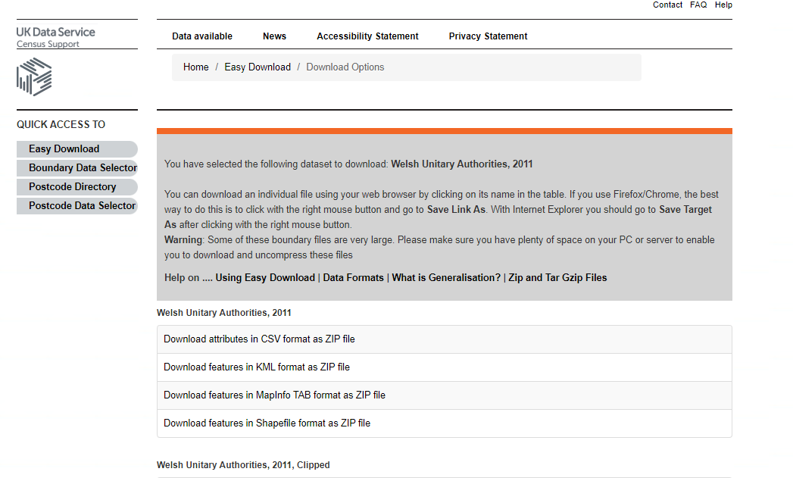
With this map, it was possible to quickly combine the extracted data to look at Covid Vaccine uptake in Wales.
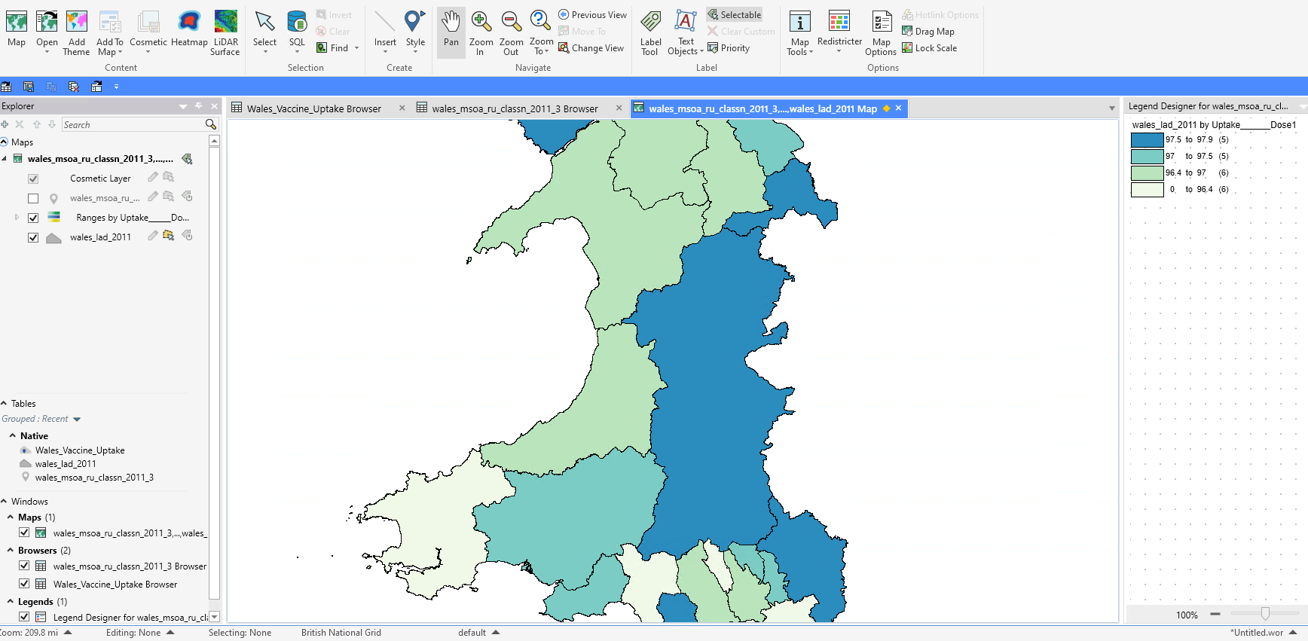
As it stands, this map merges all of the available data which is actually separated out by age group.
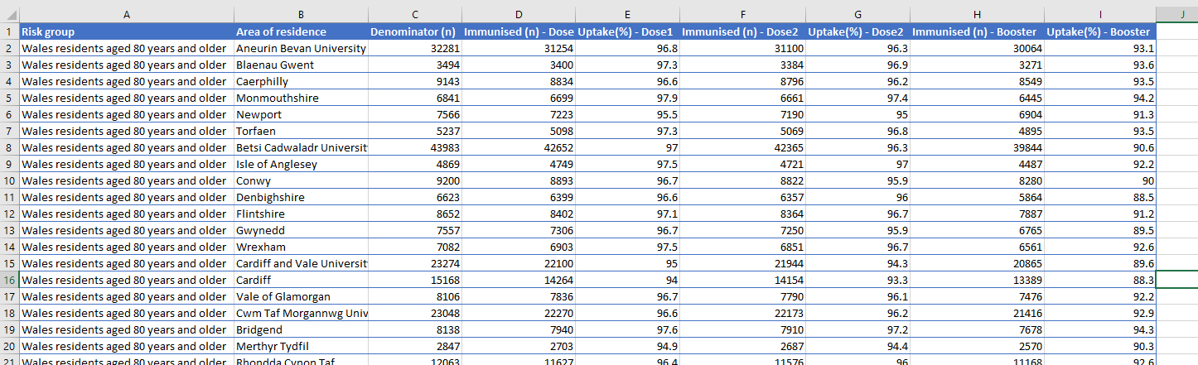
To improve the ability to scrutinize this data, it would be better to separate out the age groups in to their own spreadsheets and control them using MapInfo layers.
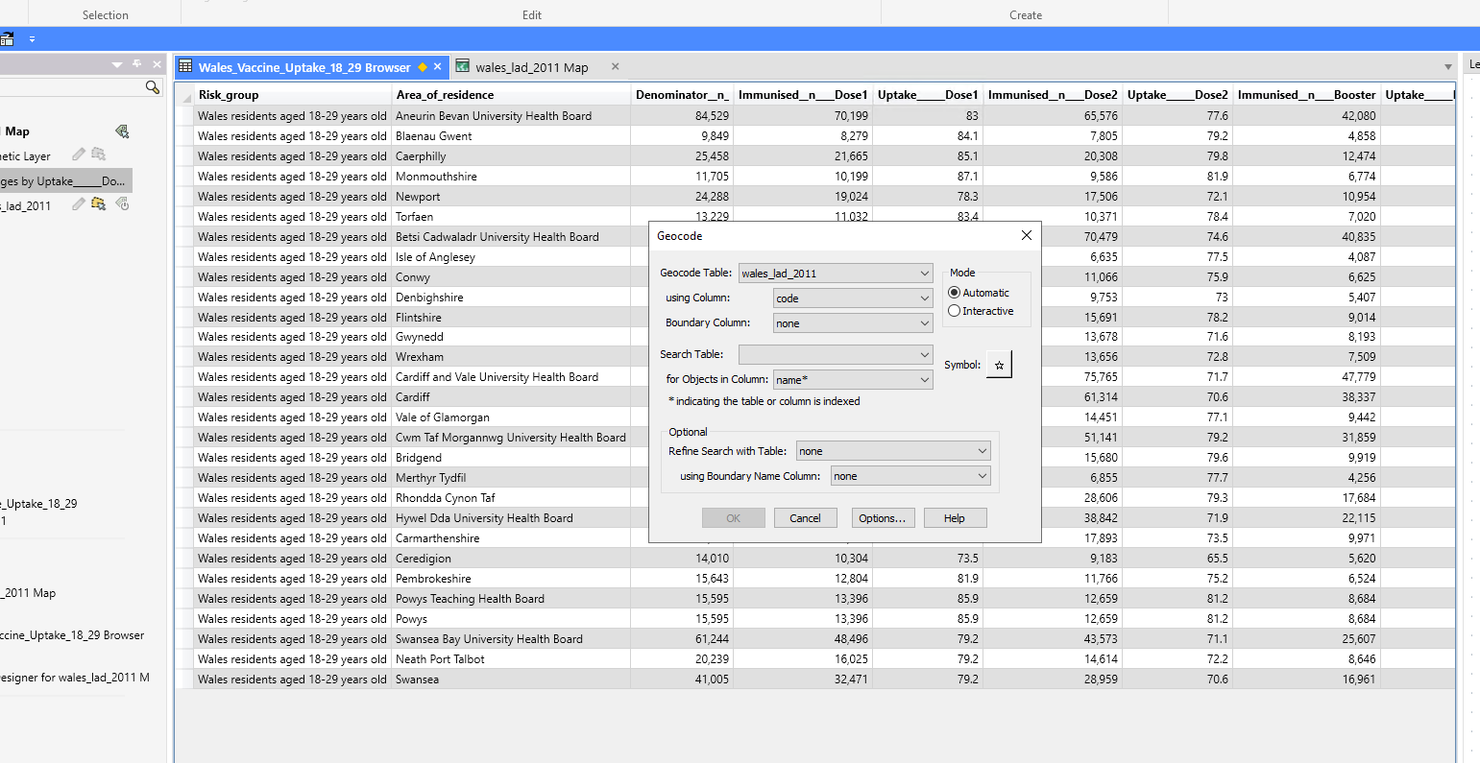
Once this data is geocoded, the age group data will be interchangeable in MapInfo.
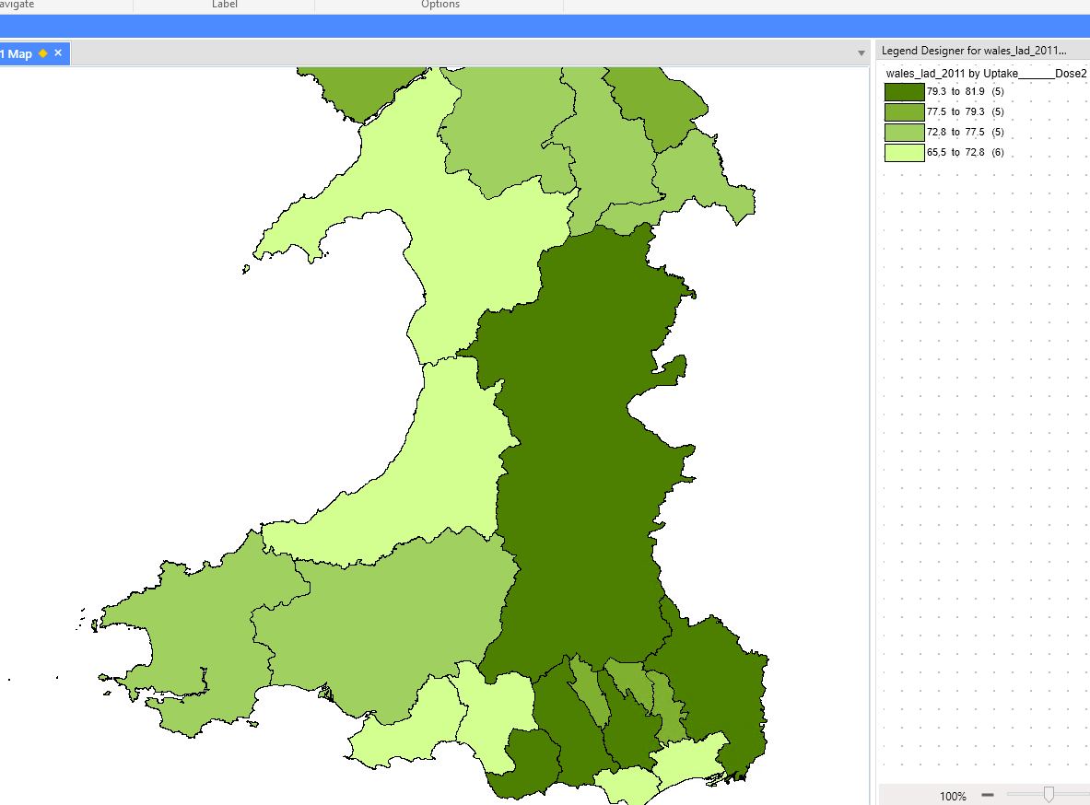The map now shows clearly where the highest percetange of vaccine uptake in 18-29 year olds was, and this can be built upon.
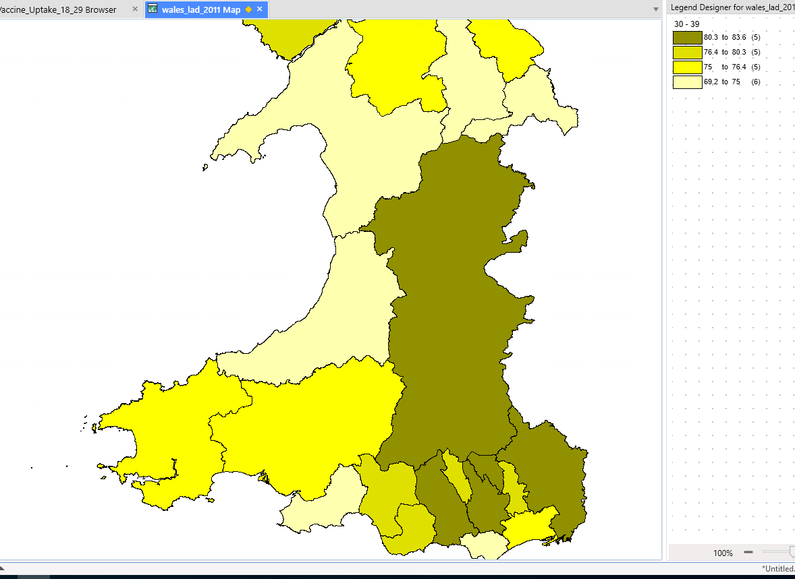
The data for 30-39 year olds looks very similar, differing only in North Wales.
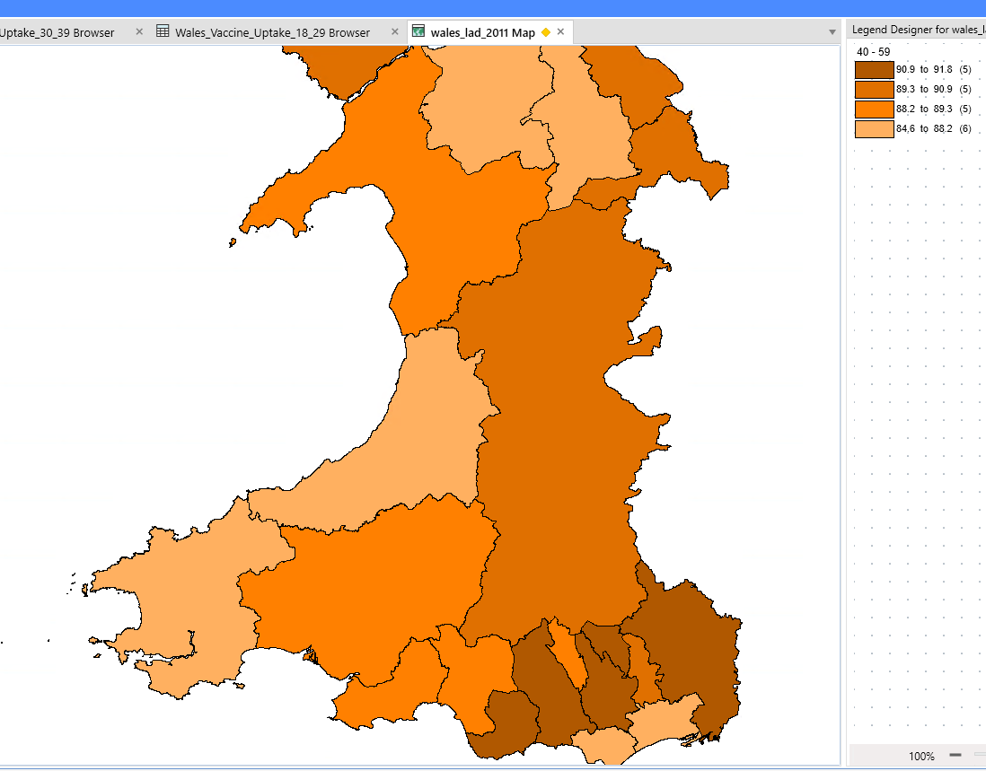
As the age group increase, the layout changes, but also the bottom ranging uptake percentage is much higher. This could be due to rollout speed, starting with the oldest, but at the time this data was taken, people were already being given a booster jab, so it is more likely representative of the willingness to get immunised in the older age groups.
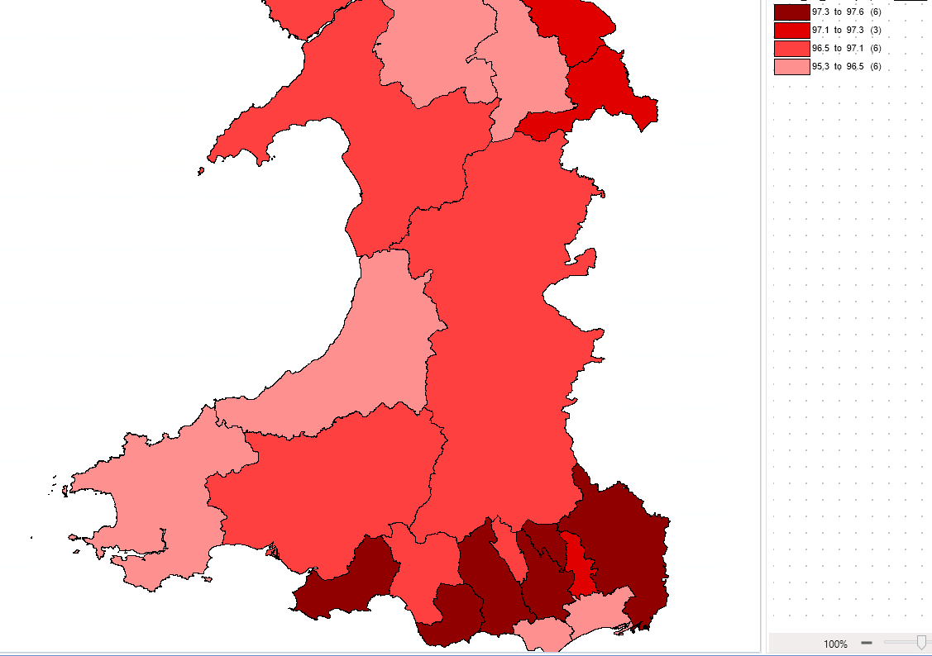
There is little difference as the age bracket is increased to the next two decades, but again the bottom percentage is a much higher 95.
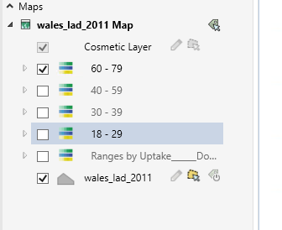
The further the data is broken up, the more it can be scrutinised and compared to evaluate; in this case the uptake of Covid vaccines.
The data input is the most important factor when manipulating data for visualisation, with GIS as much as any other data visualisation. By using the area codes available in the MSOA data from the UK Data Service, it is possible to use MapInfo (or other GIS software) to explore data geographically, adding layers to the Covid cases and vaccine uptake (if the data had corresponding area codes) and comparing this to education, income, and deprivation levels.
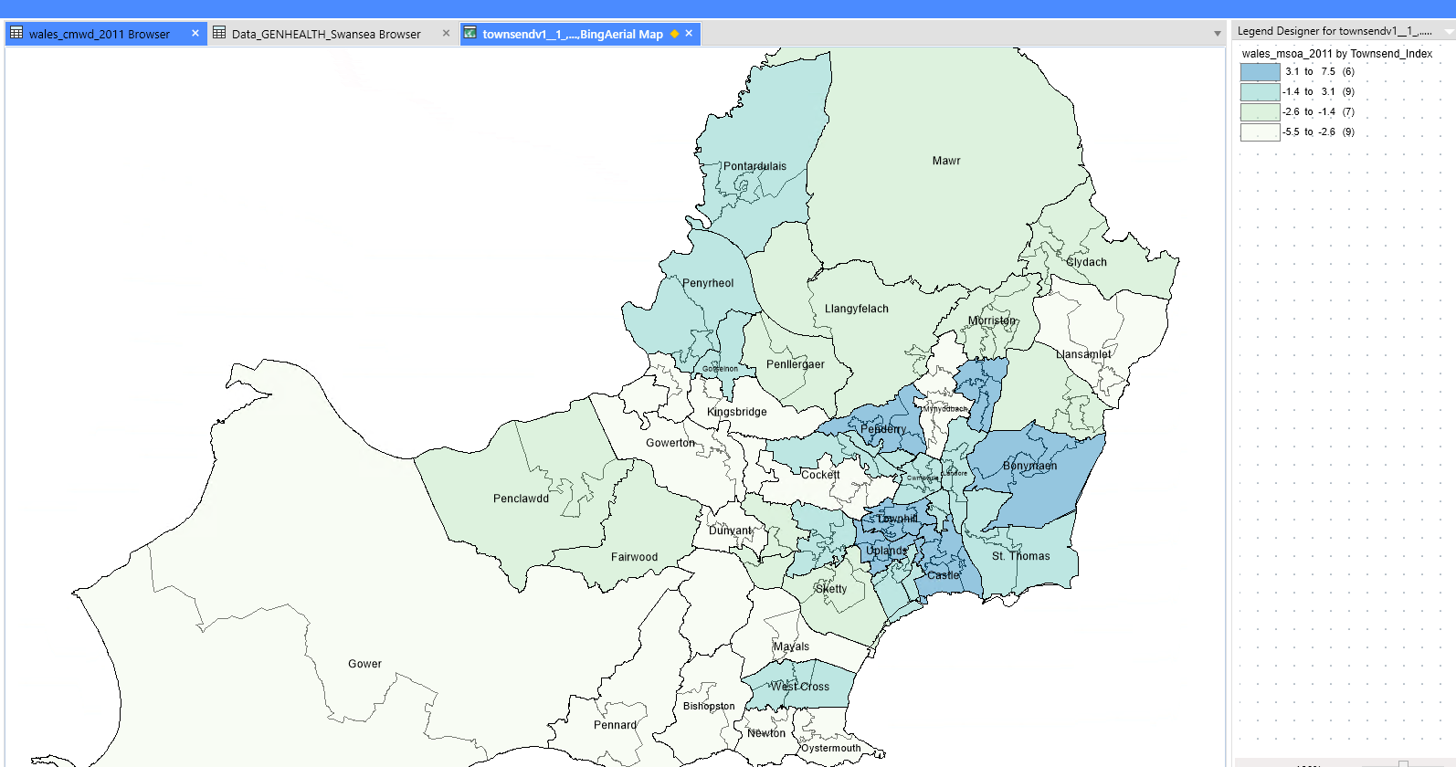
Using Swansea as an example, above is a map demonstrating deprivation levels according to the Townsend Index. If the data for number of Covid cases is added, layers can be switched on and off to compare the overlays.
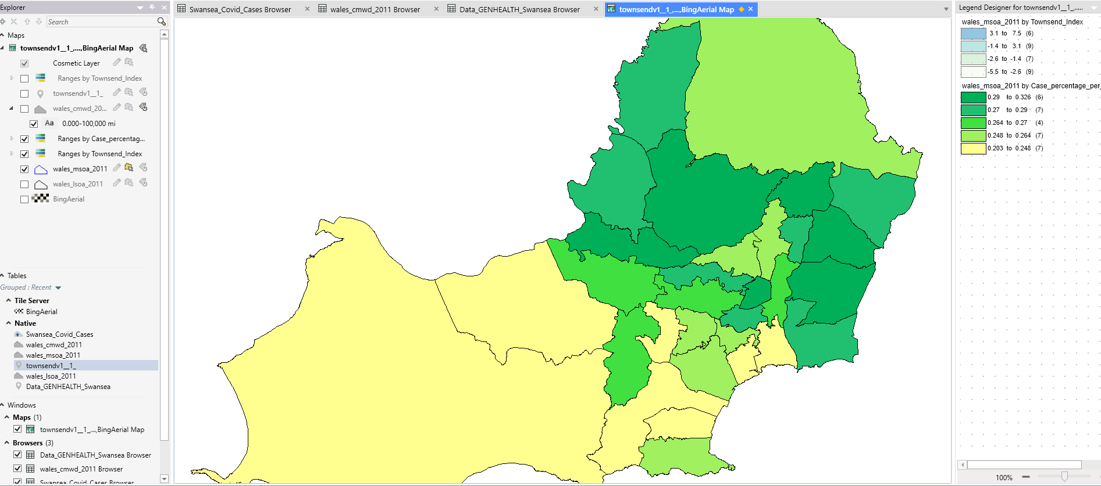
Furthermore, symbols can be used for an overlapped view when it would be of use.
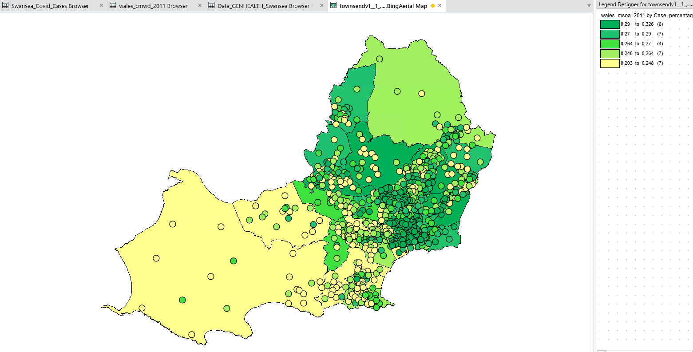
This map demonstrates deprivation levels as per the Townsend Index by coloured circle; the lighter the dot the more deprived an area, while the map denotes Covid cases as per the legend. Again, with a better matched set of data, clarity could be improved.
Additional data might also prove interesting, such as hospital location. It has been noted in other studies that distance from a hospital or vaccination centre is a contributing factor in vaccination uptake.

Report

Using the Geographical Information System; MapInfo and the data visualisation built, it is now possible to examine the data to inform healthcare professionals on the uptake of vaccine programmes, as well as much more besides. It can be used to search patterns and view data in a different way, that will provide evidence not only as to the vaccination uptake, but trends that might be influencing this, such as trends in age, income, academic levels and much more.
GIS can be used as a means of problem solving and decision making, and has more applications than one might initially think. For example:
- Locations in relation to other locations
- The density/occurrence of a feature on a map
- Activity in relation to a geographical point
- How an area has changed over time [1]

Vaccination uptake in Wales
To firstly examine the uptake of the Covid Vaccine in Wales, the data allows examination by age group of vaccination uptake.
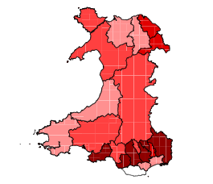
Starting with 60 – 79 years old, vaccination uptake in the lowest area (pink) is still over 95%, with the highest being 97.6%. It is a variability of less than 3% between the lowest and highest uptake areas.
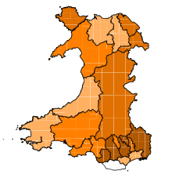
Comparing this map to 40-59 year olds, where uptake has a much wider range, from 84.6% (pale yellow) to 91.8% (brown). The highest uptake is also much lower than the lowest uptake in the age bracket above, though the uptake trends closely follows that of the higher age group in terms of geographical area. These facts could point simply to the vaccination rollout speed, with it having been offered to the older population first, however there are some key differences to highlight. Comparatively, the uptake of vaccination in mid-Wales has proven to be relatively more successful in the younger age group. If we were to consider the difference in uptake range to be solely down to rollout pace, we would expect to see the colours follow the same trend. On the other hand, the uptake in Swansea was much higher in the older age category, while In 40-59 year olds the relative scale positioning is 2 points lower.
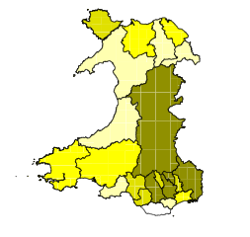
Examining next 30-39 year olds, the map is changing quite significantly. Firstly, the uptake now ranges from 69.2% (pale) to 83.6% (dark). Once again the lowest in the higher age category is a higher uptake than the highest in this. This adds credence to the vaccination rollout speed playing a part. However, the relative percentage uptake by area changes more this time. While we still see the highest uptake in Monmouthshire, Blaneau Gwent, Rhondda Cynon Taf and Caerphilly in South Wales, uptake in Bridgend has lessened. Neath Port Talbot has remained consistent, but Swansea has dropped still further behind with some of the lowest relative uptake figures, as has Gwynedd and Wrexham where there has also been a significant drop. Pembrokeshire has seen an improvement in 30-39 year old uptake, while Powys continues to become a leading area for the age group in Wales.
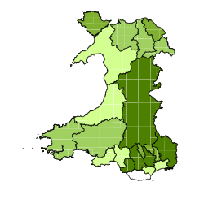
Looking lastly at 18-29 year olds, uptake ranges from 65.5% (pale green) to 81.9% (dark green). This is the first time there are been an overlap in ranges with the higher age group. While there is a 4% difference at the bottom of the scale, there is only a 2% difference in the areas of highest uptake. Given that we know 18-29 year olds were the last to be offered the vaccination in the Welsh rollout program, this is the first time vaccination rollout pace seems to lessen as a contributing factor. Bridgend joins the counties with highest rate of vaccine uptake, while uptake also improves in Denbighshire and Wrexham. Neath Port Talbot sees a relative decrease in uptake, as does Newport and Blaenau Gwent.
Comparing the data presented so far, it would seem that 30-39 year olds were the most hesitant to take up the Covid vaccine, as evidenced but the 18-29 year olds catching up and overlapping the percentage uptake range.
The next data under examination to look at in relation will be population data. Rollout speed may have lost momentum or been harder to maintain in areas of high population.
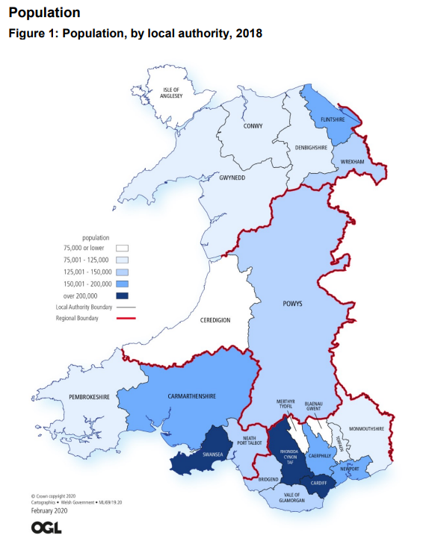
Looking at this map published by Welsh Government for population in 2018 [2] we can see which counties in Wales have the highest population. Referring back to the vaccine uptake data, the areas which saw the biggest decrease in uptake as age groups decreased were Gwynedd, Wrexham, Swansea, and Neath Port Talbot. The only county of these four to have a high population is Swansea, While the rest are quite low on the population scale. Meanwhile the biggest increases in vaccine uptake are seen from Pembrokeshire, Conwy, Denbighshire and Powys.
Population density doesn’t seem to have had any detrimental effect on vaccination rollout, as Rhondda Cynon Taf remained consistently a top performer in terms of vaccination uptake through the time period, While Cardiff, another of the three most populated areas was consistently low. Meanwhile the areas that saw the largest increases in vaccination uptake are all similarly low on the scale of population density. Taking also in to account the larger land mass of these areas, the data suggests that the delivery of the vaccination might have improved over time with logistical experience development, as an additional factor to a willingness to get vaccinated in the descending age groups.
Examining external data sources;
“Both the highest odds and the predictive margins for being unvaccinated for dose 1 among all individuals in the study and for dose 2 among those aged 70 years and above were observed in the most deprived and among the black/African/Caribbean ethnicity.” [3]
It could be that the Cardiff, with the highest diversity of race in Wales [4], when compared to the study of NHS England data, had the consistently lowest vaccine uptake for this same reason. Meanwhile, Rhondda Cynon Taf, the consistently strongest area for vaccine uptake has a non-white population of just 2.6% [5] compared to Cardiff’s 18.5%.
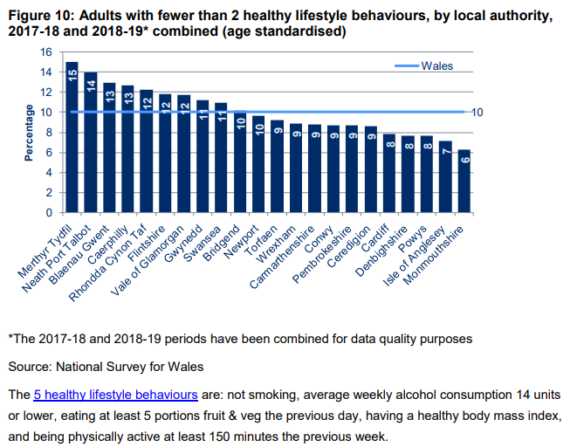 [6]
A determined “healthy lifestyle” does actually seem to link to the uptake of Covid vaccination. Monmouthshire, Anglesey and Powys do indeed report both healthy lifestyle behaviours, as well as high vaccination uptake. Cardiff however is an anomaly here, in that it scores as highly as Powys on the measure of healthy lifestyle, and yet is in the lowest range of vaccination uptake.
Upon review of this additional data, ethnicity is still proving the strongest contributing factor to vaccination uptake. This is reinforced by the similarly low uptake in Newport, with it’s second highest non-white population at 12.1% [4], and while Swansea, with a non-white population of 10.2% [4] has one of the highest uptakes in the aging population, but falls significantly to an area of the lowest uptake by the youngest age group.

A Focus on Covid cases in Swansea
Returning to the GIS data presented in MapInfo, but focusing in on Swansea; Overlaying a map of deprivation levels in Swansea, as calculated using the Townsend Index* with the number of Covid cases by area within Swansea;
*The Townsend Index is a measure of material deprivation, calculated by the incorporation of unemployment, non-car ownership, non-home ownership and household overcrowding [7]
The most appropriate measure of socio-economic position is not yet known. TDS’s are calculated from Census data, but have been found to be of stronger significance at an enumeration district level than at a ward level. [8] For the purposes of this examination, TDS will be used for comparison.

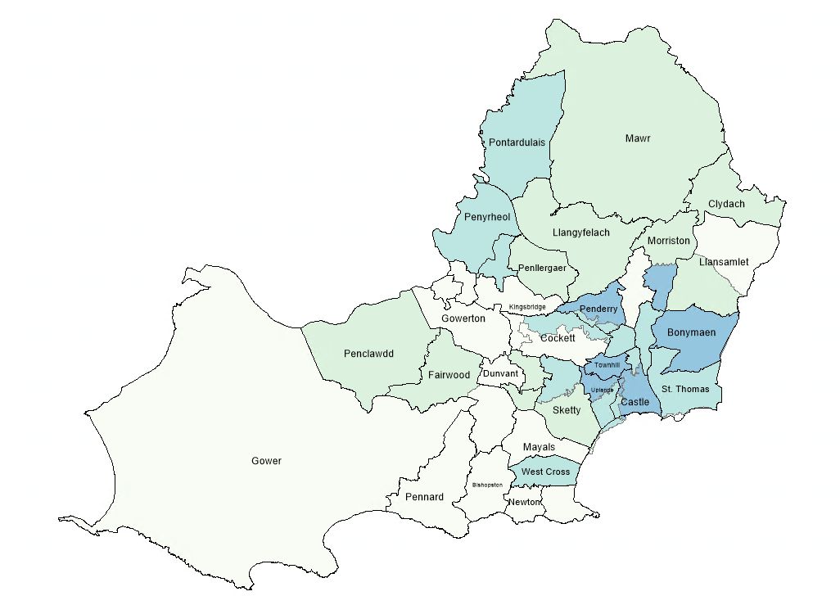
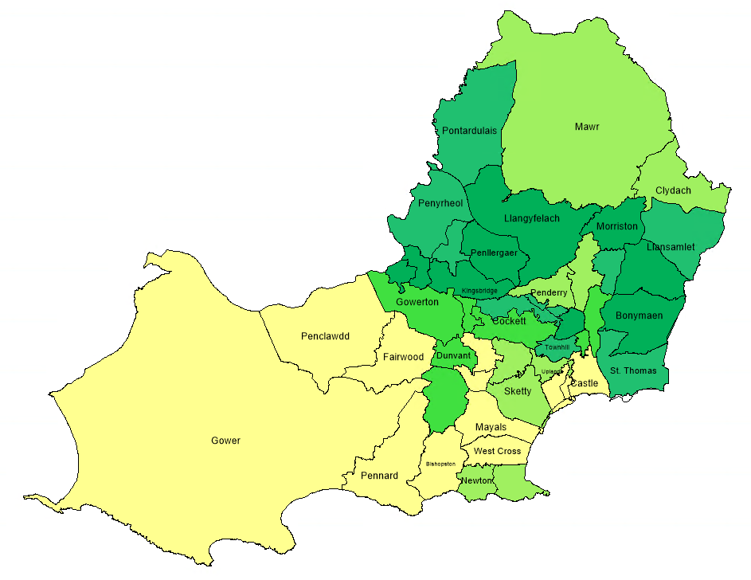
The TDS map indicates deprivation by area spanning from pale green (most deprived) to blue (least deprived), while the map of Covid cases (overlay screenshotted separately for clarity during the comparison) spans least cases for the captured time period (2-2.4% of the population) in yellow, to most cases (2.9-3.7%) in dark green.
One might expect to see a larger number of Covid cases in the more socio-economically deprived areas, but at a glance it would appear that the opposite is true. The outlying districts of Swansea, tend towards being the most deprived areas according to the TDS, and yet it is these areas that have the lowest number of covid cases for the given time period.
Focusing in on some specific areas, Bonymaen and Townhill are some of the highest scoring on the TDS scale, and they are similarly the places with the highest percentage of Covid cases according to their populations.
Kingsbridge and Cockett are some of the most deprived areas, and yet they also record the top percentage of Covid cases, while Pontardulais and Penyrheol score reasonably high on TDS scale, and around the same area of the scale for Covid cases.
With this data, it would seem there is no correlation between deprivation levels, as calculated using the Townsend Index, and the number of Covid cases; contrary to the earlier hypothesis.
Looking at the density of Covid cases towards the central geographic area of Swansea, the Covid data suggests instead that it might be the most densely populated areas that have the highest number of Covid cases.
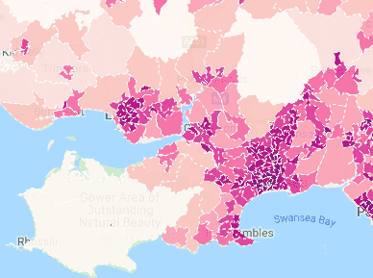 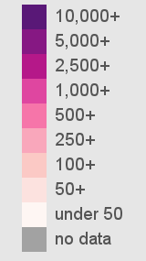 [9]
A quick glance at this map of population density in Swansea doesn’t match exactly to the number of Covid cases as shown on the MapInfo plot. Using Swansea data to examine more closely:
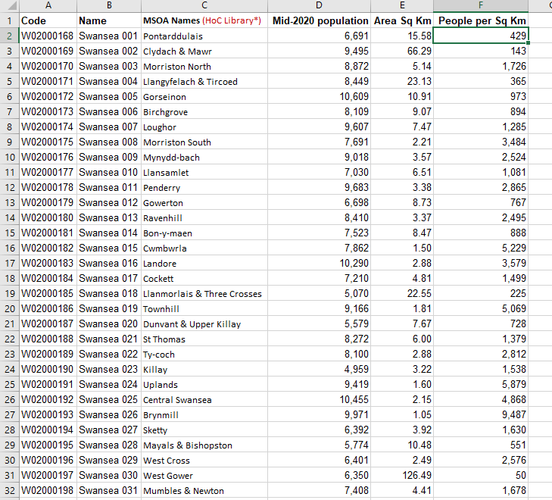
[6]
Adding this data to MapInfo shows that while some areas of high population density, such as Townhill and Morriston correlate to the high number of Covid cases, some of the least densely populated areas of Swansea, such as Bonymaen, Llangyfelach and Pontardulais also have very high numbers of Covid cases.
Cross examining this data using GIS continues to disprove hypotheses. Covid cases so far do not appear to be related either to socio-economic position, as measured with the Townsend Index, nor population density either, and yet looking at the Covid case map it is clear that there are concentrated nuclei in the central areas of Swansea, while the outlying districts report fewer cases.
The concentration of cases in Swansea within the examined time period could be related to services, such as sporting facilities or shopping centres. It could be related to locations of schools or Universities. By continuing to add data, hypotheses can be eliminated until one is proven as the common factor between the societal demographic and the number of Covid cases. Higher case numbers could also be linked to ethnic diversity as evidenced on the wider map of Wales with Cardiff, or even something as specific as nuclei of religious activity or political positions. By continuing to add data to GIS, a picture can be created, which could in turn feed back in to the health services, evidencing the demographics they should target to increase the uptake of vaccination in this case.

Wider GIS applications
Other use important industry applications for GIS include
- Supply Chain Management
- Insurance
- Forestry
- Urban Planning
- Banking
- Health Services
From setting up delivery areas, to examining risk based on geographical area with the ability to add layers of data, such as flood risk and crime rates, to deciding the most effective location to place branches for an optimum caption area, [10] GIS has grown to become a vital technology in modern business and health care. “The use of GIS so as to solve public health issues has an exponential increase and has been vital to the understanding and treatment of heath problems in different geographic areas.” [11]
Public health is a very complex field, with everything from lifestyle and environment, to socio-economics, to population and proximity. Medicine as a field has largely grown through experimentation, and the modern practice of medicine is based heavily on the evidence of what has come before. Diagnosing conditions can so often be finding corresponding factors that combine to create a certain situation, and the data behind each diagnosis is incredible, and only increases with the population, the accumulated evidence, and the ever increasing combination of factors that create such situations. GIS is just one piece of this puzzle, but none the less a vital piece.

Conclusion
By cross examining the accumulated GIS data in MapInfo, with some additional external resources, the data has shown that the most common correlation to low vaccination uptake in Wales would appear to be those of a non-white ethnic background.
Focusing in on Swansea, while there was no clear correlation in number of reported Covid cases with regards to socio-economic positioning as measured by the Townsend Index, nor either by the population density of Swansea geographic districts, in disproving these hypotheses valuable information was still gained. Additional data can be added to continue to work towards a conclusion, and indeed, it might be discovered that ethnic diversity by Swansea district might also be the route cause of high case numbers.
This small case study using the available data shows what a significant impact Geographical Information Systems can have on informing Health Care, and the further research shows that the importance and dependency of GIS is only going to increase as time advances, and data available increases.

References

[1] | University of Wisconsin-Madison Libraries, “Mapping and Geographic Information Systems (GIS): What is GIS?,” University of Wisconsin-Madison Libraries, 2022. [Online]. Available: https://researchguides.library.wisc.edu/GIS. [Accessed 5 May 2022].
[2] | Welsh Government, “Summary Statistics for Wales, by region: 2020,” Welsh Government, 20 May 2020. [Online]. Available: https://gov.wales/sites/default/files/statistics-and-research/2020-05/summary-statistics-regions-wales-2020-629.pdf. [Accessed 5 May 2022].
[3] | E. e. a. Tessier, “Characteristics associated with COVID-19 vaccine uptake among adults aged 50 years and above in England (8 December 2020-17 May 2021):a population-level observational study,” BMJ Open, vol. 12, no. 3, 2021.
[4] | Diverse Cymru, “Race,” Diverse Cymru, 2022. [Online]. Available: https://diversecymru.org.uk/protected-characteristics/race/#:~:text=The%20Facts,%25)%20and%20Swansea%20(10.2%25).. [Accessed 5 May 2022].
[5] | StatsWales, “Population estimates by local authority and ethnicity,” StatsWales, [Online]. Available: https://statswales.gov.wales/Catalogue/Population-and-Migration/Population/Estimates/Ethnicity/PopulationEstimates-by-Localauthority-Ethnicity. [Accessed 5 May 2022].
[6] | Swansea Council, “Population density,” Swansea Council, 2020. [Online]. Available: https://www.swansea.gov.uk/population_density. [Accessed 5 May 2022].
[7] | Ontology Search, “Townsend deprivation index,” OLS, 2022. [Online]. Available: https://www.ebi.ac.uk/ols/ontologies/efo/terms?iri=http%3A%2F%2Fwww.ebi.ac.uk%2Fefo%2FEFO_0009711. [Accessed 5 May 2022].
[8] | J. e. a. Adams, “How accurate are Townsend Deprivation Scores as predictors of self-reported health? A comparison with individual level data,” Journal of Public Health, vol. 27, no. 1, pp. 101-106, 25 November 2004.
[9] | plumplot, “Swansea population density map,” plumplot, 2019. [Online]. Available: https://www.plumplot.co.uk/Swansea-population.html. [Accessed 5 May 2022].
[10] | University of Southern California, “The Top 6 Industries for GIS,” University of Southern California, 13 July 2021. [Online]. Available: https://gis.usc.edu/blog/the-6-top-industries-for-gis/. [Accessed 5 May 2022].
[11] | E. C. e. a. Fradelos, “Health Based Geographic Information Systems (GIS) and their Applications,” Acta Inform Med, vol. 22, no. 6, pp. 402-405, 22 Dec 2014.
[12] | A. Kumar, “Taking String input with space in C (3 Different Methods),” GeeksforGeeks, [Online]. Available: https://www.geeksforgeeks.org/taking-string-input-space-c-3-different-methods/. [Accessed 16 March 2020].
[13] | N. Kanralkar, “Scansets in C,” GeeksforGeeks, [Online]. Available: https://www.geeksforgeeks.org/scansets-in-c/. [Accessed 16 March 2020].

Appendices

Uploaded Pdfs
- Bridgend Covid Cases
- Swansea Townsend over Covid Cases
- Swansea Townsend
- Vaccine Uptake 18-29
- Vaccine Uptake 30-39
- Vaccine Uptake 40-59
- Vaccine Uptake 60-79
- Vaccine Uptake PDF
- Vaccine Uptake Wales

