Managing Change in the Streaming Industry:
A Case Study of Netflix
Keyun chen
2229979
4 May 2023

3760 words

Abstract
This paper explores the change management of Netflix, a disruptive streaming platform that has revolutionized the entertainment industry. It analyzes Netflix's change history and evaluates its transformation from a DVD rental company to a digital streaming service through strategic innovation and cultural change. Netflix utilized emergent change models to adapt to the dynamic market and cultural changes, including investing in original content, expanding its global reach, and adopting data-driven decision-making. The company also faced significant resistance factors, such as traditional media giants and network neutrality, but successfully overcame them by implementing appropriate strategies, including partnerships and lobbying. The paper highlights the drivers of change, including technological advancements, consumer preferences, and competitive pressures, and the importance of effective leadership, organizational culture, and strategic planning in successful change management. Finally, the paper offers recommendations for Netflix , including leveraging technological innovation, diversifying content, and expanding into emerging markets to maintain its competitiveness and sustainability.

Contents
1、Introduction 4
2、Analysis of change 4
2.2 Force Field Analysis 6
2.2.1 Driving Forces of Change 6
2.2.2 Restraining Force of Change and Solutions 7
2.3 Stakeholder Analysis 8
2.4 Lewin's change process 10
2.5 Kotter's eight-step model 12
2.6、Assessment of Change 14
3、Conclusion 14
4、Recommendation 15
References 16

1、Introduction
Netflix, a company in the entertainment industry that was established by Reed Hastings and Marc Randolph in California in 1997, has transformed from a DVD rental service to a streaming service that creates original content. Its innovative business model uses user data to provide personalized recommendations and has helped it acquire over 200 million subscribers in more than 190 countries. Despite challenges such as competition, rising production costs, and changes in consumer behavior due to the COVID-19 pandemic, Netflix has adapted by investing in original content and expanding in Asia to maintain its industry leadership.（Netflix，2023）

2、Analysis of change
2.1 Typology of change
We can use Hodges and Gill's (2015) classification table to examine the various types of change that have occurred at Netflix：
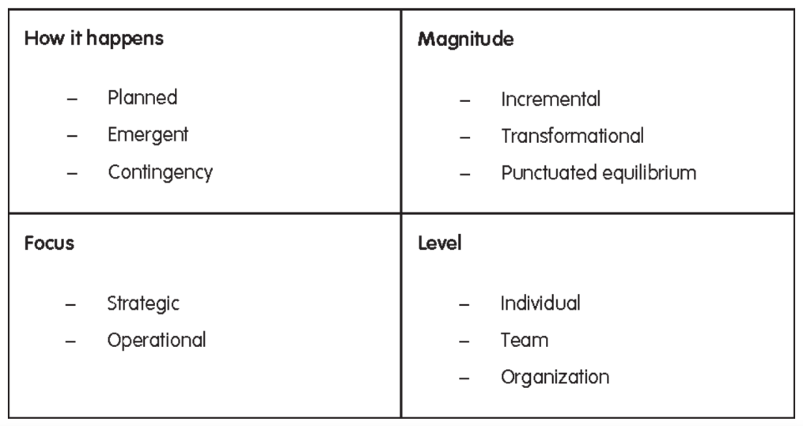
Figure 1：Typology of change

Based on Hodges and Gill's (2015) typology of change, Netflix has undergone several types of changes to adapt to the changing market and maintain its competitive advantage.
Firstly，Netflix's changes are planned, such as its transition from DVD rentals to online streaming. In 2007, Netflix introduced its streaming service, which was a planned change aimed at expanding its offerings beyond its original DVD rental business model（Rodríguez，2023）. Secondly，Netflix has also undergone transformational change, particularly in terms of its organizational culture and strategic direction. The company has adopted a culture of innovation and risk-taking, which has allowed it to disrupt the traditional entertainment industry and establish itself as a leader in the streaming market. Additionally, the company has transformed its business model from a DVD-by-mail service to a digital streaming service, leveraging data-driven decision making to create a personalized user experience and investing heavily in original content to differentiate itself from competitors.Netflix's changes can be considered disruptive in that they have disrupted the traditional television and film industry. Its shift to streaming services has transformed the way people consume media and challenged the dominance of traditional cable television.Thirdly，Netflix's changes are strategic, aimed at achieving its long-term goals and direction. For example, the company's expansion to international markets was a strategic move to increase its customer base and revenue. Lastly，Change at Netflix requires the involvement and collaboration of the entire organization, from the CEO down to the employees. For example, Netflix's shift to original content required significant investments and collaborations between various departments to produce high-quality content that would attract and retain subscribers.（Kostovska，2023）

2.2 Force Field Analysis
The force field analysis model developed by Lewin explains how a current state of performance is maintained through a balance between driving forces that promote change and restraining forces that hinder it. Driving forces, which are often positive, logical, conscious, and economic, counteract the negative, emotional, illogical, unconscious, and social，psychological restraining forces. In order to effectively manage change, it is essential to identify and address both types of forces.

Driving Forces of Change

Restraining Force of Change

Consumer behavior Emotional attachment to traditional media
Competition Inertia and complacency
Technological advancements Industry regulations
Global expansion Cost and budget constraints
Content production costs Employee resistance

Figure 2：Lewin's of Netflix

2.2.1 Driving Forces of Change
In the case of Netflix, there are several driving forces:
Consumer behavior: As consumer behavior evolves, Netflix needs to keep up with the trends in order to meet the needs of its customers. For example, the growing trend of cord-cutting and the preference for on-demand streaming has driven Netflix's success.(Davis,2017)
Competition: As other streaming services like Amazon Prime Video and Disney+ intensify their presence in the market, Netflix is compelled to continuously innovate and produce fresh content to set itself apart from the competition.(Nafees,2021)
Technological advancements: The rapid development of technology, such as 5G networks and AI-powered recommendation engines, has driven Netflix to adopt new technologies and incorporate them into its services to enhance the user experience.
Global expansion: Netflix's global expansion strategy has been a driver of change, as the company needs to adapt to local content preferences and regulations in different regions. This requires the company to create and distribute content in multiple languages and tailor its services to local markets.
Content production costs: Netflix's content production costs are a significant driver of change, as the company needs to balance its investment in creating high-quality original content with maintaining profitability. This requires the company to carefully manage its content production and acquisition strategy.(Schauerte,2021)

2.2.2 Restraining Force of Change and Solutions
In the case of Netflix, the restraining forces of change could include:
Emotional attachment to traditional media: Some consumers may still prefer traditional cable television or movie theaters over streaming services, leading to a resistance towards change. (Hadida,2021)
Inertia and complacency: Existing employees and stakeholders may be comfortable with the current way of doing things and may resist change due to the effort and risk involved in making changes.
Industry regulations: The entertainment industry is heavily regulated, and Netflix may face restrictions and legal barriers when trying to implement changes. (Busson,2016)
Cost and budget constraints: Implementing changes often requires significant investment, and financial constraints may prevent Netflix from making desired changes.
Employee resistance: Some employees may resist changes to their job roles or processes, leading to resistance within the organization.
Overall, Netflix must consider both the driving and restraining forces when implementing changes to ensure a successful outcome. They may need to address these restraining forces by creating a culture of openness to change, communicating the benefits of change, and offering incentives to motivate stakeholders to embrace change.

2.3 Stakeholder Analysis
The Stakeholder Analysis model helps organizations identify and assess stakeholders' impact on their goals and decisions. This model allows managers to understand stakeholder relationships and take appropriate action to address related concerns, leading to effective stakeholder management and strategic decision-making.(Julia,2023)
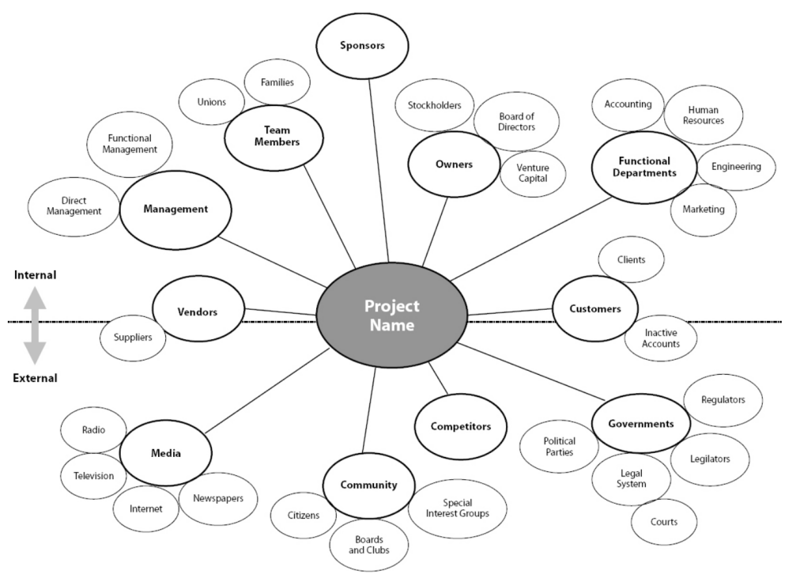
Figure 3：Stakeholder Analysis
In the context of Netflix, the stakeholders can be identified as follows:
Subscribers: Netflix's primary stakeholders are its subscribers who pay for the service. The company needs to ensure that its changes are aligned with their preferences and needs, as well as provide them with a positive user experience.
Content creators: Netflix's success relies on its ability to provide high-quality and engaging content. Content creators, including studios, producers, and writers, are critical stakeholders in this regard. Netflix needs to maintain positive relationships with content creators to ensure a consistent supply of quality content.
Employees: Netflix's employees are essential stakeholders in the company's success. They are responsible for creating and delivering content, developing and implementing new technologies, and managing the company's operations. Netflix needs to ensure that its changes do not adversely affect its employees and that they are supported during the transition.
Investors: Netflix's financial performance and growth prospects are essential to its investors, including individual and institutional shareholders. The company needs to ensure that its changes result in sustainable growth and profitability, which will benefit its investors in the long run.
Competitors: Netflix operates in a highly competitive industry, with several established and emerging competitors. The company needs to consider the actions of its competitors when making changes to remain competitive in the market.
Regulators and Government: Netflix operates in different countries and is subject to various laws and regulations related to content distribution, data privacy, and intellectual property. The company needs to ensure that its changes comply with all applicable laws and regulations in each country where it operates.
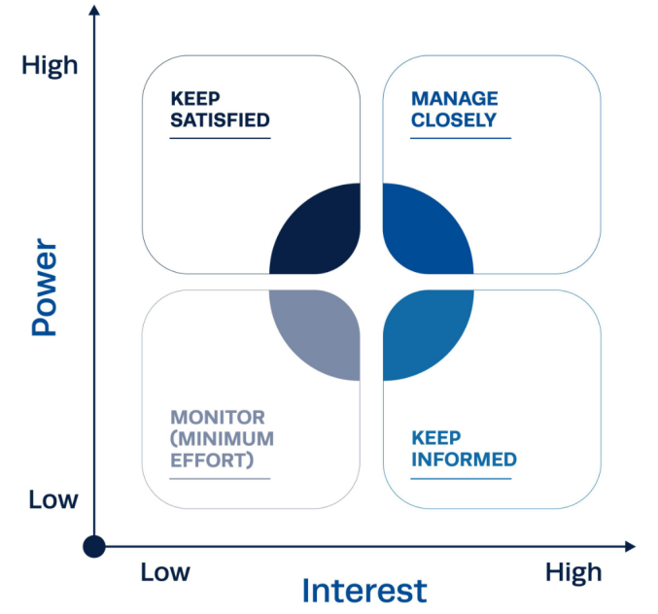
Figure 4：(Cameron & Green, 2012）
High power, high interest:Customers - Netflix's primary source of revenue and main reason for existence. They have a high level of interest in the company's products and services, and they also have significant power to influence the company's success through their purchasing decisions and feedback.
Shareholders - Netflix shareholders have a significant financial stake in the company's performance and therefore have a high level of power and interest in the company's decisions and direction.
High power, low interest:Regulators and policymakers - These stakeholders have the power to heavily regulate or even shut down Netflix's operations, but they may not necessarily have a direct interest in the company's success or failure.
Low power, high interest:Content creators - While individual content creators may not have a significant amount of power, the collective group has a high interest in Netflix's success as the company is a major distribution platform for their work.
Industry analysts and media - These stakeholders have a high level of interest in Netflix's performance and direction, but they may not have a significant amount of power to directly influence the company's decisions.
Low power, low interest:Local communities - While Netflix may have a physical presence in certain communities, these stakeholders typically have low power and interest in the company's operations.
To manage stakeholders, Netflix can use strategies like engagement, communication, and collaboration. This involves addressing the needs of each stakeholder group to minimize resistance to change and achieve desired outcomes. Strategies can include creating diverse content, investing in new technologies, and collaborating with content partners.

2.4 Lewin's change process
Lewin's change model is a framework for managing organizational change, consisting of three stages: unfreezing, changing, and refreezing. It involves identifying driving and restraining forces, implementing change, and solidifying it within the organization's culture. Planning and management are essential for successful change implementation and sustainability.（Burnes，2004）
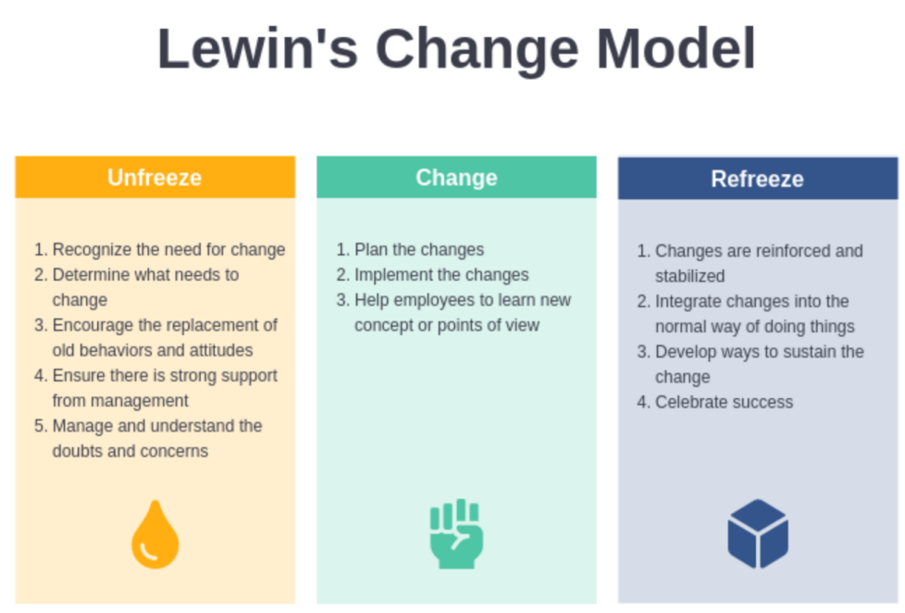 Figure 5：Lewin's change Model

Netflix has undergone significant changes using Lewin's change model, which can be examined in three stages:
Unfreezing: Netflix recognized the need for change in the early 2000s as the DVD rental market declined and the demand for digital content increased. The driving force for change was the desire to remain competitive and relevant in a rapidly changing market. At the same time, the restraining forces included the risk of moving away from a successful DVD rental model and resistance from stakeholders who were attached to the traditional way of consuming media.
Changing: In response to these driving and restraining forces, Netflix implemented a significant change in its business model by shifting to online streaming. This involved modifying organizational structures and processes, investing in technology and content creation, and changing the way it marketed its services to consumers. The change was gradual, with Netflix introducing streaming as an additional service alongside its DVD rental offering before phasing out the latter completely.
Refreezing: Finally, Netflix sought to embed the change into its organizational culture and ensure that online streaming became the new norm. This involved investing in original content creation to differentiate itself from competitors and providing a personalized user experience through data-driven decision making. By successfully refreezing the change, Netflix has established itself as a dominant player in the streaming market and become a household name around the world.
Overall, Netflix's success can be attributed in part to its ability to effectively manage change using Lewin's model. By carefully considering the driving and restraining forces at play, implementing a well-planned change, and embedding it into the organization's culture, Netflix has been able to adapt to a changing market and stay ahead of its competitors.

2.5 Kotter's eight-step model
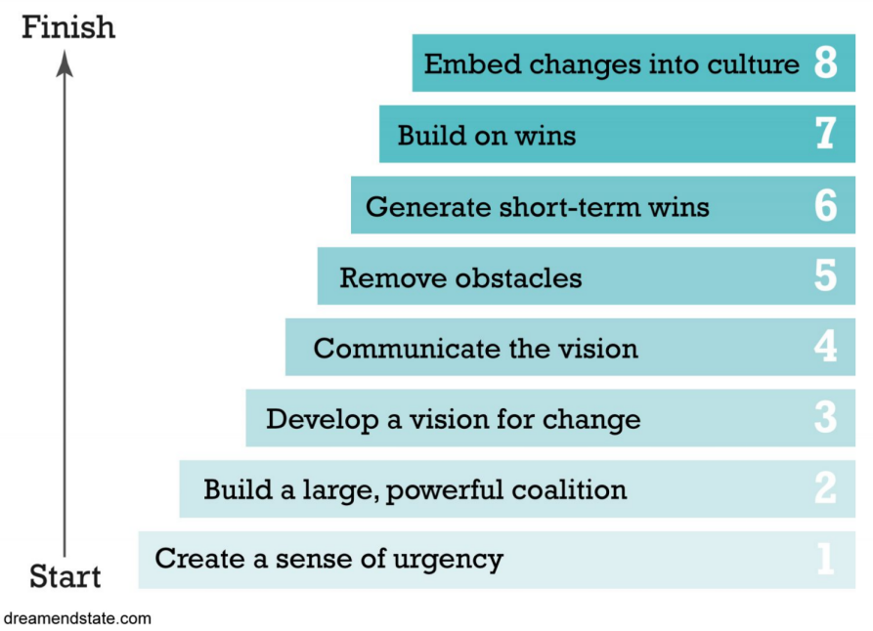
Figure 6：Kotter's eight-step model
Kotter's eight-step model is a widely recognized framework for organizational change, which emphasizes the importance of creating a sense of urgency, building a coalition of supporters, and communicating a clear vision for change. Here's an analysis of how Netflix has applied each of the eight steps in its transformation:
- Establish a sense of urgency: In the early 2000s, Netflix faced the decline of its DVD rental business and the emergence of new competitors in the entertainment industry. This sense of urgency led Netflix to launch its streaming service, which transformed its business model and allowed it to compete in the digital age.
- Form a powerful coalition: Netflix's CEO, Reed Hastings, was a key driving force behind the company's transformation. He was able to build a coalition of supporters within the organization and secure the buy-in of key stakeholders.
3、Create a vision for change: Netflix's vision was to become the world's leading internet television network, offering a wide range of original and licensed content to subscribers around the globe.
4、Communicate the vision: Netflix's leaders communicated the company's vision through various channels, such as public statements, press releases, and investor presentations.
5、Empower others to act on the vision: Netflix empowered its employees to take risks and experiment with new ideas, which helped the company to develop innovative products and services.
6、Create short-term wins: Netflix's shift to original content was a major win for the company. Its original series, such as "House of Cards" and "Orange is the New Black," were critical and commercial successes that helped to differentiate the company from its competitors.
7、Consolidate gains and produce more change: Netflix has continued to innovate and disrupt the entertainment industry by investing in new technologies and expanding its offerings to new markets. The company's recent foray into gaming is an example of its commitment to producing more change.
8、Anchor new approaches in the organization's culture: Netflix's culture of innovation and risk-taking has become a key part of its identity. The company encourages experimentation and values employees who challenge the status quo. This has helped to anchor new approaches and ensure that the company remains adaptable and responsive to change.
Overall, Netflix's success in transforming itself into a leading global entertainment provider can be attributed, in part, to its ability to apply Kotter's eight-step model to its organizational change efforts.

2.6、Assessment of Change
Netflix has undergone significant transformations in recent years, transitioning from a DVD rental service to a leading streaming service provider, and focusing on producing original content. These changes have resulted in tremendous growth in the company's subscriber base, revenue, and market value.Netflix's Q4 2021 financial report revealed a total revenue of $7.9 billion, accompanied by a net income of $1.4 billion. The company's subscriber base has also continued to expand, reaching over 214 million subscribers globally. Additionally, the company's market value has increased by over 50% in the past year alone, reaching over $260 billion as of January 2022.（Netflix Annual Report ）
Netflix's success can be attributed to its focus on producing popular original content like "Stranger Things," "The Crown," and "Narcos," and expanding into global markets with services in over 190 countries. However, the company has also faced challenges such as increased competition from other streaming services like Amazon Prime Video, Disney+, and HBO Max, and the impact of the COVID-19 pandemic on content production and consumer behavior, which forced the company to adjust its pricing strategy.（Shattuc，2020）
In conclusion, Netflix's transformation has been highly successful, with significant growth in revenue, subscriber base, and market value. However, the company will need to continue to adapt and innovate in the highly competitive streaming industry, while also navigating ongoing challenges such as competition and the impact of the COVID-19 pandemic.

3、Conclusion
Overall, Netflix has been a major disruptor in the entertainment industry, introducing the subscription-based streaming model and changing the way people consume content. Netflix has excelled in the streaming industry by utilizing its strategy of producing exclusive content, expanding its global reach, and investing heavily in technology and data analytics. The company's accomplishments are a result of its agility in adapting to evolving consumer trends and technological advancements.
Netflix has implemented organizational changes using Kotter's eight-step model and Lewin's change process model, as well as an agile approach to development and deployment. These changes have resulted in the company's ability to quickly respond to market changes and consumer demands.
Netflix encountered both drivers and resistances during its change process. Technological advancements, demand for new content, and market expansion were among the drivers, while employee resistance and competitive concerns were among the resistances. To overcome these resistances, Netflix prioritized innovation, transparency, communication, and employee training.
Netflix has shown its adaptability and innovation through expansion into new markets and investment in original content, despite facing challenges such as increasing competition and the impact of the COVID-19 pandemic. To maintain its success, Netflix must continue to anticipate and respond to changing industry trends and consumer preferences, while balancing growth with financial sustainability. The company's transformation serves as a useful case study for organizations facing digital disruption and seeking to drive change.

4、Recommendation
Continue to invest in original content: Nifty has had great success in original content and should therefore continue to invest more in this area. The company could try to diversify its content to cover different types of films, TV shows and documentaries to meet the needs of different audiences.
Expanding into international markets: Nifty is already available in many parts of the world, but there are still many countries and regions that are not covered. The company could consider expanding further into international markets to increase awareness and attract more subscribers.
Improve user experience: Nifty should continuously improve its platform and applications to enhance the user experience. This can be achieved by improving search and recommendation algorithms, streamlining the subscription process, offering more customization options, etc.
Streamline cost structure: Nifty can explore ways to reduce costs, such as reducing reliance on intermediaries and suppliers, streamlining organizational structure and reducing unnecessary expenses.
Addressing the new crown epidemic: The impact of the new crown epidemic on Nifty is significant, but it also presents some opportunities, such as more people staying home to watch streaming content. The company should strengthen its hygiene measures and expand its content library to attract more subscribers.
Coping with Brexit: The impact of Brexit on Nifty may include currency fluctuations and regulatory changes. The company should continue to monitor the Brexit negotiation process so that it can take timely steps to adapt to the new environment.
In conclusion, Nifty should continue to innovate and seek new opportunities to adapt to the changing market environment and provide better services to consumers.

References
Allen, G., Feils, D., & Disbrow, H. (2014). The Rise and Fall of Netflix: What Happened and Where Will It Go from Here?. Journal of the International Academy for Case Studies, 20(1), pp. 135-146.

Anthony, S. D., Gilbert, C. G., & Johnson, M. W. (2017). Dual Transformation: How to Reposition Today's Business While Creating the Future. Harvard Business Review Press.

Barker, C., & Wiatrowski, M. (Eds.). (2017). The age of Netflix: Critical essays on streaming media, digital delivery and instant access. McFarland.

Beech, N., & MacIntosh, R. (2017). Managing change: Enquiry and action. Cambridge University Press.

Boonstra, A., & De Vries, J. (2005). Analyzing inter-organizational systems from a power and interest perspective. International journal of information management, 25(6), 485-501.

Bullock, M. M. (2022). Change management during digital transformation projects: How to overcome barriers using an agile approach and modern change models.

Burnes, B. (2004). Kurt Lewin and the planned approach to change: a re‐appraisal. Journal of Management studies, 41(6), 977-1002.

Busson, A., Paris, T., & Simon, J. (2016). The European audiovisual industry and the digital single market: Trends, issues and policies. Digiworld economic journal, (101), 17.

Cameron, E. & Green, M. (2015), Making Sense of Change Management: A

Carnall, C. A. (2007). Managing change in organizations. Pearson Education.

Complete Guide to the Models, Tools and Techniques of Organisational Change, 4th edition.

Crawford, C. J. M. (2020). Netflix’s speculative fictions: Financializing platform television. Lexington Books.

Galli, B. J. (2019). Comparison of change management models: similarities, differences, and which is most effective?. R&D Management in the Knowledge Era: Challenges of Emerging Technologies, 605-624.
Gershon, R. A. (2018). Media innovation: Three strategic approaches to business transformation. In Handbook of media management and economics (pp. 241-258).

Hadida, A. L., Lampel, J., Walls, W. D., & Joshi, A. (2021). Hollywood studio filmmaking in the age of Netflix: a tale of two institutional logics. Journal of Cultural Economics, 45, 213-238.

Hastings, R., & Meyer, E. (2020). No rules rules: Netflix and the culture of reinvention. Penguin Publishing Group.

Hayes, J. (2018), The Theory and Practice of Change Management, 5th edition, Basingstoke: Palgrave Macmillan.

Hodges, J. (2018). Employee engagement for organizational change: The theory and practice of stakeholder engagement.

Iordache, C., Raats, T., & Afilipoaie, A. (2022). Transnationalisation revisited through the Netflix Original: An analysis of investment strategies in Europe. Convergence, 28(1), 236-254.

Julia Martins.(2023)What is stakeholder analysis and why is it important?PROJECT MANAGEMENT.[Online] Available at: https://asana.com/resources/project-stakeholder
Kostovska, I., Komorowski, M., Raats, T., & Tintel, S. (2023). 9 “Netflix taxes” as tools for supporting European audiovisual ecosystems. European Audiovisual Policy in Transition.

Kraśnicka, T., Głód, W., & Wronka-Pośpiech, M. (2016). Management Innovation and Its Measurement. Journal of ENTREPRENEURSHIP, MANAGEMENT, AND INNOVATION (JEMI), 95-122.

Kumar, J., Gupta, A., & Dixit, S. (2020). Netflix: SVoD entertainment of next gen. Emerald Emerging Markets Case Studies, 10(3), 1-36.

Lotz, A. D. (2022). Netflix and streaming video: The business of subscriber-funded video on demand. John Wiley & Sons.

Maddodi, S. (2019). NETFLIX bigdata analytics-the emergence of data driven recommendation. Srivatsa Maddodi, & Krishna Prasad, K.(2019). Netflix Bigdata Analytics-The Emergence of Data Driven Recommendation. International Journal of Case Studies in Business, IT, and Education (IJCSBE), 3(2), 41-51.

Nafees, L., Mehdi, M., Gupta, R., Kalia, S., Banerjee, S., & Kapoor, S. (2021). Netflix in India: expanding to success. Emerald Emerging Markets Case Studies, 11(2), 1-31.

Netflix Annual Report 2022，[Online] Available at: https://ir.netflix.net/financials/annual-reports-and-proxies/default.aspx

Netflix(n.d.).Netflix website.[Online] Available at:
https://about.netflix.com/zh_cn

Rodríguez Ortega, V. (2023). ‘We Pay to Buy Ourselves’: Netflix, Spectators & Streaming. Journal of Communication Inquiry, 47(2), 126-144.

Sakal, D. V., Rebić, P., Zrilić, A., Gracin, A., Bubalo, D., & Borovac, J. ANALYSIS OF NETFLIX INC. STUDENT INVESTITOR 2019.

Scafidi, T. Innovation Management: Netflix.

Shattuc, J. (2020). Netflix, Inc. and online television. A companion to television, 145-164.

Sherman. “Netflix Isn't a Media Company or a Technology Company -- It's an Entertainment ，Company, CEO Reed Hastings Says.” CNBC, CNBC, 9 Sept. 2020, [Online] Available at:
www.cnbc.com/2020/09/09/reed-hastings-netflix-isnt-tech-or-media-its
entertainment.html.

Smith, M. D., & Telang, R. (2016). Streaming, sharing, stealing: Big data and the future of entertainment. Mit Press.

Tahir Abbas.(2022)Netflix Change Management Case Study,[Online] Available at: https://changemanagementinsight.com/netflix-change-management-case-study/

The Netflix Company’s Cultural Change Management，StudyCorgi ，[Online] Available at:
https://studycorgi.com/the-netflix-companys-cultural-change-management/

The Remarkable Netflix Global Expansion Journey，[Online] Available at: https://www.centuroglobal.com/article/the-remarkable-netflix-global-expansion-journey-a-case-study

Walker, R., Jeffery, M., So, L., Sriram, S., Nathanson, J., Ferreira, J., & Feldmeier, J. (2017). Netflix leading with data: The emergence of data-driven video. Kellogg School of Management Cases, 1-19.

Wayne, M. L., & Uribe Sandoval, A. C. (2023). Netflix original series, global audiences and discourses of streaming success. Critical Studies in Television, 18(1), 81-91.

Walters, E. (2020). " Cinematic art in all its forms": Netflix and the film festival network (Doctoral dissertation, Boston University).

