
PROGRAMME: MBA - MASTER OF BUSINESS ADMINISTRATION
MODULE: STRATEGIC MANAGEMENT
MODULE CODE: LCMB7003
STUDENT ID: 2322287
NAME: SAHIL SHARMA
ASSIGNMENT TITLE: STRATEGIC MANAGEMENT REPORT
TASK 2

Table of Contents
Introduction 3
Challenges of virtual arrangements and practices 3
Opportunities of virtual arrangements and practices 5
The concept of virtual management is practiced within an organisation Like Microsoft 6
Conclusion 7
References 9

Introduction
Electronic devices are becoming more effective and necessary for maintain strong communication system. Organisations that are doing global business or trying to have competitive advantages in international business market are using electronic communication system for establishing connections or communication with its employees (Asatiani et al., 2021). Remote working system is one of the great examples of this specific communication system. This discussion will evaluate the virtual organisation and its different practices. A reputed multinational technology company Microsoft has been chosen for analysing the different virtual approaches to make effective presence and improve its competitive advantages in te global business market.

Challenges of virtual arrangements and practices
Communication issues: Virtual arrangements in companies are leading the remote working system where employees or workers of an organisation are working by staying in their homes and without moving any other places (Franken et al., 2021). Various electronic devices such as computers, software, smart phones and other advanced technologies are highly used by global companies to make strong connection and maintain effective communication system through remote working facilities (Thambusamy and Bekiroğulları, 2020). As result, these organisations are gaining high level of profits because this allows different kinds of opportunities and reduce the level of risks or issues at the time of competition operations. After the challenges of lockdown during Covid-19 pandemic, multinational companies are understanding the needs of electronic communication system through virtual practices. However, this leads the cause of ineffective communication because there is lack of face-to-face interactions in between employees. This may be the reason for ineffective performance of employees, misunderstanding the roles and responsibilities of workers or employees which can increase the chances of errors in project or operations. Therefore, it can be said that virtual arrangements can be the cause of ineffective communications in between employees or managers.
Performance management challenges: There are lots of issues may face by global business when these are using virtual arrangements to have most expected outcomes. Employees of companies are also getting huge opportunities to reflect their abilities, skills, expertise and innovative approaches for reaching organisational objectives. Virtual organisations are capable to reflect a diverse organisational culture and reduce the level of work place challenges due to the reason of virtual management or practices in business system (Asatiani et al., 2021). It is reflected that tracking productivity and performance of employee getting more difficult due to the reason of different working hours in different regions (Abdulmuhsin and Tarhini, 2021). This may be the reason for facing challenges to complete or deliver tasks or projects in real time or before them time. Therefore, it can be said that ensuring accountability highly seeks strong virtual environment or setting by which global business can develop its performance with having high expectations of productiveness.
More dependency on technologies: Remote working system are modern trends or global business trends which is the outcomes of globalization. However, remote working system is fully depended on machines, technologies and internets. High dependence on technologies, global business faces some drastic challenges like interrupting networks, machine disruptions, data theft and other issues (Klus and Müller, 2021). This impacts the ultimate objectives of companies and also be the reason for losses of sensible data which may lead to the cause of huge losses by global business. Weak internet can lead the cause of video communication issues at the time of meetings or an important discussion.
Team performance issues: Every global business seeks strong and effective relationships with each and every employee from different regions. Strong relationship and bonding in between managers and employees are the reason for maintaining diverse culture that is necessary for any kind of business that are operating in global market. However, lack virtual arrangements only allows electronic communication which is unable to establish strong connection or relationship with employees from different countries (Lois et al., 2020). This impacts the ultimate growth and objectives for having diverse organisational culture in global business system. Virtual arrangements only use the way of emailing, chats, video chats and tele communication system for making conversation or communication with team workers or employees that are not enough to establish strong relationship.
Time related issues: Remote working is done from different countries, regions and locations. employees are working from different countries to reach a specific organisational objectives and goals. This reflects different time zone which is the reason for delay in delivery tasks or project. Global businesses can face huge challenges to understand the real time execution of tasks which impacts the ultimate growth, collaboration and communication system at the same time (De Villiers et al., 2022). Different time zones area also reasons for facing difficulties to arrange important meetings in between team members and mangers from different locations.

Opportunities of virtual arrangements and practices
Improving technological environment: Multinational companies are focusing to have effective changes in technological base and use more advanced and modern technologies to reflect effective performance in the global business market (Franken et al., 2021). By increasing the uses of electronic devices and machines in work filed, companies will gain the opportunities to improve its technological base. On the other hand, at the time of remote working, employees are capable to use advanced computers like desktops, smart phones and computers for completing tasks without having a movements or travel (Chamakiotis et al., 2021). Using technologies are the reason for improving productivity and performance of a virtual organisation.
Saving cost of operations: Virtual management or arrangement is more effective and efficient to reduce the cost of operations. Electronic devices, and machines and advanced technologies are capable to reduce the level of human labours and needs one-time investments (De Villiers et al., 2022). This helps to improve the technological environment and also reduce the cost of production. As a result, global businesses are capable to sale their products with reasonable price tags and provide high and positive working experiences to its customers. Companies are gaining high level of profits and competitive advantages through cost saving method by using virtual arrangements.
Accessing the global talents: Virtual organisations seek more talented people from different countries because it has numbers of operations in different countries. Therefore, virtual arrangements help to find out best and expert talents from different countries or locations and involve creativity and innovation for more improvements of global businesses. Virtual arrangements help to identify and involve most talented people from global market who are not available in local areas (Chamakiotis et al., 2021). Therefore, it can be said that virtual arrangements are able to provide huge opportunities to acde3ss global talents and make workplace more diverse with positive workplace culture abilities.
Improve sustainable approaches: Sustainability is the needs and necessity of every kind of business which are doing effective performance in the international or global business market. Virtual arrangements are able to help environment to be safe because using of technologies and machines are the reason for decreasing the level of carbon emissions and other harmful elements in environment (Grabowski and Roberts, 2019). Virtual arrangements do not use vehicles because all are done through online communication or virtual communication system. On the other hand, employing global talents is another step towards sustainability because this approach helps society to be improved and developed.
Increased flexibility: Virtual Arrangement is more effective and efficient to improve flexibility in employees or workers. It is reflected that employees or workers can feel free and do their jobs more comfortably through remote working facilities (De Villiers et al., 2022). They can do extra work as their needs or intentions and complete tasks with full of expertise. On the other hand, this helps to improve the motivation of working which allows employees to do best, implant innovation and creativity in every step of development of the organisation. therefore, it can be said that virtual arrangements in global business is capable to engage workers or employees and retaining workers towards organisational development project.

The concept of virtual management is practiced within an organisation Like Microsoft
Improve productivity: Global businesses are focusing to have remote work by involving advanced technologies and electronic devices for managing communication risks and developing interactions with employees (Keen et al., 2022). Microsoft is one of the renowned technological brands that aims to improve its productivity by improving its cloud infrastructure. Microsoft has owned its cloud infrastructures like cloud computing platforms named Azure, has played an effective role for establishing strong virtual communication system (Fairbank, 2019). This helps to have strong connection, networks, storage by which employees are enable to work from home without having any kind of risks or issues. This also reduces the chances of workplace conflict issues which can impact the performance and increase productivity at the same time. Improve productivity continuously by Microsoft is the reason for maintaining effective and competitive presence in the global business market.
Enhance security system: Microsoft is one of the most reputed multinational IT corporations which has aimed to improve its security or data safety elements with different types of technologies and operations improvements systems. Microsoft has implanted robust security management by its owned software which is able to reduce the level of data theft, data loss and data harm related issues (Mehta et al., 2020). Strong multi factor authentication system, advanced threat detection system and encryption can be the reason for enhancing security and compliance which also helps to improve competitive advantages in global business market (Soni, 2020).
Accessing global talents: Microsoft is the multinational technology companies who are providing huge opportunities to global talents. Talents from different countries are loving to join these company because this company also provides the work from work or remote working facilities (Fairbank, 2019). The flexible working schedule and process to complete operations with their own innovative and creative thoughts is the reason for motivating employees. This entire system allows and attracts global talents. On the other hand, microsoft also provide effective training to foreign candidates through video chats or meeting facilities. This helps to gain trust and developing interpersonal relationship with newly joined global talents.
Improving organisational culture: In this present era, using digital technologies and machines are becoming necessary for each and every company like Microsoft has tried or focused to improve its company culture in regular basis. that is why this company is allowing its people to have flexible working hours through providing them remote work facilities. By attracting foreign employees from different locations, Microsoft is capable to developing diverse culture that is necessary for having a sustainable business (Hewson and Chung, 2021). Virtual wellness initiatives are used by Microsoft by which employees can separate and understand the needs of life balance. Therefore, it can be said that through virtual arrangements, Microsoft is capable to have and improve positive and diverse organisational culture.
Collaboration tools: For gaining most positive and expected outcomes from global businesses market, Microsoft has used virtual collaboration tools by which employees can continue the effective communication and develop strong relationships with each other’s (Hewson and Chung, 2021). Microsoft has used its own collaboration tools such as Microsoft teams where video chatting, video conferencing, chats and collaborations or documents are done properly. In Office 365, employees are able to create and share documents, presentations and spreadsheets on company performance (Hargreaves et al., 2022). Not only this through SharePoint helps to make effective collaboration and content management system that are necessary and important to have virtual activities.

Conclusion
In conclude it can be said that virtual arrangements are necessary and important to make company improved and competitive in global business market. multinational IT corporation. Microsoft is gaining effective and expected outcomes after having virtual arrangements in the business system. On the other hand, there are lots of challenges those are discussed in this report which can be the reason for impacting performance of virtual organisations. Proper development plan and proper executions can help to reduce the level of risks and making business more effective and competitive in the global business market. Virtual arrangements can be marked as the needs of future of every company who are looking for best returns and unexpected growth in global business market.

References
Abdulmuhsin, A.A. and Tarhini, A., 2021. Impact of knowledge leadership on the challenges and innovative performance of virtual teams: an empirical examination in oil sector companies. International Journal of Knowledge Management Studies, 12(1), pp.1-33.
Asatiani, A., Hämäläinen, J., Penttinen, E. and Rossi, M., 2021. Constructing continuity across the organisational culture boundary in a highly virtual work environment. Information systems journal, 31(1), pp.62-93.
Chamakiotis, P., Panteli, N. and Davison, R.M., 2021. Reimagining e-leadership for reconfigured virtual teams due to Covid-19. International Journal of Information Management, 60, p.102381.
De Villiers, C., Farooq, M.B. and Molinari, M., 2022. Qualitative research interviews using online video technology–challenges and opportunities. Meditari Accountancy Research, 30(6), pp.1764-1782.
Fairbank, N.A., 2019. The state of Microsoft?: the role of corporations in international norm creation. Journal of Cyber Policy, 4(3), pp.380-403.
Franken, E., Bentley, T., Shafaei, A., Farr-Wharton, B., Onnis, L.A. and Omari, M., 2021. Forced flexibility and remote working: Opportunities and challenges in the new normal. Journal of Management & Organization, 27(6), pp.1131-1149.
Grabowski, M. and Roberts, K.H., 2019. Reliability seeking virtual organizations: Challenges for high reliability organizations and resilience engineering. Safety science, 117, pp.512-522.
Hargreaves, C., Clarke, A.P. and Lester, K.R., 2022. Microsoft Teams and team performance in the COVID-19 pandemic within an NHS Trust Community Service in North-West England. Team Performance Management: An International Journal, 28(1/2), pp.79-94.
Hewson, E. and Chung, G.W., 2021. Beyond the VLE: Transforming online discussion and collaboration through Microsoft Teams. Hosted by UNED, Madrid (Spain), 36.
Keen, S., Lomeli-Rodriguez, M. and Joffe, H., 2022. From challenge to opportunity: virtual qualitative research during COVID-19 and beyond. International Journal of Qualitative Methods, 21, p.16094069221105075.
Klus, M.F. and Müller, J., 2021. The digital leader: what one needs to master today’s organisational challenges. Journal of Business Economics, 91(8), pp.1189-1223.
Lois, P., Drogalas, G., Karagiorgos, A. and Tsikalakis, K., 2020. Internal audits in the digital era: opportunities risks and challenges. EuroMed Journal of Business, 15(2), pp.205-217.
Mehta, J., Yates, T., Smith, P., Henderson, D., Winteringham, G. and Burns, A., 2020. Rapid implementation of Microsoft Teams in response to COVID-19: one acute healthcare organisation’s experience. BMJ health & care informatics, 27(3).
Soni, V.D., 2020. Information technologies: shaping the world under the pandemic Covid-19. Journal of Engineering Sciences, 11(6).
Thambusamy, R.X. and Bekiroğulları, Z., 2020. Virtual leadership in small businesses during the COVID-19 pandemic: Challenges and possibilities. The European Journal of Social & Behavioural Sciences.

APPENDIX 1
Precis
Techniques serve as a means to an aim. Analyzing the controls required to produce the intended outcomes is necessary to decide the best way to implement a strategy. These choices could have a significant impact on the way the company performs. When a company uses HRM control and business strategy properly, it can be a useful tool. Improved business performance can be achieved by using the right mix of HRM control systems that are in line with strategic objectives. Connecting HRM to the kind of business strategy that companies are pursuing at the same time can increase or decrease the effectiveness of any approach to HRM control.
The study concludes that businesses should employ a suitable mix of HRM control systems has practical implications. Poor performance will result from not doing this. The findings also imply that to boost corporate performance, organizations should connect HRM to strategic goals and objectives. The overall finding of this research indicates that when it comes to using HRM to improve performance, behavioural and input methods have the most potential, whereas an output-only perspective might not have much of an impact.
Business executives must understand that the HR department is aligned with company objectives as it directly affects financial performance. Scholars and industry professionals both believe that as competitive dynamics quicken, human capital is a long-lasting source of competitive advantage. Organizational effectiveness may ultimately be determined by the efficient management of human capital. Traditionally a fragmented collection of employment practices, HRM has developed through time.
The fact that the one-time data resembles a snapshot is the most evident drawback. Research indicates that various HR designs are frequently employed to manage employees in various employment contexts. The study did not differentiate between different kinds of selection and training systems. It also did not differentiate behaviour assessment protocols, performance appraisal and incentive schemes; it merely mentioned their emphasis. As an alternative to some other measure of corporate effectiveness, financial performance was the main focus of this study. This concentration was a deliberate choice and this study mainly examined the relationship between HRM control and corporate strategy. Assuming that there is a single best set of HRM practices that should be used or ideal in all circumstances could be excessively basic.
Future studies could aim to carry out more thorough investigations inside businesses to address an employment level analysis to comprehend how businesses strategically manage various employee groupings. Future investigations could examine the finer points of behaviour, output, and input control about specific HRM procedures Further research may attempt to employ the case study methodology to thoroughly analyse particular connections. Further studies may attempt to employ the case study methodology to thoroughly analyseparticular connections. Future research should examine if these findings apply to other industries and regions, given the competitive climate and industry structure differ between industries and countries. To learn more about the HRM control-performance relationship, future contingency studies utilizing additional organizational factors as moderators are needed.

Appendix 2
Title
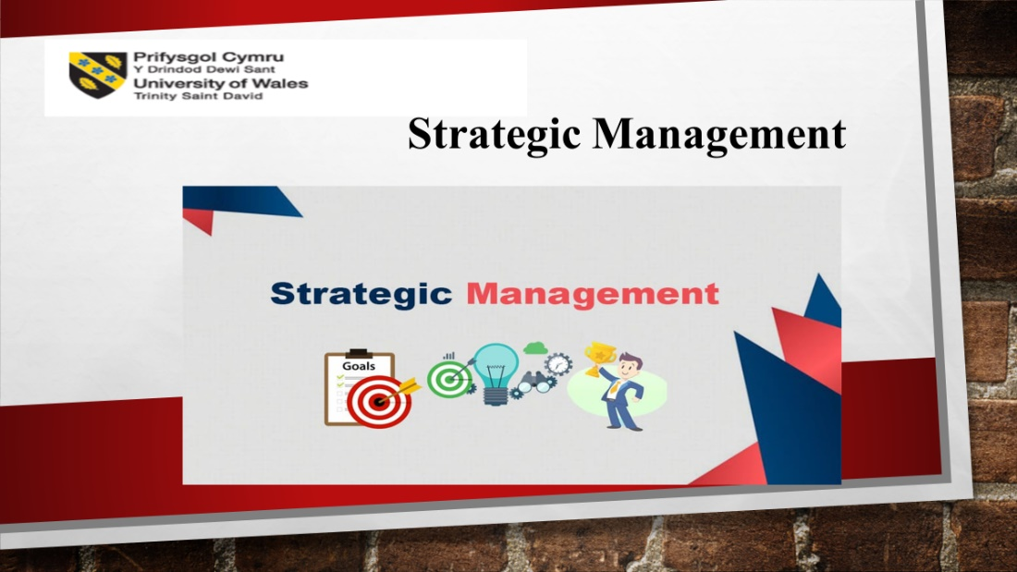
Analysing conclusion

Improved business performance can be achieved by using the right mix of HRM control systems that are in line with strategic objectives. Connecting HRM to the kind of business strategy that companies are pursuing at the same time can increase or decrease the effectiveness of any approach to HRM control.
Authors thoughts on result mean
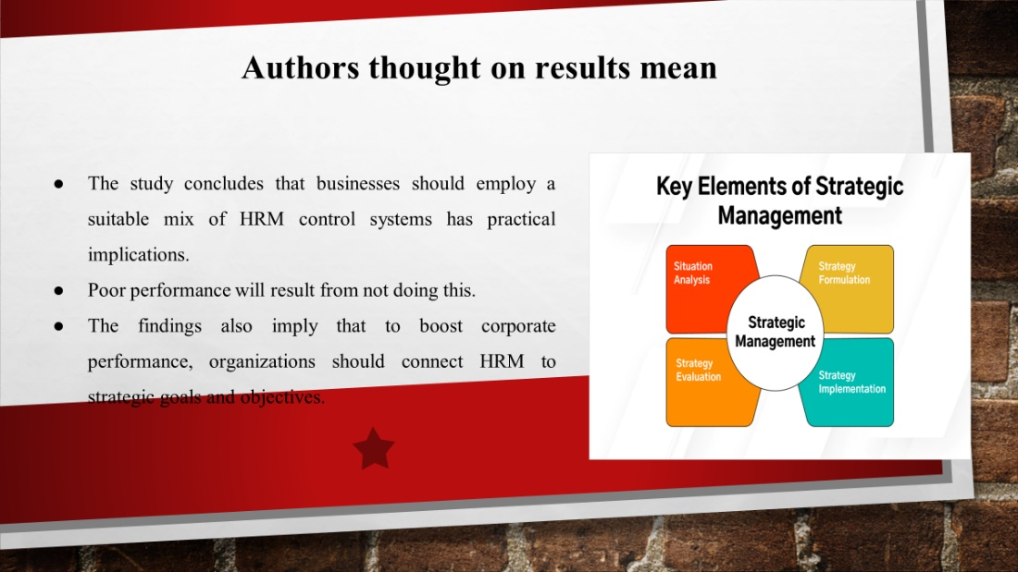

The overall finding of this research indicates that when it comes to using HRM to improve performance, behaviouraland input methods have the most potential, whereas an output-only perspective might not have much of an impact.
Summary
Introduction
An integrated and well-coordinated collection of commitments and actions intended to capitalize on key skills and acquire a competitive edge is called a strategy. In this sense, strategies have a purpose and come before the activities they are intended to support. A business-level strategy's objectives are to add value for customers and obtain a competitive edge through the use of key skills in certain product marketplaces. A business's perspective about when it is that it has a benefit over its competitors is reflected in its business-level strategy. This research focused exclusively on bureaucratic processes. The emphasis on formal HRM procedures including hiring, training, performance reviews, and incentives was constrained by this concentration.
Discussion
Connecting individual preferences with the accomplishment of group goals is a human resource management strategy that allows people autonomy over the procedures they follow while yet offering rewards for results that are advantageous to the company (Liao, 2005). When standards of acceptability become more definite, businesses tend to employ output control more. When a company has well-defined goals, an output-oriented approach to HRM may produce satisfactory results. The control system in this case can be used to specify the organization's objectives. Agency theory states that when there is insufficient knowledge, the principal can nevertheless compensate the agent based on results, which act as replacements for actions.
When standards of acceptability become more definite, businesses tend to employ output control more. When a company has well-defined goals, an output-oriented approach to HRM may produce satisfactory results. As a result, the control system allows the organization's goals to be set. Agency theory states that when there is insufficient knowledge, the principal can always compensate the agent based on results, which act as stand-ins for actions (Suoniemiet al. 2020). By finding and choosing individuals who meet the needs of the company, input control can assist in promoting common objectives among the members of the organization. When norms of desirability are unclear, performance is higher when HRM is approached through input control.
Connecting individual preferences with the accomplishment of group goals is a human resource management strategy that allows people autonomy over the procedures they follow while yet offering rewards for results that are advantageous to the company. When standards of acceptability become more definite, businesses tend to employ output control more. When a company has well-defined goals, an output-oriented approach to HRM may produce satisfactory results. The control system in this case can be used to specify the organization's objectives (Liao, 2005). Agency theory states that when there is insufficient knowledge, the principal can nevertheless compensate the agent based on results, which act as replacements for actions.
Enhancing organizational performance requires combining HRM approaches with certain commercial strategies. Businesses that employ cost reduction strategies need to strictly manage and cut costs, as well as aim for larger economies of scale. Businesses need to be efficient to prosper(Liao, 2005). Behaviour control, which involves direct supervision, behavioural performance evaluation, standard operating procedures, and feedback among other HRM practices, promotes predictability by routineizing the transformation process. The results demonstrate multiple relationships between company performances. While some of these demonstrate the existence of many contingency linkages, others point to a direct relationship between HRM and performance. The notions of behaviour, output, and input control don't seem to conflict with one another, but they do offer a workable foundation for incorporating HRM as a whole into theories of organization (Stahl et al. 2020). Considering their respective advantages and disadvantages, a mix of the three may enhance the performance of the company as a whole. Therefore, assuming the conclusion that there are effective, all-encompassing, or best-practice approaches to HRM is inaccurate.
A combination with an innovation-focused corporate strategy, however, increased the beneficial effects of input control. These ideas are supported by the study's findings. Performance is positively impacted by HRM systems based on input control, especially for innovation strategy adopters when executive performance evaluations are not predicated on highly defined norms. Employees at these companies need to be creative, collaborative, able to pursue long-term goals, willing to take risks, and capable of handling ambiguity and uncertainty because these companies need to be ready to adjust to the rapidly changing market and advances in technology (Úbeda-García et al. 2021). Recent research on the shift to more adaptable, knowledge-based organizations supports the relationship between input control and firm success.
These results show that input control can improve performance when a company prioritizes its innovation strategy. On the other hand, the performance of the company would suffer when behaviour control is prioritized. Either objective data or subjective methods can be used to measure performance. Respondents were asked to evaluate their companies' performance against that of competitors using four performance indicators as part of this study. The four items' scores were averaged to create a single performance variable to streamline the procedure. Even though these self-evaluations are sometimes incorrect they were seen to be suitable and reliable substitute indications when there were no other objective standards. This scale's coefficient of determination was 0.82 the variable under control. The number of full-time workers was used to calculate the size of the company. To take into consideration the curved link between size and structural complexity, a natural logarithmic transformation was applied.
Conclusion
The study's findings indicate that, when paired with HRM as part of a cost-cutting plan, CEOs can maximize their performance. Production efficiency is critical to a company's success when using a cost-reduction approach. This suggests that managers should be a lot more informed about the relationships between causes and effects in the transformation process. Executives can therefore program how certain behaviours result in particular outcomes, and behaviour control may lower variability while boosting effectiveness. Behaviour control typically helps to improve performance when a company's main focus is on internal operations and efficiency. The steps for the regression analysis were repeated, but this time the individual strategy variables were replaced with these strategy clusters. There was no proof from these regressions that the strategy clusters directly affected performance or that they combined with HRM control to predict performance.
References
Liao, Y.S., 2005. Business strategy and performance: The role of human resource management control. Personnel Review, 34(3), pp.294-309.
Stahl, G.K., Brewster, C.J., Collings, D.G. and Hajro, A., 2020. Enhancing the role of human resource management in corporate sustainability and social responsibility: A multi-stakeholder, multidimensional approach to HRM. Human resource management review, 30(3), p.100708.
Suoniemi, S., Meyer-Waarden, L., Munzel, A., Zablah, A.R. and Straub, D., 2020. Big data and firm performance: The roles of market-directed capabilities and business strategy. Information & Management, 57(7), p.103365.
Úbeda-García, M., Claver-Cortés, E., Marco-Lajara, B. and Zaragoza-Sáez, P., 2021. Corporate social responsibility and firm performance in the hotel industry. The mediating role of green human resource management and environmental outcomes. Journal of Business Research, 123, pp.57-69.

