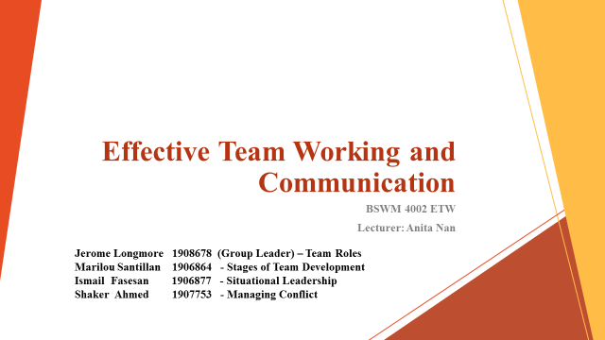
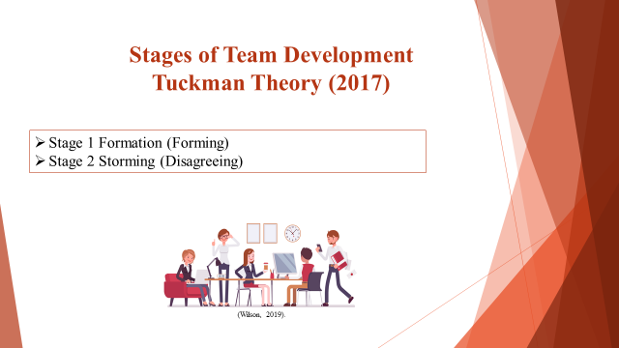

NOTES:
Before any team development can happen, a team must be formed. The Forming stage is for the team to get to know each other and begin with the task. The team leader can help with this process by organizing social events and also make sure that each person knowns what they are contributing to the task.
In the process of sharing ideas in a group, disagreements may arise. Some members may feel more heard than others. Some may contribute more than others. The team leader must try to find a way for each member to contribute equally and to calm disagreements.
I encountered the stage of forming in my work place when I was moved last year in new department, specifically in front desk reception, as a new team member in the group, it takes time for me to be part of the team which I adapt and go along with my new colleagues in the end. I recognised the storming stage in my work place, for example, team contribution and participation. Some new ideas from colleagues are not agreed by others, this is when we have meetings and short hand over before and in the end of my shift.

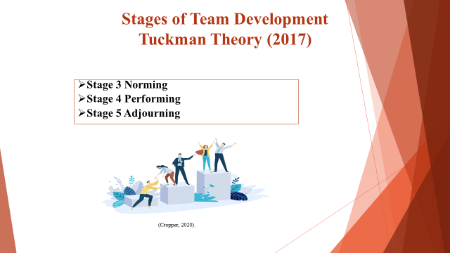

NOTES:
Norming stage is when the team tackle the disagreement phase in Storming stage. The team and team leader must work together to discuss team values and/or rules to make sure that they can work together in a civilized way. This may include speaking one at a time so each member can be heard. This way, conflict within team can be managed. Such mistakes were identified in my work place, the team leader proceed and make rectification and make sure it does not happen again through meetings, action plan and evaluation.

Performing, by this stage, as a result of the three previous stages, the team should be able to work comfortably and respectfully with each other to complete the task, and with little disagreement. Through following the same method in working environment is what we observe in my work place.

Adjourning, the final stage, as teams are formed for specific tasks, once this is completed, the team disperses. In my work place, depending on how long the project is, example group staff trainings, parting ways from new relationships can be emotional. Team may organize a celebration for themselves to celebrate their achievement and say goodbye to each other by this stage.
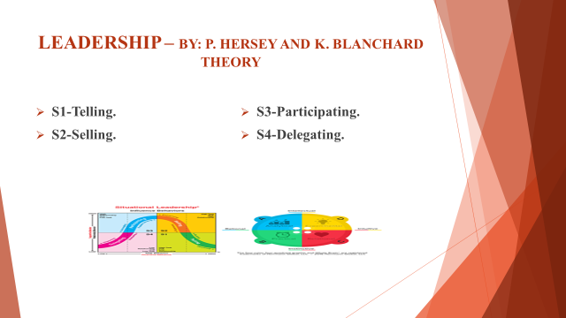

NOTES:
In other to define situational leadership, it is important to know what is leadership. This is the ability to gather various experts in a group with the aim of achieving set target or real results. For leadership to be effective, there must be the right tools provided to measure and analyse results of current leadership strengths as well as giving coaching and support. Situational leadership is the ability to adapt quickly to a given situation in order to derive maximum benefit from it. Hersey and Blanchard theory is about style and maturity. A member of the group with no experience might find it difficult to do the task or he might not even have the skills required to do it. In other words leader should be ready and willing to adapt to the members and the change in circumstances. S1. Telling- This is known as the most direct form of leadership, where the leader tell the members of the group exactly what to do and how he want it done. He has little or no interaction with the members. S2. Selling- Leader make use of persuasion and may need to convince some of the members to follow his way to get things done in a specific way. There is evidence of interaction and working with the members. S3. PERSUADING. This is were a leader become part of the team, he make effort to try and build a relationship with team members. He might also be involved in decision making process. S4. DELEGATING- This is were the leader pass most of the responsibility for the job to the individual members of the team. This only considered where most of the team members are experienced.
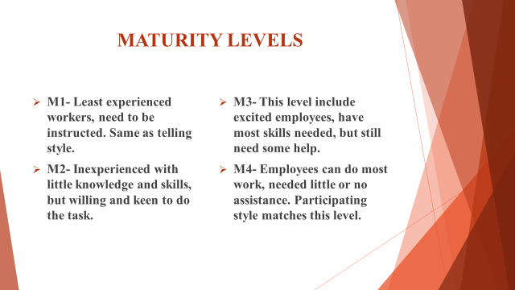

NOTES:
M1. Workers at this level are the least experienced, they will need to be instructed on how to do the job at hand. They had to be told about everything. This is could be assumed that the members has no knowledge or background of the task. Telling leadership style and M1 maturity level are similar and seems to match each other. M2- Members are known to be inexperienced and only have slightly more knowledge and skills than those in M1 level. The difference is that they are willing to do the job at hand. They could be regarded as keen to do the task, it is just that they have not mature to do it correctly without assistance of the leader of the group. The selling leadership style is similar and could be regarded as a match to M2 maturity level. M3 This level include most members who are excited and keen to do the work. They have most skills required to get the job done correctly. They can do most job correctly, but they still need some assistance. M3 and participating style matches each other. M4. This is the top level in order of scale. Members are expert, completely capable of doing the job. They can get the job done without the help or assistance of the leader. They can work independently, and they have confident in team members. M4 and Delegating are similar and matches each other. Leader is not required to do the job. When members performed excellently, it is important to be rewarded as a motivation to do more. My own experience has been rather okay, in the sense that I have not been able to work with a group at the highest level. Having said that, I think given time we could achieve the maximum
Team Roles - (Belbin)

In team roles there are 9 behaviours know as the Belbin theories. In order to be successful a team needs to access each of these 9 behaviours.

- Most people will have two or three behaviours

- Each team role has its strengths and weaknesses

- Each team role may not always be required at the same time

- Discussions should take place regarding which and when each team role behaviour should be utilised.

- Individuals have a greater self-understanding of their strengths

Notes:
By using the Belbin theory already established teams can improved. For the development of new groups this theory can create great teams that utilises each members strengths.
After identifying each members strengths we can now start to feel that we are making a difference in the workplace. It is impossible identify your teams strengths without each member completing a Belbin self-perception checklist and receiving feedback from colleagues.

Cluster behaviours

Teams can be very unbalanced if all the members have similar styles of behaviours. Should team members possess similar weaknesses, the team as a whole may tend to have that weakness. Teams consisting of members possessing similar behaviour tend to develop a more competitive approach rather than cooperating for the tasks and responsibilities that best suit their natural style.

Below displays the 9 team roles devised by Meredith Belbin
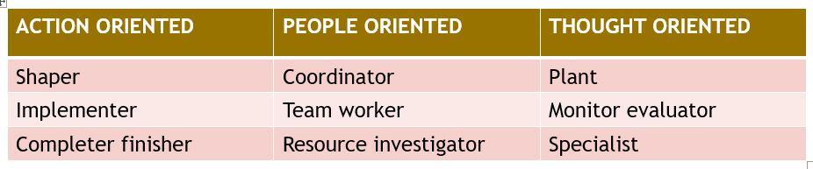
The best performing team is the team with a variation of behaviours. “Resource Investigator” is the behaviour that best describes me. My personality traits are extroverted, enthusiastic, curious, communicative. We are quick to utilise opportunities with the ability to use our initiative to respond quickly and efficiently to matters that arise. We are skilled in probing others in order to obtain information. Those possessing this particular behaviour are most suited for task s such as developing external relationships and handling negotiations.

Strengths
Resourcing useful people, promising ideas and opportunities.

Weaknesses
Likely to lose interest once the initial fascination subsides.

References
- Haibin Luo, Shanshi Lui (Social Behaviour and Personality. Journal2014, Vol42.
- Hersey, P. and Blanchard, K. H. (1969). Management of Organizational Behavior – Utilizing Human Resources. New Jersey; Prentice Hall.
- John Crawley (Constructive conflict management) Brealey, 1992
- Kenneth W. Thomas, Ralph H. Kilmann (Thomas-Kilmann conflict mode instrument) XICOM, 1974
- Luizi Paul (Fire Engineering) Aug 2017. Vol170.
- Morgan, P (2017) The Business student’s guide to study and employability. London: SAGE Publications Ltd,
- William J. Pammer, JR. Jerri Killian (Handbook of conflict management) public administration and policy-104, 2003
- Image [Online]. Available from: https://www.ntaskmanager.com/blog/best-teamwork-quotes/ (Accessed:10 April 2020).
- Image [online]. Available from: https://www.fenderbender.com/articles/14389-how-to-inspire-teamwork-among-shop-employees (Accessed: April 10 2020).
- Image (online) Available from https://situational.com/blog/situational-leadership-and-whole-brain-thinking [Accessed on April 13, 2020]

