

BA International Hotel Management
BMIH5007
Financial Management for the Hotel Industry
LEVEL 5
Module Lead:
Tristan Hawkins
T.Hawkins@uwtsd.ac.uk
Student:
Ionela Frusinica Cuciurean
2129289

Executive Summary
Shangri-La Hotels and Whitbread would represent contrasting market positions within the hospitality sector. Shangri-La targets high-margin customers by establishing premium personalized high-quality services. On the other hand, Whitbread has been striving to have more affordability and efficiency in operations through the brand, Premier Inn. Both have used technology to enhance customer experience and optimize operations, representing its adaptation to changing market demands. This analysis goes on to explain how different strategies may meet different consumer needs and preferences, which would ultimately lead to sustainable growth and success within a competitive hospitality landscape.

Table of Contents
1.0. Introduction 4
1.1. Purpose 4
1.2. Overview 4
1.3. Key Areas 4
1.4. Scope and Limitations 4
2.0. Total Revenue 4
2.1. Analysis 4
2.2. Sources 5
2.3. Trends 5
2.4. Comparison 5
3.0. Market Position 6
3.1. Market Share 6
3.2. Customer Demographics 6
3.3. Brand Perceptions 6
3.4. Model Application-Bowman’s Strategic Clock 7
4.0. Growth Potential 7
4.1. Expansion Strategies 7
4.2. Market Opportunities 8
4.3. Potential Barriers to Growth 8
5.0. Financial Commitment to CSR 8
6.0. Recommendation 9
7.0. Conclusion 9
References 10

1.0. Introduction

1.1. Purpose
This report seeks to compare and analyze the financial performance of Shangri-La Hotels and Whitbread's Travelodge from 2019 to 2022 (Guix et al., 2024). Two Bowman strategic clock graphs will be used in this comparative analysis of these firms' strategies. Based on their demand curve positions and elasticity analysis, recommendations will be provided.

1.2. Overview
The report compares Shangri-La Hotels' and Whitbread's Travelodge's financial reports from 2019-2022. Two Bowman strategic clock graphs describe Shangri-La's differentiation strategy and Travelodge's low-price focus. Demand curve elasticity and cost structures analysis provide a conclusion that points toward the recommendation for Shangri-La to enhance its value proposition, and similarly, Travelodge to optimize its cost leadership to achieve competitive advantage.

1.3. Key Areas
Shangri-La Hotels, founded in 1971, offers luxury accommodations worldwide, focusing on premium services in the U.S., Europe, and Asia. Whitbread, the parent of Premier Inn, delivers affordable, comfortable stays, catering to budget-conscious travelers (Fei et al., 2024). This report will analyze their financials (2019–2022), apply Bowman’s strategic clock, and offer tailored recommendations for each.

1.4. Scope and Limitations
This comparative analysis will look at the financial reports of Shangri-La and Whitbread from 2019-2022, using public information. Their strategy will then be identified, along with all supporting evidence, through the use of Bowman's strategic clock. It would then give further analysis into their demand curve and elasticity, providing strategic recommendations for each hotel based on their market positioning.

2.0. Total Revenue

2.1. Analysis
The Shangri-La and Whitbread (Premier Inn) business models reveal differentiating market positioning strategies. Shangri-La focused its offerings from 2019 to 2022 on luxury, which led to a 36% increase in revenue, supported by the upscale services the company is offering in all markets (Shangri-La, 2019). Whitbread Premier Inn, with budget stay offerings, reaped only moderate revenue, at 20%, based on its domestic market strength. By using the strategic clock of Bowman, Shangri-La falls in the "Differentiation" strategy that focuses on its premium offerings, while Whitbread falls in "Low Price" as their accommodation falls into the low budget category. Analyzing their demand curves and elasticity, Shangri-La may have lesser price elasticity while Whitbread remains more price sensitive.

2.2. Sources
Shangri-La Hotels generates much of its room revenue on the back of high-end positioning, where high prices are part of the core product. Sales of food and beverages as well as wellness services and event hosting add further sizeable revenues to the group. Whitbread Premier Inn focuses on budget accommodation with high occupancy but low-priced rooms driving earnings. Some revenues are generated by food and beverages while ancillary revenues generated by auxiliary offerings include parking fees, internet services, and room sales (Whitbread, 2023). The comparative review of these two companies based on the financial statements of 2019 to 2022 will help realize their respective revenue models, market approaches, and performance pathways and differentiate the recommendations made for each company.

2.3. Trends
Revenue trends between 2019 and 2022 reveal different strategic plays by Shangri-La and Whitbread, Premier Inn. Shangri-La has played a strategic expansion bet across the Asia-Pacific region with continued exploitation of growing premium demand for luxury accommodations. The expansion into this space created notable revenue growth, especially within high-premium markets where premium pricing can be greatly leveraged to raise room revenue. Strong loyalty programs will further attract repeat customers to achieve stable revenue growth (Kwiatek et al., 2020). Whitbread's Premier Inn, on the other hand, has used accessibility and high volume. Cheap rooms have allowed it to maintain consistently high occupancy rates. Its market presence in strategic areas and strong online presence in terms of online booking websites and targeted advertising have supported its revenue base. Based on this comparison, with financial data between 2019 and 2022, these strategies will be analyzed in greater detail. Recommendations will be made for both, focusing on market opportunity expansion and pricing model optimization.

2.4. Comparison
Shangri-La and Whitbread's Premier Inn differ in terms of revenues. Shangri-La operates at the luxury end of the spectrum where it yields large revenues from services, high-end facilities, and price. This is of high exclusion but high revenue per room. Premier Inn takes a more volume-driven approach where it sells budget accommodations to a wide population for high occupancy (Layrisse et al., 2021). It also utilizes online tools to maximize its bookings and market presence. This analysis, based on the financial statements of the companies from 2019 to 2022, will discuss all these different strategies and propose a solution appropriate for each company to help them maximize their revenue.

3.0. Market Position

3.1. Market Share
Shangri-La and Whitbread vary in terms of segmentation of consumer needs. Shangri-La focuses on luxury and targets high clientele, hence a smaller market share. Whitbread through the Premier Inn brand caters to budget-conscious clientele, hence a very broad market coverage and high occupancy rates.

3.2. Customer Demographics
Shangri-La Hotels focuses on excellent locations, in high-profile cities and towns around the world, suitable to the upscale traveler who demands privacy and discretion, aiming at premium clients, typically older than 35 years of age, willing to pay for exceptional service and facilities. Whitbread's Premier Inn focuses instead on value-for-money-budget-priced food and accommodation for a very large section of clients (Belarmino and Koh, 2020). This chain of hotels appeals to families and business travelers aged between 25 and 50 years looking for easy and affordable accommodation. The differing demographics also present a contrast in that Shangri-La and Whitbread serve market segments that are significantly different from each other in the hospitality industry.

3.3. Brand Perceptions
Shangri-La Hotels has largely maintained a pretty good reputation as a luxury hotel chain with some of the best services and lavish surroundings. Guest surveys indicate that repeat guests appreciate the exclusivity and customized hospitality experiences at their locations. Whitbread's Premier Inn, on the other hand, has established itself as more of a budget-friendly hotel chain, popularly known for providing quality affordable accommodation (Ramgade and Kumar, 2021). This convenience of its locations and affordability of services is lauded by customers, while the services themselves are viewed as very primitive and far from being anywhere close to a luxury hotel and its fabulous range of amenities.

3.4. Model Application-Bowman’s Strategic Clock
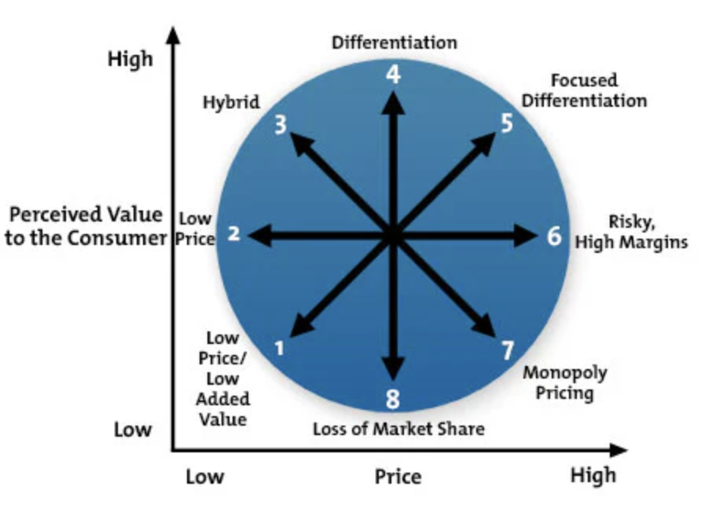
Figure 1: Bowman’s Strategic Clock Diagram
(Source: Bader-El-Den and Perry, 2023)
This positions Shangri-La in the "Differentiation" quadrant; here, Shangri-La would be differentiated at a higher price point. The group's strategy lies on high-class hospitality and the best in luxury accommodations with personalized services and, thereby affluent guests suited to only luxury and exclusivity. In this regard, this creates the scope for earning a substantial reputation and loyalty from the niche market. Premier Inn of Whitbread: Whitbread on the other hand, is operating in the "Low Price" segment with simple accommodation services that are relatively cheap. This strategy emphasizes the efficiency and affordability of every product that is produced by the operation of price competition to reach a great population of cost-sensitive customers that either belong to a family or are mainly business persons (Bader-El-Den and Perry, 2023). With basic, yet comfortable facilities, Premier Inn has satisfied value-sensitive customers' needs. This position provides Whitbread with the opportunity to maintain dominance in the budget hotel market and maximize occupancy levels.

4.0. Growth Potential

4.1. Expansion Strategies
Shangri-La focuses on emerging markets such as China and India, where growing wealth leads to increasing demand for luxury service providers. They have an entry strategy for these markets, guaranteeing brand presence and catering to high-end clients who perceive luxury experiences. Shangri-La reduces the risks that come with unknown regulatory environments and cultural systems by acquiring partnerships with local investors. Apart from diversifying its business services through the provision of wellness programs and event catering, Shangri-La reaches out into new revenue streams and expands its attractiveness toward health-conscious and corporate clients.
Whitbread's Premier Inn takes a very different approach by focusing on price-sensitive tourists. By using the franchising and management contract model, Premier Inn can expand its business quickly without investing much in capital because it collects fees in the form of franchise fees rather than property ownership (Sherman, 2024). In this manner, Whitbread can grow fast without losing profitability. The prime locations in denser and tourism-oriented areas normally bring constant flows of visitors, whether they are commercial travelers or leisure tourists. Premier Inn has maximized occupancy and optimized efficiency in its operations through advanced online booking systems and effective digital marketing strategies that keep it competitive in the budget hotel business.

4.2. Market Opportunities
Shangri-La focuses on the expansion of wellness tourism and luxury event services for high-end travelers in emerging markets such as China and India. The investment in sustainability initiatives may attract both luxury and eco-sensitive tourists. Strong presence in the high-growth regions and catering to changing customer preferences are a result of such initiatives.
Whitbread's Premier Inn will, in addition to a focus on affordability and sustainability, enter more key urban and suburban locations (Saiu et al., 2022). Preceding green initiatives and the building of a digital presence, Premier Inn further hopes to improve customer satisfaction and increase direct booking while keeping its market share in this highly competitive budget hotel space.

4.3. Potential Barriers to Growth
Some of the major issues are the response to fluctuations in the macroeconomic scenario, regulatory uncertainty, and especially, the stiff competition in the luxury segment of hospitality. Whitbread faces challenges related to the consistency of service within its growing portfolio, increasing competition, and the adoption of operational efficiency in properties.

5.0. Financial Commitment to CSR
Shangri-La pushes for sustainability in its initiatives like ISO 22000 food safety certification, the use of environmentally friendly building practices, and community engagement programs. This support matches with its luxury brand image that caters to the eco-sensitive high-end traveler. Whitbread (Premier Inn) has been diversified in Whitbread's "Force for Good" in the categories of diversity, inclusion, carbon reduction, and societal value (Konadu et al., 2022). Here is a kind of balance because of having improvement concerning environmental responsibility coupled with business growth. Whereas Shangri-La's CSR initiatives respond to consumer demand in the luxury space for sustainability, Whitbread has chosen a model that responds to an infinitely broader social agenda as part of the wider support of brand mid-market positioning and the financial imperative.

6.0. Recommendation
Shangri-La aims to deliver the best customer experience through services delivered personally and by further building its digital relationships using technological aids as it strives to provide best-in-class facilities given the stringent expectations of luxury travelers. Whitbread continues to focus on operational efficiency with the help of technological advancement for smooth customer experiences and optimized cost structures, mainly across its brand, Premier Inn (Bharwani and Mathews, 2021). The Shangri-La strategy portrays the affinity of the company with luxury and personalization, while Whitbread uses the strategy consistent with its mid-market positioning further to enhance the quality of service while maintaining affordability. Both companies are efficient in using technology to meet the specific needs of their customers and to fuel market growth.

7.0. Conclusion
Conclusion Shangri-La and Whitbread are two different strategies in the hospitality industry. While Shangri-La aims to offer exclusivity and luxury using tailored service and an upscale market with technology further supporting customer interactions, Whitbread is premised on operational efficiency and affordability through its brand Premier Inn and uses technology to optimize services while having competitive prices. Both have operated successfully in the targeted market segments: Shangri-La, on luxury client markets; Whitbread, on price-sensitive clients. Differences in the two strategies affirm that hospitality operations can achieve sustainable growth through myriad approaches in response to changing customers' needs.

References
Bader-El-Den, M. and Perry, T., 2023. Self-optimised cost-sensitive classifiers for early field failure prediction in storage systems. Swarm and Evolutionary Computation, 83, p.101388.
Belarmino, A. and Koh, Y., 2020. A critical review of research regarding peer-to-peer accommodations. International Journal of Hospitality Management, 84, p.102315.
Bharwani, S. and Mathews, D., 2021. Techno-business strategies for enhancing guest experience in luxury hotels: a managerial perspective. Worldwide Hospitality and Tourism Themes, 13(2), pp.168-185.
Fei, A., Kim, J. and in Kim, S., 2024. Effects of environmental sustainability practice in the economy hotel to Gen Zer’s purchase decision: Behavior economy approach using choice based conjoint analysis. International Journal of Hospitality Management, 118, p.103678.
Guix, M., Sánchez, J.J.N., Priego, M.J.B. and Font, X., 2024. The changing institutional logics behind sustainability reports from the largest hotel groups in the world in 2014, 2018 and 2021. Tourism Management, 106, p.105031.
Konadu, R., Ahinful, G.S., Boakye, D.J. and Elbardan, H., 2022. Board gender diversity, environmental innovation and corporate carbon emissions. Technological Forecasting and Social Change, 174, p.121279.
Kwiatek, P., Morgan, Z. and Thanasi-Boçe, M., 2020. The role of relationship quality and loyalty programs in building customer loyalty. Journal of Business & Industrial Marketing, 35(11), pp.1645-1657.
Layrisse, F., Reficco, E. and Barrios, A., 2021. What social enterprises can learn from the freemium business model. Academia Revista Latinoamericana de Administración, 34(1), pp.165-181.
Ramgade, A. and Kumar, A., 2021. Emergence and development of hostels as alternative accommodation and their popularity amongst the millennials. Vidyabharati International Interdisciplinary Research Journal, 13(1), pp.642-646.
Saiu, V., Blečić, I. and Meloni, I., 2022. Making sustainability development goals (SDGs) operational at suburban level: Potentials and limitations of neighbourhood sustainability assessment tools. Environmental Impact Assessment Review, 96, p.106845.
Shangri-La, 2019. Luxury Hotels and Resorts | Official Site Shangri-La Hotels and Resorts. [online] Shangri-la.com. Available at: https://www.shangri-la.com/.
Sherman, I., 2024. Exclusive Taxation of Real Estate, and the Franchises of a Few Specified Moneyed Corporations and Gas Companies. BoD–Books on Demand.\
Whitbread, 2023. Whitbread. [online] Whitbread.co.uk. Available at: https://www.whitbread.co.uk/.

