Analyse the link between employee wellbeing and the ability to do your job

Employee wellbeing is discussed more in the media now than ever before (CIPD,2022). Primary and secondary research looked into the effects wellbeing has on the ability for employees to do their job and found there was a link. The objectives of the report are to see if the following :

-The relationship employees have with their line managers
-Employee job satisfaction and high workloads/ demands
-How an organisation performs with employees with a good wellbeing

If UWTSD ensure that employee wellbeing is a focus for their strategic objectives this will help the university be seen as an employee of choice as well as being beneﬁcial in attracting and retaining staff (Taylor, 2021) as well as reduce sickness which will also be beneﬁcial to the university ﬁnancially (CIPD,2023).
Secondary research found that employee wellbeing was worsening and action was needed not to impact on retention (Goforth, 2023) and that the support from line managers has a strong inﬂuence on employee wellbeing (Huo, Bosxall & Cheung, 2020) as well as a direct impact on levels of employee engagement and individual performance (Alfes, 2013).

Secondary research also found that covid blurred the lines between home and work which could have in turn impacted on employee wellbeing (Demerouti &Bakker, 2022; Kingsford-Smith et al, 2023). However the research also highlighted that work demands even before covid were high on university staff( (Wray and Kinman 2021; Bungay et al, 2023), in 2019 for example 72% of UK academics described themselves as stressed (Education Support 2019; Bungay et al, 2023). The performance of an organisation and employee engagement are linked with good wellbeing of employees (CIPD, 2023) and working long hours may have a negative impact on mental health (Bu, Steptoe, and Fancourt 2020; Bungay et al, 2023).
 | A Questionnaire was used for the primary research as it is a cost effective method to reach a large selection of participants(Kumar, 2014).10 closed ended questions were asked as part of the questionnaire to the Wales Institute of Science and Art as this offered a variety of participants, lecturers, production and workshop staff and professional services. Microsoft forms was then used to facilitate the questionnaire and to analyse the data.
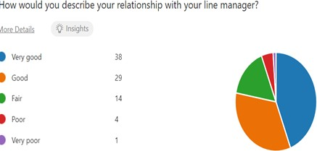  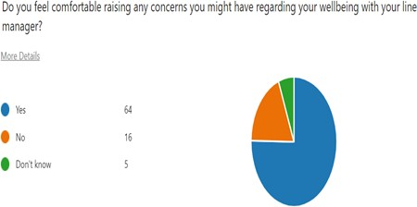  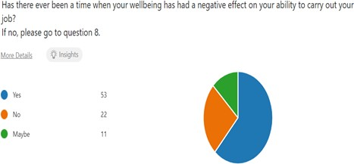  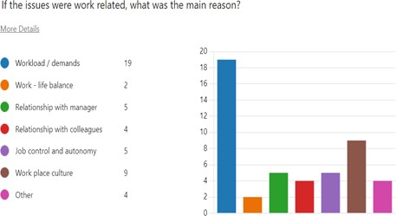  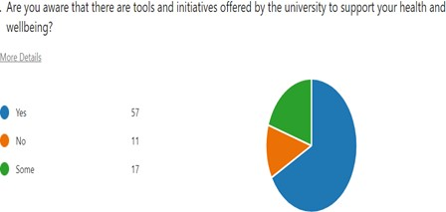 | The report found that an employee’s wellbeing impacts on their ability for an employee to do their job. It found that the relationship between line managers and employees plays an important role in employees wellbeing (Huo, Bosxall & Cheung, 2020). Just under half of the respondents described their relationship with their manager as good , and all of these felt comfortable raising concerns with them.  The report found that high workloads/demands negatively impact on wellbeing and productivity (Taylor, 2021), for those that felt their wellbeing was poor, all of them said this impacted on their ability to carry out their job.  The survey found that although some employees were aware that UWTSD had initiatives in place to support health and wellbeing nearly a third said they were aware of some or none. It appears that although we may offer some initiatives that not all employees are aware  UWTSD needs to be aware of these ﬁndings in order toput some new initiatives in place,. if employees don’t feel supported they can become disengaged resulting in poor performance which effects company performance (Winne,2019; Rose et al,2019 and Dul & Neumann, 2009)  Conclusion  The report has shown from both primary and secondary research that there is clearly a link. Employee wellbeing therefore needs to be considered as part of UWTSD business and HR strategy as a matter of high importance.  Please note there is also a Supplementary report and proposed recommendations along with an implementation plan as separate documents.  Acknowledgment: I would like to express my gratitude to the University of Wales Trinity Saint David for helping me facilitate my research report, the employees who took the time to complete the survey. I would also like to give personal thanks to my supervisor Natasha Davies for her support during the report and my husband for his continued support to my career development.  Bethan Wilson . Word count - 689

1. Alfes, K. et al. (2013) ‘The Relationship Between Line Manager Behavior, Perceived HRM Practices, and Individual Performance: Examining the Mediating Role of Engagement’, Human resource management, 52(6), pp. 839–859. Available at: https://doi.org/10.1002/hrm.21512..
Introduction

Literature review

Methodology

Findings

Figure 1. Graph demonstrating how employee describe their relationship with their line manager

Figure 2. Graph demonstrating whether employees feel

comfortable raising concerns regarding their wellbeing with their line manager

Figure 3. Graph demonstrating whether employees feel there has been a time when their wellbeing has had a negative impact on their job

Figure 4. Relating to ﬁgure 3 , demonstrating what the employees felt the issues were

Figure 5. A graph demonstrating whether employees are aware of the tools and initiatives UWTSD offer to employees
2. CIPD (2022)A Health wellbeing work report 2022, Available at: https://www.cipd.org/globalassets/media/comms/news/ahealth-wellbeing-work-report-2022_tcm18-108440.pdf
3. CIPD (2023) Wellbeing at work, Available at: https://www.cipd.org/uk/knowledge/factsheets/well-being-factsheet/
4. Dul, J., & Neumann, W. P. (2009) ‘Ergonomics contributions to company strategies’, Applied Ergonomics, 40, pp: 745–752, Available at: https://www.sciencedirect.com/science/article/pii/S0003687008001221?casa_token=3PYmJSiiVssAAAAA:4SdW20xsPZmcU4bjios0h2xdcRxHX-5i0SVtoHz6SCJIWHoYM3f5PS7UaoXXAcecIBd6USF4Uzdo
5. Goforth, A.(2023), ‘Greater accountability needed as workplace wellbeing declines, study ﬁnds’, BeneﬁtsPRO, Available at: https://www.beneﬁtspro.com/2023/06/19/greater-accountability-needed-as-workplace-wellbeing-declines-study-ﬁnds/?slreturn=20230825153025
6. Huo, M.L. , Boxall, P. & Cheung, G. (2020) ‘How does line-manager support enhance worker wellbeing? A study in China’, The International Journal of Human Resource Management, 31 (14), pp.1825-1843, Available at: https://www.tandfonline.com/doi/abs/10.1080/09585192.2017.1423103
7. .Rose, L.M., Orrenius, U.E. and Neumann, W.P. (2013) ‘Work Environment and the Bottom Line: Survey of Tools Relating Work Environment to Business Results’, Human factors and ergonomics in manufacturing & service industries, 23(5), pp. 368–381. Available at: https://onlinelibrary.wiley.com/doi/10.1002/hfm.20324
8. Taylor, S. (2021) Resourcing and Talent Management: The Theory and Practice of Recruiting and Developing a Workforce. London: Kogan Page.
9. Winne, S.D. , Marescaux, E. , Sels, L. , Beveren, I. V. & Vanarmelingen, S. (2019) ‘The impact of employee turnover and turnover volatility on labor productivity: a ﬂexible non-linear approach’, The International Journal of Human Resource Management, 30 (21), pp.3049-3079, Available at: https://www.tandfonline.com/doi/full/10.1080/09585192.2018.1449129

