Web Development
Assignment 1

Joshua Ford
1707602
Web Development BSc
15th December, 2017.

Contents
1.Introduction 2
2. The website. 2
2.1 Site map of website. 2
2.2 wireframe diagram 3
3. Implementation. 4
4. Implementation 12
5. Evaluation 12
References 14

1.Introduction

This report is about the website that is all about sport in Wales. Sport in Wales was chosen because it is very popular and is on the way up. The contents of this report are all about sport in Wales. There are five pages and each page has its own information on its sport. It has information and pictures to tell you all about sport in Wales and to show how important and popular it is in Wales.

2. The website.

This website is all about sport in Wales and how important it is. Its purpose it to tell people about sport in Wales and how important it is too people. Wales has top teams in all its sports including football, rugby, rallying and surfing. All which are very popular and have thousands of fans all over Wales, and is growing every year. It is Vitaly important because not only does it help people get closer but its keep lots of people fit and that is very important in Wales. It has some of the best sports teams in the world and I think that this website will help get to know how good and how important sport is in Wales. The Target audience of this website would be people who do not know much about Wales and want to get to know the sport a bit better.

2.1 Site map of website.
Home page
Welsh Surfing
Welsh Rallying
Welsh Rugby
Welsh Football

This Site map of the website shows that you can access any page from any page. You do not have to be on any certain page to open any of them. All the pages are just as accessible as the others. This means that you cannot miss any of the pages out when going through them because you can access them all equally. This site map shows that when you are on any page you can access any page from any page.

2.2 wireframe diagram

3. Implementation.
Home page
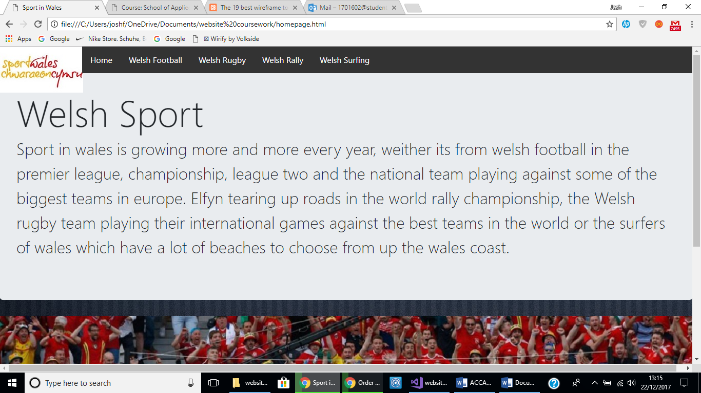
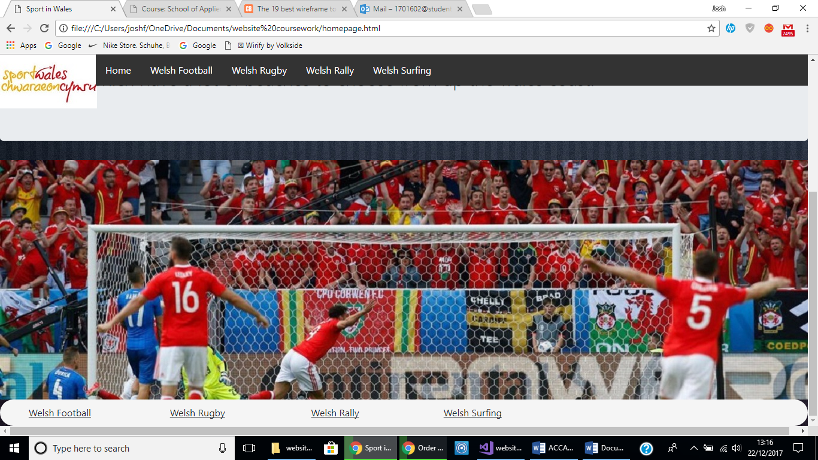

Welsh football page
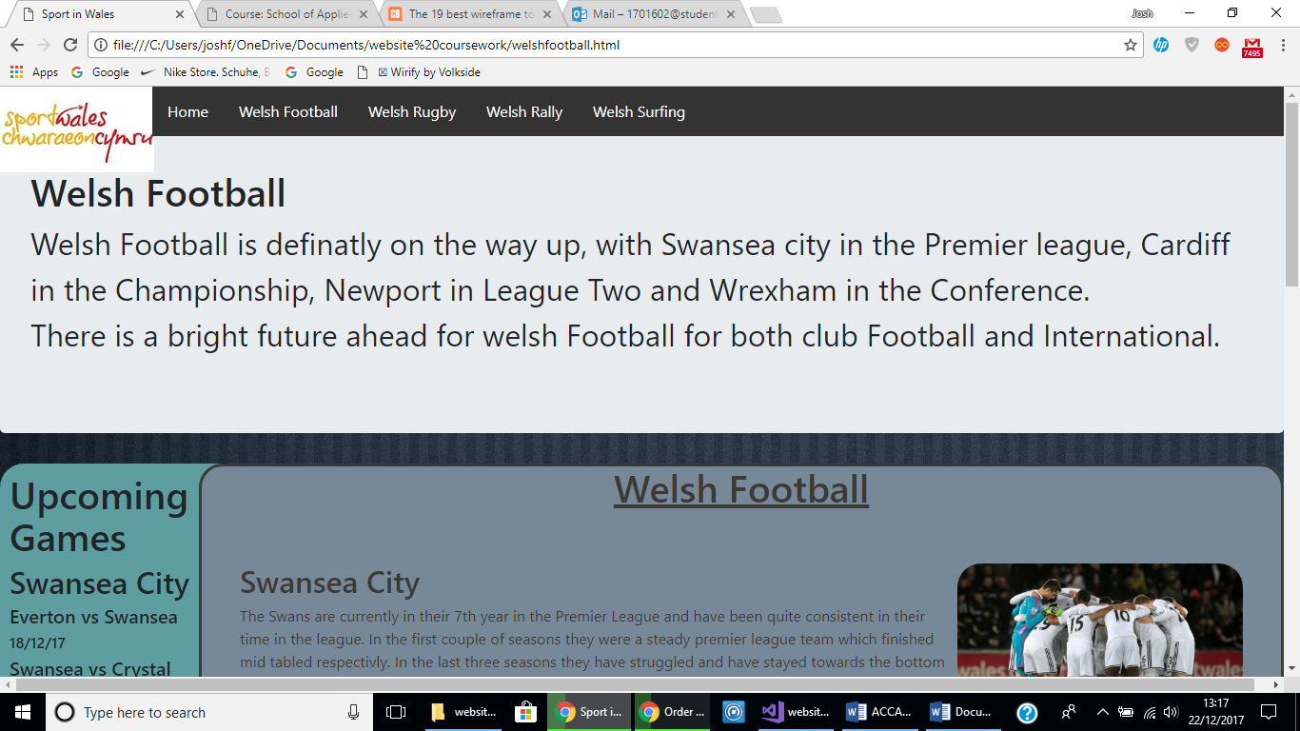
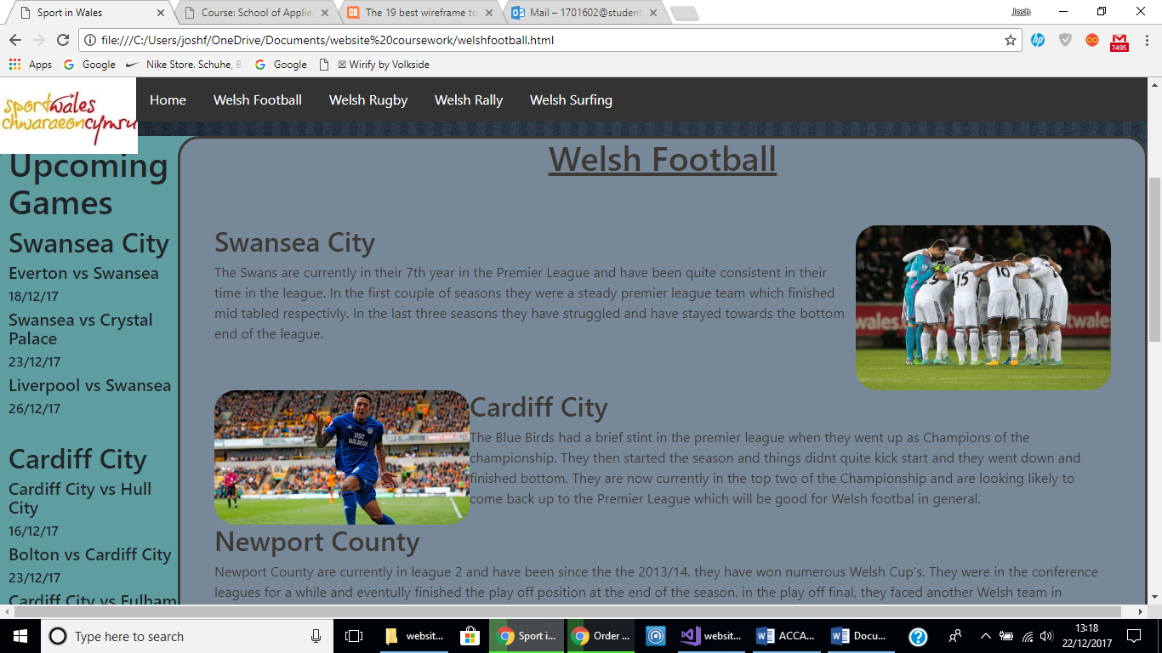
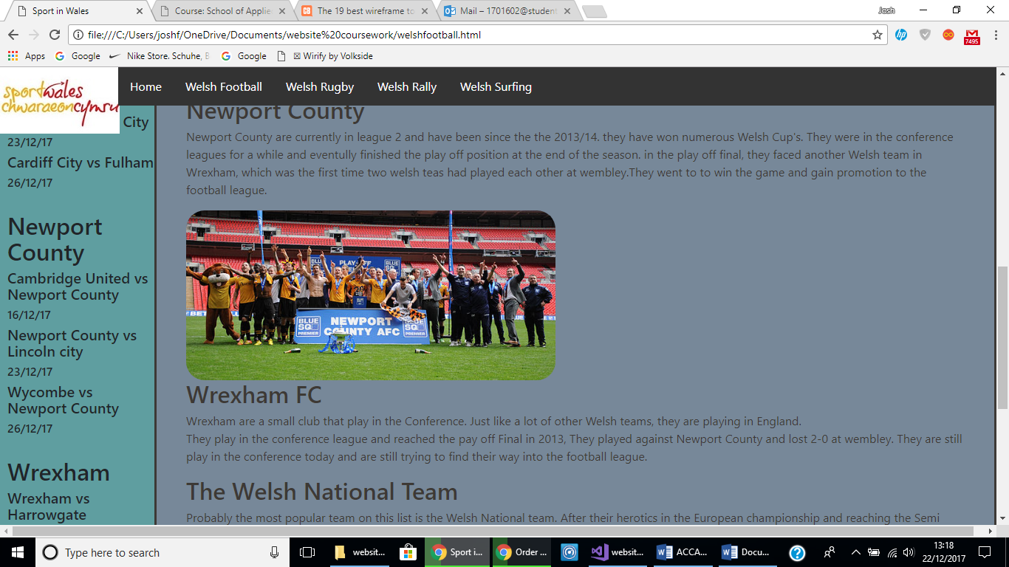

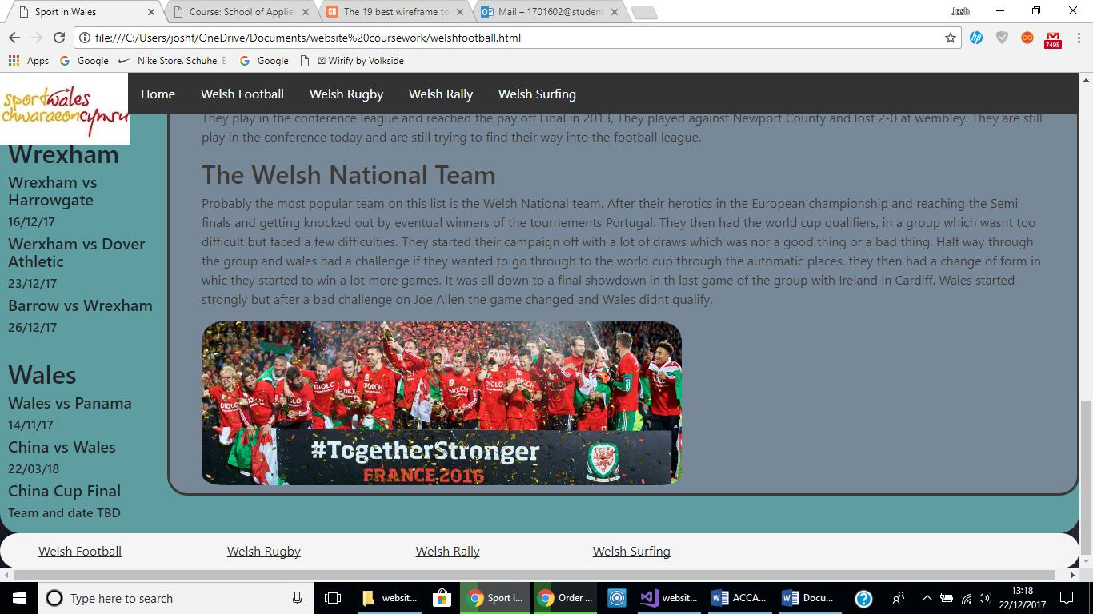

Welsh Rugby page
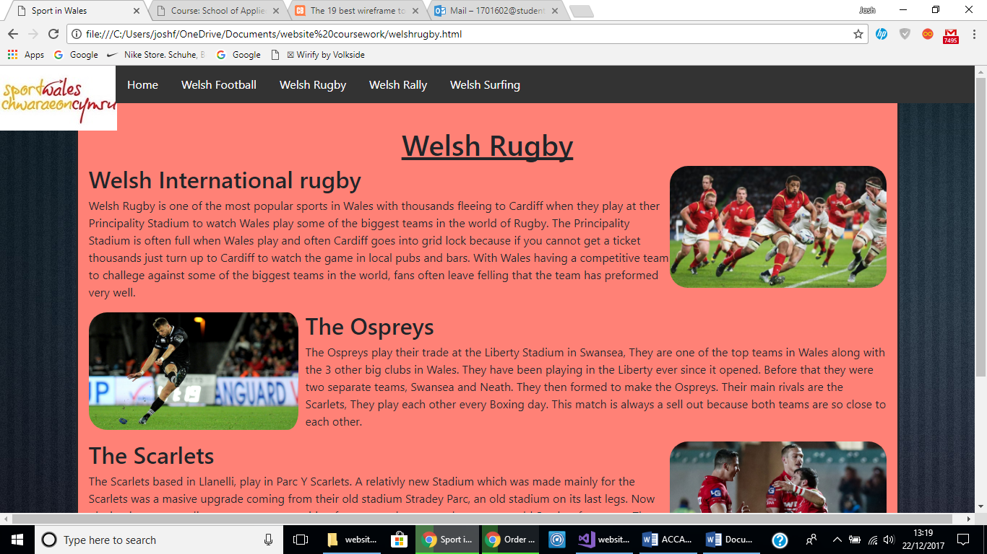
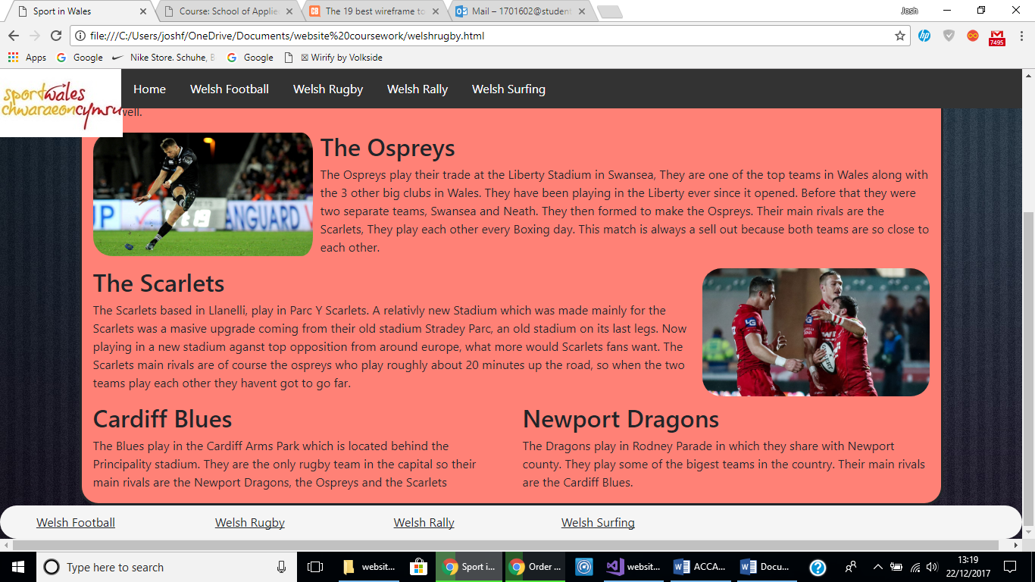

Welsh Rally
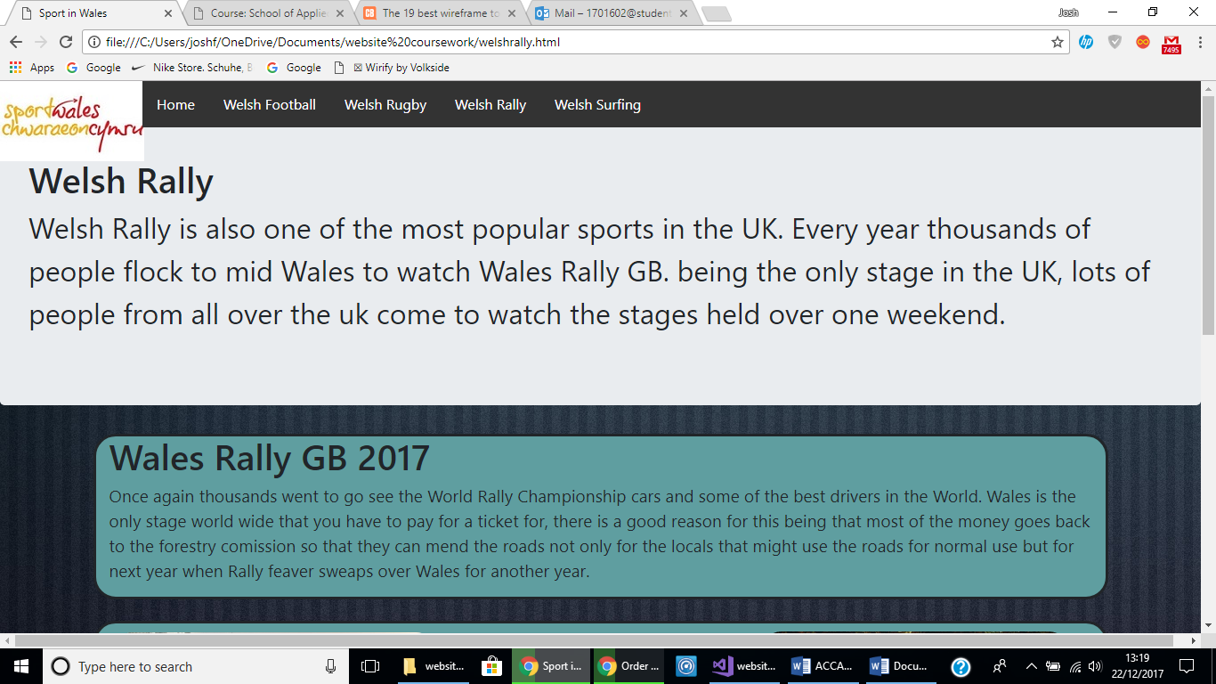

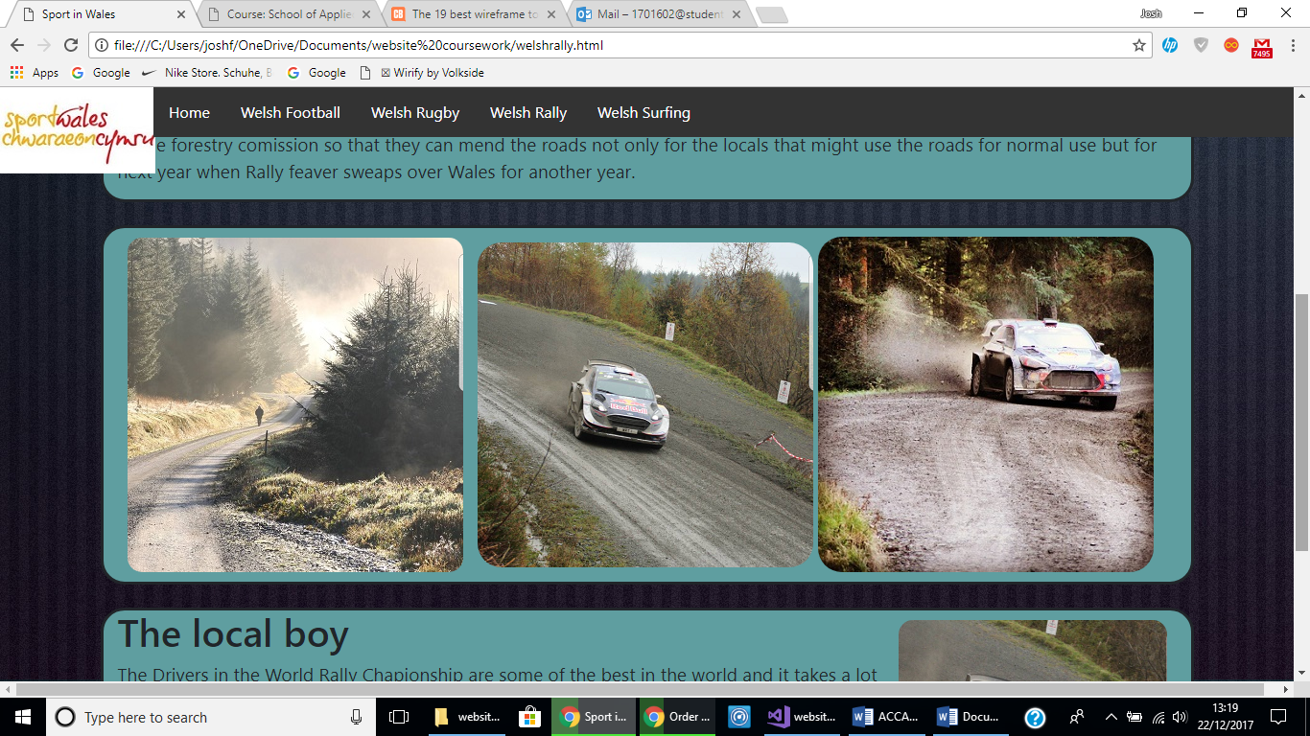
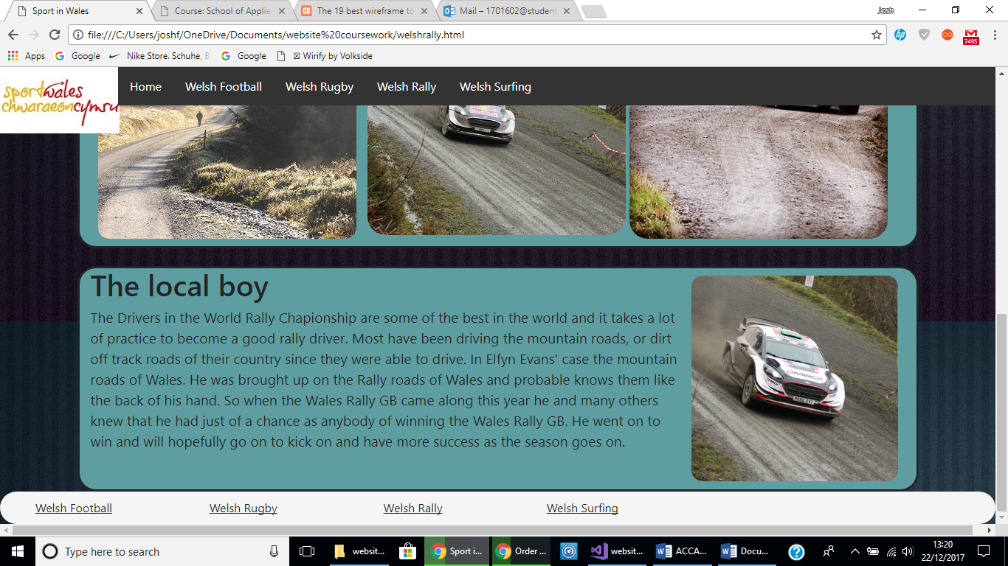
Welsh Surfing page
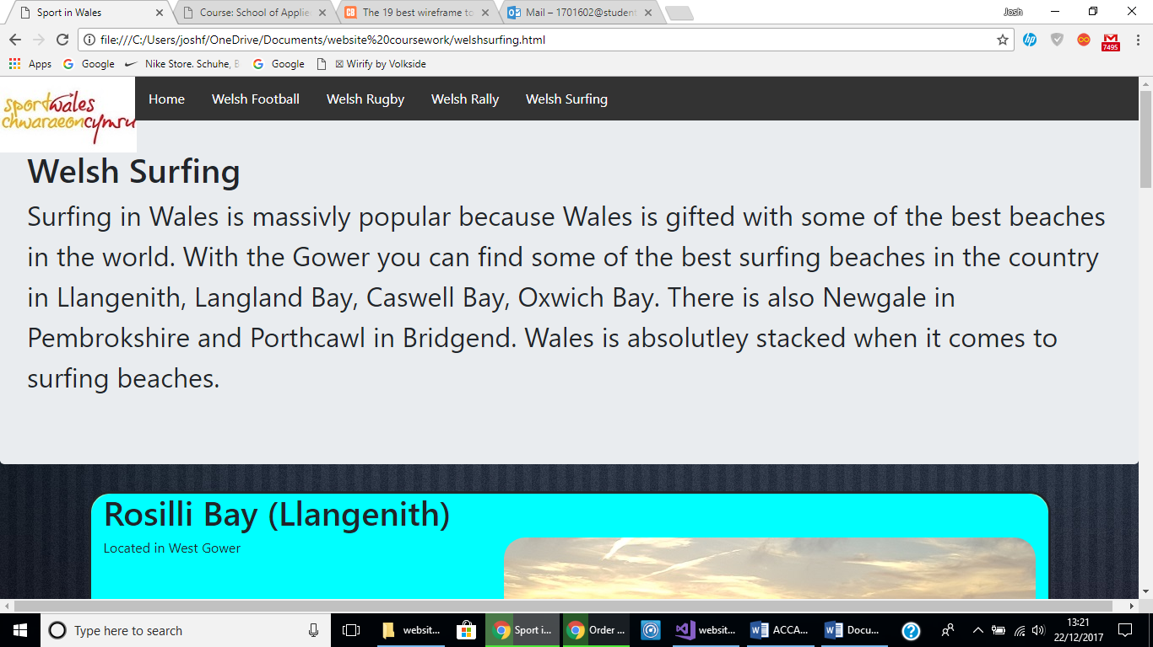
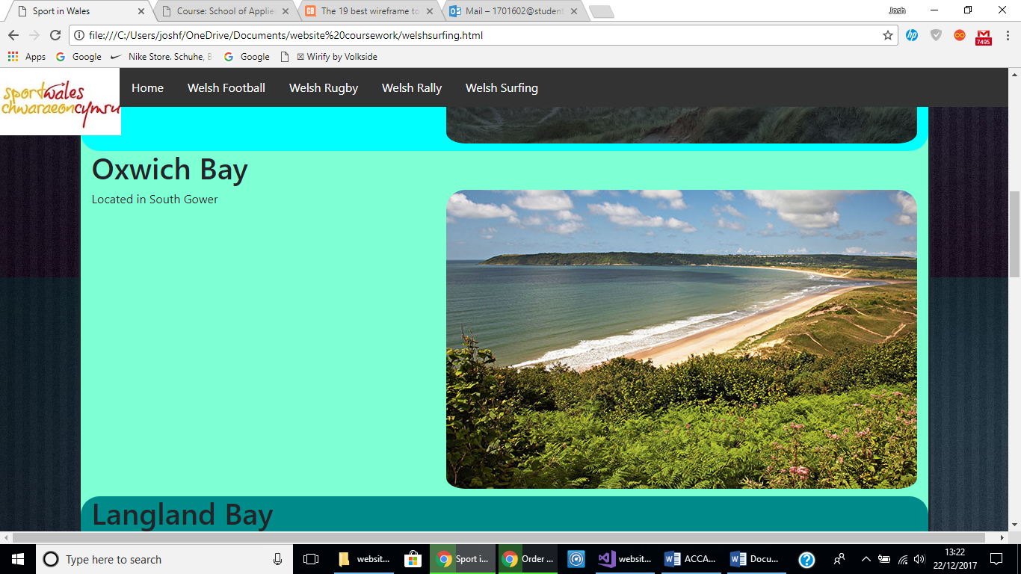
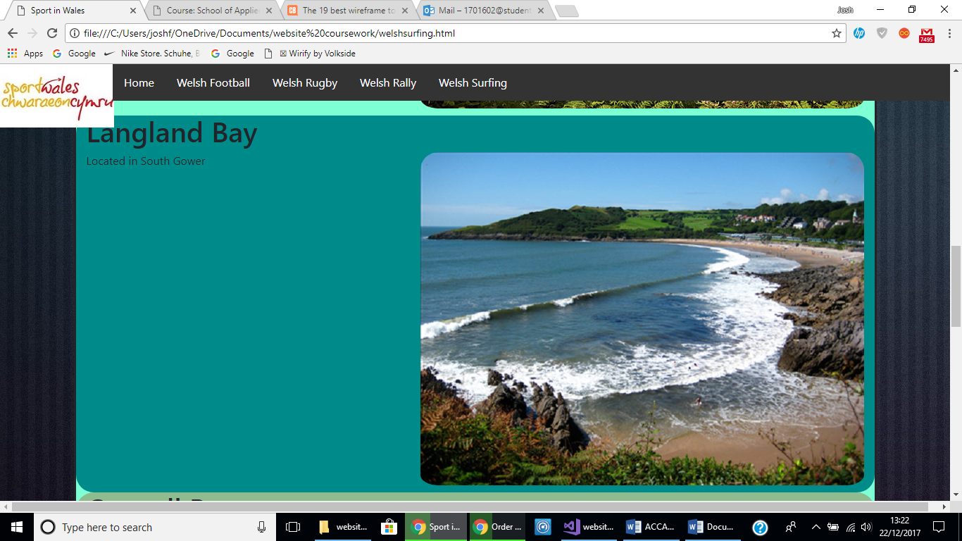
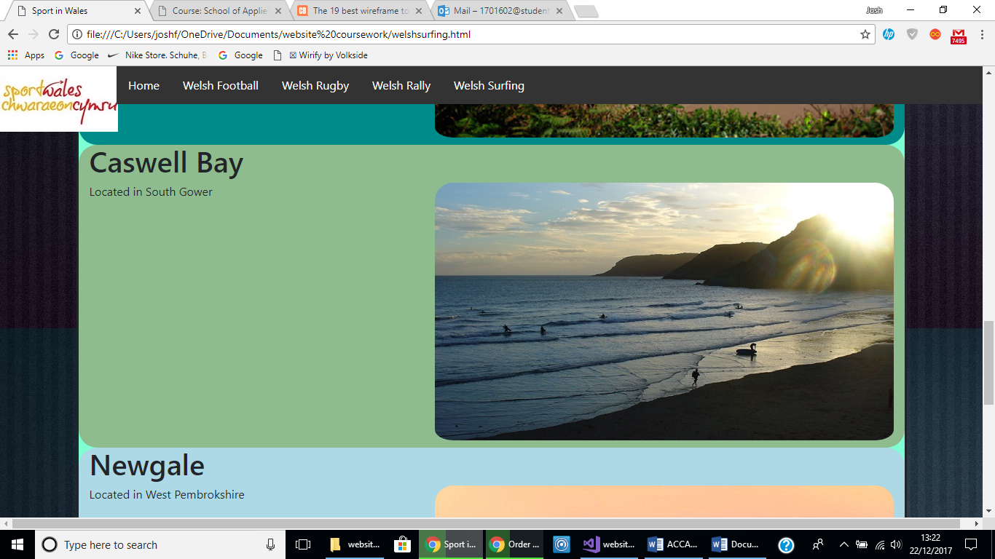

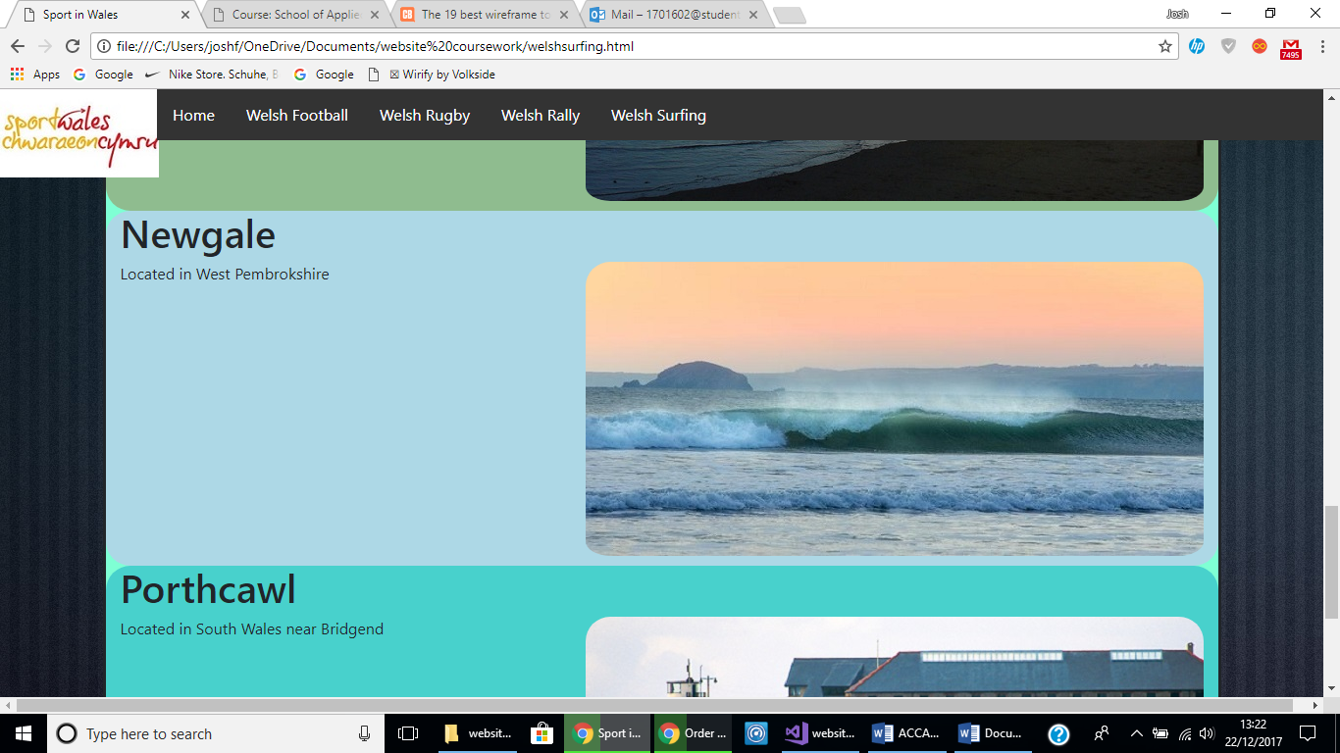
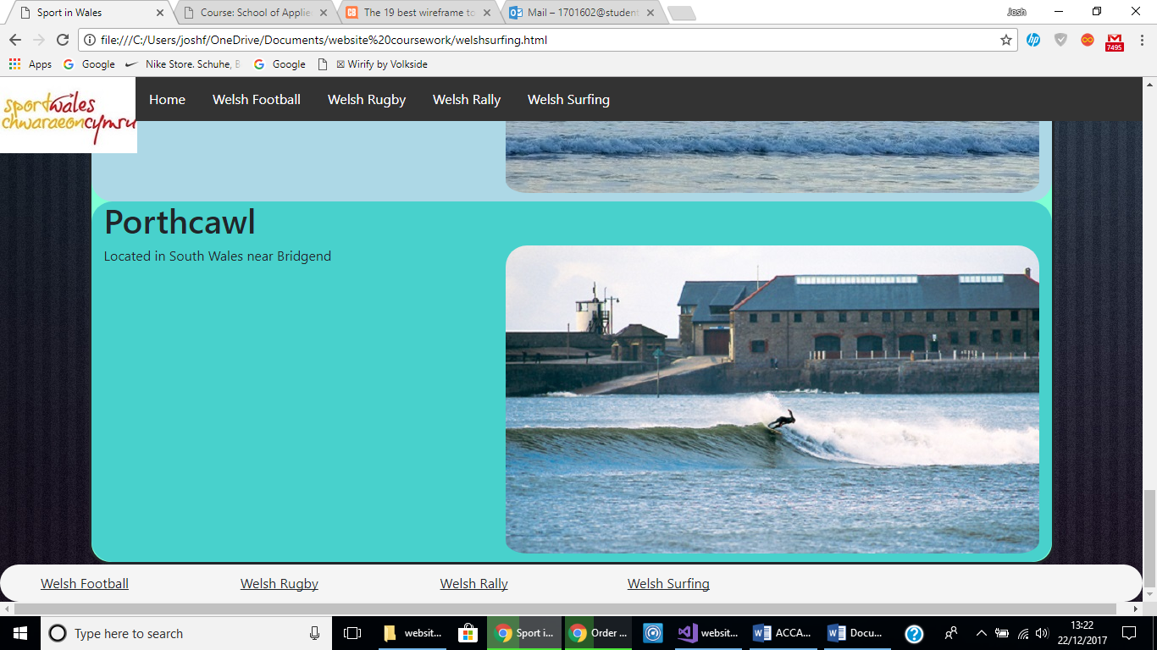

4. Implementation
After validating the website these are the errors that occurred.
Home page HTML.
The first couple of errors were all on one line and it was in the head section where there was a line of code with the content which included the width and initial scale and it had been put into one line and it was saying that the error was that they were all in one set of speech marks rather than one set for each of them. Also, one of the errors was a stray div tag which must have been put in there but then taken out and must have forgotten to delete the end of the div tag. Another error was that the slideshow on the homepage did not have a heading and that is what was causing the error.

Homepage CSS.
The errors in the CSS file were a Lexical error, a phrase error, unknown pseudo element and a value error. These errors were found in the CSS of the website and it might mean that there was a typo that was not making the CSS do what it is supposed to do. Another error was a parse error, a parse error is [1] according to this article on the webpage it is an,
‘Error that shows up because you have more errors in your custom CSS.’
A value error was also appearing which might mean that one of the values in the CSS was not the right type or was not correct in general.

5. Evaluation
When the website was being made the H1, H2 and other uses of headings were used because it is a good way of making headings stand out. You could you a H1 heading at the top of the page, so it stands out the most. For sub headings, h2, h3 and h4 headings could be used because they still stand out, but they are not mistaken and so that the main h1 heading still stands out the most. Also having big headings can help people who can’t see as good recognise text on the screen, as sited in [2], it says under the heading perceivable that guideline 1.1 states that text must be presentable in different types large text for the short sighted, speech or words that are understand. With the images in the website, when they appear on the screen they are placed so that they are clearly visible to the user and if they were to view them on a smaller screen they will shrink or enlarge to suit the size of the screen so that the website interface still looks the same. The colours of the website are designed so that they can be read easily and not confused. The background colour is a darker colour while the main text and headings are in a lighter colour, this is because it is easier to view the website then. As sited in [3], it states that in one of the guidelines, it must make it easier to see background content like the background image to the foreground content like the jumbotron’s with all the text in them. This has been done by making them two different colours. The forms navigation on the website was made so that you could go from each page to another without having to go on one page to view another page. Cited in [4], in guideline 2.4,
‘ways to help to users navigate, find content, and determine where they are.’
This was done by linking all the pages in the navigation bar so that you could go from each page to another, this was also easier to find content.

After looking at the completed website, the design was put in place so that it would suit the needs of the users and they wouldn’t have to go out of their way to view the website. The feel of the website was good because it was easy to look at one thing then maybe go to another page to view something else. The content on the website was suitable for the topic and the correct information, useful and extra information included. The recommendations for future improvements is to probable plan the display of the information, images and content so that it would look better and more attractive and for it to be more web responsive. Also, more pages with more information on top of what is there now could be added to help and advise the user more than what is there now.

References

[1] | "Parse Error," [Online]. Available: http://docs.pagelines.com/support-troubleshooting/parse-error. [Accessed 27th december 2017].
[2] | "Web content accesibility guidelines," 11th August 2017. [Online]. Available: https://en.wikipedia.org/wiki/Web_Content_Accessibility_Guidelines. [Accessed 27th December 2017].
[3] | "we content accessibility guidelines," 2017 August 2017. [Online]. Available: https://en.wikipedia.org/wiki/Web_Content_Accessibility_Guidelines. [Accessed 27th December 2017].
[4] | "web content accessibility guidelines," 11th August 2017. [Online]. Available: https://en.wikipedia.org/wiki/Web_Content_Accessibility_Guidelines. [Accessed 27th December 2017].

