

Student Name | Joseff Williams
Student Number | P152113
Module Code | ACBA6000
Programme | BSc Hons Construction Management

Assignment Title

Programme Control

Submission Deadline | 08/12/2020
Contribution | 60%
Lecturer | Deborah Hughes

Table of Content

- Introduction
- Gantt Chart
- Time, Cost and Resources Reports
- Productivity and Incentivisation
- Site Layout Plan
- Scenario 2

- Introduction
In this assignment I will be assessing the principles and application of effective project planning and programming utilising the Microsoft project programme to create a sequence of events in the format of a Gantt chart.

This Gantt chart will be specifically designed for the SA1 waterfront development and construction of the new library building and will identify the working timescales, labour resources and cost plan throughout the build.

- Gantt Chart

Below is the complete Gantt chart showing the task names, Time durations, Start dates, Labour Resource and Critical Path highlighted in RED.

- Site specific reports for Time, Cost and Resources

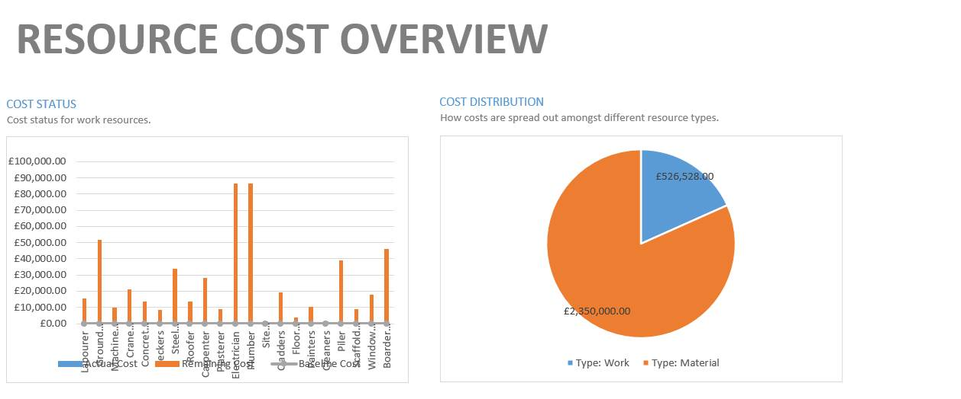
This first chart the Resource cost overview highlights the various trades that will be expected to work on site with their wages for the duration of the project.

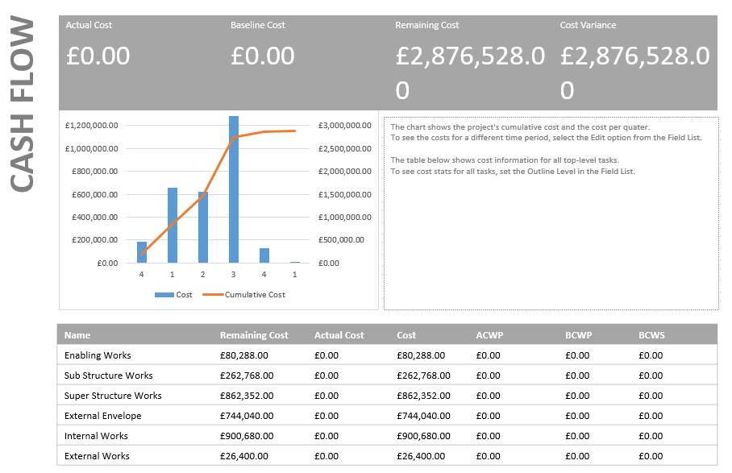
This next chart is the Cash flow diagram which identifies how much it is going to cost to complete each phase of works.

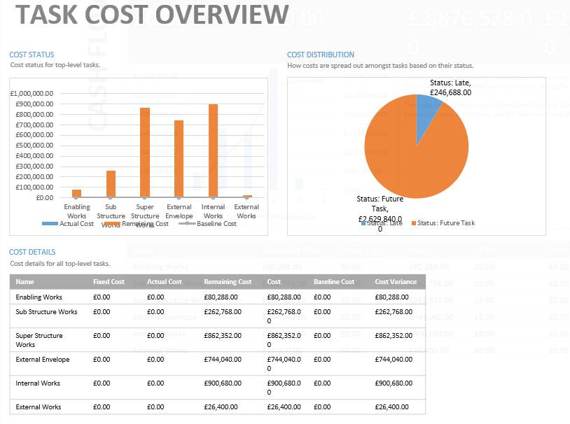

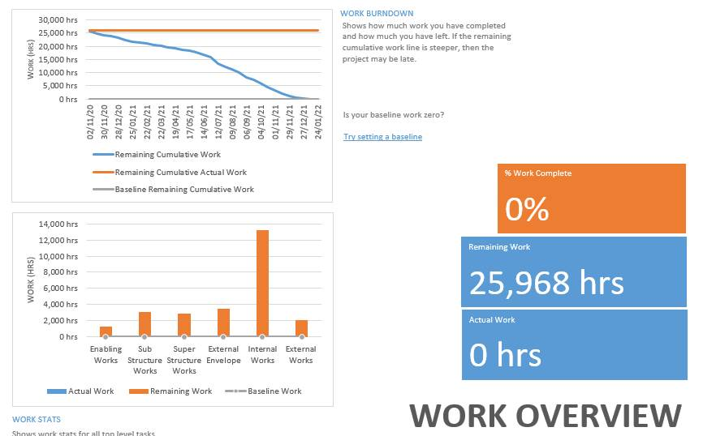

This diagram identifies the hours spent on site to complete each phase of works.

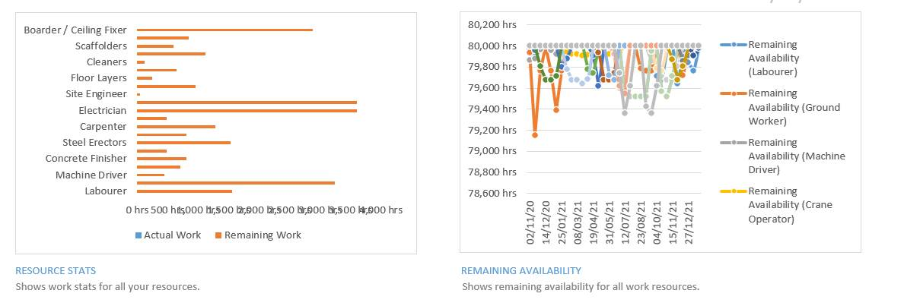

These charts help to paint a picture of the cost and resource allocations throughout the project and will help to understand the cash flow requirements throughout the build project.

These charts also look very professional when reporting back to the board of directors on progress, cash flow and resource allocation.

- Incentivisation within the workplace

Construction projects are often known to be fast paced with tight deadlines to ensure client satisfaction, throughout any construction process it is likely there might be periods of poor performance, underachievement and targets missed.

In this section I will be looking at various ways to address performance issues in regards to productivity and Incentivisation, in this scenario the client needs to bring the project in on their completion date, which is 2 weeks earlier than the existing construction programme, below I will be talking about how Incentivisation might help to achieve this early completion date and highlighting the necessary changes in the form of a Gantt chart.

The most important thing to consider when addressing poor performance or underachieving is to discuss the issues by being clear and concise ensuring the employees understand what is going wrong. The key task of addressing poor performance is to focus on the potential solutions rather than problems.

The talk with each employee must be specific and relevant to the individual or sub-contractors team. You must know when to be direct or when to step in to calmly discuss a situation, during times of addressing performance it is also important to listen to what the other party has to say as there might be reasons for their under achieving or slow production rates that are out of their control.

As a leader it is important to set targets and strive to complete deadlines and goals. As a leader it is also important to speak to the operatives undertaking the tasks but look to identify ways to speed up or gain maximum efficiency, this is where micromanagement might come into effect to help achieve realistic targets set up by the employees. Leaders will also identify key points within a job when they might be able to bring in trades earlier than their anticipated start date on site to complete a phase or section of the project taking a large weight off their shoulders further down the line when it comes to commissioning, snagging and handover phase of the project.

Incentivisation helps to encourage the workforce and employees to reach their reasonably set targets by rewarding continuous improvement in the form of monetary rewards (Bonuses) for completing work by a set time or by offering overtime (Weekend work) to allow the employees to earn more money but also allowing the job to claw back lost work days over the weekend. Another way Incentivisation occurs in the workplace is by rewarding the operatives and staff who have achieved a positive deadline or goal time off work in the form of additional annual leave, this is one way companies try to give back to the workforce by rewarding those that have put the effort in.

A construction contract might incorporate Incentivisation by adding LADs to any contractor that runs over their programmed completion date or adding delays to a project, this will then take away the profits made by the contractor in the form of a fine for not completing their section of works on time.

Incentivisation might include a working relationship that has grown over many years with the contractors being the favoured companies to undertake their section of works, this is a benefit to the specialist sub-contractor as they might benefit from cost plus contracts or agreeing quicker payment terms, this all encourages companies and employees to try to achieve completion of works as soon as possible.

The main purpose of Incentivisation is to align the motivations of the contractors, consultants and suppliers with those of the clients, so that by working collaboratively they are working for the success of the client’s project. The rapid increase of using Incentivisation in contracting is to achieve state of the art buildings with better qualities, built quicker increasing innovation and decreasing on project and cost over-runs.

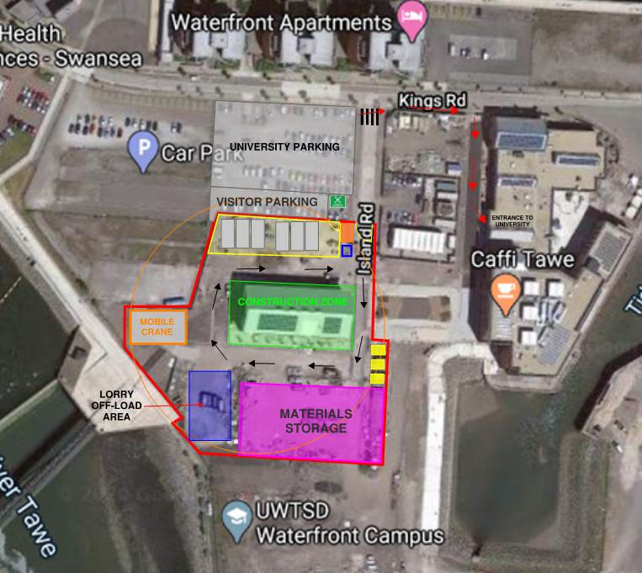
- Site Layout

Above is a site logistics plan identifying the key areas for the successful delivery of the library project whilst ensuring the University remains open throughout the build.

Below is a small breakdown of the site layout showing images of the types of things that would be on the project.


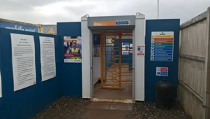
Fire Assembly Point
Pedestrian Entrance to Site
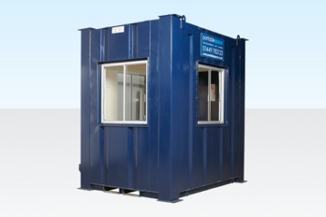
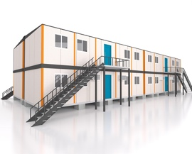
Site Delivery Entrance

Visitor Parking by Site Entrance
Site office Double Stacked with meeting room.

Gate Mans Hut
Wheel wash station at site exit

Site Welfare Units Double Stacked.
Toilets
Canteen
Stores
Yellow Area denotes site welfare and office zone

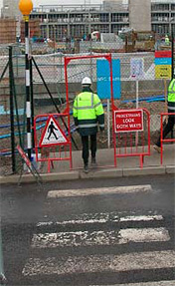

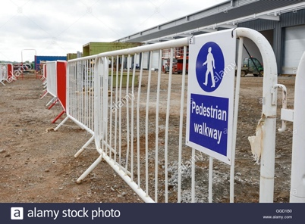
Designated Crossing area for students and staff
Designated walking route to university entrance

Students and Staff car park

Black arrows identify the one-way route around the site for deliveries and construction plant. To avoid any accidents
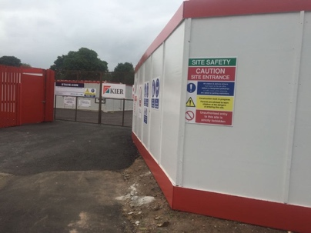
Red Line identifies perimeter of site boundary, Timber Hoarding to be installed as a safety barrier.


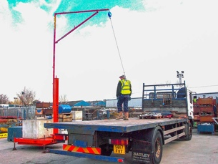
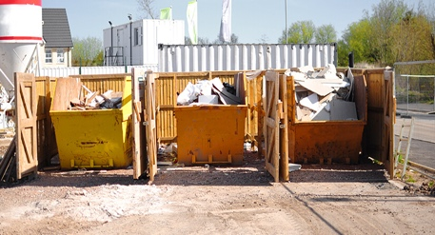
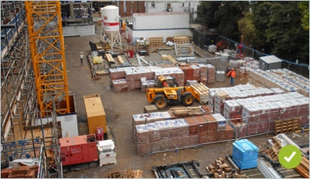
Mobile Crane location, orange line identifies the cranes sluing zone
Turning Circle and Material Delivery Off-load Zone
Site materials storage and lay down area.
Site Skips storage area.

Wood, Metal and Mixed Waste

- Scenario 2

If the client needed to bring the project in two weeks earlier than the target deadline I would suggest using methods of Incentivisation to encourage workers to work weekends or employ more labour resources to the project in order to complete a section of works faster than anticipated, for instance if internal 1st fix plaster boarding will take 8 weeks for 1 gang, I would suggest employing 2 gangs to speed up the work which would then in turn free up more work throughout the project for follow on trades who will be able to start sooner.

Lean management techniques to analyse data will also help to identify which contractors are not meeting their required targets and the reasons why. Ensuring site management have a good plan and it is monitored regularly should ensure efficiency in work.

Being able to allow guys to work weekends and work on past 5pm on a week day will allow the projected packaged contractor to build up a number of additional hours which would save time off their end programme.

Other trades would also be required to do the same thing in order to collaboratively work together to achieve the clients desired goals. This will give the client trust in the contractor and could potentially lead to future negotiated works.

