
Zsolt Varkonyi, BEng Motorcycle Engineering, P142563
Malcolm McDonald, Powertrain & Sustainability, M3X8824
02 OCT 2017

12

POWERTRAIN & SUSTAINABILITY
LEVEL 6

COMBUSTION CHEMISTRY CALCULATIONS

TABLE OF CONTENTS

1 Introduction 2
2 Calculations 2
(A) Mass Percentages 2
(B) Air-Fuel Mass Ratio 3
(C) Calculation of Lower Heating Value 4
(D) Enthalpy of Formation 5
(E) Difference Between Higher and Lower Heating Values 5
(F) Mass of CO₂ Produced 5
(G) Properties of an “Ideal” Fuel 6
3 Appendix 7
4 Bibliography 8

Introduction

Molar composition of blended bio-ethanol
Ethanol/Ethyl alcohol (National Center for Biotechnology Information, 2017)
Molecular Formula: $C_{2}H_{6}O$
Molecular Weight: $46.069\frac{g}{mol}$
Iso-Octane/2,2,4-Trimethylpentane/Gasoline (National Center for Biotechnology Information, 2017)
Molecular Formula: $C_{8}H_{18}$
Molecular Weight: $114.232\frac{g}{mol}$

Molar Composition of Blend $50\%-50\%$

Atomic Weight of Components (Cayman Chemical, 2017)
Carbon, $C$ $12.01078\frac{g}{mol}$
Hydrogen,$H$ $1.007947\frac{g}{mol}$
Oxygen, $O$ $15.99943\frac{g}{mol}$
Nitrogen, $N$ $14.00672\frac{g}{mol}$

Calculations

Mass Percentages
Molar weight of blended bio-ethanol:
$0.5×46.0687\frac{g}{mol}+0.5×114.2293\frac{g}{mol}$ $=80.1490\frac{g}{mol}$ (Eq. A.1)
Mass percentages of components in blend:
50% ethanol in blend weights $23.0345\frac{g}{mol}$ $=28.74 \%$
50% iso-octane in blend weights $57.116\frac{g}{mol}$ $=71.26 \%$
Mass percentages of elements in blend:
Carbon $5×12.011\frac{g}{mol}$ $=60.0539\frac{g}{mol}$ $=74.93 \%$
Hydrogen $12×1.0079\frac{g}{mol}$ $= 12.0954\frac{g}{mol}$ $=15.09 \%$
Oxygen $0.5×15.9994\frac{g}{mol}$ $= 7.9997\frac{g}{mol}$ $= 9.98 \%$

Air-Fuel Mass Ratio

Stochiometric Combustion
Equation of stoichiometry of combustion: (Kirk, 2018)
$C_{n}H_{m}+\left(n+\frac{m}{4}\right)\left(O_{2}+3.76N_{2}\right)→n{CO}_{2}+\frac{m}{2}H_{2}O+3.76\left(n+\frac{m}{4}\right)N_{2}$ (Eq. B.1)
Stochiometric reaction of ethanol:
$C_{2}H_{6}O+3.5\left(O_{2}+3.76 N_{2}\right)→2 {CO}_{2}+3{ H}_{2}O+13.16 N_{2}+0.5O_{2}$ (Eq. B.2)
Stochiometric reaction of gasoline:
$C_{8}H_{18}+12.5\left(O_{2}+3.76 N_{2}\right)→8 {CO}_{2}+9{ H}_{2}O+47 N_{2}$ (Eq. B.3)
Stochiometric reaction of the blend:
$\left(0.5{ C}_{2}H_{6}O+0.5 C_{8}H_{18}\right)+\left(0.5×3.5+0.5×12.5\right)\left(O_{2}+3.76 N_{2}\right)$
$→\left(0.5×2+0.5×8\right){CO}_{2}+\left(0.5×3+0.5×9\right){ H}_{2}O$
$+\left(0.5×3.5+0.5×12.5\right)×3.76 N_{2}+(0.5×0.5) O_{2}$ (Eq. B.4)
$\left(0.5{ C}_{2}H_{6}O+0.5 C_{8}H_{18}\right)+8 \left(O_{2}+3.76 N_{2}\right)$
$→5 {CO}_{2}+6{ H}_{2}O+30.08 N_{2}+0.25 O_{2}$ (Eq. B.4)

Ethanol can be considered as a partially oxidized hydrocarbon, because it contains an oxygen atom in its basic form. When a partially oxidized hydrocarbon is taking part in the combustion process, it provides more oxygen (see (Eq. B.2) and (Eq. B.4)) and leads to the so-called “leaning effect” and achieves better combustion. (Sadiq, Ali , & Noor, 2011)

Mass Calculations
Molar weight of blend from previous calculation (Eq. A.1)
$\left(0.5{ C}_{2}H_{6}O+0.5 C_{8}H_{18}\right)$ $=80.1490 g$ (Eq. B.5)
Total weight of air needed for stochiometric combustion of 1 molecule of blend:
$8 \left(O_{2}+3.76 N_{2}\right)$ $=8×\left(2×15.9943g+3.76×2×14.0067g\right)=1098.6352 g$ (Eq. B.6)
Total weight of ${CO}_{2}$ produced by burning 1 mol of blend:
$5 {CO}_{2}$ $=5×\left(12.011g+2×15.9943g\right)$ $=220.0482 g$ (Eq. B.7)
Total weight of $H_{2}O$ produced by burning 1 mol of blend:
$6 H_{2}O$ $=6×\left(2×1.008g+15.9943g\right)$ $=108.0919 g$ (Eq. B.8)
Total weight of $N_{2}$ produced by burning 1 mol of blend:
$30.08 N_{2}$ $=30.08×\left(2×14.0067g\right)$ $=842.6443 g$ (Eq. B.9)
Total weight of $O_{2}$ produced by burning 1 mol of blend:
$0.25 O_{2}$ $=0.25×\left(2×15.9943g\right)$ $=7.9997 g$ (Eq. B.10)

Air-Fuel Ratio
Using previous calculations (Eq. B.5) and (Eq. B.6):
$\frac{A}{F}=\frac{1098.6352g}{80.1490g}=13.7074$ (Eq. B.11)
$\frac{F}{A}=\frac{80.1490g}{1098.6352g}=0.0730$ (Eq. B.12)

Calculation of Lower Heating Value
Below calculations are based on (Eq. B.4).
$\left(0.5{ C}_{2}H_{6}O+0.5 C_{8}H_{18}\right)+8 \left(O_{2}+3.76 N_{2}\right)→5 {CO}_{2}+6{ H}_{2}O+30.08 N_{2}+0.25 O_{2}$
Assuming, that fuel is vaporized in the cylinder.

Enthalpy required to get reactions to zero level for 1 kmol blend:
$0.5×\left(-234.6 \frac{MJ}{kmol}\right)+0.5×\left(-224.1\frac{MJ}{kmol}\right)$ $=-229.35 MJ$ (Eq. C.1)
Enthalpy of 1 kmol blend released from zero level:
$5×\left(-393.5 \frac{MJ}{kmol}\right)+6×\left(-241.8\frac{MJ}{kmol}\right)+0\frac{MJ}{kmol}+0\frac{MJ}{kmol}$ $=-3418.30 MJ$ (Eq. C.2)
Net enthalpy of 1 kmol blend:
$3418.30 MJ-229.35 MJ$ $=3188.95 MJ$ (Eq. C.3)
Lower Heating Value of 1 kg blend, using value of previous calculation $\left(0.5{ C}_{2}H_{6}O+0.5 C_{8}H_{18}\right)$ $=80.1490 g$ (Eq. B.5):
$\frac{3188.95 MJ}{80.149 kg}$ $=39.7878 \frac{MJ}{kg}$ (Eq. C.4)

Enthalpy of Formation
Enthalpy of formation of a compound is the enthalpy required to make 1 kmol of compound from its constituent building blocks ($C$ (graphite), $H_{2}$, $N_{2}$ and $O_{2}$) at a constant pressure of 1 bar and a constant temperature of 298.15°K. It is an activation energy which does occur when appropriate number of molecules are dividing from their stable structure into unstable atoms, then energy is released when these atoms are forming new molecules, which are the products of combustion (${CO}_{2}$, $H_{2}O$)

Difference Between Higher and Lower Heating Values
The heating value of a fuel is the amount of heat released during the combustion of a specified amount of it.
The higher heating value (HHV) is determined by bringing all the products of combustion back to the original pre-combustion temperature, and in particular condensing any vapor produced.
The lower heating value (LHV) is the net heat released per kg of a fuel and the products are permitted to escape and when the product of water is in the form of gas.
HHV = LHV + Latent heat of vaporization of water vapor. (THI LUONG DINH & VU NGUYEN HOANG, 2014)

Mass of CO₂ Produced
The stochiometric condition of the blend (Eq. B.4) shows, that
1 molecule of fuel makes 10 molecules of ${CO}_{2}$.
Using previous calculations, (Eq. B.5) and (Eq. B.7), it means, that
1 kmol fuel is 80.149 kg and is producing 220.0482 kg ${CO}_{2}$.
In other words,
1 kg fuel is producing 2.7455 kg ${CO}_{2}$.

Properties of an “Ideal” Fuel
Characteristics of a liquid fuel, marked as “ideal”, should fulfil the following:
- High calorific value.
- Moderate ignition temperature.
- High octane rating to resist self-ignition.
- High compression ratio to make the engine more powerful and economical.
- High laminar flame speed to make the power more useable.
- High flashpoint to make transportation and storage safer.
- Cleaner/Better burning to reduce air pollution and decrease HC and CO emissions.
- Non-poisonous or residue by products on combustion.
- Other important features in the name of sustainability:
  - Availability is easy, at low cost, and in plenty.
  - Transporting and storage is easy and convenient.

Appendix
All the calculations included in this assignment are calculated in Excel to ensure their correctness. This is the calculator used:
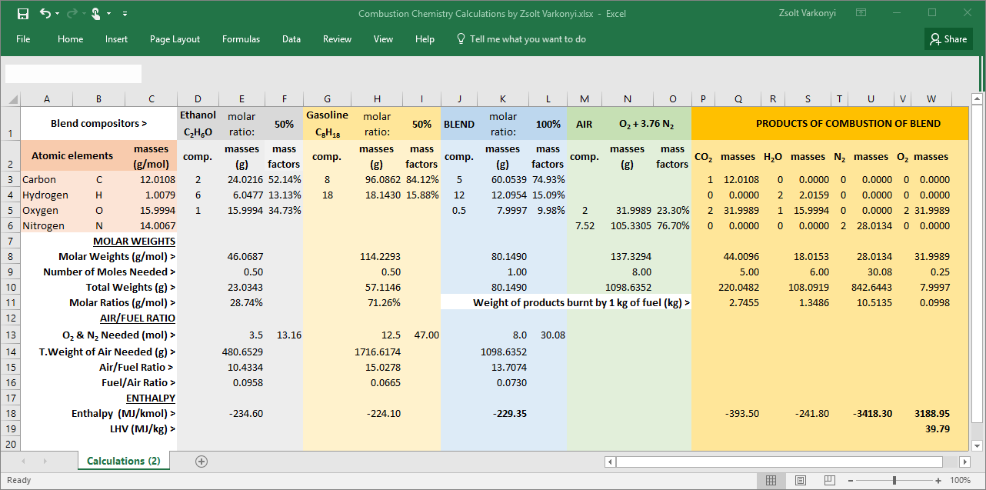

Bibliography
Cayman Chemical. (2017, 11 18). Molar Mass and Mass Percent Composition Calculator. Retrieved from Molar Mass Calculator Tool: https://www.caymanchem.com/chemAssistant/Tool/4002
CONCAWE Fuels Quality and Emissions Management Group. (2006). Assessment of the impact of ethanol content in gasoline on fuel consumption, including a literature review up to 2006. Brussels.
Flagan, R. C., & Seinfeld, J. H. (1988). Combustion Fundametnals. In C. I. Technology, Fundamentals of Air Pollution Engineering (pp. 59-166). New Jersey: Prentice-Hall Inc.
Kirk, D. R. (2018, 01 01). Advanced Propulsion - Introduction and Chemical Equilibrium. Retrieved 11 18, 2017, from Slideplayer.com: http://slideplayer.com/slide/5284369/
National Center for Biotechnology Information. (2017, 11 18). 2,2,4-Trimethylpentane. Retrieved from PubChem Compound Database: https://pubchem.ncbi.nlm.nih.gov/compound/10907
National Center for Biotechnology Information. (2017, 11 18). Carbon. Retrieved from PubChem Compound Database: https://pubchem.ncbi.nlm.nih.gov/compound/5462310
National Center for Biotechnology Information. (2017, 11 18). Ethanol. Retrieved from PubChem Compound Database: https://pubchem.ncbi.nlm.nih.gov/compound/702
National Center for Biotechnology Information. (2017, 11 18). Home. Retrieved from PubChem Compound Database: https://www.ncbi.nlm.nih.gov/pccompound
National Center for Biotechnology Information. (2017, 11 18). Hydrogen. Retrieved from PubChem Compound Database: https://pubchem.ncbi.nlm.nih.gov/compound/783
National Center for Biotechnology Information. (2017, 11 18). Oxygen. Retrieved from PubChem Compound Database: https://pubchem.ncbi.nlm.nih.gov/compound/977
Sadiq, M. A., Ali , Y. K., & Noor, A. R. (2011). Effects of Ethanol-Gasoline Blends on Exhaust and Noise Emissions from 4-Stroke S.I.Engine. Eng. & Tech. Journal, 1438-1450.
THI LUONG DINH, & VU NGUYEN HOANG. (2014). Determination of C/H/O fractions and lower heating values for diesel-biodiesel blends derived from Vietnam. International Journal of Renewable Energy and Environmental Engineering.

