
Skills for the Workplace
Module Assignment Submission
Student Name: | Rhys Ieuan Durlucia
Student Number: | 2010254
Module No: | BMSK4007
Module Title: | Digital Skills and Personal Branding

Statement of Confirmation of Authenticity
By the act of making this submission, the student declares that this is the work of the student named above. The work has not, in whole or in part, been knowingly presented elsewhere for assessment, or where assessment has been built on a previous assessment, this has been identified. Where materials have been used from other sources it has been properly acknowledged. If this statement is untrue, the student acknowledges that an assessment offence has been committed.
Attention is drawn to the plagiarism and unfair practice policies of both the University and of ILM.
Permission for ILM to use this script
ILM uses learners’ submissions – on an anonymous basis – for assessment standardisation. By submitting, both the centre and the learner agree that ILM may use this script on condition that identifying information is removed. However, if you are unwilling to allow ILM use this script, please refuse by ticking the box: □

Table of Contents
What has been the impact of 21st Century Technologies on the modern workplace? 3
Evaluate the appropriate use of modern technologies and social media in the workplace generally 3
Explore the use of modern technologies and social media in own workplace 3
How can Personal branding help YOU? 4
Your LinkedIn Profile to promote your Personal Brand 4
Evaluate the value of other social media platforms to enhance networking and career prospects 4
Examine the impact of Personal Branding on your own employability 4
Discuss personal and professional security and safety online. 4
References 6
Appendix 1 7
Appendix 2 8

What has been the impact of 21st Century Technologies on the modern workplace?

Evaluate the appropriate use of modern technologies and social media in the workplace generally

The report writer would like to talk about some of the technologies that are commonly used within the workplace during the 21st century. Some of the main examples of this would be: Mobile Phones, Computers and WIFI systems. In the 21st century, businesses rely on technology heavily to try and help progress their sales or productivity. The use of these technologies allows the business and the consumer to have a flexible and smooth experience whilst carrying out their service. An example of this could be if a customer was to order a product online from a retailer or a business, then then the company would receive all their order details via a form of technology. This could be from a computer, an automated delivery system or even a mobile phone.
Technology also allows people to work from home if they need to. During the COVID-19 Global Pandemic, Governments around the world recommended people are to stay home so that they can avoid catching the virus. This meant a lot of businesses were forced to close, but it also allowed some businesses to remain open due to technology. For example, a person may have been told to work from home. This would mean that the person would be using technology such as a computer or a laptop to complete their work.
Some technology is more accessible and easier to use. An example of this is a mobile device. These devices are quite considerably smaller than a laptop or computer. This would allow members of the workforce to be able to carry on their job roles without being restricted to a desk and a computer. This makes a mobile device much easier and accessible to use. Workplaces also use technology such as a cloud. A cloud is a storage network which allows people to store information and documents which is easy to access. Businesses tend to rely on Cloud Storage as they can store records and any sensitive information that may need to be accessed at any given point.
There is also messaging services such as WhatsApp and Facebook Messenger. These services allow you to create group chats, which could be an ideal way to create a works group chat. It also allows you too have a facetime meeting as well. This would work well if you were told to stay at home during the pandemic and you had to have virtual meetings with staff and other workforce members. Even though this is a popular way of contacting people, it still has its faults. For example, Facebook messenger allows people to store key personal information such as mobile number and email addresses. This could mean that staff unnecessarily contact managers and other staff members whilst they are at home. Whilst the circumstances may be suitable, it still is frustrating for managers and other staff members to be contacted during off-peak hours.

Explore the use of modern technologies and social media in own workplace

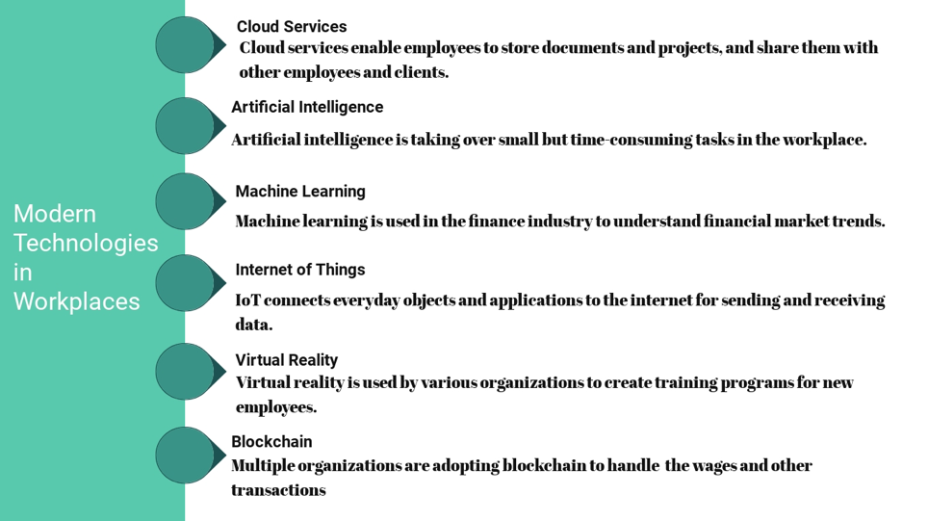

(Modern technology is constantly rewriting the future of work (allerin.com) 2018.

The report writer has done research into the use of modern technology in the workplace within the 21st Century. The report writer has found that there are various types of technology used within the modern workplace. As seen above, the writer found some online research which highlighted what types of technology is used within the workplace. For example, the report found highlighted that Artificial Intelligence. The use of Artificial Intelligence is being more and more used within workplaces especially when the demand for certain things become more advanced.
According to Bernard Marr, a Writer for the FORBES magazine, an example of this would be when a company uses employment pre-screening when someone applies for a job. In his article from 29th May 2019, (Artificial Intelligence In The Workplace: How AI Is Transforming Your Employee Experience (forbes.com) , Marr goes on to explain how AI is being used and utilised in the current day and age. The pre-employment screening mechanism allows companies to have a narrowed list of potential candidates based on their suitability for the job and their qualifications. This type of AI (Artificial Intelligence) is becoming used much more frequently within businesses. This is because companies do not have to use people to manually sift through the applications and speak to the candidates, the AI would do that for them. It would also be cost effective for businesses as well as they would not have to pay someone a wage to complete these tasks so it would also be cost effective for the businesses as well.

Another example of technology being used within the workplace is Machine Learning. This type of technology can be used in many sectors. An example of this would be in the medical profession. The medical profession uses things like X-Ray machines, MRI machines and devices which allow medical professionals to discover if someone has a disease.

How can Personal branding help YOU?

Your LinkedIn Profile to promote your Personal Brand

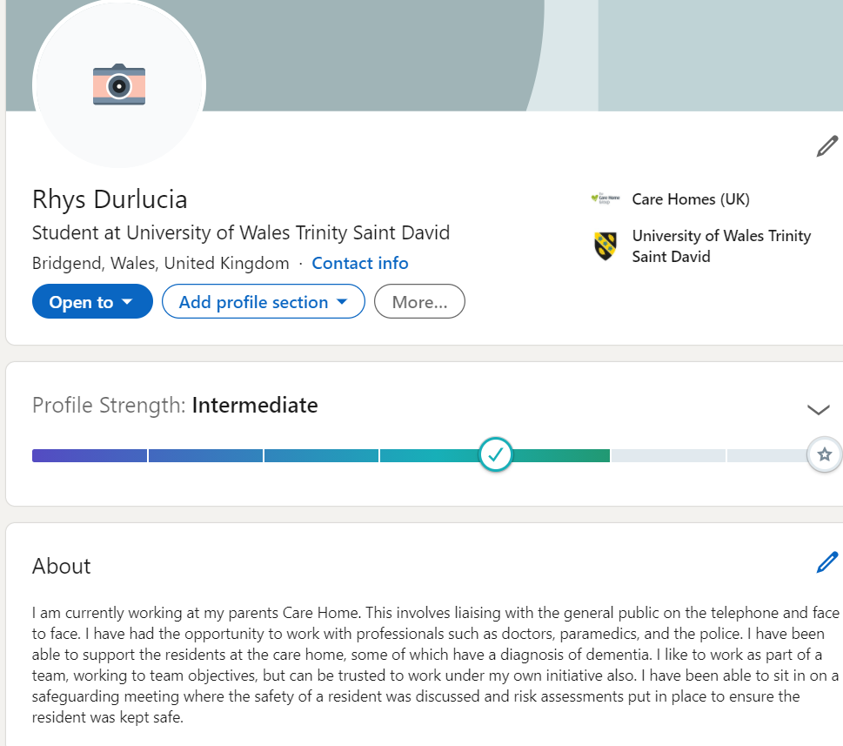

Evaluate the value of other social media platforms to enhance networking and career prospects

Name of the Social Media | The type of social media | Is it used for social networking or professional networks? | The Advantages | The Disadvantages
Facebook | This is a platform which allows people to connect with friends and family across the world. | It can be used for both social and also professional networks. | There are many advantages of facebook:  Able to create a profile which has information about you and facts about you.  The ability to upload photos and videos so that all of your friends and followers can see.  There is no price incurred to create an account, it is completely free. | There are also many disadvantages of facebook:  For Example: It is becoming a problem on facebook where people are creating fake accounts and portraying themselves as other people.  Other people can see information about you and photos of you.  People are able to send you spam messages, which can be very frustrating.
Instagram | This Platform allows you to post photos and videos. There is also a feature which allows you too start a live video so you can share | It is both social and professional networking. | There is no cost to sign up to Instagram.  The ability to post photo and videos for all of your followers to see. | People can create fake accounts.  People can send you spam messages as well as spam photos.

Examine the impact of Personal Branding on your own employability

Personal Branding is they way someone portrays themselves too other. The official description of personal Branding is “Personal Branding is the practice of marketing people and their careers as brands.” (digital marketing.org). Other examples of this could be that the report writer could make a good first impression when they go for an interview.
A famous example of personal branding could be Oprah Winfrey. Influencer marketing hub created an article about ten famous people that have their own unique personal branding. One quote emphasizes just how she used her personal branding to her advantage. “Oprah has managed to leverage her personal branding to enable her to become a billionaire” (Influencer Marketing Hub). This quote outlines just how people how have developed a personal brand and how they can potentially use it their advantage.
A way the report writer could improve there personal branding and make it have a better impact is making sure that when they meet new people, they set good impressions and that they come across as confident. This can be reassuring to the person that you are talking too. They could also make sure that they have positive body language as the report writer will want it too to make it look like they are engaged in the conversation

Discuss personal and professional security and safety online.

Online safety and security are a massive issue in the current day and age. There are now many ways in which your personal data and details can be stolen or intercepted. People who illegally obtain your personal information are called “Scammers”. There are authorities and mechanisms in place in which can try and stop those people. One of these mechanisms is “The Data Protection Act”. According to www.Citizensadvice.org.uk, There are around “4 million “online scams each year across England and Wales. That works out to be just under 11,000 successful online scams.
The people who enforce those data protection rules are the ICO (Information Commissioners Office). These are the UK data protection watchdog. The regulators enforce the rules of data protection. The rules are called GDPR (General Data Protection Regulation).
There are many ways to protect your computer also from virus’. For example, there are many anti-virus software’s that you can download which protect your computer storage and files from being stolen or even deleted. An example of this would-be Norton 365 and McAfee. Norton have said that “Multi-layered, advanced security helps protect your devices and information from online threats like viruses, malware, and phishing”
Mcafee’ mission statement is “We believe that no one person, product, or organization can fight cybercrime alone. Its why we rebuilt Mcafee around the idea of working together.”
Norton and Mcafee also offer password protector. This is where they store all of your passwords so that they can be kept safe, convenient and also out of the hands of the scammers who will try and steal your information. Norton said on their website “ Secures logins and more in your private, online vault. Creates complex passwords when you need them. Encrypts your information before it leaves your device.”

References

(Modern technology is constantly rewriting the future of work (allerin.com) 2018.

(Artificial Intelligence In The Workplace: How AI Is Transforming Your Employee Experience (forbes.com)

“Personal Branding is the practice of marketing people and their careers as brands.” (digital marketing.org)

. “Oprah has managed to leverage her personal branding to enable her to become a billionaire” (Influencer Marketing Hub)

www.Citizensadvice.org.uk – statistic of 4 million online scams each year across England and Wales.

www.gdpr.eu - what does GDPR mean?

www.ICO.org.uk - What does ICO mean?

www.nortonlifelock.com - “Multi-layered, advanced security helps protect your devices and information from online threats like viruses, malware, and phishing”

www.comparably.com – Mcafee mission statement - “ We believe that no one person, product, or organization can fight cybercrime alone. Its why we rebuilt Mcafee around the idea of working together.”

www.my.norton.com – on password manager “ Secures logins and more in your private, online vault. Creates complex passwords when you need them. Encrypts your information before it leaves your device.”

Appendix 1

Appendix 2

