Morgan Jones
2210512

BA Computer Games Design

Changemakers: Building your personal brand for future employment
ACCA5035

E-Portfolio Evidence of learning

Contents
- Website Design Link
- Research and Inspiration
- In depth Research
- My Website Design
- Fonts
- Reoccurring features
- Accessibility
- Reference images
- References
- Bibliography

Website Design Link

https://a2210512.myportfolio.com/

Research and Inspiration
When creating the design for my website, I knew that I wanted the design to be that of a portfolio/showcase website. Before I started working on the layout of my website, I had a look online for examples of portfolio websites from other 3D artists in the games industry. Below you can see some screenshots of the websites I found to be inspiring:
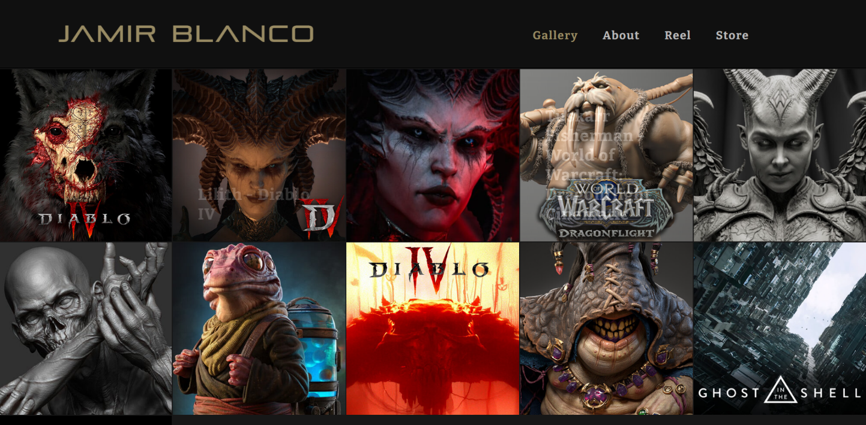
[1]
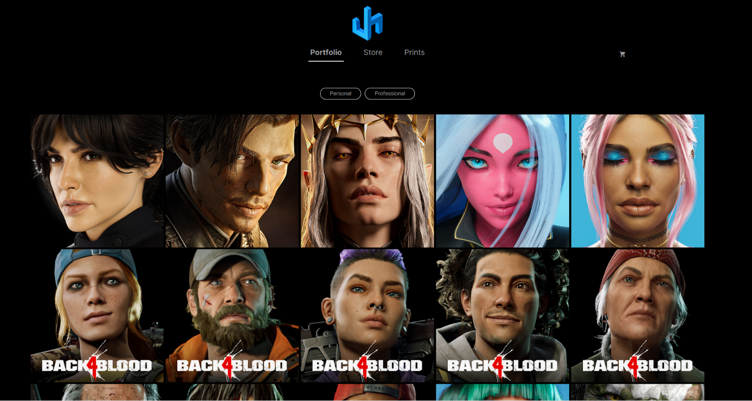[2]

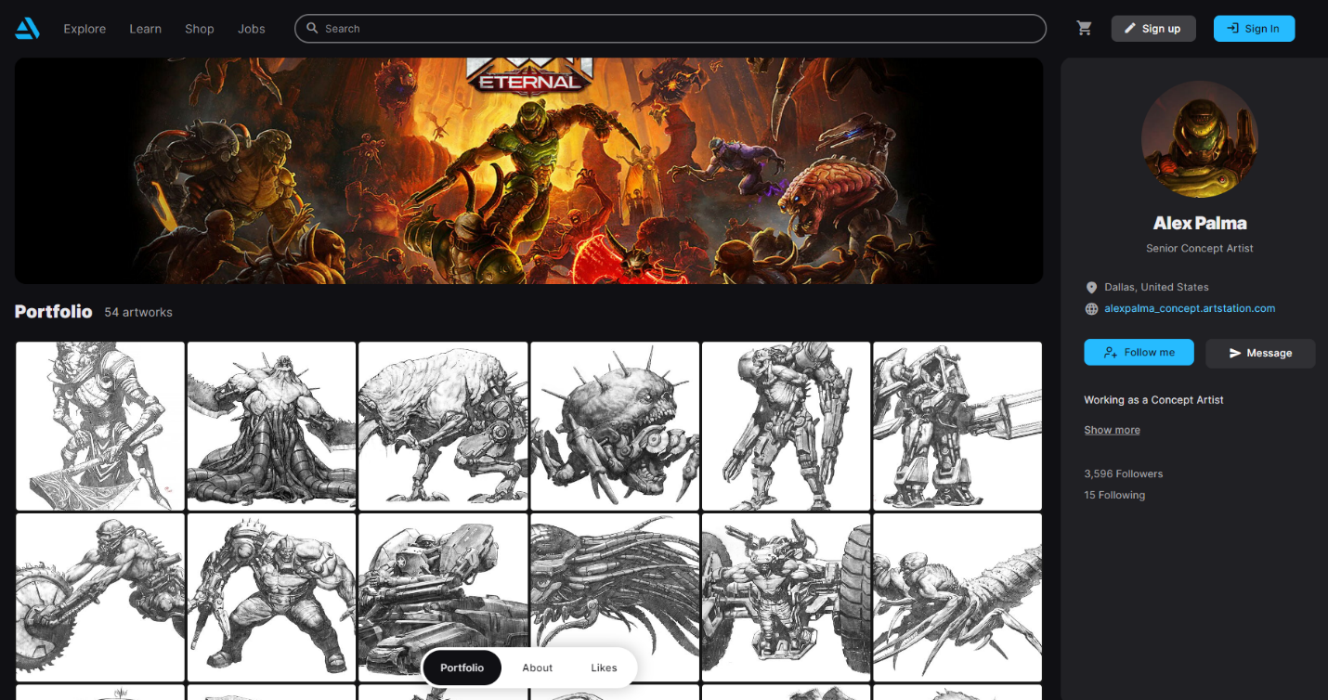[3]

In depth research
Now I’d like to use JHill’s portfolio website to take a more in-depth look and to show what I liked about their website design.
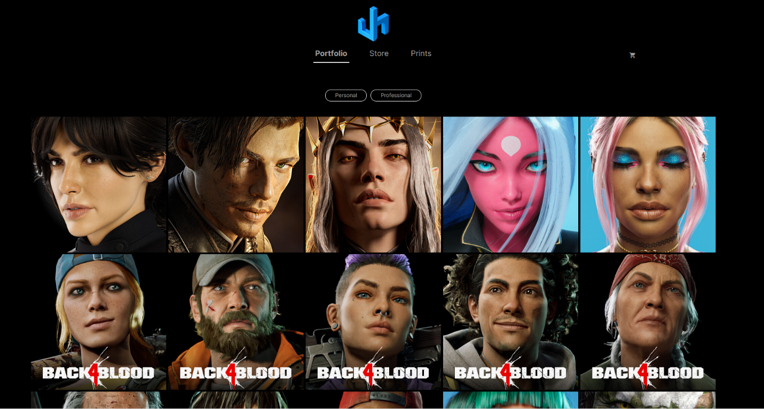[2]
The homepage for this website has little to no text but is filled with different photos of characters that Jhill has worked on. I like this approach as each photo is unique and eye catching, with no text to distract you.
If there is a particular character photo you like the look of and would like to get more detail; you can click the photo which will take you to a new subpage with more detail of said character. For example, if you click the photo of “Holly” from “Back 4 Blood”, you are greeted with a page like this:
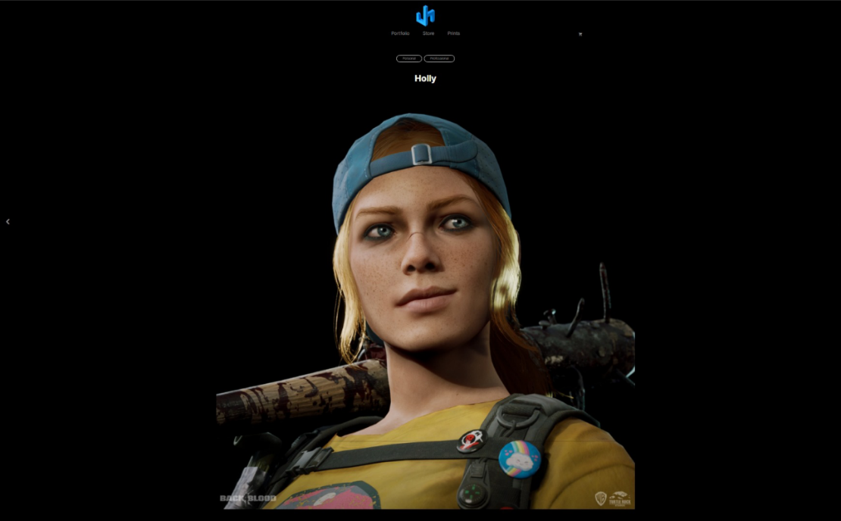
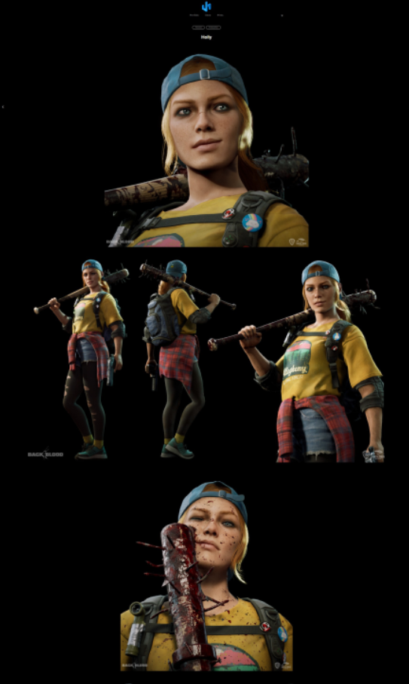
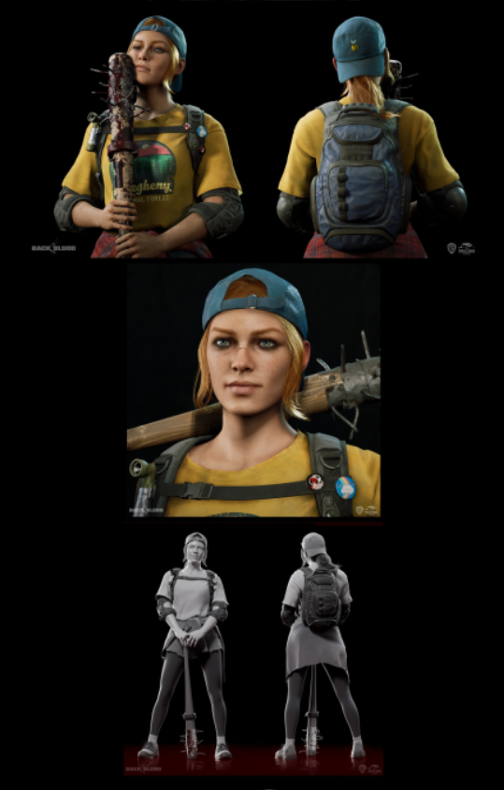
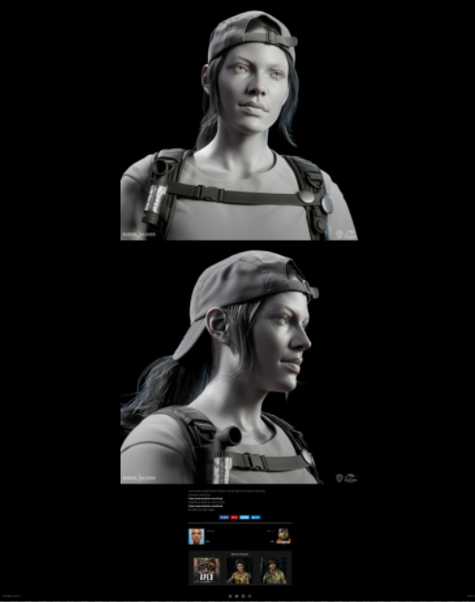

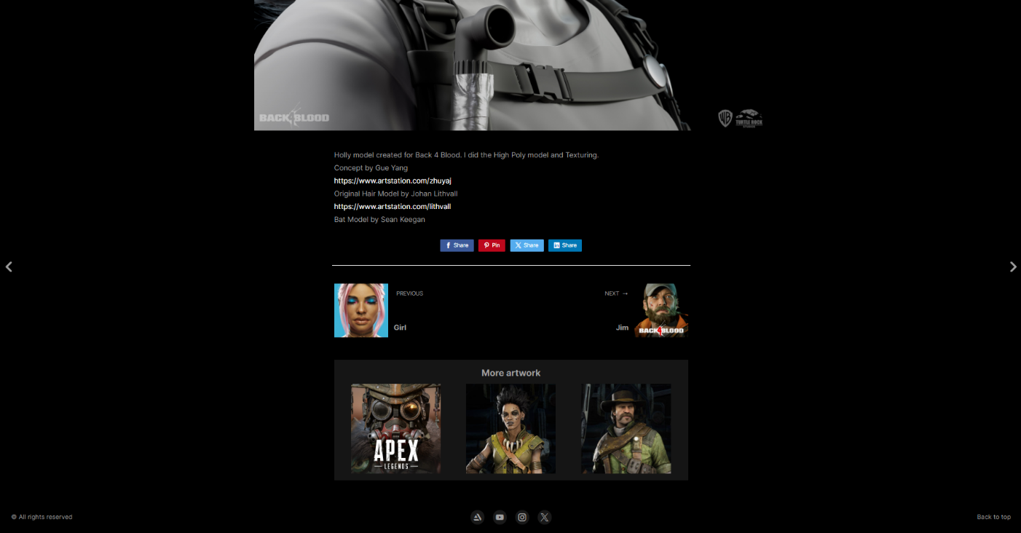
[4]
As we can see by the images the layout follows a structure of:
Home + Navigation buttons - (Great for navigating the user back to the homepage).
Showcase photos of the work - (Allows the user to see more photos from the project).
A brief description of the work + Credits - (Gives the user an insight on the project).
Other projects - (Gives the user an opportunity to look at other work that grabs their attention).
Socials - (Helps the artist grow their following, by providing a link to their social accounts).
This is the type of layout I am looking to replicate in my portfolio.

My Website Design
For my portfolio I decided to create my website in Adobe Portfolio. The reasoning for this is that I'm familiar with the tools of Adobe Portfolio, and knew that I could build a website layout that I wanted, using Adobe portfolio.
Homepage
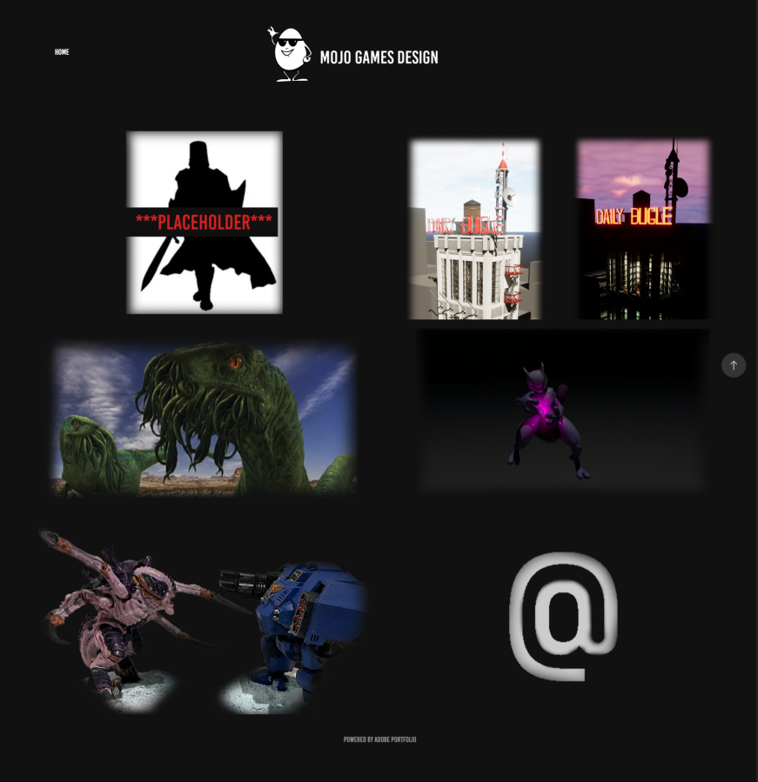
[5]
My websites homepage is broken into 6 sections:
-3D Character Models [6] -3D Environment Models [7]
-Concept Art [8] -Animations [9]
-Miniature Paintings [10] -About me [11]
Thanks to the ‘Ludwig’ template in Adobe Portfolio, I was able to have a homepage that was populated with images. These images have subheadings when the user hovers over them; I can also have the images serve as link to a subpage on my website; similar to Jhill’s website.
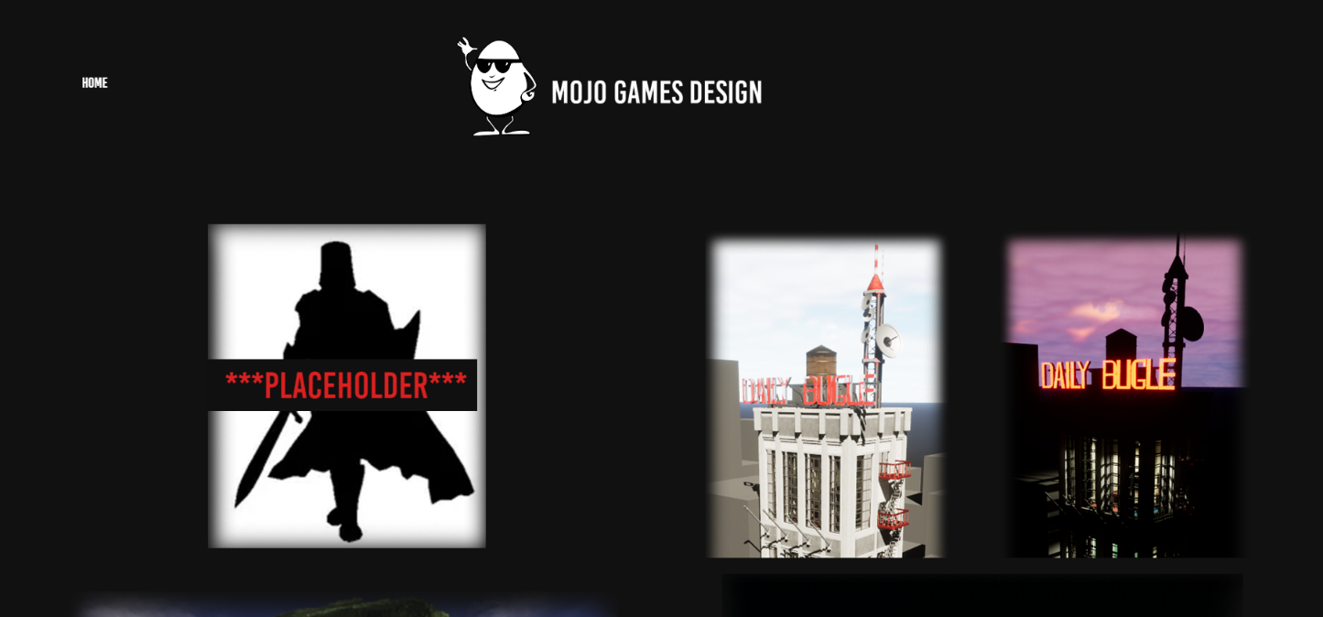
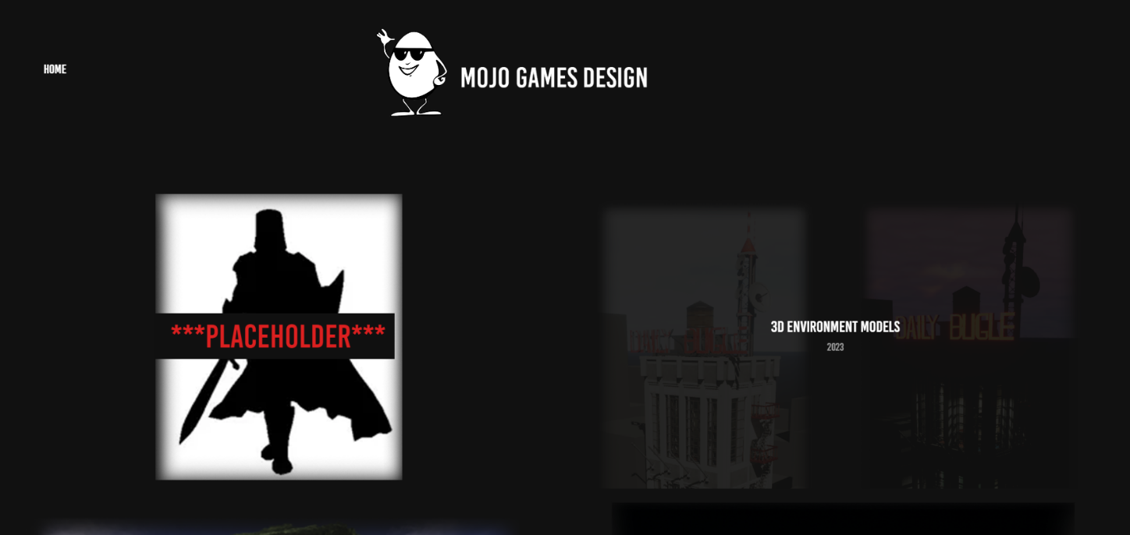[5, 12]
The only downside to the ‘Ludwig’ layout is that you aren’t able to have any text on your homepage, however this allowed me to make a separate page for an “about me” [11], which I feel benefitted me as I could have an entire page dedicated to me and my brand, rather than a small section on the homepage.

Fonts
I decided to use the “Bebas Kai Regular” font for the text on the website.
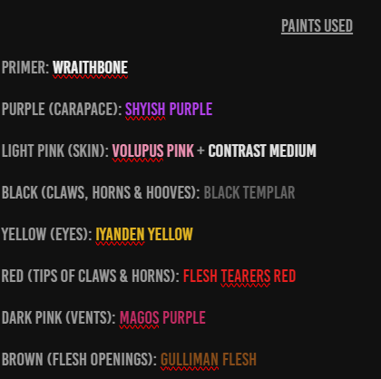
[13]
I like this font as it makes the letters big and bold; and although the letters are always in capitals, I think it works as my website doesn’t have much text. I also wanted to mention that for the “paint used” in the “miniature paintings” section [13]; I thought it would be a nice touch to change the font colour of the paint names to match the paint colour. For example “Iyanden Yellow” is the colour yellow.

Reoccurring features
To make navigation easier for the user I wanted to make sure that every page had a button that would take you back to the homepage. Due to most pages being long, I went with the option that allows the “Home” button and the website's main graphic to stay at the top of the page, even when scrolling down.
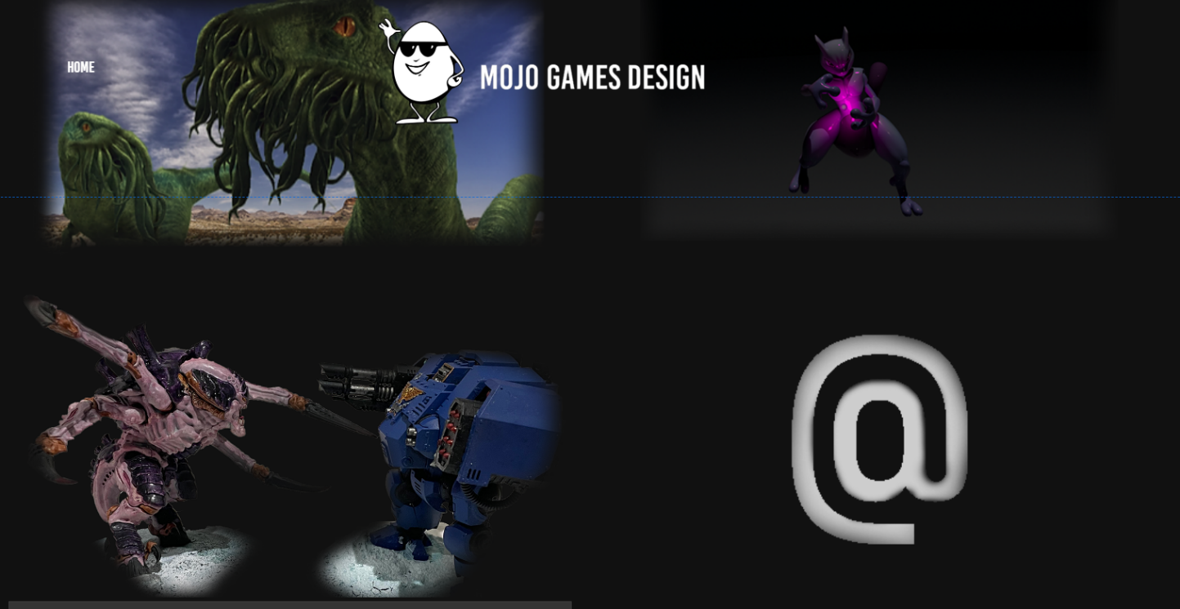[14]
At the bottom of every page there is a “You may also like” that allows the user to quickly navigate to one of the other subpages.
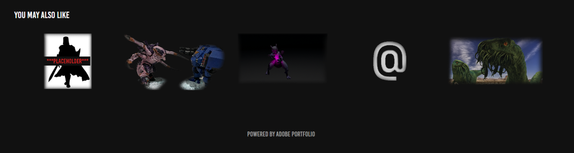[15]
Finally, for the subpages that go into more depth on a certain piece (Daily Bugle scene, Screamer Killer, model etc). I’ve made it so the website opens them in a new tab, in case the user wants to bookmark, or keep a specific project open, whilst they navigate the rest of the website.

Accessibility
To help users with poor eyesight, you can click on an image to enhance it, as well as hovering over an image will give you a brief description of the image.

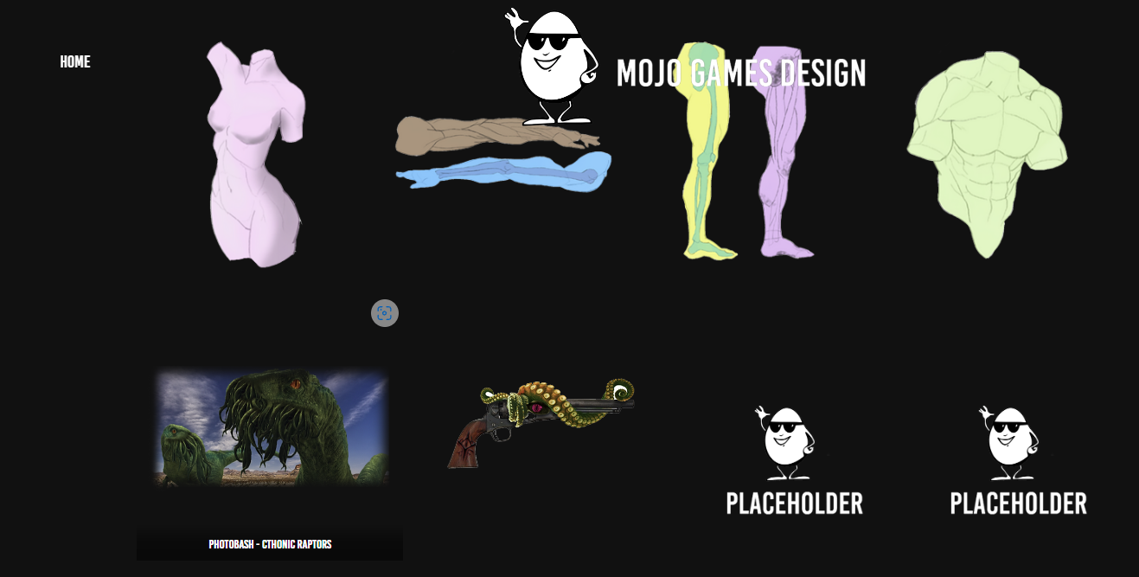
[16]
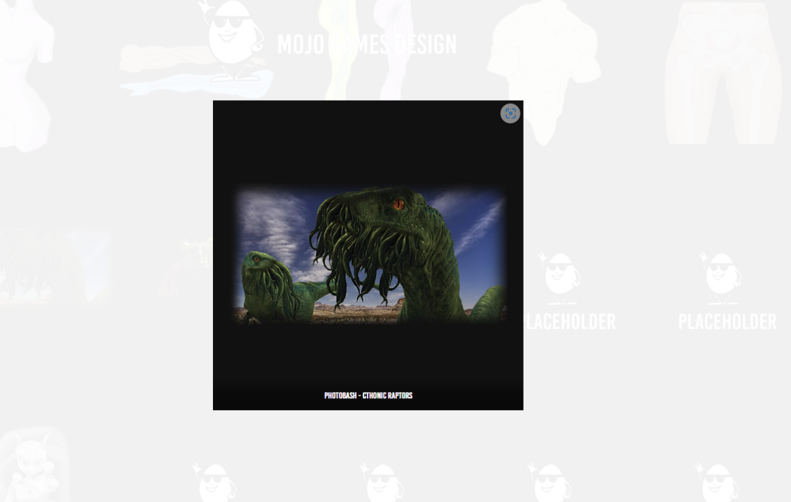
[17]

Reference Images
References for images that were used as placeholders.

[18]

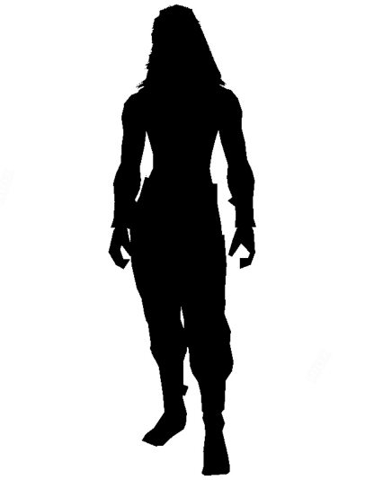
[18]

References
[1] Blanco, J. (No date). Jamir Blanco. Picture: “Screenshot of homepage”. Available at: https://jamirblanco.com/ (Accessed: 20 October 2023).
[2] Hill, J. (No date). Portfolio Art of JHill. Picture: “Screenshot of homepage”. Available at: https://artofjhill.com/projects (Accessed: 20 October 2023).
[3] Artstation.com. (No date). Artstation - Alex Palma. Picture: “Screenshot of homepage”. Available at: https://www.artstation.com/alexpalma_concept (Accessed: 20 October 2023).
[4] Hill, J. (No date). Portfolio Art of JHill. Picture: “Screenshot of Holly character”. Available at: https://artofjhill.com/projects/yk9Yn9 (Accessed: 24 October 2023).
[5] Jones, M. (2023). Portfolio Morgan Jones. Picture: “Screenshot of homepage”. Available at: https://a2210512.myportfolio.com/ (Accessed: 01 November 2023).
[6] Jones, M. (2023). Portfolio Morgan Jones. Available at: https://a2210512.myportfolio.com/3d-character-models (Accessed: 01 November 2023).
[7] Jones, M. (2023). Portfolio Morgan Jones. Available at: https://a2210512.myportfolio.com/3d-environment-models (Accessed: 01 November 2023).
[8] Jones, M. (2023). Portfolio Morgan Jones. Available at: https://a2210512.myportfolio.com/concept-art (Accessed: 01 November 2023).
[9] Jones, M. (2023). Portfolio Morgan Jones. Available at: https://a2210512.myportfolio.com/animations (Accessed: 01 November 2023).
[10] Jones, M. (2023). Portfolio Morgan Jones. Available at: https://a2210512.myportfolio.com/miniatures-paintings (Accessed: 01 November 2023).
[11] Jones, M. (2023). Portfolio Morgan Jones. Available at: https://a2210512.myportfolio.com/about-me (Accessed: 01 November 2023).
[12] Jones, M. (2023). Portfolio Morgan Jones. Picture: “Screenshot of homepage, showing subpage title”. Available at: https://a2210512.myportfolio.com/ (Accessed: 01 November 2023).
[13] Jones, M. (2023). Portfolio Morgan Jones. Picture: “Screenshot of paints used for Screamer Killer miniature”. Available at: https://a2210512.myportfolio.com/screamer-killer (Accessed: 01 November 2023).
[14] Jones, M. (2023). Portfolio Morgan Jones. Picture: “Screenshot of homepage, home button and website graphic scrolled own”. Available at: https://a2210512.myportfolio.com/ (Accessed: 01 November 2023).
[15] Jones, M. (2023). Portfolio Morgan Jones. Picture: “Screenshot of You may also like tab”. Available at: https://a2210512.myportfolio.com/animations (Accessed: 01 November 2023).
[16] Jones, M. (2023). Portfolio Morgan Jones. Picture: “Screenshot of accessibility text on concept art photo”. Available at: https://a2210512.myportfolio.com/concept-art (Accessed: 01 November 2023).
[17] Jones, M. (2023). Portfolio Morgan Jones. Picture: “Screenshot of accessibility zoomed in option”. Available at: https://a2210512.myportfolio.com/concept-art (Accessed: 01 November 2023).
[18] Reddit.com. (2023). You guys seen this little fella? he’s got sunglasses on. Reddit. Picute: “you-guys-seen-this-little-fella-hes-got-sunglasses-on-v0-0b7m7da5gc1b1” Available at: https://www.reddit.com/r/ColdOnes/comments/13of6jg/you_guys_seen_this_little_fella_hes_got/?rdt=58725 (Accessed: 01 November 2023).

[19] Silhouette.pics. (No date). Mottled prisoner character silhouette picture @ Silhouette.pics. Picture: “mottled-prisoner-character-silhouette-picture-52650-200209” Available at: https://www.silhouette.pics/200209/mottled-prisoner-character-silhouette-picture.php (Accessed: 01 November 2023).

Bibliography
Websites:
Blanco, J. (No date). Jamir Blanco. Available at: https://jamirblanco.com/
Hill, J. (No date). Portfolio Art of JHill. Available at: https://artofjhill.com/projects
Artstation.com. (No date). Artstation - Alex Palma. Available at: https://www.artstation.com/alexpalma_concept
Jones, M. (2023). Portfolio Morgan Jones. Available at: https://a2210512.myportfolio.com/ (Accessed: 01 November 2023).

Pictures:
Blanco, J. (No date). Jamir Blanco. Picture: “Screenshot of homepage”. Available at: https://jamirblanco.com/
Hill, J. (No date). Portfolio Art of JHill. Picture: “Screenshot of homepage”. Available at: https://artofjhill.com/projects
Artstation.com. (No date). Artstation - Alex Palma. Picture: “Screenshot of homepage”. Available at: https://www.artstation.com/alexpalma_concept
Hill, J. (No date). Portfolio Art of JHill. Picture: “Screenshot of Holly character”. Available at: https://artofjhill.com/projects/yk9Yn9
Jones, M. (2023). Portfolio Morgan Jones. Picture: “Screenshot of homepage”. Available at: https://a2210512.myportfolio.com/
Jones, M. (2023). Portfolio Morgan Jones. Picture: “Screenshot of homepage, showing subpage title”. Available at: https://a2210512.myportfolio.com/
Jones, M. (2023). Portfolio Morgan Jones. Picture: “Screenshot of paints used for Screamer Killer miniature”. Available at: https://a2210512.myportfolio.com/screamer-killer
Jones, M. (2023). Portfolio Morgan Jones. Picture: “Screenshot of homepage, home button and website graphic scrolled own”. Available at: https://a2210512.myportfolio.com/
Jones, M. (2023). Portfolio Morgan Jones. Picture: “Screenshot of You may also like tab”. Available at: https://a2210512.myportfolio.com/animations
Jones, M. (2023). Portfolio Morgan Jones. Picture: “Screenshot of accessibility text on concept art photo”. Available at: https://a2210512.myportfolio.com/concept-art
Jones, M. (2023). Portfolio Morgan Jones. Picture: “Screenshot of accessibility zoomed in option”. Available at: https://a2210512.myportfolio.com/concept-art

Reddit.com. (2023). You guys seen this little fella? he’s got sunglasses on. Reddit. Picute: “you-guys-seen-this-little-fella-hes-got-sunglasses-on-v0-0b7m7da5gc1b1” Available at: https://www.reddit.com/r/ColdOnes/comments/13of6jg/you_guys_seen_this_little_fella_hes_got/?rdt=58725
Silhouette.pics. (No date). Mottled prisoner character silhouette picture @ Silhouette.pics. Picture: “mottled-prisoner-character-silhouette-picture-52650-200209” Available at: https://www.silhouette.pics/200209/mottled-prisoner-character-silhouette-picture.php

