Digital Surveying - Levelling & Computation

Name of Student: Mark Robinson

Student ID: 0952289

Name of Award: HND Construction managment

Mode: Part Time

Table of Contents

Introduction 3
General overview of levelling surveying 3
Equipment used in levelling. 3
Levelling procedure 4
Computation and plotting of level 7
Conclusion 9
Reference list 10

Introduction
This report will give an overview of what constitutes a levelling survey, the equipment used, a step by step guide when conducting a levelling survey and finally how to organise the data that was collected. As part of the assignment we undertook a levelling survey within the grounds of Swansea campus to plot the path of a new road, we were provided with the equipment and a benchmark in order to provide us with starting data.
We were tasked to take levels at 20-meter intervals for a minimum of 25 survey points along the route. From this raw data we must then calculate the reduced levels using either the rise and fall method or height of collimation. The reduced levels can then be plotted graphically and used to provide the estimated volume of earthwork that will need to be excavated and / imported onto site.

General overview of levelling surveying
A levelling survey can be conducted to find a number the height of one point relative to another, this can be used for a number of applications within the construction industry. This could be used to determine the relative height of a location taken from a known point or benchmark, it could be used just to create a new benchmark point within the construction site or a series of points that show the shape of the land over a chosen route (Designing Buildings, 2020). By taking datum points at regular intervals, we can map the shape of the land and use this information for earthwork calculations,

Equipment used in levelling.
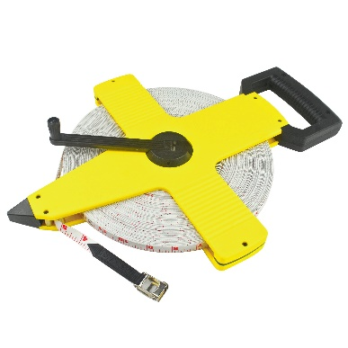
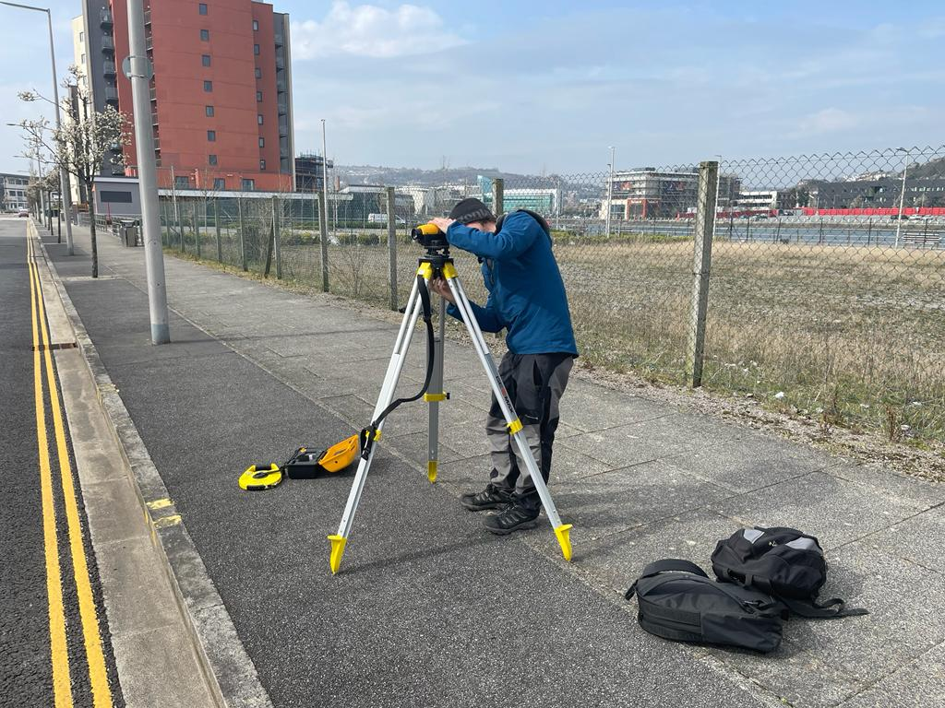
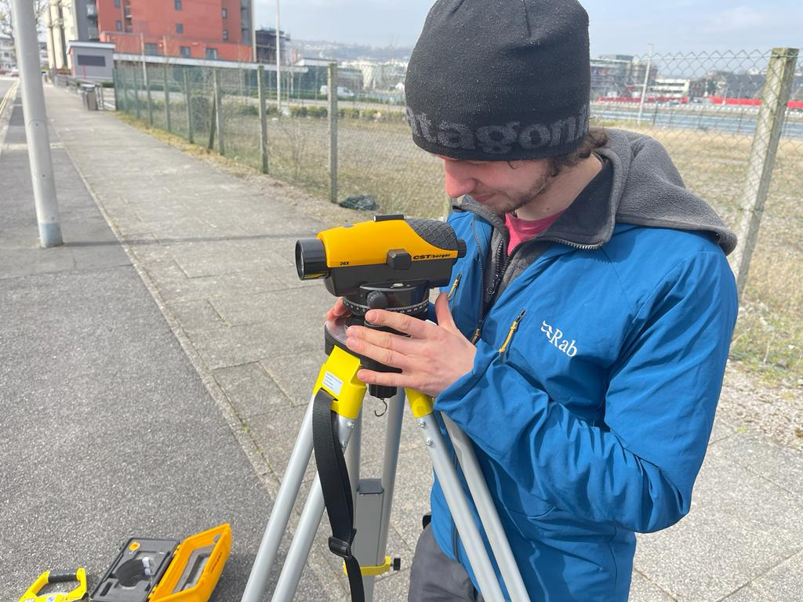
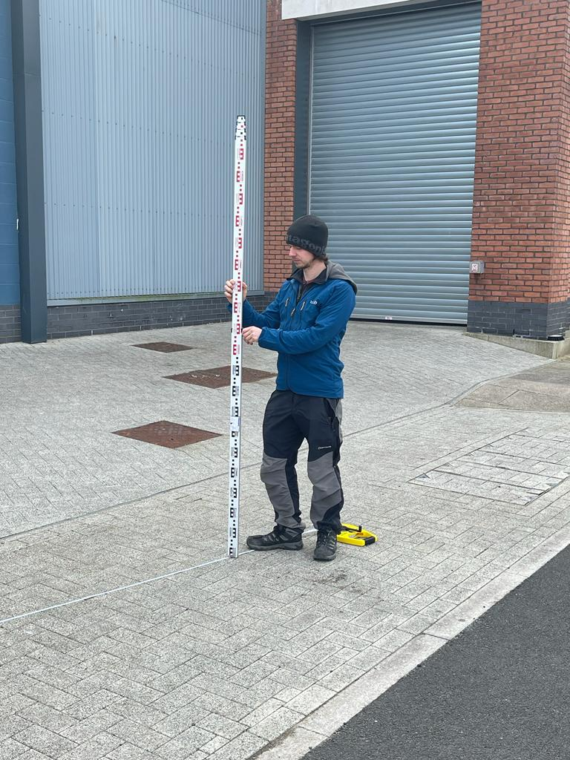
Tripod – Figure 1
Figure 1
Figure 2
Figure 3
Figure 4
The tripod is used to securely hold the dumpy level at a height comfortable for the used (Wiki How, 2019). The tripod will have three adjustable legs and is usually made from a strong but light material.
Dumpy Level – Figure 2
This instrument consists of a telescope that can be rotated horizontally but has no vertical movement. A base on three adjustable screws so that instrument can be easily adjusted. A bubble level that’s usually fixed to the side of the telescope, this is used in conjunction with the screws get the instrument level (Civil Today, n.d.).
Fabric tape – Figure 3
To measure distance between each datum point we can use this tape. The fabric tape means it will not rust when used in inclement weather conditions and that’s its lightweight relative to its length.
Staff – Figure 4
Historically the staff was made from timber but now its used is usually of an extendable aluminium make between 2 and 4 meters. The markings are easily read from a distance being made up of blocks of red and black colour (Civil Seek, n.d.).
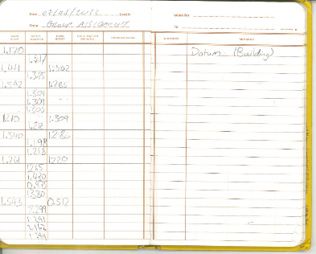
Chalk – Used to mark datum points
Figure 5
Recording sheet – Figure 5
A booklet with pre-determined columns for recording the essential data in a levelling survey. The benefit of this type of book is that it reduces risk of recording information as the wrong type of sight.

Levelling procedure
When conducting a levelling survey its important to ensure accuracy of the data that is recorded. In our survey we took a number of steps to reduce the chance of error.
- We had two people take the readings through the dumpy level to double check the reading was accurate in order to reduce human error reading and writing the raw data.
- The person holding the staff put their hand up once they were holding the staff plumb (using the spirit bubble so the rest of the team knew they were ready for a reading to be taken.
In addition to this, we undertook a number of steps to increase the efficiency of the survey.
- We did not do any computation in the field; this was all done later once all raw data was collected.
- We identified locations for our stations that would be able to capture the most data before moving on to the next.
- We used chalk to mark 20m intervals for our readings prior to moving the station.
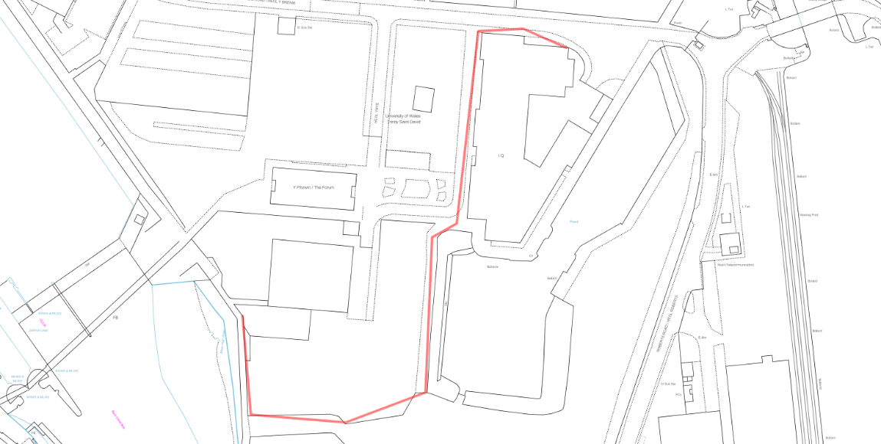
Benchmark
Final Foresight
First instrument station
Route of the survey
Figure 6
N

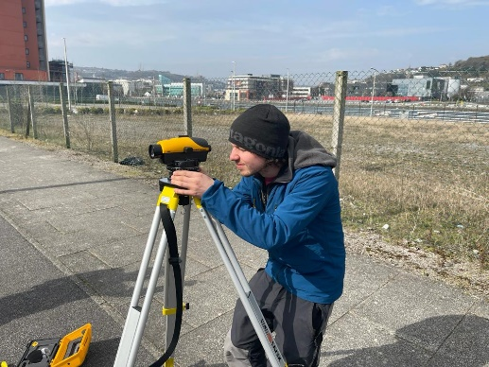
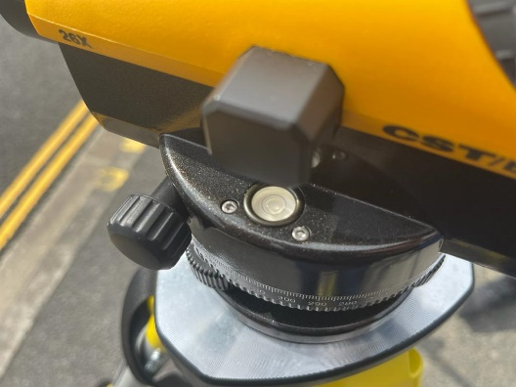
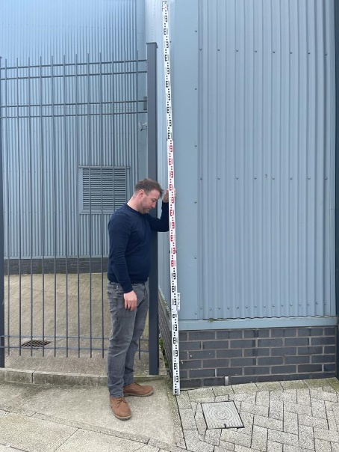
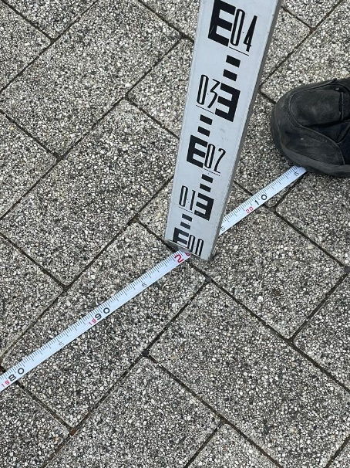
We started our survey by identifying our starting point, this was the north east corner of the IQ building on Swansea campus, this corner is our benchmark and known point (see figure 6). From here our route took us west and then south around the building, across the car park, south perpendicular to the dock and lastly west and then north following the edge of the waste ground.
Figure 7
Figure 8
Figure 9
Figure 10
We decided to set up our first instrument station opposite the corner of the building and within sight of the first road we would be carrying out our survey on. We set out the tripod making sure each leg was secure and not resting on lose ground such as gravel or pebbles. The top of the tripod was positioned so that it would not be a strain for any of the members in the group to use and was levelled by eye so that minimal adjustment would be required on the dumpy level. The dumpy level was fixed securely to the tripod with the thumb screw fitting (see figure 7), then using the three levelling screws the bubble was cantered in the bubble level (see figure 8). As a check to make sure the instruments level was accurate we rotated the telescope and looked at the level, there was no alteration of the bubble level so we proceeded to the next step. We decided to rotate the members of our team on each position, two using the dumpy level, one holding the staff and the last member would measure to the next datum point and mark the area with chalk.
In order to get accurate measurements we made sure each person was briefed on how to read the staff as it is not used like a standard tape. Each block of colour is equal to 10 millimetres with measurements being taken from the bottom of the block of colour and working up to the crosshair.
The north east corner of the IQ building was out starting point / temporary benchmark, we held the staff at this point ensuring that it was held plumb using the bubble level on the rear (see figure 9). Once the staff was vertical and steady looked through the telescope, using the focus wheel to make the image as clear as possible and the left right adjustment to center the image on the staff readings. We concluded the measurement was 1170 millimetres. We entered this reading into the backsight column on our recording sheet.
Using the tape we measured a 20 meter interval (see figure 10) to our next point and marked it with chalk (see figure 11), this becomes our first intermediate sight. The staff was relocated to the point marked with chalk and a reading taken with the same procedure as before but the figure taken was put into the intermediate column on the row below the backsight, row 2. This figure was 1417 millimetres. We followed this procedure again measuring 20 meters, marking another point with chalk which was 40 meters from the starting point we moved the staff and took another reading, this would be our foresight before we moved our dumpy level to its second instrument station along the route. A figure of 1502 millimetres was recorded in the foresight column on row 3.
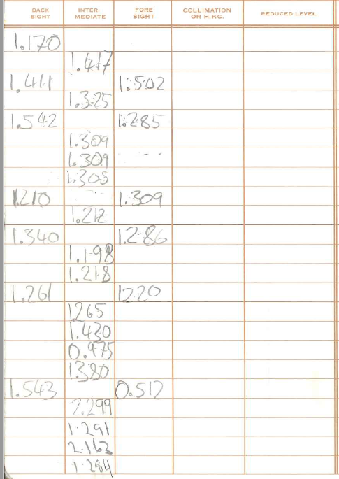
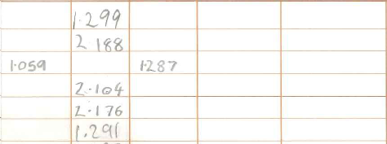
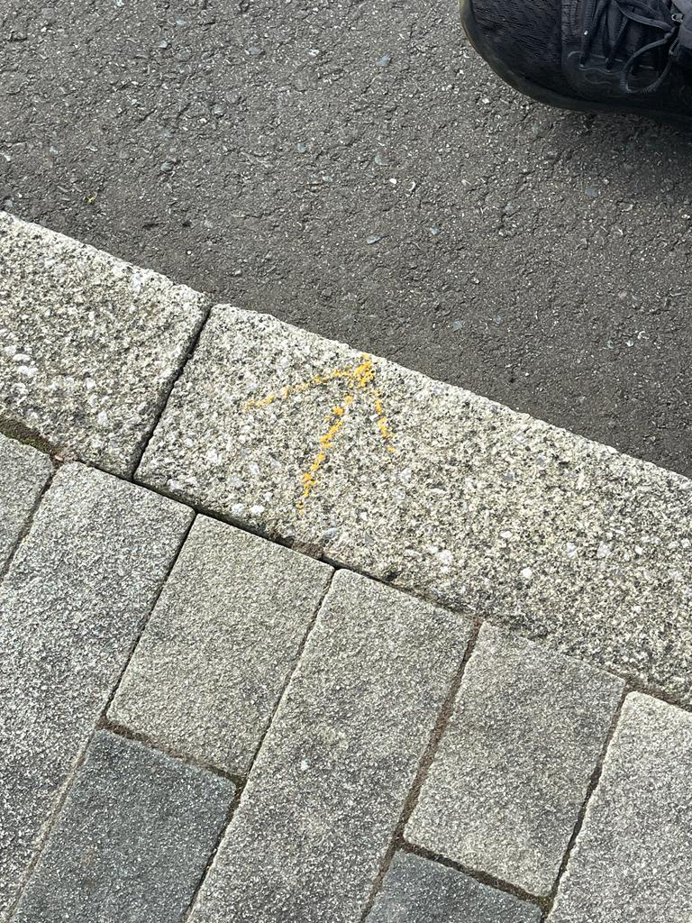
At this point we needed to move the dumpy level to a new station point in order to proceed with the survey, we kept the staff in the same place but now we moved the dumpy level to a new point where we could see further down the route of our survey. We set the tripod and level up using the same steps to ensure accuracy and took a backsight reading to the last point the staff was held, this was a measurement of 1411 millimetres and was recorded in row 3 in the backsight column. The survey was completed using this method of moving the staff at 20 meter intervals until we reached a distance from the dumpy level where we couldn’t no longer accurately read the staff, we then moved the dumpy level ahead. In total 29 datum points (including the temporary benchmark) were recorded over the length of the proposed road.
Figure 11
Figure 10
The complete record of the data taken from the survey is shown in figure 11.

The Weather at the time of the survey was clear, cold and with a strong wind, this wind may have had a negative impact on the accuracy of the data recorded however it is deemed negligible for the purpose of this survey.

Computation and plotting of level
T | Backsight | Intermediate | Foresight | Rise/Fall | Reduced Level | Distance (m)
1 (Datum) | 1.170 |  |  |  | 595 | 0
2 |  | 1.417 |  | -0.247 | 594.753 | 20
3 | 1.411 |  | 1.502 | -0.085 | 594.668 | 40
4 |  | 1.325 |  | 0.086 | 594.754 | 60
5 | 1.542 |  | 1.285 | 0.040 | 594.794 | 80
6 |  | 1.309 |  | 0.233 | 595.027 | 100
7 |  | 1.309 |  | 0.000 | 595.027 | 120
8 |  | 1.305 |  | 0.004 | 595.031 | 140
9 | 1.210 |  | 1.309 | -0.004 | 595.027 | 160
10 |  | 1.212 |  | -0.002 | 595.025 | 180
11 | 1.340 |  | 1.286 | -0.074 | 594.951 | 200
12 |  | 1.198 |  | 0.142 | 595.093 | 220
13 |  | 1.218 |  | -0.020 | 595.073 | 240
14 | 1.261 |  | 1.220 | -0.002 | 595.071 | 260
15 |  | 1.265 |  | -0.004 | 595.067 | 280
16 |  | 1.430 |  | -0.165 | 594.902 | 300
17 |  | 0.975 |  | 0.455 | 595.357 | 320
18 |  | 1.380 |  | -0.405 | 594.952 | 340
19 | 1.543 |  | 0.512 | 0.868 | 595.820 | 360
20 |  | 2.299 |  | -0.756 | 595.064 | 380
21 |  | 1.291 |  | 1.008 | 596.072 | 400
22 |  | 2.163 |  | -0.872 | 595.200 | 420
23 |  | 1.284 |  | 0.879 | 596.079 | 440
24 |  | 1.299 |  | -0.015 | 596.064 | 460
25 |  | 2.188 |  | -0.889 | 595.175 | 480
26 | 1.059 |  | 1.287 | 0.901 | 596.076 | 500
27 |  | 2.104 |  | -1.045 | 595.031 | 520
28 |  | 2.176 |  | -0.072 | 594.959 | 540
29 |  |  | 1.291 | 0.885 | 595.844 | 560
 | Backsight | Foresight | Diff | Rise/Fall | Reduced Lvl Check | Total Distance (m)
Total | 10.536 | 9.692 | 0.844 | 0.844 | 0.844 | 560.000
Figure 12
The raw data recorded from the levelling survey was recorded in a levelling book (see Figure 11) but it was then transferred into Microsoft excel (see figure 12) where it could be more easily manipulated. The data from excel contains three basic checks to ensure accuracy of the data, the difference between the sum of the foresights and sum of the backsights, the overall rise and fall over the whole survey and the first reduced level minus the last reduced level. These figures all came out to 844 millimetres and proves that the calculations are correct.
The reduced level and the distance were then extrapolated and created into a line chart.

Figure 13
The line chart (see figure 13) gives a graphical representation of the data and of the rise and fall of the land. The line shown straight between the first and last point illustrates the road, any area below this line would need to be filled and any areas above will need to be excavated.
Figure 14
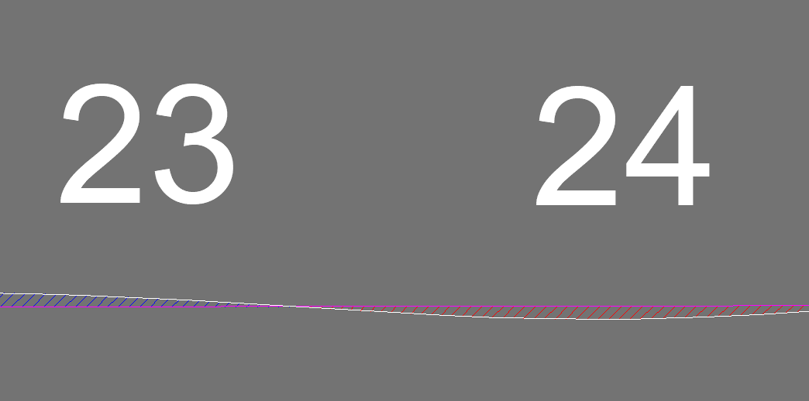
There are various methods that can be used to calculate the earthwork volume, I decided to draw a 1:1 depiction of the route in autoCAD and then drew a straight line from the first to the last point to represent the road (see figure 14). Using the hatch tool I coloured all excavation areas in blue and all fill areas in red (see figure 15).
Figure 15

The data gathered from the hatched areas in autoCAD was inputed into the table below.
Volume of earthwork
From AutoCAD in Meters Cubed
Cut | Fill
20.1 | 145.8
Difference
125.7m² Fill

Conclusion
This survey concluded that 125.7m³ of fill must be imported onto site for each meter width of road that’s required, for example for a 6 meter wide road there would need to be 754.2 meters cubed imported for the base of the road only. This figure assumes any cut would be stored on site and reused.
This does not include for:
- Compaction of imported fill
- Chamfered banks for structural support on filled areas
- Chamfered banks to mitigate collapse on cut areas.

Reference list

Civil Seek, n.d.. Levelling Staff | Procedure of Taking Staff Reading.. [Online]
Available at: https://civilseek.com/levelling-staff/
[Accessed 28 march 2022].
Civil Today, n.d.. Dumpy Level Survey–What, Where, How, Parts. [Online]
Available at: https://civiltoday.com/surveying/12-dumpy-level
[Accessed 28 March 2022].
Designing Buildings, 2020. Levelling in surveying. [Online]
Available at: https://www.designingbuildings.co.uk/wiki/Levelling_in_surveying
[Accessed 28 March 2022].
Wiki How, 2019. How to Use a Dumpy Level. [Online]
Available at: https://www.wikihow.com/Use-a-Dumpy-Level
[Accessed 28 March 2022].

