Biomechanics of Sport and Exercise

SHSS5093

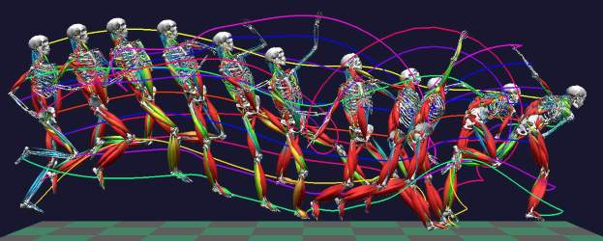

Assessment and Laboratory Work Book
2019-20

Module Tutor: David Gardner d.gardner@uwstd.ac.uk 01267 676727

MODULE CODE: SHSS5093

TITLE: Biomechanics of Sport and Exercise

LEVEL: 5
CREDITS: 20

Module Tutor: David Gardner d.gardner@uwstd.ac.uk 01267 676727

AIM(S)

To develop the skills and techniques required to measure and analyse human movements.

To provide recommendation that reduce the occurrence of injury or rehabilitate once an injury has occurred.

LEARNING OUTCOMES

Upon the successful completion of this module you will be able to demonstrate the ability to:

Use a range of techniques to collect information on biomechanical function and performance;

Analyse information and data collected to form an opinion on function and movement characteristics related to efficient and safe performance;

Produce an experimental report reviewing evidence collected and providing recommendations to enhance performance, prevent injury and aid rehabilitation.

Room DR1,DR2 and DR3
Lecture details Monday 9.00 am to 12pm Tutorial Monday 3-4pm
ASSESSMENT
Assessment Component 1 – 50% - Coursework - workbook (2000 words).
Submission Date: 6th December 2018

Assessment Component 2 – 50% - Coursework – Journal Article (2000 words).

Submission date: 17th January 2019

Sport Biomechanics

What is Sport and Exercise Biomechanics?
Sport and exercise biomechanics is an area of science, research and application that is concerned with the analysis of the mechanics of human movement and equipment associated with that movement.
Biomechanics is traditionally divided into the areas of kinetics (concerning the analysis of the forces acting on the body) and kinematics (concerning the analysis of the movements of the body).

What Do Biomechanists Do?
A sport biomechanician records and analyses athletic movements in order to offer advice about functionality and performance. Specifically they analyse and apply mechanical principles to movements and equipment to improve performance and reduce the likelihood of injury.
Specifically a biomechanician will;
- Identify optimal movement patterns for enhancing sports performance and reducing injury,
- Analyse forces applied to and within the body to improve performance and reduce injury,
- Assess musculo-skeletal recruitment patterns and functional performance,
- Analyse the design and use of equipment e.g., shoes, surfaces and racquets used in sport, health and exercise.

For potential careers in biomechanics have a look at;

https://www.glassdoor.co.uk/Job/biomechanics-jobs-SRCH_KO0,12.htm

https://www.indeed.co.uk/Biomechanics-jobs

In addition the links below will give you some insight into what the biomechanician does and also provided research that will support this module.

Useful Links

British Association of Sport and Exercise Scientists - http://www.bases.org.uk/Biomechanics

Overarching academic association in the UK that promotes the roles and importance of the sport sciences in enhances performance and research. There is a specific biomechanics section.

Biomechanics World Wide - www.yext.com
Biomechanics World Wide is designed to assist individuals in their search for information on the broad topic of biomechanics. Acts as a biomechanics search engine and listing of a wide range of biomechanics related sites. Has a section for sport and exercise.

International Society of Biomechanics - www.isbweb.org
Details of member services, conferences and special interest/technical groups. Excellent links to sites to download biomechanical applications and data sets.

International Society of Biomechanics in Sports - www.isbs.org
One of the few sites dedicated specifically to the biomechanics of sport. The society site offers details of member services (including the Coaches’ information service – see CIS above). There are also links to the reports produced from various ISBS supported projects at major sports championships.

Sportscience - www.sportsci.org
The home site for the Sport Science discussion group hosted by Will Hopkins. Not biomechanics specific, but contains some general interesting and topical sport science discussions with occasional biomechanics issues.

Teaching Information Service for Biomechanics - www.usfca.edu/ess/tis
The Teaching information service provides links to a wide range of websites offering data sets, simulations, virtual laboratory sessions and tutorials across the spectrum of sport and exercise biomechanics. You need to be selective but a good starting point if you want to find teaching materials.

Key References and Resources
- Ackland, T.R., Elliot, B. & Bloomfield, J. (2009) Applied anatomy and biomechanics in sport Champaign, IL: Human Kinetics.
- Behnke, R.S. (2012) Kinetic Anatomy. Champaign, IL: Human Kinetics.
- Loudon, J.K., Manske, R.C. & Reiman, M.P. (2013) Clinical Mechanics and Kinesiology. Champaign, IL: Human Kinetics.
- Whiting W.C. & Zernicke R.E. (2008) Biomechanics of Musculoskeletal Injury. 2nd ed^{n}. Champaign, IL: Human Kinetics.
- Baechle, T.R. & Earle R.W.(2000) Essentials of strength training and conditioning. Champaign, Ill.: Human Kinetics.
- Blazevich, A. (2007) Sports biomechanics: the basics: optimising human performance. London: A. & C. Black.

Journals

Journal of Applied Biomechanics
International journal of sport biomechanics
Journal of Strength and Conditioning Research
Journal of Sport Science
Workbook Contents and Assessments
This workbook is designed for you to complete as you progress through the semester course and will comprise 50% of your module grade.
Each week you will have 1 hour lecture, 2 hours of practical and 1 hour to complete the workbook, which must be submitted at the end of day outside my office.
Date | Experimental Topic | Page No
30th Sept | Module Introduction – Basic Maths
7th Oct | Displacement / Velocity and Acceleration | 6
14th Oct | Introduction to mechanics and forces | 13
21st Oct | Phase analysis | 24
28th Oct | Linear and angular kinematics | 27
4th Nov | Friction | 32
11th Nov | Restitution | 39
18th Nov | Equations of motion and Projectile Motion | 42
25rd Nov | Centre of Mass / Balance and stability | 45
2nd Nov | Muscle Forces | 53
9th Dec | Assignment 2
6th Jan | Assignment 2
13th Jan | Assignment 2

Grading – Complete 8 experimental labs all topics have equal weighting.
Date | Experimental Topic | Grade
7th Oct | Displacement / Velocity and Acceleration
14th Oct | Introduction to mechanics and forces
21st Oct | Phase analysis
28th Oct | Linear and angular kinematics
4th Nov | Friction
11th Nov | Restitution
18th Nov | Equations of motion and Projectile Motion
25rd Nov | Centre of Mass / Balance and stability
2th Nov | Muscle Forces
 | Final Grade | %

Assessment 1
Introduction to Displacement / Velocity and Acceleration
The section will develop your understanding of the forces and mechanical principles that underlie training, performance and equipment design. Your ability to apply this knowledge will not only improve your ability to support athletes in their performance and training but also improve you as a researcher and potentially new career opportunities.
Weight, Mass and Force.
There is confusion in the use of these terms within the general population. For example when we step on a set of scales to weigh ourselves we are actually measuring our mass not our weight. Weight is actually a force caused by gravity acting on our mass and so our weight is actually our mass (kg) x gravity (9.81ms⁻²).
When we multiply the numeric values we must also multiply the unit. In the case of weight this is Kg x ms⁻² or Kgms-² which is termed a Newton (N).
What is your mass?
What is your weight?

Linear and Angular kinematics
Sport and health biomechanics considers the application and implication of forces applied within and to the human body and equipment used within sport and health. The summation of these forces results in changes to linear and or angular movements of the limbs of the body as a whole.
The same mechanics laws and principles applies to both linear and angular movements - It is only the units that change
Linear Angular
Displacement meters (m) Degrees (⁰) - θ
Velocity meters per second (ms⁻¹) Degrees per second (⁰s⁻¹) - ω
Acceleration Meters per sec per sec (ms⁻²) Degrees per sec per sec (⁰s⁻²) - α
Remember numbers reported in biomechanical reports require associated units.

Distance & Displacement
Defining distance is a way of measuring how far we have travelled, which may be useful in events such as a 10km race for calculating pacing strategies etc. However in sports such as golf when the commentator says that a drive was hit a distance of 250m they are actually defining the displacement of the ball (the distance between where the ball was hit and where it stopped). The flight of the ball actually means the ball has travelled a much further distance (Figure 1).
Figure 1: Golf ball distance and displacement

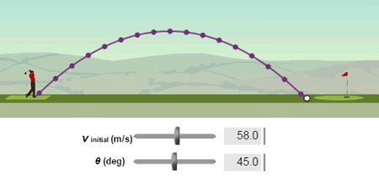

Distance is a scalar quantity that refers to "how much ground an object has covered" during its motion.

Displacement is a vector quantity that refers to "how far out of place an object is"; it is the object's overall change in position.

Scalars are quantities that are fully described by a magnitude (or numerical value) alone.

Vectors are quantities that are fully described by both a magnitude and a direction.

As a group set up the course shown using cones (2m intervals) and a tape measure and after a practice record the following times

Figure 2: Sprint run course set up Table 1: Agility course times (2dp)

Participant | Time
 | 2 | 4 | 6 | 8 | 10 | 12 | 14 | 16
A
B
C
D
E
F
G
H

FINISH

Start

Plot the distance time graph for the fastest person, the slowest person and yourself (figure 3).
Figure 3: Distance v time graph for an agility run.

What is the mean time for the sprint?
How far have your run in 1 second?
What is the time taken to run 10 m for each athlete? you
fastest
slowest
Describe the data in figure 3

Speed and Velocity
Speed is a scalar quantity and refers to how fast an object is moving. For sports such as cycling, running, motor racing this is generally sufficient information and is important information in monitoring performance and devising race strategies. However sometimes, such as when we consider joint movements we also need a directional (flexion and extension) or vector component and this is termed the velocity.
- When we measure distance travelled during a period of time we are calculating the speed.
- When we use displacement during a period of time we are calculating the velocity.
Calculating speed and velocity
$Speed=\frac{Change indistance}{change in time}$ $Velocity=\frac{Change in displacement}{change in time}$
Calculate the average velocity between the start and the first cone for each on the group?
Table 2: Average velocity v time
Subject | Start Time (s) | Time at 4m  (s) | Average Velocity to 4m (ms⁻¹) | Time at 8m  (s) | Average Velocity to 8m (ms⁻¹)
A | 0.00
B | 0.00
C | 0.00
D | 0.00
E | 0.00
F | 0.00
G | 0.00
H | 0.00
Mean | 0.00
SD | 0.00

Write a statement describing these results -
Acceleration
Acceleration is a scaler quantity determined by the rate of change of velocity.
$Acceleration=\frac{Change in Velocity}{change in time}$
When the value is negative it refers to deceleration or that the object is slowing down.
Acceleration is a key component of power based sports or when applying more advanced training method such as velocity based training. Controlled acceleration is also key in accuracy based sports such a tennis and golf.
Calculate the average acceleration when the person is at the first cone (4m) and second cone (8m).
Table 2: Sprint velocity and acceleration
Subject | Start Time (s) | Time at 4m (s) | Time at 8m (s) | Vel at 4m  (ms⁻¹) | Vel at 8m  (ms⁻¹) | Accel^{n} to 0-4m  (ms⁻²) | Accel^{n} to 4-8m  (ms⁻²)
A | 0.00
B | 0.00
C | 0.00
D | 0.00
E | 0.00
F | 0.00
G | 0.00
H | 0.00

In biomechanics time is often used on the x-axis and displacement, velocity and acceleration on the y-axis. Data are converted to (value) per second.
To do this you plot the displacement / time graph (Figure 4a) – do this for your own data.
Figure 4a: Displacement / time graph

Time (s)

Displacement (m)
Now read off the displacement at every 0.2 second

Table 3a - Displacement v time

Time (s) | Distance (m) | Time (s) | Distance (m) | Time (s) | Distance (m)
0.0 |  | 1.0 |  | 2.0
0.2 |  | 1.2 |  | 2.2
0.4 |  | 1.4 |  | 2.4
0.6 |  | 1.6 |  | 2.6
0.8 |  | 1.8 |  | 2.8

Figure 4a: Displacement / time graph

Displacement (m)

Time (s)

From this data we can calculate the velocity at any given time

Table 3b - Displacement v time

Time (s) | Velocity (ms⁻¹) | Time (s) | Velocity (ms⁻¹) | Time (s) | Velocity (ms⁻¹)
0.0 |  | 1.0 |  | 2.0
0.2 |  | 1.2 |  | 2.2
0.4 |  | 1.4 |  | 2.4
0.6 |  | 1.6 |  | 2.6
0.8 |  | 1.8 |  | 2.8

Figure 4b: Velocity / time graph

Velocity (ms⁻¹)

Time (s)

From this data we can calculate the Acceleration at any given time

Table 3c - Displacement v time

Time (s) | Accel (ms⁻²) | Time (s) | Accel (ms⁻²) | Time (s) | Accel (ms⁻²)
0.0 |  | 1.0 |  | 2.0
0.2 |  | 1.2 |  | 2.2
0.4 |  | 1.4 |  | 2.4
0.6 |  | 1.6 |  | 2.6
0.8 |  | 1.8 |  | 2.8

Note any negative values here so deceleration or slowing down.
Figure 4c: Velocity / time graph

Accel (ms⁻²)

Time (s)

Write a statement describing these results -

Assessment 2
Mechanics, Forces and Vectors
A biomechanician is concerned with forces acting on an athlete and or the equipment they use in order to define the performance characteristics of that athlete or equipment. The role of a biomechanician is to measure, with as much accuracy as possible these forces so they can provide advice regarding training, performance, reducing the potential for injury and the design / use of equipment.
Forces are measured in Newtons (N or kgm-2) and when they have a defined direction are referred to as vectors. This is important in being able to summate forces and to determine their resultant effect.

Figure 5 - Vectors
F =10 N (magnitude)
Angle=30 degrees (direction)

Figure 1 identifies that these forces have both magnitude (scalar) and direction and therefore are considered vectors.
These vectors (2 dimensions are circular vectors whilst those in 3 dimensions spherical vectors) can be resolved in the 3 cardinal axis; frontal (horizontal - y), Longitudinal (vertical - Z) and sagittal (x) which can then be added together in order to determine the resultant vector. When working in two dimension, as will be case in this course frontal (horizontal – x) and Longitudinal (vertical – y ) are more commonly use.
Figure 6: A - Biomechanical Cardinal Axis and planes B – Mechanics Cardinal axis
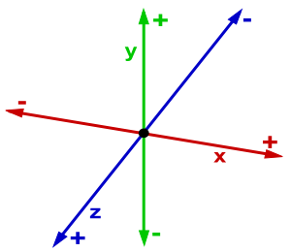
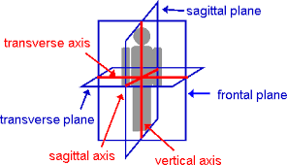

Forces
Knowing the magnitude and direction of the applied forces allows the biomechanician to predict the movement characteristic of that object e.g. when a ball (figure 7) is kicked the foot applies a force which is translated into the ball the ball will then takes off in a certain direction with a certain speed – remember speed (scale or magnitude) and direction (degrees to the horizontal ground).

Figure 7 – Starting characteristics of a ball kicked
45 ms⁻¹

25⁰

However the ball has other forces acting on it which will affect its motion so the first stage of understand exactly what is happening to the ball is to draw a free body diagramme (figure 8).
Identify 3 other 3 that potentially act on the ball as it begins to move? and draw in their directions of application.
Figure 8 – Free body diagramme showing all the forces acting on a ball

Summating or Resolving forces
To understand what happens to the ball exactly the biomechanician must resolve the resultant force and to do this they must directly measure or calculate each of the component forces. However all these forces act in different direct so in order to summate all forces are resolved in to their cardinal axis (for this course we will only consider the 2 dimension of x (horizontal) and y (vertical)).
So another way of considering the resultant force of the ball at this exact point in time is that it travels up and forward or vertically (+) and horizontally (+) (figure 9).
By measuring (video) the resultant flight characteristics of the ball we can then use trigonometry to work out the horizontal and vertical components of the ball. This information can then be used to determine flight characteristics, such as range, height and time of flight (these will be calculated in the practical on equations of projectile motion later in the course).
Figure 9 – Starting characteristics of a ball kicked $sinθ= \frac{opp}{hyp}$
Velocity v
$cosθ= \frac{adj}{hyp}$
45 ms-1
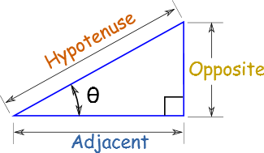
Velocity h
25⁰

Calculate the horizontal velocity of the ball? (remember units)

Calculate the vertical velocity of the ball?

By resolving all forces (described in figure 8) into their vertical and horizontal components it is possible to add multiple forces together and find a resultant force vector.
Figure 10 – Forces acting on a ball

40N
70N
50⁰
20⁰

75⁰

20N

Calculate and then draw the resultant Force Vector i.e. the direction and forces the ball is travelling

When these forces and other are applied to the object they bring about a change in the movement of that object but it should also be note that the object also has an effect on the force as described in motion Newton’s 3rd law.
Newton’s Third Law
‘For every action there is an equal and opposite reaction’
This means that when objects interact the magnitude of the force acting on one object is exactly equal to the magnitude of the force acting on the other but in the opposite directions – this is called the reaction force.
Figure 11 – Reaction forces
Where;
G=gravity which always acts directly downwards and is 9.81ms⁻²
M= mass of the object = 15kg
R

2mg N
What value is R?

If the object is free to move then the it will travel through space until it impact another object or force. However often, such as in the musculo-skelatal system or in the use of equipment such as a golf club or tennis racket or bike pedal one end is fixed. In this case the object will rotate and cause a force call torque or moment force.

Moment Force or Torque
‘The moment of a forces is the magnitude of the forces multiplied by the perpendicular distance between the application of the force and the axis of rotation’

Figure 12 – Moment forces
45 ms⁻¹
A
20 N
What is the moment force?
2m

B

70⁰
20 N
2m
What is the moment force?

Figure 13- Moment force of a bike pedal
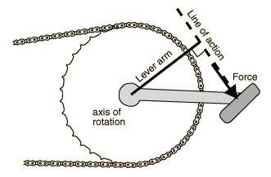
The angle of the pedal define the line of action of the force and therefore the lever arm and so the moment force or simply the applied force.
Moment force or the force on the down stoke on the pedal is;
M = Lever Arm x Force

Figure 14 – Manipulation of equipment to improve torque
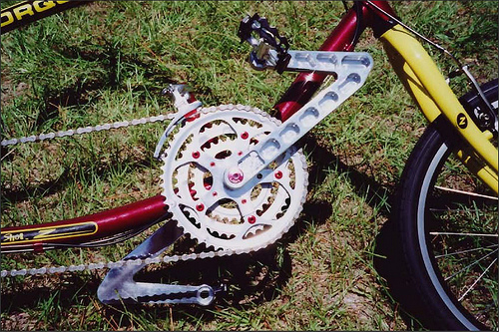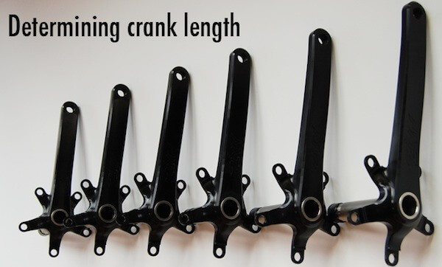

Give another example of how and why this information is importance for an athlete?
Momentum
Once the object is in motion Newton’s first law state that the object will have an inertia an want to keep moving
Newton’s first law states
“An object either remains at rest or continues to move at a constant velocity,
unless acted upon by a force”

therefore the momentum of an object will remain constant until an impact occurs (ignore air resistance).
In a stable mass situation momentum (p) is the vector quantity comprising the product of mass (kg) and velocity (ms-¹).
p=mv kgms⁻¹ = kg x ms⁻¹
Once impact occurs and according to Newton’s second law;
“The rate of change of momentum of a body is directly proportional to
the force applied, and this change in momentum takes place in the direction
of the applied force”

It is therefore possible to determine the transfer of momentum and impact characteristic between two objects (see also coefficient of restitution). This is very useful in equipment design, cricket and baseball bats and in sporting performance such as snooker, football etc.

Inertia
The resistance of an object to changes in its position and or speed or
direction of motion.

If the object is rotating then it will have angular momentum which is the product of angular velocity and the moment of inertia.

Levers
If, as mentioned before one point of an object is fixed and the applied force is not directly through the axis of rotation then there will be a turning force. This turning describes and explains levers and leverage.
Understanding levers and leverage is vital to the sport biomechanics as it allow strategies to be develop that improve performance and reduce the occurrence of injury, it is only of the mechanical principles that allows the musculo-skelatal system to work. Understanding levers is also important in equipment design.
The are 3 classification of levers;
- First class - the joint lies between the effort and the load e.g. movement of the head
- Second Class - the load lies between the joint and the effort e.g. standing on tip toes
- Third class - the effort lies between the joint and the load – bending the elbow
Draw a representation and give an example in the human body of each class of Lever
Figure 15 – Classifications of Levers

First Class Levers Second Class Levers Third Class Levers

Stress and Strain
The transfer of forces from their initiation in the muscles through the body and possibly to equipment creates stress and strain within these structures. Too much stress in the bone, for example is likely to result in bone fractures, too much strain in a ligament may cause rupture. If the stress and strain is too great in equipment then that equipment will underperform or break.
The techniques used by a biomechanician would therefore be vital in reducing injury, optimising performance and designing equipment.
Stress is the force per unit area applied to a structure $Stress=\frac{force}{area}$
Strain is the change in length divided by the original length $Strain=\frac{change in length}{original length}$
If you weigh 75 kg and the cross sectional area of your femur 4.4 x10⁻⁴ m² and then stand on one leg what is the stress in the femur? Nm²
If a tennis racket string has a cross sectional area of 4mm² and hits a ball with 10 strings equally with a force 200N then what is the force in each string? Nm²
When the ball makes impact with the tennis racket strings the impact stress is as above however the string will stretch due to this impact, storing elastic potential energy and then return to the original length releasing kinetic energy. This change in length causes strain within the string. This value of strain is a ratio and therefore has no units.
If the string is 0.4m long and stretch by 0.07m what is the strain in the string?
After impact or when the applied force has stopped the string should return to its original length. If it does so then this is called Elastic deformation (figure 17). If the string does not return to its original length then this is called plastic deformation (figure 17).
Understanding the magnitude of stress that results in plastic deformation allows you to identify the point at which the body or equipment fails. This relationship is called Young’s Modulus.
Bone is considered viscoelastic which implies that its strength is dependent on the rate of loading; it is stronger when loaded rapidly rather than slowly, allowing us to withstand impact such as plymetric or falls.
Young's (elastic) modulus has units of pressure and its unit is therefore the pascal (Pa or N/m² or kg·m⁻¹·s⁻²).
$E=\frac{\frac{F}{A}}{\frac{∆L}{l}}$ or $E=\frac{FL}{A∆L}$
where
- E = the young modulus in pascals (Pa) F = force in newtons (N)
- L = original length in metres (m) A = area in square metres (m²)
- ∆L = change in length in metres (m)

Figure 16 A & B – elastic and plastic deformation

A
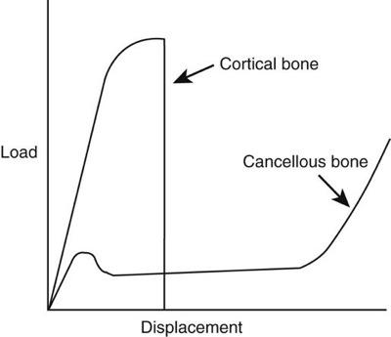
With reference to Fig 10B describe the implications of Figure 10A

B
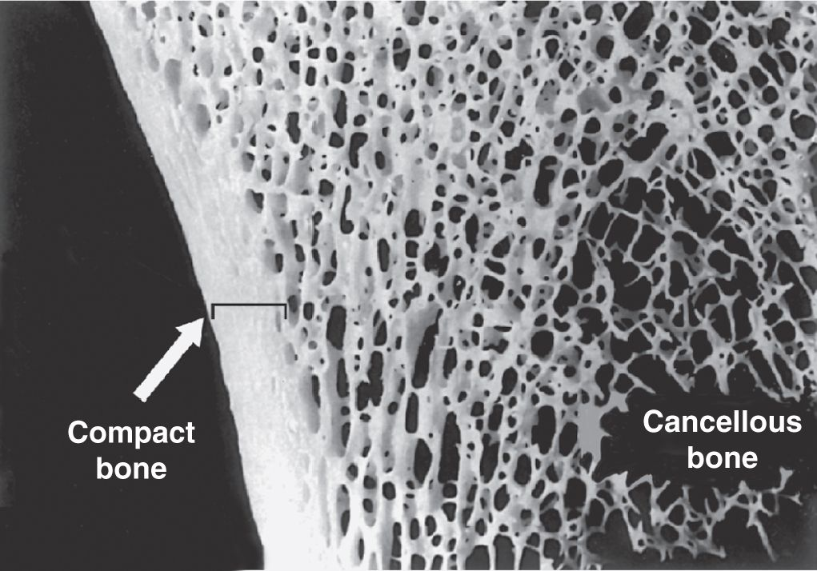

Figure 17 – Young’s Modulus
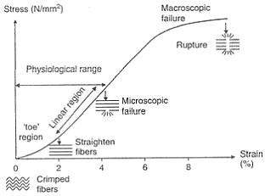
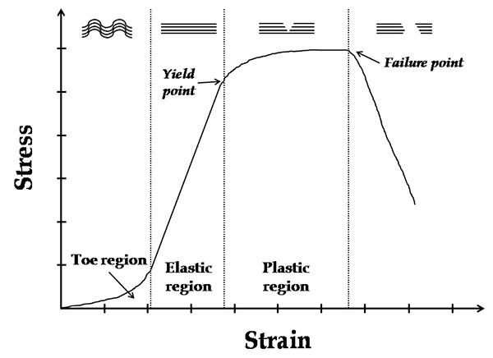

Approximate values for Young’s modulus (E)
Cortical Bone 17 GPa
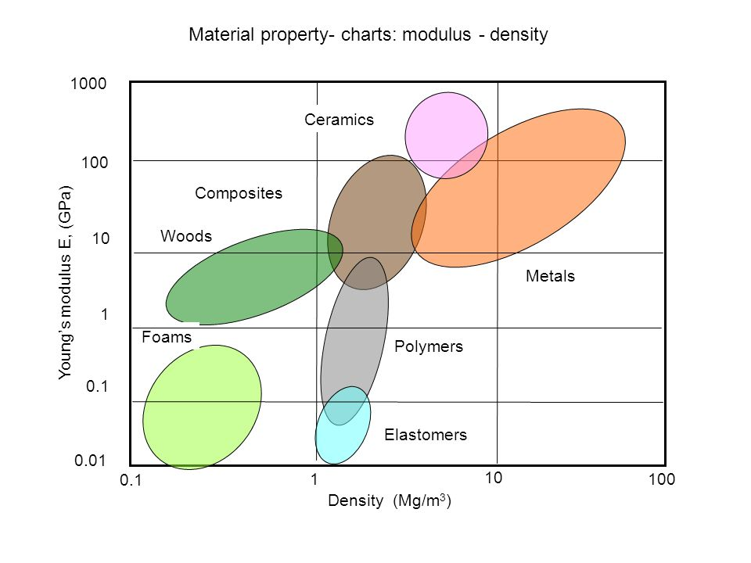
Cancellous bone 350 MPa
Cartilage 12 MPa
Meniscus 10-15 MPa
ACL 98 MPa
MCL 366 MPa
LCL 266 MPa
Steel 193 GPa
Plastic 2 GPa
Aluminium 70 Gpa
Wood (Pine) 10 GPa

In which equipment would you want a high E? and why?
A
B
C

In which equipment would you not want a high E? and why?
A
B
C

Energy
There are many type of available energy that may impact on human performance but from a biomechanical perspective it is Potential and Kinetic energy that are most important.
Kinetic energy (KE) is the energy stored in a moving object and is dependent on the mass and velocity of the object. Potential energy (PE) on the other hand is the energy stored due to an objects position and is determined by mass, distance and either gravity or the elastic spring constant.
M=mass
V = velocity
G= gravity
H = height
K = spring constant
X amount of compression / stretch

KE= ½ mv²
PE_{gravity} = mgh
PE_{elastic} = ½ kx²

Write 300 review on the role of a sport Biomechanist.

Assessment 3
Movement & Phase Analysis
Whilst many actions in sport seem continuous they are in fact made up of a coordinated sequence of distinct and functionally discrete phases that are important in order to optimise effective and safe performance.
Whilst a coach may have ‘gut feeling’ of what an athlete is doing poorly it is the role of the biomechanician to quantify in detail the exact movement characteristic of the action and to offer advice on movement patterns, coaching technique, injury prevention etc.
The first stage of this analysis is to conduct a phase analysis of the movement and describe each phase in terms of;
- Purpose of the phase
- Key joints involved
- Movement
- Type of contraction
- Range of movement
- Muscles involved
Conduct a phase analysis of a single stride running (lower limbs only) for each member of your groups running at 10 km/hr
Description of the whole movement

Phase 1 - name:
Description of Phase purpose:

Joint | Movement | Muscles involved | Type of contraction | ROM  (degrees)
Hip
Knee
Ankle

Phase 2 name:
Description of Phase purpose:

Joint | Movement | Muscles involved | Type of contraction | ROM  (degrees)
Hip
Knee
Ankle

Phase 3 name:
Description of Phase purpose:

Joint | Movement | Muscles involved | Type of contraction | ROM  (degrees)
Hip
Knee
Ankle

What is the average stride length?

What is the cadence or frequency of stride?

Write a results section describing this data

Assessment 4
Angular kinematics
When performing sporting actions such as running and jumping the objective tends to be optimise linear movement, in either horizontal or vertical direction. However, whilst the muscles themselves contact in a linearly the limbs bringing about these movement actually rotate around the joint. Successful performance therefore depends not only on the physiological capacity (exercise physiology) of the muscle but the coordination of these muscles (skill acquisition) to bring about the desired movement.
One role of a biomechanist is to evaluate whether this coordination of events for a particular action is effective and efficient and to subsequently to provide advice to the coach and athlete as what can be changed to improve performance and reduce the likelihood of injury.
The biomechanist will record the action using video and then transfer this, using joint markers located on the joint centres (figure 1) of the athlete into computerised software. From this the biomechanist can track movement of all the joints, limbs and centre of mass thereby more full understanding the action in terms of muscle coordination as well as linear and angular displacement, velocity and accelerations.
Figure 1 (A & B):Joint markers
A B
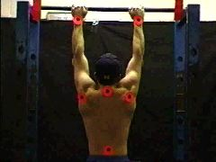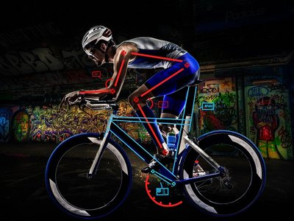

Complete table 1 identifying the location of joint markers
Table 1: Location of joint markers for a side on analysis i.e figure 1B
Joint | Marker above the Joint | Marker below the Joint
Ankle
Knee
Hip
Trunk
Shoulder
elbow
Wrist
Head

Video Analysis
Two dimensional video motion or kinematic analysis such as gait analysis, weight lifting and cycling only require one camera that is perpendicular to the plane of performance and are therefore relatively easy to conduct. However as with any data collection the more time and care spent in setting up and calibrating the equipment before recording the more accurate and useful the data will be.
Task – Conduct a video analysis of a front squat (40kg) – only consider the knee joint.
Procedures
- Locate and mark the plane in which the action will take place.
- Position the camera exactly perpendicular to the plane of action and mark the position of the tripod legs.
- Check that the camera will record the whole action.
- Place a calibration object on the plane of action and record for 3-5 seconds.
- Place joint location markers on the subject and check all a visible to the camera throughout the action.
- Record the action several times.
- Check that you have the necessary footage before putting the equipment away.

Data Transfer
Most often the process of data transfer and analysis is completed using computer technology. However for the purposes of this workbook you will do it by hand!
- Place an acetate over the computer screen and mark on the calibration reference.
- Having decided which of the recorded actions you are going to analyse play through the action to determine it full duration.
- Divide this action into approximately 10-12 segments or equal time intervals (e.g. 0.02secs).
- At time 0.00s i.e. the start of the movement place the acetate over the action and mark each joint centre location with a dot (or other symbol).
- Frame advance your specified time interval (e.g. 0.1s) and repeat the joint markings using a different colour or symbol.
- Continue until the movement is complete.
- Take the acetate off the screen and join up the dots.
Data Analysis
- Measure the joint angles at every time interval and input it table 2 (time & angular displacement).
- Calculate the angular velocity and input into table 2.
- Calculate the angular acceleration and put in a table.
- Plot each data as a graph with time along the bottom and displacement, velocity or acceleration up the side.
Note: this method only determines the average between two points.
If you need an exact point you will need to take a tangent at the point). As such when you plot the time v velocity graph and table you need to make sure the average velocity equates to average time.

Using the method outlined above analyse one joint movement of a simple 2D action e.g. elbow of the arm curl, knee of squat or vertical jump.
Table 2: Kinematic characteristic of
Time  (s) | Angular Displacement  (θ) | Time  (s) | Angular velocity  (ώ) | Time  (s) | Angular Acceleration  (α)
0.0 |  | 0.00 |  | 0.00
0.1 |  | 0.05 |  | 0.025
0.2 |  | 0.15 |  | 0.1
0.3 |  | 0.25 |  | 0.2
0.4 |  | 0.35 |  | 0.3
0.5 |  | 0.45 |  | 0.4
0.6 |  | 0.55 |  | 0.5
0.7 |  | 0.65 |  | 0.6
0.8 |  | 0.75 |  | 0.7
0.9 |  | 0.85 |  | 0.8
1.0 |  | 0.95 |  | 0.9
1.1 |  | 1.05 |  | 1.0
1.2 |  | 1.15 |  | 1.1
1.3 |  | 1.25 |  | 1.2
1.4 |  | 1.35 |  | 1.3
1.5 |  | 1.45 |  | 1.4
1.6 |  | 1.55 |  | 1.5
1.7 |  | 1.65 |  | 1.6
1.8 |  | 1.75 |  | 1.7
1.9 |  | 1.85 |  | 1.8
2.0 |  | 1.95 |  | 1.9

Figure 2: Time v angular displacement of

Figure 3: Time v angular velocity of

Figure 4: Time v angular acceleration of

Write the results section describing the data in table 2 and figures 2-4.

Assessment 5
Coefficient of Friction

Introduction

When objects touch there is a tendency for these objects to try and slide over each other. In doing so a resistance force opposite to the direction of impact is generated. This is called the frictional force between the two objects. The magnitude of this force is determined by a coefficient (µ) specific to the two surfaces in contact and the weights of the reaction force between the objects.
Static friction.
This friction force acts to prevent the objects sliding and is equal and opposite to forces trying to make the objects slide.

F= µR
Where F is the Frictional force
µ is the Coefficient of Friction
R is the Normal Reaction force
R
F

α
mg

Therefore
Resolving up the plane F= mgsin α
Resolving perpendicular to the surface R=mgcosα

If F= µR then mgsinα = µ mgcos α
Or µ = mgsinα / mgcosα

As mg are the same in both then µ = sinα / cosα

Rolling Friction
This is a force opposing motion that acts to slow the motion of an object that is rolling across a surface. The impact of rolling friction is determined by the coefficient of rolling friction (µ) and the mass of the object. This is important in sports such as cycling where µ is dependent on the type and pressure of tyres and the road surface.
Table1: Coefficient of rolling friction on various surfaces
Surface | Coefficient of Rolling Friction
bicycle tire on wooden track | 0.001
low resistance tubeless tires | 0.002 - 0.005
bicycle tire on concrete | 0.002
bicycle tire on asphalt road | 0.004

µ can be determined experimentally by observing the way in which an object slows down whilst free-wheeling across a surface and coming to a stop.
The force of rolling friction can be calculated using
F= µ x N
Where µ= u/tg u= initial rolling velocity
g = gravity
t=time taken for the ball to stop

Exp 1
Measure the coefficient for sliding friction between you shoes (5 different ones) and a wooden surface.
- Using a shoe place 2 kg weight in it and lay it on a flat bench.
- Tip the surface slowly until the shoe begin to slide.
- Measure the angle
- Calculate the CoF
- Repeat for each person in your group.

Exp 2
Measure µ for 2 different surfaces for 5 different shoes

Tasks / Questions
- Explain 3 examples where the CoF is used in sport

As a player

As a governing body

As an equipment designer

- For Exp 1 show the differences in CoF graphically.

Figure 1- Coefficient of friction in shoes

- Calculate and discuss the Friction force just before sliding for one shoe, assuming each member of you group was wearing it.

- Give an example of where and why this information might be useful.

- Conduct an independent t-test to determine if a wooden surface provides significantly more or less frictional resistance than a concrete surface.

Describe the results and there importance.

Include reference to Table 1 (below) within your descriptions.

Table 1: SPSS independent t-test output data (include mean±SD) comparing frictional forces of shoes.

Drag and lift and Turbulence
Friction also exists where fluids e.g. air and water move across a surface. These forces may act to slow movement but they also act to develop additional forces such as lift and drag.
In some sports lift and drag are essential (sailing, motor racing) and in other useful to develop performance strategies (tennis, golf, cricket).
Athletes and equipment designers deliberately manipulate these characteristics to enhance their performance.
Drag – golf ball as an example
As a golf ball flies through the air it pushes the air out of the way in front and the air will flow around the ball. This creates an area of high pressure in front of the ball and as the air does not perfectly flow around the ball an area of low pressure behind it.
Figure 1 a and b – Air Flow around a golf Ball
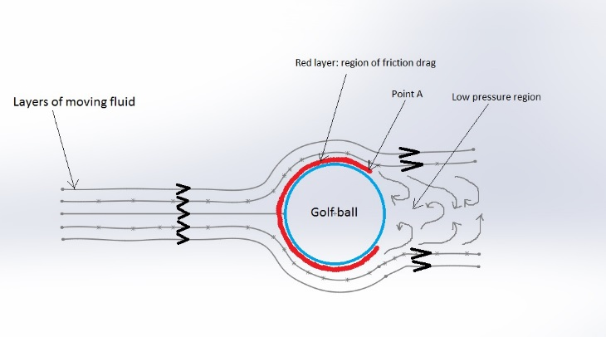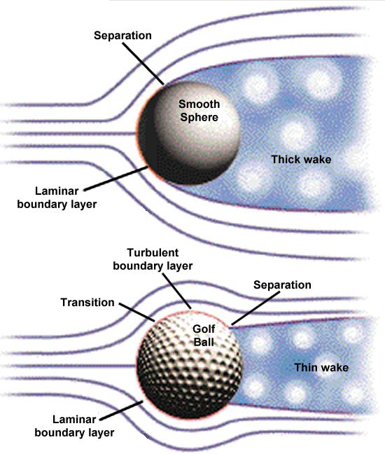

In addition to the frictional drag both of these forces will act opposite (if no spin on the ball) to the direction of flight and slow the ball down.
However as the surface of the golf ball has dimples on it then the friction force increases and the air will adhere to the ball for longer (less flow separation). This results in a reduced size of the low pressure zone behind the ball and so reduces the drag i.e. the ball travels further.
Golf ball manufacturers therefore put a lot of effort into research the exact depth and configuration of the dimples to ensure optimal flight characteristics as too much friction will eventually reduce the flight distance.
Table: Impact of Golf ball dimple depth on flight.
Depth of dimple  (mm) | Flight  (m)
0.005 | 107
0.01 | 171
0.015 | 194
0.02 | 204
0.025 | 218
0.03 | 206

Spin
Air friction become more turbulent when a ball is spinning which will change the high and low pressure zones around the ball (figure 2). The ball will then move from a high pressure to a low pressure zone and you will observe the ball curving.
Figure 2 The use of spin to curve a ball.
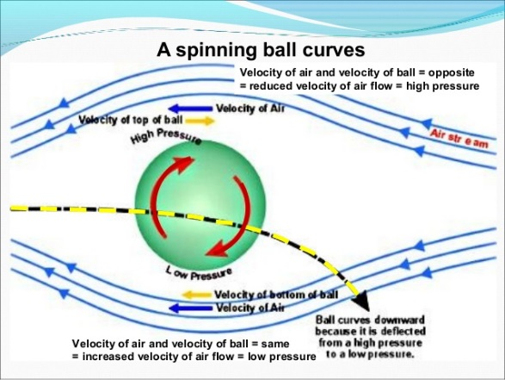

This phenomenon is used extensively in sports such as tennis, cricket, table tennis, football – almost anywhere a ball flies through the air.
Figure 3 – Impact of Spin
A - free kick in football B – Table tennis
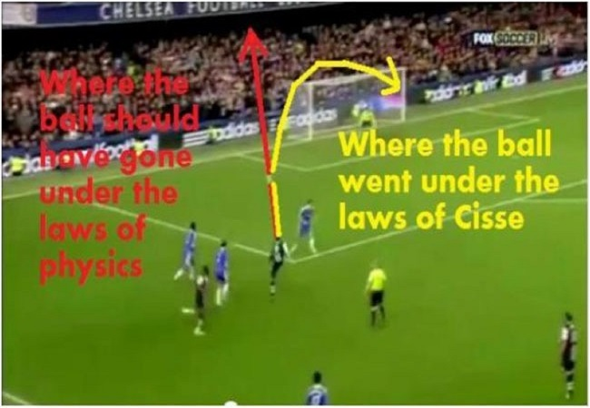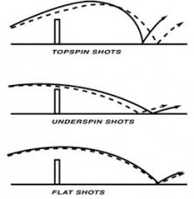

The principle of developing high and low pressure zones around an object is the way in which sailor’s power their boats, pilots develop lift to fly and spoilers on cars increase traction.
Figure 4 – A- Pressure zones in Sailing for thrust B - Pressure zone in flying for lift
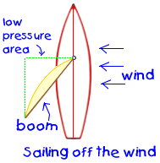
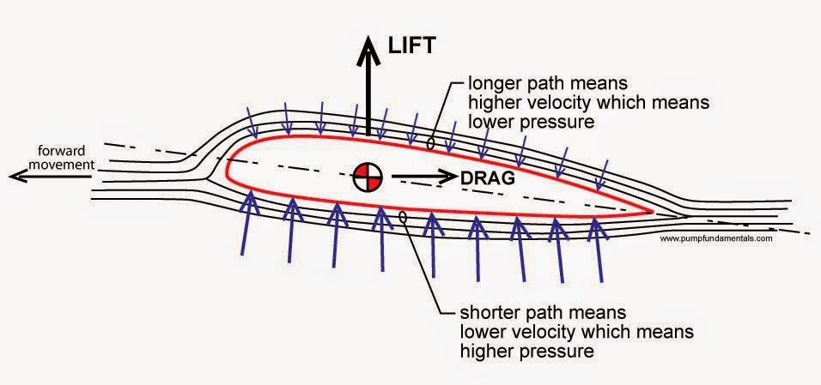

C - Pressure zones in a car for traction
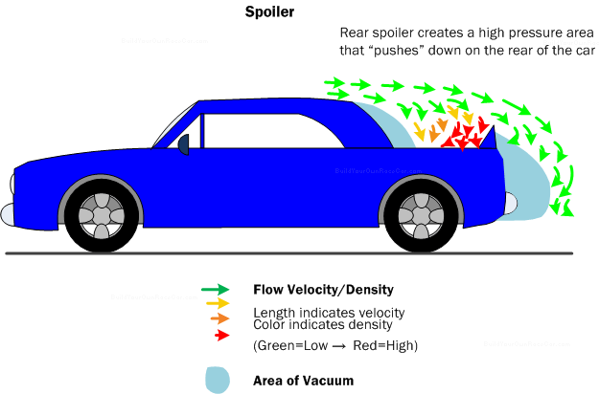
Assessment 6
Coefficient of Restitution

When objects collide energy is transfer between these objects resulting in a change in kinetic energy of each object. As mass does not usually change this energy loss must be due to a loss in speed, or simply the speed of rebound is less than the speed of impact. In addition energy is lost due to noise of impact, overcoming frictional forces and deformation, though much of this may be regained if the objects are elastic.
The ratio of this loss in energy is called the COEFFICIENT of RESTITUTION (e) and can be determined by measuring the difference of speed of each object before and after collision.
If however the object is dropped vertically onto a flat unmoving surface then the C of R (e) is this change in energy and speed can be simplified to the ratio between the height rebounded and the height dropped
$$e=\sqrt{\begin{aligned}\frac{height bounced}{height dropped} \\ \end{aligned}}$$
Table 1 – Coefficient of restitution for various surfaces and balls.

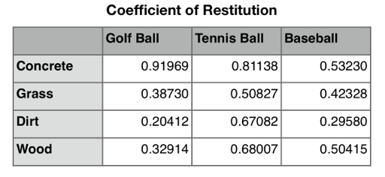

The high the values means that more energy is returned to the ball.

Exp 1
Calculate the coefficient of restitution of a golf ball, tennis ball and cricket ball on wood, tarmac and grass.
- Using the rebound board drop a ball from 1 m and video the rebound height,
- Drop each ball from the 1 m height and determine the rebound height,
- Calculate the CoR for each surface,
- Repeat for all difference surfaces.

Plot the mean C of R for each ball on each surface

Figure 1- Mean coefficient of restitution for each ball on different surfaces.
Wood Concrete Grass
Exp 2
Determine the effect of pressure on the playing characteristics of a ball.
Perform 3 drop tests for three different pressures of a ball on the outside court
Table 2
Ball type:
Pressure | C of R

Tasks / Questions
Explain 3 examples where the CoR is used in sport

As a player

As a governing body

As an equipment designer

Assessment 7
Equations of Motion

The equations of motion describe and predict the behaviour of an object in terms of its motion as a function of time within Euclidean space (3 dimensional).
Figure 1 – Euclidean Space coordinates.
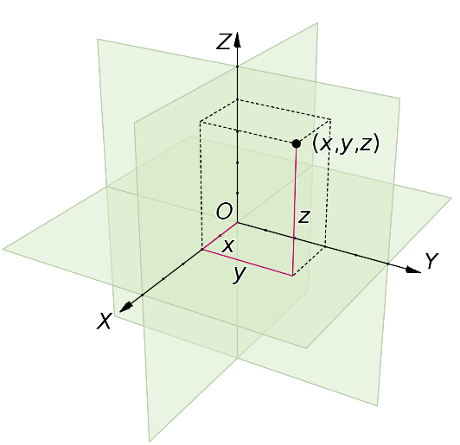
This means that you can develop a better understanding of the movement characteristic in all types of sporting events.
By combining theoretical predictions and experimental evidence we are able to make useful deductions of how objects are most likely to react or the outcome of performances.
Equations of motion
- v= u+ at
Where
S = distance
U= initial velocity
V = final velocity
A = acceleration
T=time

- s= ut+ ½ at²
- s= ½ (u+v)t
- v²= u²+2as
- s= vt - ½ at²

To use these equations you must assume there to be constant acceleration,
movement in a straight line, uniform gravity and air resistance is negligible.

Section A
- A sprinter runs a 100m race in 10.6 seconds what is their average velocity?
- If the sprinter accelerates at 2.5ms⁻¹ for 4 seconds and maintains this speed till the end of the race how fast are they running when they cross the line?
- How long did it take for this athlete to run the 100m?
- A sprint cyclists accelerates constant for 15 seconds to a speed of 45 km/hr what is their acceleration.
- In a race a cyclist in the peloton is travelling at 10 ms⁻¹. To make a break she accelerates to a speed of 15ms⁻¹ in 10 seconds. Determine how far she travels in these 10 seconds and her acceleration.

Make sure to include units for all answers
Equations of projectile motion

These equations of linear motion can be adapted to describe projectile flight.
When an object (ball) flies through the air it is subject to variety forces including spin and air resistance which change the flight characteristics. However if we ignore these for the moment it is possible to predict the flight using the following equations of projectile motion;
Time of flight T = (2VsinƟ) / g Time to peak height Tp = VsinƟ / g
Maximum height reached H = (VsinƟ)² / 2g Horizontal range R= v cos Ɵ x T

Where v is the initial velocity, Ɵ is the angle of take-off and g is gravity (9.81 ms⁻²)

Section B
A ball is kicked at an angle of 25⁰ to the ground at a velocity of 20ms⁻¹
What is the balls Time it is in the air?
Maximum Height reached?
The distance before it hits the ground?
Section C
Using suitable calibration references record the take-off angle and initial velocity of a kicked football.
- Compare the theoretical and actual flight characteristic of the ball in terms of;
Theoretical Actual
Flight time
Height reached
Range

When the ball lands is subject to other forces such as restitution and friction which act to change the subsequent flight characteristics.

The ball bounces on the ground where both friction and restitution act – see sessions of coefficient of friction (e) and coefficient of restitution (µ). Use the theoretical values from the above.
Assume e=0.8 and µ=0.9
- Calculate the range and height of the second bounce
First bounce Second Bouince
Flight time
Height reached
Range

Remember the angle of bounce will change
Useful equations
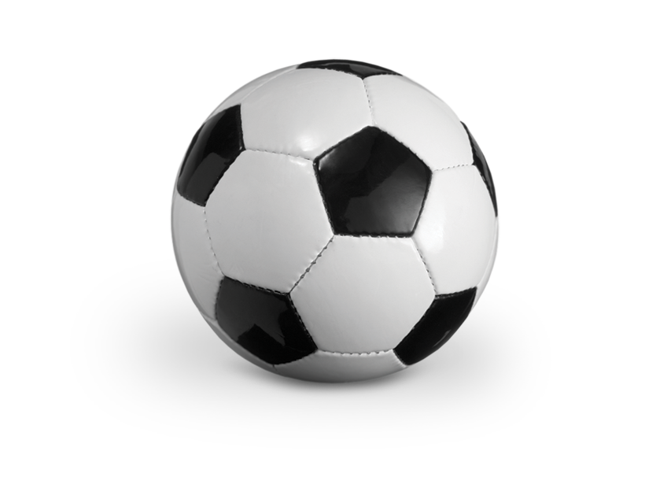
vsinƟ
v

Ɵ
Vcos Ɵ

Write a results section describing the information calculated in section .

Assessment 8
Centre of Mass and Stability
Introduction
Often used synonymously with the centre of gravity
The centre of mass of an object is the position where the distributed mass of the object equals zero, or the point where if a force is applied there is no tendency for rotation.
The importance of the centre of mass comes when considering the balance of objects and of people and therefore in adapting techniques and equipment design.
Figure 1 – Location of centre of mass standing (A) and during high jump (B)
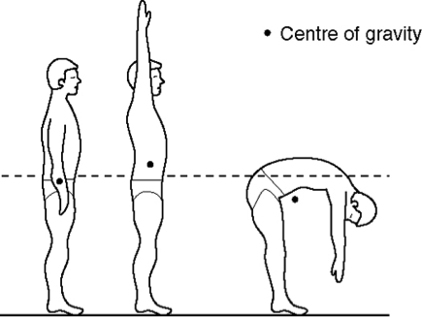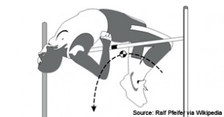
Changing the position of the centre of mass can be used to assist performance;
- Sprint Start
- Judo
- Chi Running
- Gymnastics
- Surfing
- Diving

Calculating the centre of mass
In 1 and 2 dimensions the centre of mass can be calculated using moment forces.
Figure 2 - Calculating centre of mass in 1 dimension
Scale reading (S)

Distance (M)

Weight (W)
Scales
Distance (D)

If forces are in equilibrium then forces are equal and opposite. If the moment forces is the magnitude of the force multiplied by the perpendicular distance between the application of the force and the axis of rotation.

Then
S x D = W x M or Centre of mass of the person (M) = (S x D) / M

Data Collection
Using the methods outlined in the introduction calculate the centre of mass from the toes for everyone in your group.
The compare and contrast the centres of mass of the people in your group

Include and make reference to tabulated data to support your answers.
What is the differences in centre of mass between men and women?

Include and make reference to tabulated data to support your answers.

Figure 3: Centre of mass for the group as an absolute value and relative to height?

Is there a correlation between the position of CofM as a % of height and body Weight and body fat?
Table 1: Centre of Mass compared to body weight and body fat
Participant | % CofM vHT | Weight | %fat

Table 2: Correlation between CofM, weight and %Fat
Measures | N | r | P | Significant
CofM v Weight
CofM v %Fat

Write a statement describing your results

Calculating Centre of Mass in 2 Dimensions
PIVOT (P)

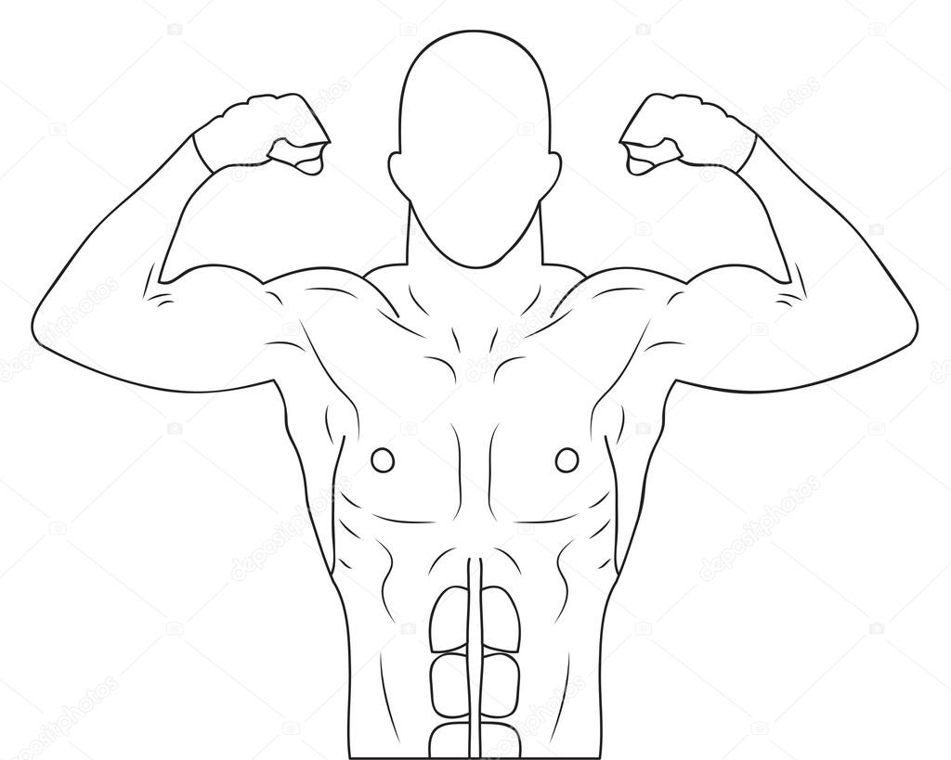

Scale 1 (s1)
Scale 2 (s2)
Using the same method as used for 1 dimension calculate the distance of the centre of mass from (P S2) and (P-S1). Where these line intersection is the centre of mass.
Data Collection
- Position an athlete lying in a sporting aspect (i.e. squat position or cycle position) and draw sound them in chalk.
- Take the scale readings s1 and s2.
- Locate the perpendicular lines and intersection to locate the centre of mass.
- Change the position of the athlete and repeat.
Discuss the implications of changing body position and the Centre to enhance performance?

Balance and Stability and Impact Forces
Introduction
Measuring the stability of athletes provides a useful indicator as to the trained status of their neuromuscular systems and includes the central coordination of vision, joint proprioception, muscle strength, postural reflexes, vestibular input and nerve conduction.
For older people the importance of this may manifest in reducing the incidence falls subsequently broken bones and early mortality. This may also have importance in measuring capacity, deterioration and potential improvements due to training in people with neuromuscular disorders or ageing populations.
Good technique in walking and running improves stability allows us to move efficiently and confidently. However this does not mean that we cannot improve our technique by reducing negative impact forces.
Research Questions
- Is closed eye one leg balance test a good measure of balance and centre of pressure data for a group of sport science students.
- Are there differences in impact forces between walking and running.

Data Collection
- Discuss the difference in balance between the group (use Romberg coefficient on the Hur force platform).

- Are there any significant difference between balance on the dominant and non-dominant sides?

- Discuss the difference in stability within the group (use limit of stability test on the Hur force platform).

- Are there any significant difference in stability on the dominant and non-dominant sides?

- Compare the one leg balance time to the Romberg coefficient and centre of pressure scores.
Table 1 : Comparison of measure of balance
Participant | Closed eyes |  | Romberg | Centre Pressure
 | Left leg balance | Right Leg balance

Table 4: Correlation between measures of balance
Measures | N | r | P | Significant
Romberg v Left
Romberg v Right
CofPv Left
CofPvRight
Romberg v CofP.

Write a statement describing the data

- Using the Hur force platform software, for a members of the group compare walking impact forces to those running?

For the group compare (correlation) balance (Romberg coefficient) with leg power (Kieser Air 200 leg press).
Number of participants
R value
Significance
Write a statement describing this data.

For the group compare (correlation) balance (Romberg coefficient) with reaction and movement time (lightwall).
Number of participants
R value
Significance
Write a statement describing this data.

Assessment 9
Muscle forces

Introduction

When an object is moved by muscle actions the weight of the object does not equal the force generated at the muscle. Knowledge of exactly how hard the muscle is working is important to understand implications form technique maximal potential and the susceptibility to injury.
Calculate the muscular force generated in the biceps brachii when holding a 10 kg weight at 90⁰ elbow flexion. Assume that the biceps brachii is the only muscle acting.
Assume - Weight of Hand and Forearm relative to body weight
Hand Forearm
Male 0.65%BW 1.9%BW
Female 0.5%BW 1.55%BW
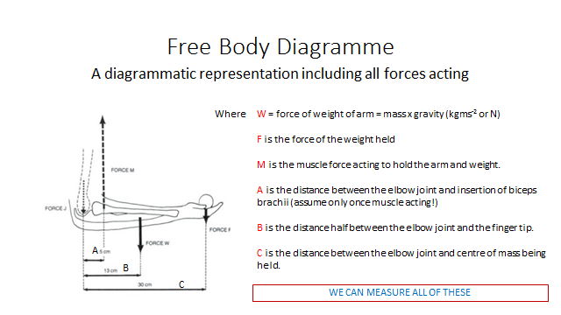
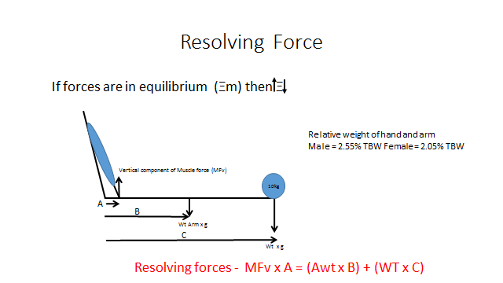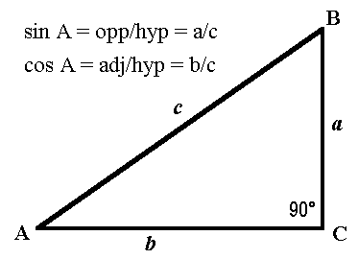
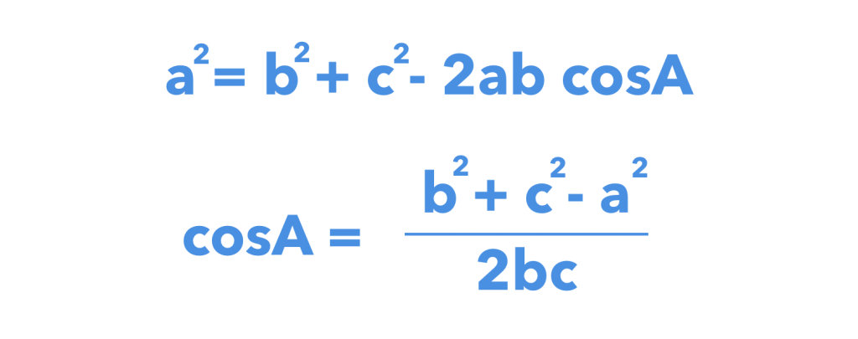

Calculate the rotational and stabilising forces as well as the magnitude of the total force.

Total muscle force N
Rotation force N
Stabilising force N

Discuss the differences in forces between the different members of your group



LEVEL 5

SEMESTER 1

MODULE CODE: SHSS5093

MoDule Title: Biomechanics of sport and Exercise
aSSESSMENT TYPE: Experimental Research
Assessment/Component: 2

COMPONENT WEIGHTING: 50 %

WORD COUNT: 2000

MODULE TUTOR: David Gardner

SUBMISSION DETAILS: 17th January 2020 by 3.00 pm through Turnitin

Kinematic Analysis

Conduct a biomechanical analysis of a sporting action or piece of equipment of your choice in order to evaluate performance and provide advice or recommendations sufficient to enhance performance or play characteristics.

Produce a 2000 words article (Journal of Sport science format) describing data collected and justifying your recommendations.

Tasks

Using biomechanical techniques to evaluate the performance characteristics of a performer or piece of equipment.

Develop advice or recommendations based on evidence / information collected that will enhance performance or play characteristics.

Produce a 2000 journal article (in the format of the Journal of Sport Sciences) describing your data and presenting your findings;

Abstract

Introduction

Method

Results

Discussion

Conclusions

References

Assessment Criteria

Further details relating to the specific requirements of levels grading and format for the article will be provided during lectures and tutorials.

School of Sport, Health & Outdoor Education

Assessment Feedback Sheet

Student No./Name:

Module Code: SHSS5093
Module: Biomechanics of sport and Exercise

Personal Evaluation – to support your academic progress please complete the section below BEFORE submitting your work.
What do you consider to be the best aspects of this work?
Which aspects do you consider could have been improved in this piece of work?
What have you found most satisfying whilst undertaking this submission?
ASSESSMENT CRITERIA | Learning  Outcomes |  | GRADE
ASSESSMENT CRITERIA |  |  | Poor  < 25% | Fail  26-39% | Satisfactory  40 – 49%  3rd Class |  | Good  50 – 59%  (2:2) | Very Good  60 – 69%  (2:1) | Excellent  70 – 84%  (1st) |  | Exceptional  85– 100% | %
Abstract | 1,2 |  |  |  |  |  |  |  |  |  |  | 5
Introduction | 1,2 |  |  |  |  |  |  |  |  |  |  | 15
Method | 1,2 |  |  |  |  |  |  |  |  |  |  | 15
Results | 1,2 |  |  |  |  |  |  |  |  |  |  | 30
Discussion | 1,2 |  |  |  |  |  |  |  |  |  |  | 25
Conclusion | 1,2 |  |  |  |  |  |  |  |  |  |  | 5
References | 1,2 |  |  |  |  |  |  |  |  |  |  | 5
It is expected that students will present work that is proof read, correctly referenced and adheres to the Assessment Checklist. Therefore a range of 0 – 10 marks will be deducted for non-completion of any of the points on the checklist below.
TUTOR COMMENTS:
Submission date:  via Turnitin |  | Return date:  (at least within 4 weeks) |  |  |  | Tutor: |  |  |  | Mark:

Assignment Checklist

- Please complete the Personal Evaluation section of the Assessment Feedback sheet, add your name and details, and paste the whole of this assignment document into the front of your assignment

- Submission is a single .pdf file, clearly labelled with your name and module code
- Font style - Times New Roman, size -12 for text and 14 for headings
- Ink colour – black only
- Line spacing – 1.5 line spacing and 2cm- 2.5cm page margins
- Quotations more than three lines to be indented 1 line spacing
- One line space between paragraphs, paragraphs must be left aligned
- Pagination (your assignment should have page numbers)
- All tables and figures are internally referenced and have a title
- Word count checked and written at end of text (before references and any appendix)
- Assignment is within 10% of the word limit (excluding references and any appendices)
- All references in the text are included in the reference list
- Correct referencing as described in UWTSD Harvard Referencing Handbook on the Library website https://www.uwtsd.ac.uk/media/uwtsd-website/content-assets/documents/library-and-learning-resources/infoskills/harvard-eng.PDF
- Correct spelling and punctuation, using UK English
- Grammar and syntax correct- double check anything that has a green line under it
- I have read my assignment out loud to myself and it makes sense and is easy to read
- Somebody else has read my work and it makes sense to him or her!
- I have checked and I have not plagiarised
Failure to follow these guidelines will cost you marks!

