

Designing a tanker propeller: Fluid flow assessment
Course Code: ACMA6010
Course Title: Structural & Fluid Analysis
Submitted by:
Ieuan Wyn Morgan
ID: 2014408
Department of Engineering
Submitted to:
Kelvin Lake
Submitted on:
05/06/2022

Table of Contents
Introduction 3
1. 3
2. 4
3. 5
4. 7
5. 9
References……………………………………………………………………………………….…………………………………12

Introduction
In this assignment I will be exploring the concept of fluid around an object. The object in question is a non-ducted propeller on a ship. I will be discussing subjects such as Reynolds number, boundary flow and composite materials. As well as researching test methods and tools which are used to carry out experiments on different designs on propellers also proposing my own experiment which I will compare to a simulation.

1.
Bill Rehm, 2008, explains that the Reynolds number is a ratio of inertial forces to viscous forces. Reynolds number will always be a dimensionless number which is used to categorise the fluids systems where the viscosity is important in controlling the velocities or the flow pattern of a fluid. Rehm, 2008, further explains that Reynolds number is defined as NRe I mathematics.
$$Re= \frac{ρuL}{μ}$$
Re = Reynolds Number
Ρ = Density of Fluid
U = Flow Speed
L = Characteristic Linear dimension
μ = Dynamic Viscosity of the Fluid

Importance
Cadence CFD, 2019, explains the importance of Reynolds number, they explain that a low Reynolds number indicates laminar flow, meaning that fluid will travel in a smooth, regular fashion. A high Reynolds number gives us a turbulent flow, meaning that the fluid goes through an irregular fluctuations and mixing. Reynolds number is important is many CFD testing. For example, the aircraft industry, aircraft designers will be looking for a low Reynolds number to aid the airflow over the fuselage. By using an advanced CFD model, it is possible to optimize the design and ensure an efficient performance.
Robert W. Deters, et. al., 2014, says that with regards to the propeller, as the Reynolds number increases the thrust coefficient of the propeller also increases and the power coefficient decreases.
A high Reynolds number will have a greater effect on the propeller as the higher the Reynolds number, they higher the thrust and power decrease. With the changes in thrust and power coefficients are due to the sectional lift coefficients and the decrease in sectional drag with increasing Reynolds number.

Assumptions
- The propeller is constructed of four blades
- The propeller is made from a carbon fibre composite
- The density of the water will be based on sea water as I assume the propeller will be used in sea water ( 1029 kg/mᶾ)
- I’m assuming that the diameter of the propeller is 5.75 m.
- Assuming that the propeller is a non-ducted propeller.
- Assuming that all four blade will be connected to one boss
- The diameter of the boss is 0.6m
- Will be basing the viscosity of the sea water on the average temperature of the Pacific Ocean (21 degrees Celsius) (8.90 x 10-4 Pa.s Viscosity)
- The propeller will be turning at 210 rpm or 20.16 cps

$$Re= \frac{1029 X 20.16 X 5.75}{21}$$
Re = 5 680.08
Looking at the Reynolds number that I have derived from my assumptions, the propeller will have good turbulence. Bill Rehm, 2008, explains that a Reynolds number of 2000 or less gives us a laminar flow, meaning the flow is viscous. Anything over 200 gives us a turbulent flow.

2.
James Liburdy, (2010), states that, boundary layer flow, or boundary flow is defined to be “the region of a larger flow field that is next to the surface and has significant effects of wall frictional forces.” As the region of interest is near the surface, the surface is therefore assumed to be impervious to the flow the velocity is nearly parallel to the surface. Irfan A. Khan, (1987) explains that the fluid on the boundary layer has zero velocity relative to the boundaries, there is a steep velocity gradient from the boundary to the flow meaning that the gradient in a real fluid sets up near the boundary resulting in shear forces which will reduce the flow which is relative to the boundary. The fluid layer which gets its velocity affected by the boundary shear is known as the boundary layer.
Victor L. Streeter, E. Benjamin Wylie, (1983) tells us that boundary layers provides a link between the ideal-fluid flow and the real-fluid flow. The fluids flow outside the narrow region near the solid boundaries may be considered as ideal flow or potential flow. Relations that lie within a boundary layer can be equated to the general equations for viscous fluids, but use of momentum equations permits the development of approximate equations for boundary-layer growth and drag.
Two-dimensional flow along a flat plate is studied by using the momentum relations of both the laminar and turbulent boundaries. This describes what it known as wake.
Joao Baltazar, (2021), says that a propeller uses torque from a shaft to increase the momentum of the fluid which will be submerged which uses force which is then used for propulsion.
The ship propeller we have been presented with is designed in such a way to cause turbulence in the water to propel the ship forward. The curved design of the blades form a helical spiral which will form a ‘screw’ in the water. This is shown in figure. 1. This creates thrust, thrust is known as linear. The thrust will act upon the water in a way that creates pressure on the front and back of the propeller blades, moving a mass of fluid in one direction, propelling the ship forward.
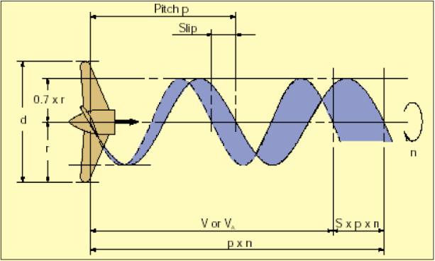
Fig. 1

3.
Philip Howes, Zoe Laughlin, (2012) explains that Carbon fibre is made from many chains of carbon atoms which range from five to ten microns thick. Single yarns are made from thousands of individual fibres which have been wound together. The yarns are wound together to create a pattern that we are used to seeing on race cars.
Philip Howes, Zoe Laughlin, (2012) further expands by saying that the fibres are derived from petroleum, the carbon fibres are produced by isolating the carbon from the nitrogen in the fibres molecular structure. Properties of carbon fibre include strong, light, good tensile molecules, extremely fine and its easily incorporated into composites.
Simonetta Pegorari, (2018), explains that marine propellers are subjected to high loading, pulsating forces as they rotate through fluid as well as bending, vibrations, and centrifugal forces. Propellers work in a heterogeneous flow environment due to the wake pattern behind a ship meaning that long term stresses are applied. Material choice is important. Traditionally, ship propellers are made from materials such as nickel aluminium bronze, magnesium bronze or a stainless cast steel alloy. These materials suffer with properties which will relate to corrosion, cavitation and maintenance costs. Carbon fibre propellers are built on a combination of good properties such as, light weight, improved fatigue properties, less corrosive and high thermal resistance.
ClassNK, (2017) inform us that Carbon fibre propellers were first developed for the German navy in 2002. Used on their submarine division with a propeller diameter of 3.5 meters.
Further expanding, ClassNK (2017) explain that there is an ongoing production of carbon fibre propellers being made by the FabHeli company. Sea trials were conducted using a one-meter diameter carbon fibre propeller which resulted in a passenger ship, the palais (30 meters long, 84 tons) with twin 1100hp engines to cover the Lorient-Best route comfortably at a speed of 21 knots or 10.8 meters per second. With the successful implementation of the carbon fibre propeller. FabHeli’s vision is to progress into a full-scale production of composite propellers.
In a case study found online revealed that ClassNK installed a carbon fibre composite propeller on the chemical tanker “TAIKO-Maru” in May 2014. The propeller diameter came in a t 2,120mm or 2.12M. ClassNK ran a sea trial and published their results. They are as followed.

- Under a smooth sea conditions with ship on full load. To run the ship at 11.5 knots the shaft power was reduced by 9%. Meaning that the load upon the shaft was improved with the carbon fibre propeller. Fig 2. shows a graph showing the reduction in shaft load over different knots.
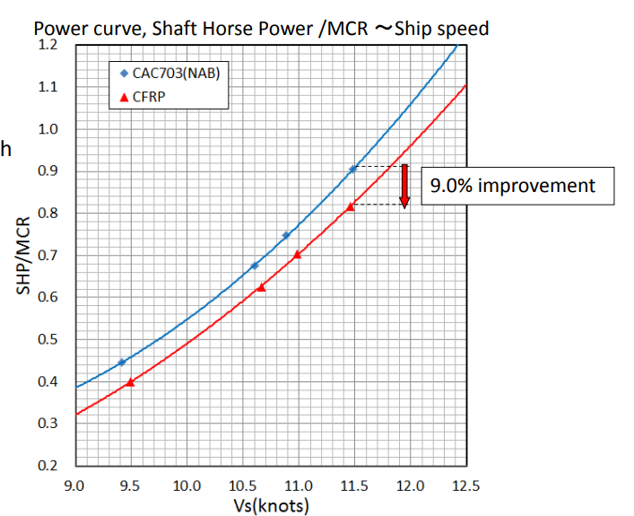

Fig.2

- Vibration Measurement. The carbon fibre propeller is smaller than the original propeller. Crew reports state that the overall noise is quieter, and they are now able to talk to each other in the dining room. Fig. 3 shows the difference in the two propellers.
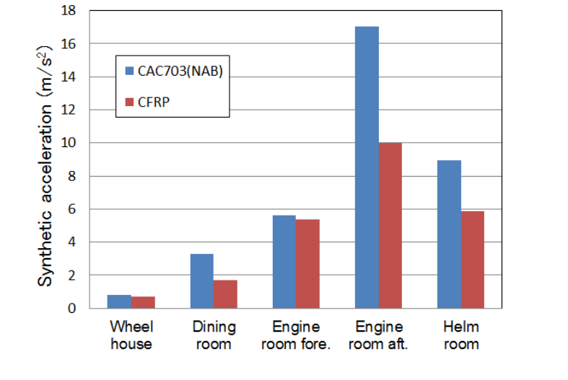

Fig. 3

In future ClassNK hope to install large carbon fibre propellers to over 60 thousand vessels. The carbon fibre propeller was approved for use in MAY 2017.

4.
In this section I will talk about three different types of fluid flow experiments and their advantages and disadvantage. The three that I have chosen to cover is computational fluid dynamics or CFD testing, wind tunnel testing and shadowgraph testing.

Computational Fluid Dynamics (CFD)
Simscale, (2021), Informs us that computational fluid dynamics or CFD, is a process which will mathematically model a physical phenomenon which involves fluid and solve it using computational prowess. CFD testing is commonly used in the automobile industry, aerodynamics play an important role in the engineering process. The CFD software analysis the fluid flow in accordance with its physical properties such as velocity, pressure, temperature, density and viscosity. The CFD analysis is a key element in generating a sustainable product development process. Meaning the number of physical prototypes can be reduced.

Advantages
- Physical boundary conditions can be considered in isolation
- Flow parameters are gathered, which are not accessible in experiments
- Costs are lower compared to full blow experiments
- Can be a quick process compared to setting up experiments

Disadvantages
- Errors can occur due to simplified boundary conditions
- Computation time may extend for large models
- Costs may be higher due to wrong consulting compared to experiments
Ifes GmbH, (2019)

Wind tunnel testing
Flint Wild, (2018) tells us that wind tunnels are large tubes with air moving inside. Many companies use wind tunnels to test to aerodynamics of their products. For example, Boeing, Boeing uses wind tunnels to simulate how the aircraft will behave when in flight. Some air tunnels are big enough to accommodate full sized vehicles whereas others are only large enough to accommodate models.
Powerful fans will move air through the designated area and across the object that has been fastened to the tunnel. The air moving around the object will show how the air/fluid will react when the object is moving. The air/fluid can be studied in different ways, either through using smoke or dye. Long pieces of string or thread can also be attached the object to show the flow. The force of the air is measured on the object throughout the process.

Advantages
- Low construction costs
- Superior design when using the smoke and dye method.

Disadvantages
- Possibility of a poor flow quality.
- High operating costs
- Causes a lot noise pollution

Flint Wild, (2018)

Shadowgraph testing
Wolfgang Merzkirch, (2011). Shadowgraph is a form of optical system that is suitable for observing the flow or air/fluid. The system does not use any optical component except for a light source, usually a lamp and a recording plane onto which to project the shadows. The shadow effect is generated due to the light ray being refractively defected so that the position of the on the recording plane where the undeflected ray would arrive now remains dark. Simultaneously, the position where the deflected ray arrives appears brighter. A pattern of variations is produced on the recording plane. The shadowgraph is sensitive to changes of the fluid density.
The shadowgraph can be used to view the turbulent given from the ships propeller, giving us an idea of the laminar and turbulent boundaries. Figure 4 shows a picture recorded on a shadowgraph of air moving through oil.
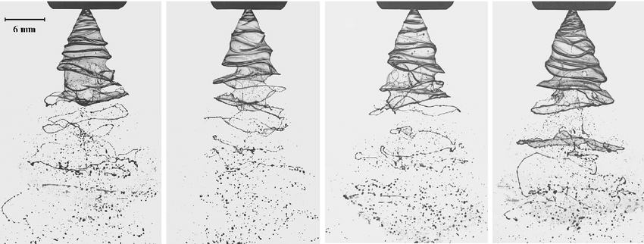
Fig.4

Advantages
- Large fields of view
- Unique solution to some problems, i.e, aircraft design.
- Low cost to purchase and run

Disadvantages
- Limited or low resolution.
- Limited real-time imaging

During the development of this component, it is proposed that a prototype is produced and tested in a laboratory to understand the fluid flow around it and also to correlate it to the simulation carried out in task 4. Discuss how you think this experiment should be carried out and how the acquisition of data should be obtained and compared to the simulation.

5.
After finalising the specification of my propeller which is, 5.75m with a 0.6m boss, formed of carbon fibre composite. I have decided to carry out my experiment with a 1:4 scale propeller, reason being is cost saving. The propeller will be fitted to a shaft which will vary the speed that the propeller is rotating. The tests that you should be carrying out are, open water tests, where you should test to see how much power Is needed to generate the thrust required to move the given ship.
The data gathered through carrying out this test will tell us if the propeller is suitable for its intended ship and how the propeller performs when being used in open water.

Propeller open water test
When testing the propeller in the open water test you should power the propeller along an open water tank. The propeller is fitted to a horizontal shaft which is then moved through the water, recordings of the thrust and torque are taken to give us a range of carriage speeds and revolutions of the propeller. The temperature and viscosity of the water will be calibrated although they can fluctuate. After the measurements are taken, the thrust values are corrected for the resistance of the hub and cap. The correction will be determined from a previous experiment where only the hub and cap were used, with no propeller. The torque and the adjusted thrust will be expressed as a non-dimensional coefficient. It is not assumed that the propeller open water characteristics have been corrected for scale effects.
The data will be collected on a conventional open water diagram similar to Figure. 5.
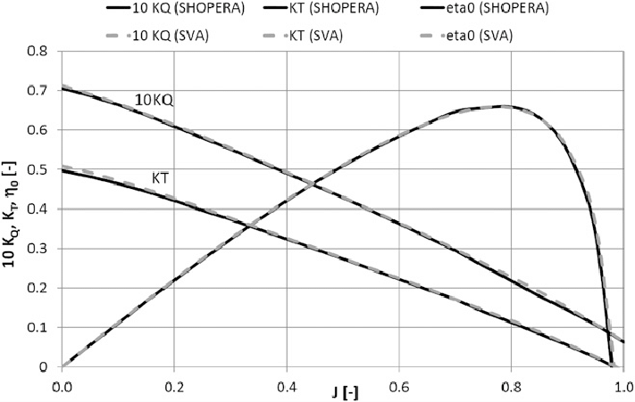

Fig.5

Comparison
In this section I will compare my real-world experiment to my CFD simulation. There are many factors that need to be the same before the real-world experiment can be carried out. This includes, viscosity of the water, dimensions and design of the propeller, all velocities and materials properties.
Although the results may be similar, there will be differences due to some contributing factors, the CFD will struggle to simulate real world heat within the fluid. A figure can be inserted into the CFD software. However, the heat will fluctuate within the tank second to second due to contributing factors such as, room temperature, humidity and air flow. Also, the CFD software will always create the perfect model, whereas a propeller that has been manufactured will have defects and the tolerances on the model propeller will not be as tight as the CFD model, meaning that little imperfections can cause the results to flutter. CFD testing is cheaper than real-world testing, with CFD, there is no need to manufacture a propeller or rent a test facility.
In conclusion, I feel as though real-world testing outweighs CFD as it gives a more realistic vision of how the propeller will perform. Although CFD testing will reduce both the time and the cost, real world testing will give us a better idea of how the propeller will perform and if the equipment will operate under its desired conditions.

References

Baltazar, Joao. Et al. (2021), Prediction of the Propeller Performance at Different Reynolds Number Regimes with RANS. Instituto Superior Tecnico, Universidade de Lisboa. 9(10). pp. 21-22. Available at: https://www.mdpi.com/2077-1312/9/10/1115/htm (Accessed on 23rd of May 2022)
Candance CFD. (2019), What is Reynolds Number and Why Is It Important. Cadence. Available at: https://resources.system-analysis.cadence.com/blog/msa2022-what-is-reynolds-number-and-why-is-it-important (Accessed on 20th of May 2022).
ClassNK. (2017), Benefits of Carbon Composite Marine Propeller. Composite Business Dept. Nakashima Propeller Co., Ltd. Available at: https://www.classnk.or.jp/classnk-rd/assets/pdf/katsudou201511_D.pdf (Accessed on 23rd of May 2022)
Deters W., Robert. Et. AL. (2014), Reynolds Number Effects on the Performance of Small-Scale Propellers. Department of Aerospace Engineering, University of Illinois. Pp. 11-12. AIAA Aviation. Available at: https://www.google.co.uk/search?q=how+to+harvard+reference+a+journal&tbm=isch&ved=2ahUKEwjV9_ic4JX4AhVSyRoKHfEdD8YQ2-cCegQIABAA&oq=how+to+harvard+reference+a+journal&gs_lcp=CgNpbWcQAzIFCAAQgAQyBQgAEIAEMgUIABCABDIFCAAQgAQyBAgAEBgyBAgAEBgyBAgAEBgyBAgAEBgyBAgAEBgyBAgAEBg6BAgjECc6BggAEB4QCFCSA1ihMGCvMmgFcAB4AIABXIgBzweSAQIxNJgBAKABAaoBC2d3cy13aXotaW1nwAEB&sclient=img&ei=SVacYpWvC9KSa_G7vLAM&bih=722&biw=1536&hl=en#imgrc=emXExIF8MI0OUM (Accessed on 20th of May 2022)
Howes, Phillip., Laughlin, Zoe., (2012), Materials Matters: new materials in design. London: Black Dog Press
Ifes. (2019), Computational Fluid Dynamics (CFD). Ifes. Available at: https://www.ifes-koeln.de/en/services-20-years-project-experience/simulation-analysis/computational-fluid-dynamics-cfd.html (Accessed on 28th of May 2022)
Khan, Irfan A. (1987). Fluid Mechanics. USA: Holt, Rhinehart and Winston
Liburdy, James . (2010), Boundary Layer Flows. Oregon State University. Available at: https://open.oregonstate.education/intermediate-fluid-mechanics/chapter/integral-boundary-layer-relationships/ (Accessed on 23rd of May 2022)
Merkirch, Wolfgang. (2011), Shadowgraph Technique. Thermopedia. Available at: https://thermopedia.com/content/1117/ (Accessed 28th of May 2022)
Pegorari, Simonetta (2018), Carbon Fibre Composite Propellers, Mets Trade. Available at: https://www.metstrade.com/news/construction-and-material/carbon-fibre-composite-propellers/ (Accessed on: 23rd of May 2022)
Rehm, Bill. Et. al. (2008), Managed Pressure Drilling. 1st edn. Texas: Gulf publishing company.
Streeter, Victor L., Wylie, Benjamin E. (1983). Fluid Mechanics. 1st edn. Japan: Mcgraw-Hill Book Company Japan
Wild, Flint , (2018). What Are Wind Tunnels? NASA. Available at: https://www.nasa.gov/audience/forstudents/k-4/stories/nasa-knows/what-are-wind-tunnels-k4.html (Accessed on 28th of May 2022)

