The following points were agreed upon and became known as the Pittsburgh Platform:
1. We recognize in every religion an attempt to grasp the Infinite, and in every mode, source or book of revelation held sacred in any religious system the consciousness of the indwelling of God in man. We hold that Judaism presents the highest conception of the God-idea as taught in our Holy Scriptures and developed and spiritualized by the Jewish teachers, in accordance with the moral and philosophical progress of their respective ages. We maintain that Judaism preserved and defended midst continual struggles and trials and under enforced isolation, this God-idea as the central religious truth for the human race.
2. We recognize in the Bible the record of the consecration of the Jewish people to its mission as the priest of the one God, and value it as the most potent instrument of religious and moral instruction. We hold that the modern discoveries of scientific researches in the domain of nature and history are not antagonistic to the doctrines of Judaism, the Bible reflecting the primitive ideas of its own age, and at times clothing its conception of divine Providence and Justice dealing with men in miraculous narratives.
3. We recognize in the Mosaic legislation a system of training the Jewish people for its mission during its national life in Palestine, and today we accept as binding only its moral laws, and maintain only such ceremonies as elevate and sanctify our lives, but reject al such as are not adapted to the views and habits of modern civilization.
4. We hold that all such Mosaic and rabbinical laws as regulate diet, priestly purity, and dress originated in ages and under the influence of ideas entirely foreign to our present mental and spiritual state. They fail to impress the modern Jew with a spirit of priestly holiness; their observance in our days is apt rather to obstruct than to further modern spiritual elevation.
5. We recognize, in the modern era of universal culture of heart and intellect, the approaching of the realization of Israel s great Messianic hope for the establishment of the kingdom of truth, justice, and peace among all men. We consider ourselves no longer a nation, but a religious community, and therefore expect neither a return to Palestine, nor a sacrificial worship under the sons of Aaron, nor the restoration of any of the laws concerning the Jewish state.
6. We recognize in Judaism a progressive religion, ever striving to be in accord with the postulates of reason. We are convinced of the utmost necessity of preserving the historical identity with our great past. Christianity and Islam, being daughter religions of Judaism, we appreciate their providential mission, to aid in the spreading of monotheistic and moral truth. We acknowledge that the spirit of broad humanity of our age is our ally in the fulfilment of our mission, and therefore we extend the hand of fellowship to all who cooperate with us in the establishment of the reign of truth and righteousness among men.
7. We reassert the doctrine of Judaism that the soul is immortal, grounding the belief on the divine nature of human spirit, which forever finds bliss in righteousness and misery in wickedness. We reject as ideas not rooted in Judaism, the beliefs both in bodily resurrection and in Gehenna and Eden (Hell and Paradise) as abodes for everlasting punishment and reward.
8. In full accordance with the spirit of the Mosaic legislation, which strives to regulate the relations between rich and poor, we deem it our duty to participate in the great task of modern times, to solve, on the basis of justice and righteousness, the problems presented by the contrasts and evils of the present organization of society.

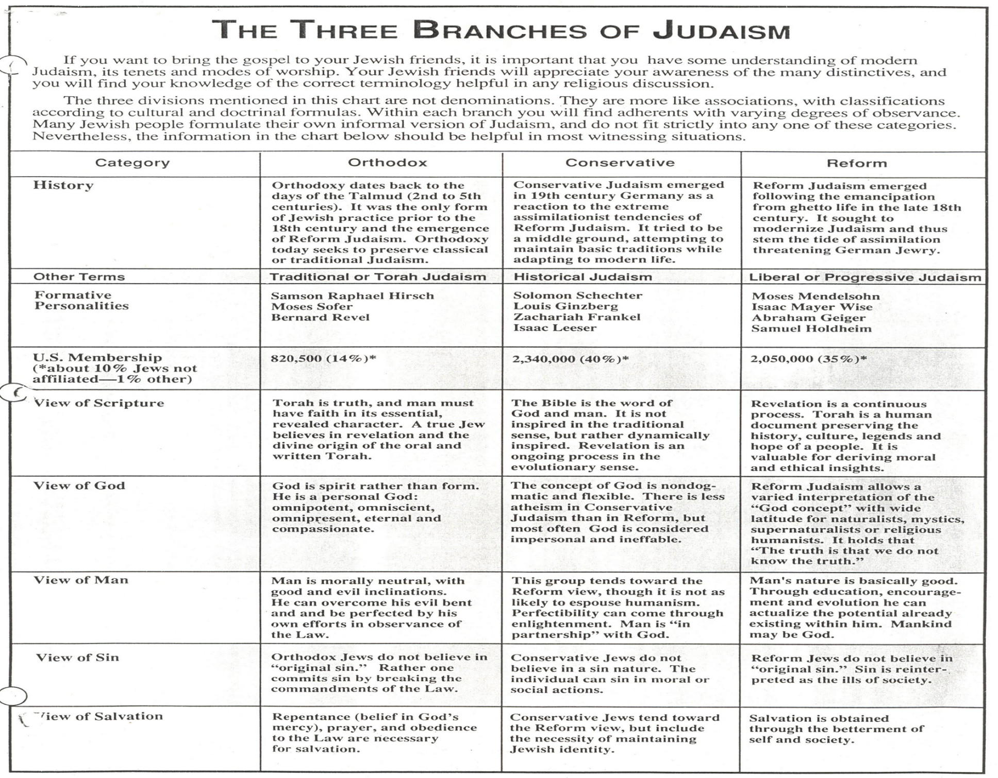
Source: http://orthodoxjudaismlou.blogspot.com/

