Academic report on different Forces that affect the conrod

By Joshua Davies : 1803092

Contents
1.0-List of figures
1.1-Inrtoduction
1.2 Research
1.3 Methodology
1.4 Analysis
1.5 Recommendations

List of Figures

Fig 1- Diagram of Connecting Rod
Fig 2- Spreadsheet with Data

1.1 Introduction
The connecting rod has the aim of connecting the crankshaft to the piston in a piston engine. There are certain forces that affect the connecting rod in a piston engine, such as tensile and compressive forces. To present how these forces affect the connecting rod, several values of these forces can be used to compare and contrast how the connecting rod acts under these conditions. The small end of the rod connects to the gudgeon pin, which also connects to the piston, and can allow swivel movement within it. The big end of the rod connects to the crankshaft which transfers the energy from the top of the piston to the bottom. The connecting rod undergoes stress from the piston and so compresses with every rotation and thus increases with engine speed.
1.2 Research
1.2(a) What is a conrods role?
The conrod is one of the main components of the engine its job is to change reciprocating motion into rotational motion, the top of the rod is connected to the piston and the bottom is connected to the crank, as pressure builds in the chamber this pushes the conrod down which then turns the connected crank shaft.
1.2(b) Design of a conrod
A conrods purpose is to withstand tensile and compressive forces and because the compressive forces are a lot higher than tensile force this means when designing a conrod the centre of the conrod is made as a strut.

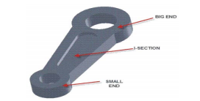
Fig 1- Diagram of Connecting Rod

1.3 Methodology
How will you analyse? To analyse the forces that a conrod undergoes inside an engine graphs can be used to analyse the data, one method that can be used is Microsoft excel as it has many essential tools for creating and analysing data, the data that will be discussed will be:
- Crank radius
- Conrod length
- RPM
- Mass of piston
These factors will be shown in a spreadsheet and then put into different formulas to show many different statistics on the connective rod.
Below is a screenshot of the spreadsheet
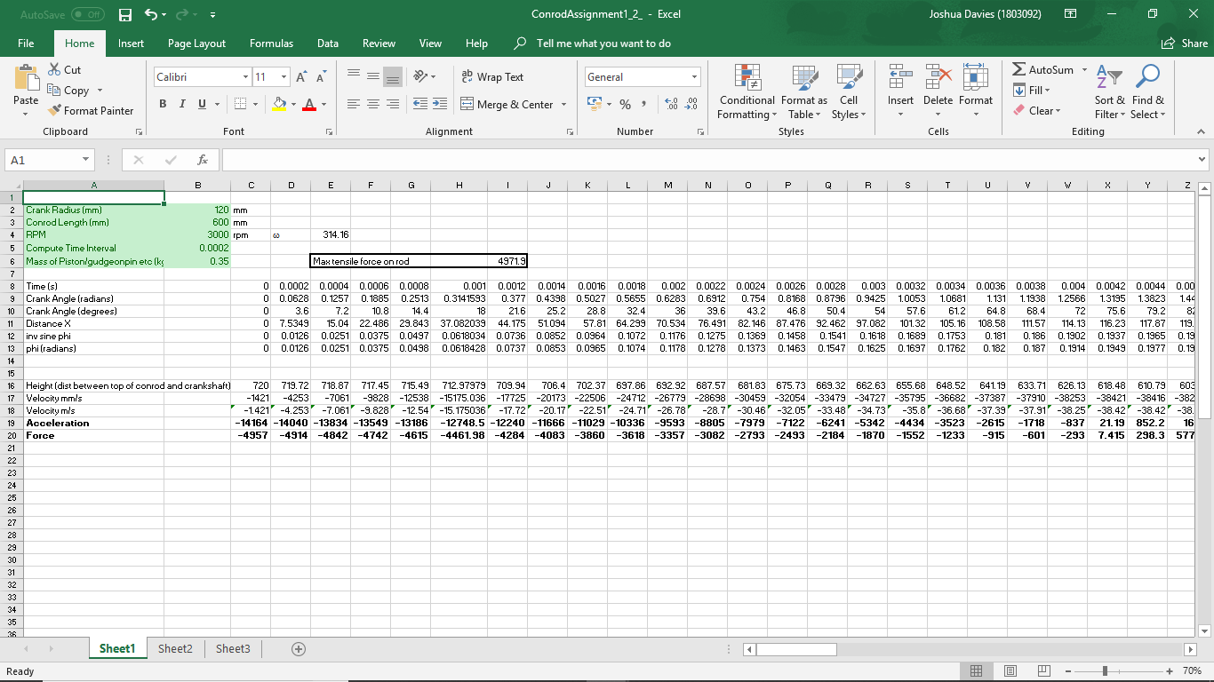

Fig - 2 Spreadsheet with Data

1.4 Analysis
Graph 1 (height/time of the connecting rod)

this graph shows that as time increases the height of the connecting rod decreases from its starting point (top dead centre) down to the lowest point (bottom dead centre) then it increases back up to where it began completing one revolution (one rev)
Graph 2 velocity/time

This graph shows the velocity of which the connection rod is moving in circular motion so as time increases the velocity goes higher until it reaches 180 degrees and then decreases until its back to its starting point

Graph 3 Force and acceleration/Time

this graph shows the acceleration and force that is applied to the connection rod, as the acceleration increases the force also increases at the exact same moment this shows that as more work is done the force increases and as the connection rod moves back to its starting position the force becomes less.

1.5 recommendations
This report can be improved by collecting more data on the same engine at different RPM and also collecting more data on other engines to make the data more reliable, also most the information and references are from the internet another improvement would be collecting more information from books etc.

1.7 References
1. Leela Krishna Vegi, Venu Gopal Vegi (, June, 2013), ‘Design And Analysis of Connecting Rod Using Forged steel’, [Online]. Available: https://www.ijser.org/researchpaper/design-and-analysis-of-connecting-rod-using-forged-steel.pdf, [Accessed Date – 2018, 12, 8th].

2. Wayne Ward, ( July 03, 2012) ‘The effect of con rod length’ , [Online] . Available: https://www.highpowermedia.com/blog/3332/the-effect-of-con-rod-length, [accessed Date – 2018, 12, 8th]

3. Author unknown (2014) ‘QUALITY PARAMETERS FOR A CONNECTING ROD’ [Online] Availble: http://www.preciousind.com/quality-parameters.php , [Accessed Date – 2018, 12, 8th]

